

Assessment 1 – Reading Task Template
:
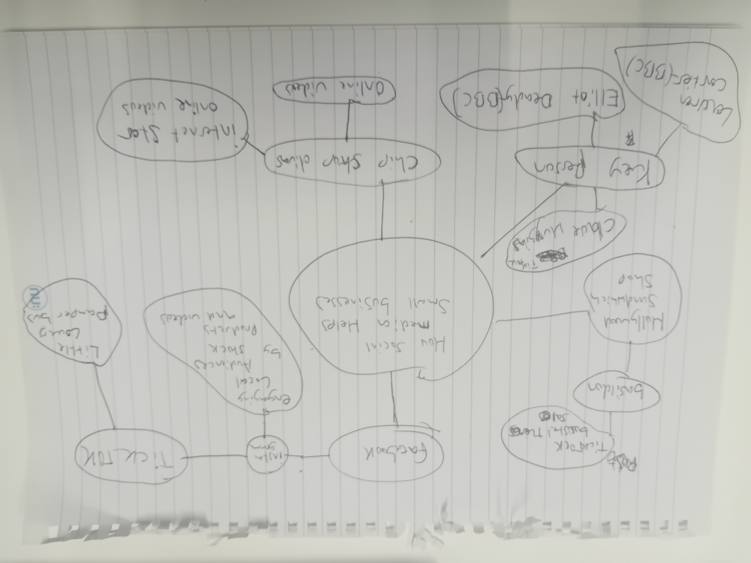
Amir singh 2617743

- What is the main idea of the whole text?

The main idea that social media like tic tock and Instagram has helped many small businesses grow. They get noticed from people all over the country

- What is one key point that supports the main idea, and which specific example from the text shows this?

I would say one key point is social media platforms such as tic Tok and Instagram can promote business and make them very successful. Example from the text is like people travelled 3 hours for our chicken burger or even the main title explains.

- What is a different key point that supports the main idea, and which specific example from the text shows this?

Key point is how small business can expand by getting a lot likes and followers to promote business to do well. A good specific sample from text would be like Chrystal’s boutique the owner said all their stock got sold after sitting in their van and getting so many followers then sold everything”.

- Which part of the text do you think is most important, and why?
The most important part I would say is the main heading and caption because it explains a lot, and the most important part of the text is how it explains how small business went viral.

Reflection:
- What did you find difficult in this task (including in-class components), and why was it difficult?
I found it difficult working alone in this task prefer in partners. Found it bit difficult identifying the main idea properly.

- What helped you with this difficulty, and how did it help you?

What helped was after working with fellow classmates. Sharing ideas with each other mad me understand more

