The Decisiveness of the English Longbow in the Battle of Agincourt

Jordan Hayston

Ordnance Munitions and Explosives
Technical Authoring
ACDA 6015

Wales Institute for Science and Art
University of Wales Trinity Saint David



Abstract
Many historians believe the use of the English longbow in conjunction with the bodkin-tipped arrow was the major contributing factor in King Henry V’s success against the French army in the Battle of Agincourt, 25th October 1415. It is questioned whether these claims are true; how big of an impact did the English longbow truly have in defeating the French?

This paper explores some of the physics and penetration mechanics behind the longbow and bodkin arrow to determine its reliability against types of medieval armour. Other defeat mechanisms are investigated to determine what may have aided in the French defeat and it is discovered that an accumulation of different factors contributed to the success of King Henry V. These include varying battle tactics between the two sides, weather conditions and the use of a fortified defensive position.

Contents
Abstract 2
1 Introduction and Background 4
1.1 Context 4
1.2 The Forces In Play 4
1.3 The English Longbow 4
1.4 Needle Bodkin Tip 5
1.5 Medieval Armour 6
2 Armour Penetration 7
2.1 Armour Thickness 7
2.2 Kinetic Energy 7
3 Other Reasons for Defeat 9
3.1 Weather and Battlefield conditions 9
3.2 Battle Tactics 9
3.3 Armour Weight 10
3.4 Fortifications 10
4 Conclusions 10
5 References 11
6 Appendix A 12

Table of Figures
Figure 1, Replica of 13th Century Longbow 6
Figure 2, Replica of Bodkin-Tipped Arrow 7
Figure 3, Replica of Medieval Plate Armour 8
Figure 4, The KE of an Arrow over Distance 10
Figure 5, Diagram of Troop Formations Before The Battle Commenced 11

Introduction and Background

Context
The Battle of Agincourt followed was the 42nd major battle in the Hundred Years’ War, following the Siege of Harfleur. The war was a series of conflicts fought between England and France, mostly over territory and the right to the French throne.

Upon his succession of the English throne in 1413, King Henry V reignited the war by leading an army to take control of Harfleur, a strategically important port town in Normandy. [1]

Following a lengthy 6-week battle, the English army successfully took control of Harfleur however, this victory came at a heavy cost of manpower and resources. The King of England left many of his troops in Harfleur to recover and protect the site whilst he marched the remainder toward Calais, where they could disembark for England. [2]

French defences tracked the army, preventing them from crossing the Somme River. This forced King Henry V and his men to divert inland and cross further upstream. They marched around 200 miles until they were intercepted by a large French army by the village of Agincourt.

The Forces In Play
The English were severely outnumbered in the battle of Agincourt; it is estimated that their army had around 6000 soldiers [1], 5000 of which were archers. Many of the English soldiers suffered from dysentery from their previous battle and 200-mile march to Agincourt, which is an infectious disease of the intestine. Despite this, King Henry V still managed to lead his army to success.

The opposing side was estimated to have between 20,000-30,000 soldiers led by both Charles D’Albret and Boucicaut, under which were several other commanding officers. The French fleet appeared strong, outnumbering the English 5 to 1 with a fleet of armoured horses, knights and even a small number of primitive artillery weapons. Despite their vast number of men and resources, the chain of command and hierarchy of the French army may have caused them a number of issues.

The English Longbow
The English longbow is often described by historians and authors as the deciding factor in the Battle of Agincourt, with its penetrative capability helping to eliminate heavily armoured units in the French army. Believed to originate from Wales, the English longbow had a great range and accuracy which allowed armies to engage in combat from a safe distance. It was commonly made using yew wood, which is known for being both strong and flexible. Its light-coloured outer layer possesses good elastic properties, allowing the bow the flex without breaking whilst its darker inner has good resistance to compression. Mechanically speaking, it was the perfect available material for this type of weapon. [3]

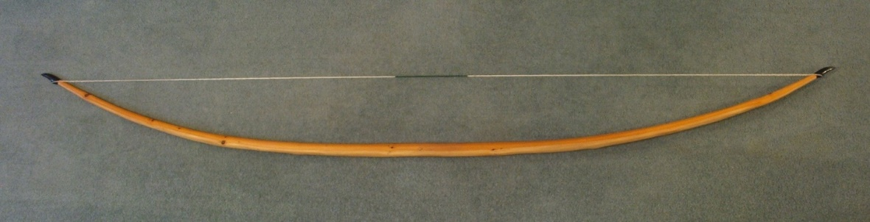
Figure 1, Replica of 13th Century Longbow [4]

The average length of the longbow was 6ft, which made it taller than most archers although, the sizes varied drastically. As a result, the draw weights and bow powers also had a vast range of 80-180lbs however, the archers drawing 160-180lbs were in a minority.

The high draw weight contributed to the longbow’s exceptional power, range and precision. This also meant that it required a lot of training to become a consistent and accurate archer. The English were known for their remarkable arching capability, as it was encouraged to carry out regular training in place of other games and activities. The highest skilled archers had the ability to fire up to 10-12 arrows per minute, despite the high draw weights of the bow. It has been found that those who had spent a long time using the longbow ended up with a deformed body shape.

Needle Bodkin Tip
The needle bodkin tip was commonly used on arrows with the English longbow around this time. The bodkin tipped arrows were made using a yew wood shaft, again for its sturdiness and flexibility, and a narrow point resembling a needle, forged from wrought iron or occasionally steel. [5]

Armour penetration was crucial for the English in the battle of Agincourt, facing the heavily armoured French knights and cavalry. The needle pointed tip concentrated the force exerted on the target, which increased the likelihood of penetrating armour. This differed to broad headed arrows, which were designed for cutting through soft targets.

Combined with the high draw weight of the longbow, the bodkin arrows were able to carry a large amount of energy, giving them the ability to punch through plated armour from a relatively long range. A direct hit from a further distance would likely penetrate, but not perforate the armour, meaning it would leave a dent but not punch a hole through to the other side.

The data seen in Annex A shows that an arrow weighing around 116g would be travelling at roughly 53m/s, or 118mph, at the moment of impact at 100m. Its initial velocity would be much greater, but friction forces play a role in slowing the projectile.

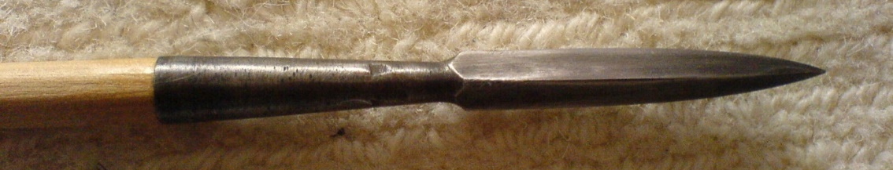

Figure 2, Replica of Bodkin-Tipped Arrow [6]

Medieval Armour
Wealthy knights often wore full plate armour, which covered the entire body. This included a close-fitting helmet, chest and backplate, gauntlets (arms), greaves (shins), and sabatons (boots). The joints were protected by articulated pieces, and the chest plates often had V-shaped guards to direct incoming arrows away from their neck. The quality of the plated armour varied significantly, particularly in its carbon content. The wealthiest knights could afford hardened steel, whilst others’ were made using wrought iron. Although plated armour provided a strong and durable form of protection for knights, the joints offered weak spots and were susceptible to the needle bodkin arrow.

For those who could not afford plate armour, chainmail was the next best protection. Chainmail consisted of a hauberk, which was a torso piece going from the neck down to the knees, and a coif, which was a head piece. The hauberks in particular were common at the time of this battle, and some men may have worn them with partial plate armour alongside other forms of protection.

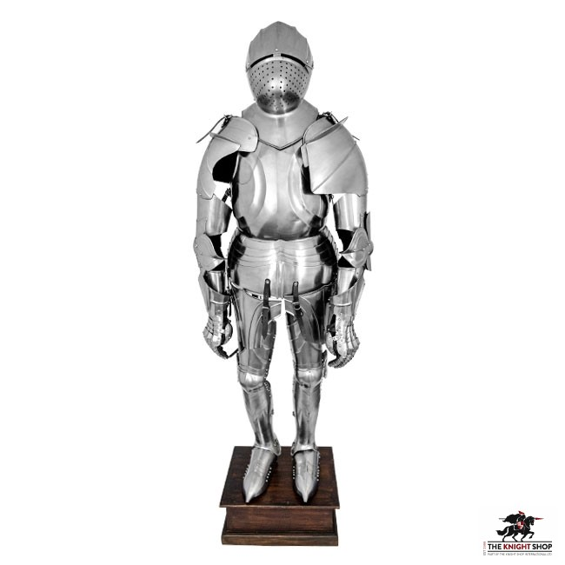
Figure 3, Replica of Medieval Plate Armour [7]

Armour Penetration

Armour Thickness
With regards to the penetration capability of a projectile, one of the key factors is the relationship between the angle of attack, the armour thickness and the path length through the armour. Using the data in Annex A, it is possible to determine the range in path length the bodkin-tipped arrow would have faced during the Battle of Agincourt.

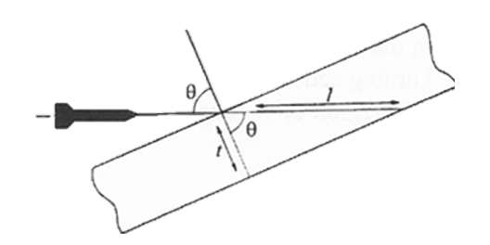
$$l=\frac{t}{\cos{θ}}$$
Where:
l = path length through armour
t = armour thickness
θ = angle of attack

With a varied thickness between 2.5-4mm and an impact angle of 30°, it is calculated that the path length the arrow tip would have to travel through plate armour would range from 2.9mm up to 4.6mm.

One key issue relating to this is the ability to consistently hit the target at the specified angle. Medieval plate armour was mostly made up of curved surfaces to fit the shape of a person, and so it would be difficult to hit at a specific angle. If the movement of the target is factored into this scenario, the difficulty of achieving a direct hit would further increase; it would be more effective to target joints and weak spots, where it is less likely for the plate armour to protect the soldier.

Kinetic Energy
The formula for kinetic energy is described below as one half multiplied by mass by the velocity squared.

$$Kinetic Energy, KE=\frac{1}{2}mv^{2}$$

The mass and velocity values for the needle bodkin arrow in Annex A can be used to determine its kinetic energy at the moment of impact. The total mass of the arrow is 0.116 Kg, and its velocity at impact is 53.34m/s. By substituting these values into the formula, the arrow has a calculated kinetic energy of 165 Joules.

Unfortunately, it is not possible to calculate the opposing kinetic energy from the knight on horseback or the men on foot as there is no reliable data on the average mass for either body. Therefore the calculations must be based on the impact of the arrow on a static target.

This information can be cross referenced with other data sources to compare the penetration to different types of amour.

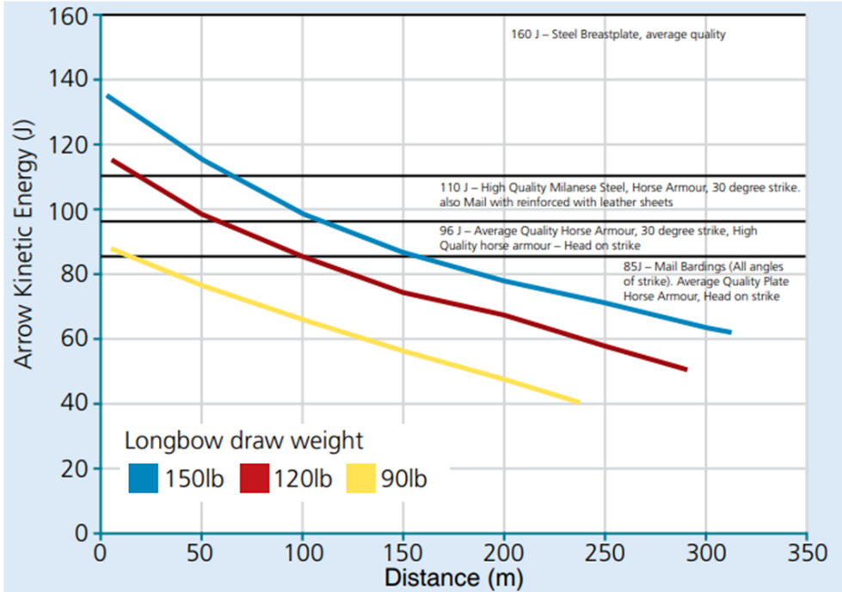
Figure 4, The KE of an Arrow over Distance

Figure 4 above demonstrates how the kinetic energy of an arrow changes over the distance that it travels, with bows of different draw weight colour coded to show the range of weapon capability. It is clear that there is a gradual loss of kinetic energy over the distance travelled, which can be directly related to the arrows velocity. The drop in velocity and kinetic energy can be assumed to be caused by air resistance.

It can be seen that even from a 150lb draw weight longbow, an arrow would fail to penetrate an average quality steel breastplate. However, it could perform quite well against the mid to lower quality plate armour and extremely well against chainmail. The horse armour also seems to be particularly vulnerable in this example, which may establish why the English longbows performed so well against the French cavalry.

The kinetic energy value for the needle bodkin arrow calculated earlier sits above the values in Figure 4. If a value of 165 Joules is applied to this diagram, and the impact distance remains at 100m, it brings to question the reliability of the information sources and historical accounts on the Battle of Agincourt.

Other Reasons for Defeat
The English longbow is proven to be a significant threat to most types of medieval armour, and appears to be a major factor in the defeat of the French during the Battle of Agincourt. However, looking at the bigger picture reveals other major factors which are arguably just as, if not, more crucial to the success of King Henry V and his army.

Weather and Battlefield conditions
The first factor to consider is the weather conditions in which the battle took place, and how they affected the environment the armies fought in. The night before the battle, heavy rainfall hit the area. Following the recent ploughing of the field, the subsequent weather turned the terrain into a bog. This made it extremely difficult for soldiers to traverse, particularly the French army as they were the first to advance and attack. As a result, the slower moving targets on foot were much easier for the English archers to target and achieve a consistent impact. It has also been suggested that some men may have fallen and become stuck in the mud, causing them to drown or suffocate. [8]

Battle Tactics
Another significant factor affecting the outcome was the difference in battle tactics and leadership styles between the two sides. The French were disorganised under multiple leaders and those in control failed to relay a solid battle strategy to their soldiers. As a result, the English had the opportunity to advance their position and form a defensive formation with the archers on the flanks before the battle commenced. King Henry ordered his highly trained archers to fire a rain of arrows toward the French army first, which provoked them to send forward their cavalry. The newly positioned English army forced the cavalry to funnel through between the treelines, as seen in Figure 5, and with the effect of the English longbow against horse armour seen in section 2.2, it is apparent that they would have been under significant stress. In addition, the push of the cavalry under the severe weather conditions also caused further damage to the terrain, increasing the difficulty for the men at arms which followed. [9]

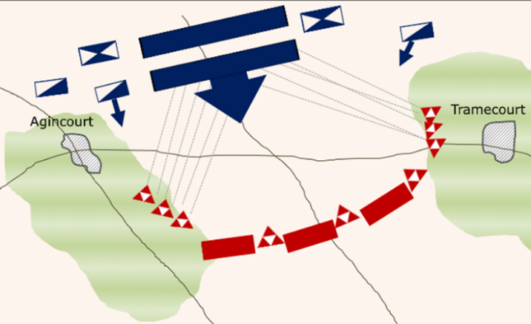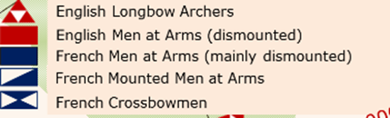
Figure 5, Diagram of Troop Formations Before The Battle Commenced

Armour Weight
A key factor in the French defeat was in fact the use of heavy plate armour. In other circumstances, a heavily armoured front line would be ideal. However, in this scenario, the sheer weight of the armour combined with the quality of the ground the men had to traverse may have caused significant issues such as slowing them or getting them stuck. The archers in the English army decided it best to remove their armour so that they could have more freedom and better perform with their bow. The remaining French soldiers that made it to the English front line had limited movement in their armour and as a result, they got beat in hand-to-hand combat by the archers, who were carrying small hand weapons such as hatchets.

Fortifications
Finally, it is noted that the English army had erected fortifications to protect their position from the large opposing army. King Henry had ordered his archers to craft and carry a sharp pointed stake with them, measuring around 6ft in length. In preparation for battle, the archers would secure the stake into the ground with the sharp end facing the enemy. The exact orientation of the stakes is often debated about however, they provided the perfect level of protection against the incoming cavalry. Once the horses made it to the front line, they could not make it past the wall of stakes and so their formation was abandoned causing more chaos for the French men at arms following. [10]

Conclusions
In conclusion, the English longbow and the needle bodkin tipped arrow did have a significant impact on the outcome of the Battle of Agincourt, 25th October 1415. Under the right conditions, the longbow had enough penetrative power to pierce the medieval plate armour used by the French knights. Despite this, it may be that the initial attack of arrows was nothing but a provocative act on King Henry’s behalf to force the French to advance first. There are many variables which play a part in the penetrative power of the longbow, such as the bow size and power, the skill of the archer and the materials used for the arrows and armour (a range of iron and steel with different carbon contents). By looking at the kinetic energy carried by the arrow compared to the energy required to break multiple types of armour, it can be deduced that even the more powerful bows only effectively penetrate their target within a range of 100m.

Looking at the larger picture of the battle, it is clear that an accumulation of several factors led to the defeat of the French Dauphin in the Battle of Agincourt. The freshly ploughed terrain was decimated by rainfall the night prior to the battle, creating a bog in which the soldiers struggled to manoeuvre. The cavalry further churned the earth in the French army’s attack, with the men at arms to follow who were weighed down with heavy plated armour. Strong leadership from King Henry V ensured the English archers were protected from the cavalry with fortifications made of pointed stakes, and their decision to remove armour allowed them increased speed and agility to beat the French in hand-to-hand combat.

References

[1] | J. Martinez, “Battle of Agincourt,” Britannica, 18 October 2023. [Online]. Available: https://www.britannica.com/event/Battle-of-Agincourt.
[2] | J. Barker, Agincourt : Henry V and the battle that made England, New York: Little, Brown and Co., 2006.
[3] | D. Keunecke, “Elasto-Mechanical Characterisation of Yew and Spruce Wood With Regard To Structure-Property Relationships,” Zurich, 2008.
[4] | Wikipedia, “English longbow,” Wikipedia, 28 August 2023. [Online]. Available: https://en.wikipedia.org/wiki/English_longbow.
[5] | J. Barker, Agincourt: The King, the Campaign, the Battle, Little, Brown Book group, 2010.
[6] | Wikipedia, “Bodkin point,” Wikipedia, 15 November 2023. [Online]. Available: https://en.wikipedia.org/wiki/Bodkin_point.
[7] | The Knight Shop, “Agincourt Suit of Armour,” [Online]. Available: https://www.theknightshop.com/medieval-armour-with-stand-deepeeka.
[8] | D. Petriello, Tide of War: The Impact of weather on Warfare, Skyhorse Publishing, 2018.
[9] | J. Keegan, The Face Of Battle, Pimlico Military Classics, 1976.
[10] | A. Curry, Great Battles: Agincourt, Oxford University Press, 2015.

Appendix A
Type of Ordnance | Bodkin Arrow
Delivery System | Longbow
Length of ordnance (w/o bodkin) | 583.5mm
Length of Bodkin | 115mm
Diameter of arrow shaft | 11.11mm (assume same diameter for bodkin)
Mass of Arrow | Arrow 0.116kg (1800 grains)
Density of Penetrator | Bodkin 6.25gcm⁻³
Density of Penetrator | Yew Wood 0.67 gcm⁻³
Density of Plate Armour | 2.85gcm⁻³ (rank and file) - 5.75gcm⁻³ (knight)
Thickness of Plate Armour | 2.5mm – 4mm
Angle of obliquity of impact | 30º to the normal and greater
Yield Stress of Armour | 350-600 MPa (variation between foot soldier armour and that of a king)
Velocity of system at impact (100m) | Arrow 53.34ms⁻¹  Knight on horseback (8.95ms⁻¹)  Foot soldier (0.9ms⁻¹)

