Secure the Network from Common Threats and Attacks
Tony Witter 2114134
Networks and Cyber Security Essentials
07/01/2022

To Bruce, owner of Batman Textiles.

After reading your scenario, I have come up with a few different possible security breaches.

Possible Security Breach 1: Disgruntled Employees
Reason: In the above scenario, it was stated that there are users who recently lost their job and wasn’t happy about it. This can be the most damaging to a company, as they had full access to all the systems and know how to gain access quickly and maybe even have remote access. They could install ransomware, a virus or even just change the passwords. Employees should have a limited access to systems and only need access to the files that they need to do their job to prevent this from happening. When an employ is let go or quits their login details should be disabled as to make sure they can’t access any files or systems when they no longer affiliated with the company. As most employees will normally have plenty of time in advance before they are let go and can be a security issue. [1]
It was stated that there are users who have been given more workload to save the company money. The employees might already have too much work and putting more on them can lead to stress and staff burnout. Staff might leave their computer logged in and leave the room without realising and ultimately giving access to anyone else in the area. [2] They could be angry that their colleagues have been fired and try and get back at the company by locking up systems.

Possible Security Breach 2: Open Network for customers to use
Reason: In the above scenario, it was stated that the system network is open for anyone to use. This leaves your network vulnerable as is everyone else connected to the network. It wouldn’t be hard for people to look around the whole network and find vulnerabilities and gain access to the rest of system or install keyloggers or ransomware. The hacker could find company emails and that could lead to phishing attacks.

Possible Security Breach 3: Phishing attacks.
Reason: Phishing attacks are when someone is tricked into clicking a link that could downloaded hidden malware, ransomware or direct them to a fake copy of a website in the hopes, you’ll put your login details in. Phishing can be done in many different ways but the most common is via email. The first way to protect against phishing emails is for the users to be able to identify them but if your employees are focusing on other things, they might not have time to look for the clues and just click the links without realising what it was. [3]

Possible Security Breach 4: Internal Actors
Reason: Internal Actors add up to around 30% of all cyber security attacks according to Verizon's 2019 Data Breach Investigations Report. [4] Internal actors have already been given access to the company’s system and database, which can lead to privilege abuse and accessing systems they don’t need too. Privileged users and administrators can be more of a threat since they have access to most of systems and files. Regular employees and not as much of a threat but they can be victims of phasing attacks or misuse data. Employee negligence is the most common for security breaches, could be sending sensitive date to the wrong person and phishing attacks. Malicious insiders can cause more damage to a company as they might know security measures and what data is valuable. Credential theft is when someone stelas an employee’s login details and access the system and can move around before anyone notices [5]

Other type of threats can include:
Adware is the least damaging as it will just fill your screen with pop up ads and may install an unwanted program on your device. It will trick you by looking like a legitimate program or hide on the back of another program and install itself along with it. Adware will generate revenue for the developer by showing people the adverts.
Malware: New malware is always being created with around 360,000 a day. New ones that are getting made are mostly just slightly altered older files so they can slip past antivirus programs. There are different kinds of malware, and each will affect a system in different ways from holding a system for ransom, extracting financial data, healthcare records, person emails or login details for different accounts. [6]
Ransomware is designed to encrypt all the system files, so the owner no longer has access unless they pay the attackers for the encryption key. If payment isn’t paid by a certain time the encryption key will be deleted and the files lost forever. Trojans are more of a delivery system and is any malware that hides itself in a program or file. This will trick the user to opening the file or install the virus on to the system. Worms are programs that can self-replicate and will spread through different means, the most common being emails. As soon as the worm has infected a system it will look for a contact database or file sharing and spread itself by sending itself out as an attachment. [6]
An antivirus will protect against most of malwares but a multi-layered security system that uses an antivirus, intrusion detection systems, deep-packet inspection firewalls, email virus scanners and good employee awareness training will give you best protections from attacks. It’s also very important to keep these programs updated to patch any security holes that the malware can get through. Scheduling a weekly update to make sure everything is up to date should be sufficient. [6]
Automated Running Scrips through some web browsers is a common vulnerability. Some browsers can be exploited to run scripts by looking like a trusted piece of code and having the web browser run the malware without any knowledge to the users. Keeping employees from visiting untrusted websites to help prevent this from happening. Disabling the automatic running of files is more reliable. [6]
Hidden backdoors can be installed without the individual knowing, these can be a big security issue as it can let some access the system and any other networks connected. There are intentionally installed backdoors which are normally for remote access for people working from a different location or to do technical support. [6]
Internet of Things (IoT) are any smart device that can connect to the internet usually through WI-FI can be taken over to form a salved networks and carry out further attacks. Most of the time it’s because the default password hasn’t been changed on the device making it easy for attackers to gain access. Security audits should be done often to account for all the new IoT devices that are connected to the network. [6]
The .rekt file format is a form of ransomware called REKTLocker that quietly enters the system and encrypts various files and changes the extensions of the files to .rekt so its easy to tell what files have been encrypted. When REKTLocker has encrypted the files, it creates a text file and places it on the desktop. The file informs you that the files are encrypted using 2048-bit encryption. The attacks will try and sell you the key to unlock the system usually asking payment to be in cryptocurrency. [7] As soon as it’s noticed on one computer that computer should be taken off the network to try and prevent further infection. The files can be recovered by installing and using a decrypting software such as Hidden Tear Decrypter, making sure it’s the most up to date version. Make sure that the program is set to open .rekt files as default and the program should unencrypt the files if the file has malware inside it the decrypter should tell you if its unsafe to open. Scan the file and the whole computer with an antivirus and try again after. Make sure to do all of this with administrative privileges. If some files are still not working, it may be that they’ve become corrupt and cannot be accessed. [8]

A good way of securing your servers and network would be to keep it all closed form everyone else and all computers be connected via cables rather than Wi-Fi and have a separate open guest WI-FI for customers and staff to connect their personal devices to. I also think it might be worth installing RFID sensors on each of the doors so only people who need to be in the area can access the rooms with cards that are programmed to each sensor. Make sure that everyone only has access to the files and system that they need to do their job.

I’ve written a guideline for Batman Textiles for staff and customers to use the digital space responsibly.
‘Batman Textiles guest Wi-Fi guidance.
Here at Batman Textiles, we have an open guest network called ‘Batman Textiles Guest’ for any of customers and staff to use. All information sent over the unsecured network can be intercept by anyone connected, so make sure not to access any sensitive information like personal or any banking information.
Here are a few tips to help keep you secure while using an open network:
Use an antivirus and make sure that it’s updated as well as your device, to keep it safe from adware and malware. Make sure to do scans on your devices on a regular basis to keep your device free of malware.
To help secure your information think of using a VPN (Virtual Private Network) to encrypt your information and make it harder for someone to see what you are accessing. It’s very simple to set up and will help keep all your data secure.
Make sure you have a firewall installed and turned on to prevent any unauthorised access to your device. Turn off the file sharing before connecting to an open Wi-Fi so that others don’t have access to your shared files and prevent unauthorised access.
Only log in to trusted and secure websites. The address bar should show URL that begins with HTTPS to show it’s encrypted; HTTP mean that it is not encrypted. Even if a website has HTTPS doesn’t mean its secure however, as scammers can have access to their own websites so they can see the information they put in. That’s why it’s important to use trusted sites only. Make sure you log out of accounts after you have finished using an open network. Make sure you have Wi-Fi turned off on your devices when you don’t need to be connected to limit the chance of someone gaining access to your devices.
All staff should limit their use of the guest network and not connect any of the companies’ devices to that network, to help keep the company server secure.
Please avoid downloading large files as this will slow down the network for everyone connected.
We here at Batman Textiles won’t collect any of your data while you are using our complimentary Wi-Fi.’

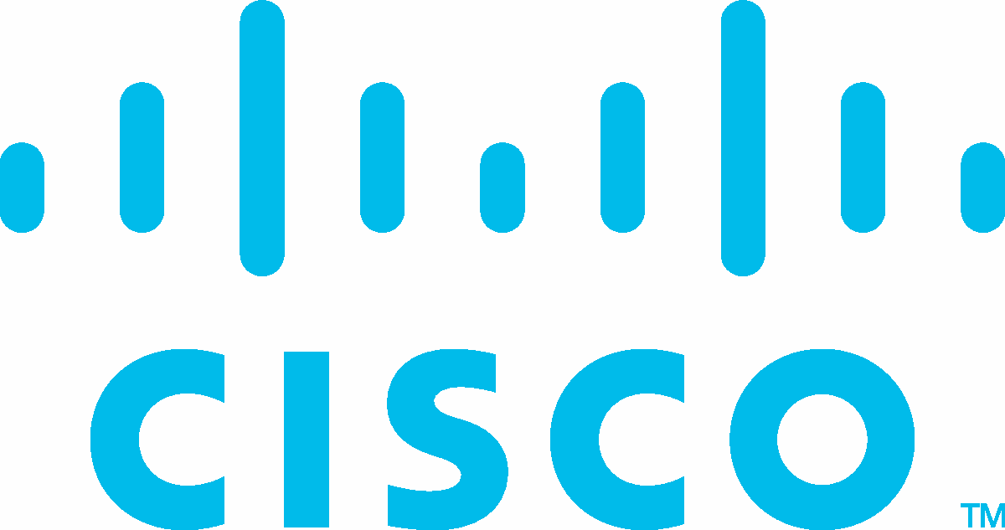
Corporate
^{Social} Cisco Networking Academy
Responsibility
Certificate of Course Completion

Introduction to Packet Tracer
For completing the Cisco Networking Academy® Introduction to Packet Tracer course.

Tony
Witter
Laura Quintana  VP & General Manager, Cisco Networking Academy | 6 Jan 2022
Student
Date

https://www.credly.com/badges/c854bf0f-3aff-4562-bcac-bef4a9383f28

References:

[1] T. Wilhelm and J. Andress, "Chapter 16 - sabotage," in Ninja Hacking, T. Wilhelm and J. Andress, Eds. Boston: Syngress, 2011, Available:https://www.sciencedirect.com/science/article/pii/B9781597495882000160. [Accessed Jan 3, 2022].

[2] H. Inegbedion et al, "Perception of workload balance and employee job satisfaction in work organisations," Heliyon, vol. 6, (1), pp. e03160, 2020. Available: https://www.sciencedirect.com/science/article/pii/S2405844020300050. [Accessed Jan 3, 2022].

[3] National Cyber Security Centre “Phishing attacks: defending your organisation”. Available: https://www.ncsc.gov.uk/guidance/phishing [Accessed Jan 3, 2022].

[4] Anonymous (). 2021 Data Breach Investigations Report. Available: https://www.verizon.com/business/resources/reports/dbir/ [Accessed Jan 3, 2022].

[5] Anonymous. Insider Threat Statistics for 2021: Facts and Figures. Available: https://www.ekransystem.com/en/blog/insider-threat-statistics-facts-and-figures [Accessed Jan 3, 2022].

[6] E. Dosal. Top 9 Cybersecurity Threats and Vulnerabilities. Available: https://www.compuquip.com/blog/cybersecurity-threats-vulnerabilities [Accessed Jan 6, 2022].

[7] T. Meskauskas. REKTLocker Ransomware. Available: https://www.pcrisk.com/removal-guides/10351-rektlocker-ransomware [Accessed Jan 6, 2022].

[8] Unknown. REKT File Extension. Available: https://www.file-extension.info/format/rekt [Accessed Jan 6, 2022].

