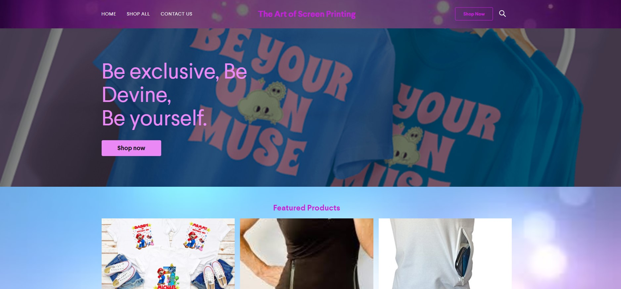  “The Art of Screen Printing” | Business Plan of  Sandra Diana Boscaneanu (2016826)  Managing Enterprise in 21st Century

Contents
1.0 Company Name and Description of the business 2
1.1 Company owner and type of business. 2
2.0 Mission statement 3
2.2 Introduction 5
2.3 How does the business work? 5
3.0 Marketing 6
3.1 Questionnaire 7
3.2 Advertising of the business 9
4.0 Physical Resources 10
5.0 Financial Resources 11
6.0 SWOT 11
7.0 Cash Flow 13
8.0 Appendix 16
8.1 Questionnaire 16
8.2 SWOT 19
8.3 Cash Flow 20

Company Name and Description of the business
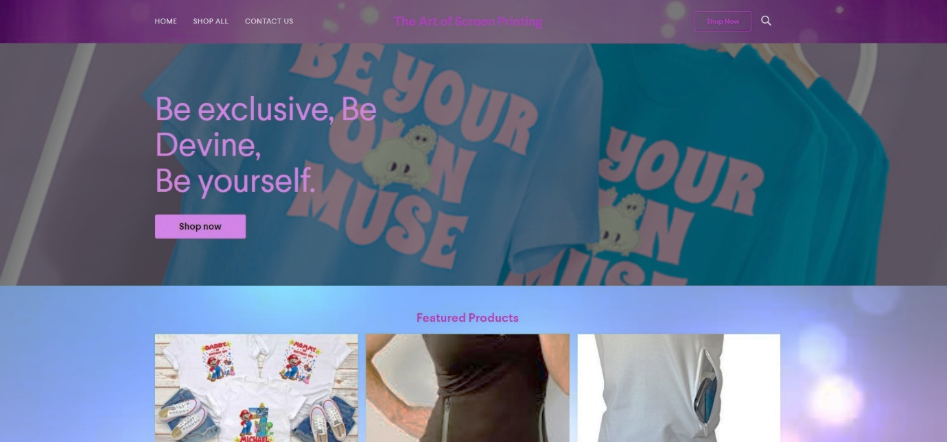
"The Art of Screen Printing" will be the name of my company. This name appealed to me because it is engaging and allows you to use your imagination to create your own designs.
My company specialises in screen printing t-shirts, which I will first operate from my house and sell online. I am going to acquire some graphic software and a web domain so that individuals can design their own t-shirt designs and place orders.

Company owner and type of business.

As a Sole Trader, I have opted to be my own boss; I will run the business on my own, and the burden of debts and success will lie on me.
A single trader, on the other hand, is someone who starts and runs their own business. They have the option of hiring people, but they are the sole proprietors. The responsibilities of a sole trader are infinite.
As a sole trader, I have complete control over every part of my business, including how it operates.
(Sole trader advantages and disadvantages - Company Bug, 2021)
Furthermore, to protect my business, I will opt for public liability insurance which means, if someone is harmed or the property is accidentally damaged because of the business's actions or the items I supply, my company may be held liable under the law, but public liability insurance can protect my company from claims for damages and legal fees brought against it by other parties.
(Public Liability Insurance | AXA UK, 2021)

Mission statement

The objective of the Art of Screens will be to supply individuals with their own t-shirt design and text, as well as the highest quality fabrics and inks, and to deliver them on time.
The company's objective will be to earn their loyalty and admiration by providing them with high-quality products and the ability to customise their own designs.

  - Aims and Objectives of Business
- Provide a high level of durability in the design.
- Provide them with adult, children, and baby sizes as well.
- Print and add pockets on demand.
- Exceed people's expectations by coming up with my own ideas.
- Buy a local and hire more staff.
- Expand my business by printing on other items other than t-shirts.

Introduction

Why I choose this product.
This concept came to me when I had my daughter and wanted a body with a text on it that said, "Hello world, I'm Natalia," which I got but at a high cost.
Furthermore, I wanted something personalised for her first birthday, and I paid enough for it. Maybe, for her second birthday and the arrival of her sibling, I will be able to make things exactly how I want them by myself.
This style of t-shirt is in high demand these days, and I am confident that the business will succeed because many mothers are willing to purchase them.
Furthermore, to differentiate myself from the competition, I will include “kangaroo” pockets in the front, which will be added on demand.
This idea came to me while I was pregnant and wanted to wear a t-shirt and leggings on a hot summer day, but there were no pockets where I could put my keys or my phone. I could not find any of those, at least not personalized, after undertaking some research.

How does the business work?
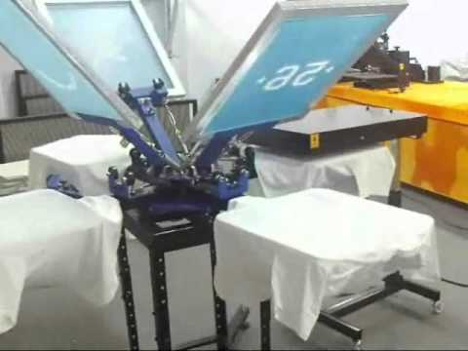
This Photo by Unknown Author is licensed under CC BY
The 4-4 Screen Press can create four exact colours in four locations after installation and maintenance. It may be used on garments, woven fabrics, metal, paper, copybooks, plastic, wood, glass, ceramics, leather, and other items, and it allows multiple people to work on multi-colour printing at the same time.
(What Is Screen Printing? A Step-by-step Guide | Custom Planet, 2021)
The owner will collect orders and construct the final items when the web platform has been developed. Customers will be able to tell her if they want to utilise graphic software or offer her an idea of what they want. She will take care of all parts of finishing the t-shirts, as well as packing and shipping the completed order to the customer.

Marketing

Marketing is the process of designing, creating, researching, and collecting data to determine what to do to best connect the idea of a product or service with the target demographic.
Marketing entails researching audience responses and developing language and design that will most effectively impact that audience. Various target markets are more receptive to pictures and messages than others.
(Marketing vs. Advertising: What is the Difference? 2021)
Marketing strategy may be divided into the following categories.
- Products or Services: What does the customer expect from the product? Alternatively, how, where, and why does the client use the product?
- Prices: It is important to get the pricing correct to not only cover expenses but also create profit.
- Place: What options are there for customers to experience our product for example online, in shop. In this case, online and local shop.
- Promotion: When is the most effective time to market my product? What tactic are my competition utilising? Shall I advertise the product on social media.
- Physical Evidence: Physical proof gives concrete indicators of the quality of experience provided by a business. It is especially beneficial when a consumer has never purchased from the company before and wants reassurance.
- Processes: In terms of processes in the marketing mix, your organization's procedure might impact the performance of the service you provide, which involves the delivery of your product to customers.
- People: To ensure that you provide outstanding products, the business need employees who are properly trained for the task, such as delivery driver, in this case.
The digital marketing mix assists businesses in reviewing and defining important problems that impact the marketing of their products and services.
(How to use the 7Ps Marketing Mix strategy model?, 2021)
Furthermore, for this business plan the owner used a questionnaire to know her target market and what are her customers preferences, to support her in creating the website where she will sell her products.

Questionnaire

Businesses can use data analytics to improve certain areas of their products and services, as well as their general brand and customer satisfaction.
Furthermore, the owner of the business Sandra Boscaneanu analysed the questionnaire made for her business plan, using Google form to create the questionnaire and the key finding response for the questionnaire came from 7 people where the average time to complete the questionnaire was 02 minutes and 16 seconds.
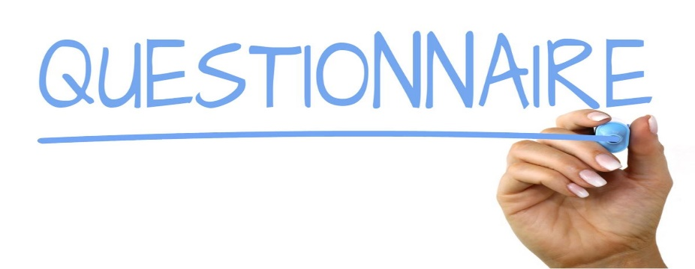
According to B2B International, a questionnaire should be as brief as necessary while still allowing the researcher to collect valid and reliable responses to all the questions posed to each participant.
This Photo by Unknown Author is licensed under CC BY-SA
The key findings are as follow:
The fact that all seven individuals said yes has a good influence on the business since it implies that the product she selects to personalise will sell extremely well.
The second good result was that with a percentage of 86 percent, everyone was drawn to create their own t-shirt, which will save her time; she will make just a few modifications to ensure the order is right and will print the design on the t-shirt.
Furthermore, with a proportion of 71 percent, they were willing to pay for an adult t-shirt between 15 and 25£, indicating that the price chosen is reasonable.
However, she discovered that most of her customers purchased a t-shirt for a birthday celebration, indicating that she should focus on these sorts of t-shirts.
Moreover, the potential customers' ages are between 25-34 and 55-70 years old, meaning that her business idea will be able to reach a wide market base.
However, with such a distance between the age averages, she must create various marketing strategies, because developing a product or service that appeals to individuals of all ages might help the business increase sales and productivity.
However, she could see from the data that people prefer zip pockets to other types of pockets, which gave her the opportunity to learn about her customers' preferences and focus on these types of pockets.
Furthermore, from the findings, she could see that most of her customers were women, and she could use that information for her webpage creation.
(Please see the appendix 8.1)

Advertising of the business

Advertising is very important for a business, because is the only way to make people know about the service or product.
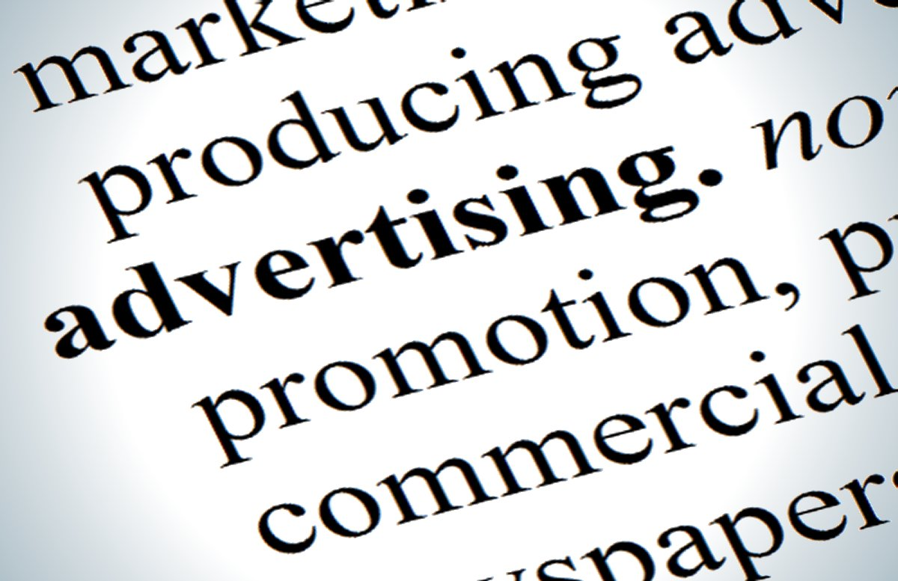
A good marketing strategy will raise awareness of your products and services, as well as attract consumers and create revenue.
This Photo by Unknown Author is licensed under CC BY-SA
(Types of advertising | Business Queensland, 2021)
Thereby, after knowing the target market the business must advertise its products.
The Art of Screen Printing will use the following options of advertising which are less expensive.
- Social Media – Facebook, Instagram, Tik Tok, YouTube, as it is free to set up an account and create a page.
- Friends, for example will recommend the product to other friends and so on.
- Flyers to spread locally.

Physical Resources
Physical resources are tangible assets that are needed and easily available for a company to function. These are items that take up space, have a monetary value, and are used in the operations of the business. Physical resources are essential for any type of company. Manufacturer businesses employ physical resources to produce goods for sale and operate its business.
(How Do Tangible and Intangible Assets Differ?, 2021)
The Art of Screen Printing resources are:
- The location will be at the owner property into the back garage of the house, the advantages is that I can save up the money for the rent, the disadvantage is that is not big and in a better geographical area.
- Screen printing machine – are machines for printing text and images.
- Screen printing materials –Ink, mesh for the frame, squeegee which is used to squeeze on the screen of the ink, aluminium frame, bulb, and latex gloves, these are all the materials needed for printing.
- Maintenance
- Office expenses, graphic design platform, web domain, computer.
- Shelves to store the products.
- Bagging, tagging, labelling, packing, shipping.
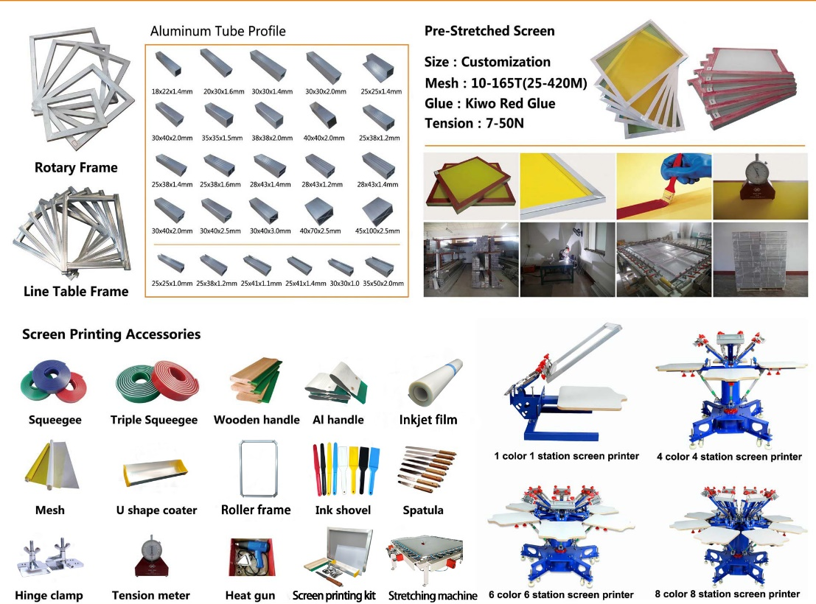

Financial Resources
For all these resources, the owner will borrow a total of 50.000£ from the bank with a fixed interest for the first 5 years of 1,9%, which she will repay gradually back. Once she has repaid all the money borrowed, she will request another 50K to develop the business.
Even though she has 20,000£ in savings, she is preserving that amount in case of an emergency. This is called Minimum Cash Balance as well, and it is very used by small businesses, because maintaining a minimum cash balance guarantees that a business has enough money in its bank or other accounts to pay all its bills when they are due.
(The Advantages of a Minimum Cash Balance Practice, 2021)

SWOT
Strengths
I feel my t-shirt will be in great demand because birthday parties are the most popular, and I will utilise high-quality materials. In addition, I will develop a webpage where individuals can create their own design, which will be a strength for my company since they will be able to do it as they want.
Furthermore, the company will employ a screen printing equipment as well as high-quality inks and textiles.
Another advantage of the business is that I will be able to add pockets.
Weaknesses
Being a start-up business has already proven to be a disadvantage because no one knows about my company, and my items are unknown at this point, and I do not have any regular customers.
Opportunity
In addition, I may be able to expand my company and recruit employees.
Additionally, when I will recruit staff, I want that the candidate to have some experience as it will save me time and money, while to recruit I must abide by the following rules according gov.uk.
As an employer you must give employees:
- a written statement of employment or contract
- the statutory minimum level of paid holiday
- a payslip showing all deductions, such as National Insurance contributions.
- the statutory minimum length of rest breaks
- Statutory Sick Pay (SSP)
- maternity, paternity, and adoption pay and leave
- doing a DBS check it is optional, but I will do it as I will feel more secure.

Later, I might start making shirts for every forthcoming event, such as St. Patrick’s Day or in honour of a loved one.
Furthermore, I could print on other objects like mugs, pillows, keyrings to by myself a threat for other companies.
Threats
The biggest threats for my business are the competitors who are already known and who sell other thing than t-shirt.
Another threat are copyright laws, only the owner of the work has the legal right to duplicate and reproduce it and I must be very careful with that, to avoid any legal potential consequences.
(Copyright Basics For T-Shirt Design: Do’s And Don’ts, 2021)

(Please see Appendix 8.2)

Cash Flow
A cash flow forecast is a projection of how much money your company expects to receive in and pay out over a given period in this case 12 months. It includes all the probable income streams such as sales or other customer payments and compare them to the expected business costs like supplier payments, premises rental and tax payments.
(The Complete Guide to Cash Flow for Small Businesses, 2021)
The Art of Screen Printing's cash flow will begin in January 2022 and finish on December 31, 2022. At first, the money going out will be higher because no money is coming in, but shortly, money will be flowing in from Sales. Furthermore, by running the business from home, I will save money on rent, and paying the utility bills monthly will make it easier to keep track of them and save money at the beginning.
Additionally, printing on demand will save the company money as I will not waste materials, and not having any employees now save me money as I do not have to pay salaries.
Furthermore, sales will grow throughout the summer months and during the Christmas season since it is summer and people wear t-shirts, and people are more cheerful during the Christmas season and want personalised t-shirts for their infants or just because it is their first Christmas together.
Furthermore, I must register my trademark to avoid any fines and it will cost me 170£ by filling the form online on Gov.UK by myself which save me 30£.
(Application to register a trademark, 2021)
Additionally, I will have public liability insurance which will cost me 450£ per annum, but I will be paying monthly 37.5£ to cut the beginning cost down.
(Please see Appendix 8.3)

References

- AXA UK home page. 2021. Public Liability Insurance | AXA UK. [online] Available at:< https://www.axa.co.uk/business-insurance/public-liability/ > [Accessed 25 June 2021]
- Business.qld.gov.au. 2021. Types of advertising | Business Queensland. [online] Available at: < https://www.business.qld.gov.au/running-business/marketing-sales/marketing-promotion/advertising/types > [Accessed 28 June 2021].
- Customplanet.co.uk. 2021. What Is Screen Printing? A Step-by-step Guide | Custom Planet. [online] Available at: https://www.customplanet.co.uk/what-is-screen-printing-a-step-by-step-guide [Accessed 20 June 2021].
- Concordia University, St. Paul Online. 2021. Marketing vs. Advertising: What’s the Difference?. [online] Available at: < https://online.csp.edu/program-resources/marketing-vs-advertising/> [Accessed 20 June 2021].
- International, B., 2021. How long should a questionnaire be? - B2B International. [online] B2B International. Available at: https://www.b2binternational.com/research/methods/faq/questionnaire-length/
- Designhill. 2021. Copyright Basics For T-Shirt Design: Do’s And Don’ts. [online] Available at: < https://www.designhill.com/design-blog/copyright-basics-for-t-shirt-design-dos-and-donts/ > [Accessed 28 June 2021].
- GOV.UK. 2021. Application to register a trade mark. [online] Available at: < https://www.gov.uk/government/publications/application-to-register-a-trade-mark > [Accessed 27 June 2021].
- Investopedia. 2021. How Do Tangible and Intangible Assets Differ?. [online] Available at: < https://www.investopedia.com/ask/answers/012815/what-difference-between-tangible-and-intangible-assets.asp > [Accessed 28 June 2021].
- Smart Insights. 2021. How to use the 7Ps Marketing Mix strategy model?. [online] Available at: https://www.smartinsights.com/marketing-planning/marketing-models/how-to-use-the-7ps-marketing-mix/ [Accessed 20 June 2021].
- Small Business - Chron.com. 2021. The Advantages of a Minimum Cash Balance Practice. [online] Available at: < https://smallbusiness.chron.com/advantages-minimum-cash-balance-practice-73649.html > [Accessed 27 June 2021].
- Supplies, S., 2021. Screen Printing Materials List -Macrokun Screen Printing Supplies. [online] Macrokun.com. Available at: < https://www.macrokun.com/News/printing-accessories/240.html > [Accessed 22 June 2021].
- Wave Blog. 2021. The Complete Guide to Cash Flow for Small Businesses. [online] Available at: < https://www.waveapps.com/blog/accounting-and-taxes/cash-flow-for-small-businesses > [Accessed 28 June 2021].

Appendix

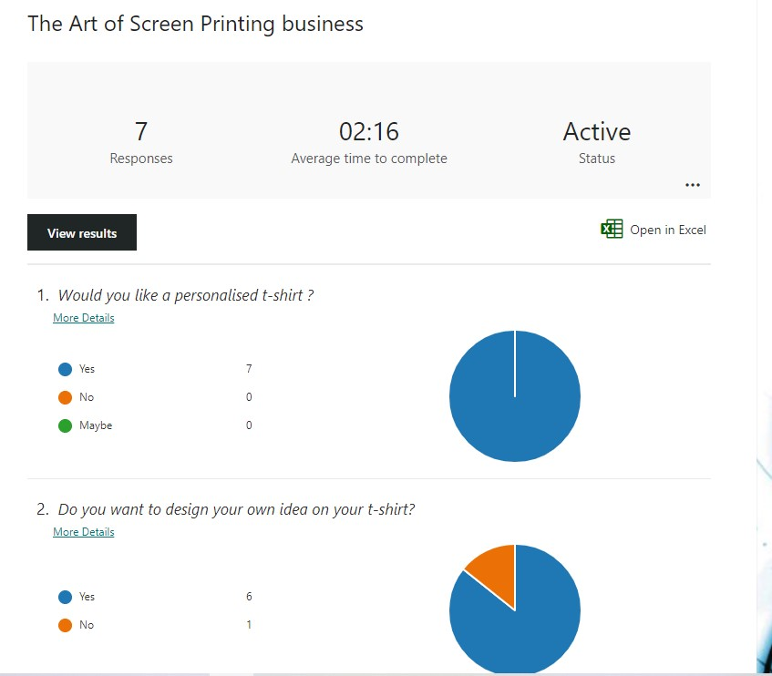
Questionnaire
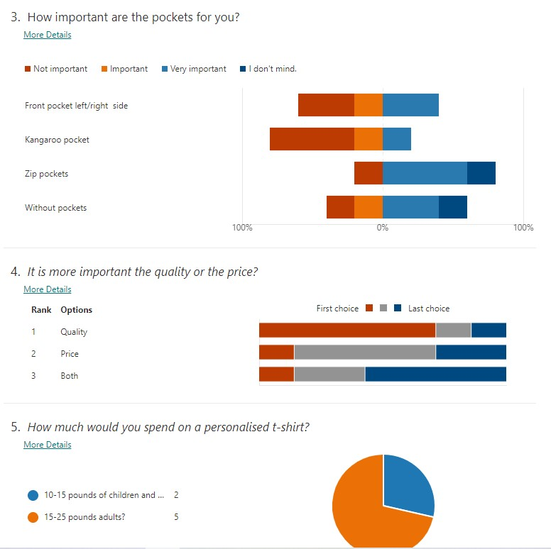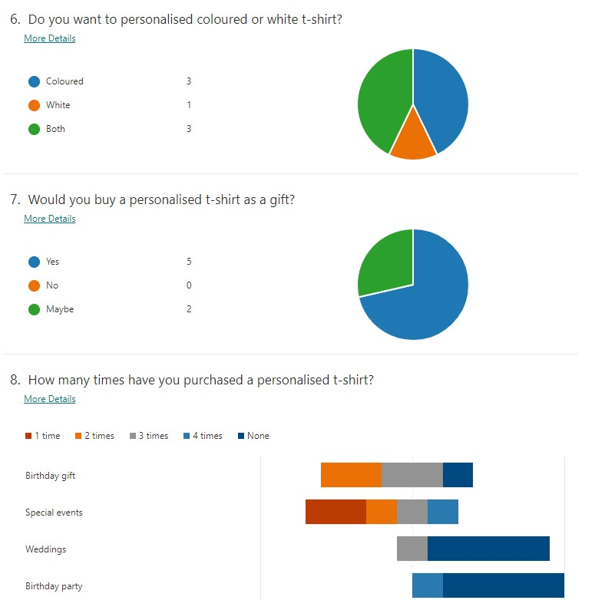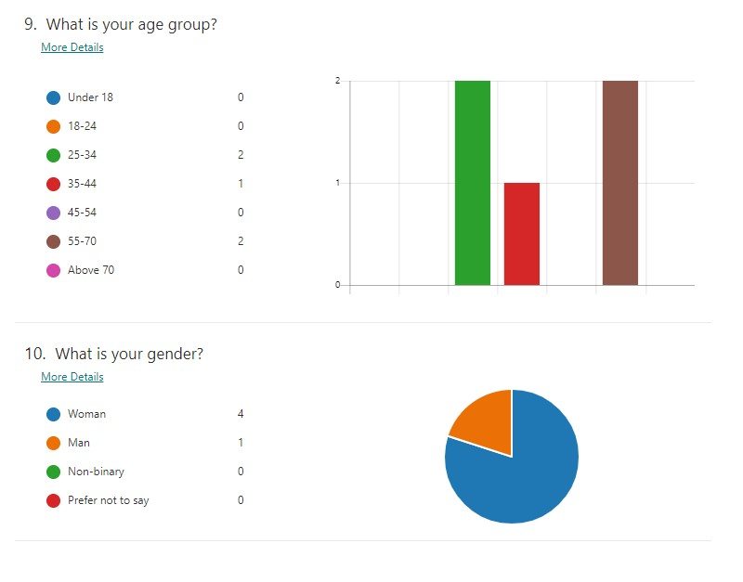

SWOT
Strengths  Unique designs  High durability products  Adding Pockets | Weaknesses  New on the market  The business is unknown on the market
Opportunity  Expansion  Hire staff | Threats  Competitors  Laws  Copyright

8.3 Cash Flow


