Component 2 Research Methods

Slide 1:

Slide 2:
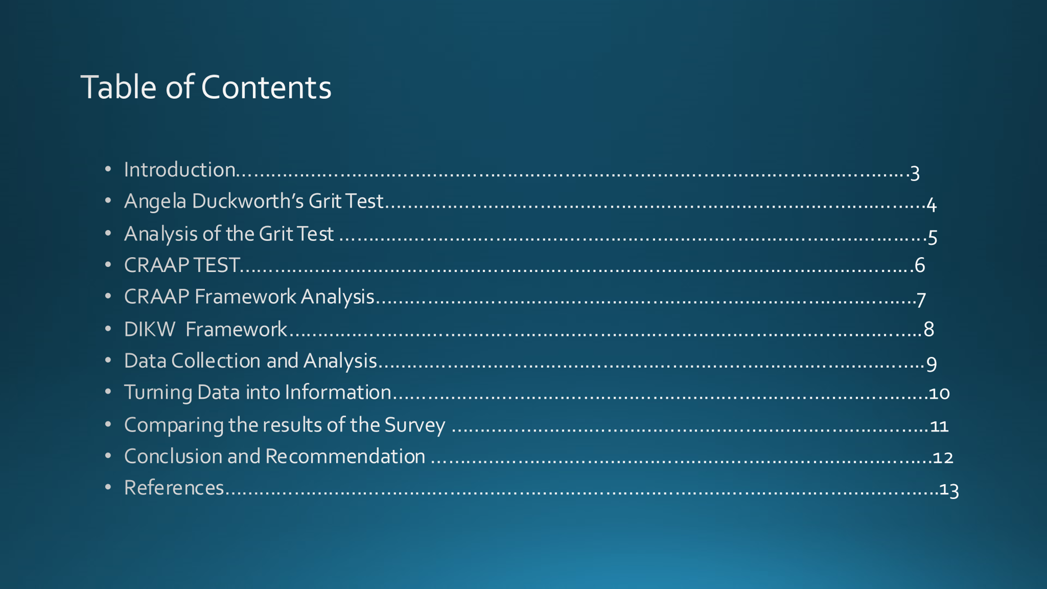
Slide 3:
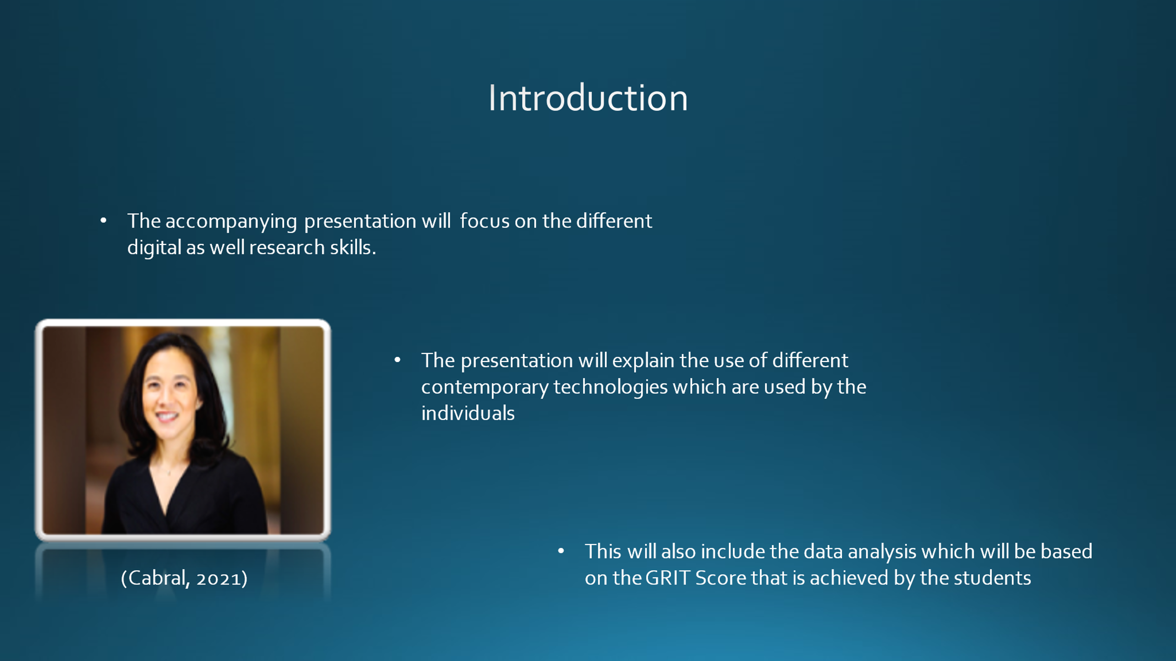
Notes:
Introduction
The accompanying presentation will focus on the different digital as well research skills. This is one of the most important aspect of the modern age which ensures that the individuals are able to gain the maximum advantages from the competitive environment. Further, the presentation will explain the use of different contemporary technologies which are used by the individuals so that they are able to maintain its position in the competitive environment. This will also include the evaluation of the different sources which are used in the overall research. Lastly, this will also include the data analysis which will be based on the GRIT Score that is achieved by the students.
Slide 4:
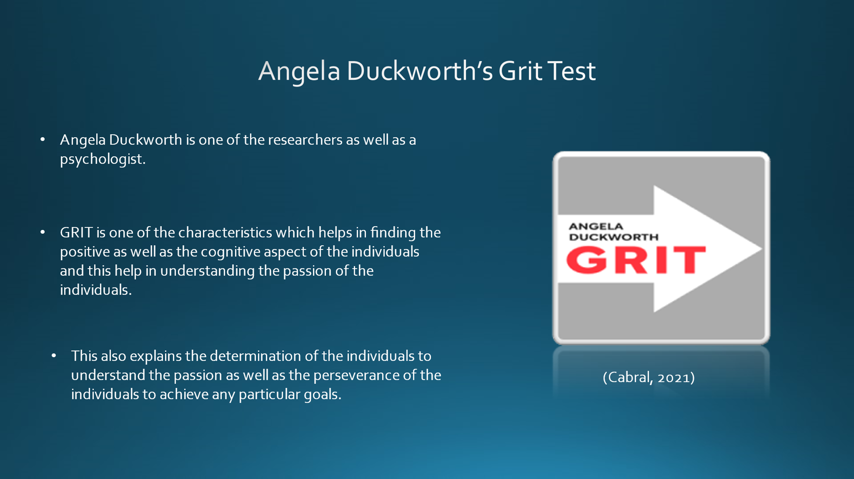
Notes:
1. Angela Duckworth’s GRIT Test
GRIT is one of the characteristics which helps in finding the positive as well as the cognitive aspect of the individuals and this help in understanding the passion of the individuals. This also explains the determination of the individuals to understand the passion as well as the perseverance of the individuals to achieve any particular goals. Further, Angela Duckworth is one of the researchers as well as a psychologist who has accomplished different researches regarding the trades which allows in the prediction of the achievement (Cabral, 2021). Her research makes it important to gain self-control and the credit which an individual has so that it can ensure that all the efforts as well as the interest are sustained (certguidance, 2021). This will also help in achieving the long-term goals of the individuals by taking the help of different regulations which are voluntary and the temptations which are gratifying. Along with this, it also ensures that the individuals are able to make the proper use of all their skills so that they are able to achieve the long-term goals (retireby40, 2021). Her research also claims that it is very much important to have self-control so that the individuals are able to overcome the difficult situation.
Slide 5:
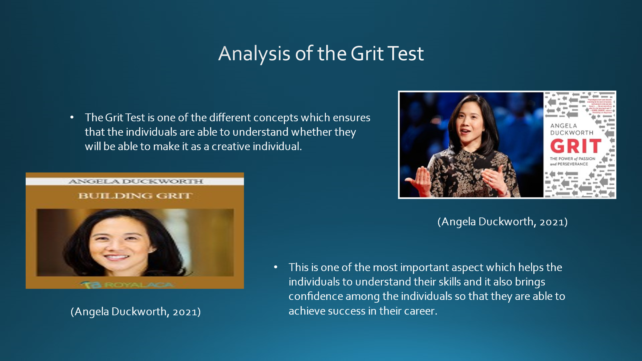
Notes:
1.1 Analysis of the Grit Test
The Grit Test is one of the different concepts which ensures that the individuals are able to understand whether they will be able to make it as a creative individual. This is one of the most important aspect which helps the individuals to understand their skills and it also brings confidence among the individuals so that they are able to achieve success in their career. Moreover, this is also significant in understanding the IQ level of the individuals (Idrlabs, 2021). The overall test helps the individuals to understand the capabilities which they have and to understand the relationship which they have among themselves. Moreover, this ensures that the individuals are able to gain the maximum benefits when they fix their goals and they will also be able to sustain in the competitive environment (Angela Duckworth, 2021). Further, this also helps the individuals to create innovative things and to ensure that the individuals can attain the maximum benefits within the competitive environment. Along with this, the overall GRIT framework helps in testing individual knowledge and making them aware regarding the capabilities which they have (i-scoop, 2021).
Slide 6:
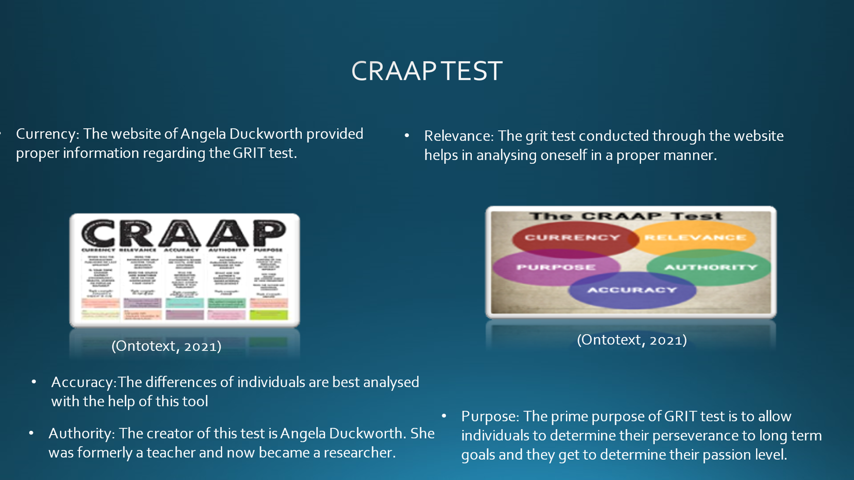
Notes:
2. CRAAP Test
CRAAP test is basically a framework which is used in order to check the various aspects of the sources from which data is collected. This helps in collecting proper data from the sources. This framework includes 5 different aspects Currency, Relevance, Authority, Accuracy and Purpose (Warner, 2019). The CRAAP Framework has been used to evaluate the source properly:
Currency: The website of Angela Duckworth provided proper information regarding the GRIT test. The website offers various ranges of question through which the perseverance and the behavioural traits of an individual can be analysed. In order to maintain the diversity, the questions in the website keep changing from time to time (Fielding, 2019, p.620).
Relevance: The grit test conducted through the website helps in analysing oneself in a proper manner. This is a process through which one can understand the challenges faced by them and work against it.
Authority: The creator of this test is Angela Duckworth. She was formerly a teacher and now became a researcher. She analyses various human behavioural traits and provides solution. She is also a certified speaker at Ted talk. Her research includes finding out methods through which long term goals of individuals can be maintained (Lowe, et.al, 2021).
Accuracy: Since the result of this test is totally based on the inputs given by the users, hence any sort of wrong input given by the researcher will give improper results. The differences of individuals are best analysed with the help of this tool (Liu, 2021, p.75).
Purpose: The prime purpose of GRIT test is to allow individuals to determine their perseverance to long term goals and they get to determine their passion level. This helps the individuals to make changes to themselves accordingly to stay consistent and dedicated towards their goals.
Slide 7:
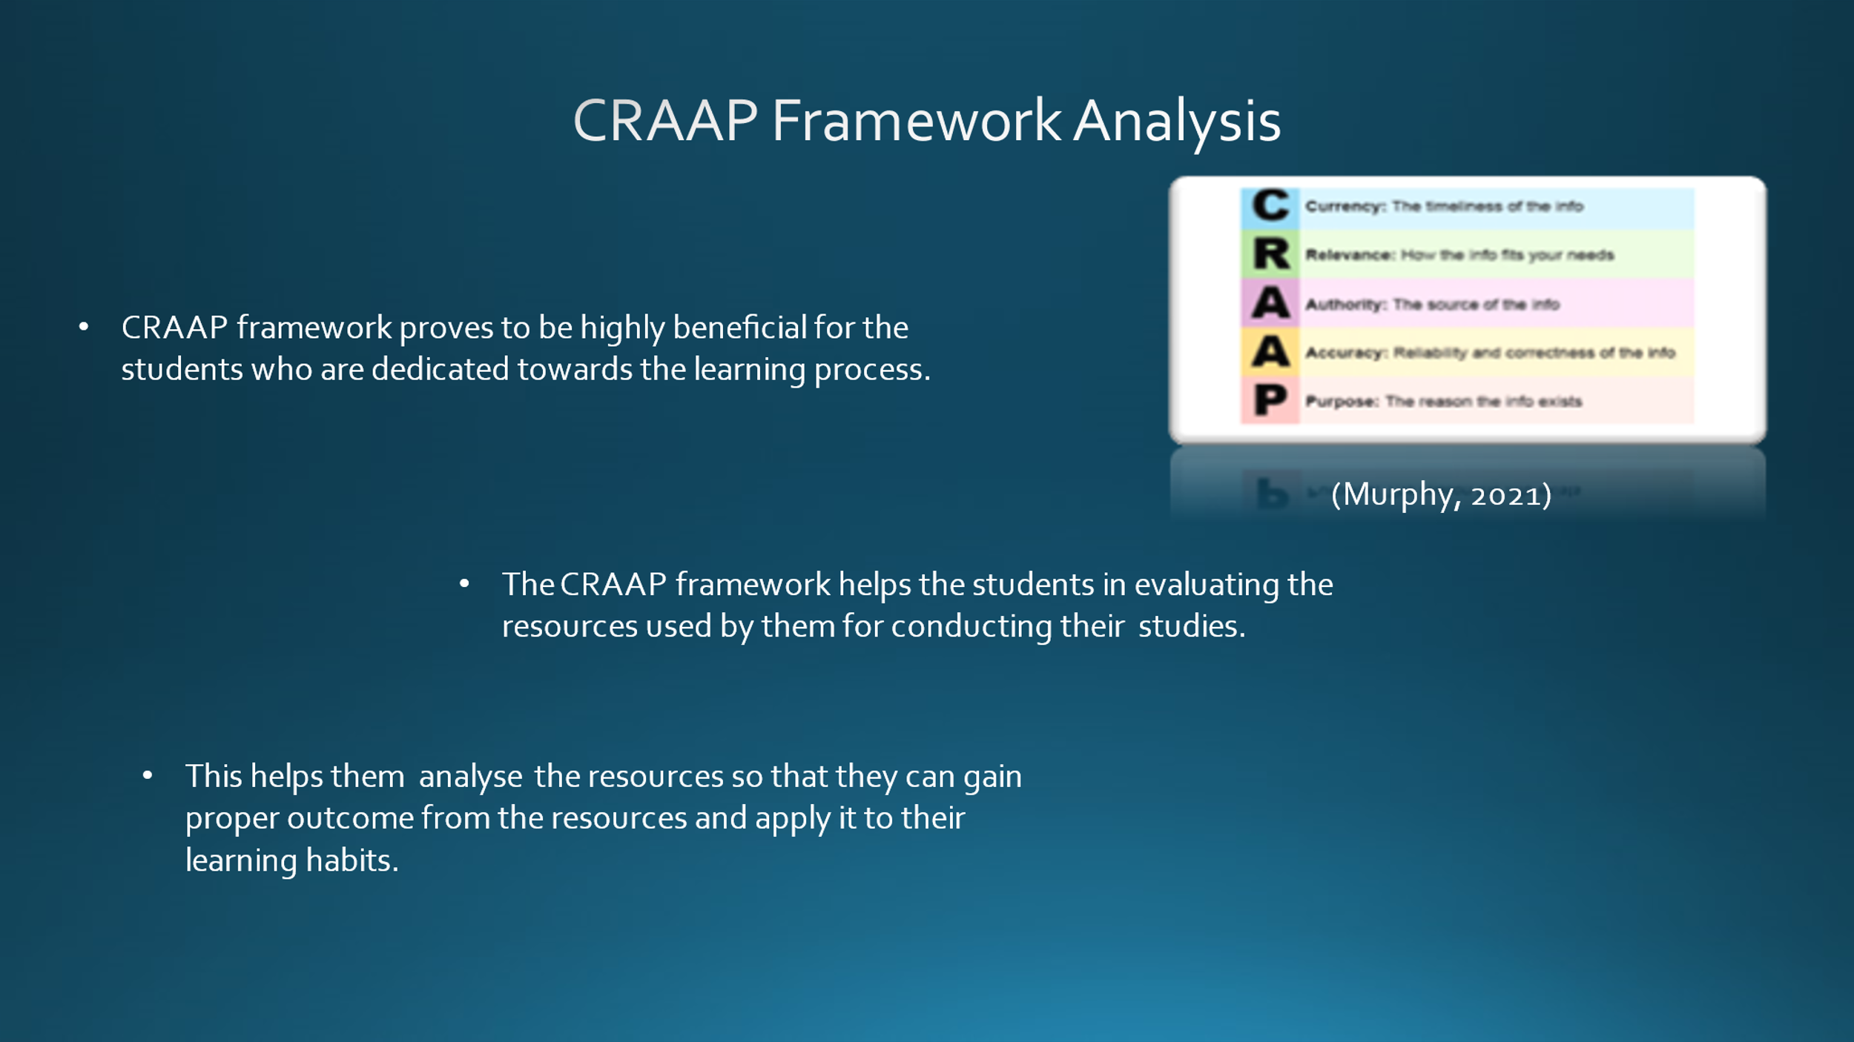
Notes:
2.1 CRAAP Framework Analysis
CRAAP framework proves to be highly beneficial for the students who are dedicated towards the learning process. The CRAAP framework helps the students in evaluating the resources used by them for conducting their studies. This helps them analyse the resources so that they can gain proper outcome from the resources and apply it to their learning habits. Apart from that this framework also provides proper confidence to the students with the help of the the appropriate concepts. Besides this, the CRAAP framework gives rise to ambiguity in its answers which allows the students to conduct the research properly. With the help of this process the complications in the learning habits are easily overcame by the students. Furthermore, this helps the students to avoid unreliable websites which gives improper information regarding certain topics (Wichowski, 2016, pp. 229-251). Every student has to complete certain assignments that are complex and require data collection from various sources. With the CRAAP framework the students get to select the sources with high confidence. Apart from that, this also helps the students to meet the expectation of the assignments. This evaluation also enables critical thinking skills within them through which they get to check validity, accuracy, reliability and point of view of a particular source.
Slide 8:
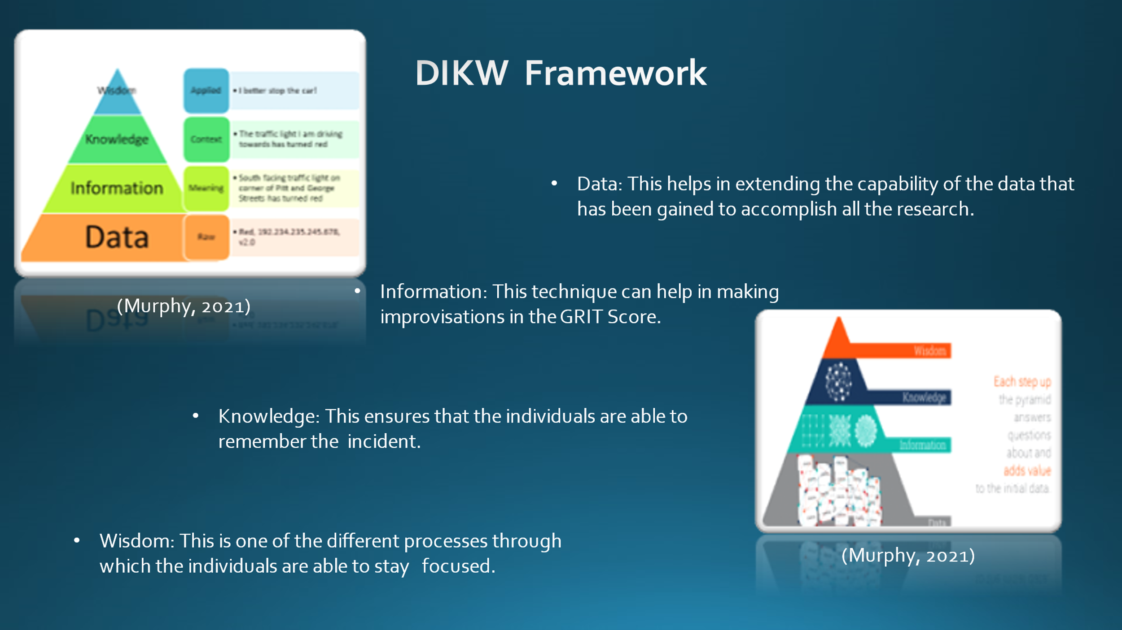
Notes:
3. DIKW Framework
This is one of the efficient models which helps in representing the relationship among the data, information, knowledge as well as wisdom. This is one of the effective models which explains that each of the building blocks is the step to achieve the higher level of success within the individuals. Further, the different steps in this particular model are described below:
Data: This helps in extending the capability of the data that has been gained to accomplish all the research. This helps in the refinement of the information from the data which has been collected for the accomplishment of the overall research.
Information: This technique can help in making improvisations in the GRIT Score. The DIKW model can help the individuals to relate the data and the information which they have gathered from any particular incident (Ontotext, 2021).
Knowledge: This ensures that the individuals are able to remember the incident and, in this way, they will be making the required improvements within the learning process. This helps the individuals to gain the maximum score from the overall test and they will be able to maintain the pace in this way.
Wisdom: This is one of the different processes through which the individuals are able to stay focused throughout their work and they are able to maximise their chances of achieving success within their career (Murphy, 2021).
Slide 9:
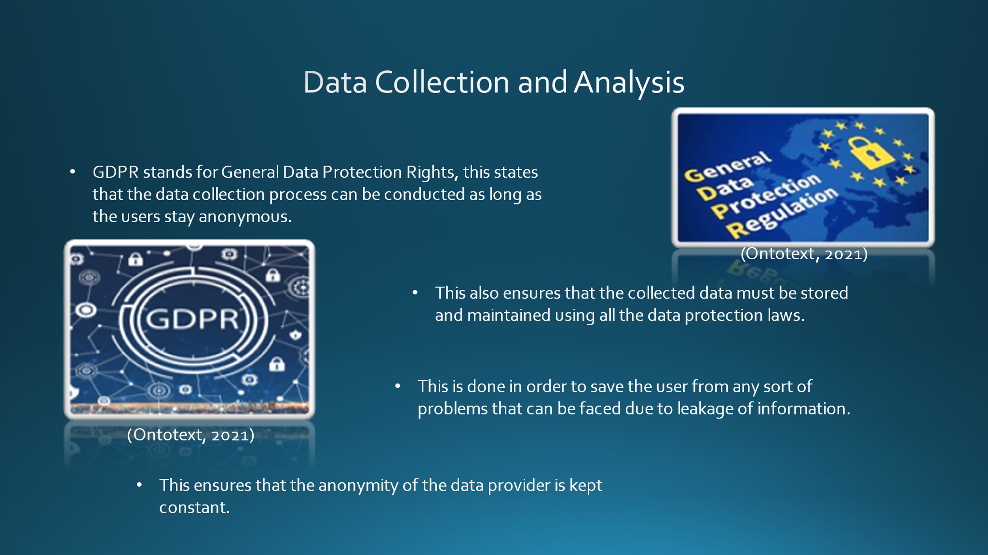
Notes:
4. Data Collection and Analysis
4.1 Data collection using GDPR
GDPR stands for General Data Protection Rights, this states that the data collection process can be conducted as long as the users stay anonymous. This also ensures that the collected data must be stored and maintained using all the data protection laws. This ensures that the anonymity of the data provider is kept constant. This is done in order to save the user from any sort of problems that can be faced due to leakage of information. Apart from that, data collection using GDPR also ensures that the collected data must be stored for the least amount of time possible. Furthermore, it is important that the user maintain the ethical considerations while data collection. The reason of the data collection needs to be explained to the data provider in order to avoid any sort of ambiguity. Along with that, with the help of this process the data collected is accurate based on the needs of the user (Goddard, 2017, pp.703-705). The GDPR used in data collection also ensures that the processing of the collected data is done appropriately.
Slide 10:
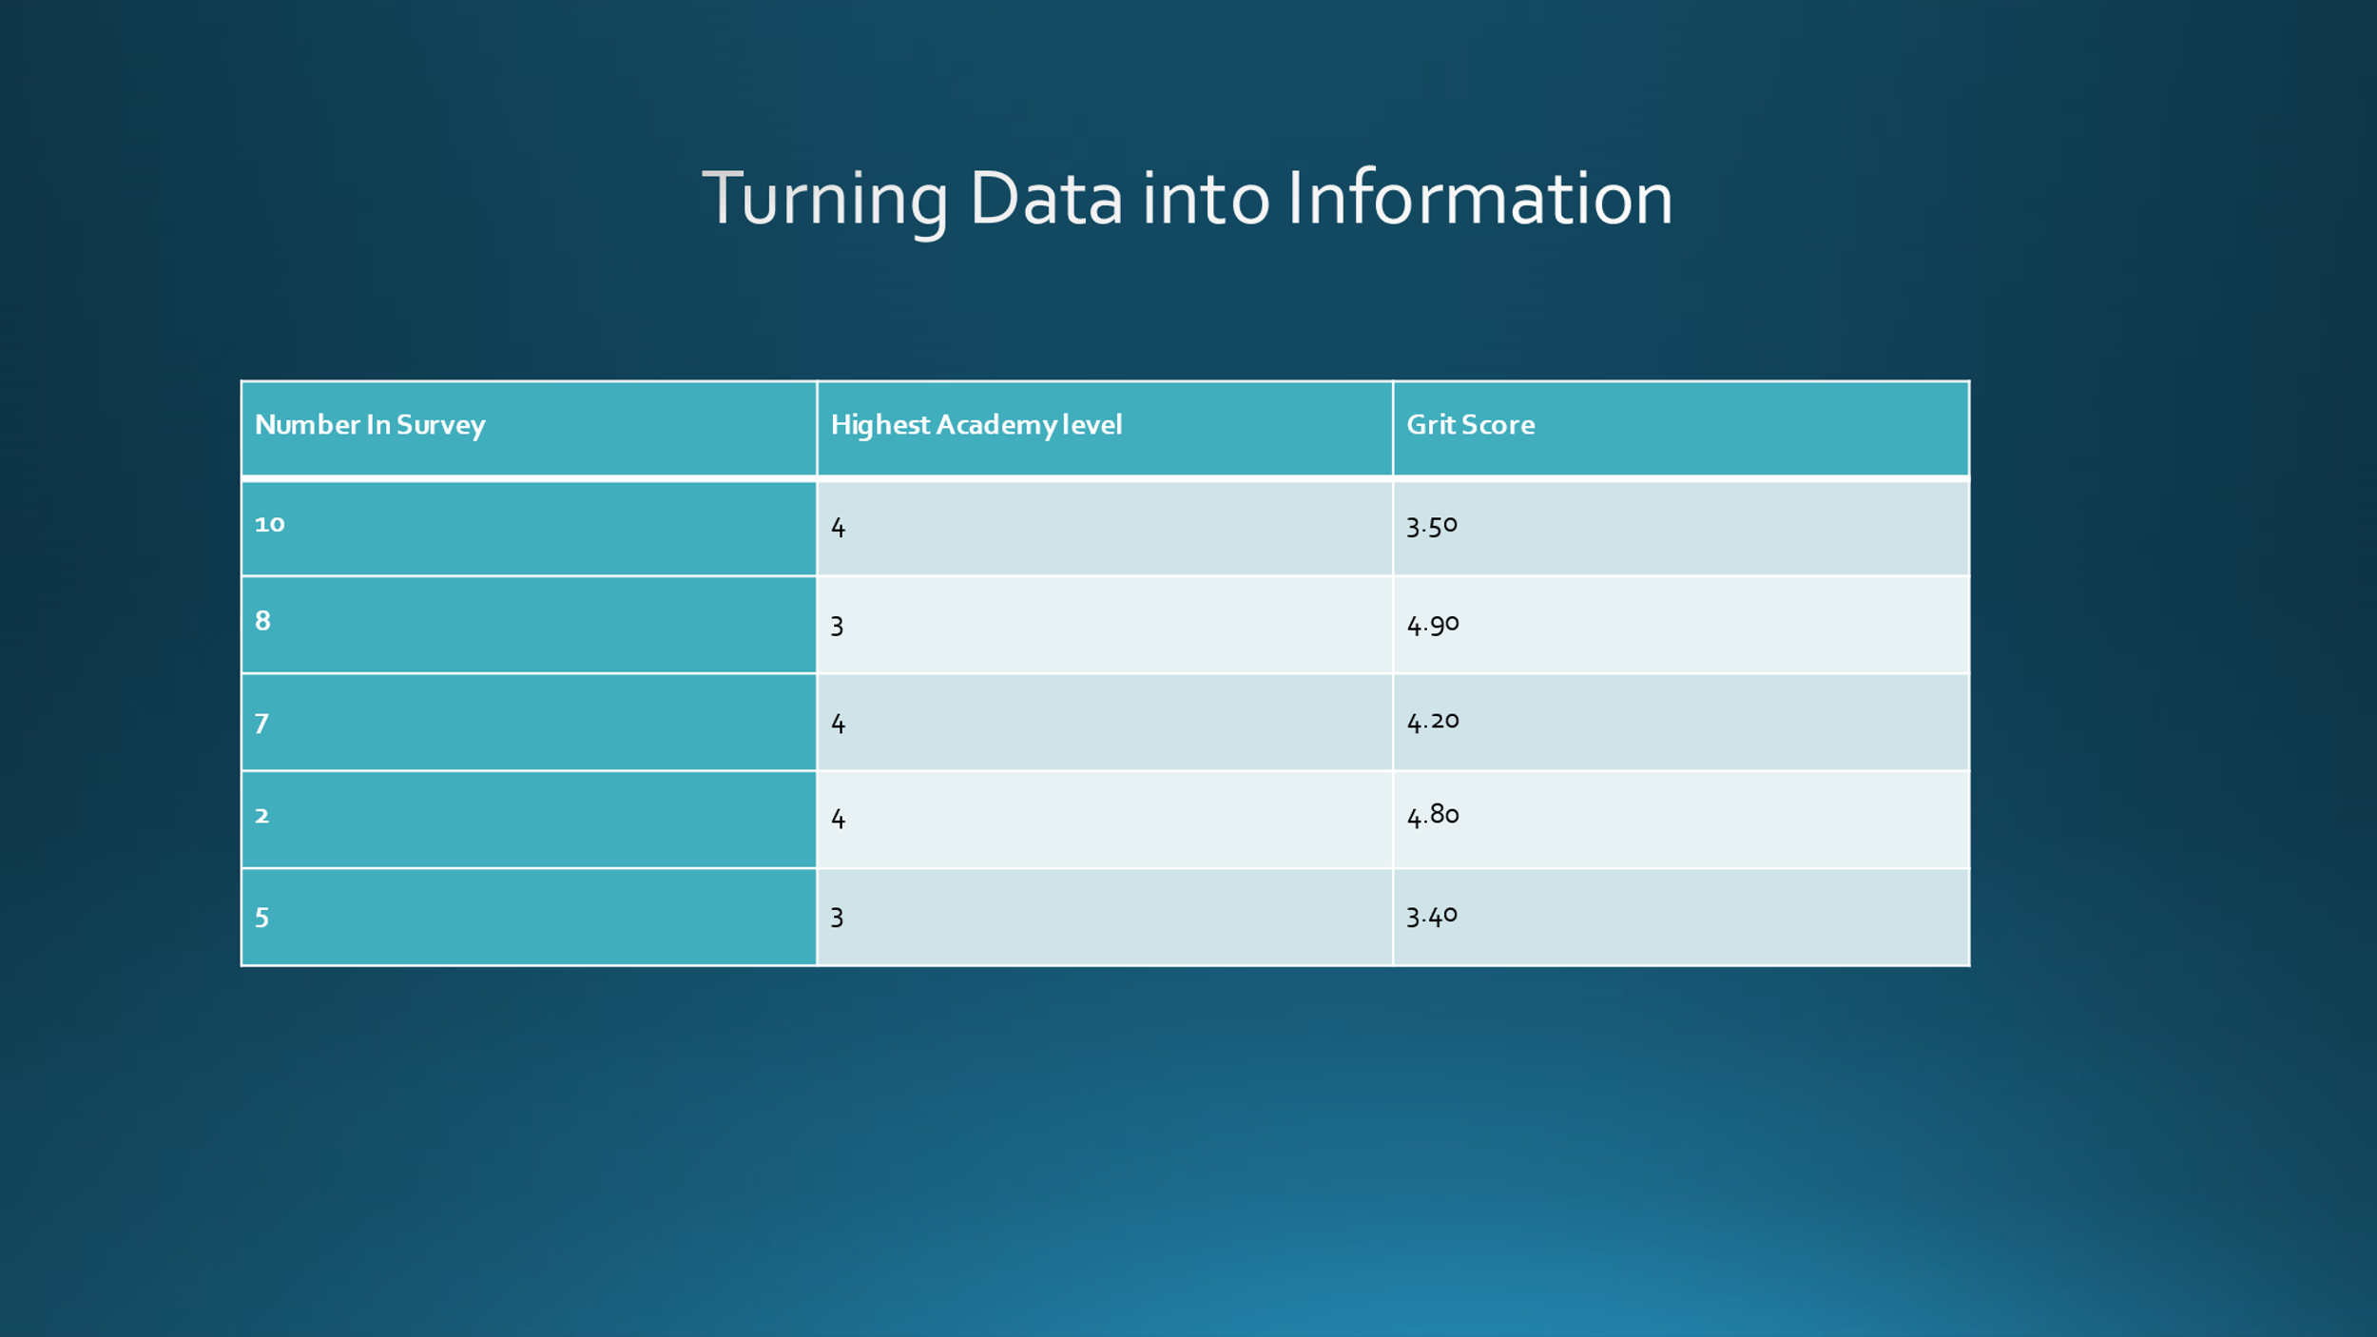
Notes:
4.2 Turning Data into Information
Data collected for a work includes a huge range of data that is complex to handle and maintain at the same time. Hence in order to gain proper outcomes from the data it is mandatory that the data is converted into information. This process includes gathering valid and relevant data for the process. Then comes the step where each data needs to be analysed properly using various tools of data analysis. Various technological tools can be used in order to analyse the tools properly. Online tools such as Excel, SAS, etc can be used in order to convert the collected data into usable information. Based on this survey it can be seen that grit score for individuals at level 4 were 4.20,4.80 and 3.50 Apart from that the ones at level 3 achieved a grit score 3.40 and 4.90 (Miao, 2018, pp.65-74).
Slide 11:
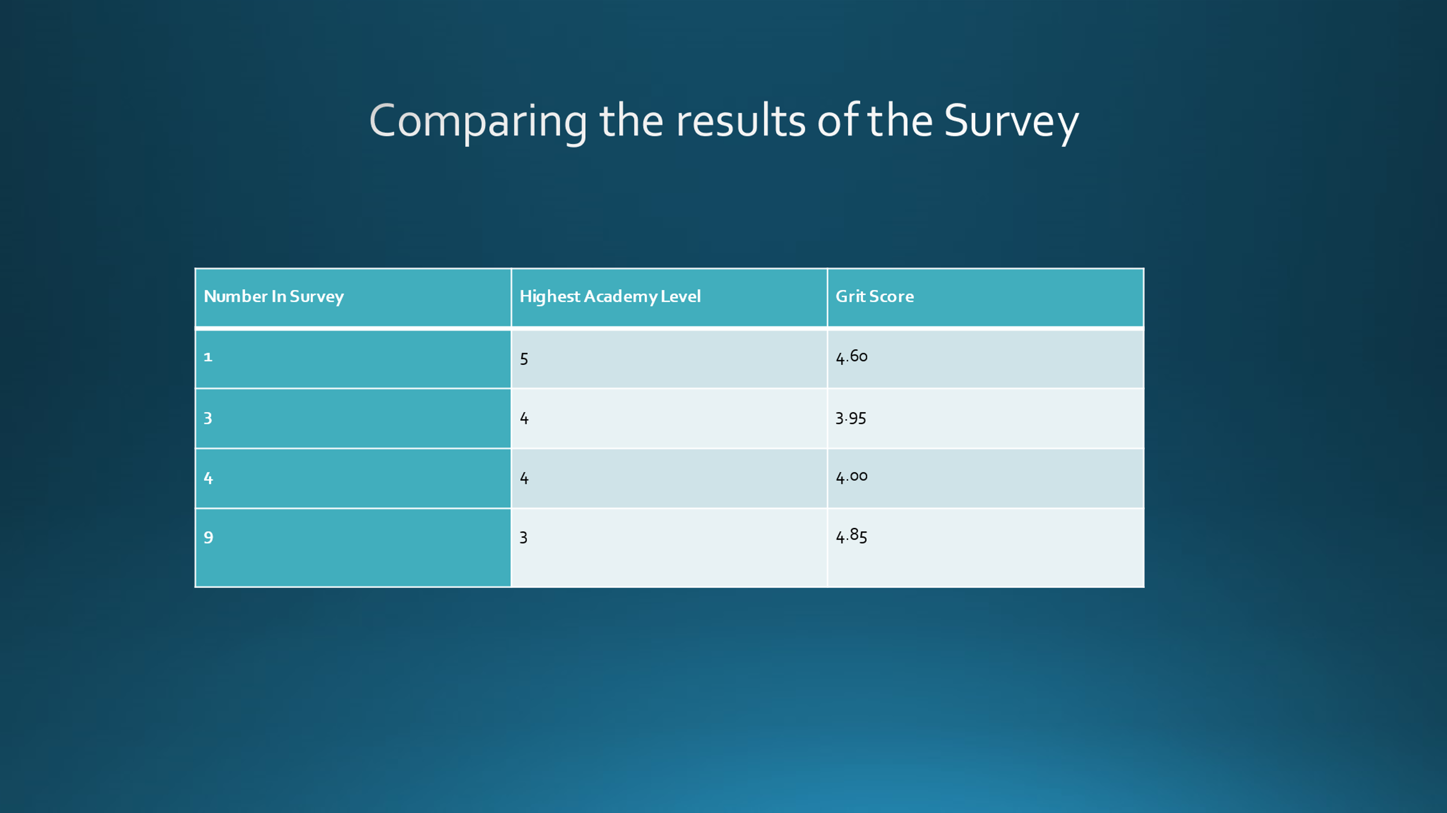
Notes:
4.3 Comparing the results of the Survey
The surveys are one of the best methods with the help of which proper results regarding a process can be gathered. This helps in collection of real-time data which is authentic and contributes towards the whole process. The comparison is basically important for identifying the preferences of various users. The preferences changes from person to person and hence this process proves to be helpful for comparing the results. One of the easiest methods in this process is providing multiple choice options in the survey. Besides that, the use of cross-tabulation graphs helps in analyse graphs and charts in order to compare variety of results among a huge variety of segments of audience. Along with that, analysing the data using graphs and charts makes the comparison of the survey results a lot easier. On comparing the surveys it was seen that ones at level 5 achieved 4.60 and the ones at level 4 got 4.00 and 3.95 and the 9th respondent at level 3 achieved 4.85.
Slide 12:
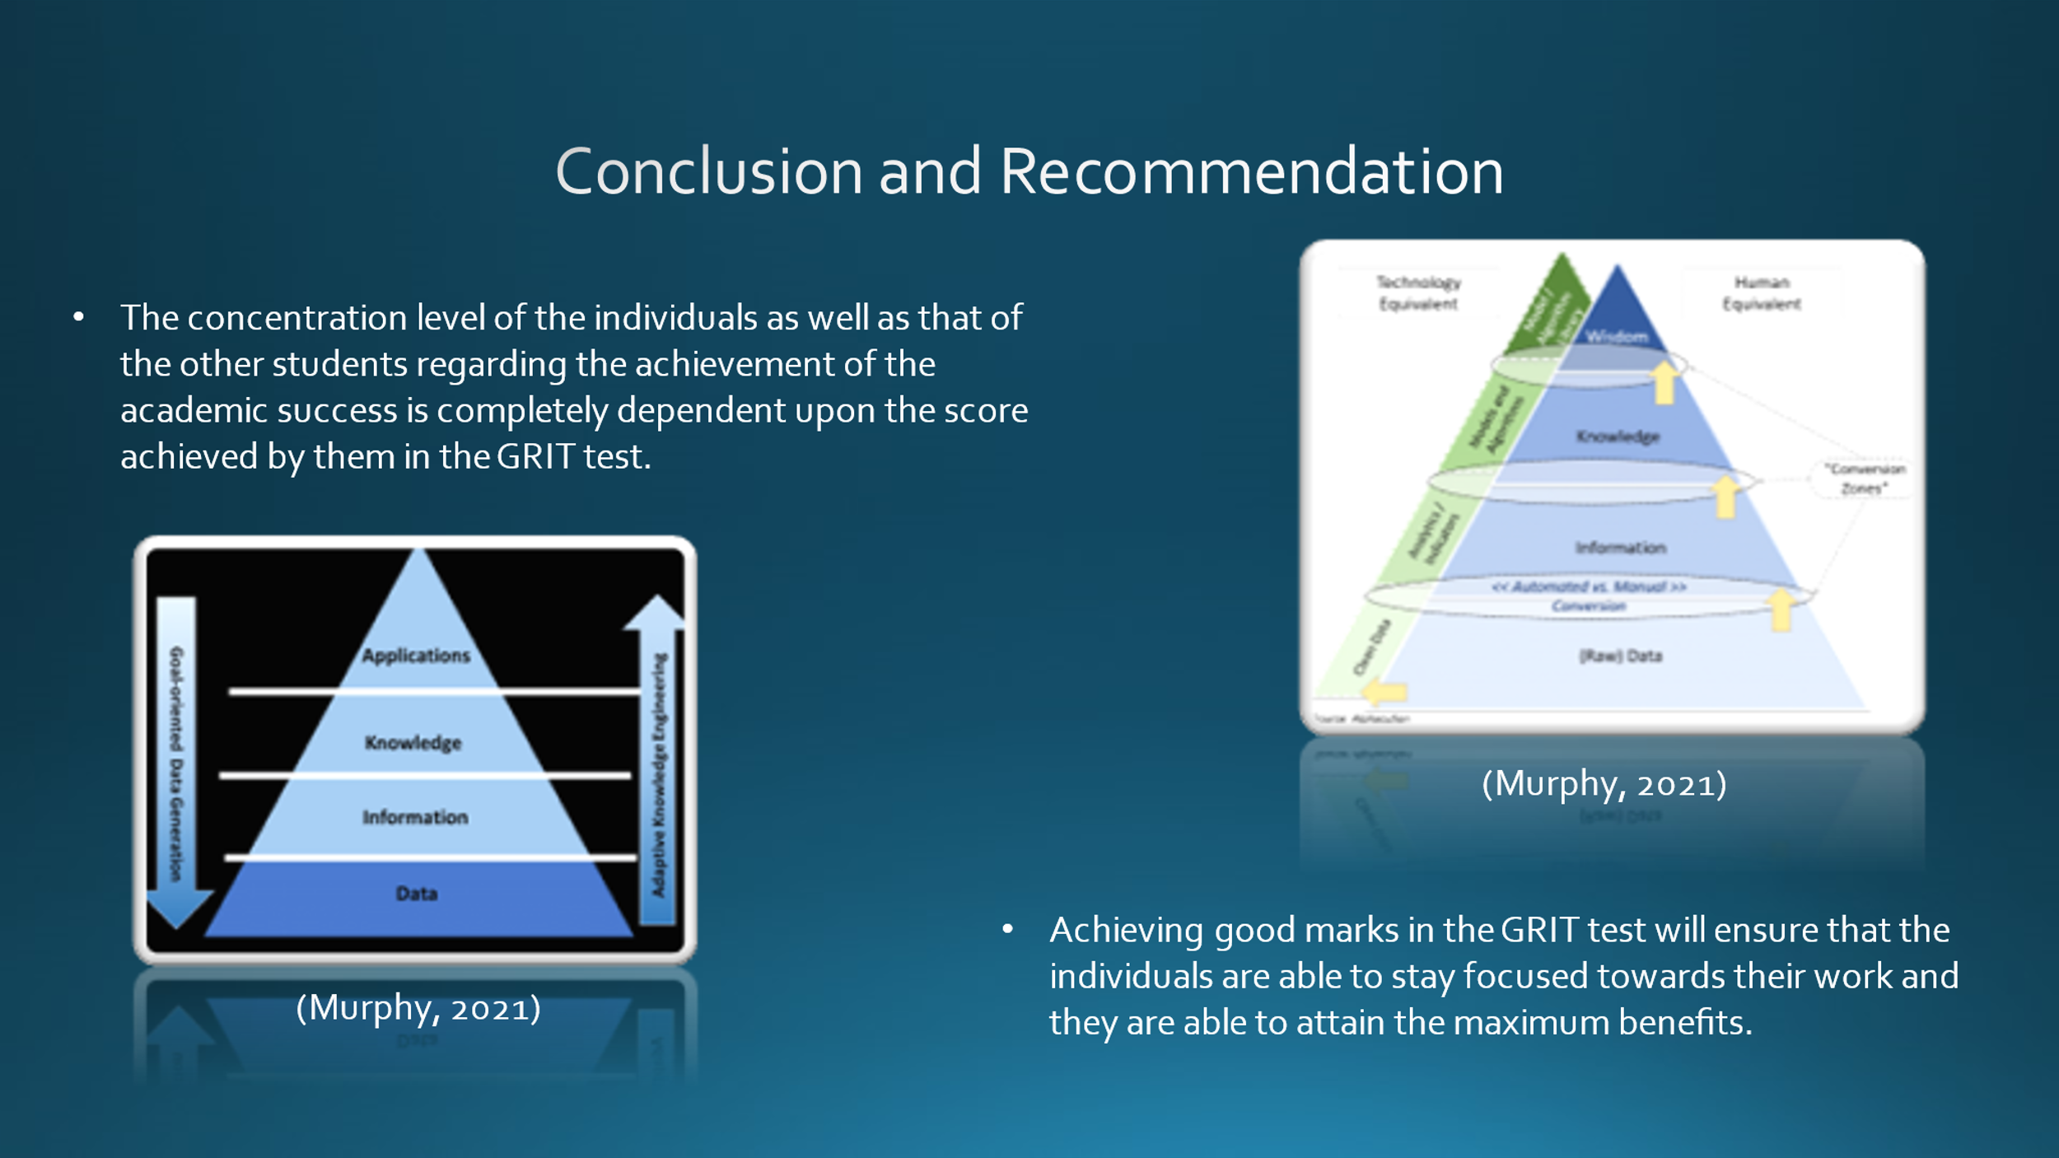
Notes:
Conclusion and Recommendation
Conclusion
The concentration level of the individuals as well as that of the other students regarding the achievement of the academic success is completely dependent upon the score achieved by them in the GRIT test. Further, this also help in increasing the confidence level of the individuals. Moreover, this is one of the effective ways through which the individuals are able to attain better score and they will be able to get the proper knowledge regarding the overall process. Further, achieving good marks in the GRIT test will ensure that the individuals are able to stay focused towards their work and they are able to attain the maximum benefits. This ensures that the capability as well as the skills of the individuals are assessed an they are able to gain the relevant advantages from this.
Recommendations
The students who has achieved less score in the GRIT test can effectively try and stay focused towards their overall work. This will help in enhancing the overall capabilities of an individual. Further, by staying focused towards their work, the individuals will be able to gain more knowledge regarding different matters. Further, this shall also help in the generation of more ideas and will make sure that the individuals do not face any kind of issues in the overall process. This is one of the effective processes which can help the individuals to manage all the work and maintain the overall balance in their work life. Furthermore, this process will ensure that the individuals can gain the effective response for the different actions that has been taken by them.
Slide 13:
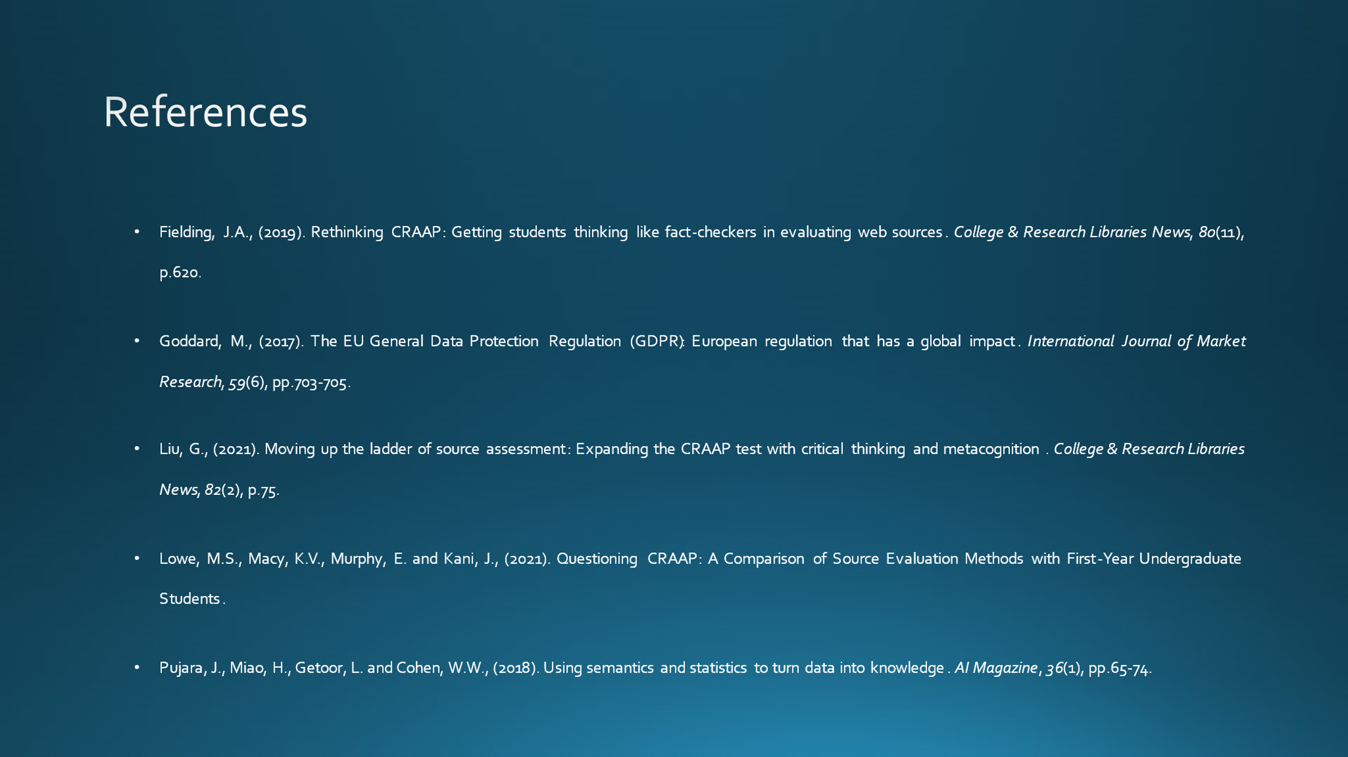
References
Books and Journals
Fielding, J.A., (2019). Rethinking CRAAP: Getting students thinking like fact-checkers in evaluating web sources. College & Research Libraries News, 80(11), p.620.
Goddard, M., (2017). The EU General Data Protection Regulation (GDPR): European regulation that has a global impact. International Journal of Market Research, 59(6), pp.703-705.
Liu, G., (2021). Moving up the ladder of source assessment: Expanding the CRAAP test with critical thinking and metacognition. College & Research Libraries News, 82(2), p.75.
Lowe, M.S., Macy, K.V., Murphy, E. and Kani, J., (2021). Questioning CRAAP: A Comparison of Source Evaluation Methods with First-Year Undergraduate Students.
Pujara, J., Miao, H., Getoor, L. and Cohen, W.W., (2018). Using semantics and statistics to turn data into knowledge. AI Magazine, 36(1), pp.65-74.
Wichowski, D.E. and Kohl, L.E., (2016). Establishing credibility in the information jungle: Blogs, microblogs, and the CRAAP test. In Online credibility and digital ethos: Evaluating computer-mediated communication (pp. 229-251). IGI Global.
Website References
Angela Duckworth, (2021). Angela Duckworth. [Online]
Available at: https://angeladuckworth.com/grit-scale/
Cabral, C., (2021). The Grit Test: Your Grit Score & What It Means. [Online]
Available at: https://www.shortform.com/blog/grit-test/
certguidance, (2021). DIKW Model: Explaining the DIKW Pyramid or DIKW Hierarchy. [Online]
Available at: https://www.certguidance.com/explaining-dikw-hierarchy/
Idrlabs, (2021). Grit Test. [Online]
Available at: https://www.idrlabs.com/grit/test.php
i-scoop, (2021). The DIKW model for knowledge management and data value extraction. [Online]
Available at: https://www.i-scoop.eu/big-data-action-value-context/dikw-model/
Murphy, D., (2021). The Grit Test: a simple quiz to see whether you’ll make it as a creative professional. [Online]
Available at: https://www.creativindie.com/a-simple-test-to-see-whether-youll-make-it-as-a-creative-professional-the-grit-test/
Ontotext, (2021). What is the Data, Information, Knowledge, Wisdom (DIKW) Pyramid?. [Online]
Available at: https://www.ontotext.com/knowledgehub/fundamentals/dikw-pyramid/
retireby40, (2021). Are you gutsy enough to take the Grit Test?. [Online]
Available at: https://retireby40.org/grit-test/
Warner, J., (2019). Getting Beyond the CRAAP Test: A Conversation with Mike Caulfield. [Online]
Available at: https://www.insidehighered.com/blogs/just-visiting/getting-beyond-craap-test-conversation-mike-caulfield

