Check your sources!!

I often like to use front covers of The Economist, since they are humourous and can be quit hard hitting.
However see the Pesa Check (2017) story, on anohter source on this tile, where a cover of The Economist was altered by a blogger claiming to show Kenya’s Deputy President, William Ruto altering the real picture of Italian Prime Minister, Silvio Berlusconi. It shows how things can be manipulated for political, social, religious or simply malicious reasons.
Therefore be careful in quoting non-academic sources, especially online!
Most articles will have “a point of view”, however bias happens when the article claims full truth, does not review alternatives and manipulates data to “prove” its viewpoint.
We will look at some of these issues in another session.
Steve

You can blow up the image to get the edition date. You can buy old issues online or use the University library that does subscribe to it.

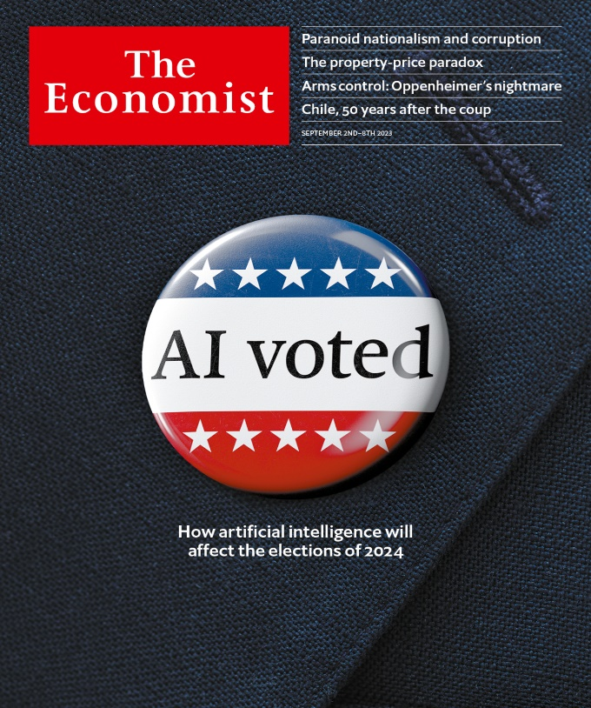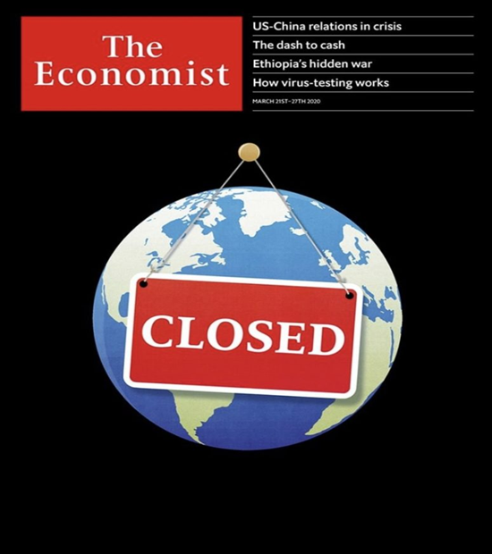

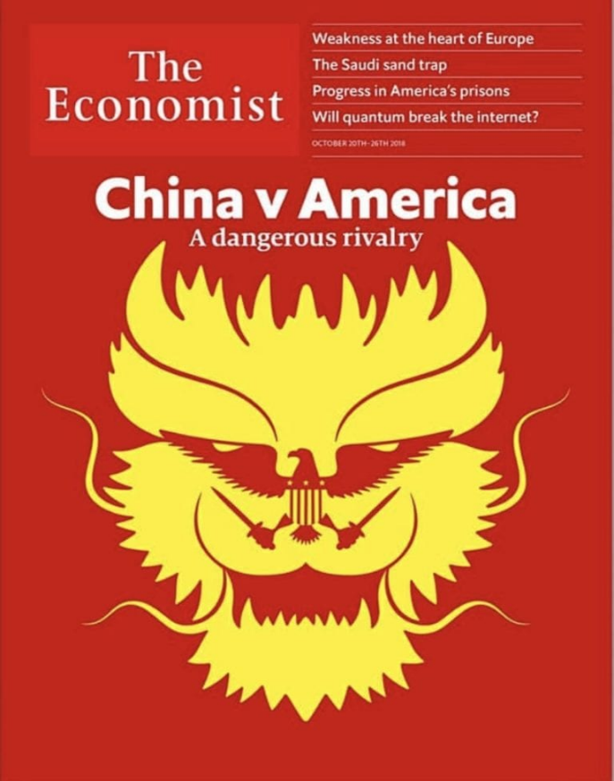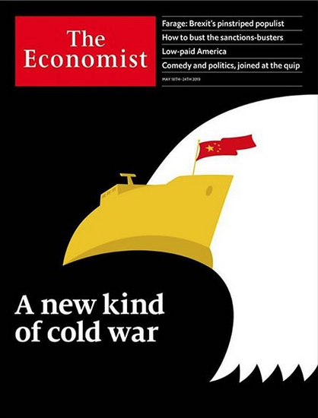

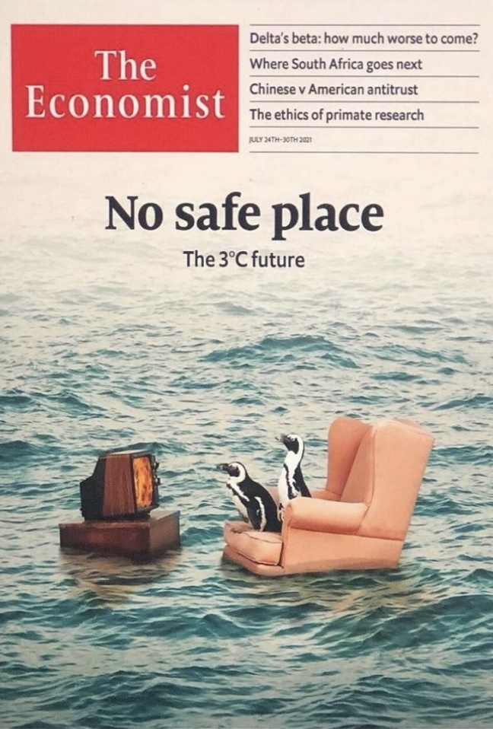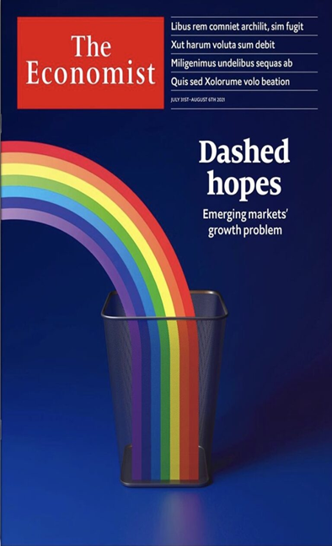

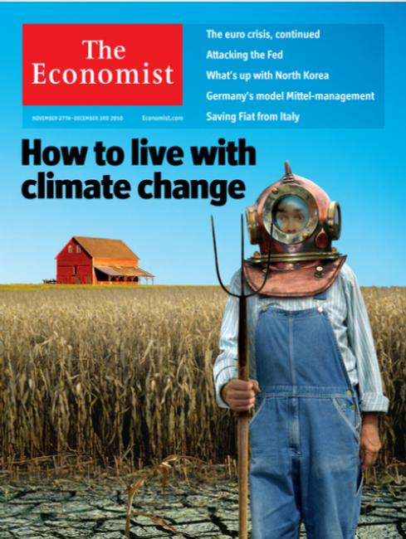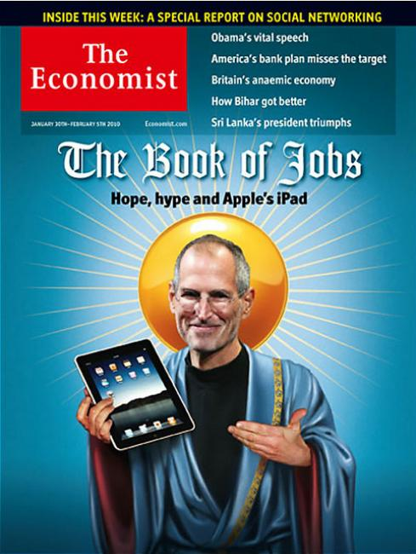

THE ECONOMIST MAGAZINE - JULY 9 / 15, 2022 - CLOWN-FALL BRITAIN AFTER BORIS Single Issue Magazine – 8 July 2022


