Craig Y Nos Habitat Management Plan.
Asahi Isabella Pollock.
Contents.
1.0 - Introduction
2.0 - Physical Landscape
3.0 - Habitats
4.0 - Human Issues
5.0 - Funding
6.0 - Recommendations.
List of Figures.
  - – Figure 1 Ordonnance Survey map of Craig-y-nos.
2.2 – Figure 2 Geological map of Craig-y-nos
2.2 – Figure 3 Soil analyses of Craig-y-nos.
3.1 – Figure 4 Woodland map of Craig-y-nos.

Introduction 1.0
Location
Craig y Nos country park is located in the upper Swansea Vally, adjacent to the A4067. It lies in the southwestern end of the Brecon Beacons National park and stretches for 40 acres in total.
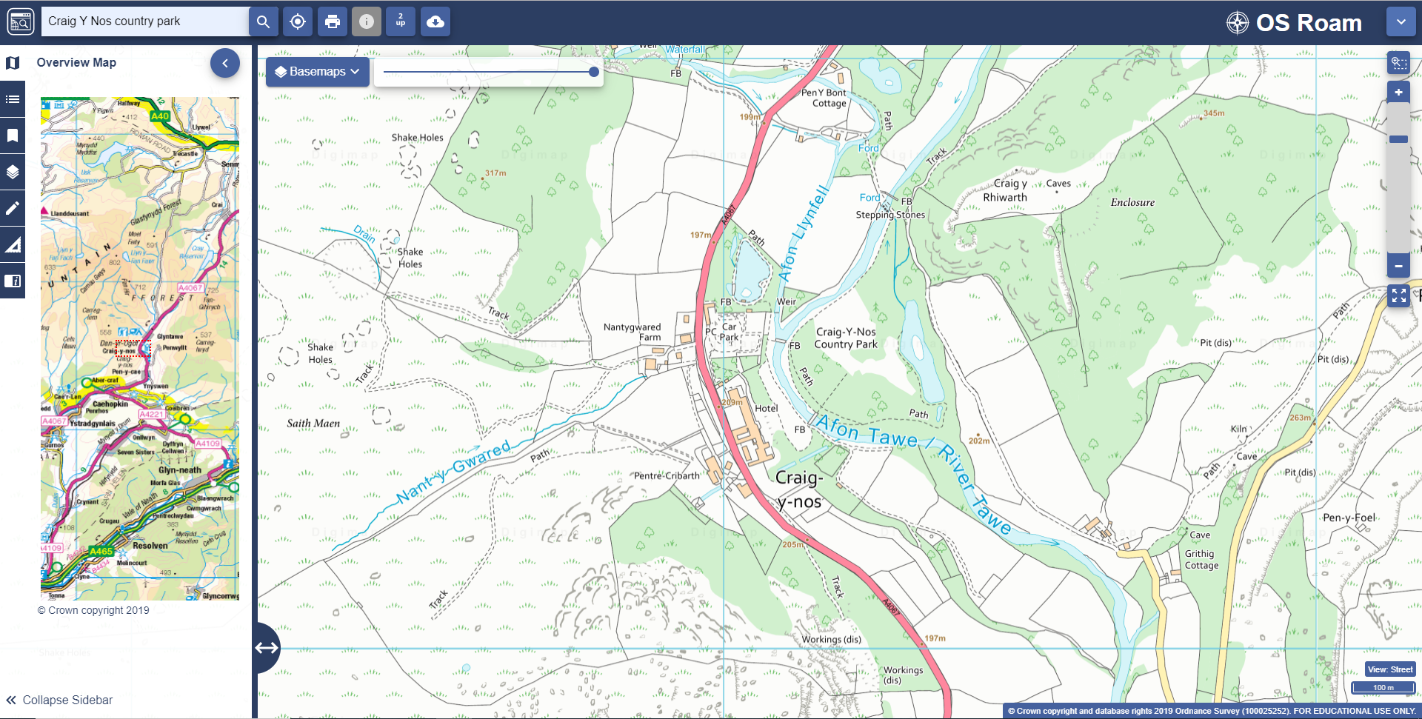
Figure 1 Ordinance survey map of Craig-y-nos. Available at: https://digimap.edina.ac.uk/os
Physical Landscape 2.0
Landscape 2.1
The upper Tawe Valley is characterised by a glaciated U-Shaped river valley, of which surrounds the park with towering hills. The park is surrounded by upland farms and pasture fields on the lower slopes, the valley bottom is grazed by sheep and ponies with some fields managed for hay and silage. (DigiMap, 2018)
Geology and soils 2.2
The park lies on a flat-bottomed and quite narrow, flanked on either sides by steep slopes of Carboniferous limestone.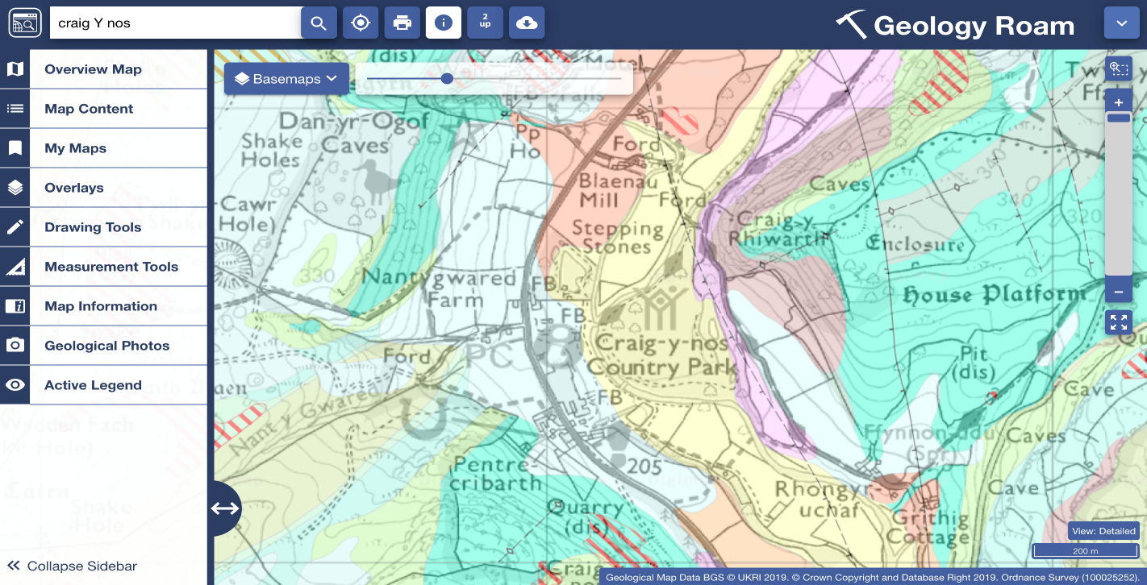
Figure 2 Geology map of Craig-y-nos. Available at: https://digimap.edina.ac.uk/geology
Figure 1 shows the Geology of the park. The majority of the park sits on an Alluvium formation (highlighted yellow) which is a general term for clay, silt and gravel. It is the material deposited by a river or other body of running water. (British Geologial Survey, 2019)
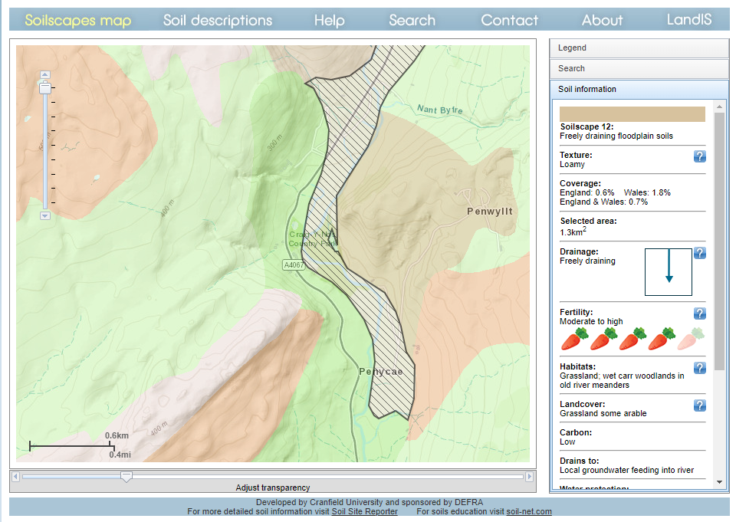
Figure 3 soil analysis of Craig-y-nos. Available at: http://www.landis.org.uk/soilscapes/
There is no detailed analysis of the soil in the 2003 management plan but on Landis there is a detailed analysis of the soils scape, shown as figure 3. (Cranfield and Agri-food Institute, 2018) The database describes the texture of the soil as loamy (comprised mostly of 40% sand, 40% silt and 20% clay) which create desirable characteristics for plant growth as it allows air and water to flow and to penetrate roots.
Hydrology 2.3
The river Tawe bisects the park and the river Llyfell joins the Tawe just north of the middle bridge. There are three open water features; The duckpond, dating back to the Victorian times, the far lake which also dates back to the same era and then the hay meadow pond which was approximately put in around 1985.
Rainfall 2.4
Levels fluctuate depending on the amount of rainfall. It is common for the river Tawe to rise and fall approximately 1m over a 24-hour period. In the management plan, it was said that throughout the year the banks will burst on average 8-12 times. (BBNPA, 2001 -2004)
Historic landscape 2.5
The park has been designated by CADW grade 2 on the register of historic parks and gardens due to the architectural features, ornamental structures and historic associations. Due to the historic landscape, parts of the park are to be considered an important feature to the it’s interest and value to the public. (BBNPA, 2001 -2004)

History 2.5.1
The Brecon Beacons National Park Authority (BBNPA) opened the site in 1976, the land has had a rich history – once owned by Adelina Patti, then following her death the property was sold to the Welsh national memorial foundation, of which was opened up to serve as a tuberculosis hospital.
Flora and Fauna 2.6
The most recent survey checklist of 170 species of wildflower identified in the park in 2003 but there is no updated survey yet. There are no rare species in the park but there has been recordings through 1994 -1999 of Arabis hirsuta which was announced as a near threatened species in 2001 in the UK. (BBNP, n.d)
Due to the outdated checklist, a phase 1 habitat survey could be implemented by the breacon beacons national park or by experienced volunteers.
Habitats 3.0
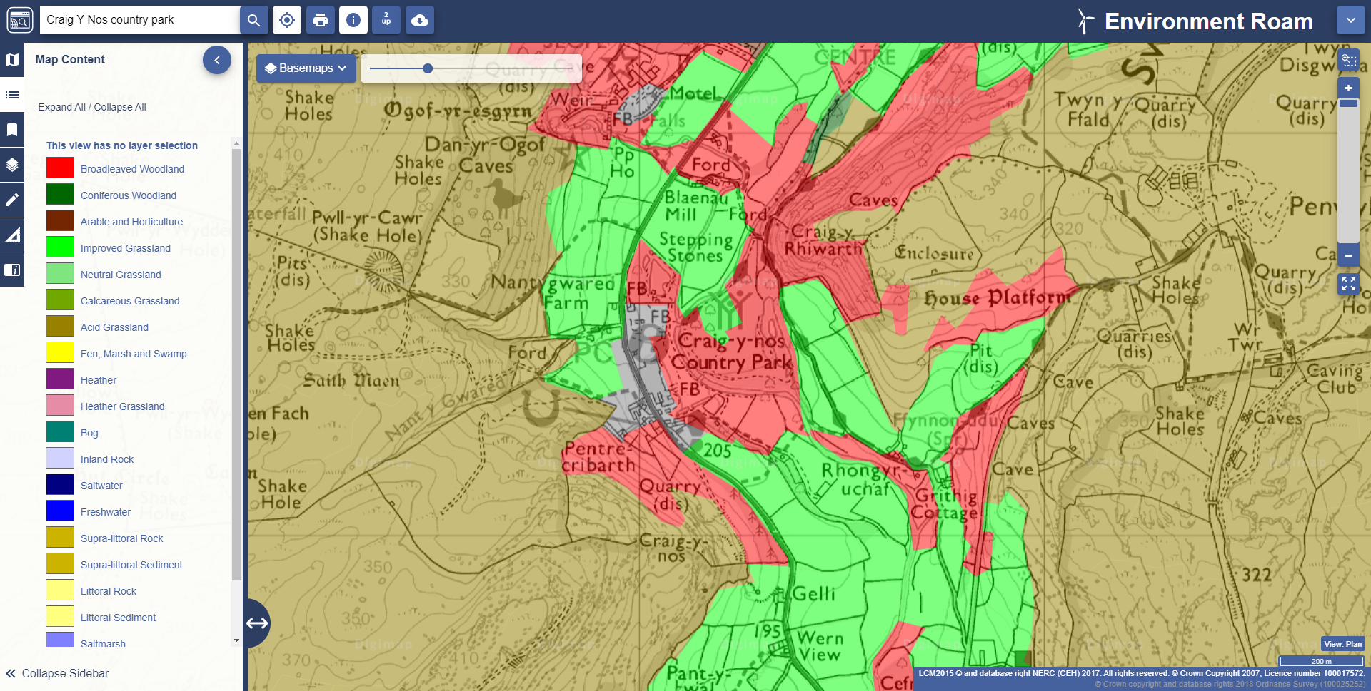
Figure 4 woodland map of Craig-y-nos. Available at:https://digimap.edina.ac.uk/environment
Woodland 3.1
Approximately 14% of the Park is considered to be woodland. (BBNPA, 2001 -2003) There are over 70 species of trees which have been recorded in the park and many of them are exotic species having been planted during the Victorian times by Adelina Patti herself. Two main woodlands include:
- Broadleaf woodland – primarily the beech which were planted by Adelina Patti.
- Coniferous woodland – Primarily black pine which were also planted by Adelina Patti
Parkland 3.2
There are 4 areas of parkland in the park – the main meadow, the small meadow the carpark lawns, the pavilion lawn. A variety of trees have been planted within the parklands but again dating back to the Victorian era. Rhododendron grows alongside the main meadow and is a popular tourist attraction, but the species is managed and contained in this area only.

Grass land 3.3
There are two distinct types of grassland in Craig Y Nos: hay meadow and rough grassland. The hay meadow covers 1.5 hectares. The hay meadow is subject to a lot of flooding due to the river Tawe which flows through the park.
Human Issues 4.0
Vandalism 4.1
Vandalism does not seem to be an issue in the park other than the odd word carved into the trees. The only other vandalism which I located on the site was on the castle grounds gift shop writing “never open”.
There is also a link of vandalism due to public perception. It can seem as though the park is not being managed properly to the untrained eye which can rub off badly on the park users. For example; if there is an ‘unkept’ part of land, the fallen beech stumps perhaps, to the public this may seem like laziness that is it not cleared up and taken away. But in fact, it is acting as a habitat to increase biodiversity.
To combat negative public perceptions, clear signs where the work is being done explain the conservation side of it to educate the public, instead of causing upset.
Tourism 4.2
There is a large interest in the castle amongst the paranormal community which the castle entertains ghost tours for guests who wish and pay for the experience. There is the historic interest of the castle belonging to famous opera singer Adelina Patti which attracts tourism also.
Litter 4.3
There are no litter bins on site for these purposes:
- Wildlife disturb bins causing a bigger mess
- wildlife may be at risk to injury from litter
- Staff to empty bins is limited
- The local authority makes a charge per bag for removal and funds are limited
Visitor pressure 4.4
The park is used daily by the public. With this heavy footfall parts of the park is bound to be impacted. Potential risks from this could include soil erosion, soil compaction and root damage, increased amount of litter etc.
Funding 5.0
Budget 5.1
The total budget for the park is £47,577 which after other expenditures are subtracted, such as staff payment and commitments, there is £3,225 left to work with. The park was funded £35,000 for a geopark center project but the spending has been delayed. (BBNPA, 2018)
Staffing 5.2
In the 2003 report is mentioned that there might be staff being made redundant from the park due to little income and funding.
“Over two-thirds of the revenue expenditure of the site is spend on staff resources. Continued pressure on the budget could lead to changes in the extent of staffing on site. External funding opportunities are constantly sought to reduce overall costs to the national park authority” (BBNPA, 2001 -2004)
Recommendations 6.0
Community food garden and orchard
I think that there could be more utilisation of the grassland in the park as they are currently just used for the public to walk though. Community food gardens are a great way of utilising soil/space and gathering a community of all ages and abilities together.
I think that something similar to could be implemented in Craig Y Nos country park, mainly concentrated by the pavilion lawn or hay meadow due to the amount of space, access and clear canopae for tree growth. This would be managed by the team of volunteers and eventually as more people come, more regular volunteers would become available.
There is an issue with fencing with the public as many people take it upon themselves to remove it or cut a part of it as they don’t think that it should be there. To combat this with the introduction of the food garden - instead of a wire fence, have a line of troughs with produce growing inside. To give it a more natural aesthetic, apple trees (Malus domestica) could be planted in-between the troughs. This utilises the space more efficiently and mostly removes the risk of vandalism, it would also be aesthetically pleasing and could encourage passersby to join the community.
The land just before the pavilion garden which would provide ample enough space to plant an orchard but the canapé is quite dense so not enough light would get through to the trees. The hay meadow floods often, and the pavilion lawn is starting to flood too. Apple trees are quite hardy but any plant which is submerged in water for too long will drown. Belleni (2014) implemented a method of planting called “Mounding” in Craigton Farm in Scotland. This involves creating a mound which is made of turf chopped up and soil. This is where you would plant the tree in the mound which would allow the root ball to exist above ground and will spend less time submerged in water. The initial aesthetics of this could upset the community but efforts to create even mounding and plant grass on the bare patches of land to restore it to look as natural as possible.
There was a heritage lottery funded project - “The Heritage of Orchard and Cider Making in Wales” in 2016 to 2018. This project worked with 13 communities in Wales to either plant or to regenerate orchards which included Welsh heritage cider apple and pear varieties, with a grand total of 926 trees planted. This project involved volunteers across all communities which were provided training. (Heritage of Orchards and cider making in Wales, 2016 -2018) The closed orchard to Craig Y Nos is in Glynneath which is a 15-minute drive away. Advice could be sought after possibly in exchange for volunteer hours.
The insects which are attracted to fruit orchard will also support bird and mammal populations, overall increasing the biodiversity of the park. There are many different apples used for cider so a variety could be planted such as Foxwhelp, Yarlington Mill and Dabinett. These trees range around £10 - £20 each on online sites such as “Adams Apples”. (Adams Apples, 2019) A cider press can be made with timber found in the park following a DIY video on YouTube.
I think that utilising land for produce is a good idea to raise more income for the park and also to get the community more involved with it. If the public are more engaged with the park then there will become more awareness of how important donation is which in turn, could encourage more of the local communities to donate more often.

Funding.
To fund these ideas I suggest working with the castle and providing them with a section of the car park, maybe 20 spaces, which the castle can pay for an overnight stay at a premium of £5 each. This would only be implemented when there is a wedding or an overnight function on which there are many cars. Due to the popularity of the castle, if the car park was used say once or twice a month for this purpose it could potentially generate £1,200 - £2,400 annually which could go towards funding trees, seeds and equipment.
Another possible way to raise funds for the park is to put on an event but somewhere more accessible, such as at the Patti Pavilion in Swansea. An event such as an opera concert in memory of Adelina Patti to raise funds for her park. Events like this have been done successfully in the park but it requires driving, Victoria park is a fully accessible park surrounded by urban environment which could encourage more people to come.
To keep this project funded, once there are enough apples to make some cider there could be a day event ran by the volunteers which would involve picking, pressing, bottling etc. Tastings of the cider could be done and can be made suitable for children under the age of 18 by tasting the apple juice before the fermentation. Tickets could be purchased for £10 per person and have deals such as having a family ticket, perhaps 2 adults and children for £25.

Referencing.
Adams Apples (2019) Cider Apples. Available at: http://www.talatonplants.co.uk/apple%2Dtrees/?types=Cider+Apples (Accessed: 5 December 2019)
Angie's List Staff (2014) 5 Essential Tips for growing cherry blossom trees. Available at: https://www.angieslist.com/articles/5-essential-tips-growing-cherry-blossom-trees.htm (Accessed 5 December 2019)
Brecon Beacons (2018) Brecon Beacons Summary Report. Available at: https://governance.beacons-npa.gov.uk/documents/s34292/Enc.%201%20for%20Budget%20Monitoring%20Quarter%202%202018-19.pdf (Accessed: 7 December 2019)
Brecon Beacons National Park (N.D) Wildflowers. Available at: https://uowtsd-my.sharepoint.com/:w:/r/personal/1802658_student_uwtsd_ac_uk/_layouts/15/Doc.aspx?sourcedoc=%7BF7C8A7AC-4F30-4DEB-AC17-1A7C9C976574%7D&file=flowers%20checklist%202003.doc&action=default&mobileredirect=true (accessed 4 December 2019)
Brecon Beacons national Park Authority (2001 - 2004) Country park management plan. Available at : https://moodle.uwtsd.ac.uk/pluginfile.php/85562/mod_resource/content/0/Craig_y_Nos_Country_Park_Management_Plan.pdf (Accessed 2 December 2019)
British Geological Survey (2019) The BGS Lexicon of Named Rock Units - Result Details. Available at: http://www.bgs.ac.uk/Lexicon/lexicon.cfm?pub=ALV (accessed: 4 December 2019)
Cranfield and Agrifood Institute, 2018. Landis. (Online) Available at: http://www.landis.org.uk/soilscapes/index.cfm (Accessed: 4 December 2019)
Digimap (2018) Geology Roam. Available at: https://digimap.edina.ac.uk/roam/map/geology (Accessed 4 December 2019)
Heritage of Orchards and cider making in wales (2016-2018) Community Orchards. Available at: https://www.welshcider.co.uk/heritage (Accessed: 5 December 2019)
Belleni, L (2014) Creating a flood friendly orchard. Available at:https://blogs.tcv.org.uk/natural-talent/2014/02/04/creating-nfm-orchard/ (Accessed 9 December 2019)

