Random number generation applied in Turtle

1. Draw a standard circle, 30 radius, with Turtle:

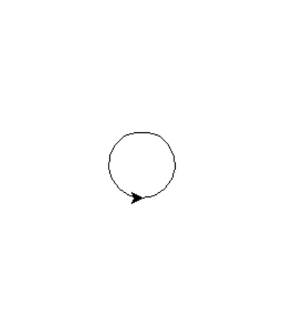

2. Make the width of the circle random, between 10 and 100. Generate the random number and then feed it in to the circle:

Sample output:
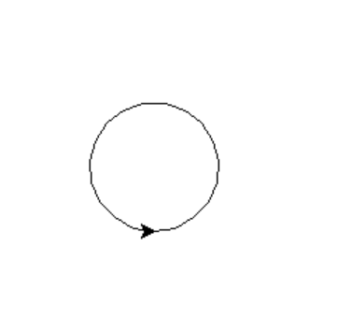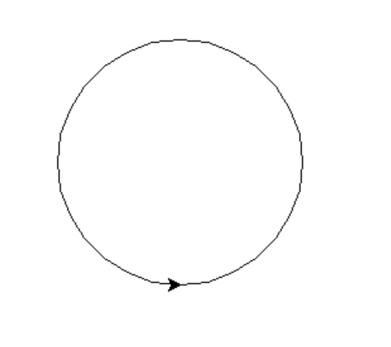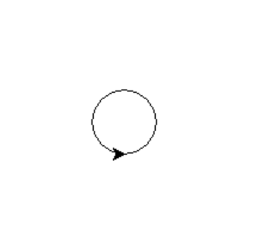

3. Change the start point for the circle randomly, generating co-ordinates within a 500 x 500 square:

Sample output:
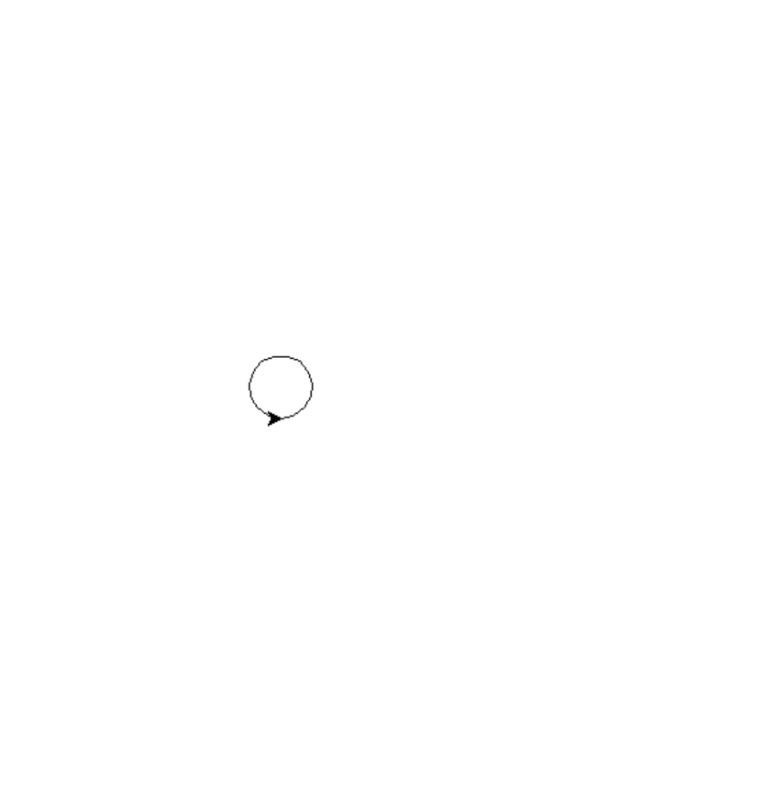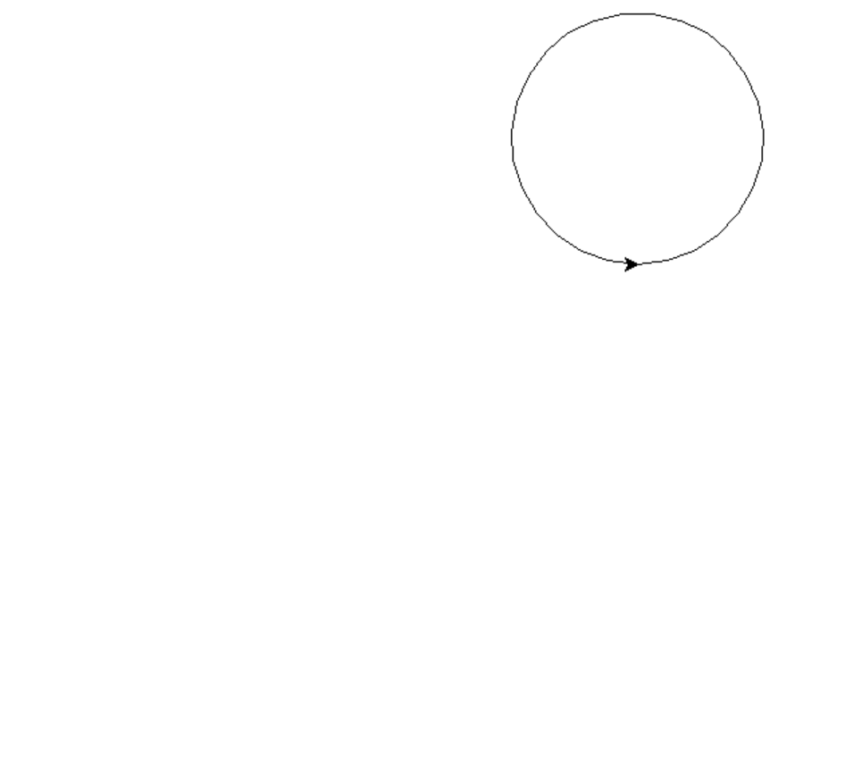


4. Loop the code 10 times:

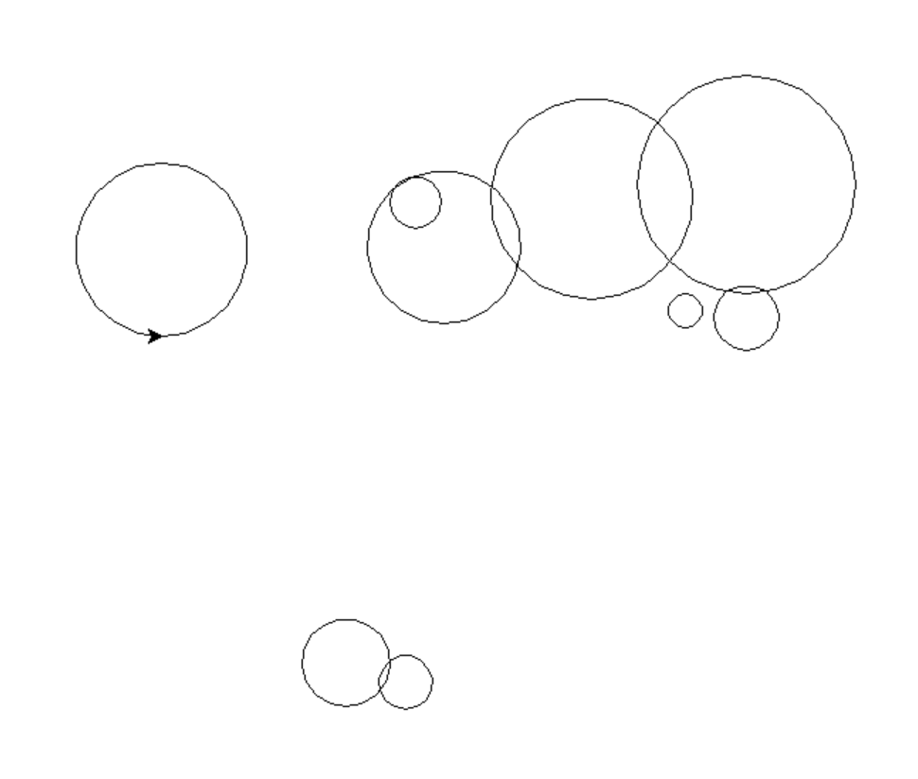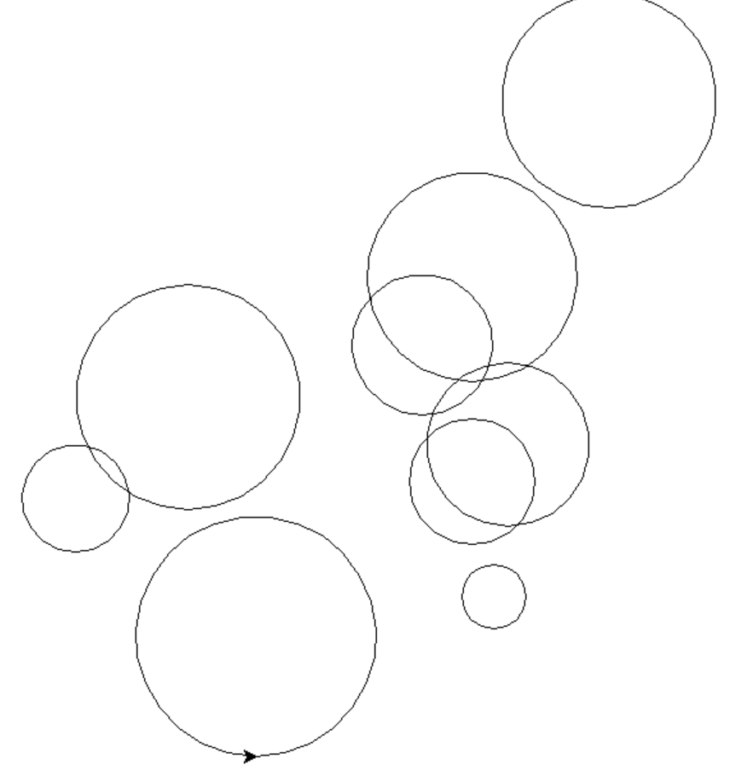

5. Loop the code a random number of times, between 5 and 100:

Sample output:

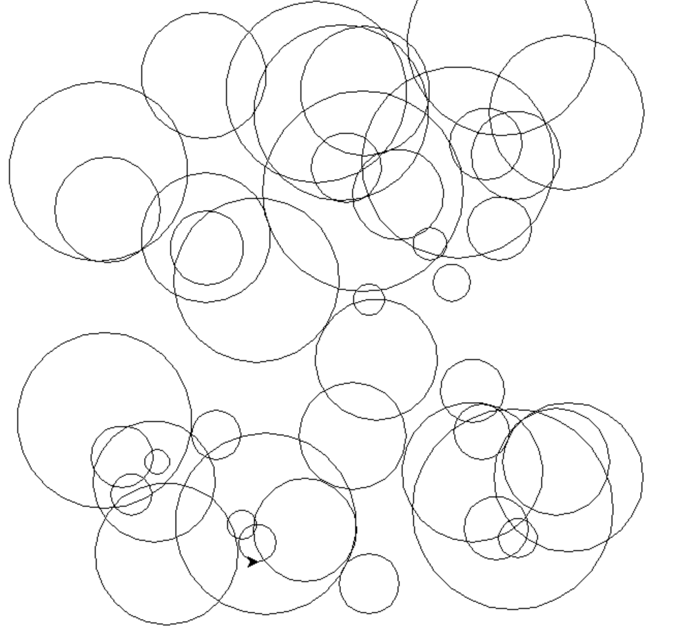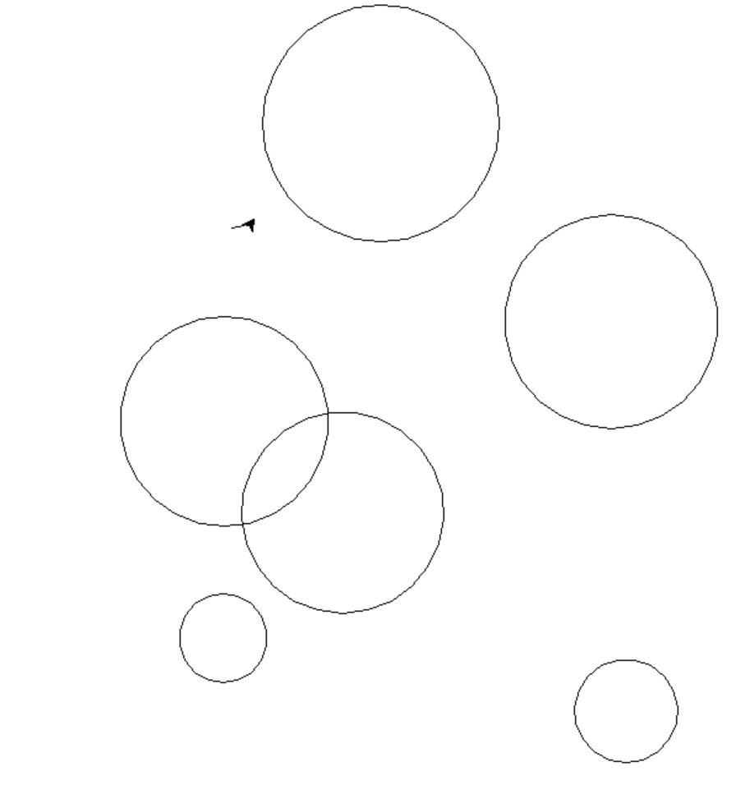

0…34 0…6
6. (Harder) Randomise fill colours for the circles. (Hint: Use a list to help you.)



