
APPENDIX GA36d

LEVEL 7 ASSESSMENT SPECIFICATION

Student name: | Rachel Warburton | Student ID number: | 1800511
Programme: | Secondary PGCE English
Module: | Curriculum Development and Enhancement
Module code: | ECSP7002 | Contribution to Overall Module Assessment (%): | 100%
Lecturer: | Helen Denny | Internal Verifier: | Angella Cooze
Assignment Title: | Research Study including Ethics Form | Word count (or equivalent): | 10.000 words in total including an Ethics form (to be given in on January 11th 2019)
Submission deadline: | May 13th 2019 | Return date of provisional marks & written feedback: | June 10th 2019
Submission method: | All written assessments, where practical and possible, must be submitted via Turnitin unless otherwise instructed by the Lecturer. (Please DO NOT put this assessment specification into Turnitin or it will match many similarities with other students’ submissions.)  Alternative submission method (if applicable):  Late submission of the assessment will result in a late penalty mark. Penalties for late submission: Up to one week late, maximum mark of 50%. Over one week late, 0%. Only the Extenuating Circumstances Panel may approve a change to submission dates.
Academic honesty / referencing: | Academic honesty is required. In the main body of your submission you must give credit to authors on whose research and ideas your work is based. Append to your submission a reference list that indicates the books, articles, etc. that you have used, cited or quoted in order to complete this assessment.

Introduction
School X is a large school with over 1500 pupils attending. The class that this research has been conducted on involves 18 of these pupils in Year 8. At the time in which this research was conducted, the class had been studying the importance of poetic devices in different poetry written by Welsh poets. Poets such as Dylan Thomas and poems such as `Cynddylan on a Tractor` used many different poetic and descriptive techniques that the class identified, explored, and analysed to help them to create their own poem based on a particular setting within Swansea. The class was a mixed ability class with levels ranging from 4 and 8, with the level 8 pupils always creating MAT standard classwork. There was a new EAL pupil, who did not participate in the study as they had very limited English and joined the class during the intervention period of the class. The class had been told they had the right to withdraw from the study at any stage of the research, however all their work would be held anonymously. I chose to research the value of “Slow Drafting” within poetry writing to see if the higher levelled pupils would still be achieving high standard levels, and to identify if any lower levelled pupils could be pushed further into achieving higher standards of writing if they were given a basic script.

Literature Review
The literature used within this research is to either support or contradict the view that ‘Slow Writing’ is beneficial to all learners in Year 8. As the research was conducted on a range of abilities, the literature used will accommodate for the range and help suggest whether the method is beneficial to all or whether it is simply a scaffolding technique used to differentiate towards the lower ability learners. The literature that shows the technique to be successful and beneficial will be backed up by the research conducted further on in the essay; the literature that shows it to be more of a disadvantage will further be backed up by the research. This is due to the method containing many advantages and disadvantages with regards to differentiating writing techniques. The literature will be reviewed within this segment and evaluated as whether it is sufficient enough to support or contradict the research. If there are concerns regarding the effectiveness of the literature, it could be argued to be unworthy of value. Any differing views to that of one’s own, could be seen as valuable as it opens up a new argument as to whether these writing techniques are worth using. This review will further explore how these readings could affect different learning styles to be used in the future by myself or others, as the different literatures used, if valuable, could contain information and techniques that are possibly more useful than ‘Slow Writing’.
David Wray and Maureen Lewis suggest that a way in which to help learners to succeed is to use different writing frames, (1998). They suggest that writing frames are a `skeleton outline to scaffold children’s non-fiction writing.’ (1998). Within these writing frames, it is possible to create different vocabulary and literary techniques necessary to succeed further in their English writing. They suggest that it allows learners to communicate their ideas rather than focus too much on the structure and form of the writing. Once the learners are using the form consistently using the framework, they `become increasingly familiar with it’ and will continue to have a better structure without needing the writing framework as a scaffold, (1998). Though this literature seems to suggest that all writing frames have certain advantages to help scaffold learners’ work, it does not specifically identify “Slow Drafting” as being that advantageous. Furthermore, the research shown within the literature only targets lower ability learners and does not mention the support given to higher learners to achieve MAT status and to further excel their learning. This suggest the writers of the literature to believe the writing frameworks are beneficial only when helping to scaffold lower ability learners. However, even though the literature does not mention higher ability learners, it cannot dispute the idea that these writing frameworks are valuable towards lower ability learners who need to focus more on what they want to say and less on how they are able to express it. Therefore, it is important to acknowledge the value of these writing frameworks suggested by Wray and Lewis (1998) to enhance pedagogical skills and use these different techniques within future lessons to ensure the lower ability learners are having the same possibilities of learning as the higher ability learners. My differentiating techniques have excelled in this research has suggested to me that these specific `skeleton frameworks’ are valuable for lower ability learners. As I taught mixed ability classes when conducting this research, it allowed me to view the difference the frameworks made towards the higher and the lower ability learners. Therefore, it can be argued that this literature is valuable to a certain extent towards writing frames, and the benefits that come with using them – if only to be used with lower ability learners to help them to gain the same opportunities as the higher ability learners, and not focus too much on structure and form of their writing.
David Didau (2014), however, explores the benefits of “Slow Writing” explicitly. As he coined the term, he also explains that it is beneficial in allowing the learners to `slow the hell down and approach each word, sentence and paragraph with love and attention’ (p.161, 2014). This expression suggests the writing technique allows the learners to attain more creative results with the writing frame and not focus too much on the structure of their writing. Unlike Wray and Lewis, (1998) this literature focuses specifically on “Slow Writing” and incorporates other writing frameworks. This supports the research more as the specificity of the literature allows for the research study to use it more in depth and more critically than the previous literature reviewed. However, with regards to the differentiation of lower ability learners and higher ability learners, there is little evidence to suggest value to either. It is weakly suggested that it is used as a scaffolding technique towards lower ability learners, with nothing to suggest it is beneficial towards higher ability learners. As the research was conducted to view a significant change in levels regarding an entire class of mixed ability learners, it can be argued that the literature is only partly sufficient enough to use alongside this research. There are some clear benefits of using this literature within lesson planning. This literature does state that it allows creativity to flow within learners’ writing and allows learners to the freedom to express their feelings as they `slow the hell down’ (2014). The technique was used within the research and showed significant difference in the creativity of the learners’ work. Many learners expressed a greater interest in the topic as they were allowed the freedom to create their own ideas without having to focus too strongly on the structure of their work. This therefore, implies the literature is sufficient enough to use within everyday practice of learning and teaching. However, with regards to the research study, it can be argued to be only partially valuable as it does not mention the benefits or limitations of the technique towards MAT learners and higher ability learners who wish to excel further. From this reading, it would suggest that lower ability learners would benefit explicitly and allow their creativity to emerge, therefore in lessons it would be believed that “Slow Writing” could be a beneficial learning tool to use to allow these learners to excel creatively.
In Long live good old handwriting: an effective `tool’ for learning, Kirschner and Neelen (2016) they explore how important writing is for learners. They explain how it is important to process the information before writing about it as learners `write slower than [they] type’. This could be useful within this research as it suggests that slowing down the writing process is important as it allows learners to process what they are writing about and could increase their learning in the long run. It suggests that when learners are creating writing and essays, it is essential for them to slow their process down to ensure they are benefiting sufficiently. This literature is sufficient enough to support the research study that “Slow Writing” is beneficial towards the learners’ progression, as it suggests writing in general should be slowed down - therefore assuming that “Slow Writing is the most appropriate writing framework for this to happen. However, as the literature does not specifically state, that this type of writing framework is valuable towards the progression of higher ability learners it can be argued to be insufficient towards supporting the research, in that all learners could benefit from this writing framework. Furthermore, as it can only be assumed that the writing framework is useful in helping slow down the processing of information, it does not directly use the technique as an example to slow down learners’ writing. Therefore, as the literature does not directly identify the writing framework, it can be argued to not have sufficient evidence to be used within the research to either support or contradict how effective the writing framework can be. The literature also only indicates that writing by hand is better than typing and therefore limits the research to those learners who are able to write by hand. The ALN learners who possibly need to type, possibly due to a disability, are not included in the literature’s findings. This, again, causes limitations for the literature as the research was intended to find out whether “Slow Writing” is beneficial towards all learners. As the writing framework can be used via typing or writing, the literature could be seen as contradicting the research rather than supporting it. It can therefore be concluded that, even though this research suggests slower writing is more appropriate for processing information, the literature itself does not directly support the research that “Slow Writing” is beneficial towards the learning of all learners.
Didau also wrote about how he would conduct the “perfect Ofsted English lesson” (2012). He explains how a “Learning Loop Model” can help a learner to process the information effectively as it suggests that repeating fairly complex skills can embed the information into their long term memory. This can be linked to the “Slow Writing” framework as it suggests that repetition of certain skills `at least three times’ allows for learners to remember the skill and use it without scaffolding, similarly to the “Slow Writing” framework in which, after learners have followed a structured plan of their essay, they will use this as formulaic structure without realising. His “Learning Loop” indicates `planning, doing, reflecting’ is a constant cycle to allow learners to embed these skills into their long term memory and to eventually take out the ‘planning and reflecting’ and just ‘do’. This again, links in with “Slow Writing” as after the learners have repeated the structure given to them, they should be able to structure their writing on their own as they have embedded the skills of structuring into their long term memory. There are very few examples of literature regarding “Slow Writing” as Didau coined the term himself, however it must be taken into account that this literature was written by Didau before he created this writing frame’s name and therefore compromises the reliability of the literature. Having written this literature before, suggests it does not directly support the idea of “Slow Writing” only indicates the importance of repetition and feedback and therefore creates limitations of this literature. This literature does not specify what level of ability the learners need to be to gain the rewards of this writing framework, and therefore could be argued to apply to all learners. This would be hugely beneficial towards the research as it suggests an idea for higher ability learners to enable them to excel further, which no other literature used has done so far. Even though, like other literature, it does not explicitly explore how to enable higher ability learners to excel, it also does not explicitly explore how lower ability learners will excel; it shows how learners in general can benefit from repeating the cycle to embed the skill. This literature suggests that the majority of writing frameworks can be used within lessons to enhance learning, not only through “Slow Writing” but many others that involve repetition and feedback circulation. As the limitations are limited themselves, it can be argued that the literature is beneficial enough to support the research, if even just to explore how different writing frames are useful to all learners enhancing their learning.
Gibbons takes a more general approach with regards to writing frames and scaffolding in suggesting that scaffolding allows learners to `gain confidence and set themselves up for success’ (2002). This could support the research in suggesting that these different skeleton frameworks and scaffolding are beneficial in allowing learners to gain the confidence to try writing on their own and achieve higher results. This literature suggests these writing frames to be beneficial for higher ability learners as they allow `teachers to maintain high expectations of all students as well as provide adequate scaffolding for tasks to be completed successfully’ (2002). The specific use of `all students’ suggests that these writing frames are valuable for all learners. However, this literature does not specifically identify “Slow Writing” as being a beneficial writing framework. It suggests scaffolding as a whole is useful. This could therefore argue that there is a lack of reliable evidence for “Slow Writing” to be valuable as a writing framework on its own. The literature also explores how Bruner (1978) defines scaffolding to be a `metaphorical sense as the steps taken to reduce the degrees of freedom in carrying out some tasks so that the child can concentrate on the difficult skill they are in the process of acquiring’ (2002). The direct statement of `metaphorical steps’ (2002) correlates with the research in that “Slow Writing” could be argued to be a script with many different steps to ensure the learners are reaching a successful structure. This literature therefore could be argued to support the research as it assumes that slowing down the learning process and creating many different steps will allow learners to acquire the skills needed in the end. This literature also explores the creativeness that the learners can control through scaffolding as they reap the skills to structure an essay. This links in with previous literature of Didau (2014), as he too explores the creative freedom that this writing framework encourages. As these pieces of critical literature link, it could be argued to further strengthen the research as there are multiple critics exploring the benefits of certain writing frames. However, this could also be argued to limit the literature as it does not explicitly explore “Slow Writing” and must be used with this in mind. Therefore, as the advantages of this literature outweigh the negatives, it can be argued that this particular piece could be used to support the ideas and results of the research conducted.
To conclude, all of these pieces of critical literature involve benefits and limitations to using them alongside the research conducted in this study. There was limited literature found on “Slow Writing” specifically and this made it difficult to explicitly use; the literature must be used to support writing frames in general, rather than for this specific technique. However, if this literature was applied to the research as supporting the writing frames in general, it could be argued that the literature is very useful in understanding how important they are in every day lessons. Furthermore, many of the different literature used also did not specify the benefits for all learners, rather than benefiting lower ability learners. However, as two of the pieces either specified all learners or did not specify a learner’s ability, it can be argued that these are sufficient enough to support the ideas that this writing frame could possibly be used to sufficiently aid all learners into achieving higher. This therefore shows that, even though they may have their limitations, the different literature can be viewed collectively to support the research and can aid further lessons to achieve the highest possible outcome from both higher and lower achieving learners.

School Policy and Practice
As the school implemented a mixed ability classroom, it was essential to create scaffolding within the class to allow the ALN learners and lower levelled learners to have the same possibilities and access to learning as the MAT pupils; it was also essential to allow MAT learners to excel as much as they can and to achieve their highest goals. In Year 7 and 8 it was often seen that “Slow Drafting” was used to help the lower achieving pupils the chance to write as creatively as they can without having to think about the structure of their work as much. A Year 7 Scheme of Work (Appendix 1) shows “Slow Drafting” to be useful as it is used throughout the topic. Year 8 also seemed to show an interest in this method as they knew what they were doing and it is seen in their Scheme of Work (Appendix 2). In the School Development Plan, School X appeared to prioritise maintaining their learners’ levels and exceeding the predicted grades of learners whilst implementing Donaldson’s Curriculum (2015). The lack of detail within this plan was highlighted in their most recent ESTYN report and suggests the school is possibly creating a way of dealing with this as Estyn consistently stresses the importance of the Literacy/Numeracy framework (2018). Even though the School Development Plan does not explicitly explore ways to improve learners’ English writing and Literacy skills, the English department does. It uses many different writing frameworks within all Schemes of Work including: Shared Writing techniques, Slow Writing techniques and PEE structures to help analyse language. This proved useful for all learners as, across the year groups all learners were familiar with the techniques. This shows that the department uses them frequently enough for learners to embed the skills into their long term memory enough for them to understand how to analyse a text and write a sufficient paragraph with three letters `PEE’ to help and scaffold them. Furthermore, these writing techniques have been proved useful by other departments such as the Science department where analysis is necessary when conducting experiments. This further shows that the school have implemented these effective writing techniques to be used around the school and not specifically in the English department. It could be argued that in order to strengthen their School Development Plan, School X could create a bigger sense of urgency with regards to writing and literacy by prioritising it as a main priority in their Plan, however by observation it has become clear that, even though it is not written down in the School Development Plan, the school are implementing the techniques throughout the learners day and time at school.

Methodology and Ethics
The methods chosen within this research study allowed research to be carried out on a mixed ability class in Year 8. This allowed the findings to show a variety of differences between higher achieving learners and lower achieving learners and to understand if this writing framework is effective across all learners. The learners were following a Scheme of Work which gave useful information on how to write `Place Poetry’ and then ended with them writing their own poem based on a place within Swansea. The methods used for this research involved a pre-intervention test where the learners could freely write a poem using as many different poetic devices they could remember from previous lessons. This then led to the intervention stage of the study. This stage asked for learners to follow a “Slow Writing” framework which included all the poetic devices needed to achieve a certain attainment level. The intervention introduced them to this style of writing and gave the learners many ideas in which they did not think of before, such as “start your second line with an adverb”. The study then staged a post-intervention test where the learners wrote a second poem on the same place in Swansea, however this time they have a structure, hopefully, embedded into their memory.
J. Arthur (2012) looks into the methodologies of research within education and suggests that a range of tasks is necessary before one starts to collect the data, (pg.31). This is proved useful throughout this research as it highlights the importance of the intervention before collecting the data from the post-intervention tests. It correlates with the idea that, in order to achieve the best research results, teachers must introduce the research topic to the learners to expect high results. He further explores how it is essential to make the research valid in his chapter `Interpretation Claims’. This would be shown within this research as the post-intervention tests would be marked against the pre-intervention tests using the same learners and therefore creating a more reliable study and valid study.
Dillon and Maguire explore how important research is in education and every day lessons. This links in as to why this particular research was chosen (2011). It is important to note the different writing frameworks used within English and the benefits that arise through using certain ones. There did not seem to be a large amount of research on “Slow Writing”, other than that of Didau (2014). Using the methodology literature of Dillon and Maguire (2011), it ensures that this specific research is important in aiding future lessons. They suggest that “carrying out good, reliable, educational research is unavoidable if we wish to improve the work of teachers” (2011). This gives a reason for conducting the study. It ensures that the study will be effective and useful for future learning in lessons. Whether “Slow Writing” is shown to be beneficial or not, future lessons can be planned regarding the results. For example, if the results show the writing framework to be successful across all learners, it can be incorporated into lessons more. Therefore, this research was conducted to understand the more beneficial uses of this specific writing framework.
Pollard further reflects on how important research is with regards to learning, (2014). He specifically mentions how different classroom research can enhance the judgement of different reading and writing frameworks, (2014). The fact that he specifically mentions writing frameworks shows how important this literature is to the study. It further shows the importance of this study to further teaching and learning. It highlights the uses of research for future learning and how reliable research can have positive effects on learners.
The research tools used throughout the study to help gain the most effective research included the University’s Research Data Management Information website which allowed access information regarding specific research ideas and how to gain effective and ethical results. It gave advice on storing data ethically and effectively and how to explore ways to gain the best results for this research. The website did not specifically explore ways in which research for writing frames could be made more reliable and effective, however the general advice given to research was effective for this study as it ensured many ways to validate the study.
BERA also was an effective tool to gather information regarding research techniques. It explored how studies can be seen as more reliable when looking at the sample studies. It suggested that learners have the right to withdraw from the study, (as three learners did) and this would create a more valid study. It was a further reminder of the importance of asking learners for their parents’ consent for them to be a part of the study and how this could affect the research.
There were some limitations of the study, however. One being that the study lasted only four lessons. This was due to the maximum limit being six lessons and two of these were used as an Eisteddford lesson which was unknown to be scheduled at the time. As this school had many events on throughout the year, it was difficult to find an appropriate time to start the pre-intervention test. It did not seem appropriate to prolong the intervention as it may have disrupted the learning, therefore the four lessons used were consistently after each other. Furthermore, the fact that the research was limited to six lessons only is a limitation for the study also. Most of the literature reviewed in the literature review showed a significant difference in attainment levels and skills being embedded into the long term memory over a long period of time; this research does not allow for the learners to embed the skills in their memory over a long period of time as the intervention stage would have lasted less than a week. A final limitation of the study was that it was not guaranteed that the learners would be attending all lessons. Two learners were ill for the post-intervention test and therefore had to be withdrawn from the study.

Evaluation
There were four lessons used for this research study, two involved tests which, when marked, would represent the levels the learners would be achieving. The aim of the study was to see if “Slow Writing” can allow learners to exceed their original attainment levels after two lessons of intervention. The first lesson would be a pre-intervention test, where the learners would create a place poem using a previously learnt scheme of work that allowed learners to understand the concept of rhyming schemes and poetic devices, such as caesura and enjambment. The average level for the 18 participants was 5.1. The highest level achieved was a level 8 and two level 7s, achieved by three participants; all of these participants were MAT learners for the school. The lowest level achieved at this stage was a level 2, achieved by an ALN learner. According to Wray and Lewis (1998), this would mean the lower achieving levels ranging from 2-5 would be improved in the post-intervention test. As they suggested the lower ability learners were more likely to benefit from these types of writing frameworks. However, it must be taken into account that this literature suggests the writing frameworks should be used over a long term; this research was done over four lessons, due to other contributing factors.
The intervention began from lesson two to lesson three. This included a recap of different poetic devices and an introduction to “Slow Writing” framework, (Appendix 3). Appendix 3 shows an introduction to the framework and allows learners to practice the structure that they would have to follow in order for the framework to be successful. Lesson three gave the learners to “Slow Writing” framework that they would be able to use in the fourth lesson and the post-intervention test. The learners were able to see the structure so that they could benefit from it as much as possible and it would allow learners to become accustomed to writing using this “script”, (Appendix 4). The reason behind giving the learners the framework before the test links in with Didau (2012), when he states that after time the learners will embed these skills into their long term memory by using the “learning loop model”. As the research was only conducted for four lessons, it seemed necessary to allow the learners time to memorise the framework before seeing the post-intervention test, allowing time to embed some of the skills into their long-term memory.
The post-intervention test was then conducted on the fourth lesson. It was found that the highest level achieved was three level 7s achieved by the same MAT learners; this shows that one learner had received a lower level after being restricted by the writing framework. The ALN learner who received a level 2 remained at a level 2, further showing a lack of improvement after using the writing framework. The average level attained across the class however was 5.2, suggesting that overall the performance of the learners had improved by 0.1 of a level. It could be argued that this difference is not significant enough to suggest the framework to be of a significant use, however there were many different limitations of the study to be discussed.
The tasks and resources could be argued to be both beneficial to the learning, and detrimental to the research. The starter tasks included activating prior knowledge of poetic devices and structural techniques. This, however, could be argued to implicate the nature of the study as it causes the problem of whether the learners benefited solely from “Slow Writing” frameworks, or a combination of all the tasks in the lessons. The APK starters seemed to be successful, in that learners understood the definition of different poetic devices and therefore reminded learners that these devices are useful in their own poetry writing, however, it then arises the question of whether the framework being studied was as beneficial as these starters. In order for the study to be more reliable in the future, the conditions of these lessons need to be more focused on “Slow Writing” and less on remembering poetic devices through a mix and match task, (Appendix 5). However, as Gibbons (2002) states, the writing frameworks should be used in a metaphorical sense to help scaffold the learners into exceeding their original level attainments. This therefore ensures that the writing framework could still be argued to be beneficial towards the improvement of learners abilities, where the learners levels improved, as it was still an important part of the lesson and a scaffolding technique used to help improve learners abilities.
By the end of lesson four, after learners had finished their post-intervention test, learners were asked to fill out exit ticket cards, (Appendix 6). These exit ticket cards allowed for learners to anonymously express their feelings towards the writing framework. They had to circle the emojis that explained best how they felt and then comment on why they circled those specific emojis. Many of the high ability learners expressed frustration with the writing framework, accusing the framework of being restrictive to their learning. This could be seen to be accurate as Learner K started at a level 8, and reduced their level to 7 after using the writing framework. Their first poem seemed to include many more poetic devices and creative, accurate description which could not be condensed into the writing framework. Many other anonymous exit ticket cards discussed how they enjoyed using the writing framework as it allowed for more creative freedom as they did not have to worry about the structure of their poem. This links in with Didau (2014), as he also explores how “Slow Writing” creates freedom within learners creative writing, and allows learners to not worry about their structure. As learners themselves correlate with what Didau states in his writing, it suggest the framework to be constructive in learning as learners see the benefits themselves without being told.
By looking at Appendix 7, it can be argued that the majority of the participants’ levels remained the same from test 1 to test 2, (Appendix 7). The participants highlighted in red show no improvement in levels; there are eight of these. Participants highlighted in green show an increase in level from test 1 to test 2; there are six of these. Participants highlighted in yellow show a decrease in level from test 1 to test 2; there are four of these. The participants who decreased a level in test 2 were originally above average in their first test. This could correlate with the idea that the writing framework is restrictive for higher ability learners; linking with Wray and Lewis (1998) that suggests writing frameworks to be beneficial as a scaffold for lower ability learners and less so for higher ability learners. Furthermore, the participants that gained a level from this study and using this writing framework started the study as a level 5 or below and gained at least one level above their original. This further correlates with the literature studied that lower ability learners benefit more from the writing framework as a scaffolding technique. However, not all lower ability learners benefited from the writing framework. Learners H, and V both were below average in their levels being a level 2 and a level 4. Both these learners should have benefited from the study according to most of the literature reviewed earlier as they are considered to be lower than average ability. However, as they did not, it can either be argued as an anomalous result or it shows the writing framework to be unsuccessful. Due to the study being only four lessons long, it can be further argued that these learners did not receive enough help and guidance with the writing framework due to the time restrictions, and therefore could be concluded that the results are not reliable enough to deem the framework unsuccessful. However, viewing the graph, (Appendix 8), it suggests there is not a big enough significant difference in the levels achieved throughout the sample to suggest the writing framework to be successful enough to be used in a short time frame. As it suggests in Wray and Lewis (1998), and Didau (2014), a long period of time is needed to allow the learners to embed the skills into their long term memory. A longer time frame was not available for this study as only six lessons were given to allow for the study. This is not a long enough time for the majority of learners to embed this skill into their memory in order for their levels to increase; this is shown in the results of the study as Learner H, who is an ALN learner, did not have the time to process the information given in two lessons to apply the skills in lesson four. An argument to be taken out of this study, therefore, is that in order for the research to have been more successful, more time should have been given to the study to allow for maximum results.

Conclusion
To conclude this research study, it was found that the majority of the participants sustained their original level after the two lesson intervention or even decreased a level. This was found to be because of a number of reasons regarding the validity of the study and the restrictions caused due to the nature of the study. It has been argued that the maximum six lessons to conduct the research is not enough of a time frame for learners to embed skills into their memory to use in future practice. The small percentage of participants who did improve their levels and support the study showed themselves to begin with an average level or below, (5.1 was the average of this sample). These achievers, however, only seemed to gain an extra attainment level due to being close to the average attainment level; this suggests that the writing framework only works for the average ability learner and is not useful for MAT learners and could take more time for ALN learners to benefit from the study. However, it cannot be argued that ALN learners would need more time to embed the skills into their long-term memory as this was not the research carried out. This links to the literature of Gibbons (2002) who suggests all teachers should maintain a high expectation of their learners and give scaffolding where possible to allow for the most successful results. This was not taken into account during the research as six lessons would not have achieved the best outcome with two of these lessons involving a test. The high expectations were maintained throughout the study, of all participants, however it could be argued that the same scaffolding technique used in the study is not appropriate across all learner abilities and therefore does not support the literature and could be argued to be the reason as to why many of the participants did not achieve higher attainment levels during the study. Furthermore, Bruner (1978) claims that writing frameworks should be used in a more metaphorical sense and not a physical thing in which learners can use to rely on all the time. This links with the nature of the study in which the learners were allegedly going to embed the skills into their long-term memory, however it seems that the time frame was not long enough for the writing frame to be embedded and therefore cannot be argued to be metaphorical, rather than a script for learners to copy from.
Furthermore, one benefit from the study is that it allowed the average ability learners to have more freedom with their creation in writing their poems. This correlates with Didau (2014) where he suggests “Slow Writing” to be a way in which learners can slow down and focus more on their creativity rather than the structure of their writing. This was shown in the intervention stage of the study in which the task with the exit ticket cards expressed how the learners felt about the study and many conveyed that they felt it allowed them to be more creative.
This study has created many different opinions and suggestions regarding future practice. One of which would be that, when conducting future research, it would be more beneficial for gaining more valid and reliable results to include a bigger time frame. The study would have gained more successful results if the research would have been conducted over the space of a few weeks, in order to see the learners progression more slowly and effectively. Furthermore, it can be argued that if the study was split into differentiating the “Slow Writing” so the tests could be applicable to different ability of learners, the results may have been more effective and reliable. For example, creating different groups for the participants may have been more beneficial; MAT learners and higher ability learners in one group and lower ability learners in another. This could possibly have created a more realistic set of results as the “Slow Writing” templates could have been differentiated and applied effectively to achieve the best results. The lower ability learners may have found the study to have been too difficult and the MAT learners may have found the study to have been too restrictive and easy.
This research could, however, be argued to benefit future practice in lessons too. It has shown that on average, learners benefit from “Slow Writing” as, even within such a small time frame, the majority of learners working below average or at an average attainment level managed to gain an extra level attainment. This links with Wray and Lewis as they state the learners may have quickly embedded the information into their long-term memory and effectively used the scaffolding technique to increase their attainment level. This suggests that in future lesson practice, it may be more suitable to create a more differentiated skeleton framework to allow for the most effective progression in learners. Furthermore, the study has shown that lower ability learners achieve higher results after using this writing framework and therefore could be argued to be a successful writing framework for school use teach English using different sets. The lower ability sets may benefit from this framework as they then do not have to focus too much on the structure of their writing and can focus on the creativity and the freedom of their writing.
Therefore, it can be concluded that the research was successful in showing how learners benefit from “Slow Writing” frameworks in a short period of time, if they are working at an average ability. Furthermore, the higher and lower ability learners can also be catered for, in that the writing framework is basically a skeleton that can be differentiated to suit the ability of the learner in order to gain the most effective results. The lower ability learners may need more time for the skills to be embedded into their long-term memory, however it is still achievable over the right time frame. Therefore, this suggests the research study to be a success, even if the specifics such as timing and sample size could have been more appropriate to the research.

Limitations and Benefits of the Study
Though it can be argued that the study is a success in understanding how to make the writing framework the most effective, it can be argued that there are many different limitations of the study. One being the time allowed to conduct the study.
Researchers were given a maximum of six lessons to conduct this research, and even though this study only used four due to other implications, it is not enough time for learners to take in the information and store it into their long-term memory ready to be used in future learning and lessons. Important schemes of work throughout the year for learners take over two weeks at least to allow learners the time to intake the knowledge and practice it in future lessons. This study was conducted in just under two weeks. This suggests a big limitation in the study as it was not considered to be reliable as it was conducted in such a short time-frame. Even though this study was a short quick way of understanding whether this certain writing frame has any effect on learning, it can be argued that these writing frameworks were designed to be used over a long period of time and therefore, were not used accurately in this study due to only having six lessons maximum to use.
Another point of discussion would be the sample size and variety. The sample size was 18 mixed ability learners in Year 8. As the sample size was only 18, it could be argued to not be representative of the wider generation. This further raises the issue of whether the study could be applicable to younger learners and learners taking their GCSEs. It could be argued that older learners aged 15 and above may find this particular writing framework to be immature and not helpful in order for them to gain more successful grades. Furthermore, the study showed a greater success for the average ability learners aiming for a level 5; it further suggested higher ability and lower ability learners to not gain as much success from the study. It was argued that in order for the research to have been more of a success in future development, the learners would be split into ability suited groups. By doing this the learners would have their own differentiated scaffold of “Slow Writing” and could benefit more from the intervention in order for them to gain higher attainment levels in the post-intervention test.
There were many different things throughout the study that also affected the sample and the timing issues. The class holds 28 learners in the class. Five withdrew from the study at the beginning due to different circumstances, and five others were absent from the test lessons, due to illness or other circumstances. The lesson straight after the reflection lesson of the study began the Eisteddford celebrations for Year 8 and therefore could not have been rescheduled to allow maximum participants to partake and therefore was a limitation of the study as it did not allow for flexibility. If the study had the flexibility of changing the dates of the tests, the sample size may have been slightly bigger and the research could have possibly been more effective in gaining more accurate results.
Therefore, due to the many different limitations of the study it can be argued that the study lacks in reliability and validity. However, overall the nature of the study showed that average ability learners benefit from the “Slow Writing” framework, even after four lessons of using it.

Reference List
Anon, (2019). [online] Available at: https://www.uwtsd.ac.uk/library/research-data-management/working-with-data/ [Accessed 9 May 2019].
Anon, (2019). Supplementary Guidance for Literacy and Numeracy in Primary Schools. [online] Available at: http://dera.ioe.ac.uk/18431/1/Supplementary_guidance_Literacy_and_numeracy_in_primary _sc hools.pdf [Accessed 12 May 2019].
Arthur, J. (2012). Research methods and methodologies in education.. Sage Publications.
Bruner, J. (1978). The role of dialogue in language acquisition. The child’s conception of language. pp.241-256.
Content.yudu.com. (2019). BERA Ethical Guidelines 2011. [online] Available at: http://content.yudu.com/Library/A1t9gr/BERAEthicalGuideline/resources/index.htm?referrerUrl= [Accessed 8 May 2019].
Didau, D. (2014). The Secret of Literacy. New York: Crown House Publishing, p.161.
Didau, D. and Beere, J. (2012). The Perfect English Lesson. New York: Crown House Publishing.
Dillon, J. and Maguire, M. (2011). Becoming a Teacher: Issues in Secondary Teaching. 4th ed. Maidenhead: OU Press.
Gibbons, P. (2002). Scaffolding language, scaffolding learning. Portsmouth: NH: Heinemann.
Kirschner, P. and Neelen, M. (2016). Long live good old handwriting: an effective ‘tool’ for learning.
Pollard, A. (2014). Reflective Teaching. 4th ed. London: Continuum.
Successful Futures: Independent Review of Curriculum and Assessment Arrangements in Wales Welsh Government February 2015
Wray, D. and Lewis, M. (1998). An approach to scaffolding children's non-fiction writing: the use of writing frames.

Appendices

Appendix 1

Appendix 2
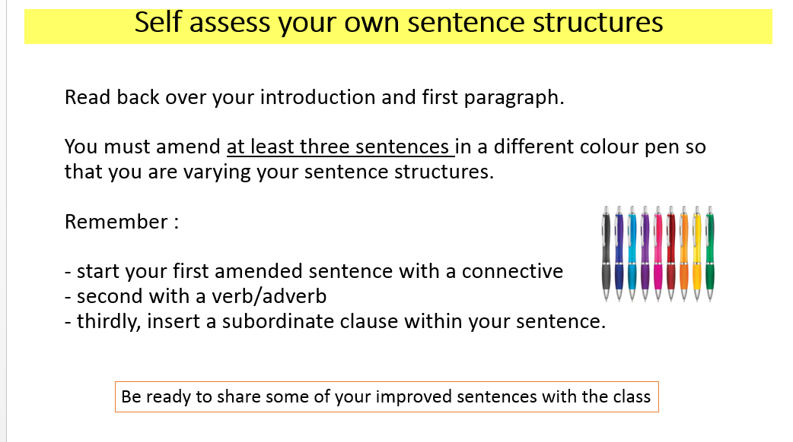

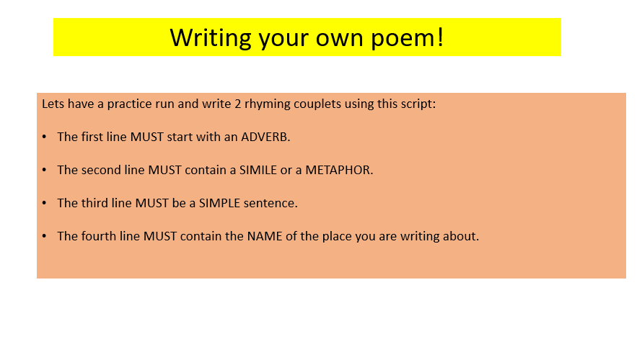
Appendix 3

Appendix 4
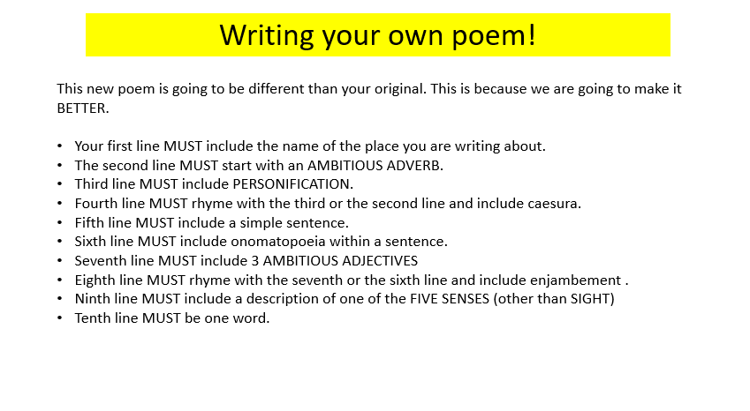

Appendix 5
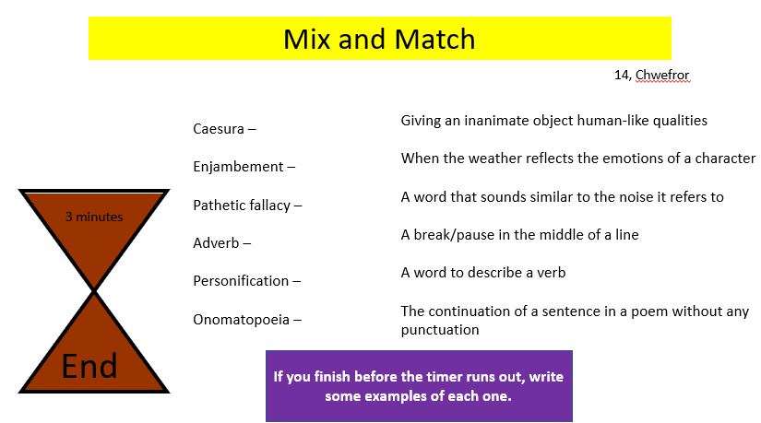

Appendix 6
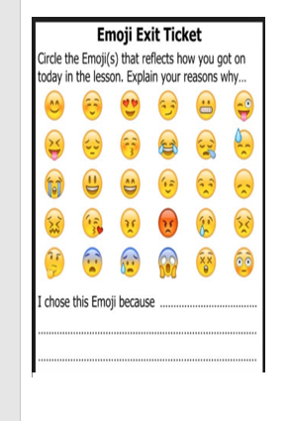

Appendix 7
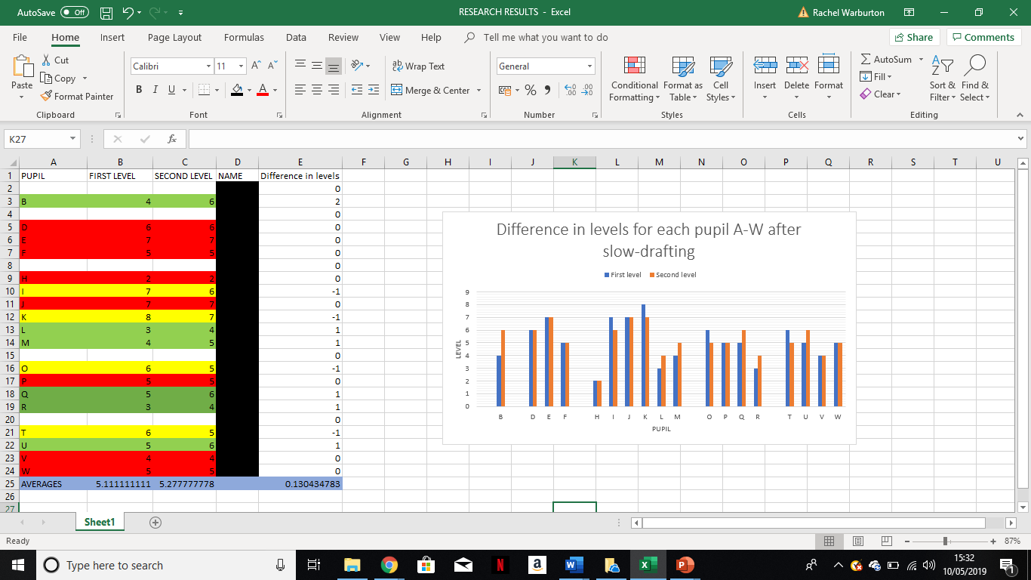

Appendix 8

