

Student Name: | Shamita m Aqbardeen
Student ID: | 2226214
Programme: | BBA (HUMAN RESOURCE)
Module: | CHANGEMAKERS: CREATIVITY AND VALUE CREATION (IUBA 5002)
Lecture: | DR EMMA ROBERTS
Assignment Title: | ASSIGNMENT 1

Content Page
Task 1 – Research Question…………………………………………. Pg.1
Task 2 – Research Techniques………………………………………Pg.2
Task 3 – Presentation of Idea………………………………………. Pg. 3
Task 4 – Data Analysis…………………………………………………. Pg. 4
References

Task 1 – Research Question
- A Research Question that has been formulated as a result of identifying an issue / problem that you would like to investigate that is appropriate to your programme of study.
My research question is What are the factors affecting stress among part time employees. Numerous factors will have a widespread effect on the general properly-being and task overall performance of part-time employees, which includes stress (Social Work Students: Stress, 2008). Job loss of confidence is a tremendous contributing detail, as the absence of a regular, whole-time hobby frequently raises questions on one's capability to preserve one's financial situation and destiny profession possibilities. Another vital element is striking a balance among art work and personal life. Part-timers may additionally find it hard to manipulate their time well, which can result in disagreements and progressed pressure levels.

Demands from the administrative centre and workload are also pretty critical; factor-timers frequently must meet strict deadlines and immoderate requirements for overall performance, that could cause pressure and burnout. Furthermore, an employee's autonomy and control over their paintings additionally influences how harassed they may be; employment with repetitive obligations and little manage can make an employee extra burdened (Risk, 2005).

Colleague and supervisor aid, similarly to interpersonal interactions at work, are important. Stress can be made worse through insufficient professional communique and a loss of social help. Lastly, a complicated interaction of personal and paintings-associated stressors is created by way of outside conditions consisting of circle of relatives’ duties, economic traces, and health worries that could add to the pressure that part-time personnel face.

- Research Approach (qualitative / quantitative / mixed methods).
My selected studies technique, the quantitative method, consists of systematically gathering and analysing numerical statistics to turn out to be privy to patterns, correlations, and causalities in order to research the elements inflicting pressure amongst detail-time employees. This technique starts with the formula of precise studies questions and hypotheses based totally on the body of modern expertise and theoretical fashions of occupational stress (industrielles, 2004). Structured surveys and questionnaires are the number one tool used to build up facts; they are intended to offer quantitative records on a number of strain-associated topics, such as autonomy, paintings-lifestyles balance, process needs, system insecurity, workload, and interpersonal connections.

To make sure representativeness, a random sample technique might be used to choose individuals, who work has part-timer and represent a selection of industries. Likert scale questions might be covered inside the surveys to gauge the frequency and intensity of stressors and how they've an effect on humans' perceived pressure tiers. This approach makes information gathering regular, which makes it less complicated to assess results during diverse mission types and demographic groupings.

- Data Collection Method(s) (primary / secondary methods).
The primary data collection method for investigating the elements affecting pressure among component-time personnel will contain the usage of mounted surveys and questionnaires, designed to seize particular and quantifiable information immediately from the target populace. These surveys could be disbursed to a carefully decided on pattern of part-time personnel from various industries to make sure a numerous and consultant dataset.

In order to higher recognize crucial pressure elements like process instability, workload, work-life balance, job expectancies, autonomy, and interpersonal interactions, the questionnaires will combine closed-ended and Likert-scale items. Respondents can use the Likert scale to price how tons they come across each stressor, giving researchers quantifiable data that may be statistically evaluated. By making sure uniformity and readability in responses, closed-ended questions facilitate the powerful processing and contrast of facts across diverse demographic and process-associated variables.

Apart from formal surveys, a restrained wide variety of individuals can be subjected to in-individual or digital semi-based interviews. The motive of those interviews is to gain a extra nuanced picture of the precise pressure elements that had been diagnosed within the surveys and the way they affect person employees via going similarly into those areas. A higher, extra entire photograph of the pressures affecting part-time people may be furnished by the qualitative insights gleaned from these interviews, with a purpose to complement the quantitative statistics.

To locate patterns, connections, and feasible causal linkages between extraordinary pressure elements, statistics gathered the use of those important techniques may be very well evaluated the usage of statistical gear. By taking a rigorous technique, we will guarantee that the results might be strong and useful in informing coverage guidelines and cantered interventions intended to lessen stress in element-time employees.

  - Sampling Method & Sample Size.
Using a stratified random sampling method, the determinants influencing pressure in factor-time employees can be investigated via sampling. By the usage of this technique, the pattern is assured to be representative of the large range of component-time employees in extremely good sectors, occupations, and demographic classes. The look at can pick out the unique pressure elements which may be pertinent to various groups of aspect-time people through segmenting the population based totally on demographic variables (e.g., age, gender, and training stage), project roles (e.g., customer support, administrative assist), and organization sectors (e.g., retail, hospitality, schooling).

Random sampling may be used to choose members interior every stratum in order that every member of the population has a same risk of being covered within the have a look at. By reducing sample bias and enhancing the findings' generalizability, this technique makes the findings more extensively applicable.

Based on the populace's variety and the requirement for statistical energy, the pattern size for this investigation can be chosen. We plan to target at the least 10–30 part-time employees in order to assure sufficient representation from every stratum. For the purpose of identifying correlations among pressure additives and overall stress tiers, this sample size is sufficient for carrying out rigorous statistical research like regression evaluation.

In order to assure that the final sample is satisfactorily large to deliver correct and legitimate effects, the pattern duration can also be changed to account for possibly non-reaction charges. The research will provide a thorough and accurate understanding of the elements contributing to stress amongst factor-time employees through using a stratified random sampling technique and selecting the right pattern period. This will result in sensible insights and successful interventions.

Task 2 – Research Techniques
- In no more than 300 words, select an appropriate research technique and conduct Primary based on your chosen research approach from Task 1.

Survey research is an appropriate research technique to perform primary research on the factors affecting stress among part-time employees. This technique is best for detecting and examining stress elements in this population because it makes it possible to get quantitative records from a considerable and varied pattern.

- Survey Design
There may be each closed-ended and Likert-scale gadgets in the established survey. Important subjects along with pastime loss of self-belief, workload, paintings-life stability, needs on the manner, autonomy, interpersonal connections, and perceived strain degrees may be the focus of the questions. Respondents can suggest how tons they experience every stress issue on a Likert scale this is going from "strongly disagree" to "strongly agree."

- Sampling
The survey will goal a sample of 10–30 detail-time personnel from a selection of industries the use of a stratified random sampling method. By assuring representation from severa industries, occupations, and demographic groupings, stratification will guarantee that the results are generally applicable.

- Data Collection
The digital survey can be disseminated via email or online survey gadget like Google Forms. This approach saves cash and enables rapid information collection. Participants could be assured of the confidentially of their responses and furnished a quick summary of the research aim to be able to enhance reaction fees.

- Data Analysis
Excel or SPSS, statistical evaluation packages, can be used to have a study the statistics that has been accrued. While inferential information, such regression assessment, could be implemented to discover giant associations among stress components and ordinary stress stages, descriptive statistics may be used to summarize the statistics.

- Reporting Findings

After the facts are collated, an intensive record may be created that identifies the primary belongings of strain for part-time employees and offers practical recommendation for growing stress-bargain and wellness-improving sports.

Task 3 – Presentation on Ideas
- Produce a 3-minute video elevator pitch that presents your area of research to identified stakeholders and obtain feedback that should be reflected upon in no more than 200 words.

- my scrip for pitching video
There are some crucial places to consider enhancing after giving the pitch a few concept. The pitch discusses a number of vast stressors, but so you can make stronger its argument and make it more comprehensible to the goal marketplace, it might be beneficial to provide extra precise examples or figures. It would enhance the argument to offer particular facts, like the percentage of element-time employees that enjoy venture loss of self assurance.

The ending can also use greater calls to motion. Give concrete pointers for actions or techniques that employers might also moreover take, inclusive of granting more flexibility in scheduling or improving assist and conversation channels, in preference to clearly urging them to take those troubles under consideration.

This pitch has an informational tone, but it might be made more interesting via asking a few direct questions to get the target marketplace involved and considering what they've got visible or visible. Doing so would possibly decorate the interactive and incredible elements of the presentation.

The target market's attention can be saved in the course of the pitch by using language that is simple and easy to apprehend. Content may be made more readable for a wider audience by manner of simplifying hard ideas or vocabulary. By making the ones modifications, the pitch can be greater effective and effective.

Task 4 – Data Analysis
- In no more than 500 words create a conference poster that demonstrates the initial analysis of your findings and highlights key conclusions drawn from your research.

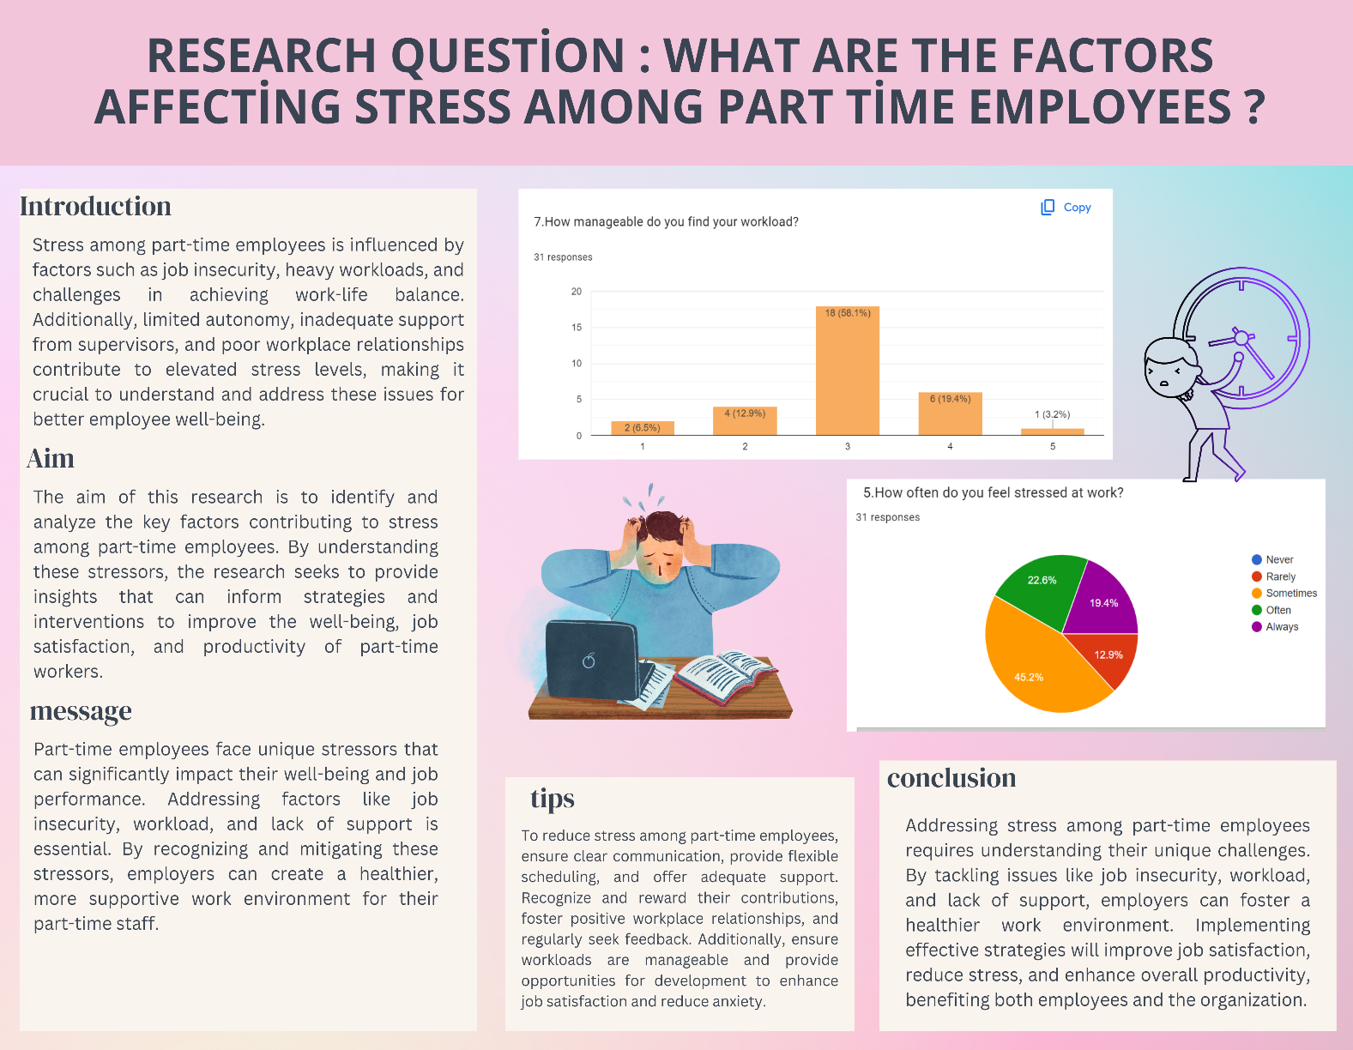

Appendix

- Sample of my survey questions
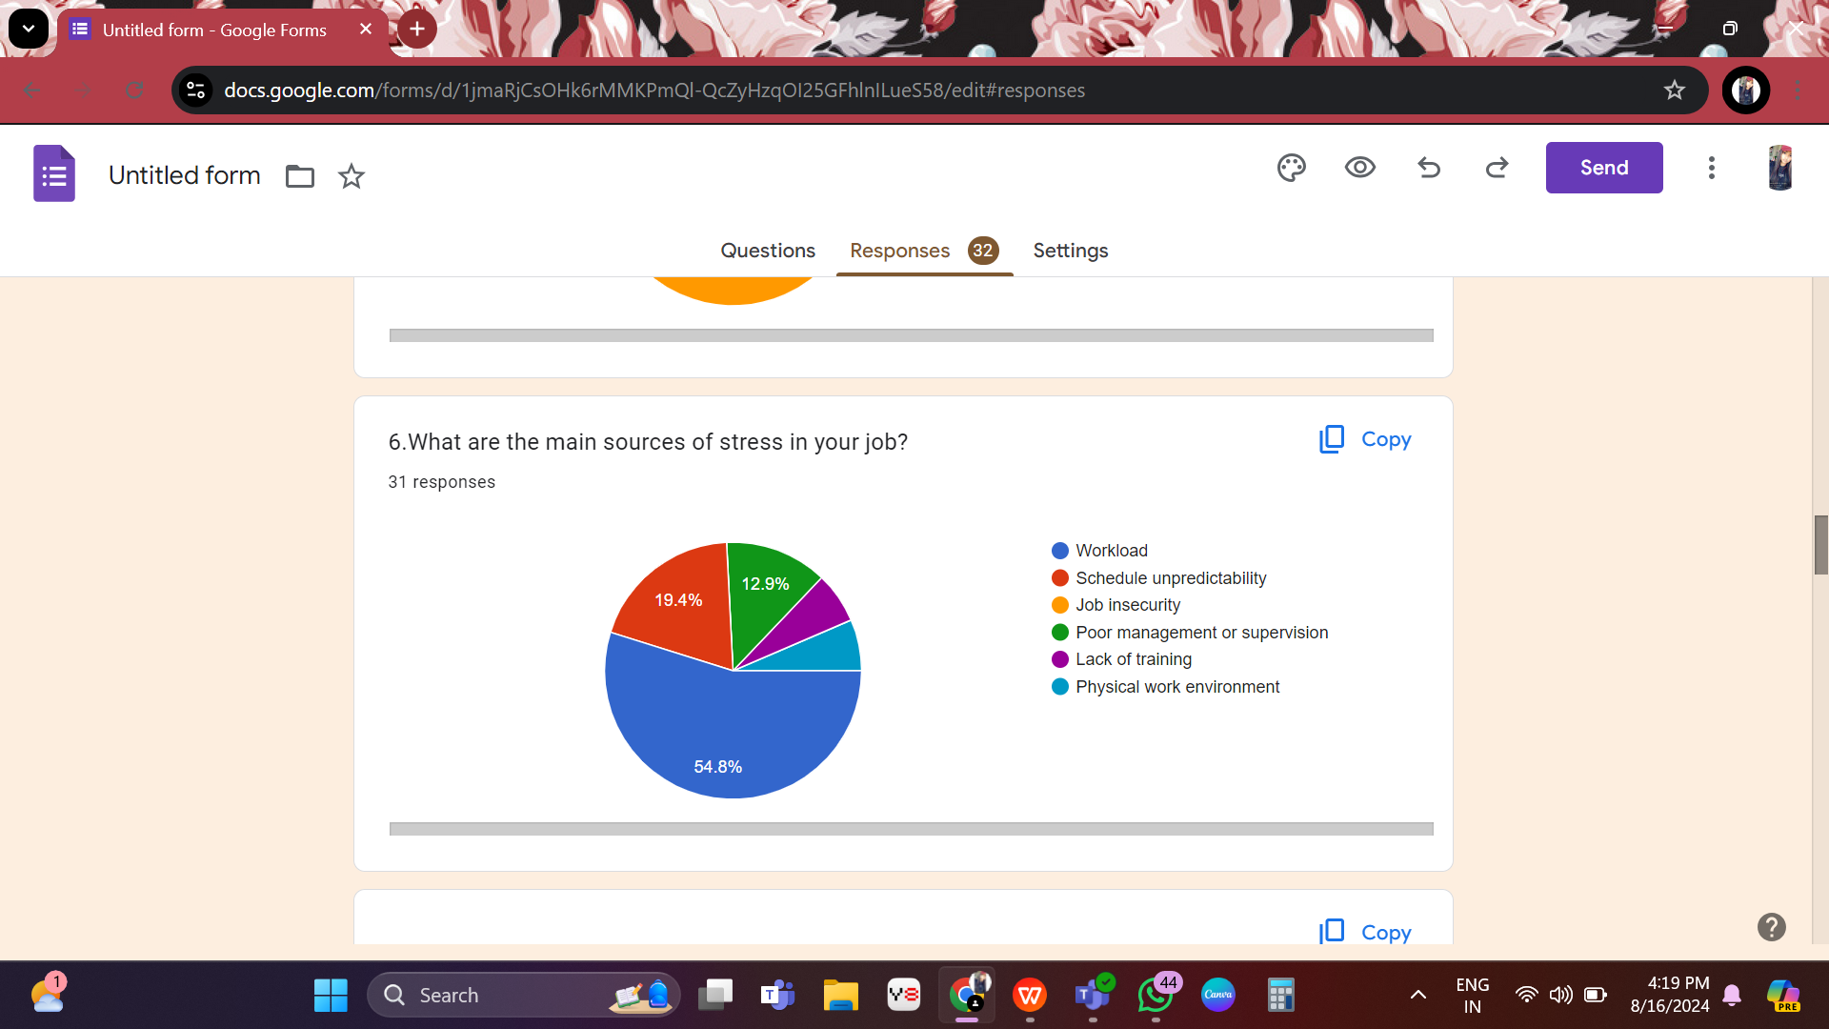

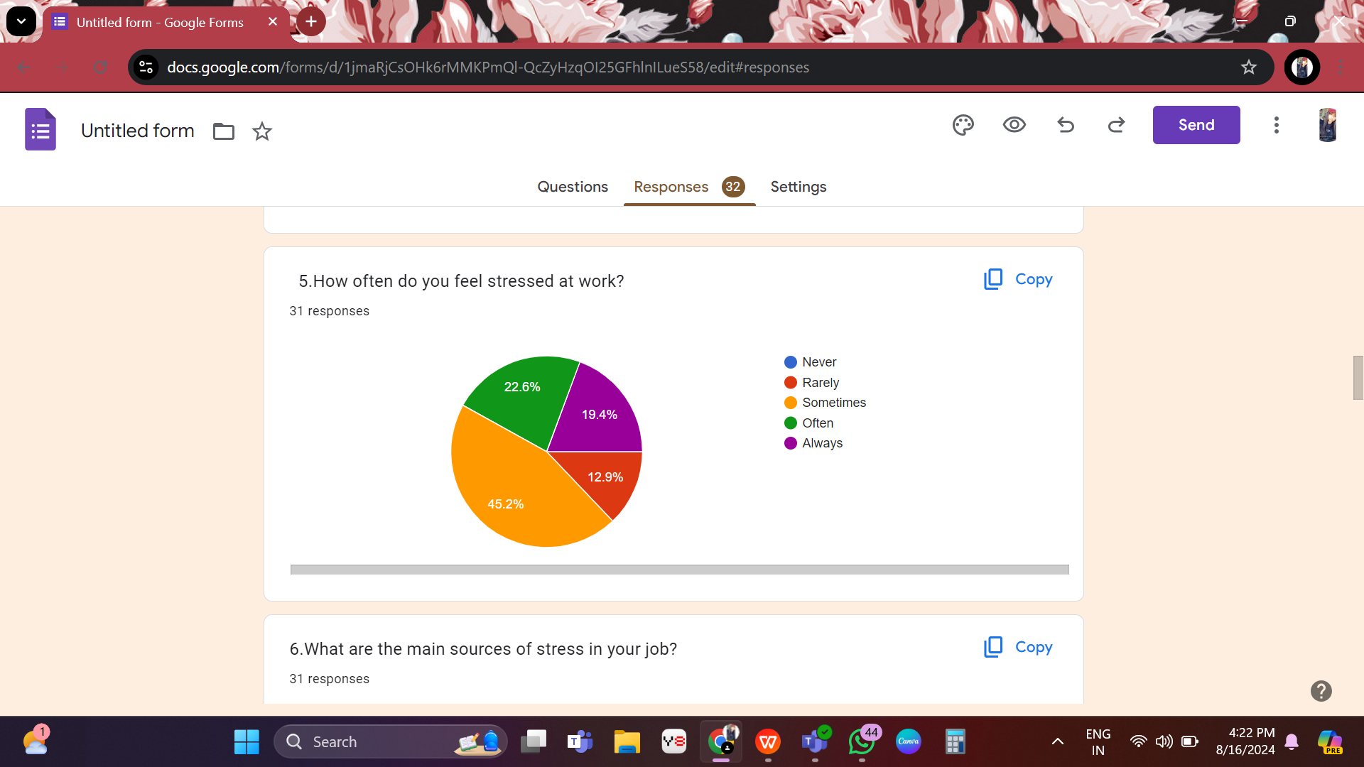

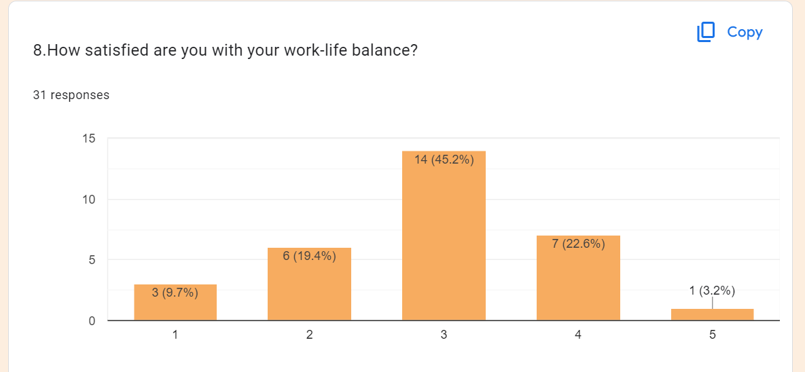

References

- Jogaratnam, G., & Buchanan, P. (2004). Balancing the demands of school and work: Stress and employed hospitality students. International journal of contemporary hospitality management, 16(4), 237-245.
- Collins, S., Coffey, M., & Morris, L. (2010). Social work students: Stress, support and well-being. British Journal of Social Work, 40(3), 963-982.
- Kobayashi, Y., Hirose, T., Tada, Y., Tsutsumi, A., & Kawakami, N. (2005). Relationship between two job stress models and coronary risk factors among Japanese part-time female employees of a retail company. Journal of occupational health, 47(3), 201-210.
- Brown, J. C. (2007). Full and part-time employee stress and job satisfaction at two upstate New York colleges (Doctoral dissertation, University of Phoenix).
- Liu, C., Spector, P. E., & Shi, L. (2007). Cross‐national job stress: a quantitative and qualitative study. Journal of Organizational Behavior: The International Journal of Industrial, Occupational and Organizational Psychology and Behavior, 28(2), 209-239.
- Zeytinoglu, I. U., Lillevik, W., Seaton, B., & Moruz, J. (2004). Part-time and casual work in retail trade: stress and other factors affecting the workplace. Relations industrielles, 59(3), 516-544.
- Alkubaisi, M. M. (2015). How can stress affect your work performance? Quantitative field study on Qatari banking sector. Business and Management Research, 4(1), 99-109.
- Zeytinoglu, I. U., Lillevik, W., Seaton, B., & Moruz, J. (2004). Part-time and casual work in retail trade: stress and other factors affecting the workplace. Relations industrielles, 59(3), 516-544.
- Zeytinoglu, I. U., Seaton, M. B., Lillevik, W., & Moruz, J. (2005). Working in the margins: women's experiences of stress and occupational health problems in part-time and casual retail jobs. Women & health, 41(1), 87-107.
- Zeytinoglu, I. U., Lillevik, W., Seaton, B., & Moruz, J. (2004). Part-time and casual work in retail trade: stress and other factors affecting the workplace. Relations industrielles, 59(3), 516-544.
- Knudsen, H. K., Ducharme, L. J., & Roman, P. M. (2007). Job stress and poor sleep quality: data from an American sample of full-time workers. Social science & medicine, 64(10), 1997-2007.
- Acheampong, J. (2023). The Effect of Stress Management Among Part-Time Students. International Journal of Finance, Insurance and Risk Management, 13(1), 152-165.

