

Strategic Management and Sustainability:
Strategic Partnership of Aston Martin

Name & Student ID: Dana Pellegrini Babcinschii (2317100)
Module: Strategic Management and Sustainability
Module Code: LCBB6015
Lecturer: Nadeem Mirza

Executive Summary
This report assesses Aston Martin's strategic position in the modern automotive sector and emphasises strategic alliances as the key objective toward improving future competitiveness and ensuring long-term success. The automobile industry is undergoing instability due to electrification, digital advancement, and evolving customer expectations, which are elevating the cost and complexity of innovation for manufacturers (Pavlínek, 2023). Strategic alliances have therefore emerged as a crucial instrument for firms to acquire external information, share technical risk, and adapt more successfully to market uncertainties (Dubey et al., 2024).
Aston Martin represents a relevant case study since it operates within the ultra-luxury high-performance automobile sector, characterised by substantial innovation requirements but limited in scale in contrast to bigger global automotive corporations. The 2024 Annual Report of the corporation indicates that Aston Martin executed a substantial renewal of its fundamental product line in 2024 (Aston Martin Lagonda Global Holdings plc, 2025). Nonetheless, the company faced supply chain disruptions and macroeconomic challenges in China, which impacted wholesale volumes and financial outcomes (Aston Martin Lagonda Global Holdings plc, 2025). The report argues that a partnership-driven strategy is the most appropriate path to enduring competitive advantage, as Aston Martin already depends on collaborative development in domains such as electrification, advanced technology, and product innovation (Aston Martin Lagonda Global Holdings plc, 2025).
Overall, the report concludes that Aston Martin should maintain ownership of the skills that characterise its brand value, specifically design, exclusivity, craftsmanship, and customer experience, while strengthening specific strategic alliances (Dubey et al., 2024).

Contents
Executive Summary 2
1. Introduction to the Strategy 4
2. Overview and background of Aston Martin 4
3. Strategic Intent 5
4. Aston Martin Current Performance 6
5. Aston Martin competitive environmental analysis 7
5.1 External Environmental Audit 8
5.2 Internal Environmental Audit 9
6. Strategy Formulation 11
Conclusion and Recommendations 13
Reference List 14

Introduction to the Strategy
Strategic management defines the process by which businesses assess their internal and external environment, allocate resources, and formulate long-term strategies to achieve sustainable performance and competitive advantage. In modern business, its significance has escalated as companies must address unpredictability, rapid technical advancements, and evolving stakeholder expectations. Recent study indicates that good strategic planning increases organisational success when associated with execution and adaptation, rather than being seen as a simply formal procedure (Mousa, Ali and Gurler, 2024).
This is especially important in the automobile sector, which is experiencing significant structural changes driven by electrification, digital connectivity, and reorganisation of the global supply chain. Recent academic research indicates that the transition to electric cars is transforming automotive manufacturing networks, supply chains, and rivalry within the industry (Ramos et al., 2024).
Aston Martin provides an ideal case study for strategic analysis due to its operation in the ultra-luxury performance market, where success depends not only on brand legacy and product appeal but also on the capacity for innovation and strategic adaptation. The firm claims that its goal is to manufacture automobiles characterised by sophisticated technology, accuracy, and craftsmanship, while its overall strategy focuses on brand development, product innovation, sustainability, and employees (Aston Martin Lagonda Global Holdings plc, 2025).
This report aims to assess Aston Martin's strategic position and determine the most suitable strategic direction for its future success. The report emphasises strategic partnerships as the preferred strategic path and is structured around the company's history, strategic objective, present performance, environmental analysis, strategy development, suggestions, and conclusion.

Overview and background of Aston Martin
Aston Martin Lagonda is a British automobile business operating in the ultra-luxury, high-performance sector of the global automotive industry (Aston Martin Lagonda Global Holdings plc, 2025). According to the company's corporate materials, its goal is to become the most prestigious ultra-luxury British brand in the world by producing unique performance vehicles (Aston Martin, 2026). This positioning is crucial since strategic management literature suggests that businesses in premium markets compete less on price and more on individuality, reputation, and perceived customer value (Whittington et al., 2023).
Aston Martin's business strategy focuses on the design, engineering, and sale of luxury automobiles that integrate modern technology with artisanal skill and exclusivity (Aston Martin Lagonda Global Holdings plc, 2025). The 2024 Annual Report emphasises a portfolio with core models such the DB12, Vantage, Vanquish, and DBX707, in addition to unique specialities such as Valkyrie, Valour, and Valiant (Aston Martin Lagonda Global Holdings plc, 2025). This combination illustrates a distinct brand strategy, whereby high-profile items increase reputation and attractiveness across the wider range (Beverland and Cankurtaran, 2021).
The company has a worldwide presence, operating in the Americas, EMEA, APAC, and the UK, supported by an international dealer network (Aston Martin Lagonda worldwide Holdings plc, 2025). Aston Martin continuously highlights its British character and legacy in its official corporate communications, hence enhancing the brand's symbolic and cultural significance (Aston Martin, 2026). From a strategic standpoint, Aston Martin presents a valuable case for analysis, since its success relies not just on manufacturing expertise, but also on its effectiveness in safeguarding brand uniqueness while navigating significant industry changes (Parnell, 2026). This is particularly important to this research, as it emphasises the need for Aston Martin to implement a strategy that fosters innovation and competitiveness while maintaining the exclusivity and tradition that are fundamental to its market position.

Strategic Intent
Strategic objectives define the long-term trajectory of the organization by clarifying its aspirations and competitive approach inside its targeted market (Whittington et al., 2023). Recent strategic research indicates that strategic planning increases organisational performance considerably when it is integrated with implementation, flexibility, and management decision-making, rather than being seen as a purely formal exercise (Mousa, Ali and Gurler, 2024). In fact, the strategic goal should be seen not as a simple symbolic statement, but as a framework that directs resource allocation, competitive positioning, and decisions made based on future advancement (Rothaermel, 2023).
This reasoning is clearly reflected in Aston Martin's strategic purpose. The firm claims that its objective is to manufacture automobiles embodying superior technology, accuracy, and craftsmanship excellence, which provide outstanding performance and a customised, industry-leading experience (Aston Martin Lagonda Global Holdings plc, 2025). The official corporate site similarly underscores the aspiration to become the world's most desired ultra-luxury British brand, indicating that Aston Martin is adopting a premium differentiation approach instead of a volume-driven competitive model (Aston Martin, 2026). This is strategically important because companies that compete via distinction must safeguard their brand's unique qualities while consistently renewing the value sources that consumers are prepared to pay for (Parnell, 2013).
Nonetheless, Aston Martin's strategic goal also exposes a strategic conflict. The company seeks to integrate cutting-edge technology with exclusivity and artisanal skill, while functioning on a far smaller scale than prominent automobile giants. The annual report indicates that the company's overarching strategy is on brand, product innovation, sustainability, and personnel, suggesting a need for advanced skills while maintaining a unique identity (Aston Martin Lagonda Global Holdings plc, 2025). In this environment, strategic alliances are crucial since they enable Aston Martin to foster innovation and competitiveness while preserving the luxury characteristics that distinguish the brand. Consequently, the company's strategic purpose delineates its aspirations and clarifies the need of strategic alliances in accomplishing them.

Aston Martin Current Performance
Aston Martin's current performance in 2024 paints a mixed strategic picture, with ongoing operational and financial difficulties combined with noticeable advancements in product renewal. Contemporary strategic management literature indicates that corporate performance should be evaluated not just on sales growth or profitability, but also on the firm's capacity to reinforce the foundations of sustainable competitive advantage (Rothaermel, 2023). Aston Martin underwent a significant restructuring of its core portfolio in 2024, facilitating its long-term brand repositioning inside the ultra-luxury performance market (Aston Martin Lagonda Global Holdings plc, 2025). Nonetheless, the financial outcomes reveal that this strategy advancement has not yet resulted in consistently solid business success.
Table 1 provides a summary of Aston Martin’s key financial and operating results for FY2024 compared with FY2023 and highlights the company’s mixed performance position
Table 1: Aston Martin key financial and operating results, FY2024 vs FY2023
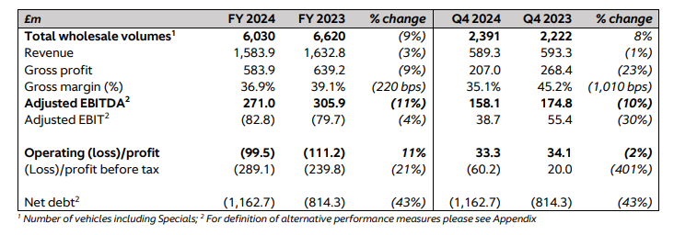
Source: Aston Martin Lagonda Global Holdings plc (2025)
As shown in Table 1, total wholesale volumes declined from 6,620 units in FY2023 to 6,030 in FY2024, while revenue fell from £1,632.8 million to £1,583.9 million (Aston Martin Lagonda Global Holdings plc, 2025). Adjusted EBITDA also decreased from £305.9 million to £271.0 million, and gross margin fell from 39.1% to 36.9%, indicating that the business remained under pressure from weaker trading conditions and operational disruption (Aston Martin Lagonda Global Holdings plc, 2025). At the same time, net debt increased substantially from £814.3 million to £1,162.7 million, which suggests that Aston Martin’s financial flexibility remains constrained despite refinancing activity during the year (Aston Martin Lagonda Global Holdings plc, 2025).
Overall, Table 1 shows that although Aston Martin made strategic progress in its product portfolio, this was accompanied by weaker volumes, lower earnings and higher indebtedness, indicating that the business remains under significant strategic and financial pressure.
However, the outcomes were not totally negative. The operating loss decreased from £111.2 million to £99.5 million, suggesting more internal discipline and improvements in cost management (Aston Martin Lagonda Global Holdings plc, 2025). The combination of product advancement, premium positioning, and financial limitations is strategically important as it indicates that Aston Martin possesses brand strength, however, still lacks the size and durability of bigger rivals (Whittington et al., 2023). Therefore, the company’s current performance strengthens the case for strategic partnerships, as external collaboration may allow Aston Martin to access technology, capabilities and innovation support without relying solely on internally financed growth (Dubey et al., 2024).

Aston Martin competitive environmental analysis

External Environmental Audit
Aston Martin functions within an external environment influenced by regulatory, economic, and technological pressures. Figure 2 illustrates that political and legal factors are crucial, since UK and European emissions regulations, particularly the shift towards zero-emission cars, are intensifying pressure on automotive companies to expedite electrification and compliance investments (Pavlínek, 2023). Economic conditions continue to be difficult, as inflation, interest rates, exchange-rate fluctuations, and diminished demand in critical regions may impact profit margins and luxury car sales (Aston Martin Lagonda Global Holdings plc, 2025). Since software capabilities, electric powertrains, and connected vehicle innovation are becoming increasingly vital for competitiveness, technological change is equally important (Ramos et al., 2024). Social and environmental concerns augment the necessity for sustainability, digital personalisation, and enhanced consumer experience. Overall, Aston Martin’s external environment increases the cost and complexity of competing independently, which strengthens the case for strategic partnerships as a means of reducing technology gaps and improving adaptability in a fast-changing industry (Dubey et al., 2024).
Figure 2: PESTLE analysis of Aston Martin
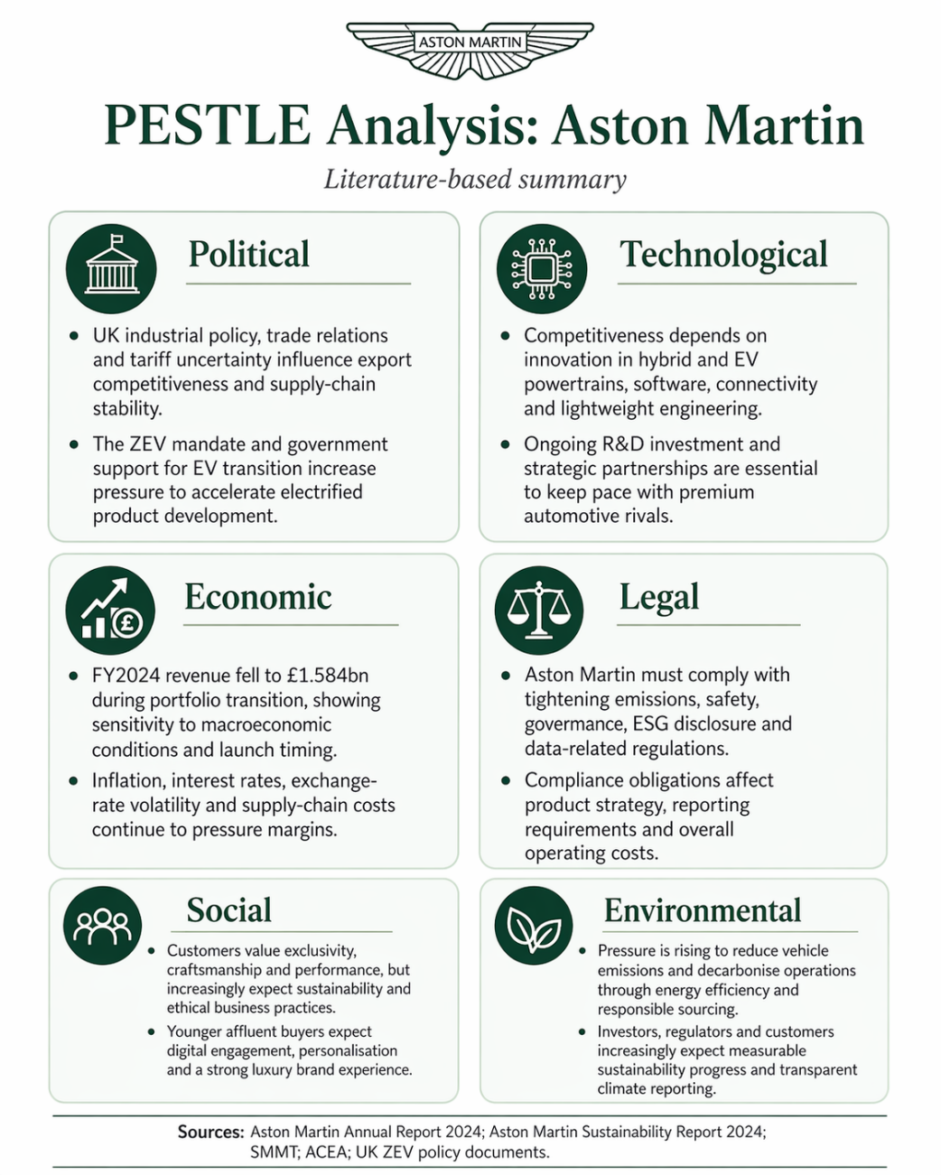
Source: Author’s own creation based on Aston Martin Lagonda Global Holdings plc (2025) and supporting literature.

5.2 Internal Environmental Audit
Aston Martin's internal position demonstrates robust brand resources, although exhibits deficiencies in financial and technological capabilities. Figure 3 illustrates that its primary strengths include brand legacy, exclusivity, craftsmanship, and premium pricing power, but its drawbacks encompass high debt, margin pressure, and a smaller size compared to major automotive competitors. These shortcomings make the successful execution and launch of products particularly critical (Aston Martin Lagonda Global Holdings plc, 2025). Figure 4 incorporates a VRIO analysis, illustrating that Aston Martin's most valuable and unique resources are its brand symbolism, British identity, and premium positioning, which are challenging for competitors to replicate (Rothaermel, 2023). Nonetheless, technology-driven advantages are less comprehensively managed internally and are more reliant on external collaboration. Overall, this suggests that Aston Martin’s strongest sustained advantage is brand-led rather than capability-led, which reinforces the need for strategic partnerships to complement internal distinctiveness with external technological expertise (Whittington et al., 2023).
Figure 3: SWOT analysis of Aston Martin
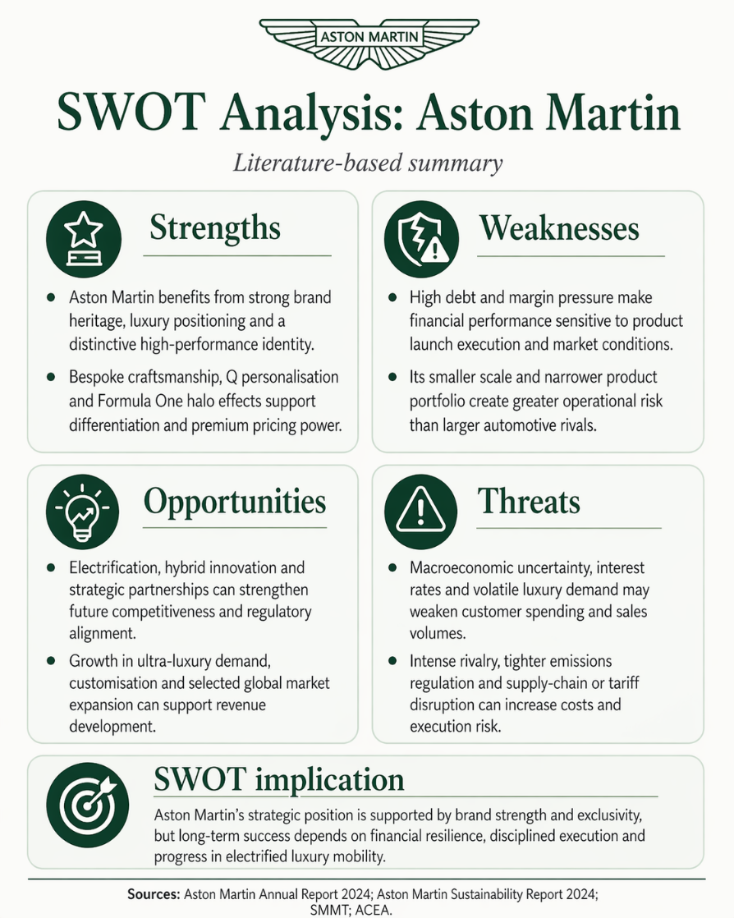
Source: Author’s own creation based on Aston Martin Lagonda Global Holdings plc (2025) and supporting literature.
Figure 4: VRIO analysis of Aston Martin
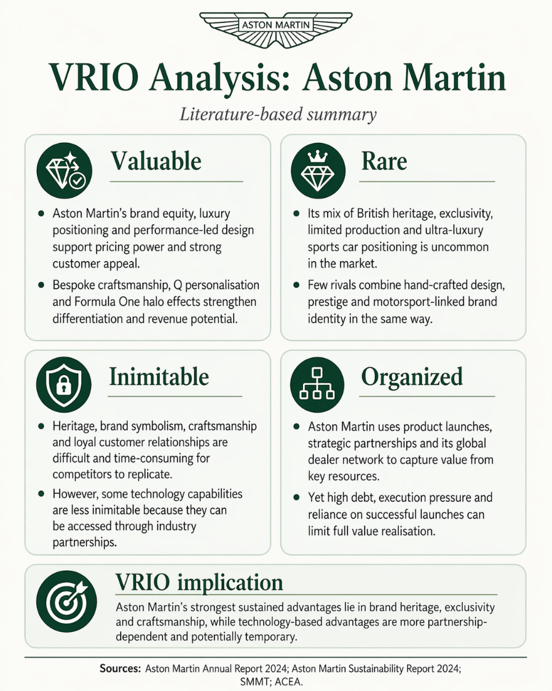
Source: Author’s own creation based on Aston Martin Lagonda Global Holdings plc (2025) and supporting literature.

Strategy Formulation
When developing a strategy, an organization must decide on a plan of action that is appropriate for both its internal capabilities and its external environment (Whittington et al., 2023). The initial investigation suggests that Aston Martin should pursue a targeted strategic relationship with Mercedes-Benz AG. Aston Martin's primary strengths lie in its brand characteristics, such as legacy, exclusivity, and superior craftsmanship, whereas its weaknesses are to technologically advanced size, electrification expenses, and depth of capabilities (Aston Martin Lagonda Global Holdings plc, 2025). Aston Martin cannot effectively develop the necessary capabilities internally in a market increasingly influenced by software, electric technology, and sophisticated vehicle architectures, since this would further strain margins and investment capacity (Pavlínek, 2023).
Using Mercedes-Benz AG as Aston Martin's primary cooperation model is more profound strategic alliance. Aston Martin asserts that its Strategic Cooperation Agreement with Mercedes-Benz AG gives access to an extensive array of premier technology for both current premium vehicles and future variants. This encompasses powertrain technology and electric/electronic architectures for internal combustion, hybrid, and electric cars. This is strategically significant as it enables Aston Martin to leverage advanced engineering capabilities while maintaining an internal emphasis on activities that differentiate it in the ultra-luxury market, specifically design, driving dynamics, craftsmanship, and personalised customer experience (Aston Martin Lagonda Global Holdings plc, 2025).
A partnership-oriented strategy with Mercedes-Benz AG aligns with broader alliance literature. Studies on automotive alliances indicate that collaborations are particularly advantageous during times of technological uncertainty, as they allow companies to share risks, alleviate development pressures, and acquire complementary expertise that would be challenging to obtain independently (Carrillo, Vallejo and Gomis, 2024). For Aston Martin, this is significant since electrification is not only a product modification; it is reshaping the framework of the automobile industry and reallocating value throughout supply chains, manufacturing systems, and innovation networks (Ramos et al., 2024). A low-volume luxury producer thus encounters heightened risk while attempting to achieve complete technical self-sufficiency. In this sense, the Mercedes collaboration signifies not weakness, but a judicious reaction to structural changes inside the business.
Nonetheless, the strategy should continue to be selective rather than reliant. Aston Martin must prevent Mercedes-Benz AG from defining the brand or diminishing the uniqueness that justifies its premium cost. The relationship should be utilised in a manner that complements capabilities. Studies on supplier orchestration indicate that companies may enhance innovation results by integrating internal strategic governance with external technology assistance, especially where specialised supplier competencies help expedite product development (Chirico et al., 2024). This is exceedingly essential for Aston Martin. The corporation need to persist in depending on Mercedes-Benz AG for enabling technology, while maintaining internal oversight of the perceptible and emotional aspects of value that buyers link to Aston Martin as a British ultra-luxury performance brand.
This method would also promote improved financial discipline. Aston Martin's 2024 performance demonstrates advancements in product renewal; yet it also reveals diminished volumes, reduced profitability, and increased net debt, suggesting that domestically financed expansion is still limited (Aston Martin Lagonda Global Holdings plc, 2025). A more profound strategic alliance with Mercedes-Benz AG can thereby mitigate capacity deficiencies without necessitating Aston Martin to bear the entire expense of autonomous technology development. Simultaneously, it may assist the organization in maintaining competitiveness in domains that customers increasingly anticipate, such as digital vehicle experience, hybridisation, and electrified performance. The optimal strategy decision for Aston Martin is to enhance its selected collaboration with Mercedes-Benz AG to merge external technology expertise with internal brand uniqueness. This provides the optimal alignment between the company's internal capabilities, external challenges, and its long-term objective to sustain its status as one of the world's most coveted ultra-luxury performance brands (Aston Martin Lagonda Global Holdings plc, 2025).

Conclusion and Recommendations
This report demonstrates that Aston Martin functions within a demanding automotive environment influenced by electrification, digital transformation, regulatory pressures, and evolving consumer expectations (Pavlínek, 2023). The analysis revealed that while Aston Martin possesses considerable strengths in heritage, exclusivity, craftsmanship, and premium positioning, it concurrently encounters substantial weaknesses associated with financial constraints, reduced scale, and a lack of technological depth compared to larger automotive businesses (Aston Martin Lagonda Global Holdings plc, 2025). Consequently, the analysis determines that a selective strategic alliance is the optimal strategic route for Aston Martin's future success.
Aston Martin should persist in fortifying its collaboration with Mercedes-Benz AG in domains such as electrified powertrains, hybrid systems, and electronic architecture, while maintaining internal oversight of design, customer experience, and bespoke luxury value (Aston Martin, 2023). This would enable the organization to utilise modern capabilities while preserving the unique brand characteristics that validate its premium positioning (Beverland and Cankurtaran, 2021). Aston Martin should establish explicit governance limits for the relationship to mitigate undue dependency, ensuring that collaboration fosters innovation and competitiveness while preserving strategic autonomy (Carrillo, Vallejo and Gomis, 2024).

Reference List
Aston Martin (2023) Aston Martin to create industry leading ultra-luxury high performance electric vehicles. Gaydon: Aston Martin. Available at: https://www.astonmartin.com/en-gb/our-world/news/2023/6/26/aston-martin-to-create-industry-leading-ultra-luxury-high-performance-electric-vehicles (Accessed: 23 April 2026).
Aston Martin (2026) About us. Gaydon: Aston Martin. Available at: https://www.astonmartin.com/en/corporate/about-us (Accessed: 23 April 2026).
Aston Martin (2026) Strategy. Gaydon: Aston Martin. Available at: https://www.astonmartin.com/en/corporate/about-us/strategy (Accessed: 23 April 2026).
Aston Martin Lagonda Global Holdings plc (2025) Annual Report and Accounts 2024. Gaydon: Aston Martin Lagonda Global Holdings plc. Available at: https://www.astonmartin.com/-/media/corporate/corporatearchive/documents/2025-gm/2024-annual-report-and-accounts.pdf (Accessed: 23 April 2026).
Aston Martin Lagonda Global Holdings plc (2025) Preliminary results for the twelve months ended 31 December 2024. Gaydon: Aston Martin Lagonda Global Holdings plc. Available at: https://www.astonmartin.com/-/media/corporate/corporatearchive/documents/2024-results/aml-fy-2024-results-announcement-vf.pdf (Accessed: 23 April 2026).
Beverland, M. and Cankurtaran, P. (2021) Brand Management: Co-creating Meaningful Brands. 3rd edn. London: Sage.
Carrillo, J., Vallejo, B. and Gomis, R. (2024) ‘Automotive alliances in times of technological uncertainty’, International Journal of Automotive Technology and Management, 24(4), pp. 479–506. Available at: https://doi.org/10.1504/IJATM.2024.142133 (Accessed: 23 April 2026).
Chirico, F., Naldi, L., Hitt, M.A., Sieger, P., Sirmon, D.G. and Xu, K. (2024) ‘Orchestrating resources with suppliers for product innovation’, Journal of Product Innovation Management, 41(4), pp. 735–767. Available at: https://doi.org/10.1111/jpim.12703 (Accessed: 23 April 2026).
Dubey, R., Bryde, D.J., Foropon, C., Tiwari, M.K. and Dwivedi, Y.K. (2024) ‘Improving supply chain resilience and performance through digital transformation and collaboration’, International Journal of Information Management, 76, article 102723.
Mousa, K.M., Ali, K.A.A. and Gurler, S. (2024) ‘Strategic planning and organizational performance: an empirical study on the manufacturing sector’, Sustainability, 16(15), 6690. Available at: https://www.mdpi.com/2071-1050/16/15/6690 (Accessed: 23 April 2026).
Pavlínek, P. (2023) ‘Transition of the automotive industry towards electric vehicle production in Europe’, Eastern European Economics, 61(4), pp. 349–377. Available at: https://doi.org/10.1007/s10663-022-09554-9 (Accessed: 23 April 2026).
Ramos, M.R., di Mauro, C., Delautre, G. and Ernst, C. (2024) ‘Inter-plant competition, employment, and supply chains: the impact of electrification on the automotive industry’, Structural Change and Economic Dynamics, 69, pp. 11–24.
Rothaermel, F.T. (2023) Strategic Management: Concepts. 6th edn. New York: McGraw Hill. Available at: https://www.mheducation.co.uk/strategic-management-concepts-ise-9781266191862-emea-group (Accessed: 23 April 2026).
Whittington, R., Angwin, D., Regnér, P., Johnson, G. and Scholes, K. (2023) Exploring Strategy. 13th edn. Harlow: Pearson.

