

Programme: Master of Business Administration

Module Code: LCMB7003

Module Name: Strategic Management

Student Name: Dhavalkumar Manubhai Ahir

Student ID: 2523550

Assessment component: Individual report

Company: Crocs Inc. (INDIA)

Lecturer Name: Ghulam Mujtaba

Words: 5288

Executive Summary
This is a strategic management report (having two sections) prepared by an acting Strategic Management Consultant (SMC) for evaluating selected multinational brand (Crocs Inc.) India based operations. The current strategic position of Crocs Inc. in India is evaluated here using different strategic management frameworks. The section 1 focuses on multinational brand Crocs with major emphasis given on its operations in the country of India. The present strategic position of Crocs in the context of the Indian market is evaluated here, followed by proposing recommendations for enhancement of its competitive advantage regarding the same. The section 2 is reflective account of mine prepared by making use of four stages of Kolb's Learning Cycle model.

Table of Contents
Section 1 4
1.0 Organisational Context and Overview 4
2.0 External and Internal Analysis 5
2.1 PESTEL analysis of Crocs 5
2.2 VRIO analysis of Crocs 7
2.3 SWOT analysis of Crocs 8
2.4 Summarised findings from analysis 10
3.0 Comprehensive and holistic view of the organisation 11
3.1 Critical discussion of Crocs' current CSR strategy and Alignment with business objectives 11
3.2 Application Balanced Scorecard (BSC) 12
3.2.1 Application of BSC tool for Crocs’ India operations 12
4.0 Strategic Choices and Implementation 15
4.1 Examination of the strategic choices at business level 15
4.2 Validation of the strategic choices 16
4.3 Recommended strategy to enhance competitive advantage 17
4.4 Identification of potential challenges in implementation and solutions for their mitigation 19
Section 2 20
1.0 Reflective Account 20
1.1 Application of Kolb’s cycle of reflective practice 20
1.1.1 Concrete Experience 20
1.1.2 Reflective Observation 21
1.1.3 Abstract Conceptualisation 21
1.1.4 Active Experimentation 22
References 23

Section 1

1.0 Organisational Context and Overview
Crocs Inc. (referred here as Crocs) is a consumer cyclical organisation that is classified within the footwear and accessories segment. Crocs was founded in 2002 in Boulder, Colorado, US. Crocs built its foundation on a single product, i.e., the Foam Clog, which was made from its proprietary material named Croslite (TSH, 2022). This forms the basis of Crocs' business model, as it operates a profitable business model centred around its Croslite-component-made clogs (Calboli and Armstrong, 2023). It usually follows an outsourced manufacturing and omnichannel sales mix strategy for driving high-margin sales by using scarcity marketing. In the year 2021, Crocs acquired Heydude and added a 2nd brand to its portfolio. This led to the creation of a dual-brand strategy, with Crocs focusing on iconic clogs/sandals while Heydude handled the casual lifestyle segment. The official mission statement of Crocs is ‘Create a more comfortable world for all’ (StockIntent, 2026). The mission statement of Crocs is actually based on three pillars of planet, community and comfort for its people. There has been a strategic shift in its mission since 2021, with it embedding sustainability, self-expression and inclusivity as a part of its business model instead of simply selling footwear. The vision statement of Crocs i.e. ‘Everyone to be comfortable in their own shoes’ depicts its focus on comfort, self-expression and inclusivity for users wearing its shoes. The January 2026’s “Wonderfully Unordinary" brand platform marks a narrative change for Crocs in a decade, despite a revenue decline (StockIntent, 2026). The mission framework of Crocs is an emphasis on management quality and moat durability on a long-term basis. Steps such as acquiring Heydude, using bio-based Croslite, and net-zero commitments reflect the strategic capital allocation of Crocs in alignment with its narrative change.
As per the latest available report, the 2025 revenue of Crocs was $4.05 billion, driven mainly by international growth, despite North American sales being down by 6.8%. Crocs experienced a sales decline in the 4th quarter of 2025 by 3.2% compared to what it was in the last year (StockIntent, 2026).
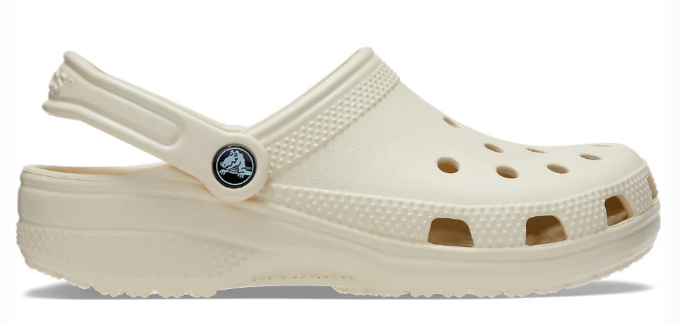
Figure 1: Classic Clog product (with Crocs logo)
(Source: Crocs-India, 2026)
Crocs is one of top global players in the casual and comfort footwear categories (Rocco, 2026). Crocs has set target of $100 million of cost savings by 2026 end and also a targeted growth of 3.7% by the same period (StockIntent, 2026). The flagship product of Crocs is the Classic Clog, which is now supplemented by sandal expansion constituting 13% of Crocs' product portfolio and contributing to $715 million of its 2025 revenue (StockIntent, 2026). Crocs can be considered to be the market leader in the moulded-foam clog footwear category. But its nearest market competitors are Skechers (known for mass-market appeal) and Birkenstock, which happens to be the closest premium rival of Crocs in the moulded sandal segment.

2.0 External and Internal Analysis
A critical examination of the external factors impacting Crocs' operations in India is evaluated here. For this purpose, the application of PESTLE analysis, VRIO analysis and SWOT analysis has been done here for Crocs in the context of its Indian operations.

2.1 PESTEL analysis of Crocs
A main purpose of the PESTLE analysis is that it helps organisations to map the environment in a broad manner while identifying risks and opportunities which are commonly outside an organisation's control. This is more like that of a strategic planning cum decision-making tool for the organisations to properly adapt to outside changes (Agyekum et al., 2024). This analysis is done here for determining the available opportunities and threats for Crocs in the Indian market.
Political- In India, high import duties are imposed on foreign footwear, which in turn encourages local manufacturing by foreign brands to cater to huge demand. Initially, Crocs absorbed a major share of its manufacturing cost but had to struggle to navigate the local supply chain in India. The 'Make in India' push by the Indian government resulted in Crocs partnering with factories in the Indian state of Tamil Nadu to manufacture its foam shoes directly in the country (ET, 2026). Despite a tariff-related tussle between India and the US, Crocs is still on track to broaden its supply chain diversification strategy in India, which showcases the market opportunity in India.
Economic- There has been a significant increase in the middle-class segment's income in India, which is a sign of fast urbanisation (George, 2025). This, in turn, results in the willingness of consumers to try non-essential apparel, thus turning out to be an opportunity for Crocs. But the fluctuating price of raw materials along with shipping costs tends to impact product price. It is balanced by Crocs by offering consumers the option of premium-priced footwear and mid to high-priced footwear. Also, the improved digital infrastructure in India has led to the growth of e-commerce, thus allowing Crocs to increase its online sales.
Social- The casualisation of work patterns in India, like that of hybrid work, has resulted in more people opting for comfortable streetwear, with Crocs being one of their preferred choices. Most importantly, the waterproof feature of Crocs has made it an extremely popular monsoon footwear among Indian consumers. Also, the influx of global brands in India, along with an increase in the number of affordable Direct-to-Consumer (D2C) footwear brands, has turned India into a competitive market for Crocs (Dey, 2026). There is a growing liking for colourful clogs in the Indian market, with it being preferred by both middle-class and young consumers, thus leading to Crocs' popularity in the Indian market.
Technological- The fast-paced integration of online platforms with physical stores has been due to the rise of omnichannel retailing that has provided a seamless purchase experience to consumers buying Crocs footwear from different channels/platforms. Crocs footwear is mainly made up of Croslite, a component which is primarily PEVA, i.e., polyethene vinyl acetate (Infor, 2023). This material innovation has resulted in extremely lightweight and durable features of Crocs. Regarding the in-office activities in India, Crocs has eliminated the use of huge phone calls, emails and other communications for addressing the requirements/complaints of the customers. This is an example of how Crocs has technologically transformed its operations in India.
Legal- The Indian footwear market struggles due to the problem of fake products, which is a threat factor for Crocs, as fake products' availability at a low price tends to attract consumers, thus impacting Crocs' market share. The intellectual property enforcement activity of Crocs has not been up to the mark, thus turning out to be a cause of concern for it. An example of this is the revival of a 9-year-old lawsuit that had been filed by Crocs accusing several local Indian footwear companies of launching identical footwear like that of rubber clogs (Chaturvedi, 2025). During that time, the lawsuit was not accepted on technical grounds, but in 2025, an Indian court allowed Crocs to go ahead with the infringement challenges.
Environmental- In recent times, there has been an increase in the number of eco-conscious consumers who prefer to analyse a brand's product carbon footprint prior to its purchase. This has made Crocs emphasise making its footwear products using bio-based, sustainably procured raw materials. The show production activities in India by Crocs align well with 'Comfort without Carbon’ objectives (Crocs-I, 2026). An example of this is Crocs selling footwear in India that is made up of 100% post-industrial recycled content instead of using cardboard show boxes. It has helped to lower Crocs' carbon footprint for its packaging activities in India by nearly 85% (Crocs-I, 2026). Also, monsoon weather is a contributory factor for increased sales of Crocs shoes as there is a seasonal spike in its demand because of the water-resistant nature of Crocs footwear.

2.2 VRIO analysis of Crocs
The main purpose of this analysis model is to evaluate the internal resources and capabilities of the organisation to determine whether the organisation has a lasting edge over its competitors. This includes evaluation of valuable resources, rarity, the imitability of products/services and the extent to which the resources are organised (Larbi et al., 2024). The application of this model is done here for determining the strengths and weaknesses of Crocs in the Indian market. The VRIO analysis of Crocs is shown in Table 1 below.
Resources & Capabilities | Valuable (V) | Rarity (R) | Inimitability (I) | Organisability (O) | Competitive Advantage
Croslite material | Yes | Yes | No |  | Temporary
Supply chain flexibility | Yes | Yes | Yes | Yes | Sustained
Brand recognition | Yes | Yes | No |  | Temporary

Table 1: VRIO analysis of Crocs
(Source: Author)
Based on the findings of the above table, it can be stated here that the Croslite material is a proprietary closed-cell resin product which is lightweight and comfortable. But the clog design of Crocs footwear is easy to replicate by competitors, thus turning out to be a temporary competitive advantage. The production and distribution technique followed by Crocs is based on the agile concept. This has helped Crocs scale its production at a fast rate in India, along with good adaptation to seasonal trends (Dosapati, 2022). Crocs has not been overstocking its products like that of typical footwear brands, which adds to one of its distinguishing factors, thus adding to its sustained competitive advantage. The brand recognition of Crocs has increased in the Indian market because of Jibbitz personalisation and the feature of iconic silhouette (Dosapati, 2022). But this cannot be termed a sustained competitive advantage and instead a temporary competitive advantage for Crocs because it is susceptible to fluctuating fashion trends and imitators as per market conditions.

2.3 SWOT analysis of Crocs
This model is a critical part of an organisation’s strategic management planning process. This is an analytical tool that is used for proper categorisation of the significant environmental (both internal and external) factors related to the organisation. This is used here in the context of Crocs for obtaining clarity regarding its strategies to build for the future and remain ahead of its competitors in the Indian market.
Strengths: Crocs has a strong presence across different digital/online channels in India. Crocs also has good retail partnerships with major shopping malls in the country that enable Crocs India to reach out to a broad customer base, especially tier-1 and tier-2 cities. Presently, the new feature of Jibbitz, introduced by Crocs, has resulted in an increase in its demand among the Gen-Z and millennial segments of customers in India (Dosapati, 2022).
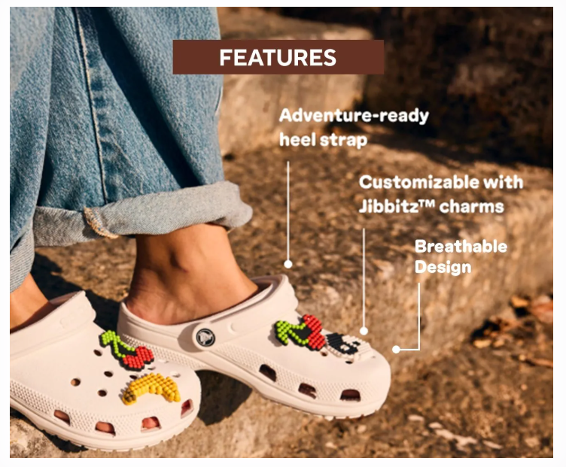
Figure 2: Personalised Jibbitz feature in Crocs clogs
(Source: Crocs-Classic, 2026)
The increased popularity of Crocs footwear in India is also due to Croslite material offering good comfort to the users, with them using it for professional as well as casual use. Also, the strategy of localised marketing used by Crocs in India has helped it to become a local streetwear preference for Indian customers, with it becoming a part of Indian youth's fashion statement.
Weaknesses: One of the weaknesses for Crocs is its pricing compared to the volume-driven footwear market of India. The pricing of Crocs is maintained within the premium range, which prevents a major part of lower-income demographics in India from purchasing the product. Crocs has year-round sales in the metropolitan areas in India, but it is not the same for tier-2 cities and semi-urban regions of the country (Findlay et al., 2025). Also, Crocs suffers due to seasonal fluctuations as there is a sudden heavy rise in demand for classic clogs during the monsoon season in India. The high demand for classic clogs of Crocs results in a disproportionate revenue distribution of the company, with it displaying limited diversification of Crocs products in the Indian market.
Opportunities: There is a good opportunity for Crocs to expand its presence and product availability beyond the three major metropolitan cities of Mumbai, Delhi and Bengaluru. The growing number of offices in tier-2 and tier-3 cities has resulted in an increased inflow of people to these cities, thus making them a part of untapped volume potential for Crocs. Crocs has a good opportunity to enter into partnerships with hospitality and healthcare organisations in India because there is a good demand for comfortable slip-resistant work clogs (Findlay et al., 2025). This makes it important for Crocs to make some modifications in the pricing of its products to make it affordable for the middle-class income segment of India while expanding the market share.
Threats: The major threat for Crocs is the abundant availability of cheap imitations and fake products of clogs and sandals at a lower price. This has a severe impact on the brand identity of Crocs, with the majority of Indian price-conscious purchasers preferring cheap alternatives over the pricey products. Crocs faces stiff competition from domestic brands like Relaxo and Campus, making similar products, along with international brands like Skechers and Puma, offering aggressive discounts on their products (Salo et al., 2021). Lastly, the market trend in India is such that it is seeing significant inflation in product prices, which impacts the discretionary spending habits of people. The consideration of Crocs footwear as a premium lifestyle and non-essential accessory by the Indian people poses a challenge for the brand as well.

2.4 Summarised findings from analysis
From the detailed analysis, it has been obtained here that Crocs has developed a strong brand position in the Indian market. The D2C supply chain using various sales modes/channels has helped Crocs to develop a very appealing picture of its brand among the Indian customers. Additionally, the Jibbitz-based customisation model of the clogs has driven the level of customer loyalty and an increase in average sales value of Crocs shoes in India as well (Dosapati, 2022). The expansion of Crocs' manufacturing operations in India is to decrease its reliance on a single country and use India as a base for launching new, lower-priced footwear for catering to its middle-class segment and export to other international markets as well. But the challenge for Crocs is due to the Indian market being extremely price-sensitive and the excessive availability of cheap fake alternatives of its footwear models, which have impacted its revenue in recent times.

3.0 Comprehensive and holistic view of the organisation

3.1 Critical discussion of Crocs' current CSR strategy and Alignment with business objectives
A proper and well-defined Corporate Social Responsibility (CSR) strategy helps in direct alignment of business objectives. It helps in turning social goals into business advantage instead of just adjusting cost factors (Alkandi, 2025). The alignment of CSR strategy with business objectives prevents wastage of organisational resources, strengthens its reputation, lowers expenditure, keeps the organisation's human resources happy and decreases the chances of legal complexities.
About Crocs CSR strategy for its India operations
Crocs has been able to localise its initiatives for building a positive image of its brand in the massive footwear retail market of India. Crocs' CSR process in India aligns with its ‘Comfort for All and Comfort for the Planet’ strategic objectives. An example of a CSR initiative undertaken by Crocs is its association with Soles4Souls and Children Rights and You (CRY), two non-governmental organisations, for donating 5000 pairs of shoes to migrant families in the state of Maharashtra, India, during the time of the COVID-19 pandemic (CSR-TIMES, 2024). This initiative was done under the Jeevan Dhara project supported by CRY to connect with people at the grassroots level (CSR-TIMES, 2024). Crocs was able to meet both of its abovementioned strategic objectives by providing comfortable and easy-to-clean footwear.
On the environmental front, Crocs has been able to lower the CO2 footprint of each pair of classic clogs to 3.94 kg CO2 eq. This is in alignment with its Net Zero target with a 2030 deadline (Crocs-P, 2026). Also, Crocs' operations in India are emphasising waste reduction by selling clogs sans shoe boxes and using 25% of plant-based materials for manufacturing the classic clogs (Crocs-CR, 2024). Lastly, Crocs has mandated 100% social compliance and restricted substance use audit across its tier-1 and tier-2 supply chain to avoid legal complexities at its manufacturing hubs and warehouses.

3.2 Application Balanced Scorecard (BSC)
The main purpose of the BSC tool is to provide clarity regarding the scope of operational performance measures of an organisation, taking into consideration the financial and non-financial data.
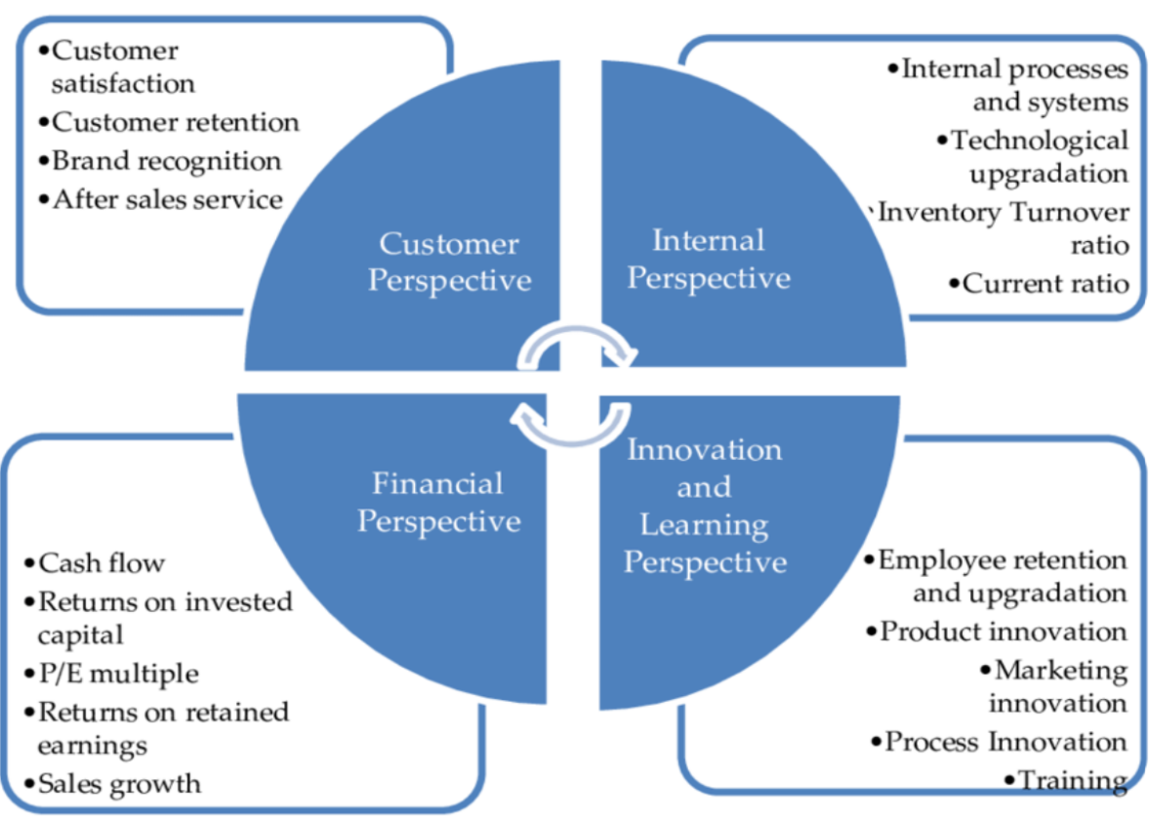
Figure 3: Basic concept of the BSC tool
(Source: Chaudhari, 2020)
This provides support for enhancing business management activities of an organisation. The feature of portfolio-level performance measurement allows interlinking of parameters with the Key Performance Indicators (KPIs). The main challenge in using this tool is that there are complexities faced by the project team while setting the metrics. This involves making use of quantifiable data for real-time tracking of the organisation's performance.

3.2.1 Application of BSC tool for Crocs’ India operations
Financial Perspective
Objective- To increase revenue, profitability, and market share of Crocs in its India operations while keeping in consideration the pricing factor.
KPI- To keep track of revenue growth (on an annual basis), corresponding operating profit margin, online and same-store sales contribution, along with evaluating the rate of inventory turnover.
Targets- To achieve a set target of 20% growth for Crocs (annually) along with increasing online sales rate and improving the turnover rate to keep operating margin constantly over the margin of 18%.
Strategic Initiative- There is a need for Crocs to strongly consider expanding its stores in tier-2 and tier-3 Indian cities. For this purpose, strengthening of the franchise partnerships is a viable option along with changing the pricing strategy on a product-wise basis (Pinto, 2026). Also, there is a need for Crocs to expand its local sourcing strategy to decrease its logistics cost and develop its sourcing market in India.
Customer Perspective
Objective- To improve brand loyalty of Crocs, enhance customer satisfaction and improve the market availability of Crocs footwear for both Gen-Z and millennial segment of customers.
KPI- To make use of parameters like Net Promoter Score (NPS), Customer Satisfaction Score (CSAT) and customer retention rate to track Crocs' performance over offline/online sales operations in India.
Targets- To aim for achieving CSAT value of more than 90% and NPS score of above 70 along with increasing repeat purchase rate by 18%-20%.
Strategic Initiative- There is a good option for Crocs to launch its influencer campaigns over the digital marketing platform as part of personalised digital marketing campaigns to showcase India-specific collaborations (Pinto, 2026). Other initiatives can include improving the omni-channel shopping experience for the customers and improving the after-sales experience by launching/expanding its customer loyalty programmes.
Internal Business Process
Objective- To improve the operational efficiency, product availability and supply chain responsiveness of Crocs.
KPI- To keep track of stock availability of different footwear variants at its franchise stores/retail stores along with keeping track of supply chain lead time, delivery rate (on-time) and defect rate.
Targets- Crocs should target to keep product availability and on-time delivery rate to be more than 95% and decrease the product defect rate to a value of less than 1%.
Strategic Initiative- There is a good option for Crocs to implement Artificial Intelligence (AI) related inventory management so as to strengthen supplier relationships. For this purpose, Crocs should opt for automation of its warehouse, improve quality control and streamline both online/offline inventory systems (Dey, 2026). There is a need for transformation of Crocs India’s internal processes for catering to growing customer demands across different channels.
Learning and Growth
Objective- To develop and enhance employee capability of Crocs in terms of strengthening digital competency and transforming the organisational culture of Crocs into a customer-centric one.
KPI- The application of employee engagement score and digital capability index can be used for keeping track of the innovation tactics applied by the employees to increase sales and improve marketing activities of Crocs for its India operations.
Targets- Crocs should emphasise hiring local talent, followed by mandatory 40 hours of training on an annual basis, to decrease employee turnover for its corporate office as well as franchise stores operating across India. The leadership positions should be filled by Crocs using internal job postings.
Strategic Initiative- Crocs should up its digital skills training for its Indian franchise stores and warehouse employees to streamline the inventory management process without fail. It should implement leadership development programmes and train the employees to make use of advanced retail analytics platform/software (Dosapati, 2022). Innovative marketing ideas should be encouraged/promoted by forming cross-functional teams in tandem with operations expansion.

4.0 Strategic Choices and Implementation

4.1 Examination of the strategic choices at business level
Application of Porter’s Generic strategies
This is a business framework that is used here in the context of Crocs for the targeted achievement of a long-term competitive advantage by evaluating and making modifications for its India-based operations at a business level. There are three options available as per this model, i.e. Cost Leadership, Differentiation and Focus, from among which only one type should be selected to prevent probable deviation from making the correct strategic choice.
Differentiation- This factor is the main value driver for Crocs. Crocs is presently driving customer engagement through its Jibbitz feature that has enabled customers to get their own customised footwear. Crocs has a very good opportunity to transition from purely monsoon footwear to more casual streetwear for the millennial and Gen-Z customers of India. There is also good scope for Crocs to further improve the customer experience by increasing the number of its mono-branded stores managed by Metro and Apparel Group, which happen to be its strategic partners (Netcore, 2026). This will contribute to an improved omnichannel experience for Crocs.
Cost Leadership – This factor adds to the operational efficiency of Crocs. Crocs management has been very optimistic about setting up manufacturing units in the state of Tamil Nadu in India (Kadakia, 2023). The step is aimed at decreasing import reliance, decreasing logistics handling costs and effectively managing supply chain volatility. The application of AI-driven data analytics will enable Crocs to do accurate demand forecasting, thus in turn will impact marketing expenses and, most importantly, inventory management activities.
Focus- Crocs is known for heavily targeting the Gen-Z and young millennial segment of footwear lovers of tier-1 Indian cities through social media channels. There is a good scope for Crocs to do the same for tier-2 and tier-3 cities, as a mass population in these regions will help Crocs to outpace revenue growth compared to tier-1 cities (ARND, 2026). Another good option for Crocs is to manufacture dedicated clogs for particular sectors like healthcare and hospitality organisations, which should be slip-resistant and easily cleanable.

4.2 Validation of the strategic choices
The validation of the strategic choices has been done here by making use of Ansoff’s Matrix. This has been used here as a strategic planning tool for businesses to properly evaluate their respective growth opportunities and assess risks in accordance with which strategies are formed (Zupic et al., 2025). It is commonly used by an organisation's management team for deciding where to focus among the options of new products/services or market. The application of the Ansoff matrix has been done here in the context of improving Crocs’ India operations.
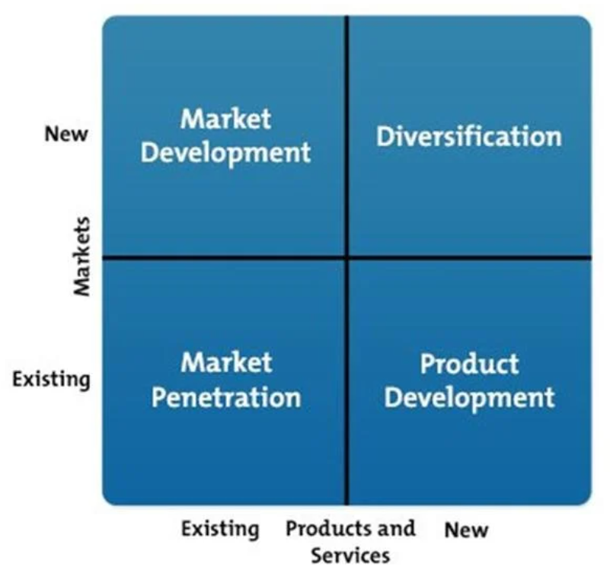
Figure 4: Ansoff Matrix
(Source: Chaudhari, 2020)
Market Development- There is a good option for Crocs to expand its geographic presence in Indian tier-2 and tier-3 cities. There is an increase in demand of affordable and durable footwear in these types of Indian cities. There is also another option available with Crocs to specifically target the healthcare and hospitality domain organisations for making customised clogs as per their organisational requirements (Findlay et al., 2025). Crocs can also target the student category demographics by marketing clogs as an everyday footwear instead of it being a premium footwear.
Diversification- Crocs should aim to enter the completely new untapped market segments in India i.e. semi-urban and rural regions. This attempt can turn out to be successful once Crocs launches its localised clogs variants at a lower price to compete with cheap alternatives available in Indian footwear market (Salo et al., 2021). Another option for Crocs is that to partner with Indian brands like Paragon and Relaxo to gain access to mass customers and then launch specialised footwears.
Market Penetration- Crocs should strongly consider about increasing its sales frequency among the Indian customers. For this purpose, Crocs need to expand its digital marketing campaigns at a localised level. The utilisation of celebrity and regional influencer partnerships is a viable option for Crocs to improve its clogs sales rate beyond monsoon season only (Findlay et al., 2025). Crocs should bring different variants clogs and make it available in both online and offline stores at same price to provide purchase mode/channel option to the customers.
Product Development- Crocs should not limit itself to clogs and sandals only, despite these two products being the most sought-after products. It should introduce new silhouettes and bio-material tailored footwear in alignment with Indian climatic conditions and demographic requirements. In addition to clogs, the breathable and water-resistant monsoon footwear can be launched (Findlay et al., 2025). The limited-edition region specific Jibbitz charms can be launched during festive seasons that will enable the people to have customised purchase option of their footwear.

4.3 Recommended strategy to enhance competitive advantage
Based on the above analysis of facts pertaining to Crocs operations in India, some recommendations are presented here for Crocs to ensure its competitive advantage remains intact for its Inda operations.
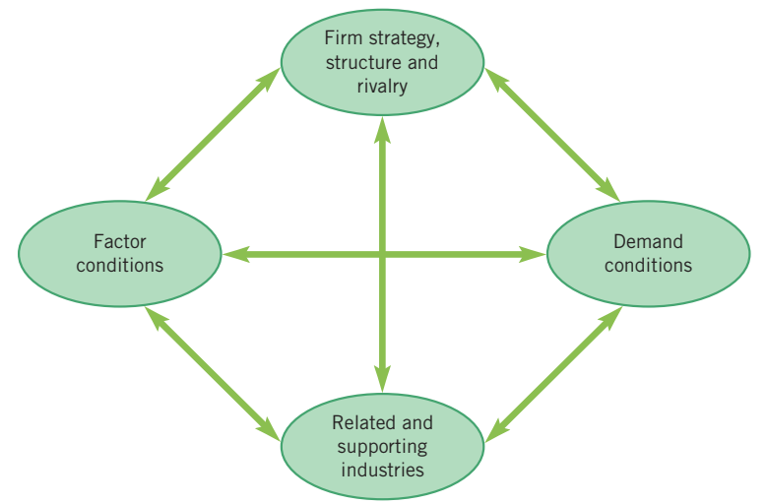
Figure 5: Porter’s Diamond strategy
(Source: Week 7, Slide 6)
The recommendations are aligned with Porter's Diamond Model which in other words is also called Theory of National Competitive Advantage (Lehene et al., 2024).
- Crocs should not import finished goods but instead opt for local contract manufacturing. It will help Crocs to decrease its logistical expenses and, in the process can properly circumvent the import duties as well.
- Crocs should expand the Jibbitz options for Indian customers and launch culturally relevant designs in accordance with festivities and entertainment industry celebrities for increasing customer engagement (Dosapati, 2022).
- Crocs should partner with local raw material suppliers and packaging manufacturers for building a resilient supply chain. The collaboration with local fashion houses or streetwear brands can yield positive result.
- Crocs should intensify its marketing activities by specifically targeting the young Indian demographic and keep the product price low. Premium pricing should be kept only for limited edition clogs and not for other show variant thus improving stronghold on local market.

4.4 Identification of potential challenges in implementation and solutions for their mitigation
The potential challenges for implementing local manufacturing plants are that it will require huge upfront investment and capital expenditure for Crocs. This can be addressed by partnering with already established Indian footwear manufacturers instead of direct building of Crocs owned factories, thus minimising the capital investment. Crocs need to be extra careful while launching customised Jibbitz options aligning with Indian festivities, so that it not harms religious beliefs/faiths, as it can have serious detrimental impact on brand image. The challenge of counterfeit Crocs product identification can be solved by Crocs by using Croslite™ pasted on its products and creating awareness among customers regarding harms of purchasing fake products. This showcases the proper consideration of geographic, cultural and economic environments are done here to present recommendations for continuation of Crocs’ sustainable advantage.

Section 2

1.0 Reflective Account

1.1 Application of Kolb’s cycle of reflective practice
This model provides clarity to learners to learn effectively based on daily experiences. There are four stages four in this model as can be seen from below Figure 6.
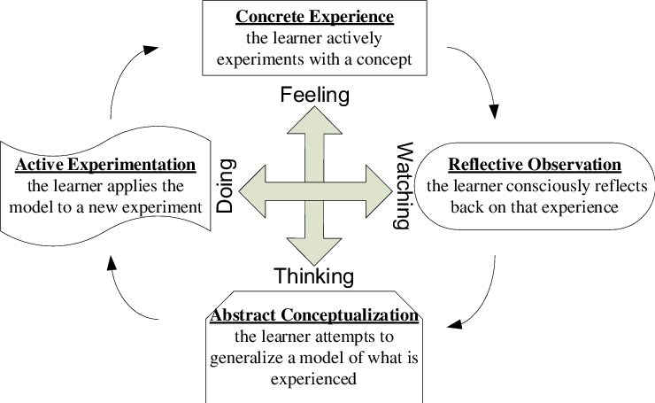
Figure 6: Kolb's Experiential Learning Cycle model
(Source: Konak et al., 2014)
I have used this reflection model for highlighting the procedural steps which I have followed for researching, analysis and preparation of this business management report.

1.1.1 Concrete Experience
The preparation of this strategic management report is done by me as an acting SMC. The role of an SMC is to evaluate organisation's strategic position and recommend techniques for enhancing organisation's competitive advantage (Tavoletti et al., 2022). I have done extensive secondary research using academic journal articles, annual comfort report of Crocs, authentic blog articles and market reports. I have used strategic management frameworks like that of PESTLE, VRIO, SWOT models for internal/external business environment’s analysis. The use BSC tool, CSR activity analysis has also been done here by me along with strategic choice models like that of Ansoff Matrix, Porter’s Diamond and Porter’s Generic strategy model. During the application of these models/frameworks, I faced the challenge of selecting the relevant information for available descriptive content. But I gained valuable experience of how to apply theoretical frameworks in real-world organisational context.

1.1.2 Reflective Observation
I take this opportunity to present my strengths which I have recognised here along with identified weaknesses as well. Firstly, I was able to collect data from different academic sources to validate the recommendations prepared here for Crocs as there is limited availability of Crocs related information from peer-reviewed journal articles. So, I applied the strategy of presenting data from organisation website or authentic blog articles followed by supporting statements from academic journal sources. This improved academic credibility of report. I have used each of the strategic management frameworks as independent analytical tools. The PESTLE model findings influenced SWOT while VRIO analysis explained internal strengths of Crocs in Indian market. I have used BSC tool to translate Crocs’ strategic objectives into organisation’s measurable performance indicators. But there were some weaknesses in my approach as well, like in the early stages of this assessment I wasted some crucial time in data collection only instead of starting to evaluate the collected data. Some of the data content collected initially by me turned out to be of no direct use in this report, which made me realise the relevance of both data and time management in this regard.

1.1.3 Abstract Conceptualisation
This assessment helped me to transform and apply my practical experience as strategic management knowledge. I developed proper understanding of how to develop successful organisational strategies while keeping in alignment of external organisational capabilities (as internal factors) and environmental conditions (as external factors). My concept about theoretical frameworks has developed as these not being merely academic models but can be used as decision-making tools. The use of PESTLE framework helped me to understand macro-environmental factors impacting Crocs operations in India. The VRIO model helped in determining the factors responsible for obtaining and sustaining competitive advantage. There BSC tool provided me clarity about organisation’s success to be not just only measured through financial performance but other factors as well. The CSR activities/initiatives undertaken by an organisation adds to its strategic performance and organisational reputation along with sustainability factors (Sergeeva and Kapetanaki, 2022). I have improved my ability of evidence-based decision-making instead of just relying upon personal viewpoints/bias. I feel that I have also developed my critical thinking ability pertaining to selection of strategic alternatives.

1.1.4 Active Experimentation
I firmly believe that the learning experience gained by me will have a significant impact on my professional career, beyond this assessment completion as a part of academic success criteria. I have learned that I should prepare a structured research plan prior to starting strategic analysis of other organisations (preferably my future workplace). I need to reduce unnecessary reading of different sources and improve my time management ability. I should present the justification with supporting evidence for describing strategic decisions of organisations and then state whether adopting alternative strategies would have fetched positive outcomes or not. The use of strategic frameworks is meant to demonstrate logical interrelationships between internal/external factors and organisation’s strategic positioning in a particular market (Dzreke and Dzreke, 2026). In a professional perspective, it can be stated that I have improved my analytical reasoning and strategic thinking ability but there is scope for improvement of my project planning ability. All these will add to my competency level while doing systematic analysis and form strategic recommendations when handling complex business problems in my future workplace.

References
Agyekum, E.B., Khan, T., Ampah, J.D., Giri, N.C., Mbasso, W.F. and Kamel, S. (2024) ‘Review of the marine energy environment-a combination of traditional, bibliometric and PESTEL analysis’, Heliyon, 10(6), pp. 1-26. Available at: https://www.sciencedirect.com/science/article/pii/S2405844024038027
Alkandi, I. (2025) ‘Nexus between green practices, green marketing, and business performance: the mediating role of corporate social responsibility in emerging economy’, Discover Sustainability, 6(1), p.329. Available at: https://link.springer.com/content/pdf/10.1007/s43621-025-01182-0.pdf
ARND (2026) ‘Crocs elevates India to tier-1 market in global growth and manufacturing strategy’, Retail News India, 28 February, Available at: https://apparelresources.com/business-news/retail/crocs-elevates-india-tier-1-market-global-growth-manufacturing-strategy/ (Accessed: 21 July 2026).
Calboli, I. and Armstrong, G. (2023) ‘Design Patents in the Fashion Industry: A US Perspective’, Oxford University Press, Forthcoming, Texas A&M University School of Law Legal Studies Research Paper, pp. 1-42. Available at: https://papers.ssrn.com/sol3/papers.cfm?abstract_id=4663112
Chaturvedi, A. (2025) ‘Indian court allows Crocs to pursue infringement challenges’, Reuters, 2 July, Available at: https://www.reuters.com/sustainability/boards-policy-regulation/indian-court-allows-crocs-pursue-infringement-challenges-2025-07-02/ (Accessed: 21 July 2026).
Chaudhari, D.T. (2020) ‘Understanding a Company for Value Investing: Business Efficiency, Business Effectiveness, Innovativeness, Sustainability’, KSP Books, pp. 1-132. Available at: https://www.researchgate.net/publication/343157949_Understanding_a_Company_for_Value_Investing_Business_Efficiency_Business_Effectiveness_Innovativeness_Sustainability
Crocs-Classic (2026) ‘Classic bone unisex clog - crocsTM india’, 21 July, Available at: https://www.crocs.in/classic-bone-unisex-clog.html (Accessed: 21 July 2026).
Crocs-CR (2024) ‘ESG frameworks 83 84 2024 comfort report’, Available at: https://s22.q4cdn.com/133460125/files/doc_downloads/2025/06/FINAL_Crocs-2024-Report_TCFD.pdf (Accessed: 21 July 2026).
Crocs-I (2026) ‘Comfort without carbon - crocsTM India’, 21 July, Available at: https://www.crocs.in/comfort-without-carbon (Accessed: 21 July 2026).
Crocs-India (2026) ‘Classic bone unisex clog - crocsTM india’, 21 July, Available at: https://www.crocs.in/classic-bone-unisex-clog.html (Accessed: 21 July 2026).
Crocs-P (2026) ‘Crocs purpose- Green comes in every color’, 21 July, Available at: https://www.crocs.in/crocs-purpose (Accessed: 21 July 2026).
CSR-TIMES (2024) ‘Crocs donates 5,000 pairs to migrant families in Cheeta Camp, Mankhurd’, Available at: https://csrtimes.org/crocs-donates-5000-pairs-to-migrant-families-in-cheeta-camp-mankhurd/ (Accessed: 21 July 2026).
Dey, A. (2026) ‘Crocs: Tariffs didn’t deter sourcing plans from India - The Times of India’, 27 February, Available at: https://timesofindia.indiatimes.com/business/india-business/crocs-tariffs-didnt-deter-sourcing-plans-from-india/articleshow/128834823.cms (Accessed: 21 July 2026).
Dosapati, J.S. (2022) ‘Crocs’ Soaring Success in the Pandemic Era and its Marketing Strategies’, pp.1-25. Available at: https://papers.ssrn.com/sol3/Delivery.cfm?abstractid=4299000
Dzreke, S.S. and Dzreke, S.E. (2026) ‘The strategic resonance engine: Reframing SWOT for dynamic competitive advantage’, Engineering Science & Technology Journal, 7(3), pp.97-113. Available at: https://www.researchgate.net/profile/Simon-Dzreke/publication/401857977_The_strategic_resonance_engine_Reframing_SWOT_for_dynamic_competitive_advantage/links/69b2cc4aa5bf176ab54ef18e/The-strategic-resonance-engine-Reframing-SWOT-for-dynamic-competitive-advantage.pdf
ET (2026) ‘The global footwear major that kept betting on India despite trump-era tariffs - the economic times’, 27 February, Available at: https://m.economictimes.com/industry/cons-products/fashion-/-cosmetics-/-jewellery/the-global-footwear-major-that-kept-betting-on-india-despite-trump-era-tariffs/amp_articleshow/128842429.cms (Accessed: 21 July 2026).
Findlay, A., Ondracek, J., Peterson, K., Saeed, M. and Meixuan, W. (2025) ‘Managing Corporate Resources: A Strategic Analysis of Crocs, Inc’, Delhi Business Review, 26(1), pp.1-13. Available at: https://www.academia.edu/download/123715135/2025_06_Crocs_DBR.pdf
George, A.S. (2025) ‘The Silent Economic Crisis: How Middle-Class Stress Threatens India's Growth Trajectory (2025-2030)’, Partners Universal International Research Journal, 4(2), pp.34-47. Available at: http://www.puirj.com/index.php/research/article/download/219/171
Infor (2023) ‘How crocs digitized their financial supply chain with Infor Nexus’, March 9, Available at: https://www.infor.com/blog/how-crocs-digitized-their-financial-supply-chain-with-infor-nexus (Accessed: 21 July 2026).
Kadakia, P. (2023) ‘Manufacturing in India is an important part of our strategy: Crocs CEO Andrew Rees’, 25 September, Available at: https://www.forbesindia.com/article/leadership/manufacturing-in-india-is-an-important-part-of-our-strategy-crocs-ceo-andrew-rees/88507/1 (Accessed: 21 July 2026).
Konak, A., Clark, T.K. and Nasereddin, M. (2014) ‘Using Kolb's Experiential Learning Cycle to improve student learning in virtual computer laboratories’, Computers & Education, 72, pp.11-22. Available at: https://www.researchgate.net/profile/Abdullah-Konak/publication/259127180_Using_Kolb%27s_Experiential_Learning_Cycle_to_improve_student_learning_in_virtual_computer_laboratories/links/5baa14a192851ca9ed23b283/Using-Kolbs-Experiential-Learning-Cycle-to-improve-student-learning-in-virtual-computer-laboratories.pdf
Larbi, A.O., Asare-Danquah, G.A. and Ackah, A.A.F. (2024) ‘Utilization of internal analysis with the VRIO framework and development of scale for resource and capabilities of fashion and design organization’, International Journal of Research and Scientific Innovation, 11(6), pp.63-70. Available at: https://www.researchgate.net/profile/Angela-Ackah-2/publication/381812546_Utilization_of_Internal_Analysis_with_the_VRIO_Framework_and_Development_of_Scale_for_Resource_and_Capabilities_of_Fashion_and_Design_Organization/links/687d59a5ba8eac4f1727c17f/Utilization-of-Internal-Analysis-with-the-VRIO-Framework-and-Development-of-Scale-for-Resource-and-Capabilities-of-Fashion-and-Design-Organization.pdf
Lehene, C.F., Jaradat, M. and Nistor, R.L. (2024) ‘An interdisciplinary and multilevel analysis of local economy determinants and their impact on Firm Performance—Considering Porter’s Diamond model, clusters, and industry’, Systems, 12(3), p.82. Available at https://www.mdpi.com/2079-8954/12/3/82?trk=organization_guest_main-feed-card-text
Netcore (2026) ‘Learn how crocs India achieved 42x ROI from Netcore Cloud’, Available at: https://netcorecloud.com/success-story/crocs (Accessed: 21 July 2026).
Rocco, B. (2026) ‘‘Revenue of Crocs, Inc. from 2014 to 2025’, Statista. Available at: https://www.statista.com/statistics/1037829/net-revenue-of-crocs-worldwide/?srsltid=AfmBOorZBu9JEa23FbbWzUUVmzEH1AAFqM9cyPfdKDS1NgxRuytL2uKd (Accessed: 23 July 2026).
Salo, M., Ondracek, J., Saeed, M. and Bertsch, A. (2021) ‘Crocs, Inc.: Managing corporate resources (strategic perspectives)’, Delhi Business Review, 22(2), pp.105-123. Available at: https://www.delhibusinessreview.org/V22n2/dbr_v22n2cs.pdf
Sergeeva, N. and Kapetanaki, E. (2022) ‘Corporate social responsibility as a strategic narrative: The cases of UK project-based organisations’, Project Leadership and Society, 3, p.100073. Available at: https://www.sciencedirect.com/science/article/pii/S2666721522000333
StockIntent (2026) ‘Crocs Mission Statement, Vision & Core Values Explained’, 26 March, Available at: https://www.stockintent.com/blog/crocs-mission-statement-vision-core-values (Accessed: 21 July 2026).
Tavoletti, E., Kazemargi, N., Cerruti, C., Grieco, C. and Appolloni, A. (2022) ‘Business model innovation and digital transformation in global management consulting firms’, European Journal of Innovation Management, 25(6), pp.612-636. Available at: https://www.emerald.com/ejim/article-pdf/25/6/612/1863019/ejim-11-2020-0443.pdf
TSH (2023) ‘The history of crocs shoes - how crocs disrupted the shoe industry — the style’, HistorianTM, 1 July, Available at: https://www.thestylehistorian.com/articles/the-story-behind-crocs (Accessed: 21 July 2026).
Zupic, I., Čater, T., Caputo, A. and Uršič, D. (2025) ‘Mapping the Influence of Ansoff's Corporate Strategy’, Strategic Change, pp. 1-19. Available at: https://onlinelibrary.wiley.com/doi/pdf/10.1002/jsc.70023

