Title: Reflective Review of Learning Journey
Lecturer: Melanie Squire
UWTSD
Cardiff.

Molik Musaddek Ahmed
Student ID No: 1710328.
Date: 14th June2019.

A Reflective statement of my learning journey of professional career development.

Table of Content
Content | Page No.
Introduction | 04
Description | 05
Feelings | 05
Evolution | 05
SOWT analysis | 06
Kolb Learning Cycle | 07
The Briggs Myers Personality test | 07-08
Analysis | 09
GO MAD framework | 10
Conclusion | 11
Action Plan | 11-12
Reference | 12

Introduction:
This reflective report is the review of my learning journey of professional and career development module of certificate of higher education skills of the workplace. This reflective statement refers to my inclination of employability and personal advancement through an understanding of personal strength and area for further development action plan.
I have been chosen the Gibbs’ reflective model to evaluate and analyses my experience and self- development during this module.
I have been assigned to conduct SOWT analysis of myself to identify my strength, weakness and threat for turning them into my opportunity by applying appropriate transitional strategies. I have also assigned two learning style questionnaires (Briggs Meyers Personality test and KOLB learning cycle) and GO MAD Framework to develop myself in order to pursue a role in the management.

Figure: Gibbs Reflective Model

1. Description:
To attempt to make a self-appraisal for developing my employability skill, I articulated a SWAT analysis of myself. These inquiries help me to explore my feelings with more formal way. It will also relate to my current study and employment. Briggs Meyers Personality test and KOLB learning cycle help me to evaluate and improve my employability skill. I have reviewed my action plan which one I had set for myself one year ago. Illustrating all of these motivate me to create my 3 year future plan by using Go Mad Framework.

2. Feelings:
Looking back at the beginning of the course, I was very excited about this module to develop my employability skill. However as a mature student on my programme, I some times feel isolated in social terms. However, I have made friends and do regularly work alongside a friend as a source of moral support. My family life and cultural background sets me apart from the “traditional” English students, although I find that I have no difficulty in engaging in superficial social contact, and enjoy the differences. I have a keen sense of anticipation now that the time for ending my module is approaching, but also some feelings of trepidation, as I am nervously waiting to see how I progress in my application to Evaluation.
3.Evaluation:
The SWOT analysis gave me a snapshot of where I am at this moment in my journey and enabled me to relate in a more creative way to my experiences, particularly with regard to my job and to my aspirations for the future. I now have a much clearer and more optimistic outlook because I have quantified my strengths and opportunities.

SOWT Analysis:
SOWT Analysis
Current Strength | Strong work ethics and commitment to my future.
Current Strength | Enjoy teamwork.
Current Strength | A good team player.
Current Strength | Life experience has enriched my interpersonal skill
Current Weakness | Challenge to get better negation skill.  Challenge face for language barrier for verbal communication
Current Weakness | Consider more passive attitude and non-verbal communication due to personal trait and cultural differences.
Current Opportunity | Doing academic course which will provide strong academic and technical knowledge
Current Opportunity | High quality tutor feedback and excellent academic support
Current Opportunity | Excellent long term career prospect
Current Threat | Balancing work responsibility with family life
Current Threat | Financial Challenge
Current Threat | Health Issue
Current Threat | Competitor in the job market

I have chosen the KOLB learning cycle because uses an analysis of self and application to past experiences to allow self- analysis and to help me to make more relevant and informed choices for going forward. In the KOLB framework I am defined as a blend of Concrete experiencer and Reflective observer. In Kolb's model concrete experiencer cannot learn by simply watching or reading about it, to learn effectively the individual, team or organization must actually do. This was informed by my reading of the descriptors and so it accurately corresponds to my experiences, especially as a postgraduate student. In my approach to my assignments, I have consistently created a logical hypothesis and then sought grounds to justify it, whilst being open to readjusting my viewpoint if the evidence indicated a contrary position. Vocabulary is very important and is needed to verbalize and discuss with others in this stage.
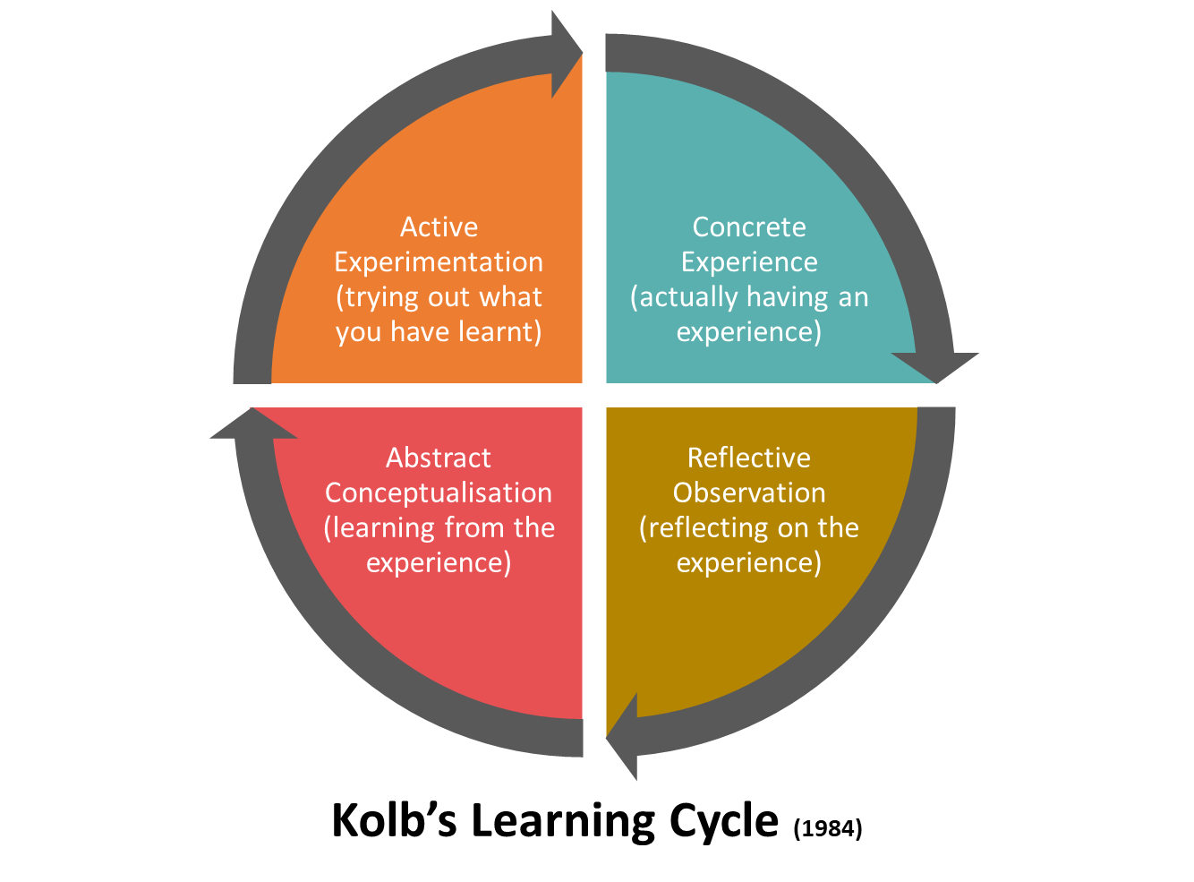

The Briggs Myers Personality test
The Myers Briggs Personality Test is based on Jung's four dichotomies and the sixteen personality types developed by Isabel Briggs Myers.
These four dichotomies exist on a continuum on which everyone can be placed. Your stance on each of these four things determine your overall personality, and there are 16 possible combinations of personality types. The four dichotomies that make up these possibilities are:
- Introversion and extroversion: refers to whether you see the world through more of an internal (introversion) or external (extroversion) lens
- Sensing and intuition: tells us if a person gathers information more from the external senses (sensing) or from inner sources like knowledge and imagination (intuition)
- Thinking and feeling: this relates to whether you make decisions based on objective (thinking) or subjective (feeling) information
- Judging and perceiving: this tells us whether you look at the world through a neat lens of organization and planning (judging) or prefer to keep your worldview more open and flexible (perceiving)

The Briggs Myers Personality test is based on Jungian theory and identifies, which of the 16 types I am via an online evaluation .The results proclaimed that I am personality type “The Protagonist” (ENFJ-A), with individual traits 64%Extraverted, 53% Intuitive, 76% Feeling, 62% Judging, and 54% Assertive , with the definitive labels Diplomat as a role and People Mastery as strategy.
The label of diplomat resonates with me emotionally but the label “People Mastery” at uncomfortably until I read the detailed outline. As I understand it, this evaluation tells me that I am energized by being with other people, that I am sensitive to atmospheres and feelings, that I am able to make my own decisions am not easily persuaded by others, and that I will stand up for my views an opinions when I am sure of my ground, and when it is an important issue. This seems, to be amazingly accurate, and has filled me with a sense of renewed optimism
4. Analyse:
Critical analysis of my previous action plan
When I last embarked upon a reflective exercise in August 2015, I had recognized several areas for improvement and had created an action plan that, at the time, seemed quite optimistic. This, I believe, is because I was good at the analysis, but less strong at the self- motivation and harnessing it to self- belief. However, twelve months on, I find that I have achieved some real developmental progress. My previous plan can be defined under the following headings:
- Seek out opportunities for interaction - I have not yet joined any club, but I have had success in obtaining an voluntary traineeship, which has presented me with the opportunity for daily interaction with fellow employees in what is a multi - cultural working environment. I now have first - hand experience of reciprocation and inclusion as positive forces for good in the change agenda and this has strengthened my determination to become more proactive and engaging in my own personal style.
- Coping with nerves - I have done some research into Cognitive Behavioural Therapy (CBT), and have found it to be informative and very relevant to my own situation. For instance, one of the simple, but effective daily practices that I have been trying to implement is to avoid apologising for what I say before I say it.
- Further reading and more independent research: - In this respect I have been quite successful – I have found that with intelligent online research I am able to access a wealth of interesting and thought provoking research. An added benefit is that I find that I am measuring my own ideas and experience against the theories and studies that have been published. This will allow me to further develop my research capabilities and my leadership potential.
- Intelligent use of time and time management - Again, in this respect I feel that I have made great strides. I am over viewing my commitments and appointments and making a much better judgement in terms of spreading out my work load. I have become more assertive and proactive in managing my personal circumstances. My health issues, which are now well under control and not impacting upon my studies as I have taken control and become more self -aware and thus more productive and optimistic.

5. Action plan
Action Plan Forward
I have used GO MAD framework for preparing future action plan.

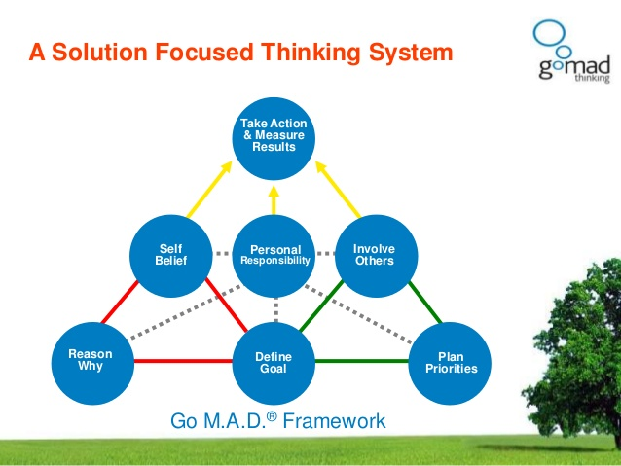

Reason Why: Improve employability skill to place myself in managerial position in my career.

Define Goal and plan priority: I want to be a successful manager in an organization. I want to get access in communication skills coaching and get more experience in delivering a presentation.

Self belief : I also found that I was nervous about presenting in public. I worried that my voice would not be strong enough and that I would stumble over my words and forget something. I worried that I would let down the standard of the group. However, I found that I did not worry about the quality of my technical knowledge, I now realize that these two facets can be considered as separate and so I have a better understanding of my strengths and weaknesses.

Personal responsibility : Personal responsibility makes me accountable to what I am think , say or do. I am capable enough to take my personal responsibility. This course help me to conscious more about my personal responsibility.
Involve other : I have now decided to join a public speaking club, this will encourage me to go along, and I know that I will be able to observe and become more confident before I need to take the plunge and speak myself.
I will make plan to improve my leadership skill. I will work voluntary to improve my teamwork skill. I will also attain seminar in my University related to improve employability skill.

I am registered on some job search websites and will receive daily updates. I need to edit and adjust my CV and personal statements to adapt to the applications that I will make. I will compile a modular approach to this challenge, so that I can easily compile the bulk of my CV and a draft for the personal statement. I will research each prospective employer to make sure that I am tailoring my application to the best effect.
Conclusion:
Take action and measure result:
This reflective journey has enabled me to engage in primary and secondary reflection that I have found, in turn, to be mildly challenging and encouraging. I have found a new curiosity in the psychological workings of the human mind and may, if time, money and circumstances permit, indulge this new interest with further study. Realistically, this exercise has proved to be a valuable tool for evaluation and coherent planning and future decision making, which is significant for employability skill.
I am slowly developing a greater sense of confidence. This gives me a great sense of relief and renewed optimism. Accordingly, I have created a new 3 years plan for my career future.

Reference:
- Agyris, C., (1976), Increasing Leadership Effectiveness, New York, Wiley
- Boud, D., Keogh, R & Walker, D., (eds) (1985), Reflection: Turning Experience into Learning, New York, Nichols
- Gibbs, G., (1988) Learning By Doing: A guide to teaching and learning methods, Further Education Unit, Oxford, Oxford Polytechnic
- Kolb, D., (1984), Experiential Learning:Experience as the Source of Learning and Development, NJ, Englewood Cliffs, Prentice Hall
- Schon, D. A., (1983), The Reflective Practitioner – How Professionals Think in Action, London, Temple Smith
- Coffield, F., Moseley, D., Hall, E., & Ecclestone, K. (2004). Learning styles and pedagogy in post-16 learning: A systematic and critical review. www.LSRC.ac.uk: Learning and Skills Research Centre. Retrieved January, 15, 2008: http://www.lsda.org.uk/files/PDF/1543.pdf
- Honey, P. & Mumford, A. (2000). The learning styles helper's guide. Maidenhead: Peter Honey Publications Ltd.
- Morgan, P. (20017). The Business Student’s Guide to Study and Employability, London, Sage Publications Ltd.
- Maund, A, Schrick, M. & Tinkler, P K. (20017). Certificate in Higher Education: Skills for the Workplace Student Yearbook, London, Sage Publications Ltd.

