Database Design (The Book Store)

Author – Kai Harley Strand Regan

Course – Computing

Module - Information Engineering

Tutor – Beverly Holland

Date – 06/05/2019

Contents
Appendix 3
Introduction 3
Initial Design 3
ERD 3
Tables and Their Corresponding Form 4
4
5
5
5
Queries 5
Reports 6
7
User Guide 7

Abxstract
This report is a brief look at the database that has been created for Dylan’s Book Store. There is a brief user guide that can be used along with screen shots of each table, form, query and report that was made.

Introduction
This document will consist of evidence and explanation on how the Dylan’s Books database has been created and the features available. It will give a guide on how to navigate along with planning documentation such as an ERD.

Initial Design
The first part of the design was to plan out the core elements that are required so that Dylan’s Book Store can update and utilise all that Access has to offer.

ERD
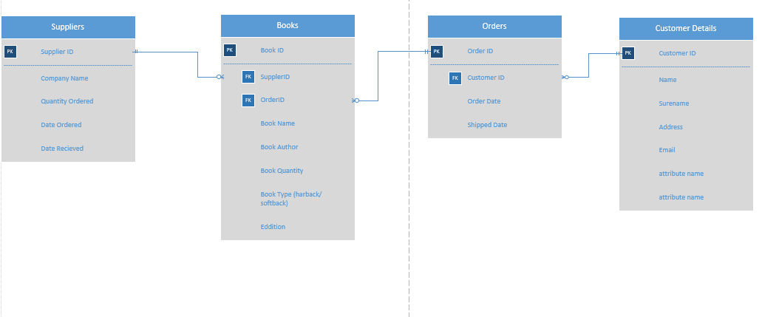
The original idea for the ERD is shown below this was not how the tables were created. There was not enough time to complete the originally planned ‘Suppliers’ table which would add an extra element to the database. The idea was that one supplier has many books, one order has many books and one customer can have many orders.
This is what was created instead, the relationships were all done in queries and although it is not perfect (by any means) the result is a working order form that can be edited by a user as much as they need. The ‘tblOrderDetails’ is used as a hub for all the key tables and is where all the primary keys connect to.
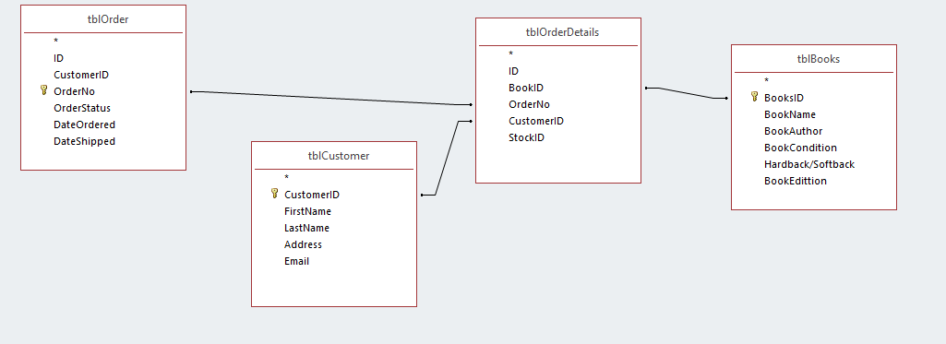

Tables and Their Corresponding Form
Books table and form that was created to store description of books.
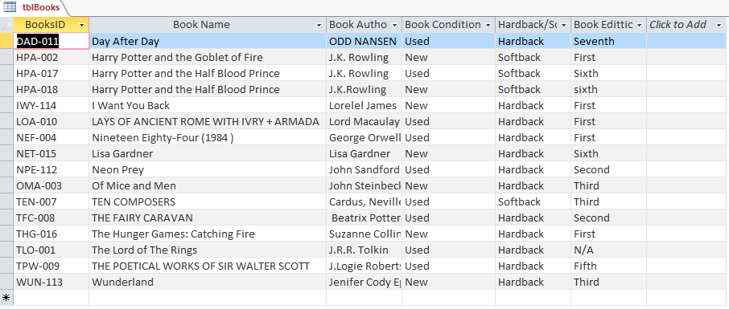
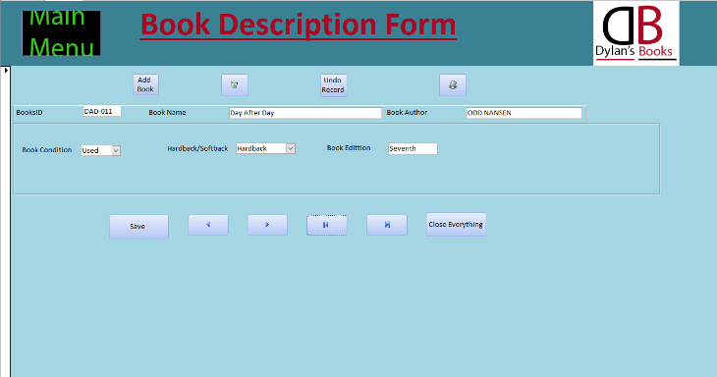

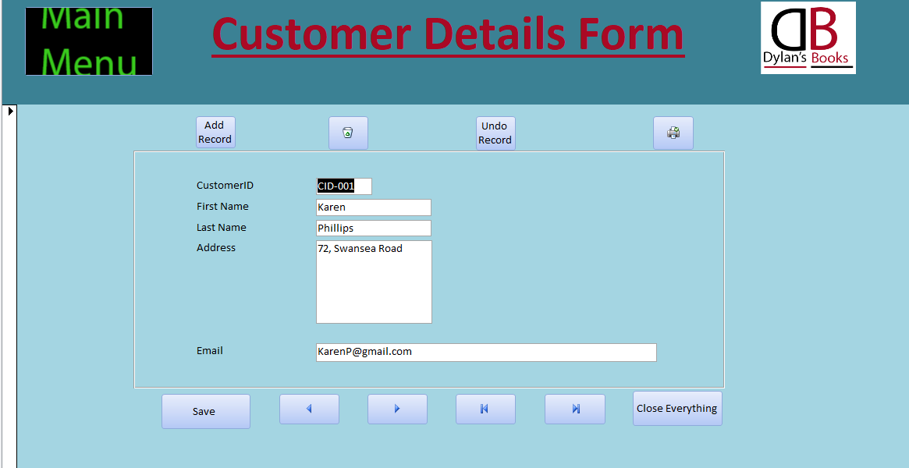
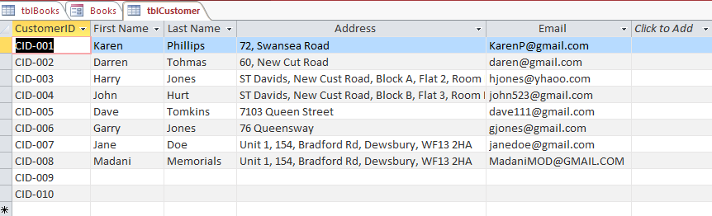
Customer table and form that stores customer details.

Table for order number and dates.
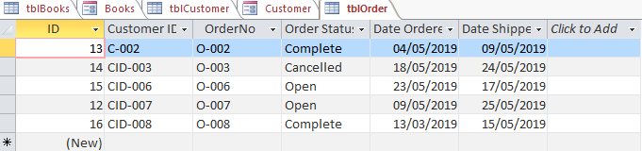

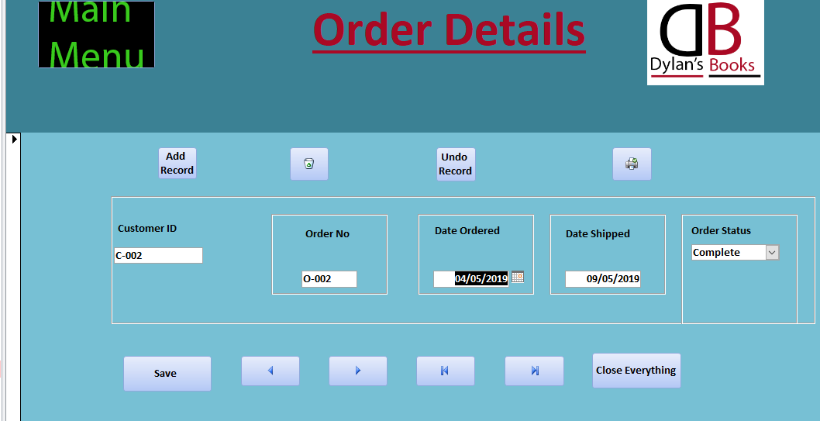

Table for all components to make a customer order.

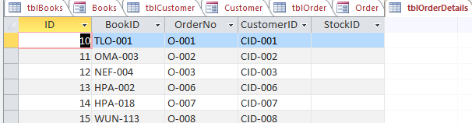

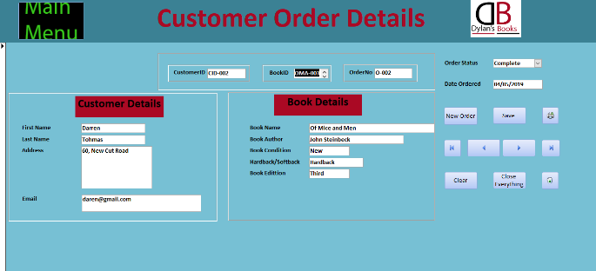

Main Menu
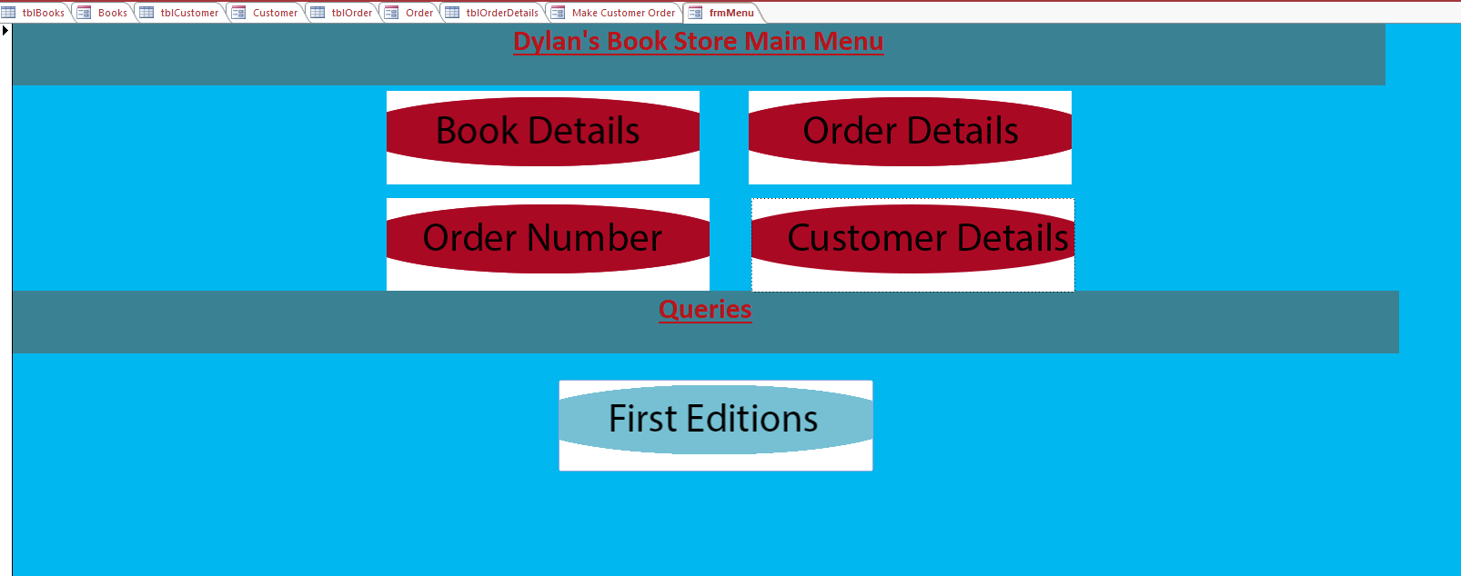

Queries
There are two queries that have been turned into forms and are used to show ‘New first editions’ and all ‘First editions’
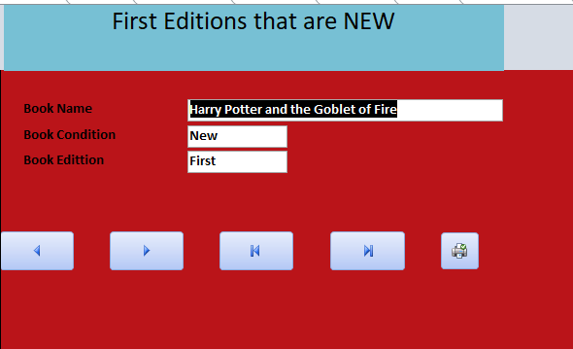

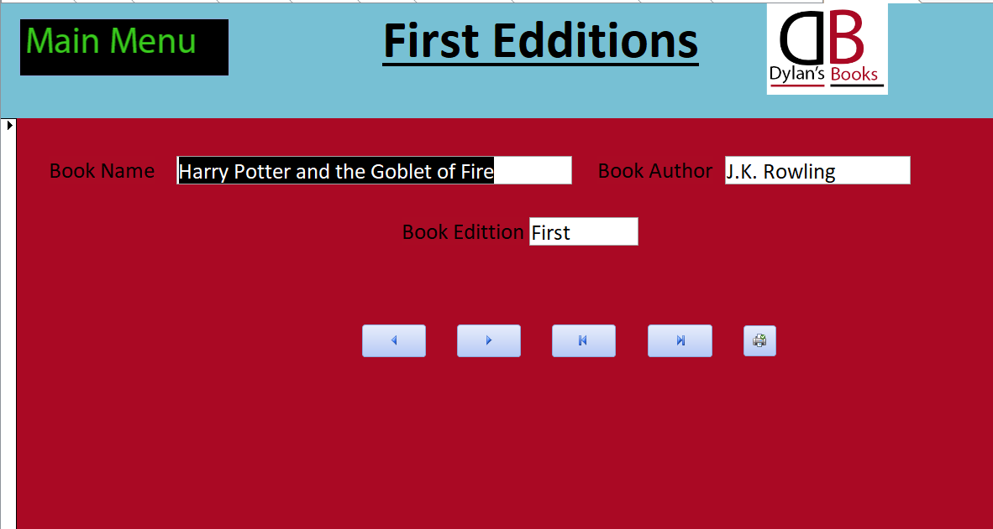

Reports
Two reports have been created the first showing the condition of books and what edition they are.
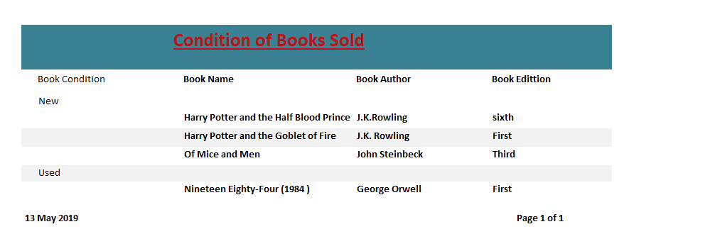
The sample size is a little low, but this shows that May was the best month for sales.
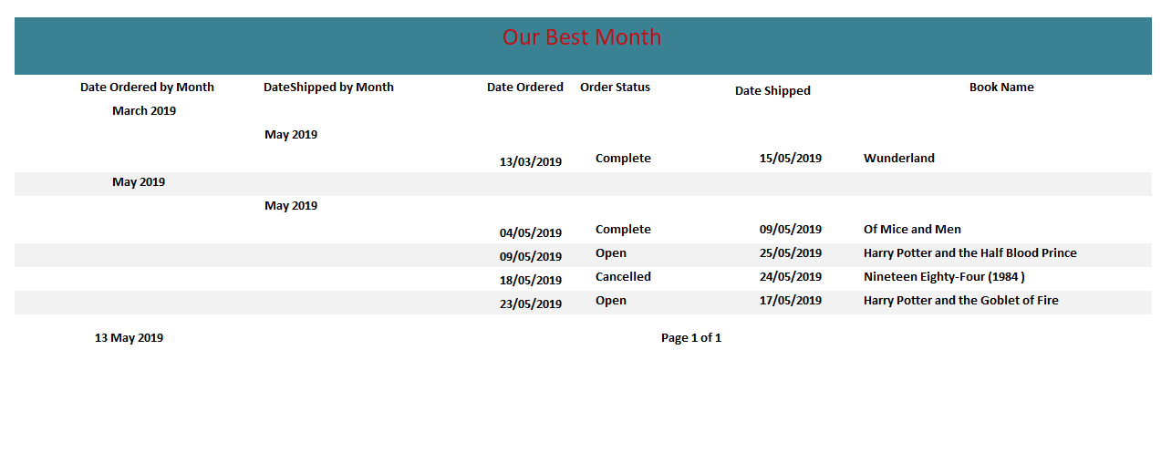

User Guide
The database has been designed with the user in mind, it combines the customer order into one location although every table is editable from deleting to printing the records.
The ‘frmMakeCustomerOrder’ is the main order form and so long as you add the ‘customerID’ the ‘BookID’ and the ‘orderID’ the information will appear automatically (assuming there is information in relevant tables/forms).
The ‘Main Menu’ is available on each form and is useful for navigating through the forms, make sure to save everything and enjoy.

Conclusion
The database does work for a user to create a customer form and this has been learned through trial and error. The database has a few queries and reports that provide some relevant information although a bigger sample of data would be useful to get the best results.

