
Applied Leadership and Management in the Workplace
Module Assignment Submission
Student Name: | Linda Bera
Student Number: | 2504322
Module No: | BMSK4011
Module Title: | Continuous Professional Development

Statement of Confirmation of Authenticity
By the act of making this submission, the student declares that this is the work of the student named above. The work has not, in whole or in part, been knowingly presented elsewhere for assessment, or where assessment has been built on a previous assessment, this has been identified. Where materials have been used from other sources it has been properly acknowledged. If this statement is untrue, the student acknowledges that an assessment offence has been committed.
Attention is drawn to the plagiarism and unfair practice policies of both the University and of ILM.

Table of Contents
Introduction 3
1.0 Identify learning styles for self and another 3
1.1 Development needs for self & another 4
1.2 Potential barriers to learning and Strategies for overcoming them 5
1.3 Development options 5
1.4 support mechanisms for the development of self & another 6
1.5 Plan of action 6
1.6 Monitor progress 8
1.7 Conclusion 8
Reflection on the Recruitment process 9
References 10
Appendix A Curriculum Vitae 11
Appendix B Continuous Professional Development Record 12

Introduction

1.0 Identify learning styles for self and another

This model has three learning styles:
Honey and Mumford Honey and Mumford, 1986)
There are four objectives: Activists, Reflectors, Theorists and Pragmatists. The purpose of this learning style is for me to learn what my learning style is, but I disagree with the use of this one because there are four questions for the Activist and Pragmatist and five for the Reflector and Theorist, therefore more people’s learning style is going to be the Reflector and Theorist. My highest score was firstly a Reflector and then secondly the Theorist.
The Activists prefer to work as part of a group; role playing and new experiences. They likely dislike long spoken lectures, doing work on their own for long periods of time.
Reflectors learn by observing, thinking and planning, they prefer taking notes and thinking before they take the next step. They dislike being rushed and care about their deadlines.
Theorists learn by understanding complex ideas and models, they prefer a well-structured lesson and clear explanations. They dislike situations where there are no logical explanations.
Pragmatists learn by forming new ideas in real life like a hands-on approach and trying new ideas, they dislike theories that are not practical for them to understand the outcome.
I learned that this model taught me to understand the variety of learning styles, identify how I learn best and therefore how to better myself.

VARK (Fleming, 1987)
There are four objectives: Visual, Auditory, Read/Write, and Kinaesthetic.
The purpose of this model is to identify the category of my learning style; there are four objectives in this learning style:
Visual learners, they learn through seeing Information like diagrams and graphs that is colourful and use photos to get ideas.
Auditory, best learns in attending lectures and discussions, by listening to podcasts or record the information.
Read/ Write, they learn best by writing and taking their own notes and to rewrite them later after reading through it again.
Kinesthetic, they learn best by hands on approaches like role play, they like to create models for them to understand better, and lastly to take part in practical exercises.
I can see why this model is helpful for identifying learning styles but I find there are less biased outcomes in most circumstances.

VARK (Fleming,1987) The reason why I am using this model is because it best describes me as Read and Write and it’s my highest score for the learning style, secondly Aural where I have group discussions and hear different ideas.

Strengths: is to plan lessons and understand how I earn.

DANTEC (based on Kolb’s (1984) I learned that there are four objectives in this learning style:
Concrete Experience – to have new experiences
Reflective Observation – they are good in having different ideas
Abstract Conceptualization – they think of new ideas
Active Experimentation – they test new ideas
What DANTEC on Kolb’s (1984) explains how we learn and what learning style we are.
Concrete Experience (CE), learning about your feelings and about people.
Reflective Observation (RO), learning about reflecting and to understand it and by watching.
Abstract Conceptualisation (AC), learning by theories, thinking logic and ideas.
Active Experimentation (AE), learning by doing things and testing it.
My highest scoring learning styles are Reflective Observation (RO), it taught me that I learn by reflecting and understanding. The Active Experimentation AE however indicates that I do and try things by testing it for results.
I agree with this learning style.
My colleague has two learning styles as per Vark and DANTEC which are both equally good at identifying learning styles, I learned she is a visual learner by seeing information in the VARK learning style, she is also Active Experimentation, learning by doing th1.1 Development needs for self & another

SWOT Person 1

STRENGTHS  Organised  Empathetic  Problem solving  Communication  Approachable  Strong personality  Can work under pressure  Have leadership skills | WEAKNESSES  No confidence  Lack of IT skills  Impatient  Self-critical  Some difficulty in public speaking
OPPORTUNITIES  Training courses  To complete my degree  Promotions  Events  Volunteering | THREATS  Loss of income  General health  Industry changes  Poor economy  Problems with import and export  Competition

SWOT Person 2

STRENGTHS  Organised  Communication  Empathy  Adaptability | WEAKNESSES  Public speaking  Motivation  No goal  Lack of confidence
OPPORTUNITIES  Training courses  Events  Conferences  Volunteering | THREATS  Managers decisions  Problem at home  Health  Long hours of work

Gap Analysis person 1
Current state:
Where I am now with my weaknesses, I am not confident, and I am critical on myself that I’m not good enough and I am impatient with things I want. My IT skills are not good enough at present..
Where I need to be is doing a course in IT
Analysis:
I need to find out why I have no confidence, once I know what my problem is I can self-build my confidence to where I was before and that will work as I need to believe in myself. Get the skills and knowledge I need.
My action plan: I will attend workshops and training courses, so I can continue learning to become a good manager. The Johari model is also helpful for fostering management skills. It has four sections:
Open area, blind spot, hidden area and unknown.
Open area is when other people and I know things about me, how I behave and my personality.
Blind spot is when other people know about me that I am unaware of like my behaviour’s facial expressions and my body language.
Hidden area is things I know about myself, but I keep to myself and I don’t share with other people.
Unknown area is my traits that myself and others are not aware of.
Desire (future) state:
My biggest desire is to complete my degree to graduate so I may go on to work a more corporate job.
Gap analysis is important to improve our performances and have a good knowledge.

Gap Analysis person 2
I have to find out what skills they have at the moment and what they will need to set a plan for myself what training they need and check to find out how they are doing with their training.

Current state:
Where her weakness currently is, she struggles to speak in public.
Analysis:
I can help her by practising with her and if I help her build her confidence it will work. She could also find more opportunities to speak professionally.
Desired (future) state:
Her ambition is to speak in public and therefore I will support her getting confident by reassuring her that she can do it and provide speaking opportunities where I hear about them.

1.2 Potential barriers to learning and Strategies for overcoming them

My Internal Barriers:
I doubt myself because I am afraid that my emotions and self belie will cause me to fail, and I am critical on myself in things I do.
External Barriers:
I have a tight schedule, but I have support from friends and family, and I know Micheala is there for support.
Distractions, a noisy home and you can’t concentrate.
Poor teaching methods or the person can’t understand.
Lack of support, from family or friends.
My colleagues Internal Barriers:
She has dyslexia and has a low self-esteem and it’s causing a physical barrier.
As her manager I will use verbal and written instructions and will make sure she understands it by asking her to repeat it back to me. When there is work courses to complete, I will give her more time to do it.
To overcome these barriers early is to provide learning styes and methods to improve their knowledge.

1.3 Development options

This model is to explain that there are two development options for formal and informal learning:
Formal learning: is when you take part in online lectures, do courses online enrolling to a university degree or sign up for work shops or you can shadow a colleague, by doing that I will achieve accredited qualifications that will build my knowledge and give me good work prospects.
Informal learning: is mentoring, on the job training, podcasts and You Tube tutorials, coaching, volunteering, reading books by visiting the library to gain knowledge.
Peer support, coaching and getting feedback from tutors and managers.
My choice is formal learning that suits me better for my development, its courses and training sessions which will help me in the longer term.
My colleague, however, prefers informal learning to do on the job training and YouTube tutorials. To make sure there is respect for everyone in the team. Feedback is important and when they do well praise them.
The purpose is to learn the preferred formal and informal learning of both my colleague and I is to make us aware of our strengths and skills, and to show empathy, and to be positive as manager.

1.4 support mechanisms for the development of self & another

My available support is family, friends and my tutor Micheala for guidance.
I have my son to cook dinner when I’m busy with studies or working, and my friends offered their help.
Coaching and mentoring is available from tutors and teachers. There is peer support, learning needs, wellbeing support and also support groups.
My goals: I will do my assessment and will pass my degree because I am determined to do this.
Formal learning by doing courses to get the knowledge I need, and informal by reading books or doing research.
My wellbeing, making sure I eat healthy do exercise and sleep enough.
My colleague, there is training available with regular performance reviews, feedback and to set a goal. There is emotional support, practical support where they provide help, educational where they give extra help by teaching.
Organised: I have set reminders in what tasks to do and when and the time the deadline is.
The support mechanism for both myself and others are to overcome these barriers what I listed above and to improve ourselves so we can set our goals.

1.5 Plan of action

Person 1
What do I want to learn? | What do I have to do? | What support and resources will I need? | How will I measure success? | Target Date for Review
IT skills | Online course | Family and friends | With feedback | Deadline
Improve IT | Pass course | Feedback from manager | Feedback from resources | June 2026
Confident with IT skills | Practise | Get feedback from manager | Personal reflection log from supervisor | Review June 2026

Personal Objectives

Short Term Goals (next 12 months)
I want to submit my assignments and pass my first year and starting my degree.

Medium Term Goals (2-3 years)
My goal is to complete my degree and graduate.

Long Term Goals (3-5 years)
I want to be a good manager in a company.

Person 2
What do I want to learn? | What do I have to do? | What support and resources will I need? | How will I measure success? | Target Date for Review
Communication skills  In work | Practice to talk to staff | Tutor and friend’s | Feedback | Her target date
Improve at work | Complete a communication workshop | Manager feedback | To receive positive feedback in meetings | August 2026
Improve on both communication and speech | Ask for feedback from staff | Feedback from staff that you can trust | Feedback forms that rate on communication log | Deadline September 2026

Personal Objectives

Short Term Goals (next 12 months)
Observing colleagues by listening and looking at their body language and tone of voice.
Medium Term Goals (2-3 years)
To improve their communication skills.

Long Term Goals (3-5 years)
Can communicate at all levels.

SMART objectives:
Specific – what you want to achieve
Measurable – how will you know it’s working
Achievable – complete leadership workshop
Relevant – development plan
Timebound – having deadline in action

1.6 Monitor progress

I will monitor all staff targets either weekly or monthly, and print off their performance of KPI’s and keep it in a file. I will have monthly meetings to keep a record of their performance and training development. If problems arise, I will make sure I deal with it and document it for my use only. I will have feedback every week that is important in the workplace. I will find out my staff strengths and weaknesses and provide my support to help them improve in the workplace. I will have feedback from my tutors or colleagues to make sure I am doing well and if I need to have guidance they can help me.
My personal development plan is to keep a record of their strengths and weaknesses, and the actions I will take to improve it, the progress they make and keep a record of how they are doing and when I set the deadline.
My progress reports is what they achieved up to date, and if I need to give more help. As I stated before I will have monthly discussions, check on their training if it’s up to date, I will also keep a record of their learning and use SWOT analysis that will help me to improve.

1.7 Conclusion

My conclusion is that being a manager is to understand other people and what their needs are we are all different and we all learn differently. The learning styes made me realise how I learn and what I’m good in and what I need to do to better myself, I will take on board what I am learning and use it in future when I am a manager.

Reflection on the Recruitment process

- Describe the roll
- Attract the candidates
- Shortlist candidates
- Interview
- Job offers
- Welcome new employee
- Qualifications
- Work permit
- References
- Candidate experience

What did I do: I went for the interview and had to wait for half an hour, she finally called me in and there were two interviewers and I was asking questions about my previous roles. I remember that the one person made me nervous, and she asked me back for a second interview, we had group discussions and had to create a perfume with the name and the notes.
What did I learn and what I will do differently: I learned that regardless of the person that made me nervous I chose to ignore her and did my best regardless and it paid off. I personally think it’s a good idea to have interviews and fill in a questionnaire that you can read later and find the suitable candidate. I don’t agree with the use of a CV, it feels unpersonal and you can’t see the person, how their reactions are when you talk to them and how they answer your questions, and how their mannerisms are and personality. Personally, I do not agree to have favourite staff, I will treat them equally the same.
What next: I will check everything and make sure if I can do something differently. It will be good to review candidates to see if he or she will be a good team worker and fit in with the staff. I will make sure they have good personalities and that they have the right skills to move forward. Lastly, I will make sure to have a plan for myself where I can make sure that my previous mistakes I made don’t happen again in future by doing this I can concentrate on important things. I will treat them all the same as manager and from doing that I believe I will improve myself as future manager.

References

Honey, P., & Mumford, A. (1986). The mutual of learning styles. Peter Honey Publications.

Gilbert, A., & Chakravorty, I. (2002) Go mad about coaching. Go Mad.

DANTEC, C., & MOZZON – Mc Pherson, M. (20006) Supporting Independent Learning through Explicit Strategy – Based Training. In Supporting Independent Language Learning: Issues and Interventions. Peter Lang.

Fleming, N. D. (1987) . VARK: A guide to Learning styles. University of Canterbury.

Gibbs, G. ((1988) Learning by doing: A guide to teaching and learning methods. Further Education Unit.

Kolb, D. A. (19884. Experiential learning: Experience as the source of learning and development. Prentice-Hall.

Panagiotou, G. (2003). Bringing SWOT into focus. Business Strategy Review, 14(2), 8-10.
https://doi.org/10.1111/1467-8616.002554

Luft, J., & Ingram, H. (1955) The Johari window, a graphic model if interpersonal awareness. Proceedings of the Western Training Laboratory in Group Development. University of California, Los Angeles.

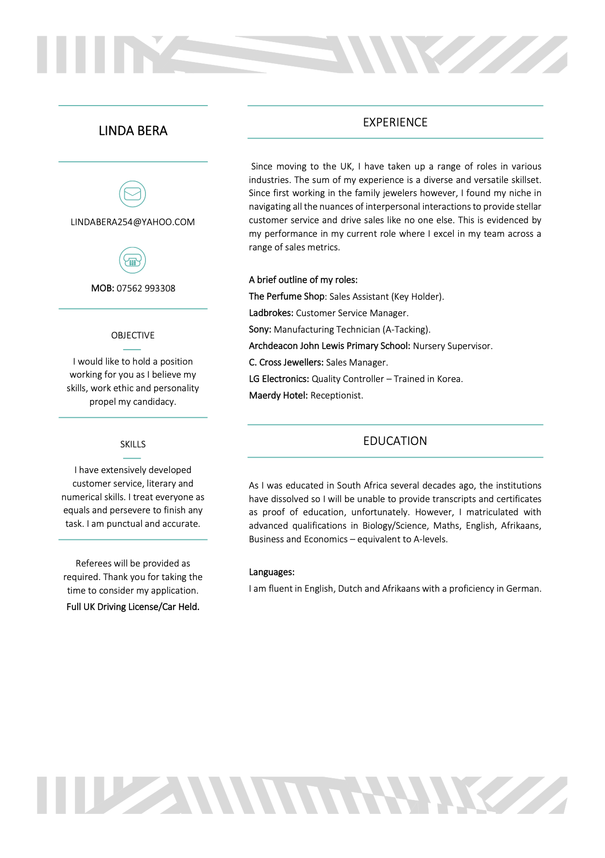
Appendix A Curriculum Vitae

Appendix B Continuous Professional Development Record

Continuous Professional Development Plan – Linda Bera
Formal | Informal | Date | Duration | Status | Details
ILM Level 4 Diploma in Leadership and Management |  | 2025 | 1 Year | In Progress | ILM
L4 Certificate of HE Applied Leadership and Management |  | 2025 | 1 Year | In Progress | University of Wales Trinity Saint David
The Perfume shop |  | 2023 | 3 Years | In progress | In work training

