LEVEL 5 ASSESSMENT INFORMATION
Detailed information about the assessment’s specification:
Student Name: | Alexandru-Teodor Ichim | Student ID: | 2323396
Programme: | BSC Applied Computing | Module: | Network Operating Systems and Services
Module code: | ACCA5023 | Internal Verifier: | Dr Sana Jokhio
Lecturer: | Dr.Dipo Dunsin & MD.  Sadeque Imam Shaikh | Word count (or  equivalent): | 2500 Words  equivalent
Assessment Title: | Research, build, and deploy a  Virtualised Enterprise  network | Return date of  all the marks  & written feedback: | Wednesday,14th January 2026
Submission  deadline: | Friday, 5th December 2025 | Student email: | 2323396@student.uwtsd.ac.uk
Submission  method: | Turnitin
Assessment Number: | Assessment 1

Contents
LEVEL 5 ASSESSMENT INFORMATION 1
Task 1 3
Different types of hypervisors or also called virtual machines - Type 1 and Type 2: 3
Type 1 Hypervisor or Bare Metal: 3
Type 2 Hypervisor or Hosted: 4
Research about IP Addressing – Additional to group activity 7
How information and data is shared and split in terms of IP addressing in regards to packets: 7
The actions and responsibilities such as rules, roles and the jobs of the IP addresses which has to be made to make sure the connection is going on in terms of routing: 8
How it is possible that routers and the connected switches function on the Internet itself to bring advantages to the flow of information and data among different Internet networks and computer networks? 8
Local traffic setup it is made by switches, here's how it is done and performed: 9
Connecting leading and communicating among different types of networks and networks themselves utilising routers as devices: 10
Any other mixed and how combined the progress is, and process is step by step: 10
Conclusion and everything in a nutshell regarding the process of routing: 10
The Services of the networks: 10
Task 2 11
The Technical documentation of the report: 11
2.1. Choosing of Hypervisor – Oracle VirtualBox – Virtual Machine 11
2.2. Configuration including Downloading 12
2.3. The configuration and setting of IP addresses from topology 105
2.4 Test, Check, Debug and Troubleshoot the problems using the networking and troubleshooting wizard 117
Task 3 120
3.1. Reflection, conclusion and explanation in a nutshell regarding the networking deployment and testing including final evaluation 120
3.2. Personal conclusions and learning reflections 121
References from across the web on networking used from research conducted about all network building topics: 122

Task 1

Different types of hypervisors or also called virtual machines - Type 1 and Type 2:

Type 1 Hypervisor or Bare Metal:
VMWare Virtual Box Hypervisor - The VM Ware V sphere hypervisor is already embedded in the system software which acts as a complex which is intended as a Kubernetes management plane executing straight on ESXi Hosts inside a vSphere environment. It shapes up vSphere as eventually it turns it into a platform which may normally and natively launch an application which executes straight on the OS (operating system) and processor, with no external layers such as web browsers or virtual machine emulators. It can as well manage and control both classic VMs (virtual machines) and modern software package files into containers (vSphere Pods) utilizing a unique supportive API.
Here are they main features which are critical for a vSphere Hypervisor:
- Here is the characteristic of already embedded kubernete: the hypervisor supplies natural kubernete API permitting the designers and developers and admin users to control in the container or in box workloads at the same time virtual machines at a single time from one single platform.
- Bare metal type of he provisor implementation or embedding which is the underlining and focused importance of virtualization technique or base which is VMware ESXi a type 1 or even Bare metal type of hypervisor which executes straight on the physical hardware of the servers. As well the management of the hypervisor which is playing as plane VMs (Virtual Machines) executes on top of the main kind of the hypervisor which is this one as explained earlier (bare metal).
- Management and control all as one it permits for censoring the application management and administration inside the client of the V sphere filling and bridging up the gap among vSphere admin users and Kubernetes cluster admin users which they are developers of the applications and designers of the applications software.
- Management and control of the resources and what it is left to build up the environment which utilises the sphere namespaces to get safe and secure tenancy and put in application and a number of resources for different workloads which involves tonnes of Kubernetes clusters including vSphere pods.
- Taking charge control managing and administrating the role of the cluster it serves the purpose as the control and management cluster as it helps with deploying launching and taking control of the operations of the Tanzu Kubernetes grid (TKG) clusters among the V sphere environment infrastructure.
Conclusion and explanation in a nutshell of Hypervisor Type 1:
In a conclusion the vSphere hypervisor it is a specially made already included layer which has automatic embedding of all levels and layers which Is expanding the abilities of the main vSphere virtualization software platform which involves native natural grade of enterprise Kubernetes management administration and integration including control.

Type 2 Hypervisor or Hosted:
Architecture of the hypervisor which executes other applications software which is involved in a conventional and appropriate host which it is an OS such as Microsoft Windows Mac OS or Linux Debian. It is tide to or has its base on the main OS which is the hosting 1 though configure on organise and even manage operatively the course towards the main utilised physical resources of hardware pieces within the machine. The quality of the hypervisor order performance is also taken into consideration. Metrics and factors such as if it's lower or higher matters here. For example in type to it is generally or normally in minus or lower in comparison with type 1 as all the components of hardware nature need access and it is compulsory store boss by the maybe and the operating system which holds the virtual machines or hypervisors in our cases, as it will add up slowness and latency over the top of the processor or CPU. In terms of safety and security it has legacy towards the vulnerabilities and sensibilities in terms of firewalls and safety the same as the main OS which is hosting the virtual machines. In the case that the host operating system is corrupted or even destroyed with compromise, the entire added virtual machines executing on the main operating system on it will be as well as risk of being vulnerable to viruses and malware. Cases of utilisation are also taken into consideration which would be the perfect match to have virtual machine for individual utilisation deployment checking up and testing systems and environments and especially scopes of education and tutorial as it is easier to utilise and very flexible which has more priority than actual performance. It is very frequent for the people who use virtual machine and would like to execute set a number of operating system including a single computer or machine laptop at the same time. Many of the good examples and models of such hypervisors Include and exist nowadays such as Oracle VM VirtualBox, is the hypervisor which is popular VM Ware workstation either pro or fusion and including parallels desktop which is less widely used. Executes on Main operating system such as software application it is lower in terms of properties memory and storage and it is executing overhead by the main operating system which is being held on, it is lower as well as in terms of weakness and it is based on the host operating system safety and security, it is intended to be more simple to utilise and downloads and has its own installation like any other kind of software application, plus it involves virtualization of the desktop computer, checking debugging and testing, utilising for personal purposes.
The hypervisor which is the best for this topology it is The virtual machine called Oracle VirtualBox. It executes other standalone software on the Windows operating system based machine. That apologies are shown below which have been made up in lucidchart software:
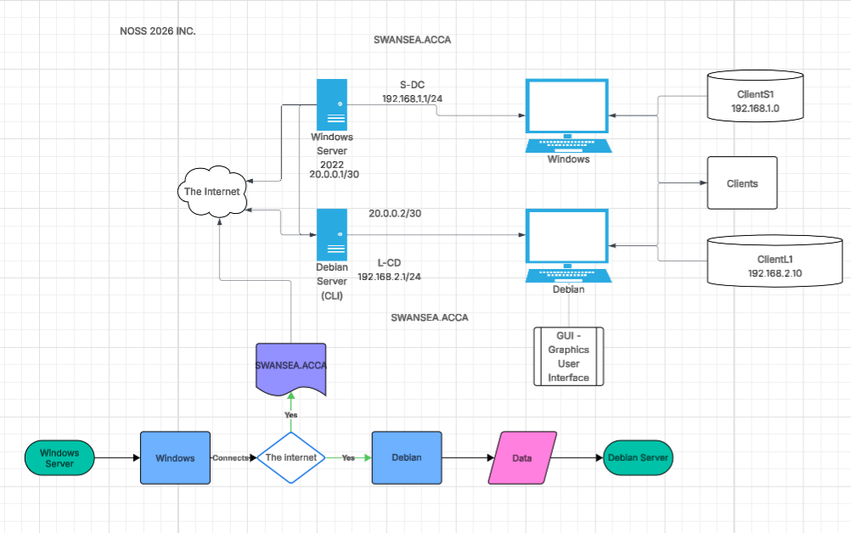
Here is the diagram including the topology which first represents the ACA .1 C networking topology including structure for an NOSS 2026 inc, which begins with the main part of the diagram which is the Internet which is connected to the cloud, then it involves the utilisation of Windows Server 2022 and including its IP address, then it connects using another configured IP address to the windows client which is the client's one with its IP address. Note that here there Debian server and Windows Server are interconnected and both of them they get their resources from the Internet cloud. The 2nd row is the Debian server which connects to the Debian client which acts and performs like a graphics user interface which is known as GUI or simply UI and it is also called as client L1. Below the topology that is also place the simple variant of the diagram which involves a template of a spider gramme which introduces the Windows Server first then connect to the windows client and forwarding the connection to the Internet and is approved by both Swansea . ACCA OK for the Debian client and it fetches up the data and information and it results in a Debian server as finally it does end up doing the loop continuously.

Here is the link of the diagram in the screenshot above which has been done in the lucid chart software: https://lucid.app/lucidchart/387392e2-fc1a-409f-990b-c56873e9c55a/view

I have taken into consideration to choose the domain name and environment Swansea.ACCA as it is absolutely necessary to support and be compatible with most operating systems windows and Debian which involves exact hardware characteristics including needs of security and safety within the topology illustrated in the diagram in the above task.
Another advantage of choosing the domain name Swansea.ACCA, is that It is facilitating the connection much easier and simpler by starting off with the Internet and then connecting with Windows Server 2022 and lower with the Debian server CLI - as the Windows Server 2022 is the controller of the domain DNS (domain name system) server DHCP (Dynamic Host Configuration Protocol) server followed by the RDS server with its own IP address. Then, Windows Server 2022 connect with Windows 10 client with the service of Client S1 so as a member of domain DHCP assigned IP.

Research about IP Addressing – Additional to group activity
The information and data gets transferred over the Internet and small segments Which are also named pockets in computational terms that are directed by IP addresses which are in the position other digital streets at the address store control an guide the package to the matching end point which is their right destination. As a machine sends information and data it is split into packets step by step every pocket consisting of the main source and the IP address from the right endpoint which is the destination. Routers detect and read all of the addresses and push the pocket on the fastest way to the next available router machine and this is going on and on till the packet arrive at the desired device which needs to receive them.

How information and data is shared and split in terms of IP addressing in regards to packets:

Data and information it is split in between as packets - A message is split down until little pieces also named packets. Every pocket it contains itself other unit of information and data which involves at the same time the data in its nature and information about all the control details. For example this information can be the main starting IP address and destination of reaching IP address.

The spaces of the information which are packets are bounced to the network and delivered there in the network system. This means that the PC delivers these pieces of information called packets do a LAN or machine of a local network in such instance the personal router as the personal router. Afterwards it bounces them as pieces of information out to the ISP the provider of Internet service.

The routers are controlling and managing the packets. Which means that they investigate the reaching IP address on every single packet and utilise their internal main routing rows and columns which are compiled as tables to define the most excellent path and optimised 1 to distribute the bucket to its next machine which it is next hop.

Furthermore, these buckets they make journeys across all the networks. They are travelling from network point to network point such as router to router. As it has every router still take a the season as which one it will be the best next stop as it is on the actual journey. This is keeping on till the bucket gets to router that is bound and connected to the network which acts as a destination.

The actions and responsibilities such as rules, roles and the jobs of the IP addresses which has to be made to make sure the connection is going on in terms of routing:

The identification number which is unique and non distinguishable - every IP address is a special label of numerical characters which are approved and assigned as in networking terms it is called obtaining an IP address which is being done to every machine connected to a network of computers that utilises the Internet Protocol technology or IP to communicate and make interaction within the network. Network can be either Ethernet Wi-Fi or WLAN. It works other special street address in terms of Networking and communicating via a source of Internet and applies at every single machine or device, making sure data and information has been set where should it go.

Distribution and routing within the network and the IP address - this is essential for making way and routing information and data. Routers as devices that utilise the destination as endpoint IP address on every single packet door realise where to distribute it and as to add the next sequence which pyramids information and data to locate it pass via the huge network of the computers connected to the Internet.

Communication utilising two ways to do so which is being found in IP which is the Internet Protocol including its system of addressing are the basic regulations and rules and structures which include it skeletons of networks which activate devices and make them work in terms of communication and swapping the information and data shaping up the base of the Internet computer network itself.

How it is possible that routers and the connected switches function on the Internet itself to bring advantages to the flow of information and data among different Internet networks and computer networks?

Routers and including their switches our basic devices of networking and engineering which function as a collection all of them all together utilising set protocols and rules to organise and manage the direction and routing of the data via the whole Internet.

Local traffic setup it is made by switches, here's how it is done and performed:

This switch is operated and perform among a one single local area network LAN at the data connection layer which is layer #2 of the OSI Which is the open systems interconnection pattern and scheme which is a model. This is a concept and innovative framework that splits the settings and options of a system of networking in between seven different layers starting from connection which is physical to the application of the user or the client. Has been made by the international organisation of standardisation ISO, it gives out a standard which is very universal off how alternatively and using all kinds of methods which hardware including software can have a connection via network having the options and the allowance to accessibility quicker to design, deploy, implement, debug, and find a solution for the systems of the Internet network. The main players which are in number of seven are called:
- physical layer
- data link layer
- network transportation layer
- session of network layer
- presentation of network layer
- application within the network layer
Therefore, elaborating on roles which are efficient, the local information and data with direction and forwarding is done by these rules:

Memorising Mac addresses - as machine connect and gets bound to a switch, the switch device starts to record and register the unique and special media access control Mac address of the device, and right down whichever physical and important part which the address is connected and associated with.

Frames which are directing - the transmission of the information data and units and pieces which are called frames it is been done. When you need frame get to the switch it detects and read the destination endpoint Mac address. Taking place off traditional broadcasting and transmission of the information and data to the whole set of the ports like out dated or old hub of network would do, the switch distributes the unit called frame just to the Exact board which has the port which the main endpoint destination device or machine is bound to or connected. This process which is set up and guided efficiently and obviously gets on minus the congestion of the network which lowers it very significantly and it can be looked at and identified that is being done so.

Connecting leading and communicating among different types of networks and networks themselves utilising routers as devices:

These devices which are called routers are more complicated in terms of network operation as in layer number three of the OSI type of pattern. Their basic and primary setting and function it is to mainly connect diverse and different networks for example as the home network the providers network and the back end which is the vast Internet back bone.

Protocols of routing and regulations including rules are also considered which is also complicating protocols of routing like OSPF or even BGP Which are cut in broader networking terms open shortest path first and brother gateway protocol which are still Internet routing sets of ruling protocols, Which have their job and being utilised to tell precisely the quickest and fastest path for data and information to have journey over a network. They are utilised to swap information and data about ways and paths being available and precisely tell the fastest and quickest and best bath for information and data to travel. IP addresses including the forwarding of the packets and delivery hope I hope which both involves data travelling via routers and being in capsules and as a hop which makes the journey faster to the packet to its final end point are being taken into consideration.

Any other mixed and how combined the progress is, and process is step by step:

- Send the packet and data request locally
- travel using a journey over the Internet with the packages
- receive locally and split between the network details and leaving it to the switch
- delivery at the end point utilising a table of the Mac addresses to distribute data straight to the right end point machine on that network

Conclusion and everything in a nutshell regarding the process of routing:

In a nutshell the management of switches including that traffic of network among the computer network safely and securely, it is important, at the same time the router devices control setup and direct traffic among diverse networks, building up the connectivity in terms of global networks of the big network of the Internet being possible and to be available.

The Services of the networks:

Virtual private network VPN key features which is safe secure and trusted which acts like a tunnel which is encrypted overlapping and laying over a not enough secure network, such as the Internet, which Max communications with users at the distance or websites to a private network.
- Confidentiality and security and including encryption preventing breaking of data and leaking
- entire security and safety and integrity of information against tampering while travelling
- authentication and verification for both cases
- anonymous identity and masking the IP address including the place of accessing the network
Dynamic host configuration protocol DHCP
- auto obtaining of the IP address
- configuration in a centralised way to be set up including masks gateways and addresses
- control and setting up of the address which takes precautions for the conflicts
Active Directory domain services ADDS
it's been created and developed by Microsoft, Which keeps up details and information regarding objects within the network clients users devices PC's printers routers and etc., and makes the utilisation of this information and data to be available to admins and clients including users. The main cell of windows of networks of the domain.
CAs or authorities of the certificates
It is a safe and secure entity which releases certificates of digital nature. These documents of a digital nature are being utilised to check and verify the ID including identity online of different people bases and online corporations activating safe connection and communication for example hypertext transfer protocols – https.

Task 2

The Technical documentation of the report:

2.1. Choosing of Hypervisor – Oracle VirtualBox – Virtual Machine
Oracle VirtualBox has its own benefits such as reduction of the cost or even the free version of it by analysing and researching systems properties, it is easy and simple and intuitive to use and handle in terms of virtual machines, simple graphical user interface Gui, optimising productivity and management for the developer and the programmer, very safe and secure testing and experimenting across many operating systems making sure that software deployment and debugging is very simple and secure including preset virtual machines and boosting safety and security for access from a distance. These are good reasons when using Oracle VirtualBox at the same time everything went granting access to an easy message to execute diverse operating systems such as Linux windows Mac OS on just only one device. Experimenting, developer options legacies settings, and learning and tutorial purposes are main reasons for choosing the hypervisor. Here are the main extended beneficial factors:
- safe and secure environments
- testing no matter which platform you use and every platform compatible
- development and progress in a faster and quicker way
- debugging and something of the problems including troubleshooting especially networking
- When executing operating systems you learn experimenting and try it out other OS on your own device and simulate it or even emulated including learning new abilities to practise administrations in a separate OS environment.

2.2. Configuration including Downloading
2.2.1. In the below screenshot a custom setup has been performed, Which permits to select the way the features to be downloaded. There is a whole list of features which are available for the hypervisor.
Critical Information in terms of my computer’s resources and in line with them and limitations:
Windows Server: Standard Desktop Version
System Configuration: -: Language: English US,
Time Format: London UK
Username: Administrator
Password: NotebooK@123 - not anymore – Actual Password: Administrat0r – due to being unable to change the password
Debian Server: CLI
Username: localadmin
Password: NotebooK@123
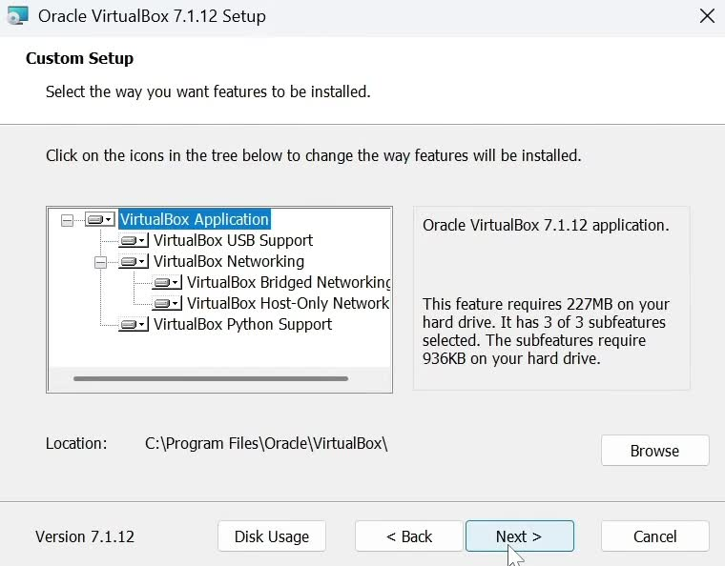Then in the below screenshot the next button has been pressed to continue with the setup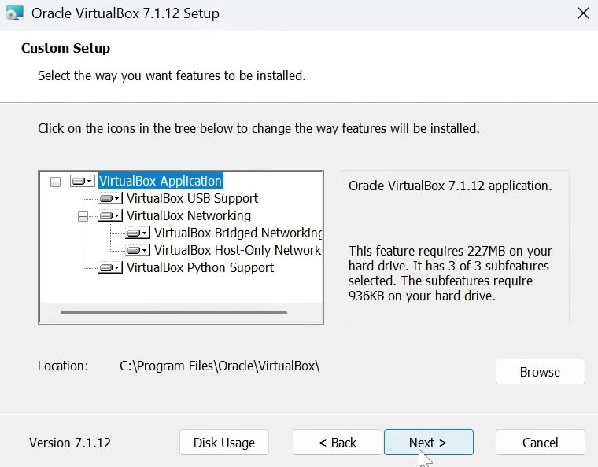set up to be continued using the next button which requires 207 megabytes on the hard drive, as shown in the screenshot above and below
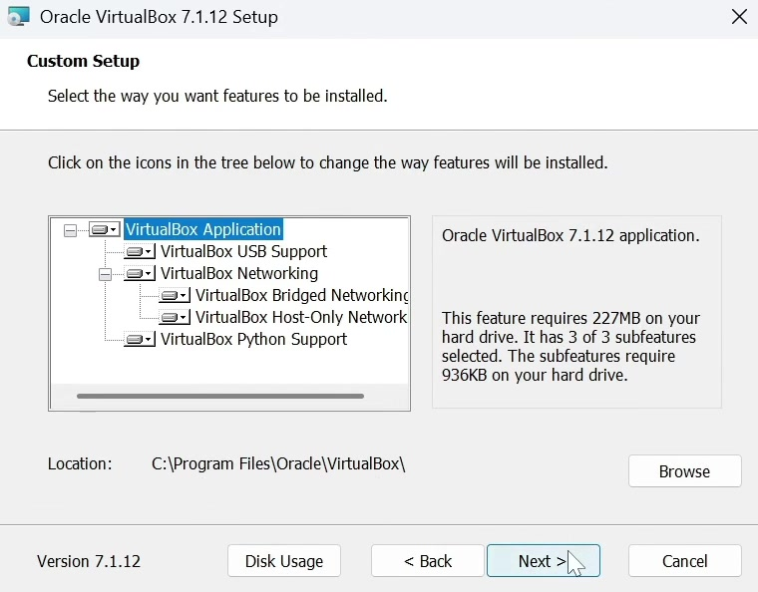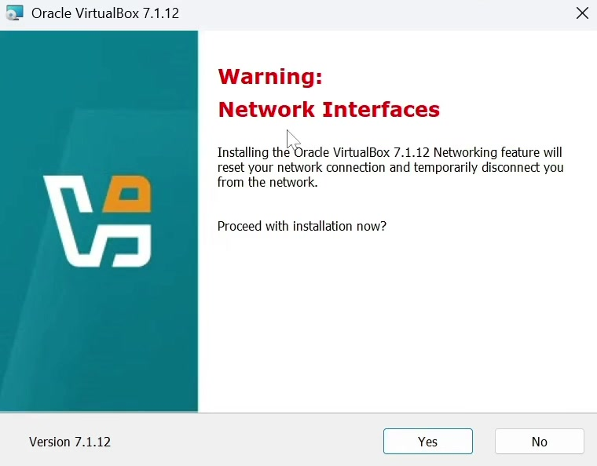this screenshot portrays a warning of the interfaces of the network that's downloading the hypervisor of networking feature but is that has a warning that network connection and only this time disconnect the user from the computer network and it asks to proceed with the installation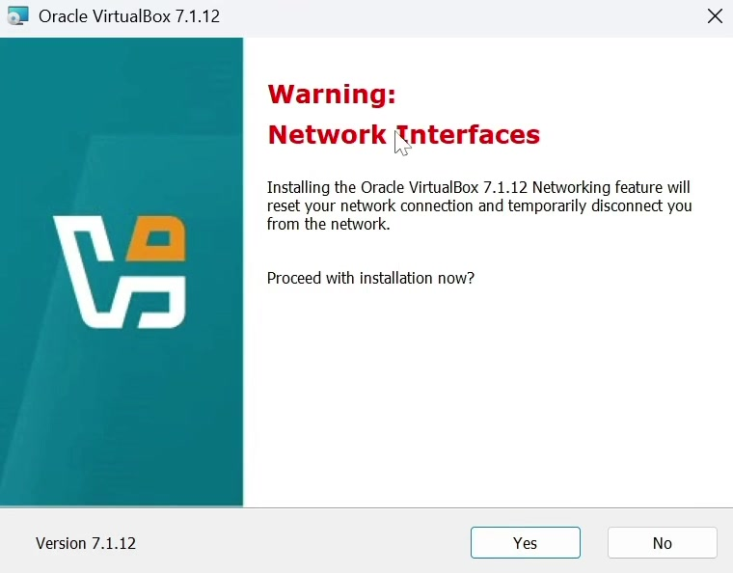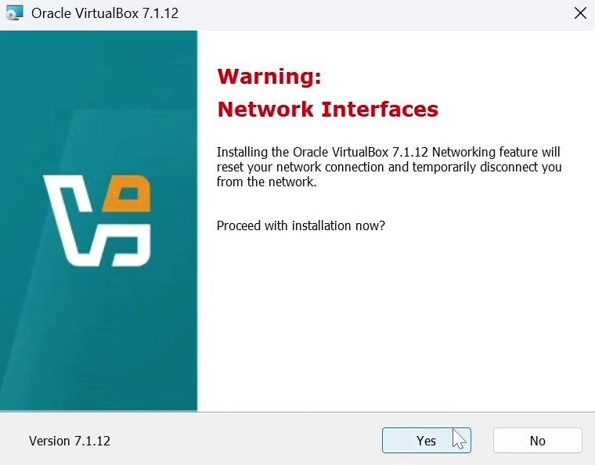In this case that it is portrayed in the screenshot above the button yes has been clicked to proceed with the setup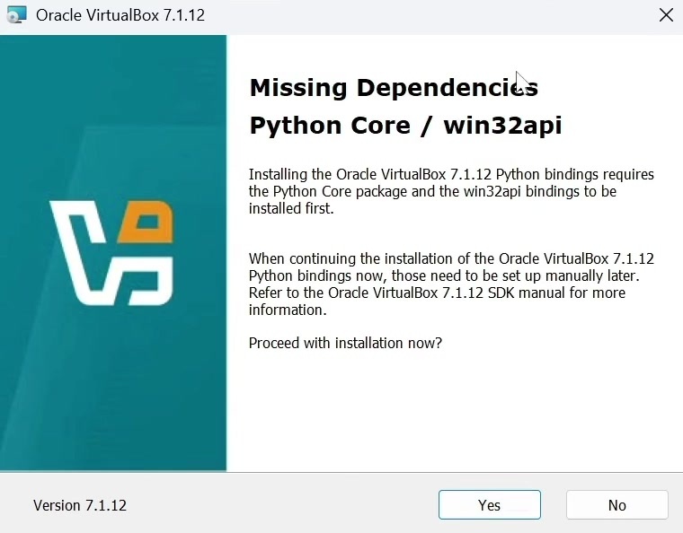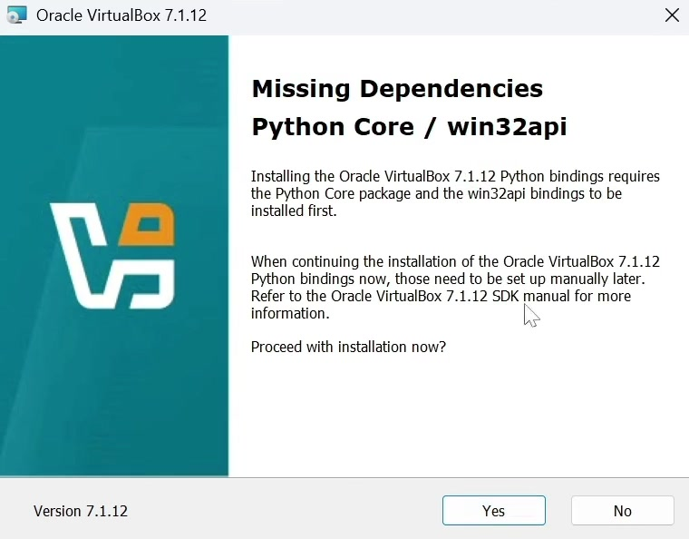here it is notice about missing dependencies on Python car and win 32API which needs the Python core package and bindings and connections to be downloaded firstly of all after continuation of install you can set manually later it asked to proceed with installation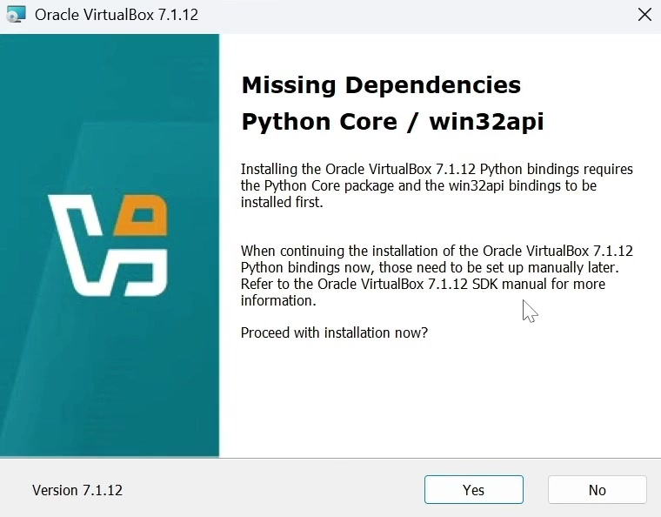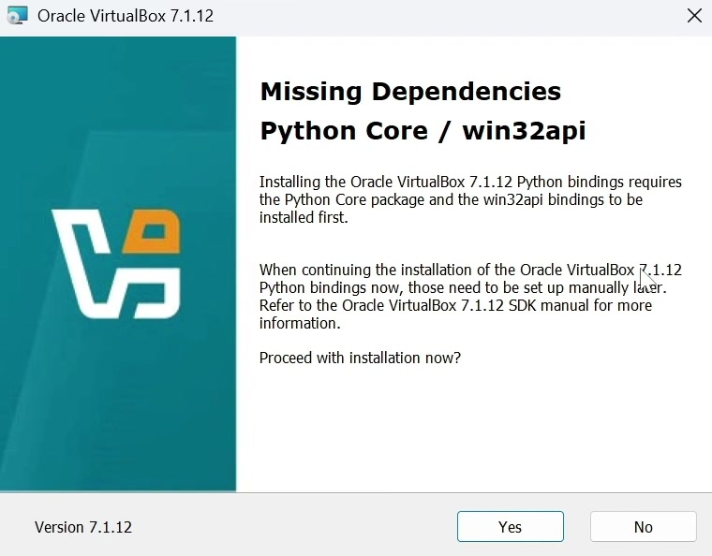As in screenshot above and below in this case the button yes has been clicked to proceed with setup installation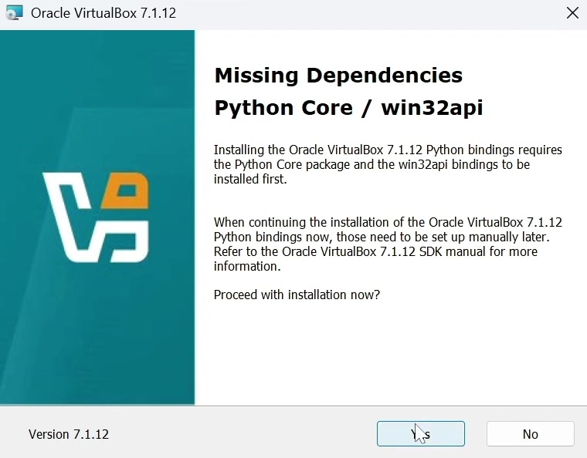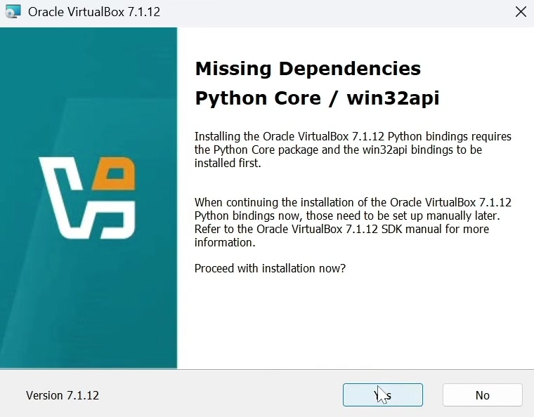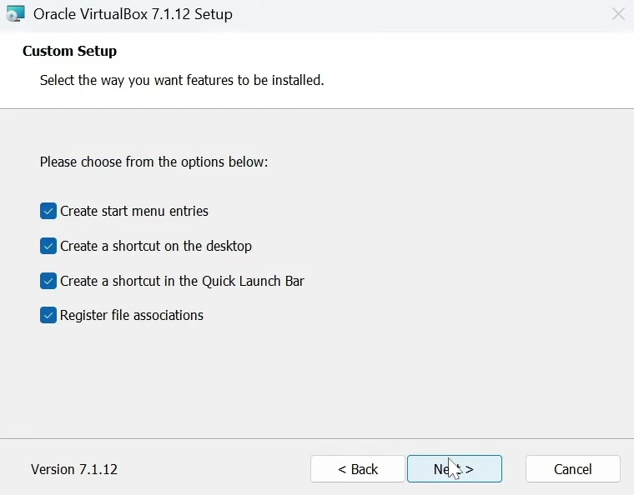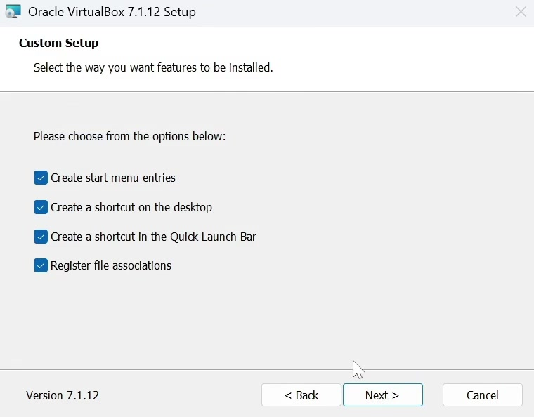In the screenshot above and below it's portrayed the custom setup and to choose the methods that you want characteristics to be downloaded and to choose from the below options and settings yes and box ticked to create start menu entries yes and the box ticked to create a shortcut on the desktop yes and the box ticked to create a shortcut in the quick launch bar yes to register file associations and the box is ticked the button next has been clicked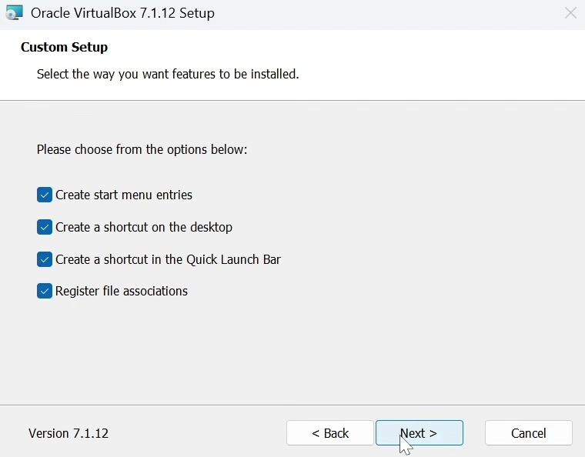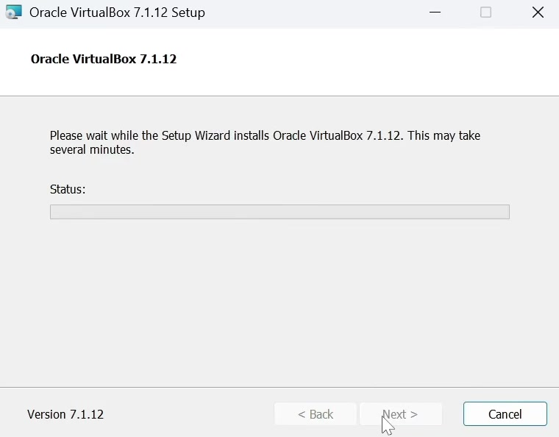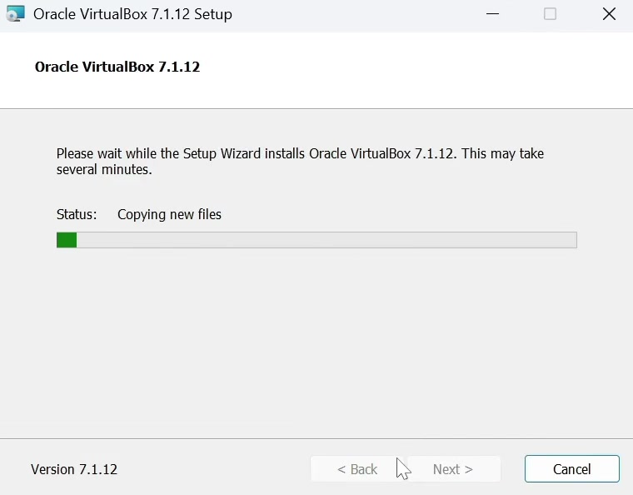Now in the below and above screenshot on the Oracle VirtualBox 7.1 point 12 setup it portrays the waiting with the progress bar as the setup result downloads the hypervisor which may take several minutes installing support driver and other files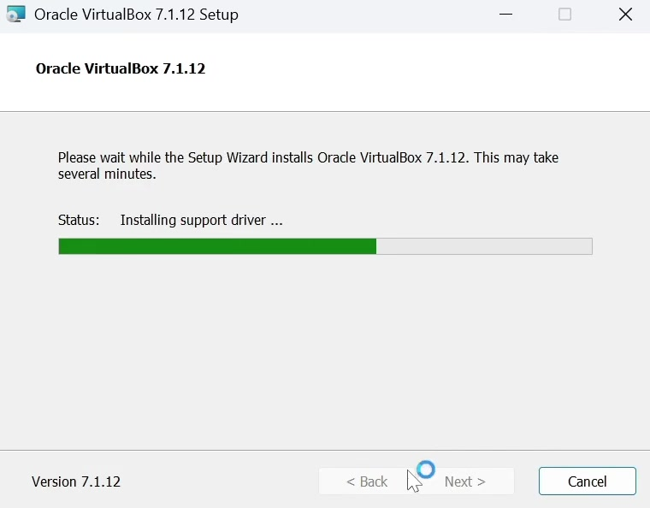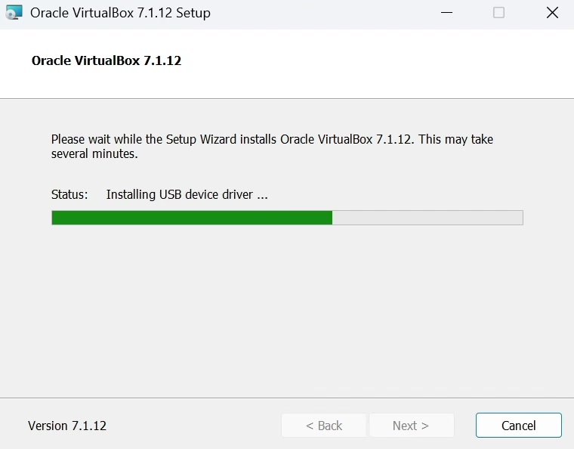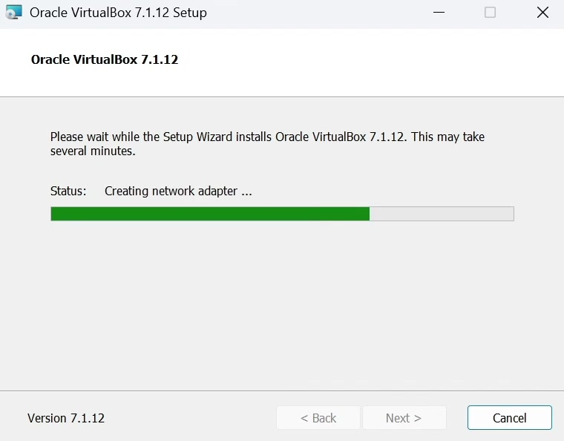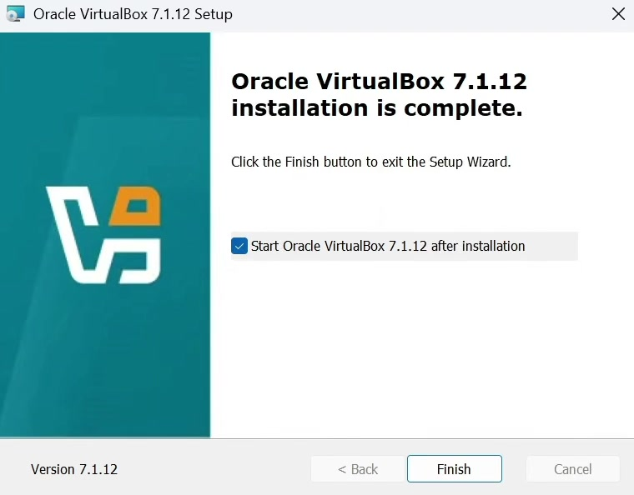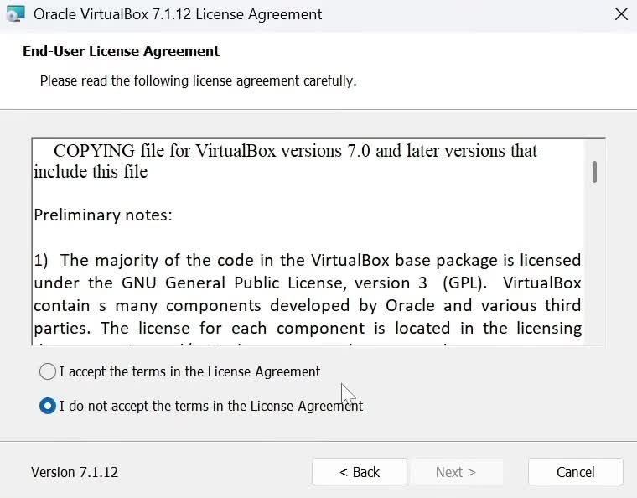It is screenshots having licence and the first one of the licence must be compulsory And chosen on I have accepted the terms in the licence agreement. The box which allows the user to choose to start the VirtualBox Oracle hypervisor was automatically selected to facilitate the ease of the software.
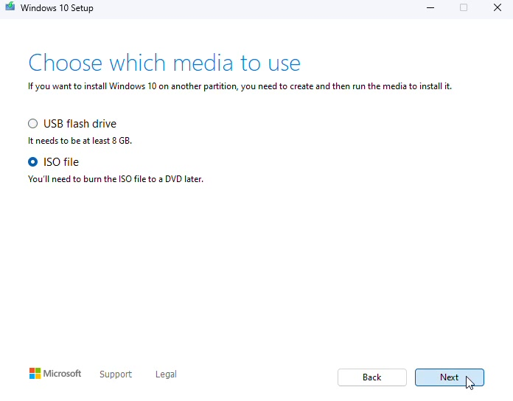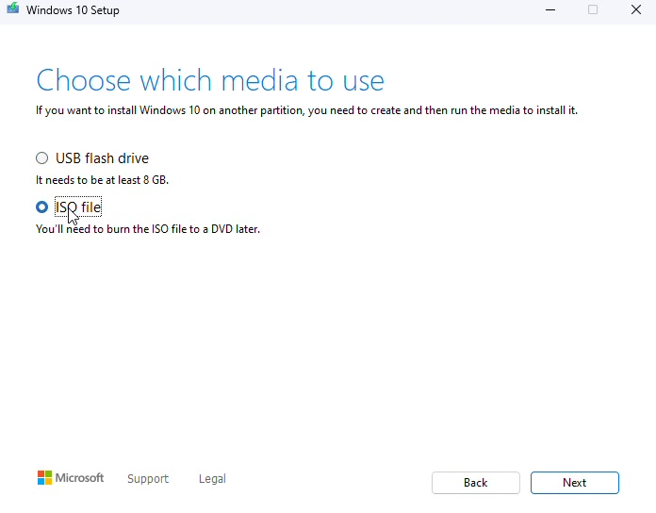In this screenshot it portrays the Windows 10 media installation for VirtualBox it portrays the user to choose which media to utilise and for the virtual machine I selected an ISO file then I click next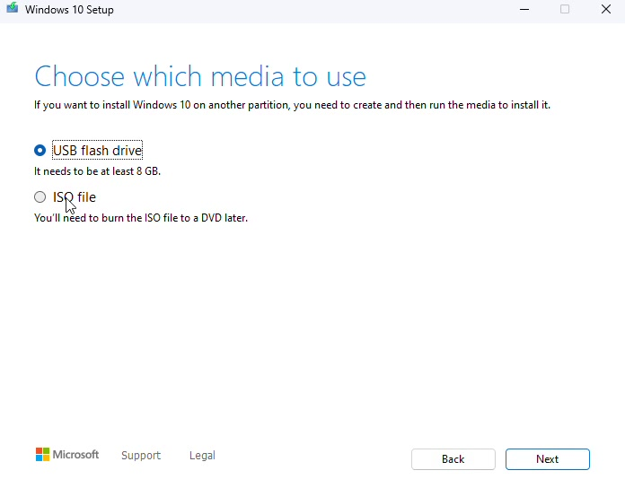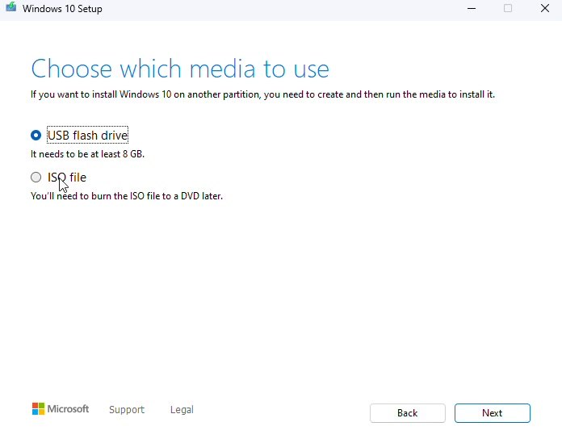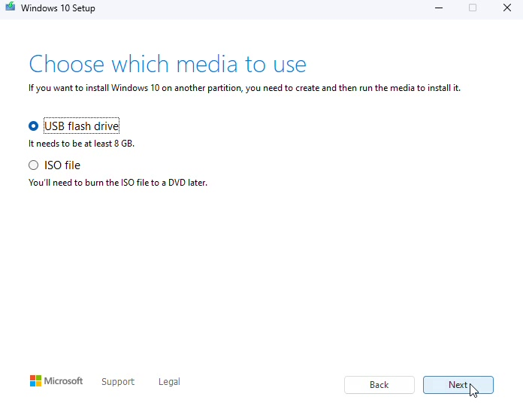In this instance I click next and utilised the second option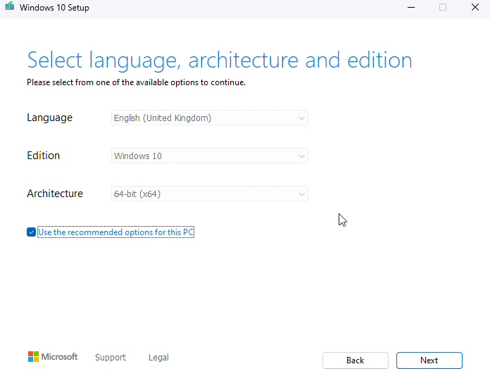

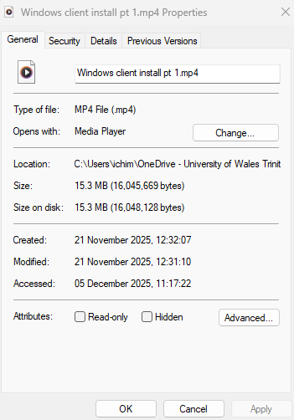
This screen captures portrays the timestamp of the screenshots made for the windows installation of the client. These properties such as date and time can be found next to created label in the capture above. A video has been recorded to showed the progress and to extract the screenshots.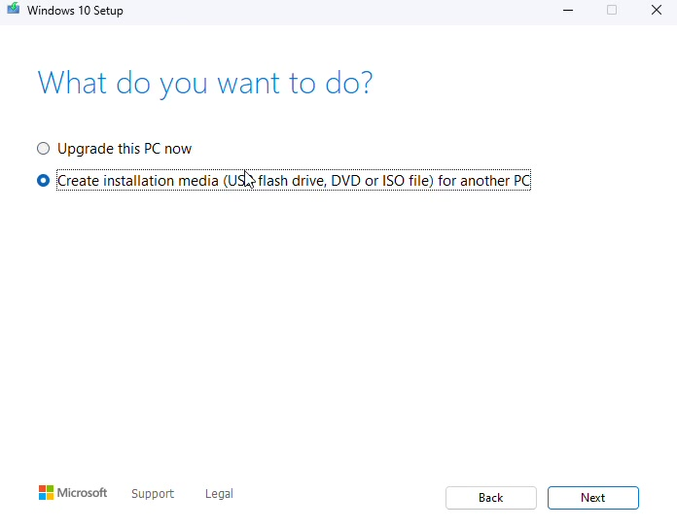It prompts the user what would they like to do whether what they would like to upgrade the PC now are the best thing for a virtual machine to create an installation media file ISO image and to click the next button. I have used the recommended options for the virtual machine and for the host machine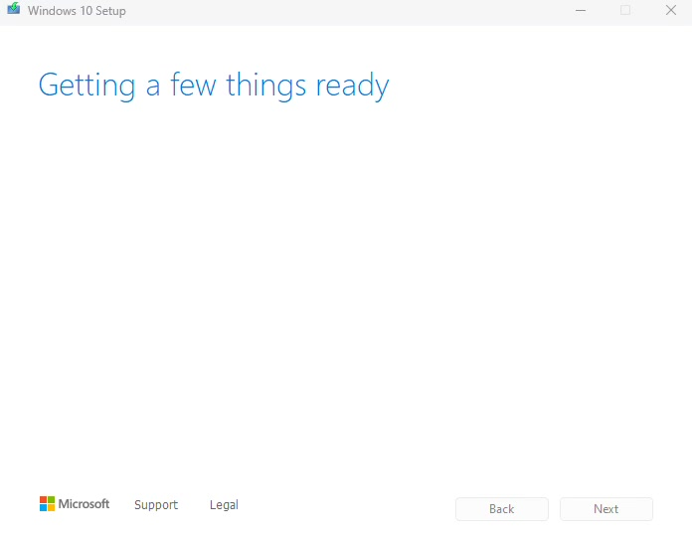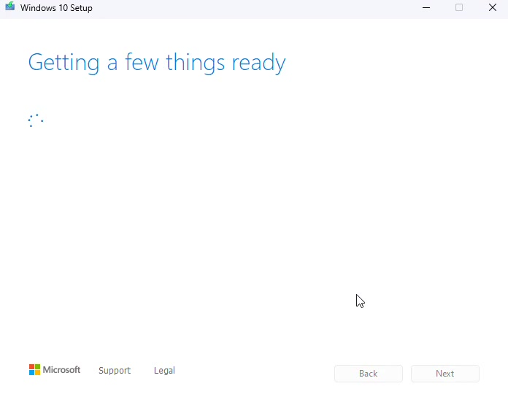they were obtaining a few things ready for the file to be downloaded into the File Manager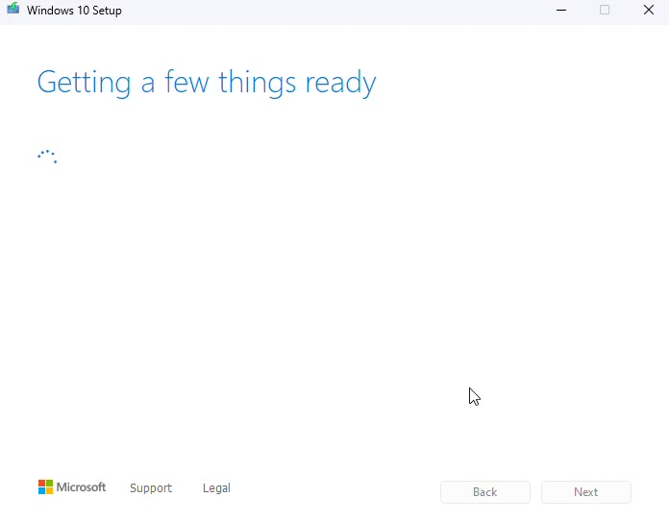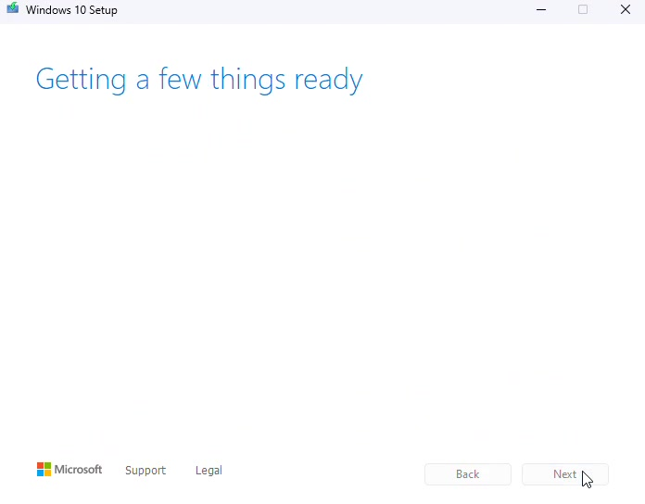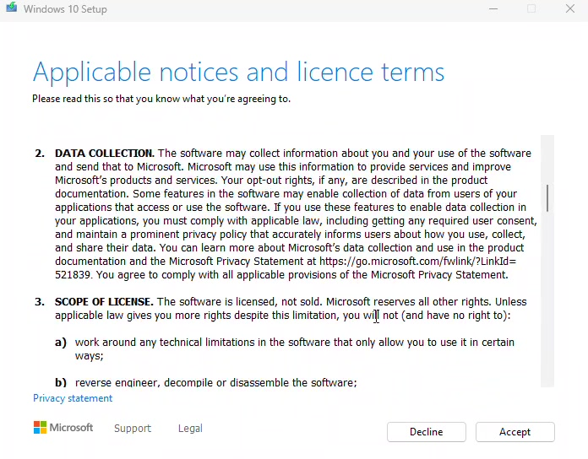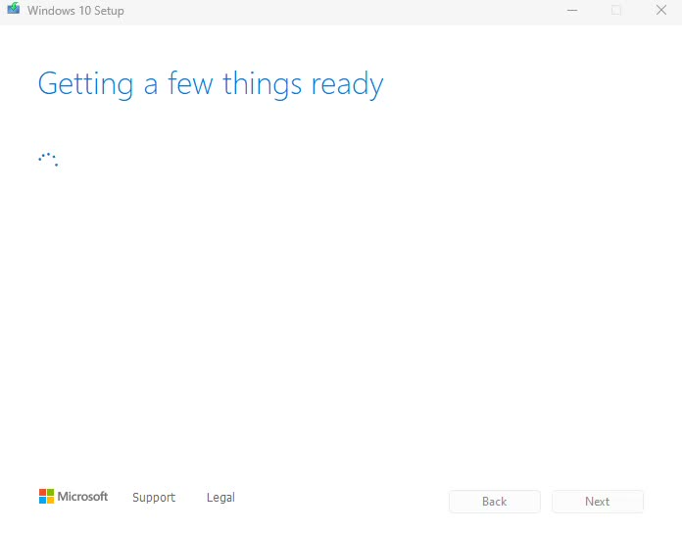they were prompting the user to agree with the licence terms and conditions regarding Windows 10 utilisation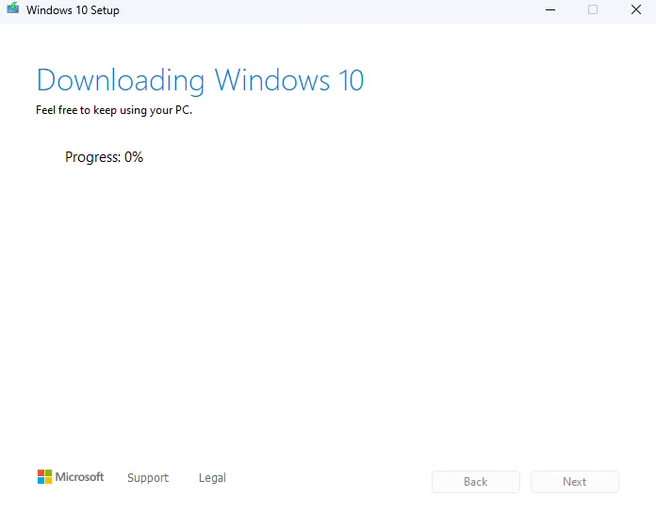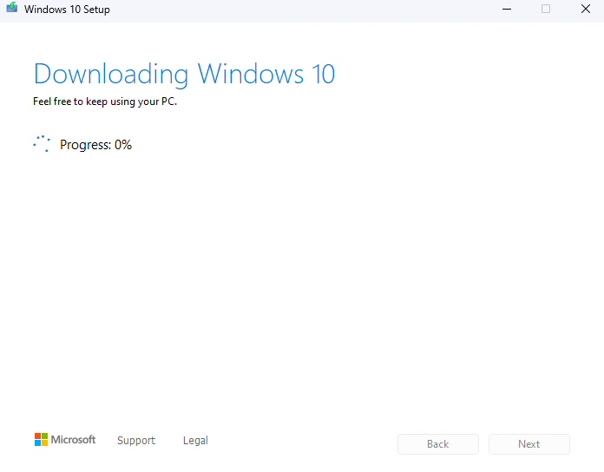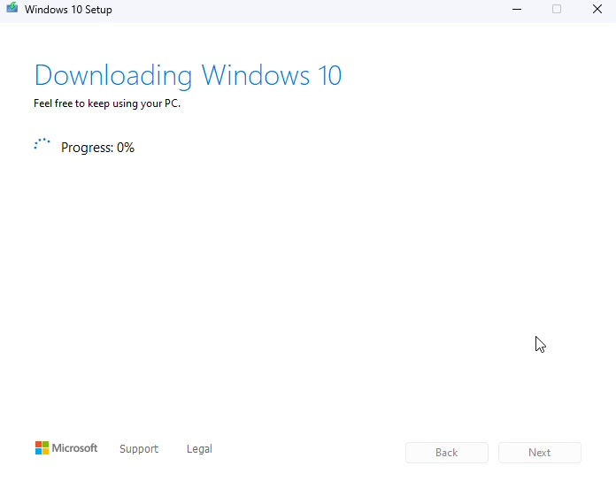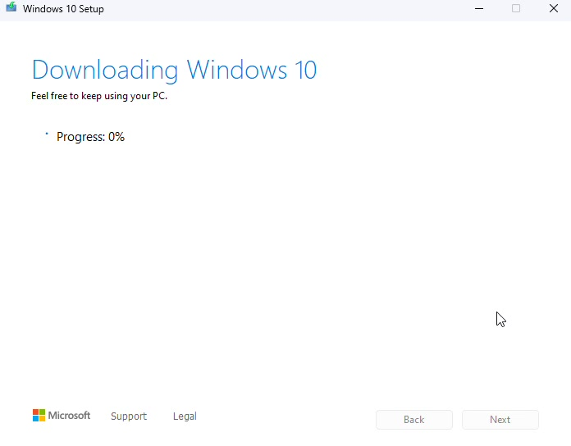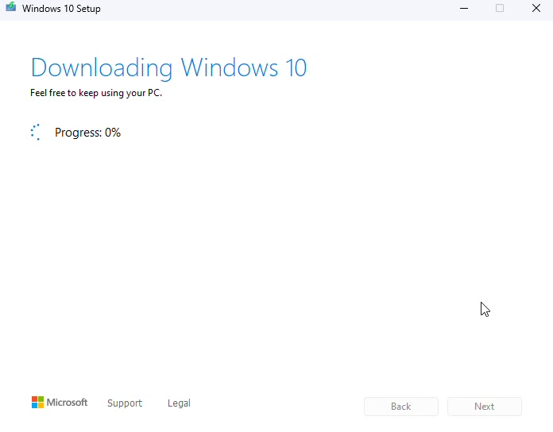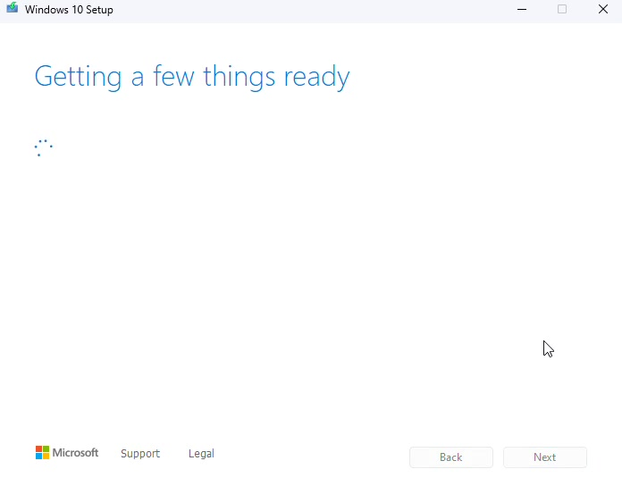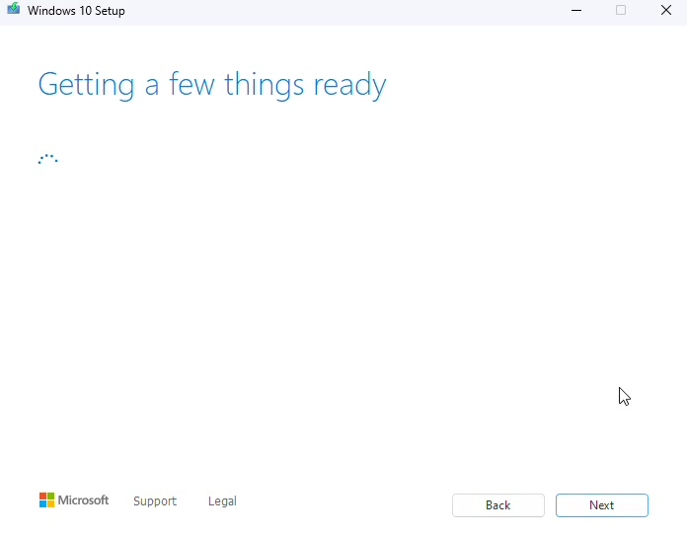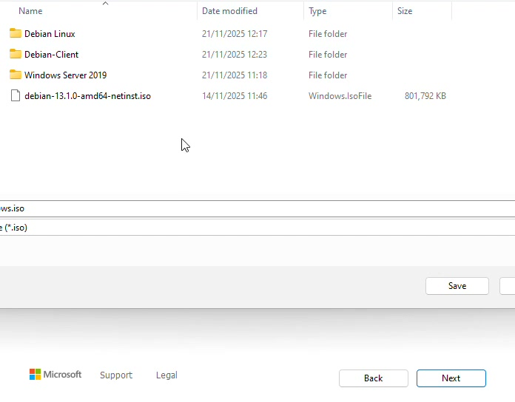in the screenshot below it portrays the user being prompt to that file manager to choose the path that they want to save the Windows 10 ISO file to be run later in the virtual machine.
2.2.2. Network is deployed using the Windows Server application which is called server manager in the screenshots below it is deployed step by step using the server manager wizard:
- please note on the first screenshot it is portrayed as the window property of the original video which they have been extracted from so they can have the original timestamp
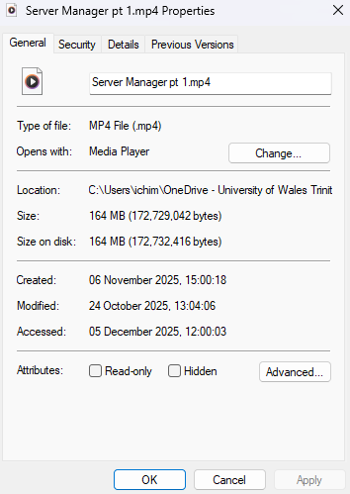
Here are the screenshots portrayed with steps to mitigate the solution from the topology and to deploy the network accordingly using server manager’s wizard of networks:
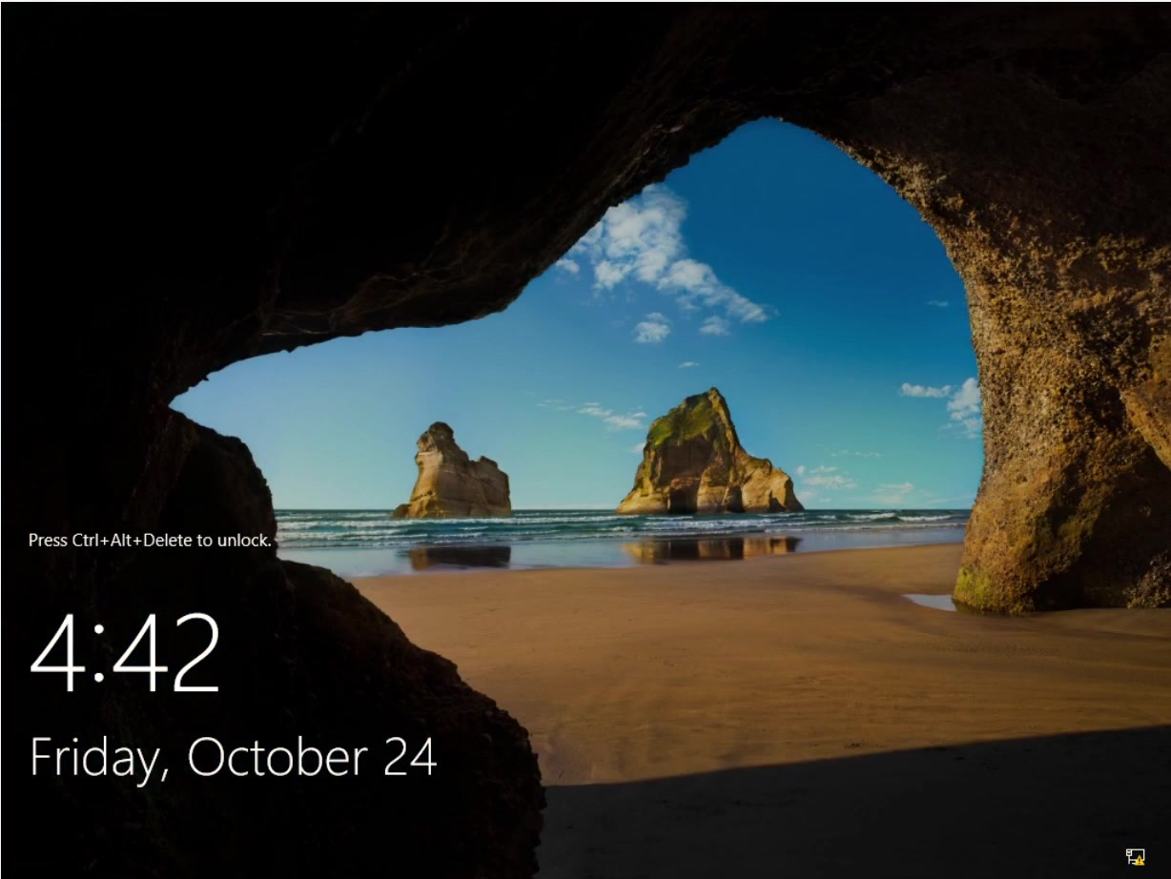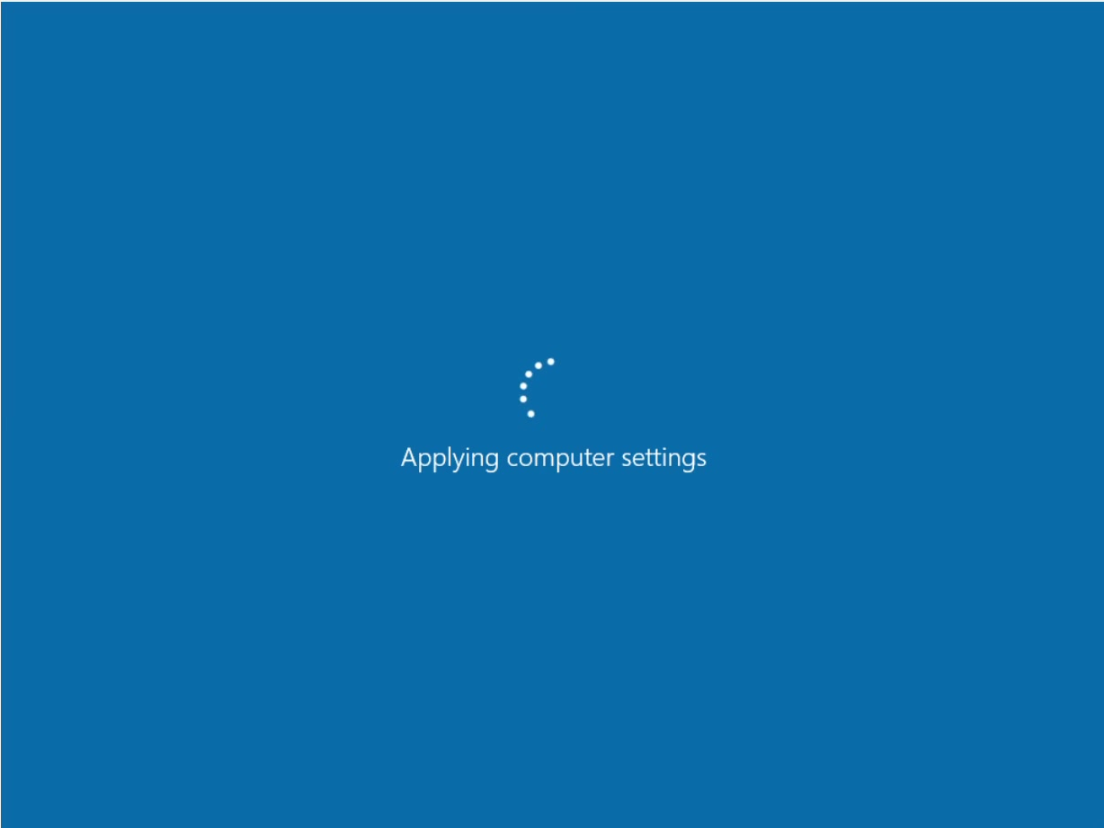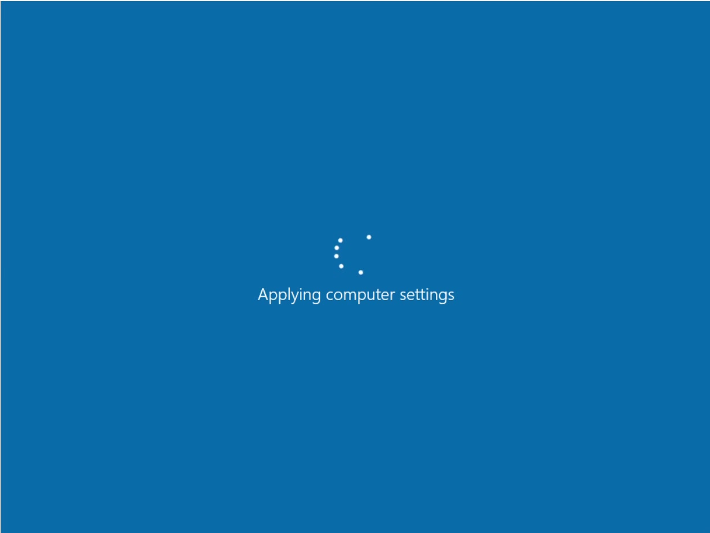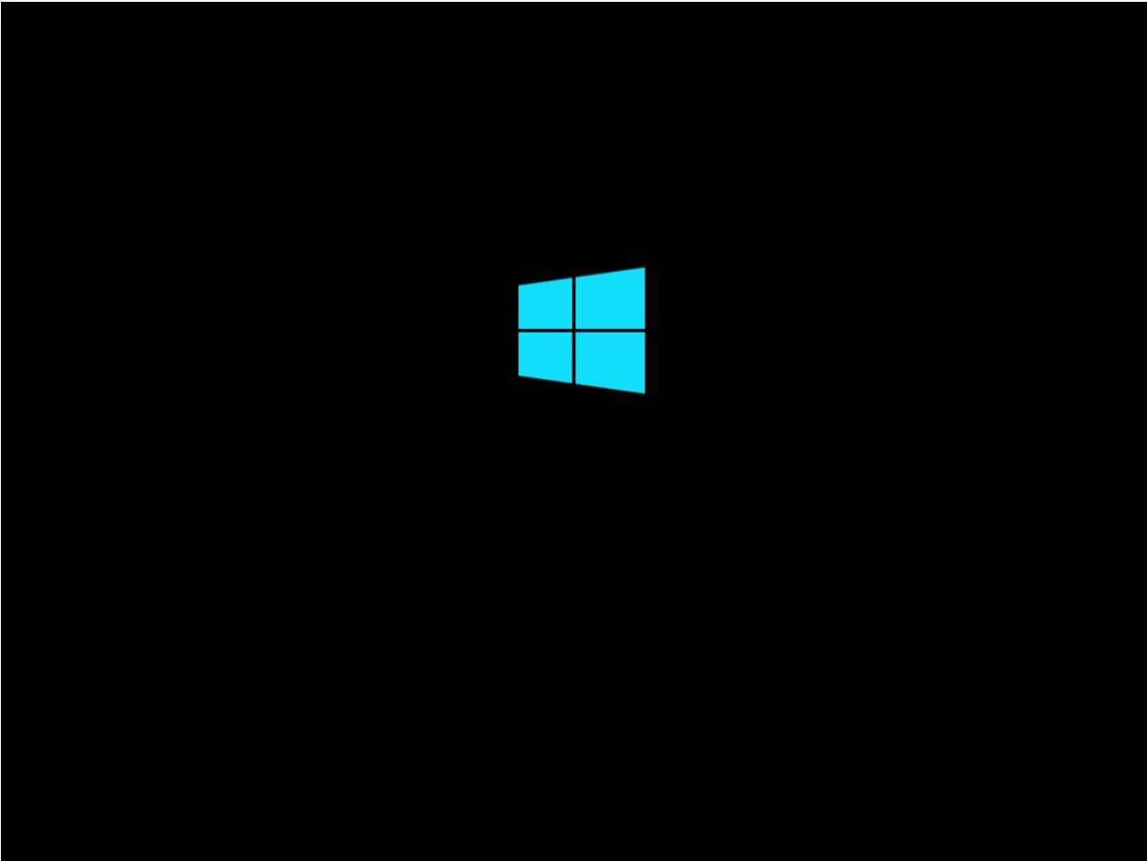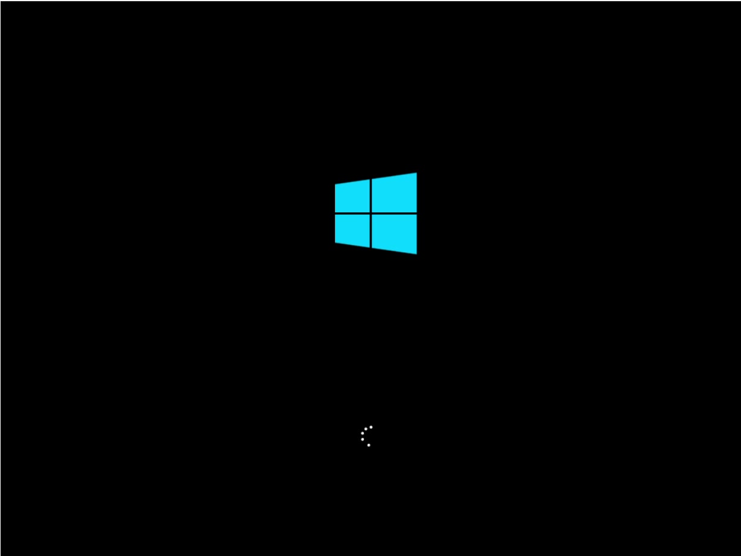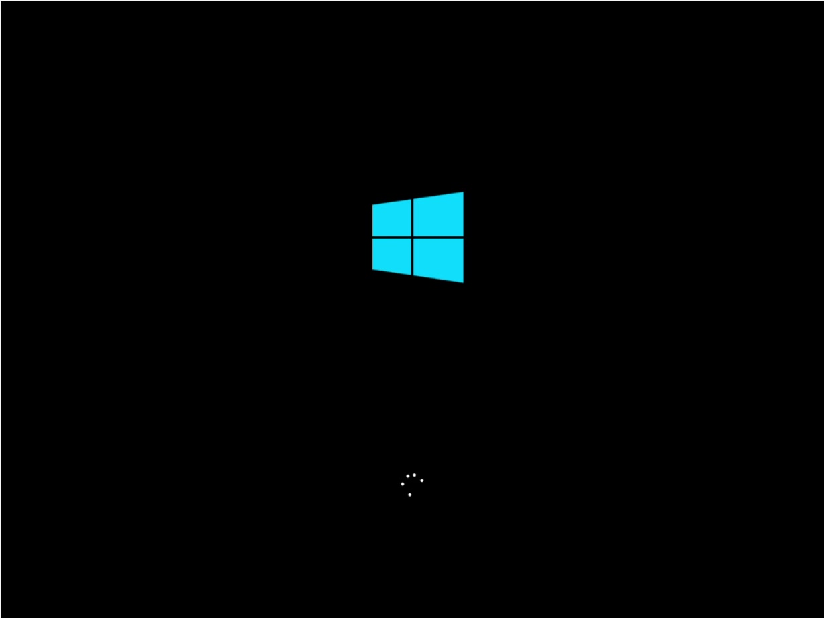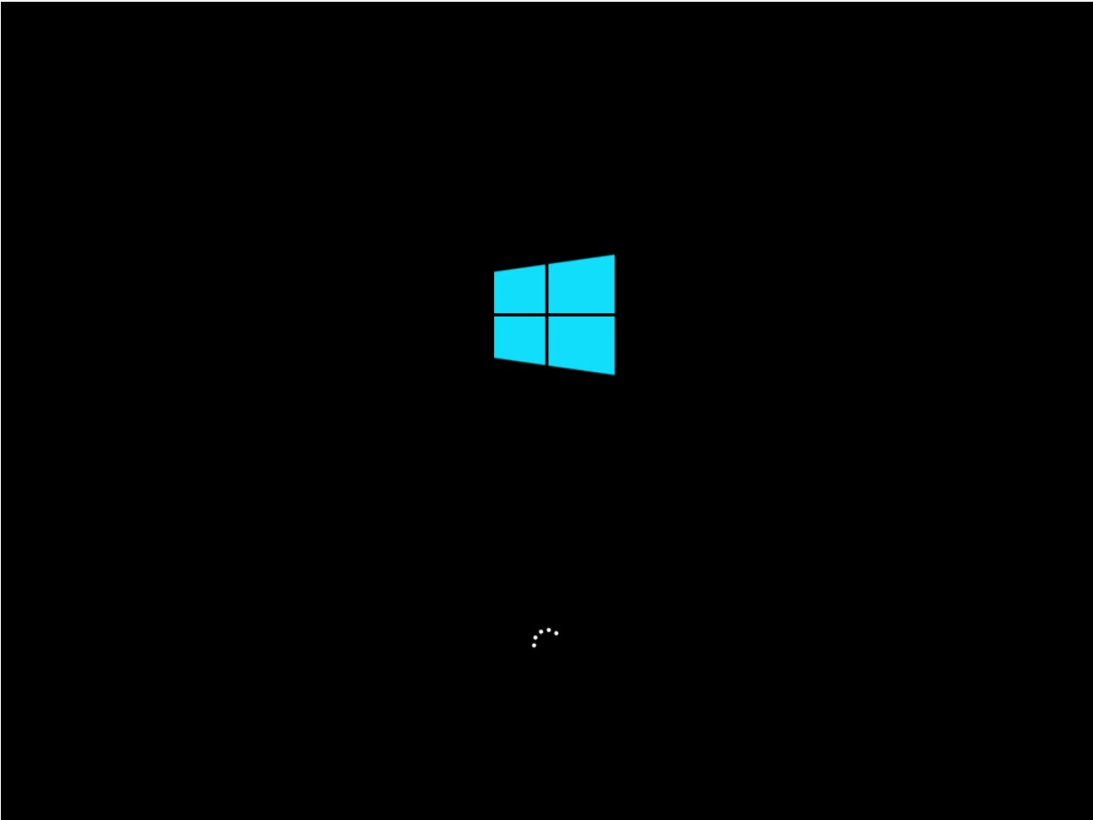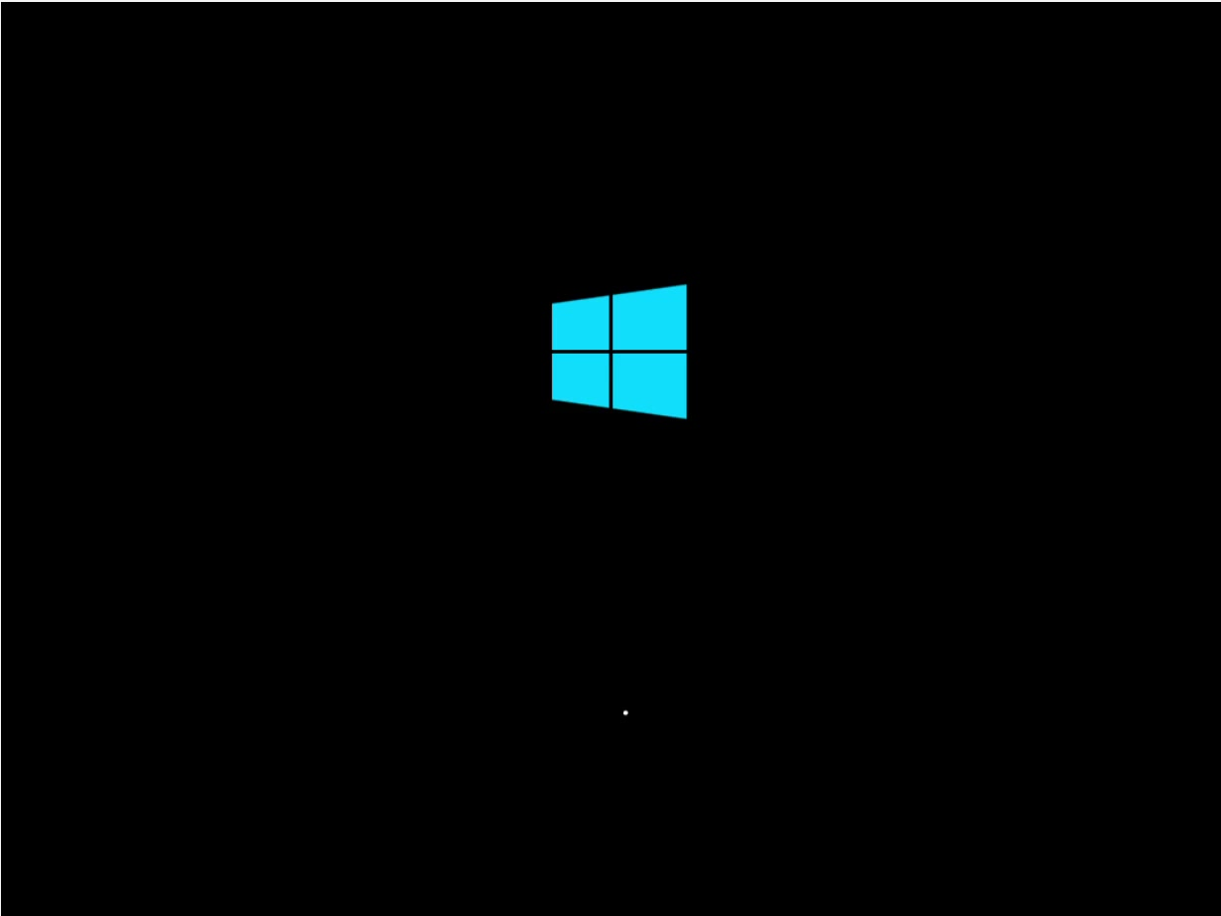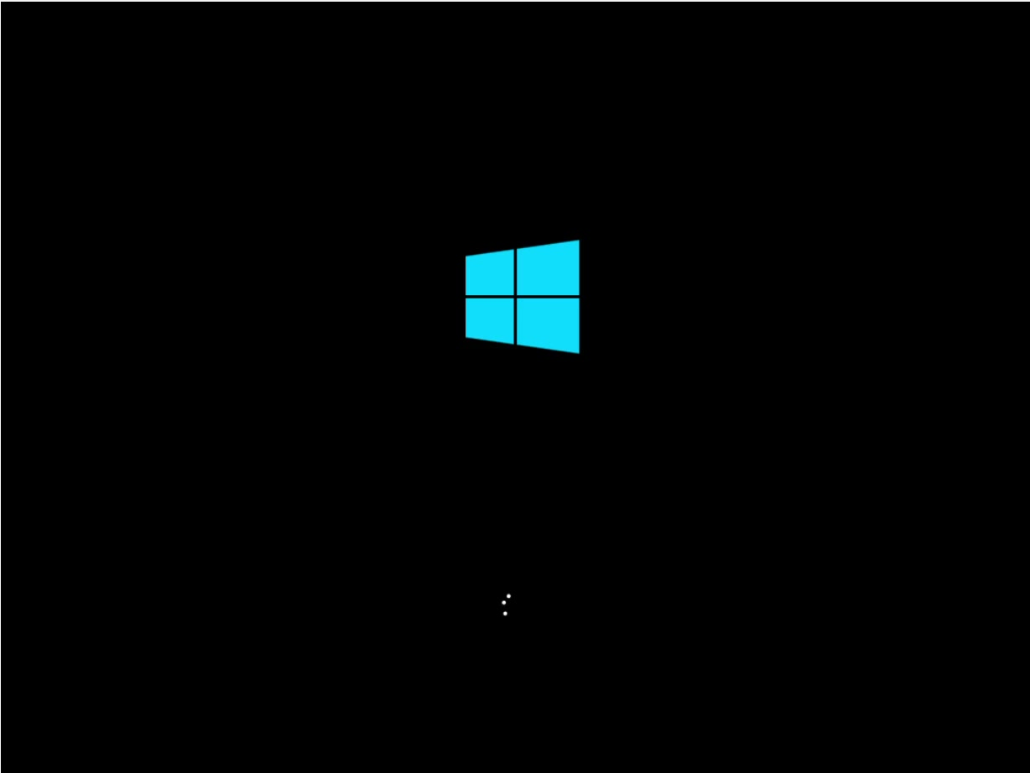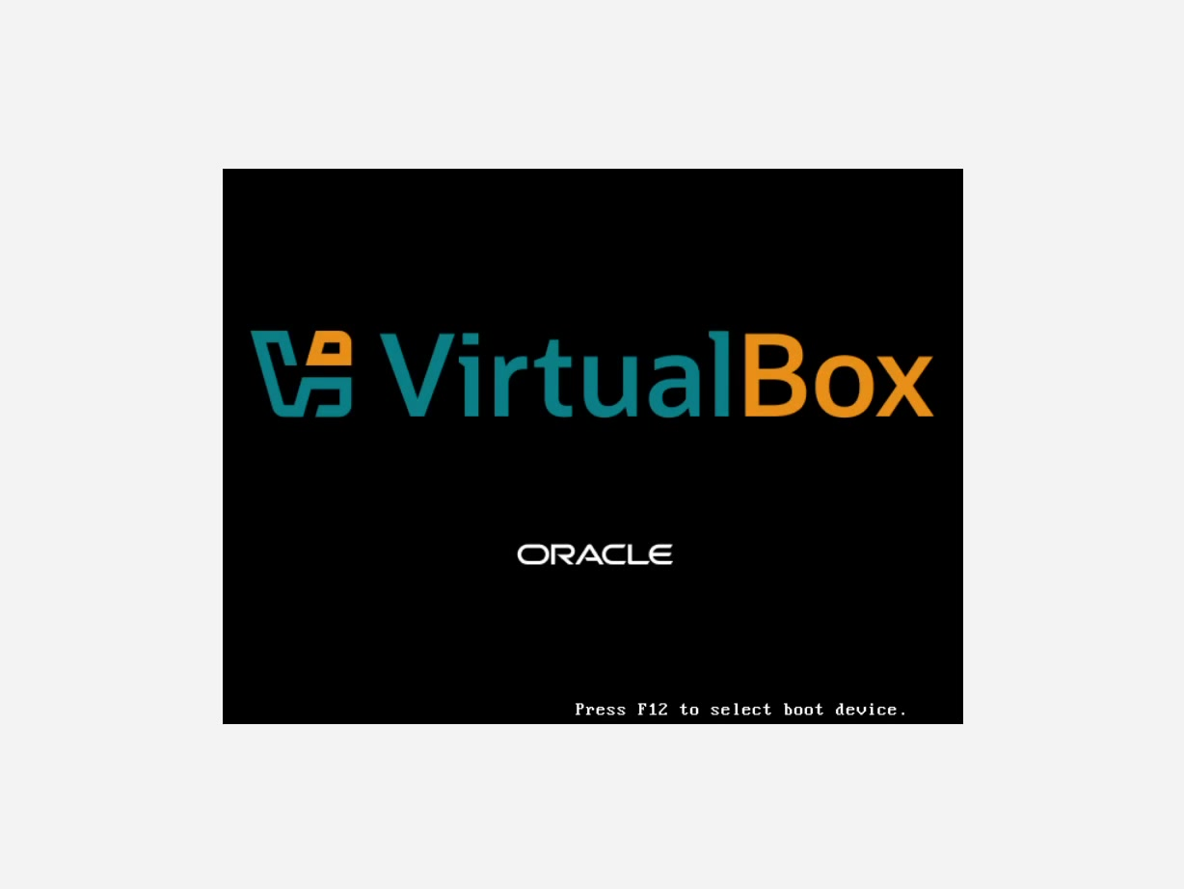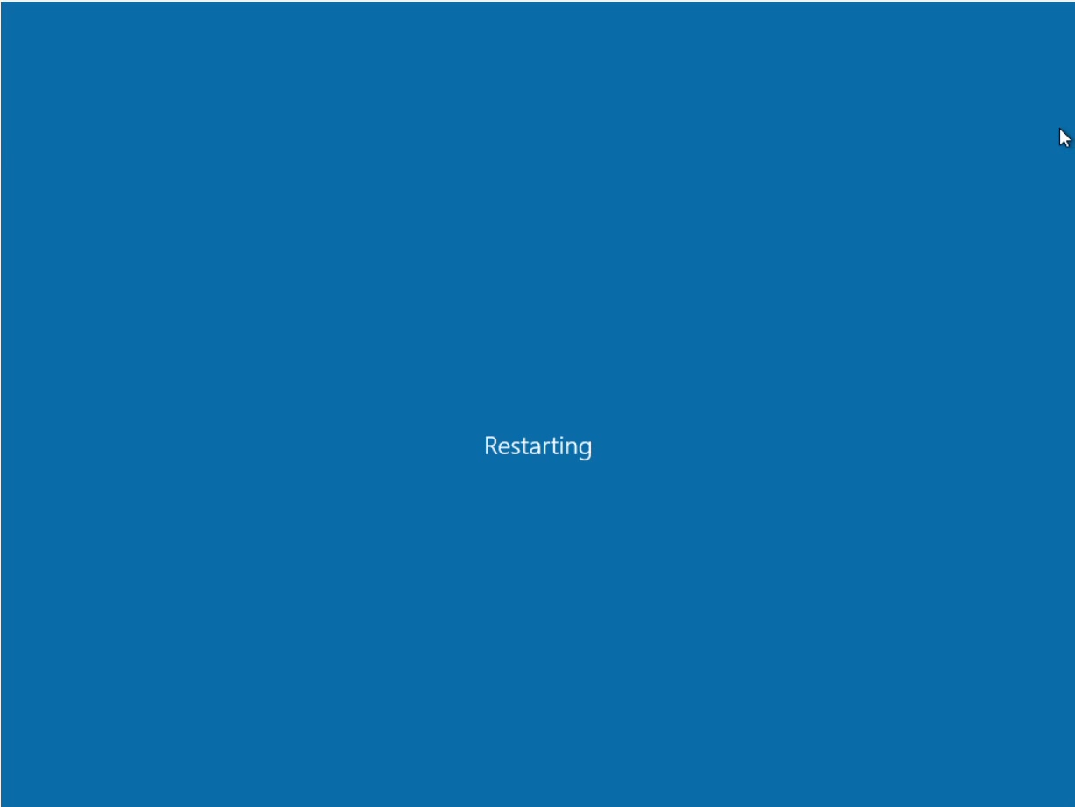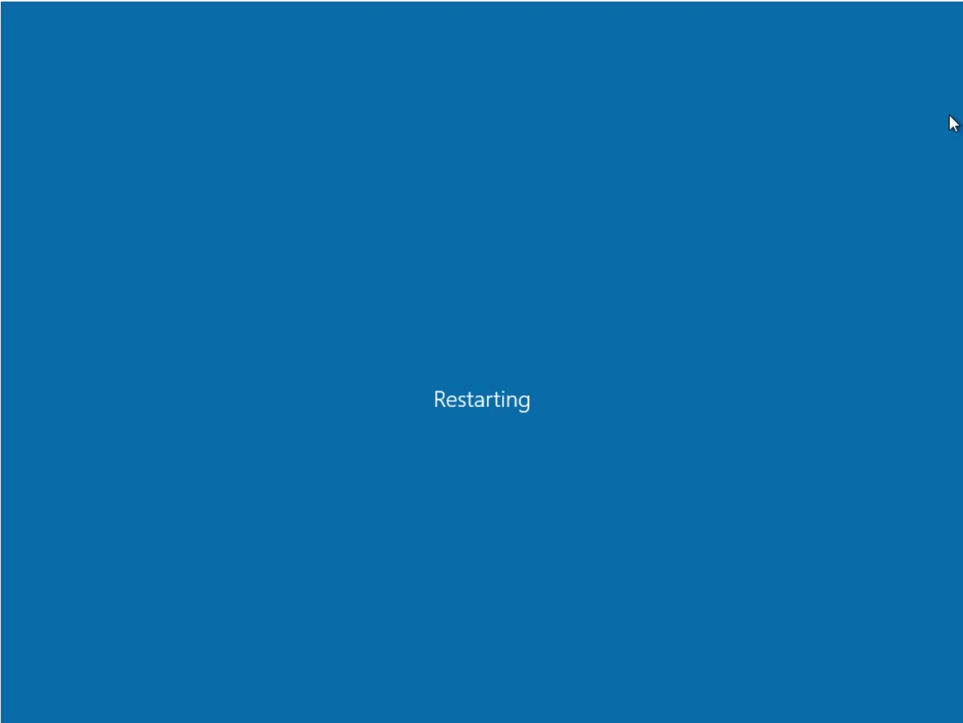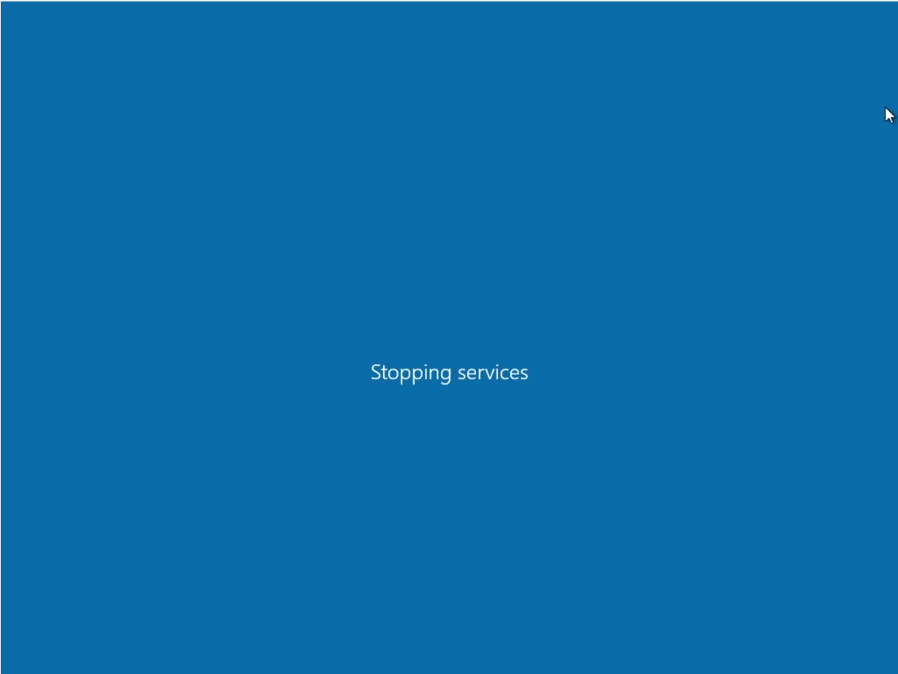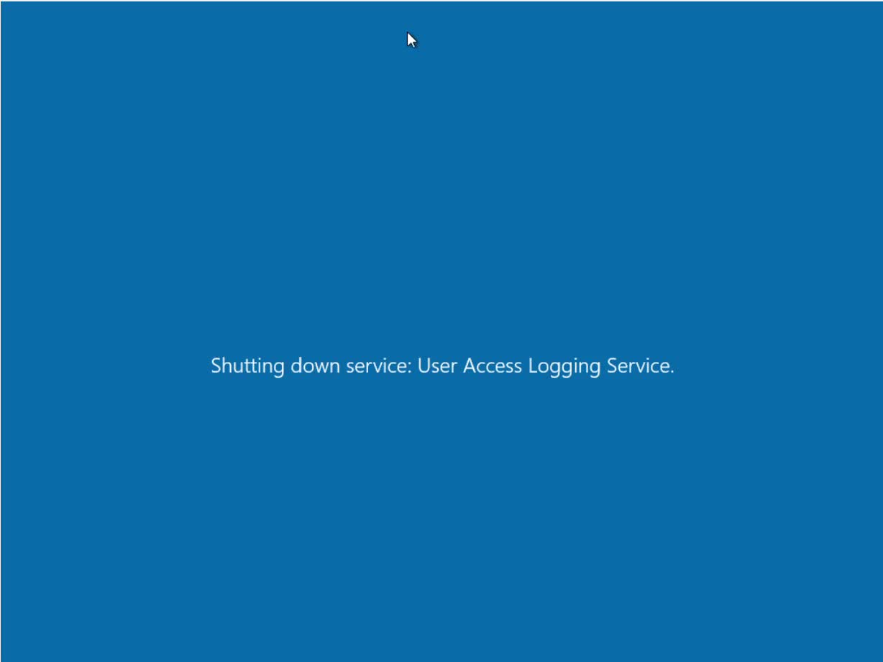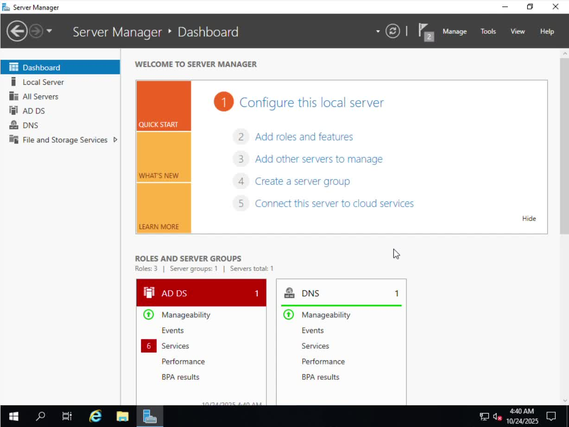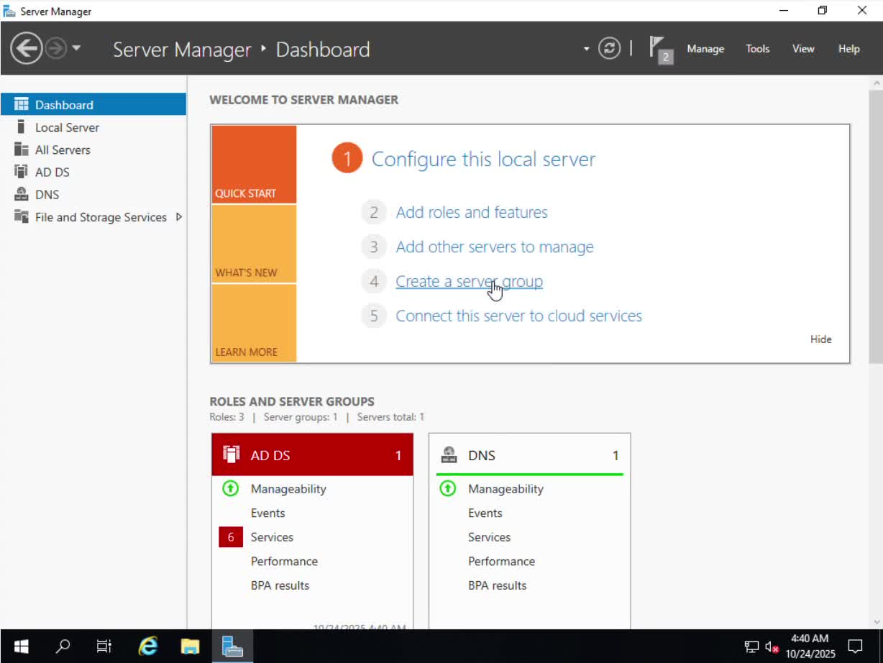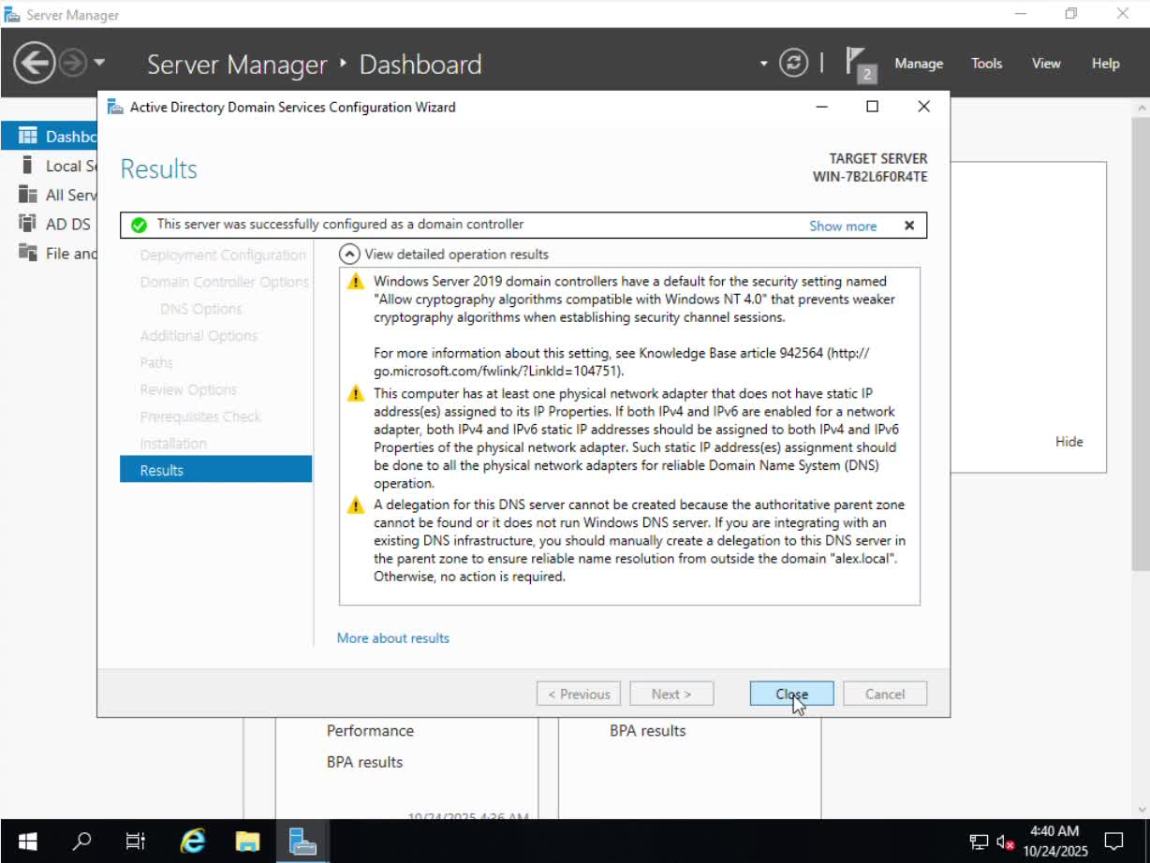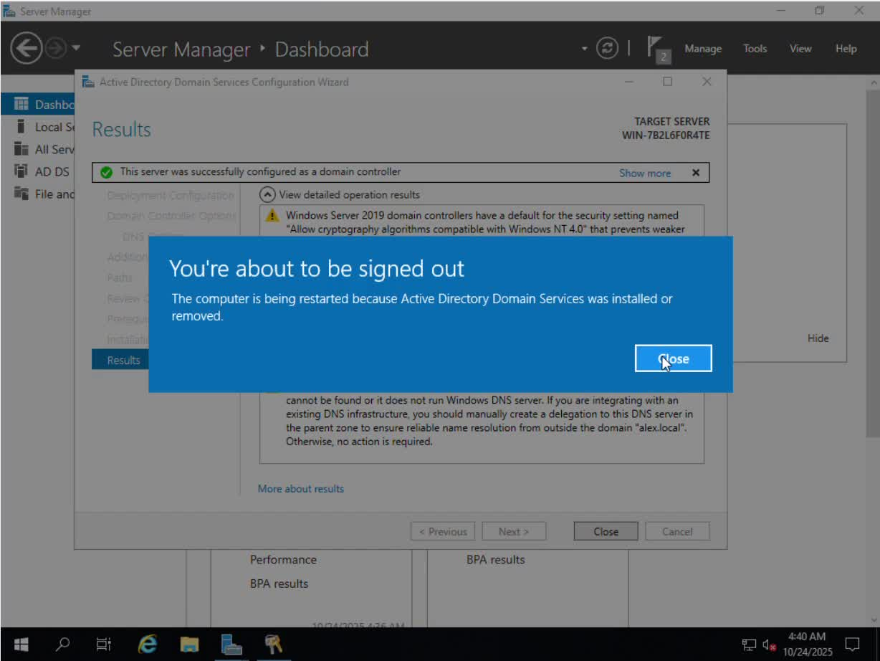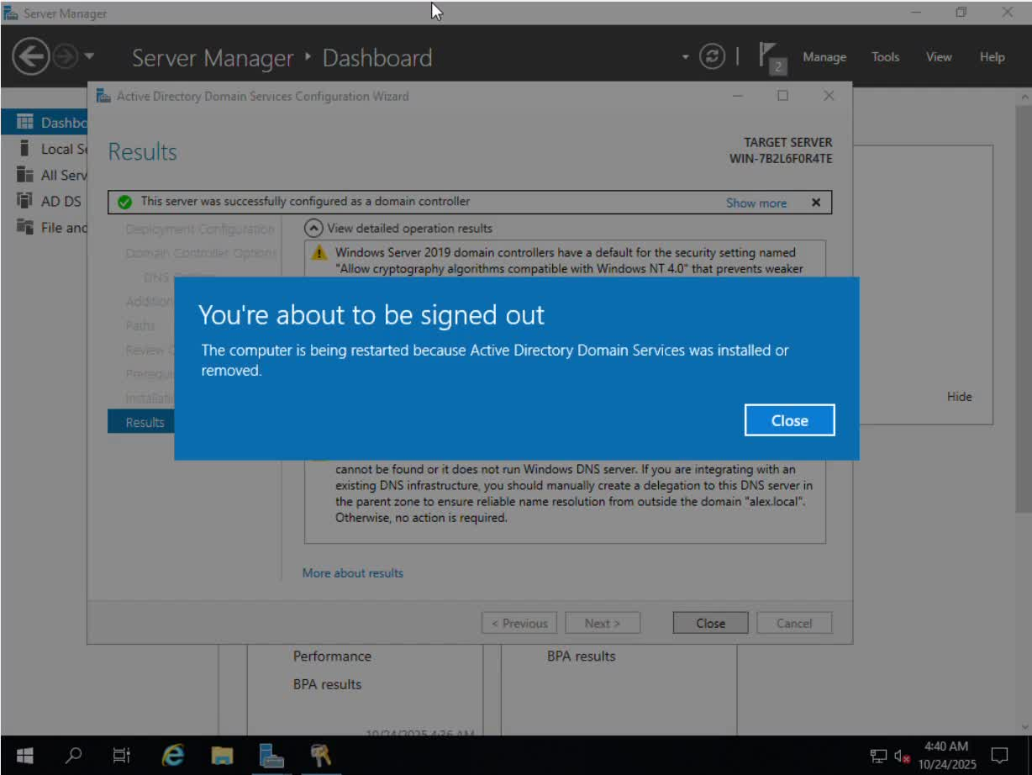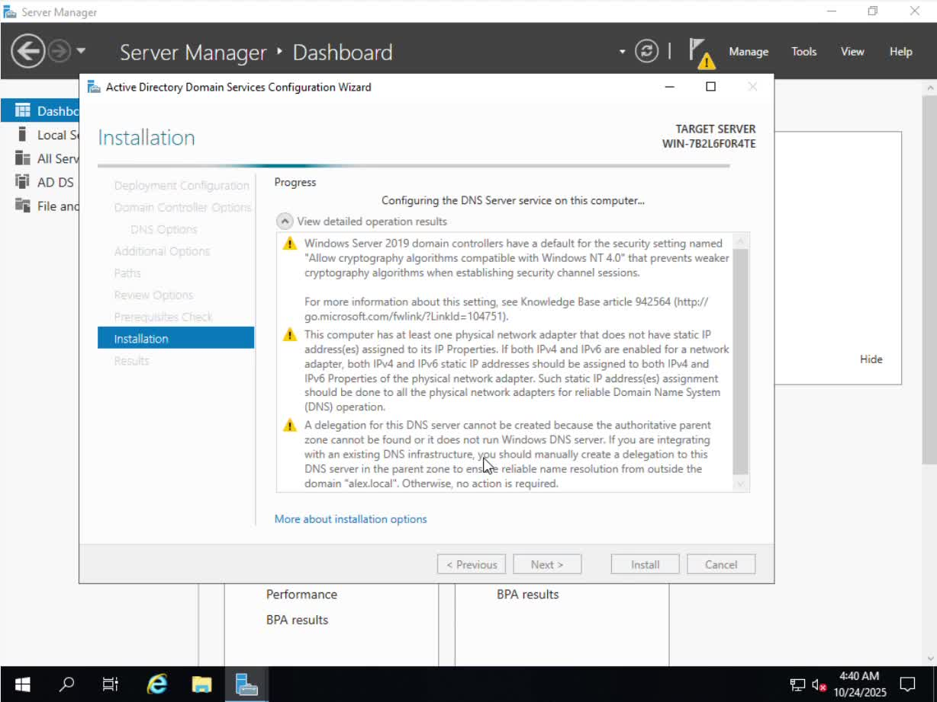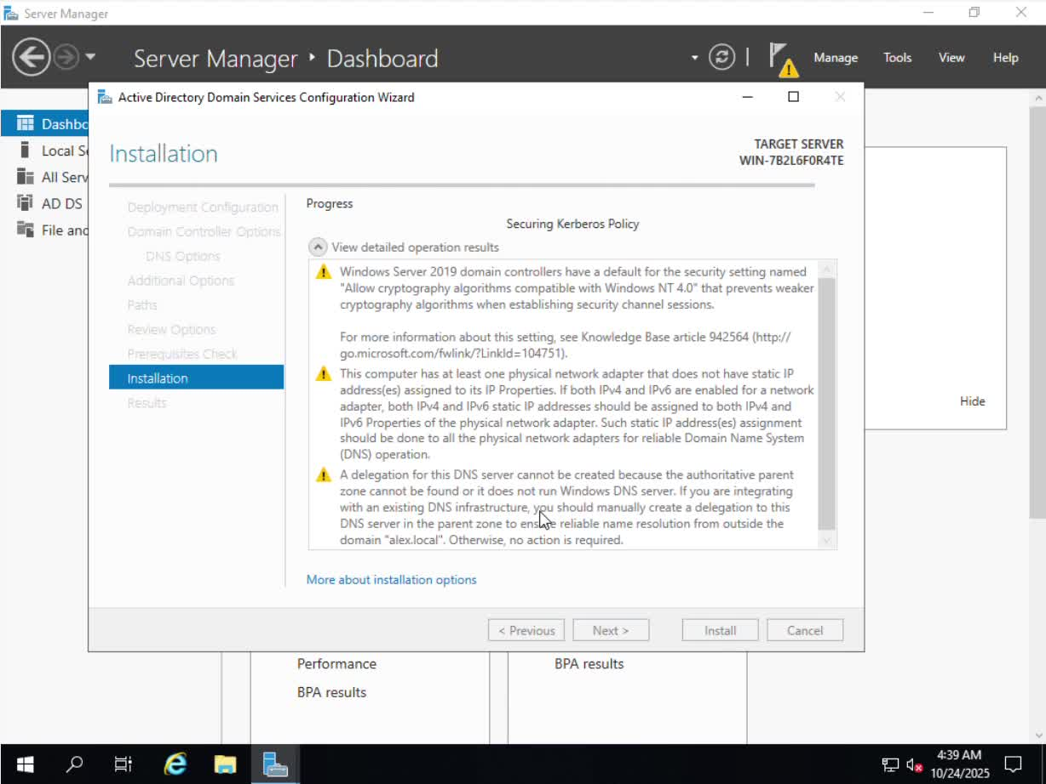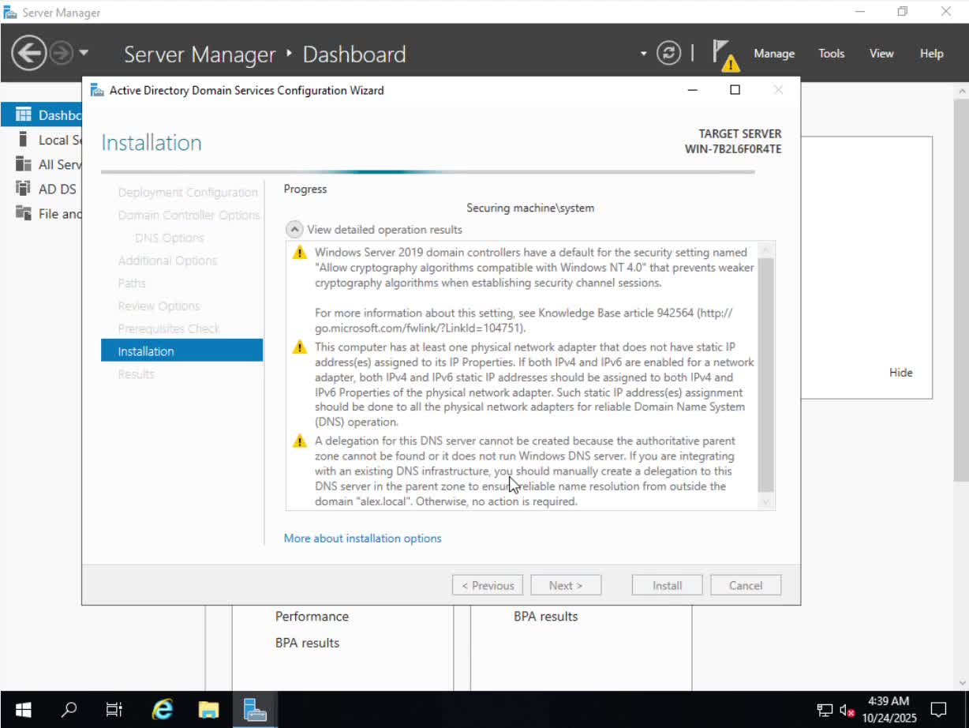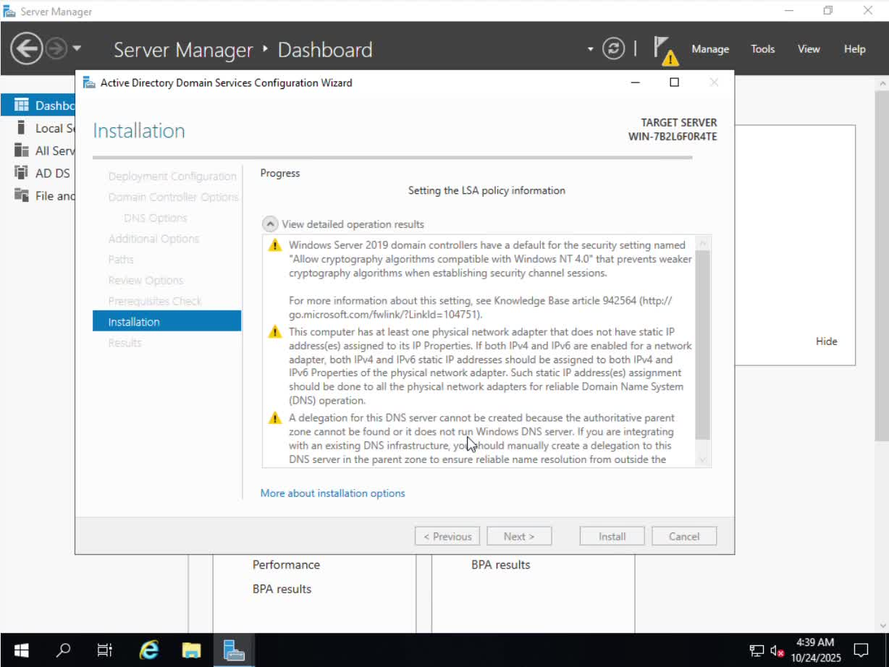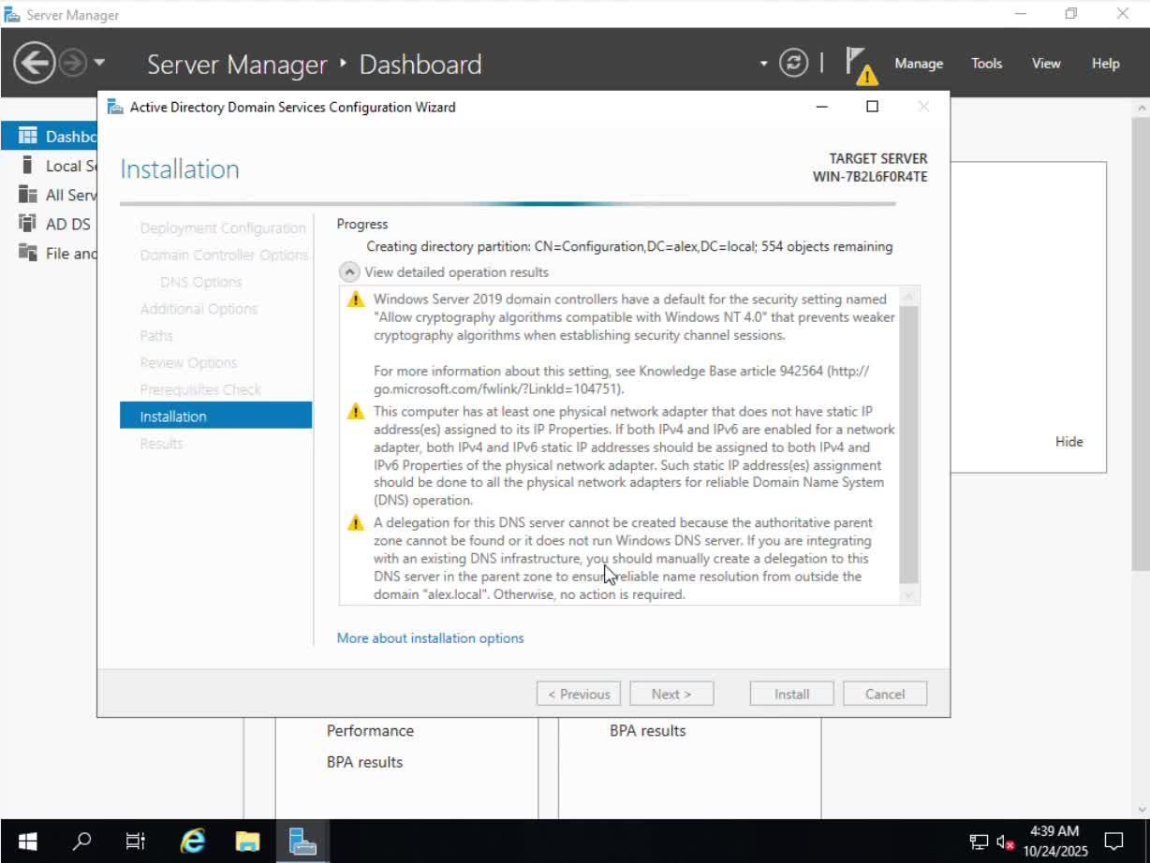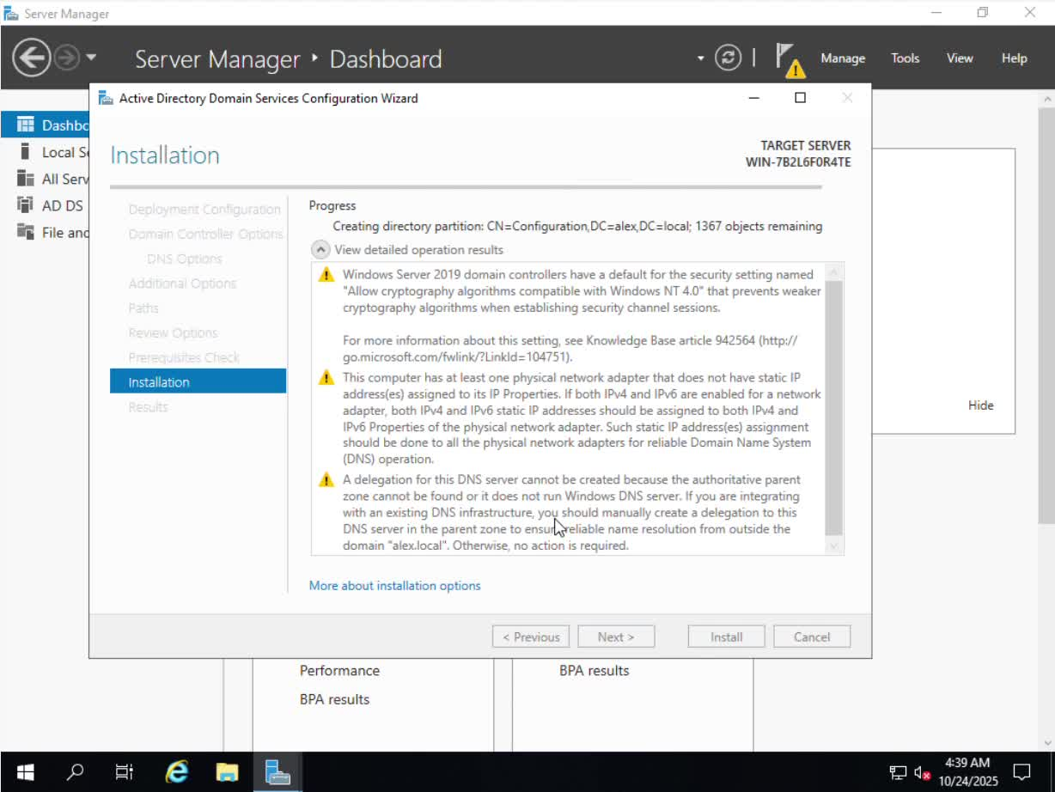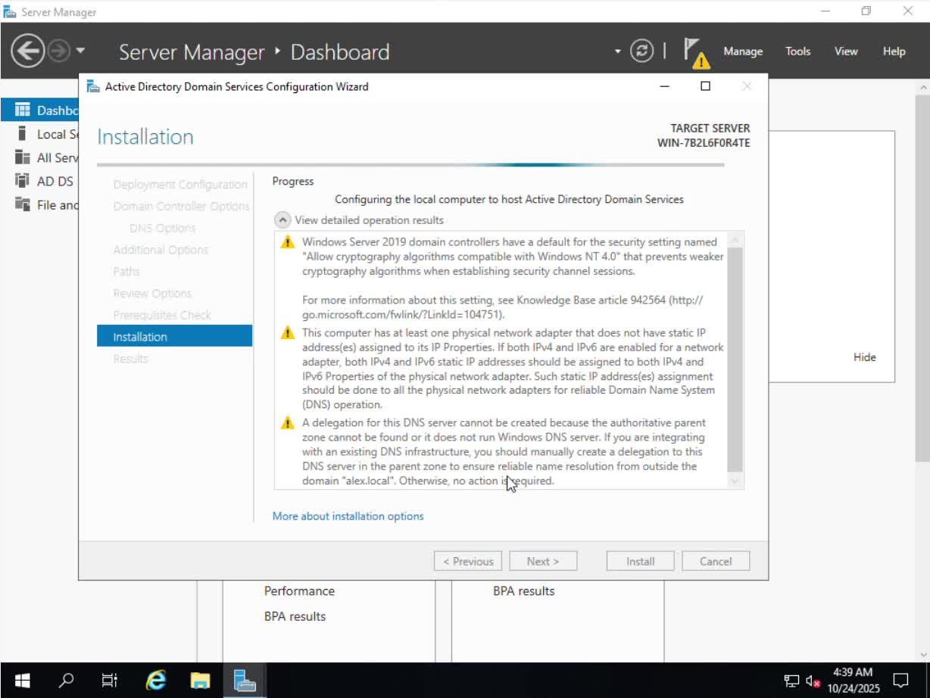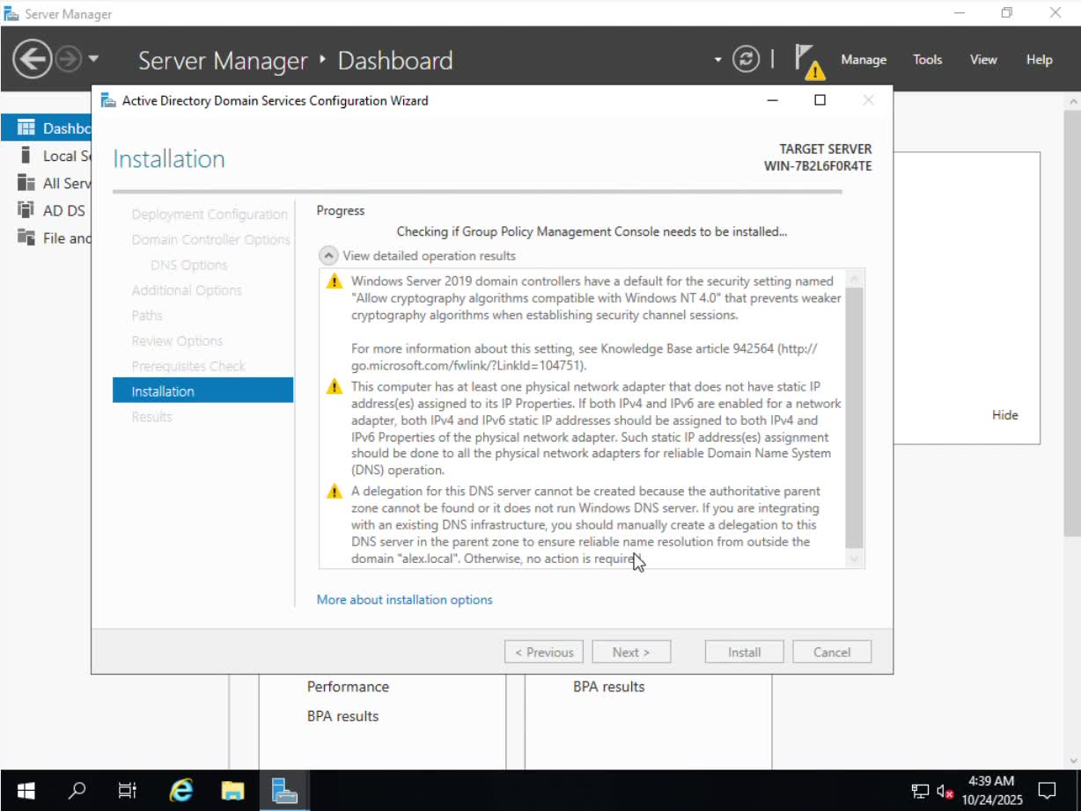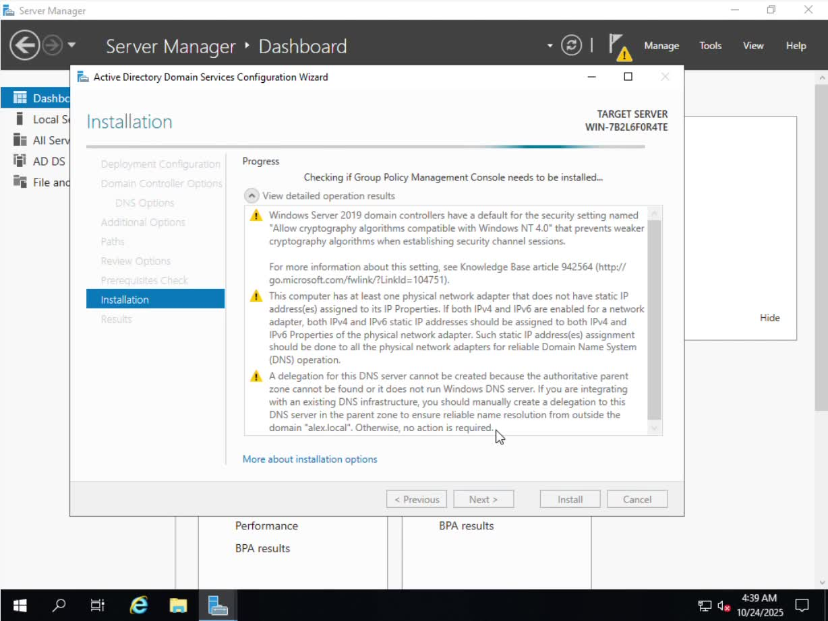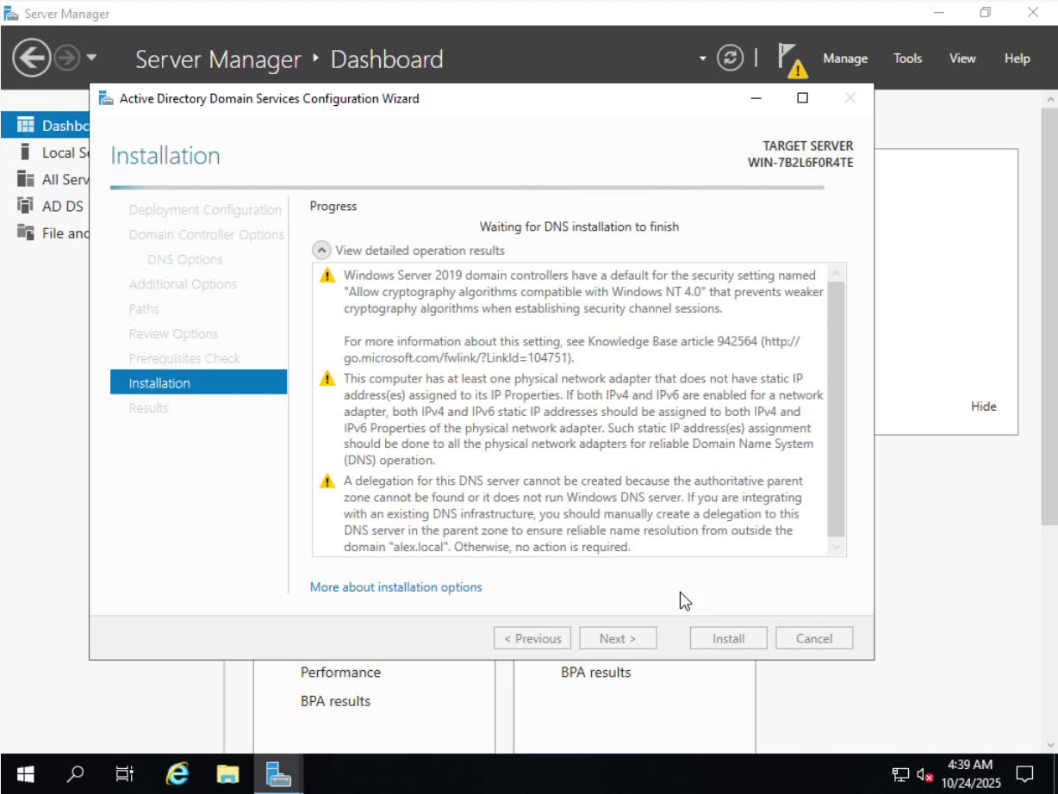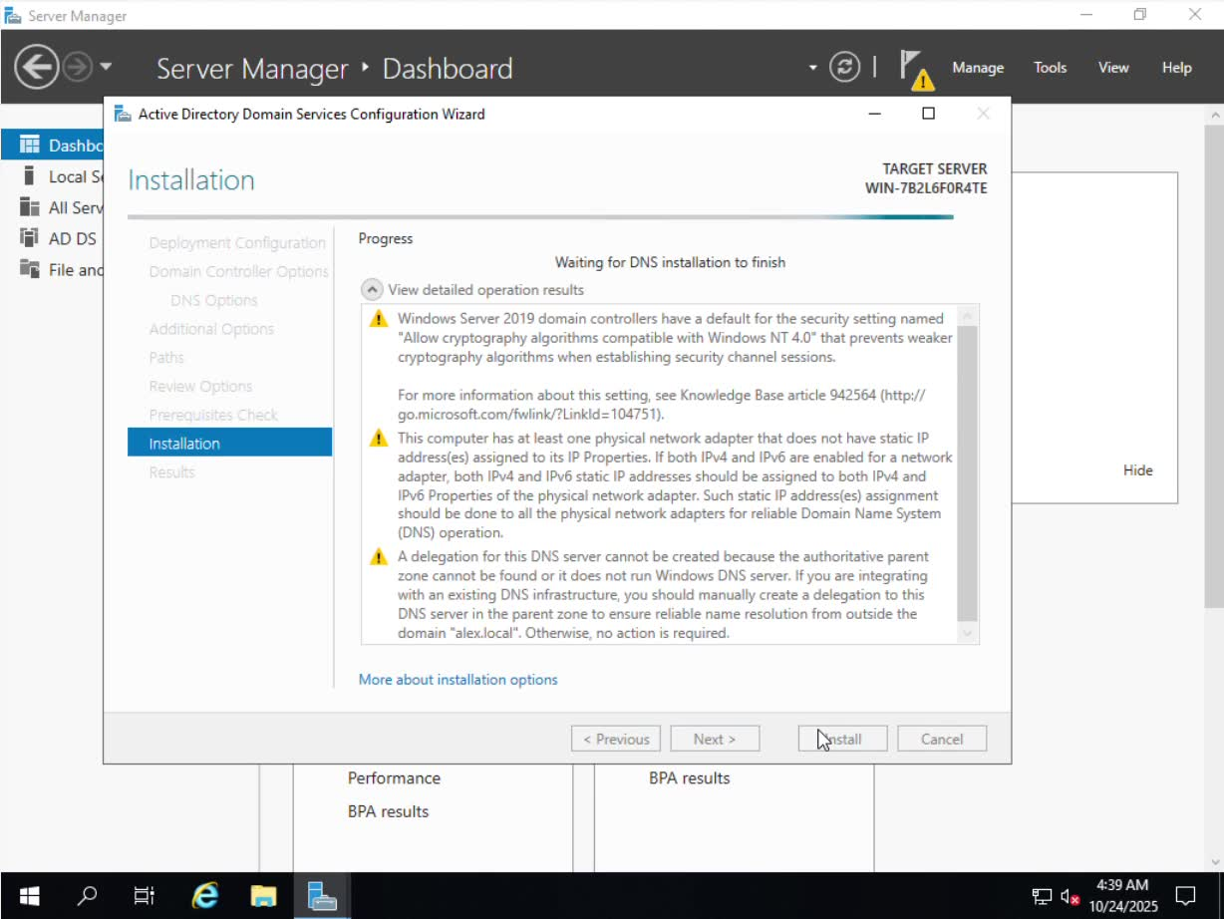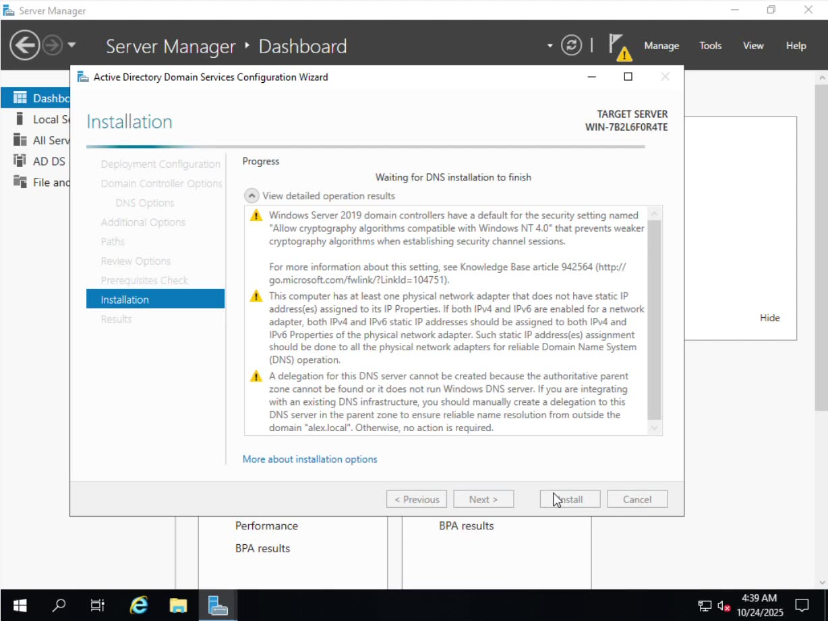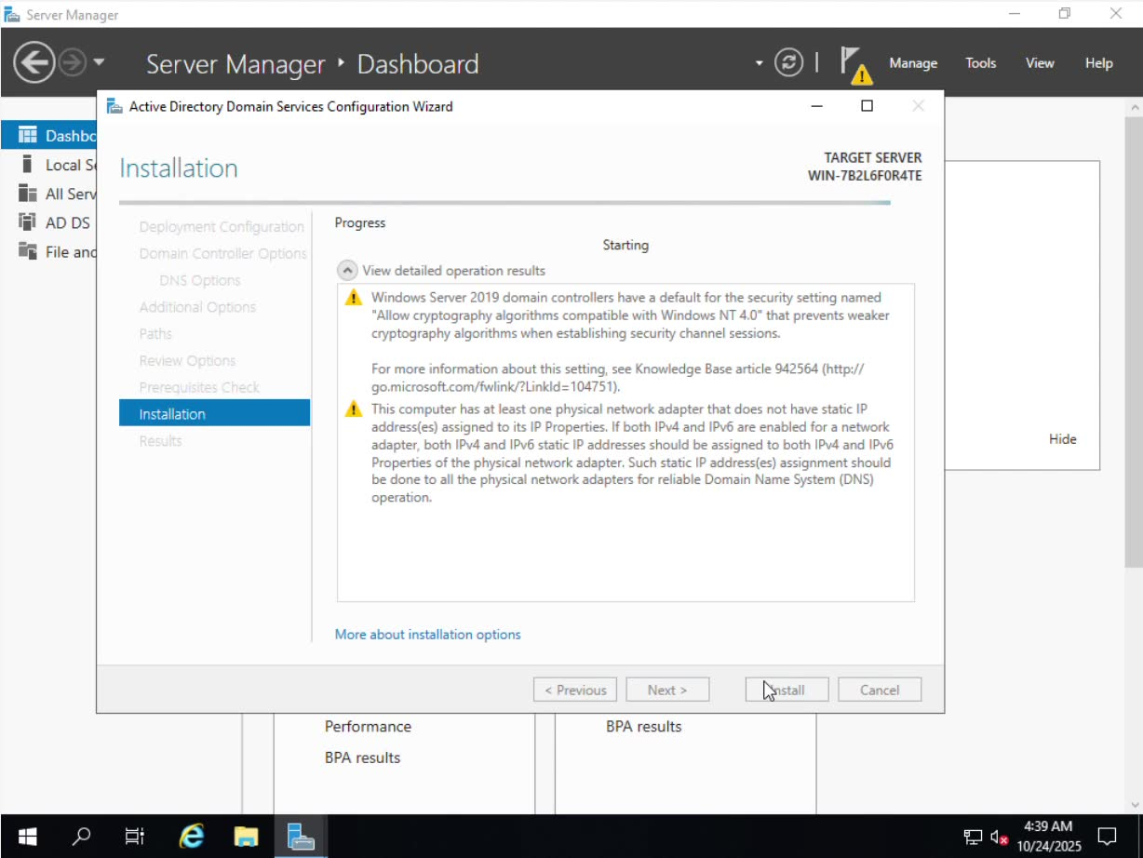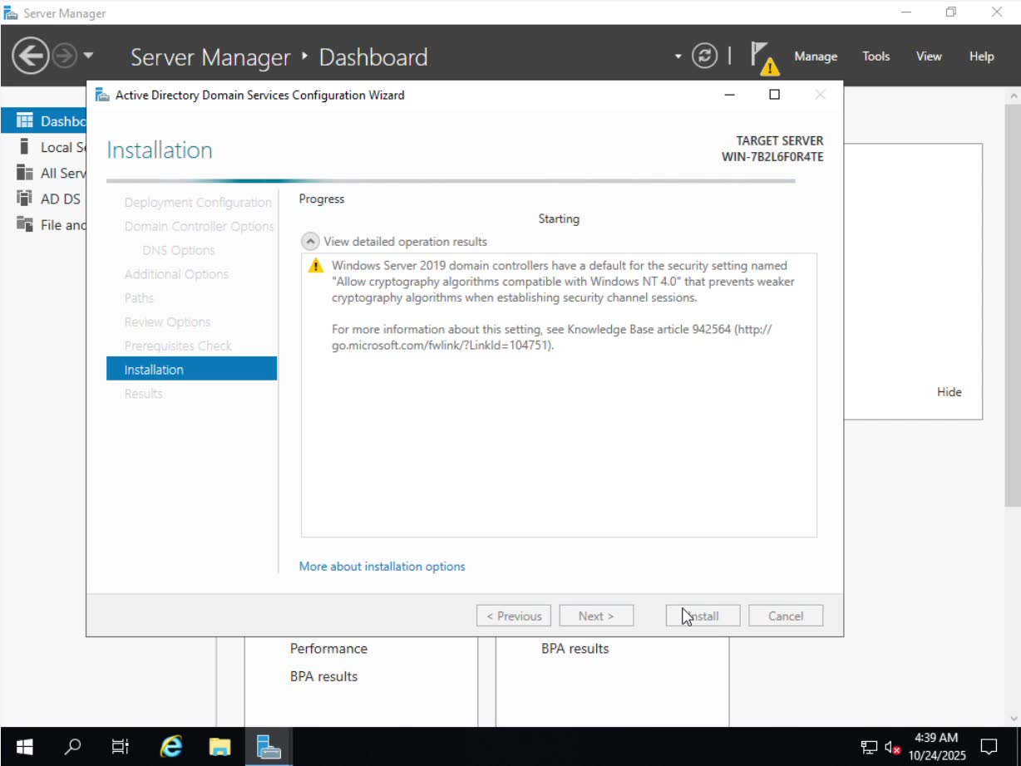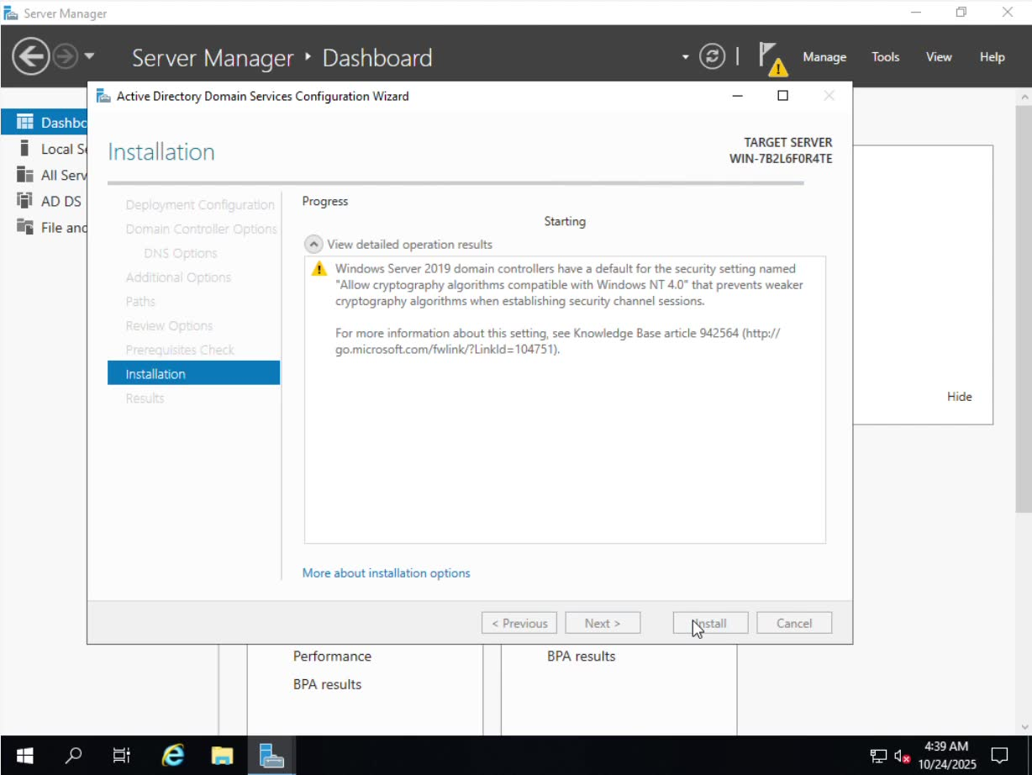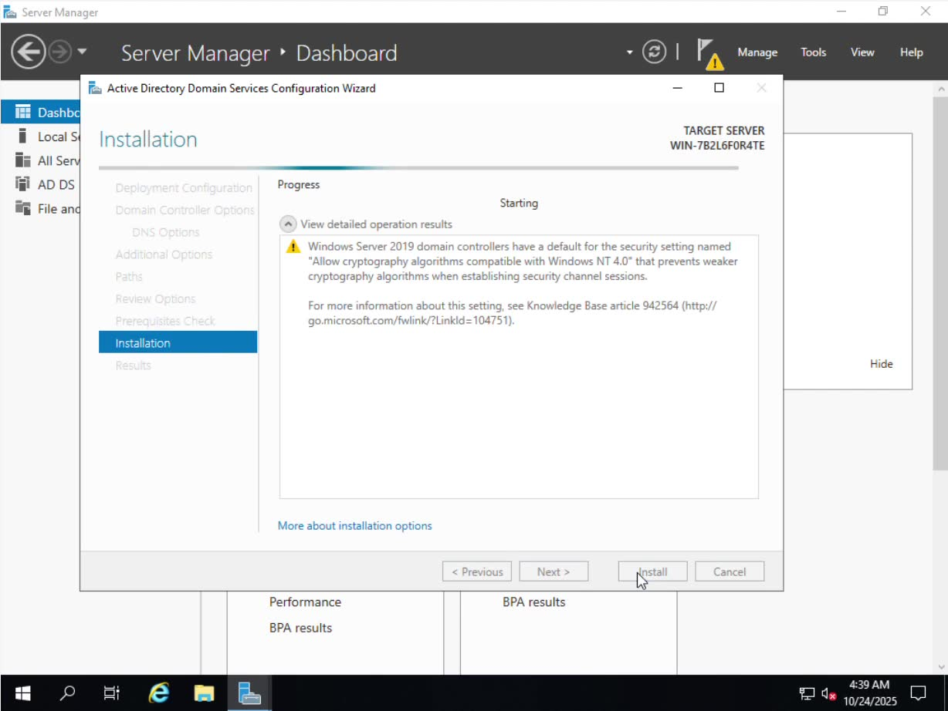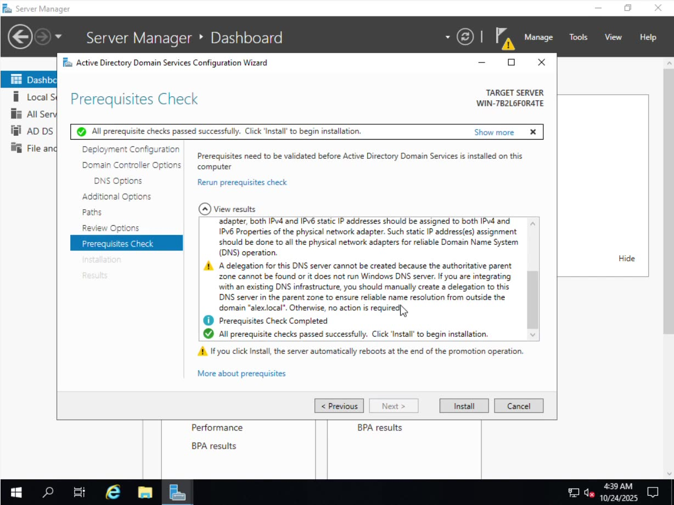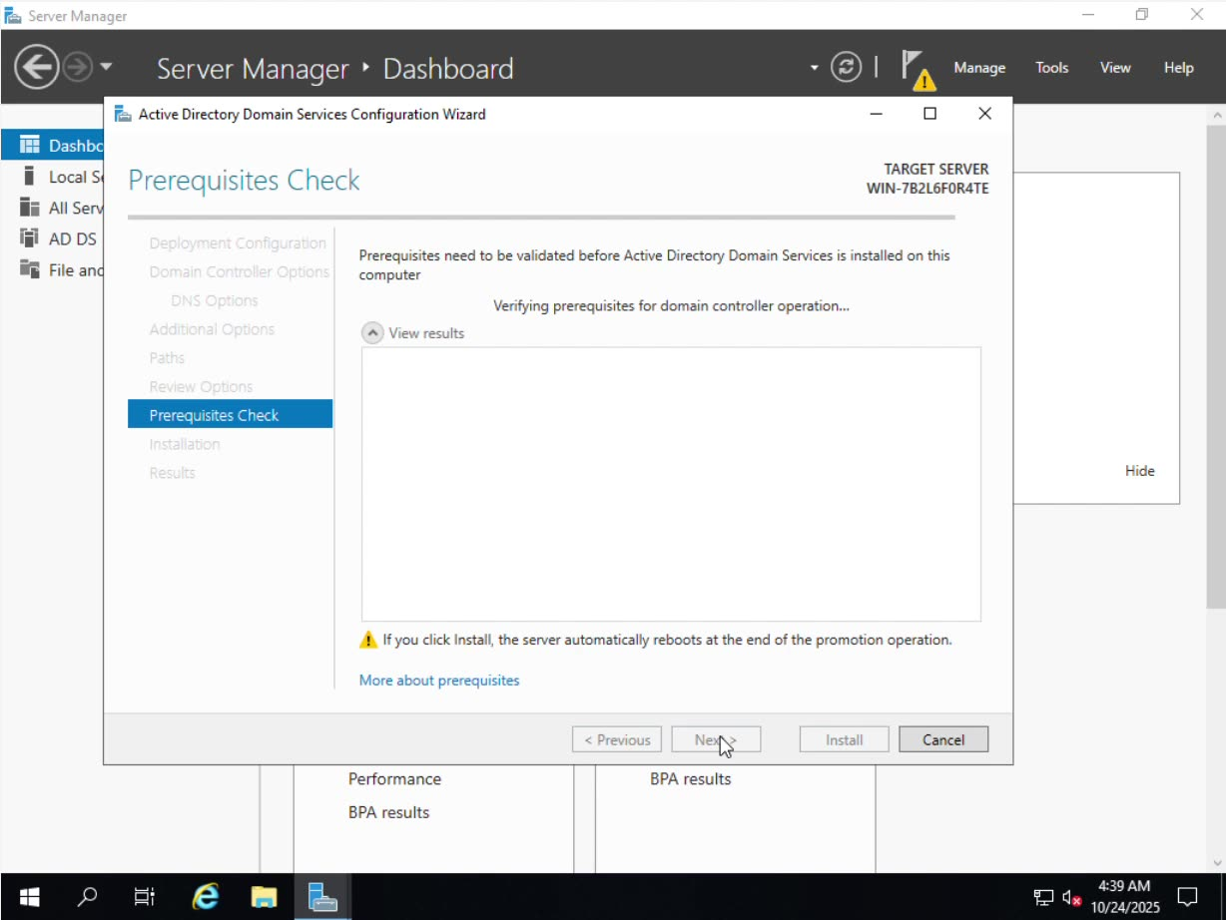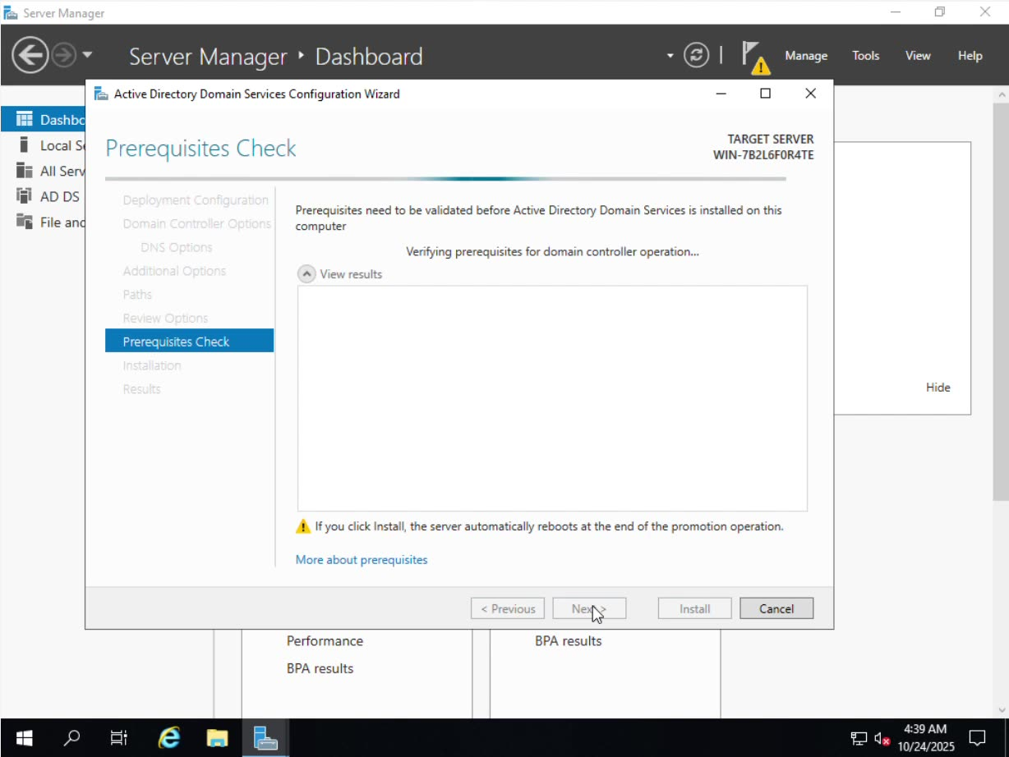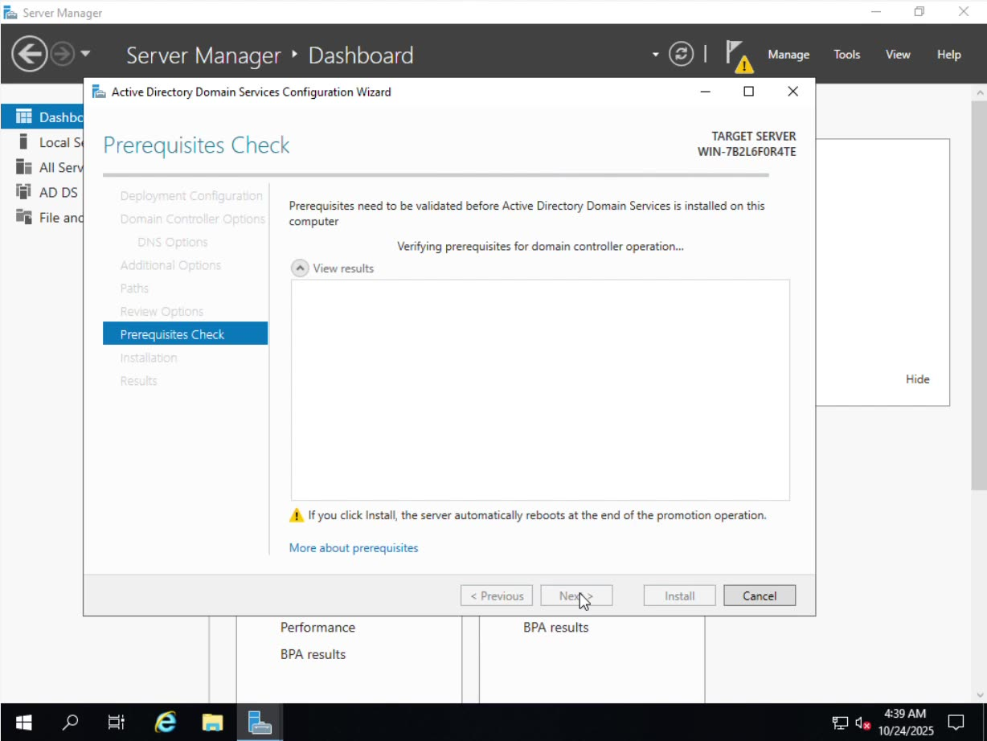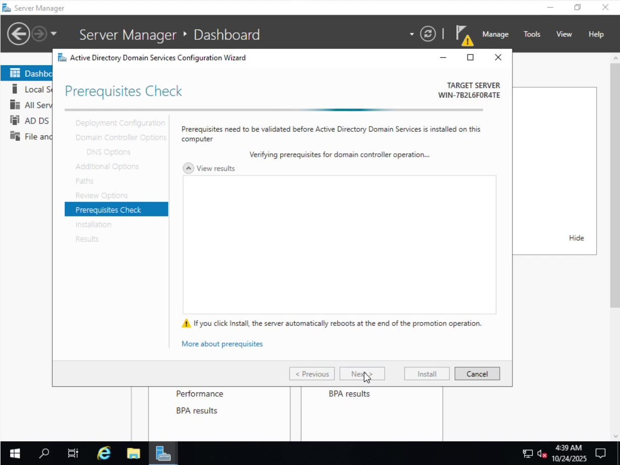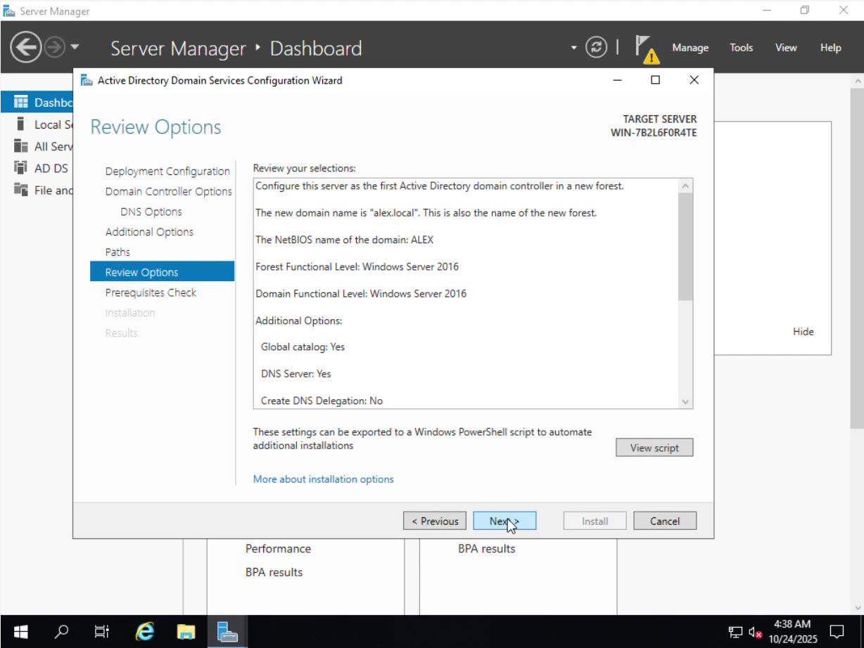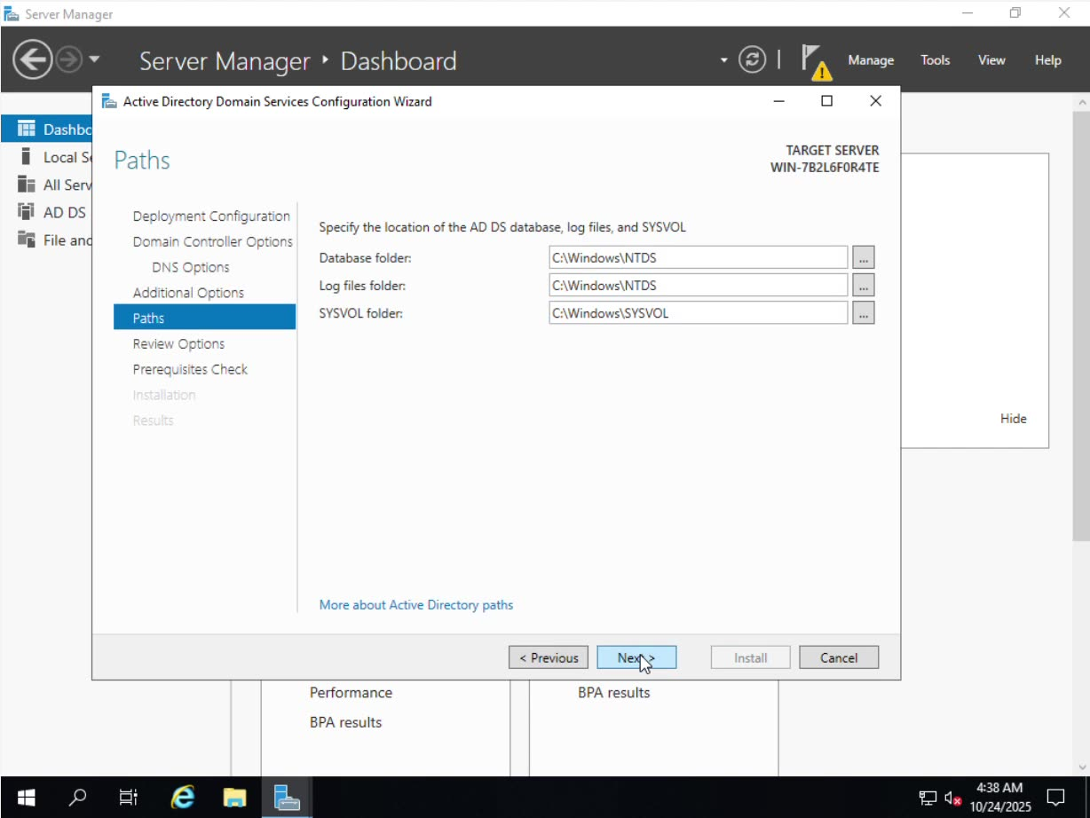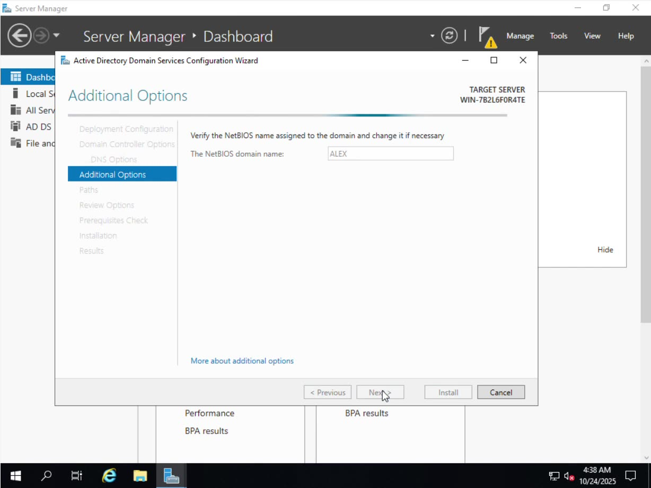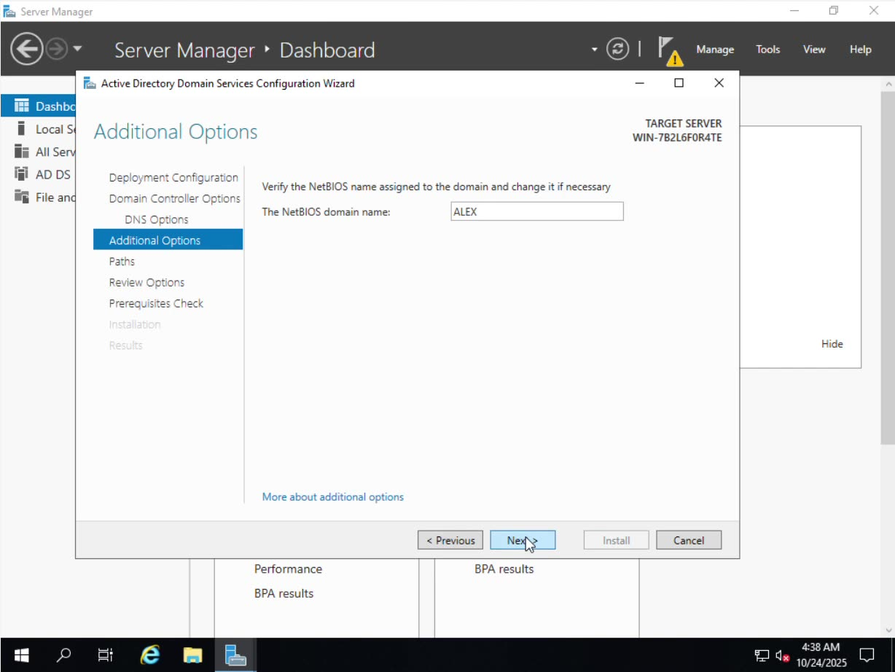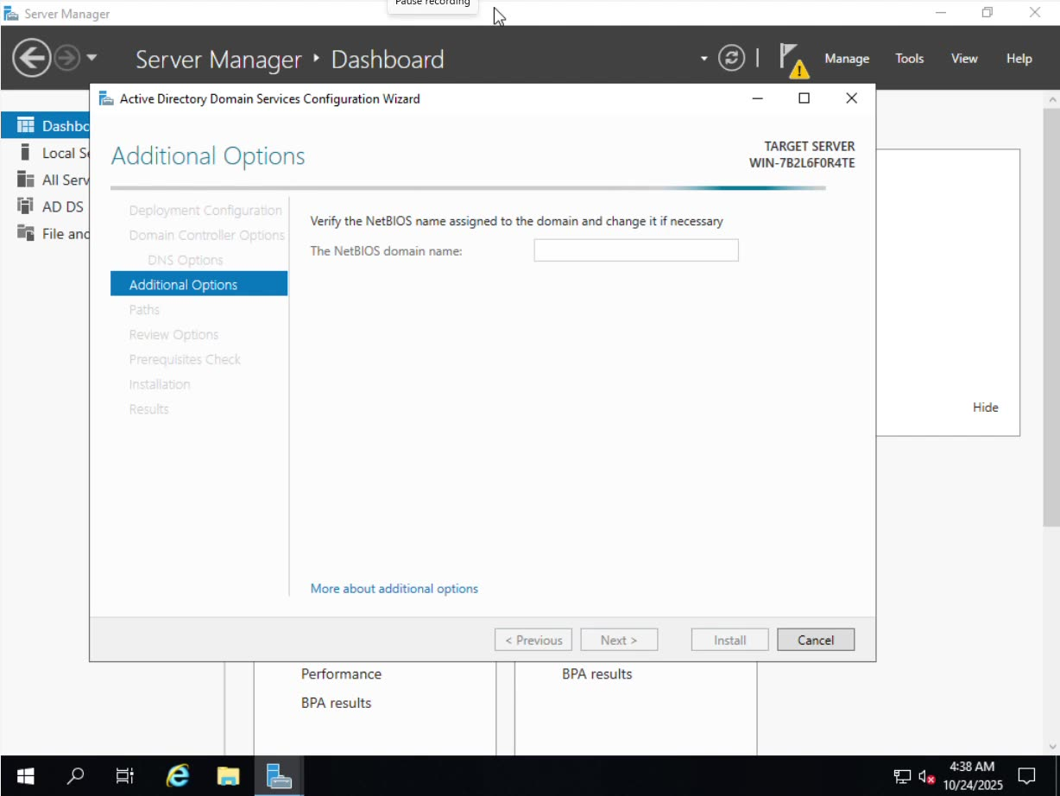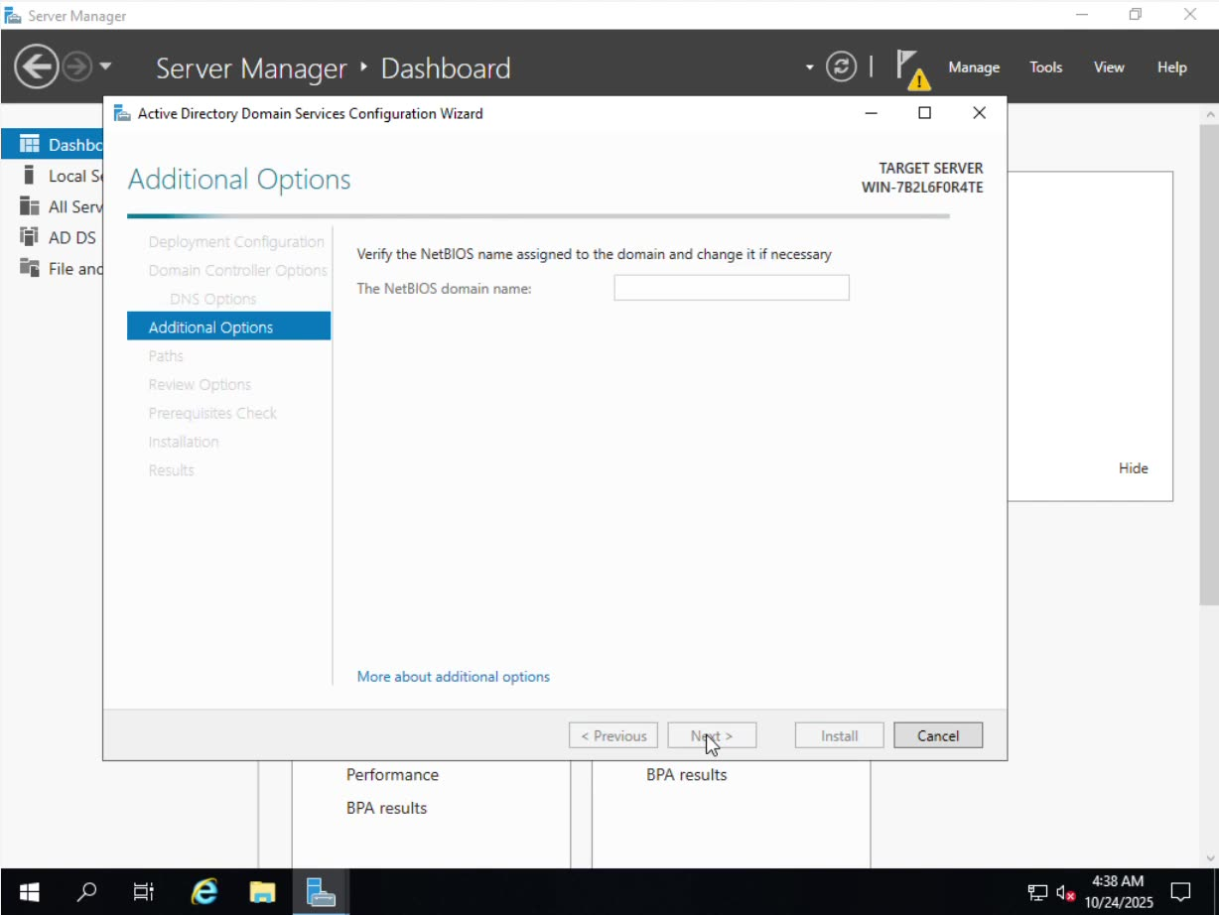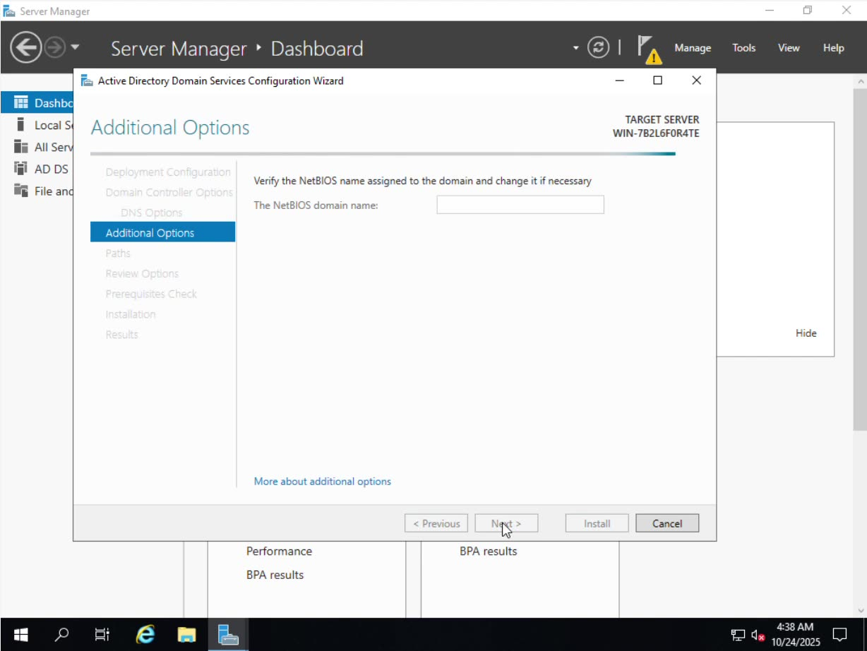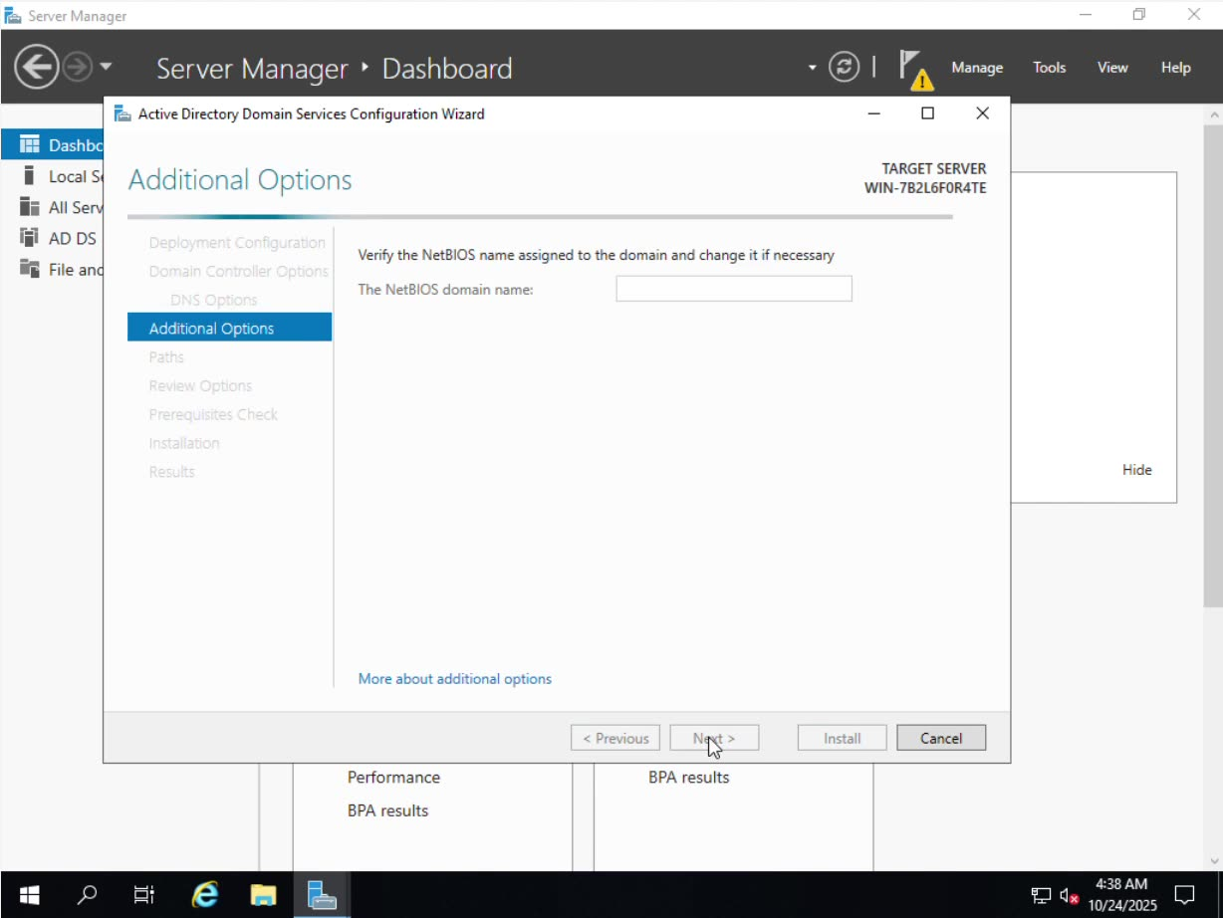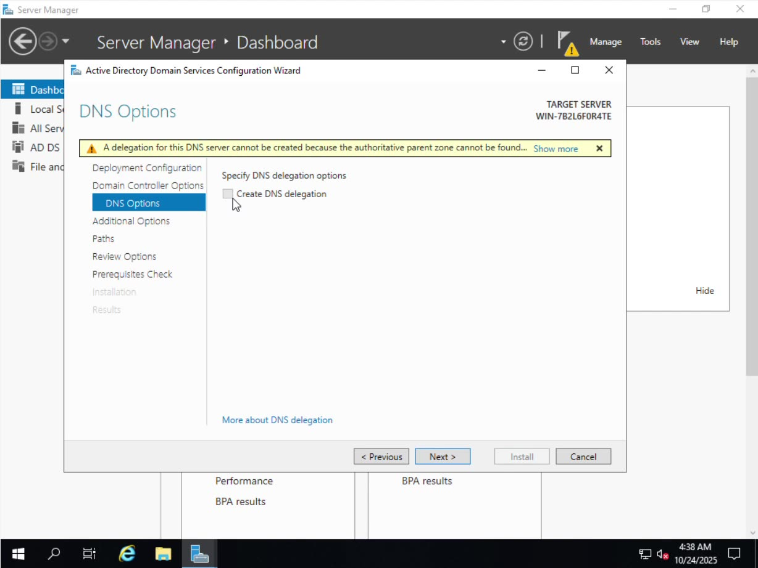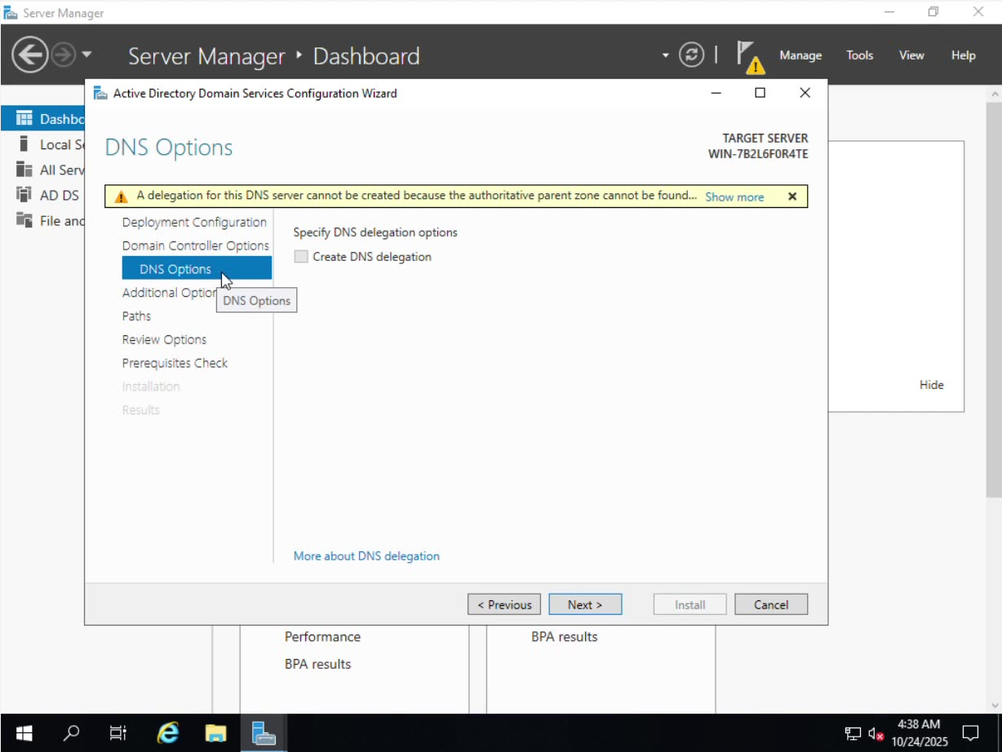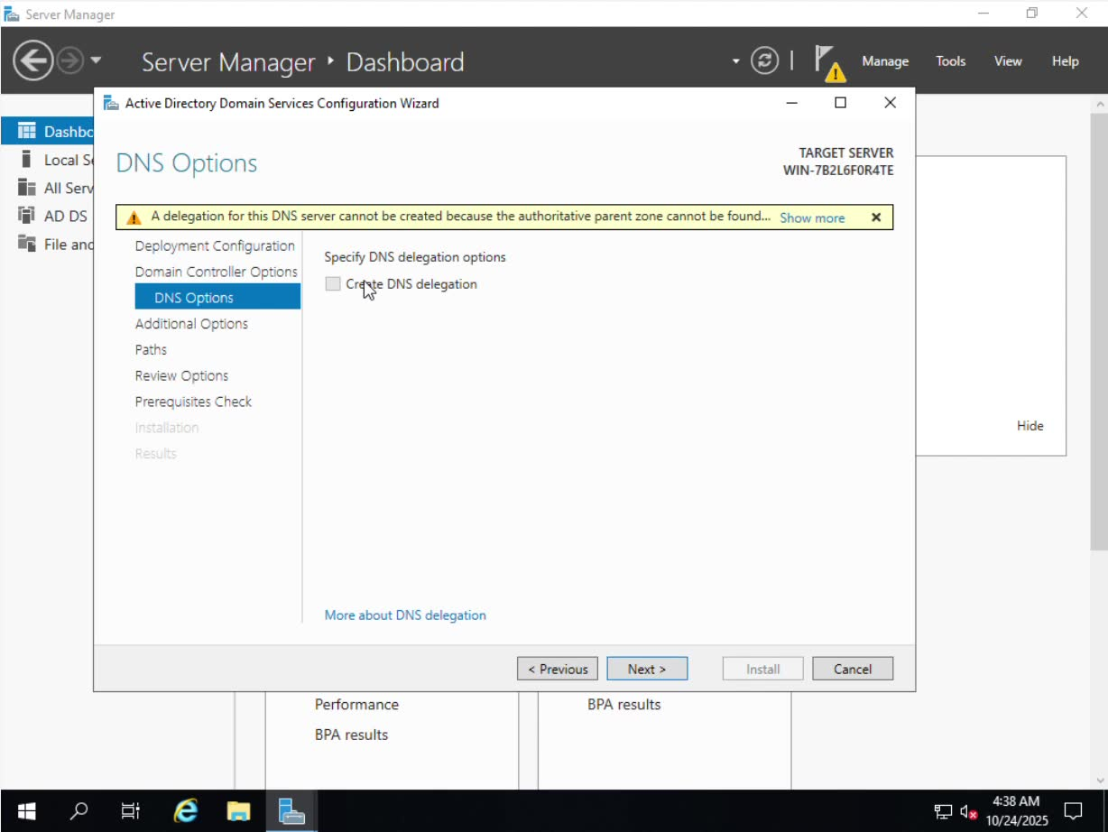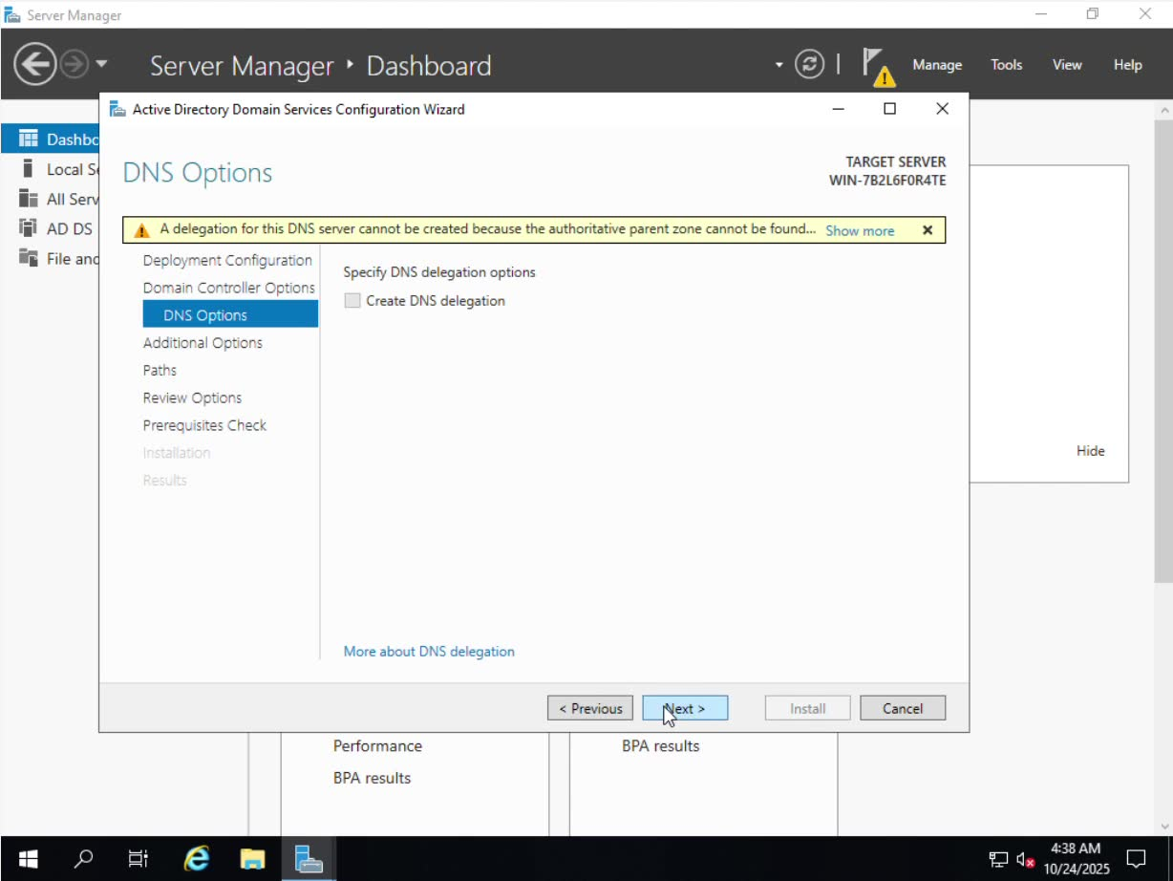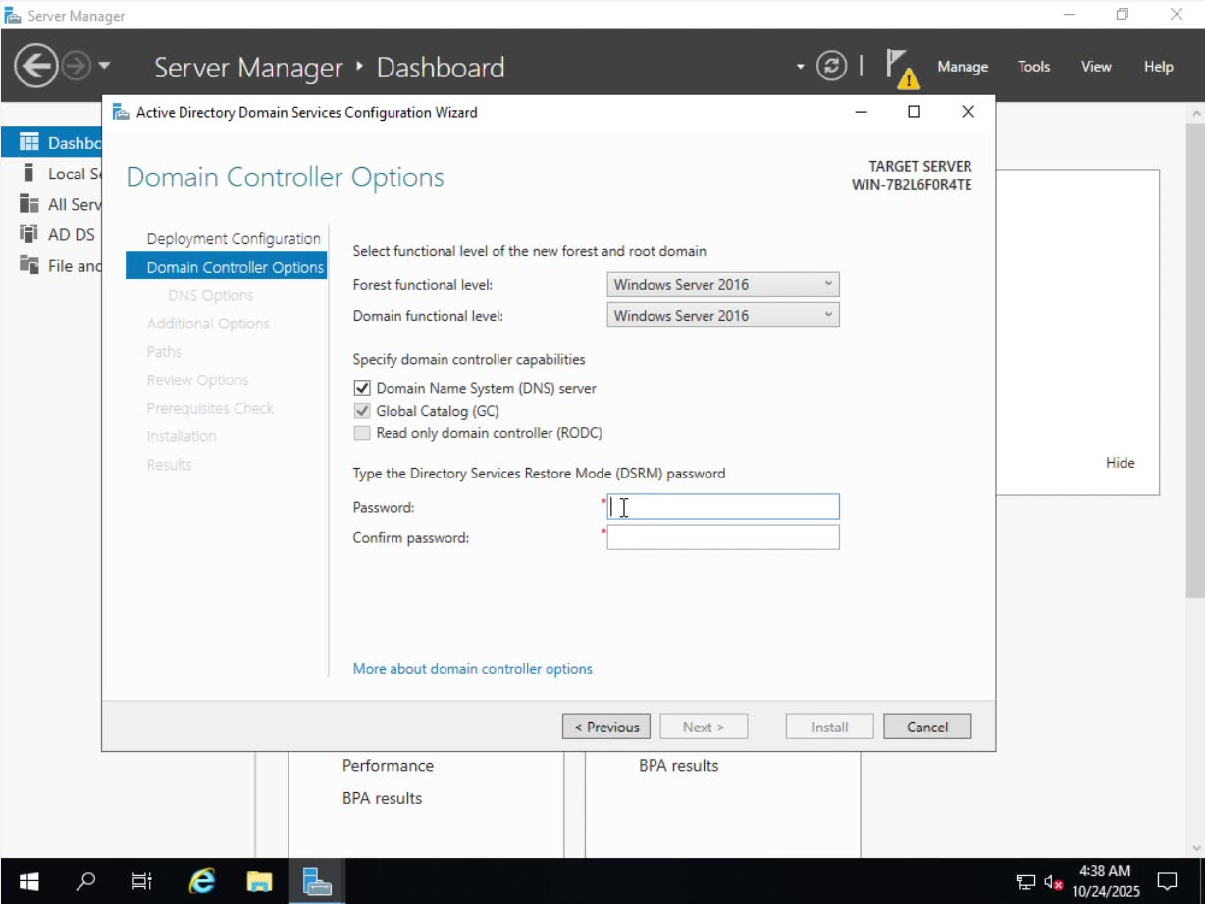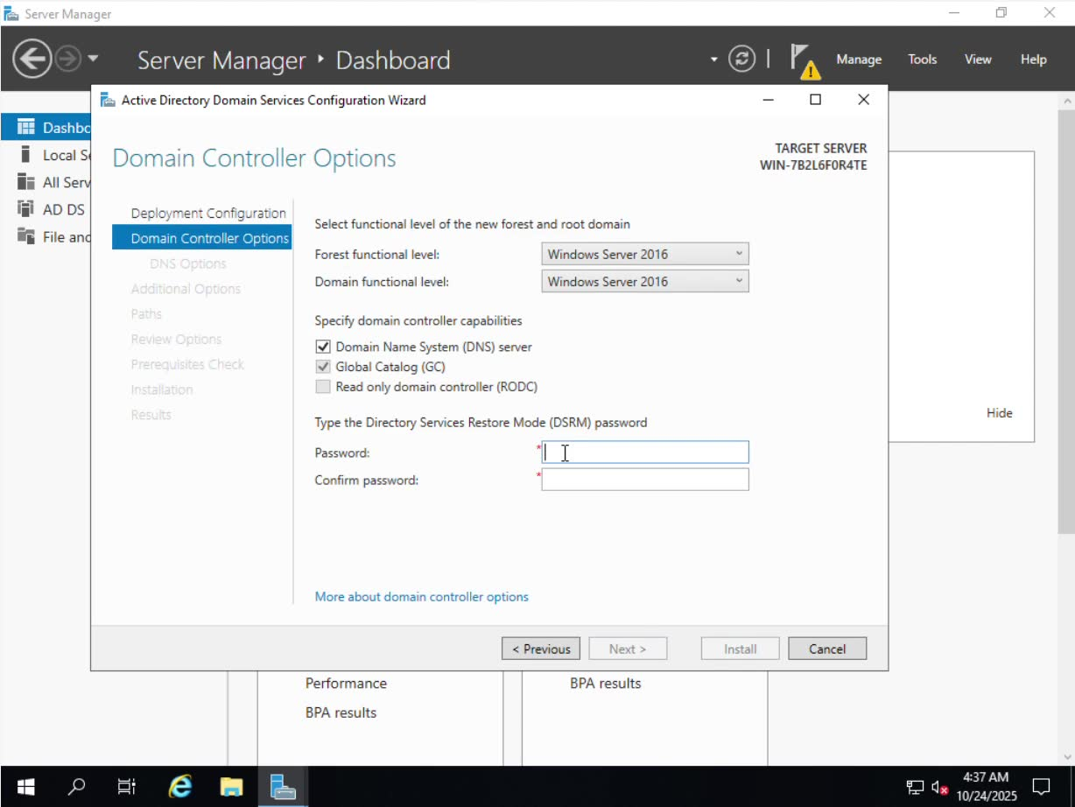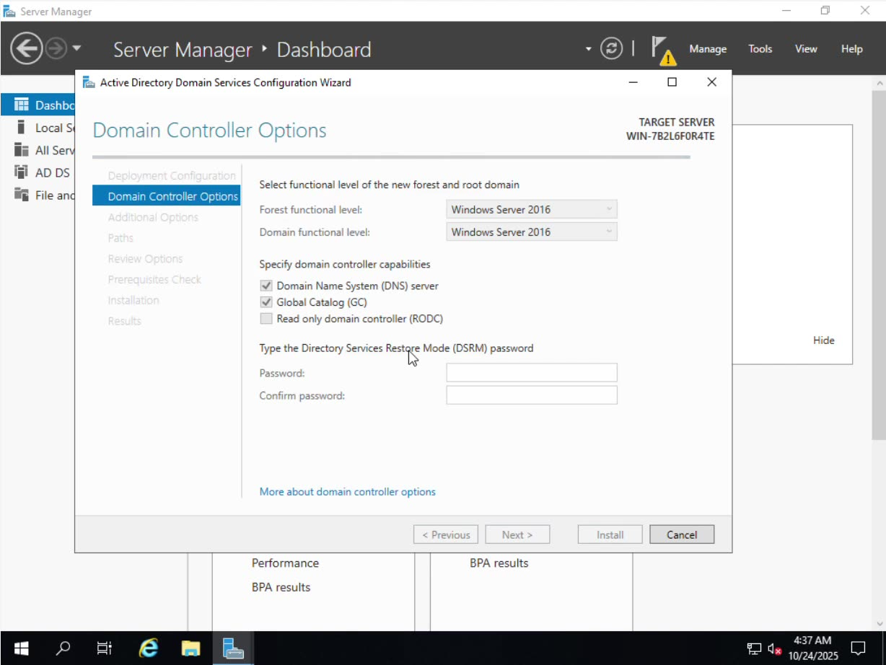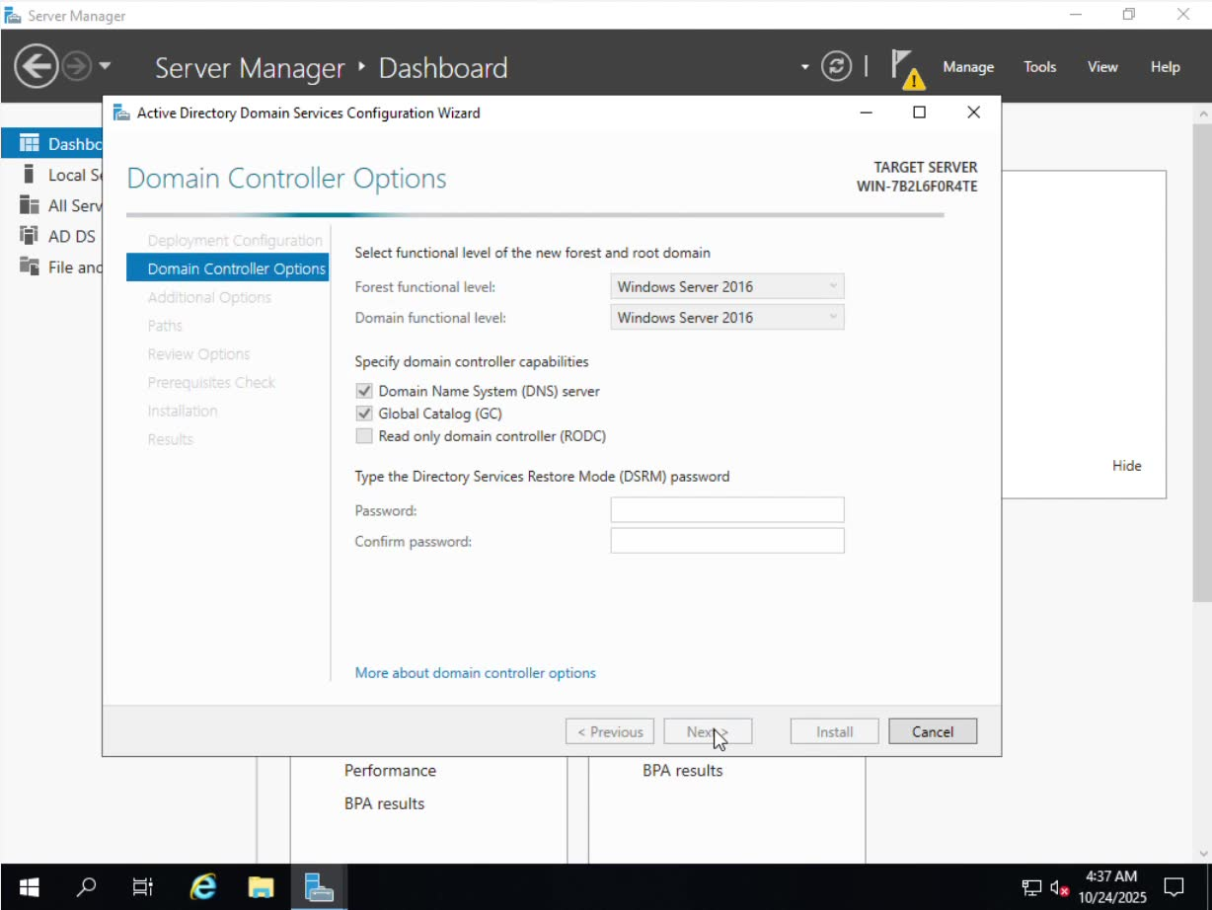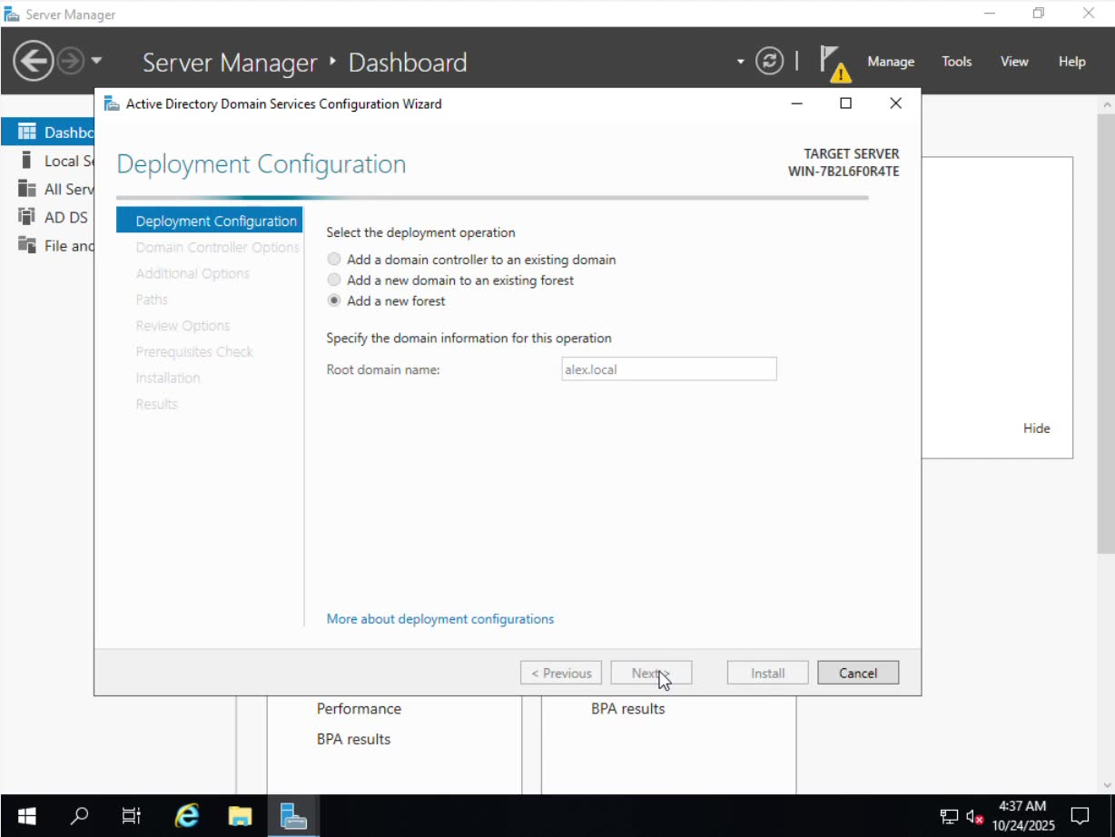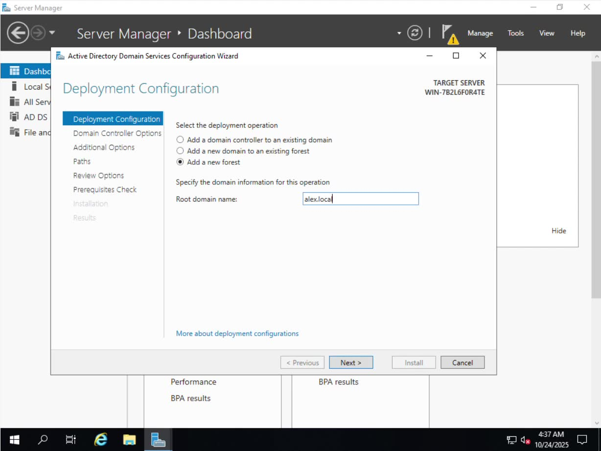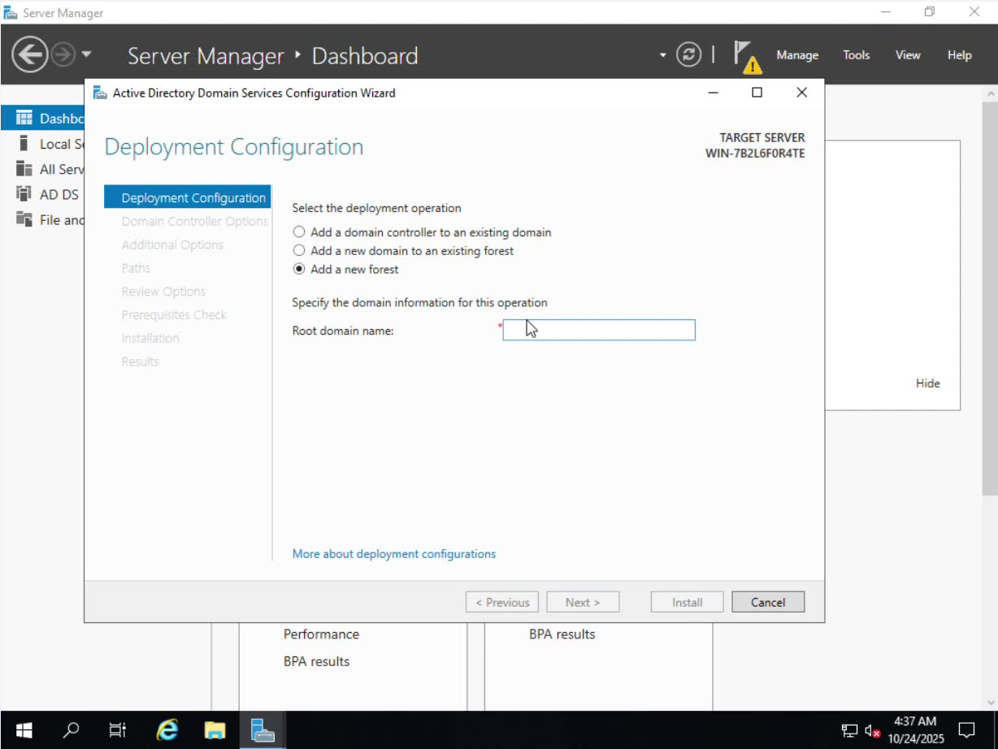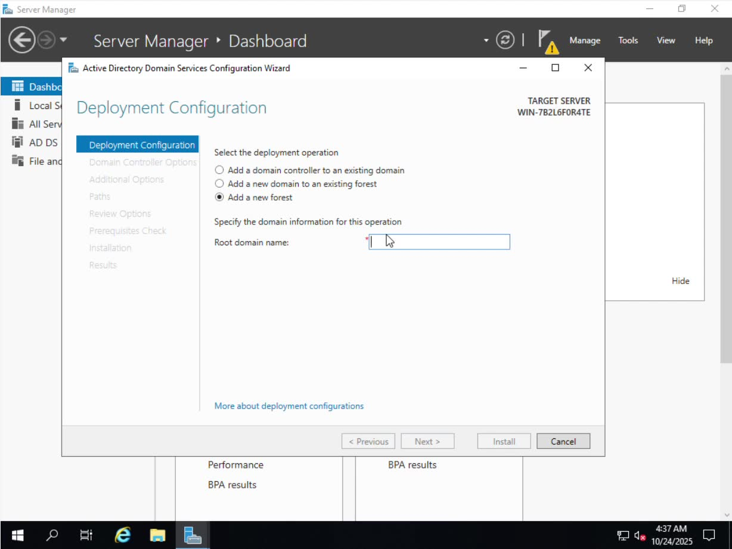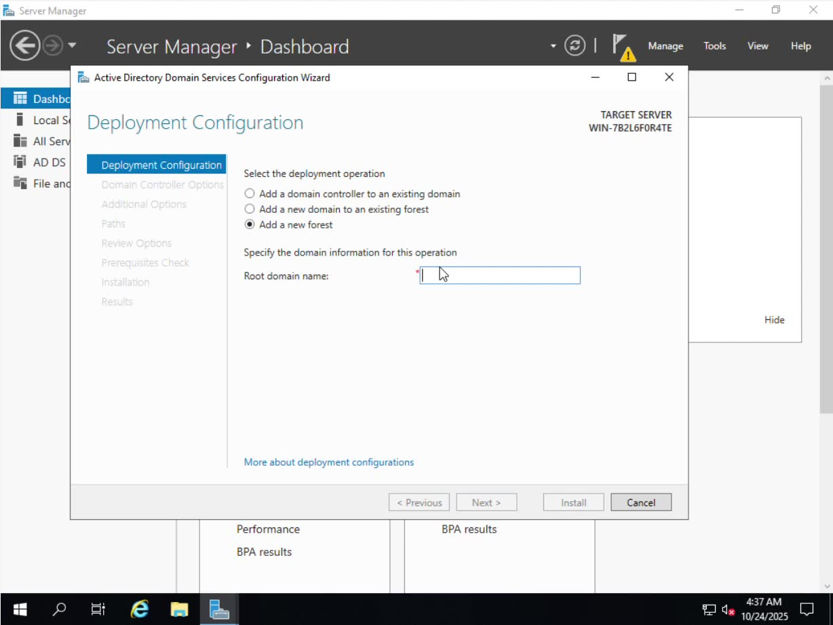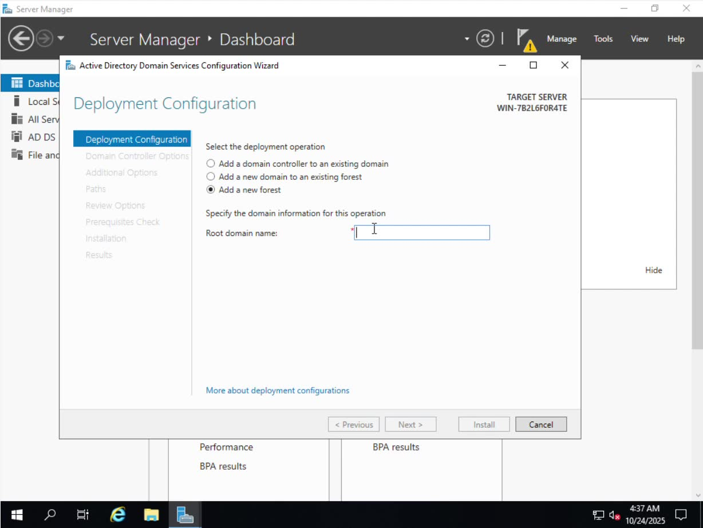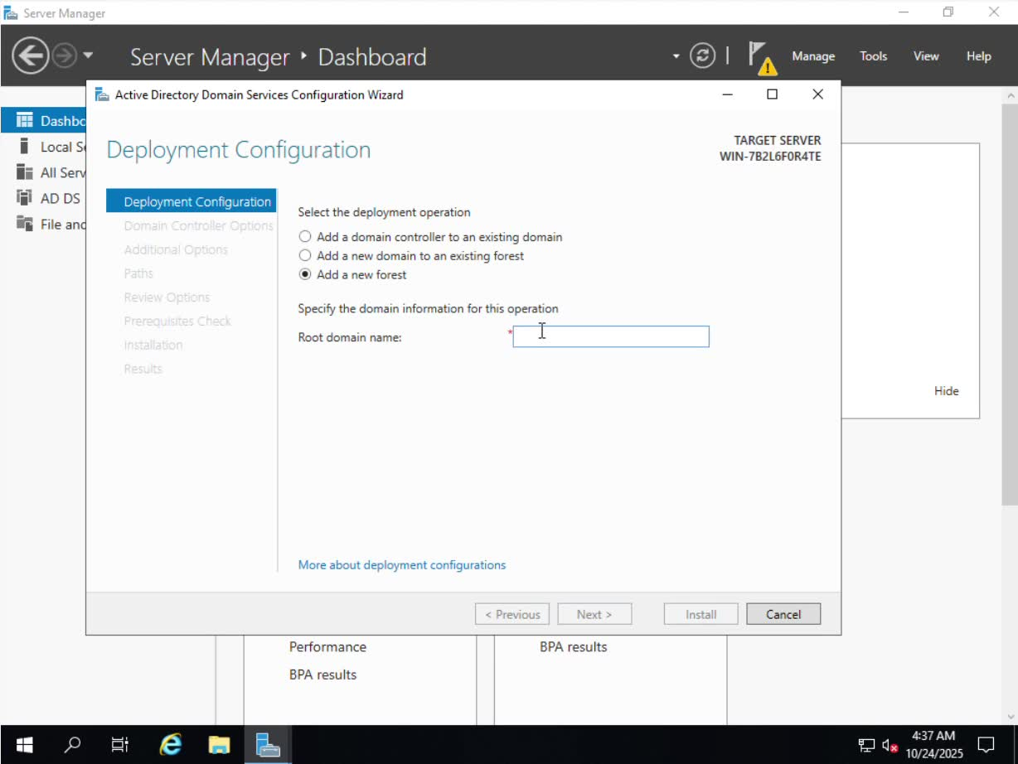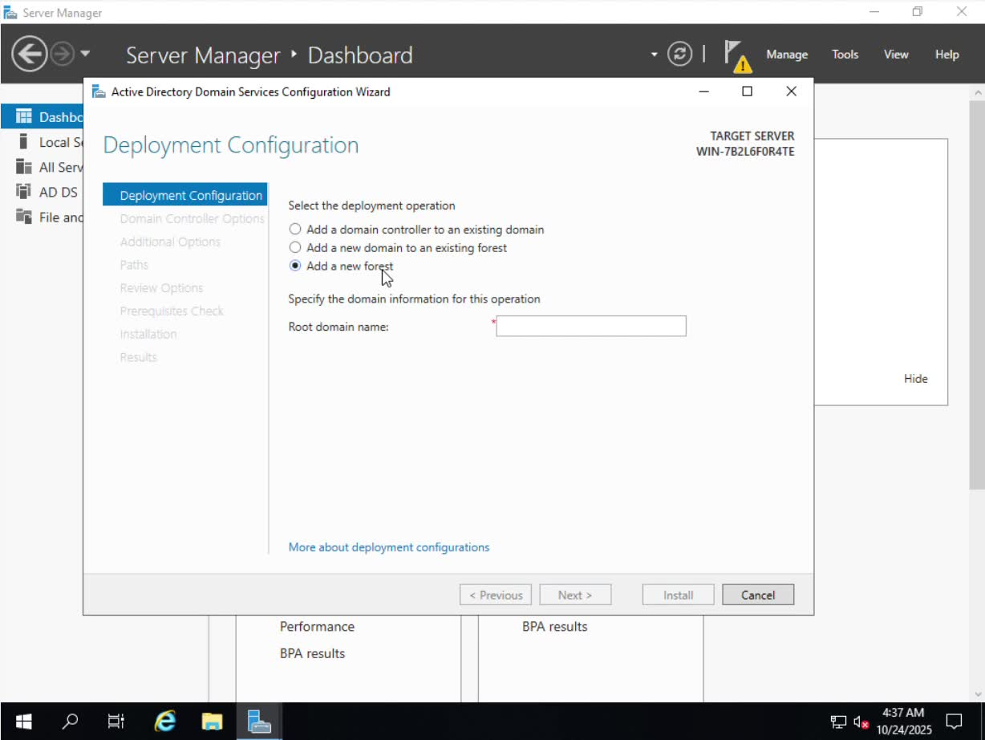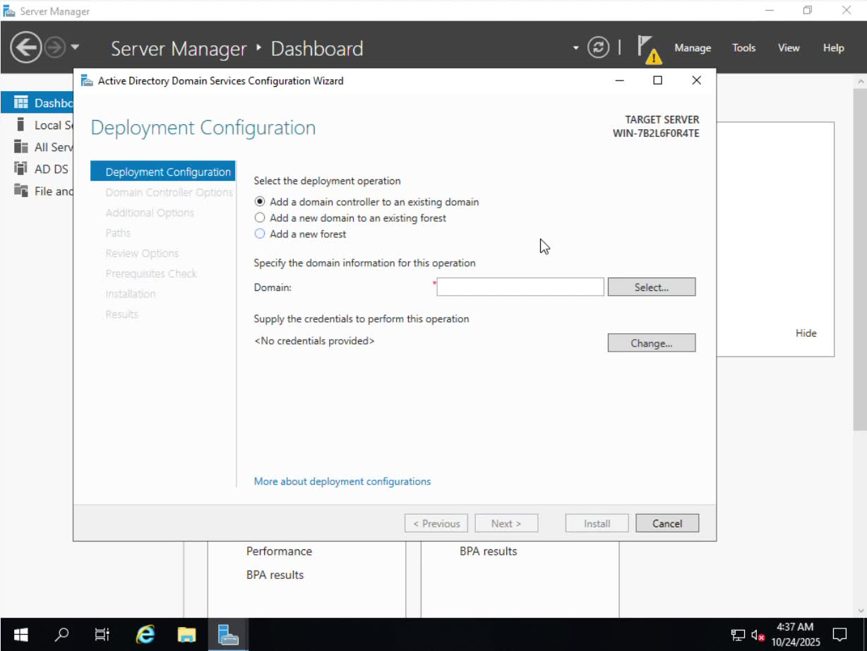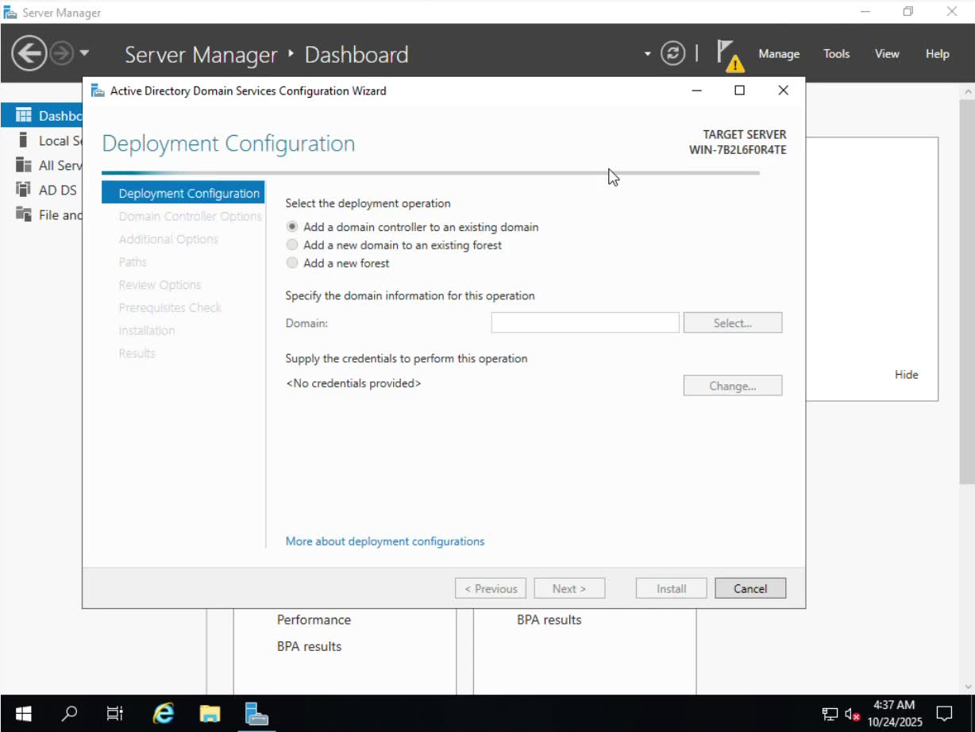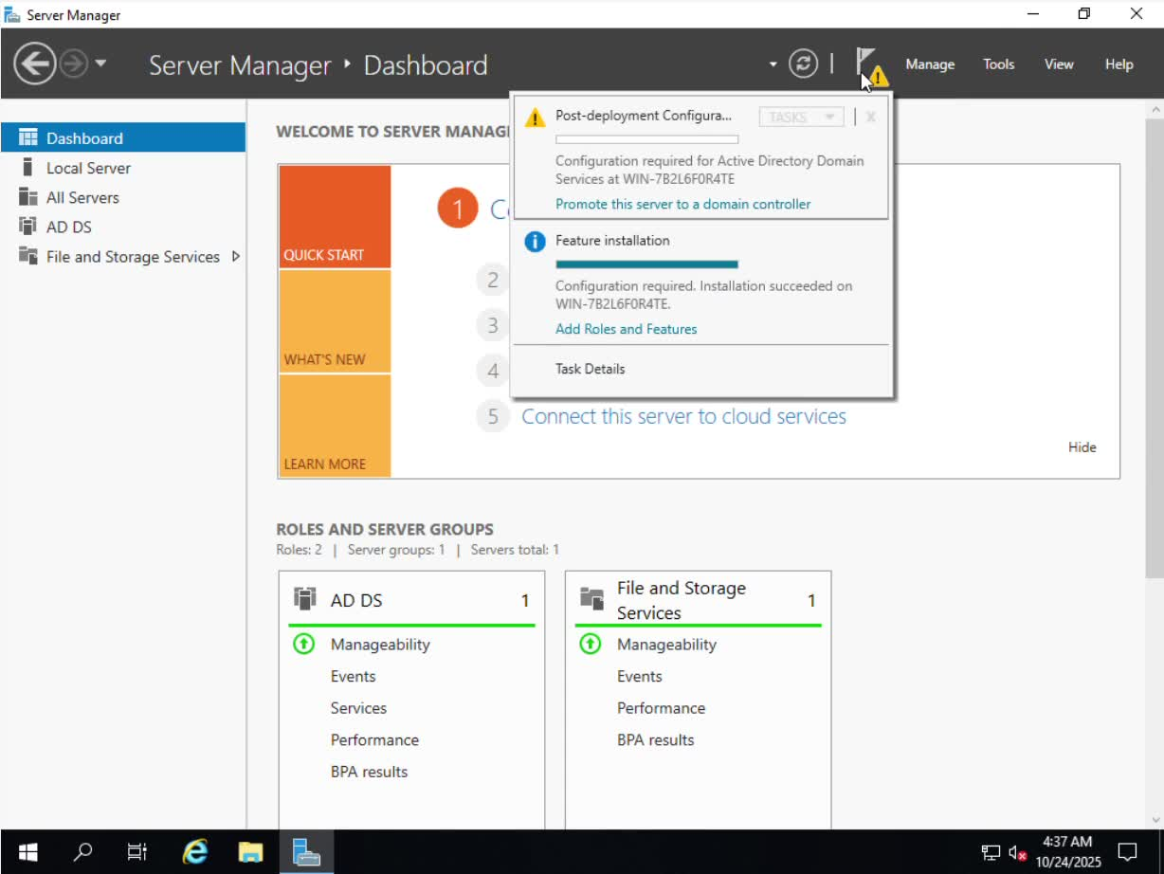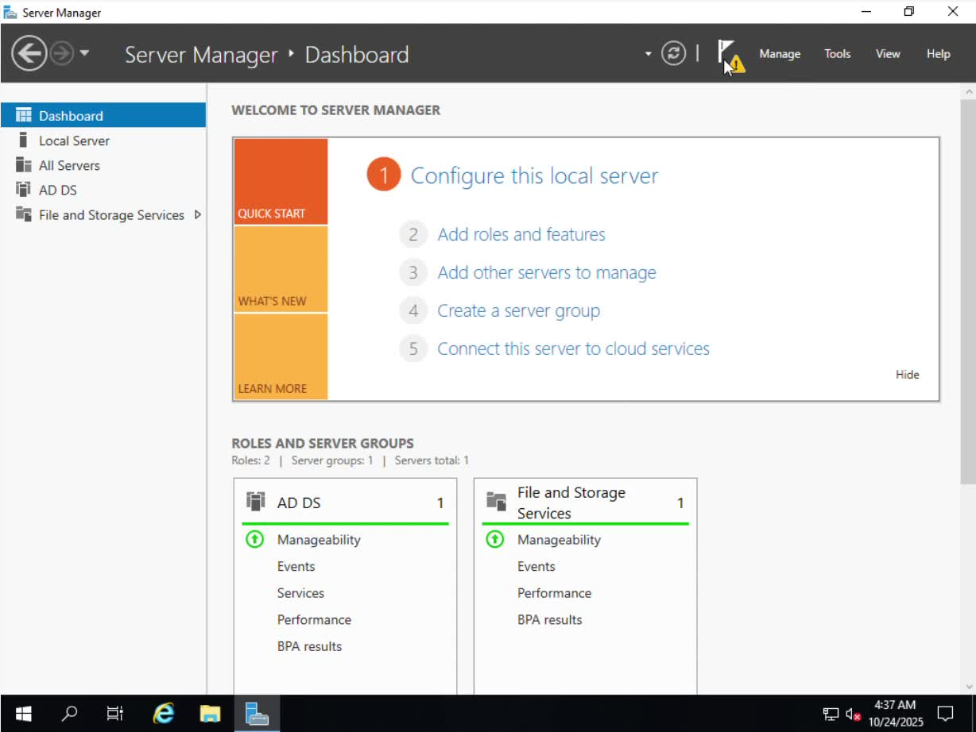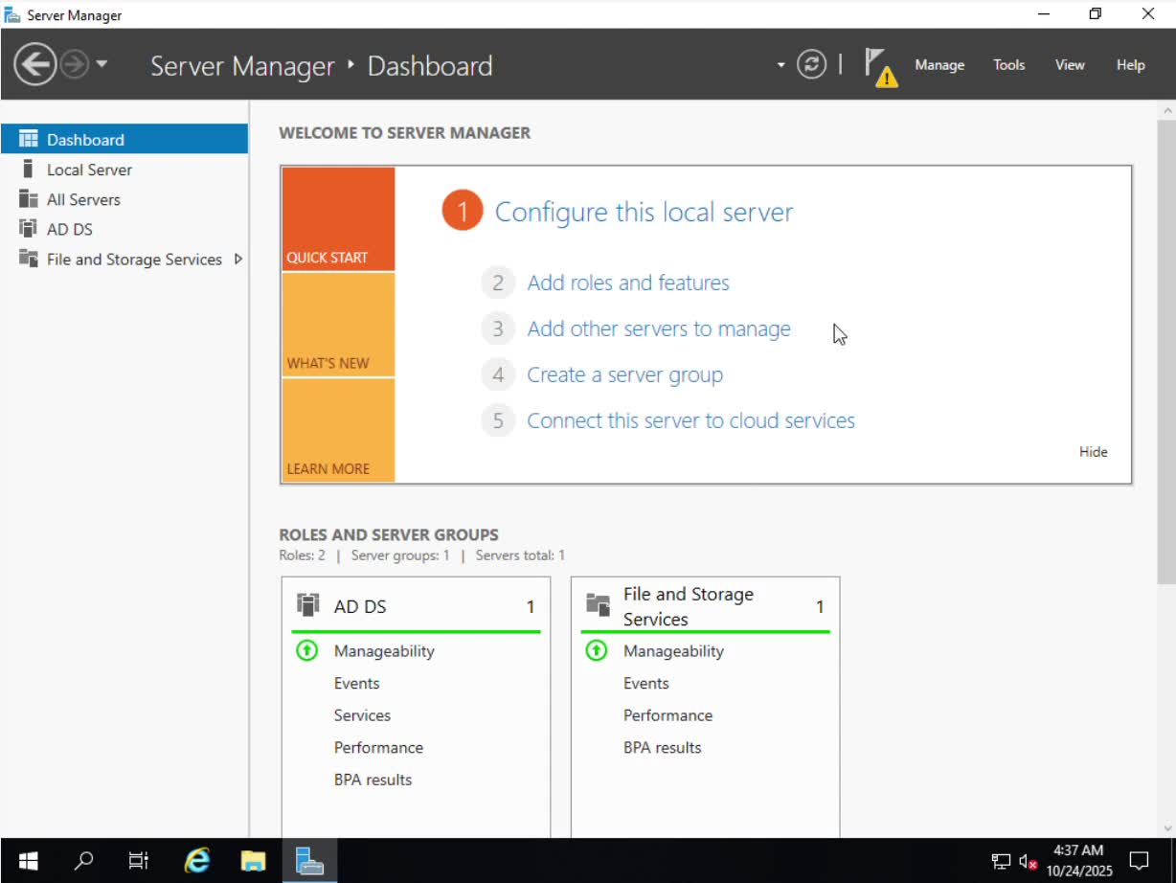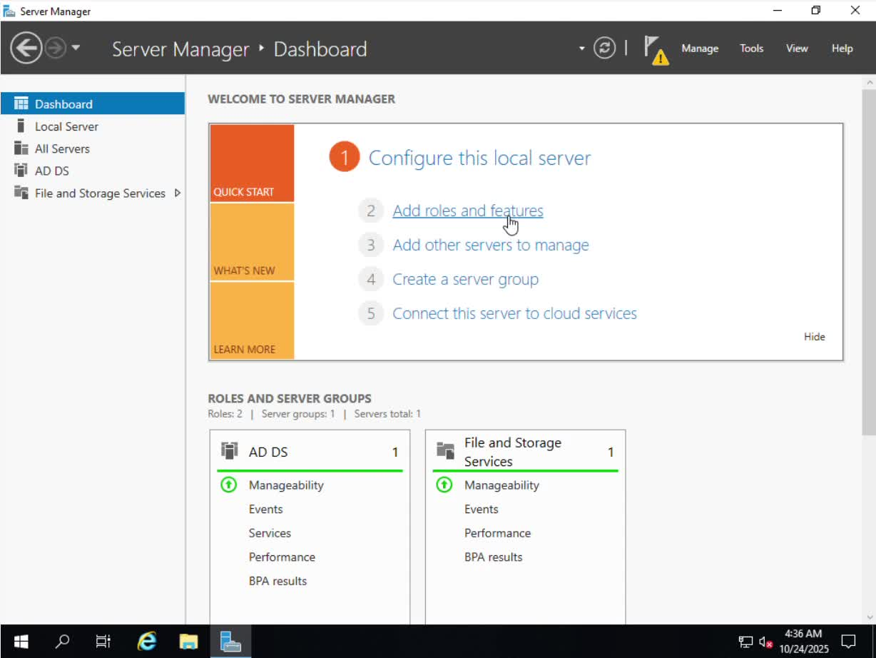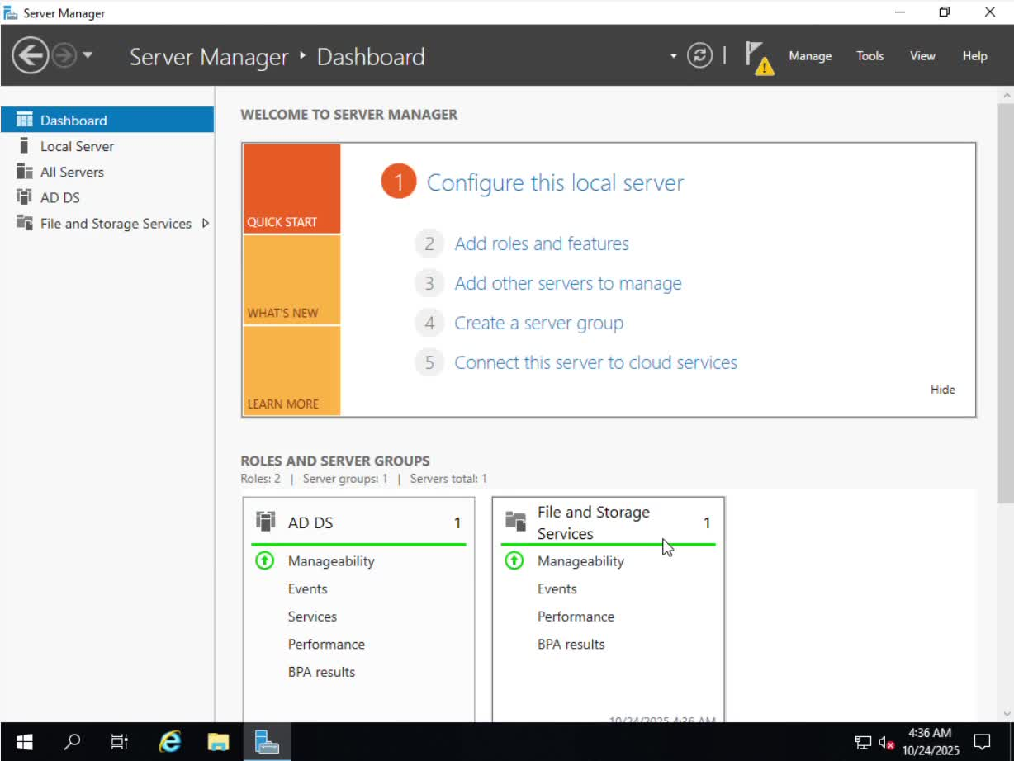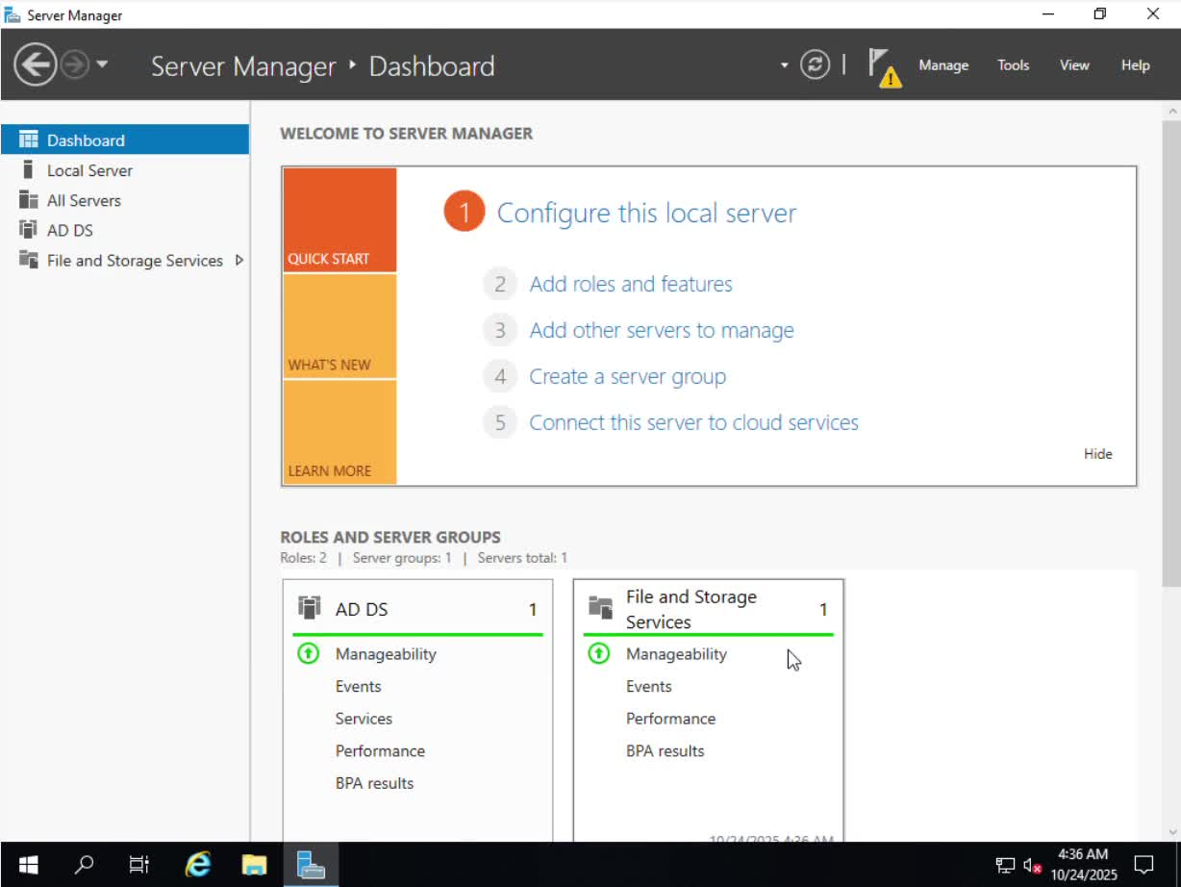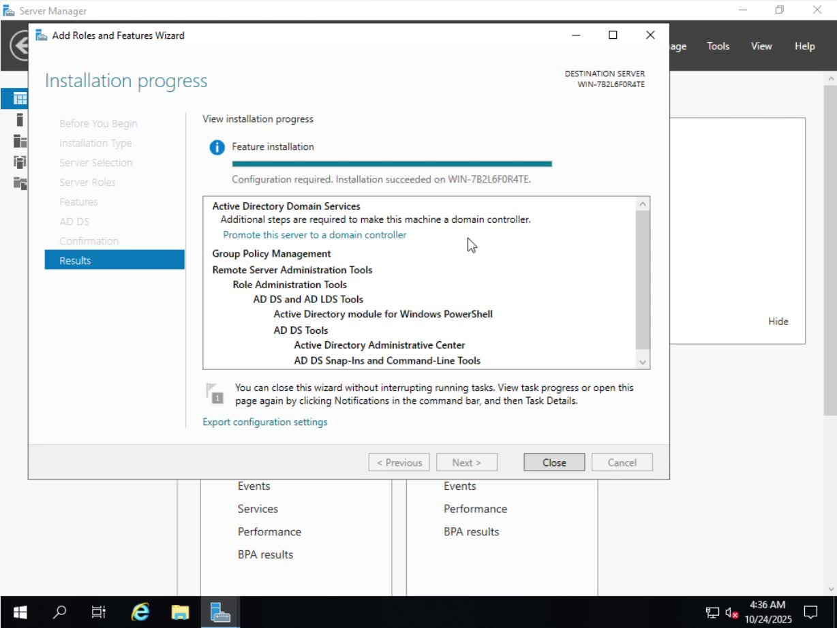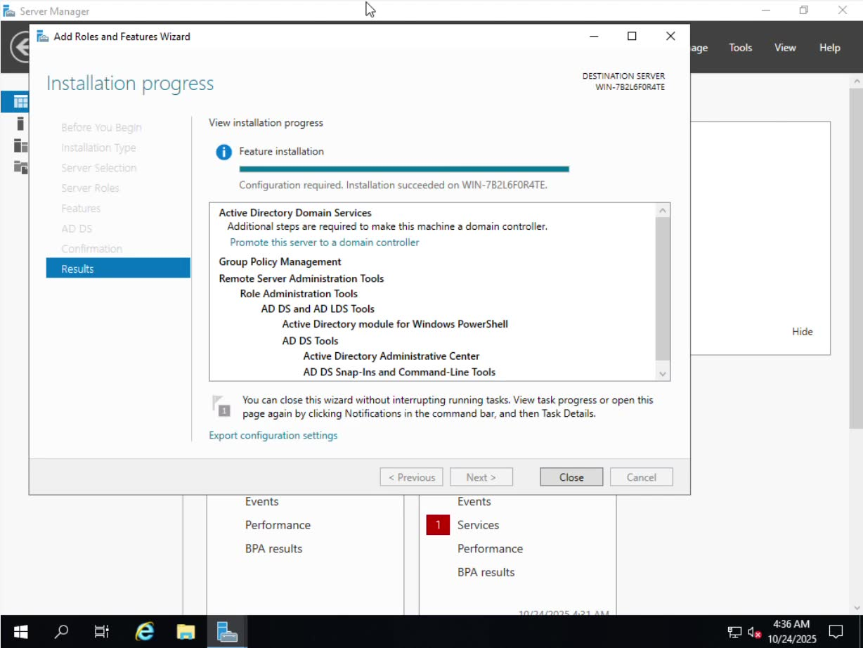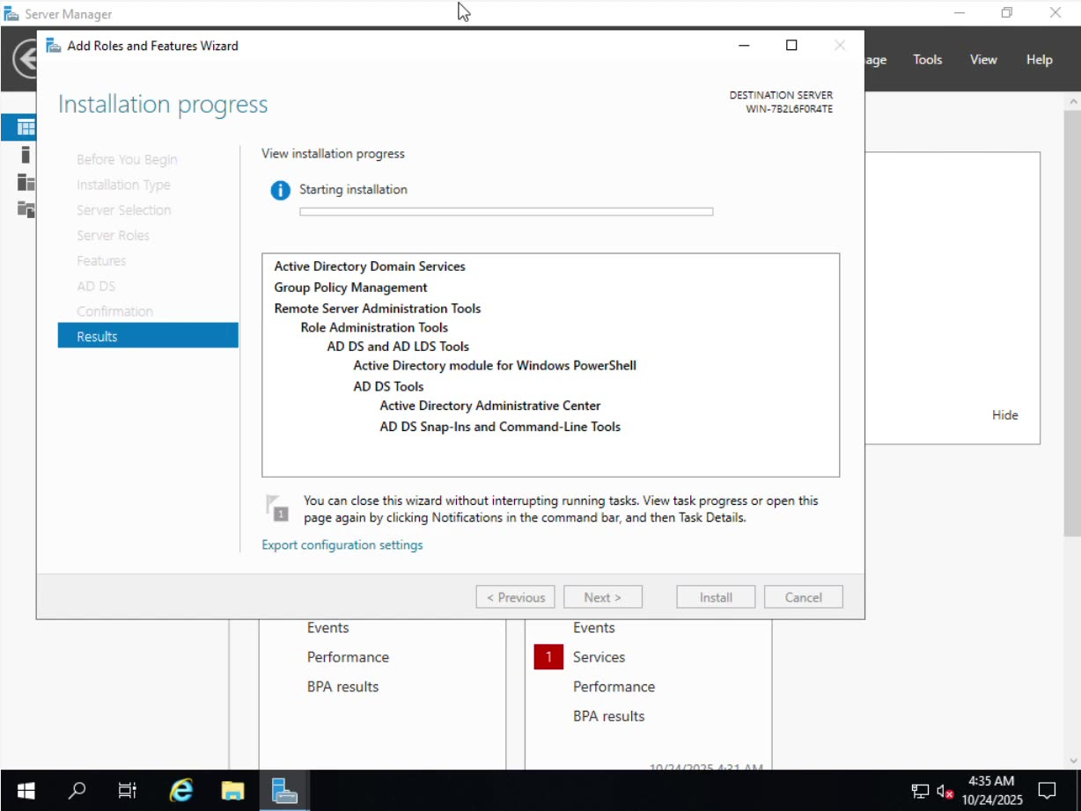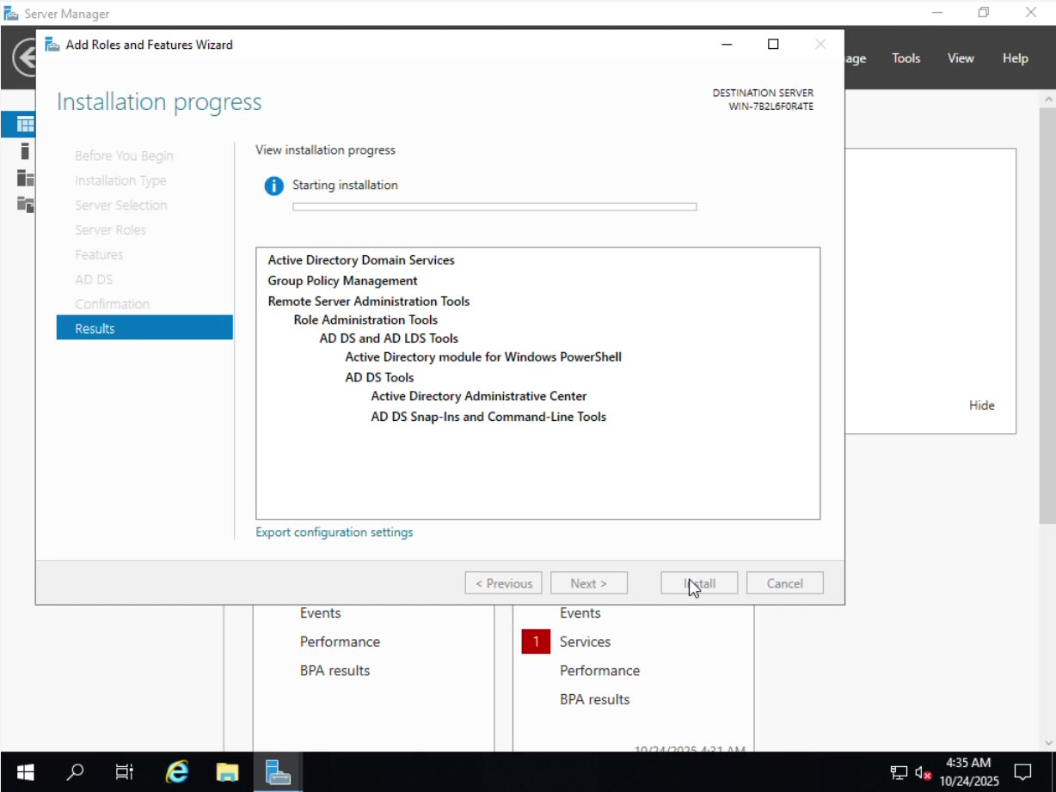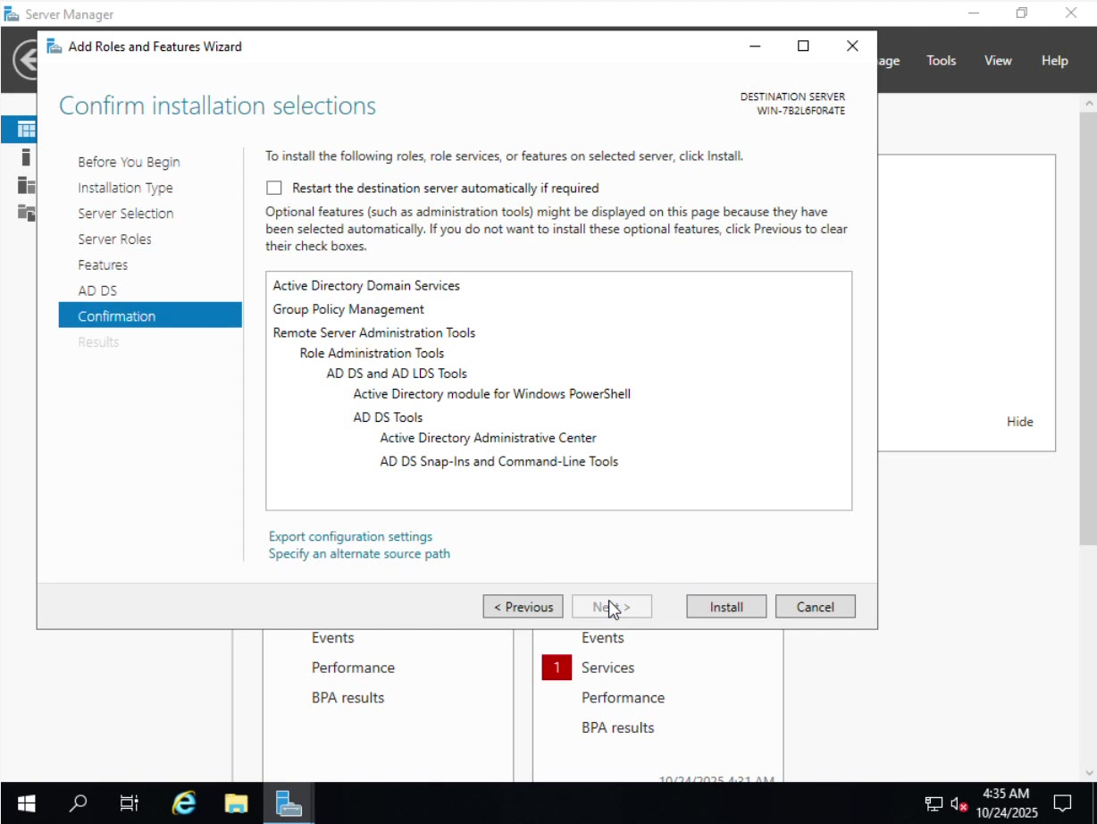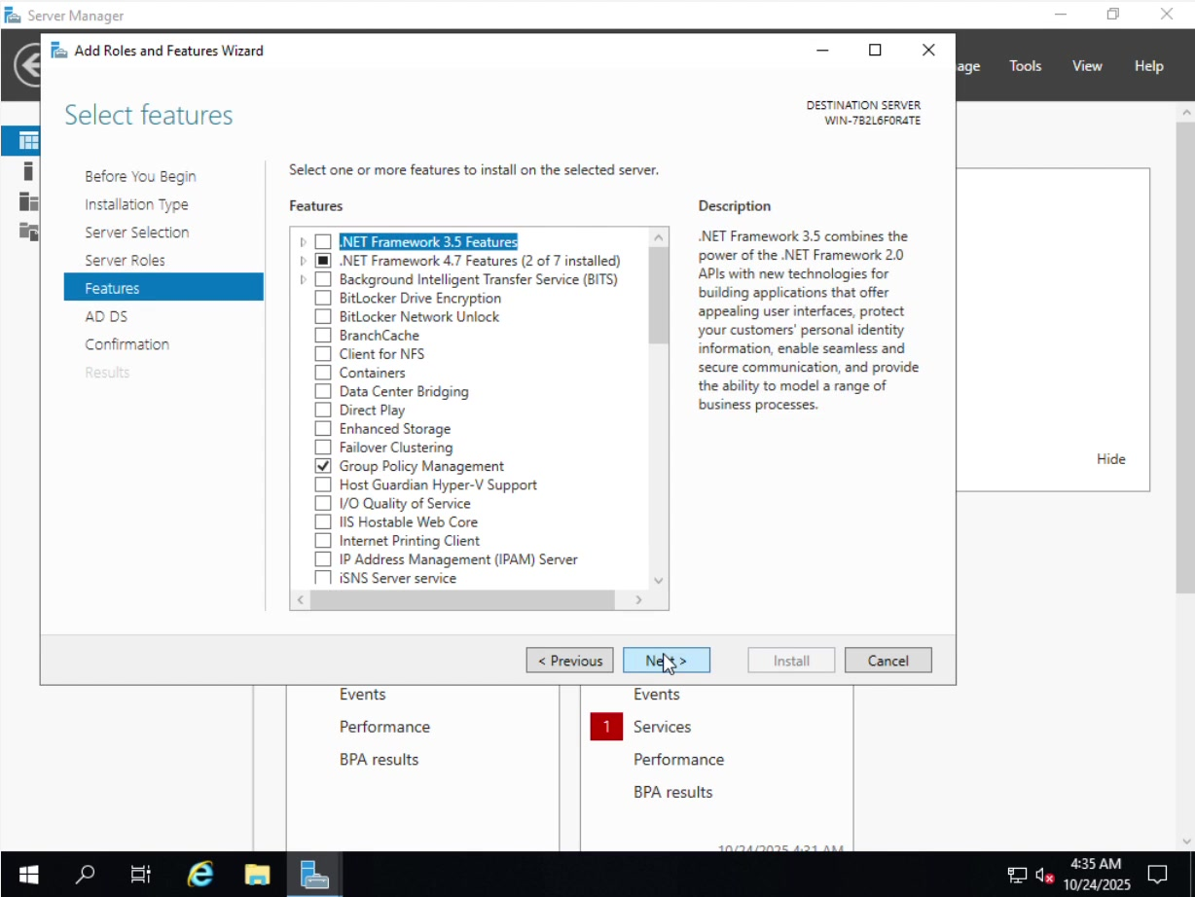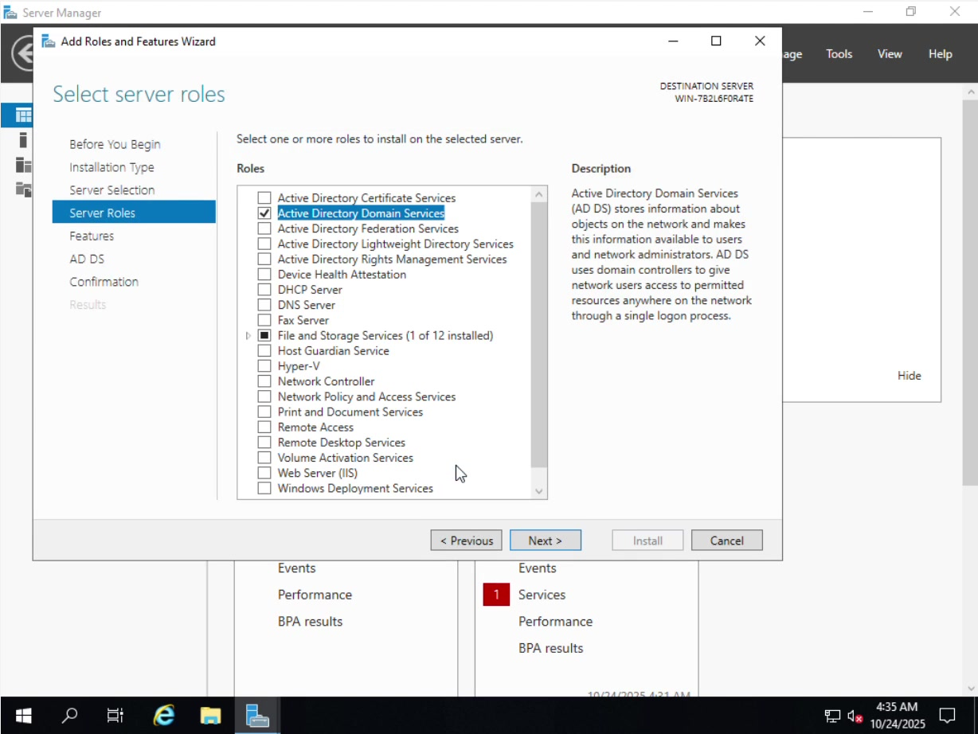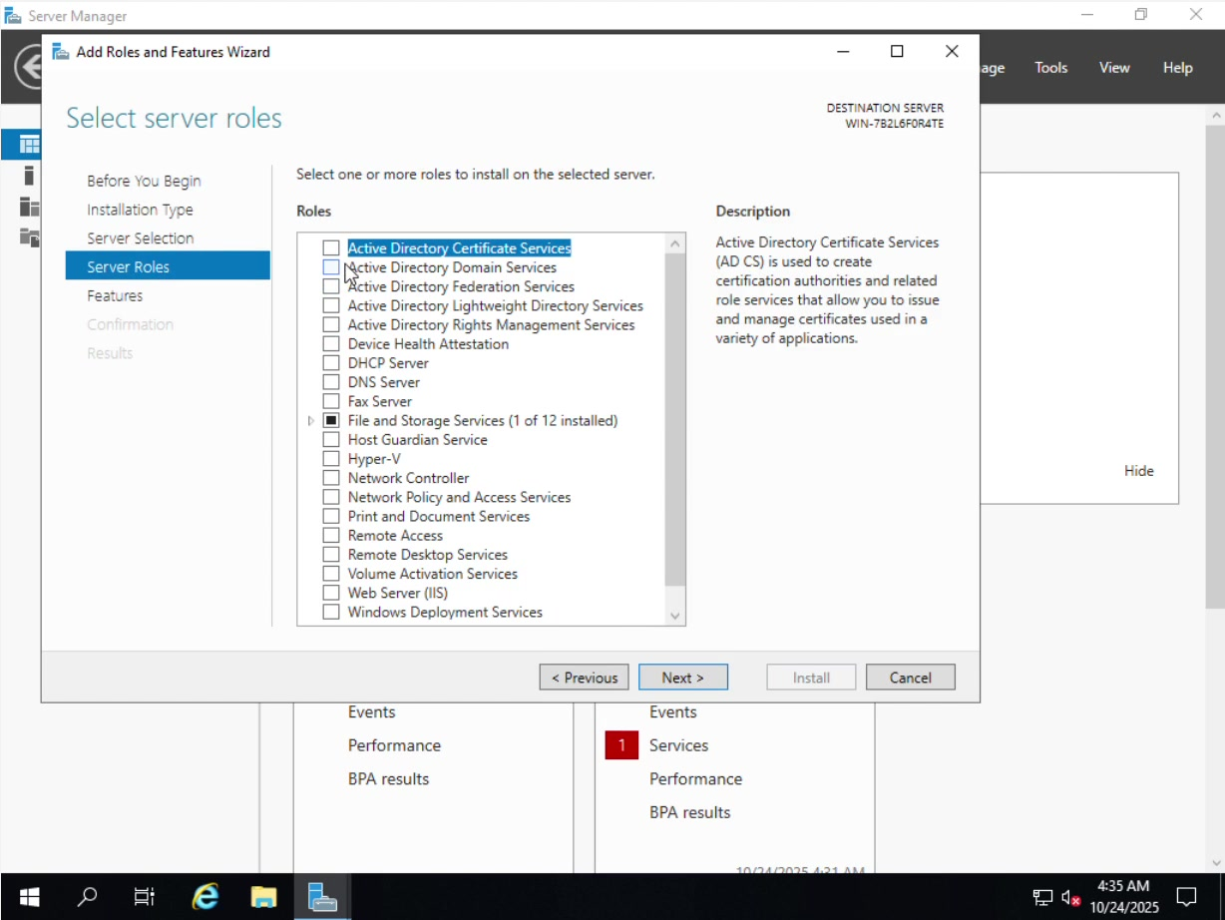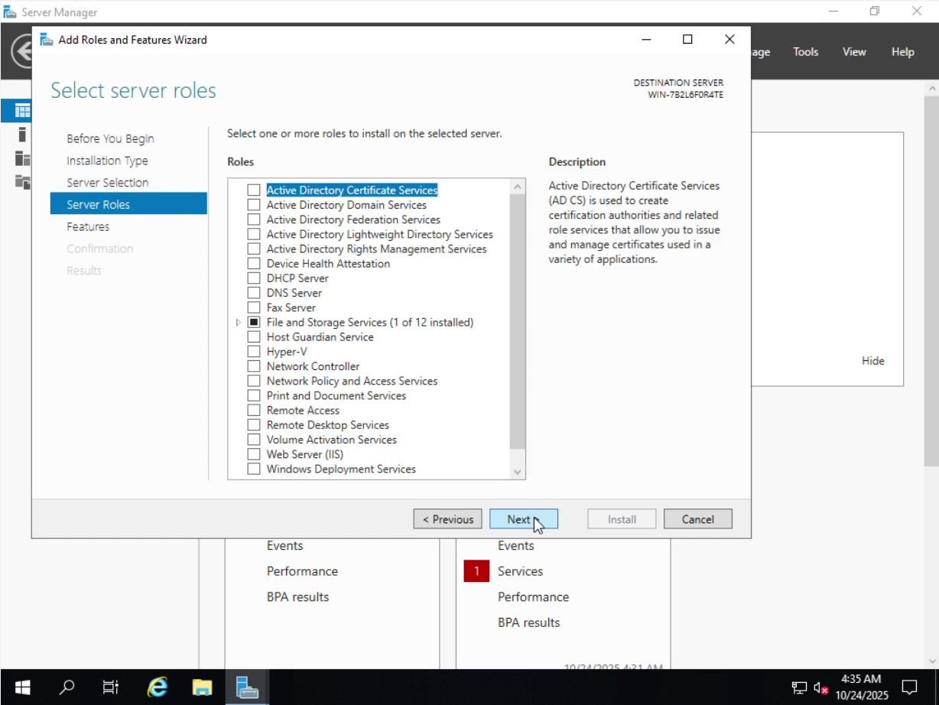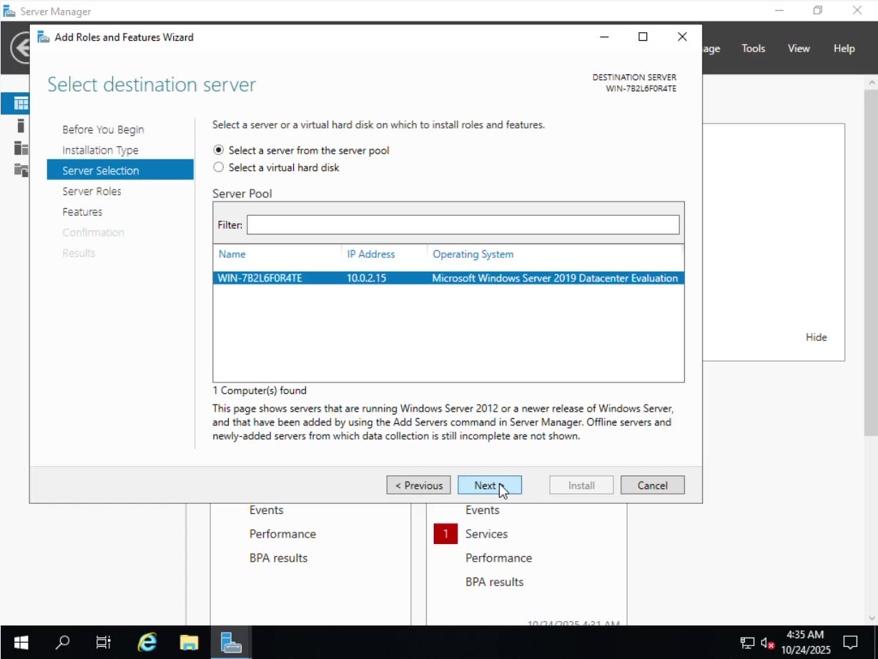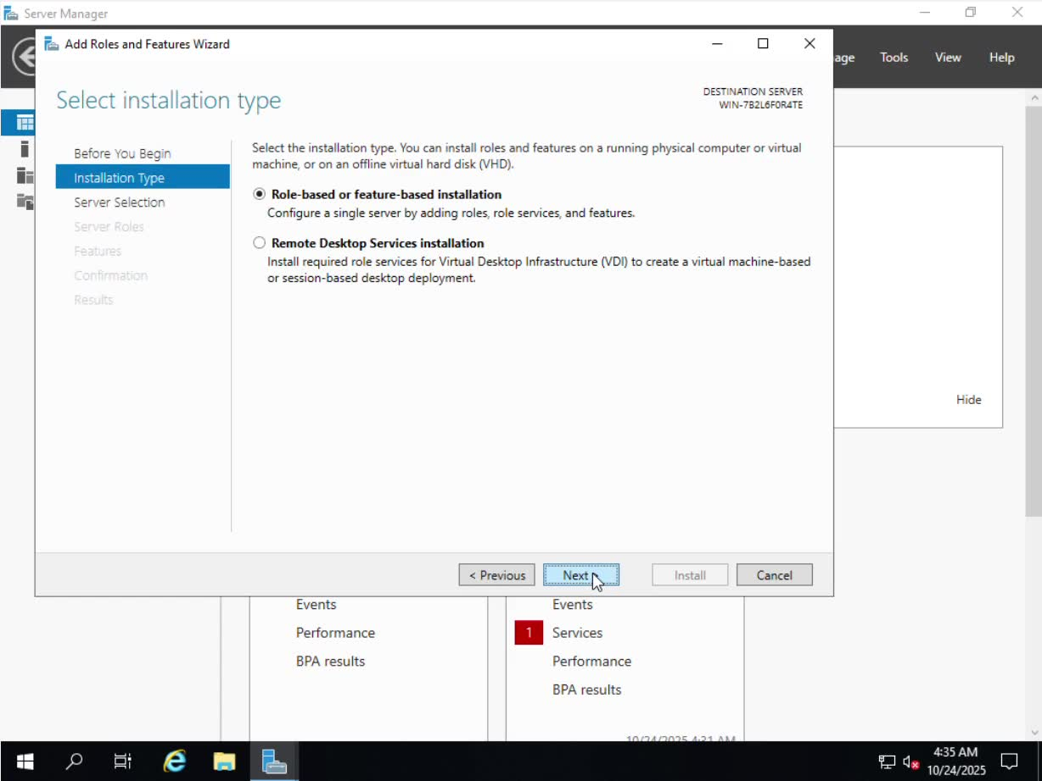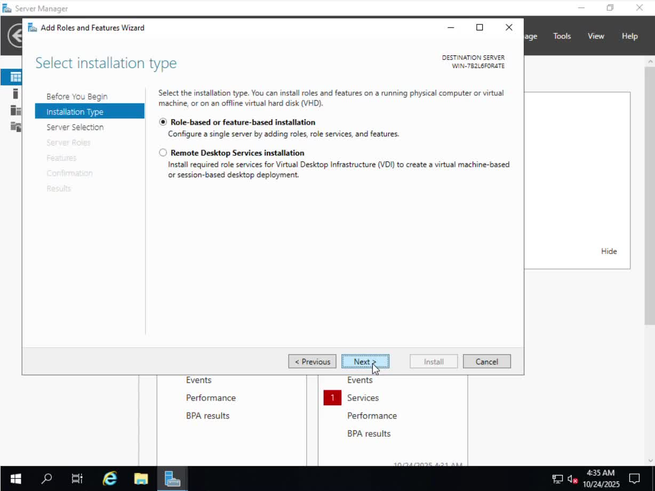

2.3. The configuration and setting of IP addresses from topology
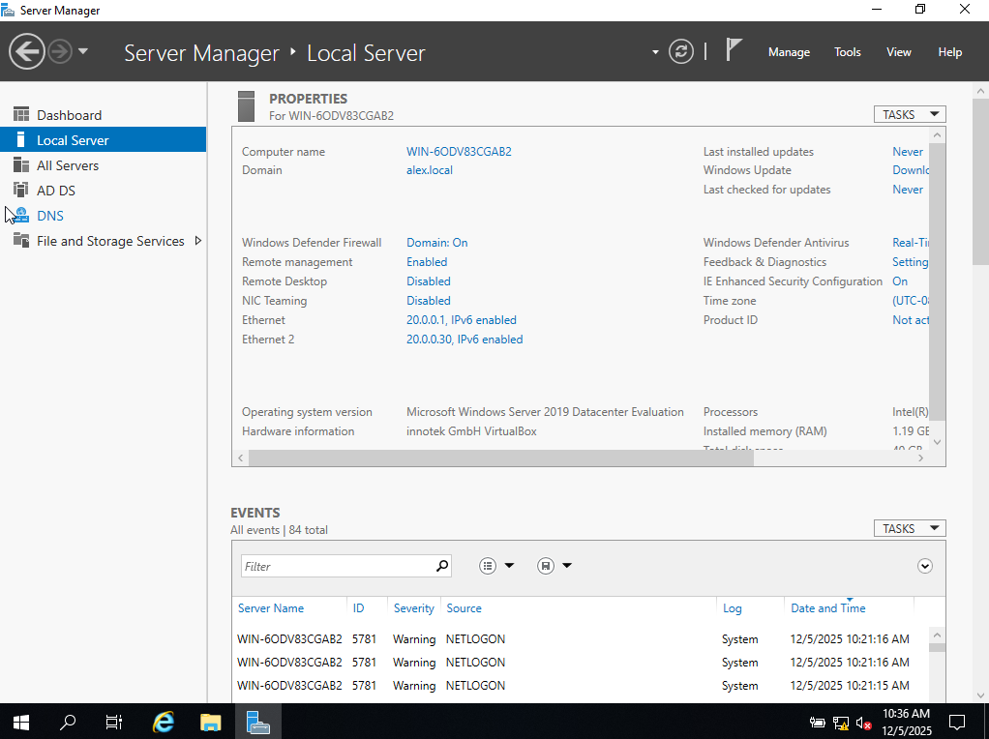2.3.1. In the screenshot it is presented to the server manager including the dashboard local server or servers ADDS DNS and file and storage services here I have selected the properties for win computer and for Alex dot local (alex.local)
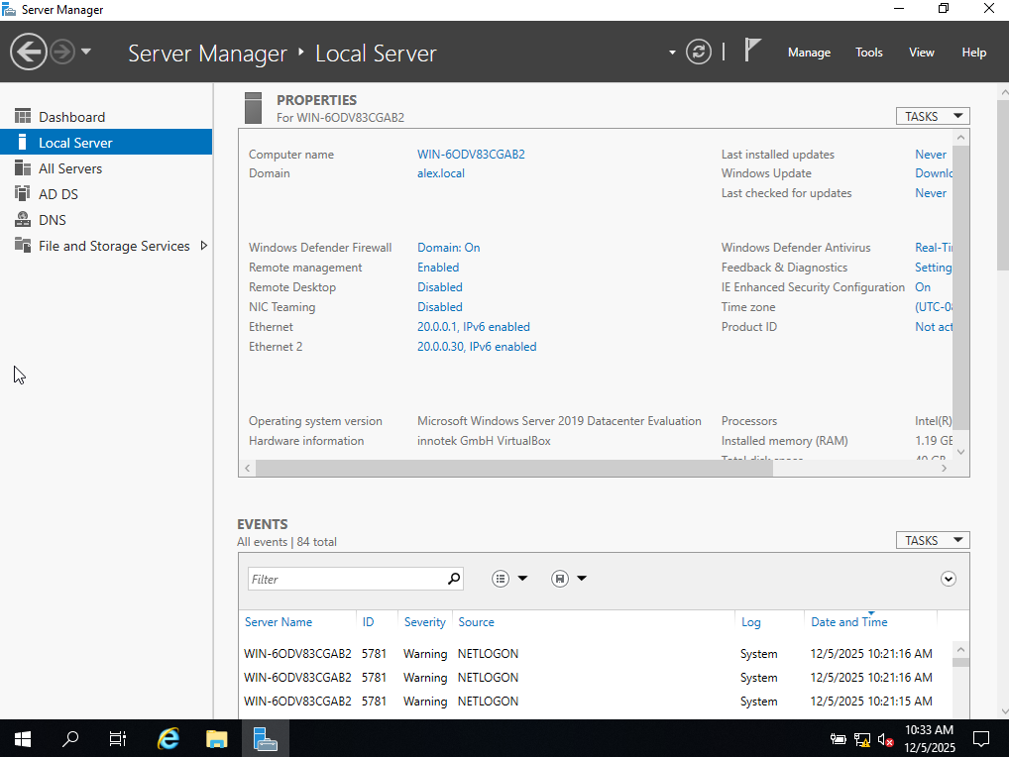
Here I have selected the right adapter in the screenshot below and assigned it the IP address in the topology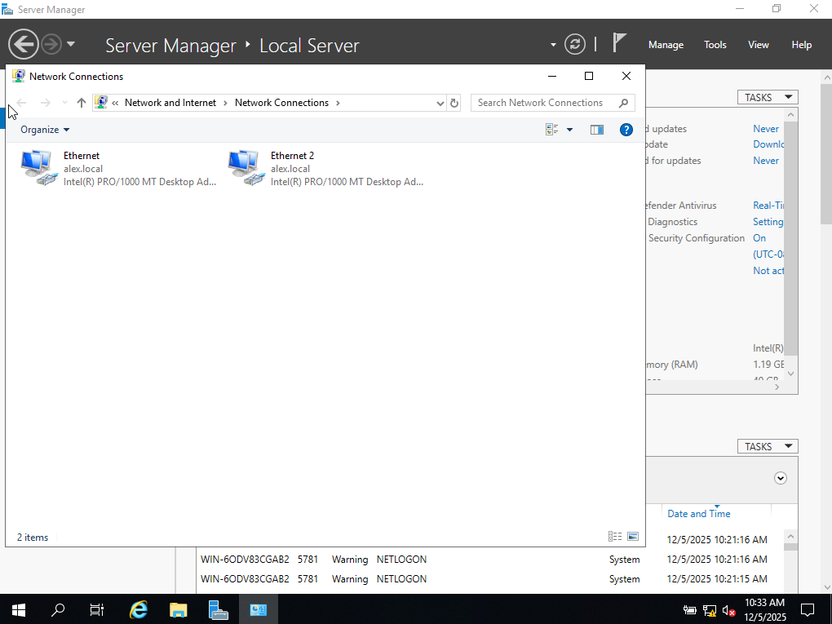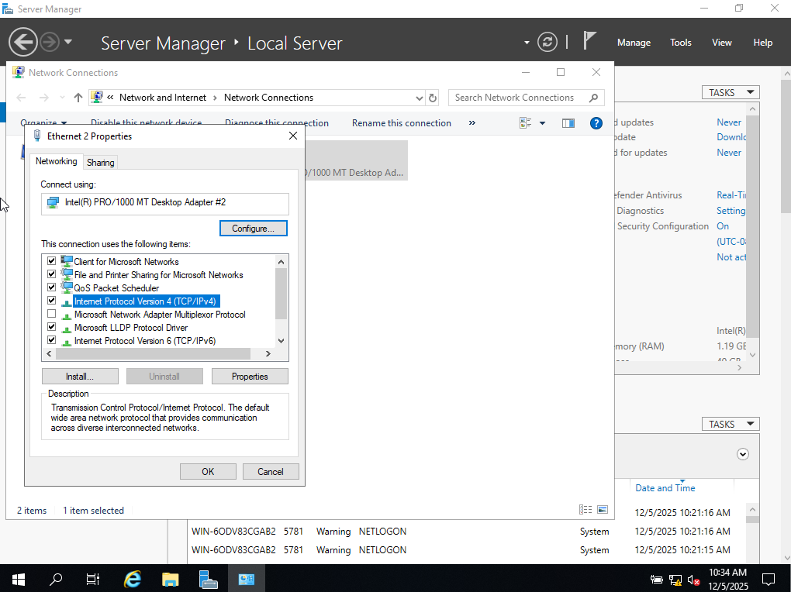
Here I have clicked the properties of the adapter an assign the IP address including the subnet mask and gateway as well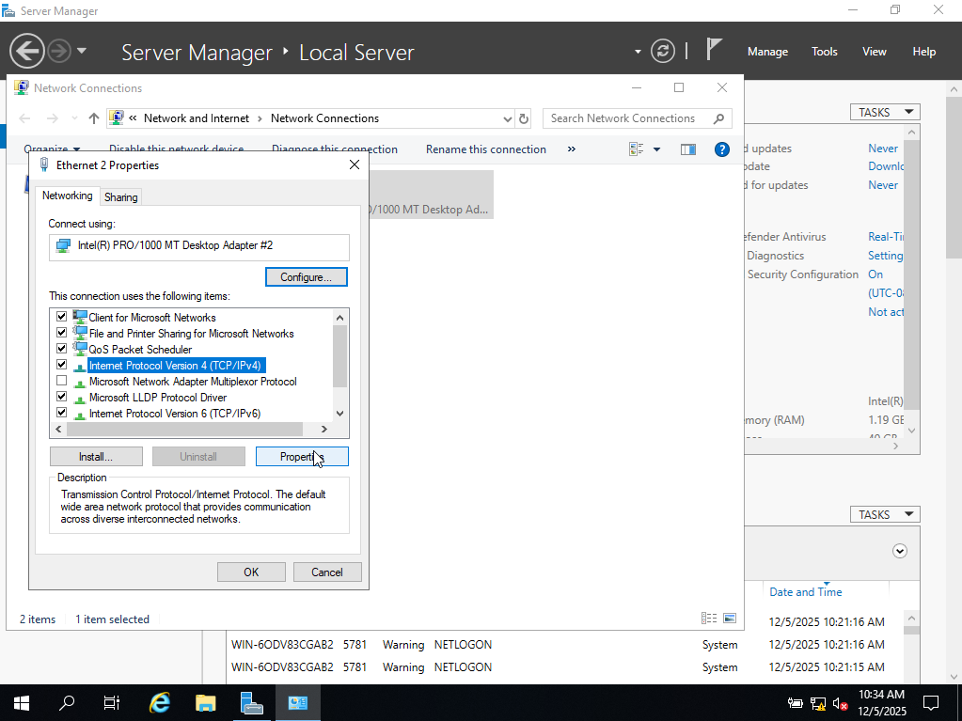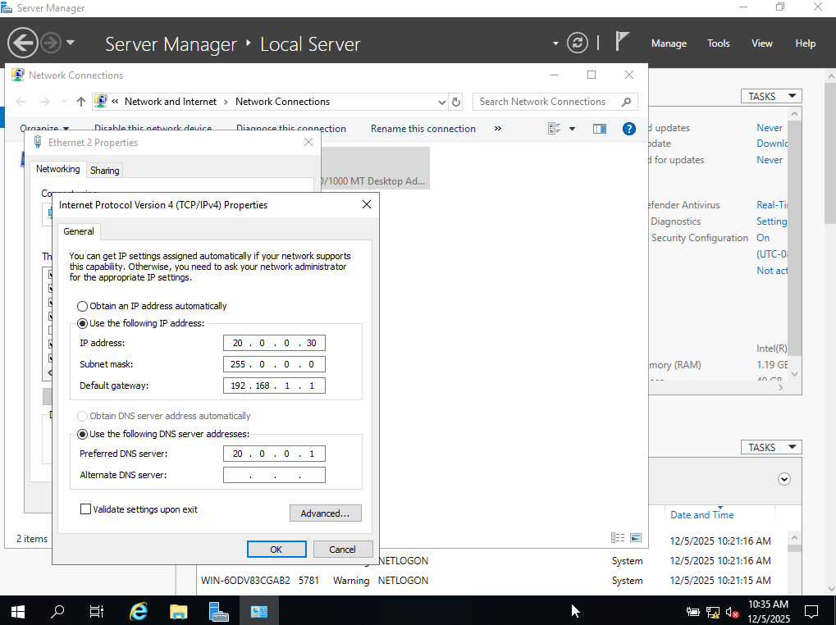
Just to note that the settings have been validated upon the exit of the window with the IP validated
In the screenshot below there is the window which shows Internet Protocol version #4 TCP slash IP version 4 properties in general and manual as following IP address from the topology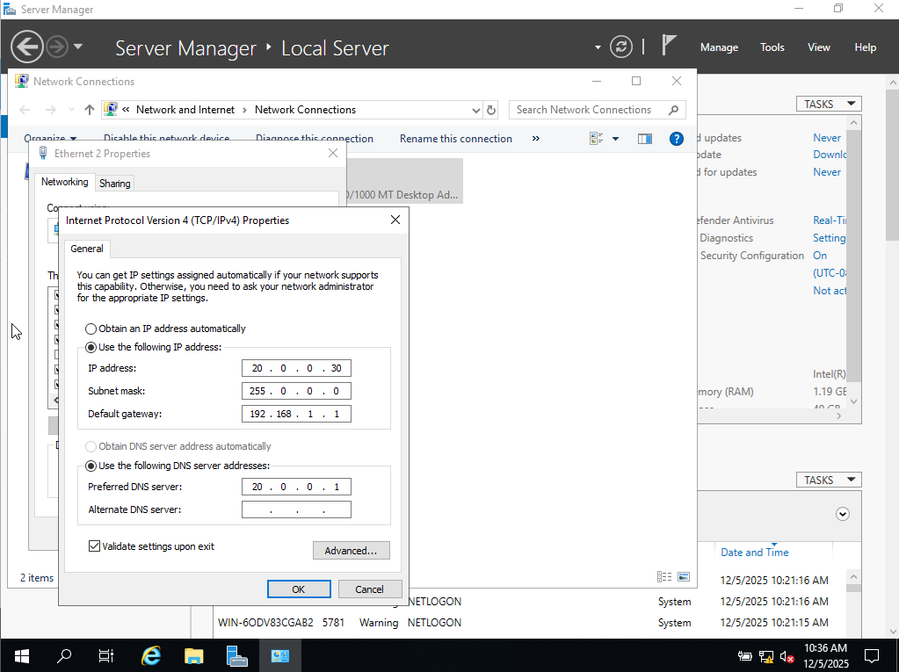
Finally it has been decided to proceed forward and press the OK button and save the configured settings above.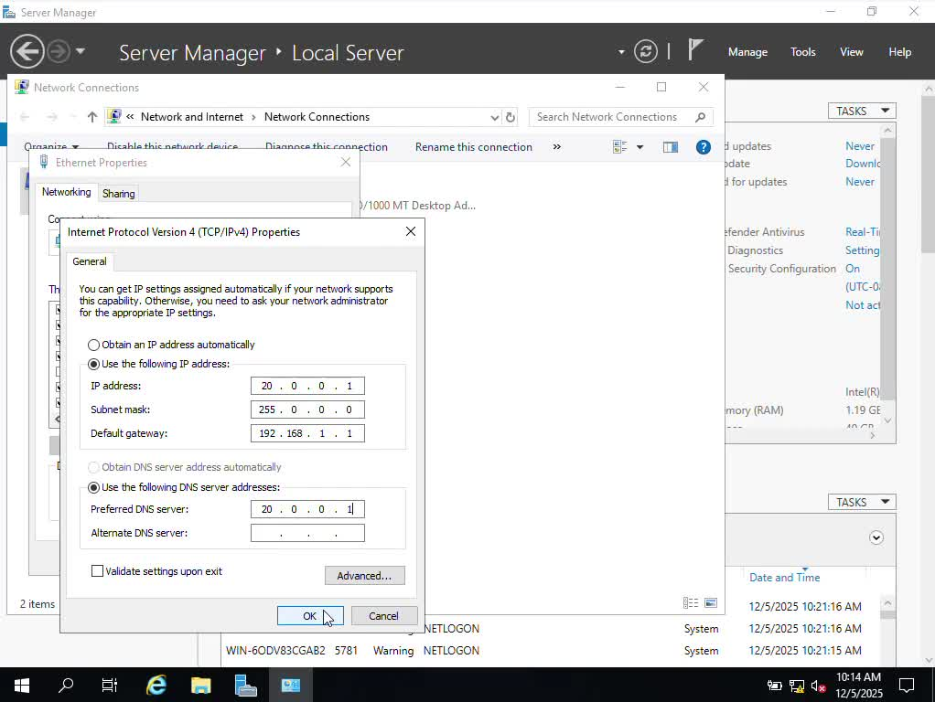
This screenshot portrays the assigned IP addresses for the first Internet adapter including the settings configured accordingly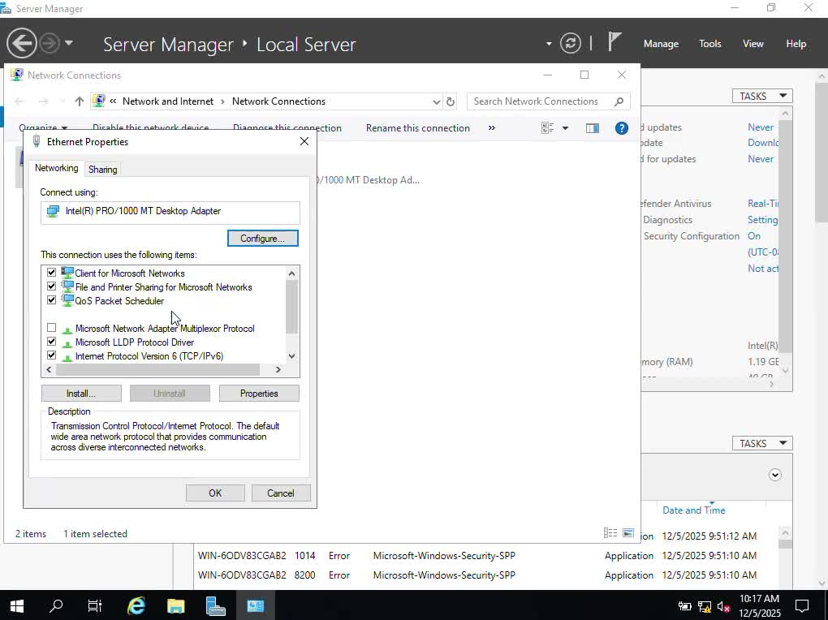

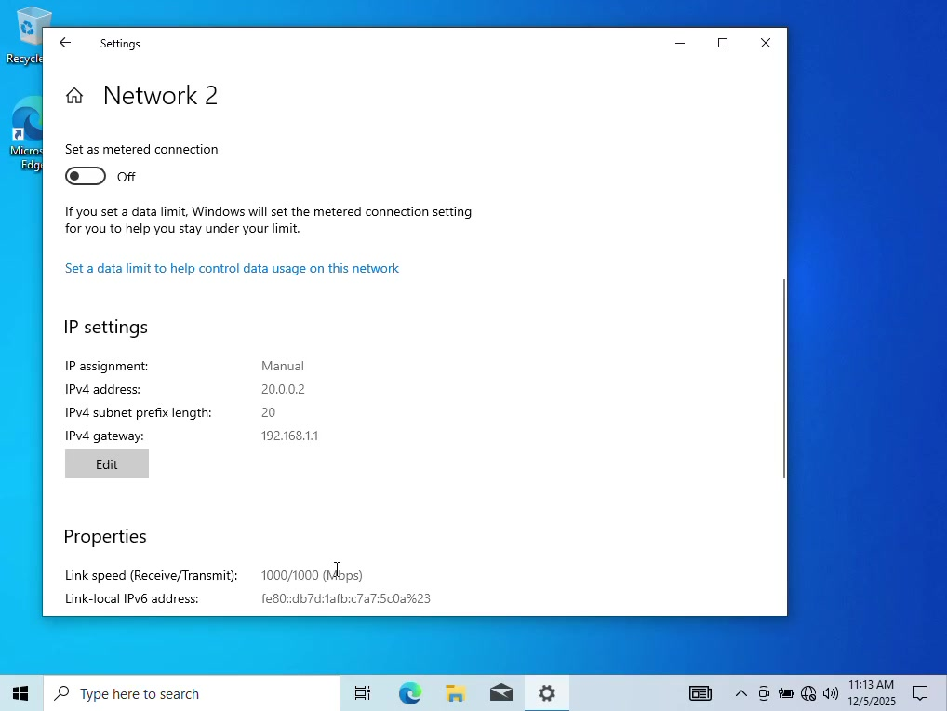
This screenshot provide information about the assigned IP address manually but is done in the Windows 10 client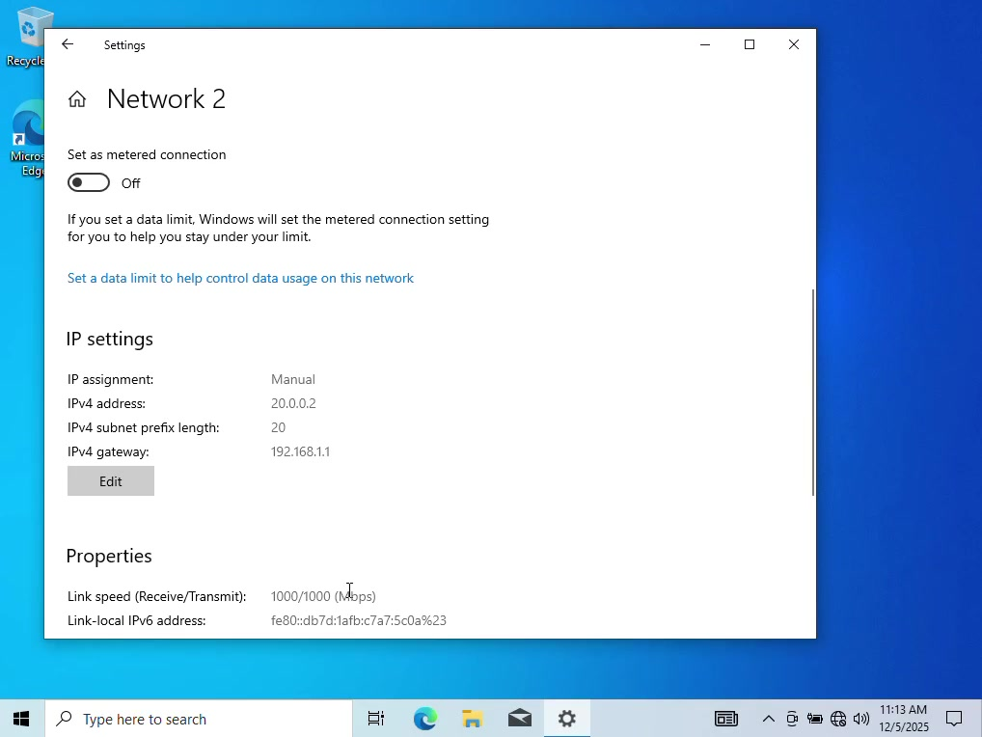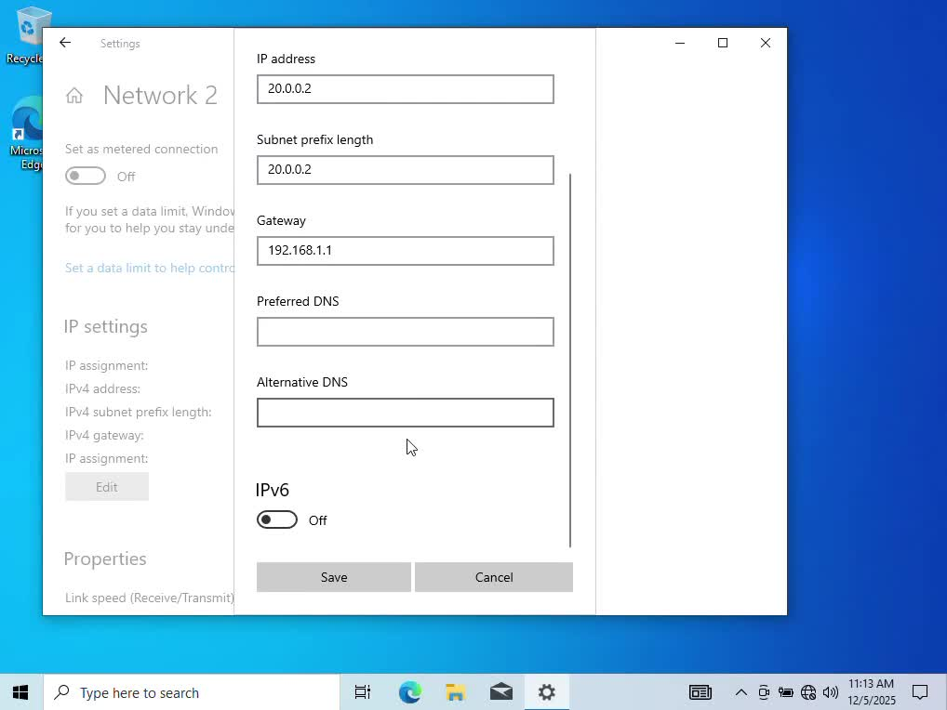
This screenshot provides the editor of the assigning or the IP address manually as per topology shown in the brief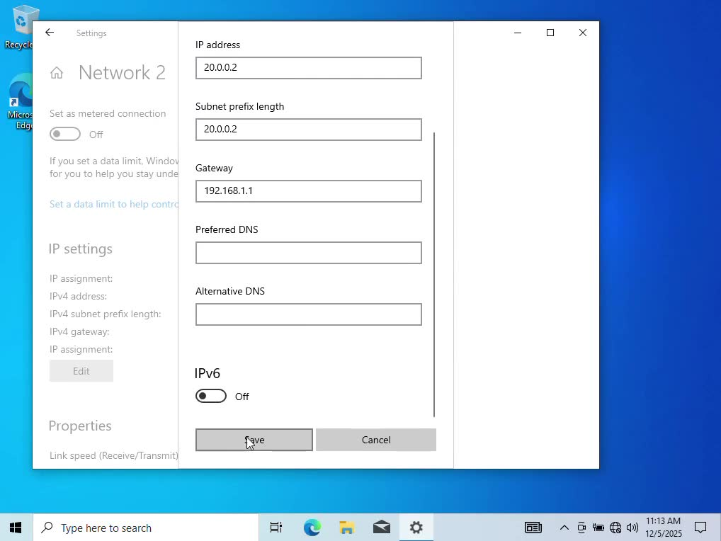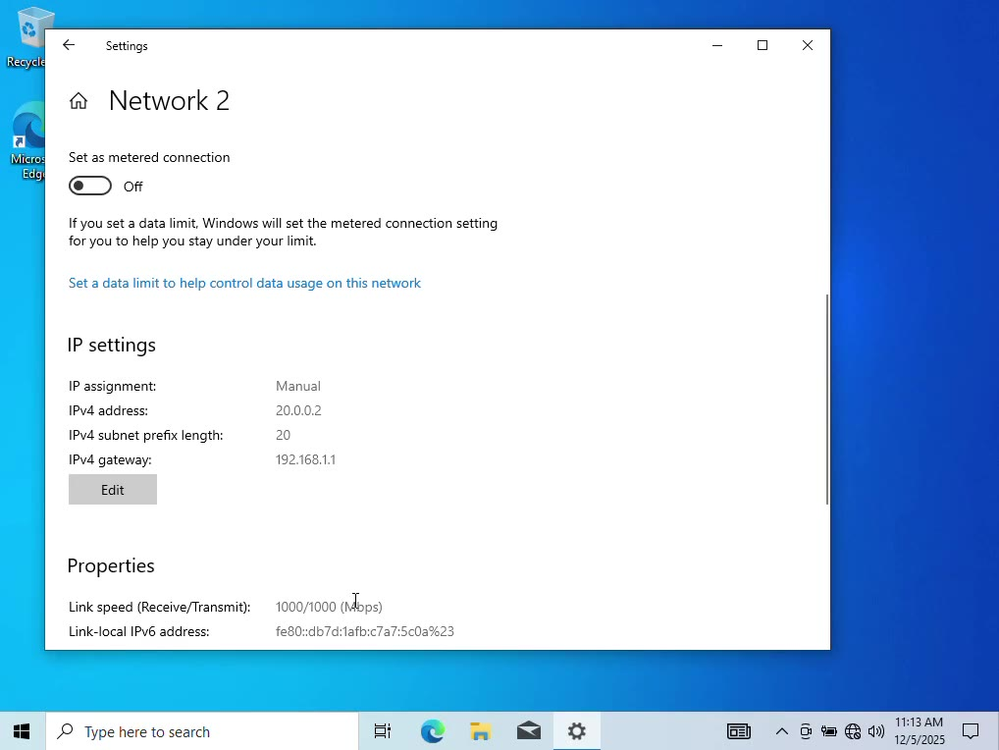

2.4 Test, Check, Debug and Troubleshoot the problems using the networking and troubleshooting wizard
The above screenshot it portrays that the network is getting ready for the tests and troubleshooting to be performed
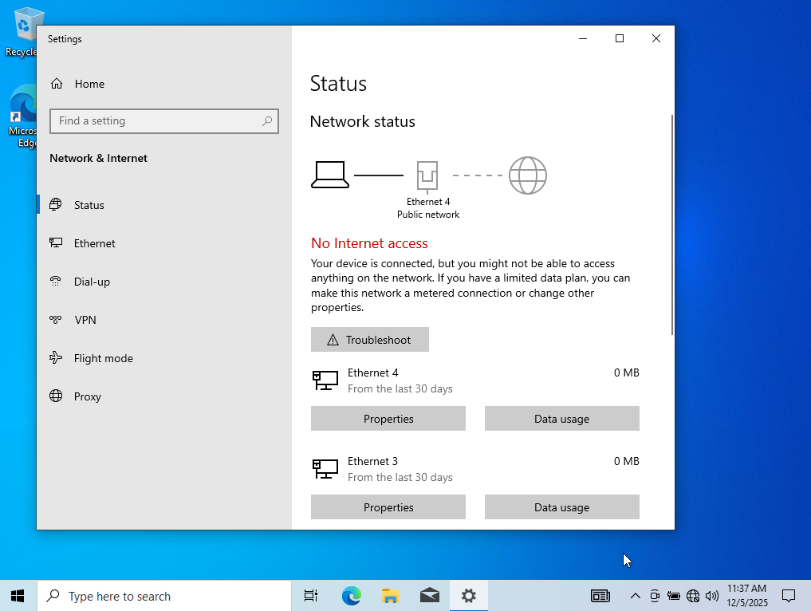
The above screenshot portrays visitors need to be troubleshooted as selected all of them as the test needs to be performed to show planning and task demonstration purposes
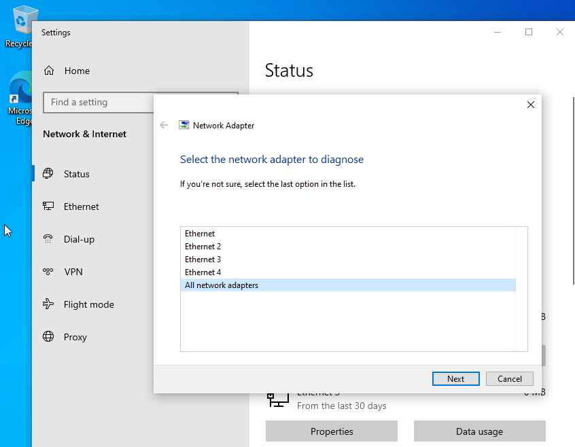
The above screenshot portrays how the settings for adapter #4 have been fixed and they are ready to go
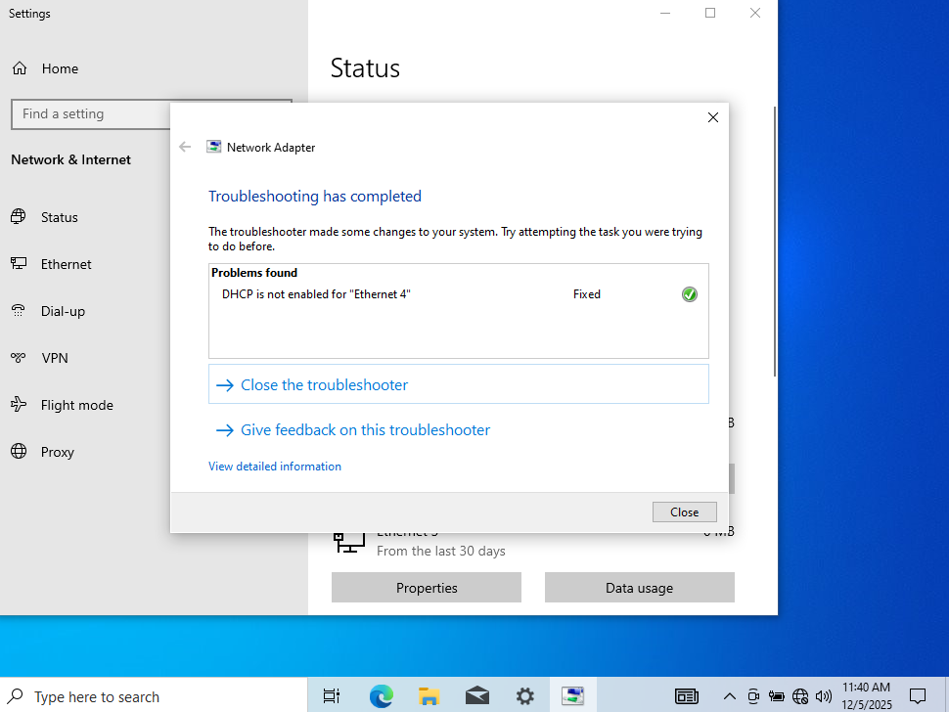

As we could see on windows client we got outcome #1 successful connectivity among Sam computer networks, but on Windows Server we got outcome #2 unsuccessful connectivity within different networks but great attempt has been done to connect the networks.

Task 3

3.1. Reflection, conclusion and explanation in a nutshell regarding the networking deployment and testing including final evaluation

Deploying and managing including verifying testing and checking a virtual private network among environment authored by VirtualBox get a very high consumable valuable special space for learning but also shows up special and ran networking hard steps in comparison to physical deployments and engineering. The main technical conclusions and reflections stress on step by step IP addressing which is very strategical the intense use of modes of networks within VirtualBox involving the setting up of management and deployment of server instruments and tools available.

The essentials of complete and working deployment within VPN networks in a virtual box it is a good planned topology of a network such as in a diagram in the 1st place which reflect environment of production and creation such as separate local area networks and wide area networks simulations and even emulations.

As when it comes to manager of the servers which is called server manager and integration within the VirtualBox utilising such tool involves a very good configuration and settings of a network to manage consult equip and deploy and debug rules regulations and rules and assign them and effectively manage and establish features directly and smoothly.

Checking debugging setting up and finding flaws within VPN networks involving troubleshooting them it is very crucial and fast quick and valid testing to making sure that functionality and security prevail within the network itself as in terms of connectivity tests and ways to to utilise tools such as ping and route stretching or even instruments such as ifconfig to verify assignment of IP from diverse points such as host machine client virtual machine server virtual machine to check weight of the network and the path and if the IP is reachable to the destination including scenarios of before and after bonding and connecting to the main VPN network.

In terms of any issues which occurred during deployment debugging and testing it was that the IP address sign was not matching the gateway and it was overlapping the DNS was alright but some settings were not matching but in the end it could still remain with the settings applied afterwards and no firewall configurations so far.

3.2. Personal conclusions and learning reflections
In this module and its own assessment I have learned how to deploy a network how to use Windows Server manager and Windows Server operating system within the VirtualBox machine including its characteristics several manager and network manager as well and the result I have also learned how to add the windows client which is Windows 10 to the VirtualBox and all the tools needed to access the desired characteristics and features on IP addressing, DHCP, VPN, and other networking features and characteristics, and also learn how to use Debian and how to deploy and set up the BIOS of the Debian as well and installed the file system into the virtual machine and utilised the Oracle VirtualBox to run it smoothly and safely as well as with Windows Server and Windows 10 which were my primary operating systems using this task as it is more common and familiar to utilise them and as my computer resources permitted as the ram used was only of four gigabits. Here’s what I have used so far in terms of OS as of what this screenshot portrays:
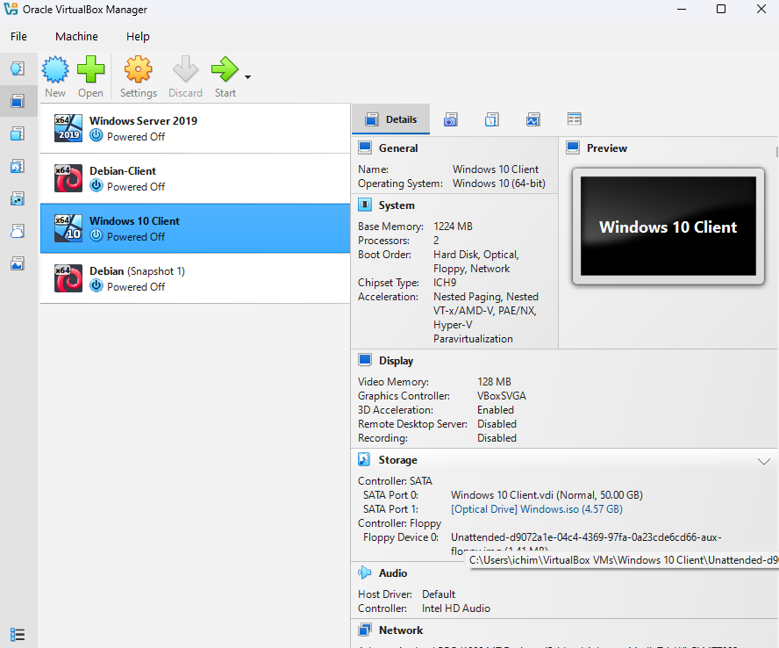
Screenshot of Windows 10 Client, Windows Server 2019, Debian Clients/Snapshots.

References from across the web on networking used from research conducted about all network building topics:

[1] A. Wang, M. Iyer, R. Dutta, G. N. Rouskas and I. Baldine. A. Wang, M. Iyer, R. Dutta, G. N. Rouskas and I. Baldine. Network virtualization: Technologies, perspectives, and frontiers. Network virtualization: Technologies, perspectives, and frontiers. J. Lightwave Technol. J. Lightwave Technol. 3131(4), pp. 523–537. pp. 523–537. 2012. .

[2] M. Portnoy. M. Portnoy. Virtualization Essentials Virtualization Essentials 2023.

[3] C. Burke. C. Burke. Implementation and evaluation of virtual network functions performance in the home environment. Implementation and evaluation of virtual network functions performance in the home environment. 2015. .

[4] S. Helapita. S. Helapita. Analysis of security attributes and vulnerabilities in cisco SD-WAN networks. Analysis of security attributes and vulnerabilities in cisco SD-WAN networks. 2025. .

[5] N. Makris. N. Makris. No title. No title. Cyber Range Development: Configuration of the Cyber Range Environment Network and Monitoring Tools Cyber Range Development: Configuration of the Cyber Range Environment Network and Monitoring Tools 2024. .

[6] I. Nikolaidis. I. Nikolaidis. Managing ip addresses; how to number your network for growth and change [book review]. Managing ip addresses; how to number your network for growth and change [book review]. IEEE Network IEEE Network 1515(1), pp. 4–6. pp. 4–6. 2002. .

[7] D. E. Comer. D. E. Comer. The Internet Book: Everything You Need to Know about Computer Networking and how the Internet Works The Internet Book: Everything You Need to Know about Computer Networking and how the Internet Works 2018.

[8] P. Gralla. P. Gralla. How the Internet Works How the Internet Works 1998.

[9] B. Đorđević, N. Kraljević and K. Kuk. B. Đorđević, N. Kraljević and K. Kuk. Impact of different hypervisor versions on the file system performance: Case study with VirtualBox. Impact of different hypervisor versions on the file system performance: Case study with VirtualBox. Presented at 2024 23rd International Symposium INFOTEH-JAHORINA (INFOTEH). Presented at 2024 23rd International Symposium INFOTEH-JAHORINA (INFOTEH). 2024, .

[10] E. Bugnion, S. Devine, M. Rosenblum, J. Sugerman and E. Y. Wang. E. Bugnion, S. Devine, M. Rosenblum, J. Sugerman and E. Y. Wang. Bringing virtualization to the x86 architecture with the original vmware workstation. Bringing virtualization to the x86 architecture with the original vmware workstation. ACM Transactions on Computer Systems (TOCS) ACM Transactions on Computer Systems (TOCS) 3030(4), pp. 1–51. pp. 1–51. 2012. .

[11] S. Ally. S. Ally. Performance analysis of KVM and oracle virtual box as type 2 open-source hypervisors. Performance analysis of KVM and oracle virtual box as type 2 open-source hypervisors. Presented at World Conference on Information Systems for Business Management. Presented at World Conference on Information Systems for Business Management. 2024, .

[12] M. P. Clark. M. P. Clark. Data Networks, IP and the Internet: Protocols, Design and Operation Data Networks, IP and the Internet: Protocols, Design and Operation 2003.

[13] L. Bellido, D. Fernández and E. Pastor. L. Bellido, D. Fernández and E. Pastor. Towards a virtualized internet for computer networking assignments. Towards a virtualized internet for computer networking assignments. Presented at 2013 IEEE Global Engineering Education Conference (EDUCON). Presented at 2013 IEEE Global Engineering Education Conference (EDUCON). 2013, .

[14] L. R. Peterson and P. Ranganathan. L. R. Peterson and P. Ranganathan. Evaluation of virtual operating systems and switches under ring, star and tree topologies for streaming large data sets. Evaluation of virtual operating systems and switches under ring, star and tree topologies for streaming large data sets. Journal of Computer Networks Journal of Computer Networks 55(1), pp. 1–7. pp. 1–7. 2018. .

[15] M. Michalski, K. Cieślak and M. Polak. M. Michalski, K. Cieślak and M. Polak. The system for large networks emulation with OSPF/BGP routers based on LXC. The system for large networks emulation with OSPF/BGP routers based on LXC. Presented at 2015 IEEE 16th International Conference on High Performance Switching and Routing (HPSR). Presented at 2015 IEEE 16th International Conference on High Performance Switching and Routing (HPSR). 2015, .

[16] M. M. Alani. M. M. Alani. Guide to OSI and TCP/IP models. Guide to OSI and TCP/IP models. 2014. .

[17] S. Kumar, S. Dalal and V. Dixit. S. Kumar, S. Dalal and V. Dixit. The osi model: Overview on the seven layers of computer networks. The osi model: Overview on the seven layers of computer networks. International Journal of Computer Science and Information Technology Research International Journal of Computer Science and Information Technology Research 22(3), pp. 461–466. pp. 461–466. 2014. .

[18] L. J. G. Villalba, J. G. Matesanz, A. L. S. Orozco and J. D. M. Díaz. L. J. G. Villalba, J. G. Matesanz, A. L. S. Orozco and J. D. M. Díaz. Distributed dynamic host configuration protocol (D2HCP). Distributed dynamic host configuration protocol (D2HCP). Sensors Sensors 1111(4), pp. 4438–4461. pp. 4438–4461. 2011. .

[19] R. Droms. R. Droms. Automated configuration of TCP/IP with DHCP. Automated configuration of TCP/IP with DHCP. IEEE Internet Comput. IEEE Internet Comput. 33(4), pp. 45–53. pp. 45–53. 2002. .

[20] G. D. Singh. G. D. Singh. The Ultimate Kali Linux Book: Harness Nmap, Metasploit, Aircrack-Ng, and Empire for Cutting-Edge Pentesting The Ultimate Kali Linux Book: Harness Nmap, Metasploit, Aircrack-Ng, and Empire for Cutting-Edge Pentesting 2024.

[21] D. Poulton. D. Poulton. MCTS 70-642 Cert Guide: Windows Server 2008 Network Infrastructure, Configuring MCTS 70-642 Cert Guide: Windows Server 2008 Network Infrastructure, Configuring 2012.

[22] W. Panek. W. Panek. MCA Windows Server Hybrid Administrator Complete Study Guide with 400 Practice Test Questions: Exam AZ-800 and Exam AZ-801 MCA Windows Server Hybrid Administrator Complete Study Guide with 400 Practice Test Questions: Exam AZ-800 and Exam AZ-801 2023.

[23] E. L. Bersack. E. L. Bersack. Implementation of a hpertext transfer protocol server on a high assurance multilevel secure platform. Implementation of a hpertext transfer protocol server on a high assurance multilevel secure platform. 2000. .

[24] M. Suresh, P. P. Amritha, A. K. Mohan and V. A. Kumar. M. Suresh, P. P. Amritha, A. K. Mohan and V. A. Kumar. An investigation on HTTP/2 security. An investigation on HTTP/2 security. Journal of Cyber Security and Mobility Journal of Cyber Security and Mobility pp. 161–180. pp. 161–180. 2018. .

[25] I. Dolnák and J. Litvik. I. Dolnák and J. Litvik. Introduction to HTTP security headers and implementation of HTTP strict transport security (HSTS) header for HTTPS enforcing. Introduction to HTTP security headers and implementation of HTTP strict transport security (HSTS) header for HTTPS enforcing. Presented at 2017 15th International Conference on Emerging eLearning Technologies and Applications (ICETA). Presented at 2017 15th International Conference on Emerging eLearning Technologies and Applications (ICETA). 2017, .

[26] R. Shah and S. Correia. R. Shah and S. Correia. Encryption of data over HTTP (hypertext transfer protocol)/HTTPS (hypertext transfer protocol secure) requests for secure data transfers over the internet. Encryption of data over HTTP (hypertext transfer protocol)/HTTPS (hypertext transfer protocol secure) requests for secure data transfers over the internet. Presented at 2021 International Conference on Recent Trends on Electronics, Information, Communication & Technology (RTEICT). Presented at 2021 International Conference on Recent Trends on Electronics, Information, Communication & Technology (RTEICT). 2021, .

[27] D. Poulton. D. Poulton. MCTS 70-642 Cert Guide: Windows Server 2008 Network Infrastructure, Configuring MCTS 70-642 Cert Guide: Windows Server 2008 Network Infrastructure, Configuring 2012.

[28] A. Finn, P. Lownds, M. Luescher and D. Flynn. A. Finn, P. Lownds, M. Luescher and D. Flynn. Windows Server 2012 Hyper-V Installation and Configuration Guide Windows Server 2012 Hyper-V Installation and Configuration Guide 2013.

[29] W. Stanek. W. Stanek. Windows Server 2016: Installing & Configuring Windows Server 2016: Installing & Configuring 2016.

[30] M. Tulloch. M. Tulloch. Installing and Configuring Windows Server 2012 Installing and Configuring Windows Server 2012 2012.

[31] A. Calcatinge and J. Balog. A. Calcatinge and J. Balog. Mastering Linux Administration: A Comprehensive Guide to Installing, Configuring, and Maintaining Linux Systems in the Modern Data Center Mastering Linux Administration: A Comprehensive Guide to Installing, Configuring, and Maintaining Linux Systems in the Modern Data Center 2021.

[32] R. P. Pollei. R. P. Pollei. Debian 7: System Administration Best Practices Debian 7: System Administration Best Practices 2013.

[33] R. Hertzog and R. Mas. R. Hertzog and R. Mas. The debian administrator's handbook. The debian administrator's handbook. Freexian SARL Freexian SARL 2013. .

