

LOCATION: Swansea | LLEOLIAD: abertawe
LEVEL 4 | LEFEL 4
EXAMINATION PERIOD | CYFNOD ARHOLIADAU
may 2024 | mai 2024
MODULE CODE: ACDA4004
Micros Peripherals & Interfaces
TIME: 2 HOURS
answer all questions

Equipment or materials required. Please select from the following:
Adnoddau neu ddefnyddiau sydd eu hangen.

Cyfrifiannell/Calculator

Llyfr Agored/Open Book

Arall/Other Nodwch/Please Note ……………………….

ANSWER ALL QUESTIONS
- The following comprise several mnemonics from the PIC16F84 microprocessor instruction set. Give the meaning of what each mnemonic stands for and explain what the instruction does.

  - ADDLW
[2 Marks]
ADD Literal to Working – Performs an arithmetic addition of the literal value with the value held in the working register. The result is placed back in the working register.

  - INCF
[2 Marks]
Increment File – increases the value stored in the file register by one.

  - DECFSZ
[2 Marks]
Decrement File Skip if Zero – Decrease the value stored in the file register by one and skip the next instruction if the result of the decrement is zero.

  - CLRF
[2 Marks]
Clear File – sets the value stored in the file register to zero.

  - ANDLW
[2 Marks]
AND Literal with Working – performs a bitwise AND on the literal value and the value in the working register. The result is placed in the working register.
  - CALL
[2 Marks]
CALL Subroutine – unconditional branch to a subroutine.
- Show with a circuit diagram how a general-purpose IO on a PIC could be used to switch a mains-powered motor on and off. You should include a description of your circuit and any calculations you may have used to arrive at component values.
[10 Marks]

3 Marks for circuit diagram, 5 Marks for accuracy of description, 2 Marks for any calculations.
Assuming the relay requires 100mA to switch, and the transistor has a current gain of 100 (Other values for relay coil current and $h_{FE}$ are acceptable)

$$I_{b}=\frac{I_{c}}{h_{FE}}=\frac{100mA}{100}=1mA$$

For the transistor to switch quickly, increase $I_{b}$ by a factor of 5.
$$R_{b}=\frac{V_{cc}-V_{be}}{I_{b}}=\frac{5-0.7}{5mA}=860Ω$$
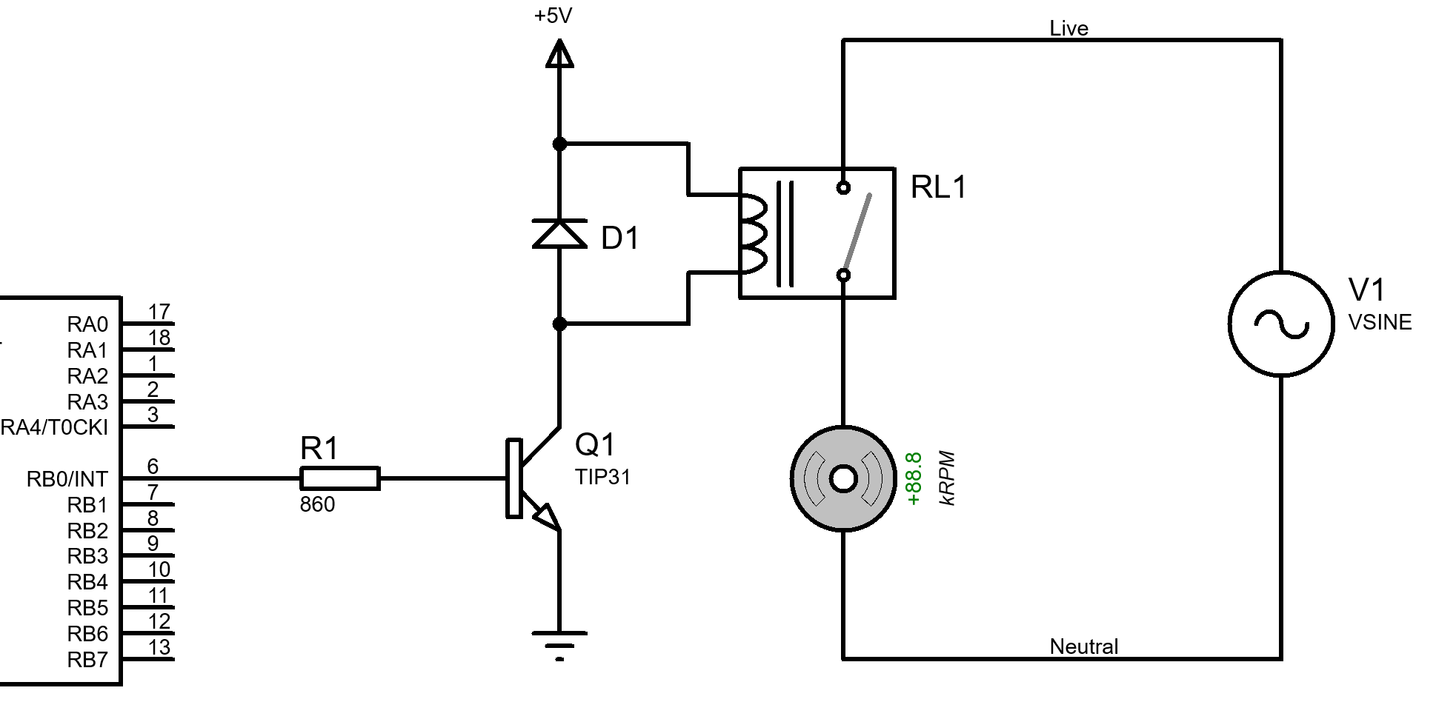

- What is the resolution of a 11-bit ADC with a maximum input voltage of 3.3V? Give your answer in mV.
[4 Marks]
$$V_{res}=\frac{V_{ref}}{2^{n}-1}=\frac{3.3}{2^{11}-1}=\frac{3.3}{2047}=1.612 mV$$
- Draw the logic symbol for an Exclusive Or gate and provide the truth table for it.
[4 Marks]
A | B | Q
0 | 0 | 0
0 | 1 | 1
1 | 0 | 1
1 | 1 | 0
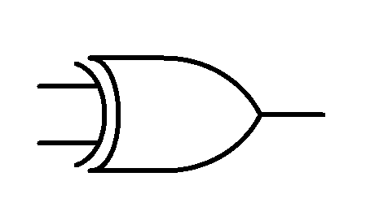

- For the circuit shown in Fig Q5, identify what it is and explain its operation.
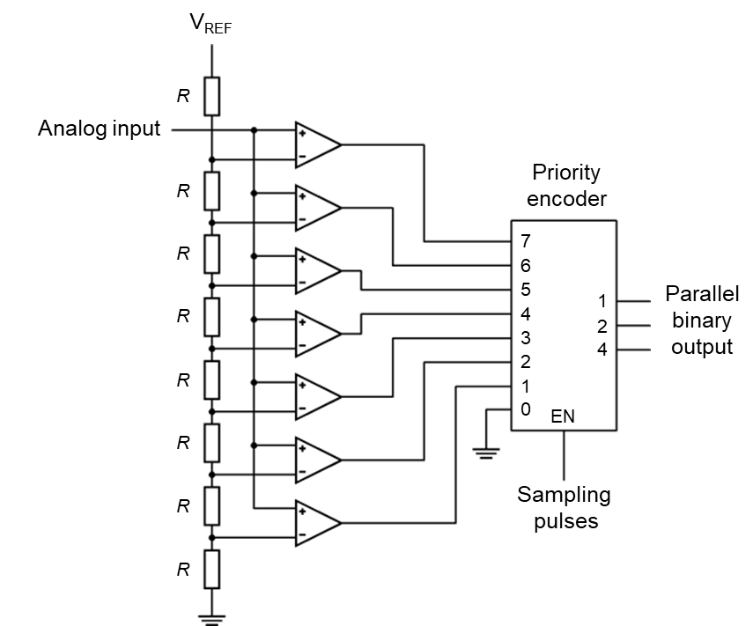
Fig Q5
[10 Marks]
2 Marks for correct identification of the circuit, 8 Marks for accurate description of its operation.
This is a 3-bit flash ADC. The resistor network sets up a voltage reference for each of the comparators. The analogue input voltage is applied to each of the comparators and compared to the reference voltage from the resistor ladder. If the analogue input voltage is higher than the reference voltage, then the comparator will output a 1, otherwise it will output a 0. The comparator outputs are connected to a priority encoder. The priority encoder will determine which comparators are outputting a signal and generate a binary output in proportion to the comparator outputs.

- Explain the phenomenon of switch bounce and describe one method that could be used in software, and one method that could be used in hardware, to overcome it. You should consider using circuit diagrams and flowcharts to illustrate your answer.
[10 Marks]
Switch bounce is a phenomenon whereby when a switch is closed the contacts of the switch bounce, repeatedly making, and breaking the contact. This causes problems in microcontroller circuits as the switch bounce could be read as more than one button press. There are several ways to combat this using software or hardware. – 2 marks for description of switch bounce.
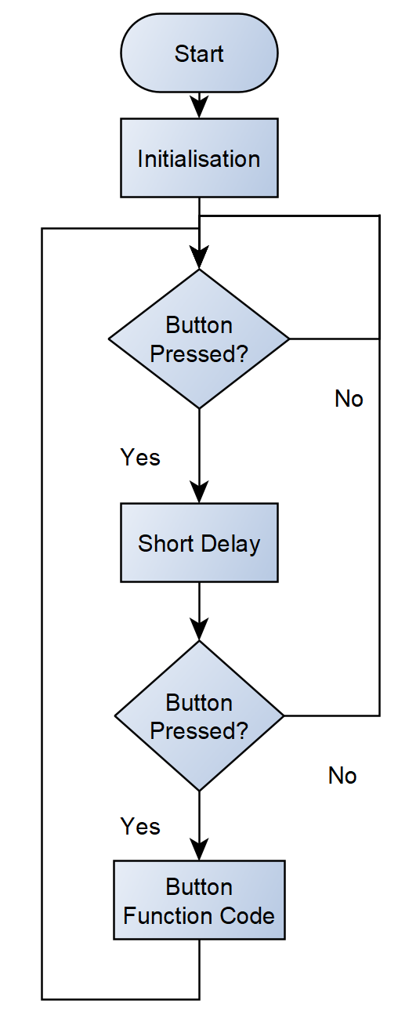
Software (4 marks available)

The simplest method uses a delay. After the button press has been detected, a short delay can be added. This is to allow the switch to stop bouncing, at which point the button can be tested again to see if it is still pressed. If the button is still pressed after the delay, we can assume that it was a genuine button press and the code for the button function can then be executed.

Hardware (4 marks available)

There are several methods that can be used to combat Switch Bounce in hardware. Any method with a sufficient description and circuit diagram will be acceptable.

Diwedd/End

