

Module Name: Academic Skills in the Digital Era
Module Code: BMSW4013
Assessment 1: E-Portfolio
Student Name: Julio Phol
Student Number: 2512123
Lecturer: Scott James
Deadline: Friday 21st November 23:59PM

Contents
Component 1: Research and Planning 4
Source Exploration 4
Key Challenge for Students 4
Key Opportunity for Students 4
Planning Your Report 4
Timeline for Component 2 5
Component 2: Answering the Question 5
Introduction 5
Challenges Students Face 5
Opportunities Digital Tools Provide 6
How Students Can Adapt 6
Conclusion 6

AI Acknowledgement

Examples of statements If you have not used AI
I confirm that I have not presented any AI generated materials as my own work.
I confirm that I have copies of my drafts, notes, and other resources I used, which I may be asked to provide in evidence.

Examples of AI statements if you have used AI
Example 1:
I acknowledge the use of Grammarly (https://www.grammarly.com/) on Date to check my work using the prompt(s):

1. Please check the following text for readability, grammar and syntax.
I confirm that I have not presented any AI generated text as my own work. I confirm that I have copies of my drafts, notes, and other resources I used before, and after the use of AI tools which I may be asked to provide in evidence.

Example 2:
I acknowledge the use of SciSpace (https://typeset.io/) on 7 March 2024 to support my research using the prompt(s):
1. Please provide me with materials on the biology of the liver.
2. Please provide me with materials on liver cells.

I confirm that I have not presented any AI generated text as my own work. I confirm that I have copies of my drafts, notes, and other resources I used before, and after the use of AI tools which I may be asked to provide in evidence.

Example 3:
I acknowledge the use of ChatGPT (https://chatgpt.com/) on 13 April 2024 to write my notes into submission format using the prompt(s):
1. Please write up these bullet points as an essay paragraph at university level.

I confirm that I have not presented any AI generated text as my own work. I confirm that I have copies of my drafts, notes, and other resources I used before, and after the use of AI tools which I may be asked to provide in evidence.

Component 1: Research and Planning

Source Exploration
The source chosen is the article written by a group of researchers from the OECD that came out in September 2025.
The main idea is that technology can help students learn better, but only if it’s used the right way. Just having digital tools doesn’t mean students will automatically do better.
I picked this source because it’s recently trustworthy and talks about both the good and bad sides of using technology in different areas of the education.
It helps me answer the question because it gives clear examples of how digital tools can support learning and shows the problems students face when using them.

Key Challenge for Students

One big challenge student face with digital tools is not having equal access. Some people have fast Wi-Fi and their own laptop, while others must share devices or use their phone for everything. I remember during lockdown for covid 19, a friend of mine couldn’t join Zoom classes properly because his internet kept cutting out. Even when students do have the tech, not everyone knows how to use it well. Some platforms are confusing, and it’s easy to get lost. This challenge matters because it creates gap students who struggle with access or tech skills and can fall behind, even if they’re smart and hardworking. If we want education to be fair, we need to make sure everyone has the tools and support to use them properly and I use this example and challenge because universities are around the world and are not like UK that offer you a laptop or more facilities to study.

Key Opportunity for Students
One of the best things about digital tools is that they let you learn at your own pace. If you don’t get something in class, you can go online and find videos or notes to help you understand. I’ve used sites like YouTube when I was stuck, and they really helped me figure things out. You can pause, rewind, or rewatch stuff as many times as you need. That’s super useful, especially when English isn’t your first language or when you need more time to process things. This kind of learning is way less stressful because you’re not rushed. You can take your time and build confidence. For me, it’s made studying feel more flexible and less scary. It’s like having a second chance to learn things properly, and that’s something I really value.

Planning Your Report
For my report, I’ll focus on both challenges and opportunities equally because I think it’s important to show both sides of how digital tools affect students. I plan to include examples like Laptops, phones, Wi-Fi and zoom, since they’re tools many students use. I’ll also mention issues like poor internet access and confusion with online platforms. I’ll structure the report with a short intro, then one section for the challenge and one for the opportunity, followed by a conclusion that reflects on what students need to succeed with digital learning.

Timeline for Component 2
Task | Date/ Deadline
Finish research | 5th October 2025
Draft first section | 8th October 2025
Complete first draft | 15th October
Final editing | 20th October

Component 2: Answering the Question

Introduction
In today’s world, digital learning is becoming more common in schools and universities. Students use tools like Zoom, Moodle, and online videos to study, attend classes, and do homework. Since the COVID-19 pandemic, digital learning has grown even faster, and many students now rely on it every day.
Digital tools can be very helpful. They make learning more flexible and give access to lots of resources. But they can also bring problems, like poor internet or not knowing how to use the tools properly. That’s why it’s important to look at both the good and the bad sides.
This report will explore one key challenge and one opportunity that digital tools bring for students. It will also give three useful tips to help students adapt and succeed in a digital learning environment.

Challenges Students Face
One major challenge students face is unequal access to digital tools and internet. Not all students have a personal laptop or strong Wi-Fi at home. This is called the “digital divide.” According to the OECD (2025), students from lower-income families are more likely to struggle with access to devices and reliable internet, which can affect their ability to learn and complete tasks.
For example, during online classes, some students couldn’t join Zoom sessions or had to share one device with siblings. Others didn’t know how to use platforms like Moodle or Teams, which made it hard to follow lessons or submit work. This lack of access and digital skills can lead to stress, lower grades, and feeling left behind.
This challenge is serious because it creates unfair differences between students. Even if someone is smart and motivated, they might fall behind just because they don’t have the right tools. To make education fair, schools and governments need to support students who are struggling with access and digital literacy.

Opportunities Digital Tools Provide
On the positive side, digital tools offer students the chance to learn at their own pace. With online platforms like BBC Bitesize or online libraries, students can watch videos, take quizzes, and repeat lessons as many times as they need. that digital tools can support different learning styles and help students become more independent.
For example, if a student doesn’t understand a topic in class, they can go online later and find extra help. They can pause, rewind, or rewatch videos until they feel confident. This is especially useful for students who speak English as a second language or need more time to understand new ideas as I mentioned before.
This opportunity is valuable because it gives students more control over their learning. It helps them feel less stressed and more confident. When used well, digital tools can make learning more flexible, fun, and effective. They also prepare students for future jobs, where digital skills are often required.

How Students Can Adapt
To improve in a digital learning environment, students can try these three strategies:
1. Learn basic digital skills
Before using online platforms, students should learn how to use tools like Zoom, Moodle, or Google Docs, or One drive etc. Many universities offer short workshops or videos to help with this. For example, Universities in UK provides digital skills training for new students if not everyone can find for free in YouTube. Knowing how to use these tools saves time and reduces stress. It also helps students feel more confident when doing online tasks.

2. Create a study routine with tech breaks
It’s easy to get distracted when studying online. Students should plan their day with clear study times and short breaks. Using apps like Forest or Pomodoro timers can help them stay focused. Research shows that taking regular breaks improves concentration and reduces screen fatigue. This habit helps students manage their time better and avoid feeling too much stress.

3. Use trusted online resources
Students should explore helpful websites like BBC Bitesize, Government sites, or their university’s online library. These tools offer videos, quizzes, and notes that match what they’re learning. Using these resources can make hard topics easier to understand. It also helps students review lessons in their own time, which is great for exams or just prepare for the future.

Conclusion
In this report, we looked at one big challenge, unequal access to digital tools and one great opportunity, learning at your own pace. We also shared three ways students can adapt: learning basic technology skills, making a study routine, and using trusted online resources.
Digital tools are now a big part of education, and they’re not going away. That’s why it’s important for students to understand both the good and the bad sides. If students learn how to use these tools well, they can improve their learning and feel more confident.
In the end, digital learning is not just about using a laptop or phone. It’s about knowing how to learn in a new way. With the right support and habits, students can succeed in this digital era.

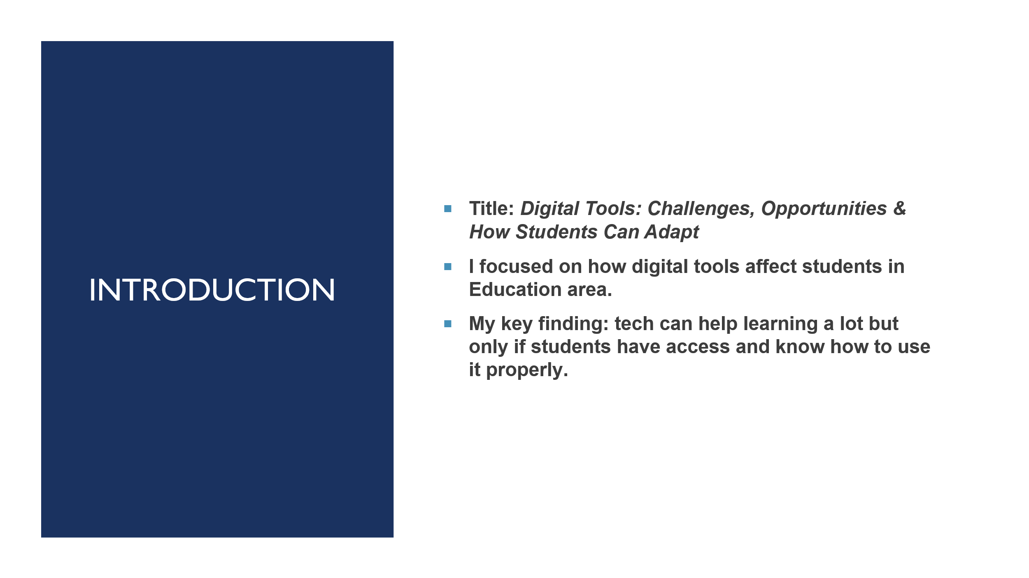
Overview (Slide 1)

Research (Slide 2)

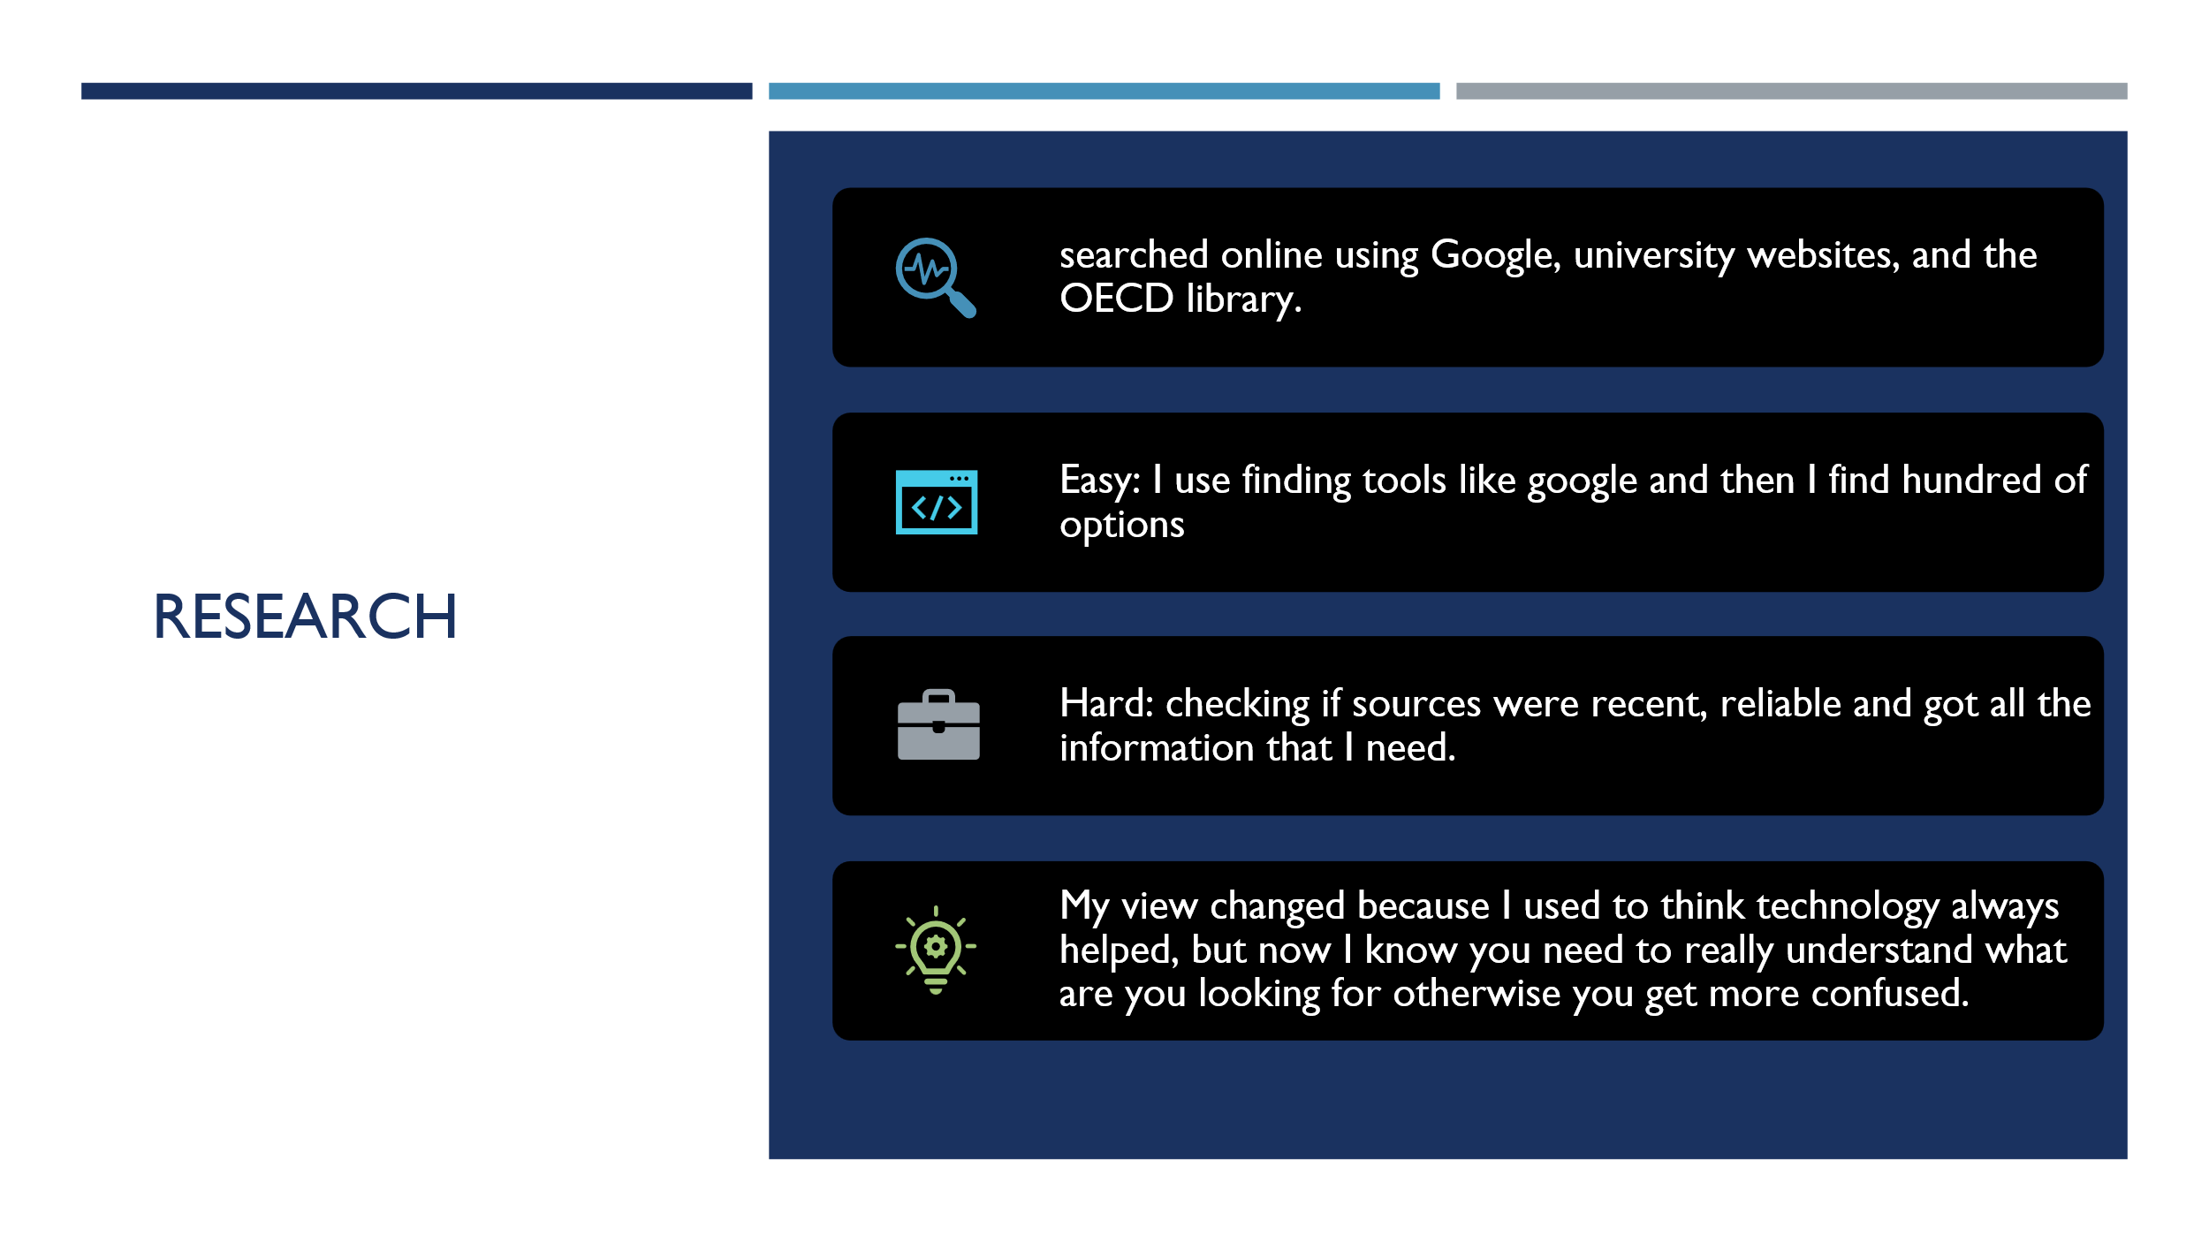

Slide 3 (Planning & Writing)
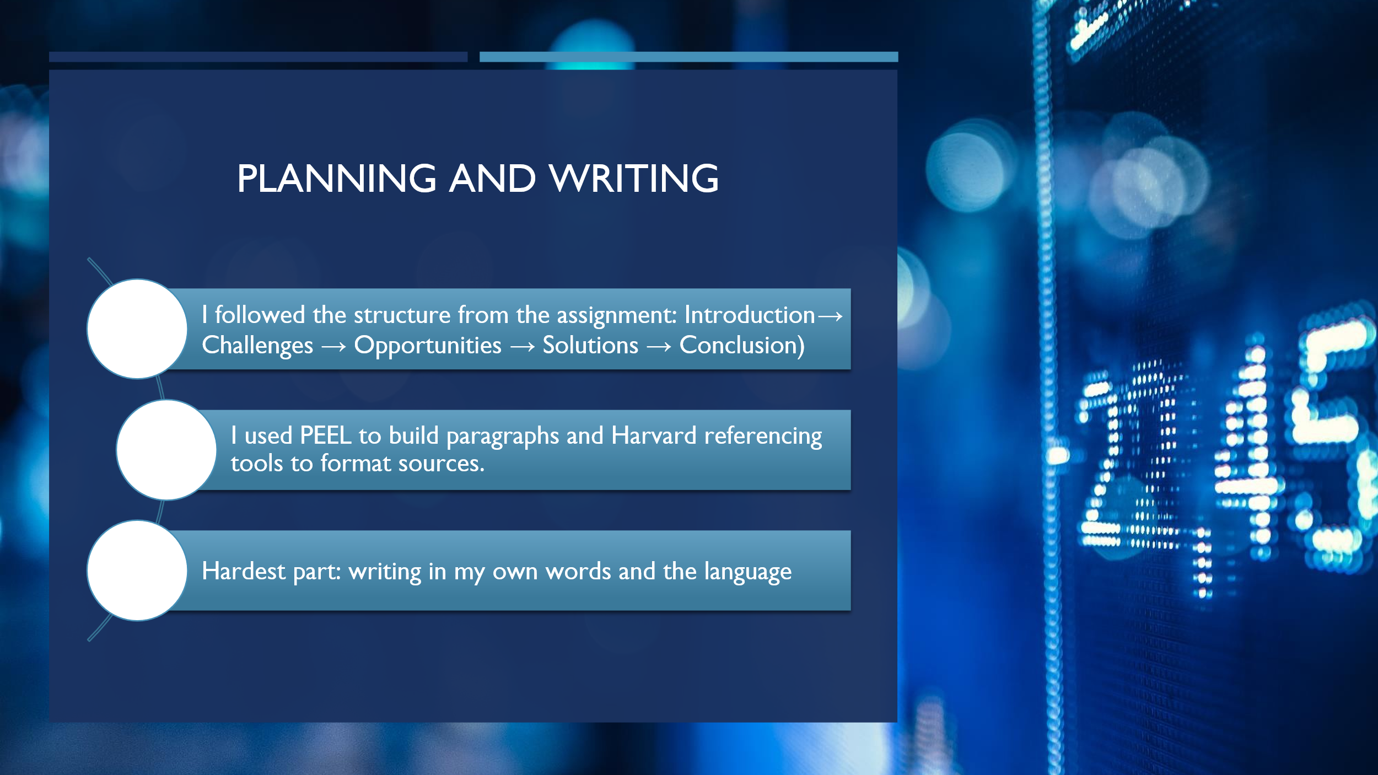

Slide 4 (Challenges)
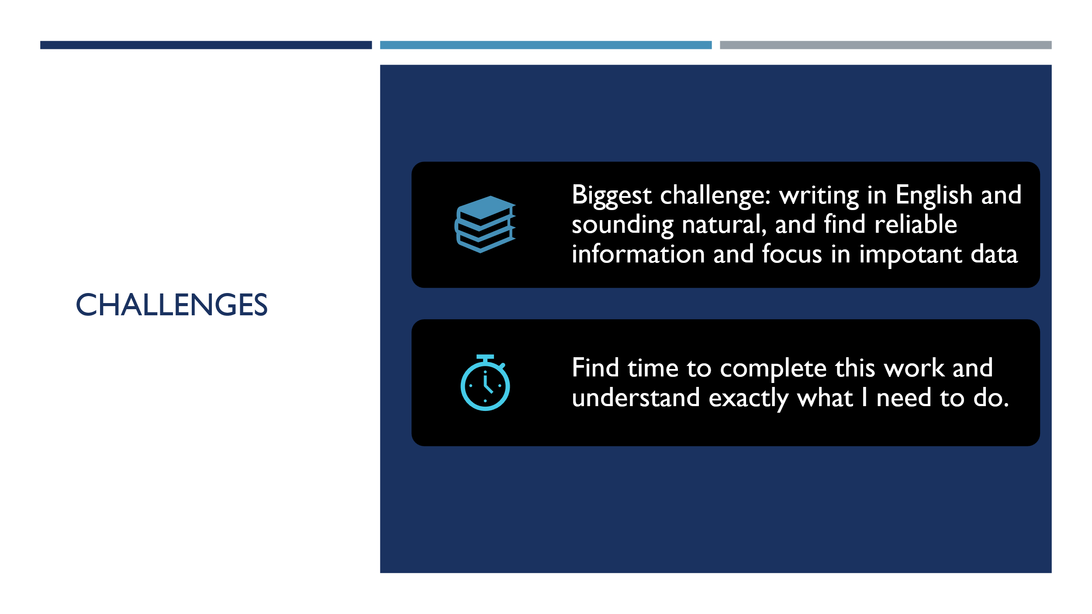
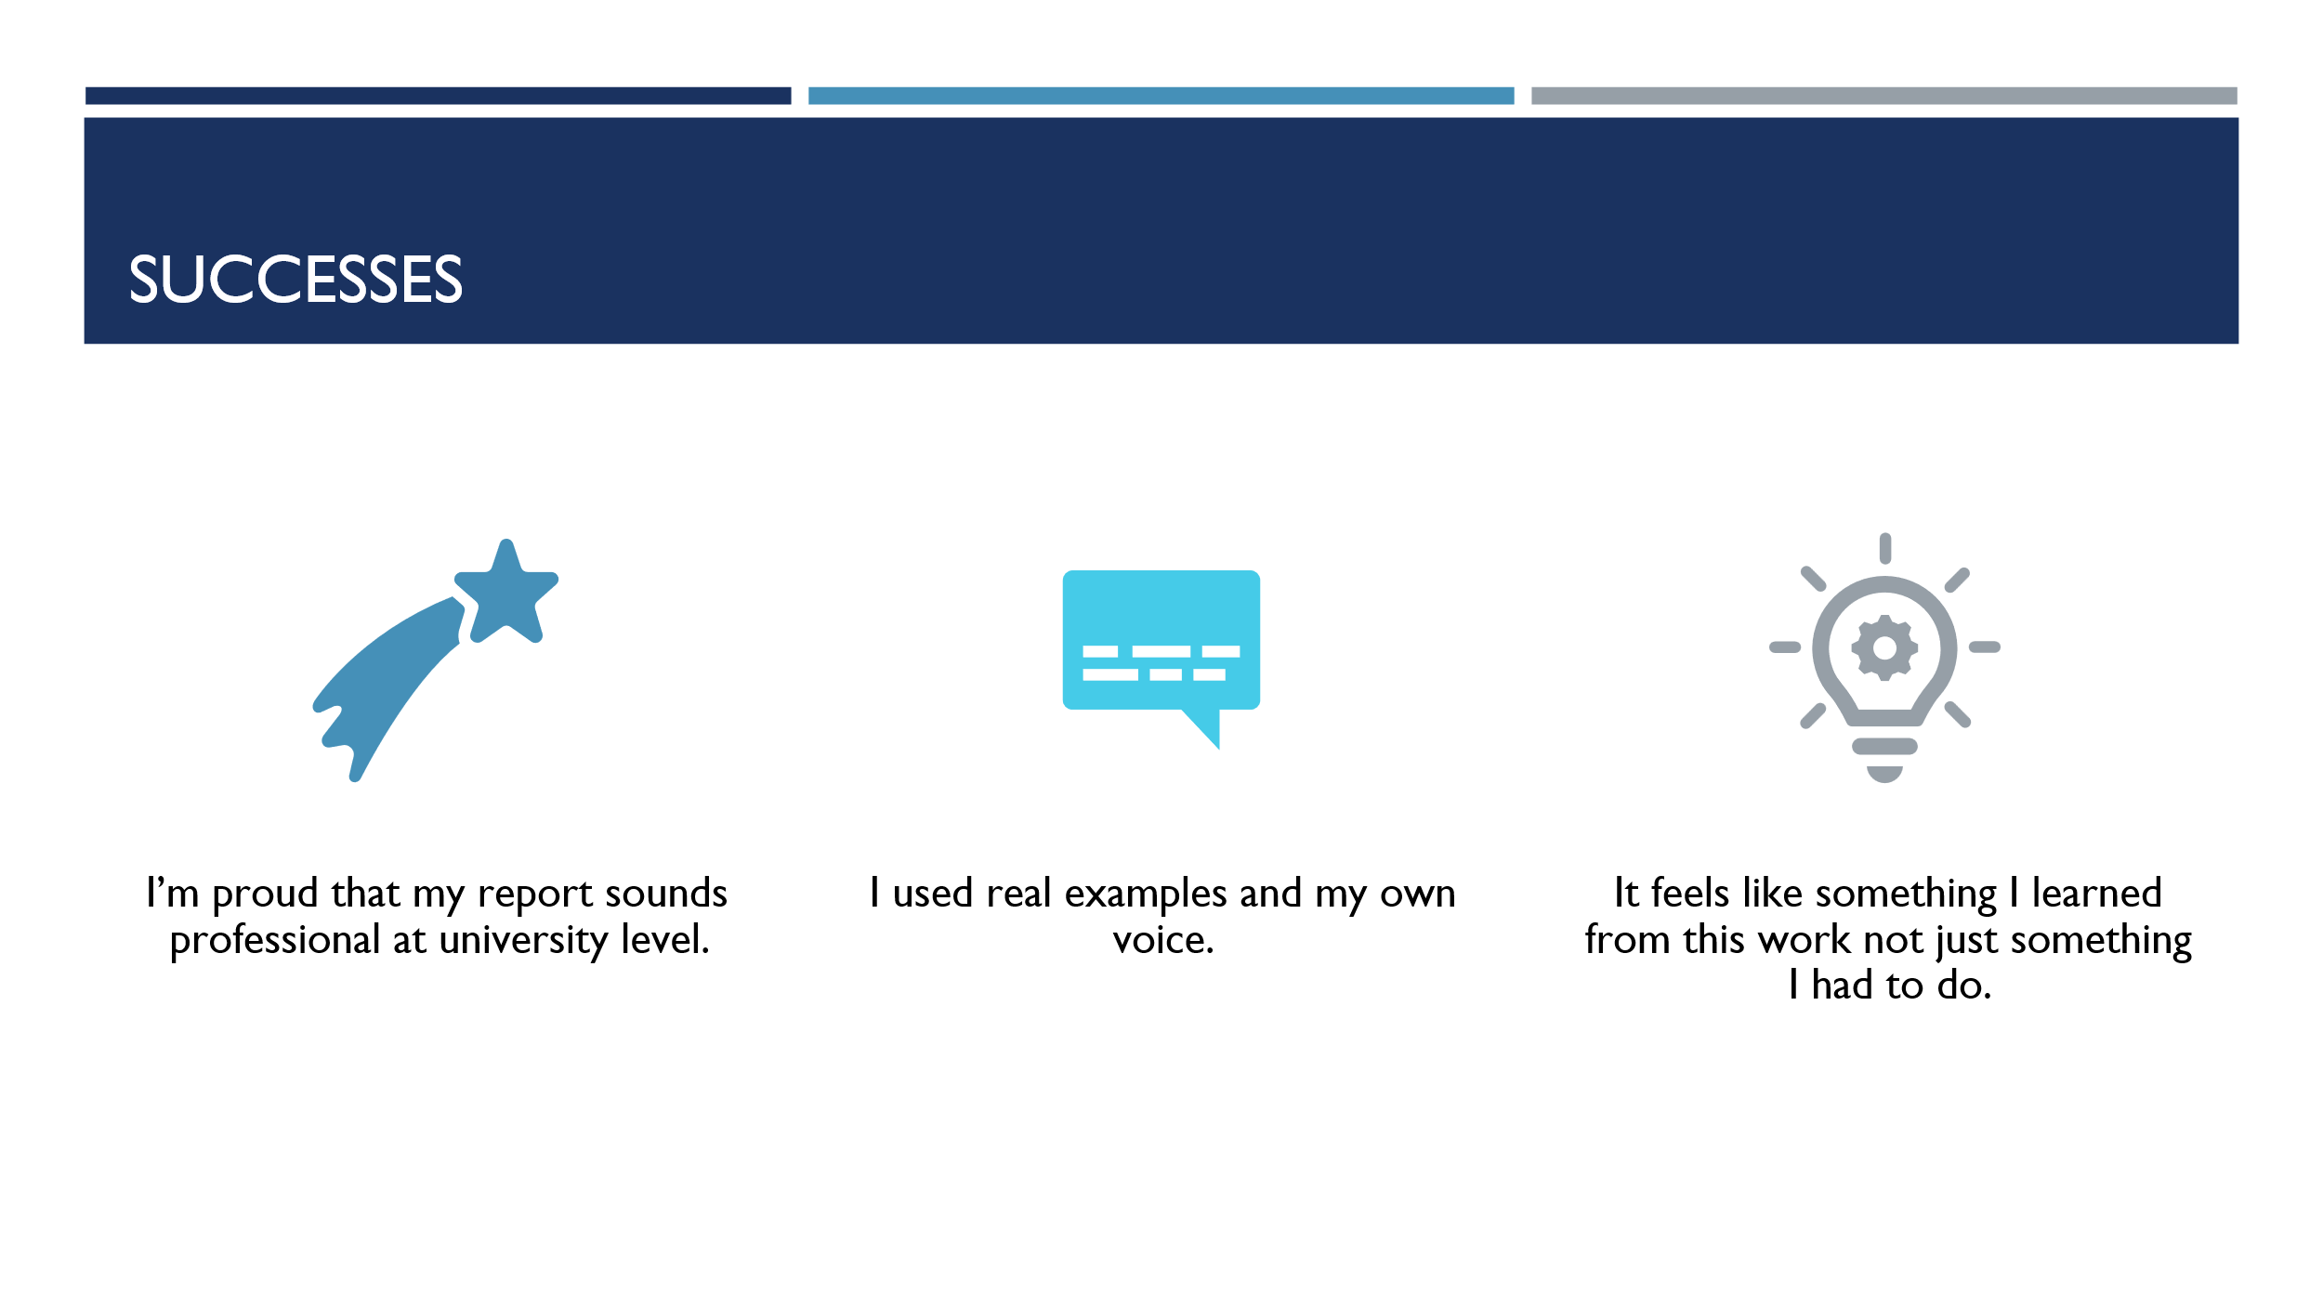
Slide 5 (Successes)
Slide 6 (Looking Forward)
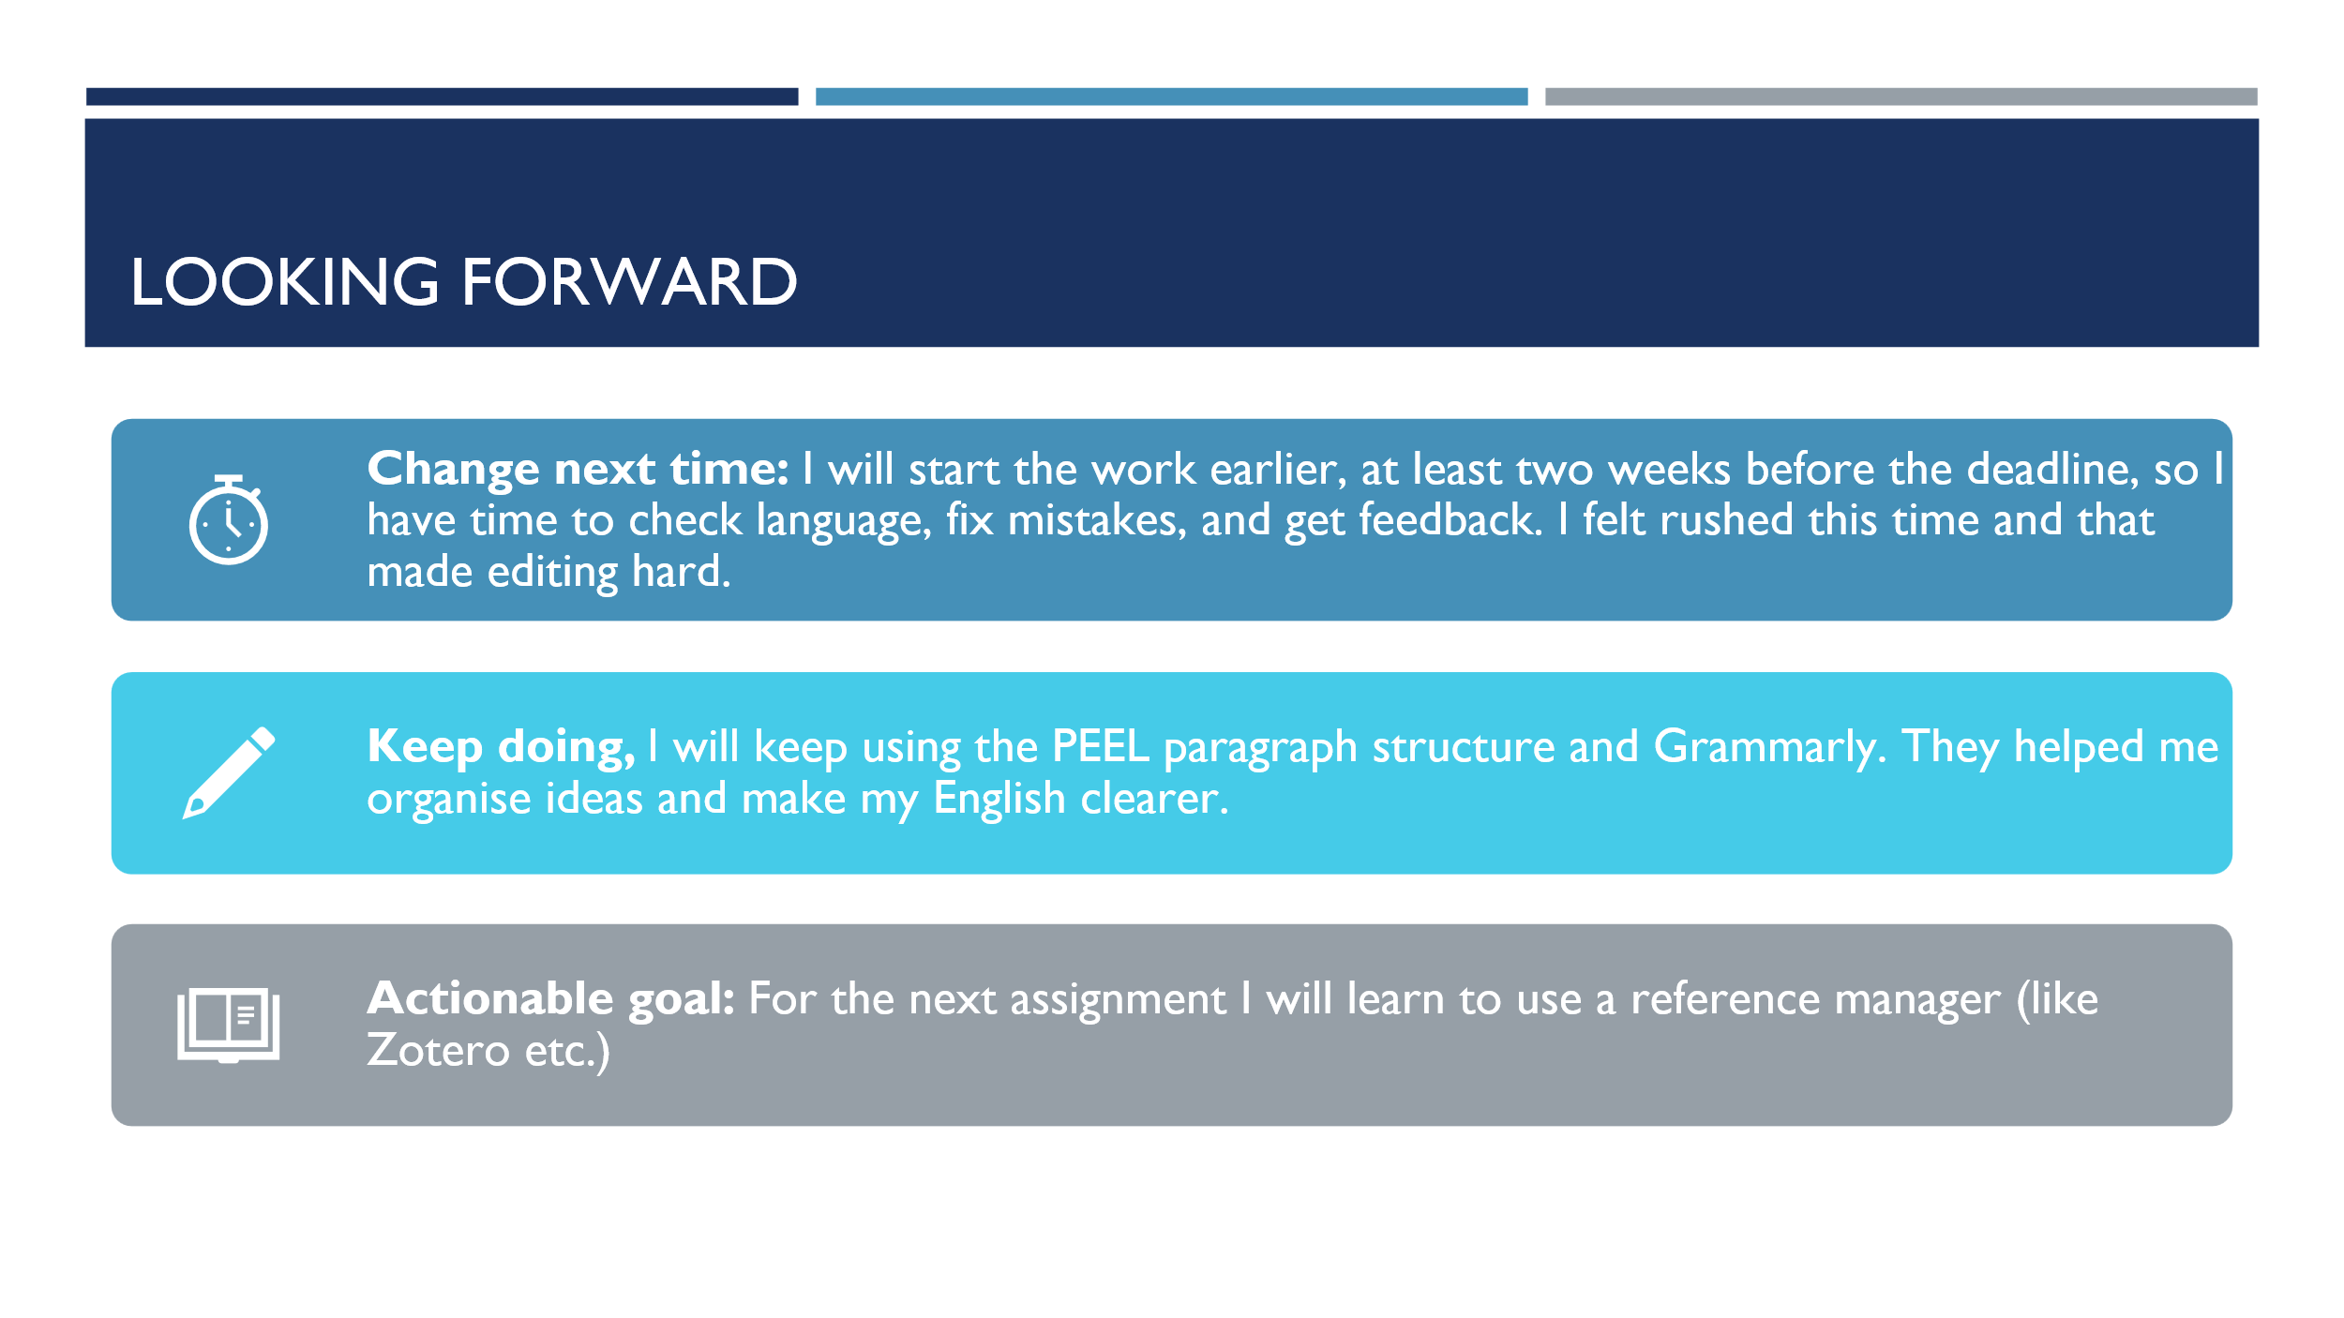
Reference List
- Angie, T. (2023). How to Use the Forest App for Studying—Set Up in 2 Minutes!. Learning with Angie. Available at: https://learningwithangie.com/how-to-use-the-forest-app-for-studying [Accessed 18 Nov. 2025].
- Birmingham City University. (2023). The Pomodoro technique for focus. Available at: https://www.bcu.ac.uk/exams-and-revision/time-management-tips/pomodoro-technique [Accessed 17 Nov. 2025].
- Cardiff University. (2024). Cardiff University drives digital skills and innovation in 2023 through successful outreach events. Available at: https://www.cardiff.ac.uk/news/view/2789002-cardiff-university-drives-digital-skills-and-innovation-in-2023-through-successful-outreach-events [Accessed 19 Nov. 2025].
- Department for Education. (2025). No child left behind in plans to narrow the digital divide in education. GOV.UK. Available at: https://www.gov.uk/government/news/no-child-left-behind-in-plans-to-narrow-the-digital-divide-in-education [Accessed 18 Nov. 2025].
- Finch, A. (2025). Unlocking Learning with BBC Bitesize: A Comprehensive Guide. Learn Wise Daily. Available at: https://learnwisedaily.com/bbc-bitesize-comprehensive-guide [Accessed 18 Nov. 2025].
- Khan Academy. (2024). Research on how Khan Academy drives learning outcomes. Khan Academy Blog. Available at: https://blog.khanacademy.org/research [Accessed 19 Nov. 2025].
- Moraes, A. (2023). Enhancing engagement: 6 strategies for effective online learning. Cambridge University Press. Available at: https://www.cambridge.org/elt/blog/2023/11/30/enhancing-engagement-6-strategies-for-interactive-and-effective-online-learning [Accessed 19 Nov. 2025].
- Morava, A., Sui, A., Ahn, J., Sui, W. & Prapavessis, H. (2023). Lessons from Zoom-university: Postsecondary student consequences and coping during the COVID-19 pandemic. PLOS ONE, 18(3), e0281438. Available at: https://doi.org/10.1371/journal.pone.0281438 [Accessed 18 Nov. 2025].
- OECD. (2025). The impact of digital technologies on students’ learning: Results from a literature review. OECD Education Working Papers No. 335. OECD Publishing. Available at: https://www.oecd-ilibrary.org/education/the-impact-of-digital-technologies-on-students-learning_9997e7b3-en [Accessed 16 Nov. 2025].
- Walkden, E. & Owens, S. (2023). What students want: An exploration of the user experience of Moodle at Lancaster University. Lancaster University Education Journal. Available at: https://ojs.library.lancs.ac.uk/lue/article/download/18/22/65 [Accessed 18 Nov. 2025].

