MODULE CODE: Digital Skills for Personal Development and Business Growth BMSW4008

ASSESSMENT COMPONENT: PORTFOLIO

STUDENT NAME: MARIA ISLAM

STUDENT NUMBER: 2509342

LECTURER: PHILIPPA FITZGERALD

DATE: 12/12/25

I confirm that I have not presented any AI generated materials as my own work.
I confirm that I have copies of my drafts, notes, and other resources I used, which I may be asked to provide in evidence.

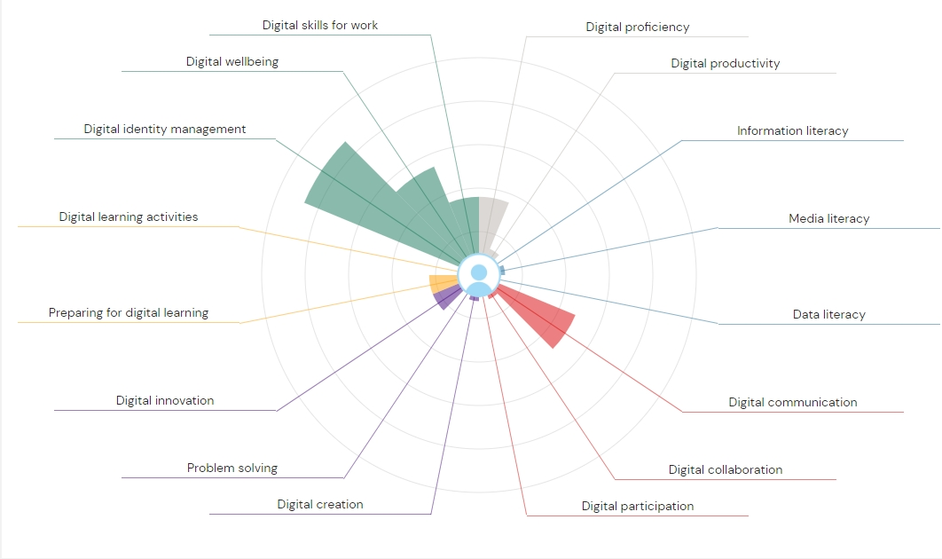
Digital tools are a wide range of software apps that make education life, work life and even day to day life easier. We use a variety of digital tools to interact and communicate with others like family, friends or colleagues, we also use digital tools to find out relevant information we are looking for. Also, another positive thing digital tools can be used for is creativity by producing personalised work using the tools provided. Digital tools have now become an essential in study life, work life and now even personal life. A lot of people have adapted to using digital tools although its always changing and developing.
From this diagram I can see I have strengths in digital identity management. I know how to manage and protect my personal information online. According to an article from the ‘National Cybersecurity Alliance’ (Staysafeonline.org, 2025) it says being aware of your data privacy you can make an informed decision of what you share online. I can use strong tools like passwords, two-factor authentication, and secure logins to keep my accounts safe from being hacked and from identity theft. For example, my bank details, data and personal messages are protected and less likely to be stolen. According to another article from ’Tech Class (Tech Class, 2025) the consequences for having poor privacy settings on can lead to hackers stealing personal information leading to identity theft and fraud. By understanding how to manage digital identity I can also control me personal information online, I can manage what information to share and what I shouldn’t share online, who can see it and where I store that information. This way my personal information is protected and helps me build a positive reputation of my digital footprint.
Another one of my strengths on this diagram is my digital wellbeing. To promote healthy digital habits, I set timers on apps that I tend to use excessively if I don’t put timers, I often find myself doom scrolling for example apps such as TikTok and Instagram can be very distracting to get other daily tasks I need to get done. According to (Lakshmi Chirumamilla, 2023) you should take regular breaks from screen time to maintain good health. I also take breaks of screen time to help reduce eye strain, staring at a screen for a lengthy amount of time I find myself getting migraines and feeling fatigue so by being mindful of how much time I spend using digital tools has helped to reduce those negative effects it has, and also by maintaining healthy habits its helped to focus better on tasks, reduced stress and also improved sleep quality.

On the other hand, looking at some of my weaknesses from the Jisc diagram I can see my media literacy is extremely low. I find it difficult to find relevant and reliable information online. A lot of sites can have misleading information especially now with how fast Artificial intelligence is developing it is very easy to believe what you see online and tell the differences between real and false information and especially now when on a lot of content there are no watermarks to tell you its AI it can be extremely misleading. According to a website called ‘Columbia Business School’ (Sperling, 2024) it talks about how we should fact check our information especially now with AI always developing its harder to figure out what is false information and what is true. A lot of websites I looked at to find my references on past assignment didn’t have reliable sources which made it hard to find correct relevant information which made it very time consuming to have to keep searching for reliable sources. Another thing is the way algorithm works, you only see similar content to what you’ve previously watched, this limits you to see everything else going on and creates a biased opinion on a lot of things, which can also mislead a lot of people.
Another one of my weaknesses is digital collaboration. I find digital collaboration quite challenging. I find it difficult to stay organised and stay focussed, I don’t put in enough effort to stay connected to teams online in a digital environment. Constant overload of information online and notifications from emails and messages makes me feel very overwhelmed so I struggle to maintain it all and stay organised. According to the ‘Forbes’ website (Expert Panel, 2025) constant notifications can be overwhelming and makes it harder to focus on what’s important. Because of this I usually leave important things to last minute and end up stressing and rushing through things like assignments I also forget about important or urgent emails I need to get back to which leads to me loosing out on good opportunities I needed.

A SMART action plan I have put together to help me focus on my weakness is as follows;
For my first weakness Media literacy:
Specific – work on finding reliable information and knowing what is true and what is false information.
Measurable – evaluate my sources before I put them into my assignment.
Achievable – I can use fact checkers to check my information is true and reliable.
Relevant – directly fixes the problem by helping me avoid false information in my work.
Time Bound - from now for every upcoming assignment.

For my second weakness, Digital Collaboration:
Specific – improve my organisation skills, manage urgent tasks first so I don’t miss out or fall behind on anything.
Measurable – take time out my day to check emails, notifications and teams messages to ensure I haven’t missed any news or updates.
Achievable – I can use a digital calendar, make to do lists and use checklists to manage my tasks and deadlines.
Relevant – this will keep me organised and on top of my tasks.
Time Bound – from now with my personal life and also throughout this course

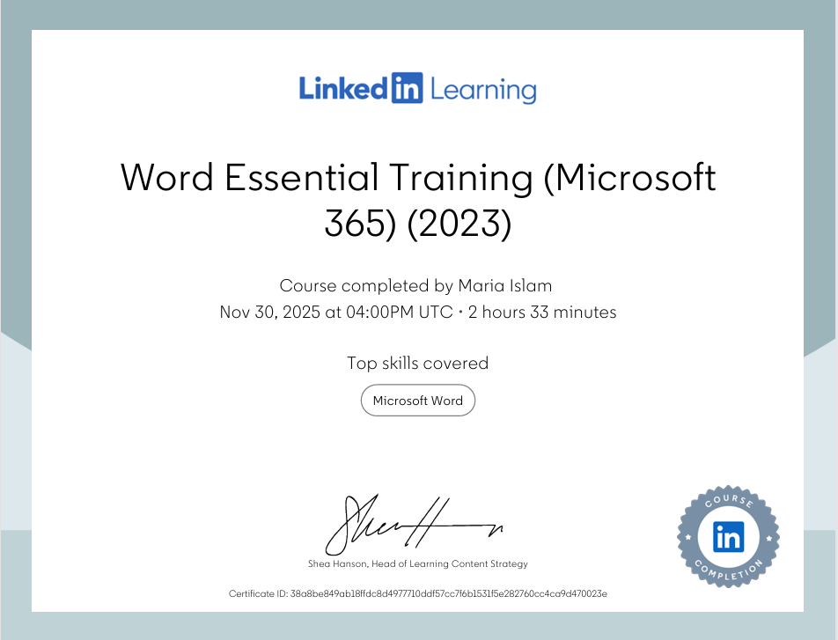

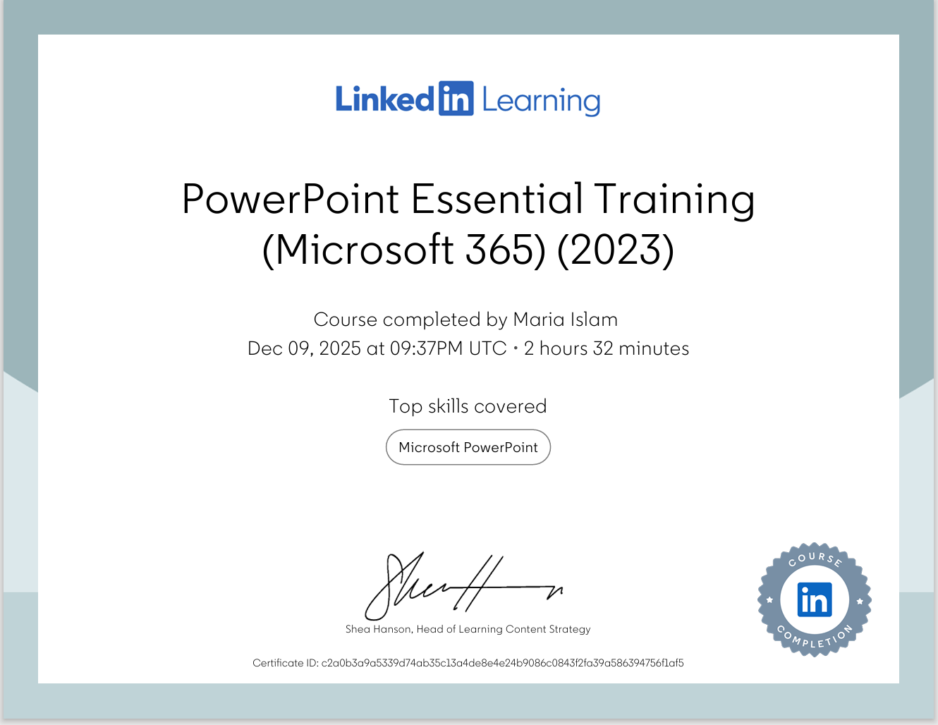

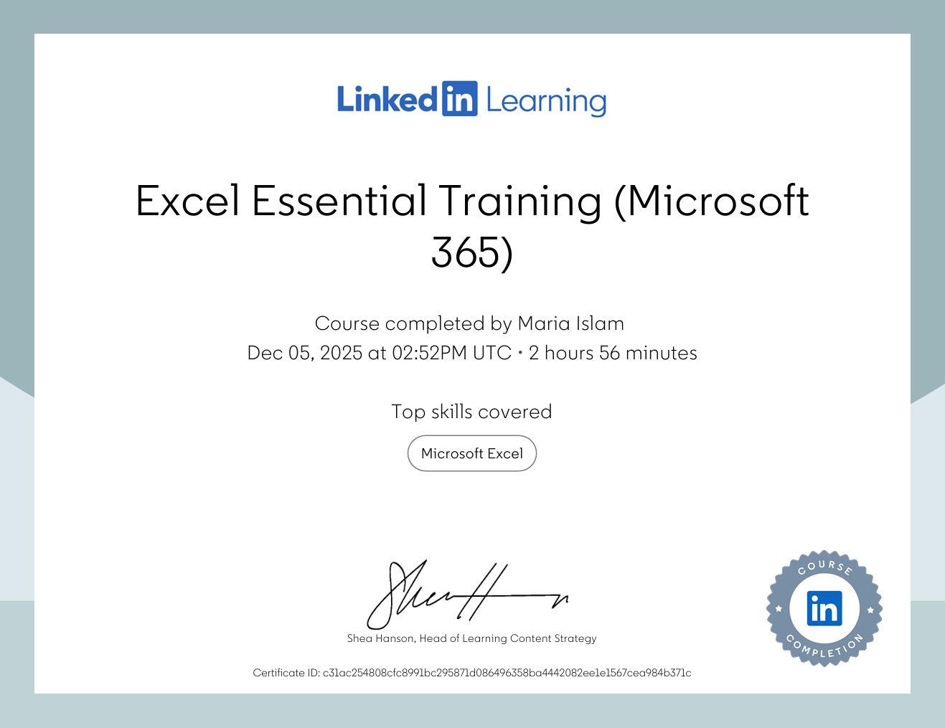

Excel - spreadsheet

Income | Amount per month £££ | Expenditure | Amount per month £££
Wage 1 | £1,350 | Rent/Mortgage | £700
Wage 2 | £500 | Council tax | £150
Trust Funds | £400 | Electric | £140
Stocks/Share payouts | £0 | Gas | £160
Universal credit | £0 | Water rates | £100
Student Finance | £300 | Food | £400
TOTAL | £2,550 | Car insurance | £180
 |  | Car Tax | £14
 |  | Fuel | £80
 |  | Child Care Costs | £0
 |  | Loans/credit cards | £0
 |  |  | £2,000 | TOTAL | £3,924

Excel is an extremely useful tool that can be used in both personal and work life. According to (Charlesworth, 2024) he says that Excell isn’t just a software for spreadsheets, but it is an essential tool for modern business. It is an app made by Microsoft that can help organise things better and analyse and see data in a clear structured way. It is a digital tool that makes handling money and finances and other things a lot easier to manage and track. Excell is widely used across a lot of different industries, the software allows users to create charts, tables, sort information and filter results which makes it easier to find specific information quickly and efficiently.
In work life excel is very useful especially for people with a huge business who deal with a large amount of information to keep it all organised and easy to access. According to a website called (GeeksforGeeks, 2025) it says that excel helps employers’ mange a large amount of data efficiently and makes it easy to analyse the information.
Big companies and businesses have a lot of data they need to keep track of like the sales they make, information about workers and even future business plans they have, which can be manged with Excell. With Excell you can have all that information neatly formatted which makes it easy to read and understand. You can create tables and arrange things how you’d like to make it easily accessible. Another great feature on Excell is it can help with mathematical calculations, which makes it more likely to be accurate if done correctly, less time consuming and easy for everyone to do.
Excell is great with math, if a person struggles with writing mathematical formulas and doing a lot of calculations, excel can do it all for you. In the sales industry excel comes in very handy especially when calculating the total number of sales being made, For example, you’re in charge of sales you can use excel to add up all the sales, find the average sales you’ve made each month and see a rough estimate of how much income you can make in the future, according to (Lindsay, 2023) she says that excel is like having your own inventory manager because it can help you monitor your stocks and sales. This feature can help make informed decisions and plans since everything Is calculated correctly if it’s being used correctly.
Another feature Excell offers is that you can make charts and graphs that can layout information in easier ways to read or analyse, for example you can create graphs or pie charts to show information or how things are developing, you can create a line graph to show how much the sales have been going up or down if the business is doing good or not making much progress. You can also use pie charts to show where cost is being spent and how much of it is being spent in those areas, some people understand things on pictures rather than a bunch of numbers or words so being able to have information on charts and graphs makes it more accessible for everyone to work together and understand.
Besides work or professional life, Excell can also be used efficiently in your personal life. You can use it to keep track of your finances and budgeting, to see where you’re spending your money and how you are saving some money. Doing this can also help you make smart and informed decisions about what you might need to purchase in the future so you can manage it all in an organised way.
Excell can also be very useful for personal plans, if you travel a lot, go to a lot of events, plan on home renovations, personal savings and even planning a wedding you can use Excell to keep track of how much and where the money is going to be spent. By inputting monthly income and expenses you can easily identify where you can cut back some money and save money. You can also use it to create ‘to do lists’ and set dates to keep you on track of things in an organised way. It helps you budget things properly making sure expenses aren’t being wasted elsewhere and things are done in time, which reduces the stress that can come with planning for big financial personal events.
Excell can also come in very handy for students, colleges and universities teach students how to use this digital tool effectively, to understand the information and how to do math. Some people might think excel is a complicated digital tool or includes using complicated maths however there is a variety of online tutorials and video guidance that shows how to create charts, look at data and do calculations that makes it easy to understand how to navigate through the app. It can take a lot of practice to fully get the hang of it but once you adjust it becomes very simple to do, according to (Puneet, 2023) out of all the other spread sheet applications Microsoft excel is one of the best once you learn how to use it. Nowadays employers look for people to employ who have good skills in Excell as it is an essential digital tool in the business world, according to a website article called ‘efficiencyandorganization’ it says an advantage of using Microsoft excel is finding employment as employers look for individuals who can use these type of digital tool as it very useful in their daily operations. So, it’s a very good skill to learn.
To conclude excel is a fundamental digital tool for both work and personal life, according to (Williams, 2024) in his article he writes that whether you’re a student, professional, or someone who just wants to be more organised excel can offer a lot to support that. It helps you keep on top of things, keeps you well organised, helps you read, understand and analyse data effectively. Learning and understanding all the features this digital tool provides like knowing how to organise data, visualise information by transforming them into pie charts or line graphs and being able to understand how to read the data can open a lot of opportunities for you to find all kind of jobs, it is a very valuable skill in the workplace. Additionally, it also helps you maintain your personal expenses or any project or business plans you may have for the future, you have a visual spread sheet presented which you create to your understandings that make managing finances or anything else much easier to do. Whether you are working in a big company or even just trying to manage your daily tasks excel can be very useful to use.

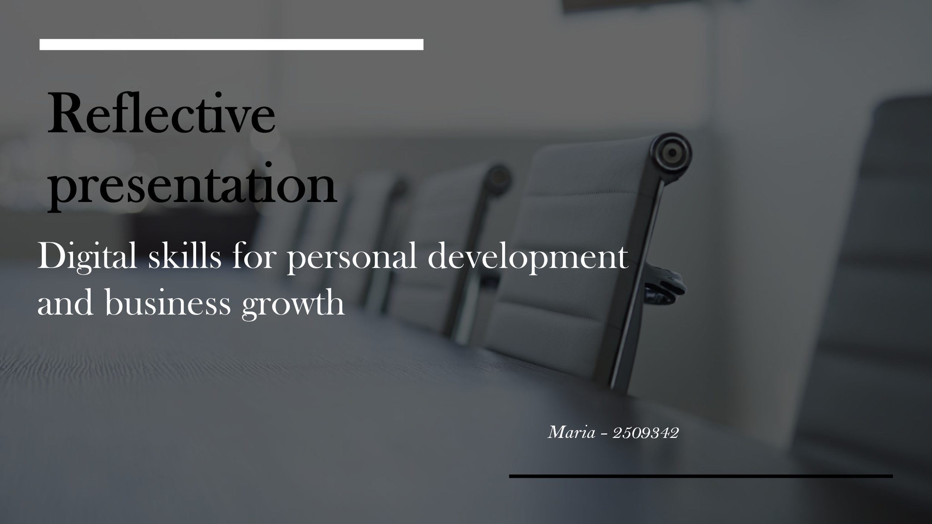

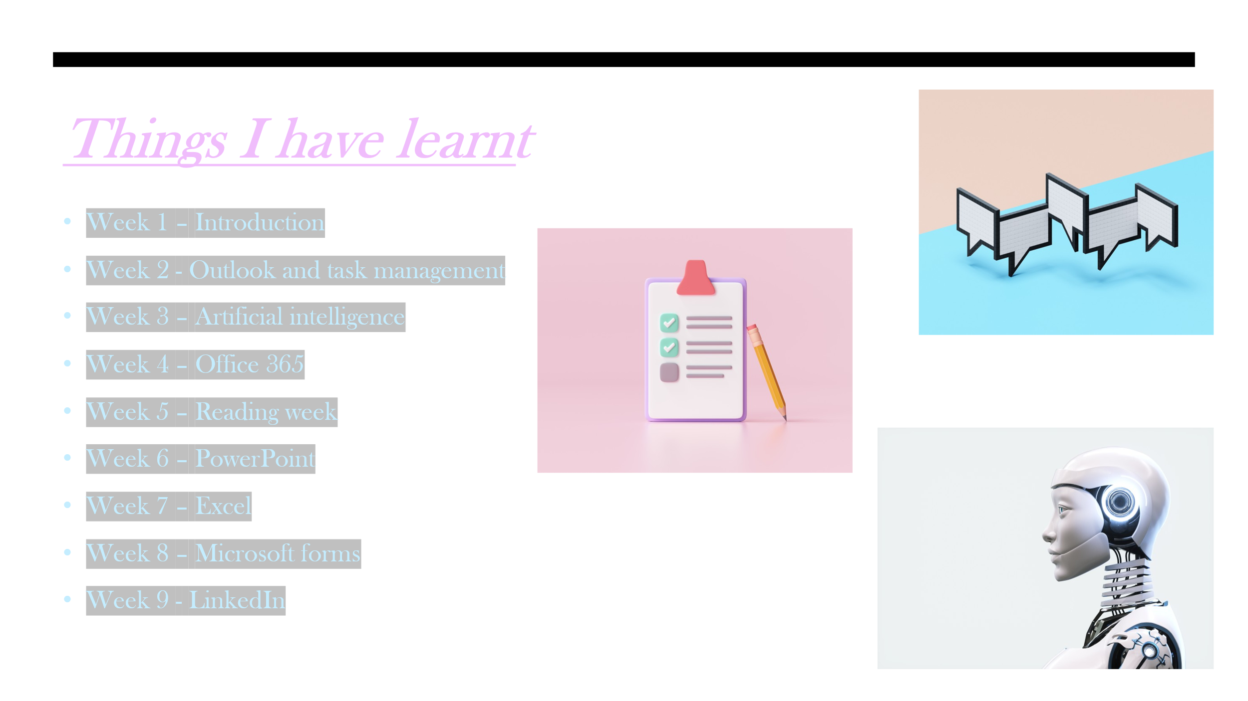

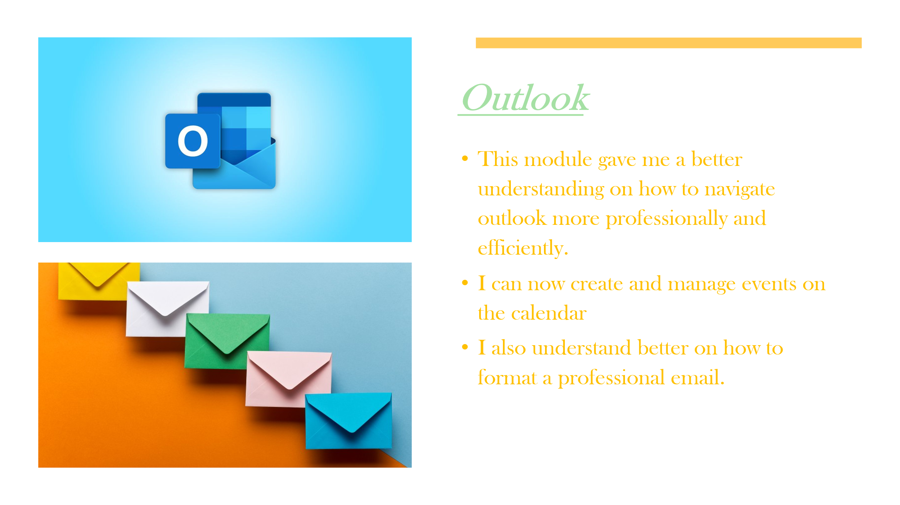

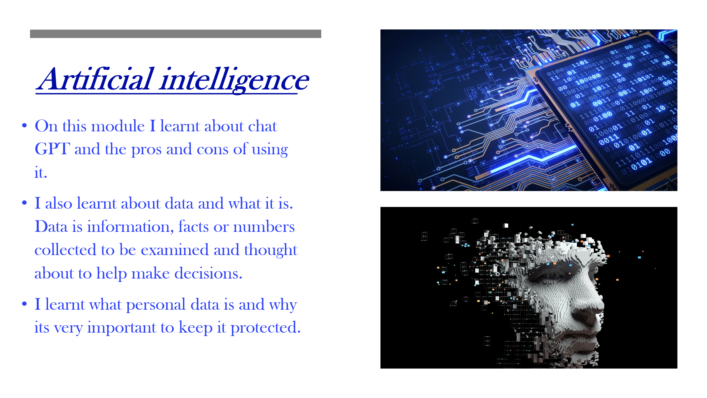

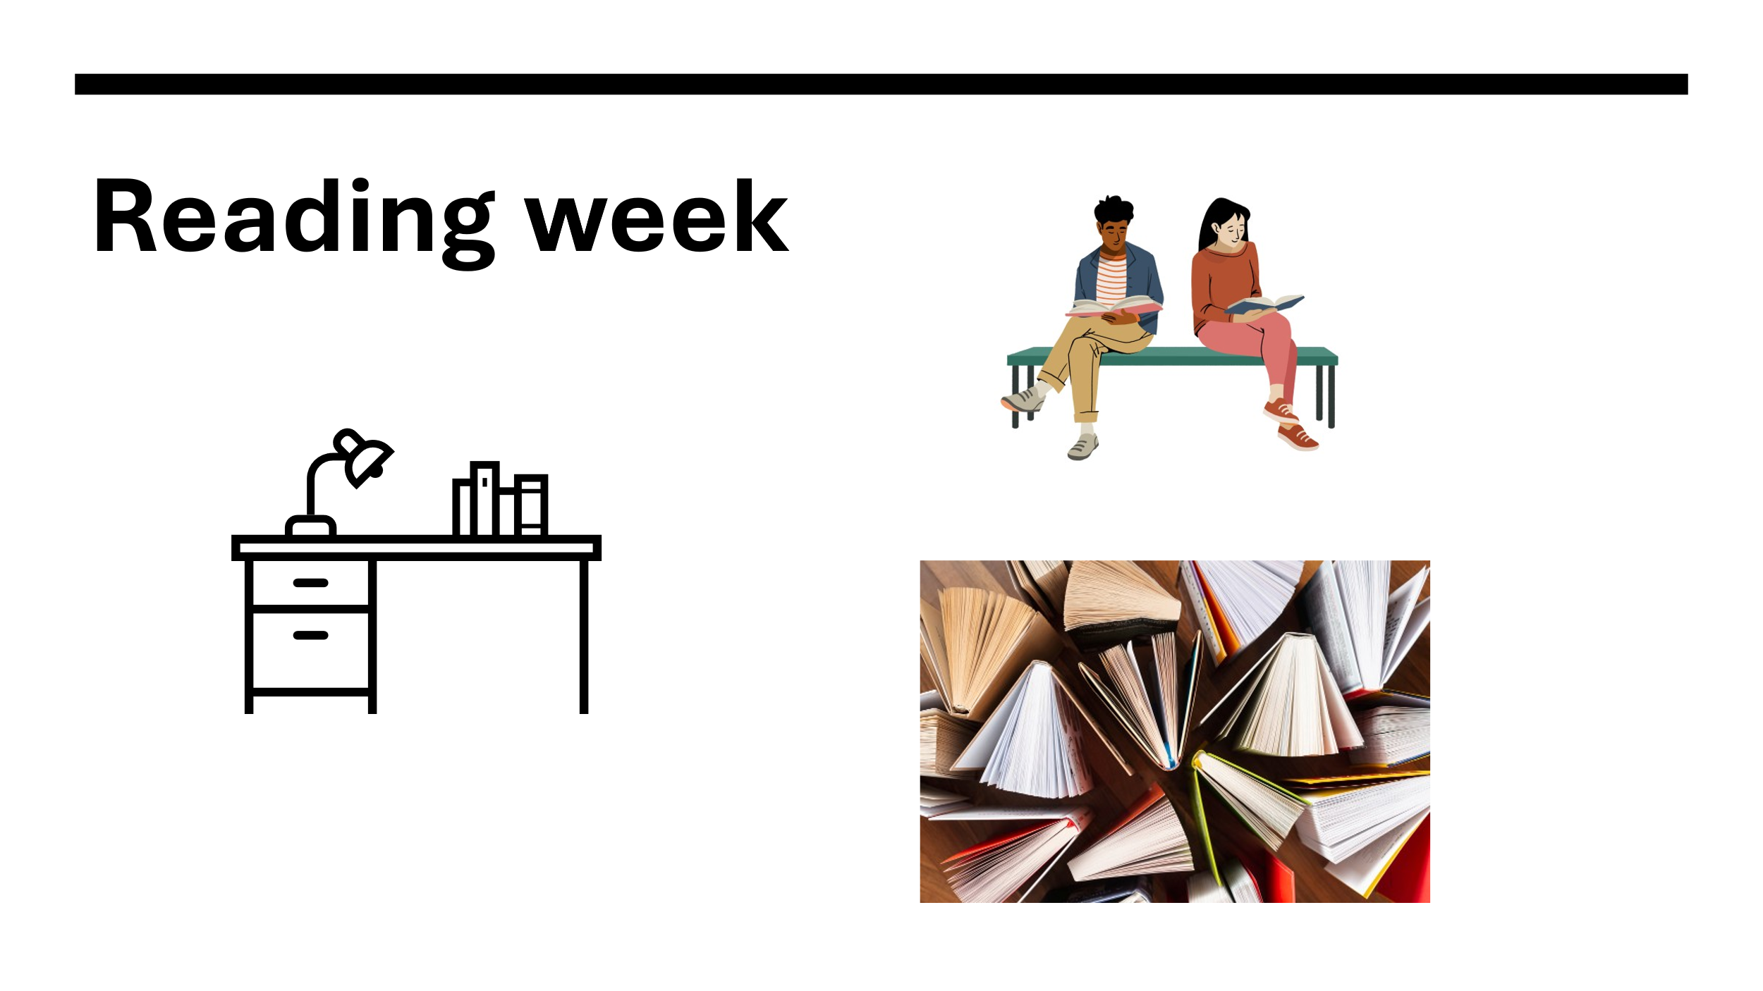

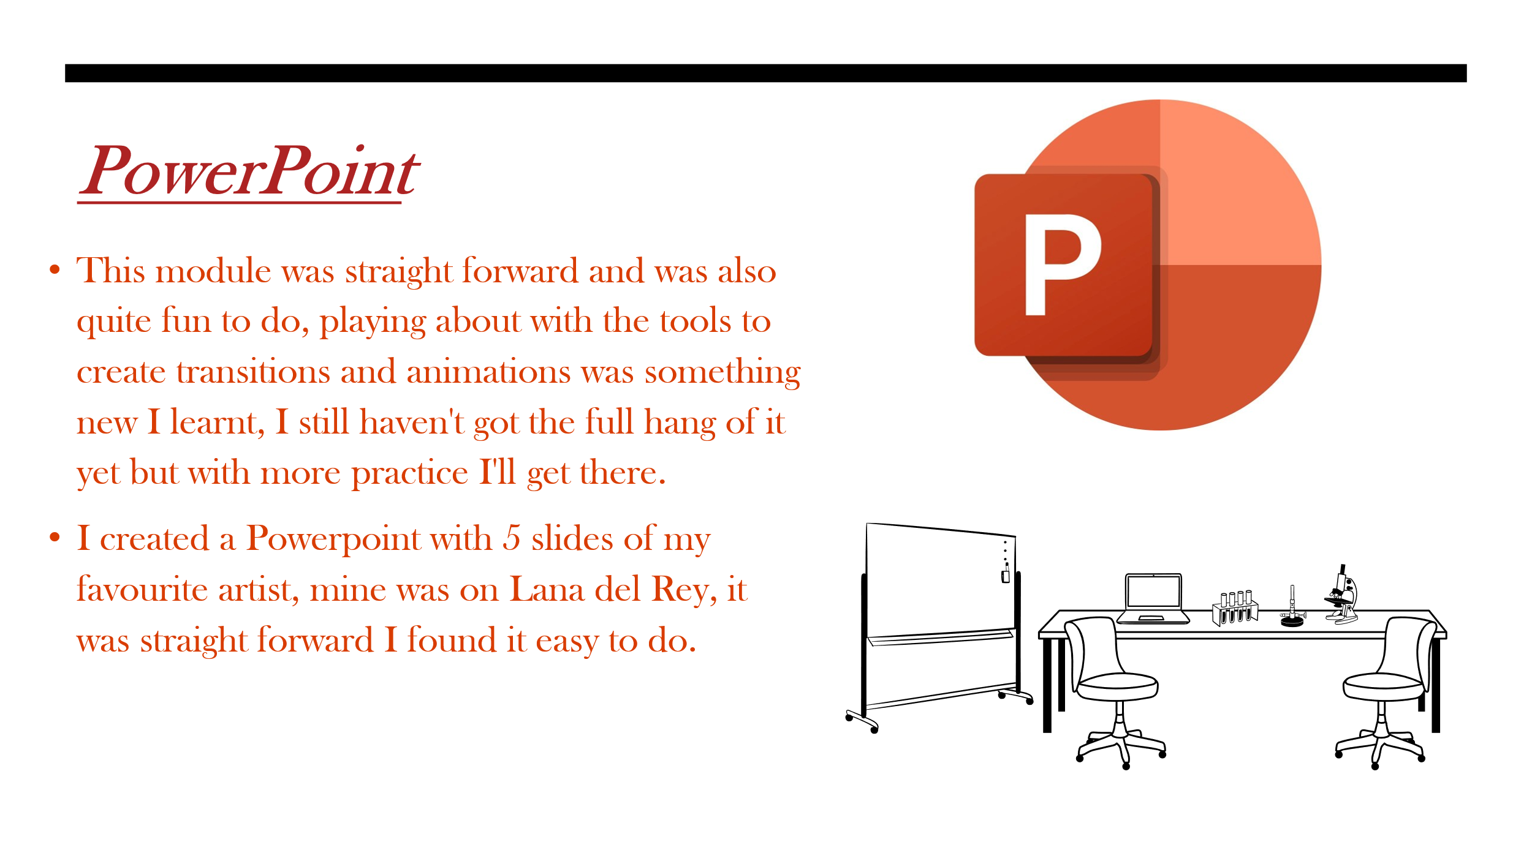

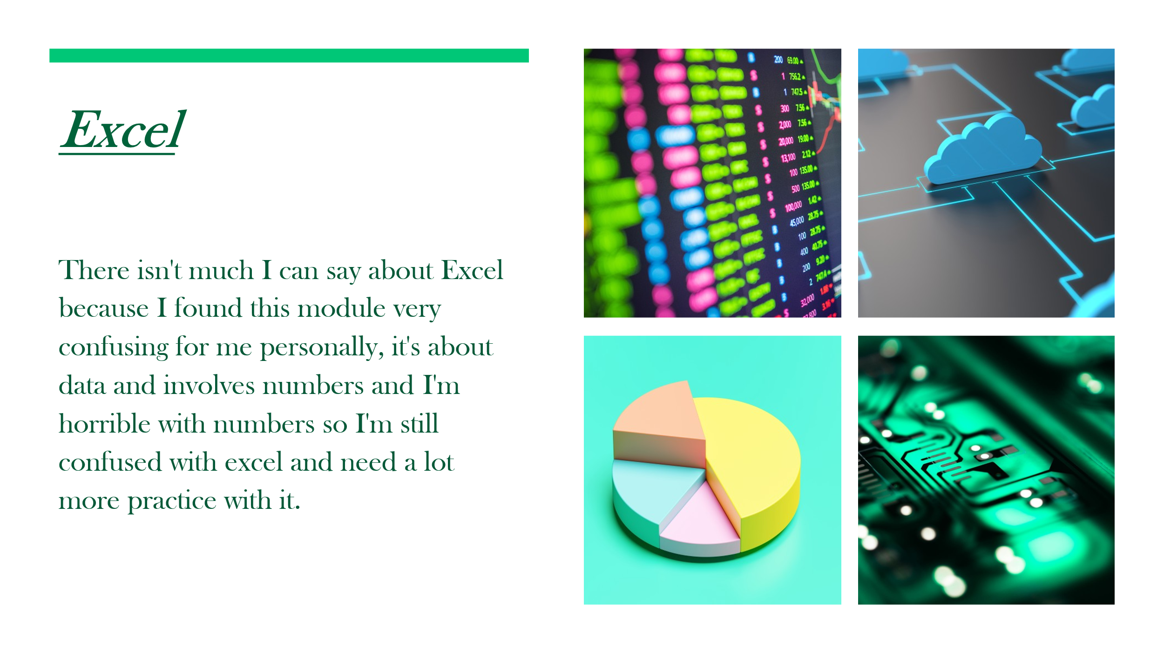

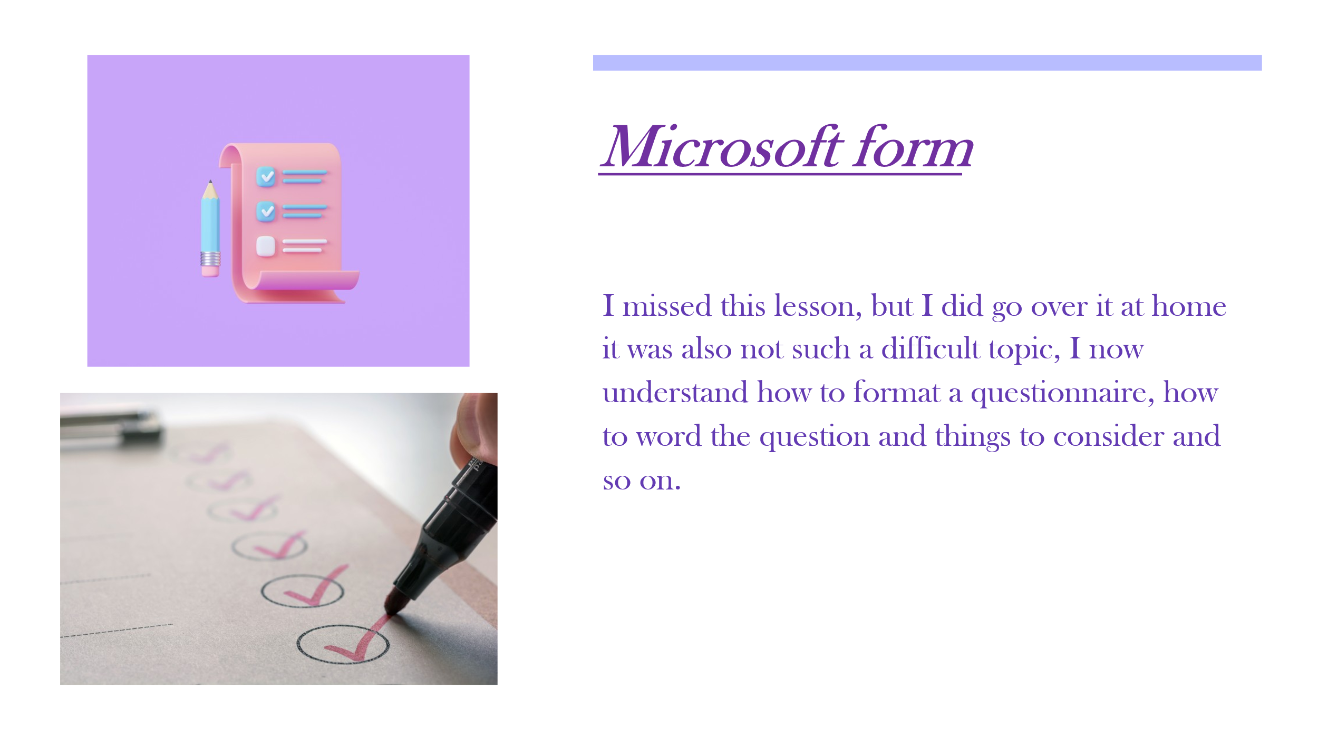

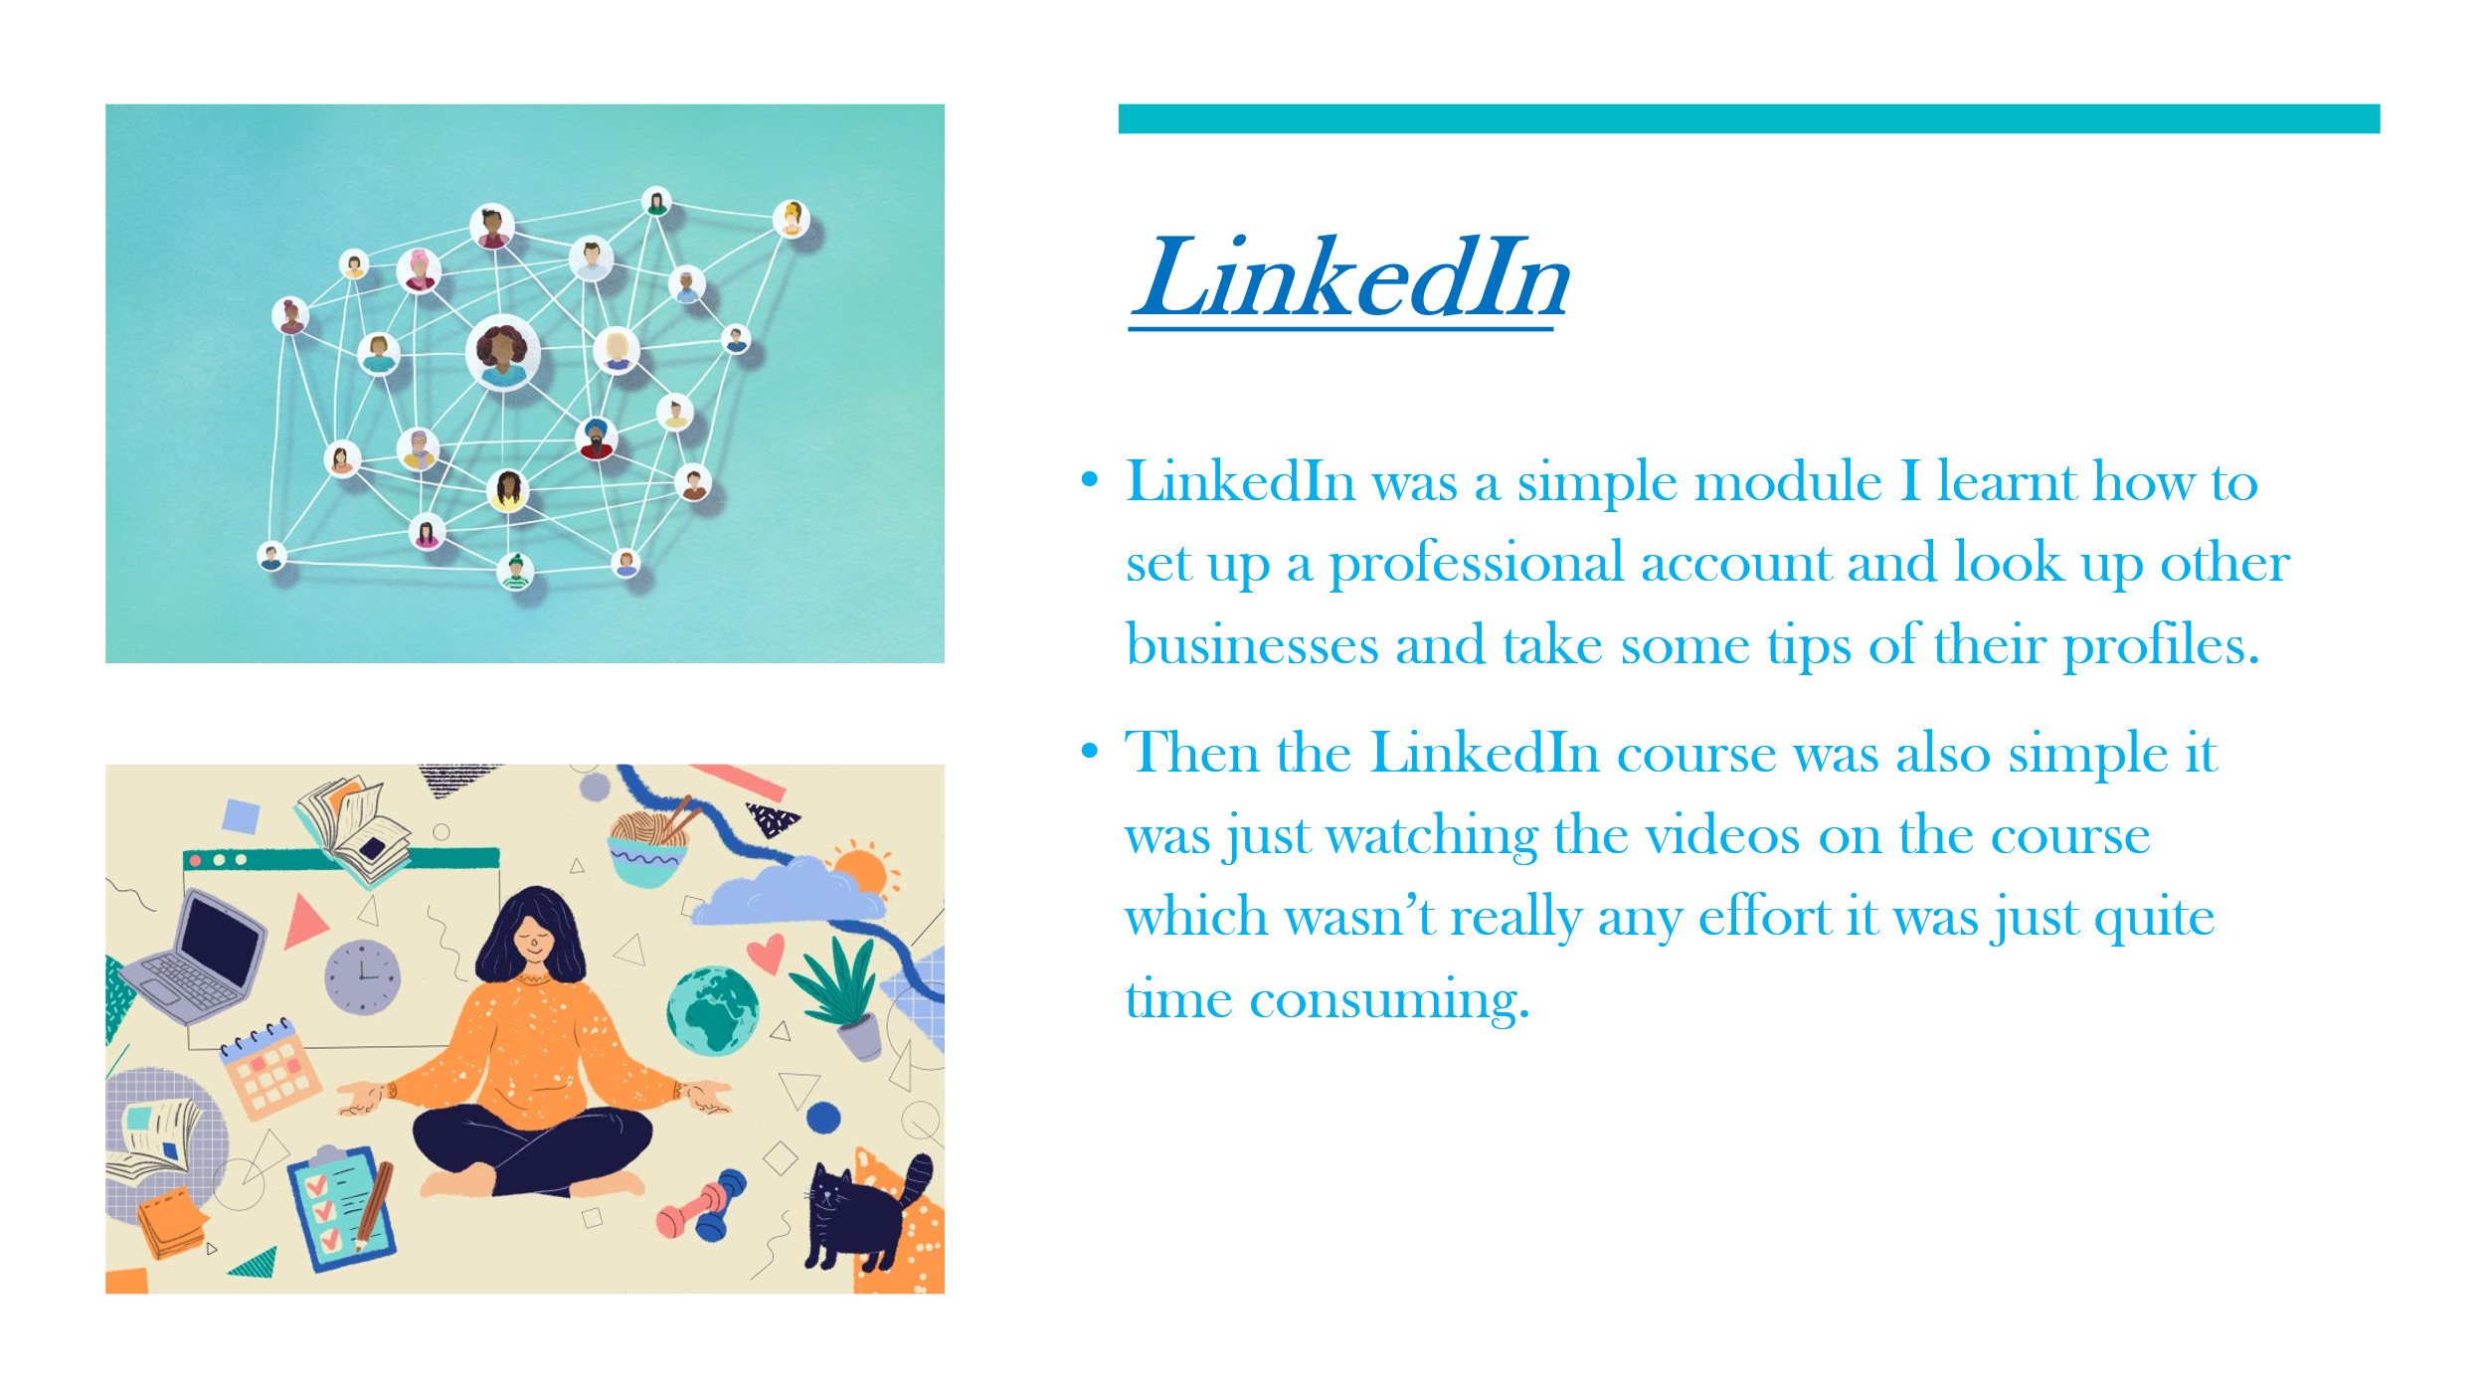

Reference list
- Charlesworth, L. (2024). What is microsoft excel used for and is it still relevant? [online] Kaplan.co.uk. Available at: https://kaplan.co.uk/blog/features/is-microsoft-excel-still-relevant.
- Efficiency and Organization (2022). 11 Ways to Stay Organized in Life by Using Microsoft Excel. [online] Efficiency and Organization. Available at: https://efficiencyandorganization.com/f/11-ways-to-stay-organized-in-life-by-using-microsoft-excel.
- Expert Panel (2025). Workplace Collaboration Tools: Top Challenges (And How To Solve Them). Forbes. [online] 18 Sep. Available at: https://www.forbes.com/councils/forbestechcouncil/2025/09/18/workplace-collaboration-tools-top-challenges-and-how-to-address-them/.
- GeeksforGeeks (2025). Importance of Microsoft Excel in the Workplace (With RealWorld Examples). [online] GeeksforGeeks. Available at: https://www.geeksforgeeks.org/excel/importance-of-microsoft-excel-in-workplace/.

- Lakshmi Chirumamilla (2023). Understanding the Importance of Digital Wellness. [online] Pacific Prime UK’s Blog. Available at: https://www.pacificprime.co.uk/blog/why-is-digital-wellness-important/.

- Lindsay (2023). 5 Practical Uses of Microsoft Excel in Your Daily Life. [online] Excel For Newbies. Available at: https://excelfornewbies.com/practical-uses-of-microsoft-excel/.
- Puneet (2023). Top 10 Benefits of Microsoft Excel – Why YOU Should Learn it in 2020. [online] Excel Champs. Available at: https://excelchamps.com/benefits-of-microsoft-excel/.
- Sperling, J. (2024). AI and Misinformation: How to Combat False Content in 2025 | Columbia Business School. [online] Columbia Business School. Available at: https://business.columbia.edu/insights/magazine/ai-and-misinformation-how-combat-false-content-2025.
- Staysafeonline.org. (2025). What is Data Privacy and Why Should You Care? - National Cybersecurity Alliance. [online] Available at: https://www.staysafeonline.org/articles/what-is-data-privacy-and-why-should-you-care.
- TechClass (2025). Why is Data Privacy Important: Safeguarding Identities. [online] Techclass.com. Available at: https://www.techclass.com/resources/learning-and-development-articles/why-is-data-privacy-important-safeguarding-identities [Accessed 12 Dec. 2025]
- Williams, E. (2024). 31 Best Uses of Excel in Daily Life: Practical Applications for Everyday Tasks - Your Excel Buddy. [online] Your Excel Buddy. Available at: https://yourexcelbuddy.com/best-uses-of-excel-in-daily-life/ [Accessed 12 Dec. 2025]

