

THE IMPACT OF DIGITAL TECHNOLOGIES ON CUSTOMER ENGAGEMENT IN THE RETAIL INDUSTRY
A Study of Marks & Spencer in the United Kingdom

Student Name: Abhi Shitalbhai Shah
Student ID: 2511298
Module Code: LCMB7037

Declaration

I, Abhi Shitalbhai Shah declare that this dissertation has been composed by myself, that the work contained herein is entirely my own except where explicitly stated otherwise in the text, and that this work has not been submitted for any other degree or qualification, in whole or in part, except as specified.

Signature: A.S.SHAH
Date:26/08/2026

TABLE OF CONTENTS
Abstract 6
CHAPTER 1: INTRODUCTION 7
1.1 Background to the Study 7
1.2 Problem Statement 8
1.3 Research Aim and Objectives 8
1.4 Research Questions 9
1.5 Significance, Scope and Chapter Structure 9
CHAPTER 2: LITERATURE REVIEW 11
2.1 Introduction 11
2.2 Digital Transformation in Retail 11
2.3 Customer Engagement Theory 13
2.4 Technology Acceptance Model 13
2.5 Stimulus-Organism-Response Framework 14
2.6 Omnichannel Customer Journey 14
2.7 AI, Personalization, Loyalty and Social Interaction 16
CHAPTER 3: RESEARCH METHODOLOGY 19
3.4 Data Preparation and Source Register 21
3.6 Thematic Analysis and Worked Coding Example 25
3.9 Chapter Summary 28
CHAPTER 4: FINDINGS, DISCUSSION AND RECOMMENDATIONS 29
This chapter applies the evidence-production process documented in Chapter 3. Each major interpretation is tied to the review register in Appendix A, the corporate/public source register in Appendix B, or both. The purpose is to make the distinction between observation and interpretation explicit: a review ID identifies what was observed, the coding framework explains how it was classified, and the theoretical discussion explains why the pattern matters. The chapter therefore uses specific cases rather than relying on generic claims about digital retail. 29
4.2 Evidence Profile and Analytical Cautions4.2 Evidence Profile and Analytical Cautions 29
4.2.1 Company Performance and Digital Engagement Context4.2.1 Company Performance and Digital Engagement Context 31
4.3 RQ1: M&S Digital Customer-Engagement Ecosystem 34
4.4 RQ2: Customer Engagement Effects 37
4.4.1 Usefulness and Convenience4.4.1 Usefulness and Convenience 37
4.4.2 Interface Friction and System Reliability4.4.2 Interface Friction and System Reliability 37
4.4.3 Sparks: Personalisation Versus Reward Friction 38
4.4.4 Fulfilment, Stock Visibility and Service Recovery 38
4.5 Omnichannel Journey Diagnosis 41
4.6 RQ3: Competitor Benchmark 43
4.7 Integrated Theoretical Discussion 45
4.8 Recommendations 45
The chapter answers the three research questions using evidence that can be traced to the methodology and appendices. RQ1 is supported by M&S corporate/platform evidence and customer examples such as A04, G02 and T18; RQ2 is supported by the six coded themes and the review-level trail in Appendix A; and RQ3 is supported by the dated competitor evidence and scoring rubric in Appendix B. The resulting conclusion is therefore evidence-specific: M&S has broad digital capability, but the selected customer evidence shows recurring friction around reward clarity, system reliability, stock/order integrity, refunds and recovery. The recommendations address these observed failure points rather than proposing additional technology for its own sake. 48
CHAPTER 5: DISCUSSION AND CONCLUSION 49
5.1 Introduction 49
5.2 Discussion of Key Findings 49
5.2.1 Digital Technology as an Enabler of Customer Engagement 49
5.2.2 The Role of Personalization and Artificial Intelligence in Customer Relationships 50
5.2.3 Omnichannel Integration and Customer Experience 50
5.2.4 Customer Trust, Digital Reliability and Service Recovery 51
5.3 Theoretical Contributions 52
5.4 Managerial Implications and Recommendations 53
5.5 Research Limitations 54
5.6 Suggestions for Future Research 55
5.7 Conclusion 55
REFERENCES 57
APPENDIX A: CUSTOMER-REVIEW CODING REGISTER 63
APPENDIX B: BENCHMARK RUBRIC AND SOURCE REGISTER 67
B1 Benchmark scoring rubricB1 Benchmark scoring rubric 67
B2 Main public source registerB2 Main public source register 67

Abstract
Digital technologies now influence nearly all aspects of the retail customer journey from product search to personalized offers, through to payment, collection, return and customer service. The following study is focused on the impact of such technologies in the case of Marks & Spencer (M&S) in the UK. Secondly, a qualitative case-study design was used, that focused on M&S corporate material, information on public platforms, 30 selected customer reviews and a functional comparison with selected UK retailers. The analysis sees only if the use of digital instruments really facilitates the process of the customer journey, without any assumptions in making whether an app or a loyalty program or AI creates engagement. Results indicate a complex picture. Customers appreciate simple and efficient search, easy checkout and helpful product information and reliable Click & Collect but if the rewards are complicated, the stock information is incorrect, orders are not fulfilled or refunds or service recovery are fragmented, they lose interest. These patterns are explained by Customer Engagement Theory, Technology Acceptance Model (TAM) and Stimulus-Organism-Response (S-O-R) framework as well as the omnichannel journey perspective. Overall, the study has determined that digital investment facilitates engagement only in combination with providing clear information, reliable execution, customer trust and good recovery if anything goes wrong. Simpler Sparks rewards, greater confidence over task reliability, greater visibility around ordering and refunding and assisted digital and journey level measures of engagement are therefore recommended.

CHAPTER 1: INTRODUCTION

1.1 Background to the Study
Digital is influencing retailing in the UK every day. Ofcom reported that 98% of those adults in the UK with access to the internet used an online retail service in May 2025, and online sales have been 28.2% of retail sales in the UK in February 2026 (Office for National Statistics, 2026; Ofcom, 2025). Retailers are therefore battling not only on the basis of product(s), price and store locations, but also on instaweb and mobile application, loyalty programs, one-to-one communication, social media, delivery information, and online and offline congruence. The relevance of Digital transformation for this study is that it transforms the value that retailers provide to customers, the way they are organized, and the way they build their business models (Verhoef et al., 2021; Mostaghel et al., 2022).
Customer engagement is important in this change, as it refers to the degree to which a customer is thinking, feeling and behaving on a brand (Brodie et al., 2011; Hollebeek, Glynn and Brodie, 2014). For retail, the indicators of engagement include use of applications, participation in loyalty programs, repeat purchases, reviews and recos, and column engagement. Digital tools can enhance engagements when they facilitate a task or make it more relevant. Personalization can also dilute it when it is too intrusive, or when the website and app or the web, store and delivery process do not complement each other (Aguirre et al., 2015; Lemon and Verhoef, 2016). That's why the study makes no assumptions about "engagement" from the presence of the technology; it examines the customer's experience with the technology, instead.
The customer journey for Marks & Spencer (M&S) is a handy example of a UK business as it encompasses stores, of course, but also a website, a mobile app, Click & Collect, the Ocado Retail relationship and the Sparks loyalty program. M&S showed that 30% of sales in the Fashion, Home and Beauty category took place online with 57% of online and app orders picked up in store in 2025/26 (Marks & Spencer, 2026a). These are the kinds of numbers that indicate that digital and physical should be thought of in conjunction with one another. Also, M&S has been toying with enhancements in its eCommerce offering, AI-driven decision making, personalized giveaways, and a revamped Sparks program that rewards using a wallet (Marks & Spencer, 2026a; 2026b). Meanwhile, the 2025 cyber event caused online service disruptions and put its brand in jeopardy based on security, reliability and customer trust, which are part of the delivery of digital customer experience, rather than technical back-office problems (Marks & Spencer, 2026c).
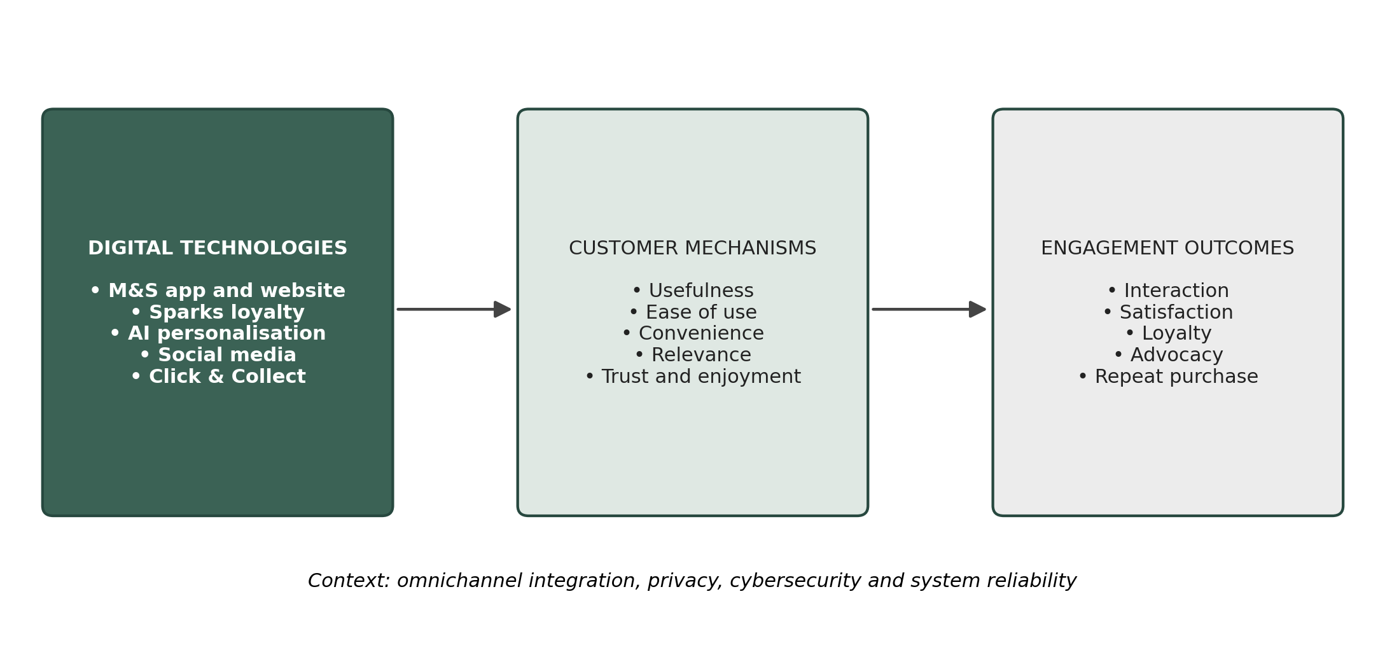
Figure 1.1: Research logic linking M&S digital technologies to customer engagement outcomes.
Figure 1.1 illustrates the logic employed in this study. Digital technology is just the beginning. It influences engagement when customers discover it to be helpful, straightforward, hassle-free, pertinent, amusing, and trustworthy. A Click & Collect option, for instance, is likely to drive satisfaction when the order is truly found and ready and can debilitate trust when an order cannot be found. Omnichannel integration, privacy, cybersecurity and system reliability are thus considered as a condition that can help to enhance or diminish the impact of digital technology on engagement.

1.2 Problem Statement
M&S has a wide-ranging digital offering, but possessing an app, website, loyalty scheme or an AI function does not demonstrate customers consider them useful, easy, reliable or trustworthy. So, the challenge could be to identify where M&S's digital journey is going well, where they are experiencing friction and where their offer could be enhanced when compared with selected UK retailers. Not much has changed with the academic problem: Still, researchers tend to focus on one technology or one outcome, such as adoption, satisfaction, loyalty or sales, even though engagement evolves as a stakeholder goes through a related journey and experience behavioral, emotional and relational responses (Pansari and Kumar, 2017; Shi et al., 2020). This study takes up the challenge of this gap by analyzing several touchpoints combined and analyzing through a match of company statements and customer evidence.

1.3 Research Aim and Objectives
This study aims to examine how digital technologies influence customer engagement at Marks & Spencer in the UK. To meet this aim, it identifies the main customer-facing digital technologies used by M&S, examines customer experiences of those technologies using public secondary evidence, considers their effects on satisfaction, trust, loyalty, interaction and repeat-use intentions, compares M&S with selected UK retailers, and develops practical recommendations from the patterns found in the evidence.

1.4 Research Questions
(1) What digital technologies are employed by M&S with regard to customer engagement?
(2) What is your customer's experience with the above technologies and what does this experience imply about usefulness, satisfaction, customer trust, customer loyalty and continued use?
(3) What are the comparisons between M&S and selective UK retailers? How can M&S improve their digital customer engagement journey?

1.5 Significance, Scope and Chapter Structure
This study can be applied to M&S, as it sees the digital investment correlate with customer experience and it offers actionable opportunities for improvement. Academically, it is a mixture of the Customer Engagement Theory, TAM, S-O-R framework and omnichannel customer-journey perspective as none of the model can cover the entire M&S journey. Only customer-facing activities at M&S and currently available evidence have been studied. The theoretical framework is elaborated in chapter 2. The rationale for the pragmatic secondary case-study approach, review and document selection and coding, competitor analysis, and quality and ethical considerations are discussed in Chapter 3. Chapter 4 shares the results and findings of the evidence and provides the recommendations.

Table 1.1: Alignment of research questions, objectives and evidence
Research question | Principal objective | Indicative evidence
RQ1: Which technologies are used? | Map the M&S digital ecosystem. | Annual reports, website/app features, Sparks and corporate updates.
RQ2: How do technologies influence engagement? | Analyze customer mechanisms and outcomes. | Reviews, app commentary, social interactions, ratings and corporate metrics.
RQ3: How does M&S compare and improve? | Benchmark competitors and develop recommendations. | Common digital-strategy checklist and competitor public evidence.

In Table 1.1, each research question is paired with the kind of evidence that can address the question. What's available from M&S is identified through corporate and platform sources and the relevance of the digital channels to the company. Customer reviews to get a sense of what a customer experiences with a certain digital / omnichannel task. Only functional comparison may be done using competitor evidence. This separation is significant, as a company claim, rating on an app-store and individual complaint do not count as the same kind of evidence.

CHAPTER 2: LITERATURE REVIEW

2.1 Introduction
This chapter is not a repeat of previous studies but includes the ideas behind interpreting the case for M&S. Digital transformation in retail is first discussed, before Customer Engagement Theory (CET), Technology Acceptance Model (TAM), the Stimulus-Organism-Response (S-O-R) framework and the omnichannel customer journey will be discussed. It also covers AI and personalization, loyalty programs, social interaction, privacy and digital resilience. Such parts of the course were selected, because determining where M&S has a technology is not simply a question of "which technology?" anymore, but rather a question of "why?". (Why do customers react to digitally positive experiences with M&S so positively and to digitally negative experiences so negatively? The literature is then compared and challenged as required, particularly if there is a possible advantage of the technology on one hand and an effort on the other, or a privacy or service issue.

2.2 Digital Transformation in Retail
Digital transformation is not simply the rollout of a new app or website. It refers to the transformation of value creation, value course customer relations and operations management of a business when using digital technologies (Verhoef et al., 2021). For retail, this can encompass ecommerce, mobile, analytics, AI, automated fulfillment, and digitally-aided stores. Grewal et al. (2017) demonstrate how technology influences the retail value creation, delivery, and capture, while Mostaghel et al. (2022) give reasons for the way technology can impact on the process of value creation, delivery and capture. This wider perspective is key in the M&S case as not even a slick interface could make up for lack in stock, collection or delayed returns. Thus, rather than thinking of the app as the unit for behavior, the researchers recognize the entire service journey as the unit of analysis.
Table 2.1: Theoretical lenses used in the study
Lens | Core constructs | Contribution to the M&S analysis | Main limitation
Customer engagement theory | Cognitive, emotional and behavioral engagement | Broadens outcomes beyond sales to attention, affection, interaction and advocacy. | Constructs can overlap and measurement varies.
Technology Acceptance Model | Usefulness and ease of use | Explains adoption and continued use of app, website and loyalty tools. | Understates emotion, context and cross-channel processes.
S-O-R framework | Stimulus, internal state and response | Connects digital touchpoints to trust, satisfaction, irritation and behavior. | Requires careful operationalization of internal states.
Omnichannel journey | Integration across touchpoints and stages | Evaluates consistency across website, app, store, fulfilment and returns. | Integration is a continuum and difficult to compare with one metric.

As Table 2.1 reveals, more than one theoretical lens is used because of the reasons explained. TAM is helpful to ask questions around appropriateness/usefulness of the app or website. S-O-R can be used to explain how a user reacted to a digital occurrence, like seeing a reward message or not getting a collection successfully, and as a result felt trust or irritation, which then triggered a behavior like buying a product, filing a complaint or avoiding a product or service. Customer Engagement Theory expands the scope of analysis to customer loyalty, customer advocacy and continued engagement, and the omnichannel assessment determines whether the experience is consistent both online and offline. No single lens can solve all of these problems, hence the use of all of these together, with clear focus on their disadvantages/weaknesses.
Linking channels is also evident in the UK retail sector. However, online retail is a significant component of consumer expenditure and most online adults in the UK do this (Office for National Statistics, 2026; Ofcom, 2025). But online and in-store channels often go together. As pointed out by Beck & Rygl (2015), retail channels can be categorized between multi, cross, and omnichannel, where the latter provides the greatest integration that sees customers seamlessly switch between channels. Previous studies by Neslin et al. (2006) concerned itself with how the channels can be designed so they complement each other while later studies put more emphasis on continuity of information, fulfilment, and service throughout the journey (Shi et al., 2020; Neslin, 2022).
This directly impacts M&S as many of its online and app orders are picked up in its stores (Marks & Spencer 2026a). This is to say that there are supporting capabilities that factor into digital maturity in addition to capabilities that face the customer. Retailers must have a linkage to customer and inventory information, trusted logistics, and effective governance and personnel that can cater to customers when digital processes break down. Piotrowicz and Cuthbertson (2014) state that mobile technology, social media, analytics and in-store systems are the bases of omnichannel retailing; however, legacy systems and organizational silos can hinder integration. Verhoef, Kannan and Inman (2015) also suggest that the focus with omnichannel retailing isn't on the individual channels, but on the entire customer journey. For M&S, it should be evident that improvements in the search or checkout interface are only beneficial in so far as they can be backed up by the supply of stock, fulfilment, stores and service recovery.

2.3 Customer Engagement Theory
Engaging customers involves more than a happy single purchase. Brodie et al. (2011) define it as an interactive and contextual psychological state and Brodie et al. (2013) demonstrate that engagement with virtual communities can include learning, sharing, co-development, advocacy and social interaction. According to Hollebeek, Glynn and Brodie (2014), consumer-brand engagement is based on three aspects - cognitive, emotional, and behavioral. This can be of interest to the M&S case because there can be a different effect of different digital experiences on each aspect of engagement – relevant personalization can capture attention, reliable service can develop confidence and a useful loyalty reward can influence ongoing behavior.
Customer Engagement Theory also makes sure not to see sales as the sole indicator of success. Despite customer experiences there may be repeat activities as M&S could be convenient and easily findable by customers, or customers may recommend or interact with M&S without necessarily buying them again. Pansari and Kumar (2017) make a connection between engagement and satisfaction, emotion, and value generation, and differentiate between direct and indirect contributions (influence and referrals). Analyzing the literature, the study is designed to investigate whether there is evidence of digital participation, as well as app and loyalty use, satisfaction, trust, complaint behavior, and intention to be advocates or to repeat use/repeat purchase.

2.4 Technology Acceptance Model
TAM assumes that attitude towards a software system heavily depends on the users' perception of usefulness and ease of use (Davis, 1989). Other factors added to later models include social influence, facilitating conditions, and experience (Venkatesh et al., 2003). In this retail case, usefulness questions whether an M&S digital tool supports customers in performing an action (e.g. locating a product, performing an order, handling a reward etc.). Ease of Use is: How difficult is it to do that thing? This is important since a feature can be highly technically sophisticated, but difficult to sell or use; it will not succeed if customers cannot see why they need it or how to use it.
TAM was chosen as practically many of the comments made by customers in this study relate to such practical activities as search, checkout, logon, access to customer account, redemption of rewards etc. It allows a relatively straightforward account of how the tasks make it easier or harder to keep using a person. But TAM alone will not work. It is largely about attitudes towards technology use and states less regarding feelings, trust, and crossing BTL or online-to-store, and store-to-online paths of service recovery. Therefore, it is not seen as a full model of customer engagement but is one part of the model's explanation.

2.5 Stimulus-Organism-Response Framework
The S-O-R framework is about an external stimulus impacting internal response which then impacts behavior (Mehrabian and Russell, 1974). For digital retail, it could be the user experience of an app, a personalized offer, a delivery notification, or a service recovery conversation. The internal response can be convenience; relevance; control; irritation or privacy concern; behavioral response can be browsing; purchasing; complaining; recommending or avoiding the retailer. This framework was selected because it provides clues as to how technology can yield varying results. For instance, a personalized offer should be useful and easily understood by the customer, for instance when the user can see its value to them, but the offer should be fair when the customer doesn't understand how the offer was generated or applied (Aguirre et al., 2015).
S-O-R is not just for successful digital experiences; it can be used to analyses service failures too. An outage, a wrong stock message or an order failure can have a negative effect, cause frustration or loss of trust and resulting in a complaint or avoidance. This is particularly pertinent to M&S as that cyber incident impacted online access and continuity of service (Marks & Spencer, 2026c). Thus, the system provides a framework that enables the study to link operational events up to customer reactions rather than seeing them as just technical issues.

2.6 Omnichannel Customer Journey
Customer-journey research considers experience as a series of touchpoints before, during and after customers' interactions with the firm and its partners, as well as with other customers (Lemon and Verhoef, 2016). The critical point in an omnichannel situation is if information, service and control are consistent regardless of whether your customer is on the website, in the app, in store, at delivery, collection and return. Studies of omnichannel experience and shopping intention most closely relate to Perceived Compatibility and Risk, such as Shi et al. (2020) and Lee et al. (2019), which relates to Integration Quality and Engagement/Loyalty, such as Gao and Huang (2021). The view of M&S is taken because the app, Sparks, Click & Collect, delivery, store support and returns constitute one customer journey as opposed to standalone services.
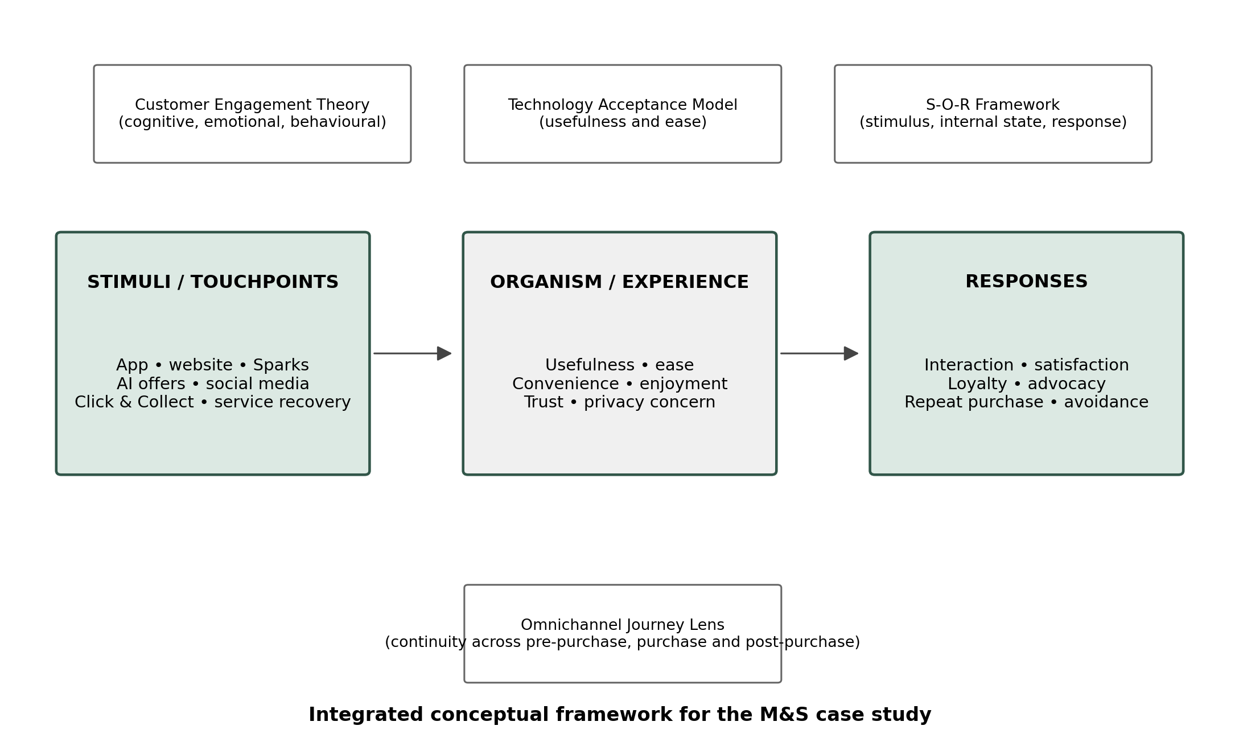
Figure 2.1: Integrated conceptual framework for analyzing M&S digital customer engagement.
Figure 2.1 integrates four theoretical perspectives into a practical order of the M&S analysis. Situations related to digital touchpoints are considered as the starting stimuli. The analysis then poses the question of what do customers say or feel about them, are they useful, convenient, relevant, do they give them control, or do they annoy them, and which of the following actions does this trigger; satisfaction, complaint, customer loyalty, repeat purchase or avoidance. The omnichannel perspective weaves throughout the entire series, as the end of a positive interface experience can be undermined by poor fulfilment, returns or service recovery. However, the figure is included as an analytical guide for the coding that takes place in Chapters 3 and 4, not to say that technology necessarily results in engagement.
Operational links are apparent in the journey perspective, as well. Search quality can impact product discovery, stock quality can impact confidence, checkout quality aims for a complete task and collection and returns quality are important for convenience, service recovery measures if trust is restored after a problem. Instead of ‘Omni-channel or Not?', Neslin (2022) considers omnichannel capability as a continuum. Hence, the competitor's comparison in this study does not make a claim; it's just that one retailer has more capabilities than another along the journey.

2.7 AI, Personalization, Loyalty and Social Interaction
AI can assist retail services in many ways such as in retail recommendations, virtual retail assistants, retail forecasting, and decision support (Davenport et al., 2020; Hoyer et al., 2020). Huang and Rust (2021) differentiate the mechanical and thinking and feeling intelligence in services and demonstrate that there are different mixes of mechanical and judgmental intelligence depending on the different services. There is evidence of selective AI use for M&S, including using AI to reduce waste, resist individuals, and to direct decision making and offer personalization. The emphasis is therefore on what those uses have for people (relevance, clarity, certainty, etc.), instead of considering the use of AI as an indicator of engagement.
Personalization can lower search efforts and deliver a feeling of being recognized, as well as fostering a dilemma, because the information provided within the personalization could lead to issues of privacy or trust concerns (Aguirre et al., 2015; Bleier, Harmeling and Palmatier, 2019). Fairness, transparency and accountable processing, including in the context of AI, are also relevant and important considerations in UK data-protection guidance. A similar issue applies to loyalty programs. Frequency can be positively influenced by rewards if they are clearly understood in terms of their value and the conditions necessary to obtain them, but confusing activation and/or reward obtainment conditions can lead to frustration. One of the additional dimensions that social media brings is the ability to interact, advocate, and be heard and/or make complaints more visible and potentially exacerbate the reputational impacts (Hollebeek, Glynn and Brodie, 2014; Lamberton and Stephen, 2016).
The literature thus resulted in a set of operational questions to be posed instead of a list of concepts to be referred to. TAM's components were coded as usefulness, ease of use/task effort; the components of Customer Engagement Theory were customer satisfaction and customer loyalty, advocacy, complaint, and avoidance; and the omnichannel literature were coded as stock check, order status check, collection and delivery checks, return and recovery checks. There was also a research gap regarding the difference between having technology and having experienced value, and to ensure the selection of evidence indicated a customer benefit, the rule was also adopted that a feature was not coded as successful unless this principle was reflected in the evidence. This process of translation from literature to coding is detailed in Chapter 3, with worked examples given for reviews A04, G01, T11, T18 and T20 in Appendix A. This directly links the conceptual framework contained herein with empirical analyses presented in Chapter 3 and Chapter 4.
The literature alludes to four gaps that are important for this study. First, there are a lot of studies on one piece of technology, or one outcome, and it can be challenging to get a handle on the interactions between the app, website, loyalty program, social media and in-store experience. Secondly, the adoption and sales mechanisms cannot encapsulate full trust, advocacy, complaints attitudes or other positive-negative engagement behaviors. Third, where the benefits of personalization must also be taken into account, privacy, cyber security and system reliability come into play. Fourth, statements of the company and experiences of customers might disagree, and therefore secondary evidence found in the public arena must be open to critical evaluations. These gaps allow for a case-study approach, enabling the linking together of a multiplicity of types of evidence for one retailer.
The M&S case considers these holes: Digital technologies as customer touchpoints, customers' contact with (and experience of) the touchpoints, and then customers' engagement response. The main customer mechanisms adopted for the analysis are usefulness, ease, convenience, relevance, control and irritation; and the outcomes are repeated use and avoidance, satisfaction, loyalty and complaint, and interaction and advocacy. Omnichannel integration, privacy and system reliability are considered factors that can enhance or hinder the experience. Chapter 3 describes the process by which these ideas were translated into working coding rules and implemented for the reviews and documents chosen.
Table 2.2: Critical synthesis of literature and implications for M&S
Theme | Established insight | Critical issue | Implication for this study
Digital transformation | Technology reshapes the retail business model and service system. | Investment does not guarantee customer value. | Assess execution and customer response, not technology presence.
Technology acceptance | Usefulness and ease encourage adoption. | Adoption alone does not capture trust or emotional engagement. | Code usability alongside relational and behavioral outcomes.
Omnichannel integration | Consistency and flexibility support engagement and loyalty. | Operational failures at one touchpoint can damage the whole journey. | Benchmark the complete journey from search to returns.
AI and personalization | Relevance can reduce effort and strengthen value. | Data collection can trigger privacy concerns and distrust. | Evaluate transparency, perceived relevance and control.
Loyalty and social media | Rewards and interaction can increase frequency and advocacy. | Poor reward clarity and public complaints may generate negative engagement. | Include positive, neutral and negative customer evidence.

A literature review summarizes the key findings of the literature. The literature review's key findings are summarized in Table 2.2. In all themes, more technology does not necessarily lead to more customer value. The important thing is that it must be done well with the technology, information may have to be passed clearly, it is about customers' control and more importantly it should be the same journey from search to fulfilment and recovery. These points are translated in the analysis, with the study analyzing customer experience not just outlining the digital features of M&S.

CHAPTER 3: RESEARCH METHODOLOGY
In this chapter, the decisions that led to the presentation of the evidence in Chapter 4 are recorded. The method was developed based on the identified gaps in Chapter 2; that technology presence alone does not comprise engagement, usefulness and ease of use have to be considered too, and that the digital as well as the physical touchpoints have to be evaluated. Those points were turned into source-selection rules, review-level codes and a competitor's rubric. This chapter, therefore, not only documents the data used, but tracks how one item became part of the data, coded, and then interpreted and recommended. The review level audit trail is in Appendix A and the benchmark and public-source trail is in Appendix B.
A pragmatic approach to research philosophy was selected due to the need for various types of evidence to answer the research question along with the aim being a diagnosis of a specific retailer and not seeking an estimate of the wider population of M&S customers. The case is a mixture of numbers and concepts from businesses and qualitative data from customers. The latter is provided in Appendix A of the 2025/26 M&S Annual Report, demonstrating that 30% of customers are shopping online in Fashion, Home and Beauty and 57% are collected goods in stores. There are a number of sources that address distinct aspects of the problem and so they have been separated analytically. This aligns with Saunders' approach of pragmatic as discussed by Lewis and Thornhill (2019).
The analysis was abductive as well. Simply put: the study began with concepts from Customer Engagement Theory, TAM, S-O-R and the omnichannel journey, but not all reviews were categorized such as this. Stale stock info, missing orders, visible refunds and exclusion of smartphones were among the more specific problems pointed to on the first reading of the reviews, but not necessarily a problem for the theories. All of these issues were converted into new codes and then reconnected to the energies or theories. This method was selected because it enabled theory to be used as a way of grounding analysis while permitting and creating scope for realignment of the explanation by recurring issues customers faced.
M&S was taken as one primary case as the study focused on multiple digital touchpoints that are connected in one retailer. Embedded areas included website, mob app, Sparks, personalization, Click & Collect and post-purchase service recovery. Secondly, Ocado, Asda, Lidl and Aldi were not considered to be individual case studies in their complete sense. They were only added as benchmarks as each offers contrasting points of comparison: Next (for fashion & homeware), Ocado (for digital fulfilment), Asda & Lidl (for app-based loyalty) and Aldi (for a simpler digital model). This ensured it was in practices that could help explain where M&S is relatively strong or weak.
The analysis followed an abductive logic. The plain language chunk of review evidence was left free to find problems that were more specific than the published constructs and thus Category 1 (Chapter 2) was merely a starting point. For instance, usefulness and ease of use as proposed to TAM, were disrupted by delivery-transparency friction (G01) and S-O-R supported the understanding of the irritation with a repeated reward step (T11). The omnichannel literature referred to integration across stages, which was implemented into cases like a confirmed order, that were failed for store-collection and also continued into the refund process.
As illustrated in the examples, the final codebook was not merely adapted from the literature, but codebooks were tried out with the actual review evidence and adapted if more specific codes were needed where evidence was duplicated. It was a purposive sampling because it wasn't to estimate the proportion of all M&S's customers that were satisfied and dissatisfied, but to understand various types of customer experience. Experiences both positive, mixed and negative were taken purposefully and included pre-purchase, purchase and post-purchase. Overall, five of the reviews were positive, five were mixed and twenty were negative.
Table 3.1: Review sample by platform and direction
Platform | Reviews selected | Direction in the sample | Why this platform was used
Apple App Store | 5 | 2 positives; 3 mixed; 0 negative | App-focused evidence on search, checkout, Sparks and usability
Google Play | 3 | 0 positive; 2 mixed; 1 negative | App-focused evidence on navigation, reliability and Click & Collect
Trustpilot | 22 | 3 positives; 0 mixed; 19 negatives | Broader service evidence on fulfilment, refunds, complaints and recovery
Total | 30 | 5 positives; 5 mixed; 20 negatives | Qualitative diagnostic sample; not statistically representative

Table 3.1 renders the selection of reviews transparent. The main point is not simply that the sample contains more negative reviews, but where those reviews came from and what they can reasonably show. The 19 negative items on Trustpilot help identify repeatedly problems on fulfilment, rewards, refunds and service recovery, and the other positive and mixed items on Apple and Google Play help provide counter observations of useful search, checkout, product info, and Click & Collect. In doing this, this table shows the balance and limitations of the sample studied, and is not meant to imply a satisfaction rate for a population.

3.4 Data Preparation and Source Register
Prior to coding, a source register was established to follow the origin of every document, platform or competitor source to its role in the analysis. The organization or platform, title, publication or review date, access date, URL, source type, how the source was used and principal limitations were documented in the register. The difference makes sense as the M&S Annual Report is authoritative and a statement of reported company performance, while Trustpilot offers evidence of customer experience, but is subject to customer selection and complaint. Limitation and Source roles are listed in Appendix B. Anonymised IDs (A04, G01, T18, etc.) were kept instead of reproducing username data or identifying unnecessary personal data so that conclusions drawn from the findings in Chapter 4 can be correlated to Appendix A.
All the customer reviews were named using an identifier like Α01, G02 and T18 to anonymize the customer. Order numbers, profile photos and other unrequired details pertaining to users were not kept. Each selected review was put onto an extraction sheet with the platform, date, journey touchpoint, direction of the experience overall and a brief evidence summary, theory-based code and issue-specific code and engagement outcome. Because there are privacy and copyright issues, longer quotes are avoided and instead paraphrased summaries are used throughout the dissertation.
The research took a snapshot of the page on a date when it was a live page and did not assume that the rating or the number of reviews would always be as presented in the study. This was needed as app-store ratings, and Trustpilot scores and feature text may change. Therefore, 31 July 2026 is the cut-off for the platforms and the period covered by the platform comparison and benchmark.
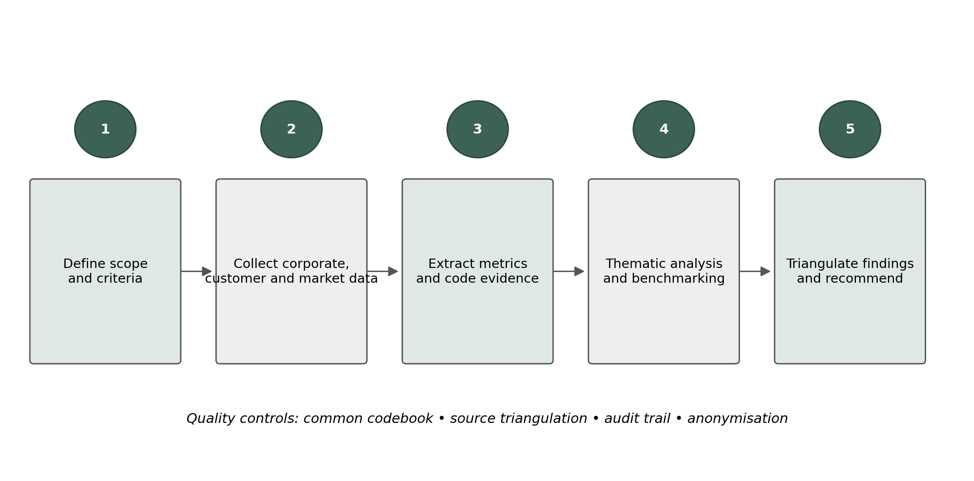
Figure 3.1: Secondary case-study data collection and analysis workflow.
Figure 3.1 shows the sequence used in practice. Initially, scope and inclusion rules were corrected. Secondly, appropriate public sources and customer reviews have been gathered. Thirdly, the useful facts and review type codes were pulled out. Fourth, patterns were repeated with themes, and details of the competitors were evaluated by the same rubrics. Finally, results obtained from the various types of sources were compared with one another for this purpose, before the recommendations were made. The source register is useful here, as it is anonymization, the common coding rules and the second coding check that have been followed throughout so the analysis can be followed, checked and does not look like an unsupported personal judgement.
The coding framework has been developed directly from the theoretical framework in Chapter 2. TAM turned into two practical questions: can the customer complete the task without the help of the digital tool and how much effort does it need to do the task with the digital tool? S-O-R turned into three interrelated fields: the digital stimulus, the internal response (feeling of trust, control or irritation, for instance) and the behavioral response (purchasing, complaining, avoiding, for instance). Outcome codes from Customer Engagement Theory were provided for satisfaction, loyalty, repeat use, advocacy and complaint behavior. The omnichannel perspective was utilized for any issue that fell under the “boundaries” of website, app, stock, store, delivery, returns or service recovery. This translation can be illustrated in Table 3.2, and be verified through each case in Appendix A such as case A04, T11, T12, T18, T20, etc.
Central rule for coding was to record what evidence, not technology intentions was/er. For example, the launch of a personalized digital wallet in M&S didn't necessarily mean that it was a positive engagement and perk when rewards on such services are coded. A positive code needed evidence of understanding how value was created, or results in use; thus, if the review referred to unclear conditions or things that were repeatedly activated and/or verified, it was coded as effort, reward-transparency/friction-trust. There are multiple redemption and verification steps detailed in the review, and the observation was coded as reward complexity/effort, and not as some measure of Sparks' increased loyalty. This rule is based on the Chapter 2 research gap that has to do with the availability of technology and how customers feel about its value to them.
The important rule was to program what the evidence indicated, whereas not what a feature should accomplish. For instance, having a personalized Sparks reward did not imply positive engagement. It could only be coded as useful/favorable if the customer understood and benefitted from it, as concluded during the review. If in the review unclear conditions, repeated activation steps or difficulty redeeming reward was mentioned, this was coded as effort/reward transparency or trust-friction. This was a crucial role as it ensured that the inclusion of technology wasn't mistaken for successful customer interaction. When a set of review comments arose again and again, the codes of the issues they pertain to were added. These were a reward-redemption complexity, visibility of stale stocks, order integrity, visibility of refunds and fragmented service recovery and assisted digital inclusion. These were then aggregated into six overarching themes that are employed in Chapter 4: usefulness and convenience, interface and reliability friction, reward clarity and value, fulfilment and stock visibility, service recovery and return, and trust and digital inclusion. The selected grouping was done so as to maintain proximity to the customer journey whilst also ensuring there was a strong correlation with the theories.
Table 3.2: How theoretical ideas were applied to the review evidence
Construct | Indicators | Theoretical basis | Application to this study
Usefulness / ease | Search success, short checkout, clear navigation, task completion, effort | TAM | A04: search and purchase completed in a few steps
Internal response | Convenience, relevance, control, irritation, trust, privacy concern | S-O-R organism | T11: repeated reward steps produced frustration
Engagement response | Satisfaction, loyalty, repeat use, complaint, advocacy, avoidance | Customer engagement | T12: failed registration led to stated exit intention
Journey integration | Stock accuracy, order status, collection, delivery, returns and recovery | Omnichannel journey | T18: confirmed order could not be located at collection
Contextual condition | Cyber resilience, data handling, smartphone access and human support | Digital resilience / inclusion | T20: colleague support enabled account creation

Table 3.2 outlines the various ways that general theoretical ideas were translated into entities that could be observed in the review data. For instance, usefulness was not defined by the presence of an app's feature, but successfully searching, completing checkout or a task. Trust (or irritation) was derived from the reaction of the customer and omnichannel integration was considered via Stock Accuracy, Collection, Delivery and Returns and Recovery. The worked examples which appear in the final column demonstrate how the coding was used for the individual reviews and not kept in the level of textbook definitions.
Chapter 2 concept | Operational question/code | Concrete source evidence | Where verified
TAM: usefulness/ease | Can the task be completed with low effort? | A04: keyword search + short checkout; G01: late delivery-charge visibility | Appendix A; Chapter 4.4.1–4.4.2
S-O-R | What stimulus produced trust, control or irritation, and what response followed? | T11: repeated reward steps → effort/frustration; T18: failed collection → trust/refund difficulty | Appendix A; Chapter 4.4.3–4.4.4
Customer Engagement Theory | What engagement response is visible beyond purchase? | T12: registration failure → stated exit intention; T20: colleague support → assisted participation | Appendix A; Chapter 4.5
Omnichannel journey | Does the experience remain coherent across channels? | T18: app/order confirmation → store collection failure → refund; T21: website stock → paid order cancellation | Appendix A; Chapter 4.5
Research gap: technology ≠ value | Is the feature beneficial in the observed experience? | Sparks investment is not coded as success; T07/T11 show reward-transparency and redemption friction | Appendix A; Chapter 4.3–4.4

3.6 Thematic Analysis and Worked Coding Example
To identify repeated patterns across the 30 selected reviews, a thematic analysis was used. The researcher approached this process from reading the reviews many times, assigning preliminary codes, clustering the codes in potential themes, and then reviewed the themes with the entire sample to determine the final themes as detailed by Braun and Clarke (2006). A second coding pass was then performed once the six themes were agreed upon, to verify the consistency of coding of the review of IDs, coding and the number of each coding contained within each theme. Multiple coding of a single review was allowed, as a review could talk of several stages of taking a journey. That is why, for example, T18 helps maintain order integrity, trust and the difficulty to refund access is not something forced into a category; it's a choice.
This example, G01 in Appendix A, is described as a concrete example. The review outlines an app of which delivery charges were not shown until checked out and would be easy to use overall. The first theory-based codes were TAM for ease of use and S-O-R reduced perceived control; and the theory-free code was delivery-transparency friction. As to the interpretation, it was somewhat mixed because it was a good browsing and ordering app, but it wasn't great at the time of the conversions because of the late cost information. This route is restated in Table 3.3 and subsequently, the interface friction and suggestion to provide delivery information earlier is addressed in Chapter 4. The second is T18 - the confirmed Click and Collect order could not be found in store and then convinced when they got to the refund screen. It, therefore, was coded under Order Integrity, Trust and refund difficulty, and the same also found its way to the findings and recommendations under the fulfilment/service-recovery section.
Review T18 is a second concrete case, illustrated in Appendix A. The customer had a verified Click & Collect order, but the store wasn't able to find it and a refund issue ensued. This was coded as difficult trust and refunds, order integrity. Then it was utilized in the fulfilment and service-recovery themes. It is important to show this path from review summary to code, theme and interpretation as it illustrates how the findings developed from the source material and not after the analysis.
Table 3.3: Worked example showing the coding process
Coding element | Application
Evidence summary | A customer found the app generally easy but could not see delivery options and prices until the final checkout stage.
Deductive codes | TAM: ease of use; S-O-R: reduced perceived control; engagement: mixed satisfaction.
Inductive code | Delivery-transparency friction.
Interpretation | The interface supports browsing, but late cost information weakens confidence at conversion.
Link to recommendation | Display delivery choices and charges earlier on product or basket pages.

Table 3.3 gives an example of how the coding will take place. It displays the evidence summary (short), theory-based codes, the issue code (more specific), interpretation and recommendation. The intent of the example is to be auditable; if a significant delivery datum is not visible in time, then the reader should be able to tell why; otherwise, the delivery info is not important and has no ability to cause a problem, so the app is generally usable anyway.
It was specifically the customer-journey problems identified in the M&S review analysis and not chosen as a 'list' of digital features that was used to make the competitor benchmark. The eight categories transaction capability, search and discovery, loyalty and rewards, personalization, order visibility, stock visibility, service recovery and privacy/security transparency correspond to issues observed in Appendix A and the conceptual framework in Chapter 2. For instance, the order and stock visibility categories were supported by being explicitly benchmarked using T18 and T21; T02, T07 and T11 justified the continuation of a separate category of loyalty/reward. The rubric for each retailer was scored from 0-3, with dated evidence in the source register, to ensure the score was provided in relation to public evidence.
The benchmark doesn't therefore make a statement that one retailer is 'better' but instead it offers the functional equivalent of a benchmark that is repeatable. The competitor benchmark included eight aspects of customer facing – transaction capability, search and discovery, loyalty and rewards, personalization, order visibility, stock visibility, service recovery and privacy/security transparency. These areas were selected to correspond with the major phases as well as challenges that the M&S customer journey showed. For each retailer a score was given ranging from 0 (no public provision found) to 3 (more integrated and customer-centered provision).
All scores were backed by a public source from which the score was drawn that was dated, and a short explanation of why the score was deduced. The benchmark was not intended as a statistical league table, but rather as a structured comparison. A high total indicates that a retailer demonstrates a wide range of public digital capabilities; this doesn't necessarily mean that customers are happy, or that the features are successful commercially. The differentiation is significant to M&S as it also achieves a good feature breadth rating, whereas the review analysis shows where the brand is weaker in terms of execution and recovery. It is therefore important to note that the benchmark was not used to say that one retailer is simply 'better' than another, but rather useful practices and capability gaps identified.
Multiple checks were performed to enhance credibility and make it transparent how the analysis proceeded. Firstly, the management statements were subjected to triangulation with the platform, customer reviews, competitor evidence and academic literature. Second is that there were no changes to the last cut off date (31 July 2026) or written criteria for inclusion prior to the final analysis. Thirdly, the codebook and source register were consistently applied and the 30 reviews were read a second time following the establishment of themes. Fourth, contradictory evidence was decided to keep: A04 (efficient ordering/collection) and T13 (efficient ordering/collection) and T18 (fulfilment failure), and T21 (stock failure). Lastly, the scores for the benchmarks were compared with the dated public record in Appendix B. These steps ensure that someone can trace from source to code and from code to find, they do not have to take the investigator's word for it.
The credibility of the survey was enhanced through several checks. Management claims were not taken at face value; they were challenged against the data on their platforms, customers' reviews, and competitor evidence and academic theory. To ensure a consistent process, a fixed cut-off date was used, as were written inclusion rules, a codebook, and a source register. All 30 reviews were then read a second time and codes were recounted after all final themes were agreed. Evidence that contradicted with other evidence was not removed, and this was done so that there is no list of complaints, for example, evidence of positive Click & Collect and return experiences were kept in the same way as evidence of mistakes. All secondary materials were public documents, and no industrial reviewers were identified. Excluded: Usernames, order numbers, profile images and long quotes. This was done in a data-minimization way: data was only kept, if there was a need to analyze the digital and/or omnichannel experience. The sources from a corporate point of view were also treated with caution as it is a management-written source and obviously the organization will represent itself in the best light. The conclusions should be interpreted in the light of four limitations.
First, the platforms have different types of users, so their ratings/reviews are not directly comparable. Second, the 30-review sample is qualitative and thus cannot describe the opinions of all M&S customers. Third, no public secondary data can be used to make a direct connection between one piece of information on digital and loyalty/sales or retention. Fourth, there may be additions and/or changes in competitor features and platform ratings after the cut-off date of 31 July 2026. The data should therefore be interpreted as a detailed analysis of the evidence, rather than a survey of the population or as a test of cause and effect.

3.9 Chapter Summary
This chapter has elaborated on the reasons behind the choice for secondary case study and the selection, preparation, coding and comparison of the data. It also displayed examples of how the coding was done, and the limitations of the sample customer review. Chapter 4 excludes only results that do not lead back to these sources, codes and comparison rules and separates the claims made by companies from the customer experience evidence.

CHAPTER 4: FINDINGS, DISCUSSION AND RECOMMENDATIONS

This chapter applies the evidence-production process documented in Chapter 3. Each major interpretation is tied to the review register in Appendix A, the corporate/public source register in Appendix B, or both. The purpose is to make the distinction between observation and interpretation explicit: a review ID identifies what was observed, the coding framework explains how it was classified, and the theoretical discussion explains why the pattern matters. The chapter therefore uses specific cases rather than relying on generic claims about digital retail.
The main finding is an execution gap between the breadth of M&S's digital offer and the consistency of the end-to-end customer journey. Search, browsing, checkout and some Click & Collect experiences were described positively. The more serious problems appeared when the digital promise depended on accurate stock, reward rules, order handover, refunds or coordinated customer service. This means that the value of the app or Sparks is partly determined by the operational and human systems behind it. The conclusion is therefore not that M&S lacks digital technology, but that engagement is weakened when the technology and the service process do not work together reliably.

4.2 Evidence Profile and Analytical Cautions4.2 Evidence Profile and Analytical Cautions
Company evidence shows why digital engagement matters to M&S. In 2025/26, 30% of Fashion, Home and Beauty sales were online and 57% of online or app orders were collected in stores (Marks & Spencer, 2026). M&S also reported investment in search, imagery, checkout, payments, selected uses of AI and a redesigned Sparks programmed with a digital wallet and more personalization. These figures do not prove that customers are engaged, but they show that digital and store channels are closely connected and commercially important.
The public platform ratings initially appear inconsistent. At the cut-off date, the M&S app was rated 4.8/5 on both Apple and Google Play, while Trustpilot was 1.7/5 and around 75% of the displayed Trustpilot ratings were one star (Apple, 2026a; Google Play, 2026a; Trustpilot, 2026). The selected review sample shows the same platform difference more clearly: of the 22 Trustpilot reviews analyzed, 19 were negative and 3 were positive, with no mixed Trustpilot reviews; the Apple sample contained 2 positive and 3 mixed reviews, and the Google Play sample contained 2 mixed and 1 negative review. This does not mean that one platform is 'right' and another is 'wrong'. App stores mainly capture app use, whereas Trustpilot attracts broader service, fulfilment and complaint experiences. For this reason, ratings are treated as context and the review text is used for the detailed analysis.
Across all 30 selected reviews, five were positive, five were mixed and twenty were negative. This distribution cannot be generalized to all M&S customers because the sample was deliberately selected for digital and omnichannel relevance and Trustpilot is complaint-prone. Its value is diagnostic: it allows the study to identify repeated mechanisms. The negative cases were most often linked not to the absence of a digital feature, but to poor information timing, unreliable execution or difficulty resolving a problem after the transaction.
Table 4.1: Evidence profile used in the findings
Evidence component | Role in analysis
Corporate and official M&S evidence | Strategy, sales-channel scale, financial performance, Sparks design, AI investment and cyber recovery
30 customer reviews | 30 selected reviews: Apple 5 (2 positive, 3 mixed); Google Play 3 (2 mixed, 1 negative); Trustpilot 22 (3 positive, 19 negative)
Platform snapshots | Apple 4.8/5; Google Play 4.8/5; Trustpilot 1.7/5 at the cut-off date
Competitor evidence | Current public capabilities of Next, Ocado, Asda, Lidl and Aldi
Interpretive basis | TAM, S-O-R, Customer Engagement Theory and omnichannel journey literature

Table 4.1 shows the role of each evidence type. Official M&S material is used to establish strategy, scale and documented performance; it is not used as direct proof of customer satisfaction. The 30 reviews provide detailed examples of customer effort, trust, convenience and failure. Platform ratings give background context, while competitor evidence is used only to compare publicly visible capabilities. Keeping these roles separate reduces the risk of overclaiming from any one source.
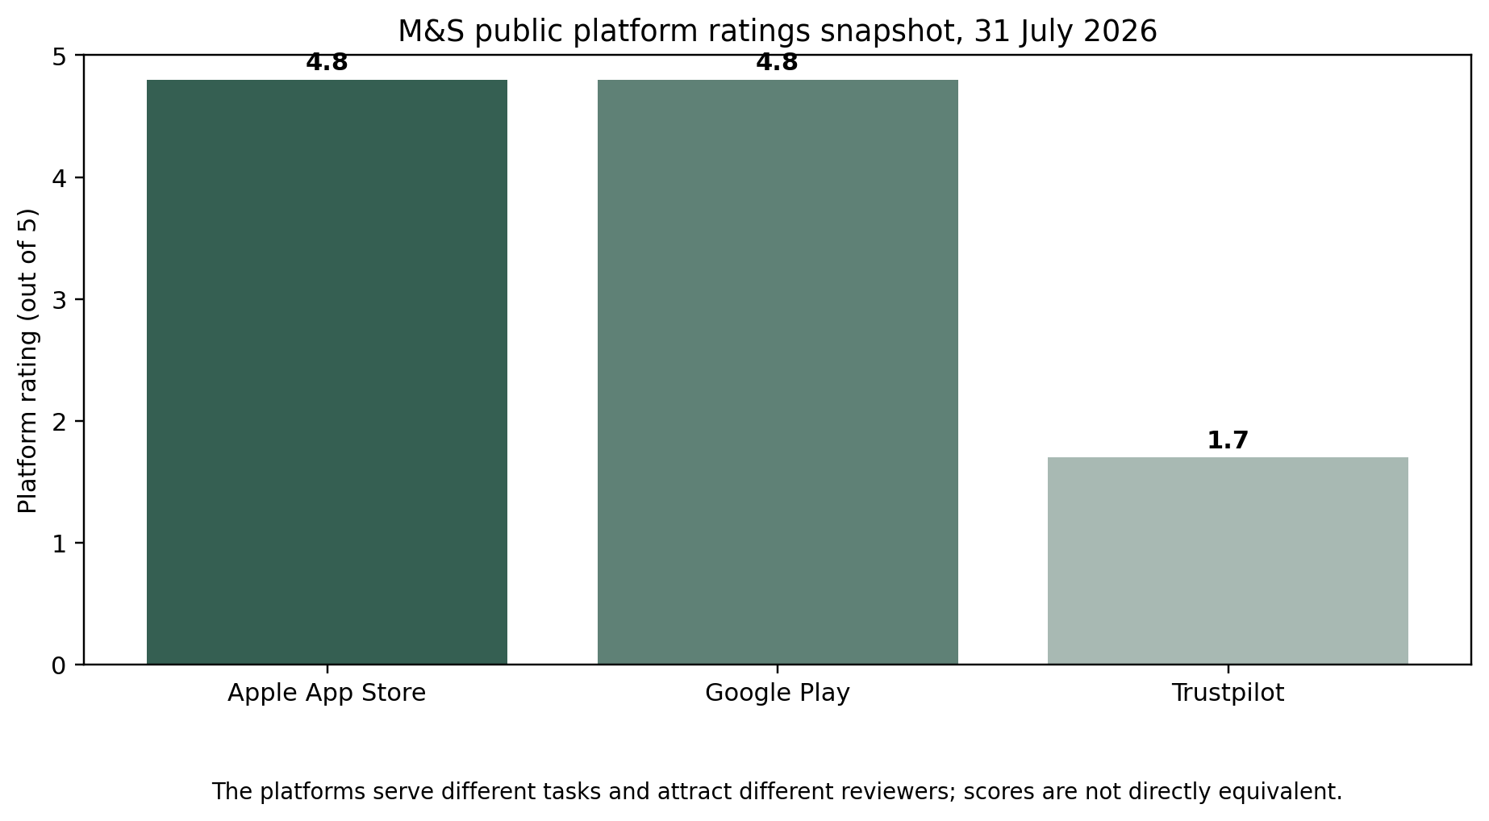
Figure 4.1: M&S public platform ratings snapshot. Sources: Apple (2026a), Google Play (2026a) and Trustpilot (2026).
Figure 4.1 highlights the gap between the two app-store ratings and Trustpilot. The important point is not that one score should replace the other, but that the platforms capture different parts of the customer journey. A customer may rate the app highly for search and checkout but still report a poor overall experience if delivery, collection, refund or service recovery fails. The figure therefore supports the finding that interface quality and end-to-end service quality need to be assessed separately.

4.2.1 Company Performance and Digital Engagement Context4.2.1 Company Performance and Digital Engagement Context
Company-level performance adds scale to the customer-review findings. M&S reported sales excluding Ocado Retail of £14,178.1m, up 1.9%, while adjusted profit before tax fell 23.8% to £671.4m. The company also reported £131.3m of cyber-incident-related adjusting costs (Marks & Spencer, 2026). These figures cannot show that customer engagement caused the change in profit. They are included because they demonstrate that digital disruption and service continuity can have a material business impact.
The online Fashion, Home and Beauty channel was particularly affected. Online sales fell 18.4% to £1,165.7m, compared with a 7.7% decline for Fashion, Home and Beauty overall. M&S linked part of this difference to the interruption and recovery of online ordering and also reported that website traffic and transactions improved later in the year (Marks & Spencer, 2026). This supports a cautious interpretation: the digital channel was more exposed to disruption, but the later recovery suggests that the fall should not automatically be read as a permanent loss of customer demand.
Three points from the company data are especially relevant to engagement. First, digital is a core sales channel because 30% of Fashion, Home and Beauty sales are online. Second, digital and physical retail are interdependent because 57% of online/app orders are collected in stores. Third, M&S is investing in AI-supported personalization and the transformed Sparks wallet, but the public evidence does not show how much these individual initiatives have increased loyalty, retention or advocacy. This is why the study separates evidence of investment and adoption from evidence of customer outcomes.
Table 4.2: M&S company and digital performance indicators, 2025/26
Indicator | 2025/26 evidence | Comparative context | Customer-engagement implication
Underlying group scale | Sales excluding Ocado Retail: £14,178.1m | Increase of 1.9% | Digital engagement operates within a large, still-growing retail business.
Profit and incident impact | Adjusted profit before tax: £671.4m; cyber-related adjusting costs: £131.3m | Profit declined 23.8% | Cyber resilience and service continuity have measurable commercial importance.
Segment performance | Food sales +7.0%; Fashion, Home & Beauty sales -7.7% | Divergent performance across the portfolio | Digital and engagement weaknesses are more visible in Fashion, Home & Beauty than in Food.
Online channel performance | Fashion, Home & Beauty online sales: £1,165.7m | Decline of 18.4%; H2 traffic and transactions improved year on year | Online demand remained, but disruption and execution reduced channel performance.
Omnichannel dependence | 30% of Fashion, Home & Beauty sales online; 57% of online/app orders collected in store | 1,059 UK-owned and franchise stores | The app, website, inventory, stores and colleagues must function as one journey.
Loyalty and personalization | Transformed Sparks launched with a digital wallet, real-money rewards and AI/data personalization | Strong early take-up reported, but limited independent outcome data | Success should be measured through clarity, redemption, retained use and trust rather than launch activity alone.

Table 4.2 puts the digital findings in their business context. The sharper decline in Fashion, Home and Beauty online sales and the separate cyber-related cost show that digital continuity has commercial consequences. At the same time, the scale of Click & Collect and the Sparks relaunch show that M&S continues to depend on a combined digital-and-store model. These indicators therefore explain why reliability, stock accuracy, recovery and trust are strategically important, but they are not treated as proof that one specific technology caused the financial results.
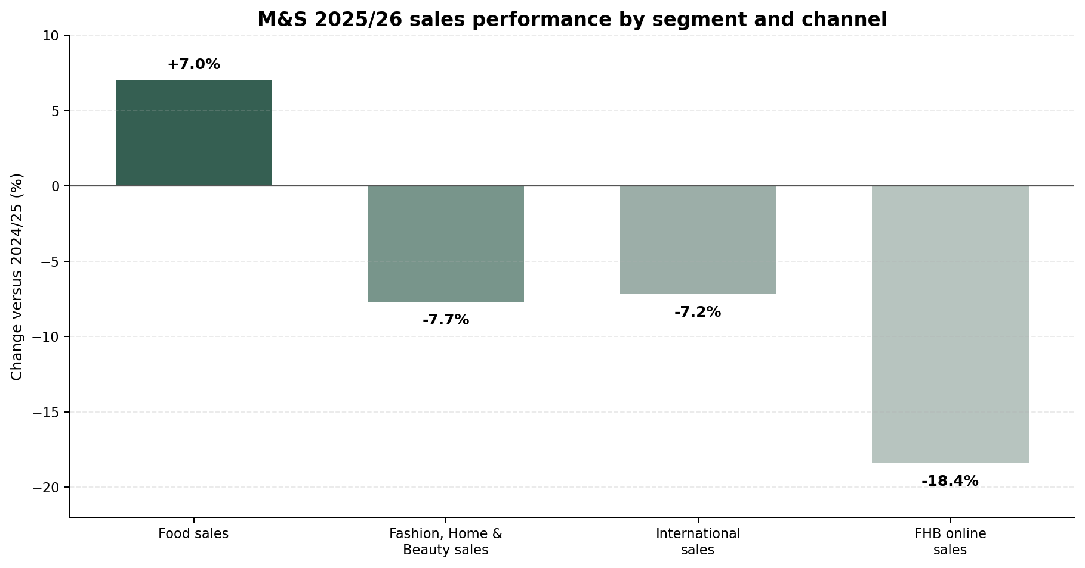
Figure 4.2: M&S 2025/26 sales performance by segment and channel. Sources: Marks & Spencer (2026a; 2026b).
Figure 4.2 shows that Food sales increased by 7.0%, while Fashion, Home and Beauty, International sales and Fashion, Home and Beauty online sales declined. The online decline of 18.4% was more than twice the 7.7% decline for Fashion, Home and Beauty overall. This makes the digital channel's exposure to disruption visible. However, M&S also reported an improvement in website traffic and transactions later in the period, so the figure is used to show vulnerability and recovery rather than to claim a permanent fall in digital demand.

4.3 RQ1: M&S Digital Customer-Engagement Ecosystem
RQ1 asks which digital technologies M&S uses to support customer engagement. The public evidence identifies six connected areas: the transactional website, mobile app, Sparks, AI-supported personalization, digital content/social interaction and omnichannel fulfilment. The app combines shopping, personalized Sparks offers, order tracking, digital receipts, product information, paperless returns and Click & Collect support (Apple, 2026a; Google Play, 2026a). The customer evidence in Appendix A shows how these capabilities are actually experienced: A04 demonstrates successful search and checkout; G02 records a home-screen failure and dissatisfaction with the new rewards logic; T18 records a failure at Click & Collect despite a confirmed order. The finding for RQ1 is therefore not simply that M&S has many digital features, but that the features operate through an interconnected service system whose customer value depends on execution.
Sparks is more than a discount feature because it links recognition, personalization and repeat purchasing. The redesigned programmed uses a digital wallet and real-money rewards, reflecting customer feedback reported by M&S that pounds were preferred to points (Marks & Spencer, 2026d). However, the review register provides the necessary counter-evidence to avoid equating programmed design with engagement. T02 describes a complex Sparks process alongside repeated stock problems; T03 records a mismatch between the customer's understanding of a spend offer and the final reward; T07 describes a restriction perceived as hidden in the terms; and T11 records multiple activation/verification steps. These cases show why the analysis evaluates Sparks through clarity, perceived value and successful redemption rather than membership or launch activity alone.
Public evidence about AI mainly comes from M&S management statements on uses such as pricing, waste reduction, decision support and personalized offers (Marks & Spencer, 2026b). There is not enough independent customer evidence in the selected sample to attribute higher loyalty or repeat purchase to AI. This is an important evidence boundary: the corporate source supports a finding about strategic use of AI, but it does not support a causal finding about customer engagement. The analysis therefore treats AI as an enabling capability and evaluates the customer-facing mechanisms—relevance, clarity, transparency and trust—using the literature in Chapter 2 rather than claiming an outcome that the available evidence cannot establish.
The cyber incident shows why digital resilience is part of customer engagement rather than only an IT issue. M&S's cyber communications document disruption to online ordering and subsequent customer actions, while the customer-review evidence shows how reliability problems are experienced at task level. For example, G02 records a failed app home screen that required a website workaround, while T12 records an account-registration mismatch that prevented Sparks joining and produced a stated exit intention. The corporate cyber source and the review evidence are not treated as equivalent; together they show different layers of the same reliability problem—system continuity at company level and task-level friction at customer level.
Table 4.3: M&S technologies, intended mechanisms and observed evidence
Technology / capability | Intended engagement mechanism | Finding from the evidence
Website and app | Usefulness, ease and reduced search effort | Strong browsing, search, imagery and checkout evidence; some navigation and information-timing friction
Sparks digital wallet | Recognition, value, personalization and frequency | Strategic investment is clear; customer evidence identifies reward clarity and redemption effort
AI and analytics | Relevance, decision quality and personalization | Management evidence is stronger than independent customer-outcome evidence
Click & Collect | Convenience and channel flexibility | Positive examples coexist with missing orders, stale stock and collection failures
Digital receipts / returns | Control and post-purchase convenience | Potentially useful, but refund visibility and escalation remain weak
Cybersecurity and resilience | Trust, continuity and perceived safety | The incident materially disrupted the journey and exposed the importance of recovery communication

Table 4.3 compares what each M&S technology is intended to do with what the public evidence actually shows. The website and app are strong in browsing and checkout, but some reviews identify navigation and information-timing problems. Sparks and AI have clear strategic aims, yet customer outcomes depend on clarity and trust. Click & Collect and digital returns can be convenient, but failed orders and slow refunds show that they depend on stock, store and recovery systems. The table therefore reinforces the main finding that feature breadth and successful execution are not the same thing.

4.4 RQ2: Customer Engagement Effects

4.4.1 Usefulness and Convenience4.4.1 Usefulness and Convenience
Usefulness and convenience appeared in 10 of the 30 coded reviews. The evidence is specific rather than inferred from the existence of an app: A04 records effective keyword search and a short checkout path; A03 records saved details and a straightforward purchase; T13 records a straightforward website and Click & Collect process; and T20 shows that human assistance can enable a difficult digital task. These examples support TAM because the digital touchpoint reduced effort or enabled completion. They also support Customer Engagement Theory because successful completion can contribute to confidence and continued participation. Appendix A allows each example to be traced back to its source-level summary.
The important point is that customers did not praise a feature simply because it was new. They responded positively when it solved a practical problem. For example, review A04 in Appendix A describes successful keyword search followed by a short checkout path, while T13 describes a straightforward website and Click & Collect process. These cases suggest that M&S should measure task completion, search success and accurate information alongside feature adoption or app downloads.

4.4.2 Interface Friction and System Reliability4.4.2 Interface Friction and System Reliability
Interface or system-reliability friction appeared in 11 reviews. The Appendix A cases include A02 (an unnecessary mandatory selection), G01 (delivery charges not visible until checkout), G02 (home-screen failure), and T12 (account/email mismatch). These are different failures, but they share the mechanism identified in Chapter 2: the digital system transfers additional effort or uncertainty to the customer. Under TAM this reduces ease of use; under S-O-R it can create irritation and reduced perceived control. The evidence therefore supports a more precise conclusion than 'the app has usability problems': specific tasks fail or become harder at identifiable points in the journey.
Some customers found workarounds, but a workaround should not be counted as a successful digital journey. For example, one review described using the website because the app home screen failed. The transaction may still be completed, but the customer has had to solve the retailer's problem. This is why average ratings alone can hide friction. More useful operational measures would include login success, repeated navigation, failed task attempts and the number of customers who switch channels to complete the same task.

4.4.3 Sparks: Personalisation Versus Reward Friction
Reward clarity and value appeared in six reviews. The Appendix A evidence includes T02, T03, T07 and T11, which respectively show complex reward processes, misunderstanding of reward value, perceived hidden restrictions and repeated redemption/verification steps. These cases explain the finding without assuming that all Sparks users are dissatisfied. They show a recurring mechanism in the selected evidence: the value of personalization can be weakened when eligibility, thresholds or redemption requirements are difficult to understand. This is the point at which the S-O-R framework adds value to TAM: the issue is not only task effort but the customer's interpretation of fairness, control and relevance.
S-O-R helps explain the difference. A clear, relevant reward can create recognition and value, while an unclear or difficult reward can create irritation and suspicion. Customer Engagement Theory adds that completing a transaction is not enough to show a strong relationship: a customer may still buy but feel less willing to advocate for the brand or continue using the loyalty programmed. The transformed Sparks programmed should therefore be judged by clarity, redemption success, perceived fairness and retained use, not only by the number of members or rewards issued.

4.4.4 Fulfilment, Stock Visibility and Service Recovery
Fulfilment and stock visibility appeared in 12 reviews, and service recovery or returns also appeared in 12. The Appendix A register shows the concrete basis for these counts: T17 records a paid next-day order that did not arrive as required; T18 records a confirmed Click & Collect order that could not be found; T19 records incomplete refunding after failed delivery; T21 records stale stock information followed by cancellation; and T22 provides a positive counter-example of satisfactory ordering, returns and refund timing. These cases demonstrate both the frequency and the mixed direction of the evidence. The finding is therefore not that M&S always fails after purchase, but that post-purchase execution and recovery generated the most repeated problems in this selected sample.
These problems occur after the website or app has already made a promise. A confirmation message, delivery update, store handover or refund message therefore becomes part of the digital experience. Review T18 is a clear example: the order was confirmed, but it could not be found at collection and the problem then moved into the refund stage. The original failure was made worse because several systems and people were involved. This is why the post-purchase stage appears weaker than browsing and purchase in the review evidence.
Several negative reviews also described behavioral consequences such as switching retailer, avoiding the online channel or stopping use of the loyalty programmed. These statements cannot be converted into a population rate, but they matter because they show how an operational failure can become a relationship outcome. In S-O-R terms, the failure creates irritation or distrust and can lead to avoidance; in Customer Engagement Theory, it represents weakened behavioral and emotional engagement.

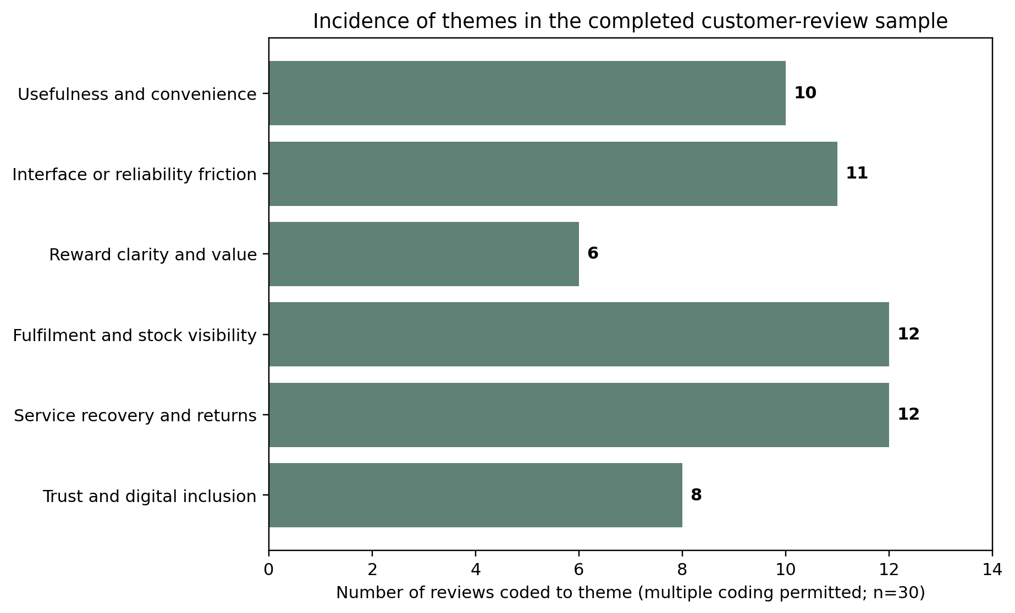
Figure 4.3: Incidence of themes in the completed customer-review sample. Source: author coding; multiple coding permitted, n=30.
Figure 4.3 shows how often each theme appeared in the 30-review sample. Fulfilment/stock visibility and service recovery/returns were the most frequent, with 12 coded reviews each, followed by interface/reliability friction (11), usefulness/convenience (10), trust/digital inclusion (8) and reward clarity/value (6). The bars should not be added together or treated as percentages of all M&S customers because one review could receive several codes. The figure is used to identify where problems repeatedly appeared in this sample, not to estimate prevalence across the customer base.
Table 4.4: Thematic findings and theoretical interpretation
Theme | Finding | Theoretical interpretation | Managerial meaning
Usefulness and convenience | Search, imagery, checkout and Click & Collect can reduce effort | TAM usefulness; behavioral engagement | Protect task simplicity and measure completion
Interface / reliability friction | Login, navigation, address and information-timing problems transfer effort to customers | TAM ease; S-O-R irritation | Prioritize failure recovery and information timing
Reward clarity and value | Personalization can be undermined by unclear conditions or redemption steps | S-O-R relevance versus irritation; trust | Simplify and preview reward value
Fulfilment / stock visibility | Digital promises fail when stock and order data are inaccurate | Omnichannel continuity; perceived control | Improve real-time status and exception handling
Service recovery / returns | Weak escalation magnifies the original failure | S-O-R negative response; complaint engagement | Create a unified recovery journey
Trust and inclusion | Cyber risk, app dependence and digital exclusion shape willingness to continue | Trust; facilitating conditions | Offer secure and assisted alternatives

Table 4.4 links the six themes to an explanation and a practical management response. The pattern is consistent: positive engagement is strongest when customers can complete a task with low effort and clear information, while negative engagement grows when effort is transferred to the customer, control is reduced, information is unreliable or recovery is weak. This link is important because it shows that the recommendations come from observed customer mechanisms rather than from a generic list of digital-retail improvements.

4.5 Omnichannel Journey Diagnosis
The omnichannel analysis shows that the quality of the M&S journey changes by stage. Pre-purchase evidence is relatively strong when search, imagery and product information work well (for example A04). Purchase-stage evidence is mixed because reward and delivery-information issues can introduce friction (G01 and T11). The clearest operational weakness is post-purchase, where the customer may depend on stock data, a carrier, a store and customer service at the same time. T18 is the clearest end-to-end example: a digital order confirmation did not translate into a successful store handover, and the failure then became a refund problem. This is precisely the type of cross-channel hand-off problem highlighted by the omnichannel literature in Chapter 2.
This is why the app and the store should not be evaluated separately. With 57% of online/app orders collected in stores, a failed collection is simultaneously a digital, inventory, store and service issue (Marks & Spencer, 2026a). The customer does not see these organizational boundaries; the customer sees one M&S journey. The more meaningful measure is therefore end-to-end completion: was the item shown as available, was the order ready when promised, and was the problem resolved clearly if something went wrong?
The review evidence also shows that human support can strengthen a digital journey. Review T20 describes a store colleague helping a customer complete a difficult account set-up. This is important because 'digital' does not have to mean removing human support. For customers who are less confident with smartphones or account creation, assisted digital service can be the difference between exclusion and successful engagement.
Table 4.5: M&S customer-journey diagnosis
Journey stage | Main touchpoints | Diagnosis | Useful performance indicators
Pre-purchase | Search, browsing, imagery, product detail, stock check | Generally positive task usefulness; stock accuracy is inconsistent | Search success; stock-data freshness; failed searches
Purchase | Basket, rewards, checkout, payment, delivery choice | Easy completion for many users; reward and delivery information can create friction | Checkout completion; reward failure; cost visibility
Fulfilment | Order status, delivery, Click & Collect, store handover | High strategic importance with both strong and failed experiences | On-time delivery; collection success; order integrity
Post-purchase | Returns, refund, complaint and escalation | Most persistent weakness in the review evidence | Refund cycle time; first-contact resolution; repeat contacts
Relationship | Personalization, trust, advocacy, repeat use or avoidance | Outcome depends on the whole journey, not the app alone | Retention after failure; complaint recovery; opt-out / avoidance

Table 4.5 summarizes this journey pattern. Search and product presentation are relatively strong, checkout is mixed, and the most persistent risks appear in fulfilment, refunds and escalation. The suggested measures therefore focus on whether each stage is completed successfully and how quickly problems are recovered, rather than relying on one overall app rating to represent the whole customer experience.

4.6 RQ3: Competitor Benchmark
The competitor benchmark compares the breadth of publicly visible digital capabilities, not overall retailer quality or customer satisfaction. M&S scores 19 out of 24, with Next and Ocado at 18. The score is reproducible from the eight categories and 0–3 rubric in Appendix B. The category-level results are more informative than the total: M&S is strong in transaction, search, loyalty and fulfilment breadth, while its recovery score is lower. The benchmark therefore addresses RQ3 by identifying capability gaps that correspond to problems already observed in Appendix A, rather than by claiming that a higher total proves better customer outcomes.
Next provides a useful fashion and homeware comparison because its public app and help information emphasize product filtering, size-specific stock visibility, detailed order tracking and store returns using a digital code (Google Play, 2026b; Next, 2026a; 2026b). It does not offer a broad loyalty programmed equivalent to Sparks, but its order visibility and returns process provide a relevant comparison for the M&S problems around order status and recovery. Ocado provides a different lesson: its digital grocery model gives customers strong control over order editing and substitutions, although it is delivery-centered rather than store-connected (Google Play, 2026c).
Asda and Lidl provide useful comparisons for app-based loyalty because their public apps emphasize coupons, wallet-style value, personalized offers and notifications. The comparison is not used to claim that their customers are more satisfied; it is used to identify different ways of making loyalty value visible and usable. Aldi represents the opposite model: a lighter app focused on browsing, offers, favorites and store finding, with less transactional complexity (Google Play, 2026d; 2026e; 2026f). Together, these examples show that M&S can learn from specific capabilities without assuming that a larger feature set is always better.
Table 4.6: Public-feature benchmark (0 = absent; 3 = integrated/customer-centered)
Retailer | Trans. | Search | Loyalty | Personal. | Visibility | Fulfil. | Recovery | Privacy | Total
M&S | 3 | 3 | 3 | 2 | 2 | 3 | 1 | 2 | 19
Next | 3 | 3 | 0 | 2 | 3 | 3 | 2 | 2 | 18
Ocado | 3 | 3 | 2 | 2 | 3 | 1 | 2 | 2 | 18
Asda | 2 | 2 | 3 | 3 | 2 | 2 | 1 | 2 | 17
Lidl | 1 | 2 | 3 | 2 | 1 | 1 | 1 | 2 | 13
Aldi | 1 | 2 | 0 | 1 | 0 | 0 | 1 | 1 | 6

Table 4.6 shows that M&S has the broadest public capability set in this benchmark, but the small gap between M&S, Next and Ocado means that the total score is less useful than the category-level comparison. M&S is strong in transaction breadth, search, loyalty and store-supported fulfilment, while service recovery is weaker. The practical lesson is therefore not to add more features simply to increase the score, but to improve visibility, control and recovery in the parts of the journey where customer evidence shows repeated problems.

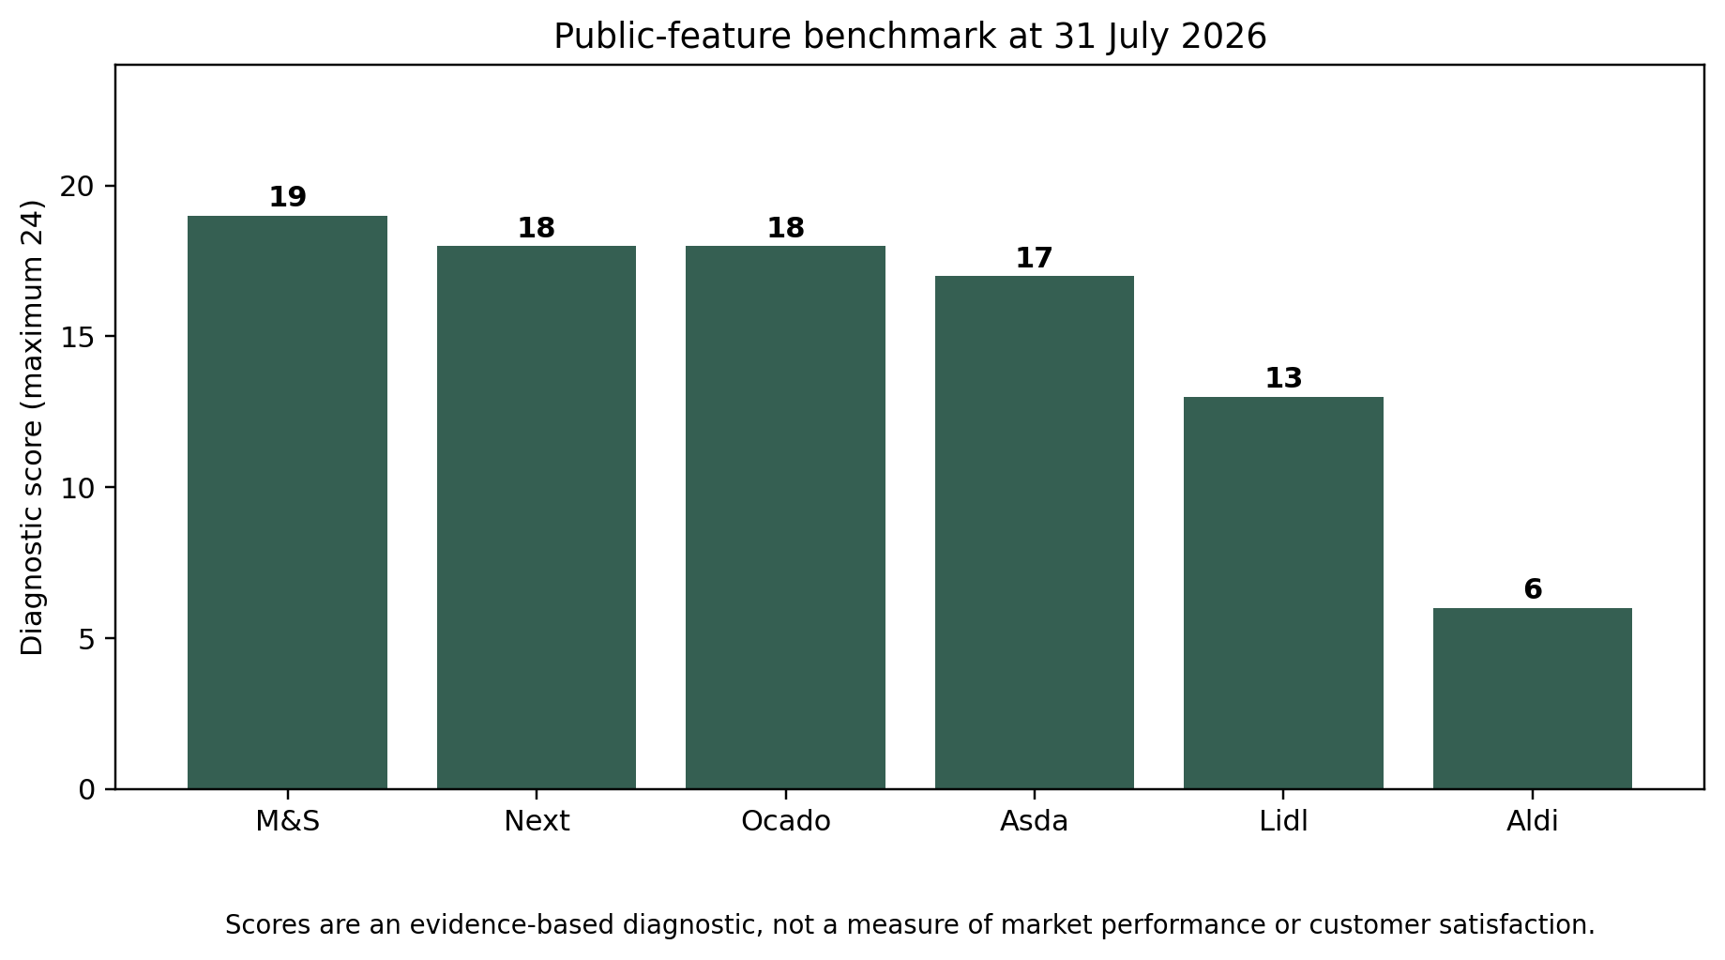
Figure 4.4: Public-feature benchmark totals. Source: author assessment from dated public evidence in Appendix B.
Figure 4.4 presents the benchmark totals visually. M&S is only one point ahead of Next and Ocado, and two points ahead of Asda. These scores are a functional diagnostic based on public evidence, not a measure of satisfaction or commercial performance. The figure is useful because it shows that M&S already has a broad digital offer; the larger opportunity is to make that offer more dependable, especially around order visibility and recovery.

4.7 Integrated Theoretical Discussion
The four theoretical perspectives explain different parts of the same customer journey. TAM is most useful when the issue is task performance: customers respond positively when search is effective, product information is clear and the number of steps is low, and negatively when login, navigation or information timing makes the task harder. However, task completion alone does not explain the whole experience because a customer can complete a purchase and still feel frustrated or distrustful.
S-O-R helps explain these emotional and behavioral reactions. A reward message, order confirmation, collection update or refund notice acts as a stimulus. The customer then experiences relevance, control, trust or irritation, and this can lead to purchase, complaint, advocacy or avoidance. The M&S evidence shows that events after checkout are part of this process: a failed collection or delayed refund can become a negative digital experience even if the original interface worked well.
Customer Engagement Theory extends the analysis beyond the single transaction. A customer who believes a reward was unclear or a complaint was poorly handled may still complete the purchase but feel less loyalty or willingness to recommend M&S. In contrast, the assisted account set-up in review T20 shows how human help can increase confidence and continued participation. Engagement therefore has cognitive, emotional and behavioral dimensions, and these dimensions do not always move in the same direction.
The omnichannel perspective brings these findings together. The M&S digital proposition depends on the app and website, but also on stock data, stores, carriers, customer service and cybersecurity. The evidence therefore supports a service-system view of digital transformation: the important question is not whether M&S has enough digital touchpoints, but whether those touchpoints operate as one reliable customer journey.

4.8 Recommendations
The recommendations are prioritized according to the strongest recurring evidence in Appendix A, the theoretical mechanisms developed in Chapter 2 and the capability gaps identified through the Appendix B benchmark. Each recommendation therefore has an identifiable chain: observed case(s) → code/theme → theoretical interpretation → action → measurable indicator. This is intended to make the recommendations auditable rather than generic.
Table 4.7: Evidence-based recommendations for M&S
Priority | Evidence base | Action | Suggested indicators
1. Simplify and preview Sparks value | Reward clarity and redemption friction appeared repeatedly | Auto-apply eligible rewards where possible; show exclusions and final value before checkout; reduce wallet steps | Reward activation failure; redemption completion; contacts per reward
2. Strengthen task reliability and information timing | Login, navigation, address and delivery-information problems reduced control | Prioritize home-screen and login recovery; show delivery cost earlier; validate address changes and cancellation routes | Login success; checkout error; address correction; abandonment
3. Create a unified order and recovery hub | Fulfilment, stock, refunds and service recovery were the most frequent negative themes | Provide real-time stock confidence, collection status, refund progress, exception reason and one escalation path | Collection success; stock cancellation; refund cycle; first-contact resolution
4. Design for assisted digital inclusion | Smartphone dependence and difficult account set-up can exclude customers | Retain web and in-store alternatives; train colleagues to support account and wallet tasks; publish a non-app access route | Assisted set-up completion; accessibility complaints; non-app reward access
5. Measure engagement at journey level | Feature presence and average ratings concealed execution gaps | Use end-to-end task completion, recovery satisfaction and retained purchase after failure alongside app ratings | Journey completion; repeat purchase after complaint; trust / satisfaction by stage

Table 4.7 turns the repeated findings into five practical priorities. The first two address reward clarity and basic task reliability; the third focuses on the most frequent post-purchase problems around stock, orders, refunds and recovery; the fourth protects customers who need non-app or assisted support; and the fifth changes how success is measured. Each priority is linked to indicators so that improvement can be assessed through customer task completion and recovery rather than through feature launches alone.
The recommendations were chosen because they respond to mechanisms identified in the evidence. For example, simpler Sparks rules respond directly to T07 and T11 and to the TAM/S-O-R interpretation of effort and perceived control. A unified order and recovery hub responds to T18, T19 and T21, where the original digital transaction was followed by a fulfilment, stock or refund problem. Assisted digital options respond to T20 and T09, which show both the value of colleague support and the risk of smartphone-dependent access. The journey-level measurement recommendation follows from the contrast between high app ratings and the more negative Trustpilot service evidence, rather than from a generic preference for more KPIs.
A practical first step would be a short diagnostic of the failure journeys that appeared repeatedly in the sample: Sparks activation, app login, stock-related cancellation, failed Click & Collect and delayed refunds. For each journey, M&S could identify where information is lost, which team owns the exception and what the customer is told at each stage. This approach was recommended because the evidence suggests that fixing the hand-off between existing systems may create more value than simply adding another digital feature.

The chapter answers the three research questions using evidence that can be traced to the methodology and appendices. RQ1 is supported by M&S corporate/platform evidence and customer examples such as A04, G02 and T18; RQ2 is supported by the six coded themes and the review-level trail in Appendix A; and RQ3 is supported by the dated competitor evidence and scoring rubric in Appendix B. The resulting conclusion is therefore evidence-specific: M&S has broad digital capability, but the selected customer evidence shows recurring friction around reward clarity, system reliability, stock/order integrity, refunds and recovery. The recommendations address these observed failure points rather than proposing additional technology for its own sake.

CHAPTER 5: DISCUSSION AND CONCLUSION

5.1 Introduction
This chapter outlines the implications of the findings presented in Chapter 4 in relation to literature and theories presented in Chapter 2. It does not duplicate the findings but, instead, provides insights as to which of the three constructs (M&S) evidence supports, extends or challenges current thinking on digital customer engagement. There are four topics that stood out in the case that they have focused on digital value, personalization and AI, integration of omnichannel, and trust/recovery. It then goes on to present the theoretical contribution, managerial implications, limitations and directions for future research.

5.2 Discussion of Key Findings

5.2.1 Digital Technology as an Enabler of Customer Engagement
The results revealed that although a role of digital technology in M&S customer engagement is highlighted, it is task success that makes it valuable. A04 is good, find and checkouts are performed efficiently. For example, G02 is an app home-screen failure, which was worked around by website; T18 involves a confirmed digital order that failed at store collection as just one example of many. They reinforce the Chapter 2 premise that digital transformation is an organizational capability not only the technology adoption (Verhoef et al., 2021). They also highlight why TAM may not be enough: there are clear insights on usefulness and ease to observe at the interface, but the promise can fall behind if stock, fulfilment/recovery processes don't follow well.
This is in line with the notion that retail digital transformation has become an organizational ability, and not only an acquisition of technology (Verhoef et al., 2021). Perhaps in the case of M&S, the same digital attribute will yield varying engagement results, with the quality of the execution behind it. For instance, an app can be very well designed however, the customer experience would undoubtedly be poor if an item is listed as being in stock but not available for pick up.
The M&S evidence is also consistent with the Technology Acceptance Model (Davis, 1989), demonstrating that usefulness and ease of use is of major importance. Customers reacted positively when searching, product information, checkout and Click & Collect was easier. Meanwhile, the case also illustrates the “only” TAM; usefulness at the interface does not necessarily translate to usefulness later in the trip. A usable app can be negated by stock accuracy, delivery, returns and recovery.
This discovery and treatment of digital engagement is, therefore, as a service experience from end to end. Customer engagement is not merely affected by the digital feature itself, but also by the operational system that makes the promise on screen a reality for M&S.

5.2.2 The Role of Personalization and Artificial Intelligence in Customer Relationships
The corporate evidence documents this direction of travel and AI and personalization represents an opportunity for M&S to better communicate and offer their customers something more relevant. But, based on the evidence provided by the customers, the increase in loyalty cannot be attributed to AI. The next empirical finding is about the actual implementation of personalized rewards; this is where expected and received value of a reward is mismatching (T03), or restriction is felt and it is hidden (T07), or redemption steps repeated (T11).
As is revealed by the findings, this is also the personalization paradox. If the conditions are uncertain or the client feels they are not involved enough in the process, a tailor-made offer can be confusing and take away time for the client that would otherwise be saved by the offer. This aligns with Aguirre et al. (2015) who reveal that the impact of personalization varies based on the relationship between relevance and privacy/trust issues.
The thing that is clearest in the sample of M&S is the experience of a reward, not the complexity of the rewards algorithm. Examples of complexity, misunderstanding, perceived hidden restrictions, and repeated steps for redemption are described in T02, T03, T07 and T11. So, one must measure personalization against the results in terms of customer understanding, successful redemption, perceived fairness and continued use, not against the existence of AI or the number of personalized offers that have been issued.
A personalized offer is, from an S-O-R standpoint, a stimulus and the customer's response to it can be a loyalty reaction, a complaint reaction or the avoidance reaction, depending upon whether or not the customer sees it as relevant, useful, intrusive, confusing and/or unfair. This M&S finding, then, confirm that AI can be an enabler of engagement, but not a direct contributor to loyalty. It will be successful if customers accept the value that is promised to be delivered with transparency and reliability.

5.2.3 Omnichannel Integration and Customer Experience
The one thing that's abundantly clear is that there's no such thing as separating the online and offline experiences of the M&S trip. Click & Collect is a blend of digital order and store fulfilment – and the current evidence shows it working and where it has not. T13 notes simple web site and collection process, and T18 notes confirmed order that was not found at collection and eventually caused refund issues. T21 also illustrates instances in which outdated website stock details can cause a payment order to be cancelled. It is through these examples that you can find the empirical evidence for the argument introduced in Chapter 2 omnichannel, that the customer experiences one journey despite there being multiple systems responsible, whether they are digital systems, inventory, store and service systems.
This helps with customer-journey research as omnichannel becomes the form of competition as opposed to that of individual channels (Lemon and Verhoef, 2016). It is evident in the M&S reviews. Customers switch from the search phase to checking stock, paying, picking up, visiting returns or customer service without it affecting the relationship with the retailer at each interface.
The biggest failure in the case would then be not an online/offline difference at all; it would be the nature of the online/offline differences. T18 ties together the order and the confirmation in the store collection, and refund; T19 connects the failure in delivery with the incomplete refunding; T21 ties the information of store collection in the website with the cancellation. To illustrate these cases, and that's why a unified order/recovery view is recommended because it's based on observed journeys, versus generic omnichannel theory, and to illustrate why repeated negative evidence was found in the post purchase stage.
Management, therefore, needs to know that they have to invest in the app or website as much as they invest in the accuracy of their inventory, logistics, store processes and customer-service recovery. The customer decides on the overall process, and not on which internal system caused the failure.

5.2.4 Customer Trust, Digital Reliability and Service Recovery
Trust has become a major element in the composition of digital engagement since customers rely on M&S to provide correct information, safeguard their data and resolve issues effectively. T12 reflects an account-registration failure coupled with an expressed resignation from that store at customer level and T18 reflects a failed collection with distrust or refund difficulty at customer level. Initiatives by M&S to take over the situation are mentioned in the document that reports outages in the organization's online services. The following sources are intentionally separated: The reviews are at customer level and provide evidence of the experience, and the organizational experience is documented at cyber source. All these helps to support the notion of reliability and recovery are not just technical matters but are customer experience matters too.
The case of M&S is a good example. Access and continuity and trust were affected by the disruption of online services or worry about customer information. Within the context of S-O-R it is a negative stimulus which can lead to feelings of frustration, avoidance and/or negative adoption. Thus, the case demonstrates that the issues of Cyber Security and Resilience are Customer Experience issues as well as technical issues.
The review analysis takes into account a particular recovery mechanism. More specifically, the measures are as follows: T04 records delayed refund and response; T05 records a prolonged multi-contact complaint process; and T19 records an incomplete refund with failed delivery. By contrast, T22 serves as a positive instance of good ordering, and good returns and refund timing. This is necessary to consider as this comparison demonstrates that only negative cases were not selected. When a lack of visibility or fragmentation of escalation adds to an original issue, the odds are high that disengagement will follow: whereas successful recovery can potentially avert a bigger relationship issue following a single failure.
Digital resilience should therefore be treated as part of the customer engagement strategy. In fact, for retailers like M&S, cybersecurity, exception handling, recovery communications and human support are customer facing capabilities, as they help to determine if the customer feels they can and want to continue the relationship following an incident.

5.3 Theoretical Contributions
The study contributes four main theories, all based on the evidence from the M&S, but not necessarily solely the evidence of technology.
First, it is grounded in 'Customer Engagement Theory' which posits three dimensions of engagement: cognitive, emotional and behavioral. A04 is when a task is completed successfully, T12 a person has stated that they wish to walk away after failing to register and T20 when they continue to participate but are being assisted by a human. The series of cases illustrates the need for purchase to be merely a part of an engagement.
Second, it discretely endorses TAM; however, it certainly gives insights into usefulness and ease of use alone to provide a complete explanation of the retail journey. A04 exhibits utility and low effort –– and G01 and G02 exhibit specific situations in which the increase in effort is related to information timing or system reliability. Next, T18 shows that despite a successful digital transaction, collection points can be missed. Hence, the contribution is to consider TAM in a broader service and omnichannel perspective instead of viewing it as a comprehensive explanation.
Third, it is evident that S-O-R is applicable to digital retail as different responses can occur to the same digital stimulus. T11 demonstrates repetitive steps of reward leading to effort/frustration, and T18 demonstrates trust and difficulty of refunds when collection is unsuccessful. It is therefore not the technology label, but the customer's interpretation of it and the customer's reaction(s) to the stimulus that is key.
Fourth, the omnichannel view depicts how these impacts interplay throughout the entire journey. T18 is important since it describes an order confirmation, stock collection and a refund; T21 is important since it can describe a payment and a cancellation as well as an order confirmation; and finally, T20, which is important, points to the role of humans in a digital process. These cases give a fuller picture of the analysis than just the individual app or website use and reinforces the notion that there is a broader service system that generates engagement.

5.4 Managerial Implications and Recommendations
The repeated evidence in Appendix A and capability gaps in Appendix B is directly associated with the managerial implications below. Because they are not described as universal good practice for the digital retail; they are mechanisms that have been observed here.
First, M&S should improve their digital services, including stock availability, order status, and refunds visibility. T18, T19 and T21 clearly demonstrate this: a potential (digital) sale and expectation, but information about the fulfilment/refund doesn't meet that expectation. So, it's not just about how many apps were downloaded that matters, it's about order integrity, stock cancellation time, refund cycle time or first contact resolution.
Second, Sparks should be clearer to use and understand. Reward friction exists in T03, T07 and T11, varying in the respective form, T02 additionally depicts repeated stock problems with reward friction. Rewarding limited steps to complete the behavior and making it clearly obvious that it is redeemable would directly address the evidence coded under reward clarity/value as well as the TAM/S-O-R mechanisms described in Chapter 3.
Third, M&S can continue to build upon their AI-driven personalization, but it is important to not lose the customer in the process. As personalization advances, transparent information on how offers are created (and where preference can differ) would aid in building trust around their use.
Fourthly, an improved interconnection of order- and service-recovery information between the app, web, stores, and customer-service teams. There are cases where the customers may now have to be taken back and forth - fulfilment to refund to complaint and back to fulfilment etc. (as indicated in T18, T19 and T05). If there was a common vision on order status, stock exception, return and refunds, then repeated explanations can be curtailed and the path of recovery can be seen.
Lastly, M&S must measure the success of the digital journey in addition to adoption measures. Downloads, membership and online sales are helpful, but should be supplemented by task completion rates, aborted journeys, recovery times, repeat contacts, trust and sustained use following problems.

5.5 Research Limitations
This study has a number of limitations that restrain the extent to which findings can be generalized.
Firstly, public secondary data are used in this study instead of a survey or interviews tailored specifically for this research. It is therefore not an accurate reflection of all M&S customers' experiences and claims, nor does it offer an in-depth analysis of individual customers' motivations.
Secondly, only 30 reviews have been included, because they have been carefully hand-picked by the customer. This is adequate for manual qualitative coding (by professionals), as well as finding out whether the same issues repeat, but it's not statistically representative. When looking at the sample, it's crucial to factor in the negative balance on Trustpilot.
In addition, third, the competitor benchmark is relative to capabilities that are publical visible and not internal performance or similar data about customer satisfaction. It can indicate variations in the design and integration of features but cannot prove that a higher-scoring retailer provides better customer outcomes.
Fourth, the study is on a defined set of dates (until 31 July 2026). The information about the benchmark/ platform features should be interpreted as based on an o snapshot of the platform (benchmark) at a particular time as such features, loyalty programs, ratings and recovery processes can vary often.

5.6 Suggestions for Future Research
In the future, further study can be conducted to include primary data from M&S customers by utilizing the interview or a survey. A survey may explore the correlation between usefulness, trust, personalization and loyalty; and interviews may delve into the reasons behind specific reward, fulfilment or recovery experiences and their impact on ongoing usage.
Longitudinal studies would also be valuable as there can be fluctuation in customer engagement after significant on-line improvement or service breakdown. By analyzing customer tracking and/or platform-attributed signals over time one could determine if there was a recovery in trust and use following updates to Sparks, fulfilment or service-recovery processes. Another study could be conducted by a bigger cross-retailer to see if the M&S patterns are found in other areas of UK retail.
Another research area is the personalization of AI from an ethical perspective, particularly the attitudes of customers toward data collection, algorithmic transparency, control and digital privacy. To distinguish the former and the latter type of personalization, the customer experienced it as useful, and the personalization experienced as intrusive.

5.7 Conclusion
The research explored the impact of digital technologies on customer engagement at the Marks & Spencer store in retail sector in the UK using the following research instruments: Corporate documents, evidence from public platform, 30 purposively selected customer reviews and one functional competitor benchmark. Convenience and relevance can be enhanced with digital tools, but technology in isolation isn't engagement. Here, the positive instances A04, A03 and T13 are the exemplification of an efficient search, order and collection; the opposite side of things is demonstrated in the failed fulfilment/reward complexity (T11, T18, T19 and T21).
M&S thus has a wide and highly significant digital landscape; however, customer results will vary depending on how the elements – app, website, Sparks, stocks, stores, delivery and customer service – aligned and functioned. Of course, the sample is heavily weighted towards Trustpilot, but Appendix A details the transparent audit trail of the evidence that was selected, and Appendix B details the source trail of the competitor evidence that was used for the benchmark. The results therefore should be viewed as a fine-grained diagnosis, based on evidence, of what was seen, rather than as an estimate of prevalence present at the time of survey or as causal testing.
Overall, M&S find that useful technology, reliable operation, communication and human support and trust come together to form effective digital customer engagement. From Chapter 2 to Chapter 3, and onwards to Chapters 4 and 5, the evidence trail demonstrates that it is not about blindly adopting more digital features but for good reason. It is more immediate opportunity to make the existing journeys more understandable and more dependable to complete and easier to recover on failure, especially the failure journeys documented by T11, T18, T19 and T21.

REFERENCES
Aguirre, E., Mahr, D., Grewal, D., de Ruyter, K. and Wetzels, M. (2015) 'Unraveling the personalization paradox: The effect of information collection and trust-building strategies on online advertisement effectiveness', Journal of Retailing, 91(1), pp. 34-49. https://doi.org/10.1016/j.jretai.2014.09.005.
Apple (2026a) M&S - Fashion, Food & Homeware. Apple App Store. Available at: https://apps.apple.com/gb/app/m-s-fashion-food-homeware/id538410698 (Accessed: 31 July 2026).
Apple (2026b) Next: Shop Fashion & Home. Apple App Store. Available at: https://apps.apple.com/gb/app/next-shop-fashion-home/id348364305 (Accessed: 31 July 2026).
Beck, N. and Rygl, D. (2015) 'Categorization of multiple channel retailing in multi-, cross-, and omni-channel retailing for retailers and retailing', Journal of Retailing and Consumer Services, 27, pp. 170-178. https://doi.org/10.1016/j.jretconser.2015.08.001.
Bleier, A., Harmeling, C.M. and Palmatier, R.W. (2019) 'Creating effective online customer experiences', Journal of Marketing, 83(2), pp. 98-119. https://doi.org/10.1177/0022242918809930.https://doi.org/10.1177/0022242918809930.
Braun, V. and Clarke, V. (2006) 'Using thematic analysis in psychology', Qualitative Research in Psychology, 3(2), pp. 77-101. https://doi.org/10.1191/1478088706qp063oa.https://doi.org/10.1191/1478088706qp063oa.
Brodie, R.J., Hollebeek, L.D., Juric, B. and Ilic, A. (2011) 'Customer engagement: Conceptual domain, fundamental propositions, and implications for research', Journal of Service Research, 14(3), pp. 252-271. https://doi.org/10.1177/1094670511411703https://doi.org/10.1177/1094670511411703.
Brodie, R.J., Ilic, A., Juric, B. and Hollebeek, L. (2013) 'Customer engagement in a virtual brand community: An exploratory analysis', Journal of Business Research, 66(1), pp. 105-114. https://doi.org/10.1016/j.jbusres.2011.07.029.
Bryman, A. (2016) Social Research Methods. 5th edn. Oxford: Oxford University Press.
Creswell, J.W. and Creswell, J.D. (2018) Research Design: Qualitative, Quantitative, and Mixed Methods Approaches. 5th edn. Thousand Oaks, CA: SAGE.
Davenport, T., Guha, A., Grewal, D. and Bressgott, T. (2020) 'How artificial intelligence will change the future of marketing', Journal of the Academy of Marketing Science, 48, pp. 24-42. https://doi.org/10.1007/s11747-019-00696-0.
Davis, F.D. (1989) 'Perceived usefulness, perceived ease of use, and user acceptance of information technology', MIS Quarterly, 13(3), pp. 319-340. https://doi.org/10.2307/249008.
Gao, M. and Huang, L. (2021) 'Quality of channel integration and customer loyalty in omnichannel retailing: The mediating role of customer engagement and relationship program receptiveness', Journal of Retailing and Consumer Services, 63, 102688. https://doi.org/10.1016/j.jretconser.2021.102688.
Google Play (2026a) M&S - Fashion, Food & Homeware. Available at: https://play.google.com/store/apps/details?id=com.marksandspencer.app (Accessed: 31 July 2026).https://play.google.com/store/apps/details?id=com.marksandspencer.app
Google Play (2026b) Next: Shop Fashion & Homeware. Available at: https://play.google.com/store/apps/details?id=uk.co.next.android https://play.google.com/store/apps/details?id=uk.co.next.android (Accessed: 31 July 2026).
Google Play (2026c) Ocado - Online Grocery. Available at: https://play.google.com/store/apps/details?id=com.ocadoretail.mobile.android (Accessed: 31 July 2026).
Google Play (2026d) ASDA Rewards. Available at: https://play.google.com/store/apps/details?id=com.asda.rewards (Accessed: 31 July 2026).
Google Play (2026e) Lidl Plus. Available at: https://play.google.com/store/apps/details?id=com.lidl.eci.lidlplus (Accessed: 31 July 2026).
Google Play (2026f) ALDI UK. Available at: https://play.google.com/store/apps/details?id=de.apptiv.business.android.aldi_uk (Accessed: 31 July 2026).
Grewal, D., Roggeveen, A.L. and Nordfält, J. (2017) 'The future of retailing', Journal of Retailing, 93(1), pp. 1-6. https://doi.org/10.1016/j.jretai.2016.12.008.
Hollebeek, L.D., Glynn, M.S. and Brodie, R.J. (2014) 'Consumer brand engagement in social media: Conceptualization, scale development and validation', Journal of Interactive Marketing, 28(2), pp. 149-165. https://doi.org/10.1016/j.intmar.2013.12.002.
Hoyer, W.D., Kroschke, M., Schmitt, B., Kraume, K. and Shankar, V. (2020) 'Transforming the customer experience through new technologies', Journal of Interactive Marketing, 51, pp. 57-71. https://doi.org/10.1016/j.intmar.2020.04.001.
Huang, M.-H. and Rust, R.T. (2021) 'A strategic framework for artificial intelligence in marketing', Journal of the Academy of Marketing Science, 49, pp. 30-50. https://doi.org/10.1007/s11747-020-00749-9.
Information Commissioner's Office (2023) Guidance on AI and data protection. Available at: https://ico.org.uk/for-organisations/uk-gdpr-guidance-and-resources/artificial-intelligence/guidance-on-ai-and-data-protection/ (Accessed: 14 July 2026).
Kannan, P.K. and Li, H.A. (2017) 'Digital marketing: A framework, review and research agenda', International Journal of Research in Marketing, 34(1), pp. 22-45. https://doi.org/10.1016/j.ijresmar.2016.11.006.
Lamberton, C. and Stephen, A.T. (2016) 'A thematic exploration of digital, social media, and mobile marketing research's evolution from 2000 to 2015 and an agenda for future research', Journal of Marketing, 80(6), pp. 146-172. https://doi.org/10.1509/jm.15.0415.
Lee, Z.W.Y., Chan, T.K.H., Chong, A.Y.-L. and Thadani, D.R. (2019) 'Customer engagement through omnichannel retailing: The effects of channel integration quality', Industrial Marketing Management, 77, pp. 90-101. https://doi.org/10.1016/j.indmarman.2018.12.004.
Lemon, K.N. and Verhoef, P.C. (2016) 'Understanding customer experience throughout the customer journey', Journal of Marketing, 80(6), pp. 69-96. https://doi.org/10.1509/jm.15.0420.
Marks & Spencer (2025) Cyber incident - further update. Available at: https://corporate.marksandspencer.com/newsroom/press-releases/cyber-incident-further-update (Accessed: 31 July 2026).
Marks & Spencer (2026a) Annual Report and Financial Statements 2026. London: Marks and Spencer Group plc. Available at: https://corporate.marksandspencer.com/sites/marksandspencer/files/marksandspencer/annual-report/m-and-s-annual-report-and-financial-statements-2026.pdf (Accessed: 31 July 2026).
Marks & Spencer (2026b) Full Year Results for the 52 Weeks Ended 28 March 2026. London: Marks and Spencer Group plc. Available at: https://corporate.marksandspencer.com/newsroom/press-releases/full-year-results-52-weeks-ended-28-march-2026 (Accessed: 31 July 2026).
Marks & Spencer (2026c) Cyber update. Available at: https://corporate.marksandspencer.com/cyber-update (Accessed: 31 July 2026).
Marks & Spencer (2026d) M&S announces transformed Sparks loyalty programme. Available at: https://corporate.marksandspencer.com/newsroom/press-releases/ms-announces-transformed-sparks-loyalty-programme (Accessed: 31 July 2026).
Mehrabian, A. and Russell, J.A. (1974) An Approach to Environmental Psychology. Cambridge, MA: MIT Press.
Merritt, K. and Zhao, S. (2020) 'An investigation of what factors determine the way in which customer satisfaction is increased through omni-channel marketing in retail', Administrative Sciences, 10(4), 85. https://doi.org/10.3390/admsci10040085.
Mishra, R., Singh, R.K. and Koles, B. (2021) 'Consumer decision-making in omnichannel retailing: Literature review and future research agenda', International Journal of Consumer Studies, 45(2), pp. 147-174. https://doi.org/10.1111/ijcs.12617.
Mostaghel, R., Oghazi, P., Parida, V. and Sohrabpour, V. (2022) 'Digitalization driven retail business model innovation: Evaluation of past and avenues for future research trends', Journal of Business Research, 146, pp. 134-145. https://doi.org/10.1016/j.jbusres.2022.03.072.
Neslin, S.A. (2022) 'The omnichannel continuum: Integrating online and offline channels along https://doi.org/10.1016/j.jretai.2022.02.003.
Neslin, S.A., Grewal, D., Leghorn, R., Shankar, V., Teerling, M.L., Thomas, J.S. and Verhoef, P.C. (2006) 'Challenges and opportunities in multichannel customer management', Journal of Service Research, 9(2), pp. 95-112. https://doi.org/10.1177/1094670506293559.
Next (2026a) How can I return my items? NEXT Help Centre. Available at: https://zendesk.next.co.uk/hc/en-gb/articles/4407488442129-How-can-I-return-my-items (Accessed: 31 July 2026).
Next (2026b) Nextunlimited information. NEXT Help Centre. Available at: https://zendesk.next.co.uk/hc/en-gb/articles/31767467126161-Nextunlimited-information (Accessed: 31 July 2026).
Ocado (2026) Online Food Shopping and Grocery Delivery. Available at: https://www.ocado.com/ (Accessed: 31 July 2026).
Ofcom (2025) Online Nation 2025. London: Office of Communications.
Office for National Statistics (2026) Retail sales, Great Britain: February 2026. Newport: ONS.
Pansari, A. and Kumar, V. (2017) 'Customer engagement: The construct, antecedents, and consequences', Journal of the Academy of Marketing Science, 45, pp. 294-311. https://doi.org/10.1007/s11747-016-0485-6.
Piotrowicz, W. and Cuthbertson, R. (2014) 'Introduction to the special issue: Information technology in retail: Toward omnichannel retailing', International Journal of Electronic Commerce, 18(4), pp. 5-16. https://doi.org/10.2753/JEC1086-4415180400.
Puntoni, S., Reczek, R.W., Giesler, M. and Botti, S. (2021) 'Consumers and artificial intelligence: An experiential perspective', Journal of Marketing, 85(1), pp. 131-151. https://doi.org/10.1177/0022242920953847.
Roggeveen, A.L. and Sethuraman, R. (2020) 'How the COVID-19 pandemic may change the world of retailing', Journal of Retailing, 96(2), pp. 169-171. https://doi.org/10.1016/j.jretai.2020.04.002.
Rose, S., Clark, M., Samouel, P. and Hair, N. (2012) 'Online customer experience in e-retailing: An empirical model of antecedents and outcomes', Journal of Retailing, 88(2), pp. 308-322. https://doi.org/10.1016/j.jretai.2012.03.001.
Saunders, M., Lewis, P. and Thornhill, A. (2019) Research Methods for Business Students. 8th edn. Harlow: Pearson.
Shi, S., Wang, Y., Chen, X. and Zhang, Q. (2020) 'Conceptualization of omnichannel customer experience and its impact on shopping intention: A mixed-method approach', International Journal of Information Management, 50, pp. 325-336. https://doi.org/10.1016/j.ijinfomgt.2019.09.001.
Trustpilot (2026) Marks and Spencer reviews. Available at: https://uk.trustpilot.com/review/marksandspencers.co.uk (Accessed: 31 July 2026).
Venkatesh, V., Morris, M.G., Davis, G.B. and Davis, F.D. (2003) 'User acceptance of information technology: Toward a unified view', MIS Quarterly, 27(3), pp. 425-478. https://doi.org/10.2307/30036540.
Verhoef, P.C., Broekhuizen, T., Bart, Y., Bhattacharya, A., Dong, J.Q., Fabian, N. and Haenlein, M. (2021) 'Digital transformation: A multidisciplinary reflection and research agenda', Journal of Business Research, 122, pp. 889-901. https://doi.org/10.1016/j.jbusres.2019.09.022.
Verhoef, P.C., Kannan, P.K. and Inman, J.J. (2015) 'From multi-channel retailing to omni-channel retailing: Introduction to the special issue on multi-channel retailing', Journal of Retailing, 91(2), pp. 174-181. https://doi.org/10.1016/j.jretai.2015.02.005.
Wedel, M. and Kannan, P.K. (2016) 'Marketing analytics for data-rich environments', Journal of Marketing, 80(6), pp. 97-121. https://doi.org/10.1509/jm.15.0413.
Yin, R.K. (2018) Case Study Research and Applications: Design and Methods. 6th edn. Thousand Oaks, CA: SAGE.

APPENDIX A: CUSTOMER-REVIEW CODING REGISTER
This register is the primary audit trail for the 30 customer reviews used in the qualitative analysis. The IDs are used throughout Chapters 3, 4 and 5 so that a reader can move from an interpretation back to the underlying evidence summary and codes. For example, A04 supports the usefulness/convenience finding; T11 supports reward-redemption friction; T18 supports the fulfilment/trust/refund finding; and T20 supports assisted digital inclusion. The register therefore evidences how individual source material was transformed into the themes reported in the dissertation.
ID | Platform | Date | Touchpoint | Direction | Evidence summary | Primary codes
A01 | Apple App Store | 03 May 2026 | App / Sparks | Mixed | Easy ordering but reward activation and product volume create friction | Usefulness; reward transparency; information overload
A02 | Apple App Store | 01 Mar 2026 | App browsing | Mixed | Strong browsing and buying, but an unnecessary mandatory selection adds effort | Ease of use; interface friction
A03 | Apple App Store | 25 May 2026 | App purchase / delivery | Positive | Saved details and a straightforward purchase supported a successful gift delivery | Convenience; trust; repeat use
A04 | Apple App Store | 26 May 2026 | Search / checkout | Positive | Keyword search and a short checkout path made the purchase efficient | Usefulness; convenience; purchase completion
A05 | Apple App Store | 08 Feb 2026 | Website / stock | Mixed | Navigation and imagery were praised, but sold-out status appeared late | Ease of use; stock visibility
G01 | Google Play | 05 Feb 2025 | App checkout | Mixed | The app was generally easy, but delivery charges were not visible until checkout | Ease of use; delivery transparency
G02 | Google Play | 27 Jun 2026 | App / Sparks | Negative | Home screen failure required a website workaround and the new rewards logic was disliked | System reliability; reward value
G03 | Google Play | 26 Jun 2026 | App / Click & Collect | Mixed | Collection and product detail were praised, but back-navigation was inefficient | Click & Collect; information quality; navigation
T01 | Trustpilot | 30 Jul 2026 | Online order / collection | Negative | A delayed order was redistributed while the customer was away and could not be held | Fulfilment; service recovery
T02 | Trustpilot | 23 Jul 2026 | Stock / Sparks | Negative | Repeated stock unavailability and a complex Sparks process encouraged switching | Stock availability; reward complexity; avoidance
T03 | Trustpilot | 18 Jul 2026 | Sparks reward | Negative | The customer interpreted the spend offer differently from the final reward received | Reward clarity; service recovery
T04 | Trustpilot | 16 Jul 2026 | Returns / refund | Negative | The return was received but the refund and response were delayed | Refund visibility; service recovery; trust
T05 | Trustpilot | 15 Jul 2026 | Complaint handling | Negative | A simple complaint became a prolonged multi-contact process | Service recovery; trust
T06 | Trustpilot | 12 Jul 2026 | Online return | Negative | A late return request received no flexible alternative or useful escalation | Returns; service flexibility
T07 | Trustpilot | 12 Jul 2026 | Sparks terms | Negative | A reward restriction was perceived as hidden in the terms | Reward transparency; trust
T08 | Trustpilot | 11 Jul 2026 | Digital complaint form | Negative | The online complaint channel restricted the length and usefulness of the message | Digital support friction
T09 | Trustpilot | 07 Jul 2026 | Sparks access | Negative | The app-led programme was perceived to exclude a customer without a smartphone | Accessibility; digital inclusion; avoidance
T10 | Trustpilot | 05 Jul 2026 | Online / store journey | Negative | The combined online and store experience was judged underwhelming and under-supported | Omnichannel consistency; service capacity
T11 | Trustpilot | 03 Jul 2026 | Sparks redemption | Negative | Multiple steps and verification made reward redemption feel unnecessarily difficult | Reward complexity; effort
T12 | Trustpilot | 28 Jun 2026 | App registration | Negative | An email-account mismatch prevented joining Sparks and led to stated exit intention | Access; system reliability; avoidance
T13 | Trustpilot | 05 Mar 2026 | Website / Click & Collect | Positive | The website and collection process were straightforward and dependable | Convenience; Click & Collect; trust
T14 | Trustpilot | 22 Mar 2026 | Online gifting | Negative | The site provided no gift-message option for a non-flower purchase | Feature gap; customer effort
T15 | Trustpilot | 21 Mar 2026 | Account / address | Negative | The address defaulted incorrectly and service agents could neither amend nor cancel | System reliability; cancellation; service recovery
T16 | Trustpilot | 20 Mar 2026 | Online return | Negative | A faulty online purchase generated disputed return and delivery costs | Returns; policy friction; service recovery
T17 | Trustpilot | 21 Mar 2026 | Premium delivery | Negative | A paid next-day order did not arrive when urgently required | Fulfilment reliability; service recovery
T18 | Trustpilot | 17 Mar 2026 | Click & Collect order | Negative | A confirmed order could not be found at collection, creating a refund problem | Order integrity; trust; refund
T19 | Trustpilot | 17 Mar 2026 | Delivery / refund | Negative | A failed delivery produced an e-gift-card refund but not the postage refund | Fulfilment; refund; avoidance
T20 | Trustpilot | 14 Mar 2026 | Account set-up in store | Positive | A colleague helped a customer complete a difficult digital account set-up | Assisted digital inclusion; service support
T21 | Trustpilot | 15 Mar 2026 | Stock visibility | Negative | Website stock data was stale and a paid order was later cancelled | Stock visibility; reliability; wasted effort
T22 | Trustpilot | 13 Mar 2026 | Online order / return | Positive | Ordering, returns and refund timing were satisfactory | Convenience; returns; fulfilment

Interpretation of Table A1. The table shows how individual reviews were translated into the themes used in the findings. Positive examples are concentrated in search, checkout, dependable collection, returns and assisted account set-up. Negative examples are concentrated in reward complexity, stock accuracy, order integrity, refunds and fragmented service recovery. The platform distribution is also visible: the 22 Trustpilot items include 19 negative and 3 positive reviews, while the Apple and Google Play items are more positive or mixed. Because reviews can receive several codes, the theme counts in Chapter 4 overlap and should not be read as percentages of all M&S customers.

APPENDIX B: BENCHMARK RUBRIC AND SOURCE REGISTER

B1 Benchmark scoring rubricB1 Benchmark scoring rubric
Table B1: Benchmark scoring rubric
Score | Meaning
0 | No observable public provision in the category.
1 | Basic or informational provision with limited transaction or integration.
2 | Functional provision with partial integration or customer control.
3 | Integrated, customer-centered provision across relevant journey stages.

Interpretation of Table B1. The four-point rubric converts observable public provision into a consistent diagnostic scale. A higher score indicates greater integration and customer control, but it does not demonstrate satisfaction, adoption or commercial effectiveness. This limitation is essential because the M&S case shows that a retailer can have broad digital capabilities while customers still encounter execution and recovery failures.

B2 Main public source registerB2 Main public source register
Table B2: Main public source register
Source | Type | Use in study | Bias / limitation note
M&S Annual Report 2026 | Corporate report | 30% online share; 57% collected in store; 1,059-store network; FHB online sales and strategic context | Management-authored; triangulated with customer evidence
M&S Full Year Results 2026 | Corporate results | Sales and profit performance, segment trends, cyber-related cost, digital investment, AI and Sparks | Management-authored and performance-focused
M&S transformed Sparks release | Corporate announcement | Wallet, personalization and customer rationale | Promotional source; used for intended design
M&S cyber updates | Corporate incident communication | Service disruption, customer data and recovery actions | Necessary official account; may limit technical detail
Apple M&S app page | Platform page | Features, rating and selected reviews | App users and rating behavior are self-selecting
Google Play M&S app page | Platform page | Features, rating and selected reviews | Displayed review sample is platform-selected
Trustpilot M&S page | Review platform | Broader service and journey complaints | Unclaimed profile; complaint-prone and non-representative of all M&S customers
Next app and help pages | Competitor public evidence | Search, order tracking, Click & Collect and returns | Functional description, not independent satisfaction evidence
Ocado app / site | Competitor public evidence | Online grocery control, delivery and Smart Pass | Delivery-centered comparison
Asda Rewards app | Competitor public evidence | Cashpot, missions, coupons and wallet | Loyalty app separate from parts of grocery journey
Lidl Plus app | Competitor public evidence | Personalized coupons, rewards and digital receipts | Recent programme changes may affect stability
Aldi UK app | Competitor public evidence | Offers, browsing, favorites and store finder | Lighter digital model without full transactional breadth

Interpretation of Table B2. The source register documents how each item was used and records its principal bias or limitation. Corporate sources provide authoritative information about strategy and performance but are management-authored, review platforms provide customer experience evidence but are self-selecting, and competitor pages describe functionality rather than independent satisfaction. Recording these differences supports transparent triangulation and prevents overclaiming from any single source.

