Account Fundamentals Assessment 2

Author: Ivanka Ivanova
Student ID: 1921381
Date: 08.01.2021
Professor’s name: Widin Bongasu Shaven a
Program study: (LCBB4001)
University of Wales Trinity Saint David

Content
Introduction ..................................................................................................1
Question 1 Break-Even Analysis..................................................................1-3
Question 2 Management accounting..........................................................4-5
References ................................................................................................6
Statement .................................................................................................7

Introduction
This assignment will firstly show the calculations and then discuss the limitations of break-even analysis.
Secondly, will discuss the importance of management accounting and how it differs from what the financial accounting cover.
Thirdly, will discuss three techniques by which management accounting can achieve its objectives.

Question 1

ANSWERS:

OLD INFO
BEP (Per unit) = FC/ Price – VC = £350,000/ 11-6 = 70,000 units need to sale to cover costs and start making profit
BEP in £ = FC/ CM Ratio = £350,000/ 0.45= 777,78
CM = Sale price – VC = 11-6=5
CM% =CM/ Sale price = 5/11 = 45%

NEW INFO
BEP (Per unit) = FC/ Price – VC = £360,000/13-7=60,000 units need to sale to cover costs and start making profit
BEP in £ =FC/CM Ratio = 360,000/ 0.45 = 782,61
CM = Sale price – VC = 13-7= 6
CM% = CM/ Sale price= 6/13 = 46%

1
B)

C)

(d) Limitations of break-even analysis
The break-even point is the production content at which a company is neither making profits or losses. (Nwachukwu 2004). ( Ndaliman and Bala 2007)
Using the theory of break-even analysis has its advantages and limitations to what can be done.

2

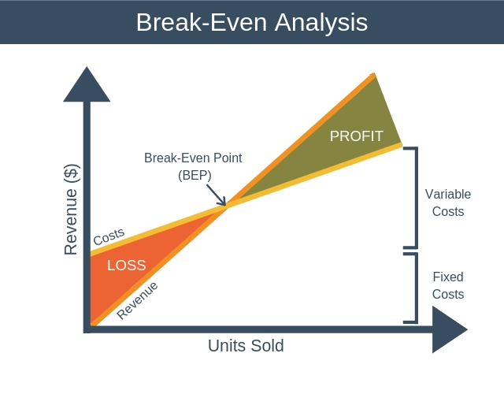
Source: Expert Program Management

Advantages of using the break-even analysis according to Solver (2020) are: “1) Measure profit and losses at different levels of production and sales. 2) Predict the effect of changes in sales prices. 3) Analyse the relationship between fixed and variable cost. 4) Predict the effects of cost.”
However, there are also limitations of break-even analysis which Solver (2020) points out: “1) Assumes that sale prices are constant at all levels of output. 2) Assumes production and sales are the same. 3) Break even charts can be time consuming to prepare. 4) It can only apply to a single product or single mix of products”.

3
Question 2
- The managerial and financial accountings are some of the largest branches of the accounting discipline which includes also auditing and tax. Even though they have similarities in usage and accession there are big differences between them referring to target audience, compliance and accounting standards. (Ross 2020)

The main differences between managerial and financial accounting according to Ross (2020) are:

1 The managerial accounting is the application of measuring, analysing, identifying and communication financial information to a company and managers to accomplish their financial goals.

2 The financial accounting includes summarizing recording and reporting the stream of transactions and economic activities occurring from the business operations for a period of time.

3 “Managerial accounting differs from financial accounting because the intended purpose of managerial accounting is to assist users internal to the company in making well-informed business decisions”.

- Managerial techniques see the fig bellow.
Technique 1 Financial Planning – that is to make planning in advance the company’s financial activities in order to achieve its main objectives.

Technique 2 Analysis of financial statements – it refers to the financial statement data that may forecast the future earning, ability to pay interests and debt maturities.

Technique 3 Historical cost Accounting – “ ..provides past data on the management relating to the cost of each job, process and department so that comparison may be made with the standard cost. (accountingnotes 2021)

4

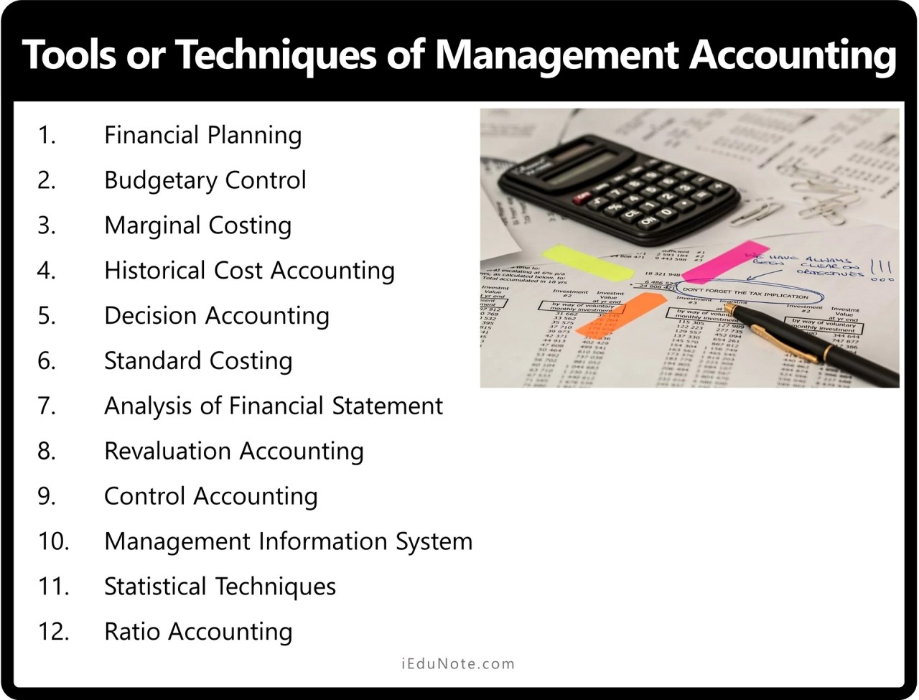

5

References
1 Ndaliman M. And Bala Kastina (2007), Practical Limitations of Break-Even Theory. AU J.T.11(1):58-61. Accessed: (08.01.2021)
2 Expert Program Management, Break-Even Analysis. [Photo]Accessed: (08.01.2021)
Available at: https://expertprogrammanagement.com/2018/11/break-even-analysis/
3 Slover M (2020) Disadvantages and Advantages of Break-Even Analysis. Accessed: (08.01.2021) Available at: https://toughnickel.com/business/Breakeven-analysis
4 Ross S (2020) How Financial Accounting Differed from Managerial Accounting. Accessed: (08.01.2020) Available at: https://www.investopedia.com/ask/answers/041015/how-does-financial-accounting-differ-managerial-accounting.asp

5 iedunote (2020) Management accounting [photo]. Accessed on : (08.01.2021) Available at: https://www.iedunote.com/management-accounting
6 accounting notes (2021) Top 11 Techniques used Management Accounting. Accessed: (08.01.2021) Available at: https://www.accountingnotes.net/management-accounting/techniques/top-11-techniques-used-in-management-accounting/5862
6
Statement

“In submitting this work, I affirm that my work adheres to the scholarly and intellectual standards of honesty and integrity. I affirm that this work is my work only and in the preparation of this work l have not consulted any person. I affirm that l have not plagiarized or misrepresented the ideas or language of someone else as my own and that I have fully and accurately attributed any ideas or text of others to the sources and documented each source”.

