UWTSD
Netflix Presentation

Workplace Culture and its impact on Organisational Efficiency (BMSK5005_SWAN)
Submission Date: 6th March 2019

supporting paper
Shafna Begum (1706147)
This assignment will consider the impact of culture on organisational efficiency.
An organisation culture is an important element of an organisational; the culture can transform any type of company into a well-focused team and can impact the overall workplace performance and employee wellbeing (Huczynski and Buchanan, 2007). Work culture is a concept which deals in the study of; beliefs, thought processes, attitudes of the employee, Ideologies and principles of the organisation. As Johnson (2013) comments: “In its broadest sense, our understanding of workplace culture is that it embodies the ethos and values of a particular organisation, which are the practices it undertakes.”
In his 4 classes of culture, Charles Handy links organisational structure to organisational culture (Handy, 1999). In this theory Handy describes the following: power culture, role culture, task culture and person culture.
It could be argued that the task culture coincides with Netflix’s culture (AC Training, 2016).
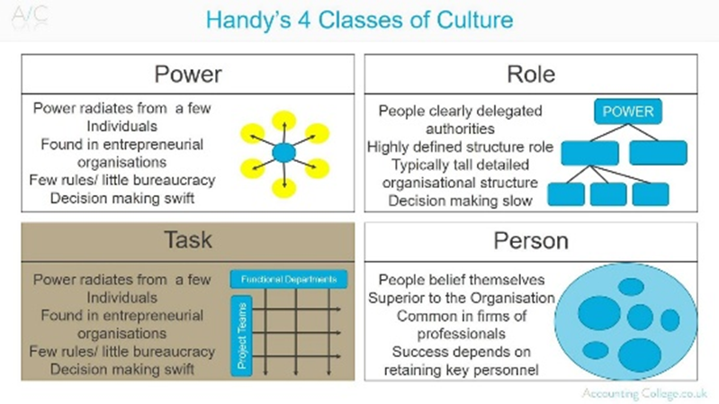

Figure 1 (AC Training, 2016)
The company Netflix clearly fits into the task culture, as they want employees to use their own judgement and make their own decisions according to what is required for the task (Netflix, 2019). This fits the category as task culture is a work environment on the basis of management delegation, giving the employees of Netflix flexibility to make snap judgements and put forward their own ideas (Croiter, 2017).
Netflix outlines its internal culture and values on its HR website pages (Netflix, 2019). The company uses performance judgement by analysing their results and solving problems accordingly. The structure of the company can be tailored according to each individual task due to the flexible structure; In order to obtain the best possible results, tasks are more likely to be distributed due to individual knowledge, rather than rank or position. It could be argued that the use of task culture is optimum for businesses in the entertainment industry as the structure is suitable for rapidly changing organisations in which groups are more established for short term projects. For the same reasons, Netflix also resembles Handy’s role culture, however it does seem to emphasise task culture over role culture.
The organisation must offer a positive ambience for the employees to be able to concentrate on their work rather than interfering in each other’s work (Brunot, 2019).
There are various ways for companies to promote successful work culture in their environment. According to Netflix founder Reed Hastings (Croitor, 2017), Netflix’s success is due to Netflix’s culture. They published their Culture Deck, which outlines their organisation culture and values (Netflix, 2019). There are seven aspects to Netflix’s culture desk. Hastings (Croiter, 2017) outlines how each aspect has been created to ensure a flexible and positive workplace for all which then lead to a growth in a company:
- “Values are what we value: Netflix values these 9 behaviours and skills: judgement, communication, impact, curiosity, innovation, courage, passion, honesty and selflessness.”
This value shows how Netflix accumulates their success to these specific values, the company promotes freedom in innovation and passion, giving their employees to explore creativity in their respective fields without restriction, this can lead to higher pay-out.
In order to establish clear commitment from the employees within an organisation, it is important to understand an individual’s values, this is imperative for both the employee and the company. The organisations values will show its personal direction and the individual employee’s values will provide the motivation to increase personal focus and contribution. (Gill, 2002).

- “High performance: We’re like pro- sports team, not a family. We do not measure people of how many hours they work or how much they are in the office.”
This be helpful as it rewards the employee for the actual work they get done, a defining responsibility and have clear business goals are set without traditional time restraints, allowing employees creativity in their work (Hutchinson, 2013).

- “Freedom and responsibility: our model is to increase employee freedom as we grow, rather than limit it, to continue to attract and nourish innovative people, we have a better chance of sustaining success. Flexibility is more important than efficiency in the long term.”
The nature of flexible working has clear benefits all around a workforce (Mullins, 2016); it allows the workforce to become more motivated and productive as the employees understand they must get their work done within a certain time frame. Flexible working also means employees can organise their work lives and can balance their personal lives more freely, this gives them a better quality of life and would allow the happier employee to work more effectively.

- “Context not control: the best managers figure out how to get great outcome by setting the appropriate context, rather than by trying to control their people. An example of which is allowing freedom in the workplace.”
This follows on with Netflix’s ‘freedom’ culture, the managers respond to their employee’s strength and allow creative freedom in order to gain the most viable results.
This fits in with Peter Senges learning organisation theory (cited in Beevers, & Rea, 2016) where employee continually increase their capacity for the results they desires and where employee are free to continually learn with encouragement.

- “Highly aligned loosely coupled: teamwork effectiveness depends on high performance people and good context. The goal is to be big and fast and flexible. ‘Flexibility is a key aspect to successful company as it enables creativity on to the workface.’”
This continues with Netflix’s theme of freedom with their employees to create an environment where the quality of the employee’s work is rewarded, rather than its quantity (Armstrong, 2009).

- “Pay top of market: one outstanding employee gets more done and costs less than two adequate employees”. Many organisations base their reward strategy on assumption that money motivates, and there is evidence that money is the most important factor for people when deciding on a job (Hutchinson, 2013). it shows an employee’s importance when they understand they are being paid at the top of their field, it can also enhance the responsibility the feel towards the company as they are an asset

- “Promotions and Developments: the opportunity to develop themselves by surrounding them with stunning colleagues and giving them big challenges to work on. Career planning not for us.”
This is a type of engagement for employees on a personal level, the employees are surrounded by the best and brightest in their field, allowing them to develop and acquire skills and move on to where they want to end up. Performance management makes sure that employees know their objectives, and this stimulates them to do their best (Armstrong, 2009).

References

AC Training (2016). Handy’s 4 classes of culture - A-Z of business termin|ology. [video] Available at: https://www.youtube.com/watch?v=E1NrJqYudPw [Accessed 4 Mar. 2019].
Armstrong, M. (2009). Armstrong's handbook of performance management. London: Kogan Page.
Beevers, K & Rea, A. (2016). Learning and Developing Practices in the Workplace. 3rd ed. London: Chartered Institute of Personnel and Development, p. 206-207.
Brunot, T. (2019). The Importance of a Positive Environment in the Workplace. [online] Chron. Available at: https://work.chron.com/importance-positive-environment-workplace-3008.html [Accessed 4 Mar. 2019].
Croitor, D. (2017). Netflix culture deck via Reed Hastings. [video] Available at: https://www.youtube.com/watch?v=2fuOs6nJSjY&feature=youtu.be [Accessed 4 Mar. 2019].
Gill, R. (2002) ‘Change management--or change leadership?’, Journal of Change Management, 3(4), p. 307. doi: 10.1080/714023845.
Handy, C. (1993). Understanding Organisations. 4th ed. England: Penguin.
Huczynski, A. and Buchanan, D. (2007). Organizational behaviour. Harlow: Financial Times Prentice Hall.
Hutchinson, S. (2013). Performance Management Theory and Practice. London : Chartered Institute of Personnel and Developement.
Johnson, R. (2013). CHANGING CORPORATE CULTURE. GOVERNANCE & COMPLIANCE, 6(3).
Mullins, L. (2016). Management and Organisational Behaviour. 11th ed. Harlow: Pearson.
Netflix. (2019) Netflix Culture. [online] Netflix Jobs. Available at: https://jobs.netflix.com/culture [Accessed 4 Mar. 2019].

