Defence-in-Depth Data Security and Governance Framework
for HealthPlus Analytics
  - ACCA4024 Networks and Cyber Security Essentials
Level 4 Coursework Report

Student Name: Ahmad Kassabi
Module Code: ACCA4024
Student ID: 2419776

Date: 27 March 2026

Lecturer/Tutor: Muhammad Azeem Abbas

Table of Contents
Abstract 2
1. Introduction 2
2. Threat Identification and Risk Context 3
3. Defence-in-Depth Security Architecture 4
4. Security Policy Framework 5
5. Mitigation Measures and Implementation Plan 6
6. Monitoring and Incident Response 7
7. Staff Training and Awareness Programme 8
8. Governance, Assurance, and Success Metrics 9
9. Conclusion 9
References 10
Appendix A. Board Presentation 11

Abstract
HealthPlus Analytics (HPA) processes sensitive patient information for hospitals and clinics across the UK and therefore faces a high-risk combination of cloud exposure, ransomware, insider misuse, supplier dependency, and strict data protection obligations. This report develops a defence-in-depth framework that aligns with the assignment scenario and the accompanying board presentation. The proposed solution begins with governance and policy controls, then applies layered security across identity and access management, networks, endpoints, applications, and data. It identifies the most likely internal and external threats, designs a practical policy suite, proposes implementable mitigation measures, and sets out a monitoring and incident response workflow that supports evidence preservation, recovery, and regulatory reporting. The report also recommends a role-based training and awareness programme so that security becomes an organisational behaviour rather than a document-only exercise. Finally, it defines assurance metrics, board responsibilities, and a ninety-day implementation roadmap to help HPA improve confidentiality, integrity, and availability while strengthening compliance with UK GDPR, the NHS Data Security and Protection Toolkit, NIST guidance, and ISO 27001. [3]-[6]

1. Introduction
Healthcare organisations are attractive targets because patient data has long-term value, medical services cannot tolerate prolonged downtime, and digital ecosystems increasingly depend on cloud platforms, remote access, connected devices, third-party suppliers, and data sharing. For HealthPlus Analytics, the stated incidents of unauthorised access to cloud-stored patient data and ransomware on analytics servers indicate both confidentiality and availability failures. The board is therefore correct to ask for a comprehensive data security and governance framework rather than another isolated technical fix.
A high-mark response to this scenario must go beyond describing controls. It must show how security policies support operational measures, how the measures reduce specific threats, how monitoring and response are organised, and how staff behaviour is changed through training and accountability. This report follows that logic. It uses the CIA triad as the core decision model: confidentiality protects patient privacy and commercial trust; integrity protects the accuracy of datasets, analytics output, logs, and audit evidence; and availability protects critical analytics services and recovery capability. The report also aligns with current healthcare and cybersecurity guidance, including NIST CSF 2.0, NIST SP 800-66 Rev. 2, ISO/IEC 27001:2022, UK GDPR/ICO breach guidance, and the NHS Data Security and Protection Toolkit. [1]-[5]

2. Threat Identification and Risk Context
HPA faces both external attacks and internal control failures. The two categories interact: a phishing email may compromise credentials, but the seriousness of the incident depends on weak role design, poor logging, or excessive permissions already present inside the company.
Threat source | Examples in the HPA scenario | CIA impact | Why it matters
External | Phishing, business email compromise, ransomware, cloud account takeover, exploited internet-facing flaws, supplier compromise | C, I, A | These attacks can exfiltrate patient data, encrypt analytics servers, or enable persistence through stolen credentials.
Internal | Excessive privileges, cloud misconfiguration, weak BYOD controls, delayed patching, accidental disclosure, poor escalation culture | C, I, A | Many breaches become severe because staff can access too much, systems are misconfigured, or incidents are not reported early.
Strategic / compliance | Weak governance, missing policy ownership, untested backups, lack of audit evidence, poor retention controls | I, A, C | Even good tools fail if controls are not reviewed, evidenced, or linked to board oversight and legal duties.
Table 1. Principal internal and external threats facing HPA
The most significant risks in this scenario are ransomware, phishing-led credential theft, cloud misconfiguration, insider misuse, and supplier compromise. Ransomware directly threatens availability because analytics servers and shared services may become unusable. Phishing and business email compromise are major entry points for credential theft and can bypass perimeter assumptions. Misconfigured storage, identity roles, or security groups are especially dangerous in a cloud environment because one error can expose a large volume of patient data. Insider threats are not limited to malicious staff; they also include negligence, weak reporting behaviour, and accidental misuse. Supplier risk matters because modern healthcare analytics depends on hosted services, support providers, software libraries, and data integrations. [1], [7]-[9]

3. Defence-in-Depth Security Architecture
HPA should adopt a defence-in-depth model in which governance and policies form the outer control layer and patient data remains the protected core. This is stronger than a perimeter-only design because it assumes that some controls will fail and therefore requires multiple, mutually reinforcing safeguards. The accompanying board presentation uses this logic, and the revised architecture below provides a clearer hierarchy. [4], [6]
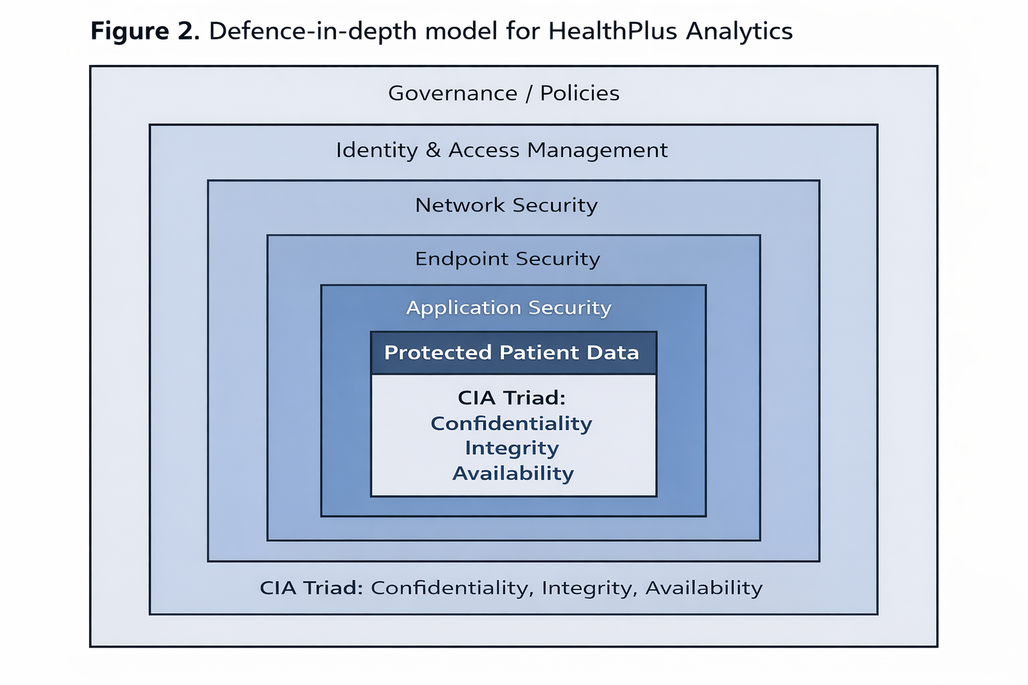
Figure 1. Revised defence-in-depth model for HealthPlus Analytics
The sequence of control layers is important. Governance and policies establish risk appetite, ownership, and review cycles. Identity and access management then ensures that users, service accounts, and administrators receive the least privilege necessary. Network security limits lateral movement and secures connectivity. Endpoint security protects servers, laptops, and mobile devices. Application security reduces vulnerabilities in portals, APIs, analytics platforms, and software changes. Finally, data security applies encryption, classification, retention, and recovery controls directly to the information asset itself. The CIA triad applies across all layers rather than operating as a separate technical product. [4]-[6]

4. Security Policy Framework
The assignment explicitly requires clear and practical security policies. For HPA, the best approach is a concise policy suite with named owners, annual approval, and operational standards beneath each policy. The following policies are the minimum set needed to support the scenario. [4], [6]
Information security governance policy: Defines board oversight, control ownership, risk appetite, review frequency, and reporting lines.
Access control and identity policy: Requires MFA, least privilege, role-based access, privileged access management, joiner-mover-leaver controls, and quarterly access reviews.
Data classification and protection policy: Classifies patient information, mandates encryption, controls data sharing, sets retention and disposal rules, and restricts copying to unmanaged locations.
Endpoint and server security policy: Sets hardening standards, vulnerability management, EDR deployment, approved software requirements, and patching deadlines.
Cloud and network security policy: Requires secure baseline configurations, segmentation, logging, key management, approved remote access, and change control for cloud resources.
Incident response and resilience policy: Defines incident categories, severity levels, reporting duties, recovery priorities, backup testing, evidence handling, and post-incident lessons learned.
Supplier assurance policy: Requires due diligence, security clauses, breach notification obligations, and evidence of supplier control effectiveness.
Security awareness and acceptable use policy: Sets staff responsibilities for phishing, passwords, BYOD, data handling, reporting, and mandatory training.
These policies are relevant because they map directly to the marking criteria. They are clear, practical, and linked to the HPA context. They also support recognised frameworks rather than inventing controls in isolation. ISO/IEC 27001 provides the management-system structure; NIST CSF 2.0 helps organise governance, identify, protect, detect, respond, and recover activities; and NHS/ICO obligations ensure the framework remains suitable for UK healthcare data handling. [3], [4], [6]

5. Mitigation Measures and Implementation Plan
Policies alone do not reduce risk. HPA needs specific controls with a realistic implementation sequence. The most credible solution is to prioritise high-impact controls in the first ninety days and then mature them through testing and assurance. [4], [6]
Priority area | Specific measure | Implementation detail | Threats reduced
Identity | Enable MFA for all cloud, email, VPN, and privileged accounts | Start with administrators and remote access; then extend to all staff; remove legacy authentication where possible | Phishing, account takeover, supplier misuse
Privilege control | Adopt role-based access control and PAM | Separate user and admin accounts; time-limit privileged sessions; review access quarterly | Insider misuse, ransomware spread
Endpoints and servers | Deploy EDR/XDR and enforce hardening baselines | Cover analytics servers, laptops, and remote devices; quarantine unmanaged or unsupported systems | Ransomware, malware, lateral movement
Cloud and data | Classify patient data, encrypt at rest and in transit, fix storage permissions | Use secure cloud templates, data loss prevention rules, and key-management procedures | Data exposure, accidental disclosure
Vulnerability management | Patch internet-facing and high-risk systems to a defined SLA | Prioritise external exposure and known exploited vulnerabilities; report exceptions to management | Exploited flaws, persistence
Resilience | Maintain immutable offline backups and perform restore tests | Test critical services quarterly and record evidence; separate backup credentials from production | Ransomware, availability loss
Suppliers | Run supplier due diligence and contract security clauses | Assess access routes, data flows, breach notification obligations, and assurance evidence | Third-party compromise
Logging and detection | Centralise logs from cloud, endpoints, identity, email, and servers | Tune SIEM alerts for privileged misuse, ransomware indicators, unusual sign-in patterns, and data exfiltration | Delayed detection, weak investigation
Table 2. Priority mitigation measures and implementation details
A practical roadmap is as follows. In days 0-30, HPA should freeze privileged access sprawl, enforce MFA, validate offline or immutable backups, and harden exposed remote access paths. In days 31-60, it should deploy EDR/XDR to servers and endpoints, define cloud baselines, classify patient data, and start supplier reviews. In days 61-90, HPA should tune SIEM detections, run a tabletop exercise, perform a full restore test, and complete policy sign-off with named owners. This sequence is feasible because it addresses the most serious risks first while generating evidence that the board can review. [1], [4]

6. Monitoring and Incident Response
The brief asks for a monitoring and response plan, and a diagram is useful here. HPA should use a central monitoring model that collects logs from identity systems, cloud platforms, servers, endpoints, email security, and critical applications. Detection rules should focus on suspicious sign-ins, privilege escalation, ransomware behaviour, unusual API activity, mass file modification, and data exfiltration attempts. However, logging is only valuable when supported by triage ownership, escalation thresholds, and rehearsed recovery actions. [2], [4]
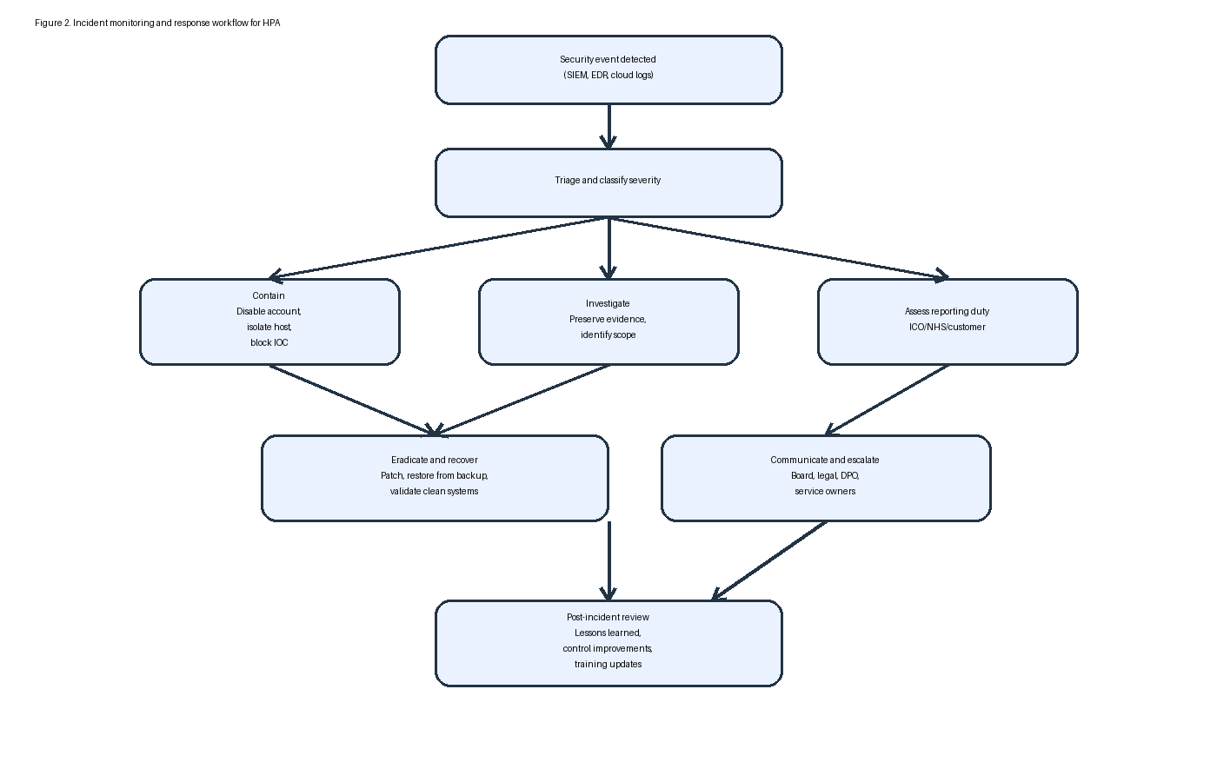
Figure 2. Incident monitoring and response workflow for HPA
The response workflow should include six stages. First, detect and triage the event. Second, contain it by disabling accounts, isolating hosts, or blocking indicators of compromise. Third, investigate scope and preserve evidence. Fourth, assess reporting duties involving the DPO, legal team, customers, and, where relevant, the ICO within statutory time limits. Fifth, eradicate the cause, restore clean systems, and validate recovery from backups. Sixth, conduct a lessons-learned review within ten working days. This process improves both technical resilience and compliance readiness because it produces audit trails, supports breach assessment, and feeds improvements back into policies, detections, and training. [2], [4], [5]

7. Staff Training and Awareness Programme
The training requirement in the brief carries a substantial mark weighting, so the programme must be more than annual awareness slides. HPA should implement a role-based security awareness model that targets behaviour change and evidenceable compliance. [11], [12]
Mandatory induction: All starters complete training within ten working days covering phishing, data handling, acceptable use, incident reporting, and remote working.
Role-based modules: Executives receive governance and decision-making content; developers receive secure coding and change control; analysts receive data handling rules; service desk and IT staff receive incident escalation and identity management training.
Quarterly phishing exercises: Simulated phishing campaigns with targeted coaching for repeat failures.
Monthly micro-learning: Short modules on BYOD, password hygiene, data sharing, AI/tool use, and reporting suspicious activity.
Tabletop exercises: Leadership and operational teams practise ransomware, cloud breach, and supplier compromise scenarios.
Manager accountability: Completion rates, repeat-click behaviour, and overdue training are reviewed by managers and reported upward.
The programme should be measured using completion rates, phishing susceptibility trends, reporting speed, and audit evidence quality. This makes the training credible and directly linked to risk reduction. A strong training section earns marks because it demonstrates practical application, not just theory. [11]

8. Governance, Assurance, and Success Metrics
For the framework to remain effective, each control layer must have a named owner, a review cycle, and expected evidence. The board or audit committee should own cyber risk appetite and review quarterly security dashboards. The CIO or security lead should own implementation and incident coordination. The DPO or information governance lead should own breach assessment, privacy impact, and data protection evidence. IT operations should own patching, hardening, access review support, and backup tests. Business managers should enforce staff compliance with training and policy. [4], [6]
Key metrics should include: MFA coverage on privileged and cloud accounts; patch compliance for internet-facing systems; quarterly restore-test completion; mean time to acknowledge and contain incidents; access review completion; supplier assurance status; and staff training completion. These indicators show whether controls are working over time. They also help the board distinguish between paper compliance and genuine operational readiness. [4], [6]

9. Conclusion
HealthPlus Analytics cannot rely on a single product or a perimeter mindset to protect patient data. The scenario shows that cloud exposure, ransomware, and weak governance can combine to create legal, operational, and reputational harm. The most appropriate solution is a defence-in-depth framework that starts with governance and policies, protects access and platforms, secures data, improves detection, rehearses recovery, and embeds security awareness into day-to-day behaviour. By implementing the policy suite, mitigation measures, monitoring workflow, training programme, and assurance metrics proposed in this report, HPA would reduce breach likelihood, improve compliance with UK healthcare expectations, and recover faster when incidents occur. This makes the framework both technically defensible and suitable for board-level decision making. [1]-[6]

References
[1] Department for Science, Innovation and Technology and Home Office, "Cyber Security Breaches Survey 2025," GOV.UK, Jun. 2025.
[2] Information Commissioner's Office, "Personal data breaches: a guide," ICO, 2025.
[3] NHS England, "Data Security and Protection Toolkit," 2025/26.
[4] C. Pascoe, S. Quinn, and K. Scarfone, "The NIST Cybersecurity Framework (CSF) 2.0," NIST CSWP 29, Feb. 2024.
[5] National Institute of Standards and Technology, "Implementing the Health Insurance Portability and Accountability Act (HIPAA) Security Rule: A Cybersecurity Resource Guide," NIST SP 800-66 Rev. 2, 2024.
[6] International Organization for Standardization, ISO/IEC 27001:2022 Information Security, Cybersecurity and Privacy Protection - Information Security Management Systems - Requirements, 2022.
[7] D. M. Sridevi, "A recent review of ransomware attacks on healthcare industries," Journal of Data, Information and Management, vol. 6, 2024.
[8] T. M. Chalasani et al., "Ransomware Attacks and Data Breaches in US Health Care Systems," JAMA Network Open, vol. 8, no. 5, 2025.
[9] A. Shamsujjoha et al., "Vulnerability to Cyberattacks and Sociotechnical Solutions for Health Care Systems: Systematic Review," Journal of Medical Internet Research, vol. 26, 2024.
[10] W. Stallings, Effective Cybersecurity: A Guide to Using Best Practices and Standards, 1st ed. Boston, MA, USA: Addison-Wesley, 2024.
[11] M. Alhajri et al., "A systematic review of current cybersecurity training methods," Computers & Security, vol. 136, 2024.
[12] M. E. Whitman and H. J. Mattord, Principles of Information Security, 7th ed. Boston, MA, USA: Cengage, 2021.

Appendix A. Board Presentation
The assessment brief requires the board presentation to be included as an appendix in the report. The following contact sheets reproduce the completed slide deck used to summarise the recommendations for the board of directors. [3]
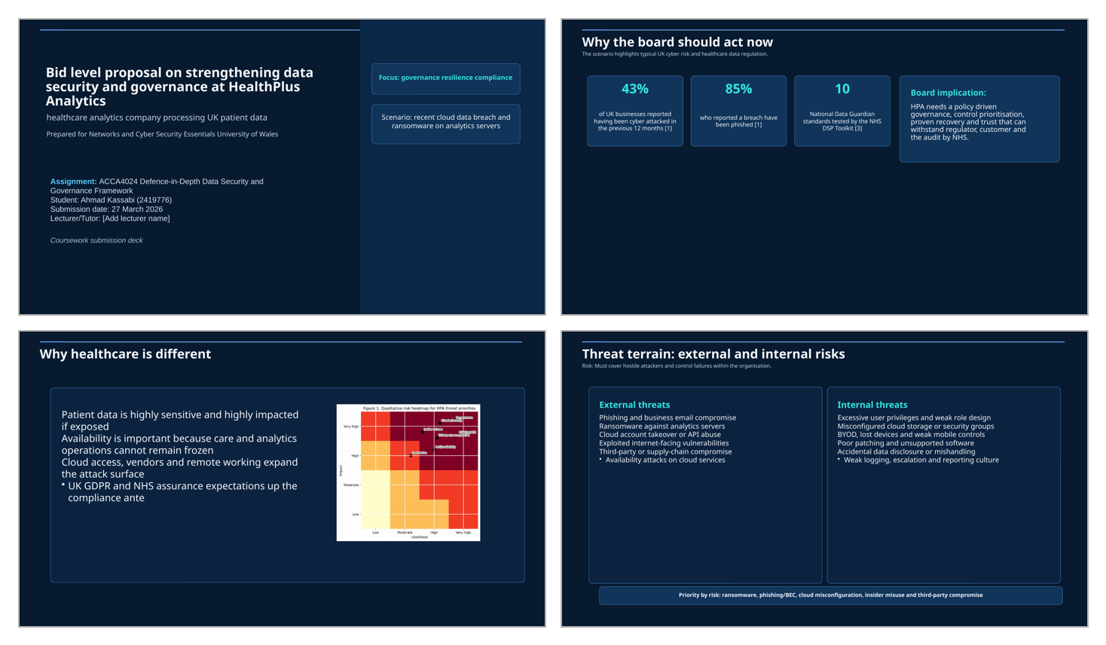
Appendix Figure A1. Contact sheet of presentation slides

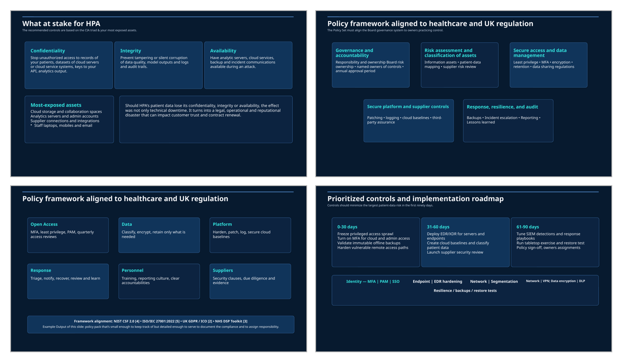
Appendix Figure A2. Contact sheet of presentation slides

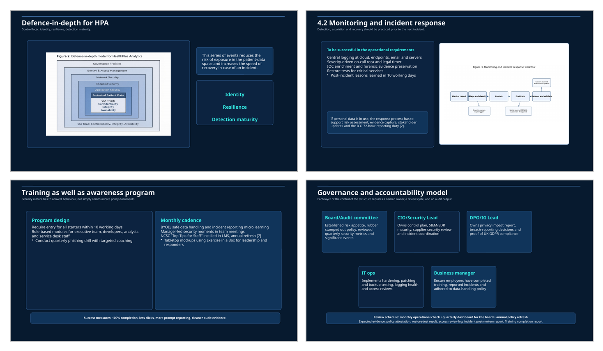
Appendix Figure A3. Contact sheet of presentation slides

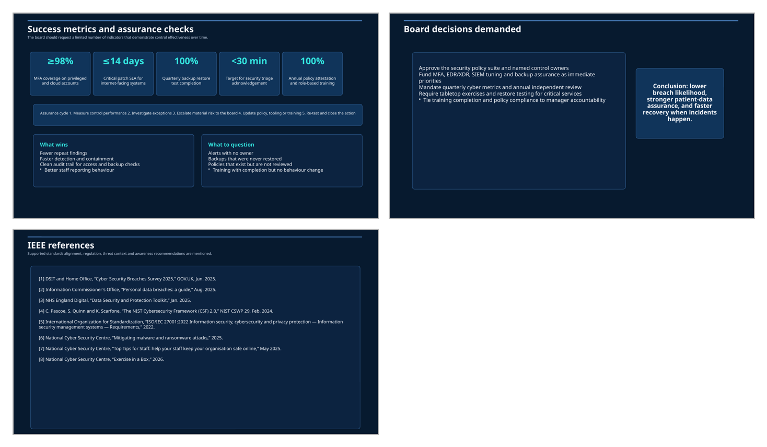
Appendix Figure A4. Contact sheet of presentation slides

