

Effective Team Working and Communication

Assessment 1

Lecturer:
Akinseye Aluko

Module:
BMSW 4002

Student:
Davide Valvano 1916733

Table of contents:

Intro
p. 3
How we do interact? Current time
p. 3
Flashback on the theories
p.4
Shannon Weaver
p. 4-5
Schramm
p. 5-6
Berlo
p.7
Conclusion
p.7
Appendix
p. 8-9
Bibliography
p. 10
This read is meant to be my own interpretation of what is my new prospective, after such long time I abandoned studies and suddenly in February restarted, built around my own considerations from some of the major theories behind the adequate manners of how we do interact in our work premises or in our ordinary life. Focusing on when the society started to role out these new concepts, until our days, where we our mobile phones are retained essential. I did not expect to find many studies in relation of behaviours I tend to assume in the company where I work and so I will try to elaborate them all for an easy understanding.
Twenty-first century: latest deals on the high-tech items retained fundamental for our more often connected lives, advertisements showing us the benefits of switching on better packages compared to the active ones we are holding, webinar, e-meeting and all of the rest of the bombarding we are now facing, are they really essential? Is there any chance of not being looped in all of this and what role is assuming this specific type of communication?
Prior to answering these questions, it is crucial for me to go through the essence of many interpretations leading all to what we retain is the meaning of interactions nowadays. Suddenly we will see, from scholastic point of view and samples from my ordinary newly work-life vision and balance, implementing valid solid models in the way we approach various duties.
According to Maund (A., 2017), “communication can be interpreted as a swap of reflections, clues or concepts ending up in a reciprocal awareness towards a group of people” in a process that we can define strict to two people minimum sharing words, texts or any other form of interaction in between.
What does it really stand in our general understanding behind this message? How easy can we import this notion in our daily lives?
It is fundamental to reflect on some normal things happening around us continuously and they way we do things. Every time we get out from home in to the first train in the tube, for example, most of the times, even though we are not talking to each other approaching early morning shift, with just our body expressions we do tend to communicate multiple times in between us. I am thinking about the hotel where I do work, how often, in my time spent liaising with guest online bookings, I tend to have an idea about the person calling even if we never met, sometimes just from their tone of voice. Imagine how many times my face is transmitting different feelings, while starring a group of ladies walking in the venue for their reservation, and mainly, how wide are our interactions without say a word.
Society had to wait until Doctor Mehrabian (1981) study search, to identify officially that, communicating without the use of words, has a sudden different grades of being recognised by who is the recipient of any message on its own as follows:

Clearly shown on these figures, most of the results are certainly coming from our eye-looks, the various shapes we tend to assume in the context rather than our cadence while saying something to someone. Final tiny role is attributed to the spoken language, leaving lots of space for us to imagine the different scenarios of nowadays life. These are facts that I have been through in our weekend lessons where I had time to think deeply and analyse my current behaviours. I have to say in most of the cases this happens to me, without even just a conversation, people do recognise me as an Italian person. Now, it can be a positive or a negative thing, I have always been the one with a positive mind while interacting in weekly event and banqueting meeting at work for example, this new perception makes stronger my inner will on doing better on creating new and seasonal drink lists, incrementing profitability significantly. It was not an easy mission when I started, because of my heritage, sometimes passing the info as I expected to. An issue I experienced multiple times, being hired in my first hotel here in London, was clearly my volume while talking. I had to work hard on my accent and right pronunciation of most of the common expressions in English, as most of the times I was passing an aggressive message involuntarily while, without that intention, people around me were completely misunderstanding what I was trying to say. Now, especially after these ten weeks of teaching in Holborn, I am confident enough to admit that I have nurtured effective language skills within my colleagues of department because, from their perspective, they can easy realise the sense behind my words in the past years. Obviously, this is one of the essential tools in our future employment that we can not risk to under valuate, we must enlarge our portfolio of abilities to be employable.
Another necessary method in our overall new consciousness can be drawn adhering to Headlee (2015) where she states her opinions in regards of owning like a pro every conversation we might be in, leading to an “efficient skill” required in our modern routine. The theory she is examining contains answers especially for those who perform in a business environment that requires good listening and talking skills. Starting from a matter of zero prejudice, while affording interactions, to a point where the sense of what we receive from the interlocutor can be something we must develop for ourselves. These traits are now a straight path for me to enter while I am joining the work premises. Imagine, as head beverage responsible in the hotel, more than one of my staff mates would come to me with his/her latest drink creation and I would completely failing to be attentive because I am disturbing this chat using my mobile phone in front of them. Simply , I would assume that I am much better than them in terms of new ideas and recipes and I would make the error to do not evaluate properly their support I must provide and personal growth skills within the team context. Certainly, I was going to be the worst manager ever!
Moving forward, I would like to introduce you to three different thesis of communication, identified in the past, still present in our today learning, reason of useful scholastic and not, improved outcomes in our overall newly awareness of this concept.
In the beginning of our process we must go back to the late forties, where a maths expert and an advanced analyst, published their first piece in an academic tabloid , basically what suddenly considered “the begin of all of the thesis” known as “Shannon Weaver” (1948). Although more relative at the vintage technology they were living in, this report gives us an idea about how we tend to encode any information we want to share, sending them through using any tool might be possible, avoiding possible noise caused in this flow as otherwise we will looase connection. Let’s say for example, any food store is encrypting their latest advertisements ready to be shown on the television, if there will be no factors “disturbing” our focus on attentive listening, we will apprehend that specific items are now in sale and we might hurry to buy them on time at this price. Imagine if this info was not easy to interpret, the sender of this offer was assuming the fail of this action on his own, since the possible customers were not able to figure out what they were watching. This was the early draft of what suddenly Doc. Weaver a year after added and completed resulting in a much wider and accessible scheme as follows:

INFO GAINED
DECRYPT INFO
MEDIUM USED
INFO ORIGIN
ENCRYPT INFO

POSSIBLE INTERRUPTION

COMMENT

The benefit, coming from this specific electronic example of interaction, are clearly related on our ability to avoid any interference that might occur during this process. One of the risks, instead, might be derived by the complexity of the information we are trying to spread across, as it could affect the capability of comprehending the final message on its own.
Six years later, another brilliant argument was made public as still a derivate from the previous model, but much more was emphasised near articulating the actual news we wanted our receiver to breakdown.
This research was attributed to Doc. Schramm (1954), actualised by Blythe (SAGE Publications, 2009), who believed that , while passing any information between two or more people, we should highlight the factors of encrypting and decrypting, as without the right understanding of the difference between people from all over the planet, the interaction might not happen as we want to.
My common-sense guides to believe that these crucial elements they are having direct impacts in our lives, especially in an “open metropolis” such as London knows how to be. It is impossible for me to figure out to perform with my role within my team with visible lack of connection manners; especially if I am pretending to ignore their provenance and so, from the various contexts, when I will share with them my hints, growing our skills together.

At the end of this throwback, we scrutinise a complex but straight interpretation of the “Shannon Weaver” studies from Berlo (1960), where his ultimate four clear key points personalisation of this structure found controversial opinions about its efficiency.
With the “SMHR” method and so, leaving space for just one direction within the procedure, we can deduce that, in his example, the comments and the confirmation of the communication just happened were not influencing much. Also, any interruptions or just disturbing factors in between sender and receiver, were not mentioned, generating occasionally negative reviews in his studies.
According to Morgan (SAGE Publications, 2017), the feelings that other people around us will perceive from our body language, will induce them to approach with us differently. In Berlo’s case I do find hard to identify where the space might be, communication wise, for the comments and in general just the response from the other person we were trying to talk with. “Being attentive as much possible with what is over us, we will potentially see a clear prospective and so, plan how to behave in the right way” (Morgan, 2017), there is a world where I feel much more familiar with, since I have space to share all of my emotions, in relation of the situation I will find myself in.
I did import an illustration of an in-class activity (appendix 1-2) where the lecturer asked us to write in two different “communication channels”, the unexpected visit of a control in a well-known fast-food chain. On one side, the head office, is straighter in terms of the points they want the extra care on, and on the other side where the employees are answering formally showing the results done. I do believe that it is an art to communicate in every reflection of duties, shapes diversity we might face up nowadays. My reaction to all of this can be only intrigued, positive and hopeful in something new to learn daily, where there will certainly be more space to affine my ability non-stop. The reason why I am following these courses, resuming from what said above, is because all of these “academic” learning is a constant presence that starts as an awareness and ends up in being already part integrant of my future.
The result of this first part of my new healthier habits leads evidently to the many “outcomes” I achieved within the lessons, with the volunteer of develop more, create with more sense what it will be my imminent. I feel grateful thanks to the scenarios I can now classify in any background I will be interacting with, planning how to use my refurbished portfolio of skills. Let us see where it will take me far, I will keep you posted!

Appendix:
- Email
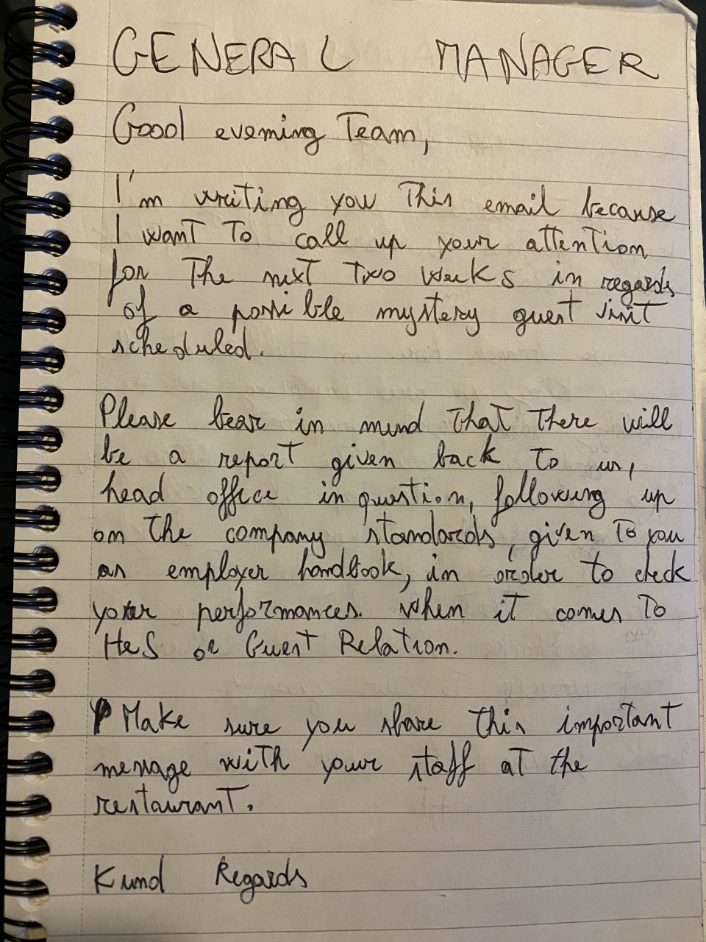

- Reply
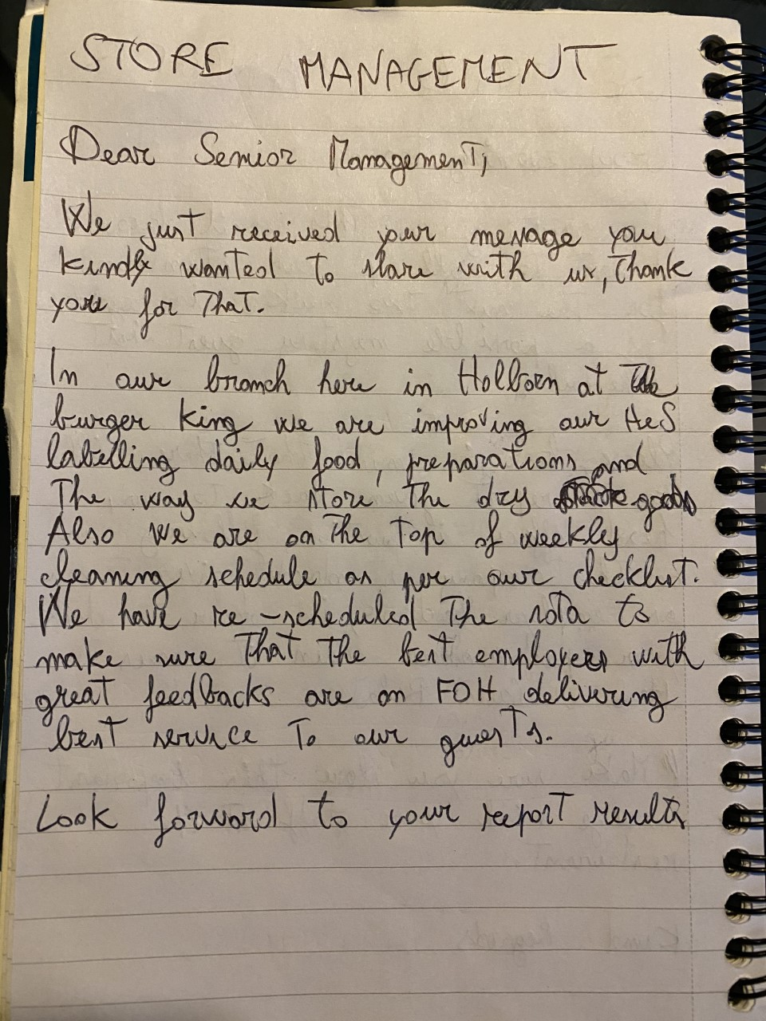

Reference list:

Griffiths, B. A., Dunham, E. B. (2017). Certificate in Higher Education: Skills for the Workplace Student Yearbook. SAGE publications: United Kingdom

Headlee, C., (2015). 10 Ways To Have A Better Conversation. Online: Ted.com. Available at: https://www.ted.com/talks/celeste_headlee_10_ways_to_have_a_better_conversation?language=en [Accessed 25 April 2020].

Shannon, C. E., (1948). A Mathematical Theory Of Communication. [PDF] ACM Digital Library. Available at: https://dl-acm-org.ezproxy.uwtsd.ac.uk/doi/pdf/10.1145/584091.584093 [Accessed 1 May 2020].

Blythe, J. (2009). The Schramm model of communication in Key Concepts in Marketing. [eBook] SAGE Publications: United Kingom. Available at: https://sk.sagepub.com/books/key-concepts-in-marketing/n46.xml

Morgan, P. (2017). The business student’s guide to study and employability. 1st edn. United Kingdom: CPI Group Ltd.

