
Challenges and Limitations of Digital Forensics in Cloud Computing Environments: A Systematic Literature Review
Research Methods and Professional Development

OM LALITBHAI GORASIYA
2435260

1. INTRODUCTION

1.1 Context and Background
Cloud computing is now among the pillars of the digital infrastructure and it allows organisations to store, process and manage data in a highly scaled and distributed environment. It is used in diverse industries such as finance, healthcare, government and enterprise systems due to its benefits of being cost-effective, flexible and demand-on-demand availability of resources. Nonetheless, cloud computing presents challenging issues to the digital forensic investigations because of the immense advantages of operation that cloud computing presents.
The classical digital forensics is based on the capability of acquiring, preserving and processing the data of the physical devices in a controlled environment. The researchers are accustomed to the physical access to the hardware, the clearly established ownership, and routine data storage systems. Clouds, in its turn, are based on the concepts of multi-tenancy, virtualization, and geographic distribution that transforms the way in which data is stored and accessed radically. These properties make it less open and controllable, and it becomes difficult to use typical forensic tools [1], [5]. The cloud service models such as Infrastructure-as-a-Service (IaaS), Platform-as-a-Service (PaaS) and Software-as-a-Service (SaaS) complicate the process of forensics, as well, adding an extra layer of control and abstraction. The access to virtual machines can be restricted to investigators in the IaaS but in SaaS settings, it is often restricted to application-level interfaces in full. This type of architecture obscures the visibility required to gather evidence and gives dependencies to cloud service providers (CSPs) to retrieve valuable forensic data.
Other than architectural complexity, there are many technical factors that complicate forensic investigations. Cloud environments often contain highly volatile and dynamic data i.e. it can be modified, migrated or deleted almost immediately. Even though encryption efforts are required in order to provide security, it can make the retrieving and analysing of evidence difficult. Furthermore, logging systems are prone to inconsistency or even CSP-controlled, thus questioning the integrity and completeness of data [3], [9]. All these issues render the digital evidence less credible and admissible. The rapid rate of cloud technologies development has outpaced the development of forensic techniques, as it was revealed in the recent study. Despite significant research conducted on identifying cloud-specific concerns, there are still no standardised methods and viable solutions to conduct effective research in the mentioned context. This has resulted in loopholes in forensic preparedness where systems are not well prepared to support investigations in case of incidents occurring [6], [32].

1.2 Research Problem
Despite the fact that extensive research has been carried out on the topic of digital forensics, there is still a significant lack of research in the cloud computing context due to a set of interconnected technical, legal, and organisational factors. The barriers in cloud systems are in-built and cannot be found in traditional computing environments. One of the greatest challenges is the inability to have physical infrastructure. CSPs have control over hardware and storage devices that can not be directly accessed by investigators. It is a disadvantage that renders it hard to acquire and preserve digital evidence. In addition, cloud environments tend to distribute data in numerous data centres located in different geographical areas, which provokes issues of jurisdiction. This introduces legal uncertainty regarding the ownership of the data, access rights and the laws.
The other problem of concern is that logging and monitoring systems are ineffective. In a huge percentage of instances, logs are either inadequate, unreachable or owned by CSPs and hence, event reconstruction is impossible. Also the dependency on CSP cooperation is a source of delay and possible conflict of interest, especially when dealing with sensitive or cross-border investigations. All this compromises the integrity, dependability and admissibility of digital evidence rendering it hard to produce competent and legally viable forensic investigations [4], [15]. It implies that there is an immediate need to critically analyze these constraints and come up with a way of alleviating their effects.

1.3 Aim and Objectives
Aim
The primary goal of the research is to critically examine the problems and limitations of digital forensics on the cloud platform, and to identify potential solutions to enhance the quality of the actual forensic practice.

Objectives
To achieve this aim, the study will aim at the following:
- To conduct a systematic review of the existing literature on cloud digital forensics.
- To identify and analyze the most significant technical challenges that affect forensic investigations.
- To speak about legal and jurisdictional restrictions in cloud settings.
- To learn how well and how limited are the current forensic tools and frameworks.
- To identify the gaps in the research and propose future research to improve cloud forensic practices.

1.4 Research Significance
The study is theoretically and practically useful. It is an academic contribution to the literature in that it collects a whole spectrum of research into a sensible comprehension of cloud forensic issues. The study offers a starting point through which subsequent studies can be developed and more effective forensic tools developed by revealing the tendencies, constraints, as well as gaps of the existing study. Practically, the results of the present study can be applied immediately to cybersecurity professionals, police officers, and cloud services providers. A better understanding of cloud forensics issues will facilitate the creation of better investigation plans, enhance forensic preparedness and eventually increase the likelihood of responding to the attacks on the cyber space. Moreover, the paper illustrates the importance of standardised framework and the policies which address the technical and legal cloud forensics. With the ongoing development of cloud computing, these standards will be a critical factor to be considered in the reliability and admissibility of electronic evidence in a court of law [10], [32].

2. LITERATURE REVIEW

2.1 Overview
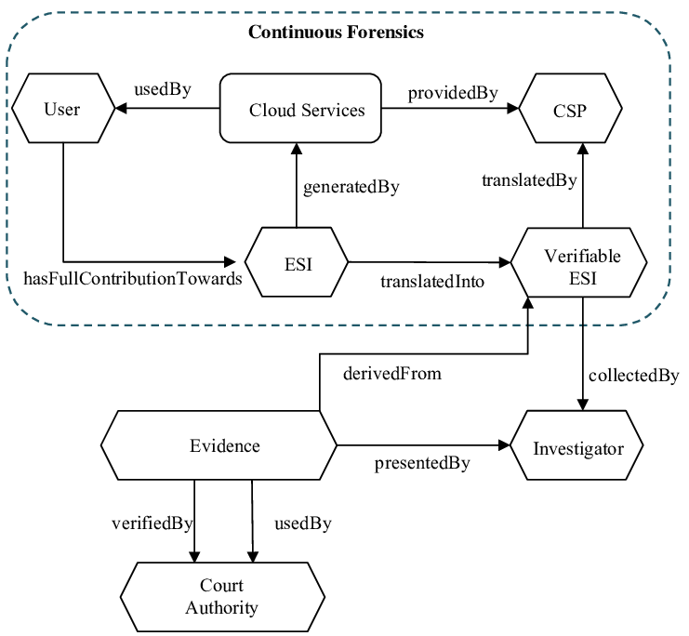
Figure 1: Open Cloud Forensics Model
(Source: [36])
Cloud digital forensics is an area where there is an increasing academic interest due to the rapid pace of integration of cloud computing solutions and the resultant increase in cybercrime. Most of the existing literature typically divides these issues into three interdependent areas: technical limitations, legal and jurisdictional ones, and development of forensic models and tools. Even though the early research was primarily to identify the challenges, the more recent research attempts to present solutions and forensic preparedness. However, this body of knowledge has increased but the field remains fragmented. Many sources address individual aspects of cloud forensics, but do not provide unified solutions that can help overcome technical and legal constraints simultaneously. The literature review critically analyzes the literature on key themes, contributions, limitations and gaps.

2.2 Technical Challenges in Cloud Digital Forensics
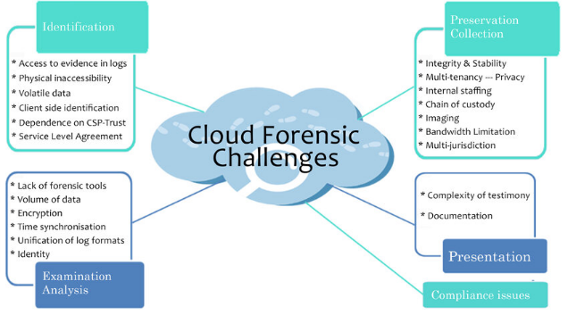
Figure 2: Cloud forensics challenges based on their stages
(Source: [37])
Technical challenges are the most explored area of cloud forensics. This is mainly because of the characteristics of cloud computing like virtualization, resource abstraction and distributed architectures. One of the most crucial issues is data volatility. In a cloud-based system, data is always created, modified, moved and deleted through a couple of distributed systems. According to Birk and Wegener [5], volatile data such as system states, temporary files, etc can be lost prior to capture of the data by investigators. Similarly, Arafat et al. [12] observe that with the dynamic allocation of resources, it is difficult to obtain consistent snapshots of data, which is significant in the forensic study. This instability undermines the quality of evidence, and it complicates the process of event reconstruction.
The other area of concern that is generally defined by shared physical infrastructures use by a multiuser is known as multi-tenancy. This model is useful in improving resource efficiencies, but it presents a large forensic challenge. Al Sadi [3] and Rani et al. [14] note that it is impossible to separate the data of a particular user without violating privacy of other users. This poses both technical and ethical challenges as investigators must ensure that the evidence collection process does not cause the unintentional disclosure of unrelated user data. Another aspect that makes cloud and traditional forensics different is the unavailability of hardware. Traditional investigations enable the forensic analysts to have physical access to the storage devices and generate forensic pictures. Cloud environments, however, do not provide access to virtualised resources which are managed by CSPs. According to Pichan et al. [9], this is a weakness because investigator autonomy is reduced and a reliance on CSPs to provide such data is established. The fact that such dependency not only slows down the investigations, but also questions the authenticity and completeness of the presented data.
Tracking and recording restrictions are also quite significant in frustrating the forensic investigations. System logs play critical roles in effective forensic analysis in order to re-assemble the events and identify bad activities. Cloud environments, though, do not always include normalised logging systems and the logs may be on any level of the architecture. Alqahtany et al. [16] point out that CSPs may not provide sufficient logging information or access, and it is difficult to establish a reliable chain of events. In some cases, overwrites may happen through deletion of logs due to storage constraints that makes investigations even more complex. Although these studies provide us with helpful information on technical issues, the weakness of these studies is that they are more likely to discuss these problems as independent problems. There is minimum information as to how these challenges interact in the real world scenario. To provide an example, the effects of data volatility, and multi-tenancy on evidence integrity have not been thoroughly studied. This is because there is no integrated analysis that limits the practical applicability of the findings provided.

2.3 Legal and Jurisdictional Issues
Both legal and jurisdictional issues equally play an important role in cloud digital forensics but are not always studied as extensively as the technical ones. Such issues are due to the global and distributed character of cloud computing where data may be stored and processed in a variety of geographic locations.
Among the main issues is the issue of data jurisdiction. As Vaciago [20] accentuates, data stored in cloud environments can be located in various countries, having different legal frameworks. This brings confusion as to which laws are applicable when conducting an investigation. Karagiannis and Vergidis [19] also believe that contradictory national laws may serve as an impediment to access data, especially when it comes to cross-border investigations. Adherence to data protection laws, including the General Data Protection Regulation (GDPR) is an added complexity. Marshall and Rea [17] mention that the existence of strict data protection laws can lead to limiting the collection and transfer of personal data including criminal investigations. This poses a conflict between the requirement to obtain forensic evidence and the requirement to safeguard personal privacy.
Chain of custody is another important concern, which is described as the procedure of preserving and recording the evidence management. This is complicated in a cloud environment where more than one stakeholder, both CSPs and third party service providers are involved. Ekwempu [22] notes that lack of transparency and jurisdictional ambiguity can compromise the integrity of the chain of custody, which questions the admissibility of evidence in court. Nevertheless, it is important to note that current studies do not provide a feasible solution to deal with legal issues. Most of the research is aimed at determining problems and not suggesting practical frameworks of cooperation across the borders or legal standardisation. Moreover, the integration between legal and technical points of view is limited, and it is necessary to work out the all-embracing forensic solutions.

2.4 Forensic Tools and Frameworks
Scholars have proposed various instruments and models to eliminate the obstacles of cloud forensics. The given strategies will contribute to altering the current forensic practices to the specifics of the cloud environments. One of the simplest of them is the integrated conceptual framework proposed by Martini and Choo [30], which offers a systematic way of conducting cloud forensic investigations. Similarly, Alex and Kishore [8] have developed a forensic framework which considers cloud specifications such as data acquisition and analysis within virtualised systems.
Recent studies have been carried out on measuring and improving these frameworks. Mohammed and Rangu [25] survey the existing cloud forensic tools, which they observe are constrained by their inability to support distributed and virtualised data. A meta-analysis of forensic frameworks by Rani and Geethakumari [26] has found that most of them were identified to be poorly scaled, and lacked real-world validation. Though these frameworks are significant steps in the right direction, they are not usually empirical validated and are more theoretical. The majority of the proposed solutions have not been tested under real cloud conditions which limits their applicability. Moreover, the existing tools typically support the traditional systems, and they are not effective to operate in cloud environments. This is among the Theory-Practice gaps that still remain a challenge in the field.
The other shortcoming is the non-standardisation. Different models adopt different approaches and techniques, and it is difficult to develop a common model of cloud forensic investigations. This disintegration contributes to the decline in interoperability and hinders the development of standardized forensics.

2.5 Forensic Readiness and Future Directions
Recent studies have changed the focus towards forensic preparedness in reaction to the limitations of reactive forensic strategies. This is the idea of having systems and processes ready to aid effective and efficient investigations. Alenezi et al. [31] and Kebande and Venter [33] highlight the significance of making forensic preparedness part of the organisational policies and cloud frameworks. Organisations can better handle their collection and preservation of evidence by undertaking proactive steps, which include improved logging, secure data storage, and incident response planning.
New solutions are cloud forensic-enabled services (CFeS), where forensic capability is directly implemented into a cloud infrastructure [27]. These services are designed to offer in-built evidence gathering and analysis, eliminating the use of other tools. Also, the use of artificial intelligence and machine learning to automatize forensics and enhance detection functionality becomes increasingly popular. In spite of such developments, there are still great challenges. A universally agreed-upon system of forensic preparedness has yet to be developed, and a significant number of these solutions are not practical. Also, the adoption of AI in forensic procedures also creates new ethical and technical issues, including algorithmic bias and transparency.

2.6 Identified Gaps in the Literature
The literature review indicates that a number of gaps have been identified that restrict the efficiency of the available literature in cloud digital forensics. Firstly, forensic frameworks do not have the required standardisation. Although a variety of models have been suggested, there is no agreement on the best practices or methodologies. This disintegration obstructs formation of uniform and dependable forensic procedures. Second, technological and legal views are not well integrated. In the majority of studies, technical issues or legal issues are discussed independently of each other, without taking into account their interrelationships. Nevertheless, to have effective cloud forensic solutions, a comprehensive approach that deals with both domains in parallel is required.
Thirdly, empirical validation is seriously lacking. Numerous of the suggested frameworks and tools are theoretical and are not tried in the real-world setting. This constrains their usefulness in practice and casts doubts on their use in real investigations. Lastly, the research on scalability and real-life implementation is lacking. With the ever-increasing complexity and scale of cloud environments, forensic solutions need to be capable of functioning effectively within large-scale distributed systems. Current studies lack the ability to meet this need.

3. RESEARCH DESIGN AND METHODOLOGY

3.1 Research Design
This study qualitative systematic literature review (SLR) is the research design. The approach is informed by the research problem under question, since the objective is not to come up with new empirical data, but rather to critically review the available knowledge. Systematic literature review enables the identification, evaluation and synthesis of the literature in a systematic manner to ensure that the outcome of the review is both qualitative and rigorous. Unlike the more conservative narrative review, an SLR is less biased, with a clear and repeatable process, which improves the believability of the results. This particularly applies to the field of cloud digital forensics, where the research is subdivided into different fields, including cybersecurity, legal research, and cloud computing. This study will attempt to synthesise the available knowledge, identify themes that continually recur as well as gaps that must be addressed through further studies through systematic review of the existing literature. The qualitative form of the study is appropriate since the research is directed at the conceptual, technical and legal problems and not quantifiable variables. It allows explaining the results in-depth and critically evaluating the existing frameworks and approaches.

3.2 Data Collection
The primary sources of data that will be used in this study include peer-reviewed academic publications (mainly, secondary sources). The secondary data is also appropriate because it corresponds to the research design and allows obtaining a large amount of valid and credible data.
The main databases of data collection are:
- IEEE Xplore
- ScienceDirect
- SpringerLink
- Google Scholar
These databases have been chosen because of the wide range of high-quality research on computer science, cybersecurity, and digital forensics. The search strategy will be structured with the help of the appropriate keywords i.e. cloud digital forensics, cloud forensic challenges, forensic readiness and cloud forensic frameworks. Search results will be refined by using Boolean operators (AND, OR) to make sure that the results are relevant.
In order to preserve the quality and relevance of the chosen studies the following inclusion criteria will be used:
- Articles should be peer reviewed
- The research should be directly linked to the cloud digital forensics
- The articles must be dated in the past 10 years to make them relevant
- Pioneering works published in the past can be incorporated where relevant
Secondly, there will be exclusion criteria to reduce irrelevant or poor quality sources. These include:
- Non-scholarly materials (e.g. blogs, opinion articles)
- Other studies that are irrelevant to cloud environments
- Duplicate publications
This will be done through screening of titles and abstracts and finally the full text to ascertain relevance. This analytical method assures that only good and relevant studies are in the analysis.

3.3 Data Analysis
Thematic analysis and comparative analysis will be used in the analysis of the collected data, which are both suitable to qualitative research.

Thematic Analysis
Recurrent patterns and themes will be identified and categorised using thematic analysis on the literature. This process involves:
- Familiarisation with the data through repeated reading
- Coding major concepts and results
- Codifications into larger themes (e.g., technical issues, legal, frameworks)
- Clarifying and explaining these themes
This will allow the identification of a set of challenges and trends across several studies, to offer an organized insight into the field.

Comparative Analysis
Various forensic frameworks, tools, and approaches will be compared and assessed. This includes a systematic comparison of studies on the basis of:
- Methodologies used
- Identified challenges
- Proposed solutions
- Strengths and limitations
This strategy will make it possible to critically evaluate the existing strategies and help to identify the most effective or practical solutions. It also highlights discrepancies and gaps in the existing studies. The thematic analysis and the comparative analysis combined ensure depth and criticality, which is essential in a good literature review.

3.4 Ethical Considerations
The research is in line with the ethical principles as stipulated in the approved ethics form and the institute policies. This research will be low-risk since it will be done using secondary data only. No human intervention is involved in this research and thus, the problem of informed consent, confidentiality, and protection of the participants do not arise. Moreover, no personal or sensitive information will be gathered, processed, and analysed. All references and materials used in the study will be referenced according to the IEEE requirements of citing references and this will curb cases of plagiarism and academic dishonesty. All the sources will be critically reviewed by the researcher to reduce the bias and guarantee the credibility of the findings.
Regarding data processing, it will store all the data (journal articles, notes, and drafts) in a secure password-locked devices and cloud storage systems allowed by the university. The researcher and supervisor will be the only people who will have access to this data. Moreover, the research will be performed considering the rest of the applicable data protection regulations, such as the General Data Protection Regulation (GDPR), yet no personal data will be used. This makes the research of good ethical and professional standards throughout its lifecycle.

4. EXPECTED OUTCOMES
The research findings are geared towards giving a holistic and critically informed knowledge of the state of affairs of the digital forensic in cloud computing environment. A systematic review of the literature in place will lead to the generation of both theoretical and practical useful information in the research. To begin with, the study will establish and classify the greatest vital technical and legal issues in cloud digital forensics. They are the data volatility issues, multi-tenancy, restricted access to the infrastructure and the complexities of the jurisdiction. The paper will provide the systematic classification of these challenges, which are the results of the different studies being synthesized and their impact on the evidence acquisition process, preservation and analysis.
Secondly, the paper will assess the weaknesses of the existing forensic systems and tools. The literature offers a lot of various frameworks, but the majority of them are not practical to implement and do not deal with the entire list of problems that may arise in the cloud environments. In this paper, I will critically review these frameworks, their strengths and weaknesses and to what extent they are practical in the real life. The study will also offer recommendations on the ways to enhance forensic preparedness in clouds. These recommendations can involve incorporation of standardised logging mechanisms, enhancement of the interaction between investigators and cloud service providers, and incorporation of forensical functionality in the architecture of cloud systems. It will examine being proactive to ensure that the organisations can be better prepared to face possible investigations.
Lastly, the study will give a course of action that will be applied in the future as it will show gaps in the current literature. It involves the necessity to possess shared frameworks, promote standardisation of legal and technical views and increased empirical validation of solutions suggested. The research will inform future research by identifying these areas of interest and help in the transformation of cloud digital forensics into a science. All in all, the research results of the present study should be used to come up with more convenient, reliable, and scalable cloud-based forensic procedures.

5. TIMELINE
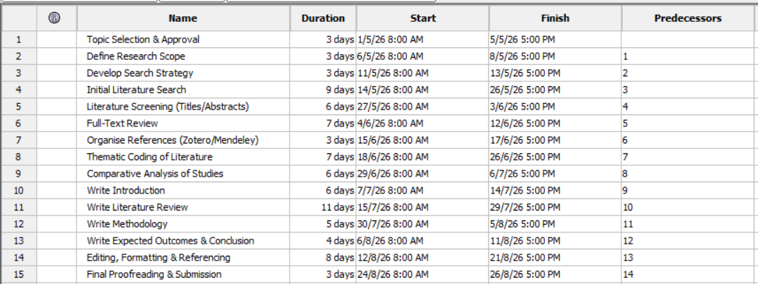
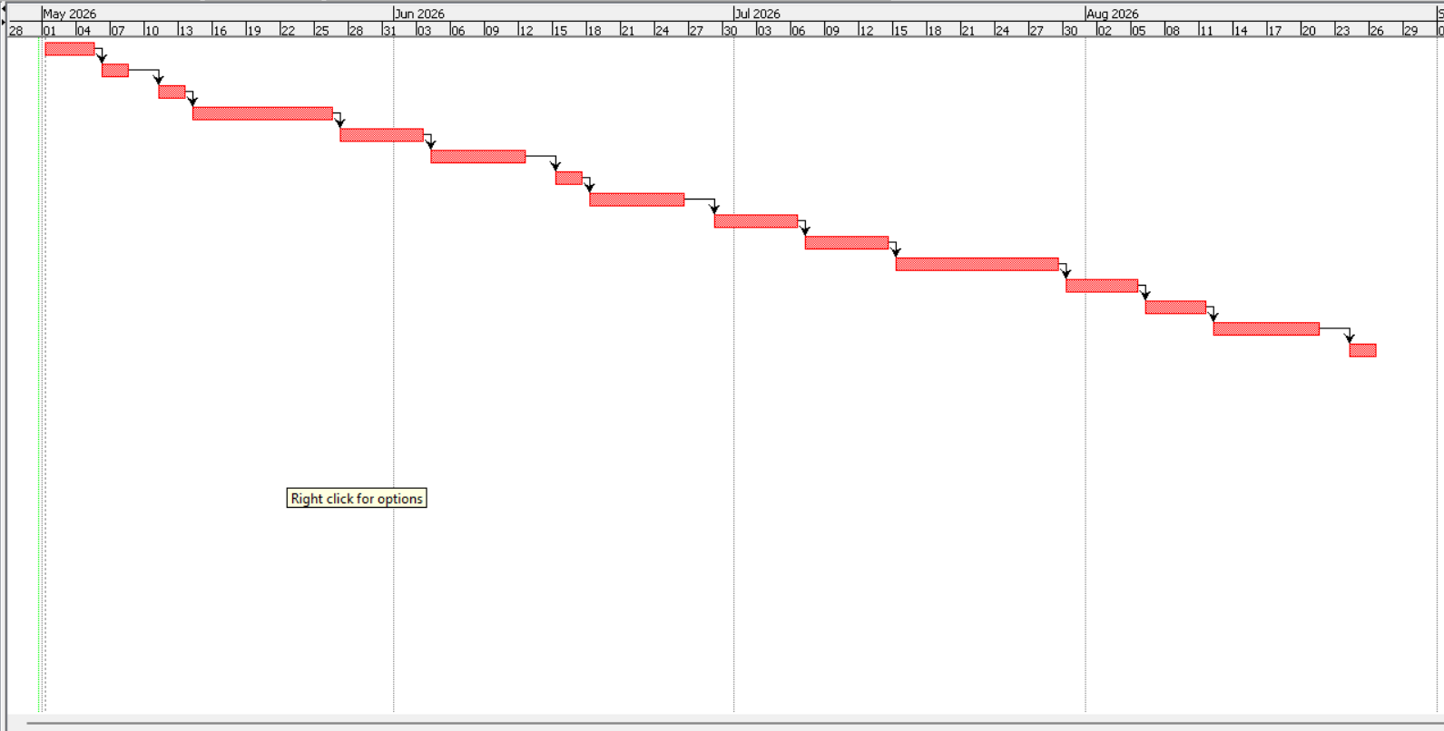
Gantt Chart
(Source:ProjectLibre)
This project schedule is chronologically ordered to complete the research step-by-step during the period between the early months of May to late months of August 2026. It is a linear dependency model in which a logical dependency exists between each of the tasks on the successful completion of the already-completed task which provides a sense of consistency and methodological rigor.
The project starts with the selection of a topic and setting a research direction. This is then succeeded by identification of search strategy that helps in making sure that the literature review is systematic and exhaustive. The second is literature acquisition and involves initial searching, title screening and reading the full-text. All these will help in inclusion of only the most relevant and quality sources. After the selection of the literature, it will pass through the organisation and analysis phase, i.e., references will be organised and analysed with the help of Zotero or Mendeley and the thematic coding will be used to determine the meaningful patterns and themes. It is then subject to a comparative analysis where various studies, frameworks and findings could be critically analyzed.
This is done in stages beginning with introduction, literature review and then the methodology, and what is expected to be found. This is a systematic presentation that renders the report coherent and as per the demands of academics. Last but not least, editing, formatting and referencing are done to ensure that the project is within the IEEE guidelines followed by proofreading and submissions. The timeline in general shows that it was well planned, there were clear dependencies between the tasks and the research till the final submission was realistic.

REFERENCE LIST
- Ruan, K. and Carthy, J., 2012, October. Cloud computing reference architecture and its forensic implications: a preliminary analysis. In International conference on digital forensics and cyber crime (pp. 1-21). Berlin, Heidelberg: Springer Berlin Heidelberg. https://www.academia.edu/download/30839702/2012_NIST_Cloud_Architecture_and_Forensic_Implications_4thICF2C_Springer.pdf
- Sharevski, F., 2013, November. Digital forensic investigation in cloud computing environment: impact on privacy. In 2013 8th International Workshop on Systematic Approaches to Digital Forensics Engineering (SADFE) (pp. 1-6). IEEE. https://www.researchgate.net/profile/Filipo-Sharevski/publication/283513580_Digital_forensic_investigation_in_cloud_computing_environment_Impact_on_privacy/links/58a5e5f84585150402d8f540/Digital-forensic-investigation-in-cloud-computing-environment-Impact-on-privacy.pdf
- Al Sadi, G., 2015. Cloud computing architecture and forensic investigation challenges. International Journal of Computer Applications, 124(7). https://www.academia.edu/download/95501140/sadi_2015_ijca_905521.pdf
- O’shaughnessy, S. and Keane, A., 2013, January. Impact of cloud computing on digital forensic investigations. In Ifip international conference on digital forensics (pp. 291-303). Berlin, Heidelberg: Springer Berlin Heidelberg. https://inria.hal.science/hal-01460613/document
- Birk, D. and Wegener, C., 2011, May. Technical issues of forensic investigations in cloud computing environments. In 2011 Sixth IEEE international workshop on systematic approaches to digital forensic engineering (pp. 1-10). IEEE. https://www.idc-online.com/technical_references/pdfs/information_technology/Technical%20Challenges%20of%20Forensic%20Investigations%20in%20Cloud.pdf
- Pandi, G.S., Shah, S. and Wandra, K.H., 2020. Exploration of Vulnerabilities, Threats and Forensic Issues and its impact on the Distributed Environment of Cloud and its mitigation. Procedia Computer Science, 167, pp.163-173. https://www.sciencedirect.com/science/article/pii/S1877050920306591/pdf?md5=5aace2fcad5e7b492165deaa70ae8b5f&pid=1-s2.0-S1877050920306591-main.pdf
- Tanveer, M., Khan, N.A., Ali, M., Islam, R., Sattar, M. and Shoaib, M., 2025. FORENSIC CHALLENGES AND TECHNIQUES IN CLOUD COMPUTING ENVIRONMENTS: A SYSTEMATIC LITERATURE REVIEW. Spectrum of Engineering Sciences, pp.67-92. https://www.thesesjournal.com/index.php/1/article/download/241/223
- Alex, M.E. and Kishore, R., 2017. Forensics framework for cloud computing. Computers & Electrical Engineering, 60, pp.193-205. https://www.sciencedirect.com/science/article/pii/S0045790617302689?casa_token=sFLr9_Rd_K4AAAAA:8tJV8V6iCK0jEPfNLH76tmI0BWNkslOW9j10q0UDOxnjWn7hbzzF7LR0Scq2IGBRaz9RhVi6Za-q
- Pichan, A., Lazarescu, M. and Soh, S.T., 2015. Cloud forensics: technical challenges, solutions and comparative analysis. Digital investigation, 13, pp.38-57. https://www.sciencedirect.com/science/article/pii/S1742287615000407?casa_token=U3hrCnPHA90AAAAA:ry_kMia-HqNeKtt2TEE8Nu33y4wql4697hiDiUSIe7PUr3GGEOYei9JV7UROU7xHJFHs6z6CJPjv
- Malik, A.W., Bhatti, D.S., Park, T.J., Ishtiaq, H.U., Ryou, J.C. and Kim, K.I., 2024. Cloud digital forensics: Beyond tools, techniques, and challenges. Sensors, 24(2), p.433. https://www.mdpi.com/1424-8220/24/2/433
- Miranda Lopez, E., Moon, S.Y. and Park, J.H., 2016. Scenario-based digital forensics challenges in cloud computing. Symmetry, 8(10), p.107. https://www.mdpi.com/2073-8994/8/10/107
- Arafat, M.Y., Mondal, B. and Rani, S., 2017. Technical challenges of cloud forensics and suggested solutions. Int. J. Sci. Eng. Res, 8(8), pp.1142-1149. https://www.researchgate.net/profile/Md-Arafat-32/publication/320335485_Technical_Challenges_of_Cloud_Forensics_and_Suggested_Solutions/links/59de65ed458515376b29dd89/Technical-Challenges-of-Cloud-Forensics-and-Suggested-Solutions.pdf
- Shah, J.J. and Malik, L.G., 2013, December. Cloud forensics: issues and challenges. In 2013 6th International Conference on Emerging Trends in Engineering and Technology (pp. 138-139). IEEE. https://www.academia.edu/download/34465899/JJshah_ICETET13.pdf
- Rani, D.R., Sultana, S.N. and Sravani, P.L., 2016. Challenges of digital forensics in cloud computing environment. Indian Journal of Science and Technology, 9(17), pp.1-7. https://sciresol.s3.us-east-2.amazonaws.com/IJST/Articles/2016/Issue-17/Article66.pdf
- Grispos, G., Storer, T. and Glisson, W.B., 2013. Calm before the storm: The challenges of cloud computing in digital forensics. In Emerging digital forensics applications for crime detection, prevention, and security (pp. 211-233). IGI Global Scientific Publishing. https://arxiv.org/pdf/1410.2123
- Alqahtany, S., Clarke, N., Furnell, S. and Reich, C., 2015, April. Cloud forensics: a review of challenges, solutions and open problems. In 2015 international conference on cloud computing (ICCC) (pp. 1-9). IEEE. https://www.researchgate.net/profile/Saad-Alqahtany/publication/276277307_Cloud_Forensics_A_Review_of_Challenges_Solutions_and_Open_Problems/links/5555bca608ae980ca60b1382/Cloud-Forensics-A-Review-of-Challenges-Solutions-and-Open-Problems.pdf
- Marshall, K. and Rea, A., 2021. Legal challenges in cloud forensics. https://scholar.archive.org/work/b6pn22dyozhfzo5uue55gqi5b4/access/wayback/https://aisel.aisnet.org/cgi/viewcontent.cgi?article=1341&context=amcis2021
- Pichan, A., Lazarescu, M. and Soh, S.T., 2015. Cloud forensics: technical challenges, solutions and comparative analysis. Digital investigation, 13, pp.38-57. https://www.sciencedirect.com/science/article/pii/S1742287615000407?casa_token=0PcnvViCYPAAAAAA:04r004LzTTJUzTlhQs8oJzX955p7B9U9BMiGOdZ-7EA_T9IpaN_L2muO8RvyvxOz0azvWdfKQmEY
- Karagiannis, C. and Vergidis, K., 2021. Digital evidence and cloud forensics: contemporary legal challenges and the power of disposal. Information, 12(5), p.181. https://www.mdpi.com/2078-2489/12/5/181
- Vaciago, G., 2012. Cloud computing and data jurisdiction: a new challenge for digital forensics. Cloud Computing and Data Jurisdiction: A New Challenge for Digital Forensics, pp.7-12. https://www.juridice.ro/wp-content/uploads/2019/09/cyberlaws_2012_1_20_70033-1.pdf
- Aqil Burney, M.A. and Abbas, Z., 2016. Forensics issues in cloud computing. Journal of Computer and Communications, 4, pp.63-69. https://www.researchgate.net/profile/Zain-Abbas-8/publication/306363250_Forensics_Issues_in_Cloud_Computing/links/57bec24508aeb95224d0a465/Forensics-Issues-in-Cloud-Computing.pdf
- Ekwempu, F.C., 2026. Investigating the Legal Complexities of Cloud Forensic Investigations in Cross-Border Scenarios and Developing Strategies for International Cooperation. International Journal of Research and Innovation in Applied Science (IJRIAS), 11(1). https://repository.rsis.international/pdfs/ijrias/vol11-iss1-pg1334-1359-202602_pdf.pdf
- Utami, R. and Julita, S., 2026. Digital forensics in the era of cyber law: challenges of cloud computing and data privacy. JISTecS: Journal of Information Systems, Technology and Security, 1(1), pp.1-19. https://ejournal.scmdigi.id/index.php/jistecs/article/download/49/48
- Alex, M.E. and Kishore, R., 2017. Forensics framework for cloud computing. Computers & Electrical Engineering, 60, pp.193-205. https://www.sciencedirect.com/science/article/pii/S0045790617302689?casa_token=K6bTF9p6YU0AAAAA:TZpCtVdG5jmmRTbAvMk8CWHslmYxAnrXHBa5XGZTXNPsWuQyNHVEuroUnWSIbaYFVsTUC5w-SF66
- Mohammed, S. and Rangu, S., 2023. The cloud forensics frameworks and tools: A brief review. International Journal of Science and Research Archive, 8(1), pp.173-181. https://www.academia.edu/download/99818181/IJSRA-2023-0023.pdf
- Rani, D.R. and Geethakumari, G., 2015, December. A meta-analysis of cloud forensic frameworks and tools. In 2015 Conference on Power, Control, Communication and Computational Technologies for Sustainable Growth (PCCCTSG) (pp. 294-298). IEEE. https://www.researchgate.net/profile/Radha-Rani-8/publication/307799931_A_meta-analysis_of_cloud_forensic_frameworks_and_tools/links/583809ab08aef00f3bf9e424/A-meta-analysis-of-cloud-forensic-frameworks-and-tools.pdf
- Simou, S., Kalloniatis, C., Gritzalis, S. and Katos, V., 2019. A framework for designing cloud forensic-enabled services (CFeS). Requirements Engineering, 24(3), pp.403-430. https://idp.springer.com/authorize/casa?redirect_uri=https://link.springer.com/article/10.1007/s00766-018-0289-y&casa_token=5_2LkW2AXBIAAAAA:EVNdmFzfyDiNDDYkEOYcsgiZzZlzNREhWF7eWCb2EUHsNAgNzsnYlvHqpCh8G1NmVD6uP3tbT--sAwNAMg
- Faheem, M., Le-Khac, N.A. and Kechadi, T., 2016, August. Toward a new mobile cloud forensic framework. In 2016 sixth international conference on innovative computing technology (INTECH) (pp. 736-742). IEEE. https://arxiv.org/pdf/1611.09564
- Prakash, V., Williams, A., Garg, L., Barik, P. and Dhanaraj, R.K., 2022. Cloud-based framework for performing digital forensic investigations. International Journal of Wireless Information Networks, 29(4), pp.419-441. https://idp.springer.com/authorize/casa?redirect_uri=https://link.springer.com/article/10.1007/s10776-022-00560-z&casa_token=nxFWr3gNgEoAAAAA:MKI9g1IcpQs7t9-rJAIwCVhhLQZM9AdMLRX5ypa3OGPvtbEMlFqAhGpUE_xDR4Qg8Hw1eAtUp28rcJ53Bg
- Martini, B. and Choo, K.K.R., 2012. An integrated conceptual digital forensic framework for cloud computing. Digital investigation, 9(2), pp.71-80. https://www.sciencedirect.com/science/article/pii/S174228761200059X?casa_token=PeBT6tNZ-ugAAAAA:JSRpig4PEI3RwMxGOgJpCug4MvDLfSlP4Lo35lqzTxgGqZfoE7ctx3SZQ-3PSDXOYgEGkTQaR7nY
- Alenezi, A., Atlam, H.F. and Wills, G.B., 2019. Experts reviews of a cloud forensic readiness framework for organizations. Journal of Cloud Computing, 8(1), p.11. https://link.springer.com/content/pdf/10.1186/s13677-019-0133-z.pdf
- Manral, B., Somani, G., Choo, K.K.R., Conti, M. and Gaur, M.S., 2019. A systematic survey on cloud forensics challenges, solutions, and future directions. ACM Computing Surveys (CSUR), 52(6), pp.1-38. https://dl.acm.org/doi/pdf/10.1145/3361216
- Kebande, V.R. and Venter, H.S., 2018. Novel digital forensic readiness technique in the cloud environment. Australian Journal of Forensic Sciences, 50(5), pp.552-591. https://www.tandfonline.com/doi/pdf/10.1080/00450618.2016.1267797?casa_token=B156jkj9SzkAAAAA:uARea9l0WeHcxX_RwSfe2JHhGh-FSM9YSnjMAq7xPXO-MK-tXf0TnymnY0mv0q2hhECEAG2cLDsIPQ
- Park, S., Kim, Y., Park, G., Na, O. and Chang, H., 2018. Research on digital forensic readiness design in a cloud computing-based smart work environment. Sustainability, 10(4), p.1203. https://www.mdpi.com/2071-1050/10/4/1203
- Alenezi, A., Hussein, R.K., Walters, R.J. and Wills, G.B., 2017, April. A framework for cloud forensic readiness in organizations. In 2017 5th IEEE international conference on mobile cloud computing, services, and engineering (MobileCloud) (pp. 199-204). IEEE. https://eprints.soton.ac.uk/410988/1/A_Framework_for_Cloud_Forensic_Readiness_in_Organizations.pdf
- Zawoad, S., Hasan, R. and Skjellum, A., 2015. OCF: An Open Cloud Forensics Model for Reliable Digital Forensics. In: 2015 IEEE 8th International Conference on Cloud Computing. https://www.researchgate.net/figure/Open-Cloud-Forensics-Model_fig3_277076806
- Alshabibi, M.M., 2022. Application of Artificial Intelligence to Network Forensics: Survey, Challenges and Future Directions. https://www.researchgate.net/figure/Cloud-forensics-challenges-based-on-their-stages-adapted-from-120_fig4_364583527

