
Master of Business Administration
(MBA International Business)
LCMB7034 – International Business Concepts

Assignment Title
An Evaluation of Fast Retailing Co., Ltd.'s Proposed Market Entry into Sri Lanka

Submitted by
Hasibur Rahman
Student ID
2436834
Lecturer
Akshay Narayanan
Word Count
5495 words
Submission Date
10 August 2026

Table of Contents
1 Introduction 4
2 International Market Entry Strategy Analysis 4
2.1 Classification & Global Strategy 4
2.1.1 Company Overview 4
2.1.2 Organisational Classification 5
2.2 Macro-Environmental Appraisal and Market Attractiveness 7
2.2.1 Political Environment 7
2.2.2 Economic Environment 8
2.2.3 Social (Cultural) Environment 11
2.2.4 Legal Environment 14
2.3 Dunning's Eclectic (OLI) Paradigm 15
2.3.1 Ownership Advantages (O) 15
2.3.2 Location Advantages (L) 16
2.3.3 Internalisation Advantages (I) 17
2.4 Entry Mode Strategy and Strategic Synthesis 17
2.4.1 Historical Pattern Recognition 17
2.4.2 Strategic Fit & Entry Mode Justification 18
2.4.3 Conclusion & Final Recommendation 19
3 Reflective Account using Gibbs (1988) Reflective Cycle 20
3.1 Description 20
3.2 Feelings 20
3.3 Evaluation 21
3.4 Analysis 21
3.5 Conclusion 22
3.6 Action Plan 22
4 Summary 22
5 References 24

Introduction
This report critically evaluates the international market entry strategy of Fast Retailing Co., Ltd. by analyzing the strategic suitability of the expansion into Sri Lanka where the company has no official UNIQLO retail stores, production offices or wholly owned subsidiaries, but has sourcing relationships with independent suppliers. The key international business models, such as Bartlett and Ghoshal's model, PEST analysis and Dunning's Eclectic (OLI) Paradigm, are used to assess the external environment, strategic fit and the most suitable market entry mode for sustainable international expansion.

International Market Entry Strategy Analysis

Classification & Global Strategy

Company Overview
The Fast Retailing Co., Ltd., with headquarters located in Yamaguchi, Japan, is one of the largest and oldest clothing retailers in the world (Fast Retailing, 2024). The Group was established in 1963, and owns brands such as UNIQLO, GU, Theory, PLST, Comptoir des Cotonniers and Princesse tam.tam (Fast Retailing, 2024). Because of its vertically integrated organization in the Japanese shoe industry known as ‘LifeWear', this enterprise unit brings together product planning, sourcing, production, logistics, and retailing, tying together the entire supply chain to ensure a better quality and operational efficiency (Fast Retailing, 2025a). Fast Retailing's consolidated revenue increased to ¥3.40 trillion in FY2025, its operating profit to ¥564.3 billion, and the number of full-time employees to 59,522, along with its 3,570 stores operating worldwide (Fast Retailing, 2025b; Fast Retailing, 2026), reflecting the company's strong financial and organisational capabilities in the international markets.
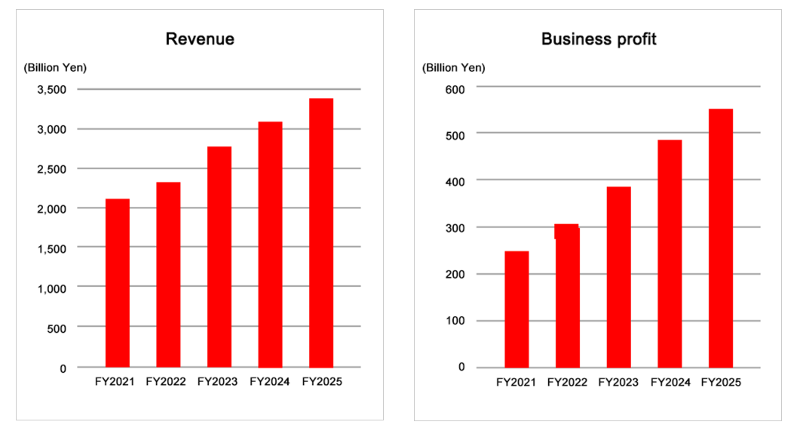
Figure 1: Fast Retailing Business Profit & Revenue (Fast Retailing, 2026)

Organisational Classification
Fast Retailing can be rightly called a Multinational Enterprise (MNE) as it has value creation activities in different countries and has ownership, coordination and control thereof, but strategic decisions are made back at the headquarters in Japan. According to Dunning (1998) MNEs have specific advantages and coordinate production and commercial activities across national boundaries to take advantage of economies of scale and competitive advantage. With its operations, proprietary apparel technology, international sourcing network and retail presence all over the world, including Asia, Europe, North America, and Oceania, Fast Retailing broadly fits this definition (Fast Retailing, 2025a). Fast Retailing, on the other hand, has a balance between exporting and the international development of its product, the coordination of its supply chains and direct retail operations in various countries, with clear international asset ownership and organisational control (Fast Retailing, 2025d).
Fast Retailing differentiates itself from many fast-fashion competitors through its LifeWear strategy, which emphasises functional, high-quality and technologically innovative apparel rather than rapidly changing fashion cycles (Fast Retailing, 2025a). This strategic positioning supports a globally consistent value proposition while enabling sustainable international expansion through product innovation and operational efficiency (Whittington et al., 2023). These characteristics reinforce the company's classification as a transnational enterprise that combines global integration with selective local adaptation.
The most suitable framework to classify Fast Retailing's international strategy is Bartlett and Ghoshal's (1989) Transnational Strategy framework. They present their model as a typology of four strategic configurations: international, multidomestic, global, and transnational, which depend on the balance between global integration and local responsiveness. Fast Retailing has strong characteristics of a transnational strategy as it simultaneously seeks global operational efficiency but also adapts selected products and marketing activities to the local market environment (Zhu, 2022). The core activities, such as product design, fabric innovation, procurement and brand management, are highly centralised in Japan, which allows the company to benefit from economies of scale and ensure consistency in quality worldwide (Fast Retailing, 2025a). Meanwhile, the company adapts product size, seasonal collections, store design and promotion to the climatic and cultural requirements and preferences of each market. This combination reflects the balance between global integration and local responsiveness; however, the effectiveness of this approach depends on the extent of local adaptation that the company can provide for individual host markets such as Sri Lanka.

Limitation of the Transnational Strategy
However, there are some disadvantages to Fast Retailing's transnational strategy. Lynch et al. (2024) propose that excessive centralisation can diminish the agility and responsiveness of subsidiaries to local markets. While the centralized product planning and decision-making process have led to consistent quality and brand identity across the world, it can hinder the company's capacity to adapt to culturally diverse emerging markets like Sri Lanka (Fast Retailing, 2025b). Fast Retailing has sourcing ties to independent Sri Lankan apparel suppliers but does not have an important enough footprint or local market knowledge. Hence, the successful strategy to become sustainably competitive will be one that combines global integration with localization to a greater extent, not just one that depends upon its current multinational approach (Bartlett and Ghoshal, 1989).

Macro-Environmental Appraisal and Market Attractiveness
The apparel industry in Sri Lanka is well-developed, the country is strategically located in the South Asia region, the investment climate is improving, and the consumer market is expanding, all of which provide promising opportunities for the country's expansion into the global market, as seen in the work of the World Bank (2025a) and the Board of Investment Sri Lanka (2025). Fast Retailing sources the garments from independent Sri Lankan suppliers, but has no official UNIQLO retail stores, production offices or wholly owned subsidiary in the country. For this reason, this section critically analyses all the political, economic, social and legal factors relevant to Fast Retailing's proposed market entry and then synthesises these findings and analyses the strategic feasibility of an investment in Sri Lanka based on Dunning (1988) Eclectic (OLI) Paradigm.

Political Environment
Political stability is an important determinant for Fast Retailing as it is essential for long-term retail investment to have a stable policy environment and policy stability. According to institutional theory, political stability, government efficiency and regulatory consistency create uncertainty reduction for multinational enterprises (MNEs) and increase the ease of long-term strategic planning (Adeyanju et al., 2025). The year 2022 was a period of severe political turmoil in Sri Lanka, because of the economic crunch, with widespread public protests, change in political leadership and lack of investor confidence (Cheema 2025). Although reforms have improved investor confidence, their long-term value depends on consistent implementation rather than policy announcements alone.
Sri Lanka has been improving its governance, restoring macroeconomic stability and strengthening public sector institutions (World Bank 2025). However, it stresses political will is needed to continue structural reforms and investor confidence. This is especially significant for Fast Retailing as they have adopted a long-term strategy by operating directly in international markets instead of a short-term export policy. Policy changes and/or uncertainty may delay investment decisions, heighten the operational risk of investment and diminish investor confidence in the long-term expansion of the market.
The country political appeal also depends on the government's attitude towards private sector development. Policy changes in recent years have shown increased commitment to enhancing the business climate and attracting foreign investment (World Bank, 2025). Political commitment, however, is not enough to provide a stable investment environment. Lynch (2024) suggests that, besides government policy, multinational companies should consider the consistency and effectiveness of the policy implementation. The policy shift toward a reform agenda, therefore, does not indicate a better political context for the country than immediately after the 2022 crisis, but risks remain to this end. Political uncertainty may also indirectly impact Fast Retailing's business via consumer confidence undermining, retail demand disruption, and business continuity disruption. The company's business model, as an international apparel company that utilises integrated global supply chains and long-term capital investment, makes it especially susceptible to institutional instability and sudden policy changes (Iriani et al., 2024). While political risks have lessened since the crisis, it is not gone.
Overall, Sri Lanka's improving political climate presents an opportunity for Fast Retailing to expand through a phased market entry supported by strengthening governance and investment reforms. However, institutional uncertainty remains a political threat. To mitigate these risks, the company should maintain operational flexibility, monitor policy developments closely and gradually increase investment as political and regulatory stability becomes more firmly established (Lynch, 2024).

Economic Environment
The economic environment is an important factor affecting the proposed market entry strategy for Fast Retailing as its success in the Sri Lankan market is closely linked to consumer purchasing power, macroeconomic stability and retail demand. Sri Lanka is moving towards economic recovery from the 2022 deep economic crisis, underpinned by fiscal consolidation, modest inflation and economic activity, says the World Bank Group (2025). After two years of economic contraction in 2022 and 2023, real GDP is expected to increase by around 3.5% in 2025 (World Bank Group, 2025). Although this indicates improving macroeconomic conditions, stronger GDP growth alone does not guarantee sufficient consumer demand for international apparel retailers. Therefore, Fast Retailing should adopt a gradual market-entry strategy with competitively priced LifeWear products until sustained improvements in household purchasing power and consumer demand are established.
As per the CBSL (2022), the Colombo Consumer Price Index (CCPI) reached its highest level in September 2022, at 69.8% year-on-year, and then reduced with the implementation of monetary tightening and macroeconomic adjustment measures. According to the Central Bank of Sri Lanka (2026), consumer confidence has been restored and uncertainty for businesses in the domestic market has been reduced due to the price stability. Stable prices are significant for Fast Retailing because they strengthen consumers' purchasing power, enable more reliable pricing strategies, and support higher retail demand, thereby enhancing sales growth, profitability and the company's long-term competitive advantage in the Sri Lankan apparel market (Central Bank of Sri Lanka, 2026). However, households' real income is still not back to pre-crisis levels and demand on the part of consumers is still in a recovery, not a restoration, phase.
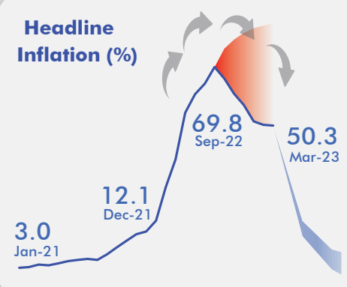
Figure 3: Headline Colombo Consumer Price Index (CCPI) inflation (Central Bank of Sri Lanka, 2022)
Another economic issue is exchange-rate stability. Breuer, Dhungana and Li (2026) adds that the improvement of the foreign exchange reserve and the external balances have helped to achieve higher stability of the exchange-rate compared to the crisis period. A more stable currency for Fast Retailing, whose business model involves importing finished goods, but runs worldwide integrated supply chains, means exchange-rate risks are reduced, inventory planning is improved and cost predictability is enhanced (Fast Retailing, 2025a; Breuer, Dhungana and Li, 2026). With the ongoing global economic shocks and financing conditions, however, one could not rule out exchange-rate volatility completely (Jayasinghe, 2026).
In addition, the well-established apparel sector in Sri Lanka adds to the country's appeal for Fast Retailing. Apparel export industry in Sri Lanka contributes approximately 6% of GDP, generating about 350,000 employment opportunities and producing high value apparel, that is known due to its quality, sustainability, traceability and compliance with international standards (World Bank, 2025). Fast Retailing already sources garments from independent Sri Lankan apparel manufacturers through its global supplier network (Fast Retailing, 2025b), which suggests that the company has established familiarity with Sri Lanka's manufacturing capabilities despite not having a direct retail presence in the country. This existing supplier ecosystem can help to integrate sourcing and future retail operations, which would reduce supply chain complexity and logistics costs and make inventory more responsive to the market (World Bank, 2025). But the benefits of these operations do not always extend into robust domestic retail demand. Despite these developments, the industry is still hampered by structural challenges such as reliance on imported raw materials, relatively high electricity costs and labour shortages, which may impact the operating efficiency of the industry in the long term (Shyamain Wickramasingha and Smith, 2025).
The overall economic outlook has improved significantly but slowly for Sri Lanka and is still fragile in the face of external risks. To Fast Retailing, better GDP growth, lower inflation, more stable exchange rate and a more developed apparel industry make the country more market attractive. However, relatively low household purchasing power implies a gradual market introduction, which would fit better with the economic situation, with competitively priced LifeWear products.

Social (Cultural) Environment
Socio-cultural context in Sri Lanka offers good prospects for Fast Retailing; however, good market entry will require the company to accommodate the Sri Lankan consumer characteristic and purchasing behaviour of LifeWear to succeed in the market. Consumer demographics are significant as they affect the market size and the long-term demand of retail. The size of Sri Lanka's population is around 22million (The Sunday Times, 2024) and Sri Lanka's adult literacy rate is around 93% (World Bank, 2026), with the country having its highest population density in highly urbanised districts like Colombo and Gampaha. While higher literacy and urbanization may increase awareness of international brands, purchasing decisions will still depend on affordability and perceived value (World Bank, 2026).
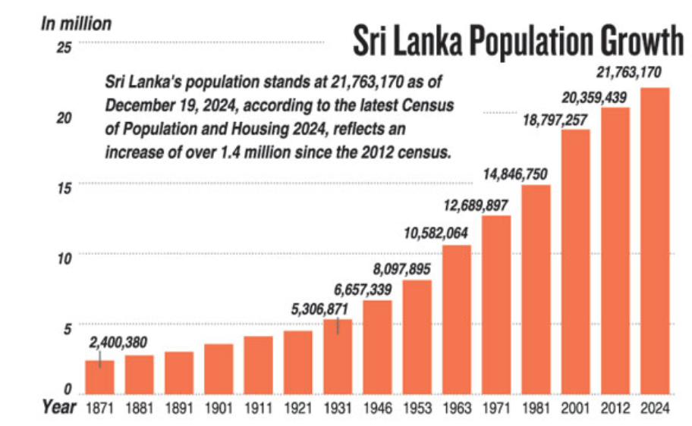
Figure 4: Sri Lanka Population (The Sunday Times, 2024)
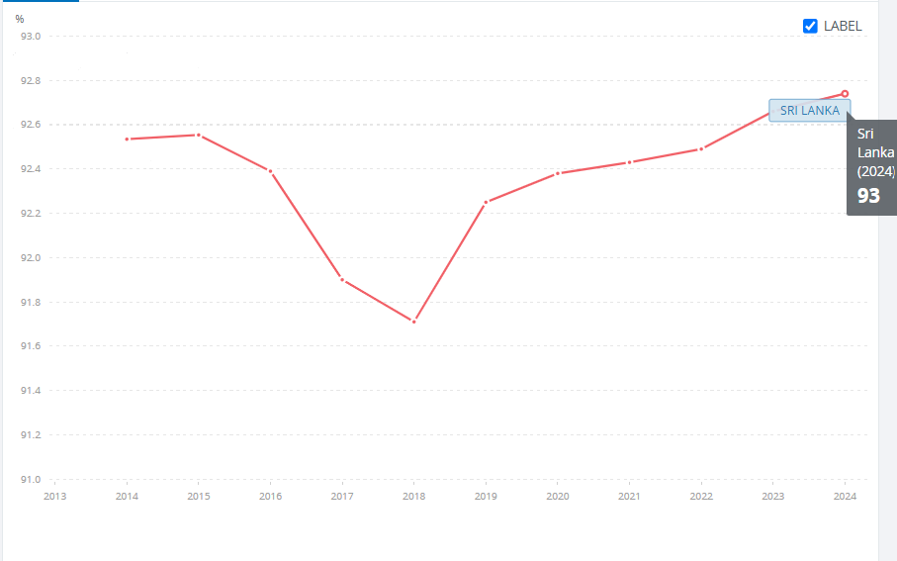
Figure 5: Sri Lanka's adult literacy rate (World Bank, 2026)
Income level continues to have a significant impact on consumer purchasing after the 2022 economic disaster. Despite the less pessimistic outlook of the economy, households are still feeling the pinch on their disposable incomes, while consumers are more inclined to value for money buying (Weerasinghe, Amarasekara and Jegajeevan, 2024). Clarke-Sather and Cobb (2019) recently conducted a study on apparel consumers in Sri Lanka which revealed that consumers tend to focus on the durability and quality of the apparel products instead of shifting fashion trends. This buying pattern is very similar to Fast Retailing's concept of LifeWear, which focuses on good quality, functional and long-lasting everyday clothes over fast fashion trends (Fast Retailing, 2025a). However, the high price sensitivity of middle-class consumers indicates that Fast Retailing should position its LifeWear products through competitive pricing and readily available product lines to strengthen market penetration, attract value-conscious consumers and achieve sustainable sales growth in Sri Lanka.
According to Hofstede Insights Sri Lanka is high on Power Distance (80) and low on Individualism (35) which is a collectivist culture; buying decisions are heavily influenced by family and trust/social relationships (The Culture Factor, 2020). For this reason, Fast Retailing should focus on brand credibility, brand products' quality, and long-term customer relationships than just basing their marketing strategies on a price promotion or individualistic appeal.
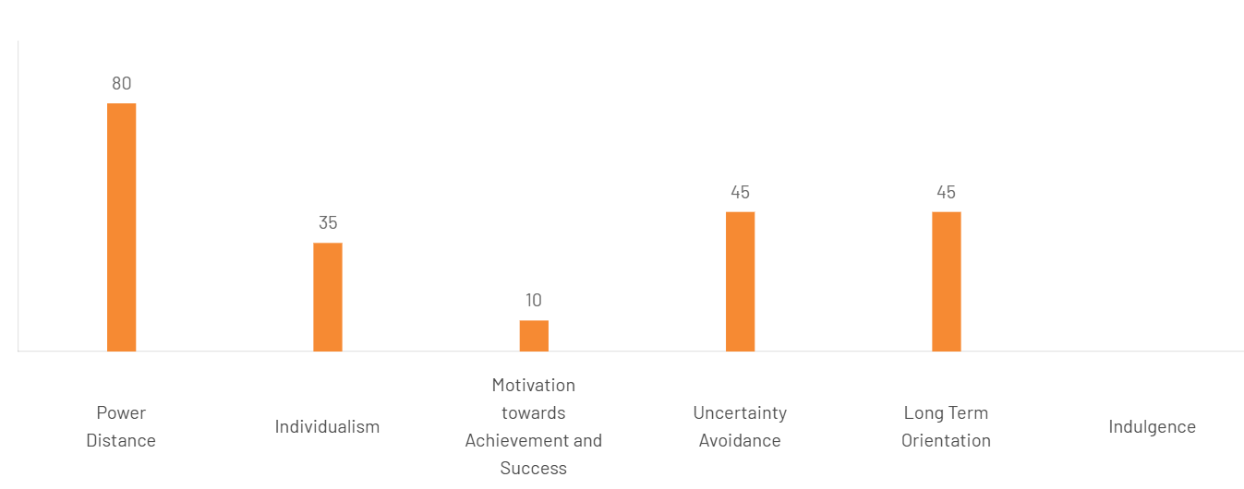
Figure 6: Hofstede Insights (The Culture Factor, 2020)
Fast Retailing's sustainability strategy also offers opportunities from the changing expectations of consumers. Ethical sourcing, environmental responsibility, and corporate sustainability are significant concerns for younger consumers, especially as it relates to the apparel industry (Li, Choe and Gu, 2024). Therefore, Fast Retailing's current responsible-sourcing, recycling of its products, and the use of sustainable materials may provide a competitive advantage, provided consumers perceive sufficient value alongside affordability (Fast Retailing 2025b). Sri Lanka's relatively well-trained retail sector enables the provision of an acceptable level of service to customers, while also enhancing the firm's capacity to adopt its global standards of retail service (Weedige et al., 2019).
Digital transformation is also key. Retail is expanding across Sri Lanka, as 90% of the population has access to mobile broadband and internet penetration is 59.7% as of late 2025 (Global Digital Insights, 2025), which will enhance opportunities for Fast Retailing's omnichannel approach. The developments align with an omnichannel retail model that integrates offline retail locations with online channels, allowing Fast Retailing to enhance customer engagement and purchase convenience (Razak, 2023). Sri Lanka's socio-cultural climate is generally conducive to Fast Retailing's global strategy. However, delivering sustainable success will require finding the balance between its LifeWear, which is standardised across the globe, and the locally sensitive pricing, marketing and digital retailing.

Legal Environment
Legal environment is another crucial factor to consider for Fast Retailing's prospects of entering the Sri Lankan market as adherence to investment law, employment law, consumer protection and data governance law will have a direct impact on the operational risk and sustainability in the long term. Sri Lanka has increasingly tightened its regulatory regime to welcome foreign investment, in a way that does not impose significant legal restrictions but also enhances corporate governance and transparency (United States Department of State, 2025).
An investment point of view, Sri Lanka allows 100% foreign investment in most industries through the Board of Investment (BOI) of Sri Lanka, which facilitates investment and offers tax incentives and legal protection for foreign investors to investment projects (Sirisena, 2026). These measures lower the entry barriers into the market and offer flexibility regarding the preferred entry mode for the company in case of a wholly owned subsidiary (WOS) or strategic joint venture (SJV) (Sirisena, 2026). However, securing investment approvals and meeting administrative requirements can remain a lengthy process and require careful regulatory planning prior to market entry.
An international apparel retailer is a company that is bound by employment laws. Sri Lanka has rather detailed labour laws, including the Shop and Office Employees Act, Wages Boards Ordinance, and the Employees' Provident Fund regulations (BIPO, 2026), that apply to the employment contract, working hours, occupational health and safety, and wages and benefits for employees. These laws impose greater compliance costs than unregulated markets but have been found to be beneficial for workforce stability (Wakerman et al., 2019) and are consistent with Fast Retailing's corporate attitude towards responsible employment practices and ethical supply-chain management.
Consumer confidence is also enhanced by the Consumer Affairs Authority Act 2026 on consumer rights and pricing practices and product standards (CAA). By enforcing these regulations, they can enhance the transparency and quality of their products, reinforcing Fast Retailing's premium brand positioning. In addition, Sri Lanka's Personal Data Protection Act No. 9 of 2022, which will be rolled out in stages, includes new regulations on collecting, processing and storing customer data (PDSLS, 2022). In the future, data protection needs will become crucial to sustain customer trust and minimise regulatory risk as Fast Retailing continues to expand its digital retailing and omnichannel services (Riaz, Ahmed and Jibril, 2024).
In general, the legal environment is pro-retail foreign investment. Regulatory compliance adds to administration, but overall, the mix of investment protection, labour regulation, consumer protection and new data governance provides an overall reasonably predictable legal landscape for the company to grow over time, as managed by Fast Retailing.

Dunning Eclectic (OLI) Paradigm
Dunning (1988) Eclectic Paradigm proposes that multinational enterprises (MNEs) undertake foreign direct investment (FDI) when they simultaneously possess Ownership (O), Location (L) and Internalisation (I) advantages. Rather than relying on exporting or licensing, the framework explains how firm-specific resources can be combined with host-country advantages to create sustainable competitive advantage.
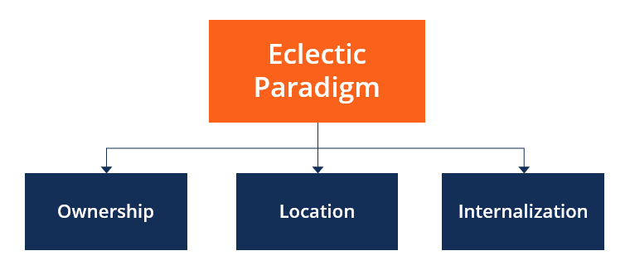
Figure 7: Dunning (1988) Eclectic Paradigm

Ownership Advantages (O)
Ownership advantages are the ones that give an MNE an advantage over domestic rivals (Dunning, 1988). The vertically integrated business model, LifeWear philosophy, global sourcing network and internationally recognised UNIQLO brand are ownership-specific advantages of Fast Retailing (Fast Retailing, 2025a). The company's combination of product planning, materials procurement, production, logistics and retailing smooths the way to consistent product quality and operational efficiency throughout its international markets. Additionally, Fast Retailing's consolidated revenue was ¥3.40 trillion, operating profit was ¥564.3 billion, the number of full-time employees was 59,522, and it had 3,570 stores in the world in FY2025 (Fast Retailing, 2025b; Fast Retailing, 2026), which shows that the company has strong financial capabilities to expand into overseas markets. These ownership advantages are further strengthened by Fast Retailing's transnational strategy, which combines global standardisation with selective local adaptation. This approach can provide a competitive advantage in the Sri Lankan market if these firm-specific capabilities are effectively transferred and adapted to local consumer preferences and market conditions (Bartlett and Ghoshal, 1989; Dunning, 1988).

Location Advantages (L)
Location advantages refer to the host-country characteristics that make Sri Lanka attractive. Governance reforms, policy stability and greater government commitment to the development of the private sector have improved investor confidence, but risks of implementation remain and need careful monitoring (World Bank, 2025; Cheema, 2025; Lynch, 2024). Macroeconomically, Sri Lanka is in a slow recovery that is projected to be 3.5% in GDP growth, with declining inflation and improved exchange-rate stability bringing more predictability for business (World Bank Group, 2025; Central Bank of Sri Lanka, 2026; Breuer, Dhungana and Li, 2026). Furthermore, the garment sector accounts for about 6% of GDP and employs about 350,000 people, and even though the company has no retail presence in Sri Lanka, it still has a familiarity with local garment manufacturing processes due to the company's sourcing from independent Sri Lankan suppliers (World Bank, 2025; Shyamain Wickramasingha and Smith, 2025). Sri Lanka is 93% adult literate (World Bank, 2026), has strong urban consumers markets, a collectivist culture, and increased digital adoption – which all support Fast Retailing's quality-driven LifeWear proposition (The Culture Factor, 2020; Global Digital Insights, 2025). Overall, Sri Lanka is moderately attractive for long-term retail investment because, although it offers strong location advantages through 100% foreign ownership, investment protection, a well-developed apparel industry and supportive legal frameworks, these strengths are offset by relatively weak household purchasing power, moderate domestic retail demand and continuing political and economic uncertainties (Sirisena, 2026; BIPO, 2026).

Internalisation Advantages (I)
The internalisation advantages provide a rationale for the direct ownership of Fast Retailing rather than licensing or franchising (Dunning, 1998). The company's key to its success is this integrated LifeWear business model, which allows it to control product quality, inventory, supply chain integration, and customer experiences very closely (Fast Retailing, 2025a). The entire legal structure in Sri Lanka to facilitate wholly foreign investment allows Fast Retailing to safeguard its proprietary knowledge and plan future retail activities with its current sourcing ties (Sirisena, 2026). While the country is still in the process of economic recovery and political uncertainty still exists (World Bank, 2025; Lynch, 2024), a phased foreign direct investment strategy which would start with flagship stores in Colombo and then roll out to other cities would ensure brand consistency, reduce investment risks and maintain sustainable competitive advantage.

Entry Mode Strategy and Strategic Synthesis

Historical Pattern Recognition
Fast Retailing has taken a selective and adaptive internationalisation approach and has selected the modes of entry based on the institutional characteristics, market size and strategic value of each host country, rather than a standardised way. Since opening its first overseas UNIQLO location in the United Kingdom in 2001, the company has largely expanded by means of wholly owned subsidiaries, especially in key markets such as China, the United States, Europe and Southeast Asia, where the company has direct control over retail operations, branding and customer experience (Fast Retailing, 2025a). This strategy is consistent with the company's vertically integrated LifeWear business model, which involves cross-functional coordination of product planning, procurement, logistics and retailing to ensure products are of consistent quality on international markets (Fast Retailing, 2025b).
However, Fast Retailing has also shown itself to be flexible in establishing joint ventures in markets involving heavy institutional constraints or risk. For instance, it first expanded into the mainland Chinese market through a joint venture, followed by a progressive acquisition approach as it gained more knowledge and expertise about the market (Zhu, 2022). This is consistent with the writings of Root (1998), who provided evidence that the selection of entry mode is a trade-off between the opportunities in the market and institutional uncertainty and commitment.
In summary, Fast Retailing's historical growth trend highlights its focus on high control entry modes and ability to fit local institutional conditions. This cautious strategy has helped the company maintain its brand uniformity, build the operational efficiency, and reduce the risks of internationalization, creating an appropriate strategic base to assess the most appropriate entry mode into Sri Lanka. (Fast Retailing, 2025a; Fast Retailing, 2025b; Root, 1998; Zhu, 2022).

Strategic Fit & Entry Mode Justification
The historical approach of Fast Retailing toward holding 100% of its subsidiaries is largely suitable for Sri Lanka as it enables the company to implement the LifeWear concept, operational standards and customer experience in a manner of absolute control, as required for the long-term success of the company (Fast Retailing, 2025a). The appropriateness of this entry strategy should, however, be tested against the political, financial and operational risks because of the PESTEL and OLI analyses conducted previously (Dunning, 1998) rather than be taken for granted.
Sri Lanka is politically more stable after a series of governance reforms and economic recovery from the IMF, and foreign retailers can be owned 100% with a policy that supports it (World Bank Group, 2025; Board of Investment Sri Lanka, 2025). However, the country remains plagued by institutional uncertainty and policy implementation risks, meaning it could be wiser for Fast Retailing to wait to invest heavily in the country at this juncture. On the economic side, the inflation has significantly reduced, and the GDP growth has returned, and investor confidence has come back, but the purchasing power of the household has been relatively low after the recent economic crisis (Central Bank of Sri Lanka, 2026; World Bank Group, 2025). This would mean a high exposure to the financial markets before demand is confirmed, which would be too early for a large-scale market rollout.
From an operational perspective, Fast Retailing also has an advantage as it already supplies garments from independent Sri Lankan manufacturers, giving them an understanding of the local manufacturers, the ability to manufacture garments and the logistics network (Fast Retailing, 2025a). This existing sourcing relationship decreases the uncertainty in operations and provides an opportunity to integrate sourcing with future retail operations. In addition, Sri Lanka's high literacy rate, growing digital connectivity and the preference for durable value-for-money clothes align with the company's LifeWear business model and aid in omnichannel retail growth (World Bank, 2026; DataReportal, 2026; The Culture Factor, 2020).
Licensing or franchising would minimise the risk of financial commitment but would result in management restrictions and lead to non-uniform product quality and product positioning, which is the core of Fast Retailing's competitiveness (Bhuiyan et al., 2023). Likewise, a joint venture can offer local market expertise but may lead to strategic conflict and decision-making power problems (Root 1998). Hence, a gradual acquisition of 100% FDI, starting from flagship stores in Colombo and gradually as the market conditions improve, is the most fitting mix of control, flexibility and strategic fit in the long run.

Conclusion & Final Recommendation
The analysis concluded the Sri Lanka is a medium to long-term market for a strategically viable company such as Fast Retailing but still has a long way to go economically before it can recover. Sri Lanka has advantages of location where there is a historical legacy of the apparel manufacturing industry, favourable foreign investment policies, and increased consumer market which benefit Fast Retailing through the LifeWear vertically integrated business model, their global sourcing capabilities, and their internationally recognized brand (Fast Retailing, 2025a; World Bank Group, 2025). Political uncertainty and moderate domestic purchasing power and implementation risk, however, mean that the company would run unnecessary risk in the event of immediate large-scale investments. Thus, Fast Retailing is advised to opt for a gradual plan of doing a wholesale foreign direct investment in Colombo but gradually opening their shops in other major urban centres in the future as the market responds positively. The company must also judiciously utilise its existing supplier network; competitive pricing based on the LifeWear value proposition; competition from roles in omnichannel retail; and the constant watch of political and economic trends. This would help Fast Retailing reduce the risks involved in entering new and unfamiliar markets and put them on sustainable growth path, gain control on strategic decision making and help them gain competitive advantage in Sri Lanka in the long run.

Reflective Account using Gibbs (1988) Reflective Cycle

Description
It was not just a matter of picking a multinationals company and analysing a new market into which it was entering, but an international market entry analysis needed a structured research process based on facts and evidence. I was initially interested in Fast Retailing and Pakistan but through further discussion and research I realized that the company already had a sourcing relationship with the market and therefore it would need to be reconsidered. I looked at other countries and decided on Sri Lanka because UNIQLO does not have any official outlets, production offices or subsidiaries in Sri Lanka, yet it has sourcing relationships with independent suppliers. This distinction more closely aligned with the assignment requirements and allowed for a more in-depth strategic analysis. Academic journal articles, module readings, publications of the Fast Retailing and the World Bank, Central Bank of Sri Lanka and government sources were used as the sources of analysis. To provide a market entry strategy based on evidence, the international strategy model of Bartlett and Ghoshal, the PESTEL analysis model and Dunning's Eclectic (OLI) Paradigm were used.

Feelings
The first thing that came to me when I started the assignment was that it was difficult to choose the right company-country combination, as assumptions were not enough and needed to be verified. At first, I thought it would be easy to find a suitable country to host but I found out that many multinational companies have sourcing relation or have some indirect business there, and it makes it difficult to choose the market. It made me even more aware of the need to check the evidence based on official company reports on primary websites rather than just secondary websites. As I continued my research, I grew in confidence to analyse international business theories and apply them to a live MNE. Being able to combine theory with up-to-date information on the company and the country was a great reward for me, as I went beyond description to strategic analysis.

Evaluation
The practice of using several reliable information sources instead of relying on one source was one of the best things I learned. The module reading list, especially Exploring Strategy (Whittington et al., 2023), enabled me to grasp the established frameworks of international strategy, and journal articles in recent times have augured strongly for the critical examination of decisions for multinational expansion. The economic and institutional information was reliable and could be found in official publications of Fast Retailing and other international organisations like the Central Bank of Sri Lanka and the World Bank, which strengthened the credibility of my analysis. One drawback, though, was the amount of time it took to check on company operations and make sure that all factual statements could be backed by a credible source. I also struggled to discern descriptive information about the countries and those aspects that were truly relevant to the strategy of Fast Retailing's internationalisation strategy.

Analysis
Overall, I can see that the lectures had a strong impact on me when I had to go about my assignment. At first, I wanted to use the traditional PEST analysis to describe Sri Lanka. Feedback from the lectures and workshop discussions, however, pointed out that international business strategy needs to be selective in analyzing the various environmental factors and not analyse them equally. Therefore, I only discussed political, economic, socio-cultural and legal aspects that were more relevant to Fast Retailing's retail strategy. In the same vein, I first considered the OLI Paradigm of Dunning to be a theoretical framework for the explanation of foreign investment. As I worked through the research process, I gained a greater understanding that the framework combines the capabilities of the firm with the conditions of the host country to make decisions for market entry. Similarly, Bartlett and Ghoshal's model offered an understanding of why the transnational approach adopted by Fast Retailing is not without its tensions in Sri Lanka, and how it requires a combination of global integration and local responsiveness. This analytical method reinforced the rationale of tying the environmental analysis to the ultimate market entry recommendation.

Conclusion
This assessment has helped me to understand international business strategy better and strengthened my conviction on the need for evidence-based decision making. I now understand how market entry decisions are influenced by market characteristics and the ability of the organisation to meet the conditions of the market and its strategic goals. The assignment also helped me to learn how to review critically company reports, academic literature and international economic data and use the international business theories systematically in practical business scenarios.

Action Plan
In retrospect, if I had to do it again, I would first confirm that companies are operating and present in the market before choosing the case study, thereby making it less likely to have to make revisions later. I would also give more time for research of recent peer-reviewed journal articles to enhance the critical discussion further. Finally, I would further cultivate my capacity to fuse theoretical approaches with contemporary business evidence so that I can continue to deliver strategically and evidence-based international market analyses in my future postgraduate research.

Summary
The report finds that Sri Lanka is a moderately attractive but strategically viable market for Fast Retailing due to several factors, including political and economic stability, a well-developed apparel industry, and a supportive investment environment along with consumer attributes that fit the company's LifeWear strategy. But with the continued institutional volatility and restricted consumer purchasing power comes caution. The report recommends a phased strategy of realizing Wholly Foreign Direct Investment in the market, starting with flagship retail outlets in Colombo, and then gradually expanding to other markets, based on the integrated analysis of external environment, organisational strategy and Dunning OLI principle.

References
Adeyanju, A.S., Vengesai, E., Akande, J.O. and Muzindutsi, P.-F. (2025). The Role of Political Stability, Government Effectiveness and Voice and Accountability on Cross-Listing Destination Premium: Evidence of BRICS Firms. Businesses, 5(4), pp.46–46. Available At: https://www.mdpi.com/2673-7116/5/4/46 [Accessed 15 July 2026]
Bartlett, C.A. and Ghoshal, S. (1989). Managing Across Borders: The Transnational Solution. [online] Harvard Business School. Available at: https://www.hbs.edu/faculty/Pages/item.aspx?num=32 [Accessed 15 July 2026].
Bhuiyan, F., Rana, T., Baird, K. and Munir, R. (2023). Strategic outcome of competitive advantage from corporate sustainability practices: Institutional theory perspective from an emerging economy. Business Strategy and the Environment, 32(7). doi: https://onlinelibrary.wiley.com/doi/abs/10.1002/bse.3362
BIPO (2026). Sri Lanka’s Labour Law & Employment Regulations. [online] BIPO. Available at: https://www.biposervice.com/wp-content/uploads/2026/02/BIPO-TIMES-Feb-2026.pdf [Accessed 4 Aug. 2026].
Breuer, P., Dhungana, S. and Li, M. (2026). Sri Lanka’s sovereign debt restructuring: Lessons from complex processes. [online] doi: https://books.google.com/books?hl=en&lr=&id=Z-mFEQAAQBAJ&oi=fnd&pg=PA4&dq=Breuer,+P.,+Dhungana,+S.+and+Li,+M.+(2026).+Sri+Lanka%E2%80%99s+sovereign+debt+restructuring:+Lessons+from+complex+processes.+%5Bonline%5D+doi:10.5089/9798229024211.001.a001.&ots=BJia_Hr-_A&sig=Pjs7OBygzDd5jQEHT1zcP78W6uE
CAA (2026). The consumer affairs authority act no 09 of 2003. [online] caa.gov.lk. Available at: https://caa.gov.lk/web/index.php?option=com_content&view=article&id=111&Itemid=560&lang=en [Accessed 4 Aug. 2026].
Central Bank of Sri Lanka (2022). Central Bank of Sri Lanka – Annual Report 2022. [online] Central Bank of Sri Lanka. Available at: https://www.cbsl.gov.lk/sites/default/files/cbslweb_documents/publications/annual_report/2022/en/5_Chapter_01.pdf [Accessed 4 Aug. 2026].
Central Bank of Sri Lanka (2026). Monetary policy | Central Bank of Sri Lanka. [online] Cbsl.gov.lk. Available at: https://www.cbsl.gov.lk/en/monetary-policy-2026 [Accessed 4 Aug. 2026].
Cheema, Z. (2025). Sri Lanka’s Economic Recovery in 2025 | APF Canada. [online] Asia Pacific Foundation of Canada. Available at: https://www.asiapacific.ca/publication/sri-lanka-economic-recovery-but-challenges-still-ahead [Accessed 15 July 2026].
Clarke-Sather, A. and Cobb, K. (2019). Onshoring fashion: Worker sustainability impacts of global and local apparel production. Journal of Cleaner Production, 208(1), pp.1206–1218. doi: https://www.sciencedirect.com/science/article/pii/S0959652618327872
Dunning, J.H. (1988). The eclectic paradigm of international production: A restatement and some possible extensions. Journal of International Business Studies, [online] 19(1), pp.1–31. Available at: https://www.jstor.org/stable/154984 [Accessed 4 Aug. 2026].
Fast Retailing (2021). Fast retailing establishes fiscal 2030 sustainability targets and action plan - making LifeWear a “new industry,” and accelerating the transition to a new business model supporting both sustainability and growth | fast Retailing Co., Ltd. [online] Fastretailing.com. Available at: https://www.fastretailing.com/eng/sustainability/news/2112021500.html [Accessed 4 Aug. 2026].
Fast Retailing (2024). Annual Reports | FAST RETAILING CO., LTD. [online] Fastretailing.com. Available at: https://www.fastretailing.com/eng/ir/library/annual.html [Accessed 15 July 2026].
Fast Retailing (2025a). About Fast Retailing. [online] Fastretailing.com. Available at: https://www.fastretailing.com/eng/about/business/aboutfr.html [Accessed 15 July 2026a].
Fast Retailing (2025b). INTEGRATED REPORT 2025. [online] Available at: https://www.fastretailing.com/employment/pdf/ar2025_en.pdf [Accessed 15 July 2026b].
Fast Retailing (2025c). LifeWear, Changing the World. [online] Available at: https://www.fastretailing.com/eng/ir/library/pdf/ar2025_en.pdf [Accessed 15 July 2026c].
Fast Retailing (2025d). Overview of Business Segments | FAST RETAILING CO., LTD. [online] Www.fastretailing.com. Available at: https://www.fastretailing.com/eng/about/business/segment.html [Accessed 15 July 2026d].
Fast Retailing (2026). Consolidated Business Results | FAST RETAILING CO., LTD. [online] Www.fastretailing.com. Available at: https://www.fastretailing.com/eng/ir/financial/past_5yrs.html [Accessed 15 July 2026].
Gibbs, G. (1988). Learning by doing: A guide to teaching and learning methods. In: Oxford Brookes University. [online] Oxford Brookes University. Available at: https://thoughtsmostlyaboutlearning.files.wordpress.com/2015/12/learning-by-doing-graham-gibbs.pdf [Accessed 4 Aug. 2026].
Global Digital Insights (2025). DataReportal – global digital insights. [online] DataReportal – Global Digital Insights. Available at: https://datareportal.com/reports/digital-2026-sri-lanka [Accessed 4 Aug. 2026].
Iriani, N., Agustianti, A., Sucianti, R., Abdul Rahman M and Wahyudi Putera (2024). Understanding Risk and Uncertainty Management: A Qualitative Inquiry into Developing Business Strategies Amidst Global Economic Shifts, Government Policies, and Market Volatility. Golden Ratio Of Finance Management, [online] 4(2), pp.62–77. Available at: https://www.goldenratio.id/index.php/grfm/article/view/444 [Accessed 15 July 2026].
Jayasinghe, U. (2026). Sri Lanka&#x27;s surprise rate hike risks choking off IMF-backed recovery. Reuters. [online] 27 May. Available at: https://www.reuters.com/world/asia-pacific/sri-lankas-surprise-rate-hike-risks-choking-off-imf-backed-recovery-2026-05-27/ [Accessed 4 Aug. 2026].
Jurevicius, O. (2021). PEST & PESTEL Analysis. [online] Strategic Management Insight. Available at: https://strategicmanagementinsight.com/tools/pest-pestel-analysis/ [Accessed 15 July 2026].
Kostruba, A. and Kostruba, O. (2025). Strategies for Companies to Enter International Markets: Literature Review and Conceptualization. DANUBE, 16(2), pp.154–175. Available At: https://sciendo.com/2/v2/download/article/10.2478/danb-2025-0008.pdf [Accessed 15 July 2026].
Li, M., Choe, Y.-H. and Gu, C. (2024). How perceived sustainability influences consumers’ clothing preferences. Scientific Reports, [online] 14(1). doi: https://www.nature.com/articles/s41598-024-80279-4
Lynch, R., Barish, O., Vinh Sum Chau, Thornton, C. and Karl (2024). Strategic Management. SAGE Publications Limited.
Paudel, R., Sherm, A. and Tehrani, S. (2024). Strategic For Direct Investment: Market Entry Dynamics And Policy Implications For Multinational Corporations. Jurnal Ilmiah Multidisiplin Indonesia (JIM-ID), [online] 3(02), pp.89–102. Available At: https://ejournal.seaninstitute.or.id/index.php/esaprom/article/download/4602/5219 [Accessed 15 July 2026].
PDSRSL (2022). Parliament of the democratic Socialist Republic of Sri Lanka printed at the department of government printing, Sri Lanka. [online] Available at: https://www.parliament.lk/uploads/acts/gbills/english/6242.pdf [Accessed 4 Aug. 2026].
Razak, I. (2023). Omnichannel marketing: Connecting consumer experiences from online to offline. Jurnal Ilmiah Multidisiplin Indonesia, 2(02), pp.89–95. doi: https://ejournal.seaninstitute.or.id/index.php/esaprom/article/view/3999
Riaz, H., Ahmed, H. and Jibril, A.B. (2024). Reassessing customer trust and privacy concerns in omnichannel customer experience. Cogent Business & Management, 11(1). doi: https://www.tandfonline.com/doi/abs/10.1080/23311975.2024.2410405
Root, F.R. (1998). Entry strategies for international markets. Journal of Marketing, 52(4), p.128. doi:10.2307/1251639.
Shyamain Wickramasingha and Smith, A. (2025). The fragility of public-private labour governance in times of crisis: The Sri Lankan apparel industry in post-pandemic times. Environment and Planning A Economy and Space. doi: https://journals.sagepub.com/doi/abs/10.1177/0308518X251334892
Singh, D. and Gal, Z. (2020). Economic Freedom and its Impact on Foreign Direct Investment: Global Overview. Review of Economic Perspectives, 20(1), pp.73–90. Available At: https://sciendo.com/2/v2/download/article/10.2478/revecp-2020-0004.pdf [Accessed 15 July 2026]
Sirisena, I. (2026). Can a foreigner register a company in Sri Lanka with 100% ownership? (2026 Guide). [online] Ananda Sirisena & Co | Company Secretary Sri Lanka – Ananda Sirisena & Co. | Corporate Secretaries - Sri Lanka. Available at: https://anandasirisena.lk/foreign-investors-company-registration-sri-lanka/ [Accessed 4 Aug. 2026].
Tennakoon, H. (2025). Small Nations, Big Impact: The Significance of Sri Lanka’s Strategic Position in Indian Ocean Trade and Geopolitics. Colombo Business Journal, 16(1), pp.127–159. Available At: https://bura.brunel.ac.uk/bitstream/2438/32093/1/FullText.pdf [Accessed 15 July 2026]
The Culture Factor (2020). Country comparison tool. [online] Theculturefactor.com. Available at: https://www.theculturefactor.com/country-comparison-tool?countries=sri+lanka [Accessed 4 Aug. 2026].
The Sunday Times (2024). Sri Lanka’s population increasing at a slower rate, 2024 census shows. [online] Print Edition - The Sunday Times, Sri Lanka. Available at: https://www.sundaytimes.lk/250413/news/sri-lankas-population-increasing-at-a-slower-rate-2024-census-shows-594598.html [Accessed 4 Aug. 2026].
United States Department of State (2024). Sri Lanka - United States Department of State. [online] United States Department of State. Available at: https://2021-2025.state.gov/reports/2024-investment-climate-statements/srilanka/ [Accessed 15 July 2026].
United States Department of State (2025). Sri Lanka - United States Department of State. [online] United States Department of State. Available at: https://www.state.gov/reports/2025-investment-climate-statements/sri-lanka [Accessed 4 Aug. 2026].
Wakerman, J., Humphreys, J., Russell, D., Guthridge, S., Bourke, L., Dunbar, T., Zhao, Y., Ramjan, M., Murakami-Gold, L. and Jones, M.P. (2019). Remote health workforce turnover and retention: What are the policy and practice priorities? Human Resources for Health, [online] 17(1). doi: https://link.springer.com/article/10.1186/s12960-019-0432-y
Weedige, S.S., Ouyang, H., Gao, Y. and Liu, Y. (2019). Decision making in personal insurance: Impact of insurance literacy. Sustainability, [online] 11(23), p.6795. doi: https://www.mdpi.com/2071-1050/11/23/6795
Weerasinghe, P., Amarasekara, C. and Jegajeevan, S. (2024). Essay series | Sri Lanka: From debt default to transformative growth disinflating an economy in crisis: The case of Sri Lanka. [online] Available at: https://odi.org/documents/9172/SRI_LANKA_6_Disinflating_an_economy_in_crisis-_the_case_of_Sri_Lanka.pdf [Accessed 4 Aug. 2026].
Whittington, R., Regnér, P., Angwin, D., Johnson, G. and Scholes, K. (2023). TEXT AND CASES EXPLORING STRATEGY T WELF TH EDITION. [online] Available at: https://api.pageplace.de/preview/DT0400.9781292282466_A39514658/preview-9781292282466_A39514658.pdf [Accessed 15 July 2026].
World Bank (2025). Sri Lanka Development Update 2025. [online] World Bank. Available at: https://www.worldbank.org/en/country/srilanka/publication/sri-lanka-development-update-2025 [Accessed 15 July 2026].
World Bank (2025). SRI LANKA DEVELOPMENT UPDATE. [online] Worldbank.org. Available at: https://openknowledge.worldbank.org/bitstreams/78f84883-fb3b-4f73-bb42-1b124aaf39bc/download [Accessed 4 Aug. 2026].
World Bank (2025). We Are Updating the World Bank Group’s 5-Year Country Strategy for Sri Lanka. [online] World Bank. Available at: https://www.worldbank.org/en/country/srilanka/brief/we-are-updating-the-world-bank-group-s-5-year-country-strategy-for-sri-lanka [Accessed 15 July 2026].
World Bank (2026). Literacy rate, adult total (% of people ages 15 and above) - Sri Lanka. [online] World Bank Open Data. Available at: https://data.worldbank.org/indicator/SE.ADT.LITR.ZS?end=2024&locations=LK&start=2013 [Accessed 4 Aug. 2026].
World Bank Group (2025). Sri Lanka’s Economic Recovery Remains Incomplete as Key Challenges Remain. [online] World Bank. Available at: https://www.worldbank.org/en/news/press-release/2025/10/07/sri-lanka-s-economic-recovery-remains-incomplete-as-key-challenges-remain [Accessed 15 July 2026].
World Bank Group (2025). Sri Lanka’s economy outpaces growth projections, more efforts needed to reduce poverty, boost medium-term growth. [online] World Bank. World Bank Group. Available at: https://www.worldbank.org/en/news/press-release/2025/04/23/sri-lanka-s-economy-outpaces-growth-projections-more-efforts-needed-to-reduce-poverty-boost-medium-term-growth [Accessed 4 Aug. 2026].
Zhu, T. (2022). International Business Strategy of fast fashion Brands (On the example of Zara). Journal of Education, Humanities and Social Sciences, [online] 4(4), pp.221–227. Available At: https://www.researchgate.net/publication/366694899_International_Business_Strategy_of_fast_fashion_Brands_On_the_example_of_Zara [Accessed 15 July 2026].

