Operating Systems Assignment
Rose Plumley
2218443
Computer Architecture and Operating Systems
ACCA4022
Gareth Jones, James Williams, Mark Huntly

Table of Contents
- Introduction………………………………………………………………………………………………………………………….3
- Key Functions of General Operating Systems…………………………………………………………………………3
- Use of Windows OS CLI Commands……………………………………………………………………………………….5
- Use of Linux OS CLI Commands…………………………………………………………………………………………..11
- Use of Windows OS Scripts………………………………………………………………………………………………...17
  - Variables…………………………………………………………………………………………………………………17
  - Switch…………………………………………………………………………………………………………………….17
  - If Statement……………………………………………………………………………………………………………18
  - Loop……………………………………………………………………………………………………………………….18
  - Array……………………………………………………………………………………………………………………...19
  - Function………………………………………………………………………………………………………………...20
- Use of Linux OS Scripts………………………………………………………………………………………………………..21
  - Variables…………………………………………………………………………………………………………………21
  - Case Statements…………………………………………………………………………………………………….22
  - If Statement……………………………………………………………………………………………………………23
  - Loop……………………………………………………………………………………………………………………….23
  - Array………………………………………………………………………………………………………………………25
  - Function…………………………………………………………………………………………………………………25
  - Snake Game……………………………………………………………………………………………………………27
- Conclusion…………………………………………………………………………………………………………………………..32
- References…………………………………………………………………………………………………………………………..34
- Appendices………………………………………………………………………………………………………………………….39
  - Tutorial Activity on OS Types from OS Tutorial 1……………………………………………………..39
  - Evidence of Engagement with an Online Certified Course……………………………………….40

- Introduction
This report aims to demonstrate a general understanding of operating systems, defining their general functions and uses, with a particular focus on Windows and Linux operating systems.
- Key Functions of General Operating Systems
An Operating System (OS) is a type of specialised software designed to manage and support the computer’s processes, memory and applications [1], acting as a medium for hardware and software, thereby allowing each to communicate with one another [2]. These provide a platform, through either a Graphical User Interface (GUI):
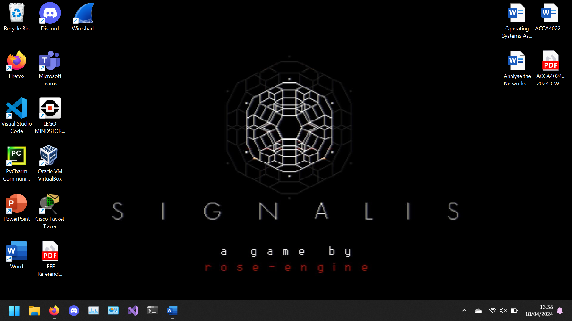
Or Command Line Interface (CLI):
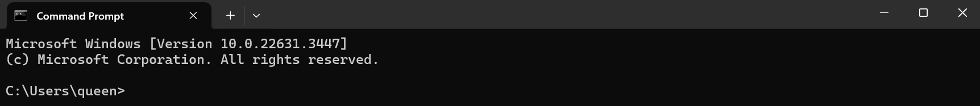
Through which a user can execute programs conveniently and efficiently [3]. Alternatively, instead of relying on user input, software can also make requests to the OS through a defined Application Program Interface (API) [4].
The core of the OS is known as the kernel. Loaded into memory from boot up to shut down, this specialised software is what allows the OS to act as the bridge between hardware and software, with responsibilities including allocation of memory to processes, switching of CPU time between processes, and the handling of interrupts – such as when opening other applications concurrently – preventing and mitigating conflicts between different processes [5] [6].
An OS has many ways it can support the hardware and software of a computer, with functions including:
- Memory and Process Management
Modern general operating systems are capable of multitasking, performing multiple operations and allowing different programs and software to run side by side [7]. To do this, an OS must also manage the memory, swapping between running, runnable and waiting processes. However, while this is simple to manage, design and implement, it often wastes memory space, due to the lack of support for multiple simultaneous programs. Thus, an OS can also use paging – where the memory is split into equal partitions that can be loaded or unloaded as needed [8].
Additionally, an OS can manage processes by splitting them into “threads”, which exist as processes within processes running in quasi-parallel. This allows individual processes (or multiple simultaneous processes, known as “multithreading”) to share the same address space and data within the CPU, which is more efficient; These mini-processes are lighter, i.e. easier and faster to create and destroy, and offer a performance boost to the system, allowing activities to overlap [9].
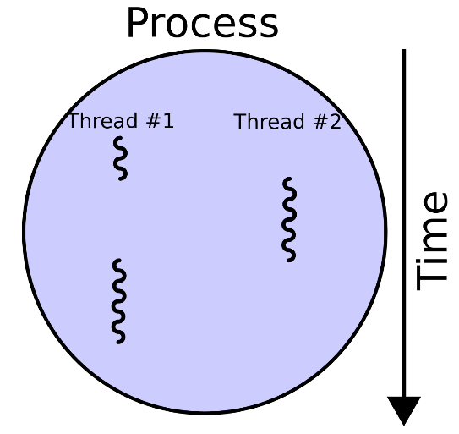[10]
- File Management
An OS can also provide a file management system. This file manager determines where and how files on a computer are stored (as well as making note of where in memory these are located), using available storage as efficiently as possible, while also providing efficient access to the files [11].
- Device Management (Input/Output Devices)
Operating Systems are responsible for the management and monitoring of device communication with the computer (through their respective drivers), usually through a dedicated device controller or manager [12], for example:
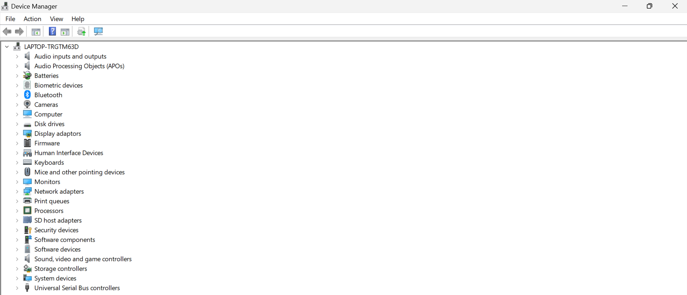
Input/Output devices are assigned to processes in accordance with their needs and priorities. When not in use, the OS may also deallocate devices, either temporarily or permanently [13]. A process may require various resources, such as CPU time, file access, access to disk drivers, and so on. If available, the OS will assign the necessary resources to the process – if not however, any allocation will be postponed until said resources become available.
Additionally, depending on the type of OS, some are more specialised towards other functions than others. For example, a Batch Operating System (BOS) is one that allows multiple users to use it, without direct communication between each other [14]. Because of this, a BOS will be very efficient in terms of resource usage, but managing the users themselves may be difficult, in part because users will need to wait their turn to make use of system resources [14]. However, this is only true in a simple BOS – the alternative solution to this would be to use a Multi-programming System, which allows for multiple simultaneous active users [15].
- Use of Windows OS CLI Commands
Windows has two main command line shells – the Command Prompt, and PowerShell. The former was the first to be developed, specialising in the automation of routine tasks through batch files (.bat), such as backups, account management, and logging [16]. Nevertheless, it is capable of many different tasks, with all versions of Windows containing a set of Win32 commands built in [16].
In a networking position, one of the most useful commands is “ipconfig,” which displays all current system TCP/IP network configuration values, including things like MAC addresses, IPv4 addresses, and IPv6 addresses; the command additionally refreshes DHCP and DNS settings [17]. For example:
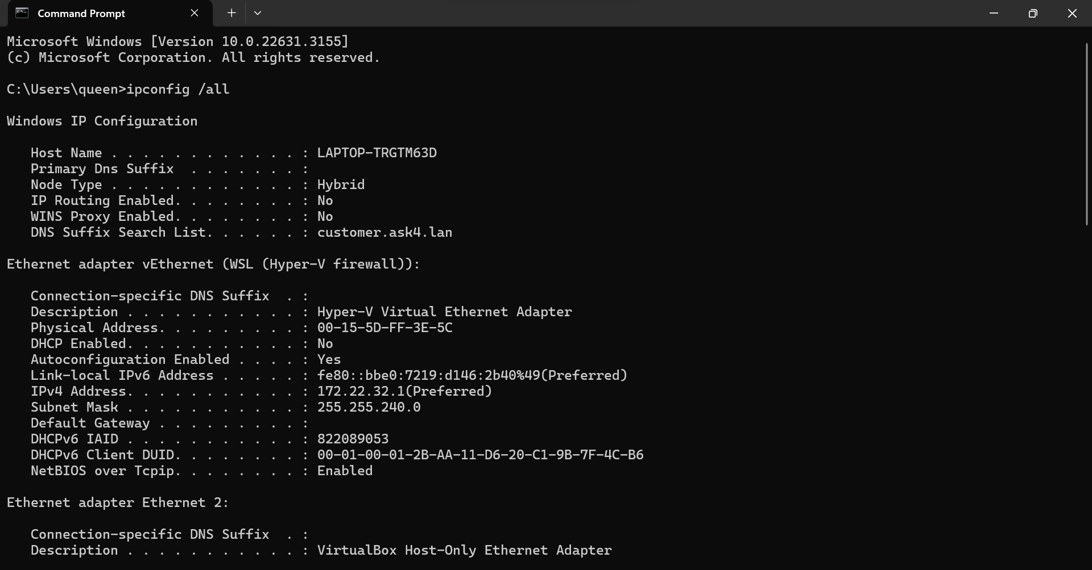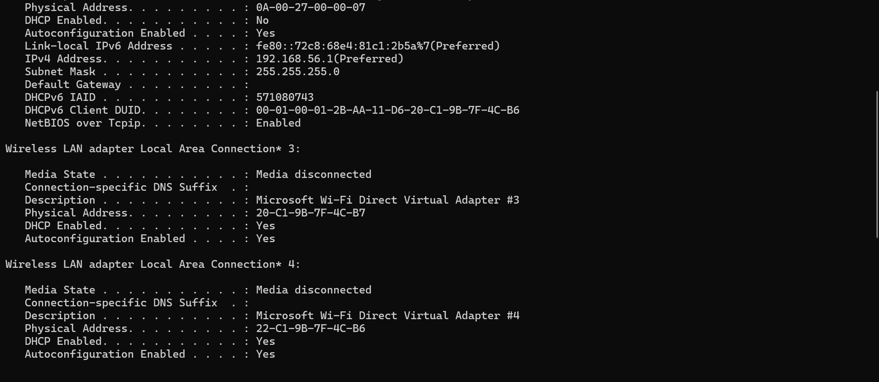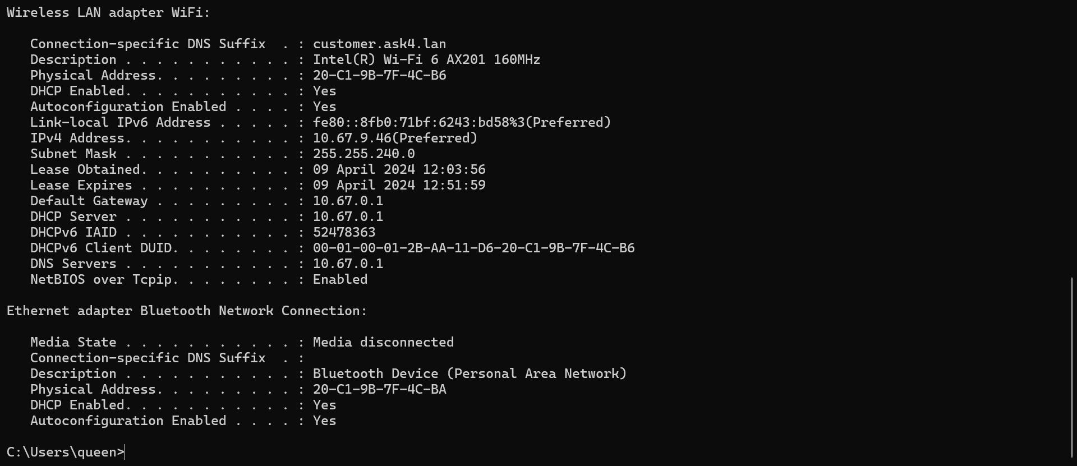
The above screenshot displays additional information due to the “/all” parameter added. This means the CLI will display the full TCP/IP configuration for all connected adapters, such as network cards and adapters, physical interfaces, and logical connections (such as dial-up connections) [17]. Other possible ipconfig parameters include:
- /displaydns
– Displays contents of the DNS client resolver cache.
- /flushdns
– Flushes and resets contents of the DNS client resolver cache.
- /registerdns
– Initiates manual dynamic registration for DNS names and IP addresses that are configured at a computer.
- /release [<adapter>]
– Sends a DHCPRELEASE message to the DHCP server to release the current DHCP configuration and discard the IP address configuration for either all adapters (if an adapter is not specified) or for a specific adapter if the adapter parameter is included.
- /release6 [<adapter>]
– Same as above, only the message is sent to the DHCPv6 server, discarding the IPv6 configuration for either all adapters, or a specified adapter.
- /renew [<adapter>]
– Renews DHCP configuration for all adapters (if an adapter is not specified) or for a specific adapter if the adapter parameter is included.
- /renew6 [<adapter>]
– Same as above, only it renews the DHCPv6 configuration instead.
- /setclassid <adapter>[<classID>]
– Configures the DHCP class ID for a specified adapter. To set the DHCP class ID for all adapters, use the asterisk (*) wildcard character in place of adapter.
- /showclassid [<adapter>]
– Displays the DHCP class ID for a specified adapter. Like /setclassid, asterisk can be used to show the DHCP class IDs for all adapters.
Following on from useful networking commands, the “arp -a” command-parameter pair displays entries in the Address Resolution Protocol (ARP) cache [18]. This contains one or more tables that store IP address and their resolved ethernet or token ring physical addresses, like so:
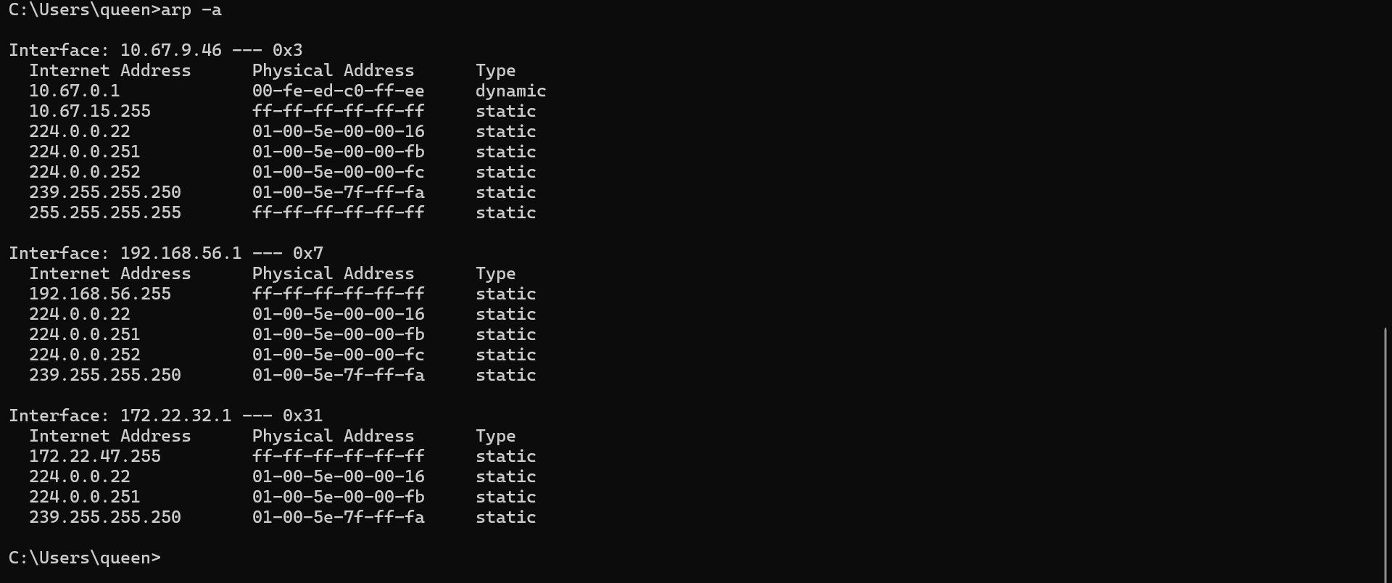
Used without parameters, “arp” displays help information:
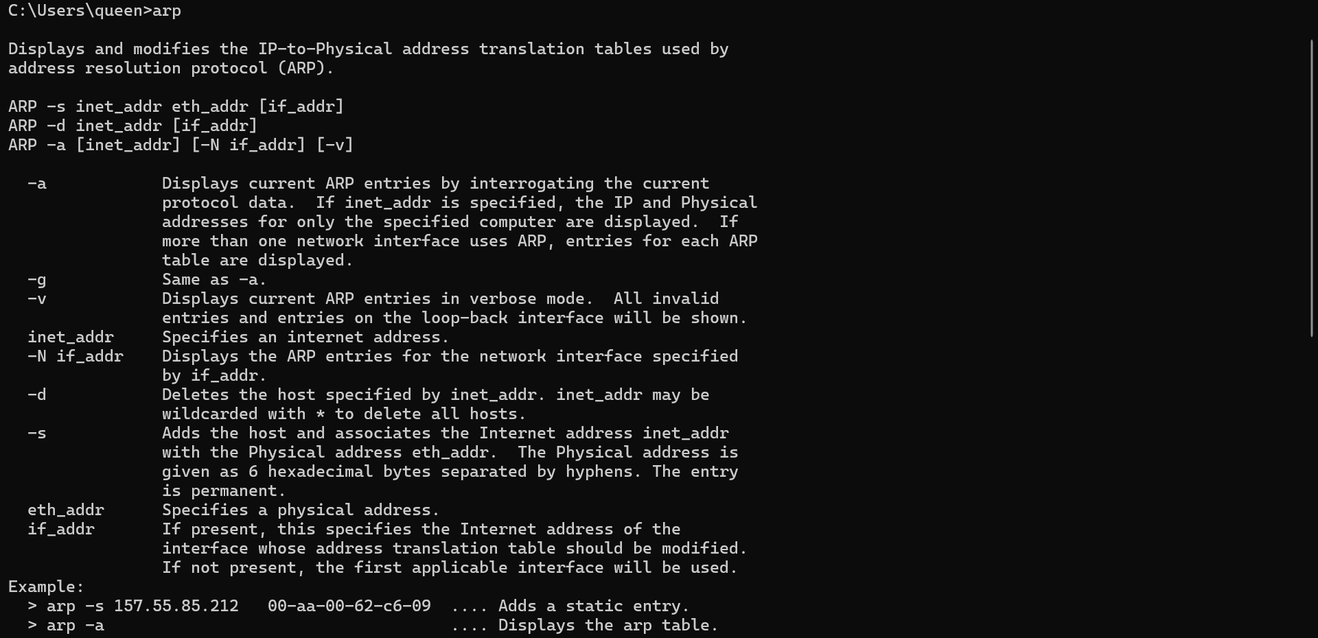
Another useful command is the “tasklist” command, which displays a list of all currently running processes on the computer (or on a remote computer) [19], like so (full list cropped for brevity):
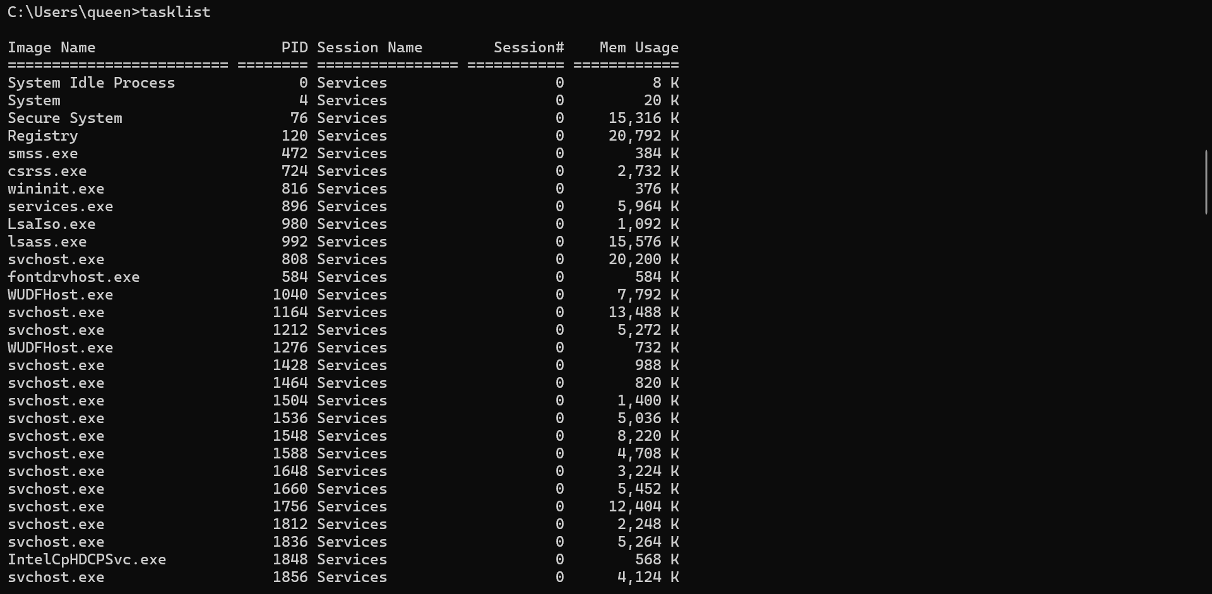
The tasklist command also has a list of associated parameters, allowing for extra detail (such as with “/s”, which specifies the name or IP address of a remote computer), changing the output format (such as “/fo {table | list | csv}”, with the default value being table, as seen in the screenshot above), or filtering for certain processes (such as with “/fi <filter>”). While most users may want to simply use Task Manager, or another associated system performance monitoring program, some systems may not have access to these programs. Additionally, the csv format specifically can be used to export the tasklist to a file, which could be used for reporting and logging purposes.
Similar to “ipconfig”, the “netstat” command displays active TCP connections, and when parameters are included, can also display ports on which the computer is listening, ethernet statistics, the IP routing table, IPv4 statistics, and IPv6 statistics [20]. Used on its own, it only displays TCP connections, as shown:
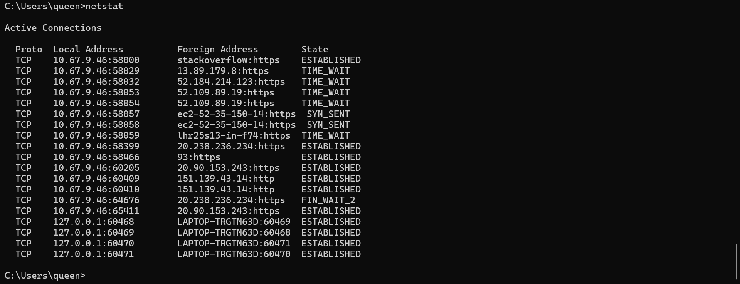
The next Windows OS CLI command examples will use PowerShell. Microsoft defines PowerShell as “a cross-platform task automation solution made up of a command-line shell, a scripting language, and a configuration management framework” [21]. Unlike the Command Prompt, PowerShell is a cross-platform program, meaning it can run on Windows, Linux, and MacOS. Additionally, it also accepts and returns .NET objects, instead of only accepting and returning plain text [21].
Also unlike the Command Prompt, PowerShell makes use of cmdlets, which exist as instances of .NET classes, rather than standalone commands and executables [22]. These cmdlets are named in a verb-noun pair, for example, “Get-Command,” which lists all cmdlets registered in the command shell (screenshot heavily cropped for brevity. The list also includes the Function and Cmdlet Command Types.):
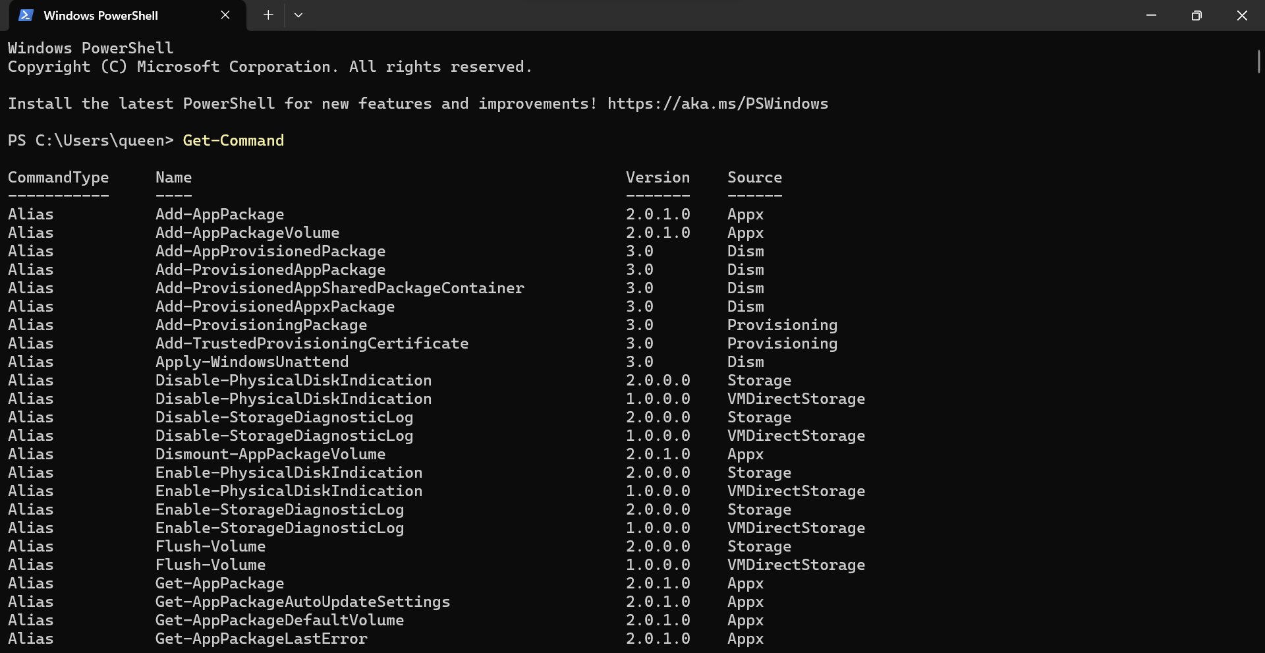
Similar to the Command Prompt’s tasklist command, PowerShell has “Get-Process”, which “gets” the processes on a local computer [23]:
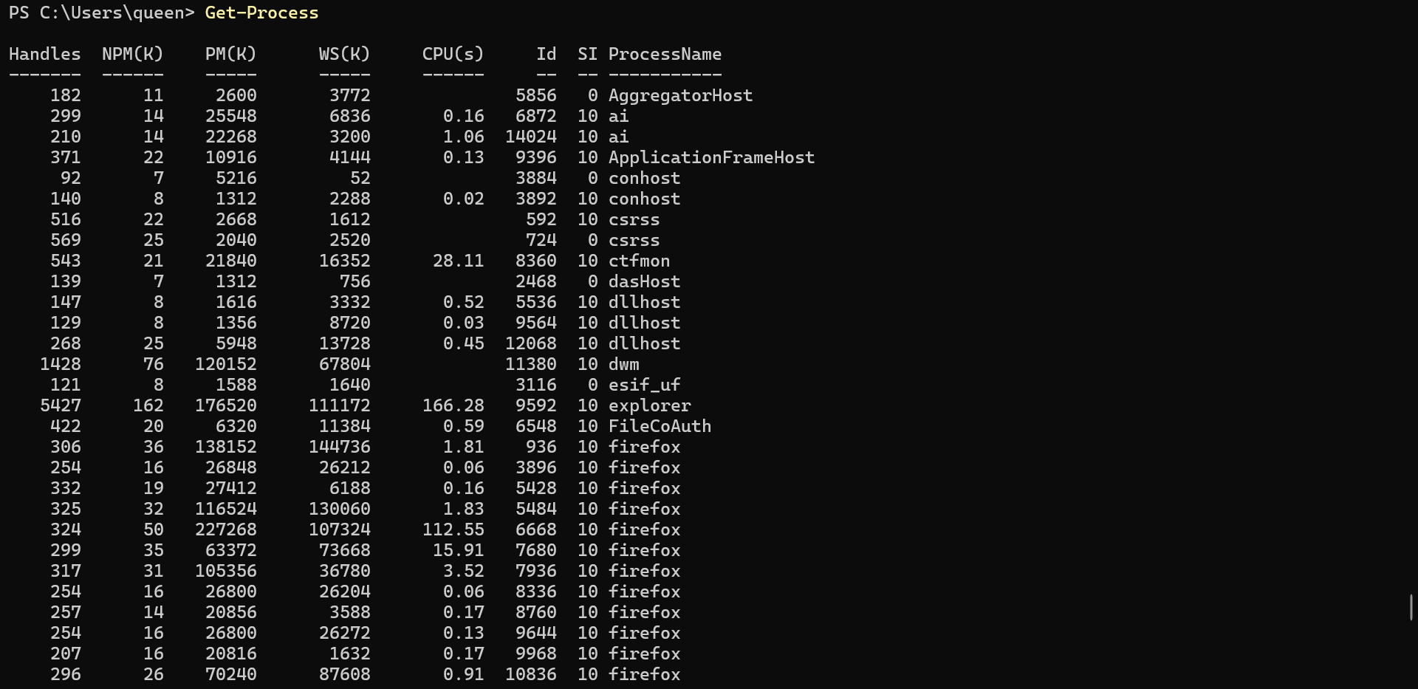
Without any parameters, this gets all processes. This can be shortened slightly by “piping” (passing a process object) “more”, which separates the processes table into pages, like so:
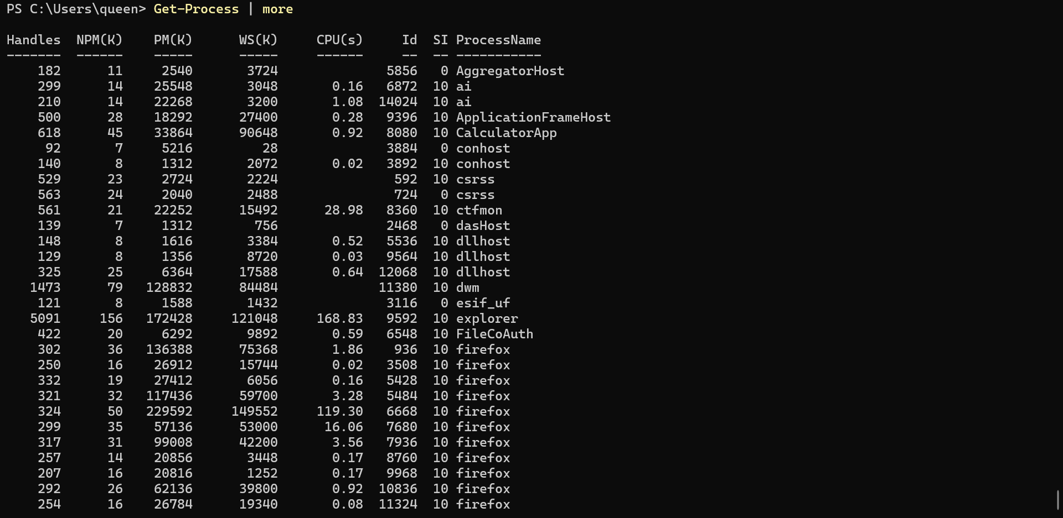
From here, pressing enter (paging) will display more output, one process at a time. Like the Command Line, the Get-Process table can then be exported to csv for logging and reporting purposes.
PowerShell can also be used to start (one or more) programs and processes using the “Start-Process” cmdlet. By default, this will create a new process that “inherits all the environment variables that are defined in the current process” [24]. The syntax of Start-Process necessitates the inclusion of the program/process. Below is an example which opens the task manager:
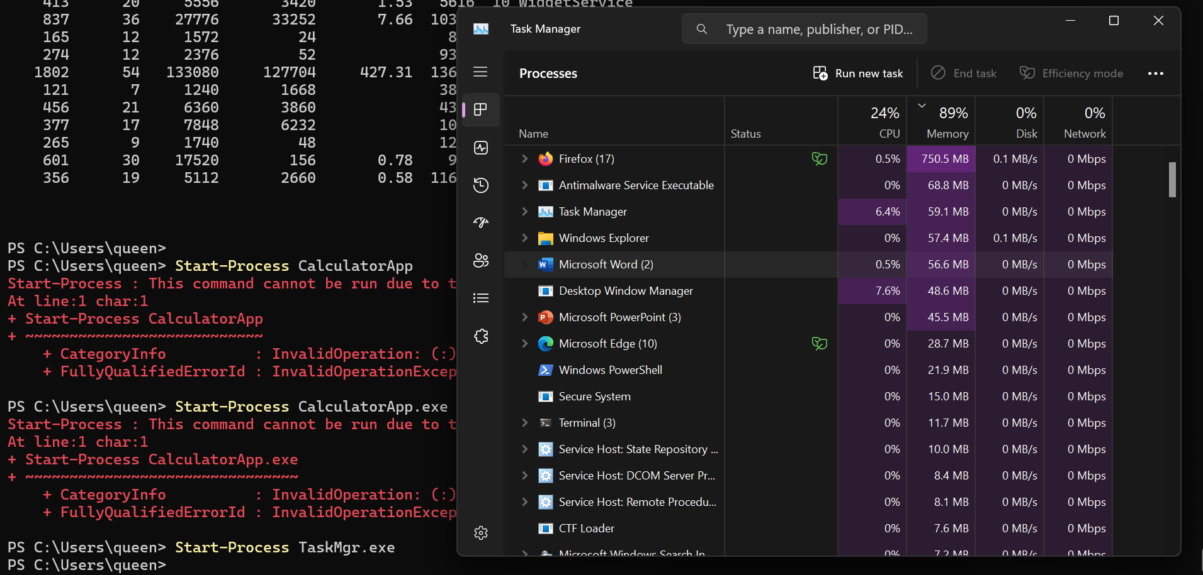
Likewise, PowerShell can also stop (one or more) processes. The process can be specified by including the process name or ID (the latter of which can be found through Get-Process). Alternatively, the process object can be passed to Stop-Process [25]. For example, using the calculator app, first the ID is found using Get-Process:
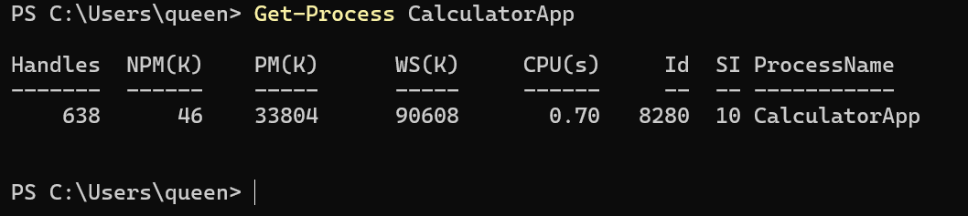
Then, using the process ID (8280), the program is closed using Stop-Process:
- Use of Linux OS CLI Commands
First developed by Linus Torvalds and the Free Software Foundation in the early 1990s, the Linux kernel (and later the complete GNU/Linux OS) was developed as an offshoot to MINIX, a UNIX OS [26]. Because of this, Linux makes use of CLIs called terminals, usually running the bash shell (Bourne Again SHell) [27]. Unlike the Windows CLIs above, Bash boasts high levels of personalisation and customisation, notably allowing users to create aliases (custom shortcuts for frequently used commands, or groups of commands) and fine-tune environment variables, on top of the usual CLI scripting capabilities [28].
Before making in-depth use of the terminal however, users should familiarise themselves with the Linux file system. In brief, most Linux distributions use “ext” – Extended File System – with most modern distros using the ext4 version. This system was initially designed to implement a virtual file system, handling file systems up to 2 gigabytes [29]. For reference, ext4 is built to handle 1 exabyte [30].
Linux organises everything from a “root,” with individual directories branching out like a tree – hence the name:
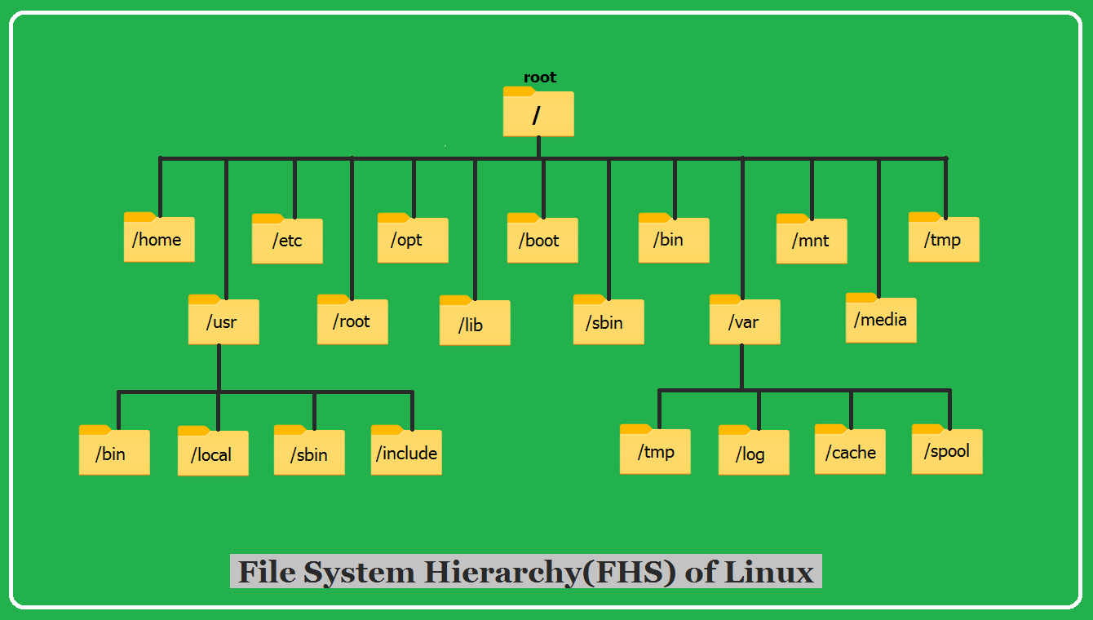[31]
Thus, one of the more useful Linux CLI commands to know is “pwd” (print working directory), which displays the path name of the working directory, outputting the full path from the root directory [32]. The output returns as follows; note that the following screenshots are taken from a Windows command prompt using Windows Subsystem for Linux, running the Ubuntu distro.
The line “/home/stargale” denotes three directories – first, the root directory, represented by the first forward slash. The root directory contains the home directory, which itself contains the “stargale” directory, the author’s current user directory.
A user may wish to work from a specific directory, however – in this case, they may use the “cd” (change directory) command. As the name implies, this changes the working directory of the current shell execution environment [33]:

When cd is input on its own (i.e. no operand is provided), it defaults to certain behaviours. Given that /home is set to a non-empty value (contains /stargale, as seen in line 3), cd behaves as if the directory named in /home was specified as the cd operand [33]. Thus, when an operand is provided, as is the case in line 4, cd changes the working directory to /home. Note how the shell prompt changes from “stargale@LAPTOP-TRGTM63D:~$” to “stargale@LAPTOP-TRGTM63D:/home$,” reflecting this change.
While the above commands have focused on directories, these will contain various files that a user may want to interact with in some way. For this, they may use the “ls” (list) command. On its own, “ls” lists all the files in the current directory, save for any hidden files [34]:
This output, however, only prints the names of files. For more detailed output, a user may then make use of the -l operand, which prints a long listing:
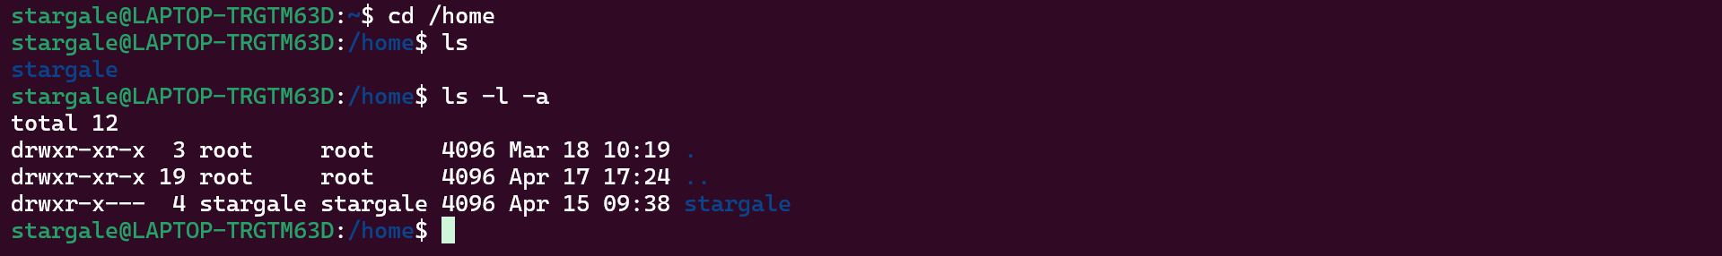
This prints various columns, describing:
- Type of file and its permissions (e.g. the “stargale” file is of type “d,” or directory, with “rwxr-x---” permissions)
- Number of links to the file (usually meaning the number of names there are for a given file. A directory tends to have multiple, e.g. “stargale” could be referred to as just that, or “stargale/.”)
- User owner of the file
- Group of users to which the file belongs
- File size (in bytes)
- Time at which the file was last changed (for a directory, this is usually the time it was last created or deleted)
- File name (in blue – note how the two root files are hidden, as they start with a dot)
For reference, the -a operand was used alongside -l to display hidden files [34].
Now that a user knows which directory they are working in, as well as what contents are listed within, they may wish to add a file. To do this, a user could use the “cat” (concatenate) command. While “cat” is typically used to view the contents of files, printing the output to the terminal, it can instead be redirected to allow for input [35]:
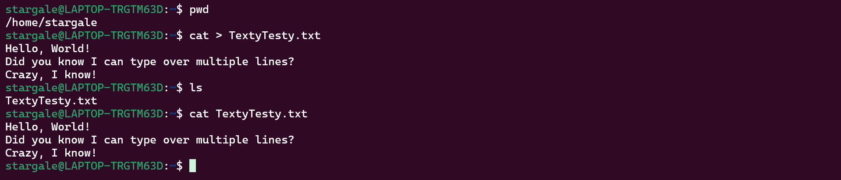
Once redirected, input can be added line by line, pressing Enter to progress. To finish, Ctrl+D exits the file. To check the file is made, ls is used, followed by cat TextyTesty.txt to display the named file’s contents.
Alternatively, one can use the “touch” command. Like “cat,” the “touch” command’s main function is not to make files. Instead, it attempts to set the modified date of a file, done by reading a character from the file, and then writing it back [36]. If the specified file does not exist however, touch will instead create it:

This creates an empty file – when cat is used alongside this new file, nothing is returned.
Briefly mentioned above in the “ls” command demonstration were permissions. This is split into four parts – the file type, user owner permissions, group owner permissions, and all other user permissions. Each set is then split further into the specific permissions – read, write, and execute [37]. For example:
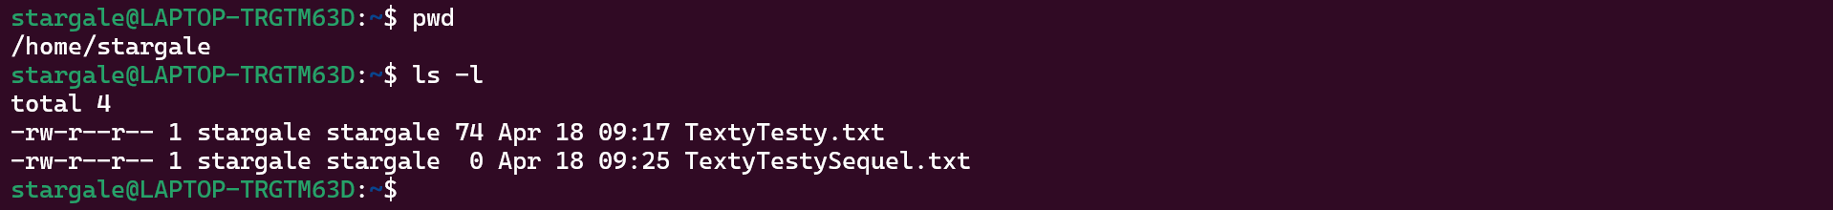
The files made during the “cat” and “touch” demonstrations both have the same permissions. First, focusing on TextyTesty.txt, the first hyphen denotes an ordinary file. The next three characters denote read/write/execute permissions for the user owner – in this case “stargale.” As permissions are “rw-“, the user owner can only read the file, and edit it. Currently, running the file as a program is not permitted. The following three denote group permissions – currently limited to read permissions – with the last three permissions (all other users) following suit [38].
To change file and directory permissions, a user could use the “chmod” (change mode) command, which is capable of “changing the file mode bits of each given file according to mode, which can either be a symbolic representation of changes to make, or an octal number representing the bit pattern for the new mode bits” [39]. For example, for collaboration purposes, a user may wish to change group permissions to allow for file editing, like so:
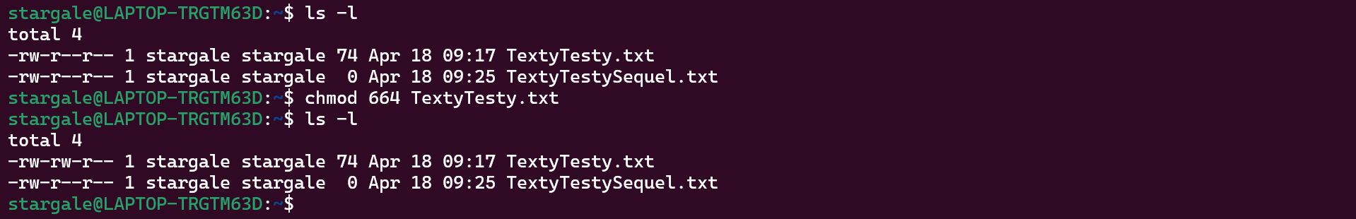
Now, the TextyTesty.txt file can be edited by any users in the “stargale” group. Notably, this was done by using octal values. When changing permissions, a set of 3 octals are used, relating to user, group and other respectively. So, the 664 octal set used above denotes 6 for user (i.e. rw- permissions), 6 for group, and 4 for other (i.e. r—permissions).
For a full list of octal value permissions:
Octal Values | File Permissions Set | Permission Descriptions
0 | --- | No permissions
1 | --x | Execute permissions
2 | -w- | Write permissions
3 | -wx | Write and execute permissions
4 | r-- | Read permissions
5 | r-x | Read and execute permissions
6 | rw- | Read and write permissions
7 | rwx | Read, write and execute permissions
[40]
As for the fine-tuning of environment variables, a good command to use is the “top” command. This provides a real-time view of the running system, sorting active running processes by CPU usage in descending order [41], like so:
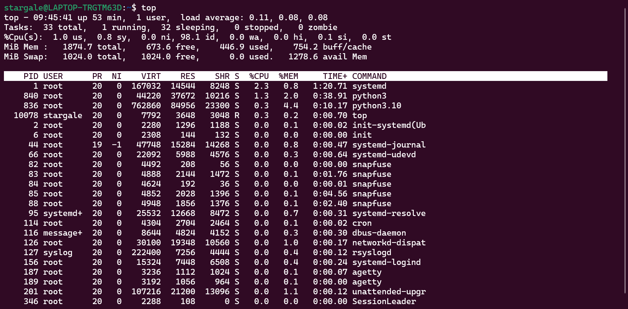
From here, a user is capable of monitoring and analysing active processes, sorting by certain criteria (e.g. Shift+P sorts all processes by CPU usage, killing processes (“k” followed by PID), as well as many others:
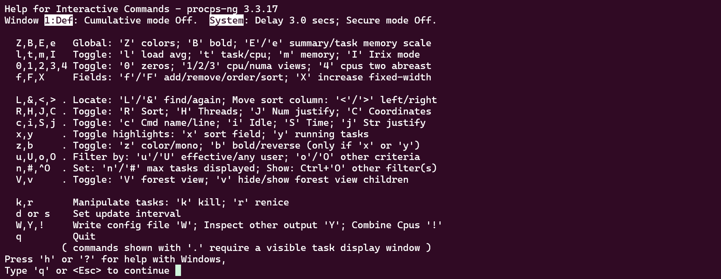
For networking positions, an administrator may need to log a system’s performance. The “top” command can use the -b operand (starts “top” in batch mode, useful for sending output to other programs or files) [42], redirected to overwrite a pre-existing file, like so:
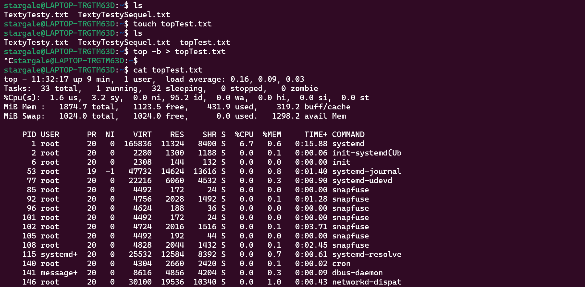
Conversely, for a little more benchmarking, the “neofetch” command can be used. This command script outputs a basic system info screen, displaying information such as the OS, kernel, memory usage, and more [43].
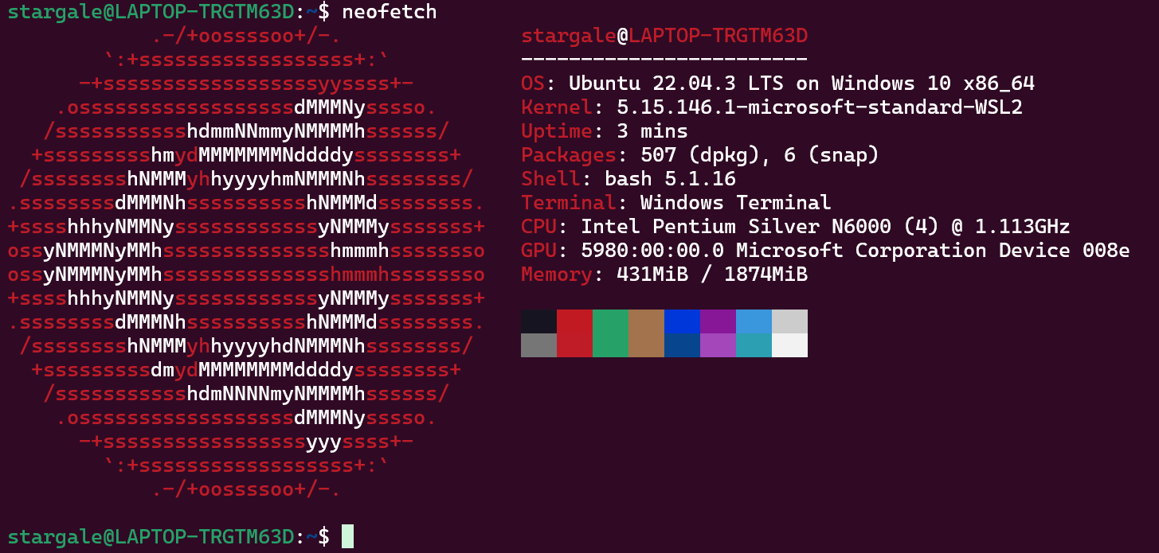
And for network configuration purposes, one may use the “ifconfig” (interface configuration) command, which displays and manages IP address and network interfaces [44], similar to the Windows Command Prompt’s “ipconfig” command. Without any arguments or operands, “ifconfig” displays the status of all currently active interfaces, as shown below:
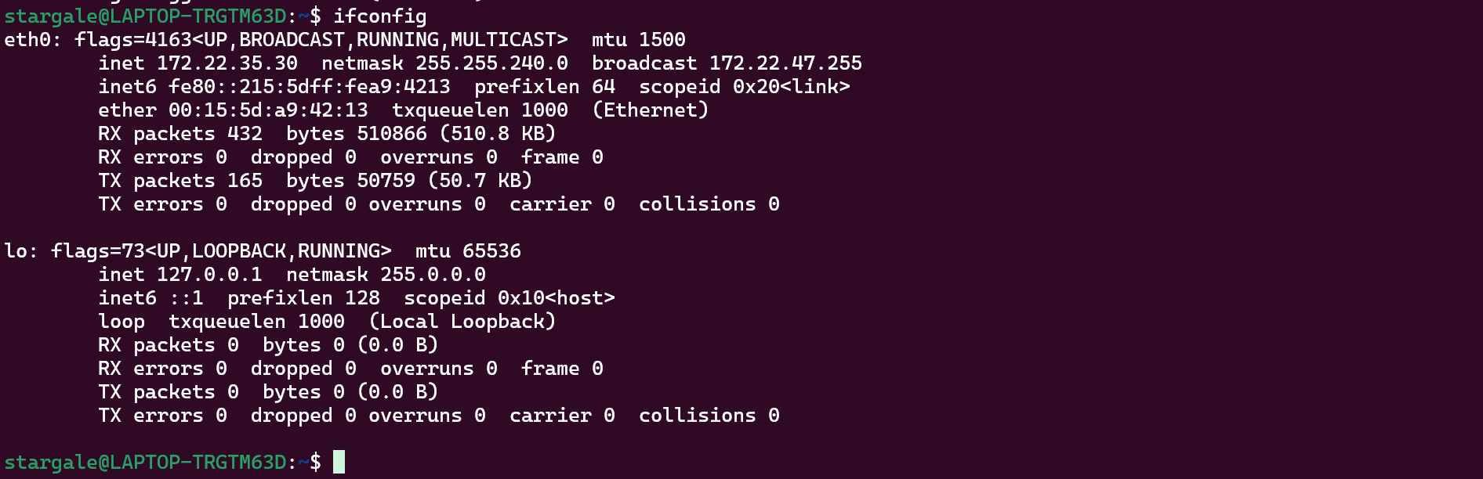
- Use of Windows OS Scripts
While singular commands in the Command Prompt and PowerShell are varied and powerful on their own, some tasks necessitate long combinations of commands, whether for complex jobs (such as network configuration), repeat processes (like scheduled backups or logs), automation, and so on. For ease of use, users may choose to create scripts – series of commands stored in plain text files which can be passed off and executed as command line arguments [45]. Below are several PowerShell scripts, written in Visual Studio Code, demonstrating the use of common programming techniques.
  - Variables
Code:
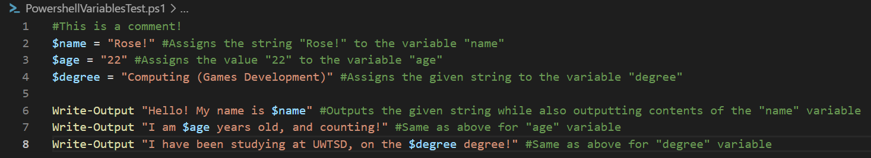
Variables in PowerShell are denoted by strings which begin with a dollar sign, such as the $name variable above. Unlike other programming languages, PowerShell allows for variable names which include spaces and special characters [46].
Output:
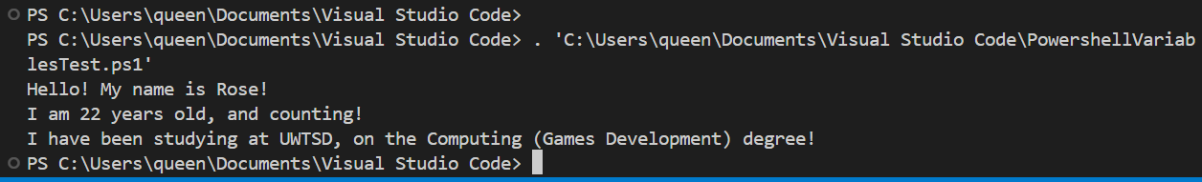
  - Switch
Code:
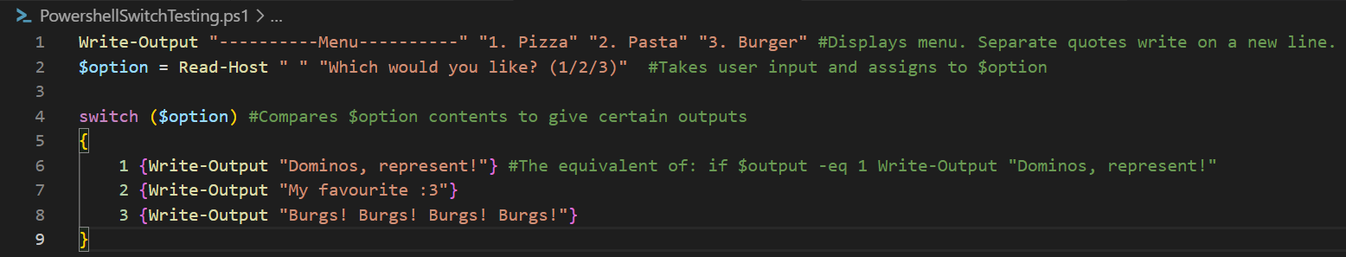
While an if statement is useful on its own, sometimes a user may want to check for multiple possible outcomes. For this, the switch statement exists, acting as a series of if statements. First, the variable to be tested is placed in the switch brackets. From there, results to be matched with the test variable are listed, with equivalent actions nestled alongside match results. Expressions to be matched can include literal values (strings and integers), variables, and “scriptblocks that return a boolean value” [47].
Also of note: Read-Host allows for user input from the console.
Output:
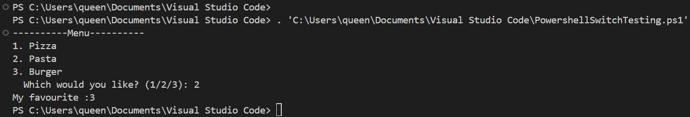
  - If Statement
Code:
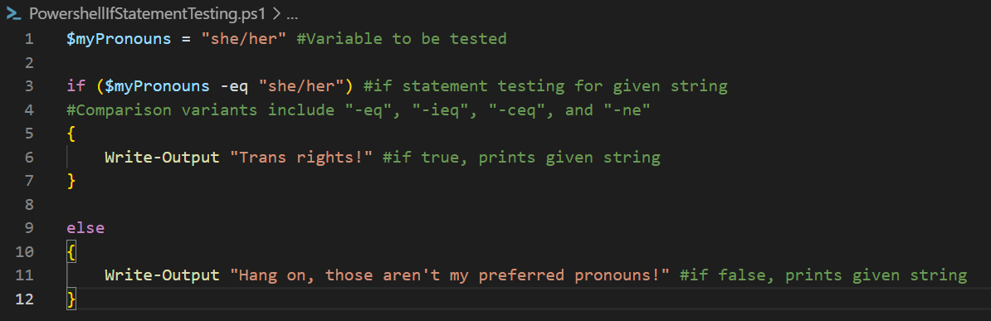
Most programming languages allow for comparison using “==”, but PowerShell needs to use “-eq”. This compares the value on the left with the value on the right within an if statement. Usually this comparison is case insensitive, but if necessary, “-ceq” can be used for case sensitive comparison. Additionally, testing for inequality can be done with “-ne.” [48]
Output:
  - Loop
Code:
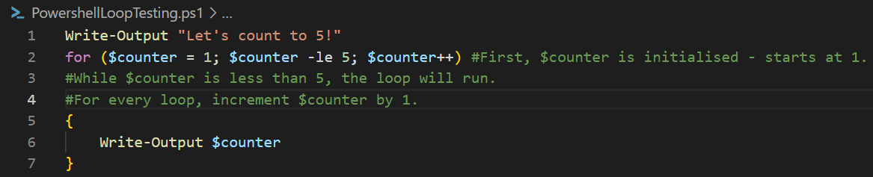
For loops in PowerShell follow a familiar syntax of initialisation, ending conditions, and increments. First, $counter is initialised and defined, starting at 1. While $counter is less than 5, the loop will run. After a loop has run, the $counter will increment by 1 [49].
Output:
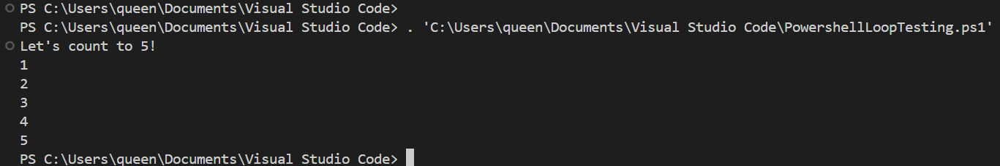
  - Array
Code:
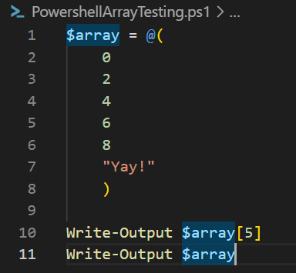
Arrays in PowerShell are also decently familiar. When assigning a variable, the “@()” syntax defines an array. When outputting, either an individual array element can be called (see above, line 10), or the entire array at once [50].
Output:
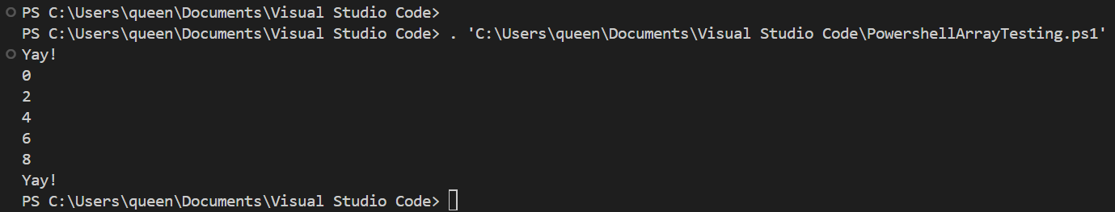
  - Function
Code:
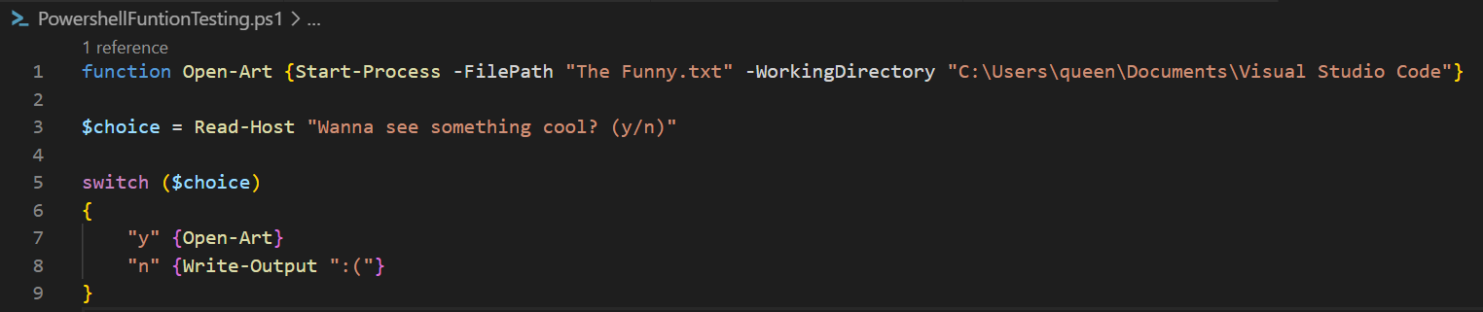
Functions are designed to help with repeat processes – less so like a for loop. Instead, it provides a method whereby code can be re-used, or for custom commands, like the above. By definition, a function is a list of statements with a name (following Pascal case, with an approved verb-noun pair) assigned by the user [51] [52].
The above function “Open-Art” opens a text file called “The Funny.txt,” which contains some ASCII art. For Start-Process to work, the function needs to know the process’ name (denoted by -FilePath), as well as where it is stored (denoted by -WorkingDirectory) [53].
Output:
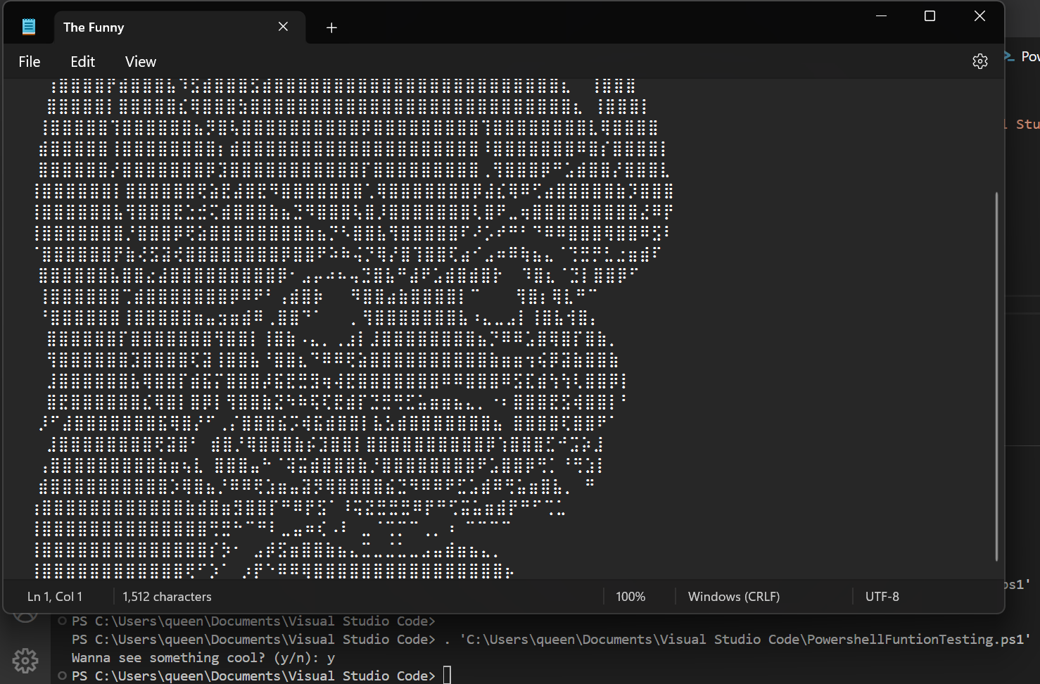
- Use of Linux OS Scripts
This section aims to demonstrate some simple bash scripting and syntax. Like section 5, the following script examples will be made in Visual Studio Code – specifically in GitBash. Scripting can also be done in a Linux terminal as well, using “cat > (FileName).sh.” Alternatively, as python comes pre-installed with most Linux distros, coding can instead be done by typing “python” into the terminal:
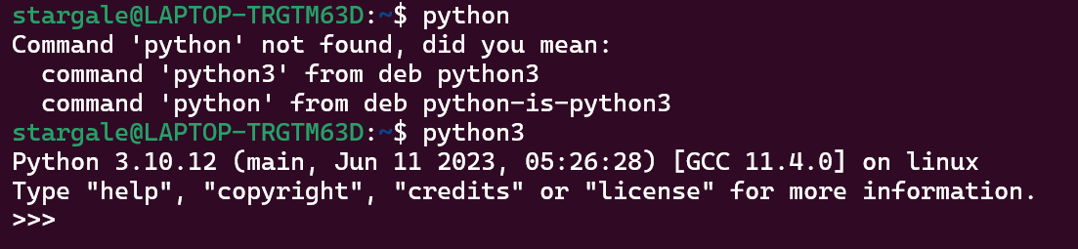
  - Variables
Code:
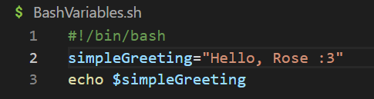
Variable values in bash are assigned without the need for prior declaration. However, when calling a variable, the value must be retrieved explicitly – done by preceding the variable with a dollar sign [54]. If done without, the echo operation will instead print “simpleGreeting” to the console.
Also of note: all bash scripts should begin with “#!/bin/bash” – This is a shebang line that tells the shell interpreter to recognise bash. While most Linux systems will default to bash, scripts could be written in any number of programming languages [55].
Output:
“echo $simpleGreeting” variant:
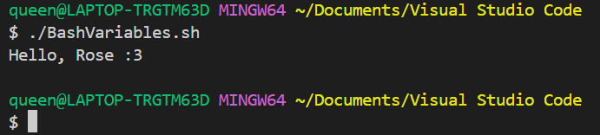
“echo simpleGreeting” variant:
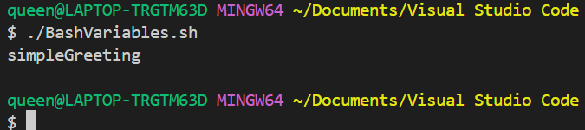
  - Case Statements
Code:
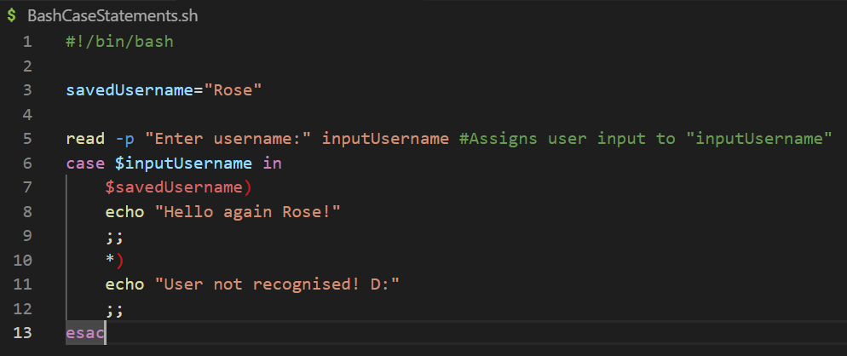
Like PowerShell’s switch case, bash allows for the implementation of case statements. Case statements follow a pattern whereby an expression or variable is evaluated against different patterns to find a match [56]. The above code takes user input (using read -p), assigning it to a new variable, inputUsername. From there, two case statement patterns exist; The first, “$savedUsername,” checks to see if $inputUsername and $savedUsername are the same. In this case, it should be Rose. If this is true, the following string is echoed to the console. The two semi-colons following indicate the end of a case block. The other case acts as an overarching “else” umbrella, known as the default case [57], where any input that does not match $savedUsername follows this case. Finally, the “esac” keyword signals the end of the case statements.
Output:
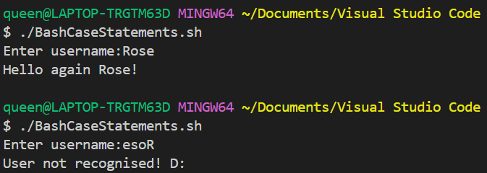
  - If Statement
Code:
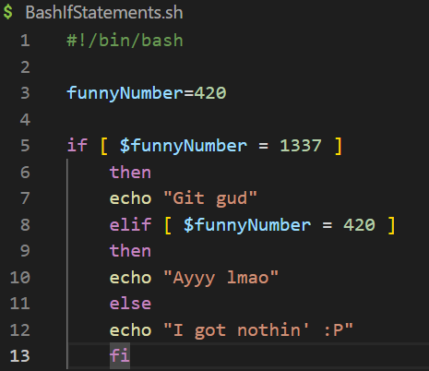
If statements in bash work by running a test command. If this command returns as “0,” the following consequent commands are executed. The following “then” keyword is used to enable any Unix command, program, shell script or statement toexecute. Finally, the “fi” keyword denotes the end of the test/consequent commands [58] [59].
Output:
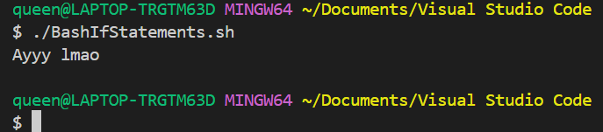
  - Loop
Code:
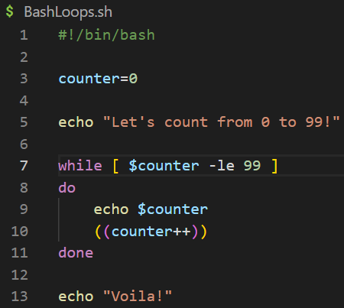
The given while loop runs any commands between “do” and “done” if the test command returns 0, i.e., is true. In this case, while $counter is less than 99, the while loop will print the value stored in $counter to the terminal, and then increment it by 1 [60].
Output:
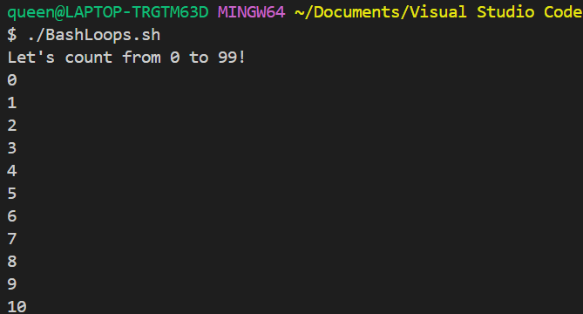
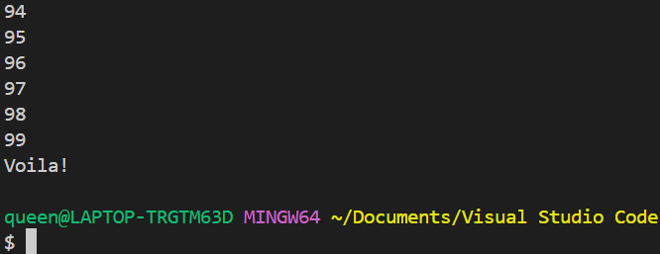
  - Array
Code:
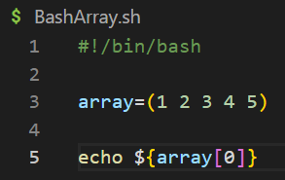
Arrays in bash can be indirectly declared at variable creation, like above. To declare variables explicitly, one may use “declare -a arrayName”. Accessing array elements use the syntax “${array[]}”, where the curly brackets denote the access of a single item of an array. Following from there, an array element can be specified in the square brackets (e.g. “echo ${array[4]}” should print the 5th array element, “5” – remember that arrays begin from a zero index). If an asterisk or “@” is input to the square brackets, all members of the array are referenced [61].
Output:
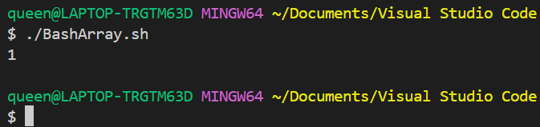
  - Function
Code:
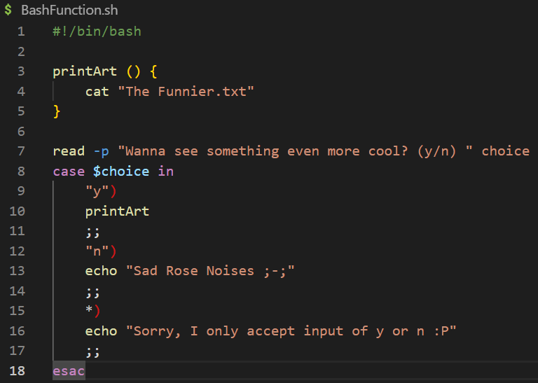
Functions can be defined in bash by entering a function name, followed by parentheses and curly brackets – the latter of which contains the body of the function, housing any commands. Alternatively, a function could be made by typing:
function functionname {
commands
}
[62]
Output:
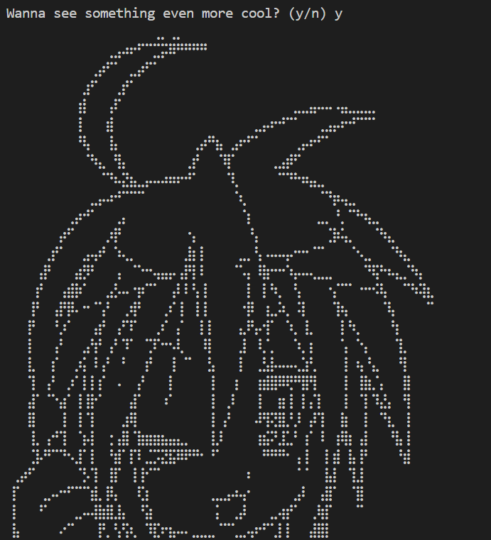
  - Snake Game
Code:
The following is not the author’s own code – this is to demonstrate more advanced use of bash.
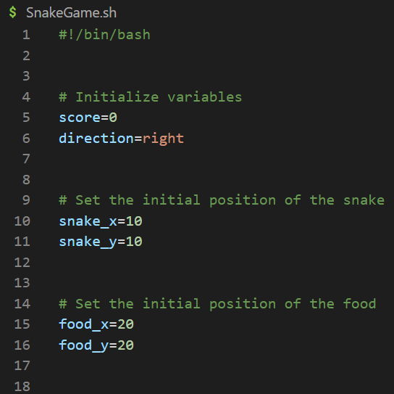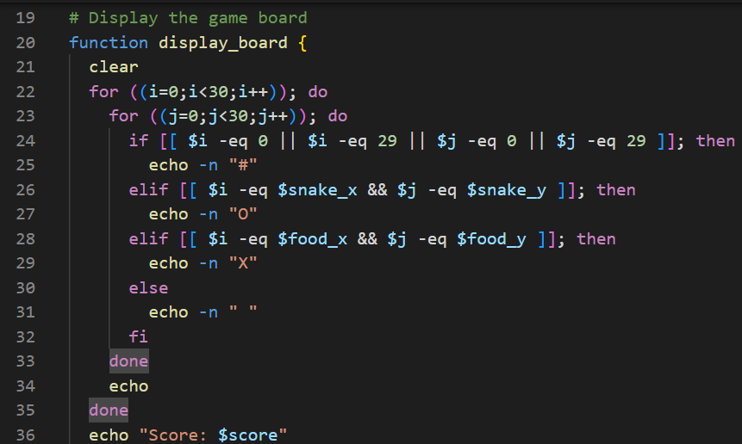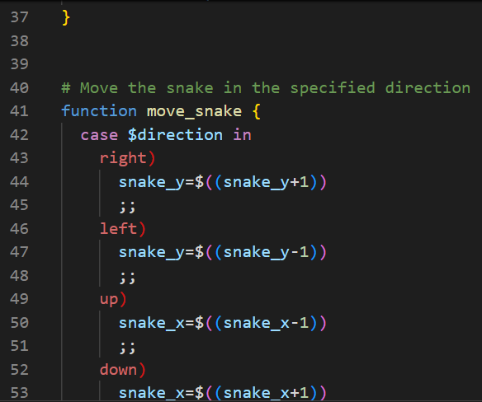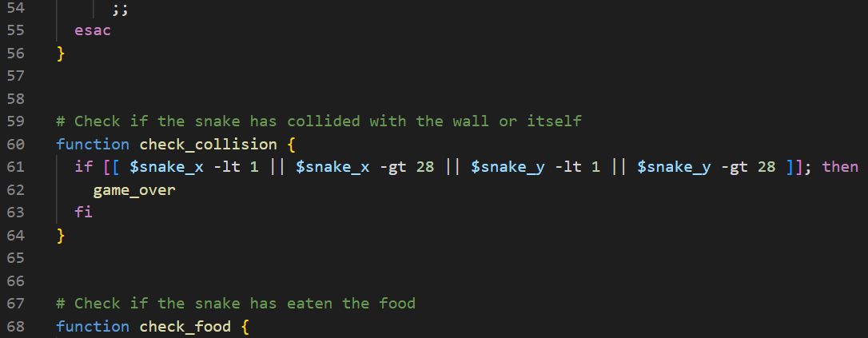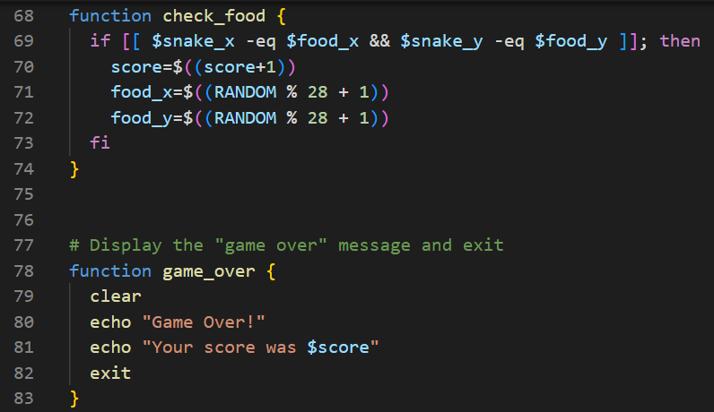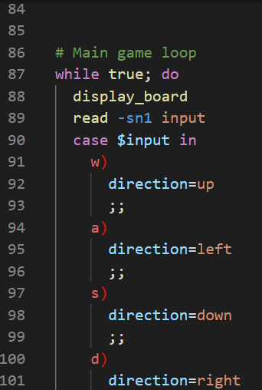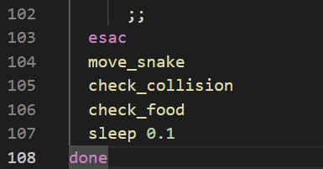
[63]
Output:
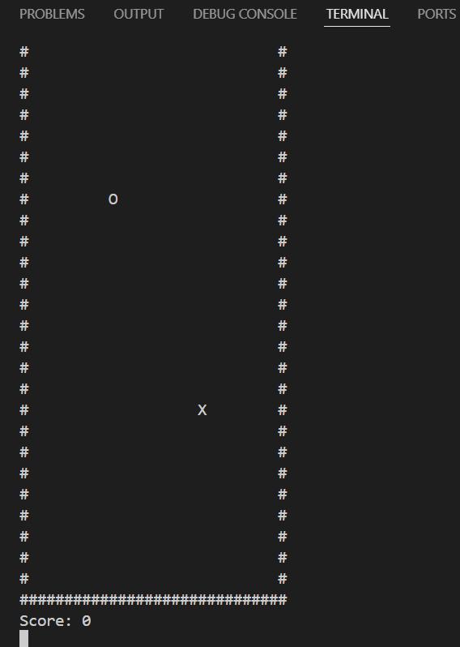
- Conclusion
In terms of software, the OS is potentially the most important piece, providing a user the means by which they can interact with underlying system software and hardware. While this can be done through a GUI, as is the case with all modern Windows operating systems, the CLI provides some of the most powerful options, be it for moderation, modification, assessment, management, and so on. And, while the commands demonstrated above have given a short introduction, the applications and potential learning of the environment, shells and languages, such as batch and bash for Windows and Linux respectively, are broad and highly in-depth. Given an understanding of OS functions and architecture (kernel versus shell for instance), one could potentially create their own, or apply their understanding to further inform use of the CLI.

- References
[1] “Types of Operating Systems (With OS Functions and Examples),” Indeed.com. [Online]. Available: https://www.indeed.com/career-advice/career-development/types-of-operating-systems. [Accessed: 01-Feb-2024].
[2] “Computer basics: Understanding Operating Systems,” Gcfglobal.org. [Online]. Available: https://edu.gcfglobal.org/en/computerbasics/understanding-operating-systems/1/. [Accessed: 01-Feb-2024].
[3] “Functions of operating system,” GeeksforGeeks, 11-Dec-2018. [Online]. Available: https://www.geeksforgeeks.org/functions-of-operating-system/. [Accessed: 08-Feb-2024].
[4] S. J. Bigelow, “What is an operating system?,” WhatIs, 27-Apr-2023. [Online]. Available: https://www.techtarget.com/whatis/definition/operating-system-OS. [Accessed: 01-Feb-2024].
[5] “What is a kernel?,” Codecademy Blog, 05-Oct-2023. [Online]. Available: https://www.codecademy.com/resources/blog/kernel/. [Accessed: 15-Apr-2024].
[6] “Kernel Definition,” Linfo.org. [Online]. Available: https://www.linfo.org/kernel.html. [Accessed: 15-Apr-2024].
[7] “Computer systems - AQA - Functions of Operating Systems,” BBC Bitesize. [Online]. Available: https://www.bbc.co.uk/bitesize/guides/zkkkw6f/revision/5. [Accessed: 08-Feb-2024].
[8] “Memory Management in Operating Systems,” www.javatpoint.com. [Online]. Available: https://www.javatpoint.com/memory-management-operating-system. [Accessed: 08-Feb-2024].
[9] A. S. Tanenbaum and H. Bos, Modern operating systems, Global edition, Fourth edition. Harlow, England: Pearson, 2014.
[10] “Thread (computing),” Wikipedia, The Free Encyclopedia. [Online]. Available: https://en.wikipedia.org/w/index.php?title=Thread_(computing)&oldid=1213198742. [Accessed: 16-Apr-2024].
[11] D. Goodwin, “Operating Systems Lecture #5: File Management,” Warwick.ac.uk, 25-Feb-2013. [Online]. Available: https://warwick.ac.uk/fac/sci/physics/research/condensedmatt/imr_cdt/students/david_goodwin/teaching/operating_systems/l5_filemgt2013.pdf. [Accessed: 08-Feb-2024].
[12] “Device Management in Operating System,” www.javatpoint.com. [Online]. Available: https://www.javatpoint.com/device-management-in-operating-system. [Accessed: 16-Apr-2024].
[13] “Device Management in Operating Systems,” GeeksforGeeks, 23-Jul-2023. [Online]. Available: https://www.geeksforgeeks.org/device-management-in-operating-system/. [Accessed: 16-Apr-2024].
[14] “Notes on Batch Operating System,” Unacademy, 11-Apr-2022. [Online]. Available: https://unacademy.com/content/bank-exam/study-material/computer-knowledge/notes-on-batch-operating-system/. [Accessed: 11-Mar-2024].
[15] “Batch Operating System,” www.javatpoint.com. [Online]. Available: https://www.javatpoint.com/batch-operating-system. [Accessed: 11-Mar-2024].
[16] “Windows Commands,” Microsoft.com. [Online]. Available: https://learn.microsoft.com/en-us/windows-server/administration/windows-commands/windows-commands. [Accessed: 09-Apr-2024].
[17] “ipconfig,” Microsoft.com. [Online]. Available: https://learn.microsoft.com/en-us/windows-server/administration/windows-commands/ipconfig. [Accessed: 09-Apr-2024].
[18] “arp,” Microsoft.com. [Online]. Available: https://learn.microsoft.com/en-us/windows-server/administration/windows-commands/arp. [Accessed: 09-Apr-2024].
[19] “tasklist,” Microsoft.com. [Online]. Available: https://learn.microsoft.com/en-us/windows-server/administration/windows-commands/tasklist. [Accessed: 09-Apr-2024].
[20] “netstat,” Microsoft.com. [Online]. Available: https://learn.microsoft.com/en-us/windows-server/administration/windows-commands/netstat. [Accessed: 09-Apr-2024].
[21] “What is PowerShell?,” Microsoft.com. [Online]. Available: https://learn.microsoft.com/en-us/powershell/scripting/overview?view=powershell-7.4. [Accessed: 09-Apr-2024].
[22] “Cmdlet overview,” Microsoft.com. [Online]. Available: https://learn.microsoft.com/en-us/powershell/scripting/developer/cmdlet/cmdlet-overview?view=powershell-7.4. [Accessed: 09-Apr-2024].
[23] “Get-Process,” Microsoft.com. [Online]. Available: https://learn.microsoft.com/en-us/powershell/module/microsoft.powershell.management/get-process?view=powershell-7.4. [Accessed: 09-Apr-2024].
[24] “Start-process,” Microsoft.com. [Online]. Available: https://learn.microsoft.com/en-us/powershell/module/microsoft.powershell.management/start-process?view=powershell-7.4. [Accessed: 09-Apr-2024].
[25] “Stop-process,” Microsoft.com. [Online]. Available: https://learn.microsoft.com/en-us/powershell/module/microsoft.powershell.management/stop-process?view=powershell-7.4. [Accessed: 09-Apr-2024].
[26] The Editors of Encyclopedia Britannica, “Linux,” Encyclopedia Britannica. 11-Nov-2008.
[27] “The Linux command line for beginners,” Ubuntu. [Online]. Available: https://ubuntu.com/tutorials/command-line-for-beginners. [Accessed: 15-Apr-2024].
[28] C. Wilson, “Bash cheat sheet: Top 25 commands and creating custom commands,” Educative, 27-Aug-2019. [Online]. Available: https://www.educative.io/blog/bash-shell-command-cheat-sheet. [Accessed: 15-Apr-2024].
[29] S. Henry-Stocker, “Understanding Linux file system types: Linux systems use a variety of file systems with very different strengths and benefits,” Network World (Online), 2023.
[30] Bartłomiej Kossak and Maciej Pańczyk, “Comparison of features and capabilities of modern Linux file systems ext4, XFS, Btrfs,” Journal of Computer Sciences Institute, vol. 4, 2017, doi: 10.35784/jcsi.610.
[31] R. Kumar, “Understanding the Linux File System: A Comprehensive Guide,” TecAdmin, 04-Apr-2023. [Online]. Available: https://tecadmin.net/linux-file-system. [Accessed: 17-Apr-2024].
[32] “pwd Command,” IBM.com, 24-Mar-2023. [Online]. Available: https://www.ibm.com/docs/kk/aix/7.3?topic=p-pwd-command. [Accessed: 17-Apr-2024].
[33] “cd(1p) - Linux manual page,” Man7.org. [Online]. Available: https://man7.org/linux/man-pages/man1/cd.1p.html. [Accessed: 17-Apr-2024].
[34] “The ls command,” Cam.ac.uk. [Online]. Available: https://www.maths.cam.ac.uk/computing/linux/unixinfo/ls. [Accessed: 17-Apr-2024].
[35] S. Edward, “Linux cat Command: How to Use it + Examples,” Hostinger Tutorials, 25-Feb-2019. [Online]. Available: https://www.hostinger.co.uk/tutorials/linux-cat-command-tutorial-and-examples/. [Accessed: 18-Apr-2024].
[36] “Touch(1) [v7 man page],” Unix.com. [Online]. Available: https://www.unix.com/man-page/v7/1/touch/. [Accessed: 18-Apr-2024].
[37] “File Permissions and Sharing Files,” Cam.ac.uk. [Online]. Available: https://www.maths.cam.ac.uk/computing/linux/unixinfo/perms. [Accessed: 18-Apr-2024].
[38] S. McBrien, “Linux file permissions explained,” Enable Sysadmin, 10-Jan-2023. [Online]. Available: https://www.redhat.com/sysadmin/linux-file-permissions-explained. [Accessed: 18-Apr-2024].
[39] “chmod(1),” Die.net. [Online]. Available: https://linux.die.net/man/1/chmod. [Accessed: 18-Apr-2024].
[40] “Changing File Permissions,” Oracle.com. [Online]. Available: https://docs.oracle.com/cd/E19504-01/802-5750/6i9g464pv/index.html. [Accessed: 18-Apr-2024].
[41] “How to Monitor System Activity in Linux,” GeeksforGeeks, 07-Feb-2019. [Online]. Available: https://www.geeksforgeeks.org/top-command-in-linux-with-examples/. [Accessed: 15-Apr-2024].
[42] “top(1) - Linux manual page,” Man7.org. [Online]. Available: https://man7.org/linux/man-pages/man1/top.1.html. [Accessed: 18-Apr-2024].
[43] “neofetch(1) — Arch manual pages,” Archlinux.org. [Online]. Available: https://man.archlinux.org/man/neofetch.1. [Accessed: 18-Apr-2024].
[44] “ifconfig(8) - Linux manual page,” Man7.org. [Online]. Available: https://man7.org/linux/man-pages/man8/ifconfig.8.html. [Accessed: 18-Apr-2024].
[45] “Basics of Batch Scripting,” GeeksforGeeks, 02-Jul-2020. [Online]. Available: https://www.geeksforgeeks.org/basics-of-batch-scripting/. [Accessed: 18-Apr-2024].
[46] “About variables - PowerShell,” Microsoft.com. [Online]. Available: https://learn.microsoft.com/en-us/powershell/module/microsoft.powershell.core/about/about_variables?view=powershell-7.4. [Accessed: 18-Apr-2024].
[47] “About switch - PowerShell,” Microsoft.com. [Online]. Available: https://learn.microsoft.com/en-us/powershell/module/microsoft.powershell.core/about/about_switch?view=powershell-7.4. [Accessed: 18-Apr-2024].
[48] “Everything you wanted to know about the if statement,” Microsoft.com. [Online]. Available: https://learn.microsoft.com/en-us/powershell/scripting/learn/deep-dives/everything-about-if?view=powershell-7.4. [Accessed: 18-Apr-2024].
[49] “About for - PowerShell,” Microsoft.com. [Online]. Available: https://learn.microsoft.com/en-us/powershell/module/microsoft.powershell.core/about/about_for?view=powershell-7.4. [Accessed: 19-Apr-2024].
[50] “Everything you wanted to know about arrays,” Microsoft.com. [Online]. Available: https://learn.microsoft.com/en-us/powershell/scripting/learn/deep-dives/everything-about-arrays?view=powershell-7.4. [Accessed: 19-Apr-2024].
[51] “About functions - PowerShell,” Microsoft.com. [Online]. Available: https://learn.microsoft.com/en-us/powershell/module/microsoft.powershell.core/about/about_functions?view=powershell-7.4. [Accessed: 19-Apr-2024].
[52] “Functions - PowerShell,” Microsoft.com. [Online]. Available: https://learn.microsoft.com/en-us/powershell/scripting/learn/ps101/09-functions?view=powershell-7.4. [Accessed: 19-Apr-2024].
[53] “Start-process,” Microsoft.com. [Online]. Available: https://learn.microsoft.com/en-us/powershell/module/microsoft.powershell.management/start-process?view=powershell-7.4. [Accessed: 19-Apr-2024].
[54] “BASH Programming - Introduction HOW-TO: Variables,” Tldp.org. [Online]. Available: https://tldp.org/HOWTO/Bash-Prog-Intro-HOWTO-5.html. [Accessed: 19-Apr-2024].
[55] “Shell scripting - define #!/bin/bash,” GeeksforGeeks, 02-Jan-2022. [Online]. Available: https://www.geeksforgeeks.org/shell-scripting-define-bin-bash/. [Accessed: 19-Apr-2024].
[56] “Using Case Statements,” Tldp.org. [Online]. Available: https://tldp.org/LDP/Bash-Beginners-Guide/html/sect_07_03.html. [Accessed: 19-Apr-2024].
[57] “Bash scripting - Case Statement,” GeeksforGeeks, 26-Jan-2022. [Online]. Available: https://www.geeksforgeeks.org/bash-scripting-case-statement/. [Accessed: 19-Apr-2024].
[58] “Introduction to if,” Tldp.org. [Online]. Available: https://tldp.org/LDP/Bash-Beginners-Guide/html/sect_07_01.html. [Accessed: 19-Apr-2024].
[59] “Introduction to if,” Tldp.org. [Online]. Available: https://tldp.org/LDP/Bash-Beginners-Guide/html/sect_07_01.html. [Accessed: 19-Apr-2024].
[60] R. Chadwick, “Loops - Bash Scripting Tutorial,” Ryanstutorials.net. [Online]. Available: https://ryanstutorials.net/bash-scripting-tutorial/bash-loops.php. [Accessed: 19-Apr-2024].
[61] “Array variables,” Tldp.org. [Online]. Available: https://tldp.org/LDP/Bash-Beginners-Guide/html/sect_10_02.html. [Accessed: 19-Apr-2024].
[62] “Bash Functions,” Linuxize.com. [Online]. Available: https://linuxize.com/post/bash-functions/. [Accessed: 19-Apr-2024].
[63] H. Mahmud, “Learn Bash : Day 9. Write a bash script to create a snake game and design happy new year 2023,” Linkedin.com, 30-Dec-2022. [Online]. Available: https://www.linkedin.com/pulse/learn-bash-day-9-write-script-create-snake-game-design-hasan-mahmud. [Accessed: 19-Apr-2024].

- Appendices

  - Tutorial Activity on OS Types from OS Tutorial 1
The following was originally written in a notepad document in the span of 30 minutes.
---What is an Operating System?---

An Operating System manages the computer's memory and processes, acting as an in-between for the hardware and software to communicate with each other, as well as acting as an interface for a user to interact with the computer [1]. It provides a platform, often through a Graphical User Interface or Command Line Interface, through which a user can execute programs conveniently and efficiently [2].
[1] “Computer basics: Understanding Operating Systems,” Gcfglobal.org. [Online]. Available: https://edu.gcfglobal.org/en/computerbasics/understanding-operating-systems/1/. [Accessed: 01-Feb-2024].
[2] “Functions of operating system,” GeeksforGeeks, 11-Dec-2018. [Online]. Available: https://www.geeksforgeeks.org/functions-of-operating-system/. [Accessed: 08-Feb-2024].

An Operating System is a program (software) that manages and supports all other software - programs and applications - on a computer [3].
[3] “Types of Operating Systems (With OS Functions and Examples),” Indeed.com. [Online]. Available: https://www.indeed.com/career-advice/career-development/types-of-operating-systems. [Accessed: 01-Feb-2024].

Software can make requests to the OS through a defined Application Program Interface (API).
Users can also interact directly with the OS through a user interface, usually a Command Line Interface (CLI) or a Graphical User Interface (GUI) [4].
[4] S. J. Bigelow, “What is an operating system?,” WhatIs, 27-Apr-2023. [Online]. Available: https://www.techtarget.com/whatis/definition/operating-system-OS. [Accessed: 01-Feb-2024].

---Research and briefly define several different types of OSs that are used today---

List:
Batch Operating System
Multi-Programming System
Multi-Processing System
Multi-Tasking Operating System
Time-Sharing Operating System
Distributed Operating System
Network Operating System
Real-Time Operating System [5]
[5] “Types of Operating Systems,” GeeksforGeeks, 05-Apr-2018. [Online]. Available: https://www.geeksforgeeks.org/types-of-operating-systems/. [Accessed: 01-Feb-2024].

---Research and document key functions of modern general operating systems---

Memory and Process Management – Modern general operating systems are capable of multitasking, performing multiple operations and allowing different programs and software to run side by side [6]. To do this, an OS must also manage the memory, swapping between running, runnable and waiting processes. However, while this is simple to manage, design and implement, it often wastes memory space, due to the lack of support for multiple simultaneous programs. Thus, an OS can also use paging – where the memory is split into equal partitions that can be loaded or unloaded as needed [7].
[6] “Computer systems - AQA - Functions of Operating Systems,” BBC Bitesize. [Online]. Available: https://www.bbc.co.uk/bitesize/guides/zkkkw6f/revision/5. [Accessed: 08-Feb-2024].
[7] “Memory Management in Operating Systems,” www.javatpoint.com. [Online]. Available: https://www.javatpoint.com/memory-management-operating-system. [Accessed: 08-Feb-2024].

File Management – An OS can also provide a file management system, though this is sometimes packaged separately as independent software [Citation Needed? Could give an example instead!]. This file manager determines where and how files on a computer are stored (as well as making note of where in memory these are located), using available storage as efficiently as possible, while also providing efficient access to the files [8].
[8] D. Goodwin, “Operating Systems Lecture #5: File Management,” Warwick.ac.uk, 25-Feb-2013. [Online]. Available: https://warwick.ac.uk/fac/sci/physics/research/condensedmatt/imr_cdt/students/david_goodwin/teaching/operating_systems/l5_filemgt2013.pdf. [Accessed: 08-Feb-2024].

Device Management (I/O Devices) –

Network Management –

System Security –

  - Evidence of Engagement with an Online Certified Course
Chosen Course: Cisco/NDG Linux Unhatched



