Student name : Mihail Danilov
Lecturer name : Akinseye Aluko
Student ID : 2133590
Module Number : BMSW4004_LON

Problem solving and decision making

Table of Contents
Introduction 3
Organizational background 3
Workplace problem 3
Impact of the problem 4
Analyzing information 4
PEST analysis 4
SWOT analysis 6
Root cause analysis 7
Possible solutions 8
Evaluating possible solutions 8
Implementing solution 10
Communication plan with stakeholders 11
Power/ Interest matrix 12
Stakeholder communication plan 12
Monitoring and reviewing techniques 13
Conclusion 14
Reference list 15

Introduction
Problem solving refers to the process of defining a problem, ascertaining its root cause, analyzing and selecting potential solutions then implementing the chosen and most viable solutions (Simplilearn, 2021). There is nothing like a one size fits all solution to various problems at the workplace rather it is all about applying a solution that aligns to an organization’s short and long term objectives and goals. The workplace is one sensitive place seeing that it has all calibers of people from varying background and cultures, it is therefore not a shocker to have problems emerge from time to time. Sharma (2022) explains that problem solving skills are among the top skills that an employer looks out for when hiring. The writer goes on to illuminate that with problem solving skills productivity is enhanced as challenges are resolved on time, there is reduced stress, better team work, and improved customer satisfaction. This report endeavors to offer viable solutions to challenges being experienced at the work place.

Organizational background
Smart solutions is a medium sized technology organization with approximately 100 employees. The company offers software development and IT services to clients in various niches. The company’s team are always organized in groups of a maximum of 10 members based on the specific project being worked on and of course the expertise needed. The company is located in London and it is through the hard work of the management that the business is able to bag tenders and projects from far and wide. Being a technology company, there are times that employees have the liberty to work remotely which had especially been used during the pandemic period. The company has recently been in wrangles with clients as a result of failed projects and delays that are unexplainable.

Workplace problem
The organisation has seen a surge in team member disagreements recently, particularly on teams working on big, complex projects. While some team members have expressed frustration with their coworkers' lack of collaboration and communication, others have expressed feeling overburdened by their workload and the pressure to achieve deadlines. There have also reportedly been disputes over the course of some projects and arguments over the most effective strategy for handling particular duties. Conflicts have lowered team morale and productivity, and some team members feel demotivated and disengaged from their work as a result. The management of the business is worried about how the conflicts would affect the standing of the business and its capacity to provide clients with high quality work.

Impact of the problem
From looking at the whole situation, the problem here is conflicts among the team members which creates a ripple effect. As a result of this complex problem at Smart solutions, there has been reduced productivity which is as a result of team members not finding a solution to their differences hence missed deadlines and delays which are not taken easily by the clients. There has been poor work done as quality standards are not being met. Already there is negative impact on morality; conflict can produce a toxic work atmosphere that lowers team members' morale and job satisfaction. This will eventually make it harder to find and keep talented workers and result in increased turnover rates.

Analyzing information

PEST analysis
This is a simple and widely used analysis tool which looks into the political, economic, social-cultural and technological factors that impact a business environment. This tool gives at the bigger picture helping a venture take advantage of opportunities as they arise and helps get insight of how to handle challenges (Mind Tools , 2022).
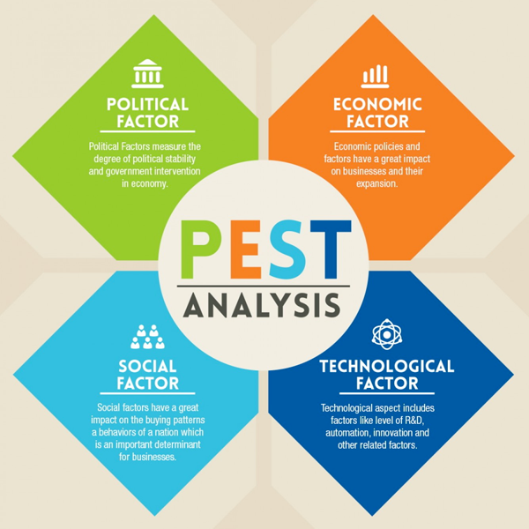
Figure: PEST analysis by Keyser (2018).
Political
The government had offered a directive where people ought to work from home. With businesses adopting to this, remote working was embraced which gave people the feeling that they do not need to collaborate with others seeing that they were working from different locations.
Economic
The economic uncertainties caused by the pandemic could have in one way or another caused anxiety and stress to the taskforce impacting how they relate with each other.
Social
With the society turning away from social living, people find it harder to create rapport with others as they are less tolerant of each other.
Technological
There are many platforms that make it possible to collaborate with each other remotely which have made social relations an option and not a necessity as it used to be.

SWOT analysis
This refers to an evaluation that compiles an organization’s strengths, weaknesses, opportunities and threats which enables the business make sound decisions in regard to its functioning (Schooley, 2023).
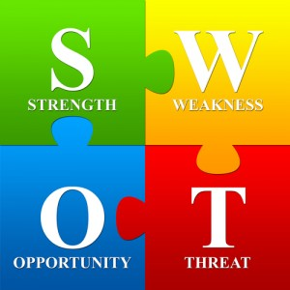
Figure: SWOT analysis by Taylor (2014).
Strengths
- Well established in the London technology company.
- Great technical expertise.
- Wide range of services.
- Good reputation for innovation and quality.
Weaknesses
- High employee turnover
- Loss of tenders
- Limited client base
- Employee conflicts
Opportunities
- Increased demand for tech services
- Expanding the client base
- Going international
Threats
- Recession and economic downturn
- High competition from other players
- Closure of business.

Root cause analysis
This section applies the fishbone analysis also known as the Ishikawa diagram. This diagram is used to analyze the possible causes of a problem and is very helpful in a brainstorming session (American Society for Quality, 2019).
Based on the data gathered at smart Solutions, there is a range of factors that have contributed to the company being where it is with a complex challenge of the team conflicting. With the application of the fishbone diagram the root causes have been identified as well as the sub-factors contributing to them at the company.

Personality
Communication challenges

Diverse team Lack clear channels
Different work approach Lack of feedback
Lack of trust Lack of recognition
Conflicts among employees.

Lack of team meetings
Too much remote working Inefficient managing
No effort toward teamwork Lack of commitment

Unbalanced distribution
Work environment
Workload

Possible solutions
Having toiled so hard to where they are, the management at Smart Solutions are determined to resolve the matter and ensure the company reverts back to its past glory. Below are some of the solution that can resolve the issue at hand:
- Encouraging open communication
- Promoting diversity and inclusion
- Fostering team building activities

Evaluating possible solutions
From the previous section, various solutions have been put forward which have the possibility of resolving the challenge being experienced at the company. Below is an analysis of the three solutions.
- Encouraging open communication
Pros
Will encourage transparency and trust
Promotes collaboration
Avails opportunity to voice opinion and concerns
Cons
Will not address all underlying root causes
Inability of some members to speak up in group settings
Inability to maintain regular meetings
- Promoting diversity and inclusion
Pros
Creating a more inclusive work environment
Help prevent discrimination
Cons
Difficulties in measuring effectiveness
Resistance to change
Requiring a lot of changes to work policies
- Fostering team building activities
Pros
Encourages trust and respect among employees
Promoting teamwork and collaboration
Boosting employee morale
Opportunity to get to know each other
Increase job contentment
Foster communication among the team
Cons
Time consuming
From the above analysis the pros and cons of the three solutions have been identified. It is evident that the solution on team building activities is the most appropriate as it has more potential to address the root cause of the complex problem at the company.

Implementing solution
Having made a decision of the most appropriate solution to the complex problem being experienced at Smart Solutions, it is now time to implement it. The ADKAR model will be applied in this section to help with the implementation. The ADKAR model is an outcome oriented change management model which aims to reduce resistance towards change (Malhotra, 2019).
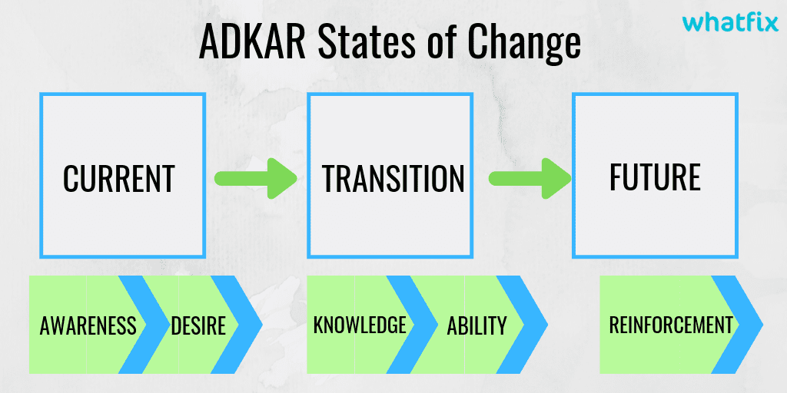
Figure: ADKAR stages by Malhotra (2019).
Awareness
- Communicating the benefits and purpose of team building activities to the team
- Express the perks of team building activities such as building trust, collaboration and team performance.
Desire
- Foster desire to take part in this initiative among the employees by making known the benefits to work satisfaction and work relationships.
- Make sure to address all concerns, setbacks and uncertainties by emphasizing on the greater picture.
Knowledge
- Offering clear information on the team building activities that have been planned, the objectives, agenda to be handled, the format and goals.
- Prior discussions to be held on the activities to be undertaken. This is to ensure that all members are on board and will be confident enough during the activities hence increase the chances of success.
Ability
- Offering the necessary training, tutorials and facilities to support successful team building.
- Offering guidance on how to structure the activities and the teams.
Reinforcement
- Recognition of employee efforts.
- Celebrating the outcomes of employee team building activities and their impact on employee relations.
- Gathering feedback from employees on their experience.
- Regular assessment of the team building activities.

Communication plan with stakeholders
As for this plan the following are the key stakeholders:
- Employees
- Department heads
- Clients
- The management
- Human resource department

Power/ Interest matrix
The matrix below classifies the above stakeholders based on their interest and power levels.
Power | High | Keep informed  The management | Key player  Employees  Department heads
Power | Low | Minimal effort  Clients | Keep satisfied  Human resource department
Power | Low |  | High
Power | Interest

Stakeholder communication plan
To ensure that the stakeholders are kept informed, below is a communication plan that will be applied.
Stakeholder | Power/ Interest | Key interest | Communication vehicle | Frequency | Comments
Employees | High  High | Fostering good relations among employees. | Face to face  Emails  Zoom | Daily | Success working as a team.  Quality work.
Department heads | High  High | Organizing team building activities. | Emails  Face to face | Daily | Influence success of plan.
Management | High  Low | Success of the company. | Emails | Monthly | More tenders won.
Clients | Low  Low | Quality output. | Emails | Time to time | Satisfactory output.
HR department | Low  High | Supporting team building activities. | Reports | Weekly | Allocation of resources.

Monitoring and reviewing techniques
It's critical to set monitoring and review procedures for the strategy to promote team building activities at Smart Solutions to ensure its success. These methods will make it easier to monitor progress, spot problems, and change as required.
As for the plan implementation at Smart Solutions, the monitoring stage will make use of milestones attained throughout the implementation process. Regular check-ins and progress updates will be conducted to track progress towards each milestone. These will include weekly or every fortnight meetings with department heads as well as team leaders to talk about the implementation's progress and any obstacles or problems that have come up. Also, it will be possible to learn more about how employees perceive and interact with the team building exercises by using feedback mechanisms like questionnaires, focus groups, as well as one-on-one interviews whenever possible. The plan may need to be adjusted as a result of this feedback. The milestones will be as follows:
Milestone 1: Plan development
Developing a detailed plan for team building activities with the objectives, time frame, specific activities and expectations. This will require a month for the planning.
Milestone 2: Awareness and communication
After the plan has been made the stakeholders will receive the appropriate details through the various communication channels that have been decided for them and that will meet the needs on time. This will be done during the second month after the plan has been put in place.
Milestone 3: Implementation
Conducting the team building exercises in accordance with the plan, making sure every employee has a chance to participate. Within the third to fifth month of the implementation, this milestone ought to be attained.
Milestone 4: Feedback and evaluation
Recognizing areas for development by gathering feedback from staff members regarding the success of the team building activities. The sixth month after the implementation should see the completion of this milestone.

Conclusion
Problem solving is among the most crucial soft skills at a workplace. It is not out of the norm to face challenges as well as difficulties at the workplace seeing that the place is full of diversity. Some challenges can contribute to the downfall of an organization as seen in this report where Smart Solutions has been losing its clients as a result of employees’ inability to work together. But on analyzing the issue at hand, it is evident that the issue can be resolved. Through the fishbone analysis the root cause has been identified and the best solution possible picked. By making effort to resolve a matter at the workplace, there is always the chance to get to the next level in regard to success.

Reference list
American Society for Quality (2019). What is a fishbone diagram? Ishikawa cause & effect diagram. [online] Asq.org. Available at: https://asq.org/quality-resources/fishbone.
Keyser, W. (2018). PEST Analysis. [online] Venture Founders. Available at: https://venturefounders.com/pest-analysis/.
Malhotra, G. (2019). ADKAR model of change management: What is it and how to use? [online] Whatfix. Available at: https://whatfix.com/blog/adkar-model-what-is-it-and-how-to-use-it/.
Mind Tools (2022). MindTools | Home. [online] www.mindtools.com. Available at: https://www.mindtools.com/aqa3q37/pest-analysis.
Schooley, S. (2023). SWOT Analysis: What It Is and When to Use It. [online] Business News Daily. Available at: https://www.businessnewsdaily.com/4245-swot-analysis.html.
Sharma, A. (2022). Importance Of Problem-Solving Skills In The Workplace. [online] Adaface. Available at: https://www.adaface.com/blog/importance-of-problem-solving-skills-in-the-workplace/.
Simplilearn (2021). What Is Problem Solving? Steps, Techniques, and Best Practices Explained. [online] Simplilearn.com. Available at: https://www.simplilearn.com/what-is-problem-solving-article.
Taylor, I. (2014). A SWOT Analysis Template For The Overwhelmed Marketer. [online] QuestionPro. Available at: https://www.questionpro.com/blog/a-swot-analysis-template-for-the-overwhelmed-marketer/.

