Web Technologies

Christine Woods 1704446

Application Development ACCA5012

Christine Woods 1704446

Kemi Ademoye

School of Applied Computing

University of Wales Trinity Saint David

9th December 2019
(2000-2500 Words)

Declaration by Christine Woods

The work of this report completed under the supervision of Kemi Ademoye. I declare that this report is the product of my own work and is not being submitted for any other degree etc.



Acknowledgments
- Kemi Ademoye – UWTSD Lecturer
- Rob Owen – (photograph)
- Bethany Jones - (photograph)
- Lucy Farrington - (photograph)
- Chloe Farrington – (photograph)
(GDPR consent form found at the end of this document)

Contents

Introduction 6
1. Application Development Concepts 7
2. Requirements 10
Main functional requirements 10
Mobile first strategy 12
3. Design and implementation 13
Screenshots of all web pages. 14
4. Evaluation section 18
Test steps 19
Test data 19
Expected result 19
Actual result 19
Status (Pass/Fail) 20
Recommendations 20
5. References 21
6. Bibliography 22
7. GDPR Consent 22

Introduction

This assignment will identify development trends within application development and go on to include discussion of a peer reviewed study relating to the chosen trend with discussion of the findings.
Following the research aspect an application will be designed and implemented using the five activities required for software development.
- Software requirements specification
- Software design
- Implementation
- Software verification and validation
- Evaluation
The activities will be discussed in this report at length detailing all relevant documentation.

1. Application Development Concepts

Application Development Concepts (Task 1)

The current top development trends identified for application development are [1]
Modular design and lower development costs
Responsive design and the rise of mobile users
Chat bots and customer support
Accelerated mobile pages and load speed
Voice search optimization
API-first design and streamlined workloads
Motion UI and suffering attention spans
Artificial intelligence and cybersecurity
5G data networks
Artificial intelligence
Block chain Technology
Internet of things
Outsourcing
Progressive web apps
The topic I have chosen to discuss is Mobile Friendly Websites.

Responsive design and the rise of mobile users

In todays’ climate it is much more common for people to own a mobile phone or tablet, this is due to a number or reasons including affordability and convenience. The first Apple I-phone came into circulation in 2007 [2], the amount of people in America who own a mobile phone has risen by 35% since 2011.

Having a hand-held device means that accessibility has changed, users can shop whilst travelling and hold meetings without leaving their homes amongst other uses. A study carried out in 2015 by Adobe [3] showed that 79% of users would not continue to use a website if the content is not displayed well.

Having a site that has been designed using responsive web design (RWD) allows the layout to adapt according to the device it is being viewed upon. Using this approach provides good viewing experiences whether on a desktop computer, laptop, different size tablet or mobile phones.

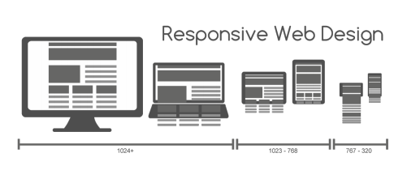
Image 1.

Previous RWD users would have to scroll and work around screens often having lengthy waits whilst pages reloaded.

Viewing photos on different devices was often a problem (see Image1), setting the correct widths for an image may be appropriate on a laptop but squashed on a mobile phone. One way around this was to use percentages i.e. if a photo was set at 50% it would be 50% on any device. This however came with its own problems. The layout would stay the same meaning that the content required zooming in or out to view.

Cosgrove [6] explores the usability of two main systems showing the importance of responsive web design. It discusses the history of responsive web design and the implications of not having this on devices.
The paper discussed several scenarios where users cannot recall required information on a mobile phone since the information is meant for a device 6 times the size.
Cosgrove puts it to the test by applying responsive web design to a variety of devices used by emergency departments and goes on to discuss the implications found.
Using a small group of users tests were carried out based on protocols and different types of software enabling the user eye movement to be tracked at different stages of web design as initialised by Nielson [7].
The discussion continues around responsive web design being introduced circa 2010 and the need for content to be viewed on various size screens. The availability of different frameworks is shown to be vast.
Web and Social Media is also detailed showing analysis of the sites resulting in one of the main problems being lack of communicating knowledge.
Samantha went on to analyse several websites in security using the same measures, the results found

“That the goals were indeed outward facing, the organization of webpages from the parent organization were found to establish in/consistencies between areas, such as local versus national pages”.

She goes on to discuss the good and bad points from various websites and the differences between design for the mobile web screen that does not allow for users that have only a laptop or larger screen and vice versa. This can sometimes be because of deprivation or logistics.

Samantha talks about applying ideas to ensure that there is a “stronger bridge” between science and culture to avoid standards being different between localised and National development. She goes on to talk about standardisation within organisations believing that will assist in the basis for usability.

The conclusion is that the emergency management websites (main topic of analysis for this paper) needs to have a standardised format for the aesthetics of a web site allowing for users to view a site that provides a responsive experience.

(Discussion of the research into application development concepts in Task 1)

Having reviewed the peer reviewed journal in Task 1 [6] it shows that although responsive web design has been around for a long time it is still an issue with some web sites. The question that should be asked is should this come as standard?
The concept of having a page that can be viewed on a small screen but not a large one and vice versa seems strange as there are frameworks out there that easily solve this problem. It isn’t as if the technology is not available? There are different techniques to ensure that devices have this ability e.g. JavaScript, flexible layouts and grids (using % for the screen size), media queries which allow your site to be guided through the headers and side bars and flexible images so that the image will resize for any particular device.
The principles behind it are that all content should be visible on all devices. If the audience cannot navigate a site easily, they will surely loose interest and move to another site.
Having an image which is smaller may easily be overcome by turning your mobile device on its side, this seems simple but not all code has the ability and limits the viewers’ experience.
Is this just a question of knowledge and the difference between a novice and experienced developer?
At this point in time it should be standard that web pages and applications automatically resize but realistically judging by how long it has taken the responsive web designs to get this far it is a long way off before it is standard.

2. Requirements/Specification

The design for this assignment is for a “Photography” web site and includes six relevant web pages which are connected to the main page.

The requirements include a site that is fully responsive and can be viewed on a variety of different sized screens. It must also be browser compatible with all the main browsers.
The site will be mobile compatible across a variety of screen resolutions. The purpose is to provide a user experience that can be viewed on many devices and is interactive.

The main page gives the options to navigate around the site followed by 5 pages of photographs and 1 set up for the purchase of the photos. The website is aimed at any member of the public that likes the photos that are presented. Many photographs are sold on the internet even if they are not relevant to that person. Sometimes it is simply a case that the viewer likes the photograph and wishes to purchase it.

The purchase page gives the options to purchase the photographs whilst the implementation of Java script allows for the user to interact with the site.
The site includes an API (application program interface) exported from google which allows the viewer to see where there are stores.

Main functional requirements

Responsive Web Design
The web pages have been designed using code so that when the screen is made smaller the photos do not collapse onto each other. Instead they re-arrange firstly side by side and then underneath each other. The text on the pages will re-arrange so that words are not lost or unable to be red. (Image 2 below)
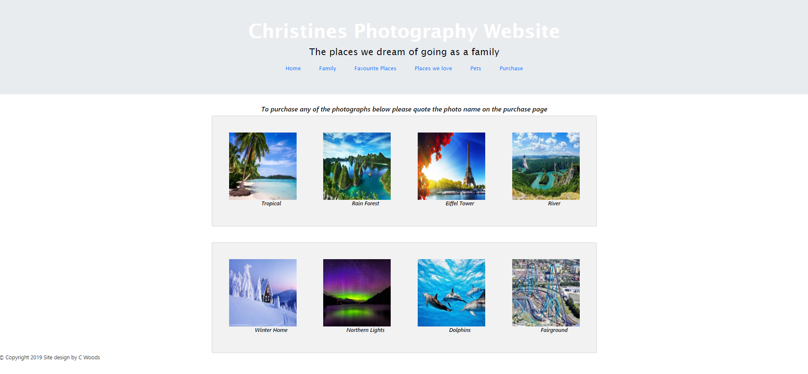
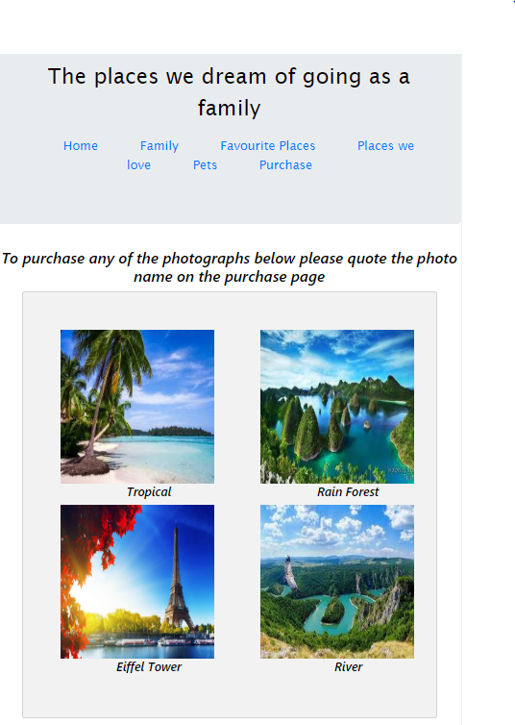

Image 2 – Responsive Web Design (Pictures and texts when the size of the screen is different)

Interactive Website
It is easy to navigate around the web site by using interactive buttons allowing the user to easily view different pages on the website. (Image 3 below)

Interactive purchase
The option to pay for the photographs has been made available for the viewer through the PayPal payment site. [8]
JavaScript has been introduced so that the user can interact with the web site to ensure the delivery details are correct.

Mobile first strategy

The media queries implemented have been to change the background colour of the website when the screen is minimized to less than 600px to ensure that the usability is easy for the user as set out in [7] Jakob Nielson usability features and the size of the photo when viewed on a mobile device less than 768px to be 100 % so that the device views the content properly.
This breakpoint was implemented because at this point the images were close together and having a black background made the pictures more visible and less likely to merge into one another, the size was altered to ensure that the image was viewed for the full mobile screen size and not distorted.
The viewports used were “col-12 col-sm-6 col-lg-3” this allows for the columns on the website to minimize and maximum easily without distorting images of text.
The google maps API was used to ensure that the user was aware that the product could also be ordered from various stores. The API allows for pins to be places showing the exact location of the stores.
The API was easily obtained from the website where the map is designed and provides a great user-friendly option for the website.
JavaScript has been used for the user to ensure they have given the right details on the user form. This will ensure that the delivery address is correct.

3. Design and implementation

The website has been built with a minimum of 6 pages, it has a professional look and is responsive and interactive with the user. It is browser independent (please see evaluation and testing sections), mobile compatible with ease of use, cosmetically pleasing to view and can be viewed upon a variety of screen sizes.
JavaScript has been used to show interactivity between device and user with a web API in the form of a google map on the purchase page allowing the user to find all related stores for purchase of merchandise.

The main design features are that the site is responsive and can be viewed on all screen sizes. It can be viewed in the main browsers and providers user interaction.
Core functionality was built around user experience by ensuring it is easy to navigate around the site.
The main scripts used were HTML & CSS for the main body of the page. JavaScript was implemented for the user form ensuring the user interaction was performed.
The methods used ensured that the user interacts with the website.
The classes implemented ensured that the overall view of the website was professional and included Jakob Nielsons usability heurists [7]
The main Java Script functions used were the form – ensuring that the user got the chance to double check their input removing room for error.
The main JavaScript function implemented was for the user form which returns the submitted details for the user to check.

Screenshots of all web pages.

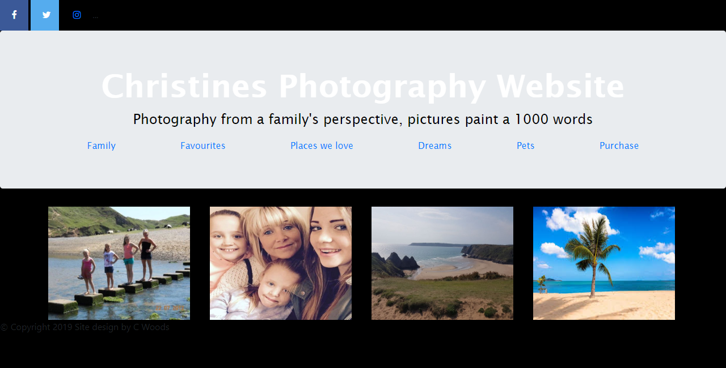
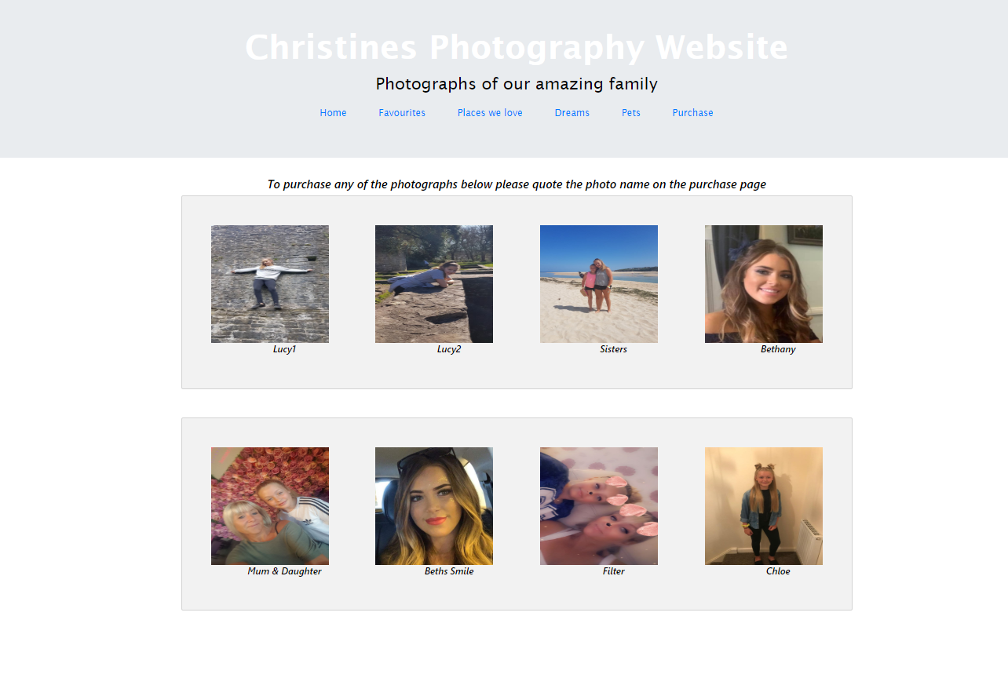
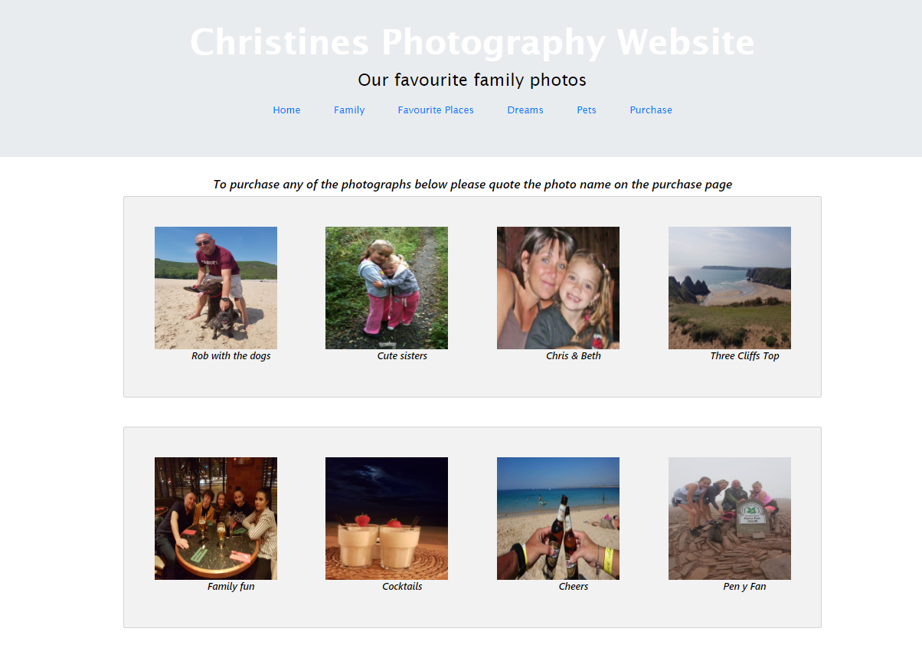
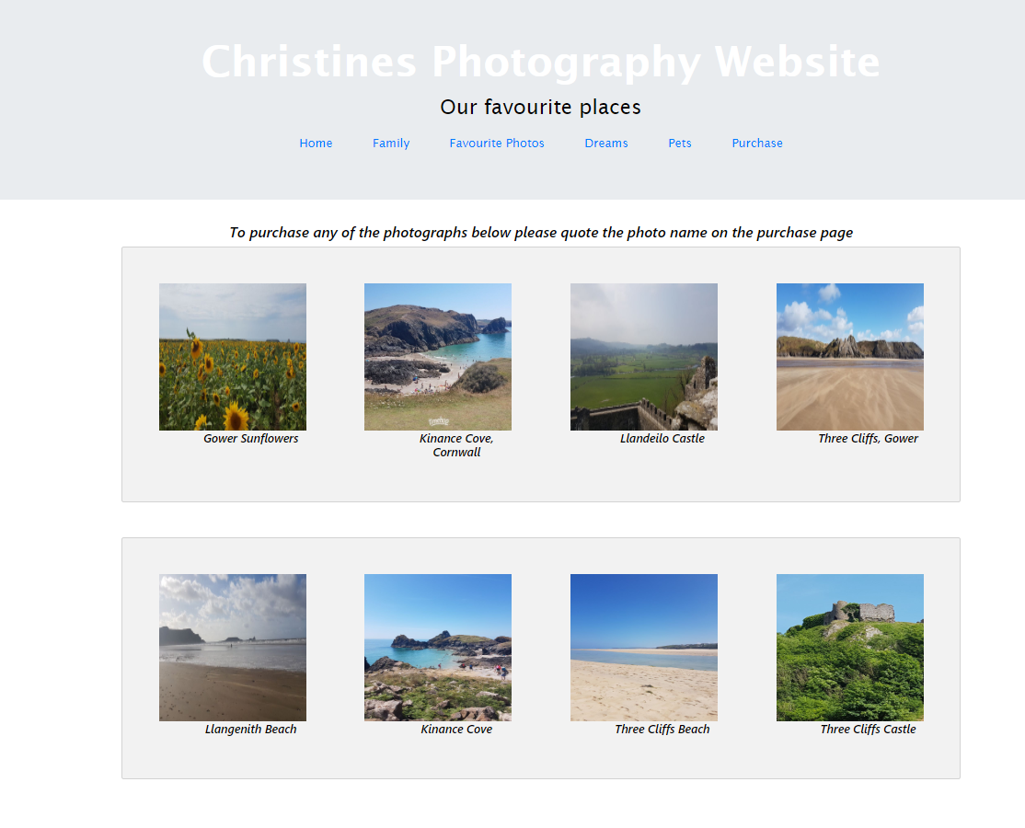

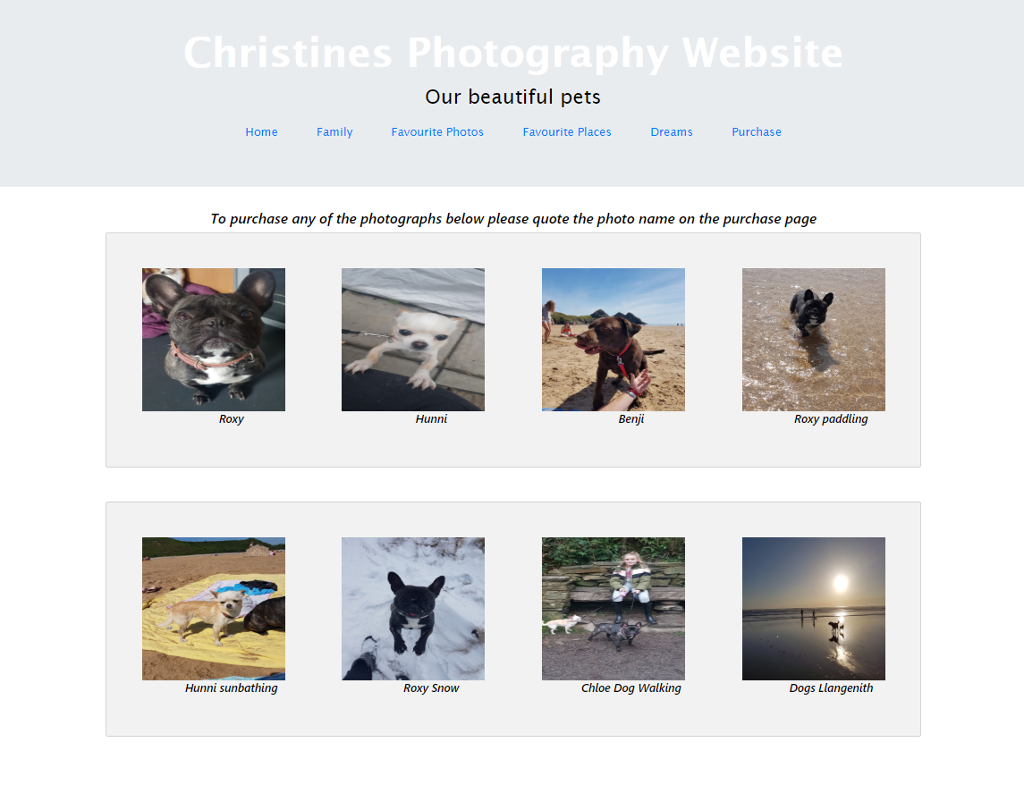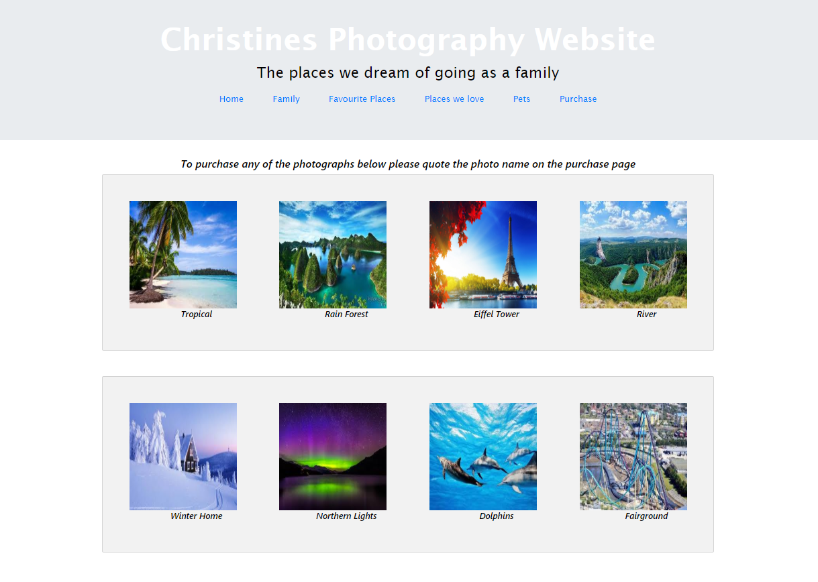

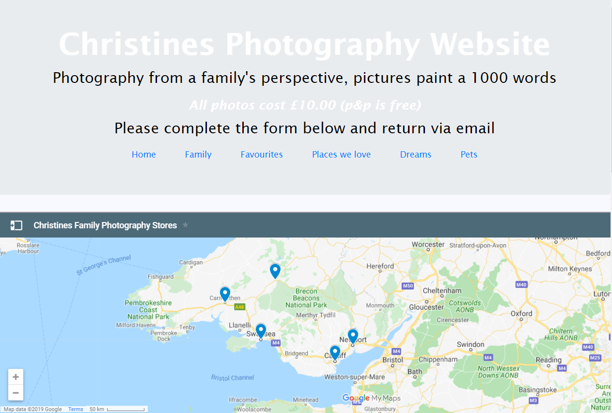
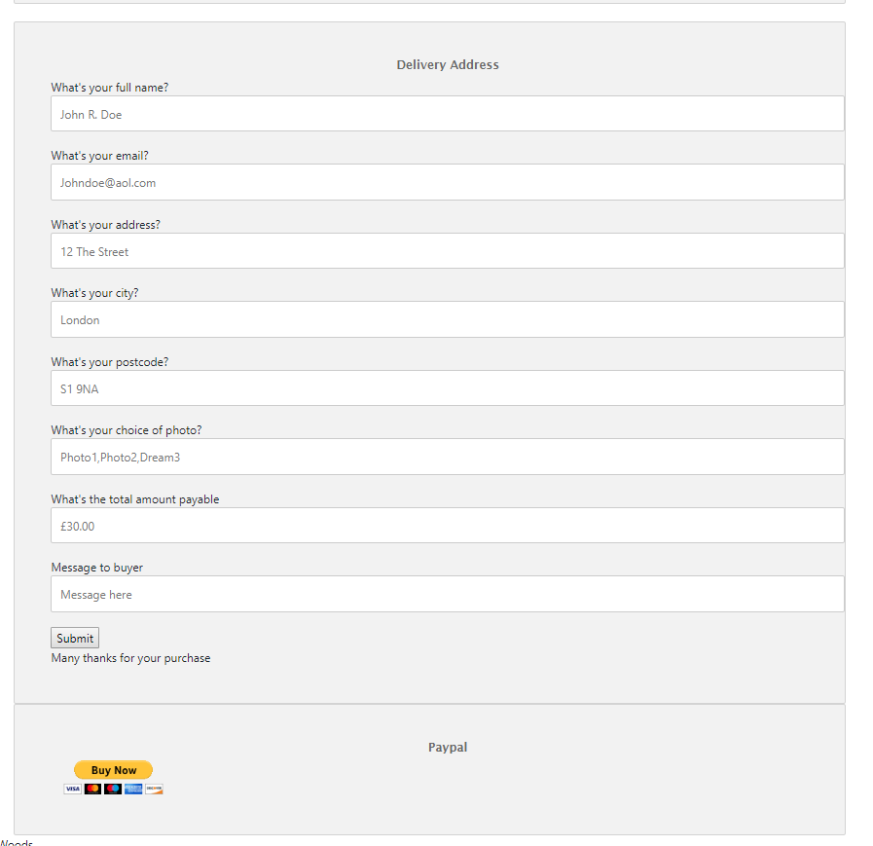

4. Evaluation/Verification section

Test case summary/description (1) – Web browsers

Ensuring that the web page can be viewed on all major browsers:
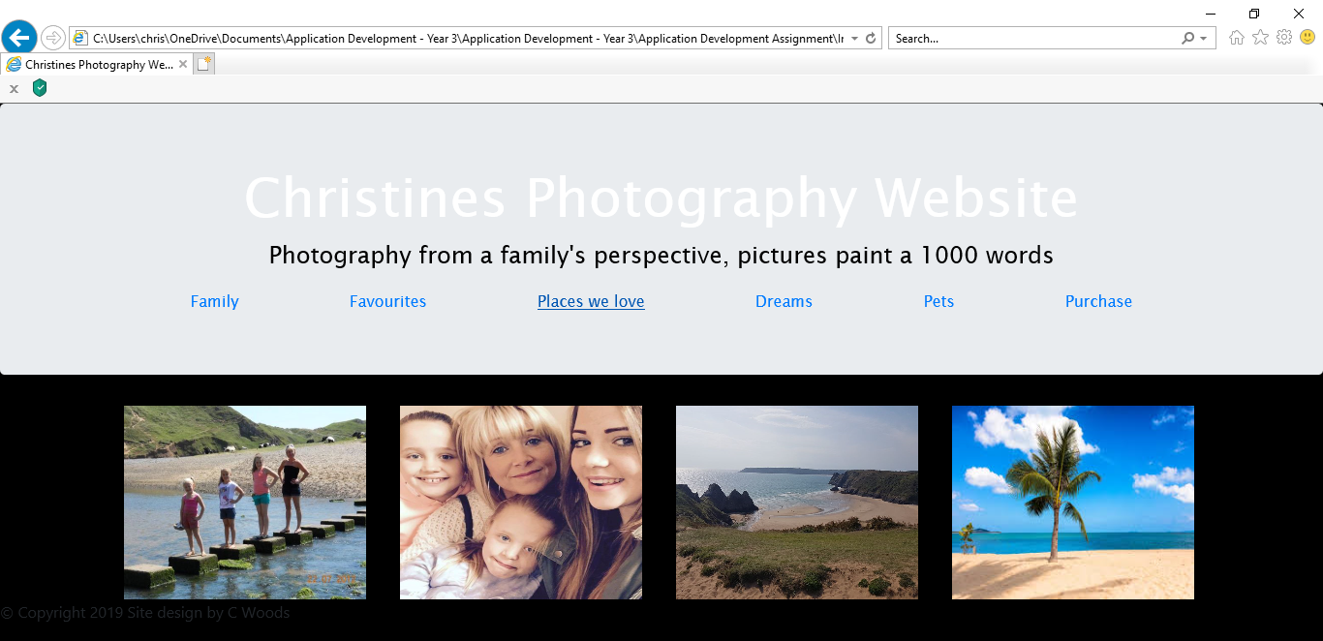
Internet Explorer
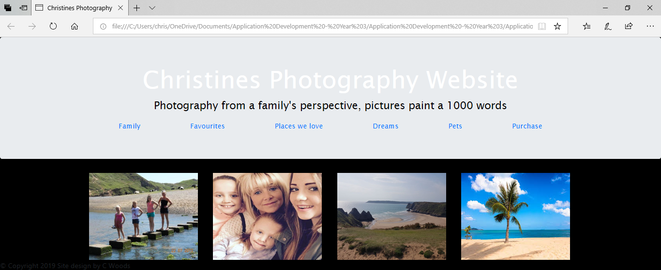
Microsoft Edge
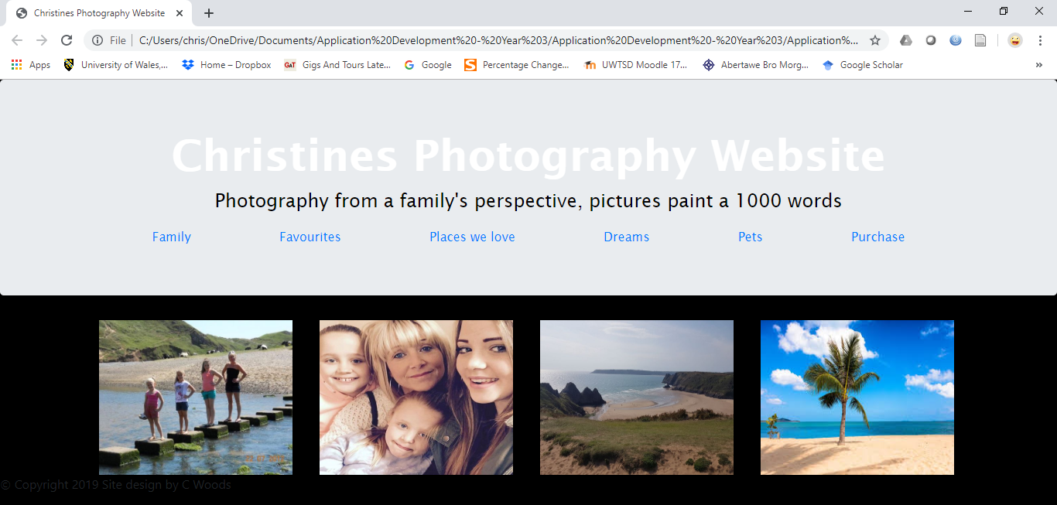
Google Chrome

Test case summary/description (2) - Responsive Web Design

Ensuring that the web pages are responsive.


Test steps
(1) Viewing the site on 3 major browsers (google, internet explorer & micro soft edge to ensure that it the website and all pages can be viewed.
(2) Re-sizing the images to make sure that they are responsive, and the images or text do not overlap.

Test data
Viewed the main index page (as all other pages would be the same)
Tested the data in the main HTML page and the CSS page

Expected result
That the website may not be responsive on all sites and may not open on internet explorer.

Actual result
The website was fully responsive although some of the wording and font styles had changed in internet explorer.

Status (Pass/Fail)
The website passed all tests that were performed. Usability was still of a high level when the screen was made smaller or viewed in different browsers.

Recommendations/Conclusion
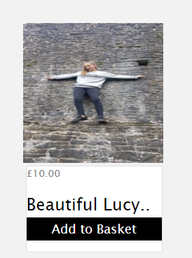
The addition of a shopping cart element for the user would be beneficial. The user would then be able to click on the basket to edit or change their choice before moving onto payment. The submit button would no longer be of use and therefore removed.
For future reference and the usability aspect it would be a much better user experience. The webpage would look like the image on the left.

On reflection there would be a hover attribute to enlarge the pictures so that the user could have a better view of the picture.
The home screen would benefit from a scrolling image gallery and a drop-down menu choice.
The submit button would send an email to the website owner with details of the order directly.
Limiting the customer to PayPal only could lose custom.

5. References

[1] | C. dna, "Web Development Trends," 26 Nov 2019. [Online]. Available: https://www.coredna.com/blogs/web-development-trends. [Accessed 11 Nov 2019].
[2] | Questex, "Timeline of Apple "Iphone"," 18 Dec 2006. [Online]. Available: https://www.fiercewireless.com/wireless/timeline-apple-iphone-rumors-1999-present. [Accessed 11 Nov 2019].
[3] | Abode, "Five rules for content marketers in 2016," 4th Dec 2015. [Online]. Available: https://blogs.adobe.com/conversations/2015/12/global-state-of-content.html. [Accessed 10 Nov 2019].
[4] | E. Marcotte, A list apart - Responsive Web Design, Northwestern, 2010.
[5] | M. D. Giurgiu Luminita, "Quality in Wb design - trends and responsive techniques," Acces la Success Acces la Success, vol. 20, no. 1, p. 335, 2019.
[6] | S. Cosgrove, "Exploting usability and user-centered design through emergency managmenet websites:advocating responsive web design," Communication Design Quarterly review, pp. Vol.6 pp93-102, 1 10 2018.
[7] | J. Nielson, "NN/g Nielson Norman Group: 10 usability Heuristics for User Interface Design," Nielson Norman, 24 Apr 1994. [Online]. Available: https://www.nngroup.com/articles/ten-usability-heuristics/. [Accessed 3 Nov 2019].
[8] | PayPal, "PayPay Developer," 2019. [Online]. Available: https://developer.paypal.com/docs/api/payments/v2/. [Accessed 26 Nov 2019].

6. Bibliography

[1] | W3Schools, "W3Schools The worlds laergest web developer site," 1999-2019. [Online]. Available: W3schools.com. [Accessed 29 Nov 2019].

7. GDPR Consent
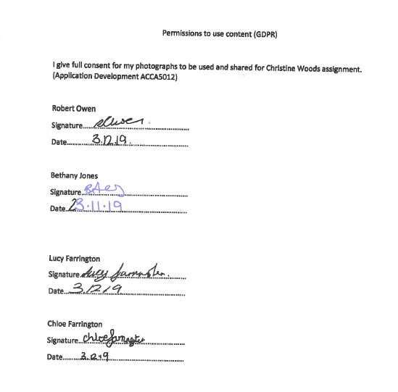

marking criteria and Student FEEDBACK

This section details the extent to which the assessment criteria are demonstrated by you, which in turn determines your mark. The marks available for each category of skill are shown. Lecturers will use the space provided to comment on the achievement of the task(s), including those areas in which you have performed well and areas that would benefit from development/improvement.

Common Assessment Criteria Applied (Assignment 1) | Marks available | Marks  awarded
1. Engagement with Literature Skills

Good, summary overview of chosen web application trend, but the discussion of responsive web design and how it works needs more in-depth detail. Also, please note that responsive web design is not really a current trend and mobile-first is now considered a must for any website. For the related peer-reviewed study, the discussion needs to be a bit more focused - for example, highlight how the study tested for a responsive web design and how it demonstrates that a lack of responsive web design can impact usability and the user experience. (Grade mark: 60.00%) | 25 | 15
2. Knowledge and Understanding Skills

3. Cognitive and Intellectual Skills

A good evaluation of the website has been provided. Please note that you were required to develop test cases for the JavaScript functionality of the website, but the limited JavaScript functionality of the website means there is little to test. (Grade mark: 55.00%) | 20 | 11
4. Practical Application Skills

A good attempt featuring a simple website with entertaining content and some basic JavaScript functionality. There is, however, some room for improvement. The implementation includes a good attempt at achieving a responsive design and some basic use of media queries, but there were some issues with the responsiveness of the implemented website generally and particularly for the media content (images, iframe) added to the page. Instead of using fixed pixel unit sizes (px), for responsive design you need to use flexible units e.g. %, rem, or em. You have also used inline styling (adding a style attribute to elements) and this is bad practice in web design. For example, defining a flexible size for your images in your stylesheet would have made it easier to specify a flexible size for all your images and also ensure that your images do not appeared skewed as some of them currently do. There is some basic use of JavaScript on the purchase page but the inclusion of the iframe linked to Google does not really demonstrate consuming an API. Although the website is made up of 6 pages, there is very little variation between the pages other than the images used. I would have liked to see some more variation to enable you to demonstrate different skills. Also, consider organising your website content into subfolders e.g. an images folder for images, etc. (Grade mark: 58.00%) | 50 | 29
5. Transferable Skills for Life and Professional Practice

The report is of a good standard. See your report for some suggested improvements. (Grade mark: 60.00%) | 5 | 3

Assignment Mark (Assessment marks are subject to ratification at the Exam Board. These comments and marks are to give feedback on module work and are for guidance only until they are confirmed. ) | Late Submission Penalties (tick if appropriate) |  | 58%
 | Up to 1 week late (40% Max) |  | 58%
 | Over 1 week late (0%) |  | 58%

