Cyrille Rene Tounoudjou (1914188)
UNIVERSITY OF WALES TRINITY SAINT DAVID (UWTSD)
BUSINESS PLAN
Programme: Certificate in Higher Education- Skills for the Workplace.
Managing Enterprise in the 21st Century.
Module code: (BMSW4006 _SWAN)
Lecturer: Brynach Heffenan.
Business Plan: 02/07/2021

Contents
Name of the Business: 2
Business Owner: 2
Mission Statement: 2
Aim and Objective of the Business 3
Introduction: 4
Business Rational 4
Product/Services 4
Marketing Activities: 5
Marketing activities use for the business 5
Market Mix 5
Place of Advertisement 6
Cost of Advertisement 6
Physical Resources: 6
Business base 6
Physical Resources for the Business 6
Financial Resources for the Business: 7
What are the company’s financial Resources? 7
Where will these be Obtained from? 7
Human Resources: 8
Qualification/Skills or experience needed within the Business Employees 8
Role of the Human Resources 8
Marketing and Finance Resources 8
Operation of the Manager 9
Job description of operation Manager 9
SWOT of the Van Delivery Services: 10
Appendix: 11
1- Questionnaire of Market Research 11
2- Website Design: 16
3- SWOT analysis of the Van delivery 18
4- 12 Month Cash Flow of (CT Van delivery services) 20
Reference List: 22

BUSINESS PLAN

Name of the Business:
CT Van Delivery Services

Business Owner:
Cyrille Tounoudjou.

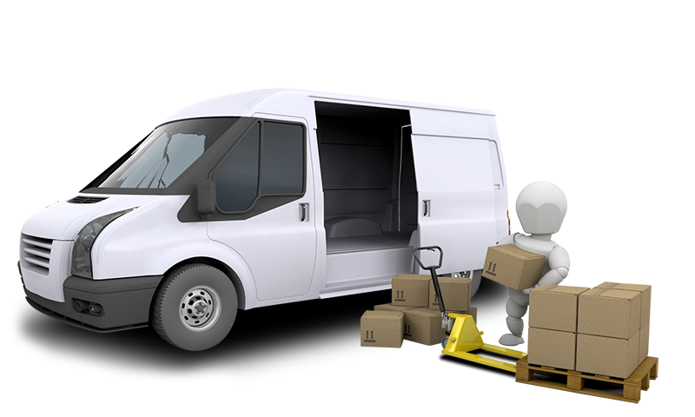
https://www.cheapmanandvan.london/images/slider/1.png

Mission Statement:
To reach clients in a short period of time by offering them the best delivery services is the target of my Van delivery business. The mission is to provide services that must be affordable for all groups of clients. All consumer interests will be served under the business along with the provision of a huge range of options (Buldeo Rai, Verlinde and Macharis, 2019). The business is commencing with the infusion of creativity of the sole proprietor. The business aims to get recognition as a distinguished van delivery experience. Delivery services will be available at all convenient durations for the consumers, either locals or travellers.

Aim and Objective of the Business
For attaining the business’ strategic administration, the aims and objectives of the van delivery services have been determined to demonstrate a vision as well as a forefield for the achievement of business success.
Aims: CT Delivery Services seeks to transform how customers receive delivery services. It also aims to target a wide range of diverse clients from all over the United Kingdom (UK) and their retention by offering world-class delivery experiences.
Objectives: The objective of the business is to adhere to the commitment of providing great employment opportunities and thus, developing a reputable business name.

Introduction:
The Business plans is produced for enabling the sole trader to consider various important factors needed in the flourishment of the Van delivery business. These are the written records of a business where the business goals and aims are stated, reading to which the trader gets a complete idea to achieve the complete business commencement success. For setting up a Van delivery business in the UK market, a well-structured and strategized business plan is required (Moore and Newsome, 2018).
The needs for delivery services by big and small enterprises have increased the demand for the business. In the UK market, delivery businesses are an emerging requirement since it enables the customers to receive their desired products and services on their doorstep without any hassle. Also, the cost of the courier businesses does not necessarily encompass the assistance for packaging. Therefore, the business plan is designed in such a way that the delivery service recognizes its aims and can be capable to attain them (McKenzie, 2017).

Business Rational
The importance that I have chosen the business idea of Van delivery service is the decision to create great market opportunities for the youths residing in the UK, intending to reduce unemployment. In the contemporary environment where there is massive competition in the pricing strategy of goods and services, the Van delivery service will enable the locals and Travellers to enjoy these services within an affordable price structure.
I have chosen to solely systemize the business as the process is easy and cheap as compared to partnership trading. In the Van delivery service, sole tradership will need to follow fewer government regulations and it will enable the trader to focus on other areas which need attention. The conducting of business rationale is also significant as it helps to illustrate the profitability rate generated from the business and the trader will be able to increase the business budget after huge profits (Esfandiar et al., 2019).

Product/Services
CT Delivery Services has selected to deliver certain products like Foods and Pharmaceutical within some major areas in the UK.
The food delivery services will focus on attaining the orders from consumers representing some chosen Restaurants, Groceries, and Supermarkets and will aim to deliver the orders to them. For doing so, first, the business needs to expand its network. The trader has to get in contact with several owners of Restaurants, Groceries and Supermarkets who are willing to incorporate the delivery services in their company (Chai and Yat, 2019).
For the delivery of the pharmaceutical item, CT Delivery needs to approach pharmaceutical stores that are in search of medicine delivery services. CT Van delivery will supply emergency medicinal services since there are high chances of profit derived from it. Big enterprises seeking pharmaceutical services will be the foremost target group of consumers for CT delivery service. For medicinal supplies, I will be needed to integrate refrigerated facilities in the Van. Regular inspections of the Van will be done for ensuring the medicines have still not exceeded the expiry dates (Gamil, 2020). Thus, the business plan must include all the above-mentioned factors to achieve the total business aim.

Marketing Activities:

Marketing activities use for the business
For selling the services by van delivery, the business plan seeks to demonstrate certain marketing activities.
- CT Delivery Service will implement the marketing activity where it will provide the delivery amenity at a relatively cheap cost, in its initial business days. This will help the sole trader to have a strong grip on customers in the market. The marketing strategy will be used in such a way that it helps to profile the target markets (Camilleri, 2018).
- For increasing the market value, advertising activities will also be implemented by the Van delivery service. Proper promotional strategies will be devised by the solo trader.

Market Mix
In the context of developing marketing activity for the Van delivery business, it is necessary to understand the concept of the marketing mix. The multiple fields of focus encompassing the business marketing plan are termed as a marketing mix (Wu and Li, 2018). It exerts a large influence on any kind of business. It also includes the set of delivery tactics and actions that the business will need to promote its product or services in the UK market. The marketing mix is generally composed of 4Ps- price, promotion, product and the place influencing the business (Mahmoud et al., 2017). Several Ps have been included like People, positioning and packaging in modern businesses.

Place of Advertisement
For the advertisement of the business, CT Delivery has decided on certain key places where an effective advertisement could be executed. Traditionally, the business will be promoted in newspapers, magazines or local television ads. With the use of technological advertisements, the business will be advertised in the search advertisements section provided by Google (Alalwan, 2018). The products and services will also be sponsored on other social media platforms like YouTube advertisements for reaching a higher target customer group.

Cost of Advertisement
The sole trader is planning to start the business with the savings of ￡100 000 he has done. The business plan will look into the proper division of this budget for advertising strategy. Around 35% of the total budget will be used for promotional strategies (Krizanova et al., 2019). Almost, ￡35000 will be used among which most of it will be given to traditionally promote the business. Due to the pandemic, many consumers are also found online. Therefore, a significant amount will be invested in online promotion.

Physical Resources:

Business base
The van delivery business will be bricks and clicks business venture. In the offline (bricks) aspect, there will be a van service headquarter where the restaurant or medicine shop owners can visit and make a deal to avail the services (Taylor and Bastien, 2017). The headquarter will be located in an area near to popular attractions. In the clicks (online) procedure, there will be an application designed like any other transport service, where individual customers can book for the services by making advance payments. Use of the application will be easy for all groups of the customer to approach.

Physical Resources for the Business
Physical resources are the physical items needed for business development. The first physical resources needed in the business are Vans. The Vans must be well-equipped with refrigerators because both the food and pharmaceutical product require to be kept chilled. For the headquarter, equipment like fixtures and fittings, chairs, tables and desks are needed.
Computers are needed for maintaining records of deliveries made. Electronic equipment like mobile phones or GPS trackers will be used for navigation purposes (Laoudias et al., 2018). Around 25% of the budget will be needed for arranging the equipment. The source of this funding will be done by the budget created by the sole trader.

Financial Resources for the Business:
Financial resources are referred to those assets from which the business will procure the funds it needs for financing the capitals, investments and present activities. Financial resources may include cash balances of bank loans.

What are the company’s financial Resources?
Since the van delivery business will mainly comprise the asset and non-asset aspects, the financial resources of the company will include a wide range of resources. The financial resources of the business will be micro and macro loans, grants from the government and a dedicated checking business account (Aranda-Usón et al., 2019). Besides, investors and automated software for accounting will also count as the business financial resources. The arrangement of all these resources will be done from the allocated budget. The sole trader will try to run the business finances through his confidential account so that in case of a huge loss, he will be able to overcome it.

Where will these be Obtained from?
The financial resources will be obtained from the debts, equity or retained earnings of the Van delivery business. The business can also obtain these assets by taking a term or working capital loan services from the banks. For increasing the business standards, CT Delivery will be required to collect large-scale funding by the process of commercial mortgage or private lending. It is necessary to contact shippers for growing the list of consumers.
The business grant will be necessary to acquire from the UK government, as the future business will be done with the help of these grants. Big enterprise owners will be contacted to function the role of business angels since they will provide the independent capital necessary for the business. Besides, crowdfunding will also be done for the business ventures by small investors dealing with food or medicine business. In this way, the whole financial resource of the business will be procured and put to use (Devari, Nikolaev, and He, 2017).

Human Resources:
The human resources of a business are the human assets that are used within a company. It is the division that is responsible for the administrating and employee-hiring purposes.

Qualification/Skills or experience needed within the Business Employees
The business aims to provide employment opportunities by employing a huge group of workers. However, the CT Delivery Services will not be recruited casually. They need to have certain skills in them for gathering the job role.
Qualifications: All the employees must be well qualified. A least of a college degree must be presented because even for delivery purpose, learning and conveying skills are required.
Skills: Skills needed within the employees are.
- Excellent organizational and communication skills
- Highly reliable and responsible skills
- Drivers must be familiar with local routes, pathways and neighborhoods
Experience: Employees with a minimum of 1-year of experience in the necessary field will be given first preference, although fresher will also be welcomed.

Role of the Human Resources
Human resources in the van business will perform certain specified roles like talent management and the development and training of the employees. It is the primary responsibility of human resources to hire and retain skilled employees that will further facilitate business growth in the UK (Ahammad, 2017). Also, proper training must be provided to the workers to avoid any kind of mishap. Marketing and finance activities will also be managed by human resource.

Marketing and Finance Resources
The management of marketing and finance resource must be done efficiently to accomplish the business goals and attain profitability. The marketing assets which will be needed in the business are mainly time, expertise, money as well as energy. The most essential resource needed in the van delivery business is money. The business has to allocate a significant amount of budget for marketing (Zhao et al., 2019). The next resource time can be often used as a substitute for money in the Van delivery business. The expertise of the employees is also a significant marketing resource. The energy of the employees, as well as managers, is also an important marketing factor.

Operation of the Manager
The functions of the manager in a van delivery service are responsible to implement the marketing measures and the relevant strategies. Working in the delivery business, the operations manager must possess certain specialist skills like extreme knowledge of delivery services and knowledge of extending the business reach (Wolniak, 2019). The operations performed by the manager in a business are critical to the achievement it possesses and thus the operating character is a key managerial aspect. If the manager performs effectively, it will provide an excellent opportunity for the business to gather a complete range of marketing goals. Operating the Van business is a great responsibility.

Job description of operation Manager
- The operation manager will be in charge to overlook the office management tasks every day and has to ensure that all the security regulations are followed.
- Consumer service is an integral factor in the job description of an operation manager. Also, the insurance of service levels is necessary to maintain.
- The manager is expected to create, revise, and frequently submit business and budget reports of the Van delivery business.

SWOT of the Van Delivery Services:

The business plan will have a look at the strength, weakness, opportunities and threats encompassing the business:
Strengths: 1. ICT availability and an area of innovation.
2. Use of operational tools for research optimization of loads and routes.
3. Vehicle service availability for all groups of consumers.

Weakness: 1. Generation of negative entities like emission of excessive CO2.
2. Traffic problems and congestion.
3. Emission of various pollutants.

Opportunities: 1. Demographic as well as urbanization development.
2. Intelligent Transportation Systems.

Threat: 1. Influence of the delivery vans on the environment.
2. Complexities included in the delivery services like mobility restrictions.

Appendix:

Questionnaire of Market Research
In this document I will analyse the key finding from my business questionnaires.

https://forms.office.com/r/vCmPMXmfwf

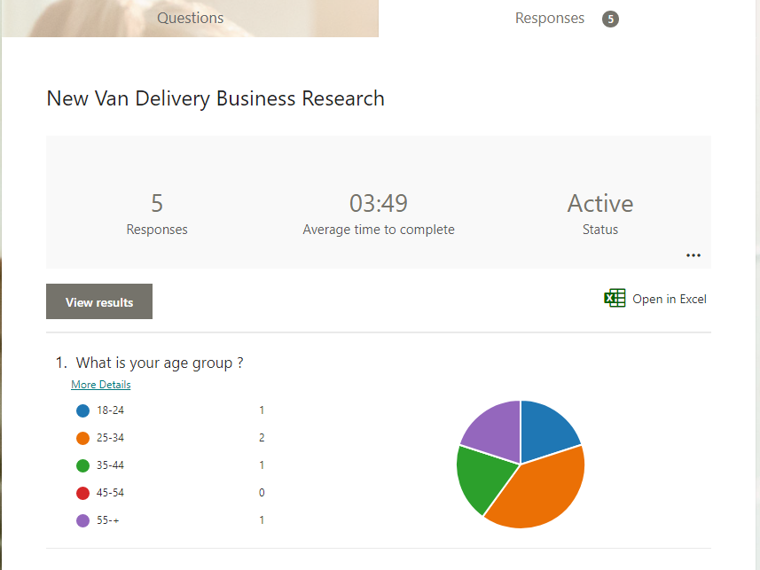
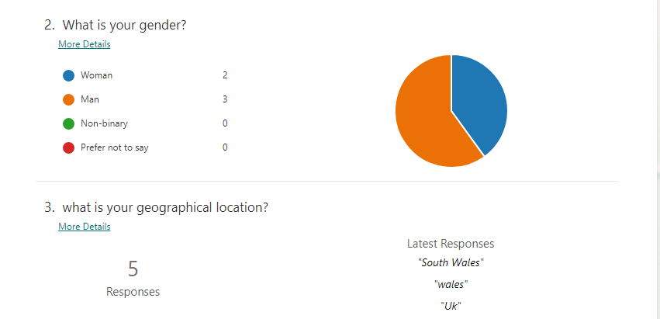
Part 1. Analysis
Within the finding revealed from the questionnaire. It is apparent that customers from these ranges come from diverse ages groups , and it can also be seeing that 40% of them are ages between 25 to 34 and, 20% come from ages between 18 to 24, 35 to 44 and, plus 55.
It has also revealed that 60% of these customers are Male, and 40% are Female. Most of them live in Wales.

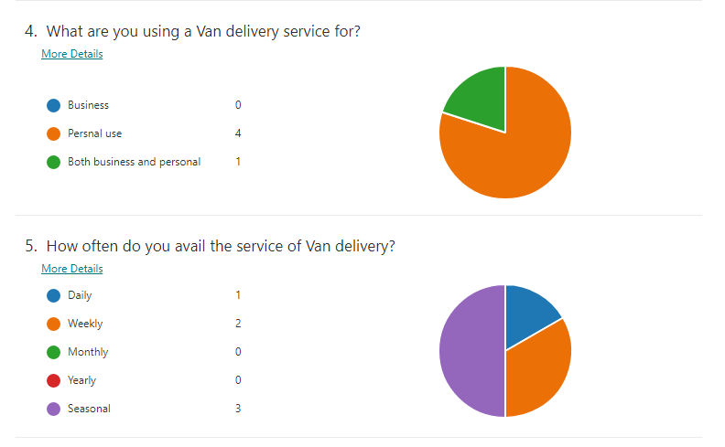

Part 2. analysis
The questionnaire revealed that 80% of customers use of van delivery for their personal need, and 20% use the van delivery for personal and for their business .
It is also apparent that 50% of customers use the van service seasonally, 30% use the van delivery weekly, and 20% daily. Therefore, it will be good for my business to target on customers who use the van delivery daily and weekly. By doing so will help my business to run ordinary.

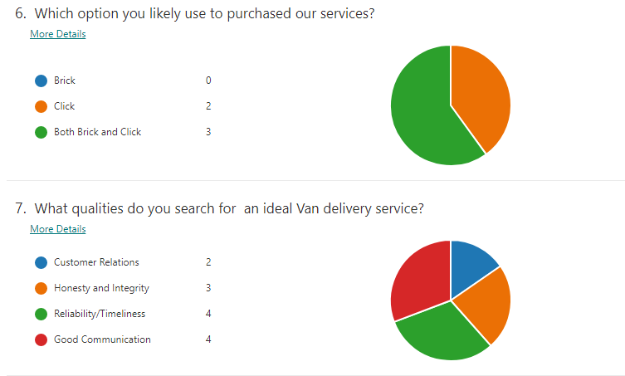

Part 3. Analysis
The information revealed in this part of questionnaire I can analyse that 80% of customers likely use Click to purchase the service, and 20% use Brick option to purchase the service of Van delivery.
It is also appeared that most customers search for a van delivery service which has a good communication, reliable, honest and integrity.
I will use these important information’s for my business. Therefore, I will be investing more to advertise my business online, and I will put attention into my website page. Also based on this information during the recruitment process I will look after applicant who have a good communication skill, are reliable and honest.

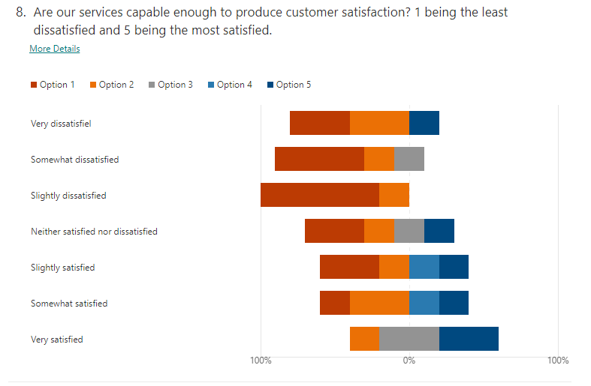

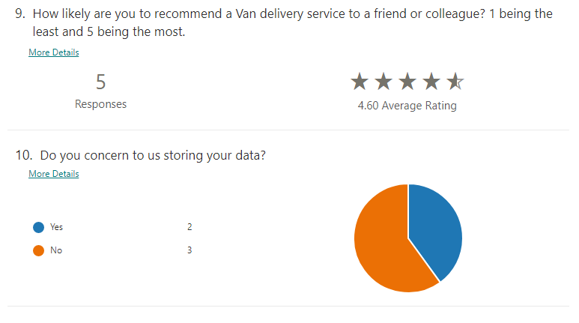

Website Design:

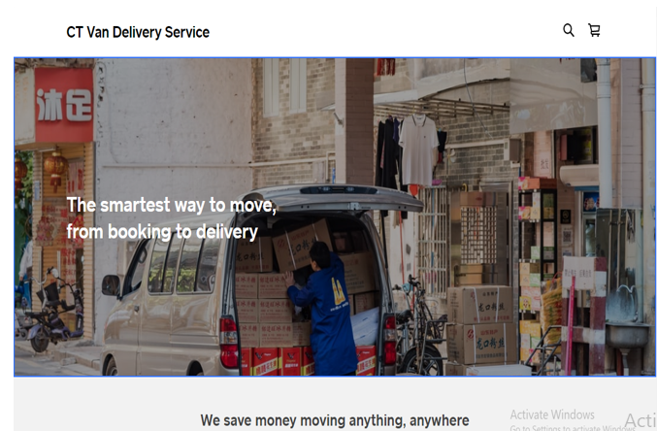
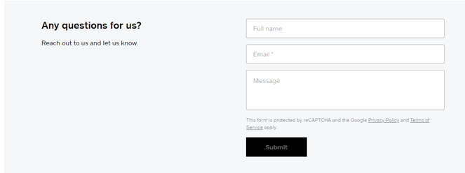
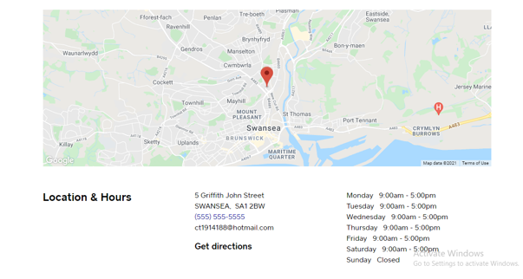
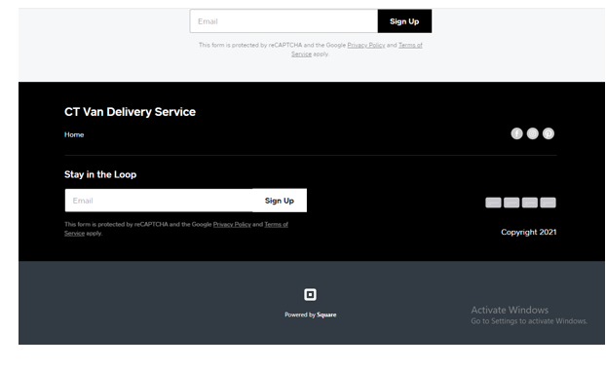

3- SWOT analysis of the Van delivery

Strengths
- ICT availability and an area of innovation- The “information and communication technologies” are considered as the major enablers of encouraging innovation in the business (Jones et al., 2017). Innovation in the business will help to deliver potential ideas
- The use of operational tools for research optimization of loads and routes has been determined as an important strength of the business. The utilization of these tools for detecting loads and routes has subsequently increased in modern delivery services.
- Another important business strength is the vehicle service availability for all group of consumers (McCollum et al., 2018). The business focuses on providing services to all group of consumers and doing so, will help it to strengthen the business name.
- The van delivery business often produces a high capacity for loading the delivery parcels. This leads the business to cope up with the heavy load capacity of the parcels.

Weaknesses
- Generation of negative aspects like emission of excessive CO2 has been recognized as one of the major weaknesses of the van delivery business. The continuous service of the vans will lead to excessive CO2 emission and this will create a threat to the environment.
- Traffic problems and congestion- Van delivery businesses often cause many traffic and congestion problems crying a disturbing environment and as a result, it can also lead to the shutdown of the services.
- Emission of various pollutants like harmful gases is noticed. The refrigeration services will emit harmful gases like hydrofluorocarbons (HFCs) (Harby, 2017). Besides, the production of CO2 gas, other pollutants like HFCs also emits out of the vans.
- Vans with a limited capacity of the load have been identified as the business’ weakness. Often the vans used for delivery services have a low capacity to carry out heavy loads often causing troubles in the delivery services.

Opportunities:
- Demographic as well as urbanization development is facilitated in the van delivery business. These services often help in the urbanization of the country (Oliveira et al., 2017). The van delivery business will create the opportunity in the UK to develop urbanization.
- Intelligent Transportation Systems or an enhanced system offering transport and delivery service is a major opportunity of the van delivery business. ITS provides the facility to devise advanced transportation services.
- The impacts of e-commerce on the van delivery business are wide. The subsequent demand for rapid van delivery services often needs retailers that are radical and practice businesses e-commerce (Rutter et al., 2017). It provides an opportunity for the business to develop interstate and highway routes access.
- Transformation of the business model by introducing green and eco-friendly vans is required since there has been the arrival of several competitors in the market. The business must develop models that will encourage the use of green products.

Threats:
- Influence of the delivery vans on the environment is huge as mentioned earlier and it causes major threats to the business.
- Complexities included in the delivery services like mobility restrictions have been recognized as a major threat to the business since many vans are restricted to be mobile enough in the local neighborhoods (Hensher, 2018).
- Entry of new business competitors with advanced marketing models poses certain risks like delivery business extinction or the loss of customer base.
- Tensions created by the “time-sensitive deliveries”- one of the major threats concerning all the delivery services is the issue of time sensitivity (Bates et al., 2018). The sole trader must aim to recruit highly skilled employees who can cope up with the situation of delivery delay.

4- 12 Month Cash Flow of (CT Van delivery services)

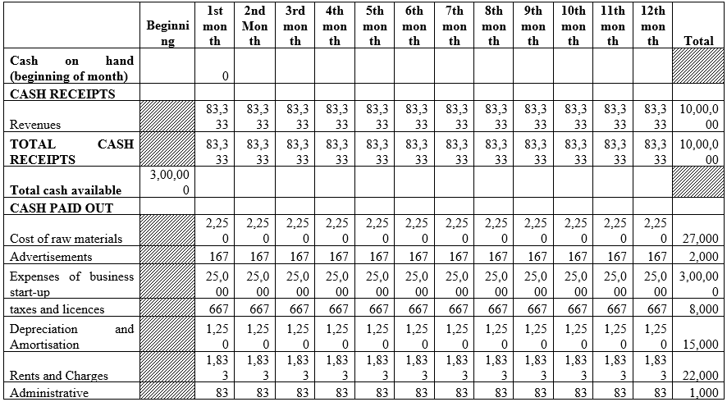
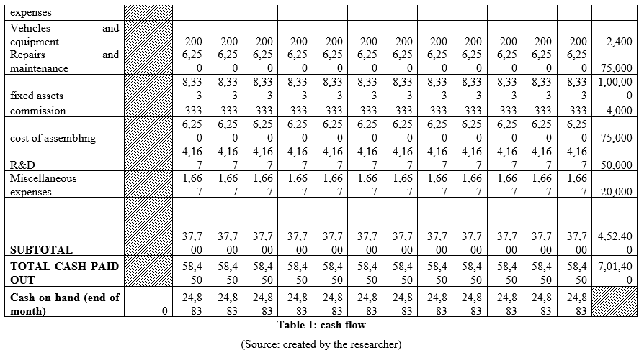

Reference List:
Buldeo Rai, H., Verlinde, S. and Macharis, C., 2019. The “next day, free delivery” myth unravelled: Possibilities for sustainable last mile transport in an omnichannel environment. International Journal of Retail & Distribution Management, 47(1), pp.39-54.
Moore, S. and Newsome, K., 2018. Paying for free delivery: dependent self-employment as a measure of precarity in parcel delivery. Work, Employment and Society, 32(3), pp.475-492.
McKenzie, D., 2017. Identifying and spurring high-growth entrepreneurship: Experimental evidence from a business plan competition. American Economic Review, 107(8), pp.2278-2307.
Esfandiar, K., Sharifi-Tehrani, M., Pratt, S. and Altinay, L., 2019. Understanding entrepreneurial intentions: A developed integrated structural model approach. Journal of Business Research, 94, pp.172-182.
Chai, L.T. and Yat, D.N.C., 2019. Online food delivery services: making food delivery the new normal. Journal of Marketing advances and Practices, 1(1), pp.62-77.
Gamil, A.M., 2020. Pharmaceutical procurement practice aspects. World Journal of Advanced Research and Reviews, 8(3), pp.337-349.
Camilleri, M.A., 2018. Market segmentation, targeting and positioning. In Travel marketing, tourism economics and the airline product (pp. 69-83). Springer, Cham.
Wu, Y.L. and Li, E.Y., 2018. Marketing mix, customer value, and customer loyalty in social commerce: A stimulus-organism-response perspective. Internet Research.
Mahmoud, T.O., Ibrahim, S.B., Ali, A.H. and Bleady, A., 2017. The influence of green marketing mix on purchase intention: The mediation role of environmental knowledge. International Journal of Scientific & Engineering Research, 8(9), pp.1040-1048.
Alalwan, A.A., 2018. Investigating the impact of social media advertising features on customer purchase intention. International Journal of Information Management, 42, pp.65-77.
Krizanova, A., Lăzăroiu, G., Gajanova, L., Kliestikova, J., Nadanyiova, M. and Moravcikova, D., 2019. The effectiveness of marketing communication and importance of its evaluation in an online environment. Sustainability, 11(24), p.7016.
Taylor, M. and Bastien, M., 2017. The ‘Bricks and Clicks’ Towards Success.
Laoudias, C., Moreira, A., Kim, S., Lee, S., Wirola, L. and Fischione, C., 2018. A survey of enabling technologies for network localization, tracking, and navigation. IEEE Communications Surveys & Tutorials, 20(4), pp.3607-3644.
Aranda-Usón, A., Portillo-Tarragona, P., Marín-Vinuesa, L.M. and Scarpellini, S., 2019. Financial resources for the circular economy: A perspective from businesses. Sustainability, 11(3), p.888.
Devari, A., Nikolaev, A.G. and He, Q., 2017. Crowdsourcing the last mile delivery of online orders by exploiting the social networks of retail store customers. Transportation Research Part E: Logistics and Transportation Review, 105, pp.105-122.
Ahammad, T., 2017. Personnel management to human resource management (HRM): How HRM functions. Journal of Modern Accounting and Auditing, 13(9), pp.412-420.
Zhao, K., Hua, J., Yan, L., Zhang, Q., Xu, H. and Yang, C., 2019, July. A Unified Framework for Marketing Budget Allocation. In Proceedings of the 25th ACM SIGKDD International Conference on Knowledge Discovery & Data Mining (pp. 1820-1830).
Wolniak, R., 2019. Operation manager and its role in the enterprise. Production Engineering Archives, 24.
Jones, P., Wynn, M., Hillier, D. and Comfort, D., 2017. The sustainable development goals and information and communication technologies. Indonesian Journal of Sustainability Accounting and Management, 1(1), pp.1-15.
McCollum, D.L., Wilson, C., Bevione, M., Carrara, S., Edelenbosch, O.Y., Emmerling, J., Guivarch, C., Karkatsoulis, P., Keppo, I., Krey, V. and Lin, Z., 2018. Interaction of consumer preferences and climate policies in the global transition to low-carbon vehicles. Nature Energy, 3(8), pp.664-673.

Harby, K., 2017. Hydrocarbons and their mixtures as alternatives to environmental unfriendly halogenated refrigerants: An updated overview. Renewable and Sustainable Energy Reviews, 73, pp.1247-1264.
Oliveira, C.M.D., Albergaria De Mello Bandeira, R., Vasconcelos Goes, G., Schmitz Gonçalves, D.N. and D’Agosto, M.D.A., 2017. Sustainable vehicles-based alternatives in last mile distribution of urban freight transport: A systematic literature review. Sustainability, 9(8), p.1324.
Rutter, A., Bierling, D.H., Lee, D., Morgan, C.A. and Warner, J.E., 2017. How will e-commerce growth impact our transportation network? Final report (No. PRC 17-79 F). Texas A&M Transportation Institute.
Hensher, D.A., 2018. Tackling road congestion–What might it look like in the future under a collaborative and connected mobility model?. Transport policy, 66, pp.A1-A8.
Bates, O., Friday, A., Allen, J., Cherrett, T., McLeod, F., Bektas, T., Nguyen, T., Piecyk, M., Piotrowska, M., Wise, S. and Davies, N., 2018, April. Transforming last-mile logistics: Opportunities for more sustainable deliveries. In Proceedings of the 2018 CHI Conference on Human Factors in Computing Systems (pp. 1-14).

