Curtis Stephens
UWTSD 1903184
ACCA4017 – Software development assignment

Introduction
In this assignment, I have been tasked with a number of scenarios to complete programming for. In this document, I will be providing documentation on the programs that I have created. This will include flow charts, a list of problems that were attempted, as well as testing that has been completed to show that the programs work.

Exercise one

Description
For this exercise, I have been tasked with creating an array in which a user can enter a string, a double and a regular integer. The array must then print the items entered onto the screen.
The items entered will be:
- A length (Double)
- A name of a book (String)
- A quantity of items (Integer)

Flowchart of how the problem will be solved
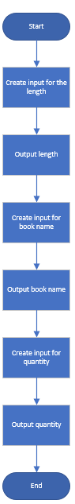

Flowchart of how the program will work
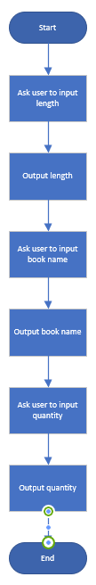

Testing
Test | Description | What should happen? | Did it work? | Comments | Evidence
1 | Testing the input for Length | Input should be accepted, no errors | Yes | An input of a decimal number was accepted | 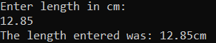
2 | Testing the output for Length | Should be output as a decimal number | Yes | Length was output as a decimal number. | See test number 1
3 | Testing a whole number | Should be accepted with no decimal point | Yes | Output was displayed as a whole number | 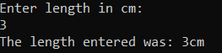
4 | Testing a non-number | Should display as 0 as a string will be input | Yes | Output displayed as 0cm. | 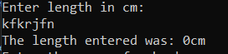
5 | Book name input | Should accept the input | Yes | Input was accepted | 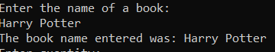
6 | Book name output - String | Should output the string correctly | Yes | String was output correctly | See test number 5
7 | Book name output – integer | Should still output the numbers | Yes | Integer was output correctly. | 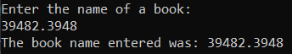
8 | Quantity input | Input should be accepted | Yes | Input was accepted | 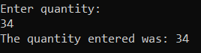
9 | Quantity output – Whole number | Output should be a whole number | Yes | Whole number was output | See test number 9
10 | Quantity output – Double | Output should be rounded down to the nearest whole number | Yes | If using a decimal, the number was rounded down. | 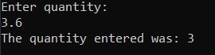
11 | Quantity output - String | Output should be 0. | Yes | Output was zero. | 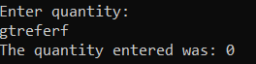

Exercise two

Description
For this problem, I have been asked to find the total area of the following shape:
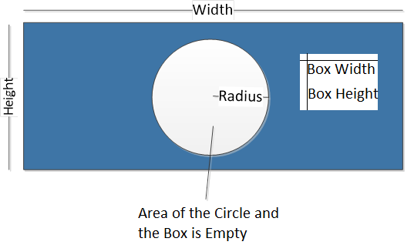
To do this, I have worked out the areas of the shapes inside the large rectangle and then taken them away from the total area of the large rectangle.
For testing purposes, in my program, I have set the program to output the area of each shape as well as the final area at the end.

Flowchart of how I am going to solve the problem
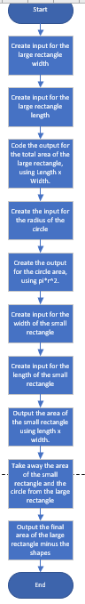

Flowchart of how the program will work
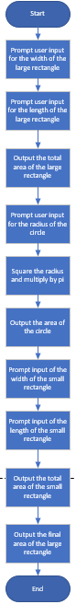

Testing
Test | Description | What should happen | Did it work? | Comments | Evidence
1 | Whole number input for large rectangle width (Input of 5) | The input should be accepted | Yes | The input was accepted | See test 3
2 | Whole number input large rectangle length (Input of 5) | The input should be accepted | Yes | The input was accepted | See test 3
3 | Calculation output – Large rectangle area with large number | The output should read as 25.00cm | Yes | Output was correctly calculated and output correctly | 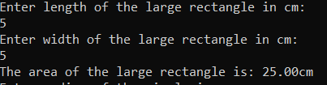
4 | Double input for large rectangle width (input of 5.5) | The input should be accepted | Yes | Input was accepted | See test 6
5 | Double input for large rectangle length (Input of 5.5) | The input should be accepted | Yes | Input was accepted | See test 6
6 | Double output for large rectangle width | The output should be 30.25 (To 2dp | Yes | Output was calculated and displayed correctly | 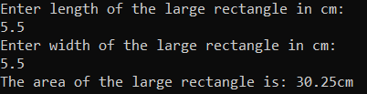
7 | String input for large rectangle width | Input should be accepted but count as 0 | Yes | Input was counted as 0 | See test 9
8 | String input for large rectangle length | Input should be accepted but count as 0 | Yes | Input counted as 0 | See test 9
9 | String output for large rectangle area | Should output as 0 | Yes | Area was output as 0.00cm and not counted. | 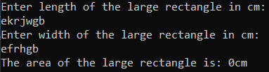
10 | Whole number input for circle radius (Input of 5) | Input should be accepted | Yes | Input was accepted | See test 11
11 | Output for circle area | Should be output as 78.50cm (To two DP) | Yes | Output calculated and formatted correctly | 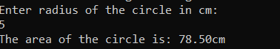
12 | Double input for circle radius (Input of 5.5) | Input should be accepted | Yes | Input accepted | See test 13
13 | Output for circle area | Should be output as 94.98 | Yes | Output was calculated and formatted correctly | 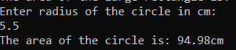
14 | String input for circle radius | Input should be counted as 0 | Yes | Input was accepted | See test 15
15 | Output for string input | Output should be 0.00cm | Yes | Output was 0.00cm. | 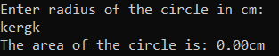
16 | Double input for small rectangle width (Input of 2.8) | Input should be accepted | Yes | Input was accepted | See test 18
17 | Double input for small rectangle length (Input of 1.3) | Input should be accepted | Yes | Input was accepted | See test 18
18 | Double output for small rectangle area | Output should be displayed as 3.64cm | Yes | Output was calculated and displayed correctly | 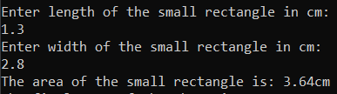
19 | Whole number input for small rectangle width (Input of 2) | Input should be accepted | Yes | Input was accepted | See test 21
20 | Whole number input for small rectangle length (Input of 1) | Input should be accepted | Yes | Input was accepted | See test 21
21 | Whole number output for area of the small rectangle | Output should be 2.00cm | Yes | Output was calculated and displayed correctly | 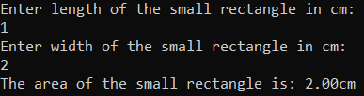
22 | String input for small rectangle width | Input should be accepted as 0 | Yes | Input was counted as 0 | See test 24
23 | String input for small rectangle length | Input should be accepted as 0 | Yes | Input was counted as 0 | See test 24
24 | String output for small rectangle area | Should output as 0.00cm | Yes | Was output as zero | 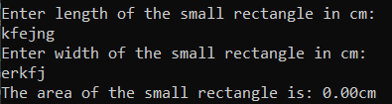
25 | Output for entire shape using Doubles (Inputs used in the screenshot | Output should work out correctly | Yes | Output was worked out correctly | 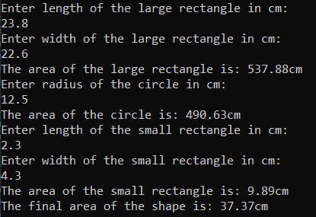
26 | Output for the entire shape using whole numbers | Output should work out correctly | Yes | Output was correct | 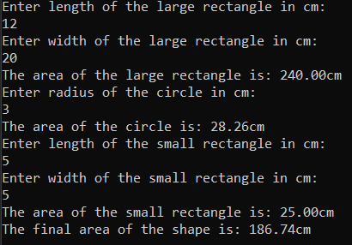
27 | Output for the entire shape using string inputs | Should be 0 | Yes | Output was 0 as expected | 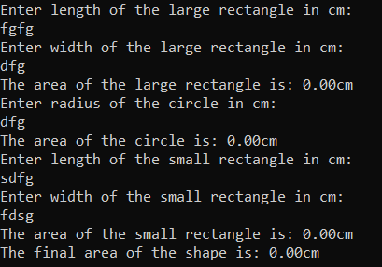

Exercise Three

Introduction
For this exercise I have been asked to create a program where a user enters an arbitrary set of values (An amount of values that the user chooses), and then that value is output, totalled and converted into Euros.

Flowchart of how the program will work
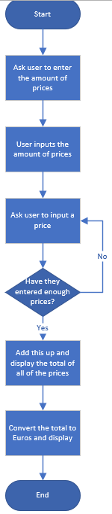

Flowchart of how I am going to code this
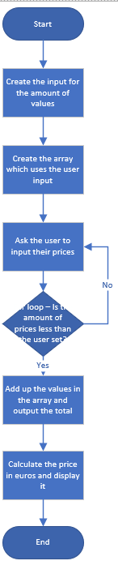

Appendix

Code listing – Exercise One
#include <string>
#include <iostream>
#include <sstream>

using namespace std;
int main(int argc, char* argv[])
{
string input;
stringstream stream;

int quantity;
string bookname;
double length;

cout << "Enter length in cm: " << endl;
getline(cin, input);
stream.str(input);
stream >> length;
stream.clear();
cout << "The length entered was: " << length << "cm" << endl;

cout << "Enter the name of a book: " << endl;
getline(cin, bookname);
cout << "The book name entered was: " << bookname << endl;

cout << "Enter quantity: " << endl;
getline(cin, input);
stream.str(input);
stream >> quantity;
stream.clear();
cout << "The quantity entered was: " << quantity << endl;
}

Code listing – Exercise two
#include <string>
#include <iostream> // For cin, cout and getline()
#include <sstream>
#include <iomanip>

using namespace std;

int main(int argc, char* argv[])

{
cout << setprecision(2) << fixed;

string input;
stringstream stream;

//Set variables
double lrectanglewid;
double lrectanglelen;
double lrectanglearea;
double circleradius;
double circlearea;
double pi = 3.14;
double srectanglewid;
double srectanglelen;
double srectanglearea;
double finalarea;

//User input length of large rectangle
cout << "Enter length of the large rectangle in cm: " << endl;
getline(cin, input);
stream.str(input);
stream >> lrectanglelen;
stream.clear();

//User input width of large rectangle
cout << "Enter width of the large rectangle in cm: " << endl;
getline(cin, input);
stream.str(input);
stream >> lrectanglewid;
stream.clear();

//Find the area of the large rectangle
lrectanglearea = lrectanglewid * lrectanglelen;
cout << "The area of the large rectangle is: " << lrectanglearea << "cm" << endl;

//User input radius of the circle
cout << "Enter radius of the circle in cm: " << endl;
getline(cin, input);
stream.str(input);
stream >> circleradius;
stream.clear();

//Find the area of the circle (Pi = 3.14 in this scenario)
circlearea = pi * (circleradius * circleradius);
cout << "The area of the circle is: " << circlearea << "cm" << endl;

//User input length of the small rectangle
cout << "Enter length of the small rectangle in cm: " << endl;
getline(cin, input);
stream.str(input);
stream >> srectanglelen;
stream.clear();

//User input width of the small rectangle
cout << "Enter width of the small rectangle in cm: " << endl;
getline(cin, input);
stream.str(input);
stream >> srectanglewid;
stream.clear();

//Find area of the small rectangle
srectanglearea = srectanglelen * srectanglewid;
cout << "The area of the small rectangle is: " << srectanglearea << "cm" << endl;

//Take the area of the circle and small rectangle away from the large rectangle
finalarea = lrectanglearea - (srectanglearea + circlearea);

//Output the final area of the shape
cout << "The final area of the shape is: " << finalarea << "cm" << endl;
}

