Kristian Crawford

1919795

Digital Degree Apprenticeship

Operating Systems

ACCA4022

29th March 2023

Table Of Contents

Front Cover Page 1

Table of Contents Page 2

Introduction Page 3

Task 1 Page 4 – 5
Task 2 Page 6 – 12
Task 3 Page 13 – 16
Task 4 Page 17 – 20
Task 5 Page 21 – 23

Conclusion Page 24

References Page 25 – 27

Appendices
i Page 28
ii Page 29 – 31
Introduction
This report will outline the key components of computer operating systems, and whilst examining the more common operating systems, take a closer look at the command line interfaces of both Microsoft Windows, and Linux operating systems, displaying the differences and the similarities of approach and abilities of both systems.

Taks 1 – Key functions of general Operating Systems
The primary function of an operating system is to act as “an intermediary between the hardware and the applications software” University of Rhode Island [1]. To enable the operating system to achieve this goal C. Franklin and C. Pollette[2] list the following categories of processes as defining the core functions.

Processor management, is where as stated by GeeksforGeeks [3] “the OS dictates the running order of each of the processes, and the length of time each process has access to the processor.” using a process known as process scheduling.
Memory Management, described by W. Laurence [4] is where the
“Memory management module performs the task of allocation and de-allocation of memory space to programs in need of this resources”.
Device Management, this is whare as stated by GeeksforGeeks [3] the operating system manages any devices available to the system using their dedicated device drivers. Using an Input/Output controller manages which processes can access which devices and for how long, ensuring the efficient and effective use of all devices.
Storage management, is described by W. Laurence [4] as the process of managing the data storage of the device to ensure that not only is the data that is required by the CPU available when needed to complete the tasks assigned to it, this means ensuring that data is moved from secondary storage locations to primary storage where it can be accessed. This also covers the need to
“optimize the use of storage devices and to protect the integrity of data for any media on which it resides” GeeksforGeeks [5].
System security management, by using tools such as account controls and passwords TyroCity [6] state that the operating system is able to limit access to the system as a whole and any data held within it, limiting unauthorised access to data, programs and system resources.
TyroCity [6] adds command interrupt handling to the required functions, for this the operating system must balance the demands of all of the processes being run by the system and when the need arises interrupt one process whilst preserving the CPU’s state in order to run another process before reverting to the interrupted process.

Whilst GeeksforGeeks [3] sees file system management as a key function, stating that an operating system is responsible for maintaining a record of file structures and locations along with user settings and file status to ensure that all files stored within the system can be speedily accessed when required, but that that access is only granted to the services that are authorised to have that access.
One final function which overlaps with many of the other functions is that of resource management which B. Smith [7] describes as the dynamic allocation of system resources including processor cores, and memory pages for the competing computations that are run by the system in order to complete the processes required by the various applications running.

Task 2 – Use of Windows OS CLI commands

There are many commands available through the command prompt here are a few provided by T. Siber[10].
Assoc
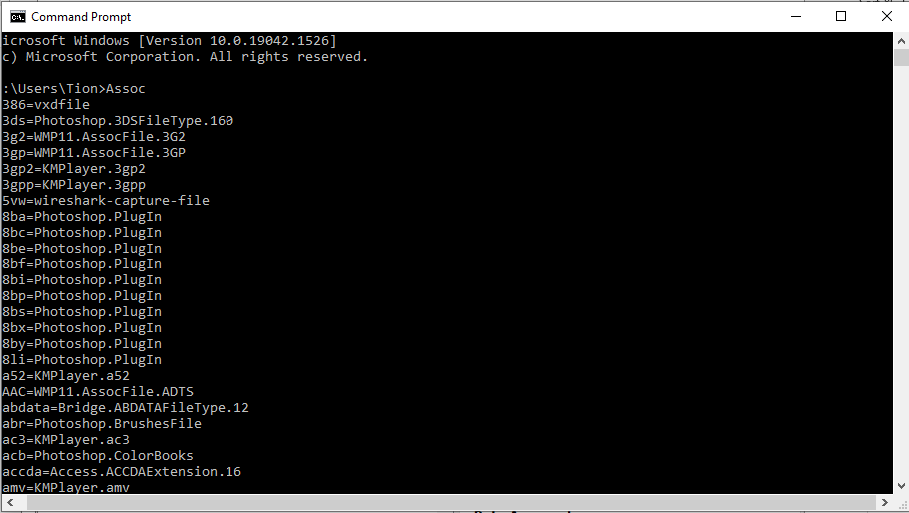
Provides a list of known extensions on the system and the associated program used to access the file type.
ipconfig
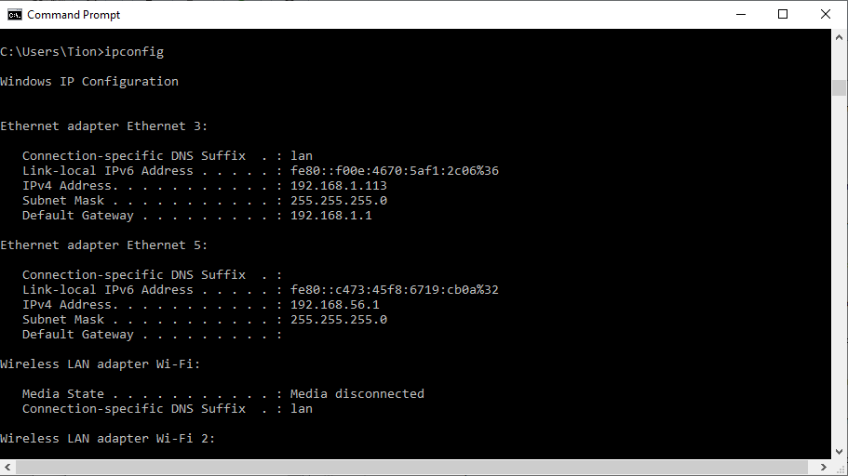
Provides details on all network adapters connected to the system.
netstat
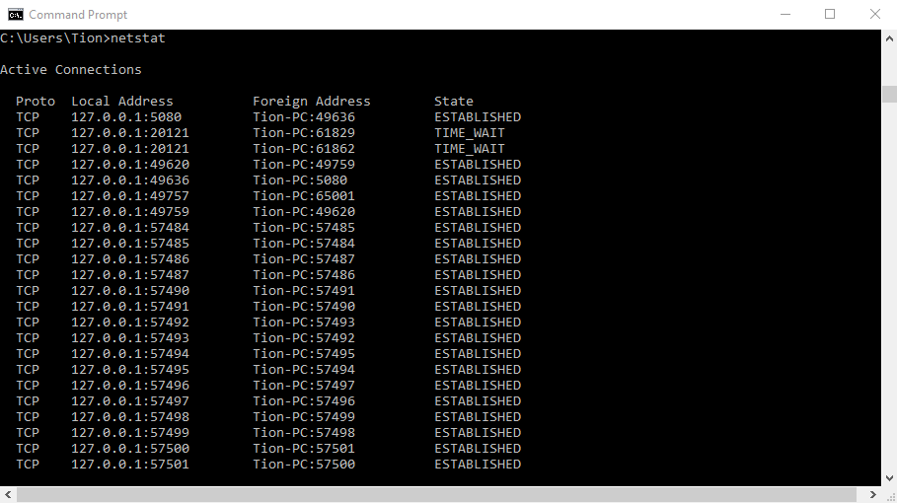
Provides a list of open ports on a system, as well as listing the state of each port, and the protocol associated with the port.
ping
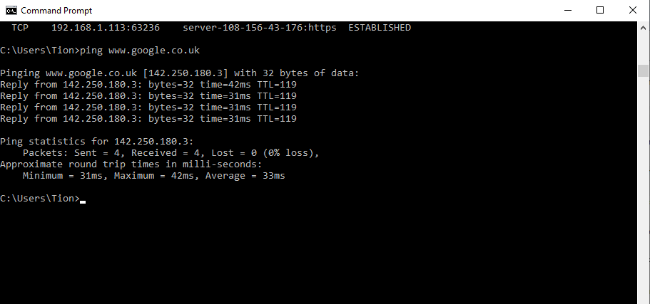
When used with a network or internet address is a good way of testing if your network is functioning properly and data packets can be sent from one device to another.
tracert
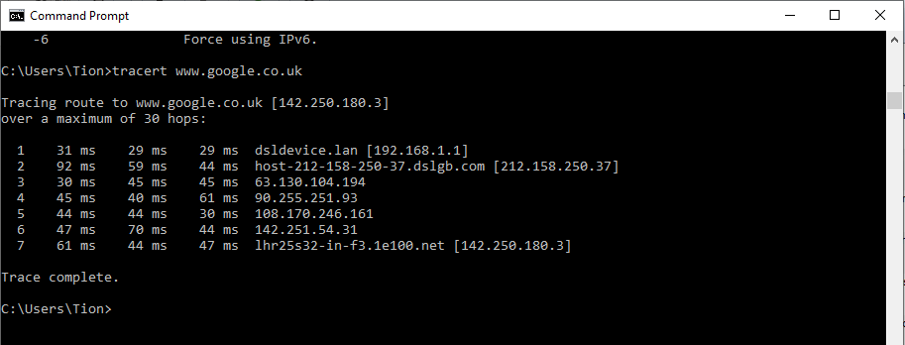
When used with an IP address or domain name this command provides a list of each step a data packet takes between the originator device and the target destination, including how long each step took. This tool is very useful for system administrators to determine where on the network packets are being dropped.
For the next few commands we turn to T. Fisher [11].
arp
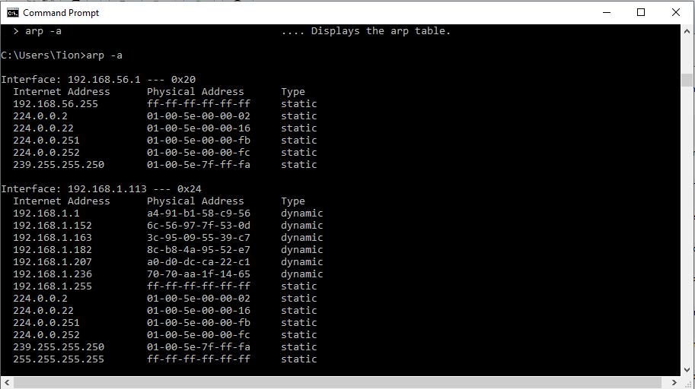
When used with the -a suffix, this command displays the current address resolution protocol entries currently listed for the device, giving a picture of all devices connected to the network which have had their address mapped by the device.
cipher
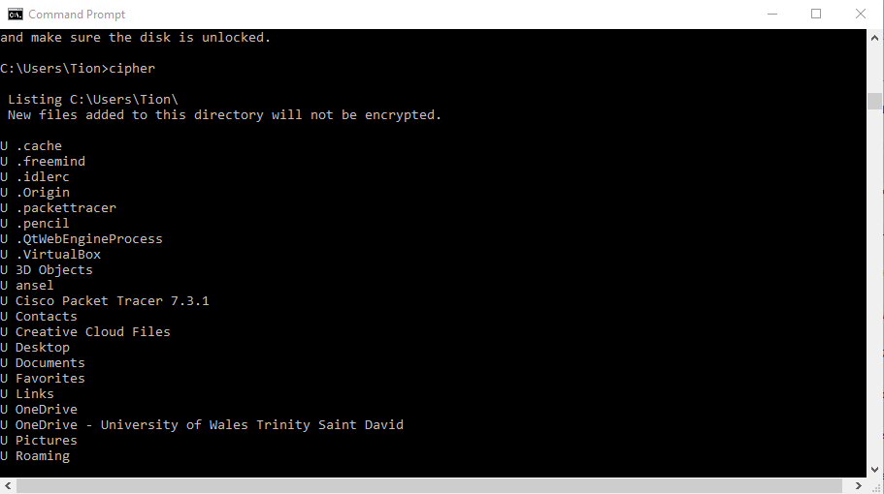
Displays the encryption status of files and folders on NTFS partitions.
color
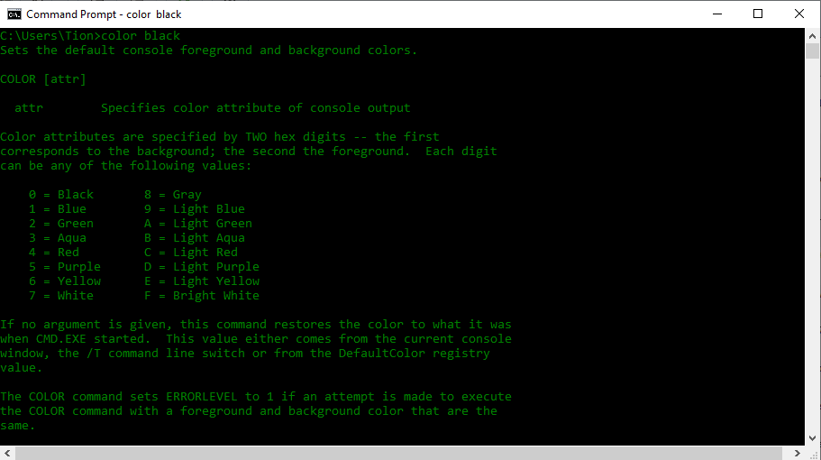
Allows the user to set the colour of the background and text in the command line interface window.
date
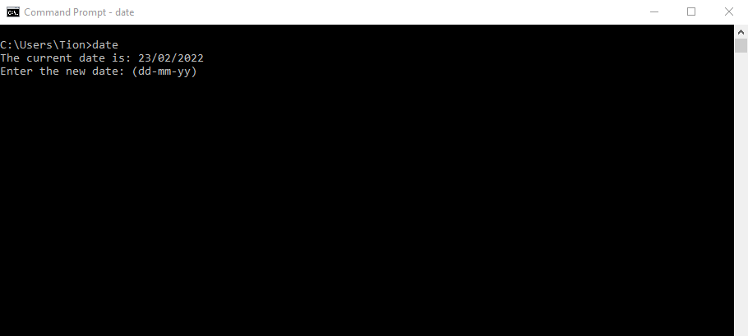
Can be used to display or change the current date.
defrag
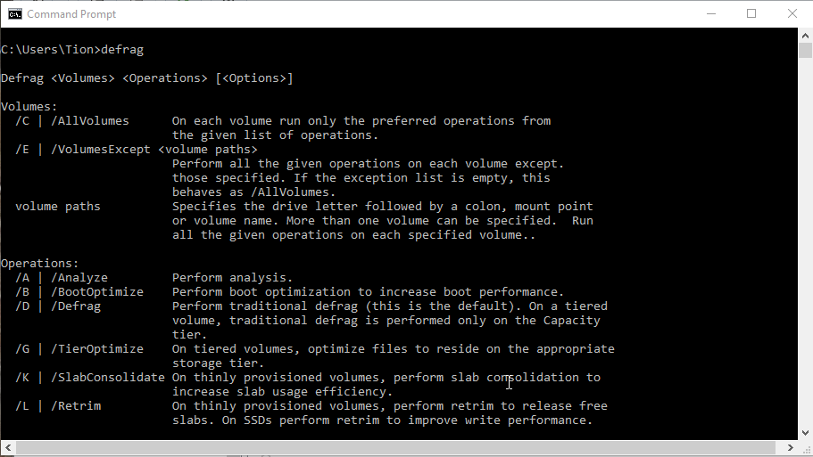
Used to defragment the available derives, with the above screenshot listing some of the available options. This tool is less useful with newer solid state drives, but has value with mechanical drives.

For the last few commands we turn to R.Dube[12].
powercfg
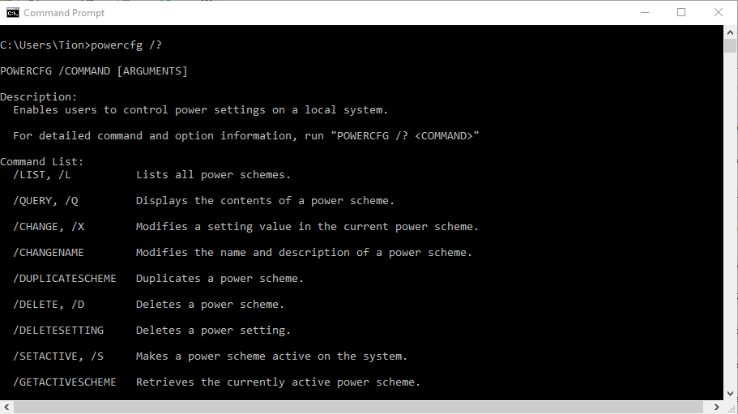
Enables the display and control of power settings with the /l suffix producing a list of available power schemes on the system.
systeminfo
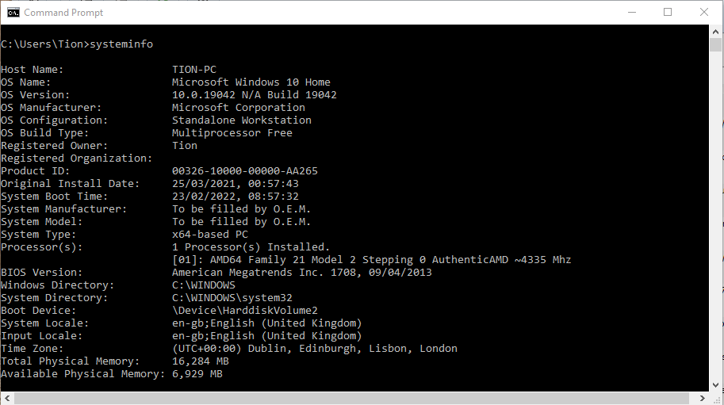
Provides information on the operating system, processor, system memory, and network cards.

chkdsk
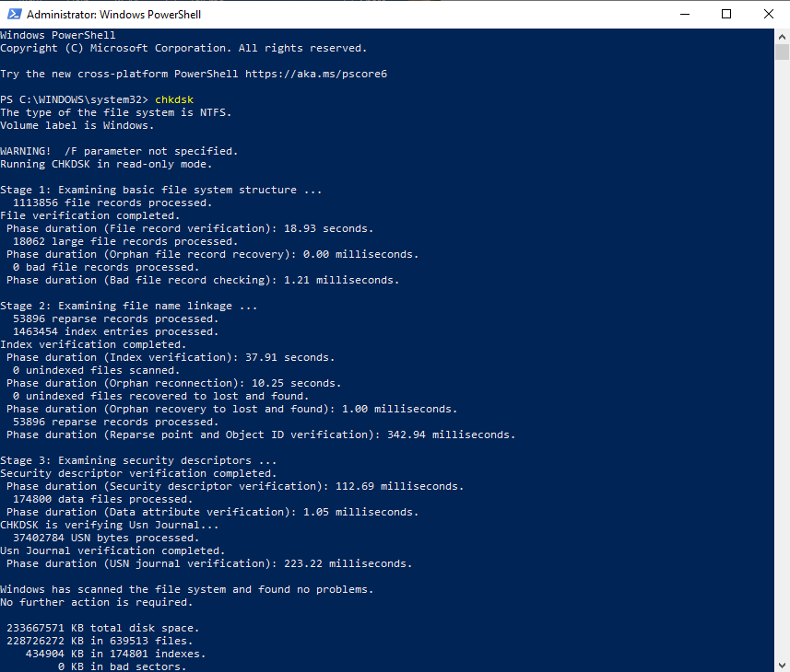
For this one I had to go into PowerShell as it requires administration rights to run. This utility will check the drives in the system and repair any issues discovered.

Task 3 – Use of Linux OS CLI Commands
For this task I opted to use the Alpine[13] browser based linux shell emulator. The following set of commands were provided by DigitalOcean[14].
pwd
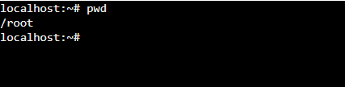
This command displays the current working directory for the user, and is handy for ensuring that the user is where they believe they are in the directory system.
cd
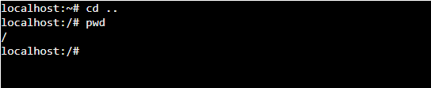
The cd command is used to change directory, using the .. argument changes the working directory up to the directory above the current directory, as shown in the screenshot.
whoami
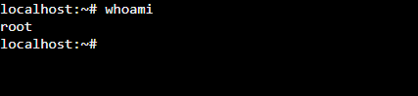
This command returns the name of the user currently in the terminal, the users name and root directory are the same.

ifconfig
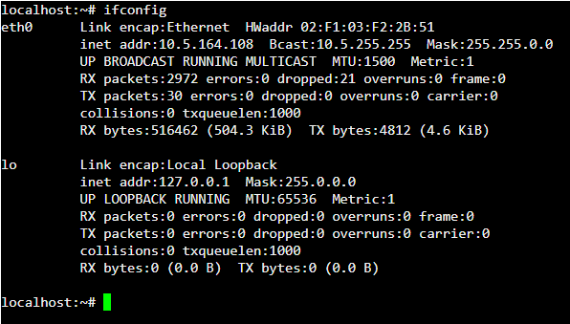
Just as the ipconfig command works for windows the ifconfig displays the network information for a linux based system.
The next set of commands are provided by Alok Naushad [15]
mkdir
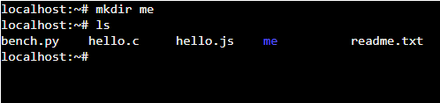
The mkdir command is used to create a directory, or folder in the Windows sense, in the current working directory, by providing an absolute or relative address it is possible to specify a different location.

rmdir
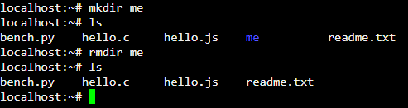
Just as the mkdir is able to create a directory the rmdir can be used to remove the directory, but this can only be achieved if the directory is already empty. To delete directories with files in them the rm command must be used.
rm
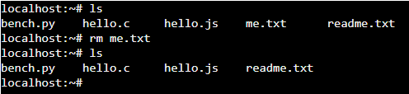
The rm command can be used to remove individual files as shown above or with the addition of the -r argument it can be used to remove directories and any files or child directories contained within.
The final set of commands are provided by Daniel Diaz[16]
ls
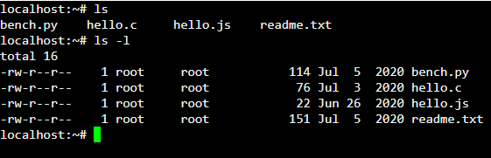
The ls command in its simplest form can be used to simply list the contents of the current directory, as shown above adding the -l argument provides much more detail on the individual files and folders.
mv
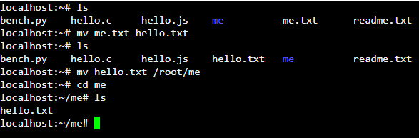
The mv command con be used to move a file or directory, but can also be used to rename the file or directory, or do both at the same time.
echo
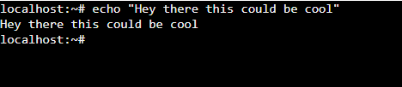
The echo command is used to reproduce defined text within the terminal, which in and of itself may not seem all that useful, but it can be used to print environmental, or predefined variables in the terminal.

Task 4 – Use of Windows OS scripts.
Windows OS scripts or Batch Scripts are described as a file containing a set of batch commands which will be run sequentially often without the need for user interaction, this type of file is useful for launching programs or automating repetitive tasks[17,18,19]. The number of possibilities for the use of batch scripts from running basic repetitive tasks to more complex actions, the limits of which are the same as the limits to which the command prompt itself is limited. Where the scripts come into their own is in the ability to perform multiple lines of code over and over with minimal user interaction.
The following examples are all variations of examples provided from the course study material produced and distributed by James Williams.
Variables
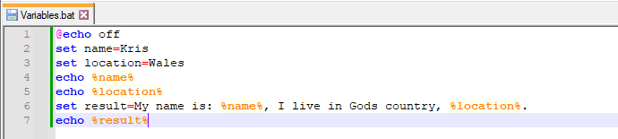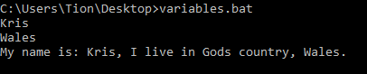
In this example I have set two variables, name and location and then passed these variables into a string of text.
For Loop
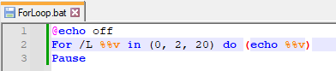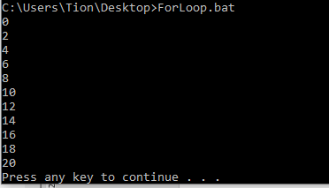
This example shows a for loop which is set to count from 0 to 20 in multiples of 2
Array.
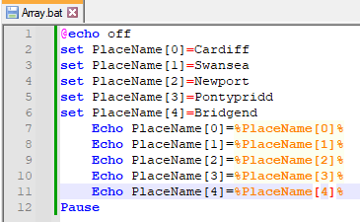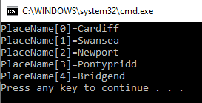
|This array shows a list of place names placed in a group under the collective Place Name array, and then prints the array to the terminal window.
Go To, If, and User Input
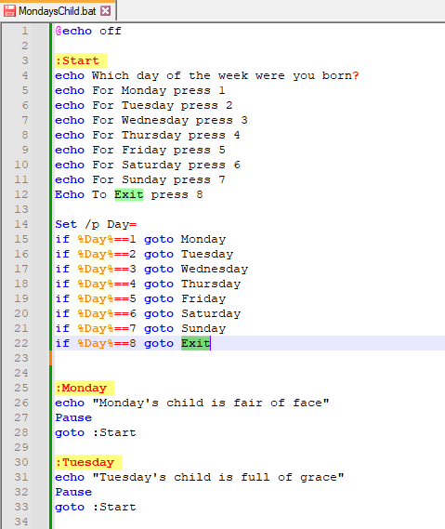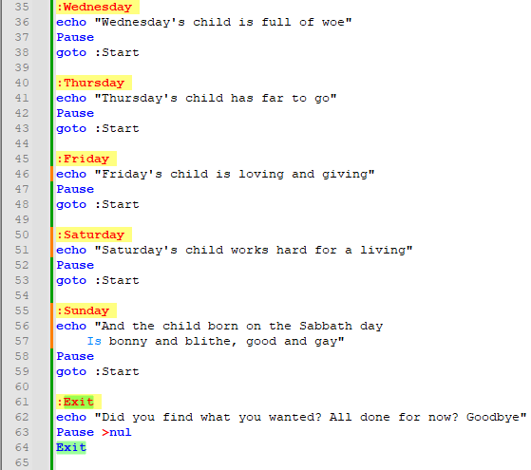
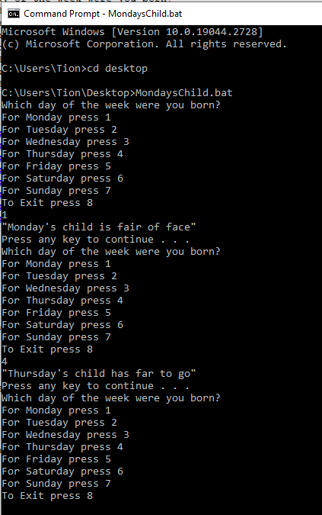
This short program uses user input to determine which path the user wants to follow, the if statements are then used to determine which go to command is required to print on screen the correct output, using the Mondays Child poem to create the available choices. Once the cycle has completed the user is returned to the start menu where they may go again or exit the program.

Functions
The following function was provided by trytoprogram.com[20] and provides a simple example of a function.
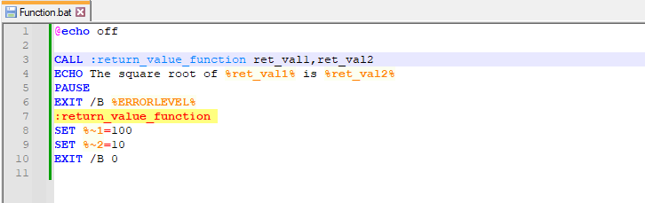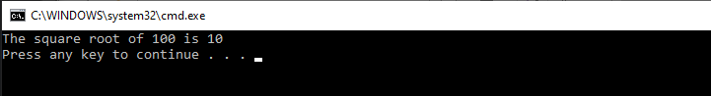
This function basically returns two set numbers to complete a statement, and whilst it is worth mentioning that the code above does vary slightly from the original example this is due to a slight spelling mistake included in the original, in line 3 the original example had misspelt the name of the function, preventing it from working. As you can see from the output above a slight change was all that was required to cure this issue.

Task 5 – Use of Linux OS scripts.
Just as with batch scripting, bash scripting[21, 22, 23] takes the all of the functionality of the bash commands available through the Linux terminal, and boosts their ease of use and possible uses by enabling the user to combine commands to be run automatically with little or no user interaction.
The examples below are all variations on the course course material produced and provider by James Williams, with a few of my own slight modifications included.
To display these examples I have opted to use replit.com’s bash console.
Variables
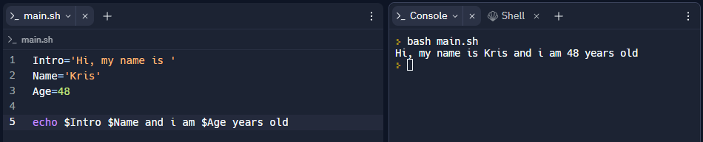
This basic example shows how easy it is to define variables with both text and numerical values. It is worth noting that whilst the text entry requires a single quotation mark on either side to allow the shell to ignore the contents the numeric data does not.
User Input
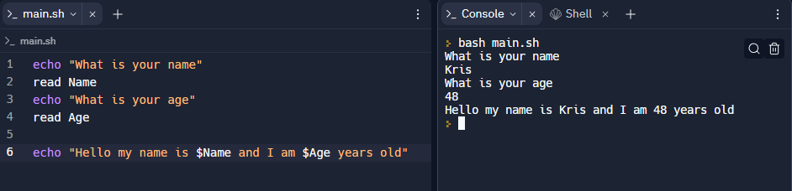This example builds on the previous one in that it allows the user to input the required data. But as you can see the end result is very similar, it just broadens the possibilities and uses of the output.
If Statement
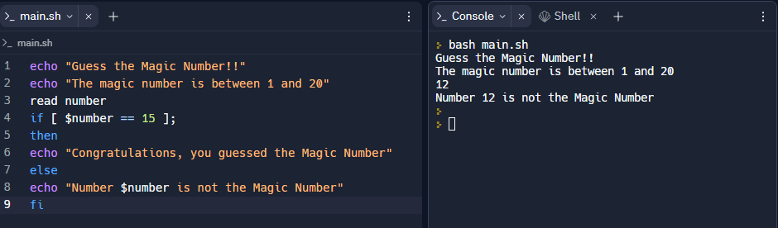
This simple number guessing game is a good example of how if statements work, and are formatted in bash. If the guess matches the provide number then the if statement is correct and the system outputs the attached message, if as in the screen shot this is not the case then it moves on to the next action.
Case Statements
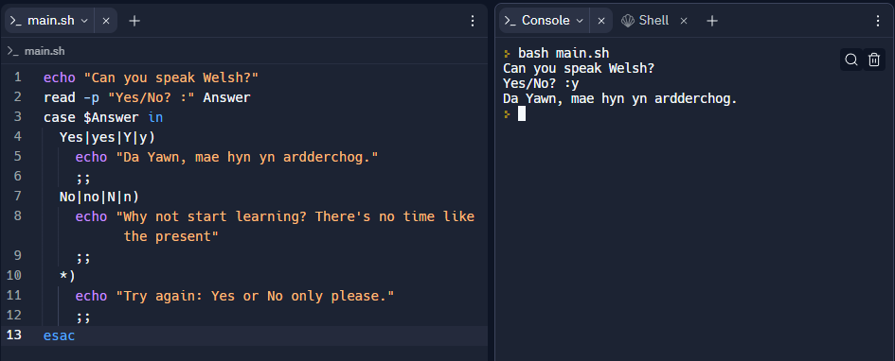
Again, a simple example of how you can use the case command to detect exact matches for the expected or required input
Loops
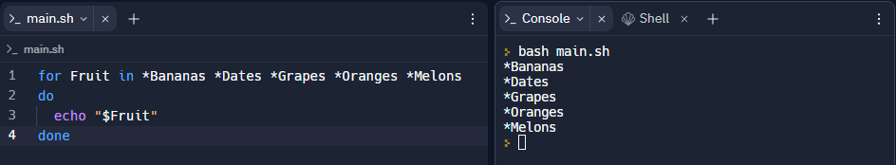
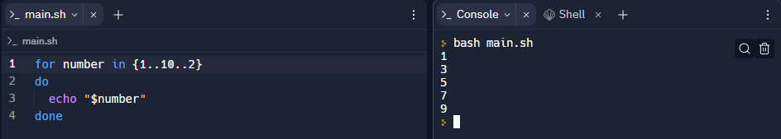
With these two examples of for loops we can see that they can be used with either text arrays or numerical ranges.
Arrays
Arrays are variables that can contain multiple values simultaneously.
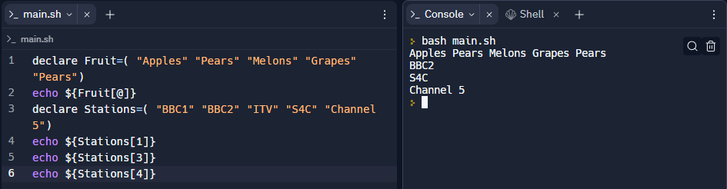
As displayed above the arrays can contain alphanumeric, but also just numeric data and can be called upon either as a group or individually.
Functions
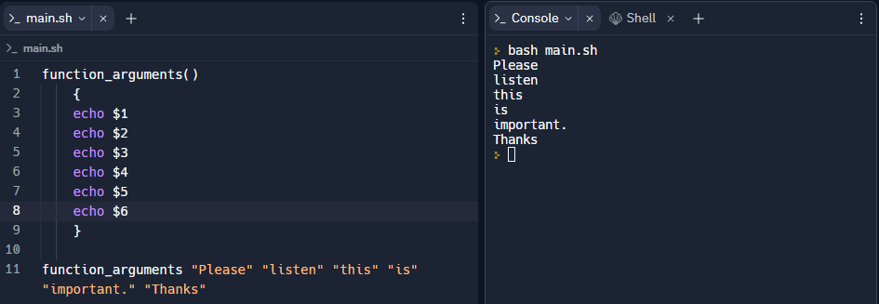
Functions are a great way of reusing code without retyping it, once entered the code can be called upon to act upon the presented arguments, though the data in the arguments can change at each use the function will continue to treat the arguments in exactly the same way.
Conclusion
After having spent some time looking at what most people consider to be extremely different operating systems, although they both more that meet the requirements of an operating system, and are both very different in their approach to how they present themselves to the user. Microsoft preferring the slightly more limited graphical user interface, whilst offering a more powerful command line and PowerShell interface, it is obvious that they intend for the average user to engage through the graphical interface. Whilst Linux favours the command line interface of the terminal it also offers a graphical interface to users, but yet again it is plain to see that the terminal interface and its bash shell are preferred.
Where these two operating systems start to look more similar is when you compare their independent terminal interfaces, and whilst it is clear that the two have gone down verry different paths when it comes to how they structure their commands and command syntax, the usability of both systems seems to travel in a similar direction with many if not all of the commands, and options available on both systems.
Though I must say that both terminal systems would seem terrifying to the uninitiated, having spent a little time with both I tend personally, to believe that the Linux system is slightly more user friendly, and intuitive. But of course Microsoft has spent a great deal of time convincing us that the graphical interface it offers is the more superior, user friendly offering, which is undeniably true, but that does not mean that it has the better core system. At the end of the day its going to be horses for courses, if you want a simple user experience that doesn’t delve to deep below the surface then Microsoft may be the one, but if you’re a system administrator or someone who likes to go under the bonnet, then the choice becomes far less clear.

References
[1] University of Rhode Island “Department of Computer Science” “Operating Systems.” [Online] https://homepage.cs.uri.edu/faculty/wolfe/book/Readings/Reading07.htm [Accessed Mar. 29, 2023].
[2] C. Franklin and C. Pollette, “Computer Operating Systems | HowStuffWorks.” [Online] https://computer.howstuffworks.com/operating-system4.htm [Accessed Mar. 29, 2023].
[3] “Functions of Operating System - GeeksforGeeks.” [Online]https://www.geeksforgeeks.org/functions-of-operating-system/ [Accessed Mar. 29, 2023].
[4] W. Lawrence, “What is Operating System? Explain Types of OS, Features and Examples.” [Online] https://www.guru99.com/operating-system-tutorial.html [Accessed Mar. 29, 2023].
[5] “Storage Management - GeeksforGeeks.” https://www.geeksforgeeks.org/storage-management/ [Accessed Mar. 29, 2023].
[6] “Functions of Operating System | Computer Notes | TyroCity.” [Online] https://tyrocity.com/computer-notes/functions-of-operating-system-3fl7 [Accessed Mar. 29, 2023].
[7] B. Smith, “Operating system resource management | IEEE Conference Publication | IEEE Xplore.” [Online] https://ieeexplore.ieee.org/document/5470386 [Accessed Mar. 29, 2023].
[8] “Processor Cpu Computer - Free image on Pixabay.” [Online] https://pixabay.com/illustrations/processor-cpu-computer-chip-2217771/ [Accessed Mar. 29, 2023].
[9] “Edit Folder Icon - Free vector graphic on Pixabay.” [Online] https://pixabay.com/vectors/edit-folder-icon-file-business-2013200/ [Accessed Mar. 29, 2023].
[10] T. Sieber, “15 Windows Command Prompt (CMD) Commands You Must Know.” [Online] https://www.makeuseof.com/tag/15-cmd-commands-every-windows-user-know/ [Accessed Mar. 29, 2023].
[11] T. Fisher, “Command Prompt Commands: A Complete List (CMD Commands).” [Online] https://www.lifewire.com/list-of-command-prompt-commands-4092302 [Accessed Mar. 29, 2023].
[12] R. Dube, “21 CMD Commands All Windows Users Should Know.” [Online] https://helpdeskgeek.com/help-desk/21-cmd-commands-all-windows-users-should-know/ [Accessed Mar. 29, 2023].
[13] “JSLinux.” [Online] https://bellard.org/jslinux/vm.html?url=alpine-x86.cfg&mem=192 [Accessed Mar. 29, 2023].
[14]“Top 50+ Linux Commands You MUST Know | DigitalOcean.” [Online] https://www.digitalocean.com/community/tutorials/linux-commands [Accessed Mar. 29, 2023].
[15 ] A. Naushad, “Basic Linux Commands for Beginners | Linux | Maker Pro.” [Online] https://maker.pro/linux/tutorial/basic-linux-commands-for-beginners [Accessed Mar. 29, 2023].
[16] D. Diaz, “The 40 Most-Used Linux Commands You Should Know.” [Online] https://kinsta.com/blog/linux-commands/ [Accessed Mar. 29, 2023].
[17] “What is Batch Scripting and how does it work? - Seobility Wiki.” [Online] https://www.seobility.net/en/wiki/Batch_Scripting [Accessed Apr. 03, 2023].
[18] “Batch file - Wikipedia.” [Online] https://en.wikipedia.org/wiki/Batch_file [Accessed Apr. 03, 2023].
[19] R. Awati, “What is batch file?” [Online] https://www.techtarget.com/searchwindowsserver/definition/batch-file [Accessed Apr. 03, 2023].
[20]“Batch File Functions (Introduction And Tutorial).” [Online] http://www.trytoprogram.com/batch-file-functions/ [Accessed Apr. 03, 2023].
[21] R. Chadwick, “What is a Bash Script? - Bash Scripting Tutorial.” [Online] https://ryanstutorials.net/bash-scripting-tutorial/bash-script.php [Accessed Apr. 03, 2023].
[22] Hira Zaira, “Shell Scripting for Beginners – How to Write Bash Scripts in Linux.” [Online] https://www.freecodecamp.org/news/shell-scripting-crash-course-how-to-write-bash-scripts-in-linux/ [Accessed Apr. 03, 2023].
[23] “What is Bash/Shell Scripting?” [Online] https://www.futurelearn.com/info/courses/linux-for-bioinformatics/0/steps/202947 [Accessed Apr. 03, 2023].
[24] W. Lawrence, “What is Operating System? Explain Types of OS, Features and Examples.” [Online] https://www.guru99.com/operating-system-tutorial.html [Accessed Apr. 03, 2023].
[25] “Types of Operating Systems - GeeksforGeeks.” [Online] https://www.geeksforgeeks.org/types-of-operating-systems/ [Accessed Apr. 03, 2023].
[26] “Distributed Operating System | What, Types & Architecture.” [Online] https://teachcomputerscience.com/distributed-operating-system/ [Accessed Feb. 08, 2022].
[27] J. D. Scott Zimmer, “Distributed Operating System | What, Types & Architecture.” [Online] https://teachcomputerscience.com/distributed-operating-system/ [Accessed Apr. 03, 2023].

Appendices
i An Operating system is the software that acts as an interface between computer hardware components and the user, and whilst there are as many operating systems as there are systems to run them on, [24] W. Lawrence groups them into seven main types.
Batch operating systems, described by [25] GeeksforGeeks as a system designed to batch similar types of processes together to speed up the processes, with no direct interaction between the user and system, often used in for payroll, and bank statements.
Multitasking/Time Sharing Operating Systems are systems where 1 processor can be shared by multiple users with each user process being allocated a set time before the system moves to the next user. [25] GeeksforGeeks lists the uses for this type of system as Multics, and Unix.
Multiprocessing Operating System designed to split up tasks to be processed by multiple processors allowing more than one processor to work in conjunction with each other to complete the tasks required, thus increasing speed [27] J.D. Scott Zimmer.
Real Time Operating System, often used by the military or space agencies, has a very fast process to response time due to limited scope for processes, as these systems are designed to do very specific tasks [24] W. Lawrence.
Distributed Operating Systems are a system of interconnected computers that are capable of sharing their resources with other computers based on the same network, software, files, or even hardware. Often used in Telecommunication and other Networks [26] TeachComputerScience.
Network Operating System, used to run network servers on the internet due to its ability to run all network functions [24] W. Lawrence.
Mobile Operating System designed to run smartphone, tablets and wearable devices due to low power demands, whilst retaining high usability, increasing the number of tasks we can accomplish on the go [24] W. Lawrence.

ii The following 5 screenshots were taken at various stages through the process of completing the Cisco course Linux Unhatched. 

