Rebecca Chamberlain (P141814)

Conformity and Boundaries

Hybrid Sportswear/Activewear/Fashion for women ages 18+

All around the world we are separated by boundaries. These include culture, gender, land, ocean, country, imprisonment, marriage, age, race, religion and even our own bodies. As humans, we try and control these certain factors, through division of farmland by hedges; gates closing off our own property; walls or boundaries restricting immigration of other cultures/religions/races. As well as this, physical and/or dietary constraints we conform our bodies into to sculpt into an ideal shaped by society and its unrealistic beauty standards. Why do we have to separate our environment, bodies and other people’s beliefs and religions in the quest for ownership and power?

I will document these boundaries through mark making and photography. I aim to combine and extract parts of these images to form designs that are abstract and blur the lines between these boundaries. These images will be sourced from the urban and natural landscape. They will be combined to make hybrid drawings and designs. I am really interested in how nature is trying to reclaim the urban environment and the boundaries enforced by humans, through decay, rust and the overgrown. I hope to reflect this in my work.

Using current sportswear trends as well as current catwalk collections to inform my designing I will produce a collection of fabric designs for Sportswear Luxe/Activewear (hybrid sportswear + fashion). By researching and sourcing a range of fabrics for fashion and sportswear such as Lycra, nylon mesh and neoprene will inform my designs and fabric manipulation choices. I will use both digital and traditional printed textile processes combined with fabric manipulation, as well as, laser cutting to create my designs.

Outcome Criteria:
- A collection of fabric designs either screen printed of digitally printed that
- Designs to be a hybrid of both womenswear fashion and sportswear
  - Either through design or fabric
- Collection is to be inspired by Alexander McQueen’s overly repartitioned use of multiples through laser cutting and embellishment
- Collection is to incorporate Maison Margiela’s used of exaggerated scale of shape and gestural marks
- 10-15 designs make up the collection
  - 3-5 placement/statement pieces of which are heavily embellished/laser cut
- Fabric samples should be displayed in such a way that highlights/emphasise the female body

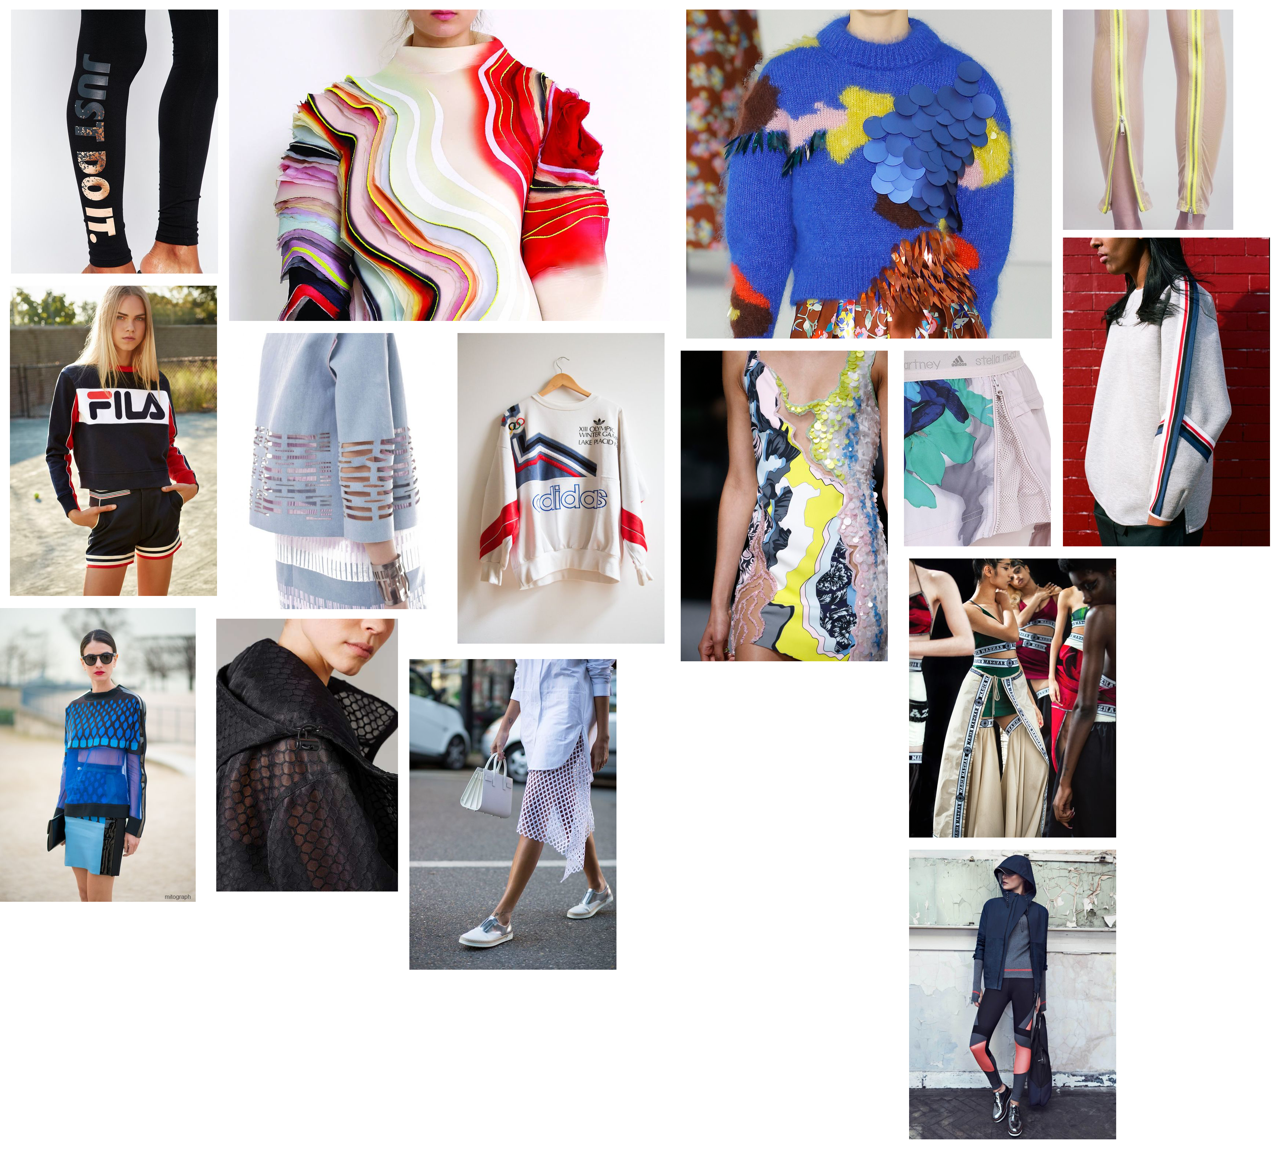
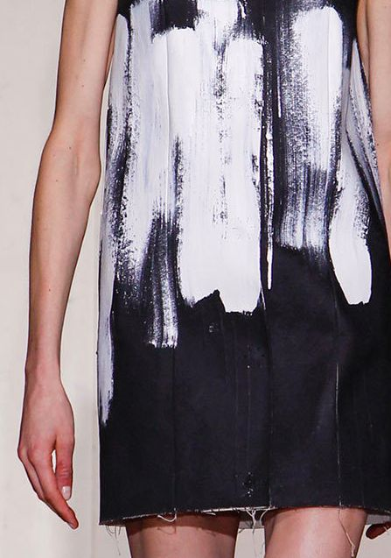
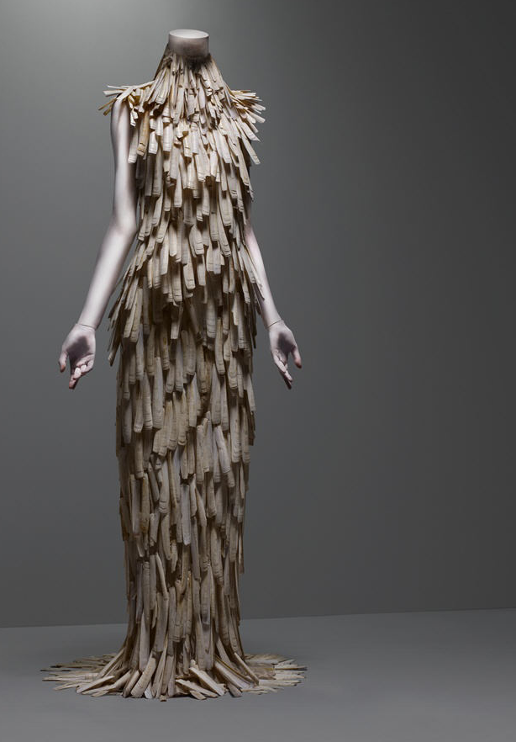
Top Left: Alexander McQueen

Top Right: Maison Margiela

Opposite: Sportswear details and inspiration (Pinterest)


