
Data Handling & Business Intelligence (LCBB5014)
Assignment 2 - report
Andra Tabaras (2335892)

Table of Contents
Introduction 2
Data Cleaning and Preparation 2
Descriptive Statistics and Summary 3
In Excel – numeric variables 3
In Excel – categorical variables 4
In SPSS – numeric variables 1
In SPSS – categorical variables 1
Trend Analysis and Visualization 1
Genre-rating summary 1
Trends Analyse by Language 2
Popularity 3
Comparison 4
Statistical Analysis using SPSS 4
T-test 5
Correlations examination 0
Regression Analysis 0
Simple Regression 1
Multiple Regression 2
Insights and Recommendations 3
References 4

Introduction
This report uses the Letterboxd Movie Classification Dataset to examine how viewer behaviour and film characteristics interact to shape popularity and ratings in the media and entertainment sector. The dataset includes variables such as film titles, directors, genres, runtimes, original language, ratings, watches, likes, list appearances, and fan counts, enabling a multidimensional analysis of both consumption and engagement. The analysis combines data manipulation and visualisation in Excel with statistical modelling in SPSS to derive evidence-based insights for business intelligence and decision-making.
The objectives are fourfold. First, the data is cleaned and prepared by correcting headers, standardising formats for categorical fields such as Genres and Original language, and handling missing or inconsistent numeric values in measures like Runtime, Watches, Fans, and Average rating. Second, descriptive statistics and frequency distributions summarise central tendencies and distributions for key numeric and categorical variables. Third, trend analysis explores patterns in ratings, popularity, and engagement across genres and languages, supported by bar charts, histograms, scatter plots, and other visual tools. Finally, statistical testing in SPSS, including hypothesis tests, correlation, and regression, is used to assess differences (for example, between English and non-English films) and to model how factors such as runtime, fans, and likes predict average rating and viewing behaviour.

Data Cleaning and Preparation
The dataset was first cleaned by promoting row 2 (Film_title, Director, etc.) to the header row and deleting the initial “Unnamed” row, along with the index column that only contained sequential IDs (0.0, 1.0, 2.0, …). This ensured that the Excel table was correctly structured when creating an official table object (Insert → Table, “My table has headers”). Columns storing labels or free text (Film_title, Director, Genres, Original_language, Description, Studios) were treated as categorical variables, while columns containing counts or continuous measures (Average_rating, Runtime, Watches, List_appearances, Likes, Fans, Lowest, Medium, Highest, Total_ratings) were treated as numeric.
Next, numeric fields were checked for missing values and data-type issues so that aggregation (e.g. averages, sums) would be valid. Cells where numbers were stored as text were converted to proper numeric format, in line with Excel’s guidance that such errors can cause formulas to evaluate incorrectly. Where values appeared as “unknown”, targeted imputation was used if reliable supporting information was available, typically by consulting the Description column or by filtering films with the same director, language, or series membership (for example, titles from Krzysztof Kieślowski’s “Three Colors” trilogy with partially missing attributes). In cases where imputation risked distorting key metrics, rows were flagged for exclusion from analysis rather than filled randomly.

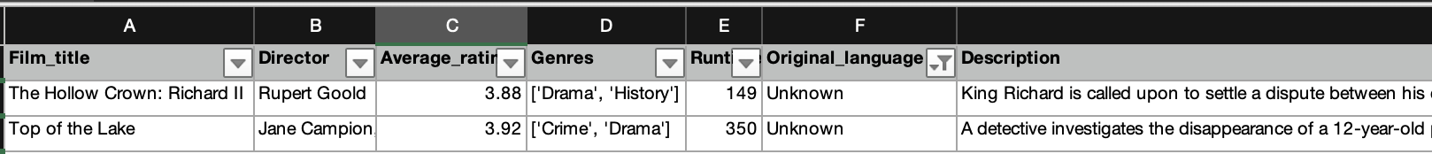

Finally, for clearer genre statistics, multi‑label genre entries were simplified so that the first listed genre became the primary genre (e.g. records beginning with “[‘Adventure’…” were recoded simply as Adventure).

Descriptive Statistics and Summary
For this dataset it is mainly needed descriptive statistics for numeric columns (Average_rating, Watches, Fans, Runtime) and frequency distributions for categorical columns (Genres, Original_language) in both Excel and SPSS.

In Excel – numeric variables
While the mean for each numerical column can be obtained separately by applying the AVERAGE function, it is, according to Meah (2022), often more efficient to rely on the Data Analysis option found under the Data tab, because this feature avoids the repetitive task of entering individual formulas and instead offers a set of tools that support a broad range of statistical analyses within the same interface.
Across the 9,682 films, the mean Average_rating is about 3.27 out of 5, indicating that movies are typically rated slightly above the mid‑point. The mean Runtime is roughly 104 minutes, so a typical film lasts around one hour and forty minutes. On average, each film has approximately 175,663 Watches, reflecting very high viewing volumes across the sample. The mean number of Fans is about 1,706 per film, suggesting that a substantial subset of users actively mark many titles as favourites.

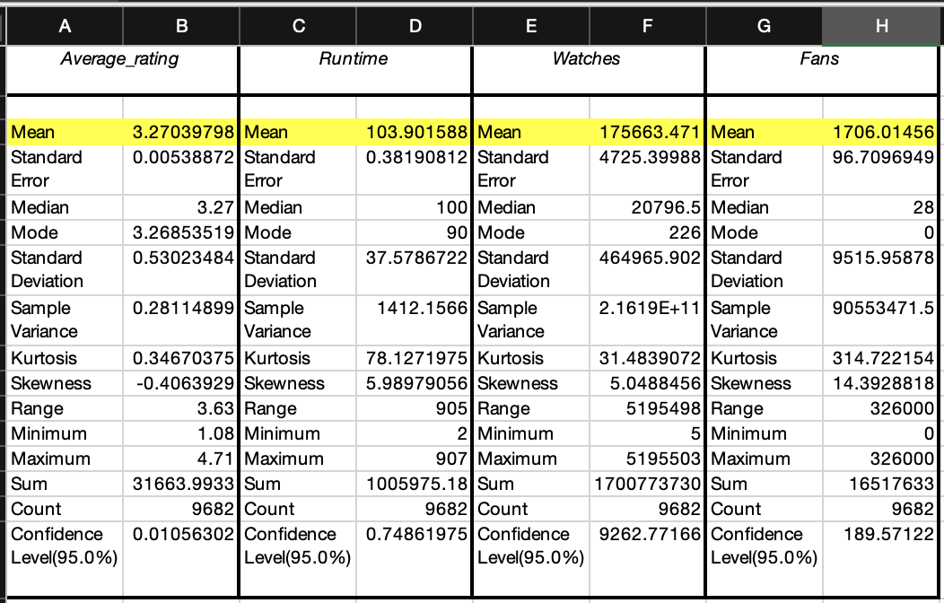

In Excel – categorical variables
According to Jonker (2017), frequency tables provide a structured way of organising and summarising data by listing how often each value appears, usually in ascending order to make later calculations more straightforward. In a complementary way, pie charts, as described by Peck et al. (2019), visually represent how each category contributes to the whole data set by displaying their relative proportions as slices of a circle. Using these tools, frequency tables and pie charts were generated for Genres and could likewise be created for Original language in order to present the distribution of movies across categories in a clear and concise manner.

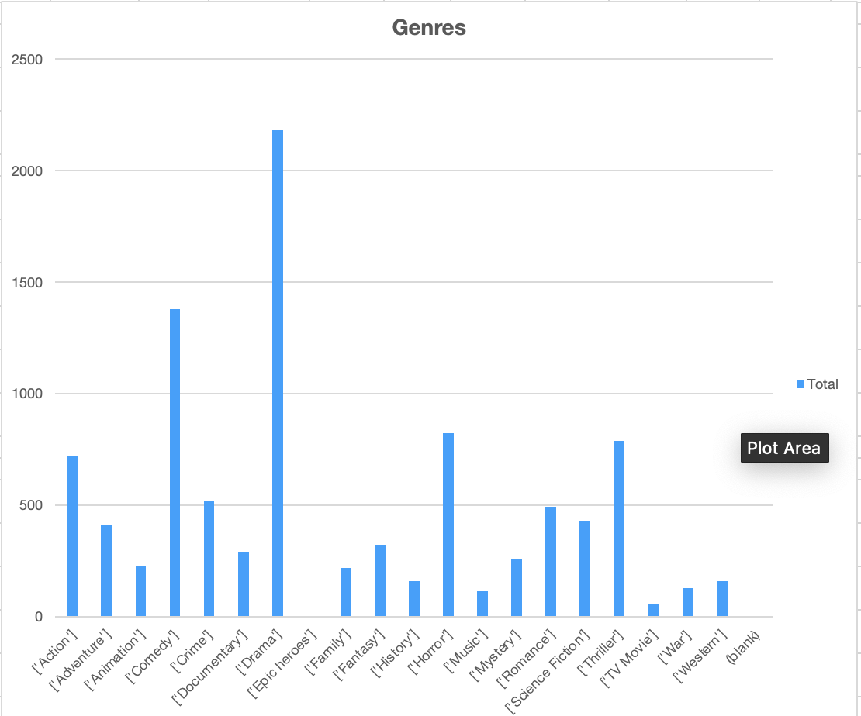
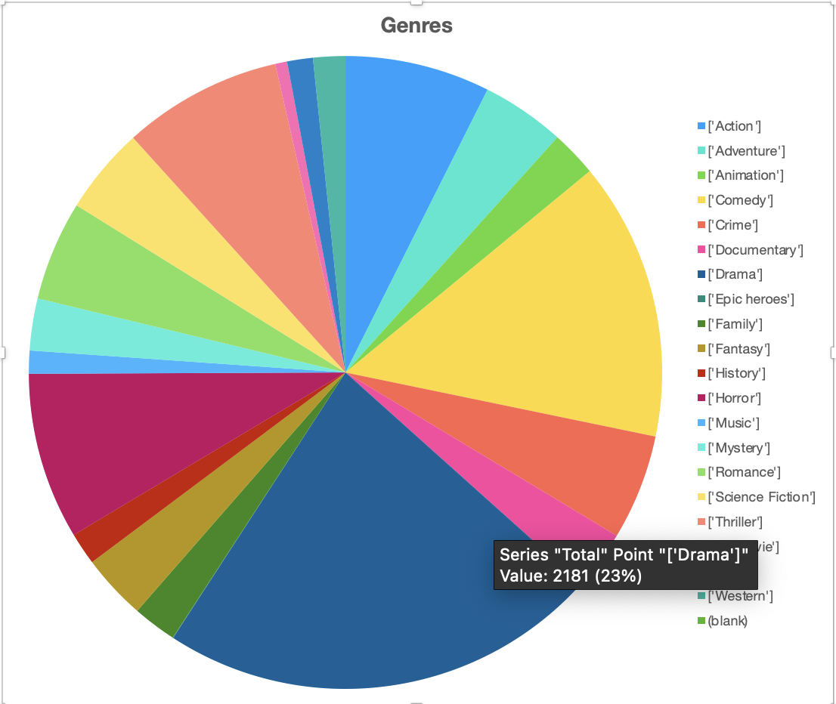
The bar and pie charts show that Drama is by far the most common genre in the dataset, with about 2,181 films, representing roughly 23% of all titles. Genres such as Comedy, Horror and Thriller also appear frequently, each contributing several hundred films, while categories like War, Western, Music and TV Movie occur much less often and form only small slices of the chart.

In SPSS – numeric variables
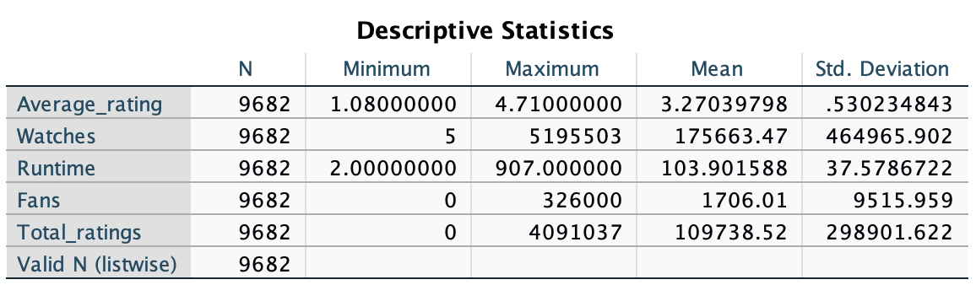

In SPSS – categorical variables
As in the Excell section, the Genres were explored, for SPSS exemplification, the Original language can be observed, for a more diverse view.

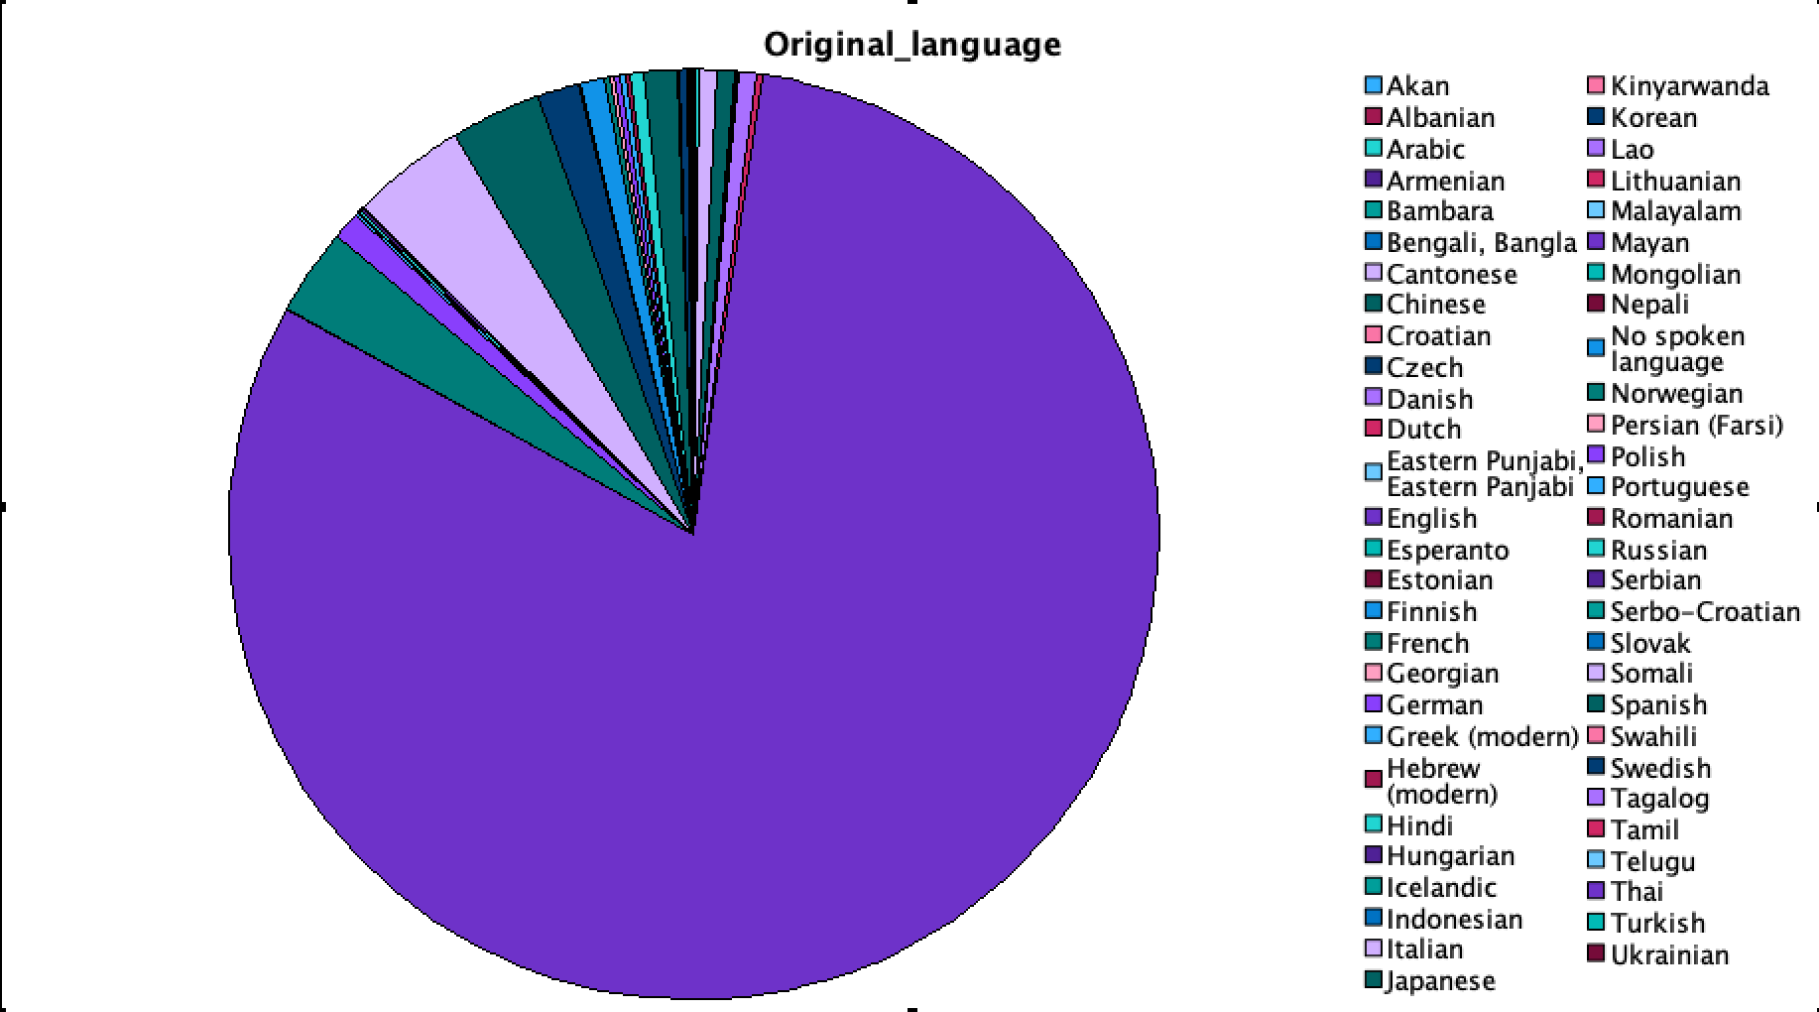
The pie chart shows how often each original language appears in the dataset of 9,682 titles. Most titles are in one main language, which takes up almost the whole chart, while all other languages only appear a little. This means the data is very unbalanced, with the main language strongly dominating and the other languages having much smaller representation.

Trend Analysis and Visualization

Genre-rating summary
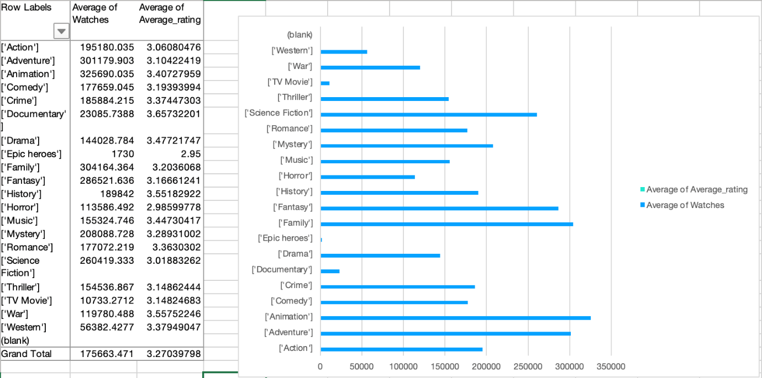
From the chart, History, Western, and Documentary appear among the highest‑rated genres, all with average ratings noticeably above the overall mean of about 3.27. In contrast, Epic heroes and Horror sit at the lower end of the scale, with average ratings clearly below 3.1.
Highly rated genres do not always have the most watches: for example, Animation and Adventure attract very high average watches but their ratings are only slightly above or close to the overall mean. Conversely, some of the best‑rated categories such as History and Western achieve strong ratings with only moderate watch levels, suggesting they are more critically appreciated than widely viewed.

Trends Analyse by Language
Languages such as Esperanto, Finnish and Mongolian appear to be associated with relatively high average ratings, as their rating bars sit noticeably above many of the other languages. However, their engagement is mixed: Esperanto and Finnish attract quite high average watches, while Mongolian combines strong ratings with exceptionally high watch counts, indicating both critical appreciation and broad audience reach.
In contrast, several languages with moderate or lower ratings (for example, Portuguese, Persian, or some smaller languages) show only modest average watches, suggesting they are more niche both in perceived quality and audience size. Overall, a few languages manage to pair high ratings with high engagement, but for many others strong ratings do not automatically translate into large viewing volumes.
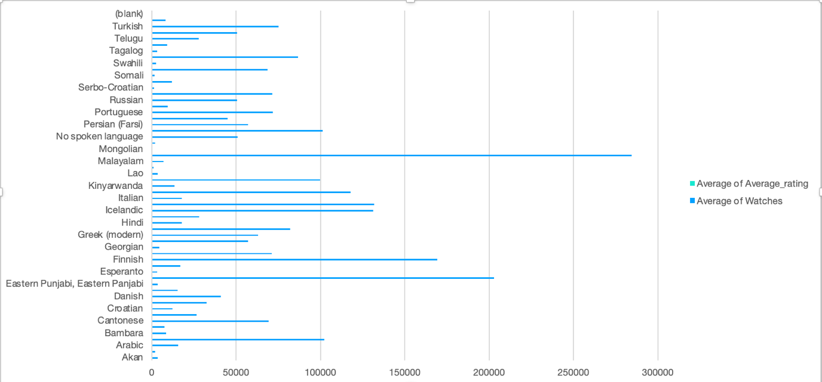

Popularity
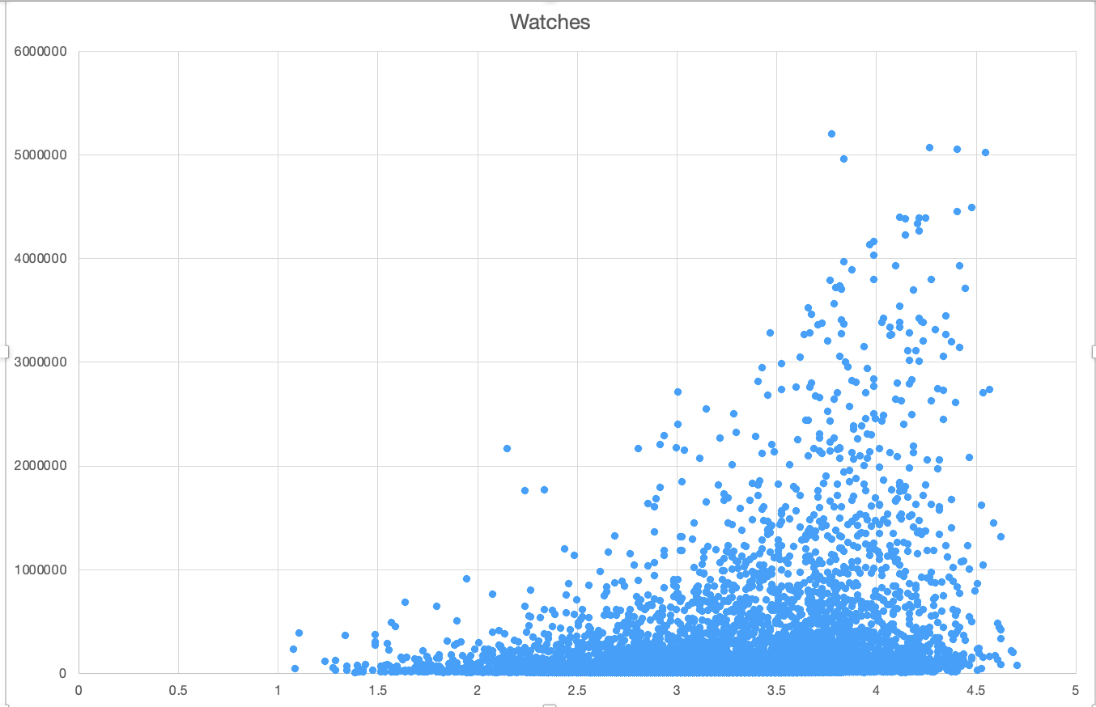
The relationship between number of watches and average rating is very weakly positive. Films with more watches tend to have slightly higher ratings on average, but the effect is small, with a lot of vertical spread at any given watch level.
On the scatter plot, most titles cluster at relatively low watch counts (hundreds to low thousands) across a wide range of ratings, showing that many films remain niche regardless of quality. At the extreme right, a small group of blockbusters has both very high watch counts and above‑average ratings (around or above the overall mean of 3.27), indicating a cluster of high‑watch, reasonably well‑rated films rather than high‑watch flops. There are also many mid‑watch films whose ratings sit close to the overall mean, so clear clusters of “high‑watch but low‑rating” or “low‑watch but very high‑rating” are limited and mostly appear as isolated points rather than dense groups.

Comparison
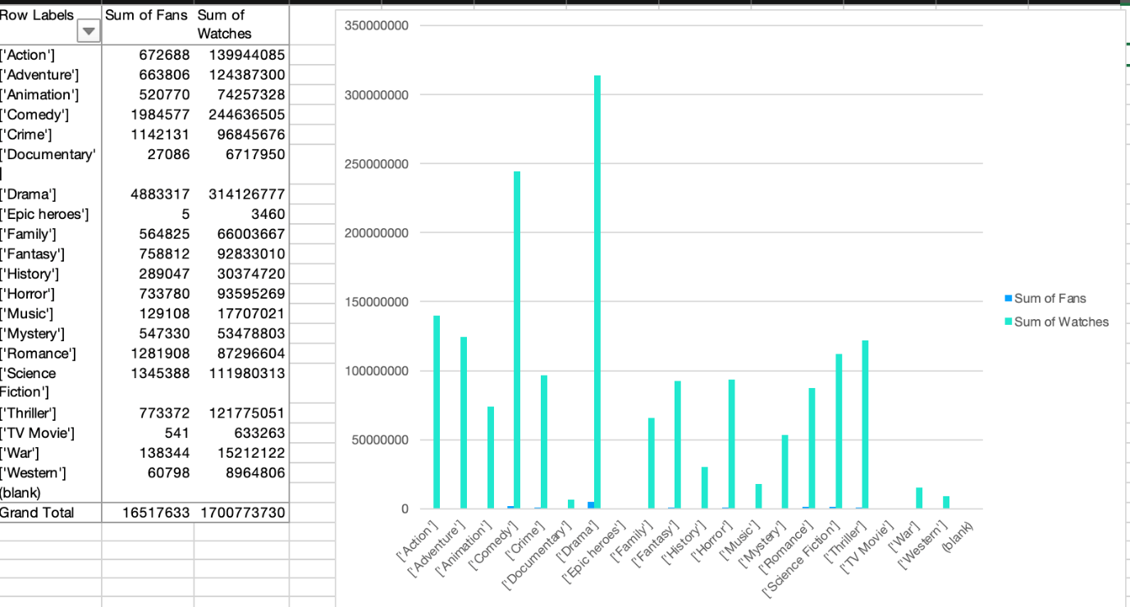
History, Western, and Documentary achieve the highest average ratings, clearly exceeding the overall mean, while Epic heroes and Horror sit at the bottom of the rating scale. In terms of engagement, Drama, Crime, Comedy, Animation, Adventure, Science Fiction, and Romance attract the most watches and fan activity, whereas History, Western, and Documentary draw smaller audiences despite strong critical appreciation. This pattern highlights a trade-off between popularity and perceived quality, with mass-appeal genres delivering large viewing volumes but only average-to-good ratings, and critically favoured genres remaining relatively niche.ieve higher scores but remain more niche in terms of audience size and fan counts.

Statistical Analysis using SPSS
The first step in SPSS was to create a dummy variable for English vs non‑English. Creating the `Eng_dummy` variable turns the textual language field into a numerical indicator that statistical tests can use. By recoding `Originallanguage` so that English films are coded as 1 and all non‑English films as 0, the dataset now contains a simple binary variable that can be entered directly into t‑tests, correlations, and regression models. This step is necessary because many SPSS procedures require numeric inputs and cannot meaningfully interpret long string labels such as full language names, while a 0/1 dummy allows the software to compare group means (English vs non‑English), estimate the size of the difference, and assess how being in English predicts engagement outcomes like watches or likes.

T-test
The t-test is a statistical method used to determine whether the difference between two sample means is significant or if it could have happened by random chance (Malec, 2018).
According to the T-test that was run, English‑language films (Eng_dummy = 1) have a mean average rating of 3.21 (N = 7,809), whereas non‑English films (Eng_dummy = 0) have a higher mean rating of 3.52 (N = 1,873). The independent‑samples t‑test (equal variances not assumed) yields t = −24.92, df ≈ 3,153, with a Sig. (2‑tailed) < .001, indicating that this difference is statistically significant at the 0.05 level. Because the mean rating for non‑English films is higher and the p‑value is well below 0.05, the results show a clear and significant difference in average ratings, with non‑English films rated more highly than English‑language films in this dataset.

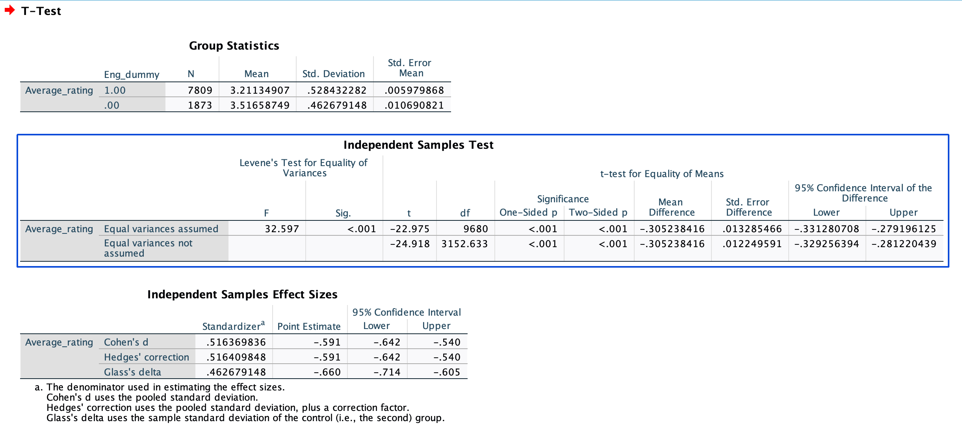

Correlations examination
According to King, Rosopa, and Minium (2018), correlation measures the strength of the relationship between two variables. The correlation table shows that Runtime has a small but significant positive association with viewing and liking behaviour. Runtime correlates with Watches at r = .143, p < .001, meaning that longer films tend to receive slightly more views, although the effect size is modest. Runtime also shows a positive correlation with Likes at r = .128, p < .001, indicating that longer movies gain somewhat more likes, but again the relationship is weak and many short films also attract substantial audience appreciation.
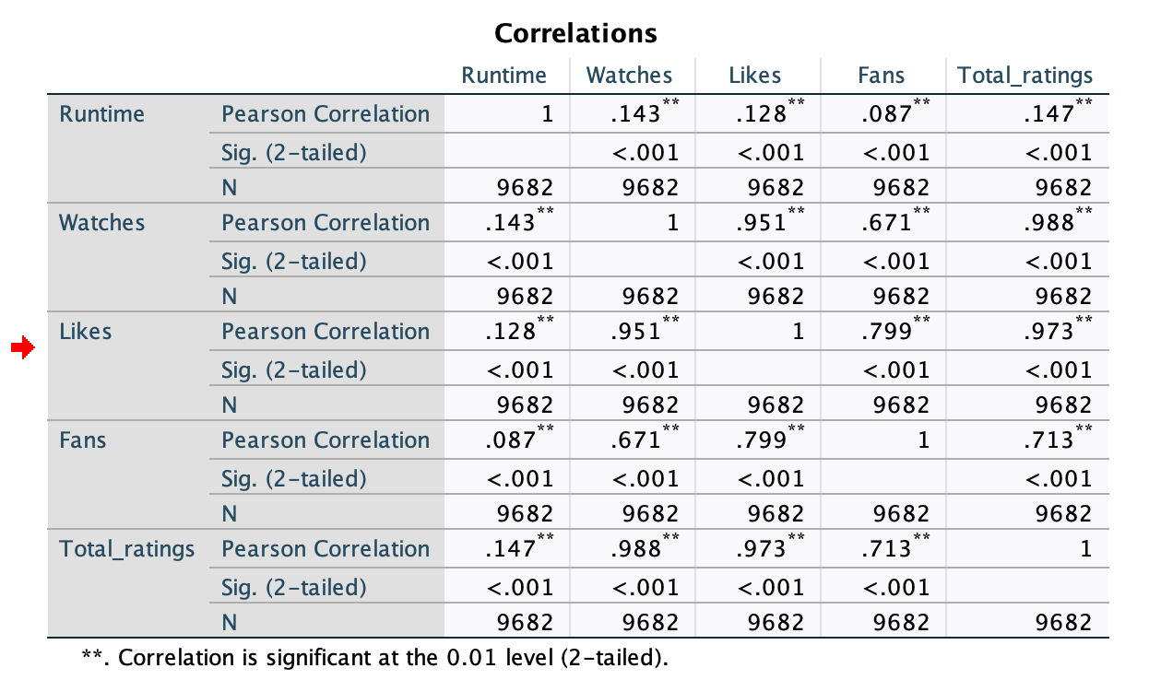

Regression Analysis
As noted by Burns and Burns (2008), regression analysis constitutes a foundational statistical technique in SPSS that examines relationships between dependent and independent variables, thereby enabling researchers to model predictive relationships and quantify the strength of associations within data, whilst Online SPSS (N.D.) further elucidates that as a parametric technique, regression analysis serves three primary functions encompassing the description of relationships between variables, the estimation of dependent variable values from independent variable observations, and the identification of risk factors that influence outcomes for prognostication purposes.

Simple Regression
As stated by Mesquita & Kostelijk (2021), simple regression analysis is a statistical method used to examine the relationship between two quantitative variables: a dependent (or outcome) variable and an independent (or predictor) variable.
The simple regression of Watches on Runtime shows a small but statistically reliable effect. From the Model Summary, the model has R = .143 and R² = .021, meaning runtime explains about 2.1% of the variance in the number of watches, with most variability driven by other factors. In the Coefficients table, the unstandardised coefficient for Runtime is B = 1,774.90, with p < .001, so runtime is a significant positive predictor of watches; on average, each additional minute of runtime is associated with roughly 1,775 extra watches, although the overall predictive power of runtime alone remains modest.
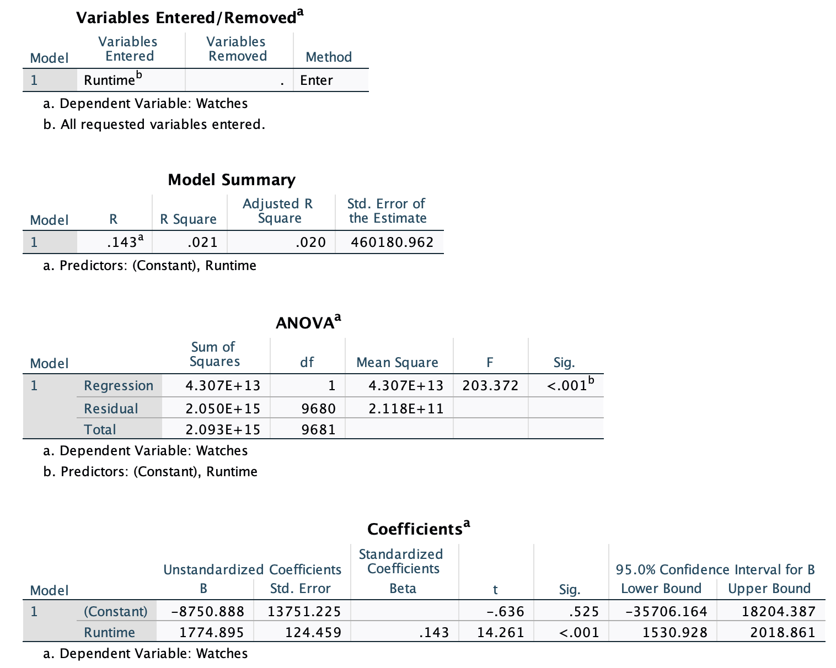

Multiple Regression
Mesquita and Kostelijk (2021) explain that when the relationship involves a dependent variable and multiple independent variables, it is referred to as multiple regression analysis, which is one of the most well-known and widely used methods in multivariate statistics.
In the multiple regression model predicting Watches, the coefficient for Eng_dummy is B = 215,536.42 with p < .001. Because B is positive and highly significant, this indicates that, controlling for runtime and average rating, English‑language films receive on average about 215,500 more watches than comparable non‑English films, showing a strong language advantage in user engagement.
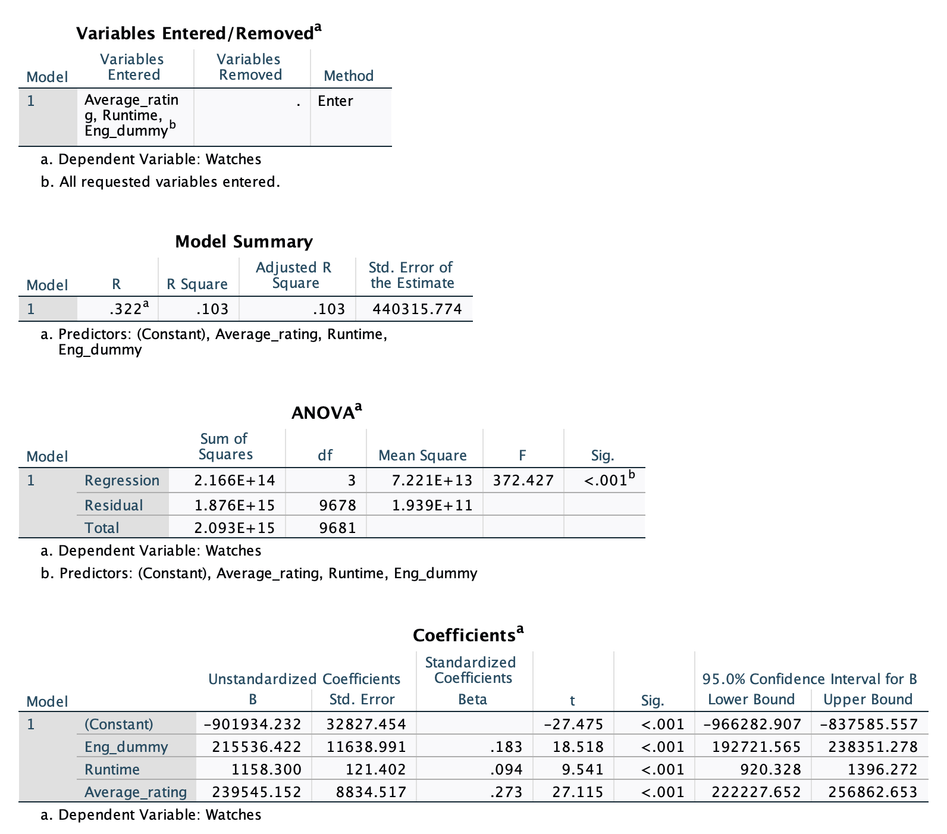

Insights and Recommendations
The analysis shows that films in History, Western, and Documentary achieve the highest average ratings, while mass-appeal genres such as Drama, Crime, Comedy, Adventure, and Animation generate the largest viewing volumes and fan engagement, revealing a trade-off between popularity and perceived quality. Non-English films are rated significantly higher than English titles, yet English-language films attract substantially more watches, and longer runtimes are associated with slightly higher viewing and liking levels.
For decision-makers, this suggests opportunities to prioritise high-demand genres for revenue, while selectively promoting critically strong but niche genres to differentiate catalogues, expand subtitles and dubbing to leverage the strong ratings of non-English content and optimise runtimes to balance engagement with production costs. BI teams should integrate these findings into recommendation systems, marketing campaigns, and commissioning decisions, for example by targeting marketing spend towards high-watch but mid-rated genres while curating premium collections around top-rated, lower-volume categories.
However, the dataset is limited to one platform and time period, with weak effect sizes for some relationships and potential unobserved variables such as marketing spend or release date. Future research could incorporate temporal data, additional platforms, user demographics, and more advanced models to capture evolving viewer behaviour.

References
Burns, R.B., & Burns, R.L. (2008) Business Research Methods and Statistics Using SPSS. SAGE Publications Ltd
Jonker, S. (2017) Introduction To Systems Development NQF2 SB. Macmillan. Available at: https://www.perlego.com/book/2306412 (Accessed: 22 December 2025).
King, B., Rosopa, P. & Minium, E. (2018) Statistical Reasoning in the Behavioral Sciences. 7th edn. Wiley. Available at: https://www.perlego.com/book/3866384 (Accessed: 22 December 2025).
Malec, M. (2018) Essential Statistics For Social Research. 2nd edn. Routledge. Available at: https://www.perlego.com/book/1597258 (Accessed: 22 December 2025).
Mesquita, J. M. C. & Kostelijk, E. (2021) Marketing Analytics. Routledge. Available at: https://www.perlego.com/book/3016268 (Accessed: 22 December 2025).
Online SPSS (N.D.) HOW TO RUN SIMPLE REGRESSION TEST IN SPSS. Available at: https://www.onlinespss.com/how-to-run-simple-regression-test-in-spss/ (Accessed: 22 December 2025).
Peck, R., Olsen, C., Short, T., Peck, R., Olsen, C., & Short, T. (2019) Introduction to Statistics and Data Analysis. Cengage Learning EMEA. Available at: https://www.perlego.com/book/3156856 (Accessed: 22 December 2025).

