Module Name: Organisational Consultancy
Module Code: BMIH6005
Assignment Title: Consultancy Report
Name of report: Holiday Inn Madrid, Ciudad Pegaso, Madrid, technical department
Student Name: Delia Sandra Isaic
Student ID: 2119909
Name of the consultancy: BlueBrett

Date of Submission: 26 February 2024
Executive Summary
I am a professional organisational consultant specialised in the field of cyber security and maintenance, of a recognised consultancy company has got an approach to resolve a specific issue of cyber-attack which has appeared in Holiday Inn Madrid, located in Madrid, Ciudad Pegaso Street, Madrid, Spain. Usually, Holiday Inn Madrid is considered one of the recognised hotel industries in Madrid, SPAIN. The hotel has received sufficient recognition throughout the world in terms of its customer base and genuine services including lodging, food, and outstanding hospitality. Recently, Holiday Inn Madrid has witnessed a serious complication regarding its cyber security management and database maintenance of the customer. The internal cyber surveillance management of that hotel has seriously been attacked by malicious dark web hackers. Of this serious complication the database operation of the hotel crashed and diverted from the internet domain. Personal information of the customers associated with Holiday Inn Madrid including identity, bank details, location, contact number etc. were circulated and hacked by the unauthorised hackers. The hotel must compensate in terms of the penalty imposed by the SPAIN Government for the violation of the Data Protection Act caused by the attackers of cyber hackers. The hotel was nearly on the verge of destruction.
The hotel then desperately needed support to deal with the cyber security implications and incidentally, Holiday Inn Madrid approached a cyber-security professional consultant of my organization. Some relevant experiments and analyses like STEEPLED analysis were done by the consultant to overview the hospitality management of Holiday Inn Madrid. Then a SOAR analysis was done by the consultant to make an overview of the hotel's strengths, staff, and other considerable areas. A proper table was framed to personify the term SOAR analysis more efficiently. After the SOAR analysis was conducted, the TOWS analysis was conducted respectively by the consultant to examine and highlight the probable future directions for Holiday Inn Madrid. This TOWS analysis also was represented by framing a graphical framework and then a table was followed to state the impacts. The Professional Consultant wanted to portray a realistic condition before coming to fix the cyber security problems. By adopting this analysis, the consultant got a clarified conception of the current condition of Holiday Inn Madrid. Whether the hotel is intentionally trying to circulate the confidential information of the customer to the third party was also checked well by the consultant concerning the customers.
After the following analysis and experiments were conducted by the consultant then gathered much information regarding the drawbacks and loopholes in the cyber security failure of Holiday Inn Madrid. The many issues which were found by consultant. The consultant found that the cyber security operators of the hotel are not well educated and trained about the advanced conception of cyber intelligence. The online network infrastructure of the hotel was too backdated and complicated which can trouble the other stakeholders of that hotel. Operators are unaware of using strong and complex passwords on the relevant personal websites of the hotel. Proper two-mode verification was not being done in the cyber security. The Antivirus that the company was using to secure its websites from external hackers was not up to date. The third-party interference was at its best in the hotel for which much confidential information of the customers was being circulated. The Internal Threat ratio in the cyber security system of the hotel was also at its peak. The cyber operators of the hotel were way casual in his or her work on protecting the data from the hackers. A ransomware virus threat was detected in the computer software system of that hotel which resulted in hacking the internal software of the hotel.
After conducting an elaborate detection by the professional cyber security consultant, various recommendations have been suggested to the cyber security and database management department of Holiday Inn Madrid. The hotel was directed to properly educate and train the novice and fresh computer operators. The hotel was suggested majorly to keep updating its websites regularly. A professional and efficient cyber security maintenance operator was directed to be appointed in the hotel workplace. Interference of third parties needs to be highly controlled by the hotel management to secure the personal details of the customers of the hotel. The hotel needs to implement and work more efficiently on adopting artificial intelligence in its cyber security department.
Holiday Inn Madrid has been successful in adopting those significant recommendations to resolve the complications of its cyber security and database management. The hotel has invested a lot to install highly secured artificial intelligence-enabled database management software. The hotel has also invested well in providing proper training to the novice and fresh staff regarding cyber security information. The hotel has been recovering gradually from previous disasters with the help of an appointed professional consultant. Gradually the additional cost incurred by the hotel to deal with different kinds of issues. In addition to these, the study has also been used SOAR analysis as this analysis is easy and simple to understand and is based on effective goals for managing market trends and business. It has been observed that the hotel has invested a lot to provide training related to cyber threats to the freshly recruited operators. Unauthorised websites have been blocked and authentic VPN applications have been installed in the computer system of the hotel.

Contents
Introduction 7
Analysis 9
STEEPLE Analysis 10
Social Factor 11
Technological Factor 12
Environmental Factor 12
Economic Factor 12
Political Factor 13
Legal Factor 13
Ethical Factor 13
SOAR Analysis 14
TOWS Analysis 17
Recommendations and Change Management 19
Phishing attacks 19
Ransomware 20
A distributed denial-of-service (DDoS) 20
Payment card attacks 20
Customer data theft 21
Provide proper education and empower all the staff and associate members. 21
Upgrade of cyber network infrastructure 22
Security Capacities Assessment of Vendor 22
Tackling internal threats efficiently 22
Adaptation of powerful VPN software 22
Strong and unique password 23
Action Plan 25
Conclusion 28
Reference list 30

Introduction
This research is going to discuss the security department of the Holiday Inn Hotel, Madrid. The location of Holiday Inn Madrid, Spain is based at Ciudad Pegaso, Av. de Aragón, 402, San Blas-Canillejas, 28022 Madrid, Spain. This is an elegant hotel that is close to Marid Airport with a bar and restaurant. They offer free Wi-Fi services and create new meeting rooms in their hotel premises. Holiday Inn Madrid- hotel is walking distance from the Airport (IHG, 2024). This hotel is based on new AC conference rooms, a 156-room property and there are lobby where customers can print their documents. There is an option for free breakfast, mini gyms are available and complimentary water for their guests. There are various amenities for the Hotel which are based on enjoying delicious dining options, business services, fitness and recreation and laundry and housekeeping purposes. Different amenities are based on restaurants, Wi-Fi, lounge, baggage storage and fitness centres. Holiday Inn is IHG’s biggest hotel brand that is developing traveller numbers by developing customer service rates. Holiday Inn Hotel in Madrid is facing issues related to security breaches that are mainly based on cyber-attacks. Cyber-attack threats have created barriers for the hotel industry (Khanraet al., 2021). They are facing security issues related to social engineering, system intrusion and primary web application attacks. Insider threats, weak passwords, malware, and ransomware have created barriers for the Holiday Inn Hotel in Madrid. Hotel industries are facing cyber security threats for using different smartphones, computers, and smart home systems (Sharma and Gupta, 2021). Cybercriminals are creating negative impacts on those types of devices for managing guests' information, launching various activities, and managing financial data. As per the comment of Florido-Benítez (2024), threats, lack of proper visibility, and lack of properly documented processes are creating barriers to managing cybersecurity-based challenges for the hotel industry. The main purpose of Holiday Inn, Madrid is to help business customers, manage leisure guests and become familiar with staying places. It was opened in 1952 and it is an award-winning global icon they have an expanding pipeline in the world. The mission statement for Holiday Inn, Madrid is based on working together to deliver proper commitment, managing services, and delivering hospitality products to control strong moral systems and help the community. As per the comment of Bellantuonoet al. (2021), internal strategy consultants are defining the issues and identity of the organisations that need to be improved. They are looking for the development of employee satisfaction rates and defining profits and management.
This research study is going to discuss the issues related to cyber-attacks that are mainly faced by the Holiday Inn Hotel in Madrid. As viewed by Costanet al. (2021), various factors are creating barriers to cyber capacity management purposes that are based on the lack of inadequate availability and sufficient funding. An overview of the hotel is going to be made based on those aspects. Income rate, reputation, scope, and feedback are going to be evaluated for this research study. STEEPLED analysis it made to know different types of business evaluation, strategies and solving issues for managing daily operations. SOAR analysis is based on proper strategic planning that helps to manage the current position of the people's ideas and manage work vision. Different change management models are going to be examined in this research study to define issues and deliver proper solutions for effectively solving those issues. Action plans are going to be made based on defining problems, delivering proper solutions for the problems, defining desired outcomes, and managing time and dates.

Analysis
Holiday Inn Hotel has faced issues regarding cyber-attacks that are creating cloud attacks, IoT attacks, ransomware attacks and mobile banking malware. A security breach is negatively affecting hotels' reputations publicly and damaging business. There are various causes of cyberattacks which include malware, phishing, the internet of things, economic disrupts and SQL injection. Other reasons are based on worms, theft, social engineering, and DNS tunnelling. Guest feedback is creating a significant role in the hotel industry (Park et al., 2020). Holiday Inn Hotel is trying to develop its reputation rate by responding to all the reviews, creating buzz for the brands, and using social listening for the development of the advantages. Holiday Inn has increased its overall revenue rate by the end of the year 2022 and the worldwide revenue rate is 3.4 billion GBP (Statista, 2024).
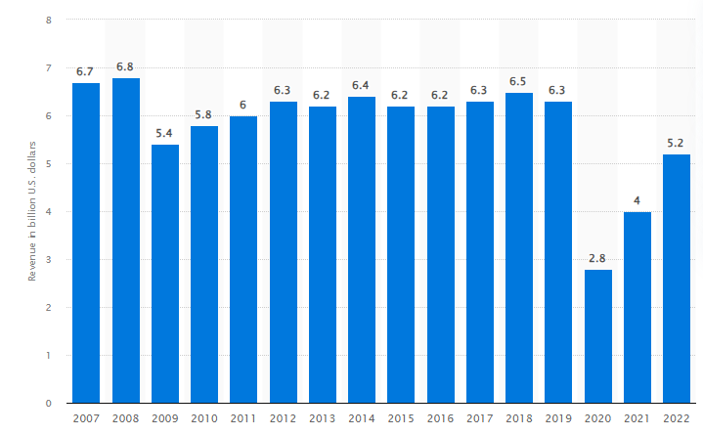
Figure 1: Gross revenue of Holiday Inn
(Source: Statista, 2024)
Madrid Hotel has faced challenges to cyber threats and unauthorised access to various time technology departments. This hotel group has faced barriers in managing bookings and controlling other applications and they are trying to manage all systems quickly (IHG, 2024). They are facing claims that IHG allowed hackers to manage access and create network disruptions for managing personal information.
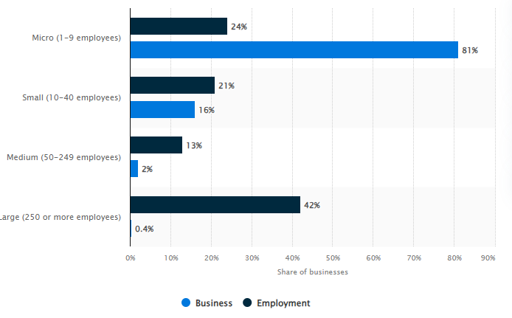
Figure 2: A proper distribution in tourism and hospitality business in the SPAIN based on employment and size.
(Source: Statista, 2024)
In 2012, the total employment size in the SPAIN hotel sectors was approximately 81% for the micro and macro businesses. The tourism and hospitality sectors are the main key factors for social and economic success and for delivering £66bn Gross Value and managing 3 million people (Statista, 2024). Overall employment among the hotel industries is around 76% in the SPAIN those are from the age of 16.

STEEPLE Analysis
STEEPLED Analysis is managing a proper technique that is helping business evaluation, and strategy and solves issues for managing daily operations. As per the comment of Richter et al. (2022), this model helps to determine and manage new opportunities and depends on various factors those are including economic, technological, social, ethical, political, and environmental factors.
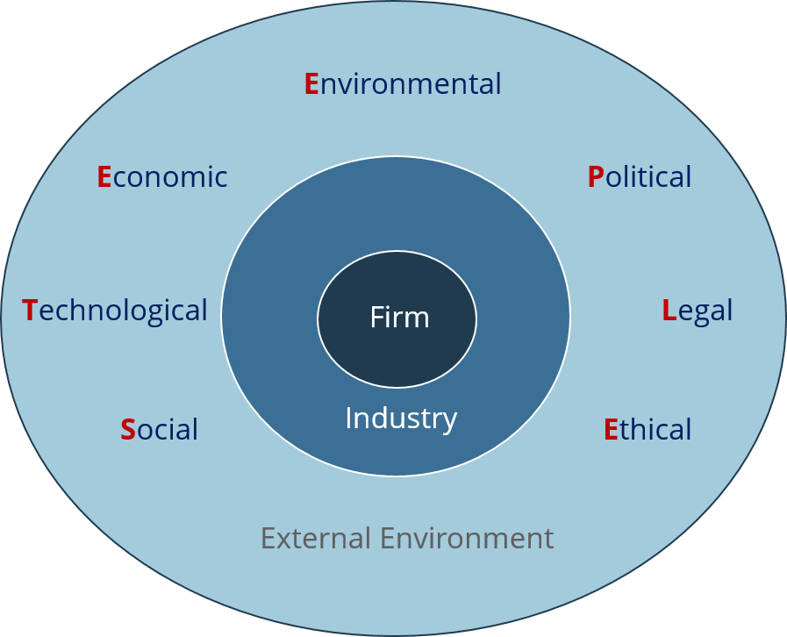
Figure 3: STEEPLED Analysis
(Source: Saidova and Muminjonova, 2022)

Social Factor
- Work-life balance is managing overall experiences and managing proper demands for the hospitality sectors for managing retreats, and entertainment among the hospitality sectors.
- In the year 2021, 2.4 million people will be involved in delivering food services and managing business accommodations for the tourism sectors in the SPAIN (Bhattacharya et al, 2021).
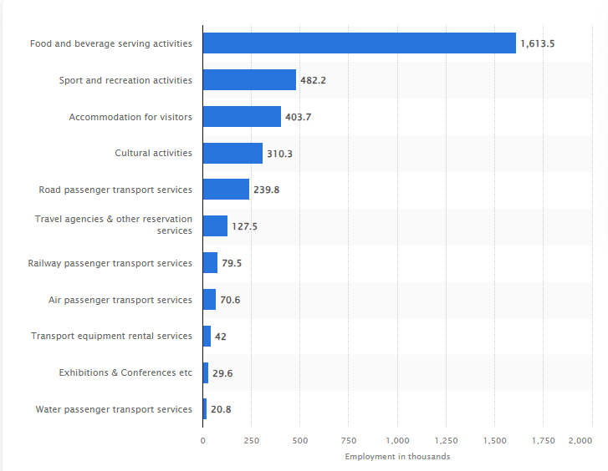
Figure 4: Total number of employees in the tourism sectors in the SPAIN
(Source: Statista, 2024)

Technological Factor
- Advanced technology, mobile technology and big data analysis are creating positive impacts for technology development purposes (Cappaet al., 2021). More deppp
- IoT has created positive impacts in the hotel industry for the development of the guest's experiences for managing systems and devices for security systems and room controls (Peletet al., 2021).
- Contactless payments are creating positive impacts in the hotel industries, the COVID-19 pandemic has defined these contactless payment methods for decreasing the rate of physical contact and decreasing transmission risks (Puriwat and Tripopsakul, 2021).

Environmental Factor
- The Environment Act of Spain has played a positive role in protecting wildlife, controlling water and air quality, and decreasing plastic waste (Averchenkovaet al., 2021).
- A high range of sustainable practices is creating barriers for the hotel industries and creating impacts for overall development purposes.

Economic Factor
- Lack of proper economy is decreasing total consumer spending is decreasing overall demands for hospitality services (Ceylanet al., 2020).
- Inappropriate exchange rates are negatively affecting the purchasing powers of the customers and increasing relative values.
- Holiday Inn has created negative impacts on the economic aspects and increasing competition rates.

Political Factor
- Government regulations and policies have created negative impacts for the SPAIN government in the time of setting proper rules and regulations on this sector (Bardoshet al., 2022).
- Brexit has some negative barriers for the hotel industries in Europe, decreasing investment rates, and tourist visiting rates among the hotel industries. It is decreasing the rate of foreign investors and decreasing attractiveness (Holloway and Humphreys, 2022).

Legal Factor
- The Employment Rights Act has played a positive role in managing employment opportunities, workers' rights, and employees' interests (Darmawanet al., 2020).
- The Data Protection Act is followed by this company for effectively managing consumers' data.
- The Consumers Rights Act plays playing crucial role in protecting consumers' rights to take services and goods from the hospitality sector.

Ethical Factor
- Hotel industries are managing cruelty-free practices and sustainability for managing proper commitment to ethical and responsible business.
- Holiday Inn is implementing cruelty-free practices and sustainability for managing the community and controlling ethical business (Nuneset al.,2022).
- Most of the hotel industries in the SPAIN follow a code of ethics for delivering proper guidance for professional and ethical behaviour of policies and managing day-to-day operations (Sifatuet al., 2020).

SOAR Analysis
SOAR analysis defines four different factors including opportunities, strengths, results, and aspirations which are based on strategic planning tools. In the thoughts of Sorooshianet al. (2020), this analysis delivers strategic planning techniques for managing organisational focus which is defining opportunities and strengths for defining results.
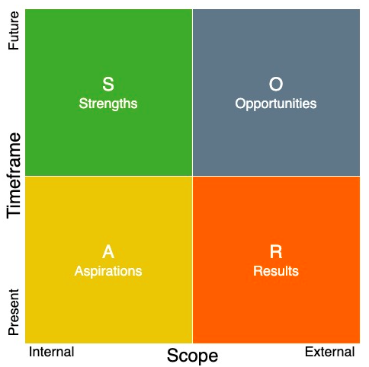
Figure 5: SOAR analysis
(Source: Eshovet al., 2023)
It is based on result result-based aspirations for managing various trends and strengths for controlling competitive advantages. As viewed by Eshovet al. (2023), SOAR approaches are managing strategic planning, controlling issues, defining organisational learning and analysis purposes. Four major key components for the SOAR analysis depend on opportunities, strengths, results, and aspirations. The main goal of this analysis is to develop proper efficiency for digital and physical security programs.

Strengths | Opportunities
- Higher visibility and brand values for managing advertising.  - Proper hotel location, proper hotel management systems and internal resources are delivering proper strengths in Holiday Inn, Madrid (Roy, 2021).  - Proper time management, communication, teamwork, and flexibility are creating strengths for the Holiday Inn, Madrid.  - The Parent company has higher brand values and higher customer satisfaction rates that create strengths.  - Higher profit margin rates, proper hotel locations, tangible assets, full flexibility, and a high brand reputation have created strengths for Holiday Inn.  - One of the main strengths is based on contributing to the local economy and managing the community (Gasga, 2022).  - Higher profit margin rate creates positive impacts for Holiday Inn, they are providing lower labour costs and managing a high profit margin.  - A higher profit margin is creating positive strengths for the hotel industry by managing luxury resorts and hotels.  - Relationship building and communication have been created strengths for hotel industries by making proper sense.  - Flexible pricing attracts more customers and makes proper sense for market development purposes.  - The comfortable and safe environment of Holiday Inn delivers offers for them and controls necessary facilities including electricity, beds, and washrooms. | - The huge scope for the technology is creating opportunities for Holiday Inn to manage the travel and hospitality sectors.  - Holiday Inn is getting technical advancement by managing robotics for managing services and controlling property management systems. To do so allow accurate employers training.  - The hotel industry is managing decision-making aspects controlling lodging and managing opportunities for delivering effective marketing segmentation (Misra, 2020).  - This organisation is delivering new opportunities for the industry and delivering new and effective ways for defining and decreasing the rate of threats.  - Uniqueness is creating opportunities for Holiday Inn to deliver higher comfort, attract more customers and help to differentiate competitors.  - Dynamic prices create opportunities for the hotels by delivering different prices for the same services.  - Huge capacity for accommodation and capacity management purposes for the tourists.  - Online booking systems are creating positive impacts for the hotel industry for managing booking systems and confirmation purposes.  - The hotel industry is contributing around £20 billion to the economy in SPAIN.
Aspiration | Result
- Holiday Inn will share all cultural aspects, respecting communities, colleagues, and guests to protect customers. They are trying to make great hotels by delivering true hospitality for the guests. | - Madrid Hotel needs to use big data, robotics, and cloud computing AI for managing cyber-attacks. They must implement Cloud for controlling property management systems, booking engines and channel managers for managing the hospitality industry.
Table 1: SOAR analysis
(Source: Developed by the learner)

TOWS Analysis
TOWS analysis is based on four different factors those are including opportunities, threats, strengths, and weaknesses. As stated by Fitriani (2022), there are various advantages of the TOWS analysis that are based on focusing on positive and negative impacts, and it is leading to the development of current positions. Those factors are determining strengths, weaknesses, threats, and opportunities. Those are matching weakness threats and external threats, external opportunities and internal strengths, and external and internal strengths and weaknesses. This is delivering proper ideas regarding weaknesses and strengths for controlling threats and opportunities. Businesses need to develop strategic action plans for detecting opportunities and strengths, threats. Holiday Inn Hotel is managing potential strategies and controlling strategic actions by defining threats and weaknesses. As mentioned by Safari and Amghani (2022), the TOWS framework helps to make, assess, and decide different business strategies. It helps to manage effective marketing strategy, decision defining threats and providing awareness for achieving success. As viewed by Dattaet al. (2020), there are various advantages of the TOWS matrix based on determining strategies for the changing dynamics. This analysis is helping to develop strategic ideas for managing external and internal factors among the organisations.
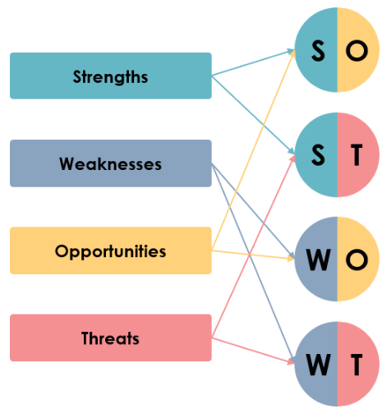
Figure 6: TOWS analysis
(Source: Savari and Amghani, 2022)

Strengths and opportunities | Strengths and threats
- Internal resources and the proper location of the hotels are creating strengths for Holiday Inn  - The proper location of the hotel is attracting more customer’s daily and attracting tourist’s visions and managing guests. It is developing guest satisfaction rates, developing booking rates and increasing profits for the hotel industry (Tomislav and STIFANICH, 2020). | - Holiday Inn is trying to manage the proper quality of its products and services in a better way rather than competitors.  - Strengthening cooperation and extensive promotions are creating positive impacts for the hotel industry.
Weaknesses and Opportunities | Weaknesses and Threats
- Holiday Inn is developing marketing promotion efficiently and effectively.  - Hotel industries have been trying to reschedule different promotional tourism programs through the years. | - Lack of promoting cooperation is creating a threat to the growth of the business and creating negative experiences for others.  - Lack of proper marketing segmentations is creating challenges for controlling marketing messages, decreasing loyalty programs and customer satisfaction rates in the business.
Table 2: TOWS analysis
(Source: Developed by the learner)

Recommendations and Change Management
After an elaborate analysis of the complicated issue of cyber-attacks in Holiday Inn Madrid, a contemplative and intense understanding has been constructed. As a professional consultancy company, the company has encountered and experienced numerous loopholes and technical glitches regarding the maintenance of cyber security in Holiday Inn Madrid (Ghelani, 2022).
First, the consultancy company has attempted to detect and analyse the prime drawbacks of the cyber security system of Holiday Inn Madrid, which have resulted in the acute cyber-attack in that hotel (Buttrick, 2009). Generally, a cyber-attack is a kind of malicious and vulnerable online assault to avail unauthorised and confidential access from database management of a computer system. The hackers who are mainly responsible for cyber-attacks usually aim to detonate and demolish a computer system and computer network to steal valuable data and information (Burnes, 2014). With this conception and information, it has been identified by the consultancy company that the cyber security and database management computerised system has been majorly attacked by malicious dark web hackers. As per the comprehensive analysis by the consultancy company towards Holiday Inn Madrid, various computerised cybersecurity-related loopholes have been found (Noordzife, 2014).

Phishing attacks
The term Phishing is defined as the transference of emails at random that are presented to be an authentic source, but it has been generated by a dark web hacker criminal. The hacker usually is involved in sending these emails to the selected recipients intending to convince the recipients to share information (Whittington, 2020). The consultancy company has detected many serious issues regarding fishing attacks in the computer network system of Holiday Inn Madrid. The company has found uncountable email senders irrespective of whether genuine or fake have sent emails targeting the Holiday Inn Madrid as recipient. The system operator of that hotel has randomly replied to the maximum number of emails. Even some official and confidential information has been unnecessarily and casually sent by the hotel computer system operator through email replies (Gunduz and Das, 2020). It has also been identified that the attackers sophistically created duplicate email accounts in the name of Holiday Inn Madrid and tried to malign the name of the hotel to the existing customers of the hotel.

Ransomware
The term ransomware threat is considered one of the worst cyber threats in recent years. Ransomware sabotage is also called one of the most notorious internet security malpractices in the world (Yohanandhanet al., 2020). Generally, the actual objective of this attack is to access the financial information of the users who are involved in paying the demanded amount using online payment websites. In the hotel industry, the respective hotel operators have been facing this ransomware trouble a lot. The consultancy company has detected that the cyber security system of Holiday Inn Madrid has been neutralised by the ransomware virus majorly (Safitraet al., 2023). The attackers intelligently have created such kinds of malicious websites which have been circulated through the internet targeting most of the hotel sectors. Holiday Inn Madrid has fallen into the trap of ransomware threat where the database management system has been critically hacked by the attackers. The confidential information of the customers and other guests has been shared automatically through the ransomware web pages. Holiday Inn Madrid has to compensate much money to fix the issue in the last year (Humayunet al., 2020). This year also the hotel has been on the verge of making the compensation.

A distributed denial-of-service (DDoS)
The term A distributed denial-of-service (DDoS) is another critical cyber threat that appeared from internet hackers. It is generally associated with the hotel industry mostly (Lallie et al., 2021). The hackers intended to create such websites through the dark web by which they can access the internal information and consequences of a specific hotel. The computer database system of Holiday Inn Madrid also has been attacked by the DDoS. The security camera management system also has been hijacked by the DDoS. The entire computer system has been impacted majorly by the DDoS. The confidential information regarding the financial statements, budgets, forecasting reports etc. also have been accessed by the attacker (Steingartner and Gelinec, 2021).

Payment card attacks
The highlighted term Payment card attacks are considered a major threat to the hotel industry in the world. Holiday Inn Madrid has faced one of the worst situations caused by the payment card attacks (Yeboah-Oforiet al., 2021). The professional consultant has witnessed a major error and miscommunication among the computer operators of that hotel. That is why the computer system has been majorly attacked by payment card attacks. Even the debit card swipe machine software of that hotel has been hacked by unauthorised online sources through a third party. For the utmost negligence and inefficiency of the computer operator of Holiday Inn Madrid. The bank account details of many customers of that hotel have been frozen and blocked by payment card attacks (Nam et al., 20210.

Customer data theft
Safeguarding the identification and valuable information of a customer is essential to the potential improvement of any business and the hotel industry. Customer data theft is considered one of the serious threats to the hotel industry. Unfortunately, Holiday Inn Madrid also has been made victim of that issue (Lai et al., 2020). There is innumerable customer data stored in the computer system but, the hotel computer operator has shown major idleness and inefficiency in protecting the entire database system by activating the safest cybersecurity software. For this reason, the attackers have been successful in accessing the debit and credit card essential data and identifications of the customers of Holiday Inn Madrid (Asadiet al., 2020).
The abovementioned highlighted points are the actual drawbacks and are responsible for hampering the cyber security management of Holiday Inn Madrid. The professional cyber security consultant of the consultancy company has adopted and implemented many infusions which have tried immensely to fix the implications of cyber security attacks in Holiday Inn Madrid. Therefore, the cyber security consultant has mentioned many solutions regarding the fixation of cyber security problems in the hotel (Yu et al., 2021). These are represented as recommendations below.

Provide proper education and empower all the staff and associate members.
A hotel without any difficulty can adopt any kind of cyber threat-solving network connection and software. It will matter seriously how a cyber-operator is technically advanced in operating the entire cyber system well (Ozdemiret al., 2021). So, according to the suggestion of the professional cyber security consultant the staff are directed to get training from specialised cyber security professionals. Holiday Inn Madrid is suggested to invest money in providing proper user-friendly training to the staff to cope with upcoming cyber-attack issues.

Upgrade of cyber network infrastructure
It is very necessary for the hotel industry to regularly update their cyber networking software to protect it from vulnerability. Holiday Inn Madrid has been properly directed to keep updating their database management software. They must protect the POS system which is very essential to store the entire identification details of a customer (Rahimianet al., 2021). The hotel has been suggested to set complex passcodes to stabilise the POS system. Dual-factor verification has been recommended to implementation in the hotel cyber security system. Authentic antivirus software and strong VPN activation have been suggested to be implemented in the system management. The hotel has also been recommended to keep filtering the external unrecognised mail chain (Ghelani, 2022).

Security Capacities Assessment of Vendor
Many cyber threats are executed through third parties. Holiday Inn Madrid has personally so many third-party vendors who generally work under that hotel to assist the customers in booking rooms (Buttrick, 2009). The cyber security operators of Holiday Inn Madrid are suggested to verify its vendors assuring that all the vendors have presently met compliances.

Tackling internal threats efficiently
Hotels generally have huge digital evidence as an outcome of all the separate systems they use. In this way, hackers attempt to gain entrance into a network and then they find sufficient access to the system (Burnes, 2024). The cyber security maintenance operator of the hotel has been advised to keep monitoring their self-made internal networking system to detect suspicious acts.

Adaptation of powerful VPN software
The cyber security operators of the hotel Holiday Inn Madrid have been recommended to adopt strong VPN software in their cyber network system which can immediately block the vulnerability of unknown websites from unauthorised sources (Ghelani, 2022).

Strong and unique password
The cyber security operators of Holiday Inn Madrid are directed to keep the customer database system by generating strong passwords so that not a single official excluding the IT Admin and system operators can access this database randomly (Noordzife, 2014).
The abovementioned highlighted points have covered the recommendations and management reformation part completely after thorough detection and analysis of the different kinds of drawbacks and loopholes caused by the cyber-attack towards the cyber operation of Holiday Inn Hotel (Buttrick, 2009). After some days, the professional cyber security consultant of the consultancy company went to visit the hotel again to measure and review the rate of success applied by the cyber security operator of the company. The professional cyber security operator has collected that after the analysis and relevant experiments done to deal with the cyber-attacks on the hotel, Holiday Inn Madrid has immensely improved its cyber security and database management software. The hotel has appointed many young efficient cyber security operators in its workplace to deal with the online slags (Ushakovet al., 2020).
After implementing the recommended strategies and frameworks from the cyber security professional consultants, Holiday Inn Madrid has witnessed sufficient success and development in its cyber security and database management (Zhonget al., 2021). Now the hotel has become successful in storing systematic personal identifications of its customer domain. The hotel is now implementing updated and organised software in operating organisational tasks. Not serious bugs and implications are appearing now in its workplace (Fandakly and Caporusso, 2020). After the elaborate analysis and recommendation made by the professional cyber security consultant, Holiday Inn Madrid has been able to reduce the excessive expenditure arising from the inadequate control of cyber security management. The hotel has been also able to reduce the compensation which was being generated from the defalcation of the customer database and leak of information (Samatovich, 2021).
Finally, it can be discussed that Holiday Inn Madrid has become successful in implementing different kinds of database security protocols in its cyber system management. However, the hotel must spend a big amount of money in the current year for the installation of additional software and cyber security system panels. The hotel has now been much aware of the utmost security and restoration of the information regarding the database management system. The third parties who are engaged in working for the hotel now are being managed properly by the management. The third party have been highly alerted by the hotel management to work positively and securely so that not a single internal information can be circulated (Yanget al.,2020). The hotel has improved the receipt and payment process software and made it user-friendly. The hotel has been regularly updating its websites in the browser so that users can deal with the latest websites regarding the hotel. Holiday Inn Madrid also has modified the social media channels of the hotel. Now individuals can be able to get information on social media platforms. The hotel has immensely modified its management system. Novice employees have been replaced by professional and experienced ones. Though these are the actual outcomes that Holiday Inn Hotel has witnessed, the hotel is still working on improving its cyber security.

Action Plan
Number | Problem | Solution | Desired outcome | Time  scale | Completion  Date | Planned  Budget
1. | Cyber security | Issues related to cyber security are based on prioritising, identifying and remediating vulnerabilities. There are various ways to mitigate cyber security that are based on employee training, providing strong passwords, and paying proper attention to physical security (Baron and Armstrong, 2007). | Cyber security is decreasing downtowns and decreasing revenue loss for specific systems and data (Ramadan et al., 2021). It will help industries decrease the rate of data breaches, phishing attempts, and malicious activities. Along with this, this is delivering skill and knowledge for safety purposes and organisations are getting success from cyberattacks. | 4 months | June 2024 | 30,000 GBP
2. | Data breaches | The use of strong passwords and authentication for delivering proper protection for personal data is trying to prevent data breach-related issues (Ernest et al., 2023). Along with this, different tools including anti-spyware, firewalls and anti-virus software are important tools those are helping businesses against data breaches. | A proper data breach response planning is managing responses and entities for data breaches and decreasing overall impacts (Newton, 2010). Along with this, proper reputation management strategy is managing online meetings, delivering proper responses for managing feedback and defining issues to prevent reputation images. | 3 months | April 2024 | 10, 000 GBP
3. | Managing online reputation | Positive reputation can be achieved by creating proper keywords, delivering positive online customer reviews, and managing brand mentions (Subramaniamet al., 2011). Along with this, it can be achieved by developing credibility, and trust, managing online reputations and developing brand images. They need to follow a long-term strategy for managing breaches and decreasing the rate of threats. | Reputation management is needed for the development of overall revenue rate, increasing opportunities, and determining the reputation rate. A positive online brand reputation helping others to develop credibility and trust and manage target audiences. Brand reputation helps customers develop credibility, trust and loyalty among other customers and negative impacts decreasing company image and sales. Brand reputation is done by defining customer reviews, and defining brand reputations (Rust et al., 2021). | 2 months | March 2024 | 5,000 GBP
Table 3: Action Plan
(Source: Developed by the learner)

Conclusion
This research study has been described regarding the Holiday Inn Hotel in Madrid, Spain. The main problem has been based on cyber security, data breaches and managing online reputation in the hotel industry. A proper overview of Holiday Inn Madrid has been examined based on scope, interest rate, growth rate and revenue. Along with this, the location of the hotel, total rooms and background of hotels have been defined in this research study. Different theories and models have been defined for this research study. Various frameworks have been examined that are based on SOAR, STEEPLED and TOWS these frameworks are helping to define issues and challenges. A proper analysis has been made based on defining the impact of cyber security in the hotel industry. The cause of cyber security impacts of negative feedback, income, scope, and reputation rate have been defined for this research study. They are facing different threats for managing hotel industries which are based on a lack of proper safety concerns, data privacy and inappropriate guest behaviours. Positive reviews are increasing bookings and managing higher occupancy rates and consequences among the hotel industries. Lewis Chnage's management theory has been used in this research study and has been based on three different stages including unfreeze, refreeze, and change. Overall success rate and impacts have been measured for strategic management purposes. An action plan has been made based on defining problems. Those problems have been based on data breaches, cyber security, and online brand reputation management purposes. Possible solutions have been delivered for mitigating those issues in the hotel industries in SPAIN. Desired outcomes have been analysed by effectively mitigating those issues. Time scale has been analysed based on 2 to 4 months and required budgets have been examined for this research study.
Coming to points of the actual threats and attacks that the hotel has faced are related to its cyber security manipulation. A professional cyber security consultant was approached by the hotel to detect the actual implications that the hotel is facing. The professional consultant studied and experimented well through thorough analysis and interpretation. The consultant has found several major drawbacks and loopholes that were creating trouble in the database management and cyber system software of the hotel. The protected data and information were being circulated through the third party to the cyber hackers. The online payment website was manipulated and crashed by the cyber-threatening bugs which troubled the customer so much. The debit and credit card details were hacked by the cyber hackers. Ransomware was found on the personal website of the hotel. This ransomware was troubling the internal software of the hotel. After the recommended strategy made by the professional cyber security consultant, the hotel gradually got recovered and back to its previous form.

Reference list
Asadi, S., Pourhashemi, S.O., Nilashi, M., Abdullah, R., Samad, S., Yadegaridehkordi, E., Aljojo, N. and Razali, N.S., 2020. Investigating influence of green innovation on sustainability performance: A case on Malaysian hotel industry. Journal of cleaner production, 258, p.120860.
Averchenkova, A., Fankhauser, S. and Finnegan, J.J., 2021. The impact of strategic climate legislation: evidence from expert interviews on the SPAIN Climate Change Act. Climate Policy, 21(2), pp.251-263.
Bardosh, K., De Figueiredo, A., Gur-Arie, R., Jamrozik, E., Doidge, J., Lemmens, T., Keshavjee, S., Graham, J.E. and Baral, S., 2022. The unintended consequences of COVID-19 vaccine policy: why mandates, passports and restrictions may cause more harm than good. BMJ Global Health, 7(5).
Baron, A. and Armstrong, M. 2007. Human Capital Management. Madrid: Kogan Page.
Bellantuono, N., Nuzzi, A., Pontrandolfo, P. and Scozzi, B., 2021. Digital transformation models for the I4. 0 transition: Lessons from the change management literature. Sustainability, 13(23), p.12941.
Bhattacharya, A., Zutshi, A. and Bavik, A., 2021. Building resilience for food service businesses in times of crisis: a Four-F action plan. International Journal of Contemporary Hospitality Management, 33(10), pp.3400-3441.
Buttrick, R., 2009. The Project Workout, Madrid: Prentice Hall
Cappa, F., Oriani, R., Peruffo, E. and McCarthy, I., 2021. Big data for creating and capturing value in the digitalized environment: unpacking the effects of volume, variety, and veracity on firm performance. Journal of Product Innovation Management, 38(1), pp.49-67.

Ceylan, R.F., Ozkan, B. and Mulazimogullari, E., 2020. Historical evidence for economic effects of COVID-19. The European Journal of health economics, 21, pp.817-823.
Costan, E., Gonzales, G., Gonzales, R., Enriquez, L., Costan, F., Suladay, D., Atibing, N.M., Aro, J.L., Evangelista, S.S., Maturan, F. and Selerio Jr, E., 2021. Education 4.0 in developing economies: a systematic literature review of implementation barriers and future research agenda. Sustainability, 13(22), p.12763.
Darmawan, D., Mardikaningsih, R., Sinambela, E.A., Arifin, S., Putra, A.R., Hariani, M., Irfan, M., Al Hakim, Y.R. and Issalillah, F., 2020. The quality of human resources, job performance and employee loyalty. International Journal of Psychosocial Rehabilitation, 24(3), pp.2580-2592.
Datta, N.R., Kok, H.P., Crezee, H., Gaipl, U.S. and Bodis, S., 2020. Integrating loco-regional hyperthermia into the current oncology practice: SWOT and TOWS analyses. Frontiers in oncology, 10, p.819.
Ernest, E., Osakwe, J. and Nhamu, I., 2023. A Framework for Data Protection and Privacy in Data Service Centres in the Public Sector: A Case Study of a Security Organisation in a Developing Countries. Available at SSRN 4645049.
Eshov, M., Saidova, M., Sabirova, D., Kutbitdinova, M. and Azizov, A., 2023. Effective use of block chain technology in business process (in case of Uzbekistan). In E3S Web of Conferences (Vol. 401, p. 05069). EDP Sciences.
Fandakly, T. and Caporusso, N., 2020. Beyond passwords: enforcing username security as the first line of defense. In Advances in Human Factors in Cybersecurity: Proceedings of the AHFE 2019 International Conference on Human Factors in Cybersecurity, July 24-28, 2019, Washington DC, USA 10 (pp. 48-58). Springer International Publishing.
Fitriani, E., 2022. TOWS Analysis on Recissbar to Increase Its Competitiveness. Revista CEA, 8(16), pp.e1876-e1876.
Florido-Benítez, L., 2024. The Cybersecurity Applied by Online Travel Agencies and Hotels to Protect Users’ Private Data in Smart Cities. Smart Cities, 7(1), pp.475-495.
Gasga, K.P., 2022. SWOT Analysis as a Strategic Tool for Local Tourism Development Planning: A Destination Review of a Municipality in the Philippines. Open Access Library Journal, 9(12), pp.1-30.
Ghelani, D., 2022. Cyber security, cyber threats, implications and future perspectives: A Review. Authorea Preprints.
Gunduz, M.Z. and Das, R., 2020. Cyber-security on smart grid: Threats and potential solutions. Computer networks, 169, p.107094.
Holloway, J.C. and Humphreys, C., 2022. The business of tourism. Sage.
Humayun, M., Niazi, M., Jhanjhi, N.Z., Alshayeb, M. and Mahmood, S., 2020. Cyber security threats and vulnerabilities: a systematic mapping study. Arabian Journal for Science and Engineering, 45, pp.3171-3189.
IHG, 2024. Holiday Inn Madrid - Madrid. Available at https://www.ihg.com/holidayinn/hotels/us/en/Madrid/lonmr/hoteldetail (Accessed on: 08 February 2024)
Khanra, S., Dhir, A., Kaur, P. and Joseph, R.P., 2021. Factors influencing the adoption postponement of mobile payment services in the hospitality sector during a pandemic. Journal of Hospitality and Tourism Management, 46, pp.26-39.
Lai, I.K.W. and Wong, J.W.C., 2020. Comparing crisis management practices in the hotel industry between initial and pandemic stages of COVID-19. International Journal of Contemporary Hospitality Management, 32(10), pp.3135-3156.
Lallie, H.S., Shepherd, L.A., Nurse, J.R., Erola, A., Epiphaniou, G., Maple, C. and Bellekens, X., 2021. Cyber security in the age of COVID-19: A timeline and analysis of cyber-crime and cyber-attacks during the pandemic. Computers & security, 105, p.102248.
Misra, M., 2020. Experiencing tentacle difficulties? SWOT it out! A SWOT Analysis on the Giant Pacific Octopus Marine Conservation Tourism Programs at the Seattle Aquarium. University of Washington.
Nam, K., Dutt, C.S., Chathoth, P., Daghfous, A. and Khan, M.S., 2021. The adoption of artificial intelligence and robotics in the hotel industry: prospects and challenges. Electronic Markets, 31, pp.553-574.
Newton, R 2010. The management consultant: mastering the art of consultancy. Financial Times.
Noordzife, G., 2014. Project Management of Hotel Opening Processes: Exploring Better Ways to Manage New Hotel Openings, CreateSpace
Nunes, B., Batista, L., Masi, D. and Bennett, D., 2022. Sustainable Operations Management: Key Practices and Cases. Taylor & Francis.
Ozdemir, O., Dogru, T., Kizildag, M., Mody, M. and Suess, C., 2021. Quantifying the economic impact of COVID-19 on the US hotel industry: Examination of hotel segments and operational structures. Tourism Management Perspectives, 39, p.100864.
Park, E., Kang, J., Choi, D. and Han, J., 2020. Understanding customers' hotel revisiting behaviour: a sentiment analysis of online feedback reviews. Current Issues in Tourism, 23(5), pp.605-611.
Pelet, J.É., Lick, E. and Taieb, B., 2021. The internet of things in upscale hotels: Its impact on guests’ sensory experiences and behavior. International journal of contemporary hospitality management, 33(11), pp.4035-4056.
Puriwat, W. and Tripopsakul, S., 2021. Explaining an adoption and continuance intention to use contactless payment technologies: during the COVID-19 pandemic. Emerging Science Journal, 5(1), pp.85-95.
Rahimian, S., ShamiZanjani, M., Manian, A. and Esfidani, M.R., 2021. A framework of customer experience management for hotel industry. International Journal of Contemporary Hospitality Management, 33(5), pp.1413-1436.
Ramadan, R.A., Aboshosha, B.W., AlshudSpainhi, J.S., Alzahrani, A.J., El-Sayed, A. and DessoSpainy, M.M., 2021. Cybersecurity and Countermeasures at the Time of Pandemic. Journal of Advanced Transportation, 2021, pp.1-19.
Richter, S., Szarka, N., Bezama, A. and Thrän, D., 2022. What Drives a Future German Bioeconomy? A Narrative and STEEPLE Analysis for Explorative Characterisation of Scenario Drivers. Sustainability, 14(5), p.3045.
Roy, M., 2021. Tourism Industry in Bangladesh: An Assessment of Advanced SWOT Model and TOWS Matrix. Tourism in Bangladesh: Investment and Development Perspectives, pp.279-310.
Rust, R.T., Rand, W., Huang, M.H., Stephen, A.T., Brooks, G. and ChabSpain, T., 2021. Real-time brand reputation tracking using social media. Journal of Marketing, 85(4), pp.21-43.
Safitra, M.F., Lubis, M. and Fakhrurroja, H., 2023. Counterattacking cyber threats: A framework for the future of cybersecurity. Sustainability, 15(18), p.13369.
Saidova, M.X. and Muminjonova, E.K., 2022, February. USING STEEPLE ANALYSIS IN BUSINESS PROCESS (IN CASE OF UZBEKISTAN). In International Scientific and Current Research Conferences (pp. 48-60).
Samatovich, R.S., 2021. Importance of Marketing in Tourism and Hotel Industry. International Journal of Business, Technology and Organizational Behavior (IJBTOB), 1(2), pp.79-84.
Savari, M. and Amghani, M.S., 2022. SWOT-FAHP-TOWS analysis for adaptation strategies development among small-scale farmers in drought conditions. International Journal of Disaster Risk Reduction, 67, p.102695.
Sharma, U. and Gupta, D., 2021, July. Analyzing the applications of internet of things in hotel industry. In Journal of Physics: Conference Series (Vol. 1969, No. 1, p. 012041). IOP Publishing.
Sifatu, W.O., Sjahruddin, H., Fajriah, Y., Dwijendra, N.K. and Santoso, A., 2020. Innovative work behaviors in pharmacies of Indonesia: Role of employee voice, generational diversity management and employee engagement. Systematic Reviews in Pharmacy, 11(2), pp.725-734.
Sorooshian, S., Aziz, N.F. and Azizan, N.A., 2020. Ranking of performance measurement systems for smaller businesses. Int J Intelligent EngSyst, 13(2), pp.108-116.
Statista, 2024. Distribution of hospitality and tourism businesses* in the Spain in 2012, by size and employment. Available at : https://www.statista.com/statistics/299758/share-of-sector-businesses-by-size-and-employment-in-the-united-kingdom/ (Accessed on: 08 February 2024)
Statista, 2024. Estimated number of employees in the tourism industry in the Spain in 2019, by sector. Available at: https://www.statista.com/statistics/582623/tourism-industry-employment-united-kingdom-Spain-by-sector/ (Accessed on: 08 February 2024)
Statista, 2024. Gross revenue of Holiday Inn hotels worldwide from 2007 to 2022. Available at : https://www.statista.com/statistics/223345/holiday-inn-hotels-revenue/ (Accessed on: 08 February 2024)
Steingartner, W. and Galinec, D., 2021. Cyber threats and cyber deception in hybrid warfare. ActaPolytechnicaHungarica, 18(3), pp.25-45.
Subramaniam, Collier, P., Phang, M., and Burke, G. 2011. The effects of perceived business uncertainty, external consultants and risk management on organisational outcomes. Journal of Accounting & Organizational Change, 7(2), 132–157.
Tomislav, C.A.R. and STIFANICH, L.P., 2020. Mobile technology: a tool to increase hotel sales and revenue. Economics Business and Organization Research, pp.454-465.
Ushakov, R.N., KrySpainova, E.M., Khetagurova, V.S., MSpainhomorova, I.V. and Zelenov, V.V., 2020. Efficiency of hotel management. Training of specialists in hotel industry field. Journal of Environmental Management & Tourism, 11(2 (42)), pp.388-395.
Whittington, R. et al., 2020. Exploring Strategy. Harlow: Pearson Education Limited.
Yang, Y., Yeo, K.C., Azam, S., Karim, A., Ahammad, R. and Mahmud, R., 2020, June. Empirical study of password strength meter design. In 2020 5th International Conference on Communication and Electronics Systems (ICCES) (pp. 436-442). IEEE.
Yeboah-Ofori, A., Islam, S., Lee, S.W., Shamszaman, Z.U., Muhammad, K., Altaf, M. and Al-Rakhami, M.S., 2021. Cyber threat predictive analytics for improving cyber supply chain security. IEEE Access, 9, pp.94318-94337.
Yohanandhan, R.V., Elavarasan, R.M., Manoharan, P. and Mihet-Popa, L., 2020. Cyber-physical power system (CPPS): A review on modeling, simulation, and analysis with cyber security applications. IEEE Access, 8, pp.151019-151064.
Yu, J., Seo, J. and Hyun, S.S., 2021. Perceived hygiene attributes in the hotel industry: customer retention amid the COVID-19 crisis. International Journal of Hospitality Management, 93, p.102768.
Zhong, L., Zhang, X., Rong, J., Chan, H.K., Xiao, J. and Kong, H., 2021. Construction and empirical research on acceptance model of service robots applied in hotel industry. Industrial Management & Data Systems, 121(6), pp.1325-1352.

