Module:
International meeting management for the Hotel Industry
Module code: BMIH6007
Student name: Melania Kolozsi
Student number: 2206485
Lecturer: Kathryn Flynn
Assignment 1: Presentation - Whitbread employee reward, Christmas dinner event.

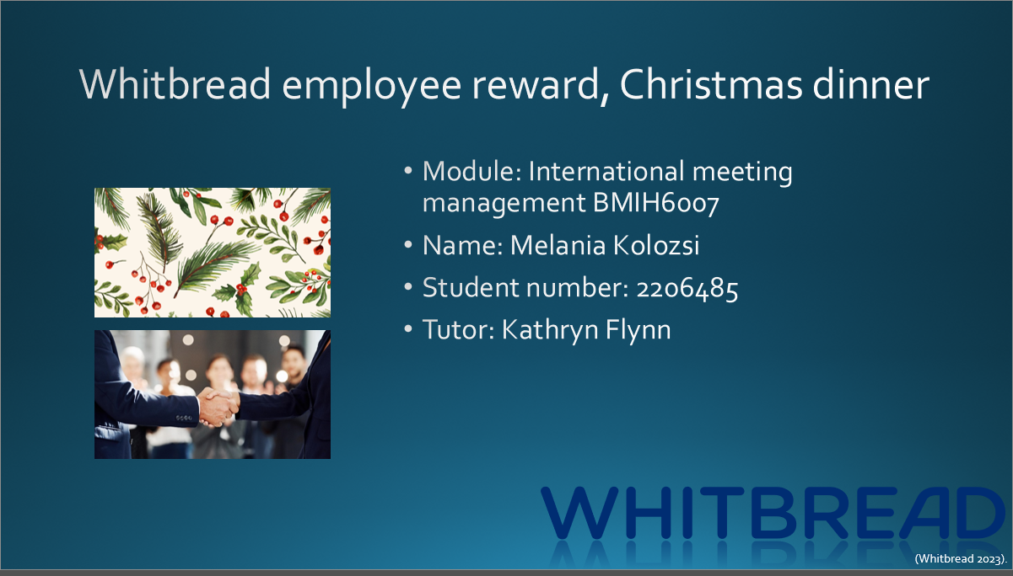
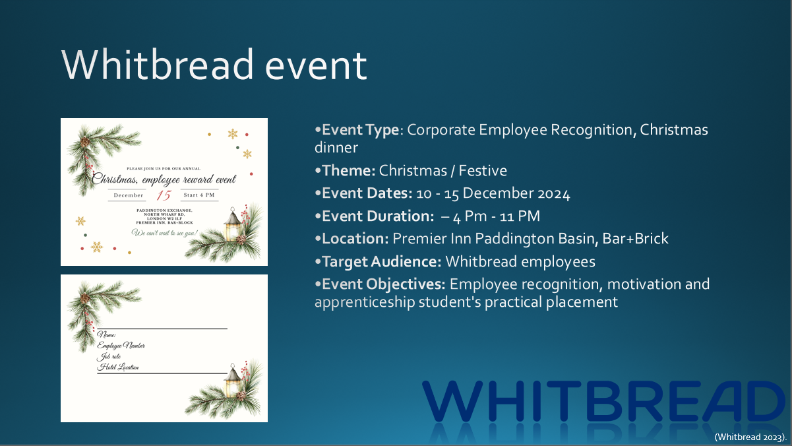
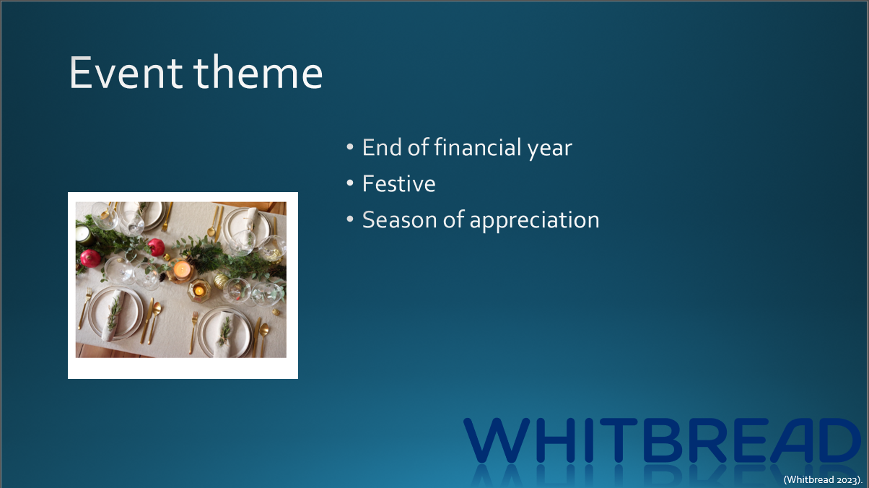
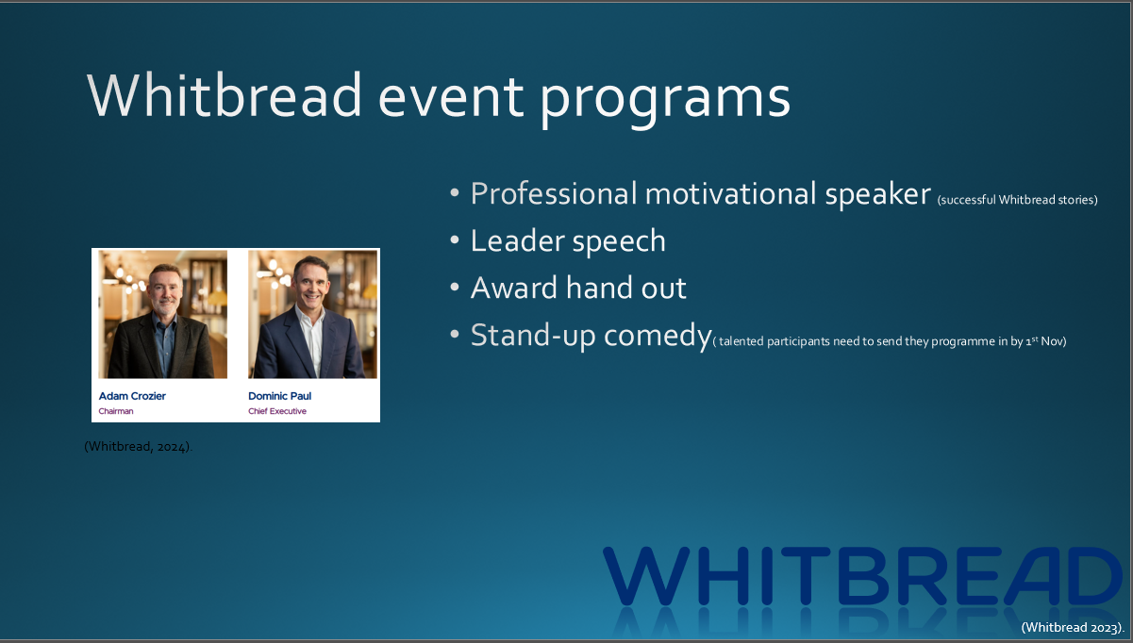
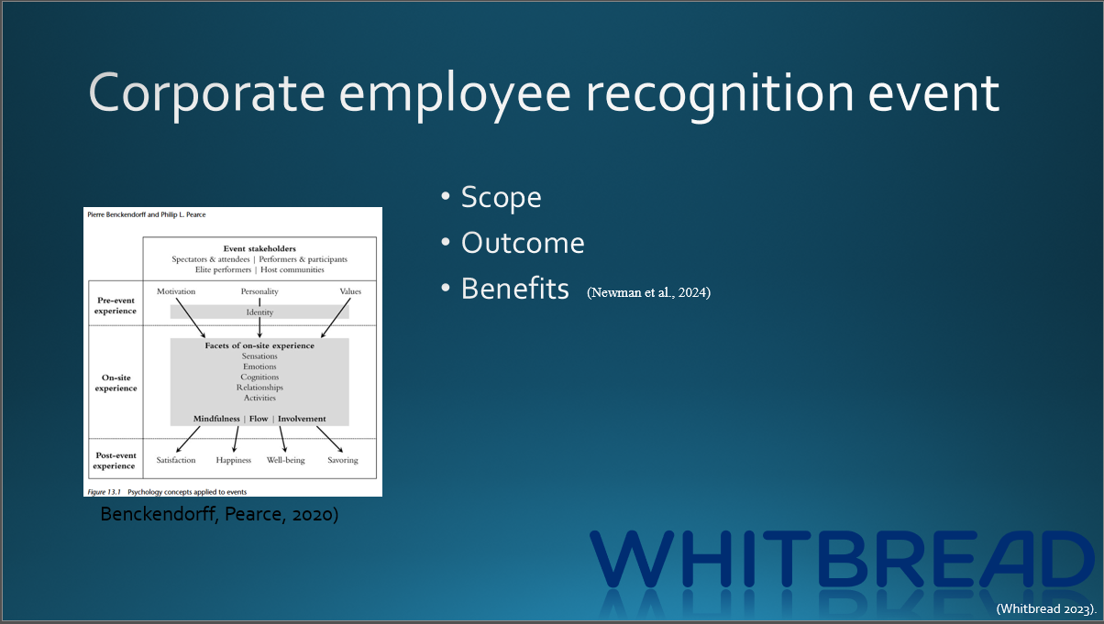
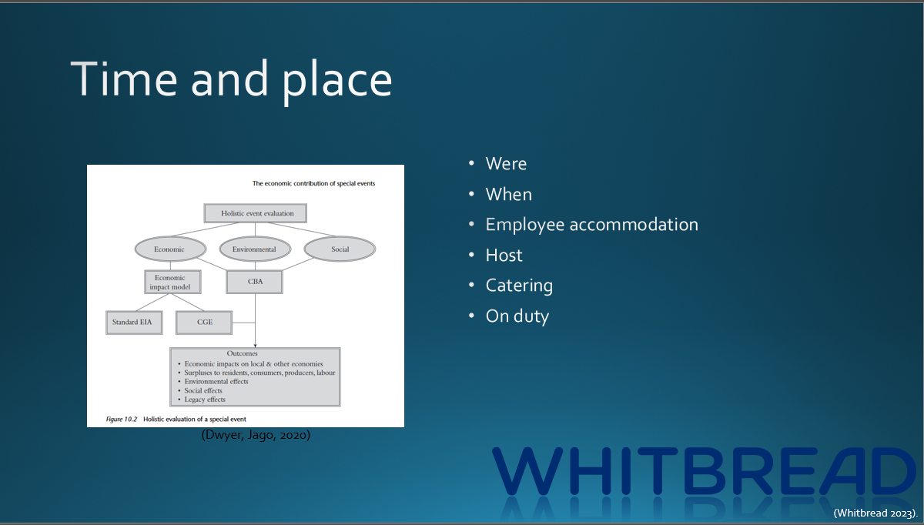
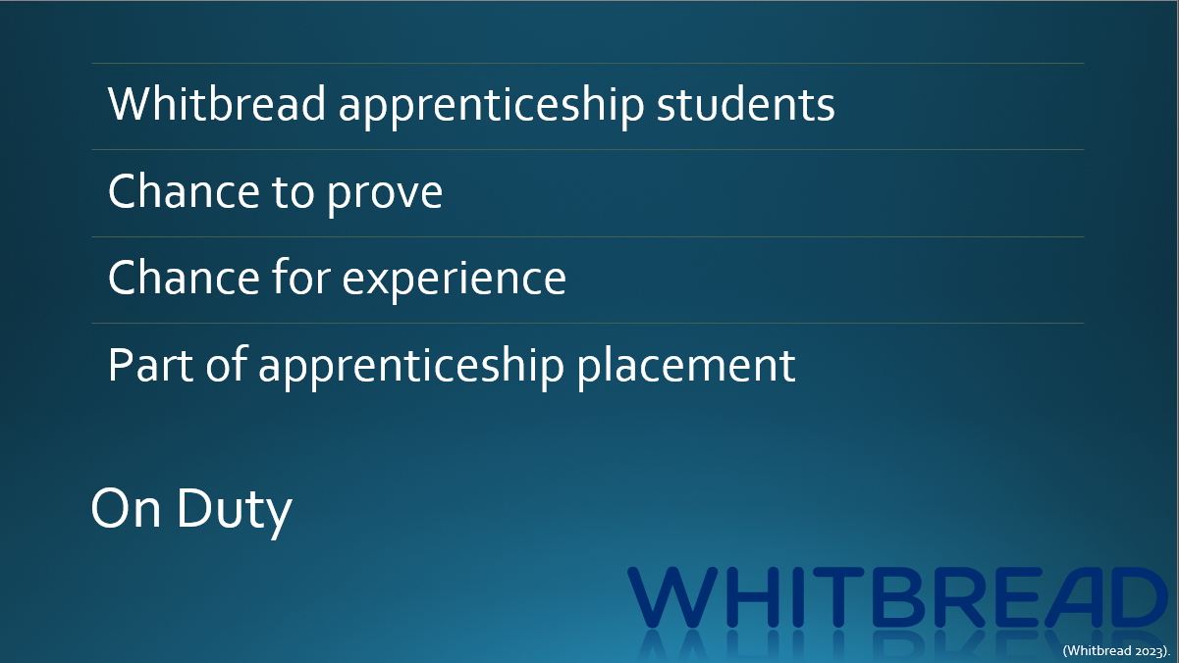
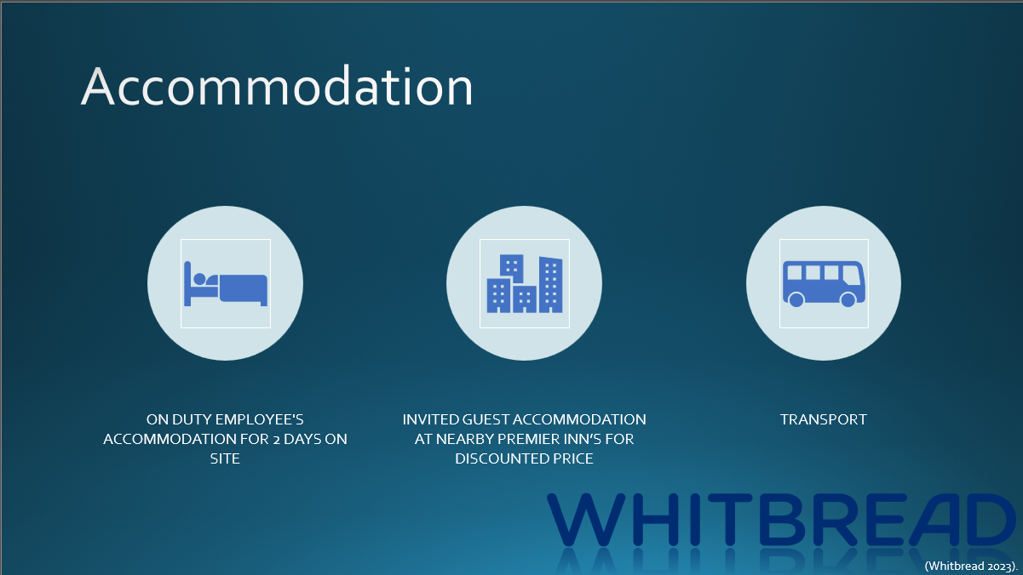
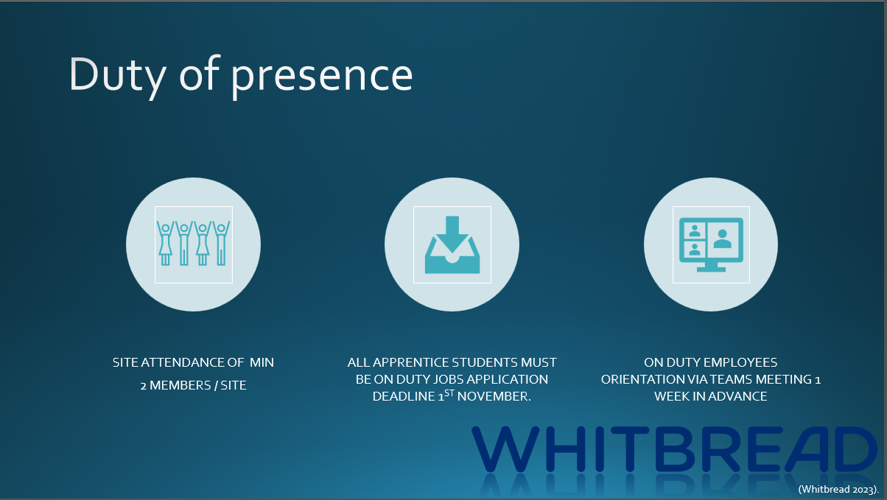
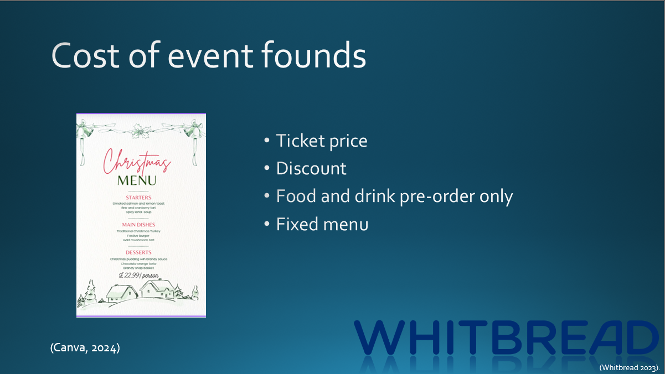
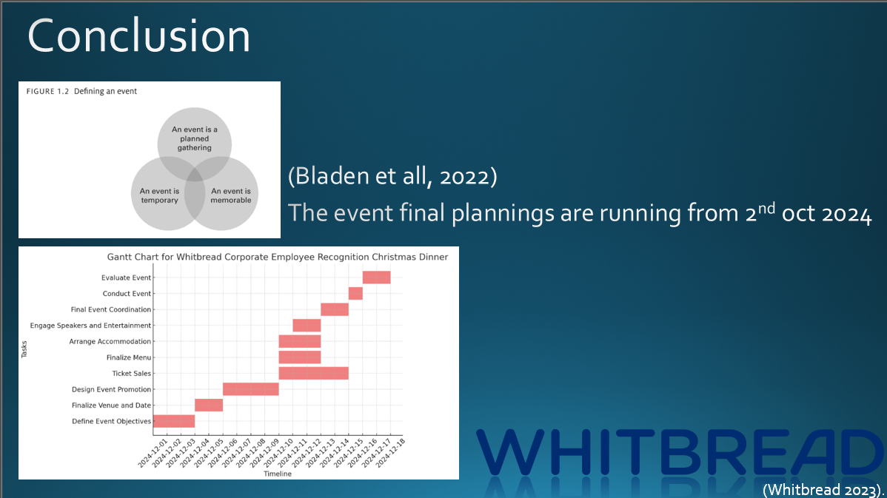

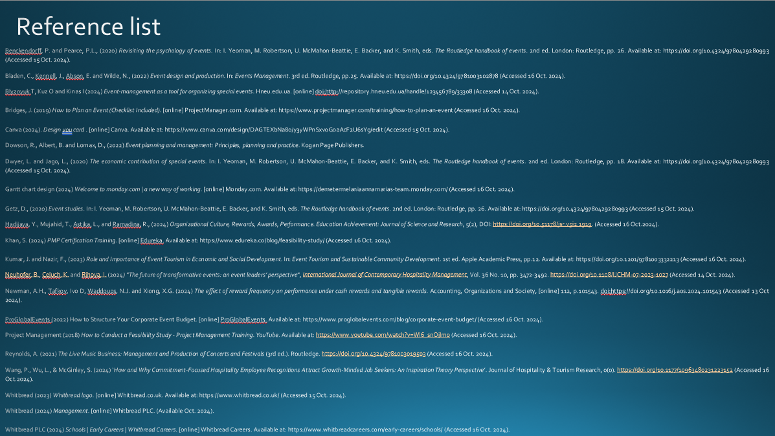

Reference list
Benckendorff, P. and Pearce, P.L., (2020) Revisiting the psychology of events. In: I. Yeoman, M. Robertson, U. McMahon-Beattie, E. Backer, and K. Smith, eds. The Routledge handbook of events. 2nd ed. London: Routledge, pp. 26. Available at: https://doi.org/10.4324/9780429280993 (Accessed 15 Oct. 2024).
Bladen, C., Kennell, J., Abson, E. and Wilde, N., (2022) Event design and production. In: Events Management. 3rd ed. Routledge, pp.25. Available at: https://doi.org/10.4324/9781003102878 (Accessed 16 Oct. 2024).
Blyznyuk T, Kuz O and Kinas I (2024) Event-management as a tool for organizing special events. Hneu.edu.ua. [online] doi:http://repository.hneu.edu.ua/handle/123456789/33308 (Accessed 14 Oct. 2024).
Bridges, J. (2019) How to Plan an Event (Checklist Included). [online] ProjectManager.com. Available at: https://www.projectmanager.com/training/how-to-plan-an-event (Accessed 16 Oct. 2024).
Canva (2024) Design you card . [online] Canva. Available at: https://www.canva.com/design/DAGTEXbNa80/y3yWPnSxvoGoaAcF2U6sYg/edit (Accessed 15 Oct. 2024).
Dowson, R., Albert, B. and Lomax, D., (2022) Event planning and management: Principles, planning and practice. Kogan Page Publishers.
Dwyer, L. and Jago, L., (2020) The economic contribution of special events. In: I. Yeoman, M. Robertson, U. McMahon-Beattie, E. Backer, and K. Smith, eds. The Routledge handbook of events. 2nd ed. London: Routledge, pp. 18. Available at: https://doi.org/10.4324/9780429280993 (Accessed 15 Oct. 2024).
Gantt chart design (2024) Welcome to monday.com | a new way of working. [online] Monday.com. Available at: https://demetermelaniaannamarias-team.monday.com/ (Accessed 16 Oct. 2024).
Getz, D., (2020) Event studies. In: I. Yeoman, M. Robertson, U. McMahon-Beattie, E. Backer, and K. Smith, eds. The Routledge handbook of events. 2nd ed. London: Routledge, pp. 26. Available at: https://doi.org/10.4324/9780429280993 (Accessed 15 Oct. 2024).
Hadijaya, Y., Mujahid, T., Astika, L., and Ramadina, R., (2024) Organizational Culture, Rewards, Awards, Performance. Education Achievement: Journal of Science and Research, 5(2), DOI: https://doi.org/10.51178/jsr.v5i2.1919. (Accessed 16 Oct.2024).
Khan, S. (2024) PMP Certification Training. [online] Edureka. Available at: https://www.edureka.co/blog/feasibility-study/ (Accessed 16 Oct. 2024).
Kumar, J. and Nazir, F., (2023) Role and Importance of Event Tourism in Economic and Social Development. In: Event Tourism and Sustainable Community Development. 1st ed. Apple Academic Press, pp.12. Available at: https://doi.org/10.1201/9781003332213 (Accessed 16 Oct. 2024).
Neuhofer, B., Celuch, K. and Rihova, I. (2024) "The future of transformative events: an event leaders’ perspective", International Journal of Contemporary Hospitality Management, Vol. 36 No. 10, pp. 3472-3492. https://doi.org/10.1108/IJCHM-07-2023-1027 (Accessed 14 Oct. 2024).
Newman, A.H., Tafkov, Ivo D, Waddoups, N.J. and Xiong, X.G. (2024) The effect of reward frequency on performance under cash rewards and tangible rewards. Accounting, Organizations and Society, [online] 112, p.101543. doi:https://doi.org/10.1016/j.aos.2024.101543 (Accessed 13 Oct 2024).
ProGlobalEvents (2022) How to Structure Your Corporate Event Budget. [online] ProGlobalEvents. Available at: https://www.proglobalevents.com/blog/corporate-event-budget/ (Accessed 16 Oct. 2024).
Project Management (2018) How to Conduct a Feasibility Study - Project Management Training. YouTube. Available at: https://www.youtube.com/watch?v=WI6_snOjlm0 (Accessed 16 Oct. 2024).
Reynolds, A. (2021) The Live Music Business: Management and Production of Concerts and Festivals (3rd ed.). Routledge. https://doi.org/10.4324/9781003019503 (Accessed 16 Oct. 2024).
Wang, P., Wu, L., & McGinley, S. (2024) ‘How and Why Commitment-Focused Hospitality Employee Recognitions Attract Growth-Minded Job Seekers: An Inspiration Theory Perspective’. Journal of Hospitality & Tourism Research, 0(0). https://doi.org/10.1177/10963480231223152 (Accessed 16 Oct.2024).
Whitbread (2023) Whitbread logo. [online] Whitbread.co.uk. Available at: https://www.whitbread.co.uk/ (Accessed 15 Oct. 2024).
Whitbread (2024) Management. [online] Whitbread PLC. (Available Oct. 2024).
Whitbread PLC (2024) Schools | Early Careers | Whitbread Careers. [online] Whitbread Careers. Available at: https://www.whitbreadcareers.com/early-careers/schools/ (Accessed 16 Oct. 2024).

