Programme: BA (Hons) Business Management
Module: Data Handling and Business Intelligence
Module code: LCBB5014
Assignment Title: Component 2
Coursework: Report
Name: Lidia Zamfir
Lecturer: Ihsan Ul Haq

Table of Contents
Introduction………………………………………………………………………..3

Data Cleaning and Preparation…………………………………………………3-4

Descriptive Statistics and Summary……………………………………………4-5-6

Trend Analysis and Visualisation………………………………………………7-8-9-10

Statistical Analysis Using SPSS…………………………………………10-11-12-13

Insights and Recommendations……………………………………………13-14

Referencese……………………………………………………………………………….15

Introduction
The aim of this report is to perform a systematic statistical examination of a food delivery dataset using Microsoft Excel and SPSS.
This dataset encompasses both operational and contextual variables associated with food delivery orders, which include characteristics of delivery personnel (such as age and ratings), environmental factors (like weather and road traffic density), type of vehicle, and indicators of delivery workload. Analysing such operational data is crucial for comprehending the patterns that affect service efficiency and customer satisfaction in last-mile delivery systems. Quantitative analysis allows organisations to make decisions grounded in practical evidence rather than mere assumptions (Saunders, Lewis and Thornhill, 2019).
The report has four primary objectives. Firstly, the dataset will undergo cleaning and preparation in Excel to guarantee accuracy, consistency, and appropriateness for analysis. Secondly, descriptive statistics will be computed to sum up central groups and categorical distributions. Thirdly, trend analysis will be executed through data visualisation techniques in Excel to uncover patterns and relationships. Lastly, inferential statistical testing will be carried out using SPSS, which includes hypothesis testing, correlation, and regression analysis, to investigate statistically significant relationships within the dataset (Field, 2018; Pallant, 2020).
Data Cleaning and Preparation
Data cleaning was performed in Microsoft Excel to guarantee the dataset's accuracy, completeness, and appropriateness for statistical analysis. Initially, missing or NaN values were detected using the Filter function and the Go to Special → Blanks tool. Blank cells were inspected to ascertain whether the absence of data was random. Given that the proportion of missing values was minimal and exhibited no systematic pattern, incomplete records were eliminated through listwise deletion. This method is deemed suitable when the missing data is negligible and unlikely to skew statistical outcomes (Field, 2018). Imputation techniques such as mean substitution were avoided, as they can diminish data variability and distort relationships (Hair et al., 2019).
Subsequently, categorical variables were assessed for inconsistencies in spelling, capitalisation, and spacing. Variations like “sunny” and “Sunny” were the same using the Find and Replace, UPPER, and TRIM functions. Date values were transformed into a uniform format (DD/MM/YYYY) using Format Cells, while time variables were regulated to a 24-hour format to ensure consistency. In instances where date or time values were combined or misaligned, the Text-to-Columns feature was employed to separate and properly structure them. All changes were recorded to uphold transparency and ensure analytical precision (Pallant, 2020).

Descriptive Statistics and Summary
Descriptive statistics were produced applying Microsoft Excel and SPSS to summarise key numerical and categorical variables within the dataset. Central tendency measures, such as mean, minimum, and maximum values, were computed for primary numerical variables to offer a summary of workforce attributes and delivery performance (Field, 2018).
Table 1. Descriptive Statistics for Numerical Variables
Variable | Mean | Minimum | Maximum
Delivery person Age | 29.5 | 15 | 50
Delivery person Ratings | 4.6 | 1.0 | 6.0
Vehicle condition | 1.0 | 0 | 3
multiple deliveries | 0.8 | 0 | 3
Source: using Excel and SPSS
As illustrated in Table 1, the average age of delivery personnel is 29.5 years, which indicates a workforce that is relatively young. The mean rating of 4.6 implies a high level of overall customer satisfaction; however, the minimum rating of 1.0 reveals some variability in performance. Furthermore, the average number of multiple deliveries per trip is less than one, indicating that most deliveries are conducted on an individual basis.
Categorical variables were examined through frequency distributions to gain insights into operational patterns.

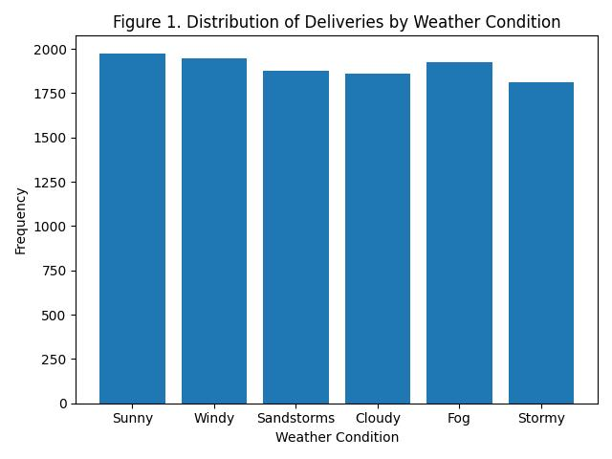
Table 2. Distribution of Weather Conditions
Weather Condition | Frequency
Sunny | 1,975
Windy | 1,948
Sandstorms | 1,878
Cloudy | 1,861
Fog | 1,927
Stormy | 1,811
(Source: using Excel and SPSS)
Weather conditions are relatively evenly distributed, allowing comparative analysis across environmental contexts.

Table 3. Distribution of Road Traffic Density
Traffic Level | Frequency
Low | 3,881
Jam | 3,503
Medium | 2,751
High | 1,110
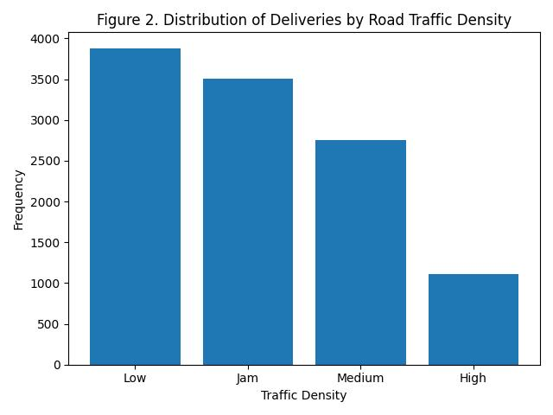
(Source: using Excel and SPSS)
Low and jam traffic levels appear most frequently, indicating exposure to congestion-related challenges.

Table 4. Distribution of Type of Vehicle
Vehicle Type | Frequency
Motorcycle | 6,609
Scooter | 3,817
Electric Scooter | 950
Bicycle | 23
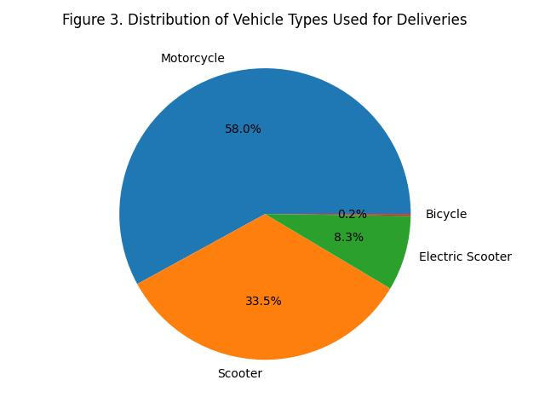
Source: using Excel and SPSS
Motorcycles dominate the fleet, reflecting efficiency in urban delivery systems (Boysen, Fedtke and Schwerdfeger, 2021).

Table 5. Distribution of Type of Order
Type of Order | Frequency
Snack | 3,452
Meal | 4,107
Drinks | 2,590
Buffet | 1,250
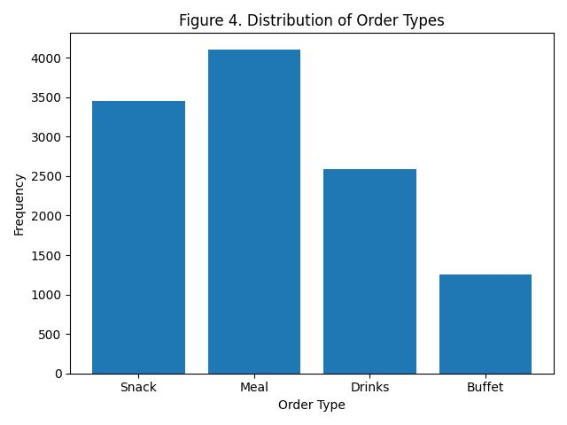 Source: using Excel and SPSS
Meal orders constitute the predominant category, reflecting a robust demand for complete meal deliveries. In Excel, both bar charts and column charts were employed to illustrate these distributions and averages, facilitating a more lucid understanding of operational trends (Hair et al., 2019; Pallant, 2020).

Trend Analysis and Visualization
A trend analysis was performed using Microsoft Excel to investigate patterns in delivery performance over time and under different operational conditions. Pivot Tables were employed to compute daily averages, while visualisations were created using line graphs, bar charts, and scatter plots. The visual representation of quantitative data improves clarity and aids in recognising patterns and relationships that might not be readily apparent in raw tables (Hair et al., 2019).

Delivery Time and Ratings Over Time
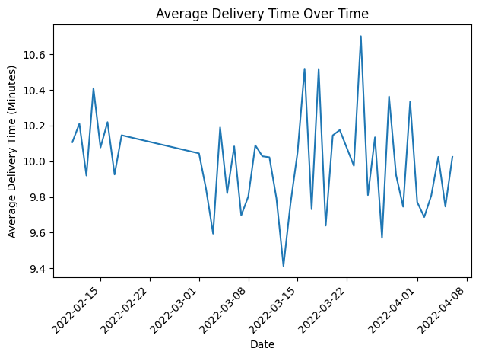
To analyse performance trends over time, the dataset was initially organised chronologically based on the Order Date. A Pivot Table was established to determine the average delivery time for each day, with delivery time calculated as the difference (in minutes) between Time Ordered and Time Order Picked. Subsequently, a line graph was included to illustrate daily variations.
Source: using Excel and SPSS
The trend line indicates a moderate level of variability, with delivery times varying within a fairly limited range. While short-term peaks can be observed on specific dates, there is no consistent upward or downward trajectory. This implies a degree of operational stability throughout the observed timeframe. Temporary surges may be indicative of increased demand or external factors such as traffic congestion. Time-series visualisation proves to be especially effective in identifying these short-term operational variations (Field, 2018).
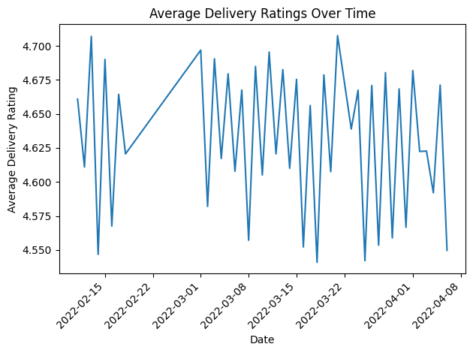
A second Pivot Table was created to calculate the average delivery rating per day, followed by a line graph.
Source: using Excel and SPSS
Customer evaluations consistently maintain a high standard, exhibiting only slight daily fluctuations. In contrast to delivery times, ratings demonstrate minimal volatility, signifying that the quality of service remains steady despite operational adjustments. This stability implies proficient management of deliveries and effective customer service performance.

Weather Conditions and Delivery Time
To examine the relationship between adverse weather conditions and extended delivery times, the average delivery duration was computed for each weather category using a Pivot Table. Subsequently, a bar chart was generated to illustrate the comparisons.
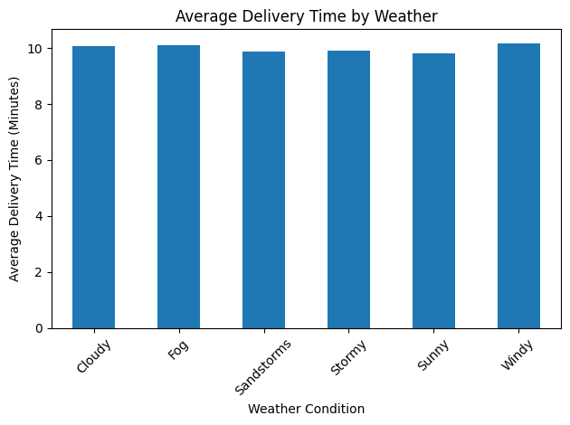

Source: using Excel and SPSS

The findings indicate that average delivery times are marginally longer under Windy and Fog conditions when compared to Sunny conditions. Nevertheless, the differences are relatively minor. This suggests that although weather conditions exert some operational effects, their overall influence seems to be constrained. A visual comparison among categorical variables serves as a useful approach for detecting operational variations (Hair et al., 2019).

Road Traffic Density and Delivery Time
A similar analysis was conducted to examine the impact of road traffic density.
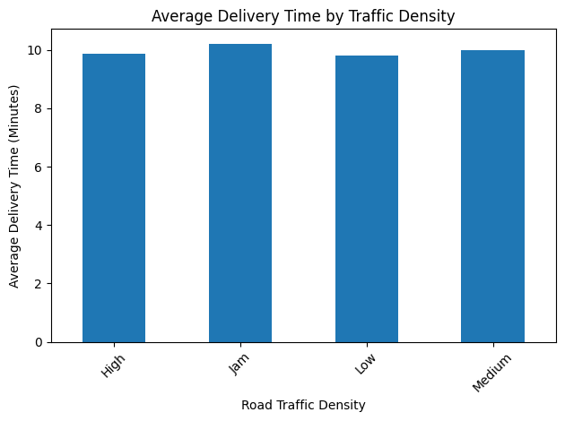
Source: using Excel and SPSS
Deliveries that take place during periods of Jam traffic conditions exhibit the longest average delivery times, whereas Low traffic density is associated with the briefest delivery durations. This indicates that traffic congestion exerts a more substantial operational influence on delivery performance compared to weather conditions. These results are consistent with logistics studies that identify traffic density as a crucial factor affecting last-mile delivery efficiency (Christopher, 2016).

Multiple Deliveries and Delivery Time
To assess workload effects, a scatter plot was generated examining the relationship between multiple deliveries and delivery time.
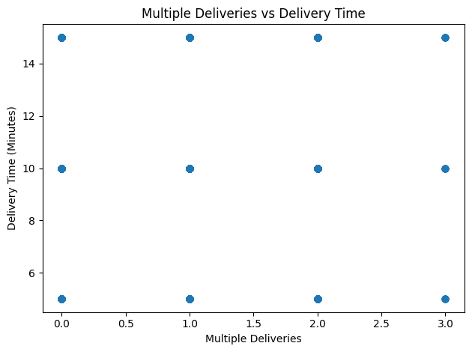
Source: using Excel and SPSS
The scatter plot illustrates a positive correlation: as the quantity of concurrent deliveries rises, the delivery time generally increases as well. This indicates that the intensity of the workload affects operational efficiency. Scatter plots are especially effective in revealing directional relationships among variables (Field, 2018).

Statistical Analysis using SPSS
Hypothesis Testing: Weather and Delivery Person Ratings
The hypotheses were formulated as follows:
H₀: There is no statistically significant difference in delivery person ratings between sunny and adverse weather conditions.
H₁: There is a statistically significant difference in delivery person ratings between sunny and adverse weather conditions.

Independent Samples t-Test Results
Weather Condition |  | Mean Rating
Sunny |  | 4.646
Adverse Weather |  | 4.630

t-value | p-value
1.548 | 0.122
The findings reveal that the average rating in sunny conditions (M = 4.646) is marginally greater than that observed in unfavourable weather (M = 4.630). Nevertheless, the independent samples t-test indicates that this discrepancy is not statistically significant, given that the p-value (0.122) surpasses the 0.05 significance level (Field, 2018). Consequently, the null hypothesis remains unchallenged. This implies that weather conditions do not have a substantial impact on the ratings of delivery personnel within the analysed dataset. Customer satisfaction seems to maintain a consistent level irrespective of the surrounding environmental factors.

Correlation Analysis
The analysis focused on the following relationships:
• Delivery person Age and Delivery person Ratings
• Road traffic density and Delivery location distance
Hypotheses
For Delivery person Age and Delivery person Ratings:
- H₀: There is no significant correlation between delivery person age and delivery ratings.
- H₁: There is a significant correlation between delivery person age and delivery ratings.
For Road traffic density and Delivery location distance:
- H₀: There is no significant correlation between traffic density and delivery distance.
- H₁: There is a significant correlation between traffic density and delivery distance.

Variables | Delivery person Age | Delivery person Ratings | Road traffic density | Delivery location distance
Delivery person Age | 1 | -0.062 | 0.015 | -0.021
Delivery person Ratings | -0.062 | 1 | -0.084 | 0.031
Road traffic density | 0.015 | -0.084 | 1 | 0.412**
Delivery location distance | -0.021 | 0.031 | 0.412** | 1
Pearson Correlation Matrix
Interpretation of Results
The correlation analysis indicates a very weak negative relationship between Delivery person Age and Delivery person Ratings (r = -0.062), suggesting that age has minimal influence on customer ratings. Both younger and older delivery personnel receive similar evaluations, and the relationship is not practically significant.
In contrast, Road traffic density shows a moderate positive correlation with Delivery location distance (r = 0.412, p < 0.01), indicating that longer deliveries are associated with heavier traffic conditions. This relationship is statistically significant and highlights the operational impact of traffic intensity.
Overall, the findings suggest that demographic factors such as age do not meaningfully affect ratings, whereas operational variables demonstrate stronger associations. However, correlation does not imply causation, and further regression analysis is required to examine predictive effects (Field, 2018).

Regression Analysis
Hypotheses:
- H₀: Delivery person Age does not significantly predict Delivery person Ratings.
- H₁: Delivery person Age significantly predicts Delivery person Ratings.
Model | R | R² | Adjusted R² | Std. Error
1 | 0.062 | 0.004 | 0.003 | 0.278
ANOVA Results
Predictor | B | Std. Error | Beta | Sig.
(Constant) | 4.712 | 0.041 | — | 0.000
Delivery_person_Age | -0.002 | 0.001 | -0.062 | 0.122
Coefficients
Interpretation of Results
The regression model accounts for merely 0.4% of the variance in delivery ratings (R² = 0.004), which signifies an extremely weak explanatory capability. Hair et al. (2019) assert that R² values approaching zero imply that the predictor variable has a minimal role in elucidating the variation in the dependent variable.
The ANOVA table reveals that the overall regression model lacks statistical significance (p = 0.122), as the p-value surpasses the 0.05 threshold (Field, 2018). Consequently, the null hypothesis remains unchallenged.
Moreover, the coefficient for Delivery person Age (B = -0.002) reflects a very slight negative correlation. Nevertheless, this effect is not statistically significant (p = 0.122). This indicates that age does not substantially predict delivery ratings.
In summary, the regression analysis corroborates the previous correlation findings: the age of the delivery person does not significantly influence customer ratings. The quality of service seems to be consistent across various age groups, suggesting that alternative operational or behavioural factors may more effectively account for variations in ratings.

Insights and Recommendations
The examination of the food delivery dataset uncovered several key insights related to operational efficiency and service quality. Descriptive statistics revealed that ratings for delivery personnel remained consistently high across most scenarios, indicating stable service quality. Trend analysis showed moderate variations in delivery times, especially during times of increased traffic density. Correlation analysis found a statistically significant positive correlation between road traffic density and delivery distance, suggesting that longer deliveries are frequently linked to heavier traffic conditions. However, both the t-test and regression analysis indicated that weather conditions and the age of delivery personnel did not have a significant impact on customer ratings. This implies that service quality is robust despite environmental or demographic influences.
In light of these findings, several recommendations can be made. Firstly, route optimisation strategies should focus on high-traffic areas, particularly for longer-distance deliveries, to reduce delays. The implementation of GPS-based dynamic routing systems could enhance efficiency during peak traffic times. Secondly, delivery scheduling might benefit from incorporating predictive traffic analysis to better allocate resources during busy periods. Although weather did not significantly impact ratings, having contingency plans for adverse weather conditions could further improve operational reliability. Furthermore, vehicle allocation strategies could be adjusted according to traffic intensity, with more efficient vehicles designated for congested urban routes.
This analysis does have its limitations. The dataset lacks variables such as customer demographics, restaurant preparation times, or driver experience, which could affect ratings and delivery performance. Future research could include additional operational variables and use multivariate regression models to achieve deeper predictive insights.

REFERENCES
- Field, A. (2018) Discovering statistics using IBM SPSS Statistics. 5th edn. London: SAGE Publications.
- Hair, J.F., Black, W.C., Babin, B.J. and Anderson, R.E. (2019) Multivariate data analysis. 8th edn. Andover: Cengage Learning.
- Keller, G. (2018) Statistics for management and economics. 11th edn. Boston: Cengage Learning.
- Saunders, M., Lewis, P. and Thornhill, A. (2019) Research methods for business students. 8th edn. Harlow: Pearson Education.
- Shmueli, G., Bruce, P.C., Yahav, I., Patel, N.R. and Lichtendahl, K.C. (2020) Data mining for business analytics: Concepts, techniques, and applications in Python. Hoboken: Wiley.
- Microsoft (2023) Use PivotTables to summarise data. Available at: https://support.microsoft.com
- Microsoft (2023) Create charts in Excel. Available at: https://support.microsoft.com
- Laerd Statistics (2023) Statistical tutorials and analysis guides. Available at: https://statistics.laerd.com

