

Undergraduate Dissertation

Research Topic question: How do the advantages and disadvantages of police taser use effect its ethical justification in the role of being a police officer?

University: UWTSD Swansea
Student Number: 2320243
Word count: 8,571 Words

Declaration
This work has not previously been accepted in substance for any degree and is not being concurrently submitted in candidature for any degree.
Signed: Evan Rogers
Date: 10/06/2026
Statement 1:
This dissertation is being submitted in partial fulfilment of the requirements for the degree of BSc Professional Policing Practice.
Signed: Evan Rogers
Date: 10/06/2026
Statement 2:
This dissertation is the result of my own independent work/investigation, except where otherwise stated.
Other sources are acknowledged by footnotes giving explicit references. A bibliography is appended.
Signed: Evan Rogers
Date: 10/06/2026
Statement 3:
I hereby give consent for my dissertation, if accepted, to be available for photocopying and for interlibrary loan, and for the title and summary to be made available to outside organisations.
Signed: Evan Rogers
Date: 10/06/2026
Statement 4:
I hereby give consent for my dissertation, if accepted, to be available on the university’s IT system to those who have consent to use the system.
Signed: Evan Rogers
Date: 10/06/2026

Acknowledgements
I would like to thank my supervisor Andrew James for his support throughout the process of completing my dissertation and to further give thanks for his continued guidance throughout.
I would also like to thank the participants that gave up their time to answer the questions in my questionnaire allowing me to gather valuable data.
Lastly, I would like to give great thanks my family and girlfriend for their endless support, time and guidance they have provided to me throughout this process. This support has ensured I persevere throughout my entire three years of university work and ensured I powered through to the very end.
I would like to express my gratitude to all the people supporting me and I can not express how lucky I feel to have people around me that support everyday and will continue to support me in the future.

Contents Page
1.Chapter 1: Introduction
1.0 Introduction ……………………………………………………………………………………. 6
1.1 Background ……………………………………………………………………………………… 6
1.2 Research Rationale ………………………………………………………………………….. 7
1.3 Aims and Objectives …………………………………………………………………………. 6
1.3.1 Aims ……………………………………………………………………………………….. 6
1.3.2 Objectives ……………………………………………………………………………….. 6
1.4 Research structure …………………………………………………………………………...6
1.5 Conclusion ………………………………………………………………………………………9
2.Chapter 2: Literature Review
2.0 Introduction …………………………………………………………………………………… 9
2.1 Adoption and integration of tasers in Policing ………………………………………..10
2.2 Conceptualising police use of force and ethical standard issues ……………..11
2.3 Officer discretion and decision making ……………………………………………….. 12
2.4 The benefits of taser use within Policing ………………………………………………. 13
2.5 Public Confidence …………………………………………………………………………….13
2.6 Conclusion ………………………………………………………………………………………14
3.Chapter 3: Methodology
3.0 Introduction …………………………………………………………………………………… 15
3.1 Research Funnel …………………………………………………………………………….. 15
3.1.1 Open Questions …………………………………………………………………………. 16
3.1.2 Closed Questions ……………………………………………………………………… 16
3.2 Research Approach and Strategy …………………………………………………….. 17
3.3 Data collection and Analysis …………………………………………………………….17
3.4 Reliability and Validity ……………………………………………………………………. 18
3.5 Limitations …………………………………………………………………………………… 18
3.6 Ethical Considerations …………………………………………………………………… 18
3.7 Conclusion …………………………………………………………………………………… 19
4.Chapter 4: Analysis of results
4.0 Introduction …………………………………………………………………………………. 19
4.1 Data Analysis …………………………………………………………………………………19
4.2 Analysis Method ……………………………………………………………………………. 20
4.3 Analysis of the Data gathered from Questionnaires …………………………….. 20
4.4 Them One – Ethical justification of taser use as a less lethal weapon in
the role of being a police officer …………………………………………………….20
4.5 Theme two – The benefits of taser use within policing ……………………….22
4.6 Theme three – Media Coverage and the impact of taser use on public
confidence ………………………………………………………………………………..23
4.7 Theme four – Officers justification and ethical decision maker when
Using taser ………………………………………………………………………………..23
4.8 Conclusion ………………………………………………………………………………. 24
5.Chapter 5: Conclusions, Recommendations and Limitations
5.0 Introduction …………………………………………………………………………….. 25
5.1 Achievement of Research Objectives …………………………………………… 25
5.2 Findings …………………………………………………………………………………….26
5.3 Recommendations ……………………………………………………………………..27
5.4 Limitations ……………………………………………………………………………….. 27
5.5 Future Research ………………………………………………………………………… 28
5.6 Conclusion ………………………………………………………………………………..28
6. Bibliography
7. Appendices
7.1 Appendix A – Blank Questionnaire ………………………………………………………32
7.2 Appendix B – Copy of Consent form …………………………………………………….35
7.3 Appendix C – Questionnaire Result Matrix ……………………………………………38

Chapter 1: Introduction

- – Introduction
This chapter aims to provide a background and rationale for this chosen study. It will outline the aims and objectives of the research.
The taser was introduced into policing in the United Kingdom in 2003 to firearms officers only, as a non-lethal firearms option. This was later changed upon the introduction of more relaxed polices in 2007 and by 2008 any trained officers could carry a taser if they were trained properly (McGuinness, 2021).

Taser is used widely amongst different departments amongst policing today. Although, according to research done on Police forces in Wales and England taser trained officers being 14% as of 2019. As for the Metropolitan Police Force as of 2023 only 23% of officers were trained to carry a taser (Dr Sophie Chambers , 2024). This developed an area for discussion as to why less than a quarter of the entire Police force is not carrying taser. But also started debates regarding the public ethical opinions on the use of taser amongst police.

Due to taser being a use of force that can be used by Police Officers there are procedures and polices an officer must follow when drawing their taser. Whilst ensuring that they are ethical in their decision making when using them. According to (Crow and Adrion, 2011) the idea of police officer being able to use their own national decision making when making the decision to fire it, has led to questions being asked the factors an officer takes into account before firing the taser and whether officers are being influenced by factors such as race or gender.

The use of taser differs in views amongst both the public and Police. The wide range in views will be analysed and discussed throughout the dissertation.

1.1 Background
The use of tasers has become increasingly important in modern day policing. Introduced as les lethal option to firearms and other forms of force, taser are to be used as a less lethal option. Within the United Kingdom, the deployment of tasers has increased significantly over the past two decades, reflecting concerns regarding officer safety, public protection and the reduce reliance on more injurious methods of force (College of Policing, 2023). On the other hand, despite tasers intending purpose of reducing harm, taser use is often considered ethically controversial due to concerns regarding excessive force, accountability, proportionality and Human Rights implications.

Police officers are legally authorised to use force when it is necessary, reasonable and proportionate to achieve a legitimate policing objective. The use of force is governed by Criminal Law Act 1967, the Human Rights Act 1998 and Common Law principles of self Defence. The College of Policing’s Authorised Professional Practice further requires that officers assess the necessity and proportionality of force during an incident (College of Policing, 2023).

A key principle argument supporting taser use is its operation benefit surrounding reduced injuries to officers and members of the public. Research suggests that tasers can effectively incapacitate violent individuals, reducing the likelihood of serious injuries associated with batons, physical restraints or firearms (Ariel et al,, 2019).

Despite these operational benefits, there are many ethical concerns regarding the use of tasers including medical issues. There have been medical cases involving tasers associated with serious injury or death, particularly where individuals have underlying health conditions (Independent Office for Police Conduct, 2023).

Public confidence represents another important aspect of the ethical debate. Policing in the United Kingdom operates on the principle of Policing by consent (Home Office, 2012). Incidents involving taser use have resulted in widespread media coverage. This raises concerns regarding officers justification, transparency and accountability.

1.2 Research Rationale
This research is important to discuss the ethical implications of taser use and how it extends beyond legal compliance, necessity, proportionality, accountability, human rights and public trust.
The rationale for this research also stems from the evolving nature of Policing in the United Kingdom. As more officers continue to become trained and authorised to carry taser, understanding whether their use of force remains ethically justifiable is relevant to Policing Policy and officer training.
Evaluating the Advantages and disadvantages through ethical frameworks and principles will provide a more comprehensive understanding of the moral responsibilities associated with police use of force powers.
Ultimately, the research seeks to support a balanced understanding of the ethical challenges of taser use within modern policing.

1.3 – Aims and Objectives
1.3.1 - Aim
The aim of this dissertation is to investigate, discuss and critically evaluate the advantages and disadvantages of police taser use effect its ethical justification in the role of being a police officer.

1.3.2 - Objectives
- Outline the Advantages and Disadvantages of Police officers being upskilled and trained as a taser trained officers.

- Explore the ethical challenges of taser being used as a use of force within Policing

- Analyse how tasers are being used within policing effectively and how officers decided when to use taser

- Identify which ethical principles support taser use within policing and what opposes its use.

1.4 – Research Structure

To fulfil the aims of this research, the dissertation is structured into five chapters.
Chapter 1 introduces the study by providing an introduction to the dissertation and outlining both the overarching aim and specific objectives. The research will incorporate both primary and secondary data, including a questionnaire and a review of existing literature.
Chapter 2 presents the literature review based on police taser use. The literature review provides peoples understanding of the ethical considerations surrounding taser use within policing and public perception. As well as providing the laws, legislation and practices surrounding taser use in policing.
Chapter 3 will provide the methodology which will be used throughout the dissertation to identify the suitable primary research techniques for this research. This helps identify the research gaps and data that can be analysed. This then leads on to chapter 4.
Chapter 4 will use primary data collected and analyse this to present finding. This then leads directly onto to Chapter 5. During this chapter the aims and objectives of the research will be reviewed in order to discuss the findings, provide recommendations and provide limitations.

1.5 Conclusion
Chapter 1 has clearly identified the aims and objectives of the research project and introduced the research. The next Chapter, is the literature review. This chapter will provide a more comprehensive review of the issues discussed regarding the research project.

Chapter 2 – Literature Review
2.0 Introduction

This part of my dissertation seeks to discuss and provide an analysis, evaluation, and synthesis of the existing academic scholarly sources of literature and valued research relating to my topic of the advantages and disadvantages of police taser use and its effect its ethical justification in the role of being police officer.
The focus of this part of the dissertation is dedicated to the completion of the objectives. In order to critically research and analyse valued academic literature and understanding surrounding the advantages and disadvantages of police taser use and its effect its ethical justification in the role of being police officer
This outcome can be obtained, and Objectives can be achieved by examining valued literature and research through the use of the UWTSD online library database. This is a digital collection of credible and valued research material including academic journals, valued literature and research reports.
The online research search engine called Google Scholar will be used. This organised search engine also provides valued research information that comes from a number of different academic literature including Journals, Articles, Government publications/ statistics, textbooks, publications and other valued literature sources.
Furthermore, analysis and reviewed research of the ethical principles that support taser use within policing and the general research of the challenges of taser use for officers will be discussed. Whilst also the analysis of general research of how tasers are being used effectively and how officers are deciding when to use them being reviewed.

2.1 - Adoption and integration of tasers in Policing
The taser was introduced to police officers in the United Kingdom in 2003. These officers were authorised firearms officers. This was due to the guidance in place at the time put in place at the time by the Association of Chief Police Officers. Although, this was later relaxed in 2007 and by 2008 all officers who were trained were allowed to carry and use taser whilst on duty (McGuinness, 2021).
Since the introduction of tasers within Policing in the early 2000’s onwards there has been numerous organisational concerns about officers’ safety, pressure to demonstrate less lethal options and public issues with taser use. This resulted in the introduction of the taser being questioned by researchers as early as 2007, with Adams and Jennison’s (2007) publication of “What we do not know about the use of taser”.
The early research by Adams and Jennison (2007) analysed and discussed the lack of effective policies of taser use and applications surrounding taser training. Their research highlighted operational inconsistencies through policing policies like use of force. Use of force is defined as “the amount of effort required by police to compel compliance by an unwilling subject” (Home Office, 2022).
The inconsistencies found by Adam and Jennison (2007) found it difficult to show the advantages and disadvantages of taser use as it was difficult to compare the use of taser being effective amongst different police forces. The inconsistencies found shown the impact on people’s thoughts on officer and public safety, as well their thoughts as taser being used as a less lethal force, Adam and Jennison (2007). The research (Adam and Jennison, 2007) also found that the key issues and inconsistencies were as a result of lack of effective training and training staff qualifications.
Furthermore, Adam and Jennison (2007) found that more research and development of policies was needed to analyse the ethical community implications of taser use within policing. Whereby, Adam and Jennison (2007) concluded that it would inform safe and effective police policy. This statement was supported by research from De Angelis and Wolf (2013).
De Angelis and Wolf (2013) found in their research that training and effective policies help both taser trained and none taser trained officers understand the advantages and disadvantages of its use. As well as this, their research found out about the officers struggles with their ethical justification of its use.
The research (De Angelis and Wolf, 2013) was conducted on 27 police officer participants, whereby 92% of them were taser trained. Whereby, the general consensus of the research published was that controversy surrounding the introduction of taser use had effected public opinion.
Also, the research (De Angelis and Wolf, 2013) found that the majority of people who participated in the interview confirmed the main benefit of the taser was to reduce injury to officers and members of the public. Although, on the other hand the research these same officers were shown to say the main factor to contribute to drawback of taser use was “the burden” of their decision making that could lead to implications in public confidence (De Angelis and Wolf, 2013).

2.2 - Conceptualising Police use of force and Ethical Standards issues
The topic of ethics is very important amongst policing, and it has led to many academics doing research into it. Including the ethical standards and considerations when officers use their tasers. As well as how officers use of force is affected when carrying taser and how it can affect it being used ethically.
One example of research is “Balancing safety and Ethic: The TASER Consideration in Healthcare” conducted by (Choudhury et al., 2025). The research (Choudhury et al., 2025) analysed the effects of taser use and the ethical implications that follow when a taser is deployed. The main findings of the research (Choudhury et al., 2025) were “Psychological and clinical consequences” even when taser is used following the correct ethical framework and the use of force is being used Justifiably, Proportionately, legally, accountable, necessary and ethically.
The research (Choudhury et al., 2025) found that taser use can cause or contribute to a range of different “Clinical Outcomes” including cardiovascular issues, as their research analysed multiple studies whereby taser has caused or contributed to “atrial fibrillation, elevated troponin levels, and myocardial infarction” (Choudhury et al., 2025). As well as this, their research found that taser caused serious eye injuries and neurological problems.
Furthermore, the research (Choudhury et al., 2025) found that taser also contributed to pregnancy complications. Whereby, a case they analysed they found taser contributed to the miscarriage of a child. Subsequently, resulting in concerns for taser use on pregnant individuals.
The ethical standards issues and legal implications found within the research (Choudhury et al., 2025) to remain ethical and avoid any legal implications, taser should be avoided on children, elderly, pregnant individuals and any individual with cardiovascular issues. A statement supported by research from Dr Barak Ariel (2018).
According to Dr Barak Ariel (2018) he supported that taser must be used following the ethical standards and principles that are in place. Although, his research (Dr Barak Ariel , 2018) found that officers who were visibly carrying a taser were more likely to be assaulted by 48%. Whereby, he described this as being the “Weapons Effect” (Dr Barak Ariel , 2018). As according to (Dr Barak Ariel , 2018) even when ethical principles are followed using taser it likely to result I higher aggression situations, resulting in higher use of force statistics and subsequently leading to hostility in police public reactions.
Dr Barak Ariel (2018) found that due to peoples heightened aggression towards taser trained officers, he concluded tasers were being overused. This is statement also supported in research from Kleinig (2007) around the time taser was initially introduced.
Kleinig (2007) found in his research that through the development and introduction of ethical taser use in policing it as allowed for police to take control of situations with fewer injuries for all people involved. Although, the research (Kleinig, 2007) also found that this caused an issue of taser overuse and highlighted ethical issues with unnecessary and unproportionate force being used.

Going back to the research from Dr Barak Ariel (2018), he refers to taser use needing to be proportionate and necessary. If it is not the use of taser is not ethical. This is discussed in research conducted by The House of Commons (McGuiness, 2016), which discusses that if taser is used without following the Authorised Professional practice on conducted energy devices (APP) it may be a breach of Article 3 of the European Convention on Human Rights 1998 (Human Rights Act, 1998).

2.3 - Officer discretion and decision making
The use of officer discretion and effective decision making is a key part in the role of being a police officer and is used by officers everyday including those officers carrying taser. One example of such research is the research “Towards a socio-technical understanding of discretion: a case study of Taser and police use of force” (Dymond, 2019).
The research (Dymond, 2019) analysed information and drawn insights through scientific and technological studies. Whereby, Dymond (2019) found that officers can use discretion well in situations whilst following ethical practice but recognised that there is a risk of human and societal impact factors in officers making ethical decisions.
Dymond (2019) defined discretion as “central to our understanding of officials, and their exercise of power, in the criminal justice system and civil service”. The research (Dymond, 2019) identified that there four key influences that were impacting officers discretion when deploying a taser these were officer variable, offender variables, variable involving the criminal justice system and situational variable.
The gender, stress levels, amount of service and confidence had been explored by Dymond (2019) through the use of analysing scientific studies, to which he has then contributed these factors to justification of ethical taser use. As well as this, the research (Dymond, 2019) found that taser officers were regularly sent to more aggressive and high-risk incidents, whereby the offender would be volatile and often have weapons. Dymond (2019) concluded that discretion is being used during the decision-making process of using a taser, whereby it can be used effectively and ethically.

2.4 - The benefits of taser use within policing
Taser has become a frequently used piece of police equipment within policing, whereby academic literature and research from The University of South Wales (Dr Sophie Chambers, 2024) found that taser were used and drawn approximately 33,531 by officers across Wales and England between 2022 and 2023, whereby the taser was only fired approximately 2,978 times during that time.
There has been a lot of research surrounding the benefits of taser use within policing. One piece of research from Roberts (2024) highlighted numerous benefits of the taser been used in policing and the ethical supporting factors.
According to Roberts (2024) the main ethical benefit and justification for taser use is because it’s a non-lethal option to subdue an offender without causing them lasting harm, which allows officers to mitigate the risk to themselves and members of the public (Roberts, 2024).
This statement is supported by study (Petersen et al., 2024) whereby they have analysed the less lethal options police can use force in their encounters between 2015 to 2019. The research Petersen et al (2024) found that taser was the most effective non-lethal use of force during encounters and out of all encounters nearly 70% of all encounters didn’t result in an injury (Petersen et al., 2024).
The main findings of the study (Roberts, 2024) found that other benefits that justify taser use where it provided a safe distance for officers from the offenders, unlike spray or batons. Whereby, “the typical range of a Taser is around 15 to 35 feet, depending on the model” (Roberts, 2024).
Furthermore, the study (Roberts, 2024) found that taser use reduces the need for lethal force and stops fatalities, lowers the legal liability for offers as the study found taser as a use of force resulted in fewer legal challenges.

2.5 – Public confidence
With regards to public confidence surrounding the use of taser as use of force, Nash (2018) published from his research that despite lack of positive media coverage, “the public perception of the police use of Tasers does not appear to be as negative as was initially predicted” (Nash, 2018). Additionally, a study from Jackson (et al., 2006) found public confidence derives from the publics personal views on crime, values and media influence.
Furthermore, additional research by Ready (et al., 2008) investigated news reports of taser deployments in comparison to the police reports of those incidents. Whereby, the research (Ready et al, 2008) found that due to the media having limited information of the taser incidents it could lead to an impact on public perception.

Another, piece of literature from Donoghue (2018) found that media reports impacted public confidence that threatened use of force and caused issues with accountability. Although, Donoghue (2018) also found that incidents where taser was used ethically to safeguard the public and it was covered through the media, it resulted in increased public confidence.

This statement is supported by Deuchar (et al., 2024) who through their study of both officers and members of the public found that when a taser was used proportionately and ethically it increased public confidence. Although, the study (Deuchar et al., 2024) also found that there were ethical concerns regarding taser use on youths and vulnerable people. Whereby, Deuchar (et al., 2024) stated that is causing risk of further taser expansion with police and his research demanded for vast improvements with current policies, practices and training.

2.6 - Conclusion
To conclude this chapter of the dissertation, the variety of different research and literature reviewed has shown and informed varied views on the advantages and disadvantages of taser use and the ethical justifications for its use.
Furthermore, through the use of research it has become evident that further training in regards to taser being used ethically and officers’ awareness to factors that effect their decision making. As there are gaps in academic literature surrounding the decision-making process and discretion when using a taser. Also, Dymond (2019) identified this gap surrounding the impact factors.
There is also very little recent studies or investigations done on the number of current taser trained officers and the reasons behind this. This was not acknowledged by Dr Sophie Chambers (2024) during her investigation as she analysed statistics from 2022 and it appears that there has been no updated statistics published since then. Despite the regular use tasers amongst policing as established by Peterson (et al., 2024).
Throughout my literature review it has also become evident that throughout the majority of the literature they have established the risks and unethical issues of taser use as a use of force, also mentioned by Choudhury (et al., 2025) and Dr Barak Ariel (2018). Although, there is very little on the benefits of taser use within policing that are discussed throughout the research conducted by Roberts (2024).

The following chapter will determine the best research methods for investigating the gaps identified in the literature review.

Chapter 3 – Methodology
3.0 Introduction
Research is the systematic and methodical process that is used to analyse, explore and interpret different information to answer specific questions and solve problems. By following different research methodologies, collecting reliable data, draw up conclusions (Jain, 2023) with Bouchrika (2025) in addition noting that there two types of research methods commonly used are Primary research and Secondary Research. Bouchrika (2025) describes primary research as being often based on scientific method, whereby an individual will develop research questions, in order to collect and analyse data to then draw up conclusions through the use of surveys, interviews etc. Whereas secondary research involves the researcher summarising the data or work of others. As established in chapter two of the dissertation there is a gap surrounding the research question of the advantages and disadvantages of police taser use effect its ethical justification in the role of being a police officer. Therefore, primary research will be used to answer the question in the dissertation. This chapter will provide a better understanding of the research process and state the methodology used for this dissertation.

3.1 Research Funnel
One of the main techniques used upon doing research regarding the research techniques used regarding the collecting of primary data is “The Research Funnel” created by Boulton (2014).
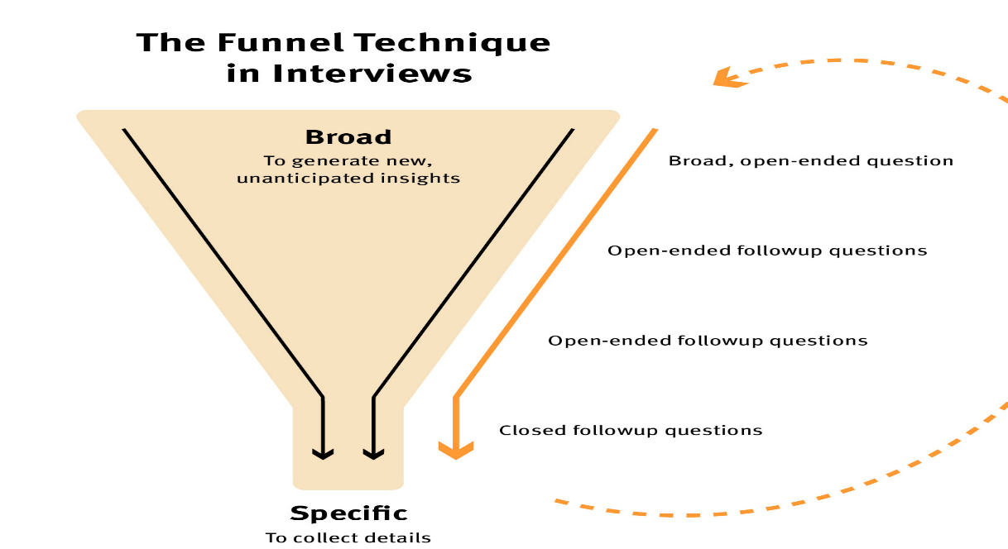

Figure 3.1 – Annotated Diagram - Research Funnel (Source: Boulton, 2014)

The diagram shown in Figure 3.1 shows the chosen research technique process for this dissertation, whereby it shows how research techniques can lead to collecting specific data.

3.1.1 Open Questions
The term open question refers to the type of question that allows for a detailed broad response, encouraging the person answering to share their thoughts, feelings, or knowledge freely (Bhat, 2018).
Open questions will be used for this research project as Boulton (2014) states within Figure 3.1 to obtain a broad insight into a person’s feelings surrounding a topic. This subjective and broad qualitative data can provide explanations on each individuals feelings surrounding the topic, as well as expanding and enhancing the current academic understanding of the topic – whilst aiming to achieve objective 2 of this research project- Explore the ethical challenges of taser being used as a use of force within Policing.

3.1.2 Closed Questions
The term closed question refers to the type of question that provides a specific response from the question asked. This type of question is often used to collect quantitative data (Boulton,2014).
Boulton (2014) refers to closed questions as a research technique being like the metaphor of a mouse in a maze – When you shut of the wrong pathways in a maze but show a mouse the pathway to the exit instead it gets there quicker. The use of closed questions in this research project will allow to gather quantitative data and specific data required to answer the research question.

3.2 Research Approach and Strategy
There are two different types of research approaches these are Inductive research approaches and the other being Deductive research approached. An Inductive research approach is when data is collected, patterns are identified and a hypothesis is derived. Whereas Deductive data is the opposite as it uses a hypothesis, then uses research to test the hypothesis (Streefkerk, 2023). Subsequently, an inductive approach will be used for throughout this research project.
As for the research strategy for this research project, the project will be using a “Mixed Method approach. This term refers to the use of qualitative and quantitative data being used in a single study (McLeod, 2024). Through conducting a survey with various people from within a professional organisation, valuable information van be obtained from each individual offering varied opinions and perspectives.
The participants of these surveys are currently actively serving police officers across different specialist departments within policing. Obtaining data from a variety of different specialist backgrounds within policing allows for better informed data to achieve the objectives of the research project.

3.3 Data collection and Analysis
Due to individual circumstances and issues with obtaining data from actively serving police officers, the data collection of the questionnaires will be sent through the use of via the created questionnaire link. A blank copy of the survey can be viewed in Appendix A of this dissertation.
The research will be conducted amongst 20 participants. Each person who participates in the Questionnaire is a serving police officer and has experience regarding the research subject.
The data that is to be obtained from a questionnaire through the use of Google Forms. This software will be used to keep the participants data anonymous and to analyse the data obtained.

3.4 Reliability and Validity
O’Reilly (2025) outlines the importance of reliability of data when it is can be observed, consistent, complete and free from any errors. The reliability to the research project is key to ensuring that validity of the project also.
Through the use of Surveys and the software Google forms the data can be credible, transferable and valid (O’Reilly, 2025) this allows to draw up reliable conclusions that can be made through the study and draw up conclusions for the research project.

3.5 Limitations
Due to individual circumstances and issues obtaining data from actively serving police officers being the participants of the survey, there are likely to be limitations in participants availability and the return of data. Furthermore, this is likely to be due to individual time constraints for researchers and participants. Additionally, it is very likely that there will be limitations of existing research from other police officers that affected the ability to compare finding with others.

3.6 Ethical Considerations
There were many ethical considerations that were considered throughout this research project, whereby an ethics form was completed prior to the start of the project to ensure that all ethical considerations were considered, and all aspects of this project were approved. Upon the collection of the data through the use of primary data surveys, all participants were informed of the projects and how their data may be used pending their active participation. All participants were informed that their participation would be voluntary and it was their right to withdraw or reject being apart of the project through out the project. Additionally, all participants that took place in the survey were asked to complete a consent form that can be viewed in Appendix B of the dissertation.

All participants remained anonymous throughout the research project through the use of the software Google Forms. As for all data and information obtained throughout this project it was kept secure, confidential and stored on a very secure password protected Laptop.

3.7 Conclusion
In conclusion, this chapter of the dissertation clearly highlights the rationale behind the chosen methodology for this dissertation. It successfully identified and explained why certain research methods and approaches have been used. The next chapter of my dissertation will focus on presenting and analysing the data gathered.

Chapter 4 – Analysis of Results
4.0 - Introduction
In the last chapter of the dissertation, the different methodology for the research project using the model created by Boulton (2014) have been implemented. During this chapter of the dissertation it will provide and analyse the finding of the research project through the collection of primary research data.
A Blank copy of the Questionnaire can be found in Appendix A. This copy presents the questions within Questionnaire. This Questionnaire was emailed to twenty different police officer individuals within the policing organisation. With all these participants working as a response police officers covering different areas within the policing organisation area.
Due to limitations on word count throughout the research project, only four topics can be analysed during this chapter.

4.1 - Data Analysis
The Data analysis used during this chapter ensures that the research explored throughout: “How do the advantages and disadvantages of police taser use effect its ethical justification in the role of being a police officer?”. The term data analysis in simple terms involves the organising and extracting of information from large amounts of data to identify patterns and themes that relate to the research question.

4.2 - Analysis Method
As the data was collected via a survey, all answers were collated from participants and complied into a document. Each individual participant gives a Participant number, to assist in analysis when going through data. The data collected is qualitative and it was vital to find a method to analyse the answers and identify themes.

4.3 - Analysis of the Data Gathered from a Questionnaire
To assist with the analysis of the data collected through the use of a Questionnaire, I used the online tool Google Forms. This tool allowed me identify themes easily and gather an overall view of the data collected from participants.

4.4 - Theme One – Ethical justification of taser use as a less lethal weapon in the role of being a police officer
At the start of the survey participants were asked to state whether they strongly agree, Agree, Neutral, Disagree or Strongly Disagree to the question “Do you agree that it is ethical to use taser as a less lethal weapon within Policing?. Adam and Jennison (2007) discussed that there were inconsistencies regarding people ethical justification on the use of taser. A display of these answers from the survey can be seen in Figure 4.4 Below.

Do you agree that it is ethical to use taser as a less lethal weapon within Policing?
Strongly Agree | 16
Agree | 4
Neutral | 0
Disagree | 0
Strongly Disagree | 0

Figure 4.4.1 – Do you agree that it is ethical to use taser as a less lethal weapon within Policing?

Subsequent to assembling all the answers, a clear consensus and theme emerges from the participants answers. Based on the answers from the participants 80% of them strongly agree that it is ethical to use taser within policing as a less lethal option. This data contradicts the findings in chapter 2 by Adam and Jennison (2007), whereby they stated that there were inconsistencies regarding this as a topic.

Although, one of the following questions in the survey asked the participants the following question “What disadvantages of taser use effect its ethical justification in the role of being a police officer?”. Please see Figure 4.1.2 below.
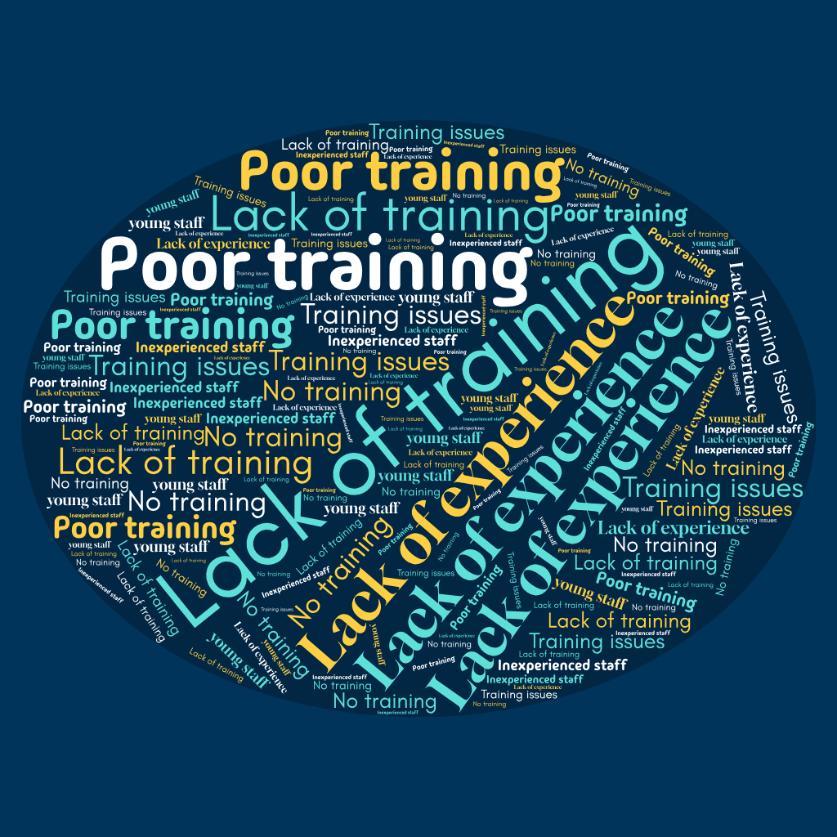

Figure 4.4.2 - What disadvantages of taser use effect its ethical justification in the role of being a police officer?
These findings support the theories of Adam and Jenison (2007) in Chapter two where one of the key issues and disadvantages highlighted surrounding the ethical justification of taser use within policing being lack of or poor training.

4.5 Theme two – The benefits of taser use within policing

During the survey participants were asked to state what they believed to be the benefits of police taser use within policing. This was an open question whereby all 20 participants could have answered openly. Although, all data collected fell within three categories – a display of these answers can be seen in Figure 4.5 below.

Figure 4.5 – What are the benefits of using taser within policing?

Following the analysis of the answers given, a clear consensus emerges. Based on the answers given officer safety has been identified as a vital benefit of using taser by police officers. This agrees with Roberts (2024) discussed in chapter two. Whereby, it was discussed that a key benefit identified was to mitigate the risk to officers on duty.

4.6 Theme Three – Media coverage and the impact of Taser use on public confidence
With regards to the impact media coverage and public confidence has on the ethical justification of taser within policing, participants did not agree with the analysis presented by Donoghue (2018) in Chapter 2. This can be seen in Figure 4.6 below.

Figure 4.6 - Do you agree or disagree with Donoghue (2018) where he states that the media majorly impacts in the ethical justification in taser being used by officers?

Following a compilation of the answer from the survey 75% of the participants disagree with Donoghue (2018). Therefore, more of the police officer participants do not believe that media and public confidence impact them when using taser.

4.7 Theme Four – Officers justification and ethical decision making when using taser
Figure 4.7 is a collection of the most used words by the participants during their answers within the survey when asked the following question, “What impact factors do officers consider when using their taser within day-to-day policing?”.

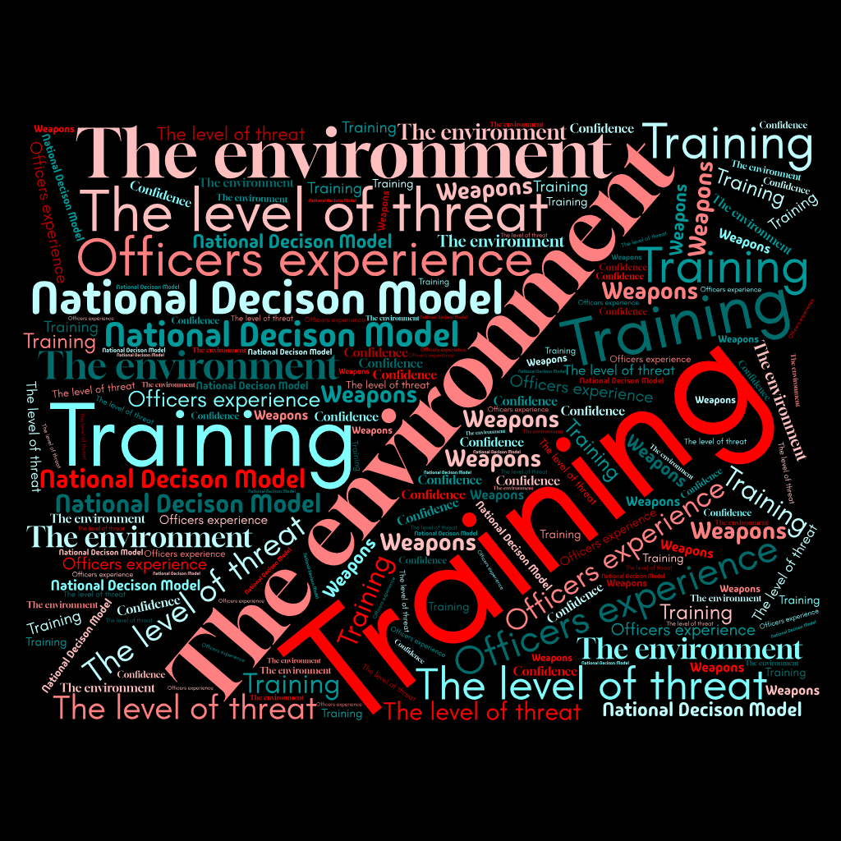

Figure 4.7 - What impact factors do officers consider when using their taser within day-to-day policing?

The most frequently used factors mentioned by the participants were Training, The environment, The National Decision Model and the level of threat. These words were included in the majority of participants surveys and these also shared views with Dymond (2019) in chapter two of the dissertation.

4.8 Conclusion
Through analysing the data collected through the use of qualitative surveys similarities and differences have been discovered in regards to the research discussed in Chapter two.
This chapter has presented the analysis of the data collected through the use of qualitative surveys. This chapter has also continued to complete the objectives set out for this research project.

Chapter 5 – Conclusion. Recommendation and Limitations

5.0 Introduction

The preceding chapters of this dissertation have systematically advanced the research project through its introductory, theoretical, methodological, and analytical stages. The most recent chapter has critically examined and interpreted the findings derived from primary data, collected through qualitative interviews. Throughout the dissertation it has set out clear objectives that have been achieved.

This chapter will provide conclusions of the research question; “How do the advantages and disadvantages of police taser use effect its ethical justification in the role of being a police officer?”.

This chapter will also discuss and highlight the limitations surrounding this topic and discuss areas for future academic research surrounding the topic.

5.1 Achievement of Research Objectives

- Outline the Advantages and Disadvantages of Police officers being upskilled and trained as a taser trained officers.

The advantages and disadvantages of police taser use were outlined in Chapter 4 successfully.

- Explore the ethical challenges of taser being used as a use of force within Policing.

This was explored successfully in Chapter two of the dissertation after gaps were identified in Chapter 2 of the dissertation, with the use of qualitative interviews from police officers being the most appropriate.

- Analyse how tasers are being used within policing effectively and how officers decided when to use taser.

This objective was achieved in Chapter 4 of the dissertation. During Chapter 4 an analysis of data was discussed and analysed successfully.

- Identify which ethical principles support taser use within policing and what opposes its use.

Objective 4 was achieved successfully during the identification of ethical principles during chapter two of the dissertation and also through the further analysis during Chapter 4.

5.2 Findings
The findings of this research project discussed during this chapter both support and go against the literature analysed during Chapter 2 of the dissertation.

Firstly, as a result of the responses received through the questionnaire. It was found that many responses referred to issues surrounding poor training and lack of training contribute to the taser being used unethically. This was a common factor discussed throughout Chapter 2 meaning that the majority of participants agreed with Adam and Jennison (2007).

Secondly, the media does not impact the justification on taser use. This was not supported by academic research from Donoghue (2018). However, through primary data collected through questionnaires with participants of the research stating that they disagree that media use effects an officers justification when using taser. Instead, the primary data highlighted that the level of threat, environment, training and confidence are major impact factors in the justification of officers when using taser ethically.

Lastly, there are more advantages to taser use than disadvantages within policing. This finding can be concluded due to there being more advantages provided when completing academic research with Roberts (2024) strongly agreeing with this. Furthermore, the primary data collected also supports this as 80% of 20 participants agree that taser is ethical as a less lethal weapon in policing. Furthermore, 100% of 20 participants provided benefits of taser use with 70% of the participants stating that tasers major benefit was officer safety, 20% of the participants stating it reduces the risk of injury and 10% of participants stating taser can be used as a deterrent.

5.3 Recommendations
These recommendations are derived from the insights gained throughout the research projects discoveries, findings and questionnaires.

Firstly, due to a range of different answers provided by the participants regarding polices surrounding taser use and the ethical justification of taser use. It identified a recommendation for the establishment independent oversight bodies or boards that regularly review taser use policies, training and incidents were taser is used to ensure accountability and to ensure its being used ethically.

Secondly, police forces should engage in open dialogue with communities regarding taser use practices and policies to work towards building trust and to address any concerns that members of the public may have.

Lastly, there needs to be an increases in mandatory comprehensive data collection every time a taser is used by a police officer. This should include a subjects behaviour, the officers justification for use, the outcome of the incident and any injuries suffered by any person involved. This will ensure accountability, promote ethical decision making and allow for taser incidents to be analysed critically and inform taser policy moving forward.

5.4 Limitations
The biggest limitation to this research project is the amount of available police officer participants. Due to the participants being current serving police officers, there were many limitations and difficulties regarding the obtaining of data using the questionnaire due to them having lack of free time.

Furthermore, another limitation of the research project has been the size of the project itself. This research project is of an undergraduate level and there were a variety of different areas within the research project that could be considered and explored within my research. However, due to restrictions with the word count these areas were not explored.

5.5 Future Research
Due to the participant size being small due to limitations, the qualitative data analysed during this project was also small. Although, if further research were to be completed in the future, a research project of a larger group of police officers across different forces would provide a wider range of data and understanding regarding the topic of taser use.

5.6 Conclusion
This research project successfully met its aims and objectives. It also addressed the research question of “How do the advantages and disadvantages of police taser use effect its ethical justification in the role of being a police officer?” and provided the reader with a wider understanding of taser use within policing.
This dissertation has explored key finding, academic research and primary data collected surrounding the ethical justification of taser use with numerous factors being considered and analysed throughout to draw up conclusions.
This was a goal throughout the research project, with Chapter 1 introducing the research project surrounding taser and providing a rationale of the project, Chapter 2 gathered existing academic research, data and conclusions on the topic, Chapter 3 outlined the analysis model selected for the research project, with Chapter 4 and 5 presenting the finding gathered, the limitations identified and provided recommendations.
To conclude this dissertation, throughout the research project it has been highlighted that there are numerous factors that impact the ethical justification of taser use within policing. Although, the research project has identified gaps in research in this area that identifies the room for further research that can be done to better discuss this topic.

6. Bibliography
Adams, K. and Jennison, V. (2007) ‘What we do not know about police use of TasersTM’, Policing: An International Journal of Police Strategies & Management, 30(3), pp. 447–465. doi:10.1108/13639510710778831.
Angelis, J. and Wolf, B. (2013) ‘Tasers and community controversy: Investigating training officer perceptions of public concern over conducted energy weapons’, Qualitative Report, 18. Available at: https://eric.ed.gov/?id=EJ1005496 (Accessed: 1 March 2026).
Ariel, B. (2018) ‘Carrying Tasers increases police use of force, study finds’, University of Cambridge. Available at: https://www.cam.ac.uk/research/news/carrying-tasers-increases-police-use-of-force-study-finds (Accessed: 1 March 2026).
Bhat, A. (2018) ‘Open ended questions: Definition, characteristics, examples, and advantages’, QuestionPro. Available at: https://www.questionpro.com/blog/what-are-open-ended-questions/ (Accessed: 1 March 2026).
Bouchrika, I. (2025) ‘Primary research vs secondary research: Definitions, differences, and examples’, Research.com. Available at: https://research.com/research/primary-research-vs-secondary-research (Accessed: 1 March 2026).
Boulton, E. (2014) ‘The research funnel’. Available at: https://www.emmaboulton.co.uk/writing/the-research-funnel (Accessed: 1 March 2026).
Chambers, S. (2024) ‘The truth about Tasers: What the statistics and research tell us’, University of South Wales. Available at: https://www.southwales.ac.uk/news/2024/august/the-truth-about-tasers-what-the-statistics-and-research-tell-us/ (Accessed: 29 December 2025).
Choudhary, R. et al. (n.d.) ‘Balancing safety and ethics: The TASER consideration in healthcare: A systematic review’.
College of Policing (2022). Conducted energy devices (Taser). [online] College of Policing. Available at: https://www.college.police.uk/app/armed-policing/conducted-energy-devices-taser [Accessed 14 November. 2025].

College of Policing (2023). Authorised Professional Practice: Use of force. [online] College of Policing. Available at: bing.com/ck/a?!&&p=ef2c9a9445c7d0cc11f44ee77d611f35c7f8ba6997a45ef16a01e0bf3e0bad0eJmltdHM9MTc4MjYwNDgwMA&ptn=3&ver=2&hsh=4&fclid=1495a0ac-c42c-6a81-3730-b7cdc5b66b2d&psq=college+of+policing+authorised+practice&u=a1aHR0cHM6Ly93d3cuY29sbGVnZS5wb2xpY2UudWsvYXBw&ntb=1
[Accessed 15 November. 2025]
Crow, M.S. and Adrion, B. (2011). Focal Concerns and Police Use of Force. Police Quarterly, 14(4), pp.366–387. doi: https://doi.org/10.1177/1098611111423740 .
Deuchar, R., Frondigoun, L., Densley, J.A. and Davidones, C. (2024) ‘Taser use in Scotland: A qualitative study of police officer and community perspectives’, European Journal on Criminal Policy and Research. doi:10.1007/s10610-023-09569-3.
Donoghue, K. (2018) ‘How police Tasers threaten public confidence’, Donoghue Solicitors. Available at: https://www.donoghue-solicitors.co.uk/how-police-tasers-threaten-public-confidence/ (Accessed: 15 January 2026).
Dr Sophie Chambers (2024). The truth about Tasers: what the statistics and research tell us - University of South Wales. [online] Southwales.ac.uk. Available at: https://www.southwales.ac.uk/news/2024/august/the-truth-about-tasers-what-the-statistics-and-research-tell-us/ [Accessed 14 November. 2025].
Dymond, A. (2019) ‘Towards a socio-technical understanding of discretion: A case study of Taser and police use of force’, Policing and Society, 30(9), pp. 1–15. doi:10.1080/10439463.2019.1660338.
Home Office (2012) Definition of Policing by consent. London. Home Office. Available at: Definition of policing by consent - GOV.UK (Accessed: 17 November 2025)
Home Office (2022) Use of force guidance for immigration enforcement officers. Available at: https://assets.publishing.service.gov.uk/government/uploads/system/uploads/attachment_data/file/1072789/Use_of_force.pdf (Accessed: 22 December 2025).
Human Rights Act 1998 (1998) Available at: https://www.legislation.gov.uk/ukpga/1998/42/schedule/1 (Accessed: 1 March 2026).
Jabr, F. (2023). John A. Long - Publications List. Publicationslist.org, 14(6).
Jain, N. (2023) ‘What is research? Definition, types, methods and process’, IdeaScale. Available at: https://ideascale.com/blog/what-is-research/ (Accessed: 1 March 2026).
Jackson, J. and Sunshine, J. (2006) ‘Public confidence in policing: A test of the process-based model’, British Journal of Criminology, 47(2), pp. 214–233. Available at: https://academic.oup.com/bjc/article-abstract/47/2/214/519133 (Accessed: 10 January 2026).
Kleinig, J. (2007) ‘Ethical constraints on Taser use by police’, Policing: A Journal of Policy and Practice, 1(3
Kocurkova, K. and Hrinko, M. (2024). Analysis of the Effectiveness of Taser in Police Intervention and Overview of the Main Causes of Failure. TEM Journal, [online] 13(4), pp.2918–29301. Available at: https://www.ceeol.com/search/article-detail?id=1286399 [Accessed 15 November. 2025].), pp. 284–292.
McGuinness, T. (2016) Taser use in England and Wales. Available at: https://researchbriefings.files.parliament.uk/documents/CBP-7701/CBP-7701.pdf (Accessed: 28 December 2025).
McGuinness, T. (2021) Taser use in England and Wales. Available at: https://commonslibrary.parliament.uk/research-briefings/cbp-7701/ (Accessed: 16 December 2025).
McLeod, S. (2024) ‘Mixed methods research’, Simply Psychology. Available at: https://www.simplypsychology.org/mixed-methods-research.html (Accessed: 1 March 2026).
Nash, J. (2018) ‘A critical examination of the police use of Tasers’. Available at: https://pearl.plymouth.ac.uk/plcjr/vol10/iss1/1/ (Accessed: 2 January 2026).
O’Reilly, D. (2025) ‘What is data reliability and why do you need it?’, Dataversity. Available at: https://www.dataversity.net/articles/what-is-data-reliability-and-why-do-you-need-it/ (Accessed: 2 March 2026).
Petersen, K. et al. (2024) ‘Less-lethal weapons and civilian injury in police use of force encounters: A multi-agency analysis’, Journal of Urban Health. doi:10.1007/s11524-024-00940-1.
Ready, J., White, M.D. and Fisher, C. (2008) ‘Shock value’, Policing: An International Journal of Police Strategies & Management, 31(1), pp. 148–170. doi:10.1108/13639510810852620.
Roberts, J. (2024) ‘20 pros and cons of Tasers’, Prospluscons.com. Available at: https://prospluscons.com/pros-and-cons-of-tasers/ (Accessed: 2 January 2026).
Streefkerk, R. (2023) ‘Inductive vs deductive research approach’, Scribbr. Available at: https://www.scribbr.com/methodology/inductive-deductive-reasoning/ (Accessed: 1 March 2026).

7. Appendices

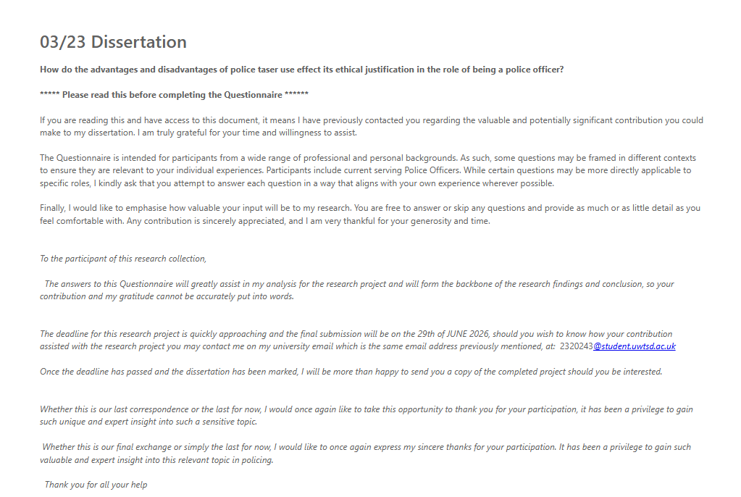
Appendix A - Blank Questionnaire
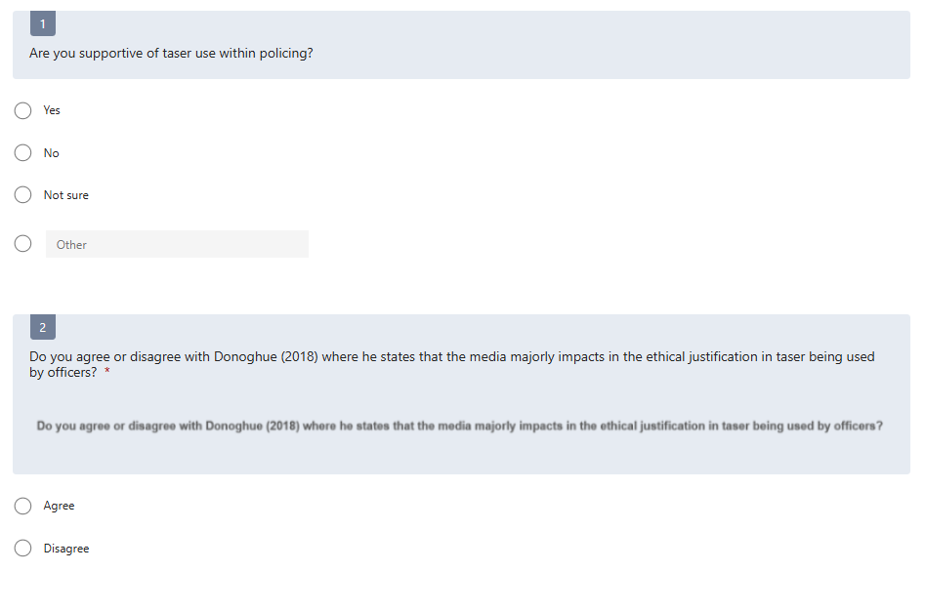

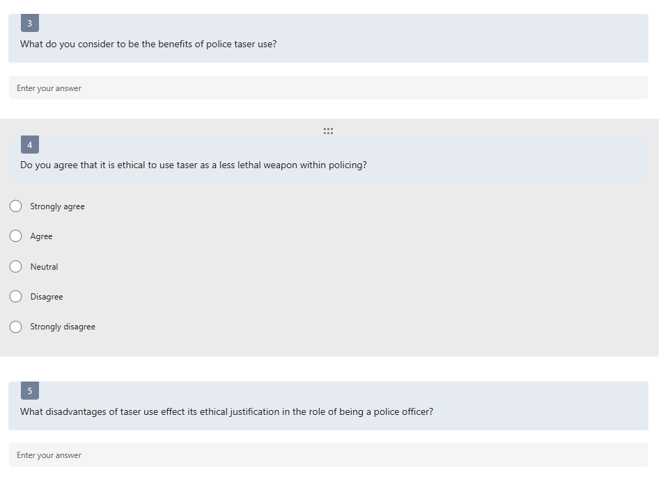

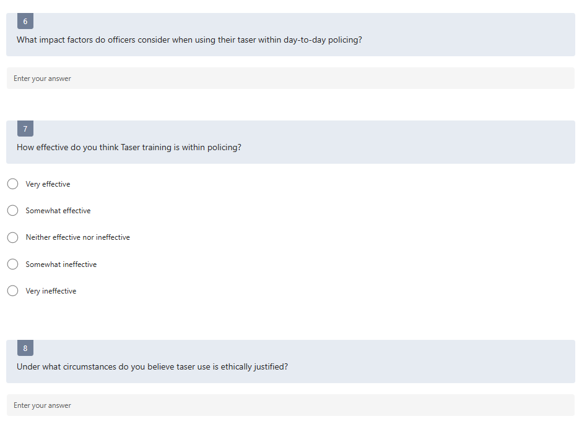



Appendix B – Copy of consent Form

PARTICIPANT CONSENT FORM

Research Project Title

How Do the Advantages and Disadvantages of Police Taser Use Affect the Ethical Justification of Their Use by Police Officers?

Researcher Information
Researcher Name: _Evan Rogers
Institution/School: __UWTSD Swansea
Email Address: _2320243@uwtsd.ac.uk

Invitation to Participate
You are invited to participate in a research study investigating the ethical justification of police taser use. Before deciding whether to participate, please read the information below carefully.

Purpose of the Study
The purpose of this research is to investigate how the advantages and disadvantages of police taser use influence the ethical justification of their use by police officers. The research aims to explore opinions and perspectives regarding the effectiveness, safety, and ethical implications of tasers in policing.

What Participation Involves
If you agree to participate, you will be asked to:
- Complete a questionnaire.
- Provide your opinions regarding police taser use and its ethical implications.
- Participate for approximately 10–15 minutes.

Voluntary Participation
Your participation in this study is entirely voluntary. You may refuse to participate or withdraw from the study at any time without giving a reason and without any negative consequences.

Risks and Benefits

Potential Risks
There are no anticipated physical risks associated with this research. Some participants may find discussions about policing, use of force, or ethical issues uncomfortable. You may choose not to answer any question and may withdraw at any time.

Potential Benefits
There may be no direct personal benefit from participating. However, your responses may contribute to a greater understanding of policing ethics and the role of tasers in Policing

Confidentiality and Data Protection
- All information provided will be kept confidential.
- Responses will remain anonymous unless otherwise stated.
- Data will be stored securely and accessed only by the researcher.
- Information collected will be used solely for educational and research purposes.
- Data will be securely deleted following completion of the research project.

Consent Statement
Please tick each box to confirm your understanding:
☐ I have read and understood the information provided above.
☐ I understand that my participation is voluntary.
☐ I understand that I may withdraw from the study at any time.
☐ I understand how my information will be stored and used.
☐ I agree to participate in this research project.

Participant Declaration
Participant Name (Print):

Participant Signature:

Date:
____ / ____ / ________

Researcher Declaration
I confirm that I have explained the purpose of this research project and answered any questions raised by the participant.
Researcher Name:

Researcher Signature:

Date:
____ / ____ / ________

Thank you for your participation.

Appendix C – Questionnaire Result Matrix
Questions
(Q)
 |  | Q.1 | Q.2 | Q.3 | Q.4 | Q.5 | Q.6 | Q.7 | Q.8 | Q.9
Participants Answers  Each participant shown as (P) | P1 | Yes | Agree | Officer Safety | Agree | Poor training | Training, Weapons and the level of threat | Neither effective nor ineffective | During high risk incidents | More training
Participants Answers  Each participant shown as (P) | P2 | Yes | Disagree | Officer Safety | Strongly Agree | Lack of training | Threat, The environment and training | Somewhat effective | To effect an arrest during dynamic High Risk incident. | Scenario based training
Participants Answers  Each participant shown as (P) | P3 | Yes | Agree | Deterrent | Agree | Lack of experience | Environment, national decision model and the officers level of experience. | Neither effective nor ineffective | When officers are at risk and/or members of the public | More training
Participants Answers  Each participant shown as (P) | P4 | Yes | Agree | Reduction of Injury | Strongly Agree | Lack of effective training | Officer training, specific environment and NDM. | Neither effective nor ineffective | To mitigate threat, risk and harm | Longer Training
Participants Answers  Each participant shown as (P) | P5 | Yes | Disagree | Officer Safety | Strongly Agree | Lack of experience | Confidence and training of the officer | Very Effective | When there is a risk to officers or members of the public | Taser to be introduced as a mandatory piece of PPE
Participants Answers  Each participant shown as (P) | P6 | Yes | Disagree | Officer Safety | Agree | Poor training | Any weapons and the use of the national decision model | Somewhat effective | When a taser trained officer deems proportionate. | More training and regular refreshers for taser officers
Participants Answers  Each participant shown as (P) | P7 | Yes | Disagree | Officer Safety | Strongly Agree | Training issues | The level of threat and the national decision model | Somewhat effective | It can be used by trained officers to deal with high risk calls. | Regular officer reviews
Participants Answers  Each participant shown as (P) | P8 | Yes | Disagree | Officer Safety | Agree | Poor training | The specific environment, level of training and level of experience from officers | Somewhat Ineffective | At calls when a person has a weapon | Better longer training courses
Participants Answers  Each participant shown as (P) | P9 | Yes | Disagree | Officer Safety | Strongly Agree | Lack of training | Officer confidence, the environment and application of the national decision model. | Neither effective nor ineffective | During an incident whereby a taser is necessary to preserev life and/or effect an arrest. | Regular taser call reviews
Participants Answers  Each participant shown as (P) | P10 | Yes | Disagree | Reduction of Injury | Strongly Agree | Poor taser training | Threat to officers, training and experience | Somewhat ineffective | During a call when the person is a High risk to themselves or other. Eg. Yeilding a weapon. | High intensity training for a longer period
Participants Answers  Each participant shown as (P) | P11 | Yes | Disagree | Officer Safety | Strongly Agree | No training | The level of training officers have and the level of threat | Somewhat ineffective | To mitigate risk during calls | Only experienced officers to be given tasers
Participants Answers  Each participant shown as (P) | P12 | Yes | Disagree | Officer Safety | Strongly Agree | Inexperienced staff | The environment | Somewhat effective | During high threat risk and harm calls | More training
Participants Answers  Each participant shown as (P) | P13 | Yes | Disagree | Officer Safety | Strongly Agree | Training issues | Training and the Environment | Somewhat effective | If a taser trained officer applies the NDM and feels that a taser is necessary to ensure the safety of all people involving. | Structured review process of taser use
Participants Answers  Each participant shown as (P) | P14 | Yes | Disagree | Officer Safety | Strongly Agree | No experience | The national decision model and the level of threat for example weapons | Somewhat Ineffective | When it is necessary to do so | It would be beneficial that only officers with a lot of years experience carry taser
Participants Answers  Each participant shown as (P) | P15 | Yes | Disagree | Reducing the risk of injury | Strongly Agree | Poor training | Weapons | Somewhat effective | To ensure the safety of all people attending an incident. | More often training
Participants Answers  Each participant shown as (P) | P16 | Yes | Agree | Deterrent | Strongly Agree | Young staff | Officer experience and weapons | Somewhat ineffective | If it is JPLANE and you are a taser trained officer | Better training with a complex theory test
Participants Answers  Each participant shown as (P) | P17 | Yes | Disagree | Officer Safety | Strongly Agree | Due to poor training | The environment and training of the officer | Somewhat ineffective | To incapacitate a dangerous offender and ensure safety of all involving. | Reviews regarding taser use of force by Sergeants and Inspectors
Participants Answers  Each participant shown as (P) | P18 | Yes | Disagree | The risk of injury is reduced | Strongly Agree | Inexperienced staff and poor training | Confidence, training and threat level to the officer | Neither effective nor ineffective | To preserve life, effect arrest and as a less lethal option | Body worn video that turns on when a taser is withdrawn
Participants Answers  Each participant shown as (P) | P19 | Yes | Disagree | Officer Safety | Strongly Agree | Lack of experience | The specific environment | Somewhat ineffective | Any call where the T/R/H is HIGH | Dynamic training scenarios given to all officers surrounding taser
Participants Answers  Each participant shown as (P) | P20 | Yes | Agree | Officer Safety | Strongly Agree | Lack of training | The national decision model and training | Neither effective nor ineffective | To ensure safety to all parties involved | Further training is necessary to ensure ethical taser use. I also believe that refresher would be beneficial

