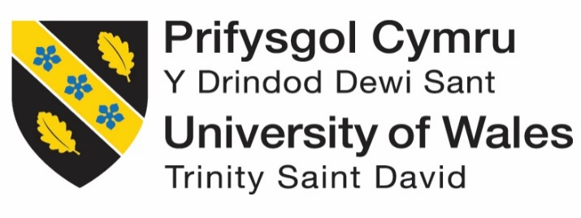

LONDON

Developing Relationships and Workplace Achievement
(BMSW5102_LON)

Organisation: The Travellers Club London

Romulo Santillan s/n 1906875
Lecturer: Dr Nadish Patel

Training and development of HR officer in “The Travellers Club London”

Table of Contents
Slide 1 3
Slide 2 (Need of HR officer and Development Training) 3
Slide 3 (Job Description of HR officer in the Travellers Company) 6
Slide 4 (HR Officer Knowledge, skills and competencies) 7
Slide 5 (Carer plan and Training needs) 10
Slide 6 (UK legal context of employment) 12
Slide 7 (Discrimination, UK law against crimination to protect employees) 13
Slide 8 (How to avoid discrimination in organisation) 15
Slide 9 Summary 16
Conclusion 18
References 19

Slide 1
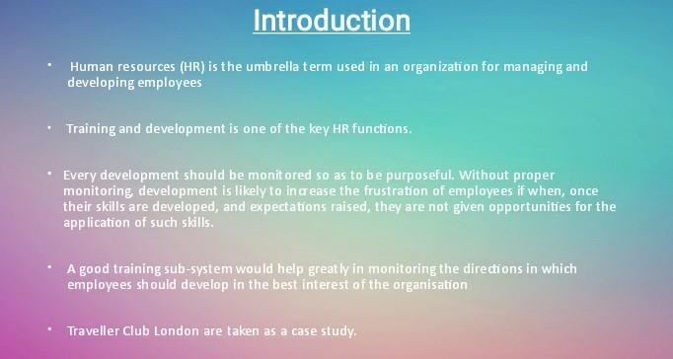
Travellers Club London: Preparation and improvement is one of the key HR capabilities. At the turn of the century, there was an increased focus on something very similar in international associations. (Breckon, and Dodson, 2016).Preparation is very important because innovation is constantly and rapidly growing. Structures and practices are rapidly becoming obsolete due to new discoveries in innovation, including specialised, administrative and behavioural aspects. Associations that do not create systems for finding and exploiting emerging innovations will soon become flat. This power point will concentrate on the Travellers Club London facilities and what makes it one of the best club in the United Kingdom by applying the best training program for their HR management.
In any case, creating people in an association can increase its vitality. (Robinson, et al 2016). So in this, we are taking TRAVELLERS CLUB LONDON as a case study in order to get know how their HR management works and what kind of training and development they adopt.

Slide 2 (Need of HR officer and Development Training)
The club was founded in 1819 for men of honour who left the British Isles 500 miles from London in a straight line. The set was extended to strangers and negotiators represented in London. (Apollo, 2017).
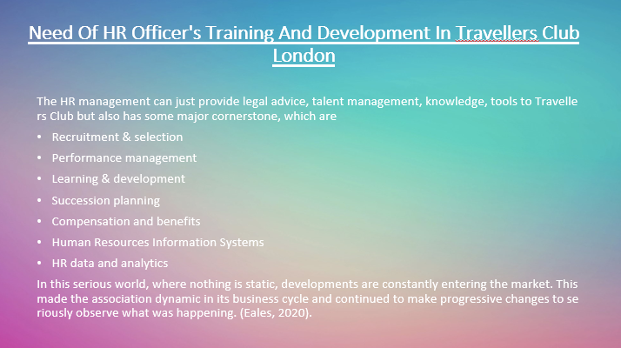
The idea behind the Club was to create a meeting place for such respected people who travelled abroad and where they could similarly attract strangers and negotiators represented in London. (McBride, 2015).
The HR management can just provide legal advice, talent management, knowledge, tools to the Travellers Club but also has some major cornerstones, which are (Zheng, et al 2015).
• Selection and determination
• Management efficiency
• Training and promotion
• Organisation of inheritance
• Compensation and benefits
• Information systems for personnel management
• HR information and investigation
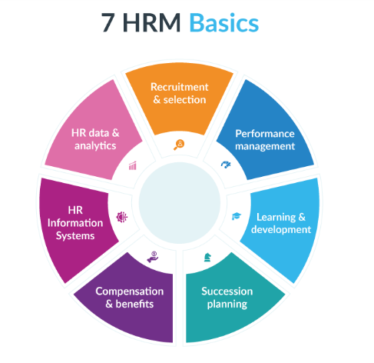
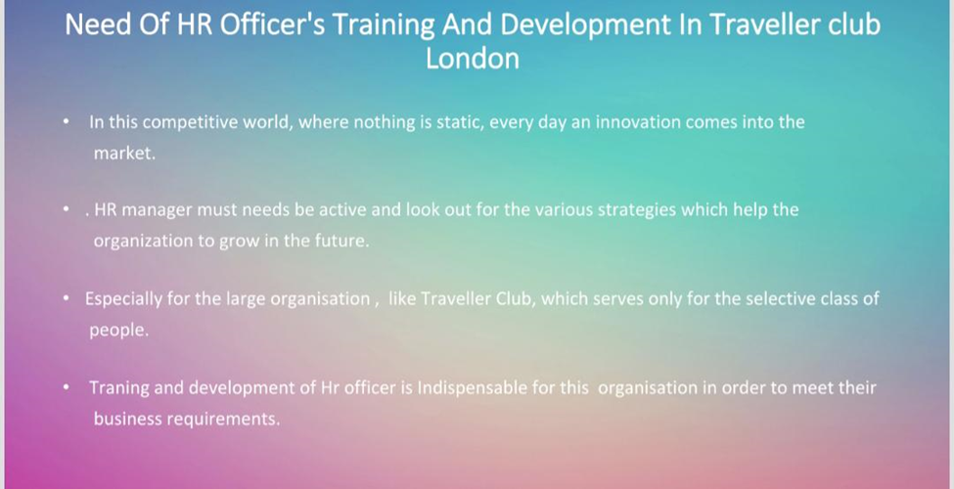
In this serious world, where nothing is static, developments are constantly entering the market. This made the association dynamic in its business cycle and continued to make progressive changes to seriously observe what was happening. (Akers, 2017).

Slide 3 (Job Description of HR officer in the Travellers Company)
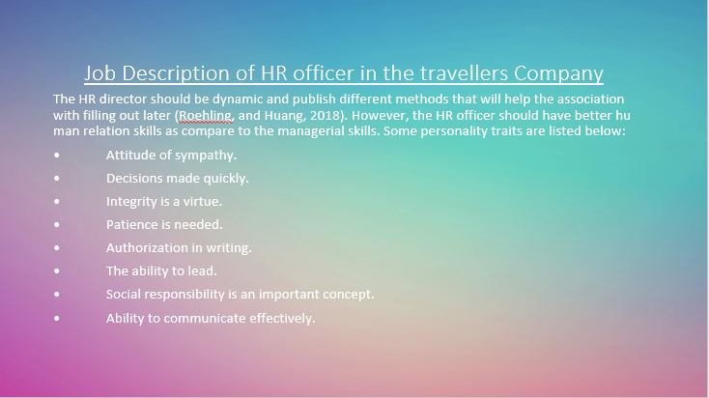
The HR director should be dynamic and publish different methods that will help the association with filling out later (Boella, 2017). However, the HR officer should have better human relation skills as compared to the managerial skills. Some personality traits are listed below:
- Attitude of sympathy.
- Decisions made quickly.
- Integrity is a virtue.
- Patience is needed.
- Authorisation in writing.
- The ability to lead.
- Social responsibility is an important concept.
- Ability to communicate effectively.
In large associations such as the London Explorers Club, preparing employees to make the most of their abilities is considered a must. Likewise, they recognise the importance of preparing and improving the impact on the association. (Xu, et al 2018).

Slide 4 (HR Officer Knowledge, skills and competencies)
Another responsibility of the HR department is to improve the implementation of the management system. Without a human resources specialist who develops the mechanism of actions performed by the employee, representatives may find themselves in positions that do not correspond to their abilities (Pijpker, et al 2017)
The pre-assessment of HR officer s knowledge are:
• Personnel and human resources - knowledge of the standards and methods of recruiting trainers, selection, training, pay and benefits, working relationships and organisation, and personnel data structure.
• Administration and management - knowledge of business and management standards related to key organisation, asset ownership, talent mapping, initiative strategy, individual strategies and strategies for creating and coordinating assets (, 2018).
• English - knowledge of the structure and content of the English language, including the meaning and spelling of words, location rules and syntax.
• Customer and personal service - knowledge of standards and cycles to provide customer and personal administration. This includes assessing customer needs, implementing quality guidelines for administration, and assessing customer loyalty.
• Brand and culture are key ingredients of any productive business. HR can devote time and energy to building a brand and culture that will work for you and your meeting (Noe, et al, 2017).
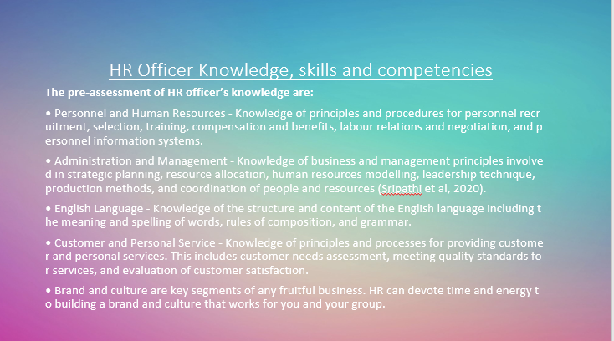
The pre-assessment of HR officer s skills are (Nenkov, et al 2017):
• Active listening
• Speaker
• Social sensitivity
• Human resource management
• Coordination
•Critical thinking
• Reading comprehension
• Negotiations
• Judgment and decision making
• System analysis
• Assessment of systems
•Time management
• Persuasion
• Monitoring
• Solving complex problems
- Active Learning
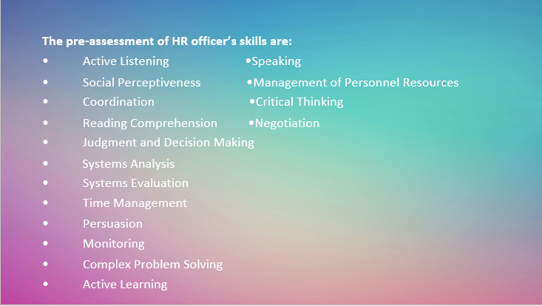
The pre-assessment of HR officer competencies are (Mayfield, et al 2016):
• Selection, training and creation of personnel
• ensuring effective and timely remuneration of employees
• Organisation of pensions and benefits
• Approval of sets of expectations and notifications
• Concern for well-being, safety and government assistance, all other things being equal,
• Organisation of training courses and exercises for staff
• monitoring the performance and participation of staff
• advising line directors and various employees on commercial law issues, as well as business approaches and company systems.
• ensuring that young people reserve the right to work in an association
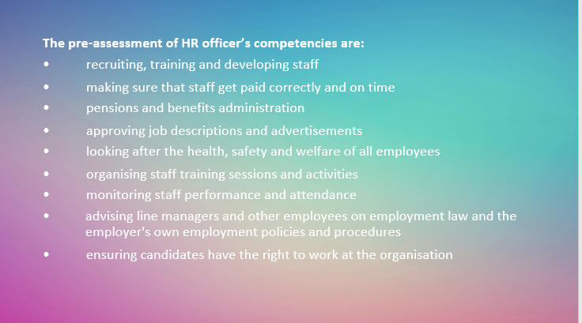

Slide 5 (Carer plan and Training needs)
• Today, HR allows employees to take responsibility for their own professional plan and development, and also ensures that the organisation offers representatives opportunities to be more productive in their day-to-day work (Phillips, and Phillips, 2016).
• The HR department must demonstrate to the two directors and staff that development is beneficial.
• Managers will find it difficult to prepare costs and will lose efficiency if there is no quick return on investment.
- Comprehensive preparation is needed for an organisation to effectively carry out its training and career plan.
- Employee training and growth aids in the achievement of various company goals by allowing workers to learn and concentrate on what is essential to the organisation (Raheja, 2015).
Employee skills, awareness, and attitude can all be improved through training and development. This is accomplished by careful preparation, execution, and assessment.
An organisation should conduct an evaluation of its employees to evaluate the type of training needed in order to carry out effective training and growth. Trainers are important because they provide preparation, evaluate trainees, and collaborate with management to ensure that the training programme runs smoothly. They also provide input to management on the process that will be used to produce the required reports (Ingham, and Ulrich, 2016).
As an organisation HR manager, assist in the development and implementation of the assessment process, as well as the allocation of appropriate resources.
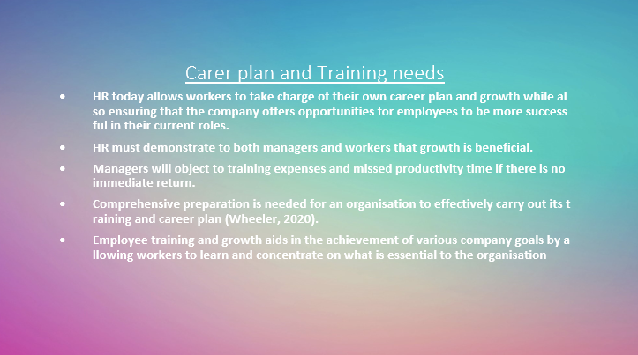
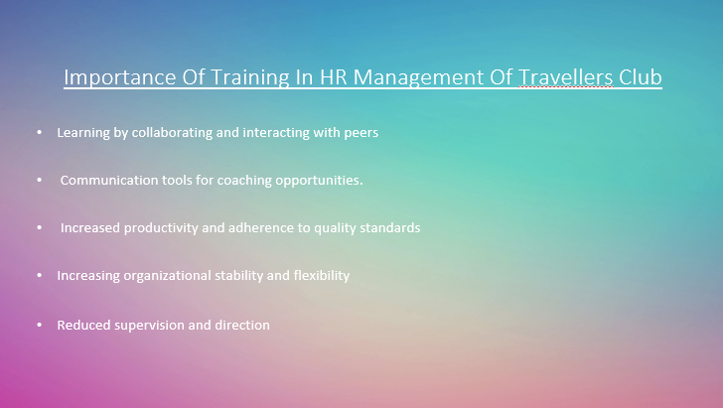
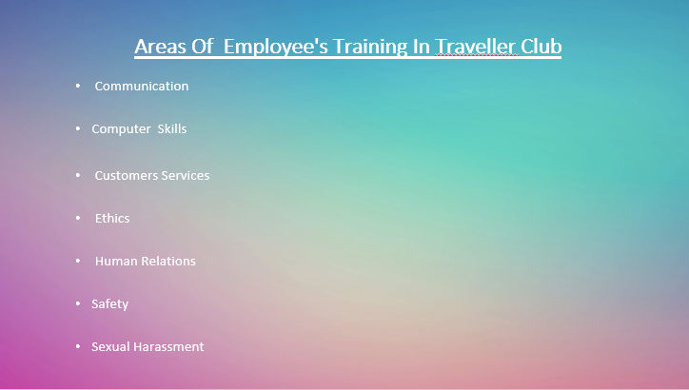

Slide 6 (UK legal context of employment)
An agreement is an agreement for UK representatives (Kirchner, and Akdere, 2017):
• working conditions
• Rights
• Responsibilities
• Responsibilities
These are known as clauses of agreement.
Employees and managers from the UK must abide by the agreement until it is closed (for example, due to the departure of the company or representative or the termination of an employee) or until the terms are changed, as indicated (Manna, et al, 2016). (Usually based on an understanding between the representative and the boss)
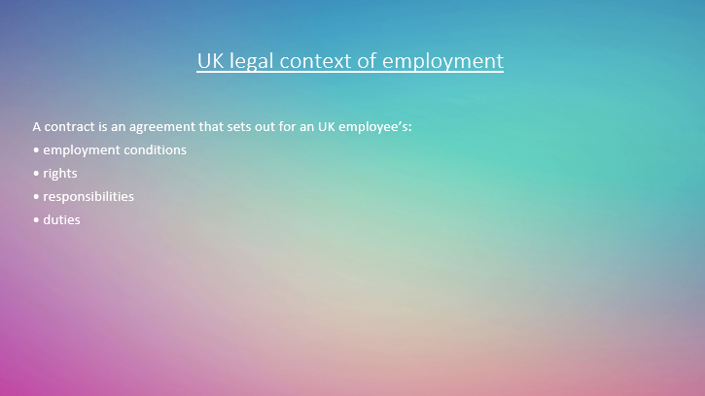

Slide 7 (Discrimination, UK law against crimination to protect employees)
Segregation: When a company treats one person worse than another, it is called segregation. This could mean that a female employee is paid less for the same job than her male partner, or that an ethnic minority is denied access to job opportunities for different employees (Clark and Higgs, 2016).
Here are anti-separation laws based on:
• Gender
• Marriage or joint communication
• Gender reassignment
• Maternity leave
• Sexual direction
• Disability
• Race
• Colour
• Ethnic origin
• Nationality
• Religion or political assessment
• Age (Mishra, 2018).
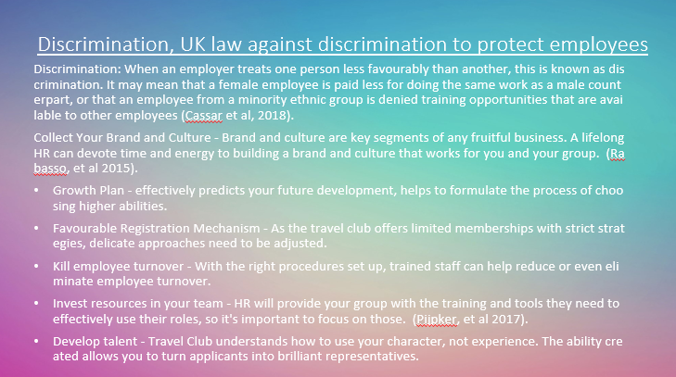
The law protects the representative from separation at work, including (Clark and Higgs, 2016):
• Dismissal
• Terms of employment
• Payment and benefits
• Promotion and movement of vacancies
• Training
• Recruitment
• Redundancy
Collect your brand and culture. Brand and culture are key ingredients in any productive business. Deep-rooted HR can spend time and energy building a brand and culture that works for you and your meeting. (Manna, et al 2016).
Growth Plan - effectively predicts your future development, helps to formulate the process of choosing higher abilities.
Favourable Registration Mechanism - As the travel club offers limited memberships with strict strategies, delicate approaches need to be adjusted.
Kill employee turnover - With the right procedures set up, trained staff can help reduce or even eliminate employee turnover.
Invest resources in your team - HR will provide your group with the training and tools they need to effectively use their roles, so it’s important to focus on those. (Kirchner, and Akdere, 2017).
Develop talent - Travel Club understands how to use your character, not experience. The ability created allows you to turn applicants into brilliant representatives (Ingham, and Ulrich, 2016).

Slide 8 (How to avoid discrimination in organisation)
Improving the hiring process - By improving the hiring cycle, you attract and attract the best people.
Welcome Review - In the business world, you need to be versatile. Support your group for ideas and criticism to improve your business (Raheja, 2015).
Develop Passion - Passion is contagious. When you have enthusiasts in your group, it’s easier to do things.
Make your team visible - the travel club needs to recruit people from a wide variety of foundations from a wide variety of clients. This will give you alternative perspectives and a more visible organisational culture.
Explore new ideas - Let your group be creative and push the boundaries of what works for your business. (Phillips, and Phillips, 2016).
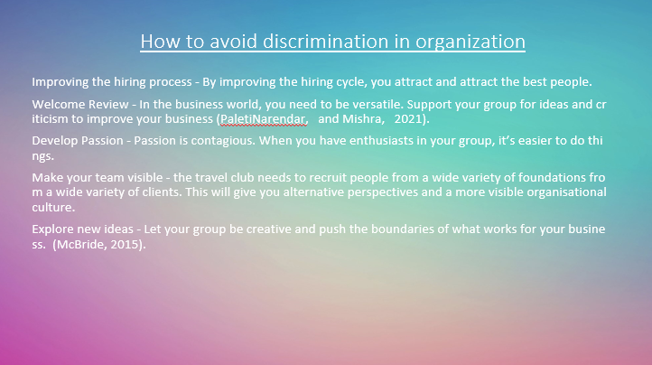

Slide 9 Summary
There is no school of thought that denies the importance of the HR department and the training and development in it. Training programs enhance employee satisfaction and retention of employees. Employees appreciate building new capacities, improving their job performance and developing into more challenging roles. Employees value a company that promotes employee training (Mayfield, et al 2016).
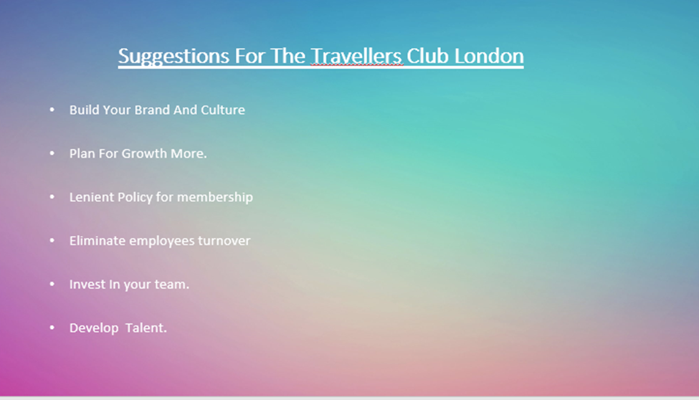
As we can see in the HR management of Travellers Club London. Its HR department not only trained their staff effectively but adopted new strategies and techniques time to time according to the situation. Although this organisation is doing well but there is some space which requires more efforts to make their organisation remarkable (Nenkov, et al 2017).
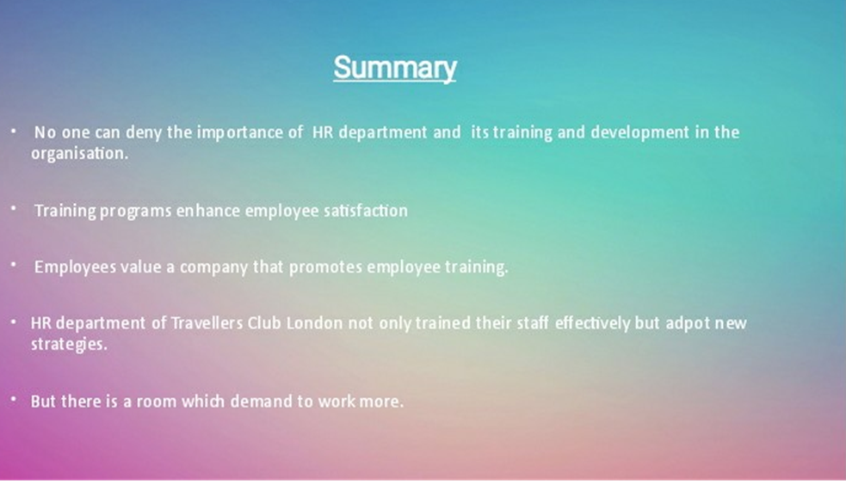

Conclusion
Employee building is widely recognized as an important methodology for the long-term development of an organisation, increasing efficiency and the ability to retain profitable reps. Employee growth would be difficult for the organisation if such issues are ignored.
Employees find the organisation frustrating, and the importance of both is unknown. The market climate has changed dramatically in recent years, necessitating selection of new technologies by organisations. This is important in order for them to be more fruitful in their particular business. Training and improving representatives at work is one of the methods that have become the norm. This is because organisations with highly qualified representatives with the necessary skills and experience have proven to be helpful better. One of the most critical aspects of business growth is training and development. Any organisation or business has often offered instruction to its workers in order to help them achieve greater success.
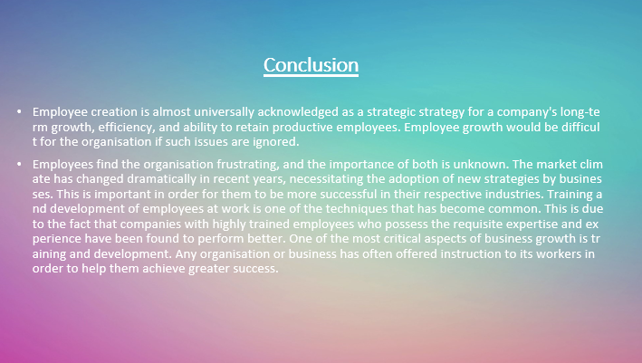

References
Akers, H.F., 2017. The genesis and development of the Endodontic Study Club of Brisbane (1964–1970). Australian Endodontic Journal, 43(1), pp.38-46.
Apollo, M., 2017. Can an ethical approach to tourism bring development, prosperity and well-being to all stakeholders? A full report from the 3rd International Congress on Ethics and Tourism, Krakow, 27–28 April 2017. Annales Universitatis Paedagogicae Cracoviensis Studia Geographica, 11, pp.7-25.
Atewologun, D., 2018. Minority ethnic careers in professional services firms. In Research Handbook of Diversity and Careers. Edward Elgar Publishing.
Boella, M.J., 2017. Human resource management in the hotel and catering industry. Taylor & Francis.
Breckon, J. and Dodson, J., 2016. Using Evidence. London: Alliance for Useful Evidence.
Clarke, N. and Higgs, M., 2016. How strategic focus relates to the delivery of leadership training and development. Human Resource Management, 55(4), pp.541-565.
Ingham, J. and Ulrich, D., 2016. Building better HR departments. Strategic HR Review.
Kirchner, M. and Akdere, M., 2017. Military leadership development strategies: implications for training in non-military orga nisations. Industrial and Commercial Training.
Manna, R., Singh, A. and Sharma, P., 2016. Does training need analysis help to minimize competency gap: an investigation. Amity Journal of Training and Development, 1(1), pp.109-131.
Mayfield, M., Mayfield, J. and Wheeler, C., 2016. Talent development for top leaders: three HR initiatives for competitive advantage. Human Resource Management International Digest.
McBride, C., 2015. A study exploring the role of the GAA and employment of expat’s abroad (Doctoral dissertation, Dublin, National College of Ireland).
Mishra, A.K., 2018. Assessment of human resource capacity of construction companies in Nepal. J Adv Res Jour Mass Comm, 5(4), pp.14-25.
Nenkov, N., Sushchenko, O. and Dyachenko, Y., 2017. Role of chief information officer within the system of human resource development in service orga nisations (tourism). Economic annals-XXI, (165), pp.97-103.
Noe, R.A., Hollenbeck, J.R., Gerhart, B. and Wright, P.M., 2017. Human resource management: Gaining a competitive advantage. New York, NY: McGraw-Hill Education.
Phillips, J.J. and Phillips, P.P., 2016. Handbook of training evaluation and measurement methods. Routledge.
Pijpker, R., Vaandrager, L. and Koelen, M.A., 2017. Salutogenesis in the workplace: The role of generalized resistance resources, sense of coherence, and learning. In 21st Annual Health Promotion Conference: Promoting Health and Wellbeing in the Workplace: National University of Ireland Galway, June 15th 2017 (pp. 42-42).
Raheja, K., 2015. Methods of training and development. Innovative Journal of Business and Management, 4(02), pp.35-41.
Robinson, P., Fallon, P., Cameron, H. and Crotts, J.C. eds., 2016. Operations management in the travel industry. Cabi.
Xu, H., Ye, T. and Chan, D., 2018. When cosmopolitan corporations meet local environments: The impact on managerial structure in international luxury hotels. International Journal of Hospitality Management, 74, pp.30-39.
Zheng, C., Wang, B.X. and Hu, M.C., 2015. New Chinese Entrepreneurs: Perspectives of Confucian Attributes and Social Settings. In Technological Solutions for Sustainable Business Practice in Asia (pp. 19-35). IGI Global.

