Llanllyr field journal 2024
Upon entry to the site for 2024, the students were given an introduction to where and what would be happening over the next three weeks. We were given a walk around of the multiple adjacent fields in which excavation work has been previously completed or backfilled with a purpose to reopen in the upcoming excavation season. This was to give knowledge to the students that haven’t been to a dig before and to refresh the memory of those that worked on the site in previous years.
After first arrival to the site & moving in equipment to the first ‘mound’ (suspected natural island of 4000 years of age within an ancient lake that is clear of larger vegetation, such as, the reeds that are found in the marshland areas suspected to pinpoint where the lake used to be). We were asked to look around and say what we see, as observation of our surroundings is a key skill needed for the course being taken. Focusing solely on vegetation, soil and topography it becomes clear the differences seen in multiple areas across a singular field. The reason for the differences may become useful in deciding on where trenches could be placed and where to avoid excavation work, as difficulty and convenience comes into question whether the right choices have been made.
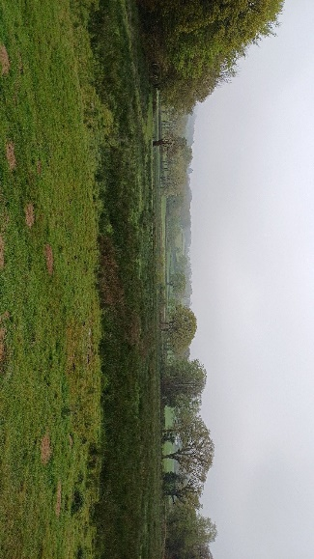
Observation of the first field concluded that there were multiple types of vegetation seen, where the mound is and where the lake used to be. This could be because of aquatic succession, in which trophic stages occur through pioneer, intermediate and climax stages to become different stage types of land from a lake. This starts to occur due to sediment deposits from runoff, erosion and biotic or abiotic factors, such as, wind, rain or animal activity such as cattle compaction. This can also explain the reason behind potential differences in soils and soil composition in the areas of the field in which differences in vegetation can be seen. This could be caused by different varieties of vegetation species growing in certain compositions of soil in which particular optimal ecological niches allows growth and dispersal.
We were introduced to test pits that were completed in a prier year, which measured 1x1 meter squares. The purpose of these were explained as examining the stratigraphy in different areas to see if any contour lines are found parallel to each other. We were also asked to picture the landscape in which instantly knowing where north is can be important for such work to keep constants within notes and work to add a sense of accuracy to completed paperwork. Pace setting was another skill talked about as knowing the speed of ones pace can be useful as another constant in which coordinates can be found when writings are taken as a way of rough mapping, for example my pace is 58 to 50 meters and therefore a coordinate point can be taken, such as, 50m east of a landmark.
The material finds were subsequently introduced to the students, in which bedrock, flint, quarts and peat were discussed:
- Bedrock= common rocks consisting of large and small sizes of a grey colour mostly smooth due to conditions faced over time.
- Flint= a silicone based pebble broken by ancestors to create sharper stones for various uses, visibly small with a white eggshell coloured pebble with an inside of orange and reddish orange hues.
- Quarts= multiple sized grainy stones of a range of transparent to white hues, consisting of rough edges and are mostly found in fragmented pieces.
- Peat= context layer made up of organic matter, visibly a dark brown colour, similar to soil (could contain additional organic matter than common soil).
Trench 13
Before starting a trench, an accurate measure must be made in which the scale, placement and marking are completed. This is done by verifying the placement in which a potential trench could be opened, the direction it is facing and the alignment in which a new trench can begin being laid out. To create an accurately measured square or rectangle the use of multiple measuring tapes and the Pythagoras theorem (where A² + B² = C^{2,} using 3x4x5 meters) to properly make right angles for a perfectly planned shape with straight side in which to begin opening the trench from.
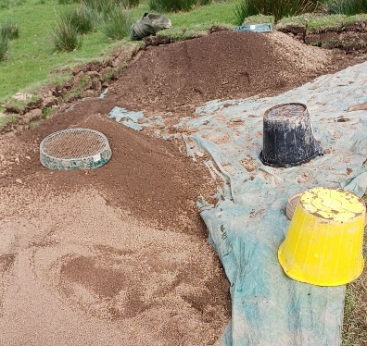
After plotting the sides of the trench the first step to open it is to de-turf the top to remove the vegetation layer of the topsoil. Laying a tarp one meter away from the trench on an optimal side, which is usually along the longer side to make the process smoother, building walls on three sides on the outer edges of the tarp checking the underneath for any finds. To prevent a collapse to the edge of the trench and any refilling of what has already been taken out, the avoidance of siting, standing or leaving heavy objects along the edges of the trench is taken into practise as this could cause a setback to the dig. To remove the turf, using an edging tool and a spade, small sections are cut at an estimated one foot square, or the rough size of the spade, for consistency and ease during the returfing process. When removing the cut sections of the turf, dig horizontally according to a symmetric level in which the depth of the turf is determined to create a consistent level of the topsoil layer uncovered and to try preventing dips and raised outlines of the sections leaving behind an uneven level.
spoil heap on tarp.
Now that the topsoil is uncovered the next step completed is a light mattocking to remove any possible aforementioned dips and raises to make sure the level is as even as possible allowing other processes to be completed subsequently. This method allows for a few inches to be taken away at a time, including leftover divots, and makes for a quicker movement of the topsoil if any suspected finds are thought to have been found in a lower depth or context level. Now that loose soil is being extracted from the trench each bucket full can be sieved onto the tarp inside the turf walls to start the process of building a spoil heap of surplus soil.
Another method to extract soil and not damage any finds is light trowelling, in which two centimetre layers are taken away at a time. This is a slow method but is important to keep any finds intact and in situ so that measurements can be taken, coordinates plotted and depth measured. This is essential for accurately recorded paperwork, such as, find sheets, context sheets, trench records and plans. While trowelling a flint was found, at the southern end of the trench, along with a second context level was found and left intact while the remaining topsoil was taken away, leaving the natural contours behind. This second context was identified as clay and was monitored for any animal burrows and bioturbation that may have been present. This would show suggestions of what could have possibly occurred in the area in different time period as any possible radiocarbon dating to be conducted in labs from samples taken from the site. Radiocarbon dating can also be performed on any untouched finds to determine which period it could have been in use, possibly Mesolithic, and the potential for a fragment of a fingerprint to be detected which would make the find even more significant.
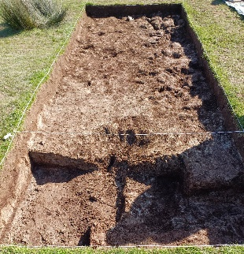
After levelling out the trench to be completely the second context of clay, a 2x1 meter section was plotted on the north end of the trench and a plan was started to only continue digging down into this part to see if any significant find could be found withing the stratigraphy. While this was to be completed a second trench was to be opened in a different location to optimise the remaining time on the dig site.
facing south, the 2x1 section.

Trench 16
The start of this trench was planned to be inline with the southern side of trench 10 south, and be on the southern side of the second mound. Using the Pythagoras theorem again to plot the trench with right angles, a 6x2 meter trench was laid out ready for de-turfing, mattocking and trowelling, the same methods used for the previous trench. These processes were completed quickly within a weeks time period and within this time a flint was found while sieving the surplus soil from a second round of light mattocking. After this find a switch to light trowelling was underway in which a second flint was found in situ and was recorded accordingly along with the first, and the correct paperwork was filled out.
Once the time frame of the dig was coming to an end all of the opened trenches were all backfilled accordingly, including trench 16 which had an added layer of landscape fabric, placed inside before the spoil heap, to prevent the majority of root length from forming with the purpose of reopening in a subsequent dig season in the future.
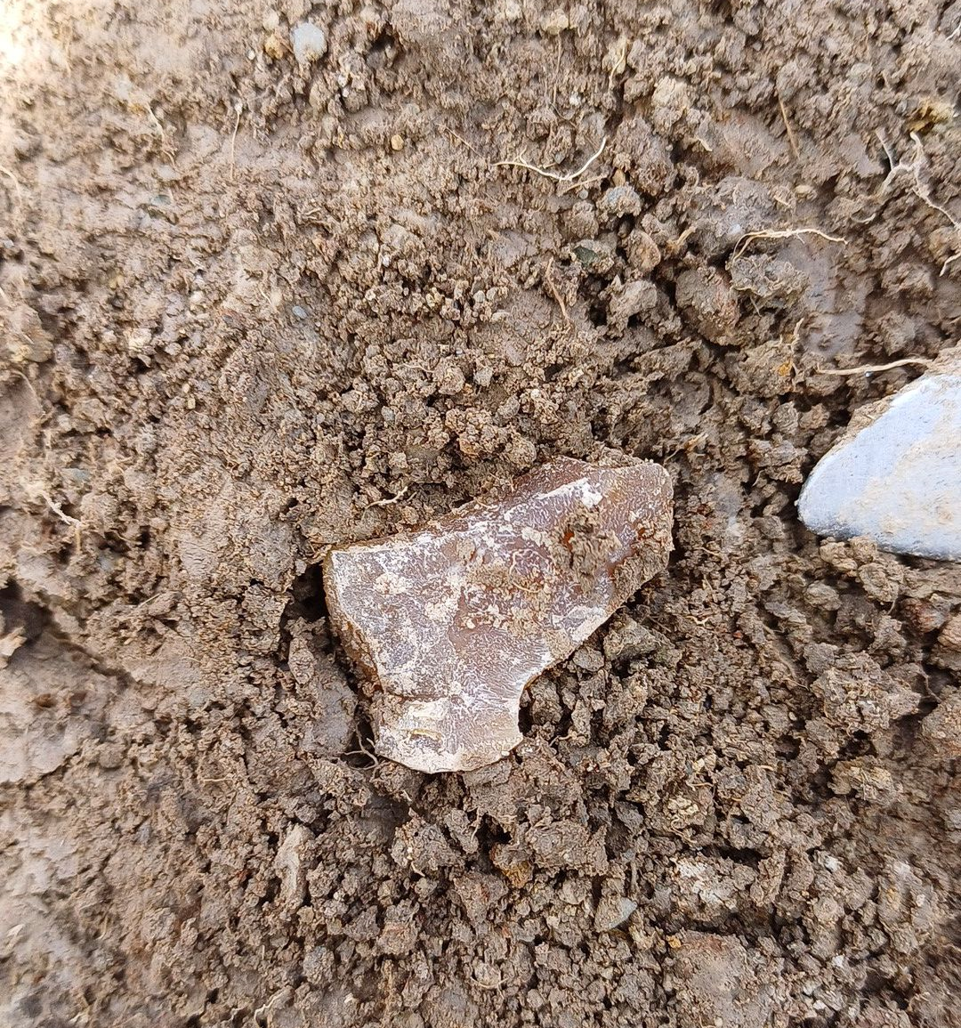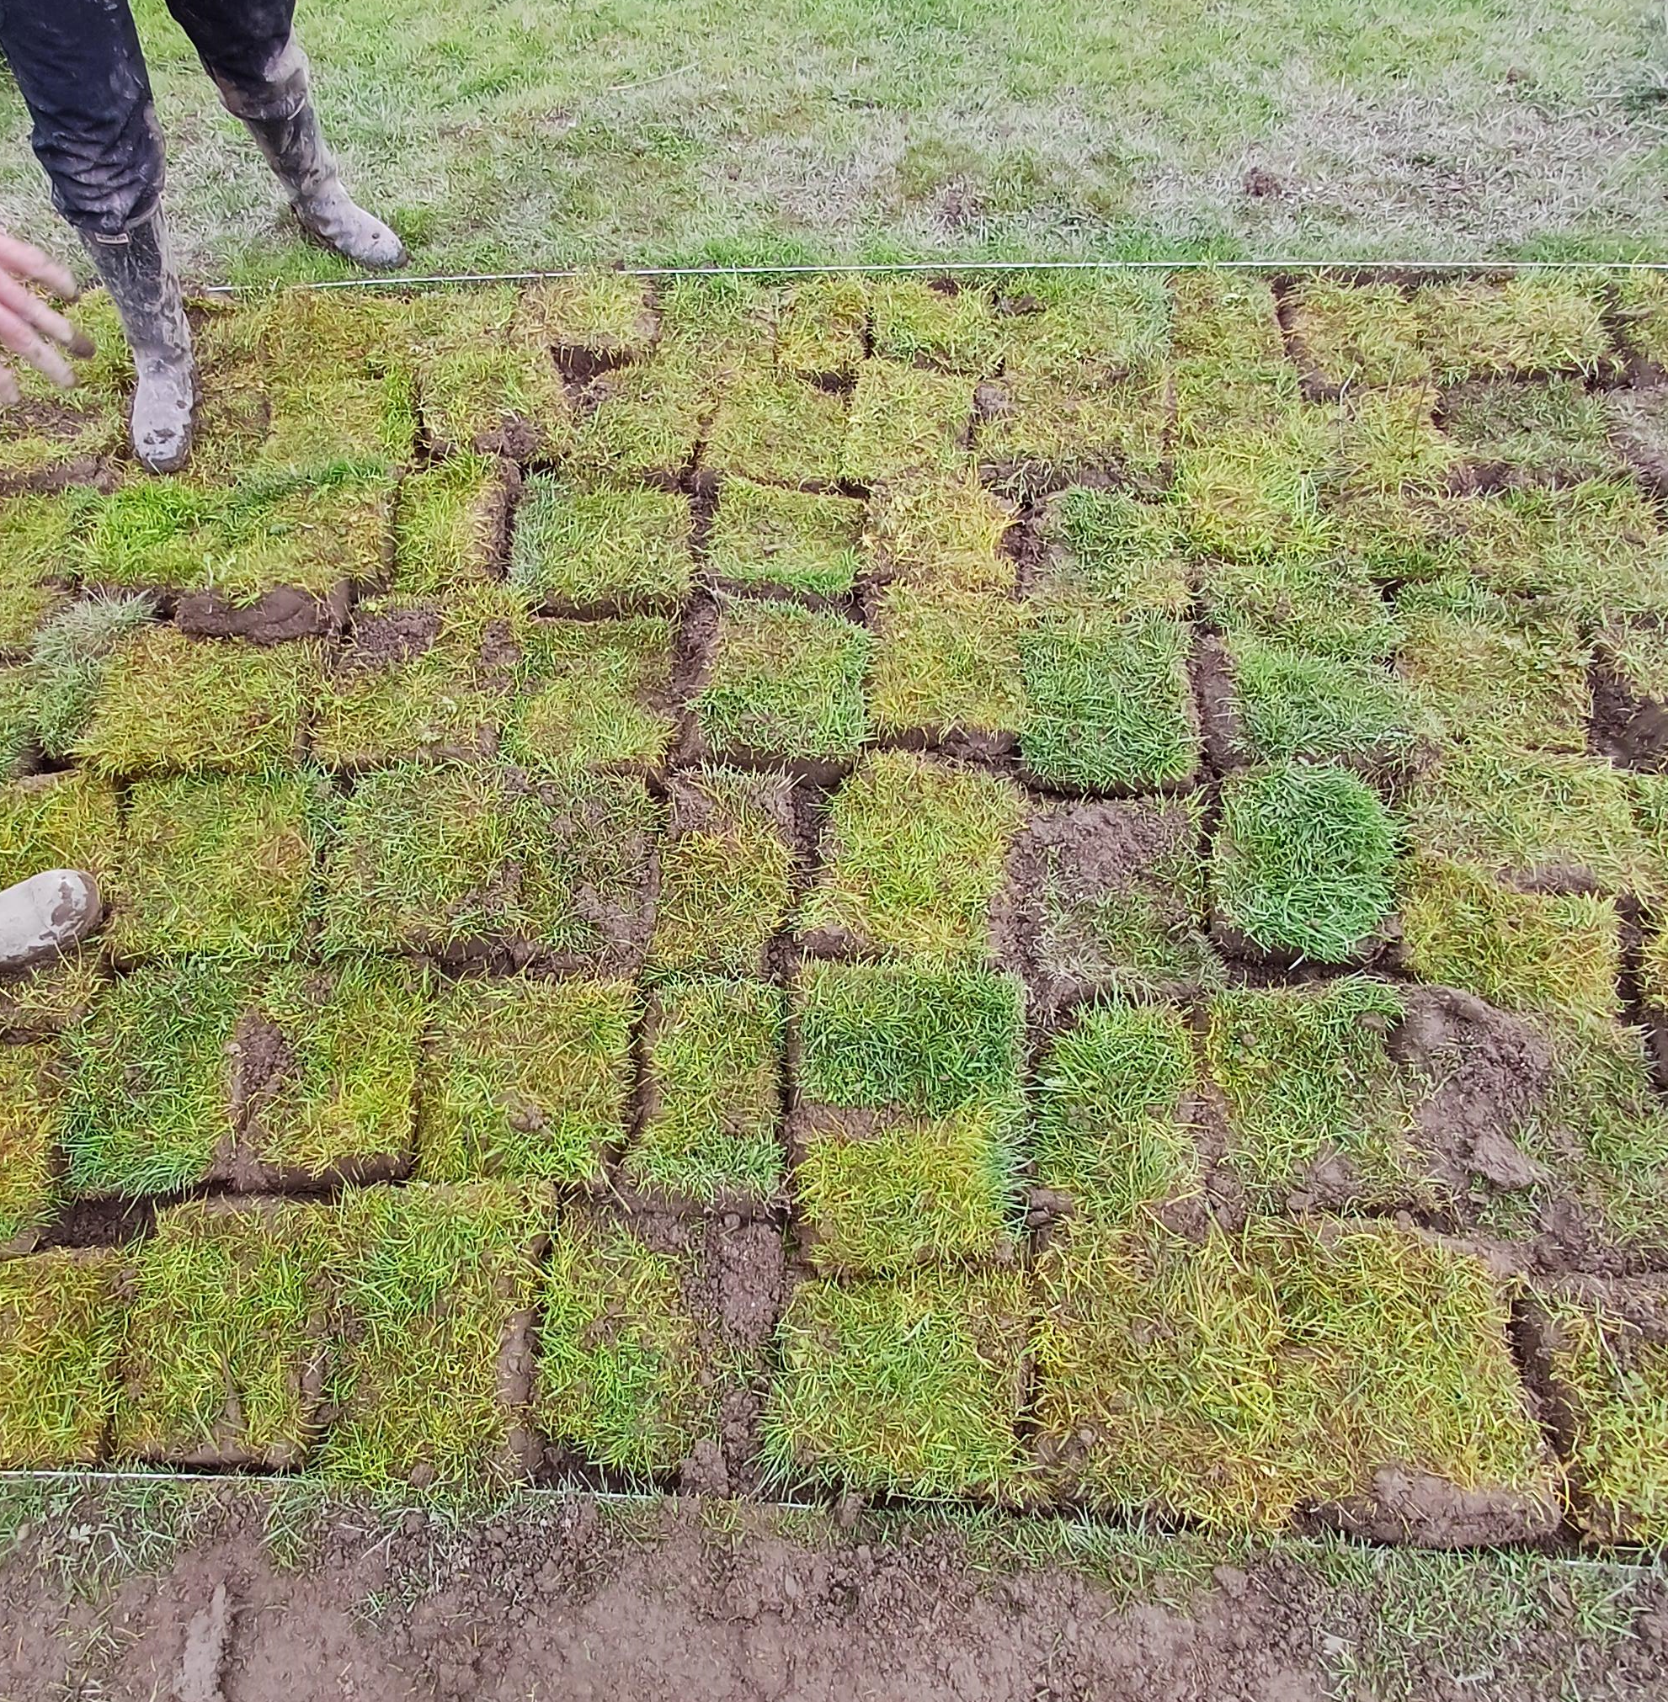
The in situ flint found on the south side of the trench. The returfed trench waiting for reopening.

