Experimental Data Analysis

ACCA4002

Helen Frey - P131560

Abstract
To resolve a dispute concerning whether a rugby ball filled with helium would travel further than a rugby ball filled with air, a series of rugby ball kicks, which were filled with either air or helium, was carried out. The results were noted and the conclusions are set out below.

Introduction
To ascertain whether a rugby ball filled with helium would travel further than a rugby ball filled with air, tests were made and analysed. The analysis includes a null and alternative hypothesis with alpha levels of 0.10, 0.01 and 0.02. T-obt will be calculated and compared against the t-crit for p=0.10, p=0.01 and p=0.02. Outliers will be looked for and any possible effect will be noted. Finally, a decision will be made as to whether the null hypothesis can be rejected and the alternative accepted.

Hypotheses

The Null Hypothesis is: that the distance travelled by the balls would be identical.

The Alternative Hypothesis is: that the distance travelled by the ball filled with helium would travel further than the ball filled with air.

The test will be directional with a one-tailed distribution [1] towards the ball filled with helium being able to travel further than the ball filled with air.

H_{0:} $μ$air = $μ$helium
H_{1:} $μ$air < $μ$helium

Data Sets
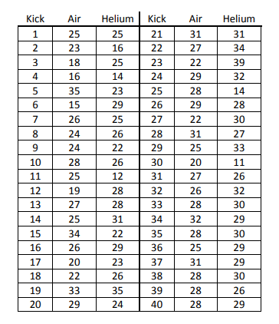
Figure 1 - Raw Data Set [2]

Figure 2 represents the above data in a scatterplot diagram where it is easy to ascertain whether there are outliers, as they can be detected easily [3].

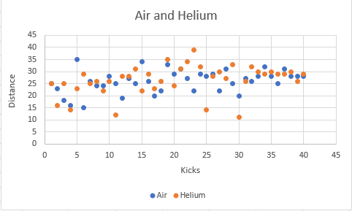
Figure 2 - Scatterplot Diagram of Distance

Outliers
A point is considered to be an outlier when the it falls “more than 1.5 times the interquartile range above the third quartile or below the first quartile”[4][5]. How this is worked out can be seen in Figure 3.

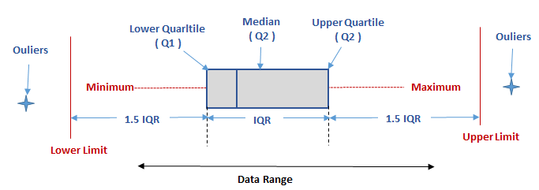
Figure 3 - How to Calculate Outliers [6]

“Outliers is often regarded as the cause of an error in measurement due to presence of extreme values which may underestimate or overestimate a study because it lies at an abnormal distance from other values in a random sample from a population.”[4]

According to “Statistics Lectures” [7], outliers can cause data to be skewed and should be removed [5]. Therefore, the data will be tested with the outliers and without the outliers to see if there is any significant difference.

Box and Whisker Plots
As can be seen in figure 2, outliers are present. To interpret these in an easier manner, a box and whisker plot will be used.

As can be seen in Figure 4, 50% of the data can be seen immediately above and below the median. Those in the top 25% are represented by the ‘whisker’ and the dots represent the outliers. The bottom half is represented in mirror fashion [5].

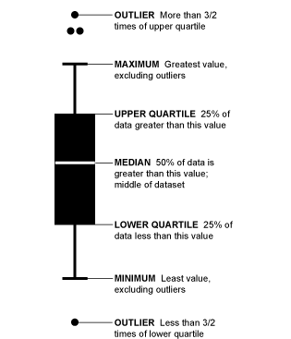

Figure 4 - Example of a Box and Whiskers Plot [8]

A box and whiskers plot has been made from the rugby ball data and can be seen in Figure 5.

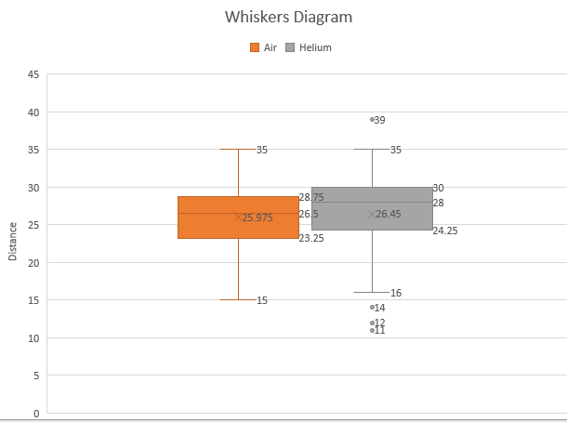
Figure 5 - Diagram of Data with Outliers

Figure 5 shows that the specific outliers for the rugby ball filled with helium are 11, 12, 14 and 39 and that the rugby ball filled with air does not have any outliers [5][9].

Hypothesis Testing with Outliers

t Testing

As the samples are not paired in any way the t Test for independent samples will be used [10].

The sample sizes are equal so the following formula will be applied:

t_{obt =}$\frac{{\overline{x}}_{1}-{\overline{x}}_{2}}{\frac{\sqrt{SD_{1}^{2}+S}D_{2}^{2}}{n}}$

t_{obt} = the value of t obtained from the data
n = the number of items in test 1 and 2
sd1, sd2 = the estimates of the variances of the two results
$\overline{x}$1, $\overline{x}$2 = the mean of the two samples
[11]

Critical Value (t_{crit)}

Tcrit is a value used for significance testing and is the point that must be exceeded to enable the null hypothesis to be statistically rejected [12][13]. It is also necessary to know the Degree of Freedom which is N1+N2-2= 40 + 40 – 2 = 38. This is cross-referenced with the level of significance (eg p=0.05) to get the value required [14].

Alpha (‘α’) is the probability of making a Type I error (rejecting the null hypothesis when the null hypothesis is true) [13]. For example, p= 0.05 means that there is less than a 5% probability that the difference occurred by chance etc [15].

Results with outliers on an Alpha of 0.10

The Excel results from the t test with α = 0.10 is shown in Figure 6.

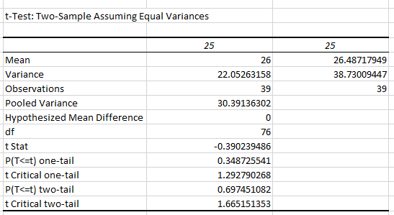
Figure 6 - Results of the t Test with an alpha of 0.10

The P value remains the same whether there is a plus or minus sign at the outcome [9].

Analysis of α = 0.10

t_{obt} = -0.39

t_{crit} = 1.29

Conclusion of α=0.10

As t_{obt} is smaller than t_{crit,} the null hypothesis cannot be rejected.

Results with outliers on an Alpha of 0.01

The Excel results from the t test with α = 0.01 is shown in Figure 7.

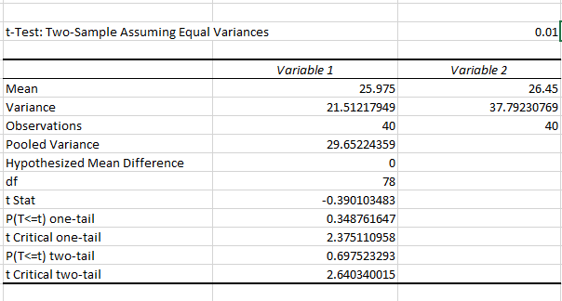
Figure 7 – Results of the t Test with an alpha of 0.01

Analysis of α = 0.01

t_{obt} = -0.39

t_{crit} = 2.38

Conclusion of α=0.10

As t_{obt} is smaller than t_{crit,} the null hypothesis cannot be rejected.

Results with outliers on an Alpha of 0.02

The Excel results from the t test with α = 0.02 is shown in Figure 8.

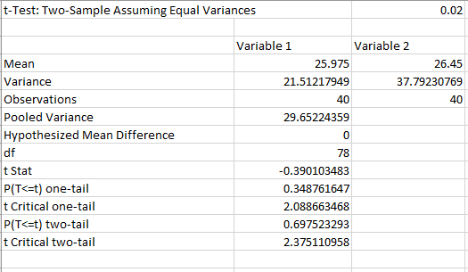
Figure 8 - Results of the t Test with an alpha of 0.02

Analysis of α = 0.02

t_{obt} = -0.39

t_{crit} = 2.08

Conclusion of α=0.10

As t_{obt} is smaller than t_{crit,} the null hypothesis cannot be rejected.

Hypothesis Testing without Outliers

Results without outliers on an Alpha of 0.10

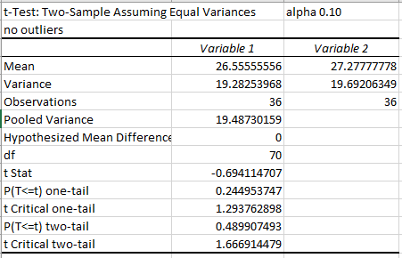
Figure 9 - Results of the t Test with an alpha of 0.10

Analysis of α = 0.10

t_{obt} = -0.69

t_{crit} = 1.29

Conclusion of α = 0.10

As t_{obt} is smaller than t_{crit,} the null hypothesis cannot be rejected.

Results without outliers on an Alpha of 0.01

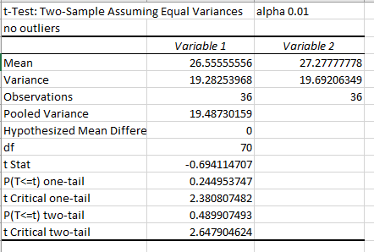
Figure 10 - Results of the t Test with an alpha of 0.01

Analysis of α = 0.01

t_{obt} = -0.69

t_{crit} = 2.38

Conclusion of α = 0.01

As t_{obt} is smaller than t_{crit,} the null hypothesis cannot be rejected.

Results without outliers on an Alpha of 0.02

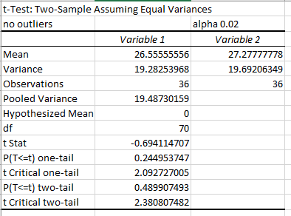
Figure 11 - Results of the t Test with an alpha of 0.02

Analysis of α = 0.02

t_{obt} = -0.69

t_{crit} = 2.09

Conclusion of α = 0.02

As t_{obt} is smaller than t_{crit,} the null hypothesis cannot be rejected.

With or Without Outliers

It appears that although the figures do change and become closer, the outcome does not change significantly with or without outliers.

Conclusion

As the null hypothesis cannot be rejected it must be accepted. Therefore, from the recorded data – a rugby ball filled with helium travels the same distance as a rugby ball filled with air.

References
[1] “FAQ: What are the differences between one-tailed and two-tailed tests? - IDRE Stats.” [Online]. Available: https://stats.idre.ucla.edu/other/mult-pkg/faq/general/faq-what-are-the-differences-between-one-tailed-and-two-tailed-tests/. [Accessed: 01-May-2018].
[2] “Course: L4 - Data Analysis &amp; Visualisation (ACCA4002).” [Online]. Available: https://moodle.uwtsd.ac.uk/course/view.php?id=2040. [Accessed: 28-Feb-2018].
[3] “Outliers in scatter plots (article) | Khan Academy.” [Online]. Available: https://www.khanacademy.org/math/cc-eighth-grade-math/cc-8th-data/cc-8th-interpreting-scatter-plots/a/outliers-in-scatter-plots. [Accessed: 01-May-2018].
[4] “Box Plot Diagram to Identify Outliers.” [Online]. Available: http://www.whatissixsigma.net/box-plot-diagram-to-identify-outliers/. [Accessed: 02-Mar-2018].
[5] “7.1.6. What are outliers in the data?” [Online]. Available: https://www.itl.nist.gov/div898/handbook/prc/section1/prc16.htm. [Accessed: 01-May-2018].
[6] “BBC - GCSE Bitesize: Box and whisker plots.” [Online]. Available: http://www.bbc.co.uk/schools/gcsebitesize/maths/statistics/representingdata3hirev6.shtml. [Accessed: 02-Mar-2018].
[7] “The Effects of Outliers.” [Online]. Available: http://www.statisticslectures.com/topics/outliereffects/. [Accessed: 07-Mar-2018].
[8] “How to Read and Use a Box-and-Whisker Plot | FlowingData.” [Online]. Available: https://flowingdata.com/2008/02/15/how-to-read-and-use-a-box-and-whisker-plot/. [Accessed: 02-Mar-2018].
[9] “Understanding and interpreting box plots | Wellbeing@School.” [Online]. Available: https://www.wellbeingatschool.org.nz/information-sheet/understanding-and-interpreting-box-plots. [Accessed: 01-May-2018].
[10] “Social Research Methods - Knowledge Base - The T-Test.” [Online]. Available: https://socialresearchmethods.net/kb/stat_t.php. [Accessed: 01-May-2018].
[11] K. Yeager, “LibGuides: SPSS Tutorials: Independent Samples t Test.”
[12] “Critical Value.” [Online]. Available: http://davidmlane.com/hyperstat/A134826.html. [Accessed: 02-Mar-2018].
[13] “Stats: What is an alpha level?” [Online]. Available: http://www.pmean.com/definitions/alpha.htm. [Accessed: 01-May-2018].
[14] “Degrees of Freedom: What are they?” [Online]. Available: http://www.statisticshowto.com/degrees-of-freedom/. [Accessed: 01-May-2018].
[15] “Critical Values: Find a Critical Value in Any Tail - Statistics How To.” [Online]. Available: http://www.statisticshowto.com/probability-and-statistics/find-critical-values/. [Accessed: 25-Mar-2018].

