Problem solving and decision making

Addressing low customer satisfaction

Lucy Hiatt - 2020343
BMSW-4004
University Wales Trinity St David

Contents

Introduction 3
Initial analysis 4
Scope and impact 5
Analysis of the problem 5
Swot analysis 6
Fishbone diagram 7
Proposed alternative solutions 8
PMI Analysis 9
Grid analysis 12
Evaluation 12
Implementation and monitoring 13
Conclusion 13
References 14

Introduction
Companies and growing businesses regardless of size face an array of different challenges and problems. Problems can be short term or long-term barriers or situations that can potentially threaten to hinder or derail a business’s pursuit of growth and success. Success or mere survival depends on businesses being agile, and their managers making the best decisions in a timely manner to respond to market driven forces i.e., rapidly identifying and addressing problems and taking advantage of the opportunities. (Delen, Ram, 2018). Once a problem is identified in a business it is highly important to establish how to prioritize potential solutions to implement a course of action, this is the responsibility of the decision maker within the company. The decision maker determines which factors should be taken into consideration to find and achieve a resolution for the problem they are facing. In this paper I will be explaining how a problem at my old previous place of work ‘Purley chase golf club’ was experiencing low customer satisfaction. This paper suggests how the problem could potentially be resolved within the company by exploring different methods that analyse the problem in depth which would provide the workplace a clearer insight of the problem, the causes, and a clear strong approach in composing positive decisions for solutions.

Initial analysis

Purley chase golf club Restaurant staff and managers received a high number of complaints of poor service and low customer satisfaction regarding the staff’s service and the quality of food in the restaurant. The club had a huge decline in custom and private bookings for hiring the venue and occurred frequent cancellations. Staff morale was low due to lack of associates which was causing longer workdays for the staff, less holidays, and greater responsibilities for the staff covering the club. There was regular staff resignation due to overwhelming working conditions and constraining work hours, which increased the pressure on associates. Maslach C, Leiter M P (2016) defines that ‘Burnout is psychological syndrome emerging as a prolonged response to chronic interpersonal stressors on the job. The three key dimensions of this response are an overwhelming exhaustion, feelings of cynicism and detachment from the job, and a sense of ineffectiveness and lack of accomplishment. This is a strategic problem within the company that will not improve instantly but there are many solutions that can be implemented and put in place to develop a synthesis to improve the functionality of the restaurant.

Scope and impact
Purley chase golf club is struggling with staff numbers and faces the problem of declining staff resignation and poor customer service within the restaurant. With the restaurant becoming understaffed it is having a detrimental effect on the service and custom as complaints have been made that the staff are lacking inadequate table service, that they are not up to speed with orders, that food is cold, and they are overall not enjoying their dining experience. Strategic problems are arising, and the restaurant cannot function and run to its best capability. This has led to a drop in customers and a decline in profit margins. The management of staff is a cause for concern, efficient team management and leadership in the long run will help to establish a sounder organization. This would establish effective authority, responsibilities, and work relationships. (Johnson, D) states that ‘Organisations are effective when they achieve qualitative goals and targets that are customer centric, such as satisfaction.’

Analysis of the problem
SWOT analysis or SWOT matrix is a strategic tool which can help with planning and management in organizations. In accordance with the system approach, organizations are wholes that are in interaction with their environments and consist of various sub-systems. In this sense, an organization exists in two environments, one being itself and then other being outside. It is a necessity to analyse these environments for strategic management practises. (Gürel, Emet. 2017). The SWOT analysis below has been devised to effectively weigh up the businesses strengths and weaknesses which are the internal factors, and the external factors being the companies’ opportunities and threats. Categorizing these four primary elements into identified internal and external factors can help Purley chase golf club determine what steps are needed to improve and move forward and create links between the positive and negative sides of the situation the company is going through and help evaluate the degree of control over an opportunity or a given problem. Purley chase golf club can implement change to improve as a team and workplace to help build on what the firm does well and take advantage of opportunities and chances to gain success.

Swot analysis
Strengths  Great local market knowledge/ locally sourced menu items  Gluten free option  World class chef  Great atmosphere  Price of food and beverages is reasonable and affordable | Weaknesses  Location (rural)  Lack of staff  Unmotivated staff/ inexperienced staff  Lack of staff training  Poorly managed/ out-dated social media  Dated menu and venue  Outdated kitchen  No entertainment  Poor employee recruitment  Low customer satisfaction can affect reputation
Opportunities  Up to date social media management  Revamped venue and kitchen  New staff employment  Creating more functions  New menu  Business loans | Threats  Other local restaurants  Covid – 19 lockdowns and restrictions  Rising cost of ingredients  Loss of customers

Fishbone diagram
A cause-and-effect diagram has been devised below which enables further breakdown from the above SWOT analysis. This is called a Fishbone diagram also known as an Ishikawa diagram, devised by Professor Kaoru Ishikawa in the 1960’s. The value of this diagram is to go beyond the initial incident report, by digging deeper in which the team can identify the issues in major categories known as ‘Brainstorming’. (Pfeiffer 1998) States that ‘One of the reasons brainstorming works is that ideas generate further ideas through the power of association.’ It helps the organization better understand what in the businesses system and processes are causing a potential problem.
‘Causes in fishbone diagram are usually grouped into main categories to identify the overall sources of variation that lead to a main effect of a specific phenomenon’ (Coccia, Mario. 2020) Countermeasures can reduce the effects of vulnerability and threats to the organization once the root cause is identified. A visual is provided to determine why an effect or problem is happening. By establishing a sound basis for action after further gathering of data. The fishbone diagram below clarifies the relations between effect and causes of low customer satisfaction and the potential causes of a problem so that they can be addressed.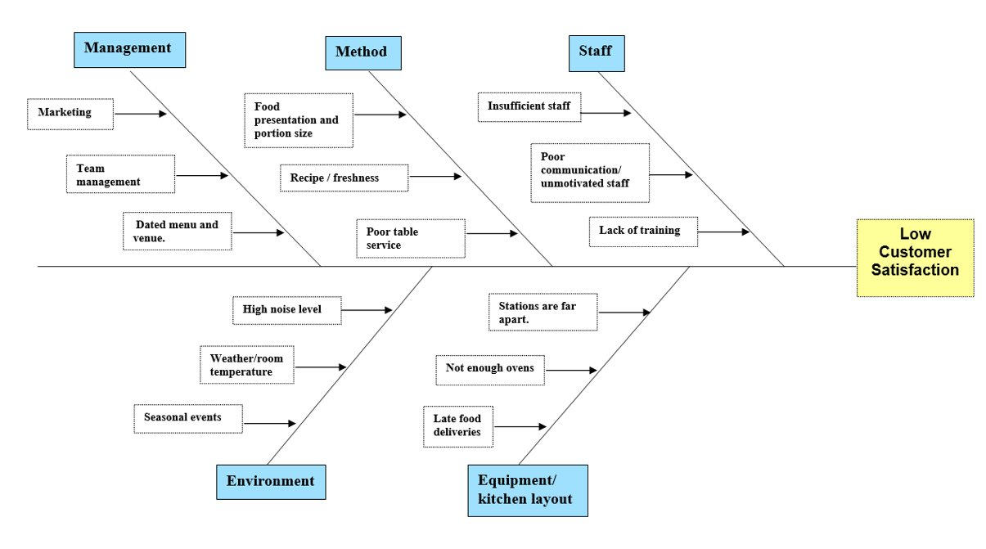From the case study the fishbone diagram displays elements that contribute to the low level of customer service within the restaurant. It is evident that there are numerous possible causes that are contributing, the diagram helps to give a better visual for the team to investigate those issues to structure the data for decision making by reviewing it. It is evident that management and unmotivated staff are a cause for concern. Therefore, below I have devised several PMI analyses which can investigate further.

Proposed alternative solutions
Preventative measures the restaurant staff could take to avoid and alleviate staff burn- out and low customer satisfaction is a change in structure of client and staff interaction. The proposed alternative solutions for the company would be to
- Incorporate staff training
- Consider a Loan investment to redecorate and modernise the venue and kitchen
- Update organisations social media and menu

PMI Analysis
PMI is used below to determine the pros and cons for Purley chase golf club. ‘PMI (plus, minus, interesting) is a brainstorming, decision making decision tool used to encourage the examination of ideas, concepts, and experiences from more than one perspective. It was developed by Dr Edward de Bono, a proponent of lateral and critical thinking.’ (Virtual library, 2021)

The PMI chart below focuses on staff training for the company. This could help to drive down costs and help increase custom to the restaurant by motivating staff, managing their performance and increase staff’s productivity.

Plus | Minus | Interesting
- Address staff  declining performance (5)  - Positively affect staff morale and team motivation (5)  - Help business adapt to change and prepare for growth (4)  - Reduced supervision (3)  - Better environment (3)  - Improve customer valuation (5)  - A more transparent company structure (4)  Total 39 | - Increased stress (-5)  - Work time is lost (-3)  - Employees may leave (-5)  -13 | - Opportunity to have more frequent staff training (4)  - Opportunity to carry out staff surveys (3)  - Recruitment opportunities (5)  12

PMI chart – staff training

Plus | Minus | Interesting
- Employ more staff (4)  - Invest in advertising (3)  - Restaurant would have more stability with cash flow boost (5)  - Invest in new kitchen equipment/uniform/ furniture (4)  - Update and renovate the venue (4)  Total 19 | - Extensive paperwork/ application process (-2)  - Lack of flexibility (-4)  - Default risk (-5)  -11 | - Multiple loan options (3)  - Tax benefits (4)  7
The PMI chart below focuses on the business obtaining a business loan. Taking this into consideration gave a positive insight into future business prospects for the golf clubs restaurant.

PMI - business loan

The 3rd PMI chart devised below focuses on the restaurant updating the food menu and making the social media advertising more current.

PMI chart – updated menu and social media
Plus | Minus | Interesting
- Seasonable menu (3)  - Allows staff to engage/show-off creativity & keeps them interested (2)  - Keeps the restaurant on trend and up to date (2)  - Creates excitement (2)  - Keeps up with customer preference i.e., gluten free options/ healthier (3)  Total 12 | - Printing costs (-2)  - More training time (-4)  -6 | - Lower produce bill (4)  - Try out and test new things (2)  6

 | Time | Cost | Complexity | Total
Weight | 3 | 5 | 2
Staff training | 3 9 | 3 15 | 2 4 | 28
Business loan | 1 3 | 1 5 | 3 6 | 14
Update menu and social media | 2 6 | 1 5 | 3 6 | 17

Grid analysis

The grid analysis above focuses on solutions that Purley chase golf club could benefit from.
After carefully devising a grid analysis I have reflected on the scores and weightings that I have applied and the option of staff training I believe Is the best choice for the organization to plan and go ahead with. It clearly outweighs other options.

Evaluation
From the analysis conducted staff training would be the best decision for the company to make to address and resolve all the issues explored in the above fishbone diagram. Staff training can strengthen the business now that it is identified as a need, I think that this would be beneficial to the company to help drive down costs and help the business adapt to change and prepare for growth. By managing staff performance, associate’s performance and productivity will improve. Establishing how training will be delivered such as in house or through external trainers should be considered. Purley chase can explore the options of training methods that fit the organization best.

Implementation and monitoring
Now that staff training has been an identified need for the company to resolve issues and improve the business, a staff training plan could be beneficial. Staff training may be needed in multiple areas, it is important to develop a training needs analysis. ‘Key performance indicators, also known as KPI’S, help you measure and evaluate the effectiveness of solutions, functions and processes in your business.’ (Northern Ireland Business Info).

Conclusion
There were a wide range of problems at Purley chase Golf club that began to raise major concern for the business. There was a large decline in customer satisfaction, this was an internal problem as the feedback and complaints from customers were dissatisfaction with the food and staff’s service. This became clear that the problem was not an overnight fix and had to be thoroughly analysed to begin addressing the root causes. I strongly believe that by undergoing staff training it would be more beneficial and important to the business to begin improving the overall skill and relationship of the team workers. Rather than invest in business loans and update the social media aspects of the business to begin with. The company need to develop the staff’s skills, mental agility, and attitude further to ensure efficient quality of work.

References

Maslach C, Leiter M P (2016) Understanding the burnout experience: recent research and its implications for psychiatry. World psychiatry 2016. [Web] Available at: (https://www.ncbi.nlm.nih.gov/pmc/articles/PMC4911781/).
Delen, D & S. Ram Journal of business analytics. Vol 1, 2018. [Web] Available at: (https://www.tandfonline.com/doi/full/10.1080/2573234X.2018.1507324).
Johnson, D (2021). Management: The four functions. [Web] Available at: (https://www.ligsuniversity.com/en/blogpost/management-the-four-functions).
Gürel, Emet. (2017). SWOT Analysis a theoretical review. Journal of International Social Research. [Web] Available at: (https://www.researchgate.net/publication/319367788_SWOT_ANALYSIS_A_THEORETICAL_REVIEW/citation/download)
Coccia, Mario. (2020). Fishbone Diagram for Technological Analysis and Foresight. SSRN Electronic Journal. [Web]Availableat:(https://www.researchgate.net/publication/348070286_Fishbone_Diagram_for_Technological_Analysis_and_Foresight/citation/download)
Jossey-Bass, Pfeiffer (1998) The Pfeiffer Library Volume 26, 2nd Edition. 1998 [Web] Available at: (http://home.snu.edu/~jsmith/library/body/v26toc.pdf)
Cathy Costello. M Ed (2021) Virtual Library. PMI Plus, Minus, Interesting. [Web] Available at: (https://www.virtuallibrary.info/pmi-plus-minus-interesting-strategy.html)
Northern Ireland Business Info (2021) Measure performance and set targets [web] Available at: (https://www.nibusinessinfo.co.uk/content/use-kpis-assess-business-performance)

