

LOCATION: Swansea | LLEOLIAD: abertawe
LEVEL 7 | LEFEL 7
EXAMINATION PERIOD | CYFNOD ARHOLIADAU
may 2021 | mai 2021

MODULE CODE: ACCA7029
COD Y MODWL: ACCA7029
ENTERPRISE CORE NETWORKING
TIME: 3 HOURS (including uploading all the work on Moodle)

answer ALL quESTIONs

Equipment or materials required – None
Adnoddau neu ddefnyddiau sydd eu hangen - Dim

ANSWER ALL QUESTIONS

  - In reference with ISP redundancy, explain
    - Single-homed
Answer: single-homed topology is where is a single connection to a single ISP. With this design, there is only one exit path to the ISP network. this means, if either the router at the end of the customer or the ISP fails, then the link fails. In a nutshell, single-homed is nor resilient to network fails.
    - Dual-homed
Answer: on the other hand, with Dual-homed topology, we use single router on both ends with redundant links. There are several ways to build a fault tolerant topology with the design. For example, we can add one router on the customer and link to the ISP or vice versa. But, still if the router fails there will not be connectivity to the other end. Hence, it is not fault-tolerance network.
    - Multihomed
Answer: in this topology, the customer router is connected to at least two different ISP to eliminate single point of failure. There are various types of Multihomed, containing single link with two or more IP addresses and multiple links with multiple IP addresses. This type of topology is robust to network failure. (12 marks)

  - Refer to Figure 1, identify RSTP port roles and explain them. (13 marks)
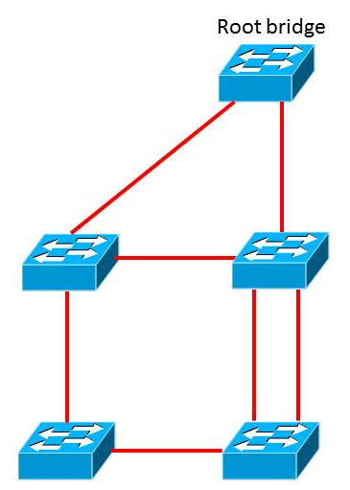

Figure 1

Answer: figure 2 a screenshot taken from a packet tracer to represent figure1. S1 is the root bridge, and therefore both ports are operating in forwarding mode or as Designated ports (DP). The port roles are explained as follows:
- Designated ports (DP)- are the ports in forwarding state and are only seen in stable active topologies. They receive frames on the segments that are destined for the root bridge.
- Root Ports (RP): they are switch ports on every nonroot bridge that is chosen path to the root bridge and is part of the active topology. It forwards, sends, and receives BPDU messages.
- Alternate Port: is represented with A in the figure below and offers an alternate path toward the root bridge. It assumes a discarding state in an active topology. It becomes active when the designated path fails.
- Disabled: has no role within the operation of spanning tree.
- Backup: is an additional switch port on the designated switch with a redundant link to the shared segment for which the switch is designated. It has a discarding state in active topology.

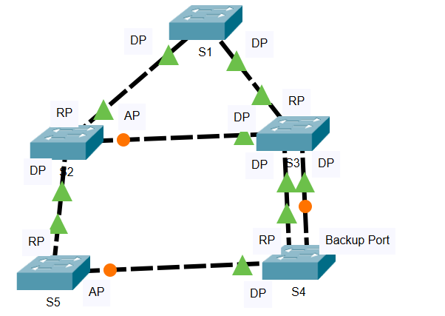
Figure 2: RSTP ports

  - Explain the functionality of a Routed port and how it can be enabled on a Switch? (6 marks)
Answer: routed port enables to route packet just like layer 3 devices. It can be converted from a layer 2 switch port to a routed switch port with the interface configuration command no switchport. Then it can be assigned with IP to operate similar to routers and layer 3 switches.
  - Briefly explain OSPF packet types. (5 marks)
Answer: there are five types of OSPF packets. The list below explains OSPF packets:
- Type 1: hello packet: Hello packets are used to discover, build, and maintain OSPF neighbor adjacencies. To establish adjacency. OSPF peers at both sides of the link must agree on some parameters contained in the hello packet to become OSPF neighbors.
- Type 2: database description (DBD) packet: when the OSPF neighbor adjacency is already established, a DBD packet is used to describe LSDB so that routers can compare whether databases are in sync.
- Type 3: link-state request (LSR) packets: when a database synchronization process is over, the router might still have a list of LSAs that are missing in its database. The router will send an LR packet to inform OSPF neighbors to send the most recent version of the missing LSAs
- Type 4: link-state update (LSU) packet: there are several types of LSUs
, known as LSAs. LSU packets are used for the flooding of LSAs and sending LSA responses to LSR packets. It is sent only to the directly connected neighbors who have previously requested LSAs in the form of LSR packets. In case of flooding, neighbors routers are responsible for re-encapsulation of received LSA information in new LSU packets.
- Type 5: link-state Acknowledgment (LSAck) packets: are used to make flooding of LSAs reliable. Each LSA received must be explicitly acknowledged. Multiple LSAs can be acknowledged in a single LSAck packet.
  - With reference to EIGRP, explain the following
    - Fast convergence
Answer: EIGRP uses dual update algorithm (DUAL), which run when a router detects that a particular route is unavailable. The router queries its neighbors looking for a feasible successor. That is defined as a neighbor with a least cost route to a particular destination that does not cause any routing loops. EIGRP will update its routing table with the new route and the associated metric. Route changes are advertised only to affected routers when changes occur. That utilises bandwidth more efficiently than distance vector routing protocols.
    - Partial updates
Answer: EIGRP uses the terms, partial and bounded, when referring to its updates. Unlike RIP, EIGRP does not send periodic updates and route entries do not age out. The term partial means that the update only includes information about the route changes, such as a new link or a link becoming unavailable.
    - Multi network layer support
Answer: EIGRP uses protocol-dependent modules (PDMs) to support multiple network protocols, such as IPv4, IPv6, Apple Talk, and IPX. EIGRP is written so that the PDM is responsible for the functions to handle the route selection criteria for each communication protocols. In theory, new PDMs can be written as new communication protocols are created. Current implementation of EIGRP support only IPV4 and IPV6.
    - Successor and feasible successor (14 marks)
Answer: a successor is the route with the best metric to reach a destination and is stored in the routing table. On the other hand, a feasible successor is a backup path to reach that same destination that can be used immediately if the successor route fails. Also, they are stored in the topology table.

- The University is planning on merging all its locations and bringing it under one network. You have been hired as an IT Infrastructure consultant by UWTSD. Your task is to lead and work with the IT&S team to successfully complete this migration. The key objectives of this migration are design and implement:
    - Secure scalable network
    - Network management
    - High Availability
    - Support Digital Transformation

Your answer should include not only the technical aspects (LAN/WAN design, topology, architecture, choice of devices, redundancy, technologies, implementation, etc) addressing the key objectives but also the entire scope of the project. This should include planning, designing, project management, risk assessments, etc (50 marks)

Answer:
1.First information about the current network and services should be collected and analysed. It is also a good idea to compare the functionality of the existing network with the defined goals of the new project. Also, all existing devices, equipment’s, infrastructure, and protocols should be assessed if we can reuse them again, and what new protocols, or equipment’s are needed to complete the design and achieve the UWTSD key objectives.
2. At this stage as a network consultant we can start design the network topology. To design the topology a top-down approach will be used. By doing this the network applications and service requirements are identified. When the network design is complete, the prototype needs to be tested before the start of implementation. This approach will ensure that the new design functions as expected before it is implemented.
Risk assessment
3. Also, the scope of the project should be clearly identified at this stage to avoid any mistakes during the implementation. Also, we should identify the issues that affect the entire network and that affect only specific portions. For example, which department will severely be affected etc. this will help to reduce cost and time required to migrate. We need to identify those issues that impact the entire network as follows:
- Integrating new security measures can affect the entire network.
- Improving the efficiency of network addressing or routing protocol changes.
- Adding any new network services, such as voice traffic.
- Moving servers to a new place could also affect the entire network.

Design and implementation
To meet the four key objectives of the project, a network must be built on an architecture that allows for both flexibility and growth. Therefore, the network design will be on a hierarchical network design. As such, the network design will consist core, distribution, and access layer. This will benefit UWTSD in many ways including scalability and flexibility. Using this design also is easy manageable and local traffics remain local.
As a designer, the core layer will be designed with fault tolerance, this is because all students and customers can be affected by a failure of the core layer. This will provide UWTSD with high availability. At the core layer will use two layer 3 swithces with high CPU speed, hardware resources, and memory. The core layer will also include one or more links to the devises at the edge of UWTSD to provide internet, VPN and WAN access. The core layer will be designed to optimise throughput, facilitate network growth and 100% availability. They will also support redundancy and load balancing, high-speed aggregate links. Besides, the routing protocols will be selected those they can scale well and converge fast, and therefore OSPF will used as routing protocol at the core layer because it can provide fast convergence and is not vendor dependent. All routes will be summarised at the core layers to enhance convergence time.
To provide redundancy, partial-mesh will be used to save cost for buying extra cables.
Also, to avoid any network down time, Dual power supplies and fans will be implemented at the core layer. The devices at the core layer will be hot-swappable to reduce repair time and disruption of network services.
At the distribution layer all the device will be connected to more one device to provide redundancy (HSRP) and load balancing. All internal routers will be advertised as summarised. All traffics which are sensitive to delay such as voice and video will be prioritised before transmission through the uwtsd core layer. Trunk links will also be configured at this layer to allow multiple VLANs from the access layer. Besides, network traffic filtering methods such as ACL will be used at this layer. Both standard and extended will be used. The distribution layer will use EIGRP to allow multi-vendor in the design.

At the access layer, redundant components and failover strategies will be implemented to improve reliability and increase availability for the end devices. Also, at this layer, all naming structure, VLAN architecture, traffic patterns and prioritization strategies will be applied. To simplify network management, the network will be not be designed too complex. It will be designed allow easy troubleshooting when a problem occurs. Also easy to add new features and expansion.
Further, the network needs to be secure, predictable, and measurable. To avoid congestion, the network will include QoS mechanism using classification and prioritization process.
Security
Security weaknesses can occur at the access layer. Therefore, antivirus, anti-worms and anti-malware will be installed on all devices, especially to devices which contain sensitive information of UWTSD. all access layer devieces will be secured using strong passwords, using SSH, disabling unused ports. All public accessbible servers will be separated from the internal network on the DMZ. Intrusion detection will used to detect internal attacks. Also both the LAN and the servers (data storage areas) will be secured using firewalls at the edge. Wireless network will also use strong security measures. Guest will use the internet without any security but they will register via a browser. The UWTSD staffs will be on different vlan than the guest with strong encryption protocol. SSID will not be public

The migration process will start with services and application testing.

Diwedd/End

