Assignment 1

Kalan Hughes
1902299

Higher National Diploma: Computing (Web Development)
Internet Technology and Security
8 January 2020

Table of Contents

- Title Page – 1

- Table of Contents – 2

- Introduction – 3

- Requirements – 3

- Implementation – 4-8
5.1 Screenshots – 4-7
5.2 Validation – 8

- Evaluation – 9-11
  - Website Quality – 9-10
  - Website Evaluation – 10-11

- References – 12

Introduction
The following report will contain a variety of different information. First, the report will talk about the requirements for the website. The requirements section will contain an introduction to the website. It will talk about the purpose and the subject matter of the website. It will also talk about the target audience and the websites relevance.
The next section is the implementation. In this section, there will be screenshots of every page on the website. This section will also include the validation of the websites HTML and CSS. There will be a brief description of any errors that were encountered and how they were solved.
The third section is the evaluation. This section will include information about the website’s usability, accessibility, and search engine optimisation. It will also talk about their roles in web development. This section will also include an evaluation of the website. The evaluation will be based on three sections. These are Usefulness (usability and utility), Search Engine Optimisation (SEO), and Accessibility.
Finally, the last section is references. This is a list of any sources that have been consulted.

Requirements
The website that was created is about video games. It has many different pages which all talk about different things to do with video games. There are seven pages in the website. The home page gives a description of the information that can be found on the website. The history page talks about the history of the first video game and console. The genre page talks about the different video game genres. The games page talks about my two favourite games. The best-selling page talks about the two best-selling video games of all time. The contact page gives information about how to contact us. Finally, the references page gives links to all of the sources where information was consulted from.
The purpose of the website was to help expand people’s knowledge about video games. If they wanted to expand their knowledge on video game genres, they can use the website to do that.
The target audience for this website is teenagers. This is because the subject matter is video games which is something a lot of teenagers like. Because the target audience is teenagers, the website had to be laid out in a way that was appealing to teenagers. This meant that the website should not include a lot of writing as teenagers are not going to want to do a lot of reading. The website also includes images which teenagers are attracted to. This website is relevant as it has considered the target audience and the content it should include in order to attract the target audience.
Implementation
Below are some screenshots of all of the pages in the website.
Screenshots:
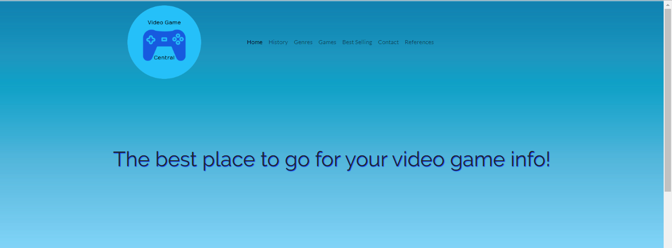
Header:

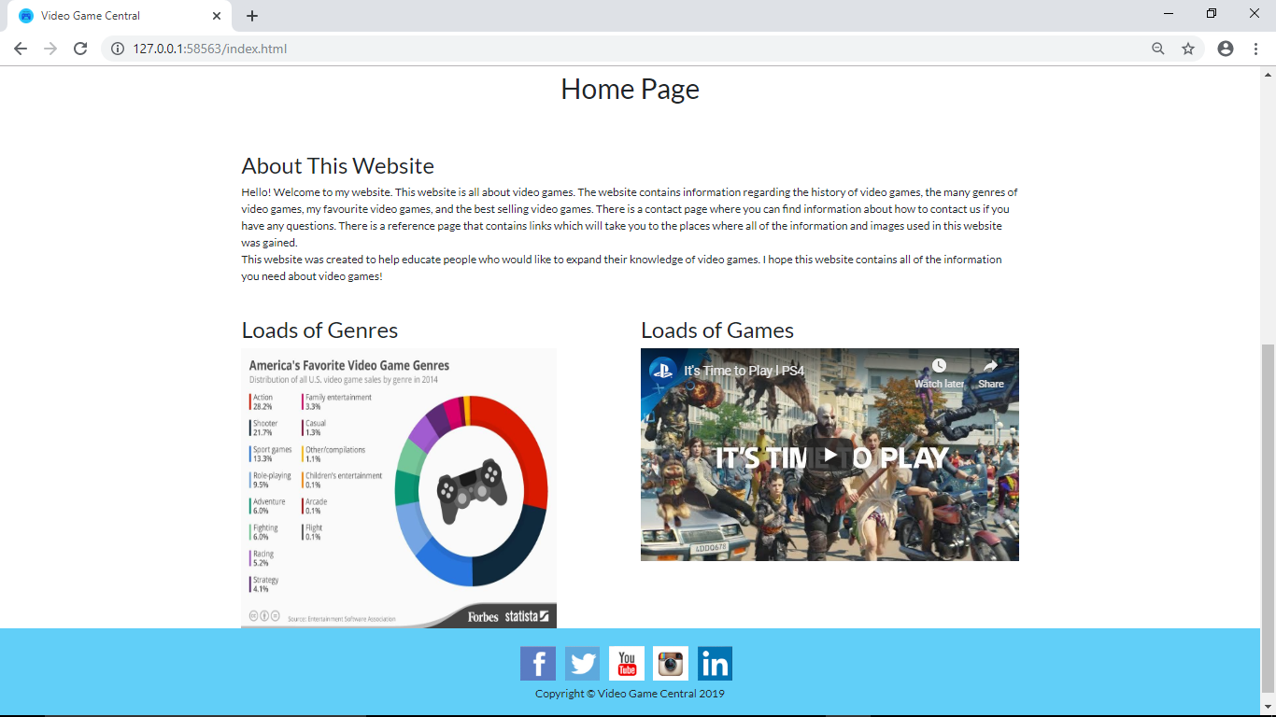
Home Page:

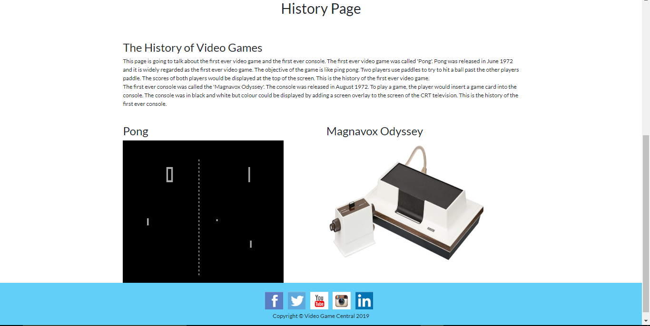
History Page:

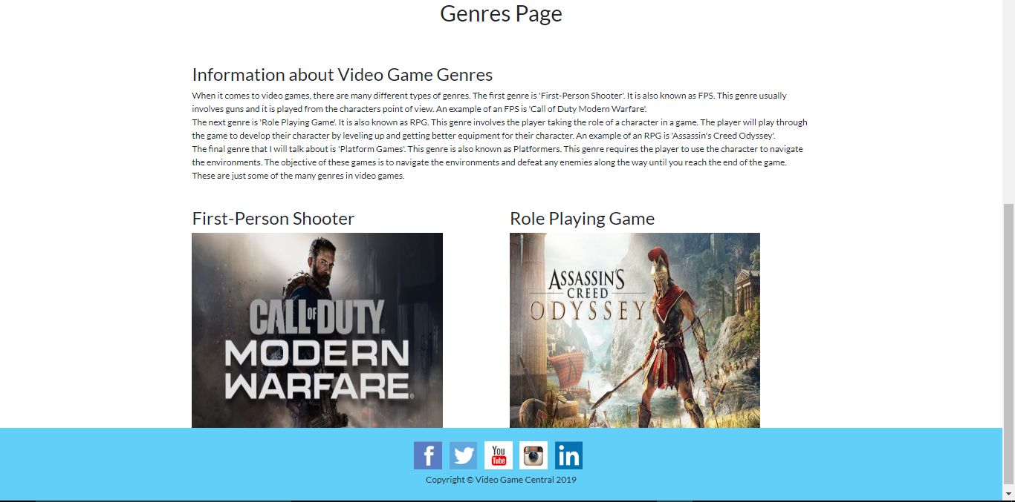
Genres Page:

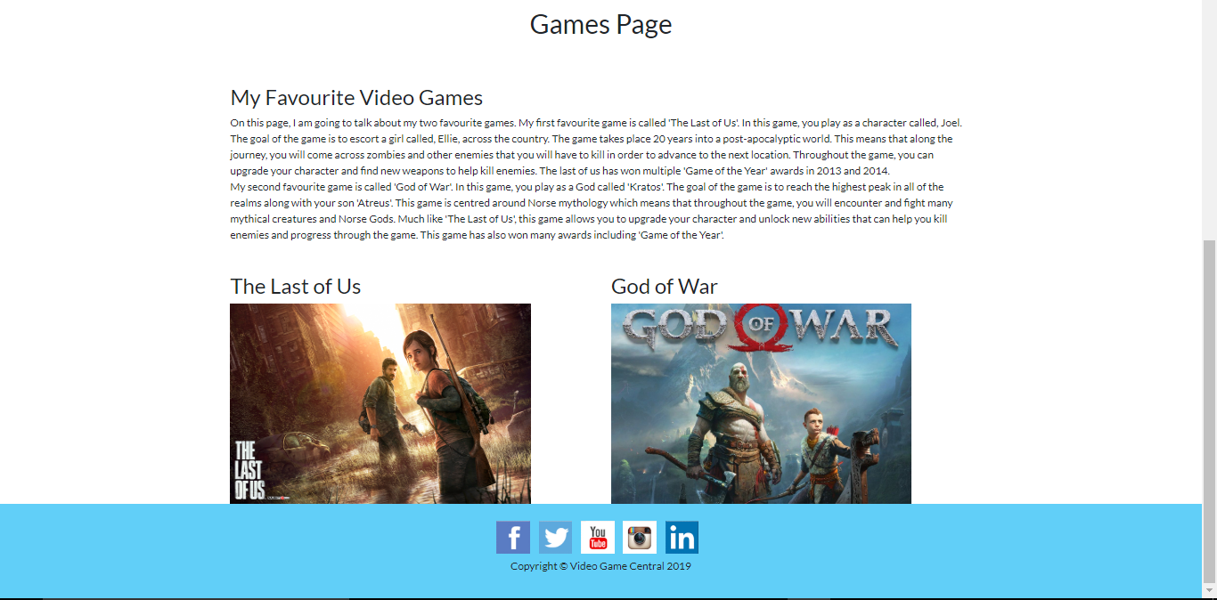
Games Page:

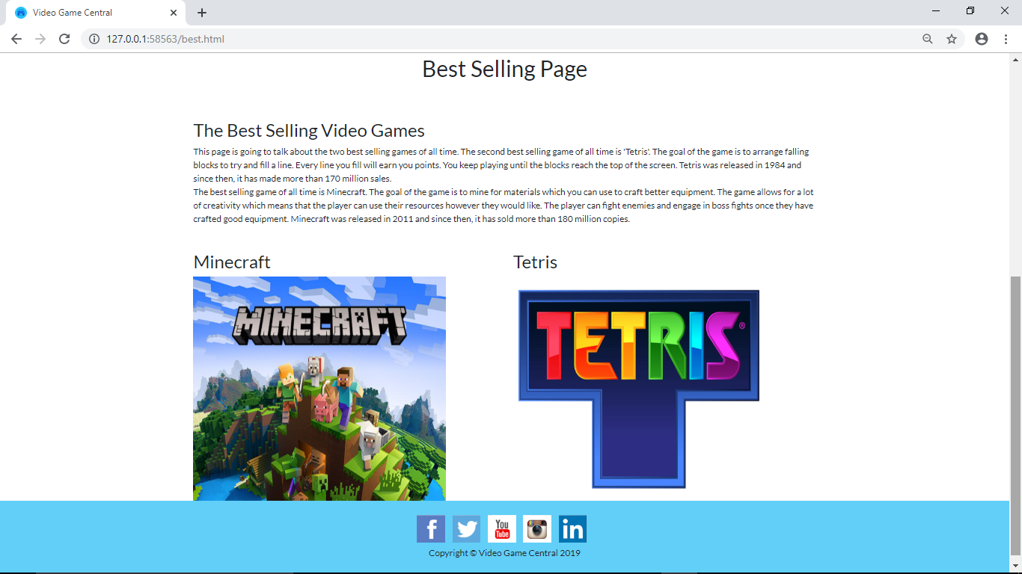
Best Selling Page:

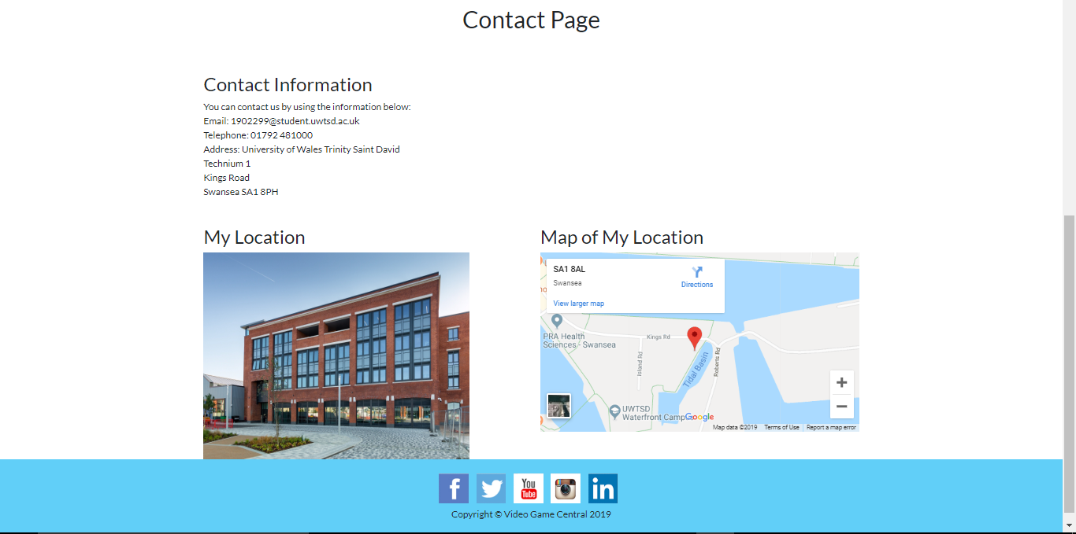
Contact Page:

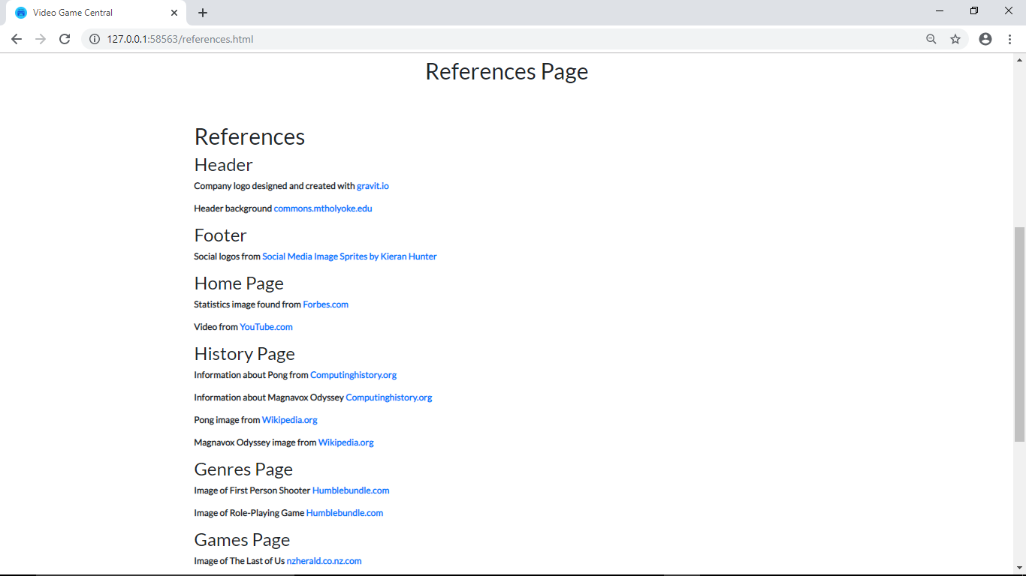
References Page:

Validation:
After the website was completed, it was validated. The CSS and the HTML were both validated.
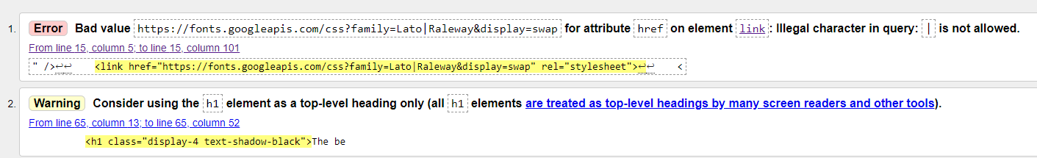
Home Page HTML Validation:
These are the results of the HTML validation. There was one error and one warning. I did not have to worry about the warning as it did not affect the website and it was not as serious as the error.
The error was unable to be fixed. This is because the line of code was supplied by Google Fonts which meant that the line was correct. It also meant that the line could not be changed, or it would change the fonts on the website.

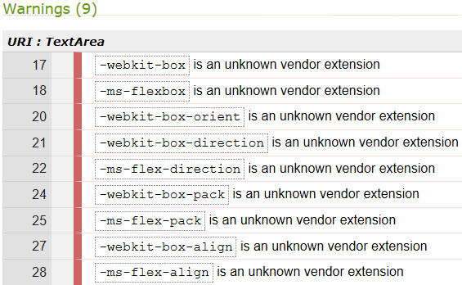
Stylesheet CSS Validation:
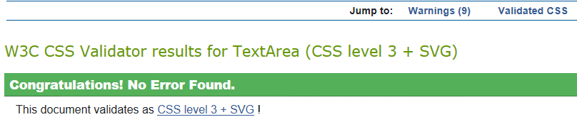

These are the results of the CSS validation. There were no errors which meant that I did not have to correct anything in the website.
There were nine warnings which all had to do with unknown vendor extensions. I did not have to fix these as they did not affect the website and they were only warnings.

Evaluation
Website Quality:
In this section, three terms are going to be talked about. These terms are website usability, accessibility, and search engine optimisation. The first term that will be talked about is website usability. Website usability refers to how easy the website is to use for users [1]. This means that if you want your website to have good usability, it needs to be easy for users to use. Website usability has a big role in web development. This is because it determines whether or not your website is going to be liked by people. If you do not take into account usability when developing your website, then you may develop a website that is hard for the users to use. There are four main areas in website usability. These are clear navigation, performance, readability, and responsiveness [1]. Clear navigation is important as it determines how easy it will be for the user to navigate the website. If your website has clear navigation, then your user will not have any problems navigating the website which will result in a better user experience. Performance is also important because if the website is slow, then the users will be annoyed which could result in a bad user experience. This is why it is important to optimize your website to have a good performance [1]. Readability means that the information on your website is laid out in a way that is easy for the user to read [1]. If the information is hard to read, the users may get annoyed with the website which is bad for user experience. Finally, responsiveness is important because users are going to view your website on many different devices [1]. If users can not view your website on all devices, it will result in a bad experience. This is the role of website usability in web development. A research paper that is linked to this term is ‘WEBUSE: WEBSITE USABILITY EVALUATION TOOL’ [2]. To summarise the paper, it talks about different methods that could be used to make websites more usable. They did this by creating questionnaires called WEBUSE, that visitors of the website would complete [2]. They found that people who completed the WEBUSE questionnaires were mostly satisfied with WEBUSE [2].
The second term that will be talked about is accessibility. Accessibility means that your website needs to be accessible to people who have disabilities [3]. This means that if someone has a disability, they need to be able to easily use your website despite their disability. Accessibility has a big role in web development. This is because it determines whether or not your website is usable for people with disabilities. You need to take into account different disabilities when designing a website. You need to take into account people who are visually impaired, hearing impaired, physically impaired, and people who find words difficult [3]. One way to make your website accessible to visually impaired people is to have a screen reader implemented into your website [3]. A screen reader reads out what is being displayed on screen. This means that visually impaired people will still be able to understand what is on screen as they can hear what is on screen. One way to make your website more accessible to hearing impaired people is to have subtitles [3]. This means that if there are any videos in your website, they should have subtitles so hearing impaired people can understand what is going on. You can make your website more accessible to physically impaired people by allowing the keyboard to control the mouse. This means that people who are unable to use a mouse can use the keyboard to navigate the website. Finally, you can make your website more accessible to people who find words difficult by having a text-to-speech option. This means that the user can hear words that are written on the website so they can get a better understanding of the words. These are ways to make a website more accessible. A research paper that is linked to this term is ‘Website accessibility in Western Australian public libraries’ [4]. To summarise the paper, it talks about the accessibility of public library websites in Western Australia. They found that public libraries in Western Australia did not comply with WCAG 1.0 or 2.0 [4].
The final term that will be talked about is search engine optimisation (SEO). SEO is when you improve the rankings in the search engine algorithm results which means that more visitors will come to your website [5]. SEO has a big impact on web development as it determines how many people will view your website. This is because if you do not take into account SEO when developing your website, then your website will not be one of the top results when people search for key words related to your website. One way to improve your SEO, is to use onsite optimisation [5]. This means that you can design your website in a way that will target search phrases that are relevant to your website [5]. Another way to improve your SEO is to use user experience [5]. This is because if you design your website in a way that users like, then they are likely to return to your website. This will help your website gain popularity which can help to improve its SEO [5]. These are ways to improve your websites SEO. A research paper that is linked to this term is ‘Analysing Google rankings through search engine optimization data’ [6]. To summarise the paper, it talks about the most popular techniques that are used to help make a website rank highly in Google [6]. They found that many SEOs use older domains to help reach a higher ranking [6]. They also found that having many in-links helps to improve the SEO of a website [6].

Website Evaluation:
The website that was created is now going to be evaluated. The website will be evaluated based on its usefulness (usability and utility), search engine optimisation, and its accessibility. The first point that will be talked about is its usefulness. I think that the usability of the website is very good. This is because the website is designed in a way that is easy for the user to read and understand. This is because the layout is the same for every page. This helps as the user will become familiar with the positioning of the information and images on the website. I also think that the utility of the website is very good. This is because there is a navigation menu that the user can use to help them navigate the website. This means that the user can easily go to a certain page without any complications. This is why I think the functionality of the website is good. I think that the content of the website is good as it is relevant to the subject matter. This is because it contains information about video games. This means that if the user wants to learn more about video games, they can use the website as it has information that will help them increase their knowledge of video games. One future improvement that I think could be made is adding more links in the footer. These links could take the user to FAQ’s, guides, and more. This will help the user if they have any questions or if they want any additional information.
The second point is search engine optimisation (SEO). One SEO technique that I have applied is improving user experience. This is because the content is laid out in a way that is easy for the user to understand. There is also a navigation menu that the user can use to navigate the website. These two features are on every page and they will improve the user experience as they help to make navigation easier for the user. Another SEO technique that I have used is content optimisation. This is because I have included keywords on all of my pages in the website. This means that if the user searches for these keywords, my website will appear high on the list of websites. These are the SEO techniques that I have used in my website.
The final point is accessibility. There are four areas in the WCAG 2.1. These are perceivable, operable, understandable, and robust. The first area that I will talk about is perceivable. My website is perceivable as I have used text colours that are easy to read on the background colours. This helps the user as they can easily read the information. Another way my website is perceivable is because it is responsive. This means that the website works on all devices. This helps the user as they are able to view the website regardless of the device they are using. The final way my website is perceivable is because the content is structured appropriately.
The next area is operable. My website is operable as I have provided titles for every page. This allows the user to easily see what page of the website they are on. Another way the website is operable is because I have used appropriate headings. This allows the user to easily identify the areas which contain the content that they need.
The third area is understandable. My website is understandable as I have kept the sentences short and they are all in English. This helps the user as they will be able to easily understand the information provided. Another way my website is understandable is because all of the features are consistent as they have the same layout. This makes it easy for the user to understand the content in the website.
The final area is robust. My website is robust because if the user clicks on a link, it will open in a new tab. This means that the website is still open so once they have finished with the link, they can close the tab and go back to the website. These are all of the ways my website complies with WCAG 2.1.

References

[1] | B. Litwin, "An Introduction to Usability and User Experience in Web Design," 11 July 2018. [Online]. Available: https://www.a2hosting.com/blog/usability-and-user-experience/. [Accessed 14 December 2019].
[2] | Thiam Kian Chiew, Siti Salwa Salim, "WEBUSE: Website Usability Evaluation Tool," 1 June 2003. [Online]. Available: http://jummec.um.edu.my/index.php/MJCS/article/view/6118. [Accessed 14 December 2019].
[3] | "What is accessibility?," 2014. [Online]. Available: http://www.bbc.co.uk/accessibility/best_practice/what_is.shtml. [Accessed 14 December 2019].
[4] | V. Conway, "Website accessibility in Western Australian public libraries," 8 July 2013. [Online]. Available: https://www.tandfonline.com/doi/abs/10.1080/00049670.2011.10722582. [Accessed 14 December 2019].
[5] | "What Is SEO? A Quick Guide To Search Engine Optimisation," [Online]. Available: https://www.screamingfrog.co.uk/what-is-seo/. [Accessed 14 December 2019].
[6] | M. P. Evans, "Analysing Google rankings through search engine optimization data," 6 February 2007. [Online]. Available: https://www.emerald.com/insight/content/doi/10.1108/10662240710730470/full/html. [Accessed 14 December 2019].

