Business Model Canvas "FeastFlow Buffet & Bistro" with entrepreneurial reflection

Diana Tanase
2210013
Entrepreneurship BMIH5001
Neil Dyer
Wordcount 2233
Introduction
This essay will examine the strategic underpinnings of "FeastFlow Buffet & Bistro" using the Business Model Canvas (BMC). It seeks to examine how the establishment distinguishes itself in the competitive landscape of the hospitality industry by emphasising sustainability, customisation, and strategic operational decisions. By using current industry examples, the research will demonstrate the company's potential for success and sustainability. According to the thesis, "FeastFlow Buffet & Bistro" is well positioned to offer a compelling value proposition that combines convenience with an outstanding cultural and gastronomic experience. "FeastFlow Buffet & Bistro" emerges as a trailblazer in the hospitality business, seamlessly merging the rich heritage of traditional Romanian cuisine with the modern convenience of buffet eating. Nestled in the hectic setting of a corporate centre, this creative dining endeavour caters to a broad clientele, providing a gastronomic experience that goes beyond the typical lunch rush. It exemplifies the changing needs of modern diners, who seek not only nourishment but also an immersing cultural experience. This distinctive dining experience is intended to captivate the palates of businesspeople, event organisers, tourists, and locals alike, offering a varied dining choice that prioritises both quality and efficiency.
Main Body
"FeastFlow Buffet & Bistro" caters to four key client segments based on market trends and dining habits and behaviour. First, many businesspeople in and around the business core require quick, high-quality food. Fast-paced workdays need efficiency, therefore buffet-style cafes are open for lunch. Second, business events, seminars, and conferences necessitate dependable, customisable meals. Targeting this market necessitates the ability to tailor catering to individual dietary needs and event themes while keeping the trend of personalised event experiences. Traditional Romanian cuisine draws the third sector. Cuisine tourism provides unique dining experiences that reflect local culture and customs. "FeastFlow Buffet & Bistro" introduces Romanian cuisine to this group. The fourth sector consists of locals looking for various dining and event hosting services. This group wants restaurants to be social and cultural hubs in their communities, thus they expect excellence, diversity, and community-oriented dining. Targeting these segments, "FeastFlow Buffet & Bistro" provides a diverse and delightful meal experience through ease, personalisation, and cultural exploration.
"FeastFlow Buffet & Bistro" stands apart in the competitive hospitality industry by offering enticing value propositions that meet the needs of its diverse customer base. The daily options are fresh and varied, which is the highlight. Using industry best practices, this strategy adapts to changing customer interests and encourages repeat business. Cosmo and other successful UK buffet restaurants demonstrate the appeal of a diverse menu. "FeastFlow Buffet & Bistro" stands out by serving authentic Romanian cuisine. This practice is popular in restaurants such as Polpo in the United Kingdom, which serve Venetian cuisine to provide locals and tourists with a distinctive and culturally diverse dining experience. Businesspeople and event organisers can take use of the bistro's business centre location for quick lunches and catered corporate gatherings. This aligns with Pret A Manger's aim of locating restaurants in business districts to provide fast, excellent lunches to professionals. Catering can handle diets and events. Luxury caterers, such as "Rocket Food" in London, customise dishes for special occasions to keep consumers satisfied. Finally, buffets provide self-service and a variety of dishes, which encourages dining. Buffet-style restaurants, such as "The Real Greek," which provide variety and satisfaction, influenced this strategy. These value propositions demonstrate "FeastFlow Buffet & Bistro’s’ ’commitment to meeting evolving consumer expectations and implementing industry best practices to deliver a great dining experience.
"FeastFlow Buffet & Bistro" effortlessly integrates on-site dining, online booking, and social networking to improve client satisfaction. We offer a seamless and personalised consumer journey, from discovery to dining and post-visit feedback. On-site dining allows customers to sample the restaurant's special deals. Online booking systems make event planning easier for executives and planners. This is followed by industry leaders such as "Wagamama," which use an online booking system to cut wait times and increase consumer convenience. Social media promotes "FeastFlow Buffet & Bistro," daily menu updates, and consumer interaction. This strategy is modelled after "Nando's," which uses social media to boost brand exposure, client loyalty, and engagement. These channels enable "FeastFlow Buffet & Bistro" to meet market expectations for accessibility and convenience while engaging its diverse consumer segments through many touchpoints, matching hospitality omnichannel pioneers.
"FeastFlow Buffet & Bistro" promotes long-term client relationships through personalised consultations, loyalty programmes, and effective feedback methods. Personal consultations for catering services help event organisers and customers feel heard and respected, resulting in more personalised dining experiences. I think of "The Ivy Collection," where personalised attention enhances meals and fosters loyalty. Loyalty programmes provide visitors and companies with discounts and special offers. It's like "Starbucks," whose loyalty programme keeps customers coming back. Continuous improvement and user satisfaction necessitate online and in-person participation. "FeastFlow Buffet & Bistro" demonstrates their devotion to service by consistently soliciting and responding to consumer feedback. This is like "Wagamama," which employs real-time feedback tablets at the end of meals to assess client happiness and answer complaints, tailoring the dining experience to customer preferences. Inspired by successful organisations that utilise comparable customer relationship management approaches, "FeastFlow Buffet & Bistro" employs these practices to enhance the client experience and establish long-term connections.
To survive and thrive, "FeastFlow Buffet & Bistro" diversifies its revenue streams in the same way as hospitality industry pioneers have. Buffet sales, which include Romanian and international cuisine, are the primary revenue source. This concept is modelled after global buffet chains such as "Buffet World," which have demonstrated that providing a range of selections at a fixed price may attract customers while retaining income. Catering tailored meals for business parties, weddings, and private gatherings is a significant source of additional cash. The UK company "Caterwings" has benefited from the desire for one-of-a-kind catering solutions, demonstrating that providing tailored services outside of the restaurant can be profitable. Regular clients benefit from membership or subscription schemes, which include discounts and exclusive deals. This strategy is like food subscription companies such as "HelloFresh," which both retain customers and generate revenue. Corporate contracts with centre businesses for routine food and special events, such as "Sodexo"'s corporate alliances, boost revenue and clientele. To ensure financial stability and market expansion, "FeastFlow Buffet & Bistro" diversifies its revenue streams in accordance with hospitality standards.
"FeastFlow Buffet & Bistro" provides excellent service and efficiency because of its exceptional culinary team and strategic business centre position. The restaurant serves traditional Romanian and foreign cuisine, like Michelin-starred London restaurant "Le Gavroche" and its renowned chefs. Celebrating culinary perfection elevates each meal, drawing foodies and boosting the restaurant's reputation. The location in a bustling commercial district, like "The Shard" eateries in London, draws both businesspeople and neighbours. This convenient lunch or business meeting location capitalises on the area's population to attract consumers. In the competitive hotel sector, "FeastFlow Buffet & Bistro" combines expert chefs and a prominent location to mimic famous restaurants.
"FeastFlow Buffet & Bistro," like other successful restaurants, relies heavily on menu creation, marketing, and customer service. Menu planning ensures variety and quality, satisfying diverse tastes while preserving Romanian cuisine. This is like "Noma" in Copenhagen, which is well-known for its seasonal menu. Online marketing improves awareness and engages customers. Like "Shake Shack," "FeastFlow Buffet & Bistro" uses social media to build brand recognition and community, illustrating how effective marketing can attract and retain customers. Excellent service enhances eating experiences and fosters loyalty. "The Ritz-Carlton" hotel brand represents this philosophy through its superb service. "FeastFlow Buffet & Bistro" mimics similar success by providing personalised service, making clients feel cherished and eager to return. These critical phases help the restaurant's operating plan, allowing it to compete in the hospitality industry.
"FeastFlow Buffet & Bistro" collaborates with local food and technology suppliers to improve product quality and efficiency. Local producers provide fresh, high-quality ingredients for both traditional Romanian and foreign dishes. In the United Kingdom, "Farm-to-Table" restaurants such as "The Ethicurean" source locally to maintain food quality while also benefiting the local economy, demonstrating that local sourcing improves dining experiences. Bookings, orders, and comments are all streamlined through technology partnerships. Innovative inventions, such as "Wagamama," which sends tablet orders directly to the kitchen, increase service speed and accuracy. Modern technologies cut wait times while enhancing efficiency, order accuracy, and customer satisfaction. “FeastFlow Buffet & Bistro" improves quality and efficiency, and it joins industry experts who show how strategic collaborations can strengthen a restaurant's profitability and reputation.
"FeastFlow Buffet & Bistro" strikes a balance between quality, pricing, and service. "Chipotle Mexican Grill," known for its locally sourced products, carefully chooses local sources to reduce transportation costs while maintaining ingredient freshness and quality. Order reservation and management technology reduces labour expenses and errors. "Domino's Pizza," which switched to computerised ordering, has increased profitability and efficiency. “FeastFlow Buffet & Bistro," like "Pret A Manger," prioritises employee training to increase productivity and reduce waste. "Lean Kitchen" approaches save costs without compromising client service. Cost control is critical in the hospitality industry, as "FeastFlow Buffet & Bistro" ensures financial sustainability without sacrificing quality or service.
Conclusion
"FeastFlow Buffet & Bistro" offers a distinctive fusion of authentic Romanian gastronomy and self-service dining, specifically designed to cater to the needs of a varied customer base located in a business hub. The Business Model Canvas (BMC) framework has been used to carefully design strategic decisions, such as targeting specific consumer categories and diversifying revenue streams, to achieve sustainability, customer happiness, and market distinctiveness. "FeastFlow Buffet & Bistro" aims to provide a unique dining experience by incorporating effective industry practices, digital platforms, customised service, and locally sourced ingredients. This strategy highlights both the practicality and originality of the concept, as well as positions "FeastFlow Buffet & Bistro" to have a substantial influence in the hotel industry, showcasing the effectiveness of strategic planning and market-focused innovation.

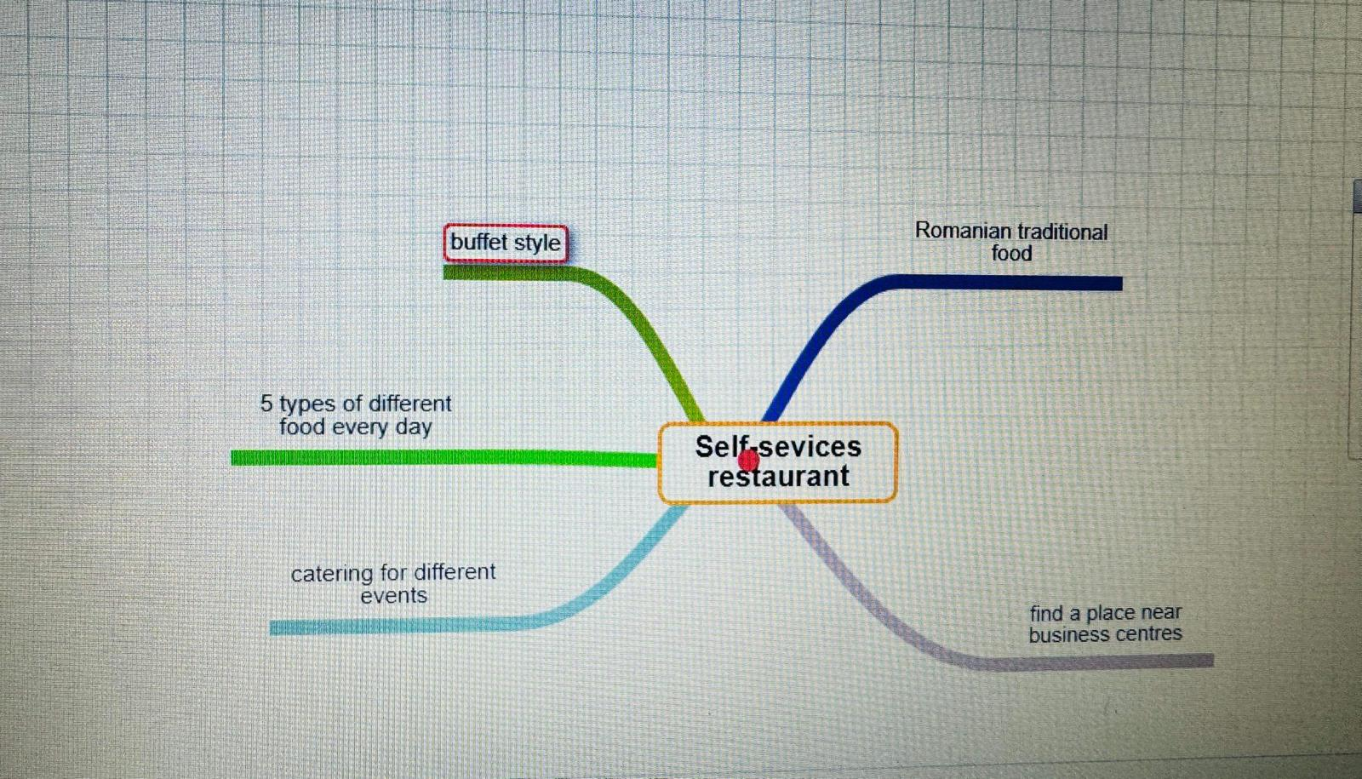

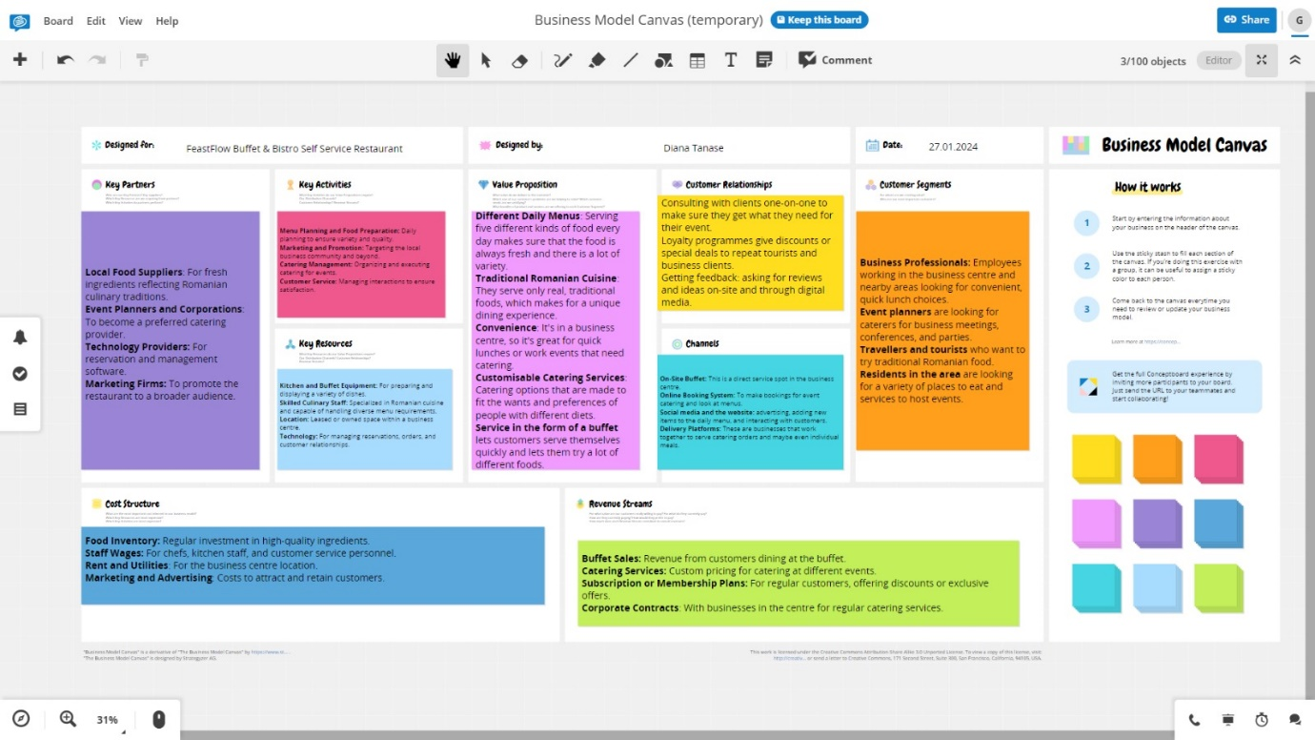

Personal reflexion
Introduction
This reflective essay uses the Gibbs Reflective Cycle to examine the outcomes of an in-class entrepreneurial and managerial test. The assessment measured my abilities in important dimensions such as achievement, autonomy, creativity, risk-taking, and control, all of which are necessary for business success. This cycle will facilitate the reflection of these findings to inform personal and professional growth initiatives.
Main Body
The evaluation evaluated five fundamental entrepreneurial traits, resulting in a diverse profile: a GET Score of 74%, a high Achievement score of 92%, a moderate Autonomy score of 50%, Creativity score of 67%, Risk Taking score of 75%, and Control score of 75%. The ratings represent a combination of my ability to start and run a business.
After examining my test results, I experienced a strong sense of satisfaction due to my high Achievement score. However, I also felt a bit uneasy about the middling Autonomy figure, which made me contemplate my ability to make independent decisions and my potential for leadership.
The assessment of my entrepreneurial test outcomes reveals a clear contrast between my strong ambition for achievement and a noticeable hesitation towards independent decision-making. The 92% score in Achievement validates my self-perception as a highly motivated and goal-oriented individual, a characteristic praised in entrepreneurial literature. Nevertheless, the Autonomy score of 50% signifies a notable dependence on collaborative procedures, which, although beneficial, implies a possible obstacle in circumstances that require autonomous leadership. This contrast emphasises the importance of maintaining a harmonious collaboration within a team while also allowing individuals to take independent action.
Examining my test scores using McClelland's Theory of Needs offers a convincing rationale for the elevated Achievement score. According to McClelland (1961), individuals who possess a high need for achievement are motivated to establish and accomplish difficult objectives, a trait that is clearly demonstrated by my 92% score. This indicates an inherent drive to perform and achieve, which is consistent with the determinants for entrepreneurial success revealed in academic studies. In contrast, the moderate Autonomy score is subject to examination according to the Self-Determination Theory (Deci & Ryan, 1985), which highlights autonomy as a crucial psychological requirement that affects self-motivation and personal well-being. The score of 50% signifies a possible opportunity for development, implying that although I prioritise independence, there is room for further enhancement in cultivating stronger self-direction and internal motivation. Augmenting autonomy has the potential to not only enhance entrepreneurial efficacy but also foster personal satisfaction and fortitude in the face of entrepreneurial obstacles. These academic models emphasise the significance of maintaining a balance between the desire for achievement and the motivation that comes from within oneself. They highlight a means for personal growth that leverages both internal drive and the ability to make independent decisions.
Conclusion
Upon analysing my test results through the lens of academic models, it becomes evident that I possess a strong motivation to excel but may benefit from developing greater independence to attain success in entrepreneurship. Important insights involve utilising my goal-oriented disposition while fostering increased autonomy in decision-making to enhance my entrepreneurial and managerial capabilities.
To improve my entrepreneurial profile, I intend to take targeted steps. First, I will create personal goals to increase my autonomy, such as directing a project from start to finish. To boost my creativity, I plan to participate in brainstorming sessions and workshops. Networking with successful entrepreneurs will provide valuable insights into effective risk management and control tactics. Regular reflection on these experiences will encourage improvement in these areas. Furthermore, I intend to capitalise on my high achievement drive by setting increasingly more difficult goals, assuring ongoing personal and professional growth.
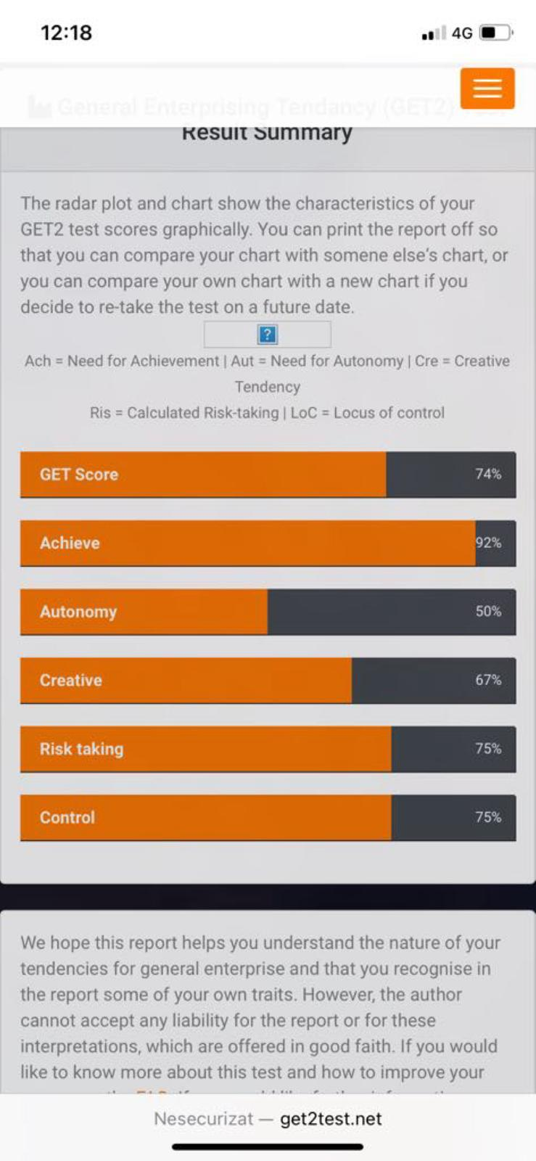

References:

Conceptboard. (n.d.). Conceptboard - Visual Collaboration Workspace for Teams. [online] Available at: https://conceptboard.com/

Chipotle (2023). Chipotle Mexican Grill. [online] Chipotle. Available at: https://www.chipotle.com/.

Deci, E.L. and Ryan, R.M. (1985). Intrinsic motivation and self-determination in human behaviour. New York: Springer Science + Business Media.

Dominos (2020). Domino’s Pizza: Pizza for Delivery or Takeaway Near You. [online] Dominos.co.uk. Available at: https://www.dominos.co.uk/.

HelloFresh (2019). HelloFresh: #1 Recipe Box Delivery Service | Dinner is Solved. [online] @HelloFreshUK. Available at: https://www.hellofresh.co.uk/.

Le Gavroche - Michel Roux Jr’s two Michelin-starred restaurant. (n.d.). Le Gavroche - Michel Roux Jr’s two Michelin-starred restaurant. [online] Available at: https://www.le-gavroche.co.uk/.

McClelland, D.C., 1961. The Achieving Society. Princeton, NJ: Van Nostrand.

Nando's (2019). Nando’s. [online] Nandos.co.uk. Available at: https://www.nandos.co.uk/.

Noma (2022). Noma. [online] noma.dk. Available at: https://noma.dk/

Pret A Manger (2022). Freshly prepared food, organic coffee. [online] Pret.co.uk. Available at: https://www.pret.co.uk/en-gb.

Rocket Food. (n.d.). London’s Top Luxury Caterer - Remarkable Parties & Weddings - Rocket. [online] Available at: https://www.rocketfood.com/.

Shake Shack UK. (n.d.). Shake Shack UK | Official UK Site | Delicious Burgers & Shakes. [online] Available at: https://www.shakeshack.co.uk/.

Starbucks (2019). Starbucks coffee shops - Starbucks.co.uk. [online] Starbucks Coffee Company. Available at: https://www.starbucks.co.uk/.

SimilarWeb (2023). Similarweb.com - Digital World Market Intelligence Platform. [online] SimilarWeb.com. Available at: https://www.similarweb.com/.

Sodexo UK. (n.d.). Catering Services Companies | Catering Hospitality Services | Sodexo. [online] Available at: https://uk.sodexo.com/food-services--catering.html.

The Ethicurean (2023). Welcome to The Ethicurean Restaurant | Barley Wood Walled Garden, Bristol, Wrington, UK. [online] The Ethicurean. Available at: https://theethicurean.com/.

The Ivy Collection. (n.d.). All Day Casual Dining - The Ivy Collection Restaurants. [online] Available at: https://ivycollection.com/.

The Real Greek. (2018). Home — The Real Greek. [online] Available at: https://www.therealgreek.com/.

The Ritz Hotel London. (n.d.). The Ritz Restaurant in Mayfair | The Ritz London Hotel. [online] Available at: https://www.theritzlondon.com/dine-with-us/the-ritz-restaurant/.

The University of Edinburgh (2020). Gibbs’ reflective cycle. [online] The University of Edinburgh. Available at: https://www.ed.ac.uk/reflection/reflectors-toolkit/reflecting-on-experience/gibbs-reflective-cycle

www.the-shard.com. (n.d.). Restaurant & Bars. [online] Available at: https://www.the-shard.com/restaurant-bars/.

Wagamama.com. (2019). Wagamama. [online] Available at: https://www.wagamama.com/.

World Buffet Restaurants | Authentic World Kitchen | COSMO. (n.d.). All You Can Eat World Buffet Restaurants | COSMO World Kitchen. [online] Available at: https://www.cosmo-restaurants.co.uk/.

www.caterwings.com. (n.d.). Caterwings en-DE. [online] Available at: https://www.caterwings.com/en-GB/ [Accessed 2 Feb. 2024].

