
University of Wales Trinity Saint David, London
Assessment Title: The Influence of National and International Labour Markets on HRM and IHRM Strategies
Programme: Master of Business Administration
Module: Human Capital Management (LCMB7023)
Lecturer: Gladius Kulothungan
Student Name: Kamran Akhtar
Student ID: 2433466
Word Count: 2718
Submission Date: 12th November, 2025

Table of Contents
1.0 Executive Summary 4
2.0 Introduction 4
3.0 Technological Advancements Reshaping Labour Markets 5
3.1 Drivers 5
3.2 Labour Market Impact 5
3.3 HRM Implications 5
3.4 IHRM Implications 6
3.5 Implementation Challenges and Ethical Considerations 7
3.6 Future Trends and Strategic Preparation 8
4.0 Demographic and Geopolitical Influences on Employment 8
4.1 Demographic Shifts 8
4.2 Geopolitical Forces 9
4.3 HRM/IHRM Challenges 9
5.0 Strategic HRM Solutions for Skills Gaps 10
5.1 The Shortage Crisis 10
5.2 Strategic HRM Responses 11
5.3 IHRM & Work Redesign 11
5.4 Implementation and Measurement Framework 12
6.0 Personal Reflective Report to Global Capabilities. 13
6.1 Technology 14
6.2 Communication 14
6.3 Teamwork and Leadership 14
6.4 Self-directed Learning 15
7.0 Strategic HCM Recommendations. 15
7.1 Invest in Agile Workforce Planning & Internal Talent Development 15
7.2 Develop Geopolitically Resilient and Inclusive Mobility Policies 15
7.3 Champion Ethical Technology Integration and People-Centric Work Design 16
8.0 Conclusion 16
References 17
Appendices 18

Table of Figures

Figure 1: Global AI Adoption and Use of Generative AI (2017–2024), Source: McKinsey & Company (2024), 6
Figure 2: Global Talent Shortage Over Time (2006–2025), Source: ManpowerGroup (2025) 11
Table of Tables
Table 1: Implications of Key Technological Trends for HRM and IHRM 7
Table 2: Regional Workforce Challenges and Strategic HR Responses 9
Table 3: Strategic HRM Responses to Sector-Specific Skills Shortages 12
Table 4: HR Implementation Framework and Success Measurement 13
Table 5: PESTLE Analysis of Labour Market Pressures 20

1.0 Executive Summary
This report includes a critical examination of the impact of national and international labour markets on HRM and IHRM strategies to answer four essential questions. Section 3 analyses technological disruptions (Q1), Section 4 examines demographic and geopolitical pressures (Q2), Section 5 proposes HRM solutions to skills gaps (Q3), and Section 6 reflects on personal global capabilities (Q4). The analysis reveals that AI, automation and digital platforms are fundamentally reshaping work, while ageing populations and geopolitical instability compound talent challenges. HRM/IHRM has to change towards non-transactional administration, but strategic workforce design aimed at resilience, internal capacity building, and ethical technology utilisation. Some of the main suggestions are that it should invest in agile workforce planning, craft geopolitically robust mobility policies, and proselytise ethical technology adoption. On a personal level, there are strengths in self-directed learning and development, in cross-cultural leadership is required.

2.0 Introduction
Business environment nowadays is volatile, uncertain, complex, and ambiguous (VUCA), and labour markets are one of the most important nexuses of such forces. This report is aimed at critically assessing and evaluating how technological, demographic, and geopolitical changes in these labour markets require a change in HRM and IHRM strategies. This report will address in an organised manner the four major tasks identified: it will first discuss the effect of technological changes, then discuss demographic and geopolitical changes, and finally discuss strategic responses to skills gaps. The report ends with a reflection on the individual preparation to work in the international workplace. It is based on the synthesis of current academic literature, encompassing the seminal works like Cappelli and Keller (2020) and Ulrich (2017) on the topic and current data, such as the report by Deloitte Global Human Capital Trends (2023). The systematic review will provide a comprehensive view that will play a key role in the 21st -century human capital management. The report concludes with evidence-based suggestions on how organisations can build resilience and strategic capability in the workforce in the volatile labour markets.

3.0 Technological Advancements Reshaping Labour Markets

3.1 Drivers
The work is essentially changing with the use of artificial intelligence, automation and digital platforms. According to Cappelli and Keller (2020), this is the technological implication, which means that the concept of work architecture must be reconsidered rather than just making it more efficient (which is a paradigm shift in how we consider the concept of productivity in organisations).

3.2 Labour Market Impact
These technologies result in a high level of polarisation of skills, both creating the demand for high levels of digital skills or, at a more structural level, pushing out repetitive positions. The adoption of remote working technology has led to unprecedented borderless talent pools, and industry surveys indicate that, accurately, the vast majority of large employers have accelerated the speed of the digital workplace programmes after the pandemic (Deloitte, 2023). This democratic opportunity is, however, subjecting the high-quality global talent to fierce competition. At the same time, the datafication of work also gives an opportunity to monitor the workforce at a more specific level by productivity analytics and algorithmic management, which also evokes serious concerns about privacy and autonomy, and HR is required to respond to them.

3.3 HRM Implications
HR should spearhead strategic reactions such as extensive reskilling initiatives, job redesign fundamentals and ethical AI governance frameworks. Armstrong (2021) points out that continuous learning is becoming a strategic imperative for organisations to achieve resilience. This introduces fresh responsibilities to HRM to control algorithmic decision-making, safeguard employee welfare, and secure performance analytics transparency, and now go beyond the conventional compliance functions of the HRM and become morally responsible custodians of technology in the workplace. But there are great practical difficulties with this ethical stewardship. As much as Armstrong (2021) recommends continuous learning, upskilling is often viewed by many organisations as a cost centre but not a strategic investment. The conflict between short-term productivity gains and long-term capability building is a fundamental paradox that HR has to walk through without sufficient resources and executive support.
The figure in Figure 1 indicates that the ratio of organisations that transitioned to using AI in at least one of their business operations increased by the percentage: 20% in 2017 and 72% in 2024, exhibiting the extent and rate of technological change in the global labour markets (McKinsey & Company, 2024).
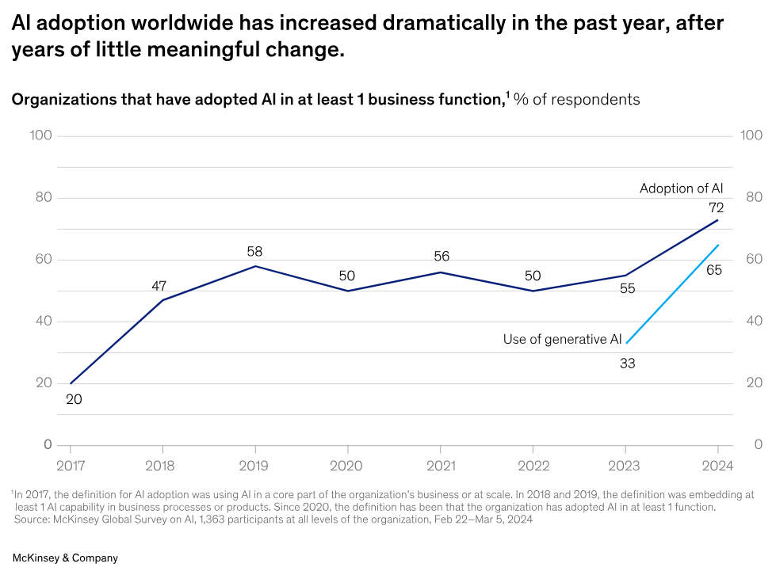
Figure 1: Global AI Adoption and Use of Generative AI (2017–2024), Source: McKinsey & Company (2024),

3.4 IHRM Implications
In this environment, global talent sourcing would be necessary and complicated. IHRM must navigate intricate cross-border compliance requirements, data privacy regulations like GDPR, and develop new competencies in virtual team leadership across diverse cultures (Ulrich et al., 2017). The traditional model of long-term expatriate is being rapidly complemented by more flexible assignments in the form of short-term projects and fully virtual assignments, which require an increased level of agility in the design and implementation of IHRM policies.
Table 1: Implications of Key Technological Trends for HRM and IHRM
Technological Trend | Implication for HRM | Implication for IHRM
AI & Automation | Job redesign, reskilling programmes, ethical AI governance, managing displacement anxiety. | Global standards of algorithmic management, across jurisdictions managing displacement, ethical global implementation.
Digital Platforms & Gig Economy | Building new models of engagement for non-standard workers, incorporating gig talent, ensuring fair pay. | Understanding international contractor laws, creating a global talent marketplace, managing cross-border gig worker rights.
Remote Collaboration Tech | Designing hybrid working policies, focusing on outcomes-based performance management, and preventing digital presenteeism. | Managing teams across time zones, ensuring inclusive collaboration, maintaining organisational culture globally, addressing digital exhaustion.
Source: Compiled from Cappelli & Keller (2020); Ulrich et al. (2017); Deloitte (2023); and industry analysis
3.5 Implementation Challenges and Ethical Considerations
The transition toward technology-driven HR practices presents significant implementation barriers that organisations must navigate. Research on digital transformation consistently shows that most large-scale technology programmes underperform primarily due to behavioural and cultural resistance rather than technical failure (Kane et al., 2020). This highlights the fact that adopting AI and analytics in HR is not only a system initiative, but also a leadership change issue. In addition to ethical issues regarding surveillance, organisations have practical issues about the efficiency versus employee trust. Although AI in hiring is said to bring about increased objectivity, in many cases, it recreates the existing biases, as long as the training data is based on historical disparities. Moreover, collaboration technologies have been rapidly deployed to such an extent that there is a phenomenon of digital fatigue, which is reported by the Microsoft Work Trend Index at approximately 250% more hours of weekly meetings, which hurts deep work and innovation capacity (Microsoft, 2023). Such issues highlight that adoption of technology needs advanced change leadership, digital instruments add value rather than eliminating human potential and organisational efficiency.

3.6 Future Trends and Strategic Preparation
The future of work will be driven by the introduction of new technologies into the sphere, such as AI, quantum computers, and immersive reality. HR professionals should also consider the future consequences of these disruptions, and the solution is constant environmental scanning and strategic planning of the workforce. These include coming up with policies which are flexible and can accommodate technological change, forming partnerships with technology suppliers and establishing innovation laboratories to test new tools. Those organisations that actively create digital literacy and agile working practise will be in a better position to capitalise on the emerging technology and uphold faith in ethical standards and employee wellbeing.

4.0 Demographic and Geopolitical Influences on Employment

4.1 Demographic Shifts
An ageing population in developed economies is causing structural labour shortages, and the OECD predicts that in most developed economies, the population share of those over 65 will increase to historic highs by 2030, putting strain on pension systems and reducing the working-age labour supply (OECD, 2023). At the same time, the concept of workforce diversity is growing in a variety of aspects such as ethnicity, gender identity and neurodiversity. According to recent world surveys, about 40% of workers are thinking about quitting their jobs in the next three to six months because of burnout and not being aligned with their values (McKinsey, 2023). Multi-generational workforces are new and need distinct engagement strategies, whereas diversity, equity and inclusion are no longer matters of compliance, but strategic employer branding and retention (Bratton and Gold, 2017). More fundamentally, such demographic pressures are revealing a more underlying structural problem: the old systems of HR, which were built to serve stable, homogeneous labour markets, are not fit to serve dynamic and diverse labour markets today. This 40% potential turnover rate (McKinsey, 2023) is an HR issue but structural imbalance between organisational design and contemporary workforce needs that requires solutions in the form of systems and interventions.

4.2 Geopolitical Forces
The world talent movement is to a large degree being interrupted by political unrest, trade wars and more confining immigration policies. The supply chain reshoring and nearshoring efforts mean that the borderlands redeploy workforce within a short time and put a strain on organisational agility. These considerations prompt the need to have advanced geopolitical risk determination logically instilled into strategic workforce planning to transform HR into an anticipatory practise instead of a reactive one. These geopolitical pressures can be systematically analysed using a PESTLE lens, as shown in Appendix A, where political risk, regulatory fragmentation, social expectations for inclusion, and technological dependency all converge to make workforce planning more volatile than in previous decades.

4.3 HRM/IHRM Challenges
HR professionals have to deal with a greater level of complex workforce planning, multi-jurisdictional compliance, and talent retention strategies that have never been seen before. Gen Z expectations around meaningful work, flexibility and support for mental health push even more pressure to evolve toward getting beyond traditional HR practices. For IHRM, geopolitical volatility demands strong duty-of-care models for employees working in politically unstable territories and fast scenario planning for talent redeployment, which makes HR the critical risk management function rather than a supportive service (Boxall, Purcell & Wright, 2022). This change reflects Marchington and Wilkinson's (2020) focus on HRM as a strategic activity rather than a centralised administrative activity embedded in daily management practise. These pressures in the region coincide with other trends of emerging work risk in the latest year on the future of jobs (World Economic Forum, 2024):
Table 2: Regional Workforce Challenges and Strategic HR Responses
Region | Key Demographic/Geopolitical Challenges | Strategic HR Responses
UK & Europe | Brexit immigration barriers, ageing workforce, skills mobility restrictions | Local talent pipeline development, complex visa management, extended retirement policies, and regional skills partnerships
Asia-Pacific | Extreme ageing populations (Japan, S. Korea), rapid digital transformation, cultural diversity complexities | Automation integration strategies, cross-cultural leadership development, digital literacy programs, and intergenerational knowledge transfer
North America | Remote work regulation fragmentation, immigration policy volatility, and generational diversity tensions | Multi-state compliance frameworks, flexible work arrangement policies, customised benefits packages, and inclusive leadership training
Source: Regional analysis based on data statistically compiled by the OECD (2023) on demographic data and the World Economic Forum (2024) on the employment trends in the region.

5.0 Strategic HRM Solutions for Skills Gaps

5.1 The Shortage Crisis
Technology is afflicted by rapidly changing digital skill demands; healthcare is plagued by burnout-induced attrition abetted by demographic demands; and hospitality regards itself as a chronically high-turnover industry where employees perceive their work as low-skilled and low-paying. The central strategic risk that transcends all three sectors is the failure of innovation and service delivery: vacancies and churn have a direct impact on service quality, regulatory compliance, and customer experience and ultimately, organisational viability.
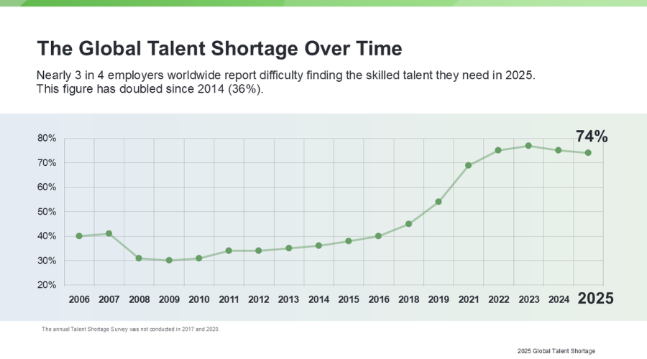
Figure 2: Global Talent Shortage Over Time (2006–2025), Source: ManpowerGroup (2025)
As shown in Figure 2, the global talent shortage has escalated from 36% in 2014 to 74% in 2025, which demonstrates a systemic and continuous shortage of skilled labour across the world (ManpowerGroup, 2025).

5.2 Strategic HRM Responses
The key foundations are building strategic talent pipelines and attractive employer branding (Pilbeam & Corbridge, 2019). However, in order to really address scarcity, internal development and upskilling programmes should be seen as strategic investments in organisational capability (Armstrong, 2021) to develop home-grown talent that is well versed with organisational culture and processes.

5.3 IHRM & Work Redesign
Ethical talent sourcing from abroad should be carefully applied so as not to create negative brain drain effects in developing economies. More crucially, work redesign, the breaking down of standard jobs into tasks and projects, presents creative structural solutions to talent shortage (Jesuthasan & Boudreau, 2022). These strategic interventions have a direct bearing on the recommendations for evidence-based practice, which are brought to bear at Section 7.
These interventions have to be accompanied by clear success measures. For example, internal mobility rates, healthcare-associated burnout turnover, and 90-day retention in hospitality are leading indicators of whether strategic HR interventions are actually bridging the skills gap instead of merely shuffling vacancies.
Table 3: Strategic HRM Responses to Sector-Specific Skills Shortages
Sector | Nature of Shortage | Strategic HRM Response
Technology | Rapidly evolving digital skills (AI, Cybersecurity, Data Science). | Internal "tech academies," partnerships with universities, promoting STEM outreach, leveraging global remote talent, and creating innovation career pathways.
Healthcare | Shortage of qualified professionals (nurses, GPs), high burnout, and physical scarcity. | Sponsored training and education, well-being and retention programmes, international recruitment (with ethical safeguards), and role redesign using AI for administrative tasks.
Hospitality | High turnover, perception of low-skilled, low-pay work, and seasonal vulnerability. | Revamping EVP to highlight flexibility and career growth, improving working conditions and job security, implementing profit-sharing schemes, and creating cross-training opportunities.
Source: Analysis based on Pilbeam & Corbridge (2019); Armstrong (2021); Jesuthasan & Boudreau (2022); and sector workforce data.

5.4 Implementation and Measurement Framework
The successful implementation of strategic HRM solutions requires a structured approach to change management and rigorous measurement of return on investment. The following framework outlines the phased approach for implementation and key metrics for evaluating success:
Table 4: HR Implementation Framework and Success Measurement
Phase | Key Activities | Success Metrics | Timeline
Pilot Implementation | Select business units, engage line managers, co-design solutions with employees | Manager buy-in rates, employee participation rates | Quarter 1-2
Full Rollout | Scale successful pilots, continuous communication and training, allocate resources | Internal mobility rates, skills proficiency gains, time-to-productivity | Quarter 3-4
Sustainability | Embed practices into organisational culture, leadership ownership, continuous improvement | Employee retention rates, promotion velocity, innovation metrics | Year 2 and beyond
ROI Measurement | Link HR metrics to business outcomes, calculate cost savings and revenue impact | Cost per hire reduction, revenue per employee, talent pipeline depth | Ongoing
Source: Implementation framework adapted from Armstrong (2021) and change management best practices

6.0 Personal Reflective Report to Global Capabilities.
My disciplined self-directed learning and organised written communication are my current strengths. However, I need development in leading culturally diverse teams confidently and using people analytics for talent decisions. Over the next year, I will address these through targeted analytics training and seeking international project leadership roles to practice inclusive leadership in real settings.

6.1 Technology
My current capability includes strong proficiency with digital collaboration tools like Microsoft Teams and Zoom, developed through managing virtual MBA group projects. In today's global labour market, being digitally fluent is a mandatory condition in order to be able to coordinate across borders/continents and time zones, directly affecting productivity and cohesion within a work group in a distributed working format. However, I lack depth in People Analytics tools. Following Boudreau and Ramstad's (2021) emphasis on evidence-based HR, I plan to complete a certified course in HR analytics to better leverage data for talent decisions, thereby enhancing my strategic contribution to organisations.

6.2 Communication
I possess strong academic and professional writing skills, evidenced by constructing clear, evidence-based arguments in assignments. Clear communication is fundamental for cross-cultural collaboration and managing stakeholder expectations in international settings. One of the development areas is negotiating with culturally diverse stakeholders. To resolve this, I will involve myself in international competitions based on cases where I will be able to employ my research strengths into practice to gain confidence in cross-cultural persuasion in a simulated setting and hence be able to negotiate on international matters.

6.3 Teamwork and Leadership
I have strength in terms of being efficient in operation and keeping project schedules within the multicultural teams, where coordinating roles are usually undertaken. Efficient coordination is paramount, yet in real leadership, one has to motivate and develop others. The responsibility and growth, as Herzberg's theory indicates, are powerful motivators. I should attain proactive mentoring skills. I will also take some formal mentoring with first-year MBA students, which will help me build my mentoring and talent development skills, which will not only fill the leadership gap but will also serve as an intrinsic motivational factor because I would be contributing to the development of other people.

6.4 Self-directed Learning
My self-directed learning skills are strong because I conduct systematic research and synthesise complex information in academic and industry sources in order to write reports such as this one. This ability will be directly connected to Maslow's theory of self-actualisation and will be essential to constant professional growth in swiftly changing professions. I will make this strength institutional through the allocated time monthly to research on the emerging trends in HR, so that my competencies will always be on top, thus bearing lifelong career resiliency in the changing global market.

7.0 Strategic HCM Recommendations.
Organisations need to test pilot programmes with defined measures of success, before rolling them out across the organisation - mitigation of implementation risk should be factored in, and resistance to change managed through continuous communication, co-creation with end-users and visible leadership buy-in. Additionally, having cross-functional governance committees ensures a variety of perspectives are given in the design of the solutions, and helps build organisational buy-in. These risk mitigation strategies will increase the chances of successful adoption of the recommended initiatives and the sustainable impact achieved.

7.1 Invest in Agile Workforce Planning & Internal Talent Development
Conduct a granular skills-gap analysis immediately, followed by agile capabilities "learning sprints" on high-demand capabilities. Within 18 months, establish a talent marketplace inside the firm for the dynamic deployment of existing talent. This directly addresses the gap of skills shortages and increases retention by providing internal mobility opportunities. The human capital view on strategic value creation is consistent with viewing people as assets that need to be actively nurtured rather than costed (Mayo, 2022).

7.2 Develop Geopolitically Resilient and Inclusive Mobility Policies
During the next quarter, audit businesses should identify global mobility risks and diversify their types of assignments to include more short-term and virtual options. Pursue inclusive packages of support for the various family situations and views to guarantee psychological safety to workers in volatile areas and secure key talent pipelines for future demand.

7.3 Champion Ethical Technology Integration and People-Centric Work Design
Establish an ethical AI charter by year-end, governing algorithmic management and data privacy. At the same time, pilot work redesign projects in a single business unit, breaking jobs down into projects and tasks in order to become more flexible. This is a compromise between technological efficiency and human dignity and human engagement.
Implementation and Metrics: Default audit and risk assessment (Q1), pilot launches (Q2-3), and scale successful projects (Year 2). Goals: internal promotion (goal: +15), employee engagement (goal: +10), and critical opening reduction (goal: -25).

8.0 Conclusion
This report has been able to critically highlight the fact that the triple pressures of technological disruption, demographic change and geopolitical turmoil are fundamentally altering the HRM and IHRM strategies. Based on the analysis, it becomes clear that organisations can no longer consider human capital management a support system and thus should position it as the core of strategic resilience. The suggested move to the idea of agile workforce planning, ethical technology control, and inclusive global mobility is not only the best practice, but also a business necessity. Likewise, on the individual level, lifelong adjustment with self-directed learning and cross-cultural competence is not a choice, but a requirement to stay relevant as a professional. Any organisation or individual that does not actively deal with these interrelated issues will find itself irrelevant in the competitive and volatile global economy. The future and sustainable advantage lies with those who realise that human capital, which is strategically used and ethically developed, is the ultimate source of sustainable advantage.

References
Armstrong, M. (2021). Armstrong's Handbook of Human Resource Management Practice (15th ed.). Kogan Page.
Boxall, P., Purcell, J., & Wright, P. (2022). The Oxford Handbook of Human Resource Management. Oxford University Press.
Boudreau, J. & Ramstad, P. (2021). Beyond HR: The New Science of Human Capital. Harvard Business School Press.
Bratton, J. & Gold, J. (2017). Human Resource Management: Theory and Practice (6th ed.). Palgrave Macmillan.
Cappelli, P. & Keller, J. (2020). Managing the Future of Work: The New HR Imperative. Harvard Business Review Press.
Deloitte Insights. (2023). Global Human Capital Trends Report. Deloitte University Press. [Accessed 3 November 2025]. Available at: https://www2.deloitte.com/us/en/insights/focus/human-capital-trends.html
Jesuthasan, R. & Boudreau, J. (2022). Work Without Jobs: How to Reboot Your Organization's Work Operating System. MIT Press.
Kane, G.C., Palmer, D., Phillips, A.N., & Kiron, D. (2020). The Technology Fallacy: How People Are the Real Key to Digital Transformation. MIT Press.
ManpowerGroup (2025). Global Talent Shortage Survey 2025. [Accessed 3 November 2025]. Available at: https://go.manpowergroup.com/talent-shortage
Marchington, M. & Wilkinson, A. (2020). Human Resource Management at Work (7th Ed.). CIPD.
Mayo, A. (2022). Human Resources or Human Capital? Managing People as Assets. Harvard Business Review Press.
McKinsey & Company (2023). Global Workforce Trends Report. [Accessed 3 November 2025]. Available at: https://www.mckinsey.com/featured-insights/future-of-work
McKinsey & Company (2024). The State of AI in 2024. [Accessed 3 November 2025]. Available at: https://www.mckinsey.com/capabilities/quantumblack/our-insights/the-state-of-ai
Microsoft (2023). Work Trend Index: Annual Report. [Accessed 3 November 2025]. Available at: https://www.microsoft.com/en-us/worklab/work-trend-index
OECD (2023). Pensions at a Glance 2023: OECD and G20 Indicators. OECD Publishing. [Accessed 3 November 2025]. Available at: https://www.oecd.org/pensions/pensions-at-a-glance.htm
Pilbeam, S. & Corbridge, M. (2019). People Resourcing and Talent Planning (6th ed.). Pearson.
Stewart, G.L. & Brown, K.G. (2019). Human Resource Management. John Wiley & Sons.
Stone, R.J., Cox, A., & Gavin, M. (2020). Human Resource Management. John Wiley & Sons.
Ulrich, D. (2017). Victory Through Organization: Why the War for Talent is Failing Your Company and What You Can Do About It. McGraw-Hill Education.
Ulrich, D., Kryscynski, D., Ulrich, M., & Brockbank, W. (2017). HR from the Outside In: Six Competencies for the Future of Human Resources. McGraw-Hill.
World Economic Forum (2024). Future of Jobs Report 2024. [Accessed 3 November 2025]. Available at: https://medium.com/@knocksfuture/world-economic-forum-future-of-jobs-report-2024-2d9be79281b3

Appendices
Appendix A:
Table 5: PESTLE Analysis of Labour Market Pressures
Factor | Key Pressures | HRM/IHRM Implications
Political | Immigration restrictions, trade protectionism, political instability | Complex global compliance, visa management, duty-of-care in volatile regions, supply chain workforce redeployment
Economic | Wage inflation in high-demand sectors, currency fluctuations, economic nationalism | Competitive compensation strategies, global pay equity, cost management for international assignments
Social | Ageing populations, multi-generational workforce expectations, DEI demands | Tailored engagement strategies, flexible benefits, inclusive culture building, mental health support
Technological | AI/automation adoption, digital platform growth, remote work infrastructure | Job redesign, reskilling initiatives, ethical AI governance, virtual team management
Legal | GDPR/data privacy, evolving employment laws, algorithmic transparency regulations | Compliance frameworks, policy adaptation, ethical technology use, cross-border legal alignment
Environmental | ESG expectations, climate-related disruptions, green transition | Sustainability competencies, "green" talent development, remote work carbon reduction strategies
Source: Compiled by the author from Deloitte (2023), OECD (2023), and McKinsey & Company (2024).

