
the Grand Hotel budget planner


October 22, 2022
University of Wales Trinity Saint David
[Company address]

Student Name Mohammed Hassan
Student # 2027186
Module Financial Management for the Hotel Industry
Module Code BMIH5007
Lecturer Christopher Wilkin

Executive Summary

The following report provides a thorough explanation of the significance of budgeting and demonstrates how to develop a strategy that considers the hotel’s objectives and use it to create a precise, sustainable budget for the upcoming fiscal year
Budgetary control relies on the hotel’s historical data, and managers create their budgets using the attributes and numbers. But they all give primary sources. Directors require plans or estimates just as much as past records when making decisions, plans and budgets are created as a result. Always, budgeting is as much an art as a science.

Table of Contents
Executive Summary Devising a budget process that examines the organization's priorities, and using it to produce an accurate, balanced budget for the coming fiscal year will help you keep control of the organization's finances 1
1. Introduction 3
2. 500 words Analysis of Grand hotel budget planner 4
3. Task 2 5
3.1 Importance of budgeting 5
3.2 understanding of incremental budgeting .6
3.3 Activity based 7.
3.4 Value proposition based 7.
3.5 zero based budgeting………………………………………………………………………………………………………… 8
3.6 How budgeting control can support sustainability 9.
3. Conclusion 10
4. Reference List 11
5. Appendix with Excel Budget planner…………………..……………………………………………………………………13

Introduction

A spending plan based on income and costs is called a budget. In another words, it is a projection of your monthly or year income and expenses. Budgetary management in business accounting is the control and monitoring of revenue and expenditure of each department and managers are habitually in charge of overseeing the departmental budget. Financial statement that has been budgeted, projections of cash inflows and outflows, and a general financing strategy. Budgets are essential to the successful and efficient operation of any firm, Ganti,(2022).
The budget for a hotel includes a lot more then just the money it spends. Developing a strong and profitable spending plan entails investigation a hotel’s coasts as well as cost-cutting, good forecasting optimization, incorporating new budgetary technique, and financial planning and tracking need to have high revenue managerial skills, Campbell, (2022).

500-words analysis of Grand hotel budget planner

This report prepares for The Grand Hotel London branch’s budgets planner from April 2022 to March 2023. This report will outline the hotel’s anticipated year revenue in detail. These, however, are reported on monthly basis and comprise anticipated payments from hotel reservations, cash sales and interest income from bank accounts and documented for an insightful analysis for the hotel's projected year.
According to the total anticipated expenses for this report, these expenses are reflected in accordance with the previous year’s record. Amount for each month take the opening balance into account and so far, opening balance for April is £ 13,500, as can be seen. In the result of increased business growth, is expected to increase each month. Totals foreshow cashflows started at £ 79090 and oscillated to £ 63160 for each month for April 2022 to March 2023. The overall progression of total figure is £ 755,501 in financial year with at its highest net cashflow is £ 85,582 in June 22 and lowest net cashflow is £42,305 in July 22.
The hotel’s prospective monthly revenue peak is in December, when it is anticipated to bring in £198,376. At the same time, this month’s outflow, at £ 125,365, is the largest ever. It’s because a significant payment of £32,100 was made for a corporate reservation and a holiday party, and additional payment of £ 8,000 of annually car insurance is due to paid along with fixed expenses as regular outflow money in terms to pay wages and overtime, utility bills and rates ext.
The data on cash sales from April to March is anticipated to be £8,900 every month. Because the hotel’s policy is not to deal with credit, and because of it their credit sale is zero, this will result in to total of £106,800. This is beneficial for business to manage other suppliers’ payment, such as the mini bar’s £7000 monthly and the £6000 annual fee for the premier league licence.
The Grand hotel’s overall situation appears favourable because its projected budget is in surplus, and it doesn’t require outside funding to cover its expense. That is a result of the net cash flow’ consistency. According to this analysis, the hotel’s monthly expenses are lower than its potential earning, and it will eventually have more money than it needs. For hotels to thrive and expend, there must be economic surplus. When a business has a sizable surplus, it signifies that money is coming in, and it may use the excess to invest in new goods, service, tools and personal to support growth. To keep control of their finances and to demonstrate to funders how their money is being spent, organisation must develop accurate and current annual budgets. If the hotel aims for monthly net cash mark surplus, this will be a smart strategy.

Task 2

The Budgets planning for The Grand hotel’s operations are the subject of this in-depth analysis report. Financial forecasting models are developed along with the costs that will be required to produce these revenues and deliver excellent customer service to hotel visitors. A hotel divided up into various departments. Each of these department’s managers develops its own budget. Together with the other managers, the general manager evaluates the consolidated budget and makes changes if needed. Its vital to have enough staff on hand to provide top-notch service, but not too many people lest the hotel lose money for being overstaffed, Hill, (n.d).

Importance of budgeting

For hotel to continuous operating, they will have to regularly pay number of expenses on a daily, weekly, monthly, quarterly basis, for this budget are crucial to ensuring that costs are covered and that there are no long-term debts for the business. The key to a business must set goals that help to expand the hotel, therefore creating targets for where the business will be in future years should be a part of the early stages of the budgeting process. Once the hotel as set a turnover level, it will be possible to predict what kind of turnover to expect and what kind of profit the hotel should make over the next 12 months. The key to this is to make sure that have examined financial budget monthly to determine next course of action and decide where improvements are needed.

Understanding of incremental budgeting

Management accounting includes incremental budgeting heavily. To create a new budget, certain minor adjustments must be made to a current budget. The budget allocation for the following year is based on the budget used for the current year. All departments are expected to operate under the present estimate, and any additional will be included in the upcoming budget. Although there is no one right way to do incremental budgeting, have a strategy in place is essential. The strategy is to use the prior year’s budget as the foundation for the subsequent year’s budget. Over the past 20 years, incrementalism has been the primary theory used to explain budgetary behaviour. The study has defined incrementalism as an increase in spending and claims that it is dependent on sustained economic development. This expansion, which took place in the 1950s and 1960s, enabled gradual behaviour, since the 1970s growth has slowed, which has caused a change in budgeting from incremental to decremental. Decremental budgeting frequently results in redistribution strife, and instability. Although budget procedures have not entirely adapted to decremental circumstance, such modifications will take place if the economy remains stagnant, Schick, (1983).

Activity based

A top-down budgeting method know as “activity-based budgeting” word by calculating the quantity of inputs needed to support the targets or outputs that an organisation has set. ABB is based on the essential ideas of ABC, although there are some significant variations. First, ABB’s is greater since it intersects and interfaces with other management activities and setting up and operating ABB requires considering the inputs and outputs of those functions. Along with being a component of a costing system, Team, (2022).
Early on in ABC’s evolution activity based budgeting seen as a potential application that could be benefivial. The essential components of ABB that must be understood in order to use it properly. First key facter term is “Rate Of Concumption” the speed at which input amounts are used up to produce outputs. ABB uses two consumtion rates: a Resource Use Rate for measuring the consumtion of resources by an activity and an Activity Concumtion Rate for measuring the consumption of activity. Secound key term known as “Financial Balance” the intended quantity and mix of output demands can be met by the hotel’s number and mix of resources, and the anticipated financial outcome will meet or surpass the hotels’s finanical aim, Turney, (1992).

Value proposition based

When revamping any financial procedures, VPB should be employed as a means of analysing and anticipating future results. VPB aims to identify the areas of hotel business that provide the highest return. Priority-based budgeting, sometime referred to as value proposition budgeting, is examining and outlining a hotel’s expenditures for specific quarter. Vale proposition budgeting’s fundamental goal is to determine where a hotel should spend money considering the value that each expense generates, Stefanka, (2022).
The VPB technique analyses each budget line to determine its significance to the company, customer, personnel, or other stakeholders, like the zero-based and activity-based budgeting methods. Driving value is the focus of VPB, as suggested by its name, this suggests that you’ll need to defend your spending. Nut when you assess every expense item, you also understand how much value each penny should generate, Anon, (2022). A hotel as a busisness make a given amound of revenue and must spend some certain sum of it. But what if this spend funds could instead be used to purchase more in-demand service or goods that the organization knows will increse future revneue?, how can companies assess which service requirement cuts against tat require more attention?, by using successful product method, it is possible to identify the areas that require focus and those where spending is redubdand, Rensburg, (2022).

Zero based budgeting

The zero-based budgeting (ZBB) system includes managers to create a budget from scratch, beginning with nothing, ZBB, however, has generated a good bit of debate over the years, mostly because of concerns over its worth. Obtained from ZBB study versus the price needed to implement ZBB, Hatry, (1982).
0 base vulnerability A zero-based budget examines that evaluates every spending, in contrast to conventional behaviour, expense, and leading budgeting. Both ongoing costs and unexpected ones that can arise during the budgeting period and considered in the process, each expense is carefully examined, supported, and if necessary. Eliminated. Zero-based budgeting is not a brand-new concept in business, as the introductory excerpts demonstrate. In addition to a revived attention on zero-based budgeting in the public sector, supporters also point to a resurgence of interest the approach among businesses, Eakin, (2015).
Zero-based budgeting may be appealing to businesses who are unable to raise prices to increase profits as a means of coast management. Other firms may use zero-based budgeting as a technique to review everything from scratch if they want a fresh perspective on operational processes. Zero-based budgets are easy to create, but depending on the size of the hotel, the effort involved can be extensive. This makes it a fantastic tool for young groups to use right now. A business’s costs always increase gradually as it expands, both in terms of monetary values and number. It takes more time to create a zero-budget as the income streams and expenditures increase, Amar, (2022).

How budgeting control can support sustainability

Companies are organisation that priorities making money. They cannot thrive if there is not enough revenue. In making decisions, assumptions and projections are crucial. Using those anticipations and projections, a scenario is created. If a situation includes financial information, a budget has been created. A budget is a particular type of capital market model. A key instrument in financial management for sustainable development is budgeting. The effectiveness of the industry’s capital and resources is also maintained via budgeting. Every sector or organisation has a different budget. Budgeting varies per industry, including production. Transportation, aviation, finance, hotel , among others. This section presented the goals of budgeting processes, budget preparation stages, industry distinction, budget relationship and strategies, Yılmaz, (2018).
Maintaining preparation is among budgeting’s goals. Budgeting is a crucial component of sound financial management. There is highly competitive among firms in modern commercial life. Therefore, each corporate decision should be carefully considered to preserve sustainability. There ought to be back up plan B or Originally Proposed in every plan, of obviously, a strategy should consider its financial requirements and repercussions. Accounting meets this need. Preparing your finances is another name for creating a budget, each step taken to build a budget is meticulously planned. Resources, investments, responsibilities, cash flow, and spending all occur in this strategy.

Conclusion

This report has covered many aspects of the budget planning for Grand hotel of April 22 to March 23 and divided into two segments. One of task’s analysis makes it clear how time-consuming a zero-based budget can be, but also makes it clear what advantages it offers. VPB is a powerful tool for companies looking to improve, but it needs to be thoroughly analysed every few months. If executed properly, it gives organisations an excellent overview and makes it clear what drives revenue and what is excess baggage.
Another task containing the comprehensive entries which categorised and documented for a conclusive analysis for the hotel’s projection year to construct the budgetary planner or the cashflow projection, and appendix budget calculations is attached at the end of this report.

5. Reference List

GANTI, A.( 2022) What Is a Budget.
Available at: https://www.investopedia.com
(Accessed 22 10 2022).

Hill, B.(n.d). About Budgets in Business Operations of Hotels.
Available at: https://smallbusiness.chron.com
(Accessed 22 10 2022).

Schick, A. (1983) Incremental Budgeting in a Decremental Age. Policy Sciences, 16(1), pp. 1-25.

Rensburg, G. v. (2022). Value Proposition Budgeting—Smart Spending to Build a Business. Available at: https://webtribunal.net
(Accessed 23 10 22022).

Team, C. (2022). Types of Budgets.
Available at: https://corporatefinanceinstitute.com
(Accessed 23 10 2022).

Turney, P. B. B. (1992). What an ActivityBased Cost Model Looks Like. Journal of Cost Managemen, p. 54.

Stefanka, L. (2022). Value Proposition Budgeting (VPB): A Step-by-Step Guide.
Available at: https://relayfi.com
(Accessed 23 10 2022).

Anon. (2022). Value proposition budgeting: Is it right for your business?
Available at: https://getdivvy.com
(Accessed 23 10 2022).

Harry. Hatry. (1982). “Zero Base Budgeting: The Manager's Budget. Public Budgeting and finance, 2(1), p. 72.

Eakin, C. F. (2015). Zero-based budgeting: everything old is new again.
Available at: https://theconversation.com
(Accessed 23 10 2022).

Amar, A. (2022). How to Create a Zero-Based Budget.
Available at: https://www.datarails.com
(Accessed 24 10 2022).

Yılmaz, F. (2018). Budgeting as a Tool for Sustainable Development.
Available at: https://www.igi-global.com
(Accessed 24 10 2022).

Campbell, K. (2022). Hotel Budgeting: 15 Tips for Hospitality Professionals.
Available at: https://www.cvent.com
(Accessed 23 10 2022).

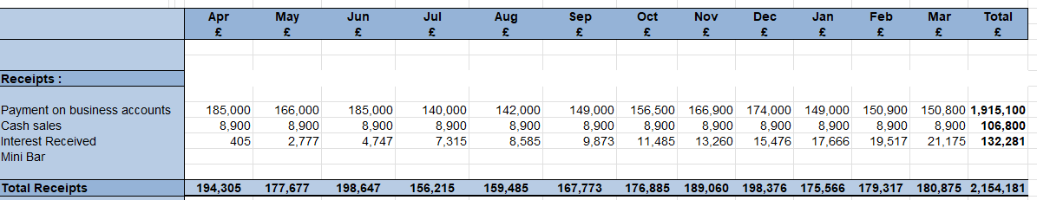
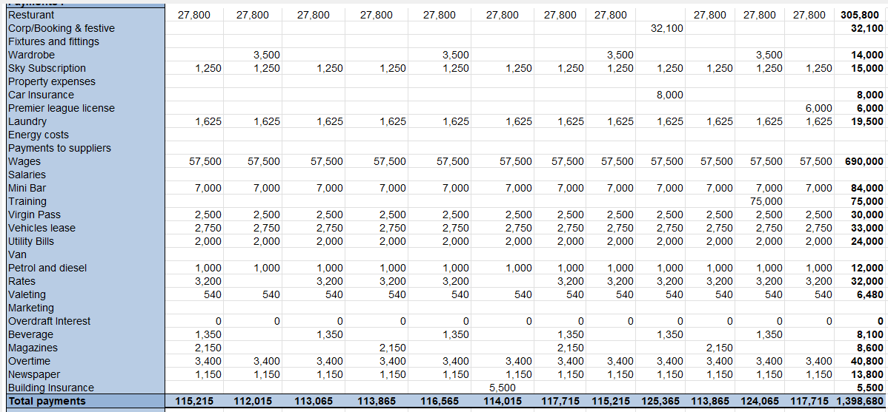
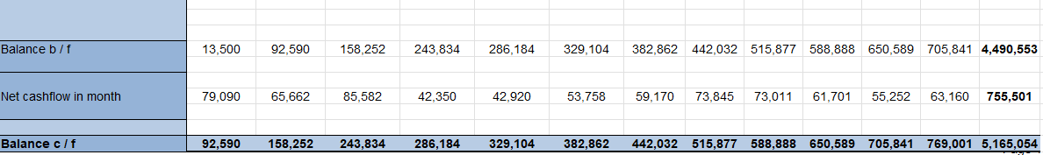
6.Appendix Budget Calculations

