PC Crafter
Interactive Web Development Assessment
Full name: Mohamed Rais Msemar
Student number: 2527548
Module: ACCA4023 Interactive Web Development
Submission date: 12/08/2026

Introduction
PC Crafter is a gaming PC website that I developed to help users find a gaming PC that suits their budget and requirements. The website focuses on creating custom gaming pcs and offering customizable set ups for users.
The website contains five main pages: Home page, Gaming pcs store, about page, contact page and Log in page. Users can log in to the website with their email and password and they can look at computers for sell on the gaming pcs page, they can also order computer and request custom modification on the contact us page, I have also made a small about page to give users a brief introduction to what the website is about
This report explains the main requirements of the website and how I implemented them using HTML and CSS. It also looks at the usability, accessibility and SEO of the website to see how well it works for its intended users.
Finally, I will compare PC Crafter with two existing websites and look at their usability, accessibility, SEO and mobile friendliness. I will then discuss what works well with my website and what could be improved in the future.

Requirements
2. Purpose of the Website
The main purpose of PC Crafter is to create a simple website where users can look at gaming PCs and choose a computer based on their budget and performance requirements.
I chose this idea because gaming PCs have different levels of performance and prices, so having different options makes it easier for users to decide what type of PC they want. The website includes budget, mid-range and high-end options so that it can appeal to users with different budgets.
The website also has a Contact page where users can select the PC they are interested in and provide additional requirements. This makes the website more useful because users are not limited to only the standard PC options shown on the Gaming PCs page.
2.1 Subject Matter
The subject of the website is gaming PCs and custom PC setups. The Gaming PCs page presents different PC options, including a budget gaming PC, a mid-range gaming PC and a high-end gaming PC.
Each PC is displayed using a card layout containing an image, the PC name, price and an option to order it. This makes the different products easier to compare.
The website also focuses on customisation. Users can go to the Contact page and select the PC they are interested in and write their requirements. This allows the website to represent a PC-building service rather than only being a basic product catalogue.
2.2 Target Audience
The main target audience for PC Crafter is gamers who are interested in buying a gaming PC. The website is aimed at users who may have different budgets and performance requirements.
The different PC categories are intended to make the website suitable for both users who want a cheaper gaming PC and users who are looking for a higher-performance system. The customisation option is also aimed at users who already have specific requirements for their computer.
The website uses a gaming-style visual design, including dark backgrounds, green highlights, PC images and animated GIF backgrounds. This was chosen to make the website visually relevant to the gaming audience.

Implementation
3. Website Structure
The website was developed using HTML and CSS. I created five separate HTML pages which are connected through the navigation bar at the top of the website.
The five pages are:
- Home
- Gaming PCs
- About
- Contact
- Login
The navigation bar is kept consistent between the pages so that users can move around the website easily.
The website uses a shared style.css file for the main styling. This means that common elements such as the header, navigation and buttons can have a consistent appearance across the website.
3.1 Home Page
The Home page acts as the main starting point for the website. It introduces PC Crafter and provides navigation to the other sections of the website.
The page uses a gaming-themed design with a dark colour scheme and green highlights. The use of animated background images was intended to make the page more visually interesting and fit the gaming theme.

Figure 1: PC Crafter Home page.
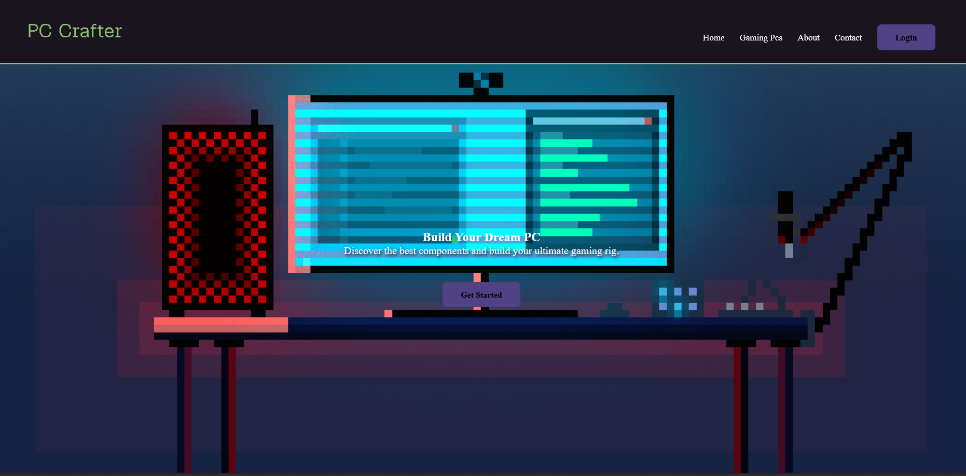

3.2 Gaming PCs Page
The Gaming PCs page was created to display the different PC options available from PC Crafter.
I used a card layout to display the PCs next to each other rather than placing them underneath each other. Each card contains an image, the name of the PC, its price and an Order Now link.
The cards were given the same size and styling so that the three products look consistent. The layout also makes it easier for users to compare the available options.
Figure 2: PC Crafter Gaming PCs page.
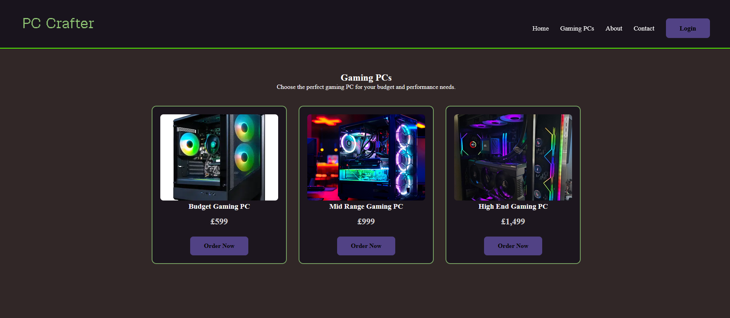
3.3 About Page
The About page provides users with a short explanation of what PC Crafter is about. I kept this page simple because its main purpose is to provide information about the website and the service.
The page uses the same header and navigation as the other pages. A background GIF and a central content box were used to keep the design consistent with the rest of the website.
Figure 3: PC Crafter About page.
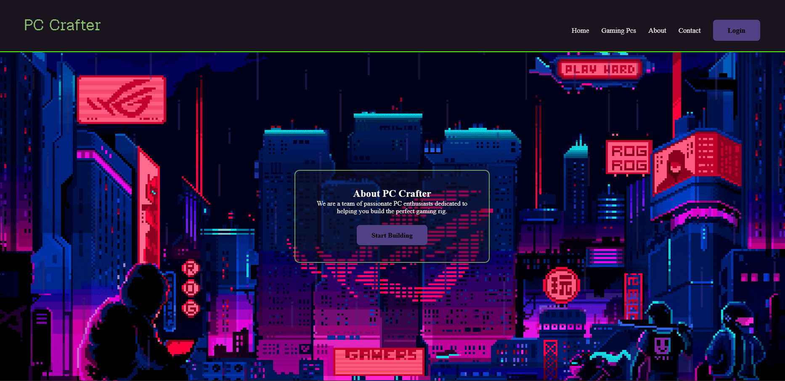
3.4 Contact Page
The Contact page was designed to allow users to request a gaming PC.
The page contains fields for the user's name and email address. It also contains a dropdown menu where the user can select which PC they are interested in. A larger requirements text box allows the user to explain any additional requirements or custom modifications.
A Send Order button was also added to the form.

Figure 4: PC Crafter Contact page.
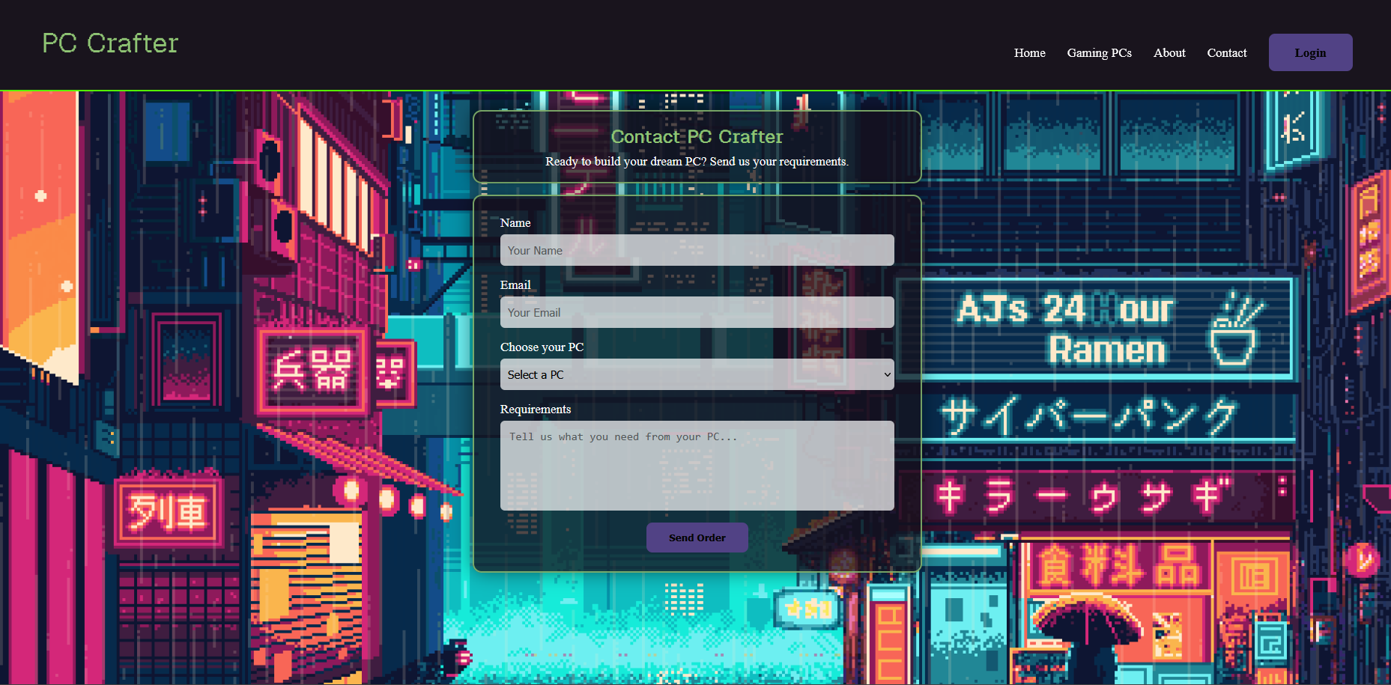
3.5 Login Page
The Login page was created as the entry point for users who need to log in. It contains an Email/Username field, a password field, a Show Password checkbox and a Login button.
The input boxes were styled with a partly transparent background so that they fit better with the background GIF while still being easy to read.
Figure 5: PC Crafter Login page.
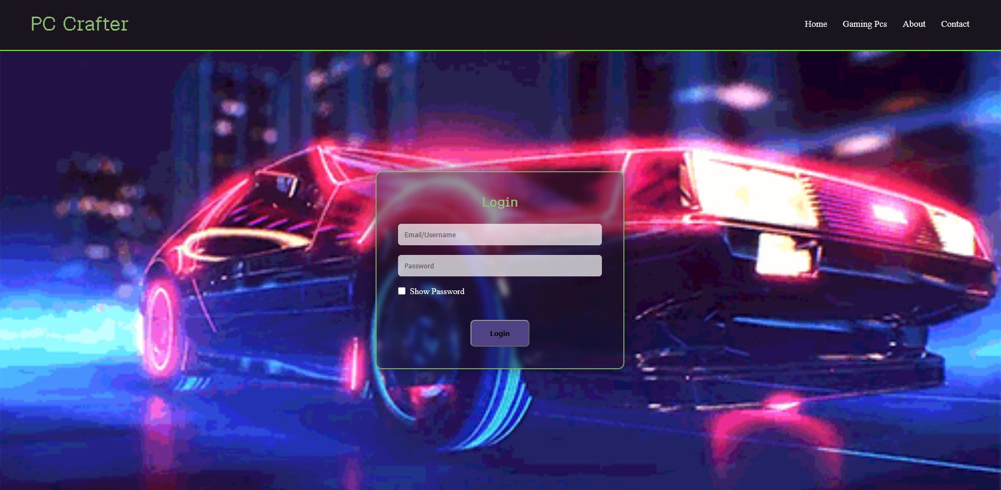

Validation
HTML Validation
Figure 6: HTML validation result.
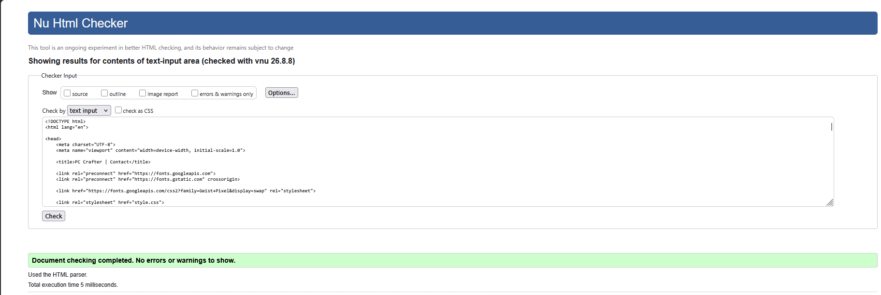
I checked the HTML of the Home page and the main CSS file using the W3C validators. Both checks were completed without any validation errors. This shows that the HTML and CSS followed the relevant syntax standards at the time of testing.
CSS Validation
Figure 8: CSS validation result.
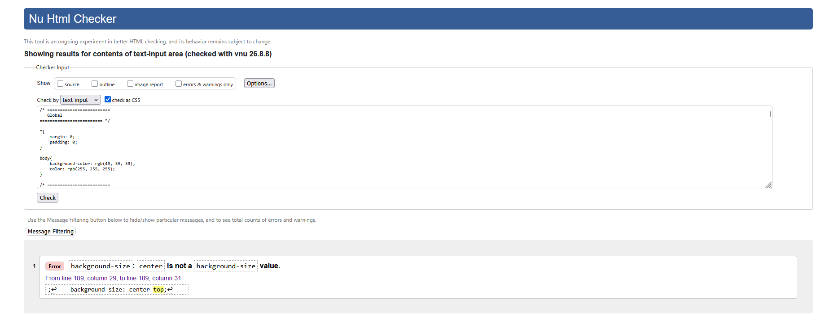
When I first validated my CSS, I found one error related to the background-size property. I had used center top as the value, but this is not a valid value for background-size. I corrected it to cover and kept center top for the background-position property. I then ran the validator again to check that the problem had been fixed.

Evaluation
5. Usability
Usability is about how easily users can understand and use a website. A usable website should make it clear where users are, what they can do and how they can complete the tasks they want to perform.
For PC Crafter, I tried to keep the navigation consistent across all five pages. The navigation bar contains links to Home, Gaming PCs, About, Contact and Login. This means users do not have to go back to the home page every time they want to visit another section.
The Gaming PCs page also uses cards so that the products can be viewed side by side. Each card has a clear product name, image, price and Order Now link. This makes it easier for users to compare the different options.
The Contact page is also designed around a simple form. Users can enter their name and email, select a PC from the dropdown and explain their requirements. This reduces the amount of information the user needs to type manually.
One improvement I would make in the future would be to make the ordering system fully functional. At the moment, the website provides the interface for ordering, but it does not have a real database or payment system behind it. A future version could allow orders to be stored and processed automatically.

5.1 Accessibility
Accessibility is important because websites should be usable by as many people as possible, including users with disabilities. WCAG 2.1 provides accessibility guidance based around four principles: Perceivable, Operable, Understandable and Robust.
Perceivable
The website uses text, images and clear visual sections to present information. The PC cards contain images and text so users can understand what each product represents.
The colour scheme uses white text and green headings against dark backgrounds. However, the use of animated GIF backgrounds could potentially make some content harder to read depending on the image behind it. This is something that could be improved by making the background darker or adding stronger overlays behind important content.

Operable
The main navigation uses standard HTML links, making it possible for users to move between pages. The forms also use normal input controls such as text boxes, dropdowns and buttons.
The Show Password option on the login page also gives users an easier way to check what they have typed.
A future improvement would be to test the complete website using only a keyboard and an accessibility testing tool such as WAVE or axe.
Understandable
The pages use straightforward labels such as "Name", "Email", "Choose your PC" and "Requirements". This makes it clear what information the user needs to enter.
The consistent navigation and similar design between pages also helps users understand how the website is structured.
Robust
The website uses standard HTML and CSS rather than relying on a complicated framework. Standard HTML elements such as forms, inputs, links and headings are used throughout the site.
However, more accessibility testing would be needed before claiming that the website fully complies with WCAG 2.1. Automated tools can find many problems, but accessibility also needs human testing. WCAG itself notes that accessibility testing involves testable criteria and techniques rather than simply relying on one automated check.
5.2 Search Engine Optimisation
SEO is important because it helps search engines understand a website and can help users find relevant pages through search engines.
I used descriptive page titles throughout the website, such as PC Crafter | Contact and PC Crafter | Login. Descriptive titles are useful because search engines can use the HTML title element when generating search results. Google recommends using unique, clear and concise page titles that accurately describe the page.
The website also uses headings such as Gaming PCs and Contact PC Crafter to describe the main content of each page.
Images on the Gaming PCs page also have alt attributes, for example the PC images have descriptions such as Budget Gaming PC. Alt text can help search engines understand what an image represents and also provides a text alternative when an image cannot be viewed.
Internal links are another basic SEO feature used by the website. The navigation links connect the five pages, allowing users and search engines to move between related pages.
One limitation is that PC Crafter is a small project website and does not currently have advanced SEO features such as structured data, an XML sitemap or a large amount of content. These could be added if the website was developed into a real business website.
5.4 Comparison With Existing Websites
For this part, you need to choose two real websites with a similar purpose. Your brief specifically asks you to compare them for usability, accessibility, SEO and mobile friendliness.
A sensible choice for PC Crafter would be two established PC retailers, for example:
- CyberPowerSystem
- Overclockers UK
But you need to actually visit/test the two websites yourself before writing this section.
Area | PC Crafter | CyberPowerSystems | Overclockers
Usability | Simple navigation and PC cards | Product grid with detailed PC information and Shop buttons | Product listings with filters, sorting and Add to Basket
Accessibility | Basic labels, contrast, etc. | More detailed product information and navigation | Lots of controls, filters and product information
SEO | Titles, headings, alt text | Detailed product names and descriptions | Detailed product names, descriptions and category pages
Mobile | Test on browser/device | Responsive commercial shopping layout | Responsive commercial shopping layout

Compare:
The main advantage of PC Crafter is that it is simple. Since the website only has three PC choices, users can see the available options without having to use filters or search through a large catalogue. The PC cards also make the products easy to compare.
However, CyberPowerPC and Overclockers have an advantage when it comes to finding a very specific PC because they have much larger product ranges and more advanced navigation. Overclockers, for example, provides filtering, sorting and a PC advisor to help users find a suitable system.
For ordering, PC Crafter is currently more of a request/order form system, while Overclockers provides a proper shopping experience with products that can be added to a basket.
This gives you a good evaluation point: PC Crafter is easier because it's simple, but the bigger websites are more powerful because they give users more ways to search and buy. That's exactly the kind of comparison your report needs.

Conclusion
Then make an actual judgement:
Overall, I think CyberPowerPC/Overclockers is better for a user who wants a large selection of gaming PCs because it offers I much more advanced customizations and product list. PC Crafter is simpler and focuses more directly on being very simple and easy to manage, with not so many buttons or options making it less stressful and more friendly. However, the comparison showed me that PC Crafter could be improved by adding more products, a bigger catalogue of gaming pcs, a search bar where you can look up specific products and descriptions on the products.

6. Future Improvements / Overall Conclusion
Overall, I think the PC Crafter website achieved what I wanted it to do. The main idea was to c[reate a simple gaming PC website where users could look at different PCs, see their prices and contact the website if they wanted to order a PC or request changes. I was able to create five connected pages and keep the same design throughout the website using HTML and CSS.
While making the website, I learned more about how HTML and CSS work together and how different parts of a website can be organised into sections, cards, forms and navigation menus. I also learned how important it is to keep the design consistent between pages so the website feels like one complete website instead of separate pages.
There are still quite a few things that I would improve if I continued working on PC Crafter. The login system could be connected to a database so that users could actually create accounts and log in properly instead of the page only providing the login interface. The order form could also be connected to a database so that orders and customer requirements could be saved and processed.
I would also add a shopping basket so users could select different products before ordering. The Gaming PCs page could be expanded with more computers and more detailed specifications such as the CPU, GPU, RAM and storage. This would give customers more information when comparing the different PCs.
Another improvement would be making the website work better on mobile devices. The current website was mainly designed around a desktop layout, so I would spend more time testing different screen sizes and changing the layout where necessary. I would also carry out more accessibility testing to make sure the website is easier for all users to use.
For SEO, I would add more useful content and improve the website's metadata and other SEO features so that PC Crafter would have a better chance of appearing in search engine results. I would also improve the contact and ordering process by giving users a confirmation after they submit an order.
In the future, I could also add different account types such as Guest, Client, Staff, Admin and Dev. Each account type could have different permissions depending on what the user needs to access.
Overall, PC Crafter is a good starting point for a gaming PC website. It has the main pages and features needed to allow users to browse PCs and contact the business, but there are still many features that could be added to turn it into a complete working online PC store.
7. References
[1] J. W. Palmer, “Web Site Usability, Design, and Performance Metrics,” Information Systems Research, vol. 13, no. 2, pp. 151–167, 2002.
[2] J. Lazar, A. Dudley-Sponaugle, and K.-D. Greenidge, “Improving web accessibility: A study of webmaster perceptions,” Computers in Human Behavior, vol. 20, no. 2, pp. 269–288, 2004, doi: 10.1016/j.chb.2003.10.018.
[3] S. Kumar, J. Shree, and P. Biswas, “Comparing ten WCAG tools for accessibility evaluation of websites,” Technology and Disability, vol. 33, no. 3, 2021, doi: 10.3233/TAD-210329.
[4] N. Silva and A. S. Aguiar, “Web site optimization for search engines: An empirical study,” in Proc. 9th Iberian Conference on Information Systems and Technologies (CISTI), 2014, doi: 10.1109/CISTI.2014.6876888.
[5] World Wide Web Consortium, Web Content Accessibility Guidelines (WCAG) 2.1, W3C Recommendation, 2025.
[6] Google, “SEO Starter Guide: The Basics,” Google Search Central, 2025.

8. Appendices
index.html
<!DOCTYPE html>
<html lang="en">
<head>
<meta charset="UTF-8">
<meta name="viewport" content="width=device-width, initial-scale=1.0">
<title>PC Crafter</title>
<link rel="preconnect" href="https://fonts.googleapis.com">
<link rel="preconnect" href="https://fonts.gstatic.com" crossorigin>
<link href="https://fonts.googleapis.com/css2?family=Geist+Pixel&display=swap" rel="stylesheet">
<link rel="stylesheet" href="style.css">
</head>
<body>
<header>
<h1>PC Crafter</h1>
<nav>
<a href="index.html">Home</a>
<a href="services.html">Gaming Pcs</a>
<a href="about.html">About</a>
<a href="contact.html">Contact</a>
<a href="login.html" class="btn">Login</a></nav>
</header>
<main>
<section class="hero">
<h2>Build Your Dream PC</h2>
<p>Discover the best components and build your ultimate gaming rig.</p>
<a href="services.html" class="btn">Get Started</a>
</section>
</main>
</body>
</html>
services.html
<!DOCTYPE html>
<html lang="en">
<head>
<meta charset="UTF-8">
<meta name="viewport" content="width=device-width, initial-scale=1.0">
<title>PC Crafter</title>
<link rel="preconnect" href="https://fonts.googleapis.com">
<link rel="preconnect" href="https://fonts.gstatic.com" crossorigin>
<link href="https://fonts.googleapis.com/css2?family=Geist+Pixel&display=swap" rel="stylesheet">
<link rel="stylesheet" href="style.css">
</head>
<body>
<header>
<h1>PC Crafter</h1>
<nav>
<a href="index.html">Home</a>
<a href="services.html">Gaming PCs</a>
<a href="about.html">About</a>
<a href="contact.html">Contact</a>
<a href="login.html" class="btn">Login</a>
</nav>
</header>
<main>
<section class="services">
<h2>Gaming PCs</h2>
<p>Choose the perfect gaming PC for your budget and performance needs.</p>

<div class="pc-cards">
<div class="pc-card">
<img src="images/budgetpc.jpg" alt="Budget Gaming PC">
<h3>Budget Gaming PC</h3>
<p class="price">£599</p>
<a href="contact.html" class="btn">Order Now</a>
</div>
<div class="pc-card">
<img src="images/Mid Range Gaming PC.jpg" alt="Mid Range Gaming PC">
<h3>Mid Range Gaming PC</h3>
<p class="price">£999</p>
<a href="contact.html" class="btn">Order Now</a>
</div>
<div class="pc-card">
<img src="images/High End Gaming PC.jpg" alt="High End Gaming PC">
<h3>High End Gaming PC</h3>
<p class="price">£1,499</p>
<a href="contact.html" class="btn">Order Now</a>
</div>
</div>
</section>
</main>
</body>
</html>
Appendix C — about.html
<!DOCTYPE html>
<html lang="en">
<head>
<meta charset="UTF-8">
<meta name="viewport" content="width=device-width, initial-scale=1.0">
<title>PC Crafter</title>
<link rel="preconnect" href="https://fonts.googleapis.com">
<link rel="preconnect" href="https://fonts.gstatic.com" crossorigin>
<link href="https://fonts.googleapis.com/css2?family=Geist+Pixel&display=swap" rel="stylesheet">
<link rel="stylesheet" href="style.css">
</head>
</head>
<body>
<header>
<h1>PC Crafter</h1>
<nav>
<a href="index.html">Home</a>
<a href="services.html">Gaming Pcs</a>
<a href="about.html">About</a>
<a href="contact.html">Contact</a>
<a href="login.html" class="btn">Login</a></nav>
</header>
<main>
<section class="about">
<div class="about-box">
<h2>About PC Crafter</h2>
<p>We are a team of passionate PC enthusiasts dedicated to helping you build the perfect gaming rig.</p>
<a href="services.html" class="btn">Start Building</a>
</div>
</section>
</main>
</body>

contact.html
<!DOCTYPE html>
<html lang="en">

<head>
<meta charset="UTF-8">
<meta name="viewport" content="width=device-width, initial-scale=1.0">
<title>PC Crafter | Contact</title>
<link rel="preconnect" href="https://fonts.googleapis.com">
<link rel="preconnect" href="https://fonts.gstatic.com" crossorigin>
<link href="https://fonts.googleapis.com/css2?family=Geist+Pixel&display=swap" rel="stylesheet">
<link rel="stylesheet" href="style.css">
</head>
<body>
<header>
<h1>PC Crafter</h1>
<nav>
<a href="index.html">Home</a>
<a href="services.html">Gaming PCs</a>
<a href="about.html">About</a>
<a href="contact.html">Contact</a>
<a href="login.html" class="btn">Login</a>
</nav>
</header>
<main>
<section class="contact">
<!-- Contact introduction -->
<div class="contact-header">
<h2>Contact PC Crafter</h2>
<p>
Ready to build your dream PC? Send us your requirements.
</p>
</div>
<!-- Order form -->

<form class="contact-form">
<label for="name">Name</label>
<input
type="text"
id="name"
name="name"
placeholder="Your Name"
>
<label for="email">Email</label>
<input
type="email"
id="email"
name="email"
placeholder="Your Email"
>
<label for="pc">Choose your PC</label>
<select id="pc" name="pc">
<option value="">Select a PC</option>
<option value="Budget Gaming PC">
Budget Gaming PC - £699
</option>
<option value="Mid Range Gaming PC">
Mid Range Gaming PC - £1299
</option>
<option value="Ultimate Gaming PC">
Ultimate Gaming PC - £2499
</option>
</select>
<label for="message">Requirements</label>
<textarea
id="message"
name="message"
placeholder="Tell us what you need from your PC..."
></textarea>
<button type="submit" class="btn">
Send Order
</button>
</form>
</section>
</main>
</body>
</html>

login.html
<!DOCTYPE html>
<html lang="en">
<head>
<meta charset="UTF-8">
<meta name="viewport" content="width=device-width, initial-scale=1.0">
<title>PC Crafter</title>
<link rel="preconnect" href="https://fonts.googleapis.com">
<link rel="preconnect" href="https://fonts.gstatic.com" crossorigin>
<link href="https://fonts.googleapis.com/css2?family=Geist+Pixel&display=swap" rel="stylesheet">
<link rel="stylesheet" href="style.css">
</head>
</head>
<body>
<header>
<h1>PC Crafter</h1>
<nav>
<a href="index.html">Home</a>
<a href="services.html">Gaming Pcs</a>
<a href="about.html">About</a>
<a href="contact.html">Contact</a>
</nav>
</header>
<section class="login">
<div class="login-box">
<h2>Login</h2>
<input type="text" id="username" placeholder="Email/Username">
<input type="password" id="password" placeholder="Password">
<label class="show-password">
<input type="checkbox" id="showPassword">
Show Password
</label>
<button class="btn">Login</button>
</div>
</section>
</body>
</html>
style.css
/* =========================
Global
========================= */
*{
margin: 0;
padding: 0;
}
body{
background-color: rgb(49, 39, 39);
color: rgb(255, 255, 255);
}

/* =========================
Typography
========================= */

h1{
font-family: "Geist Pixel", sans-serif;
font-optical-sizing: auto;
font-weight: 400;
font-style: normal;
font-variation-settings: "ELSH" 0;

font-size: 36px;
color: rgb(143, 197, 116);

}

/* =========================
Header
========================= */
header{
display: flex;
align-items: center;
justify-content: space-between;

padding: 25px 60px;

background-color: rgba(21, 16, 27, 0.85);
border-bottom: 2px solid rgb(85, 255, 0);
backdrop-filter: blur(8px);
}
header p{
text-align: center;
font-size: 18px;
margin-top: 10px;
color: rgb(143, 197, 116);
}

/* =========================
Navigation
========================= */

nav a{
color: rgb(255, 255, 255);
text-decoration: none;
margin-left: 25px;
font-size: 17px;
}
nav a:hover{
color: rgb(143, 197, 116);
}

/* =========================
Home Page
========================= */

.hero{
min-height: 77vh;
display: flex;
flex-direction: column;
justify-content: center;
align-items: center;
text-align: center;

background-image: url("images/hero.gif.gif");
background-size: cover;
background-position: center 37%;
background-repeat: no-repeat;
padding: 40px;
}
.hero p{
font-size: 20px;
max-width: 700px;
margin-bottom: 25px;
text-shadow: 3px 3px 6px rgb(0, 0, 0);
}

/* =========================
Buttons
========================= */

.btn{
display: inline-block;
margin-top: 25px;
padding: 15px 35px;

background-color: rgb(81, 66, 133);
color: rgb(5, 5, 5);
text-decoration: none;
border-radius: 8px;
font-weight: bold;
transition: 0.3s;
}
.btn:hover{
background-color: rgb(180, 230, 140);
transform: scale(1.05);
}

/* =========================
Login Page
========================= */

.login{
min-height: 89vh;
display: flex;
justify-content: center;
align-items: center;

background-image: url("images/login.gif.gif");
background-size: cover;
background-position: 50% 10%;
background-repeat: no-repeat;
}

.login-box{
width: 380px;
padding: 40px;

background: rgba(21, 16, 27, 0.45);

backdrop-filter: blur(5px);
-webkit-backdrop-filter: blur(12px);

border: 2px solid rgba(143,197,116,.8);

border-radius: 12px;

box-shadow: 0 0 25px rgba(0,0,0,.5);

text-align: center;
}

.login-box h2{
font-family: "Geist Pixel", sans-serif;
color: rgb(143, 197, 116);
margin-bottom: 25px;
}

.login-box input[type="text"],
.login-box input[type="password"]{
background-color: rgba(255, 255, 255, 70%);
color: rgb(0, 0, 0);
width: 100%;
padding: 12px;
margin-bottom: 18px;
border-radius: 6px;
border: none;
box-sizing: border-box;

}
.show-password{
display: flex;
align-items: center;
gap: 8px;
color: white;
margin-bottom: 20px;
cursor: pointer;
}

.show-password input{
width: auto;
margin: 0;
}

/* =========================
about Page
========================= */
.about{
min-height: 85vh;
display: flex;
justify-content: center;
align-items: center;

background-image: url("images/about.gif.gif");
background-size: center top;
background-position: 60% 20%;
background-repeat: no-repeat;
}
/* =========================
About Box
========================= */
.about-box{
width: 380px;
padding: 40px;

background: rgba(21, 16, 27, 0.45);

backdrop-filter: blur(1px);
-webkit-backdrop-filter: blur(12px);

border: 2px solid rgba(143,197,116,.8);

border-radius: 12px;

box-shadow: 0 0 25px rgba(0,0,0,.5);

text-align: center;
}
/* =========================
Services Page
========================= */

.services{
min-height: 80vh;
padding: 60px;
text-align: center;
}

.pc-cards{
display: flex;
justify-content: center;
gap: 30px;
margin-top: 40px;
}

.pc-card{
width: 300px;
padding: 20px;

background: rgba(21, 16, 27, 0.75);
border: 2px solid rgba(143, 197, 116, 0.8);
border-radius: 12px;

text-align: center;
}

.pc-card img{
width: 100%;
height: 220px;
object-fit: cover;
border-radius: 8px;
}
.price{
font-size: 22px;
font-weight: bold;
color: rgba(255, 255, 255, 0.795);
margin-top: 15px;
}
/* =========================
Contact Page
========================= */

.contact {
min-height: calc(100vh - 110px);

display: flex;
flex-direction: column;
align-items: center;

padding: 25px 20px;

box-sizing: border-box;

background-image: url("images/contact.gif");
background-size: cover;
background-position: center;
background-repeat: no-repeat;
}

/* =========================
Contact Header
========================= */

.contact-header {
width: 600px;
max-width: 90%;

padding: 18px 30px;
margin-bottom: 15px;

box-sizing: border-box;

background: rgba(21, 16, 27, 0.75);

border: 2px solid rgba(143, 197, 116, 0.8);
border-radius: 12px;

text-align: center;

box-shadow: 0 0 20px rgba(0, 0, 0, 0.5);
}

.contact-header h2 {
margin: 0 0 7px;

font-family: "Geist Pixel", sans-serif;
color: rgb(143, 197, 116);
}

.contact-header p {
margin: 0;

color: white;
font-size: 17px;
}

/* =========================
Contact Form
========================= */

.contact-form {
width: 600px;
max-width: 90%;

padding: 25px 35px;

box-sizing: border-box;

background: rgba(21, 16, 27, 0.75);

border: 2px solid rgba(143, 197, 116, 0.8);
border-radius: 12px;

box-shadow: 0 0 25px rgba(0, 0, 0, 0.5);
}

/* =========================
Form Labels
========================= */

.contact-form label {
display: block;

margin-bottom: 6px;

color: white;

font-size: 17px;
}

/* =========================
Inputs
========================= */

.contact-form input,
.contact-form select {
width: 100%;
height: 42px;

padding: 10px;

margin-bottom: 15px;

box-sizing: border-box;

background-color: rgba(255, 255, 255, 0.7);

color: black;

border: none;
border-radius: 6px;

font-size: 15px;
}

/* =========================
Requirements
========================= */

.contact-form textarea {
width: 100%;
height: 120px;

padding: 12px;

margin-bottom: 15px;

box-sizing: border-box;

background-color: rgba(255, 255, 255, 0.7);

color: black;

border: none;
border-radius: 6px;

font-size: 15px;

resize: none;
}

/* =========================
Send Order Button
========================= */

.contact-form .btn {
display: block;

margin: 0 auto;

padding: 12px 30px;

border: none;

cursor: pointer;
}

