

Module Name: Digital Skills for Personal Development and Business Growth
Module Code: BMSW4008_Card
Assignment Name: Evidence of Learning (E-Portfolio)
Student Name: Cristina Limbau
Student Number: 2410885
Lecturer: Philippa Fitzgerald
Deadline: 20th June 23.59pm

AI Acknowledgement
I confirm that I have not presented any AI generated materials as my own work.
I confirm that I have copies of my drafts, notes, and other resources I used, which I may be asked to provide in evidence.

Contents

Contents 3
Task 1 4
Analysis of Customer Insights of CL Nails and Beauty 4
Introduction 4
Questionnaire Analyse 4
1. How Clients Discover New Beauty Salons 4
2. How Much Clients Spend per Visit 5
3. Most Desired Treatments 6
4. Most Important Factors When Choosing a Salon 7
Audience Segmentation 7
SEO Strategy 8
Conclusion 8
Website 9
Marketing Materials 12
Task 2 17
Microsoft Spreadsheet and Bar Chart 17
Essay: The Importance of Excel in the Digital Era and Its Application in CL Nails and Beauty 18
Reference List Task 1 & 2 21

Task 1

Analysis of Customer Insights of CL Nails and Beauty

Introduction
To ensure the success of CL Nails and Beauty, it is essential to build a brand that aligns with consumer preferences, behaviours, and expectations (Shi, 2023). Based on primary research conducted through a customer questionnaire, this essay analyses key trends drawn from responses to four main questions: how clients discover beauty salons, how much they typically spend, the most desired treatments, and what they consider most important when selecting a salon. The findings have informed the business concept, website design, and marketing materials, and further support decisions related to audience segmentation and SEO strategy.

Questionnaire Analyse

1. How Clients Discover New Beauty Salons
Survey results indicate that most clients discover new beauty salons through social media platforms and recommendations from friends or family. This finding highlights the importance of maintaining a visible and engaging presence on platforms like Instagram, TikTok, and Facebook as digitalisation is a growing reality (Pinto and Guarda, 2020).
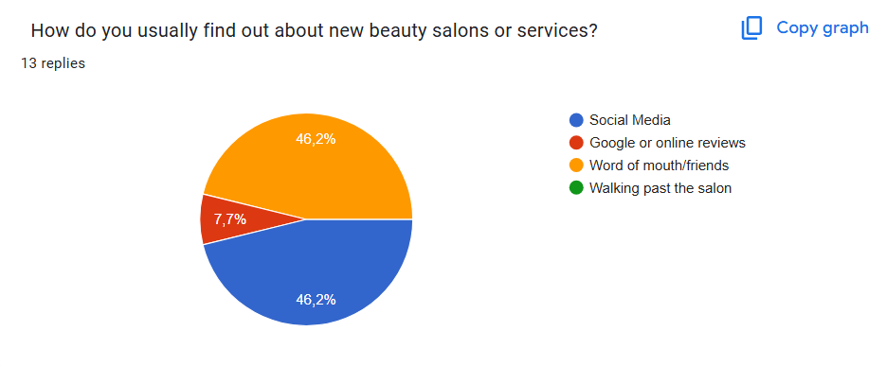
According to Dadwal (2020), the internet has revolutionised marketing by enabling brands to analyse customer interactions, while social media provides businesses with a platform to absorb intelligence and refine future strategies. Similarly, Byrd (2021) supports this notion by asserting that modern consumers increasingly rely on social media to gather information before purchasing products or booking services.
It is also essential that we also focus on word-of-mouth marketing. According to Buyapowa (2023), a large majority of consumers place greater trust in personal recommendations than in traditional advertising.
The website for CL Nails and Beauty was therefore designed to include integrated Instagram content, client testimonials, and booking options integrated with social media platforms. The significance of visual content and user-generated reviews cannot be overstated for digital engagement (Soltanifar, Hughes and Göcke, 2021).

2. How Much Clients Spend per Visit
The data shows that most clients spend between £40 and £80 per visit, suggesting a preference for mid to premium priced services. This implies that customers are willing to invest in quality experiences rather than seeking the lowest prices.
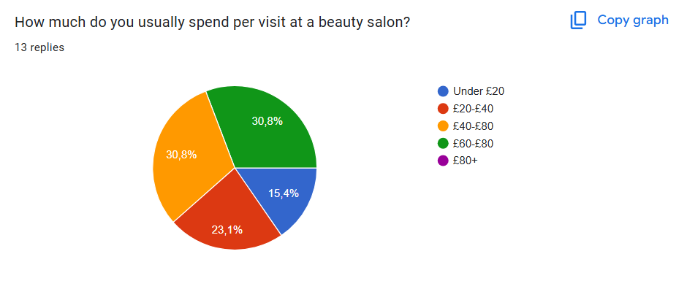
According to Kim and Kim (2021), post-COVID beauty consumers show a strong preference for trustworthy, professional, and hygienic environments, often justifying higher prices in exchange for safety and value. Sandhu (2020) also argues that service quality significantly impacts business growth, reinforcing the need for premium offerings. These insights led to CL Nails and Beauty being positioned as a luxury salon that offers expert treatments using high-quality products.
Website content was shaped accordingly, with a focus on luxury branding, premium package pricing, and personalised care descriptions. Clear pricing and value-driven service explanations were added to support transparency and increase customer trust.

3. Most Desired Treatments
When asked about their preferred beauty treatments, respondents overwhelmingly chose nails, followed by lashes, brows, and waxing. These preferences align with the services already planned for CL Nails and Beauty, reinforcing the business direction.
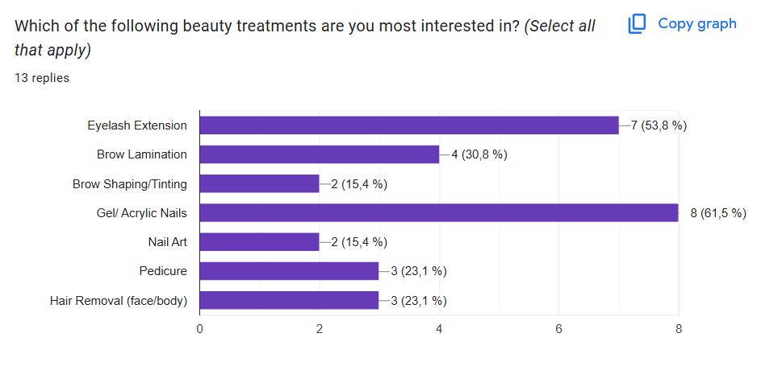
Segmenting the market by service preferences helps streamline offerings and allows targeted marketing (Kumar, 2020). Packages that combine nails with lashes or brows were integrated into the website booking system to reflect the most popular combinations. Shi (2023) explains that personalised service and presentation are central to influencing beauty consumer behaviour.
Additionally, understanding the needs of younger consumers, particularly Gen Z, was essential. Jovanka and Putri (2024) note that this demographic values authenticity and digital engagement. As a result, the site was designed with vibrant visuals and mobile-optimised booking pages.

4. Most Important Factors When Choosing a Salon
The fourth key finding from the questionnaire showed that skilled technicians, high-quality products, and friendly service were the top criteria clients consider when choosing a salon. This aligns with research that highlights service excellence as a core business growth factor (Sandhu, 2020).
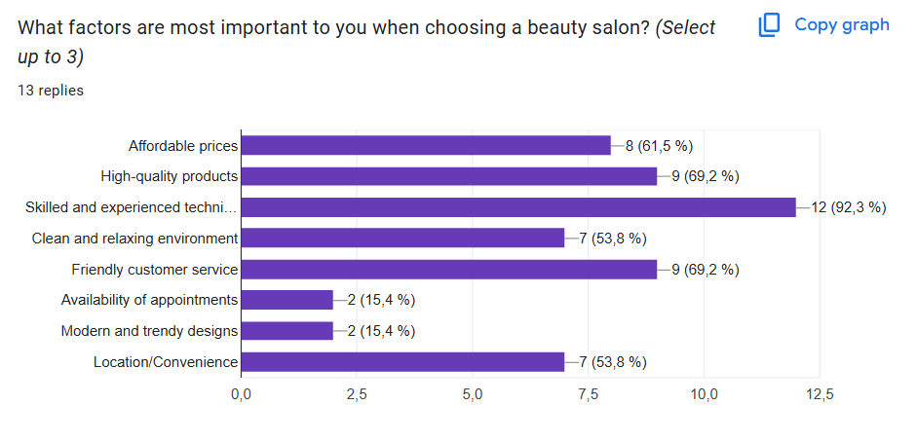
To support this, website content features staff qualifications, product details, and customer service commitments prominently. Testimonials and a photo gallery provide additional assurance of quality and professionalism. This also strengthens the brand image and encourages loyalty.
These findings directly influenced our value proposition: high standards, qualified professionals, and personalised customer care, clearly communicated through all digital and printed marketing.

Audience Segmentation
Segmenting the audience based on age, gender, preferred treatments, and spending habits allows for a more focused marketing strategy. For instance, younger consumers are more likely to book via mobile and seek trend-driven services, while slightly older demographics may prioritise reliability and product quality. These insights informed the layout and navigation of the website.
Market segmentation further allowed the business to develop appropriate tone of voice, imagery, and promotional offers for each audience group. This level of strategic segmentation increases conversion and loyalty (Kumar, 2020).

SEO Strategy
The SEO strategy for CL Nails and Beauty includes both on-page and off-page optimisation. Keywords such as “luxury nail salon in Bristol”, “expert lash technician”, and “premium beauty services near me” were integrated across the homepage, metadata, and blog section. These terms were selected using both customer input and keyword research tools.
Search engine marketing and SEO are essential in attracting organic traffic, particularly for local businesses (Pinto and Guarda, 2020). Implementing strategies such as Google Business listings, local search results, and social media metadata increases the chance of appearing in nearby searches. Rahman (2024) highlights that SEO remains a cost-effective digital marketing tool for small businesses, especially in competitive industries like beauty.
To reflect this, CL Nails and Beauty’s website was designed with mobile-first responsiveness, fast load times, and keyword-rich content blocks. Alternative text for images and consistent metadata enhance visibility further. (Investopedia, 2024).

Conclusion
The primary data collected from the customer questionnaire has been instrumental in shaping the strategic development of CL Nails and Beauty. Each insight — from how clients find salons to what they value most — has guided the formation of the business model, service offerings, marketing tone, and digital presence. Supported by academic and professional literature, this data-driven approach ensures CL Nails and Beauty is well positioned to meet the expectations of its target audience in the Bristol area.

Website

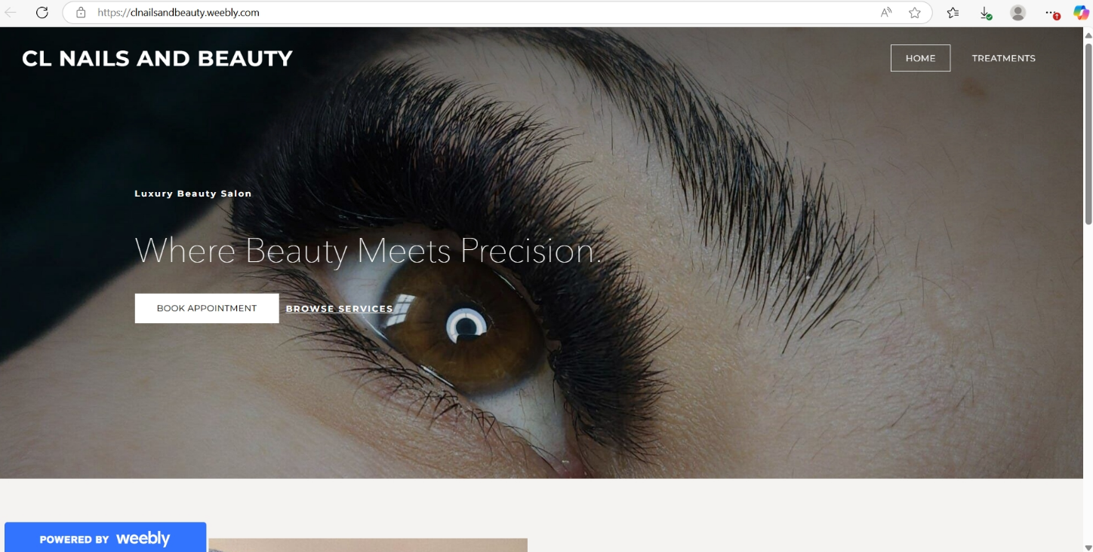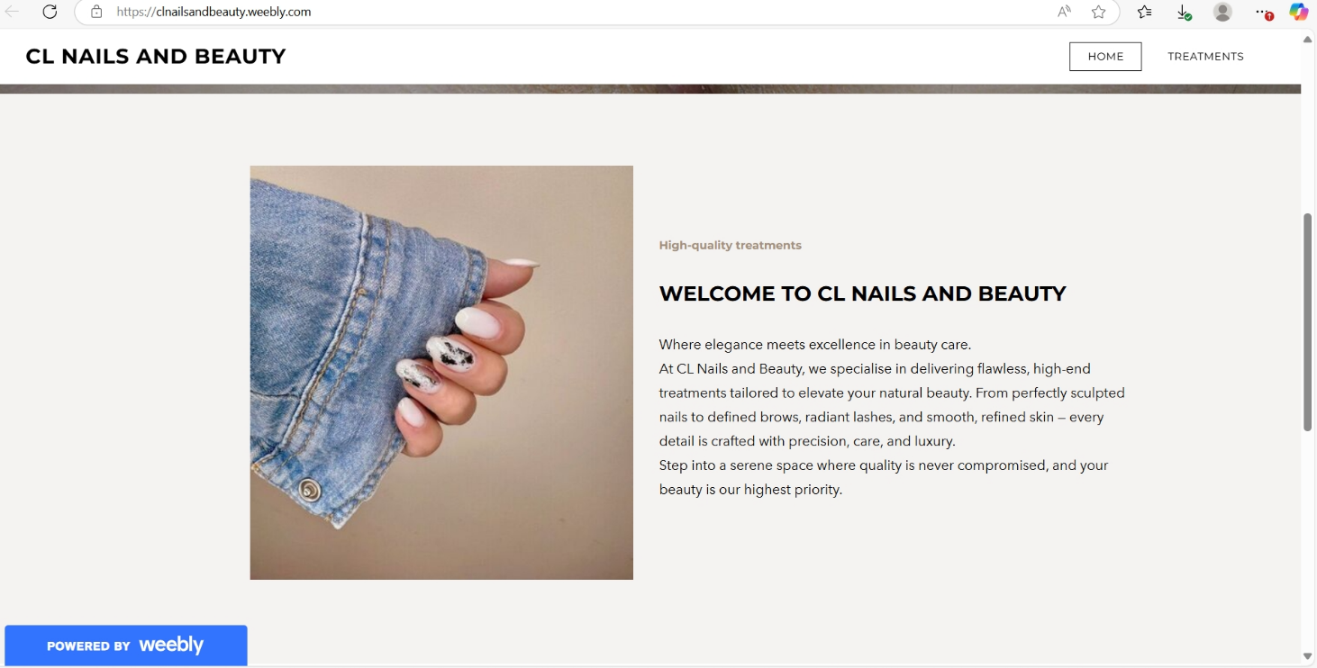
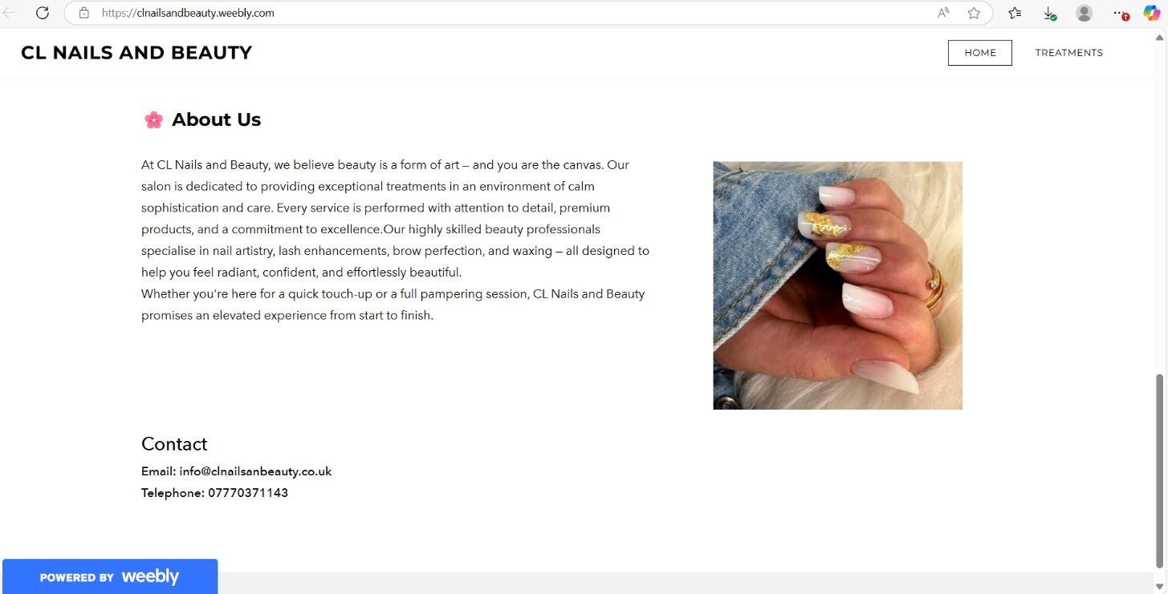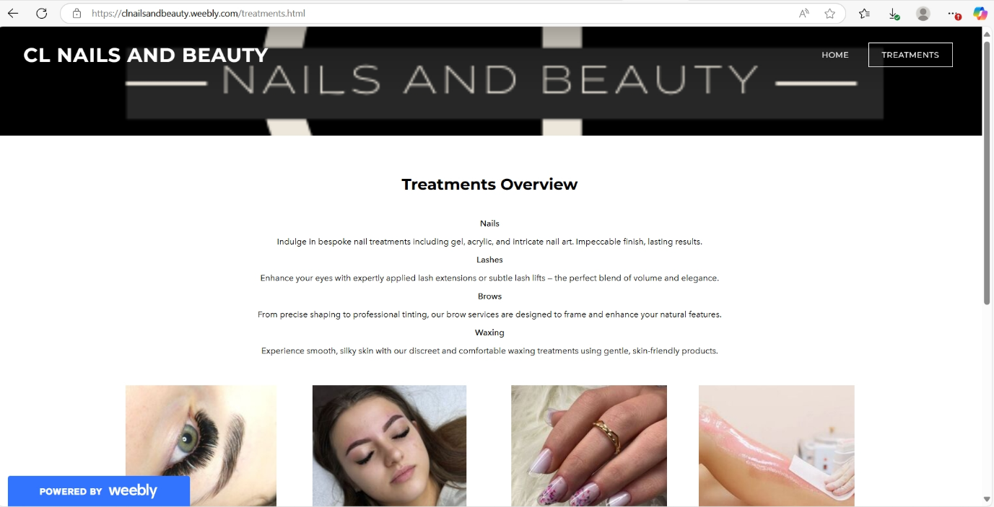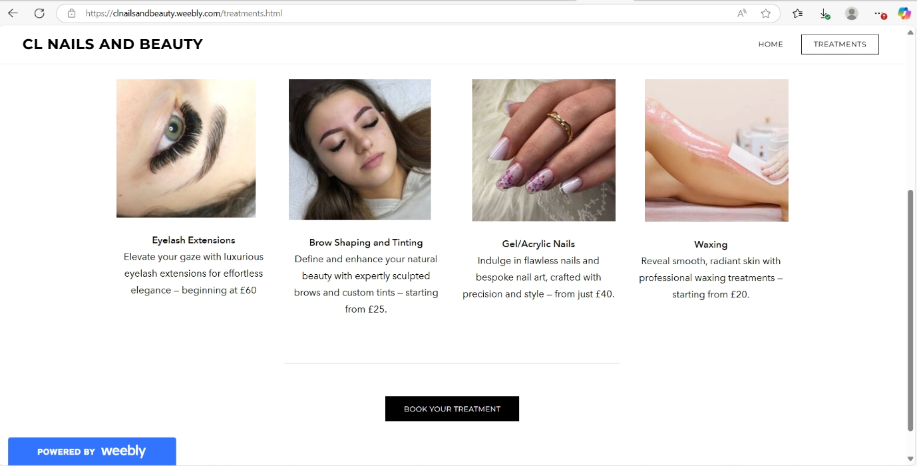

Marketing Materials

Business Card

Loyalty Card
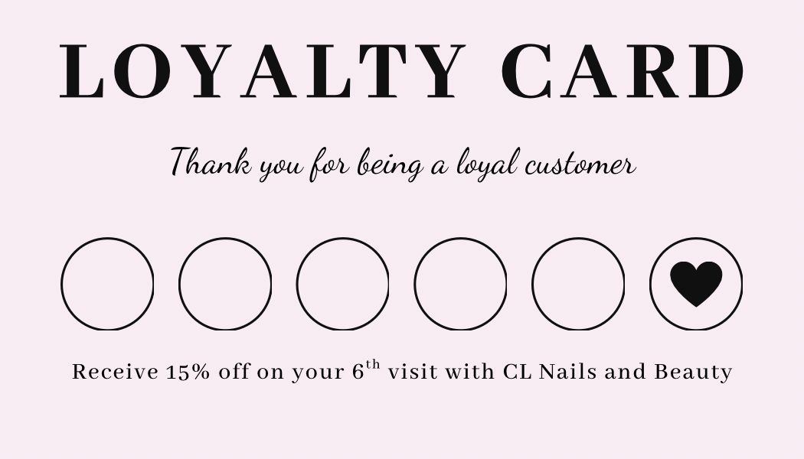

Refer a Friend Programme

QR code for Instagram account
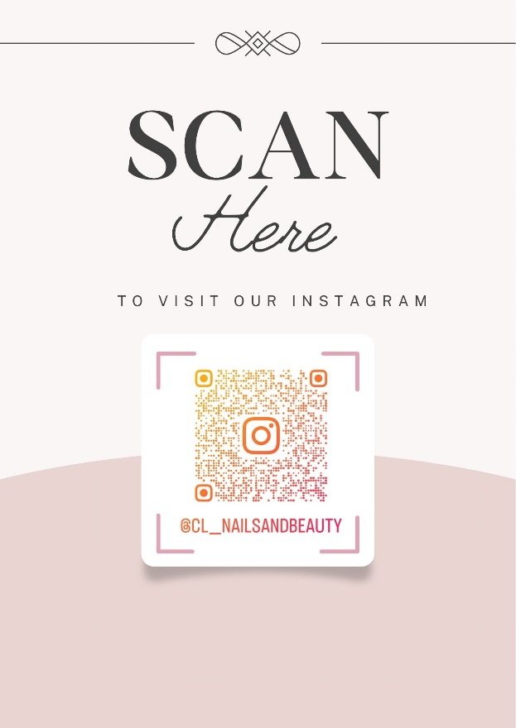

Flyer


Price List
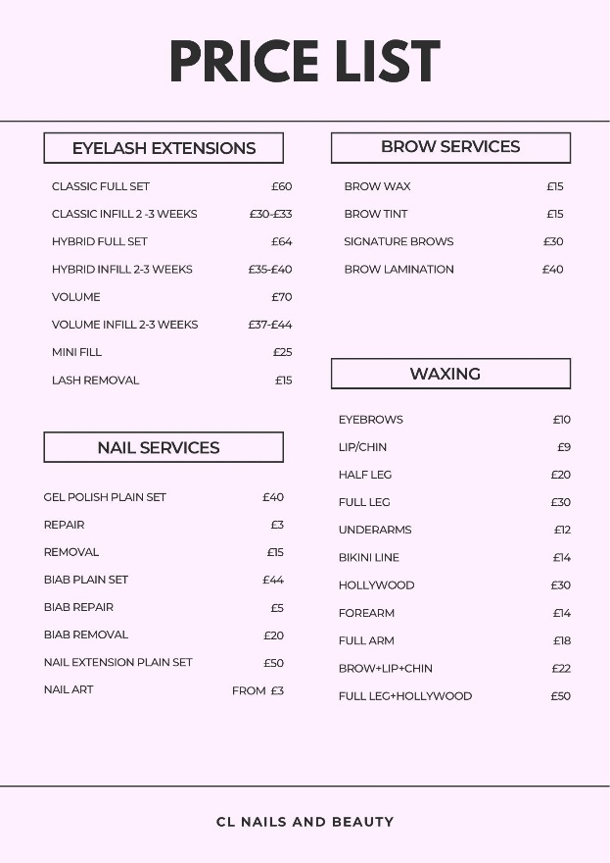
Facebook Page
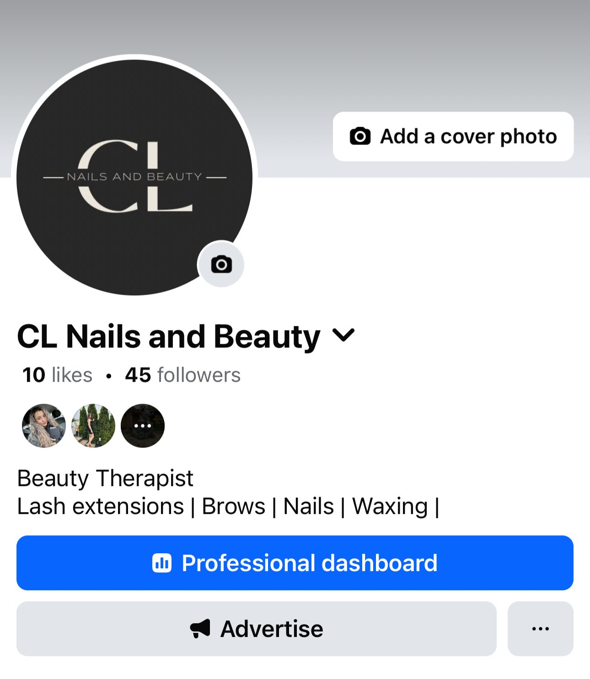

Instagram Page
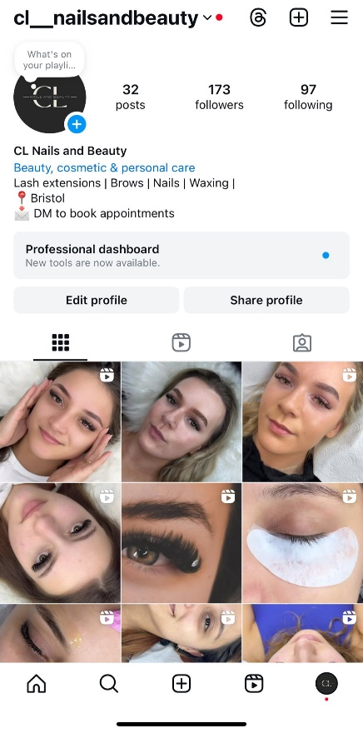
TikTok Page
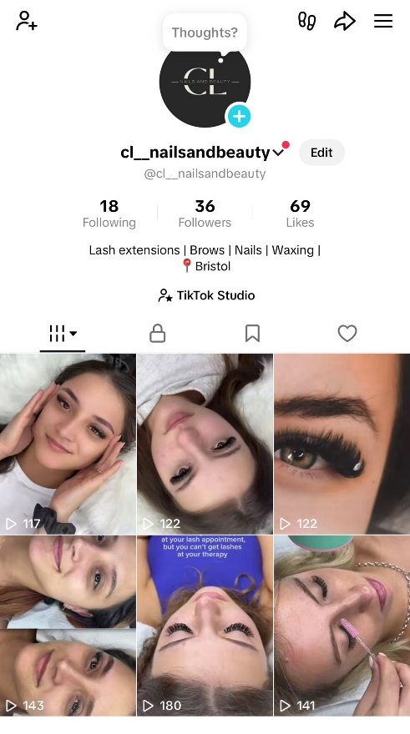

Task 2

Microsoft Spreadsheet and Bar Chart

Please, find attached link to the Microsoft Spreadsheet.
Finance project ORIGINAL.xlsx

Essay: The Importance of Excel in the Digital Era and Its Application in CL Nails and Beauty

In the digital era, tools that allow businesses to manage and manipulate data are not just useful, they are essential. Microsoft Excel remains one of the most powerful, accessible, and widely used applications for data organisation, financial planning, and analytics (Winston, 2021). It offers essential capabilities for businesses to make data-driven decisions and project future outcomes with precision. For the business CL Nails and Beauty, Excel plays a vital role in financial forecasting, resource allocation, and overall strategic planning.
Microsoft Excel has evolved far beyond its original function as a basic spreadsheet tool. Today, it integrates complex data manipulation, automated functions, and visualisation tools that support both decision-making and operational efficiency. As Kumar (2023) emphasises, Excel’s statistical tools provide vital support for research and business work by enabling the analysis of complex data to uncover actionable insights. In the context of the beauty salon, this means Excel can be used not just to track expenses and income, but also to identify seasonal patterns, evaluate marketing campaign performance, and plan staffing needs based on customer demand.
Excel’s significance in business modelling cannot be overstated. Winston (2021) explains how mastering Excel for business modelling transforms raw data into bottom-line results, helping business owners make smarter, faster decisions. This is crucial for small businesses like CL Nails and Beauty where every investment, from salon supplies to advertising, must be justified through expected returns. In the financial spreadsheet, for example, fixed monthly expenses such as rent (£1,500), bills (ranging from £300 to £600), insurance (£50 monthly equivalent), and staff salaries (£4,500 monthly) are tracked. This breakdown allows determination of the minimum monthly revenue needed to remain profitable.
Birch, Lyford Smith and Guo (2018) highlight that despite the rise of big data tools, Excel remains indispensable due to its adaptability. This is particularly true in small to medium enterprises where investing in complex software may be financially harder. For the salon, Excel provides the necessary functionality to project income based on service pricing and expected client volume. With average daily bookings of 25–35 clients, total monthly income can be estimated and aligned with the cost structure.
More than just a register, Excel now operates as a low-code analytics environment with advanced capabilities. Kumiega (2024) describes Excel as an analytics Integrated Development Environment (IDE), complete with statistical tools, and data connectors. This evolution allows entrepreneurs to create dynamic dashboards to monitor cash flow, assess growth potential, and optimise operations.
In the field of business communication and marketing, spreadsheet skills are increasingly viewed as foundational. Bobkowski and Etheridge (2023) argue that spreadsheet proficiency is essential in strategic communication roles, where data storytelling and visualisation matter. For instance, when planning social media ads or tracking client feedback, Excel is used to visualise trends, budget advertising spend and even align promotions with high-revenue months.
Additionally, Excel supports advanced decision-making methods such as sensitivity analysis and scenario planning. As Grossman (2008) outlines, native Excel techniques empower users to explore various business scenarios and mitigate risks. In the salon, this means financial impact can be simulated for offering discounts, increasing supply costs, or hiring additional staff. This foresight helps minimise financial risk and supports proactive planning.
From a financial perspective, Excel helps monitor both fixed and variable costs and assess their impact on overall profitability. Marketing expenses, including website management (£30/month), social media ads (£30/week), and printed materials (£50/month), have also been integrated directly into the spreadsheet. This allows monitoring of changes in monthly revenue alongside marketing activity.
Alliy and Brown (2008) reinforce that spreadsheets offer unique flexibility and analytical power at minimal cost, making them particularly suitable for startups. Their low entry barrier, combined with high functionality, makes Excel an irreplaceable tool in building and creating businesses. Johnson, Albizri and Jain (2024) further affirm that Excel is the most frequently required analytical tool by employers and educators in business analytics fields.
In conclusion, Excel is not just a spreadsheet tool, it is the digital engine that drives modern business decision-making. For CL Nails and Beauty, it allows real-time financial planning, strategic decision-making, and performance tracking. As the business grows, Excel will remain integral to how resources are managed, performance is visualised, and the increasingly complex demands of the beauty industry in a digital era are navigated.

Reference List Task 1 & 2

Alliy, M. and Brown, P. (2008) ‘Spreadsheets: Aiming the Accountant’s Hammer to Hit the Nail on the Head’, arXiv, published 21 September. Available at: https://arxiv.org/abs/0809.3597 (Accessed: 6 June 2025).
Birch, D., Lyford-Smith, D. and Guo, Y. (2018) ‘The Future of Spreadsheets in the Big Data Era’, arXiv, published 30 January. Available at: https://arxiv.org/abs/1801.10231 (Accessed: 6 June 2025).
Bobkowski, P. S. and Etheridge, C. E. (2023) ‘Spreadsheets, Software, Storytelling, Visualization, Lifelong Learning: Essential Data Skills for Journalism and Strategic Communication Students’, Journal of Communication Management, 27(1), pp. 1–18. Available at: https://doi.org/10.1177/10755470221147887 (Accessed: 6 June 2025).
Byrd, L. S. (Ed.). (2021). Cultivating Entrepreneurial Changemakers Through Digital Media Education. IGI Global.
Dadwal, S. S. (Ed.). (2020). Handbook of Research on Innovations in Technology and Marketing for the Connected Consumer. IGI Global. http://doi:10.4018/978-1-7998-0131-3
Grossman, T. A. (2008) ‘A Primer on Spreadsheet Analytics’, arXiv, published 21 September. Available at: https://arxiv.org/abs/0809.3586 (Accessed: 6 June 2025).
Investopedia (2024) 'SEO for Small Businesses: Everything You Need to Know', Investopedia. Available at: https://www.investopedia.com/seo-for-small-businesses-8584627 (Accessed: 29 May 2025).
Johnson, X., Albizri, Y., and Jain, R. (2024) ‘Analytics: What Do Business Majors Need and Where Do They Get It?’, Journal of Business Analytics, published online. Available at: https://doi.org/10.1080/26939169.2024.2393427 (Accessed: 6 June 2025).
Jovanka, A. and Putri, K.Y.S. (2024) 'Analysis of Generation Z's Consumer Behaviour Towards Purchasing Beauty Products', International Journal of Finance, Insurance and Risk Management, 14(3), pp. 96–104.
Kim, J. and Kim, H. (2021) 'Changes in purchasing patterns in the beauty market due to post-COVID-19', Journal of Cosmetic Science, 72(3), pp. 211–220.
Kumar, M.D. (2023) ‘A Study On Importance of Microsoft Excel Data Analysis Statistical Tools in Research Works’, Journal of Management & Educational Research Innovation, 1(3). Available at: https://doi.org/10.5281/zenodo.10449150 (Accessed: 6 June 2025).
Kumar, R. (2020) 'A brief study on market segmentation of the cosmetic industry', International Journal of Management Studies, 6(1), pp. 35–40. Available at: https://www.managejournal.com/assets/archives/2020/vol6issue1/5-6-44-288.pdf (Accessed: 29 May 2025).
Kumiega, A. (2024) ‘Excel: Automated Ledger or Analytics IDE?’, arXiv, published 3 September. Available at: https://arxiv.org/abs/2409.12976 (Accessed: 6 June 2025).
Pinto, F. M. and Guarda, T. (Eds.). (2020). Digital Marketing Strategies and Models for Competitive Business. IGI Global.
Rahman, A. (2024) 'The Effectiveness of Search Engine Optimization (SEO) in Marketing: A Meta-Analysis Study', COSTING: Journal of Economic, Business and Accounting, 7(5), pp. 45–53.
Sandhu, K. (Ed.). (2020). Digital Transformation and Innovative Services for Business and Learning. IGI Global.
Shi, R. (2023) 'The Influence of Marketing Strategy on Consumer Behavior in the Cosmetics Industry', Highlights in Business, Economics and Management, 23, pp. 623–629.
Soltanifar, M., Hughes, M. and Göcke, L. (2021) Digital Entrepreneurship. Cham: Springer.
Winston, W. (2021) Microsoft Excel Data Analysis and Business Modeling (Office 2021 and Microsoft 365). Microsoft Press.

