Education, society and policy: Contemporary classrooms

Portfolio - Create a portfolio that critically reflects how the role of the educational practitioner supports and develops learning in an education setting of your choice. You must include four separate elements to your portfolio, these can be separated in a way that suits the structure of your work.
  - Sophie Hassett P147251

Contents Page

How can the educational practitioner support and develop learning inside the classroom?
How can the educational practitioner support and develop learning outside the classroom?
How can the educational practitioner support and develop the individual?
Conclusion
References
Appendices
Appendix A
Appendix B
Appendix C
Appendix D

The role of the educational practitioner involves a number of different elements that can be seen to support and develop learning. When considering the strategies that may be used by an educational practitioner it is also important to consider the factors that may be experienced by individuals that may prevent learning from taking place and what an educational practitioner may do in order to combat this. This portfolio will discuss how the educational practitioner supports learning inside and out the classroom, how they can support the individual and also how they can support additional learning needs. Galton (2008), considers that a vital part of an individual’s educational journey is the level of support that is offered from the educational practitioner as it is within their role to ensure that any potential needs or factors effecting the learner are combated at the earliest stages.

How can the educational practitioner support and develop learning inside the classroom?

When considering the educational practitioner, it is important to look at the individual practitioner and what skills and qualities they need or inhabit in order to promote successful learning. Kamb (2012), states that it is the role of the educational practitioner to ensure that the environment within a classroom is safe, respectful and supportive of the importance of student learning as this can have a direct effect on the learner. An educational practitioner must engage with the learners in a classroom and be able to identify how they can develop themselves to meet the needs of individuals within the classroom. Galton (2008), considers that there should be a constant use of training with practitioners that allows them to improve relationships with pupils, understand the differentiating learning styles that should be displayed within the classroom and the diverse ways in which an individual can learn, thus can be seen to develop and motivate individuals. Within Wales the new curriculum ‘Successful Futures’ places a heavy emphasis of the importance on learning inside the classroom stating that that the new curriculum requires educational practitioner to have the correct judgement and skills to ensure that the correct methods are employed within the classroom this making it the responsibility of the practitioner to implement the correct resources and lessons, thus allowing for learners to be enthusiastic and motivated about learning (Welsh Government, 2015). Additionally, the Welsh Government (2010) also considers the importance of assessment as it can support and develop learning significantly, stating that the core reason for it being a fundamental element in aiding learners to improve their learning emphasising on the idea that it can give learners the confidence to understand how to grow in the areas that they need to develop and have the knowledge of how to perform that successfully. When discussing assessment it is important to consider the different types of assessment that can be seen inside the classroom employed by the educational practitioner The use of summative assessment may be seen which would employ methods such as tests to understand where a learner may be in their education journey and this would provide information on where they may need to improve, this type of assessment is seen by Black et al (2003), to play a significant role in the development of a learner by checking and analysing the progress made by a student, thus providing knowledge to the practitioner on what area a learner may need guidance to further their knowledge. In contrast to this it is said that Kibble (2017), believed that there are detrimental effects that can be seen from testing on students and learners caused from distress or inadequate results therefore a lack of motivation or effort can be seen throughout education having a direct effect on a young person’s emotional state. Another form of assessment is formative which can be expressed through constant monitoring from an educational practitioner of a learner’s work. If this is being seen as an active component within the classroom it allows for information to be gathered to ensure that an induvial can adjust learning while it is taking place, thus being highly useful for both practitioner and learner especially when under a time constraint (Garrison, 2014). This form allows for the practitioner to support and develop learning successfully by providing feedback allowing for an individual to know of their strengths nd weaknesses. In order for assessment to be successful it is considered by Black (1993), that there is a good relationship between the learner and the educational practitioner, this allowing for improvement to be a decision made from both individuals therefore this should be considered by the educational practitioner as a priority and should be visible within the classroom. Both forms of assessment have similar properties at point which can be seen in appendix A which shows that it is beneficial for the educator to adopt the two types of assessment in the classroom as it allows for the learner to be fully supported while learning, identifying different individual’s needs. In addition to this research by Sarwar, Danyal Aslam and Imran Rasheed, 2012 conducted research that highlighted that it was at high importance that practitioners were provided with continual training that allowed them to understand different ways in how to support and develop learning within the classroom, thus suggesting that practitioners need to ensure that the leadership and management elements within an institution should be understanding of the different needs of learners and by ensuring that training is provided will allow for successful learning. There are evidentially a number of different elements that are considered to be of use for the educational practitioner to ensure that learning is supported and developed within the classroom, of which should be utilised correctly.

How can the educational practitioner support and develop learning outside the classroom?

It is important to consider the different elements that may arise with regards to supporting and developing learning outside of the classroom and how an educational practitioner may combat them. It is stated by Malone (2008), that learning outside the classroom should revolve around learner’s attainment through the use of a strategic approach that allows individuals to understand the importance of not what they learn but how they learn. A factor important to consider is the parental engagement. Within recent times, the influence that a parent has on a child’s learning journey is considerably substantial. Burnage (2017), regards it as the key to success additionally adding that there is a direct correlation between a partnership that is seen between an educational practitioner and a parent allowing for an effective experience within education. It is discussed that in order for the practitioner to fully support learning it is vital that there is a whole school approach with regards to parent engagement as it ensures that schools meet the needs of all individuals, this could be done by effective communication and strategies (Harris and Goodall, 2007). When discussing parental engagement, it is important to understand how this differs from parental involvement which entails attending parents evening and attending school trips. In order to support learning outside the classroom, strategies such as workshops or events may take place for parents but there are a number of barriers visible here. Research from the Centre for Longitudinal Studies (2010), has shown that within recent years there has been a large shift in modern parenting, this could potentially cause a barrier for single or working parents as attending certain events may be difficult, therefore they may face the consequence of not knowing certain skills of how to engage with assisting with academic tasks. There have been a number of policies produced that have accentuated on the importance of parental engagement, discussing that it is a role of the educational practitioner to ensure that this is apparent, policies such as Every Child Matters (2003), involves a number of strategies to promote this. As previously discussed, parental engagement is a highly useful in assisting to support and develop learning outside the classroom but there are number of barriers that may prohibit it from happening, for example the self-esteem of a parent and their belief that they can contribute to their child’s learning. Recent research was able to provide a direct link with the self-esteem a parent possesses and their parental engagement showing that parents who understood what skills were needed to assist their child in developing learning would have a higher level of self-esteem exhibiting confidence for any task (Melhuish et al, 2008). A strategy used commonly to promote parental engagement is homework, depending on the ability and education of parents, assisting with this could be a task having an effect of self-esteem, this is heightened by Tuner (2018), who states that parents are at risk of facing embarrassment if they struggle to help and support children with homework. If a parent is incapable of providing support to help with homework, then this could have a direct effect on the learner. It is important to consider what the purpose of homework is, Baker (1994), believes that it is beneficial due to the idea that it provides learners with time to study outside the classroom. When an educational practitioner considers the concept of homework there should be clear thought of what the purpose of it is and what the learner will gain from actively taking part in it. Vatterott (2010), considers that there are five components that need to be visible within homework tasks, first this is ensuring that the task has a sound academic purpose that involves the individual applying knowledge. Second is that the homework actively involves efficiency for the learner and provides student learning. The third component involves allowing the learner to feel a sense of ownership over the task, allowing for some personal relevance to be within the task, this could be taken place by the learner being able to make choices. Fourth accentuates on the importance of competence from the learning, thus allowing learners to feel confident enough to complete a task without assistance. The final component being that the task is inspiring and has a positive meaning to the learner, thus creating motivation for future learning. The points previously discussed accentuate on the importance of parental engagement, for an educational practitioner to support and develop learning outside the classroom there are elements that need to be understood for it to efficiently take place.

How can the educational practitioner support and develop the individual?

Within the 21st century there are a number of external factors that may influence that learner as an individual, it is important to consider how they may have an effect on the induvial. A theory that could be seen to understand the factors and different environment’s that may influence a learner’s ability to learn and develop. Brofenbrenner’s theory discusses the environments in the form of layers and considers that changes within one layer can have a substantial effect throughout the other layers (Brofenbrenner, 1979). Bronfenbrenner’s Ecological Systems theory accentuates on the importance of studying learners in different environment’s and attempt to understand how this can affect their learning, this is believed by Neal and Neal (2013), to be the fundamental foundations of understanding how external factors in environment’s can effect individuals. As previously mentioned, the theory works in the form of layers, this can be seen in appendix B which demonstrates the theory, it is visible that the first layer that is closest to the child is the microsystem, this involves the immediate environment which could be their school, neighbourhood or family, relationships that take place within this layer will typically be personal having the biggest impact on the child. The next layer is the meso-system which relates connection from the micro system, connecting the structures that take place within that layer, Berk (2000) provides an example of how this layer can have a negative effect on the child, if a parent has openly negative feelings towards a subject or person then this could have an effect on the child’s disequilibrium effecting the development of that child. The next layer is described as the exo-system which is believed to be a layer which does not directly have an influence on the child but it is those involved within the micro system such as parents or siblings, for example a parent’s work schedules may cause stress to them and therefore may be taken out on the child at home, thus having an effect on the child’s development. The Macro system is considered to be the layer which considers the culture and values of an individual and how they develop depending on these variables. The final layer presented is considered to represent the importance of time and how this has a significant impact on the development of an induvial, accentuating on the idea that as children get older they may react to situations differently. This framework allows for an understanding of how different factors can affect the individual and how it is essential that for learning to be fully supported this should be considered at all times by the educational practitioner. When discussing the individual, factors such as home life, social life and health should be considered as these could have a potential impact on the learner, therefore it is important to discuss the level of provision that is provided from educational practitioners. Lavoie (1994), discusses that it Is the role of the practitioner to educate and develop a learner’s social skills, additionally stating that social skills should be developed daily within the educational setting and without this happening learners may find themselves feeling rejected. This is echoed within the Personal and Social Education Framework by the Welsh Government (2009), within Wales which aims to develop learner’s attitudes, values, also have an understanding of social responsibility, ensure that learners are aware of how to live a healthy life and also have a respect from themselves and others around them. The importance of having a policy that shows for implementation of social and emotional skills allows practitioners to understand the importance of having social and emotional skills implemented within learning. It is considered by Hurtado et al (2003), that sound social skills allow for friendships to take place within the educational environment and this plays a significant role in the learning and development of a child. This could be due to the social element of making friends as this explores different strategies that could gain transferable skills through different learning environments, such as working well with others allows and good communication skills. Appendix C shows an example of a strategy discussed by Gould (2010), that allows for a management plan to be in place to ensure that support is being offered to ensure learning and developing is taking place with the aid of utilising social skills in to lessons. As previously discussed it is evident that in order for the learning to take place and be supported there must be a good level of provision provided by the educational practitioner to ensure that factors faced by the individual are combated and understood.

How can the educational practitioner develop and support learners with additional learning needs?

As an educational practitioner it is stated by Berk (2000), that it is a high priority to have a sound understanding that learners are all different and there is not one same way of learning for all, thus then resulting in learners obtaining certain barriers if one learning style is visible over another. It is vital that educational practitioners are aware of this in order to fully support and develop learning therefore there must be strategies in place to help those with additional learning needs. With regards to policy, Wales is currently within the change of a reform when attempting to overcome issues that are associated with exclusive education. The Welsh Government (2017) state that the new reform will ensure that learners with additional learning needs are supported by educational practitioners to overcome potential barriers in their learning experience, ensuring that their needs are core to the reform while simultaneously ensuring that needs are dealt with early on within the process to ensure that interventions are put it in place to assist with combating potential learning barriers. Within wales, 22.6% of the learners have additional learning needs, therefore it should be seen as a high priority for educational practitioners to understand ways that they can provide support so that learning is taking place (The Welsh Government, 2017). Within recent years additional learning needs has had to adapt to the changes that have been presented within curriculum reform within mainstream according to Dyson (1990), thus accentuating on the idea of inclusion. However, within recent years there has been a higher focus on adapting how additional learning need barriers are tackled with education and this can be seen within the new reform within Wales. When discussing how the barriers are overcome, it is important to understand what the role of an educational practitioner is and how that role allows for support and development of the individual. The Welsh Government (2016), considers that it is the role of an educational practitioner to monitor the progress of pupils with additional needs and discuss appropriately with parents and other educational practitioners ensuring to encourage involvement, to participate within the development of legislation and have a fully comprehensive understanding and also to be knowledgeable of the process of identifying and asserting the provision that is in place for needs of individuals with additional learning needs. There are a number of documented strategies that are employed by educational practitioners in order to overcome barriers to support learning, it is stated by the National Council for Special Education (2014), that strategies to enhance learning should involve ensuring that a healthy relationship is seen between learner and practitioner, understanding their strengths and needs of the learner and heightening them, another way of combating potential barriers is ensuring that the learning process is collaborative, thus allowing for learners to have an active role in their education. It is also important to note that there is relevant literature which emphasises on the importance of discussing that technology can aid additional needs significantly, thus could be due to the idea that technology can be adaptable to certain needs and allow the learner to express themselves more freely if lacking in certain skills such as communication and language, thus making it important that educational practitioners ensure that technology is a core of their lessons. Christian (2009) states that technology aids to support learning needs by allowing independence for a student, therefore it ensures that the individual can independently choose the rate at which they learn and how they learn using specific programmes catered for additional learning needs, by providing this it can allow the learner to feel supported and therefore overcome potential barriers such as lack of confidence or understanding of a task by having it simplified or provided to them in a way that they may understand. Appendix D considers the different ways in which technology can aid certain needs and how they allow an educational practitioner to support the learner. The role of the educational practitioner is vital when supporting additional learning needs as they must be able to have a comprehensive understanding of the needs of a learner and how to support them through their education, this is echoed in the aims of the Welsh Reform for ALN stating that the new system will ‘improve the planning and delivery of support for learners from 0 to 25 with ALN, placing learners’ needs, views, wishes and feelings at the heart of the process’ (The Welsh Government, 2017, p. 2).

To conclude, it is evident that the role of the practitioner has a significant impact on the support and development of the learner. The role of a practitioner evidently differs within learning environments as there is a constant change in external factors which could have an effect on the learner, therefore it is within the role to ensure that it is fully understood what is required to ensure that learning is fully supported. The strategies that are currently employed by practitioners are evidently successful from discussed literature, however the new reform has aims to improve policy within Wales. This could suggest that previous policy was not offering enough guidance and support to the educational practitioner to influence the learner. The future within Wales aims to ensure that educational practitioners are able to provide learners with the support that is needed in order to develop.

Appendices

Appendix A
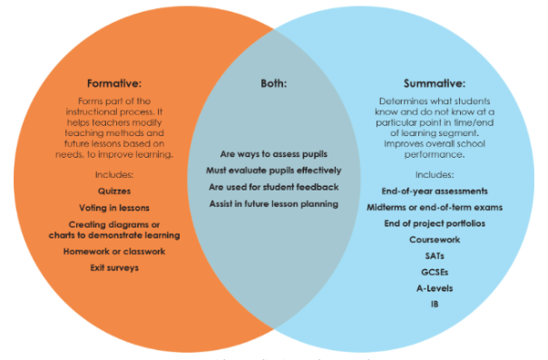
Figure 1: Showing the similarities in types of assessment. Wormeli, R. (2006). Fair isn't always equal. Portland, ME: Stenhouse.
Appendix B
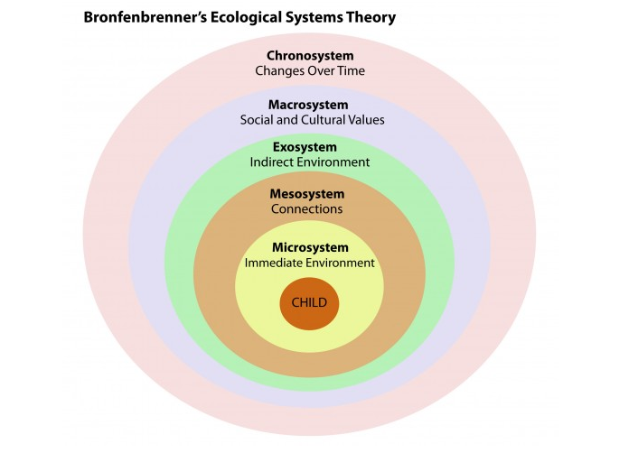
Figure 2: Image of Bronfenbrenner’s Psychology notes (2019). Bronfenbrenner’s Ecological Psychology notes (2019). Bronfenbrenner’s Ecological Theory. [image] Available at: https://www.psychologynoteshq.com/bronfenbrenner-ecological-theory/ [Accessed 14 Apr. 2019].

Appendix C
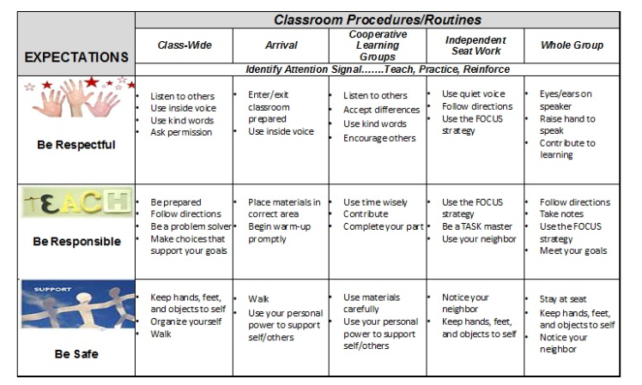
Figure 3: Elaine Gould (2010). Strategy for social skils. [image] Available at: https://education.wm.edu/centers/ttac/resources/articles/teachtechnique/strategiesforteachingsocialskills/index.php [Accessed 12 Apr. 2019].

Appendix D
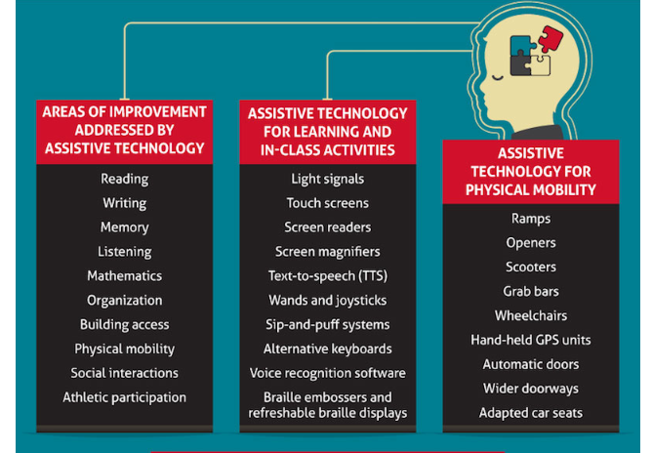
Figure 4: University of Cincinnati (2014). [image] Available at: https://mastersed.uc.edu/news-resources/infographics/how-technology-helps-in-the-education-of-special

